**Modeling the Sleeping Behaviour of a Patient Using Supervised Learning Techniques**

Aseel AlOrbani, Razan AlFar, Dimuthu Hemachandra, other profs

**Abstract**

**Introduction:**

**Data:**

Data set used in this project belong to a house that have two residents one of them is patient and the other is caregiver who is in the house most of the day. In this house, eight sensors are distributed in different rooms in 2017. Most of those sensors are motion sensors, which send a notification when triggered. Sensors have limited values, as an example: chair sensor have three different values, which are occupant, briefly vacant and vacant. The sensors are in action for 12 months, which gives us a sufficient data to make a good model. In one year a huge file with a lot of reading is produced, each notification in this file has a time stamp, source of reading and value of reading. In this project, bed and bedroom motion sensors are the most important and are mainly used as the source for prediction models. Additionally, other sensors are used to enhance the performance of prediction.

**Methods:**

The data from all the sensors have been obtained as text files and as the first step, the data was converted into *panda data frames* which is popular data structure in Python programming language that is used in data analysis. Since the amount of available data was noisy (55836 readings from 7 sensors per year), due to the simultaneous activation of sensors making it difficult to be used without been filtered. Therefore, an empty data frame was defined with *Day, Counter, Status* as fields and allocated 1440 rows corresponding to each minute of a given day (60 min x 24).

As a first trial, only bed, bedroom and chair motion sensor are kept and all the rest of sensors are dropped out. Since bed and bedroom motion sensors have little readings comparing to the rest of the sensors. We have also kept the chair sensor in order to have values for the rest of the day, since both bed and bedroom motion sensors are active mostly during the night. The choice was taking the chair sensor since it has many readings during the day opposite of bed and bedroom sensors. This sensor reading also helps the model predict better, as we know that when chair sensor motion activates then the man is not sleeping for sure. Many other sensors helps with the prediction as well, but including them was turning the bed and bedroom sensors to be considered as noise comparing the size of readings.

First, in the preprocessing stage after dropping out most of the unnecessary readings. Then the value of the columns status, which is our target, is then changed into Boolean values, where: False represents the status where the person is waken up. It replaces the bed sensor reading being vacant, the chair sensor occupied or bedroom motion idle. And True represents the person sleeping. It replaces the bed sensor occupied reading.

Going forward, input is narrowed down into four criteria: month, day, hour, and minute. Therefore, as a first trial we tried to try on bagging, random forests with maximum of one, two, and three features and AdaBoost.

GridSearch function helped to find the best learning rate and best number of estimators for the best model found previously, which was the one with the less error rate. Sensitivity and specificity scoring functions were also two parameters to try on for finding the best model. The final model with best parameters found is the best estimator that analysis will go forward with. The model is then used to predict on the test data that was separated in the beginning before training, getting us the error rate and 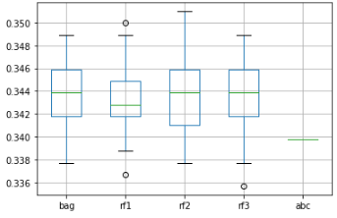the accuracy in order to evaluate the model performance. As a conclusion, those models did not give high accuracy and was not stable enough.

Then a method was implemented to go through all the data and detect the time points where the patient goes to bed (ABS bed sensor activated), and when the patient wakes us (ABS bed sensor vacated) and used those time points to fill the empty data frame with 1s for time periods of sleeps and 0s when he is awake. This leads to a data set of two classes where 1 represents minutes where the patient is on the bed and 0 represents otherwise.

Also, it was observed that the patient has not been present at home on some days and comes home in an irregular pattern making the sensor readings not interpretable since all the sensors resets at midnight. Therefore, these days were also removed from our analysis. Figure () shows a graphical representation of the status vs the counter for the selected data. To model a classifier that can predict the sleeping behaviour of this patient, the data was first divided in to sets where the odd days are considered as training data and the even days as the test data for validation. Several classifiers were tested with these data to inspect which model performs the best.

Random Forest Classifier:

Out of all the available classifiers nowadays, we used the Random Forest (RF) classifier1 since it is one of the most widely used classifiers and has outperformed other classifiers in many aspects2 3 4. RF is a collection of decision trees where each decision tree within the forests is built with a different bootstrap sample drawn from the original data set and then splitting according to the best split found over a randomly selected subset of features independently at each node. Once the forest is built, the classification can be done by simply aggregating the votes of all trees. There are few hyper parameters that you can tune in RF to improve the test accuracy5. The number of trees(n_estimators), the maximum depth of the tree (max_depth), the minimum number of samples required to split an internal node (min_samples_split) and the number of features to consider when looking for the best split (max_features) are some of them.

**Results:**

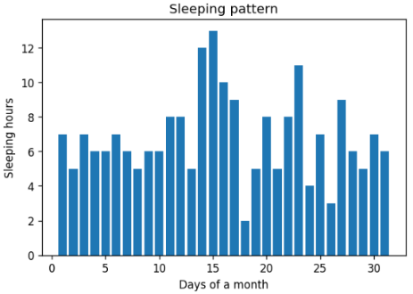Sleeping pattern was one of the useful conclusion of this data, where the data frame have records of how many hours did this person sleep every day for the whole year. Collecting sleep data could help improve the patient life style and health, by linking bedtime with the house system. In order to improve the adapting feature of a smart house, the system should be able to adapt to residents’ life style. As an example, the following figure shows the given resident’s sleeping pattern for one month.

**Discussion:**

1. Breiman L. Random Forests. *Mach Learn*. 2001;45(1):5-32. doi:10.1023/A:1010933404324

2. Fernández-Delgado M, Cernadas E, Barro S, Amorim D. Do we need hundreds of classifiers to solve real world classification problems? *J Mach Learn Res*. 2014;15(1):3133-3181.

3. Treeratpituk P, Giles CL. Disambiguating Authors in Academic Publications Using Random Forests. In: *Proceedings of the 9th ACM/IEEE-CS Joint Conference on Digital Libraries*. JCDL ’09. New York, NY, USA: ACM; 2009:39-48. doi:10.1145/1555400.1555408

4. A. Criminisi JS. *Decision Forests for Computer Vision and Medical Image Analysis*. Berlin, Germany: Springer International Publishing; 2013.

5. Probst P, Wright M, Boulesteix A-L. Hyperparameters and Tuning Strategies for Random Forest. *arXiv e-prints*. April 2018:arXiv:1804.03515.