***ISSYP*** FUN WITH PHYSICS

Activities

Working in groups of 4 or 5.

Spending 20 minutes at each station.

Activity#1: Photoelectric Effect

Materials: photoelectric effect apparatus and 2 voltmeters

Planck’s constant apparatus with 1 voltmeter

Activity#2: Planck’s Constant

Planck’s constant apparatus with 1 voltmeter

Activity#3: Superconductivity

superconductor

**liquid nitrogen**

Activity#4: Fun with physics

Bead chain, spinning disk, rattleback, inverting goggles, Bicycle wheel & seat, gyroscope, tops

Activity#5: Exploring Standing Waves

wave driver, signal generator, chladni plates and wire loop

table cloth and sand shaker

Activity#6: Hydrogen Spectrum

Activity#7: Determining the Speed of Light

Using a microwave

Activity#8: Electron Diffraction

Activity#9: Holography

using lasers to make images

ROCKETS!!!

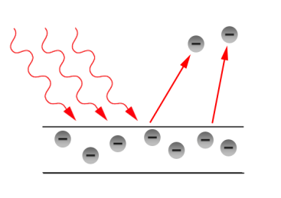***ISSYP*** FUN WITH PHYSICS #1

Photoelectric Effect

In this activity, you will observe light waves behaving like particles as you investigate how the kinetic energy of electrons ejected from a metal surface is related to the frequency of incident light. The energy of a classical wave depends on its amplitude (or intensity), not its frequency. If the energy of light is found to depend on its frequency then light must not be a classical wave.

The maximum kinetic energy of the ejected electrons is found by measuring the reverse potential difference applied across the phototube required to stop the flow of ejected electrons (cutoff potential).

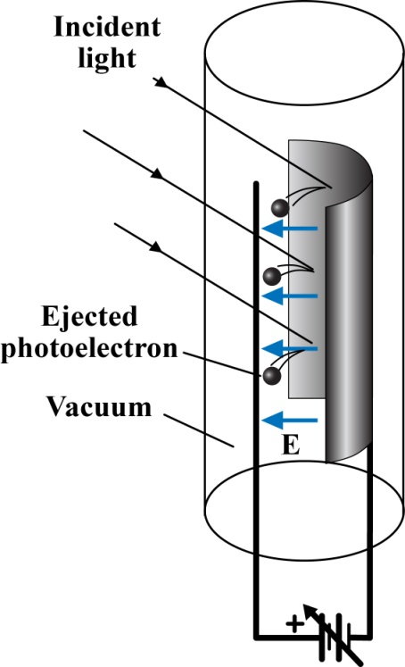

**Instructions**

1. Set the photocurrent meter to 200 mV DC.

2. Set the stopping potential meter to 20 V DC. Turn the knob on the

apparatus counterclockwise to start at zero reverse potential.

3. Insert the red LED into the apparatus (longer lead goes into + socket).

The photocurrent meter indicates the flow of electrons.

4. Increase the stopping potential by turning the knob clockwise until

the photocurrent goes to zero. Record the cutoff potential, V0, in

the table below.

5. Repeat steps 2-4 for the other three LEDs.

6. Complete the bottom row of the table.

**Observations**

|  |  |  |  |  |
| --- | --- | --- | --- | --- |
|  | Red  (660 nm) | Amber  (600 nm) | Green  (565 nm) | Blue-Green  (525 nm) |
| Frequency  ( Hz) | 4.54 | 5.00 | 5.31 | 5.71 |
| Cutoff Potential  (V) |  |  |  |  |
| Kinetic Energy*  ( J) |  |  |  |  |

* To calculate the kinetic energy of the electron multiply the cutoff potential by the charge on the electron (*e* = 1.6 x 10-19 C).

**Analysis**

1. Plot vs on the grid provided.



*f* (x1014 Hz)

EK (x10-20 J)

4

8

12

-20

-16

-12

-8

-4

0

-24

-28

1

2

3

4

5

6

7

2. What is the equation for this line? What is the physical interpretation of the terms in the equation?

**Thinking Deeper**

1. Why do the electrons ejected by blue-green light have more kinetic energy than the electrons ejected by red light?

2. How does this experiment challenge the wave model of light? Imagine going to the beach and standing in the water. If water behaved like light, what would a high-energy wave look like?

3. Examine the plot of EK vs *f*. What is the significance of the x-intercept? What do you think will happen if we shine an LED on the metal surface that has a frequency less than the intercept value?

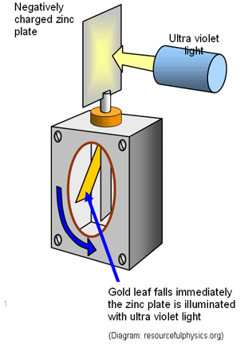**Background**

A simple experiment inspired by Heinrich Hertz’s 1887 investigation shows that light shining on the metal surface of an electroscope discharges a negative static charge on that surface. This makes sense because light has energy that electrons in the metal’s surface can absorb, giving the electrons enough kinetic energy to “jump” out of the metal. However, further experiments reveal something very strange: light below a certain threshold frequency, , does *not* eject electrons, *no matter how intense the light*. This is like saying a low frequency note will not break your eardrum no matter how loud it is; but any note above a certain pitch *will*, no matter how quiet it is. This made no sense. Isn’t it the *loudness*, rather than the *pitch* that matters?

In 1905, Albert Einstein made the bold hypothesis that light, which was thought to be a wave, is really a shower of particles, called *photons*. Applying Max Planck’s quantum formula to light, Einstein suggested that the energy of each photon would be , where is the frequency of the light “wave”. When a photon hits an electron it is absorbed and the electron gains energy, . If the frequency of light is above the threshold the electron gains enough energy to jump out of the surface and escapes with a kinetic energy , where is the amount of work required to remove the electron from the surface.

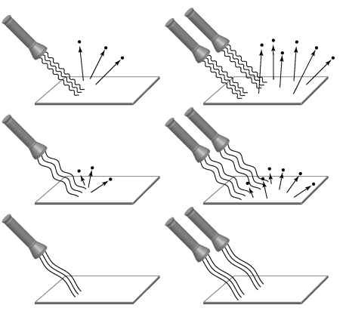If the frequency of light is too low (such that ), the electrons do not gain enough energy to escape the metal, and no electrons are ejected. This is true *no matter how intense the light* (see bottom two pictures). In the old wave model of light, “intensity” is determined by the amplitude of the wave; in the new particle model, intensity is determined by the number of photons. Super intense light might have zillions of photons, but if the frequency is too low, each photon does not pack enough punch to knock out an electron! Can you explain what is happening in the other pictures? Einstein’s idea of light waves behaving like particles was instrumental in starting the profound revolution in science we now know as **quantum mechanics**.

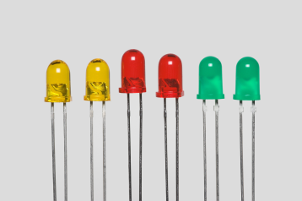

***ISSYP*** FUN WITH PHYSICS #2

Planck’s Constant

**Preamble/Background**

A light emitting diode (LED) consists of two different semiconductors joined together. One of the semiconductors has electrons that are in a higher energy state and are free to move, the other has spaces for them to drop into (holes). When the LED is initially manufactured some electrons will move from one material into the other creating a potential barrier across the junction which will prevent any further migration of electrons.

By applying a potential difference across the LED we can remove the potential barrier, allowing the electrons to flow across the junction. As the electrons cross the junction they move from a higher energy state to a lower energy state so they emit light. The energy of the light emitted will be equal to the difference in energy between the two sides of the LED.

The difference in energy between the two sides can be determined by finding the minimum amount of energy needed to produce light (ie. threshold potential). Different colours are produced by different combinations of semiconductors. The relationship for the energy of the light demonstrates a basic quantum principle of light,



first proposed by Max Planck, where h is Planck’s Constant (h = 6.626x10-34 J∙s)

Plotting the amount of energy applied to the LED vs the frequency of light produced by the LED will give us the opportunity to determine the value of Planck’s Constant experimentally.

**Observations**

|  |  |  |  |  |  |
| --- | --- | --- | --- | --- | --- |
|  | Red  (660 nm) | Amber  (600 nm) | Yellow  (590 nm) | Green  (530 nm) | Blue  (470 nm) |
| Frequency (x1014 Hz) | 4.54 | 5.00 | 5.08 | 5.66 | 6.38 |
| Threshold Potential (V) |  |  |  |  |  |

**Analysis**

1. Plot the applied potential vs the frequency of the light.

0

Threshold Potential (V)

3

2

1



*f* (x1014 Hz)

1

2

3

4

5

6

7

0

1

2

3

**Discussion**

1. Calculate the slope of your plot. Convert to standard units by multiplying your answer by the charge on an electron. What does this slope represent?
2. Weather reports monitor ultraviolet (UV) light levels. Why is UV light a concern?
3. How does this result challenge the wave model of light? If sound behaved like light, how would it change the way music is heard?

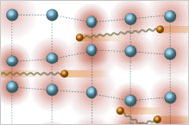***ISSYP*** FUN WITH PHYSICS #3

Superconductivity

High-temperature superconductors (HTS) are special materials that stop resisting electron flow below 90K.

One of the coolest features of superconductivity is the Meissner effect—the repulsion of a magnet by a superconductor.

**Safety Warning!!**

*Liquid Nitrogen is very cold and makes other things very cold. Touching very cold things with your bare hands can result in severe frostbite. The gloves and tongs are provided for your safety—use them!*

The superconductor is the coin-sized ceramic disk. Place it in the Styrofoam cup and cover it with liquid nitrogen. Once the liquid nitrogen stops boiling the disk is cold enough to be superconducting.

Carefully place the magnet on top of the disk. Observe and explain.

Let the superconductor warm up a bit and then put the magnet on it. Now cool the disk down again (this time with the magnet sitting on it). Observe and explain.

If you push the levitated magnet with the tweezers so as to move it across the superconductor, it will resist movement. Why does this happen?

The kit contains two superconductors, a yttrium-based one and a bismuth-based one. Try both and determine which one displays superior superconducting properties. Why?

What are some potential uses for superconductors?

Make a list, discussing each potential use.

***ISSYP*** FUN WITH PHYSICS #4

Everyday Phenomena

Some of the best physics happens in our day-to-day lives.

1. Hold the container with the metal bead chain at chest height. Pull one end of the chain out of the container, give it a quick tug towards the ground and then let the chain go (don’t let go of the container!). Watch carefully. Repeat and vary the experiment to get a good grasp of what is happening. What happens to the chain as it leaves the container? Why does this happen? What are the factors that influence this behaviour?
2. Take the ring with the disks on it. Strike the disks so they spin. If you move the large ring the small disks keep spinning. What’s going on?
3. Play around with some of the toys that we have collected. Discuss the physics behind them.
4. Sit on the chair and spin it. Draw your arms in and out holding the books. What happens? The rotational kinetic energy is larger when you spin faster. Where does that energy come from?
5. Start with the chair at rest and the bicycle wheel vertical. The wheel should be spinning so that the top edge is rotating away from you. What happens as you turn the bicycle wheel to the left or two the right, into the horizontal position?
6. Start with the bicycle wheel horizontal and the chair at rest. Turn the wheel by 180 degree until it is horizontal with opposite orientation. Measure your rotation speed. What happens if you turn it back to the initial orientation? What happens if you turn it the other way around? Does it make sense?
7. Explore the gyroscopic forces of the spinning bicycle wheel. Can you predict how the wheel will move if you try to tilt it upwards? Try it out!
8. Put a string through the handle. How does the wheel move if you hold it that way? The motion is called precession – how does it work?
9. Why is a spinning top more stable than a stationary one?

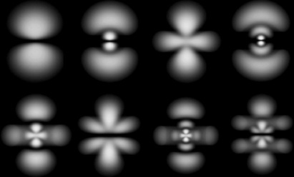***ISSYP*** FUN WITH PHYSICS #5

Exploring Standing Waves

Quantum mechanics describes the behavior of particles using waves. The amplitude of the wave at any point in space is related to the probability of finding the particle at that point.

Waves can be superimposed to form standing waves, which are easily observed in mechanical systems like strings, wire loops and Chladni plates. Watch the youtube video on standing waves and resonances.

The wave driver (a.k.a. speaker) is used to produce vibrations in the Chladni plate. At certain frequencies the plate will *resonate* (vibrate a lot), in certain standing wave patterns. Explore this phenomenon by sweeping the wave driver through different frequencies.

**Be careful to lock the wave driver if you change plates!!**

Where have you experienced this kind of phenomenon in your life?

How can the phenomenon of standing waves and resonance give insight into the behavior of the electron in the Hydrogen atom?



***ISSYP*** FUN WITH PHYSICS #******6

The Hydrogen Atom

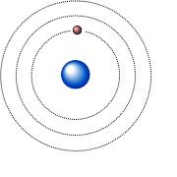**Preamble/Background**

The Hydrogen atom consists of one electron orbiting around one proton. In a simple model of this atom the electron orbits in circular shells. The inner shell represents the lowest (or ground state) energy level. If we treat the electron as a classical particle moving around the proton it will have both kinetic energy and potential energy. In order to switch from one orbit to another it must either absorb energy to go up or release energy to go down.



There are a couple of small problems with this simple model: first, it doesn’t work! According to Maxwell’s Equations a charged particle travelling in a circular path MUST radiate energy – so this atom should spiral in and annihilate itself in a fraction of a second. Second, there is no reason for the discrete energy shells. There is no mechanism in classical physics that can restrict the energy of the electron in such a way that it can only orbit at certain radii. This is a problem because we know from experience that the Hydrogen atom exists and that the electron can only orbit at discrete energy levels. In fact, we know from empirical data that the energy levels of Hydrogen must follow:



So how do we fix this? Let’s begin, as Niels Bohr did, with a few simple rules:



1. Electrons can only orbit in certain discrete energy shells.

2. When electrons drop from one shell to another they emit light

equal to the difference in shell energies (E=h*f*).

3. The angular momentum must be an integer multiple of a basic quantity.

Bohr did not having a theory motivating these rules, he was more describing how nature seemed to be working. Let’s combine his ideas with the wave-particle ideas from deBroglie and see where it takes us.



According to deBroglie, combine this with Bohr’s quantum rule:

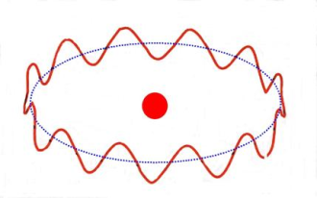

So we get a picture of what is going on to restrict the allowable energy levels. ***Electrons are only allowed to be in a shell if the circumference of that shell is equal to an integer number of wavelengths*** – in other words, the wavefunction for the electron must be a standing wave.

Another powerful result of Bohr’s quantum rule is that we can use it to find the energy levels for the Hydrogen atom using simple classical physics. The Coulomb force acting on the electron causes circular motion so we can find the classical speed of the electron. Putting this classical speed into the Bohr rule for quantized angular momentum will give us a rule for the orbital radius:



**Analysis & Discussion**

1. Solve the radius equation for n=1. Compare your answer with the wavelength for the electron.



(Use: k = 9.0x109 N∙m2/C2, m*e* = 9.11x10-31 kg, *e* = 1.6x10-19 C, h = 6.626x10-34 J∙s)

2. Consider the total energy of the classical electron in orbit. Use the Bohr radius to derive a general expression for the nth allowed energy levels.

3. Substitute values for the fundamental constants to get an expression for the nth allowed energy levels for Hydrogen. Check the units and compare with the equation based on empirical results.

4. The Balmer Series is produced by transitions that end up on the n=2 shell. Use the energy level equation to determine the colour of light emitted when the electrons drop from n=3 and n=4 to n=2. Compare these to your observations.

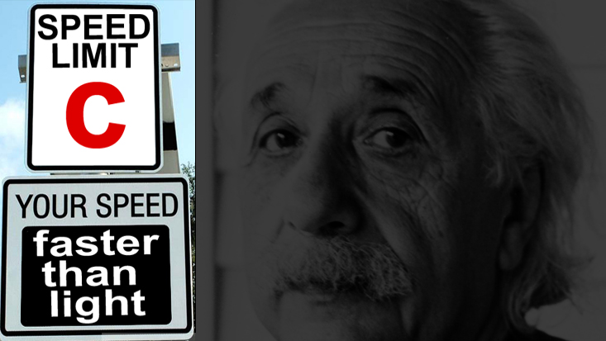***ISSYP*** FUN WITH PHYSICS #7

Determining the Speed of Light

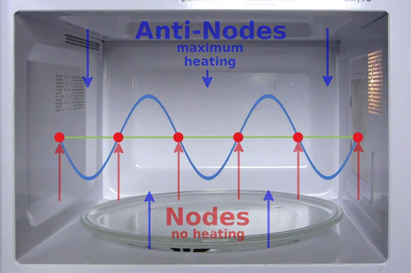

A microwave oven works by setting up a standing wave inside the oven cavity. The frequency is chosen that matches a resonant frequency for water, so the standing wave makes the water and fat molecules vibrate. This vibration makes the food hot. *Note that the standing wave created in each microwave might be different than the one shown in the image.

To create a stable standing wave there must be an integer number of ‘loops’ inside the oven cavity. Each loop is half a wavelength long. We are going to determine the wavelength of the standing wave and use the given frequency for the microwave to determine the speed of light.

1. Will the energy be equally distributed throughout the cavity?

2. Spread a thin layer of margarine over a piece of cardboard and place it in the oven. Turn it on low and watch for changes in the margarine in the first 5 sec.

3. Stop when you see several spots of margarine melting. Why is some margarine melting and not all?

4. Measure the distance between the “hot spots”. This is equal to half a wavelength. (Why half?)

5. Look on the back of the microwave to obtain the operating frequency.

6. Use the universal wave equation to determine the speed of light. Does your answer make sense?

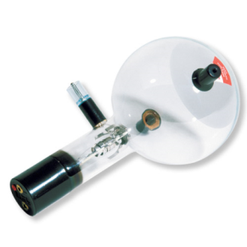***ISSYP*** FUN WITH PHYSICS #8

Electron Diffraction

**Preamble/Background**

One characteristic behavior of classical waves is diffraction: the bending of the wave as it passes through a small opening. The behavior is obvious with water and sound waves but a little more difficult to see with light. It becomes difficult with light because the wavelength of light is so small that the opening must be extremely tiny in order to produce noticeable effects.

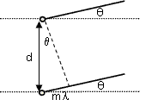According to deBroglie, the momentum of an electron can be expressed as a wavelength. If electrons have a wavelength then we should be able to observe diffraction. However, the opening that will produce diffraction is too small to use a manufactured grating so we will use a thin layer of carbon. The carbon atoms will act like a diffraction grating and cause the electron beam to diffract producing a bright ring on the diffraction bulb screen.

Geometric analysis of the diffraction pattern allows us to determine

the spacing between the carbon atoms (d). Interference maxima will occur

if the path difference from adjacent gaps in the grating is an integer multiple of the wavelength (m).

As we can see in the diagram to the right, this criterion is met when the path difference is equal to the product of the width of the gap and the sine of the angle.



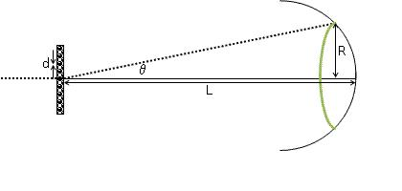

If we examine the geometry of the electron diffraction tube,

we can find a similar triangle to the one shown above,



Which leads us to the following expression for the atomic

spacing of the carbon atoms can be determined if you know:



m - what order maxima (m=1)

L - the pathlength of the tube (L=130 mm)

R - the radius of the diffraction ring

● - the wavelength of the electron



According to deBroglie, the wavelength of the electron depends on its momentum.



The momentum of the electron is determined by the energy

in the electric field used to accelerate the electron.

So the wavelength of the electron is given by:



( Use: h = 6.626x10-34 J∙s, m = 9.11x10-31 kg, *e* = 1.6x10-19 C)

**Observations**

|  |  |  |
| --- | --- | --- |
| Potential Difference  (V) | Radius of Inner Ring (cm) | Radius of Outer Ring (cm) |
|  |  |  |

**Analysis & Discussion**

1. Determine the wavelength of the electrons.

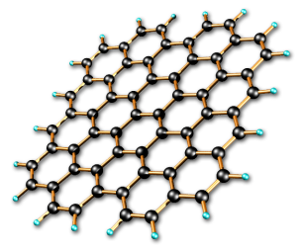2. Why are there two first order maxima diffraction rings produced?

[HINT: Look at the picture of the graphite lattice on the right]

3. Determine the atomic spacing for carbon using m=1 for both rings.

***ISSYP*** FUN WITH PHYSICS #9

Holography

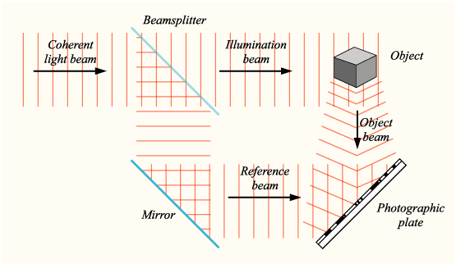A hologram is a photograph of an interference pattern created using two parts of a split laser beam. One beam reflects off the object before striking the film. The other beam travels directly to the film where it acts as a reference beam that interferes with the reflected object beam (see diagram).

Holograms are 2-dimensional interference patterns that contain 3-dimensional information. This information can be layered in such a way that holograms can contain huge amounts of data.

Not only are holograms cool to look at—they also provide us with a very powerful analogy for understanding the universe!