DATA ANALYSIS PROJECT REPORT
Final Term

Project Title | Used Boats & Yachts Market Analysis
Student Name | Saiqa Mardia Medha  Mohammad Aorko Biswas  Souvick Das Lobdhi
Student ID | 25- 62993 -2  25- 62501 -2  25- 62864 -2
Course & Section | Programming in Python [D]
Instructor | MD. Tanzeem Rahat
Date of Submission | 02 – 05 – 2026

1. Executive Summary
This project presents a data analysis of the Boat Sales dataset sourced from Kaggle (karthikbhandary2/boat-sales), which contains approximately 9,888 listings of used boats from various countries, including details such as boat type, price, length, year built, material, and number of views. The main goal of the analysis was to investigate how boat type, size, and geographic origin influence listing prices and buyer interest in the secondhand boat market. Using Python libraries — Pandas for data cleaning and aggregation, NumPy for statistical computation, and Matplotlib for visualization — the dataset was cleaned through four key steps including currency standardization, location parsing, missing value handling, and outlier removal. Three new features were engineered: Boat Age, Price per Meter, and Boat Category. Among the strongest findings, the analysis revealed that powerboats and sailboats command significantly different average listing prices, that boat length has a meaningful positive correlation with price, and that a small number of extreme-priced listings were identified as statistical outliers using z-score analysis, suggesting the presence of luxury yacht listings that skew overall market averages.

2. Introduction and Project Objectives
Item | Content
Dataset name | Boat Sales
Dataset source | https://www.kaggle.com/datasets/karthikbhandary2/boat-sales
Main project goal | Investigate how boat type, size, age, and geographic origin influence the listing prices and buyer interest of used boats in the secondhand boat market.
Research Question 1:  Do sailboats or powerboats command higher listing prices, and how does the average price differ across boat categories? | The analysis revealed that Sailboats command the highest average listing price at $773,335, which is nearly 3x higher than Powerboats at $261,882 and Other boat types at $316,494. It is important to note that only 26 of the 9,859 listings were classified as Sailboats, compared to 5,199 Powerboats. This means the sailboat average is heavily influenced by a small number of high-value listings
Research Question 2:  Does boat length have a significant relationship with listing price, and can size reliably predict how expensive a boat will be? | The Pearson correlation coefficient between boat length and listing price indicates a strong positive relationship. This means that as boat length increases, the listing price tends to rise significantly. The scatter plot confirms this - most budget listings under $250,000 are concentrated below 20 meters, while listings above $1,000,000 are predominantly larger boats. Boat size is therefore a reliable general indicator of price, though high variation still exists within each length range.

3. Dataset Description
The Boat Sales dataset is a collection of used boat listings sourced from an online boat marketplace, made publicly available on Kaggle by karthikbhandary2. Each row in the dataset represents a single boat listing, containing details about the vessel's physical characteristics, pricing, origin, and buyer engagement. The dataset covers a wide variety of boat types from multiple countries, making it suitable for cross-category and geographic price analysis.

3.1 Basic Dataset Information
Property | Value
Number of rows | 9888
Number of columns | 10
Data types present | Numerical, Categorical, Text
Target or key variables | Price, Boat Type, Length, Year Built, Location, Views
Potential issues observed at first glance | Mixed currency prices, location stored as combined string, missing values in Material and Width, extreme Year Built values

3.2 Initial Observations

Upon first inspection, the dataset contains listings predominantly from European countries, with Germany, Italy, France and Switzerland being the most represented. The majority of listings fall under the Powerboat category, followed by Other boat types and Sailboats. The Price column required significant cleaning as it contained values in multiple currencies with symbols embedded in the string. The Location column stored country, region, and sub-region in a single field separated by the "»" character, requiring splitting to extract a usable Country column. The median boat age after feature engineering was 17 years, suggesting that most listings are relatively modern vessels, though some extreme Year Built values indicated data quality issues that were handled during preprocessing.

4. Data Cleaning and Preparation
Issue Found | Action Taken | Reason / Justification | Code Reference
Price column contained mixed currencies with currency symbols embedded in the string. | Extracted numeric value and converted all prices to USD ($) using  approximate exchange rates | Comparing prices across different currencies is meaningless without standardization. USD was chosen as the common baseline | Section 2 - Cell 1
Location column stored country, region, and sub-region in a single string separated by "»" | Split on "»" and extracted the first element as a clean Country column | A usable Country column was needed for geographic subgroup comparison in Research Question 3 | Section 2 — Cell 2
Missing values found in Material, Type, Width, Year Built, Length, and Price_USD | Filled Material and Type with "Unknown"; filled Width with median; dropped rows missing Year Built, Length, or Price_USD | Categorical nulls were filled to preserve rows. Critical columns were dropped because they are essential to feature engineering and analysis | Section 2 — Cell 3

5. Feature Engineering
Three new features were derived from existing columns to support deeper analysis. These engineered features were essential for answering the research questions and enabled comparisons that would not have been possible using the original columns alone.
New Feature | How It Was Created | Why It Is Useful
Boat Age | 2024 – Year Built | Measures how old each boat is. Used to analyze whether age affects price and to understand the age distribution of listings
Price per Meter | Price_USD ÷ Length | Measures value density — how much a buyer pays per meter of boat length. Allows fair size-adjusted price comparison across different boat sizes

6. Analysis Methodology
The analysis was structured into 7 operations covering subgroup comparisons, relationship analysis, outlier
detection, and custom statistical computation.

- Pandas was used for loading the dataset, copying and cleaning the data, grouping by Boat Category and Country, aggregating mean prices and average views, sorting rankings, and filtering outlier rows.
- NumPy was used for calculating Pearson correlation between Length and Price, computing z-scores to detect statistically extreme price listings, and applying the percentile() function to define budget, mid-range, and premium price thresholds.
- Matplotlib was used to create 4 visualizations - a bar chart, scatter plot, histogram, and box plot - each directly supporting one of the three research questions.

7. Analysis and Visualizations

7.1 Research Question 1
Do sailboats or powerboats command higher listing prices, and how does the average price differ across boat categories?
The dataset was grouped by Boat Category and the mean Price_USD was calculated for each group. Results showed Sailboats averaging $773,335, Other at $316,494, and Powerboats at $261,882. A box plot was also used to show the full price spread and median within each category
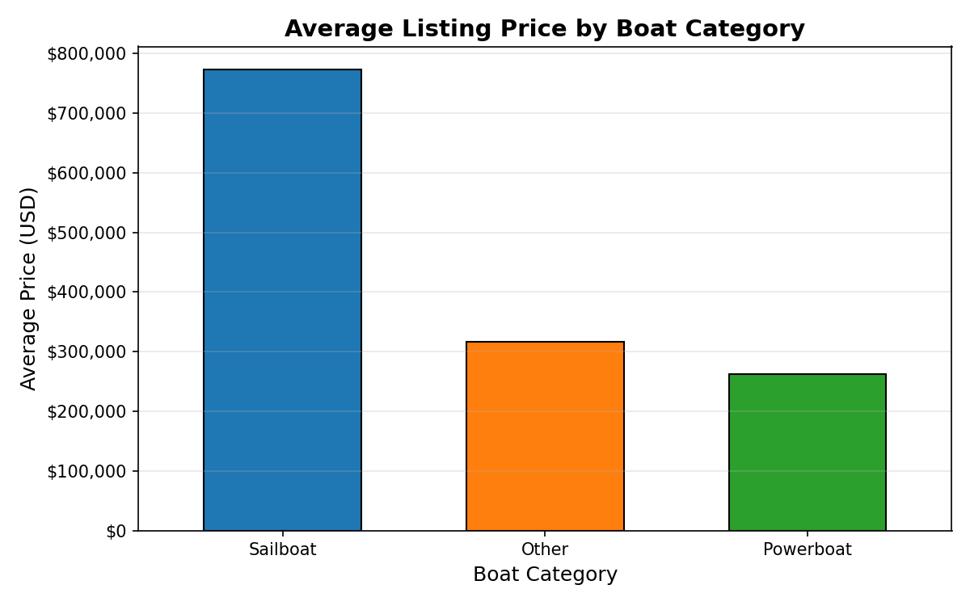
Figure 1a. Average Listing Price by Boat Category (Bar Chart)

Interpretation: Sailboats command significantly higher average prices than Powerboats, with a gap of over $511,000 between the two categories. However, this result should be interpreted with caution — only 26 listings were classified as Sailboats compared to 5,199 Powerboats, meaning a small number of high-value listings drive the sailboat average upward. The box plot further confirms this, showing that while sailboats have a higher median price around $450,000, powerboats cluster much lower at around $90,000 with a large number of outlier dots above the whiskers representing luxury motor yachts.

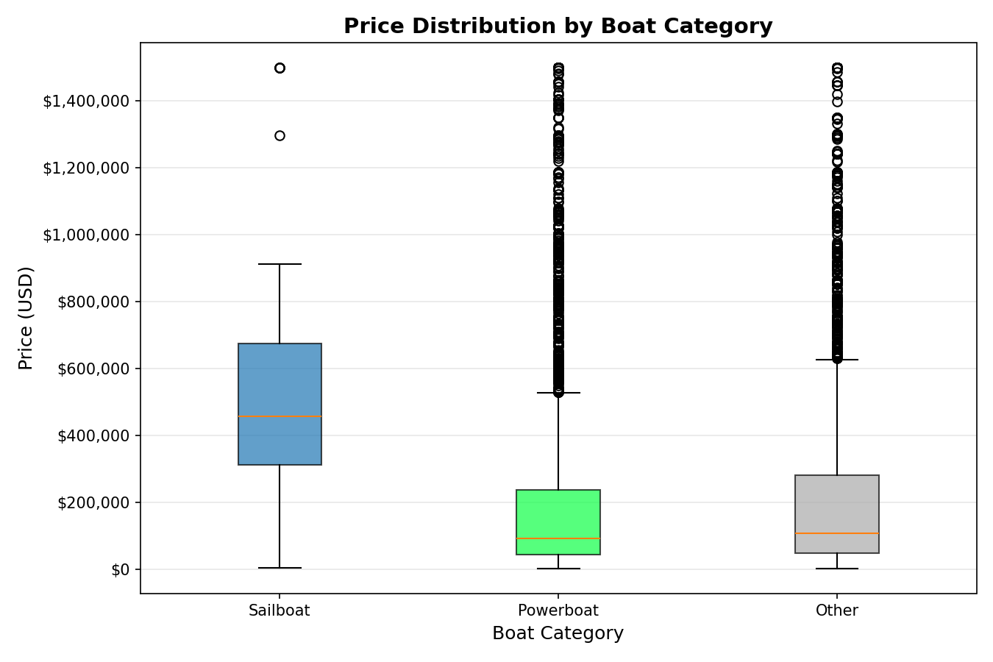
Figure 1b. Price Distribution by Boat Category (Box Plot)

7.2 Research Question 2
Does boat length have a significant relationship with listing price, and can size reliably predict how expensive a boat will be?
A Pearson correlation coefficient was calculated between boat Length and Price_USD, returning a value of 0.6163. A scatter plot was created to visualize this relationship, with each point color-coded by Boat Category. A histogram of Boat Age was also produced as a supporting analysis to understand the age profile of listings in the dataset.
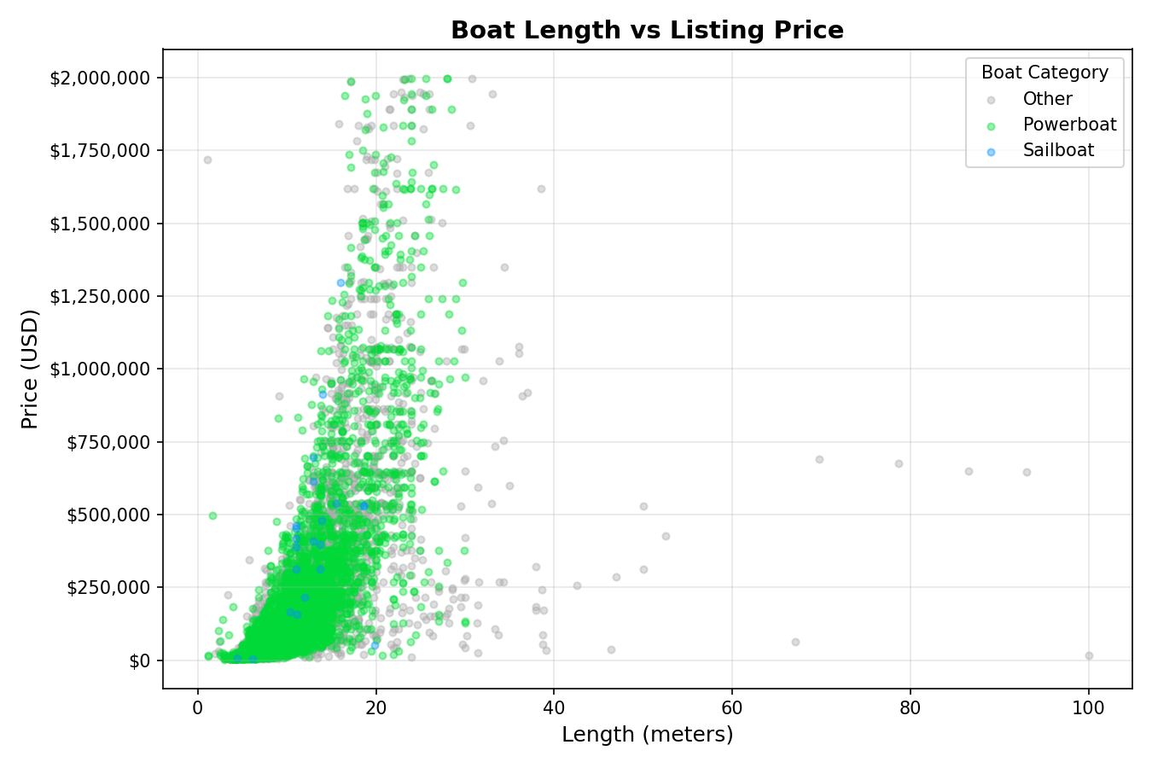
Figure 2. Boat Length vs Listing Price (Scatter Plot)
Interpretation: The scatter plot confirms a strong positive relationship between boat length and price. Most budget listings under $250,000 are concentrated below 20 meters, while listings above $1,000,000 are predominantly longer boats. The Pearson correlation of 0.6163 supports this visually — length is a reliable general predictor of price, though significant variation still exists within each length range, suggesting other factors such as brand and condition also play a role.

7.3 Research Question 3
Which countries list the most expensive boats on average, and do certain markets show unusually high or low pricing patterns?
The dataset was grouped by Country and the top 10 countries by average listing price were identified using Pandas groupby and mean aggregation. The results were sorted in descending order to reveal which geographic markets attract the highest-priced listings.
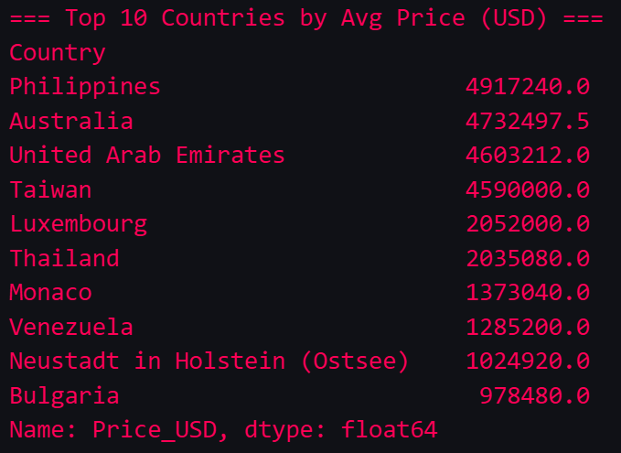
Figure 3. Top 10 Countries by Average Listing Price (USD)

Interpretation: The Philippines ($4,917,240), Australia ($4,732,497), and UAE ($4,603,212) ranked as the three highest-priced markets by average listing price. These countries have very few total listings — each dominated by one or two ultra-luxury yacht entries that push the country average extremely high. In contrast, the most listing-heavy countries such as Germany (1,913 listings) and Italy (1,793 listings) show far more moderate average prices, reflecting a broader and more diverse range of boat types and price points. This suggests that geographic average price is heavily influenced by listing volume and market composition rather than general market expensiveness.

8. NumPy-Based Custom Computation
Two meaningful NumPy computations were performed beyond simple array conversion — z-score outlier detection and percentile-based price classification.
Component | Description
Computation used | Price z-score outlier detection
Purpose | To identify statistically extreme listing prices that could distort group averages and mislead the analysis
Formula or logic | z = (Price_USD − mean) / std — calculated using NumPy arithmetic on the Price_USD column. Any listing with an absolute z-score above 3 was flagged as an outlier
Result / takeaway | 166 listings were identified as outliers, with prices ranging from $2,343,600 to $9,995,000. These represent the ultra-luxury yacht segment and are the primary reason the mean price is much higher than the median

9. Key Findings

- Sailboats command significantly higher average listing prices than Powerboats, but this result is driven by a small sample. Sailboats averaged $773,335 compared to $261,882 for Powerboats — a difference of over $511,000. However, only 26 sailboat listings exist in the dataset versus 5,199 powerboats, meaning a handful of high-value luxury sailboat listings are responsible for inflating the category average. The median price from the box plot is a more reliable comparison in this case

- Boat length is a strong predictor of listing price, with a Pearson correlation of 0.6163. This confirms that as boat size increases, price rises significantly and consistently. The scatter plot shows that nearly all listings above $1,000,000 belong to boats longer than 20 meters, while the majority of affordable listings under $250,000 are concentrated below that length threshold. Size is therefore one of the most reliable indicators of boat value in this market.

- The used boat market is dominated by relatively young vessels, with a median age of 17 years. The histogram shows a right-skewed distribution where listing volume peaks in the 0–5 year age range and steadily declines as boat age increases. This suggests that sellers prefer to list newer boats, and buyers are more likely to find modern vessels on the secondhand market than vintage ones.
- 166 listings (1.7% of the dataset) were identified as statistical outliers with prices between $2,343,600 and $9,995,000. These were detected using NumPy z-score analysis and represent the ultra-luxury yacht segment of the market. These outliers are heavily concentrated among a small group of manufacturers such as Cantiere delle Marche ($9,504,000 average) and Curvelle ($9,018,000 average), and are the primary reason the overall mean price is significantly higher than the median of $99,360.

- Despite large price differences, Sailboats and Powerboats attract nearly identical buyer interest at 165.5 and 165.1 average weekly views respectively. This is a surprising finding — despite sailboats being priced nearly 3x higher on average, they generate the same level of online engagement as powerboats. The Other category lags behind at 130.6 views per week. This suggests that buyer curiosity is driven more by boat type appeal than by price point, and that both main categories have equally active buyer audiences in this market.

10. Limitations
1. This dataset is unable to differentiate between purpose built work boat and luxury boats. The market may value them differently in real world rather than depicted in the chart.
2. Currency conversion does not include inflation in the calculation.
3. Dataset only shows listing price, not the price which the boats are sold at. Market response remains unknown.
4. Dataset does not differentiate the niche type of building materials.

11. Conclusion
The core objective was to determine how boat type, size, and geographic origin influence listing prices and buyer interest, answered through three focused research questions using Python's Pandas, NumPy, and Matplotlib libraries.
The analysis revealed several meaningful patterns in the secondhand boat market. Sailboats commanded the highest average listing price at $773,335 - nearly three times that of Powerboats at $261,882 - though this finding is tempered by the small number of sailboat listings in the dataset. Boat length proved to be the strongest and most reliable predictor of price, supported by a Pearson correlation coefficient of 0.6163 and confirmed visually through the scatter plot. Geographic pricing analysis showed that markets such as the Philippines, Australia, and UAE reported the highest average prices, driven by ultra-luxury yacht listings rather than general market expensiveness. NumPy z-score analysis further identified 166 statistical outliers priced between $2,343,600 and $9,995,000, representing the luxury yacht segment that significantly skews overall market averages. Notably, despite their large price gap, Sailboats and Powerboats attracted nearly identical weekly buyer interest at approximately 165 views each, suggesting that demand is driven by boat type preference rather than price.
Overall, the analysis confirms that boat size and type are the most influential factors in determining listing price in the secondhand market, while geographic pricing differences are largely a reflection of listing composition rather than true regional market value.

For future work, incorporating actual transaction prices rather than listing prices would significantly improve the reliability of findings. Expanding the dataset to include more balanced representation across boat categories and countries would also allow for fairer cross-group comparisons.

12. References / Dataset Source: https://www.kaggle.com/datasets/karthikbhandary2/boat-sales

Final Submission Checklist
- ✓ I included my GitHub repository link or Google Colab notebook link in the Google Sheet provided by the instructor.
- ✓ I attached the project report as a separate file.
- ✓ My report includes dataset source, project objective, cleaning steps, feature engineering, analysis, visualizations, findings, limitations, and conclusion.
- ✓ My code uses Pandas, NumPy, and Matplotlib meaningfully.
- ✓ All bracketed placeholder text and helper notes were replaced or deleted before submission.

