Welcome to Mid-air Shooter

Mid-air Shooter is a game built on pyhon. Make sure you have python installed on your computer.
To run the game-----
--Open the extracted folder in terminal and navigate into the folder: cd MId-air_Shooter
--Create virtual environment: python -m venv .venv
--Activate it: .venv\Scripts\activate
--Install required files: pip install -r requirements.txt
--Run it: python Main.py
You should have a window like this down below:
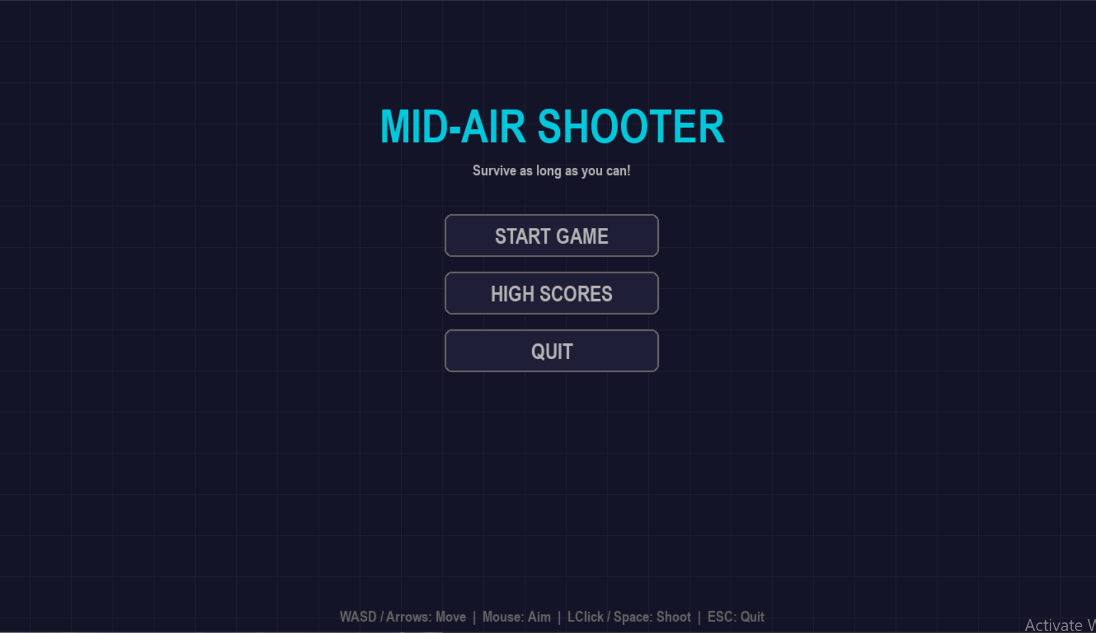
Press “START GAME” to play
Press “HIGH SCORES” to see highest scores
Press ”QUIT” or ‘Esc’ on yor key board to quit
Once you start playing, you control the blue ship. You can move with ‘W’ ’A’ ’S’ ’D’ or the Arrow keys. Shoot at enemies by pointing at them with the mouse and shoot them by pressing Left Mouse Button or Space Bar.
Self-sacrificial enemies will crash into you. Red ships also shoot at you. Avoid all the ships and fire and try to survive as long as possible
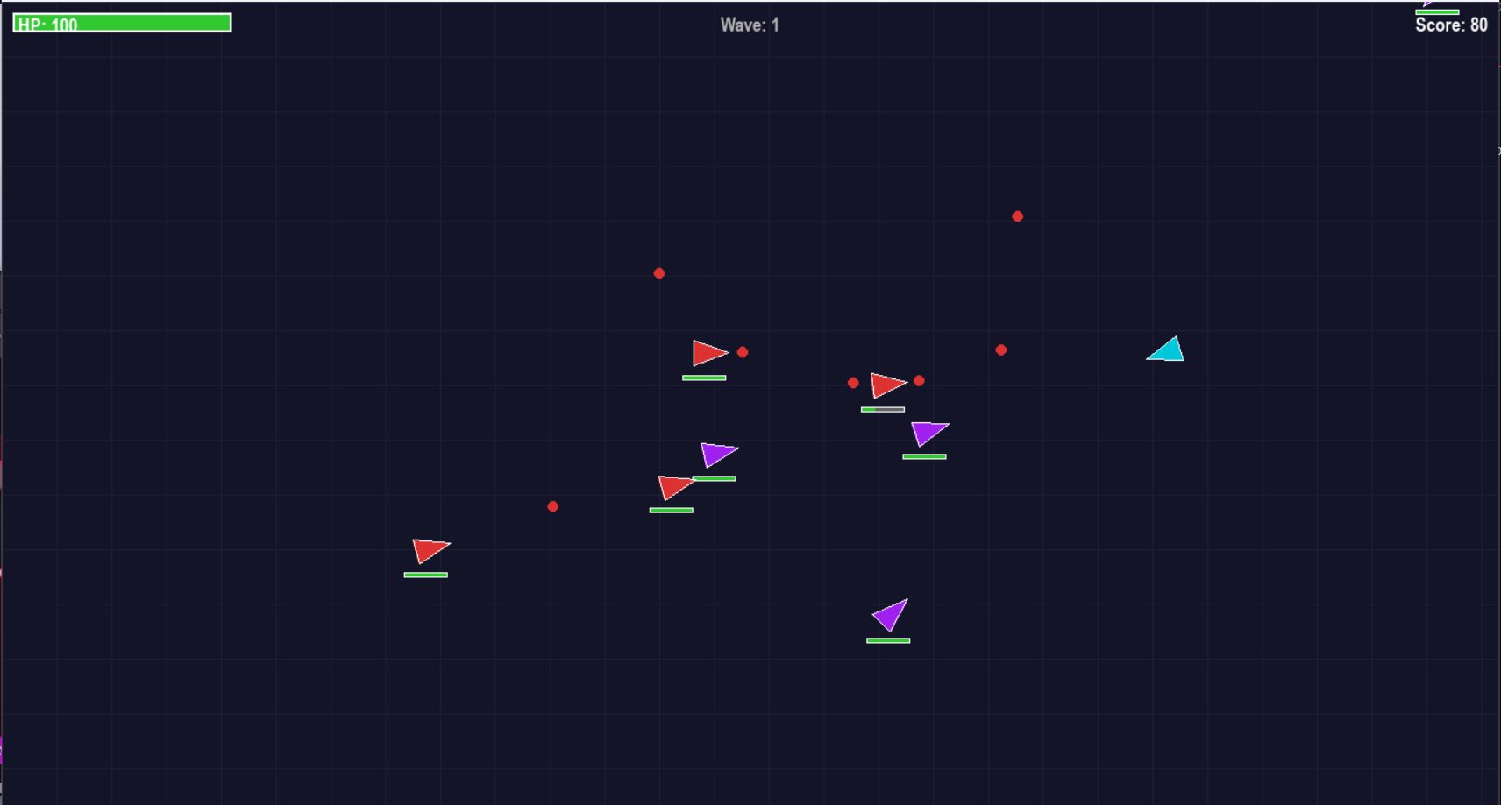

If you score high enough, you can save your score in the ‘High Scores’ list. Write your name and press ‘Enter’. Your can also choose not to save by pressing ‘Esc’.
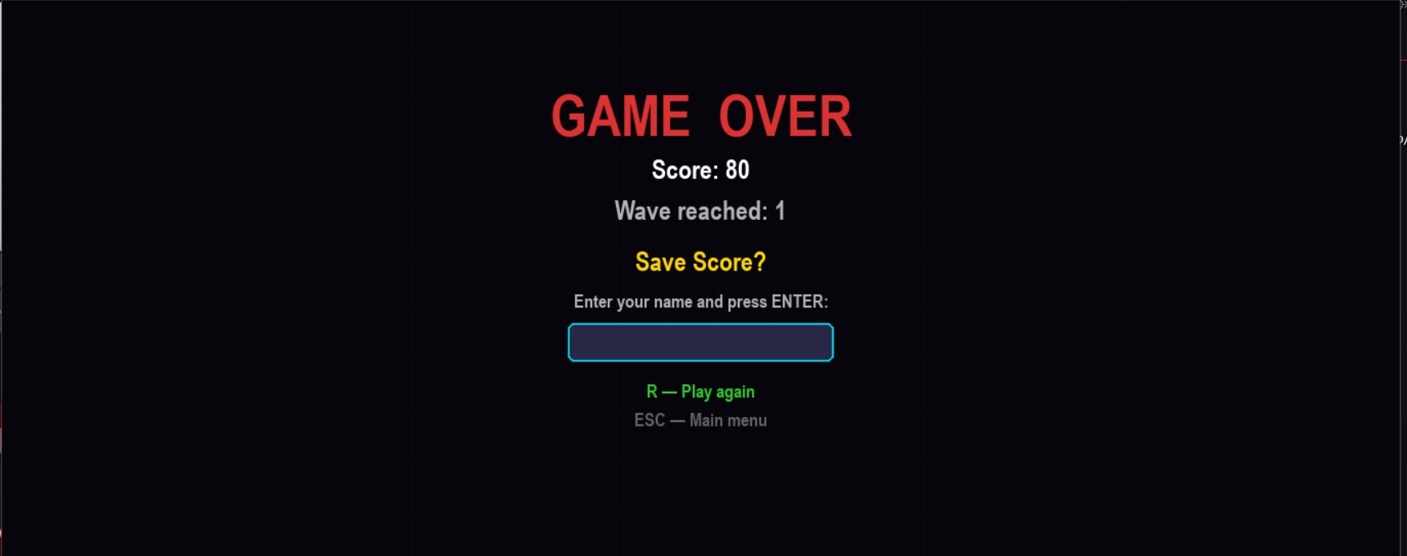
Good Luck :)

