CSY1020 - TCA 2 - 2023

## Question 1

from datetime import datetime  
  
# ENUM to define shipping types cost  
NORMAL_COST = 3.95  
URGENT_COST = 5.45  
  
"""  
Every property has been set to private by default unless explicitly needed as this is good security practice (eg. in firewalls)  
"""  
  
class Customer:  
 def __init__(self, name: str, phone: str, email: str) -> None:  
 self.__name: str = name  
 self.__phone: str = phone  
 self.__email: str = email  
  
 @property  
 def name(self):  
 return self.__name  
  
 @name.setter  
 def name(self, val: str):  
 self.__name = val  
  
 @property  
 def phone(self):  
 return self.__phone  
  
 @phone.setter  
 def phone(self, val: str):  
 self.__phone = val  
  
  
 @property  
 def email(self):  
 return self.__email  
  
 @email.setter  
 def email(self, val: str):   
 self.__email = val  
  
  
  
class Stock:  
 def __init__(self, book_name: str, author: str, price: float) -> None:  
 self.__book_name: str = book_name  
 self.__author: str = author  
 self.__price: float = price  
  
 @property  
 def book_name(self):  
 return self.__book_name  
  
 @book_name.setter  
 def book_name(self, val: str):  
 self.__book_name = val  
  
 @property  
 def author(self):  
 return self.__author  
  
 @author.setter  
 def author(self, val: str):  
 self.__author = val  
  
 @property  
 def price(self):  
 return self.__price  
  
 @price.setter  
 def price(self, val: float):  
 self.__price = val  
  
  
  
class Order:  
 def __init__(self, customer: Customer, stock: Stock):  
 self.__customer: Customer = customer  
 self.__stock: Stock = stock  
  
 @property  
 def customer(self):  
 return self.__customer  
  
 @customer.setter  
 def customer(self, val: Customer):  
 self.__customer = val  
  
 @property  
 def stock(self):  
 return self.__stock  
  
 @stock.setter  
 def stock(self, value):  
 self.__stock = value  
  
  
  
  
class Shipping:  
 def __init__(self, order: Order, ship_date: datetime) -> None:  
 self.__order: Order = order  
 self.__ship_date: datetime = ship_date  
 self.__ship_cost: float = 0.0  
 self.count_urgent: int = 0  
  
 @property  
 def order(self):  
 return self.__order  
  
 @property  
 def ship_date(self):  
 return self.__ship_date  
   
 @property  
 def ship_cost(self):  
 return self.__ship_cost  
  
 def set_ship_cost(self, val: float):  
 self.__ship_cost = val  
  
 def calc_ship_cost(self, is_urgent: bool) -> float:  
 cost = NORMAL_COST  
 if is_urgent:  
 cost = URGENT_COST  
 self.count_urgent += 1  
 self.set_ship_cost(cost)  
 return cost  
  
  
  
class Invoice:  
 def __init__(self, invoice_nbr: str, stock: Stock, ship_order: Shipping) -> None:  
 self.__invoice_nbr: str = invoice_nbr  
 self.__stock: Stock = stock  
 self.__ship_order: Shipping = ship_order  
 self.__total_cost: float = 0.0  
   
 @property  
 def invoice_nbr(self):  
 return self.__invoice_nbr  
  
 def invoice(self):  
 shipping_cost = self.__ship_order.ship_cost  
 book_cost = self.__stock.price  
 total_cost = shipping_cost + book_cost  
 self.__total_cost = total_cost  
 return self.__total_cost  
  
 def __str__(self) -> str:  
 order = self.__ship_order.order  
 customer = order.customer  
 stock = order.stock  
 return f"""  
 Customer name: -> {customer.name}  
 Phone number: -> {customer.phone}  
 E-mail address -> {customer.email}  
 --- Book details ---  
 - title -> {stock.book_name}  
 - price -> {stock.price}  
 - author -> {stock.author}  
 Date -> {self.__ship_order.ship_date}  
 Shipping fee -> {self.__ship_order.ship_cost}  
 Total cost -> {self.__total_cost:.2f}"""  
  
  
  
  
class BookStore:  
 def __init__(self):  
 self.invoices: list[Invoice] = []  
  
 def get_invoices(self):  
 return self.invoices  
  
 def search_invoice(self, nbr: str):  
 for invoice in self.invoices:  
 if invoice.invoice_nbr == nbr:  
 print(f"---------------------------\nFound invoice no. {nbr}\n---------------------------")  
 print(invoice)  
 return  
  
 print("Invoice not found!")  
  
  
"""  
Test function to simulate various operations  
"""  
  
class Test:  
 def main(self):  
 customer1 = Customer("Jack Richer", "07823456747", "j.richer@gmail.com")  
 customer2 = Customer("Jack Ryan", "07126556919", "jackryan@protonmail.com")  
 customer3 = Customer("James Bond", "07123123784", "double007@outlook.com")   
   
   
 stock1 = Stock("Spy 101", "Tom Cruise", 24.99)  
 stock2 = Stock("Spy 102", "John Wick", 14.99)  
 stock3 = Stock("Spy 103", "Mary Jane", 34.99)  
   
   
 order1 = Order(customer1, stock1)  
 order2 = Order(customer2, stock2)  
 order3 = Order(customer3, stock3)  
   
   
 shipping1 = Shipping(order1, datetime.today())  
 shipping2 = Shipping(order2, datetime.today())  
 shipping3 = Shipping(order3, datetime.today())  
   
   
 shipping1.set_ship_cost(shipping1.calc_ship_cost(True))  
 shipping2.set_ship_cost(shipping2.calc_ship_cost(False))  
 shipping3.set_ship_cost(shipping3.calc_ship_cost(True))  
   
   
 invoice1 = Invoice("INV0001", stock1, shipping1)  
 invoice2 = Invoice("INV0002", stock2, shipping2)  
 invoice3 = Invoice("INV0003", stock3, shipping3)  
   
   
 bookstore = BookStore()  
   
 bookstore.invoices.append(invoice1)  
 bookstore.invoices.append(invoice2)  
 bookstore.invoices.append(invoice3)  
   
 print(f"Number of urgent shipments: {shipping1.count_urgent}")  
 print(f"Invoice 1 total cost: {invoice1.invoice():.2f}")  
 print(f"Invoice 2 total cost: {invoice2.invoice():.2f}")  
 print(f"Invoice 3 total cost: {invoice3.invoice():.2f}")  
   
 bookstore.search_invoice("INV0004")  
   
   
if __name__ == "__main__":  
 Test().main()

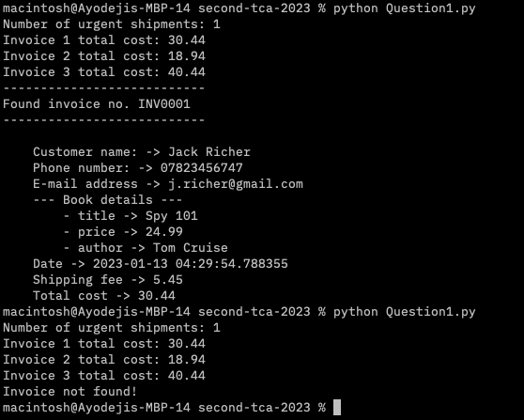

## Question 2

class SentimentLexicon:  
 def __init__(self):  
 self.dictionary: dict = self.load_dictionary("./positive-words.txt", "./negative-words.txt")  
  
  
 def load_file(self, src: str, sentiment_val: int) -> dict:  
 # load a single file and return a dictionary that contains all the words that aren't commented out with a ;  
 result = {}  
 with open(src, "r") as file:  
 lines = file.readlines()  
 for line in lines:  
 if line.startswith(";") or line.strip() == "":  
 continue  
 result[line.lower().strip()] = sentiment_val  
 return result  
   
  
 def load_dictionary(self, pos_src: str, neg_src: str) -> dict:  
 # load all source files and return a mixed dictionary of good and bad words  
 pos_dictionary = self.load_file(pos_src, 1)  
 neg_dictionary = self.load_file(neg_src, -1)  
 return { **pos_dictionary, **neg_dictionary }  
  
  
class Classifier:  
 def __init__(self):  
 self.sentiment_lexicon = SentimentLexicon()  
  
  
 def split_txt(self, txt: str):  
 # This splits the sentence and removes pre-defined punctuations to make it easier to match with sentiment dictionary values   
 txt_array = txt.lower().strip().split()  
 punctuations = [",", ".", "!"]  
 result = []  
 for word in txt_array:  
 wrd_stripped = word.strip()  
 for punctuation in punctuations:  
 if wrd_stripped.startswith(punctuation) or wrd_stripped.endswith(punctuation):  
 wrd_stripped = wrd_stripped.strip(punctuation)  
  
 result.append(wrd_stripped)  
  
 return result  
  
  
  
 def classify(self, txt: str) -> int:  
 dictionary = self.sentiment_lexicon.dictionary  
 total = 0  
 txt_array = self.split_txt(txt)  
  
 # check if word exists in the dictionary and add the value to the total if it exists, else add 0  
 for word in txt_array:  
 score = dictionary[word] if word in dictionary else 0  
 total += score  
   
 # check if total is 0, positive or negative and return the right sentiment rating (1, -1 or 0)  
 sentiment = 0 if total == 0 else 1 if total > 0 else -1  
  
 return sentiment  
  
  
  
  
"""  
Main program to simulate a couple of sentiment analysis   
"""  
  
def main():  
 classifier = Classifier()  
 sentences = ["I love Python.", "Python is the language I love!", "The iPhone is clearly not the most terrible and worst phone ever. It is the best."]  
  
 # classify test cases and print them out  
 for sentence in sentences:  
 sentiment = classifier.classify(sentence)  
 print("{'text': ",sentence, "'sentiment':",sentiment, "}")  
  
  
if __name__ == "__main__":  
 main()

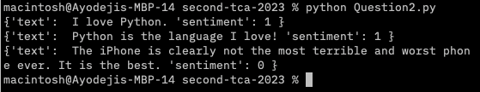

## Question 3

{  
 "cells": [  
 {  
 "cell_type": "code",  
 "execution_count": 5,  
 "id": "a331687b",  
 "metadata": {},  
 "outputs": [],  
 "source": [  
 "population = {\"England\":55550138, \"Scotland\":5466000, \"Wales\":3169586, \"Northern Ireland\":1895510}"  
 ]  
 },  
 {  
 "cell_type": "code",  
 "execution_count": 4,  
 "id": "d35277aa",  
 "metadata": {},  
 "outputs": [],  
 "source": [  
 "area = {\"England\":130309, \"Scotland\":77911, \"Wales\":20736, \"Northern Ireland\":13793}"  
 ]  
 },  
 {  
 "cell_type": "code",  
 "execution_count": 10,  
 "id": "88016aef",  
 "metadata": {},  
 "outputs": [],  
 "source": [  
 "import pandas"  
 ]  
 },  
 {  
 "cell_type": "code",  
 "execution_count": 11,  
 "id": "fcfa9acc",  
 "metadata": {},  
 "outputs": [],  
 "source": [  
 "data_frame = pandas.DataFrame({\"area\": area, \"population\": population})"  
 ]  
 },  
 {  
 "cell_type": "code",  
 "execution_count": 12,  
 "id": "b3b90f17",  
 "metadata": {},  
 "outputs": [],  
 "source": [  
 "data_frame = data_frame[[\"area\", \"population\"]]"  
 ]  
 },  
 {  
 "cell_type": "code",  
 "execution_count": 13,  
 "id": "0f60c63c",  
 "metadata": {},  
 "outputs": [  
 {  
 "data": {  
 "text/html": [  
 "<div>\n",  
 "<style scoped>\n",  
 " .dataframe tbody tr th:only-of-type {\n",  
 " vertical-align: middle;\n",  
 " }\n",  
 "\n",  
 " .dataframe tbody tr th {\n",  
 " vertical-align: top;\n",  
 " }\n",  
 "\n",  
 " .dataframe thead th {\n",  
 " text-align: right;\n",  
 " }\n",  
 "</style>\n",  
 "<table border=\"1\" class=\"dataframe\">\n",  
 " <thead>\n",  
 " <tr style=\"text-align: right;\">\n",  
 " <th></th>\n",  
 " <th>area</th>\n",  
 " <th>population</th>\n",  
 " </tr>\n",  
 " </thead>\n",  
 " <tbody>\n",  
 " <tr>\n",  
 " <th>England</th>\n",  
 " <td>130309</td>\n",  
 " <td>55550138</td>\n",  
 " </tr>\n",  
 " <tr>\n",  
 " <th>Scotland</th>\n",  
 " <td>77911</td>\n",  
 " <td>5466000</td>\n",  
 " </tr>\n",  
 " <tr>\n",  
 " <th>Wales</th>\n",  
 " <td>20736</td>\n",  
 " <td>3169586</td>\n",  
 " </tr>\n",  
 " <tr>\n",  
 " <th>Northern Ireland</th>\n",  
 " <td>13793</td>\n",  
 " <td>1895510</td>\n",  
 " </tr>\n",  
 " </tbody>\n",  
 "</table>\n",  
 "</div>"  
 ],  
 "text/plain": [  
 " area population\n",  
 "England 130309 55550138\n",  
 "Scotland 77911 5466000\n",  
 "Wales 20736 3169586\n",  
 "Northern Ireland 13793 1895510"  
 ]  
 },  
 "execution_count": 13,  
 "metadata": {},  
 "output_type": "execute_result"  
 }  
 ],  
 "source": [  
 "data_frame"  
 ]  
 },  
 {  
 "cell_type": "code",  
 "execution_count": null,  
 "id": "6b08e25c",  
 "metadata": {},  
 "outputs": [],  
 "source": []  
 }  
 ],  
 "metadata": {  
 "kernelspec": {  
 "display_name": "Python 3 (ipykernel)",  
 "language": "python",  
 "name": "python3"  
 },  
 "language_info": {  
 "codemirror_mode": {  
 "name": "ipython",  
 "version": 3  
 },  
 "file_extension": ".py",  
 "mimetype": "text/x-python",  
 "name": "python",  
 "nbconvert_exporter": "python",  
 "pygments_lexer": "ipython3",  
 "version": "3.10.7"  
 }  
 },  
 "nbformat": 4,  
 "nbformat_minor": 5  
}

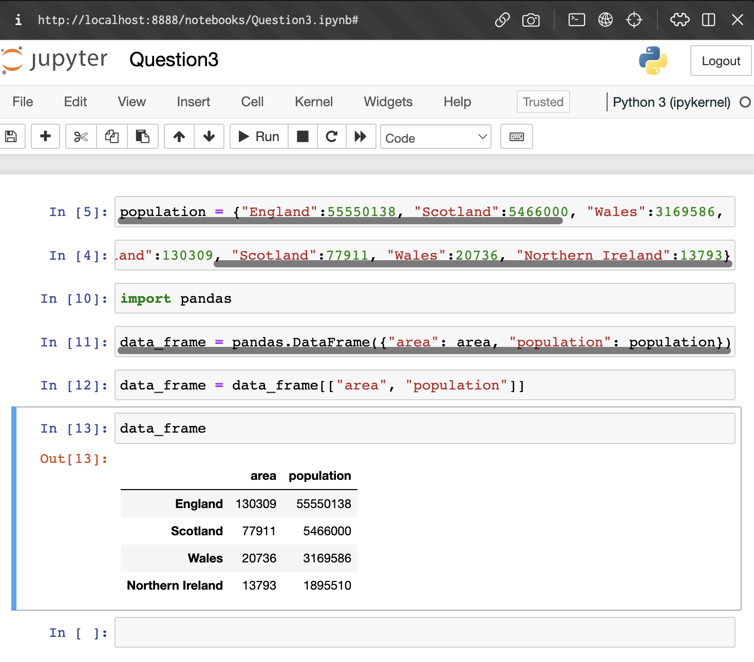

## Question 4

import pandas  
  
data = pandas.read_excel("./food-data.xlsx")  
  
  
"""  
Calculate average price increase between September 2021 and 2022  
To understand how inflation has affected the price of these items  
"""  
avg_yearly_increase = (data["Price in September 2022 pence)"].mean() - data["Price in September 2021 (pence)"].mean()) / data["Price in September 2021 (pence)"].mean() * 100  
print(f"-- Average yearly increase: {avg_yearly_increase:.2f}%")  
  
  
  
"""  
Top 3 most expensive food items in September 2021   
To understand which items had the highest profit margins or were considered "better" or as "luxury" in this time frame (2021)  
"""  
most_expensive_2021 = data.nlargest(3, "Price in September 2021 (pence)")  
print("-- Top 3 expensive food items in 2021\n", most_expensive_2021)  
  
  
  
"""  
Top 3 most expensive food items in September 2022  
To understand which items had the highest profit margins or were considered "better" or as "luxury" in this time frame (2022)  
"""  
most_expensive_2022 = data.nlargest(3, "Price in September 2022 pence)")  
print("-- Top 3 expensive food items in 2022\n", most_expensive_2022)  
  
  
  
"""  
Item that has the highest price increase percentage between September 2021 and September 2022  
To identify which item is most affected by price inflation  
"""  
highest_price_increase = (data['Price in September 2022 pence)'] - data['Price in September 2021 (pence)']) / data['Price in September 2021 (pence)'] * 100  
highest_price_increase_item = data.loc[highest_price_increase.idxmax()]['Item']  
print(f"-- The food item that has the highest price increase percentage between September 2021 and September 2022 is: {highest_price_increase_item}")  
  
  
  
"""  
Item that has the highest price decrease percentage between September 2021 and September 2022  
To identify which item is least affected by price inflation  
"""  
highest_price_decrease = (data['Price in September 2022 pence)'] - data['Price in September 2021 (pence)']) / data['Price in September 2021 (pence)'] * 100  
highest_price_decrease_item = data.loc[highest_price_decrease.idxmin()]['Item']  
print(f"-- The food item that has the highest price decrease percentage between September 2021 and September 2022 is: {highest_price_decrease_item}")  
  
  
  
"""  
The average price increase of each food item between September 2021 and September 2022  
To get an in-depth look into how each item was affected by price inflation (negatively and positively)   
"""  
price_increase_by_items = (data.groupby('Item')['Price in September 2022 pence)'].mean() - data.groupby('Item')['Price in September 2021 (pence)'].mean()) / data.groupby('Item')['Price in September 2021 (pence)'].mean() * 100  
print("-- Average price increase of each food item between September 2021 and September 2022\n", price_increase_by_items)

