# Project 1

3180103779

谢涛羽

## n_puzzle

* 1. update_cost function
     1. parameter explanation

1. curr_state & dst_state
2. method

Using specific method to determining heuristic function. It can be

* 'euclidean': 
* 'manhattan': 
* 'chebyshev': 
* 'hamming': 

1. Return curr_state with cost h and g updated.
   * 1. code structure

A loop is used to get every number’s position, and calculate the number’s distance to the destination.

Adding up all the distance, we get the heuristic function of curr_state.

As for g, the price which has been cost, we need to find the previous state of curr_state.

Since g stands for the cost from initial state to curr_state, so we update g via



because from pre_state to curr_state, we move once, add 1 for the cost.

Use the h calculated to update curr_state.h

Use pre_state’g+1 to update curr_state.g

Calculate h respect to different method

Calculate the coordinate difference separately

Get coordinates

def update_cost(curr_state, dst_state, method):

h = 0

for i in range(curr_state.state.shape[0]):

for j in range(curr_state.state.shape[1]):

curr_row, curr_col = curr_state.num_pos(curr_state.state[i][j])

dst_row, dst_col = dst_state.num_pos(curr_state.state[i][j])

x = abs(curr_row - dst_row)

y = abs(curr_col - dst_col)

if method == 'euclidean':

h = h + (x ** 2 + y ** 2) ** 0.5

elif method == 'manhattan':

h = h + x + y

elif method == 'chebyshev':

h = h + max(x, y)

elif method == 'hamming':

if x != 0 or y != 0:

h = h + 1

curr_state.h = h

curr_state.g = curr_state.pre_state.g + 1

return curr_state

* 1. find_front_node
     1. parameter explanation

open_list[]:

This is a list stored with unexplored nodes, but these nodes are expanded before. We are searching for the node with smallest price g+h.

* + 1. code structure

Return the node together with it’s index

Find the element with smallest g+h

Initialize the smallest cost with the first element

def find_front_node(open_list):

index = 0

cost = open_list[0].g + open_list[0].h

for i in range(1, len(open_list)):

cost_i = open_list[i].g + open_list[i].h

if cost_i < cost:

index = i

return index, open_list[index]

* 1. get_path
     1. parameter expalanation

curr_state:

We intend to find the path from initial state to curr_state.

Curr_state.pre_state and curr_state.pre_move recursively indicate the path.

pre_move

curr_state

pre_state

pre_pre_state

pre_pre_move

……

* + 1. code structure

Reverse move_list, a path from top to bottom, from the start to curr_state, is obtained

From bottom to top,

add the move to move_list

def get_path(curr_state):

move_list = []

state = curr_state

while state.pre_move != None:

move_list.append(state.pre_move)

state = state.pre_state

move_list.reverse()

return move_list

* 1. expand_state
     1. parameter expalanation

curr_state:

From curr_state, we normally can get 4 next_states, to move left, right, up, down (if the move is valid).

We should put the valid next_states into open_list because these are possible ways to the destination state.

* + 1. code structure

4 next_states,

If valid, expand it.

def expand_state(curr_state):

childs = []

for i in range(4):

valid, next_state = once_move(curr_state, i)

if valid:

childs.append(next_state)

return childs

* 1. state_in_list
     1. parameter explanation

state, list

Judge whether state is in list or not.

If the list is open_list, it means the state has been expand before.

If the list is close_list, it means the state has been explored before.

* + 1. code structure

Simple use a loop to compare whether the state is in list or not.

def state_in_list(state, list):

in_list = False

match_state = None

for item in list:

if item == state:

in_list = True

match_state = item

break

return in_list, match_state

* 1. thorough process

def astar_search_for_puzzle_problem(init_state, dst_state, method = 'manhattan'):

* 1. Get start_state and dst_state.

The default method

* 1. Defind empty open_list and close_list.
  2. Add start_state to open_list

LOOP: while open_list not empty

* 1. Get the element with smallest (g+h), delete it from open_list.
  2. 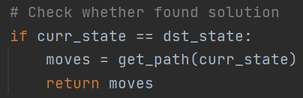Add the element into close_list, which means it’s been explored.

else

* 1. Expan the element, get valid childs.

LOOP: traverse valid childs

* If a child in close_list, continue.
* Update the child’s cost
* If a child in open_list, compare their cost, use lower one.

But this situation hardly happens

If the one in list is with higher cost

Use lower cost

if in_list:

if match_state.g + match_state.h > child_state.g + child_state.h:

match_state.g = child_state.g

match_state.h = child_state.h

match_state.pre_state = child_state.pre_state

match_state.pre_move = child_state.pre_move

continue

* If not in open_list, add the expanded child into open_list.
  1. The results

The running time varies. Sometimes it is fast while others it’s slow.

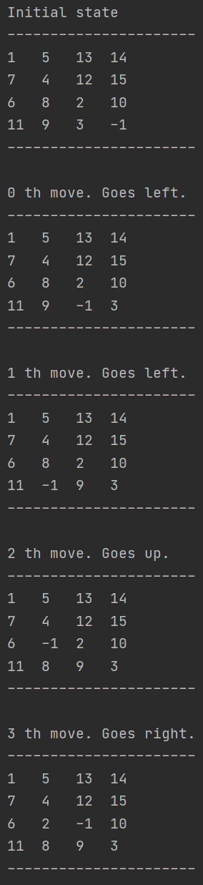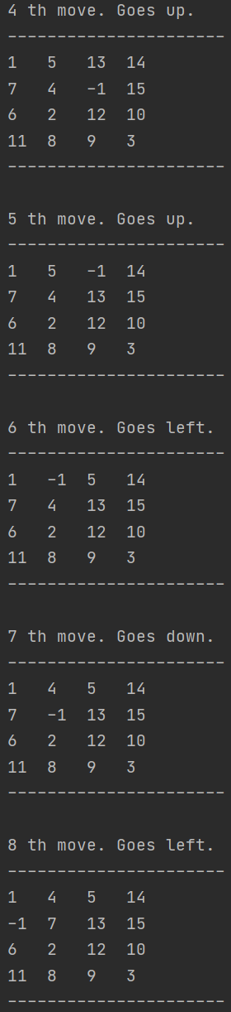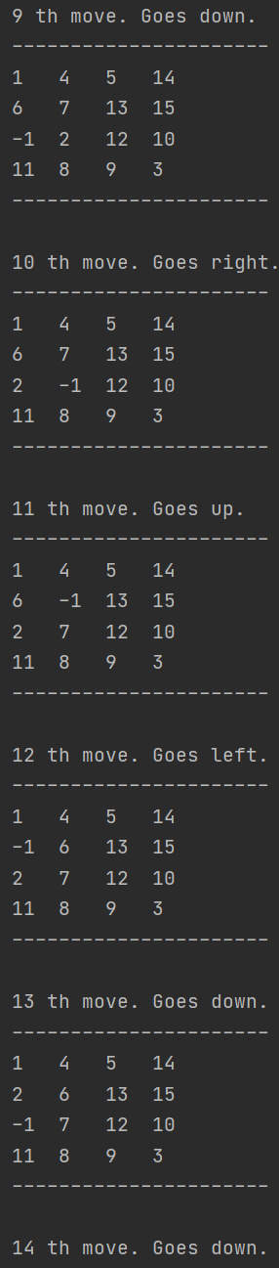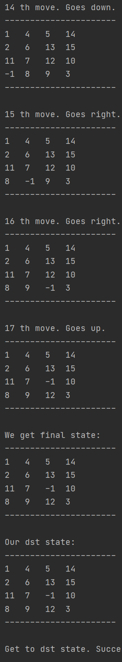Using Manhattan distance:

Change square size, this takes longer running time, so I change

move_list = generate_moves(30)

for simplicity

square size = 5:

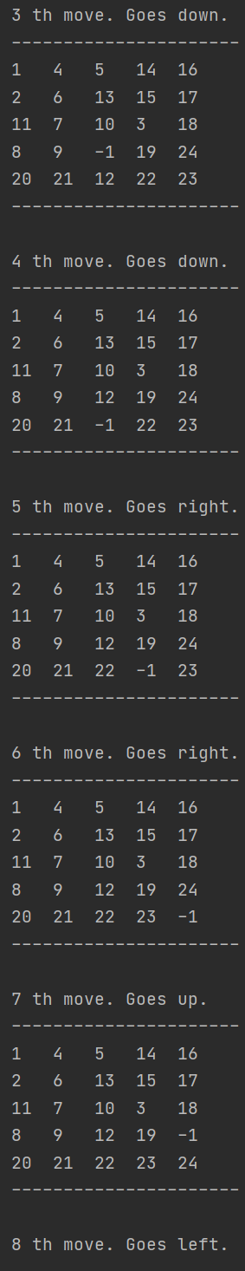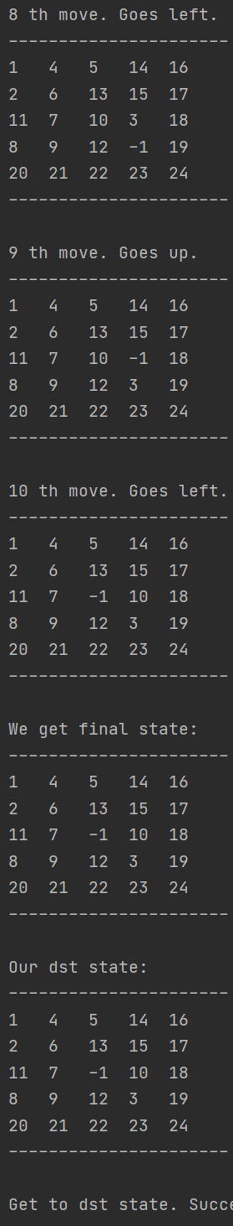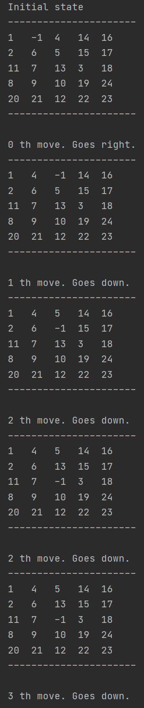

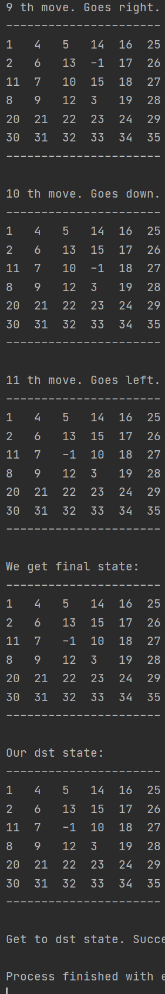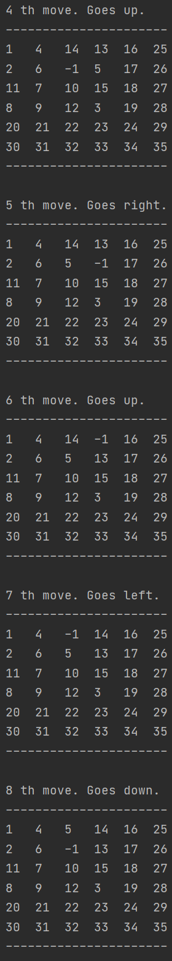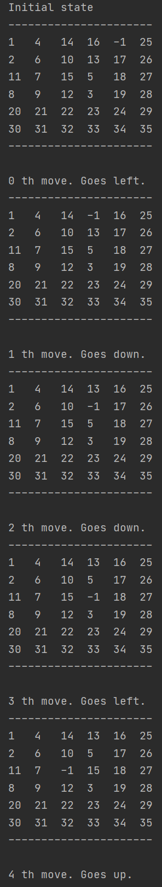squre_size = 6

## tic_tac_toe

* 1. Utility Function
     1. Parameter explanations

1. current_state: An array presents the current chess board.

-1 is the computer’s chess.

-1 is the human’s chess.

-0 means the position is blank

1. evaluation: the utility of the current state to be returned.
   * 1. Game situations

Based on the game rule:

* A line(row or column or diagonal) of three same chesses leads to the end.

【S1】Situations like these mean game over.

|  |  |  |  |  |  |  |  |  |  |  |
| --- | --- | --- | --- | --- | --- | --- | --- | --- | --- | --- |
| X | X | X |  | X | … | … |  | X | … | … |
| … | … | … |  | X | … | … |  | … | X | … |
| … | … | … |  | X | … | … |  | … | … | X |

*due to space limitation, only three typical situations are listed

* Two same chesses in a line(the third position is blank). These situations are close to win.

【S2】Situations like these have high probability to finish.

|  |  |  |  |  |  |  |  |  |  |  |
| --- | --- | --- | --- | --- | --- | --- | --- | --- | --- | --- |
| X | X |  |  | X | … | … |  | X | … | … |
| … | … | … |  | X | … | … |  | … | X | … |
| … | … | … |  |  | … | … |  | … | … |  |

*due to space limitation, only three typical situations are listed

* One chess in a line with other two positions blank. These situations, though not likely to win, show some advantages of the chess player.

【S3】Situations like these have chance to win(though the possibility is small)

|  |  |  |  |  |  |  |  |  |  |  |
| --- | --- | --- | --- | --- | --- | --- | --- | --- | --- | --- |
| X |  |  |  |  | … | … |  | … | X | … |
| … | … | … |  | … | X | … |  | … |  | … |
| … | … | … |  | … | … |  |  | … |  | … |

*due to space limitation, only three typical situations are listed

* Other situations’ utility is considered as zero.
  + 1. Utility calculation

On the board, computer uses 1, human uses -1. We calculate the sum of each row, column and diagonal.

|  |  |
| --- | --- |
| evaluation = 0 | The utility of current state to be returned. |
| max_return = 100 | If 【S1】exists, max_return is used to calculate evaluation. |
| two_chess = 3 | If 【S2】exists, two_chess is used to calculate evaluation. |
| one_chess = 1 | If 【S3】exists, one_chess is used to calculate evaluation |

1. Sum = 3

|  |  |  |  |  |  |  |  |  |  |  |  |
| --- | --- | --- | --- | --- | --- | --- | --- | --- | --- | --- | --- |
| 1 | 1 | 1 |  | 1 | … | … |  | 1 | … | … |  |
| … | … | … |  | 1 | … | … |  | … | 1 | … | …… |
| … | … | … |  | 1 | … | … |  | … | … | 1 |  |

From this state, we can tell max_palayer is the winner, so the evaluation must be very big. So max_return is used here.

max_return is a big number, which is big enough to influence the utility.

1. Sum = -3

The same as sum = 3, but this time, min_player wins, so -max_return is used, which is small enough to influence the utility.

|  |  |
| --- | --- |
| sum = 3 | Evaluation += max_return |
| Sum = -3 | Evaluation -= max_return |

1. Sum = 2, -2, 1, -1

|  |  |
| --- | --- |
| Sum = 2 | Evaluation += two_chess |
| Sum = -2 | Evaluation -= two_chess |
| Sum = 1(product=0) | Evaluation += one_chess |
| Sum = -1(product=0) | Evaluation -= one_chess |

Product = 0 means the situation is 1+0+0 rather than 1-1+1.

under other situations, we don’t change the evaluation.

Here in sum = 3 and sum = -3, we need to emphasize that the state must be final state that one player wins.

If not, things like below will happen.

|  |  |  |  |  |  |  |
| --- | --- | --- | --- | --- | --- | --- |
| 1 | 1 |  |  | 1 | 1 | 1 |
|  |  |  | Take an action |  |  |  |
| -1 | -1 | -1 | 🡪 | -1 | -1 | -1 |

Before action, the utility is extremely low due to row3, after action, the utility is close to 0 due to row1. Obviously, it’s unreasonable.

So the when the caller calls *utility(state)* function, it must judge whether it is final state or not. If is, return the utility value, stop searching any further, no matter the depth is 0 or not.

(This is an attention need to be paid while designing min_value and max_value function, the caller of utility function)

Help calculate each row, column and diagonal’s evaluation

* + 1. Code structure

def utility(current_state):

def utility_in_detail(a, b, c):

max_return = 100

two_same_chess = 3

one_chess = 1

s = a + b + c

if s == 3:

return 0.5*max_return

elif s == -3:

return -1*max_return

elif s == 2:

return two_same_chess

elif s == -2:

return -1 * two_same_chess

elif s == 1:

if not a * b * c:

return one_chess

elif s == -1:

if not a * b * c:

return -1 * one_chess

return 0

The weight of 【S2】 is 3, and the weight of 【S1】is 1. This is reasonable since 【S2】has much more probability to win.

A big number

def utility(current_state, flag):

def utility_in_detail(a, b, c):

(…on the left…)

evaluation = 0

for i in range(3):

evaluation += utility_in_detail(rowi)

evaluation += utility_in_detail (coli)

evaluation += utility_in_detail (diagonal_1)

evaluation += utility_in_detail (diagonal_2)

return evaluation

【S1】case

【S2】case

【S3】case

Product should be 0

Add all evaluations and return

* 1. Actions_result & get_available_actions

def get_available_actions(current_state):

(some assert)

actions = []

for i in range(current_state.shape[0]):

for j in range(current_state.shape[1]):

if current_state[i][j] == 0:

actions.append((i, j))

return actions

def action_result(current_state, action, player):

(some assert)

current_state[action[0]][action[1]] = player return current_state

Positions that are blank are available

Add player’s chess to the board.

* 1. Minimax Algorithm

def MinimaxSearch(current_state):

(assert, game_state copy)

actions = get_available_actions(game_state)

values = []

depth = 3

for action in actions:

values.append(min_value(action_result(game_state.copy(), action, 1), depth))

max_ind = int(np.argmax(values))

row, col = actions[max_ind][0], actions[max_ind][1]

return row, col

Get available actions

Call min_value,



def min_value(current_state, depth):

game = GameJudge()

game.game_state = current_state

check = game.check_game_status()

if check == 1 or check == -1:

return utility(current_state)

if depth == 0:

return utility(current_state, -1)

else:

actions = get_available_actions(current_state)

if not actions:

return utility(current_state, -1)

values = []

for action in actions:

values.append(max_value(action_result(current_state.copy(), action, -1), depth-1))

min_index = int(np.argmin(values))

return values[min_index]

With the help of *Class GameJudge*, judge whether the current state is finished with a specific winner or not.

If is, check=1(max_player wins) or check=-1(min_player wins), this is a terminal state, return utility no matter depth is 0 or not.

Recursive exit

No actions available

Depth decrease

Switch player



def max_value(current_state, depth):

game = GameJudge()

game.game_state = current_state

check = game.check_game_status()

if check == 1 or check == -1:

return utility(current_state)

if depth == 0:

return utility(current_state, 1)

else:

actions = get_available_actions(current_state)

if not actions:

return utility(current_state, 1)

values = []

for action in actions:

values.append(min_value(action_result(current_state.copy(), action, 1), depth - 1))

max_index = int(np.argmax(values))

return values[max_index]

Almost same as min_value



* 1. The results

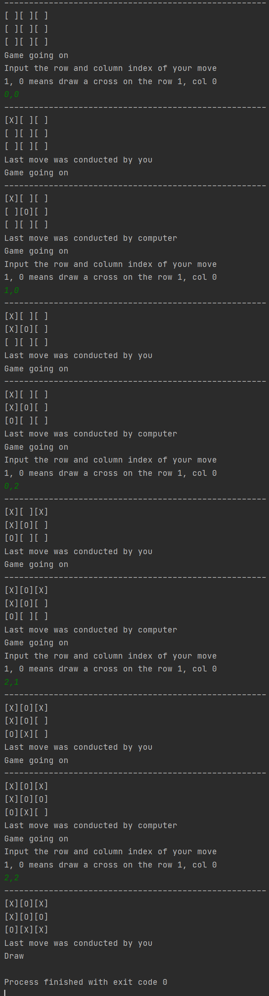

Case 1: normal case:



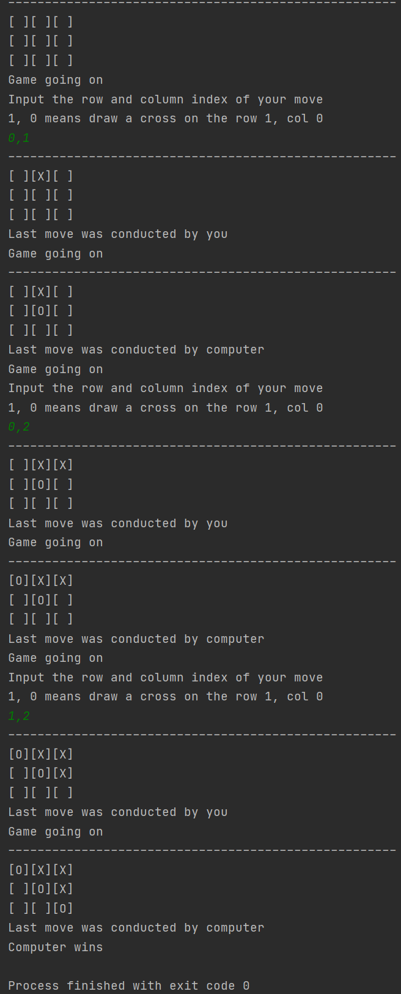

Case 2:

deliberate to lose