Pressed ctrl+c during critical code execution:

Raise(SIGEMT) at the end

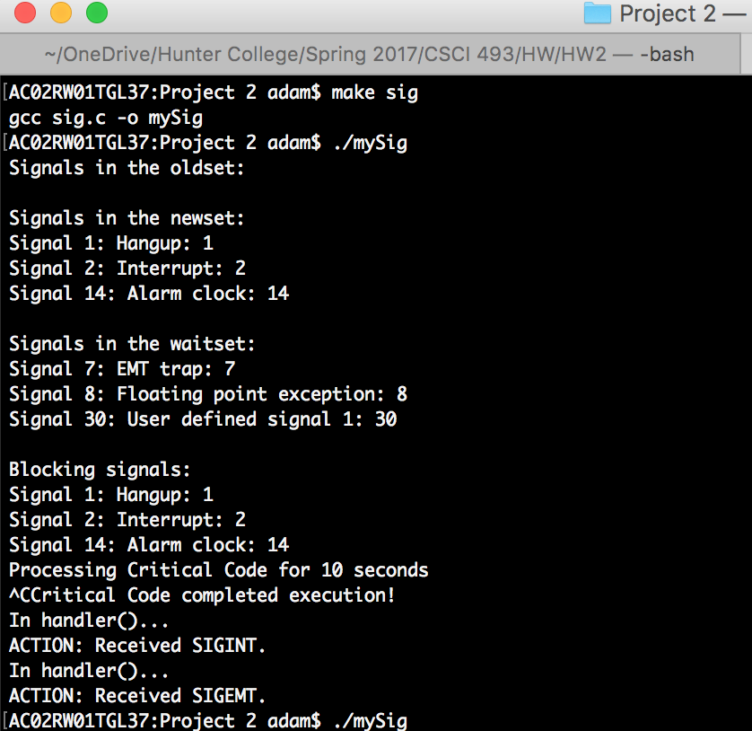

Entered ctrl+c after critical code execution

Raise(SIGEMT) at the end

