**业务系统物理模型：**

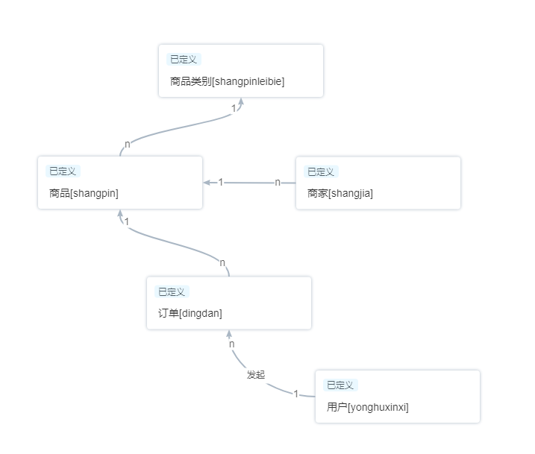

**数据仓库物理模型：**

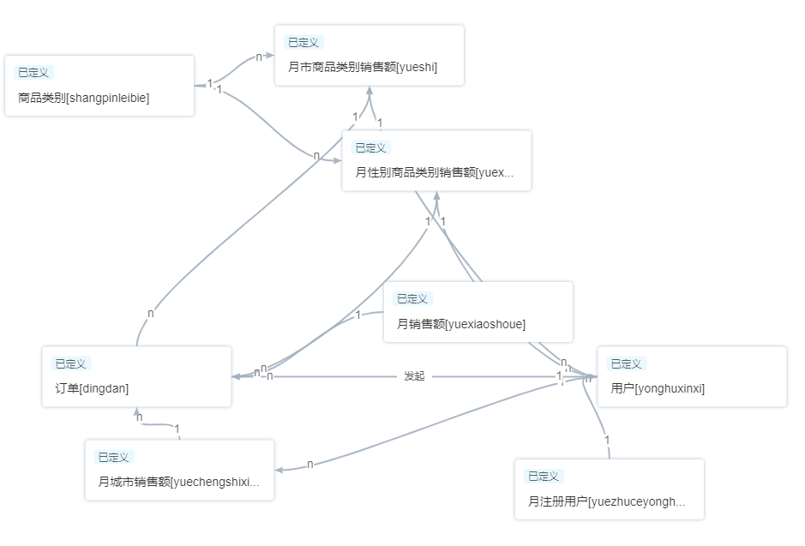

**按月查看总体销售额**

select jianliriqi, sum(jiage) from dingdan natural join shangpin group by jianliriqi

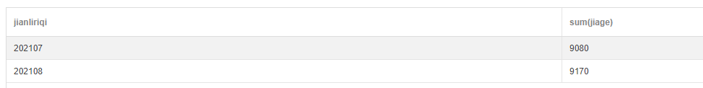

**按月查看新增注册人数**

select zhuceshijian, count(yonghuid) from yonghuxinxi group by zhuceshijian

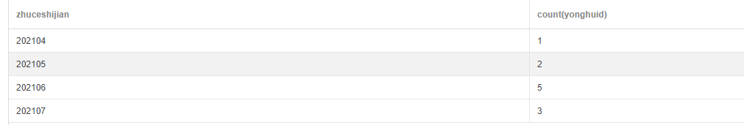

**按月查看城市销售额**

select shouhuochengshi, jianliriqi, sum(jiage) from dingdan natural join shangpin natural join yonghuxinxi group by jianliriqi, shouhuochengshi

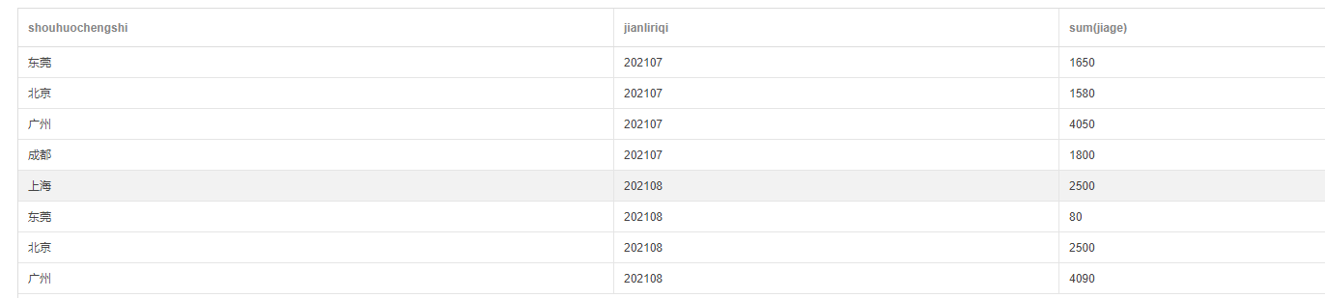

**按月查看城市、商品类别的销售额**

select shouhuochengshi, jianliriqi, leibieid, leibiemingchen, sum(jiage) from dingdan natural join shangpin natural join shangpinleibie natural join yonghuxinxi group by jianliriqi, shouhuochengshi, leibieid

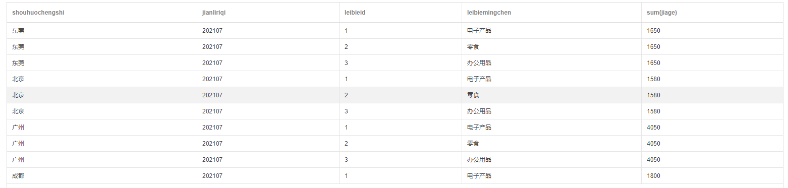

**按月查看性别、商品类别的销售额**

select xingbie, jianliriqi, leibieid, leibiemingchen, sum(jiage) from dingdan natural join shangpin natural join shangpinleibie natural join yonghuxinxi group by jianliriqi, xingbie, leibieid

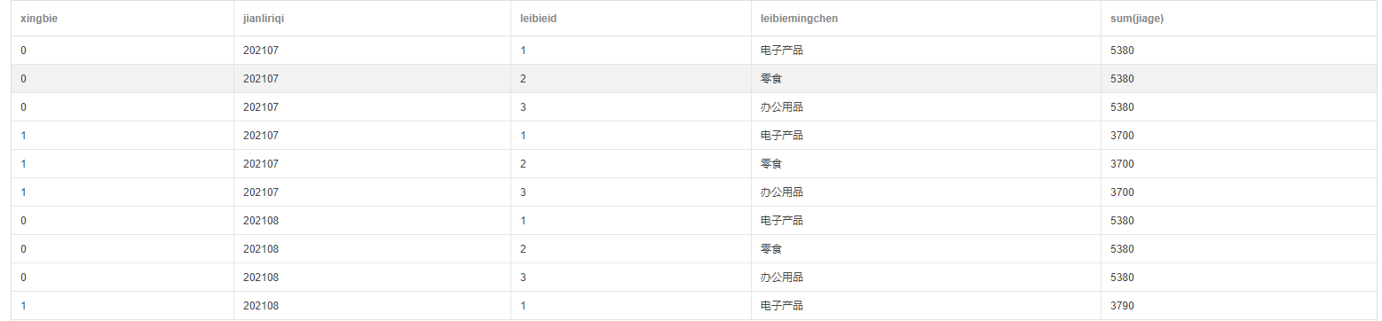

数据质量任务：

