A.P.S

Absolute Protection of Society

AV-XXX

Vuong Le , Allen Owen

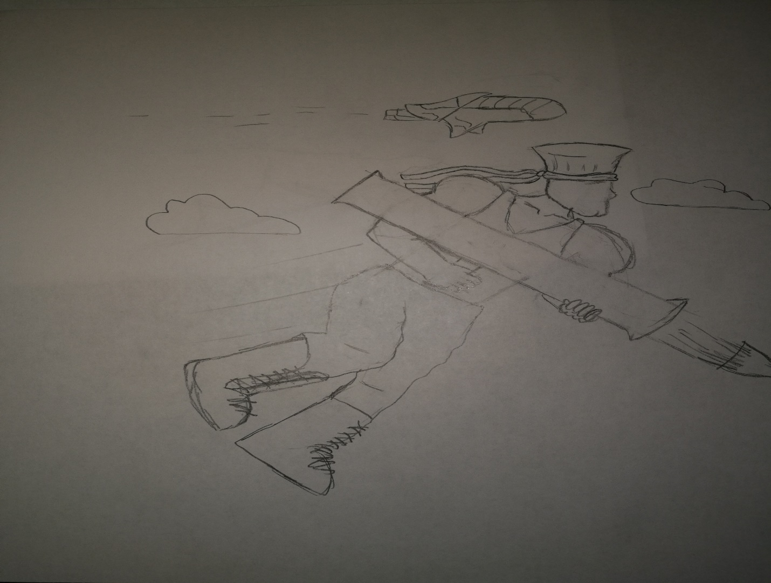

A.P.S

|  |  |  |
| --- | --- | --- |
| Genre | Platform | Team Size |
| Horizontal Shooter | PC, Mobile | 2 |

Key Features

* Player must prevent self from hitting ground by using weapon.
* Player must decide whether to use weapon to shoot enemies or to use weapon to prevent from hitting ground.
* Player can take multiple paths throughout levels, to increase replayability.
* Multiple characters player can choose to play, with unique playstyles, and design.
* Player encounters boss fights with, unique attacks and weakpoints. 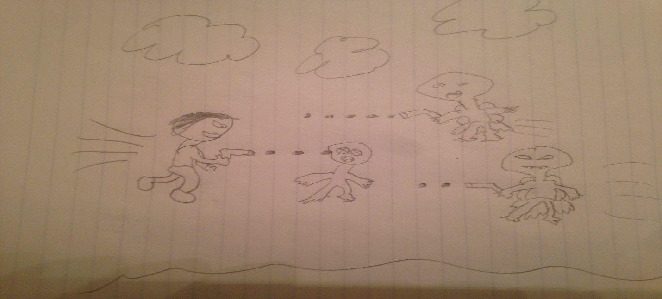

**Team Bio**

**Allen:**

I have been playing games since I was five. My first experience of game design was when I was eleven and began learning C++ to implement new features for a popular private server for a MMO game I played at the time. This first experience got me hooked on game design and throughout my youth I continued to learn code and create several basic level games. I am now a senior in college and my coding skills and game design experience have vastly improved and grown from my computer science curriculum. I have had the chance to work on a couple different games in project teams and have learned many staple concepts of creating fun and creative interactive games.

My main strengths are coding, game logic, and level design. My weaknesses are art creation, and game story creation. Based on my strengths and weaknesses I will implement gameplay that is interactive and highly replay-able but relies very little on the plot of the game to enjoy. Several art assets will be used from sources that permit non-commercial use. This focusing of skills will make sure that more time and resources may be devoted to utilizing my stronger skills.

**Vuong:**

Born in 1994, Vuong Le has always been interested in designing systems. Whether they be mechanical or virtual, he would take any system apart and learn all its parts. When he grew an interest in Video games, he made it his goal to understand and master everything that made his favorite games tick. Having a few years of experience working with and programming games on engines such as Unity, and GameMakerStudio the position of lead programmer will be in his capable hands. Vuong Le’s inspiration for game design stems from his knowledge and experience as a gamer. He believes that it is worth the time to play any game, whether it be bad or good, as long as time is taken to understand what exactly made the experience enjoyable or not. Due to the amount of time he has spent analyzing games as systems we have confidence in his ability to make a game that feels and plays as smoothly as possible.

**Game Description**

The background story of A.P.S is based around an Alien invasion. The Alien Pernicious Syndicate (A.P.S) has invaded earth, and the Army Personal Squadron (A.P.S) an elite military unit dedicated to Absolute Protection of Society (A.P.S), has been dispatched to defeat the A.P.S armed with their Advanced Propulsion System (A.P.S).

The goal of the player is to destroy the various aliens in the A.P.S. The player accomplishes this goal by navigating and surviving through levels and defeating bosses. The key challenge of the game is the use of the characters APS to stay airborne while dodging enemy fire and aiming their APS to destroy enemies. The player interacts in the game with their APS (Advanced Propulsion System), which can help maintain flight as well as dodge and dispatch enemies. The player will advance each level by defeating the boss at the end. The player will ensure APS by defeating the APS leader. Each level will take place in the air. The levels will vary by difficulty, such as more enemies and bosses with escalating difficulty. In the latter levels, as the player approaches the APS mothership, the levels will include more Alien technology. At the beginning of each level the player will be launched out of a cannon into the air, this is how he gains his horizontal velocity. The player will then continually try to maintain their airborne state while shooting and defeating monsters to prevent them from defeating the player. During boss fights the player’s horizontal velocity will be zero but they will still be fighting against gravity to stay airborne, whilst fighting the boss and trying to aim at the boss weak points which will typically be located closer to the ground, making them riskier to for the player to shoot.

**Sample Artwork**

