1. AC_total_votes data for constituency votes bar chart by alliance.

2. PS_votes for each PS in each AC by alliance.

PS votes data we have now is very complicated, and we might need some manipulation like this:

For example, Constituency 9:

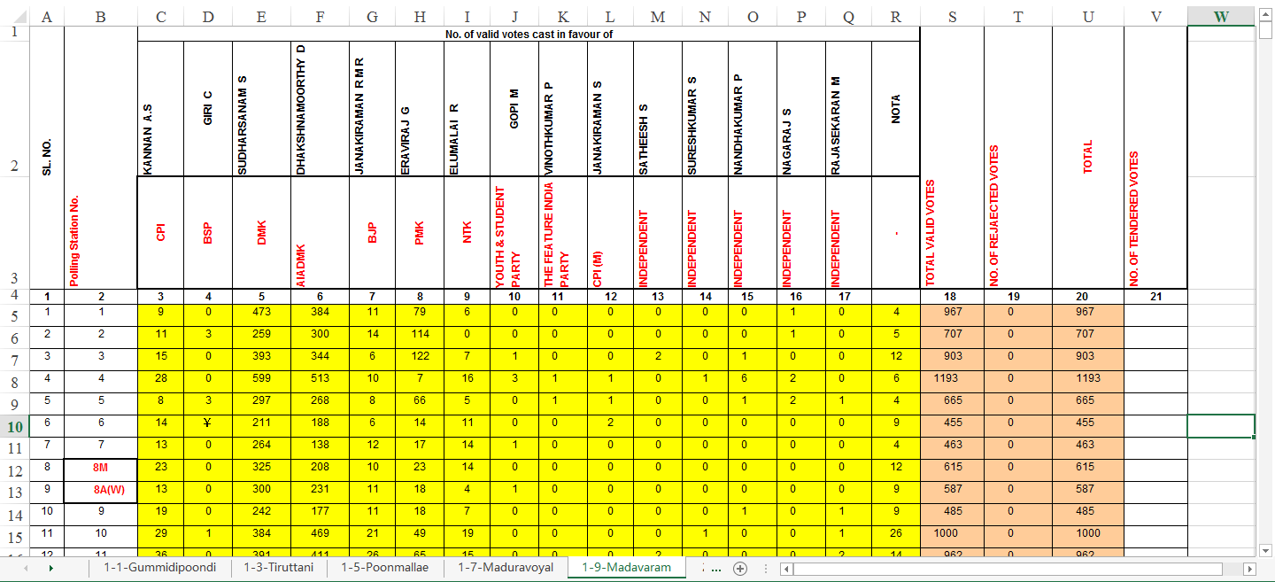

a. We need to convert the text to horizontal text for ArcGIS to read it easily.

b. For now, as we are conducting alliance level analysis rather than person level, I suggest that we only keep the text that’s red in the example. But we may need name information in the future.

c. We need to change party name into alliance name.

d. For polling station number, some of them are strings like 8M, 8A(W). We might need to convert that to number. I recommend us to keep the polling station order and move PS.NO forward. Like replace 8M as 8, 8A(W) as 9, 9 as 10, 10 as 11, so on so forth, because we might want to keep the nearby ps close to each other.

e. We might need to delete 4th row because there’s no information contained.

<I will send example file in our Wechat group :D>

So far, I’ve come up with these ideas. If I lost any points, please tell me. Thank you!