Lab’s website

Source: Emory University - Collection 6324: Emory University Archives web archives
https://web.archive.org/web/20130915171911/http://www.psychology.emory.edu/clinical/mcdowell/labwebsite/People.htm

Acronyms

ETD | Emory Theses and Dissertations
SABA | Society for the Advancement of Behavior Analysis
SEABA | Southeastern Association for Behavior Analysis
ABAI | Association for Behavior Analysis International
ORC | Office for Research Compliance | http://compliance.emory.edu
ORI | Office for Research Integrity

ETD links
Abstracts, Committees, Tables of contents, Full texts (if lucky)

Note that the ETD website has been through a major overhaul, during which many permanent links were modified and the “upload date” field for many documents reflects the when it was relocated, not when it was originally uploaded. That is why the upload dates for my masters and dissertation are in 2018.

- Popa (2013): https://etd.library.emory.edu/concern/etds/9880vr10s?locale=en
- Calvin (2019): https://etd.library.emory.edu/concern/etds/d791sh03v?locale=en
- Hackett (2019): https://etd.library.emory.edu/concern/etds/rr171z32k?locale=en

References

Popa, A., (2017). Towards a Dynamic Account of Human Development. Paper presented at the 43rd Annual Convention of the Association for Behavior Analysis International, Denver, CO.

Popa, A. (2016). Population Thinking, Psychodiversity, and Human Development. Invited speaker, Darwin Day Lecture Series, Georgia State University, Atlanta, GA.

Popa, A. (2015). Towards an Evolutionary Account for the Dynamics of Cognizant Systems. Invited speaker, Darwin Day Lecture Series, Georgia State University, Atlanta, GA.

Popa, A., Calvin, N., & McDowell, J J. (2014). Multifinality and Equifinality in an Evolutionary Theory of Behavior Dynamics. Talk presented at the 40th Annual Convention of the Association for Behavior Analysis International, Chicago, IL.

Popa, A., Calvin, N., & McDowell, J J. (2013). Complexity, Emergence, and the Behavior of Organisms. Talk presented at the 39th Annual Convention of the Association for Behavior Analysis International, Minneapolis, MN.

Popa, A., & McDowell, J J. (2012). The Computational Theory of Behavior Dynamics Predicts Effects of COD on Behavioral Variability: Evidence from experiments with human participants. Talk presented at the 38th Annual Convention of the Association for Behavior Analysis International, Seattle, WA.

Popa, A., & McDowell, J J. (2011). A Computational Model of Selection by Consequences: Evidence that Mutation is Computationally Equivalent to Impulsivity. Talk presented at the 37th Annual Convention of the Association for Behavior Analysis International, Denver, CO.

--------------------------------------------------------------------------------------------------------------------------------------

Popa, A. (2019, September 30). Imperfect Automata: Effects of “mutation” on the evolution of automaton 01101110 (Rule 110). https://doi.org/10.31234/osf.io/wgp4e

Popa, A. (2019, September 8). Psychology 2.0: The Emergence of Individuality. https://doi.org/10.31234/osf.io/m87an

Popa, A., & McDowell, J, J. (2016). Behavioral Variability in an Evolutionary Theory of Behavior Dynamics. The Journal of the Experimental Analysis of Behavior, 105 (2), 270-290.

Popa, A. (2013). The Evolutionary Theory of Behavior Dynamics: Complexity, Darwinism, and the Emergence of High-Level Phenotypes (Doctoral dissertation). Retrieved from https://etd.library.emory.edu/concern/etds/9880vr10s?locale=en

McDowell, J, J., Popa, A., & Calvin, N. (2012). Selection Dynamics in Joint Matching to Rate and Magnitude of Reinforcement. Journal of the Experimental Analysis of Behavior, 98, 199-212.

McDowell, J. J, & Popa, A. (2010). Toward a mechanics of adaptive behavior: Evolutionary dynamics and matching theory statics. Journal of the Experimental Analysis of Behavior, 94, 241-260.

Popa, A., & McDowell, J. J. (2010). The effect of Hamming distances in a computational model of selection by consequences. Behavioural Processes, 84, 428-434.

Popa, A. (2009). The Effects of Hamming Distances in a Computational Model of Selection by Consequences. (Masters thesis). Retrieved from https://etd.library.emory.edu/concern/etds/8k71nj12p?locale=en

McDowell, J. J, & Popa, A. (2009). Beyond continuous mathematics and traditional scientific analysis: Understanding and mining Wolfram's A new kind of science. Behavioural Processes, 81, 343-352.

--------------------------------------------------------------------------------------------------------------------------------------

McDowell, J. J. (2019). On the current status of the evolutionary theory of behavior dynamics: Status of the Evolutionary Theory. Journal of the Experimental Analysis of Behavior, 111(1), 139-145. https://link.springer.com/article/10.1007/s40614-017-0094-9

McDowell, J. J. (2017). The effect of reinforcement, and the roles of mutation rate and selection pressure, in an evolutionary theory of behavior dynamics. The Behavior Analyst, 40(1), 75-82. https://link.springer.com/article/10.1007/s40614-017-0094-9

ETBD

My work in McDowell’s lab revolved around his evolutionary theory of behavior dynamics, or ETBD (McDowell, 2004). This is a computational model that aims to mimic learning in living agents. Verification is done by comparing the behavior of ETBD with the behavior of biological agents. The logic is that if the outcomes look the same, their causes may be the same. In ETBD, behavior is produced by Darwinian-like rules; therefore, learning in biological organisms may result from Darwinian-like rules as well.

ETBD is abstract and acontextual. It represents real-world entities via mathematical objects like numbers, ranges, bit strings, etc. that are transformed, again and again, by simple rules of selection, recombination, and mutation.

McDowell’s hypotheses (2007)

To verify ETBD, one must map its parameters on properties of the real world. Take selection, for example. McDowell, Caron, Kulubekova, & Berg (2008; received 09/2007) showed that changes in the frequency and strength of selection events influence ETBD behavior just like changes in reinforcement rate and reinforcer magnitude influence the behavior of biological agents. Therefore, selection in ETBD may be a suitable representation of positive reinforcement.

Similarly, the authors suggested two additional parallels. One hypothesis was that the Hamming Distance (HD) between classes corresponds to the Changeover Delay (COD) arranged in real-world experiments. The second was that the rate of mutation may correspond to “a more or less fixed property of an evolved nervous system” that causes impulsivity in living organisms. Pursuing these hypotheses produced two entangled lines of work that eventually converged in my dissertation project (Popa, 2013).

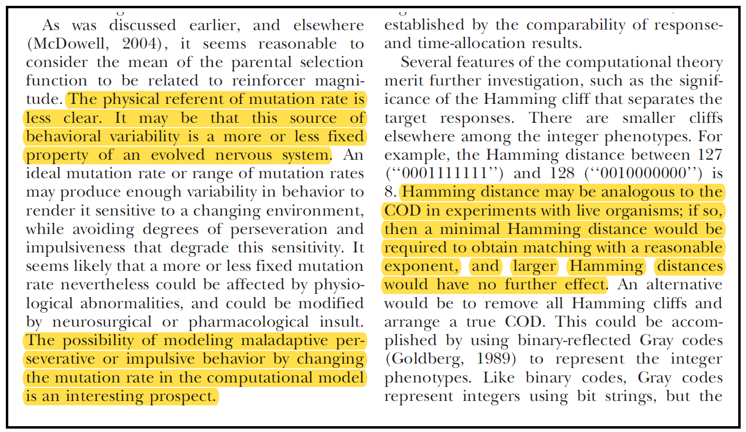
McDowell, Caron, Kulubekova, & Berg (2008), page 400
Received: September 2007

Verification (Popa, 2007 - 2013)

I. Hamming as COD (2007-2010)
(Popa, 2009; Popa & McDowell, 2010; Popa, 2013)

This topic became my master’s thesis (Popa, 2009), and then my first publication as corresponding author (or “first author”, Popa & McDowell, 2010). I showed that choice behavior in ETBD depends on the relation between the HD between classes and the largest HD within a target class, relation that, in turn, depends on the location and size of the target classes (Popa & McDowell, 2010).

Subsequent analyses showed that COD-like effects depend on the Hamming Distances between each operant and every other operant in the two target classes. Essentially, the relation provides a measure of the overall genotypic similarity between the target classes: the average probability for a behavior in one class - HD_{SAME}, to change over to the “other” class - HD_{OTHER} (Popa, 2013; pp.19-21).

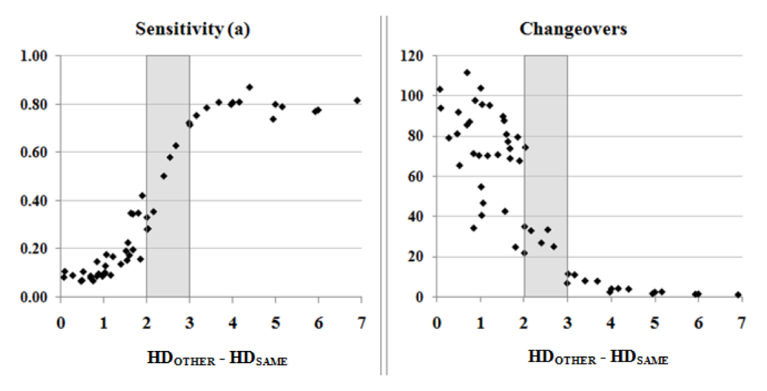
Popa, 2013; figure 4, page 111

See Hamming Emails

William Baum: https://www.abainternational.org/constituents/bios/williambaum.aspx

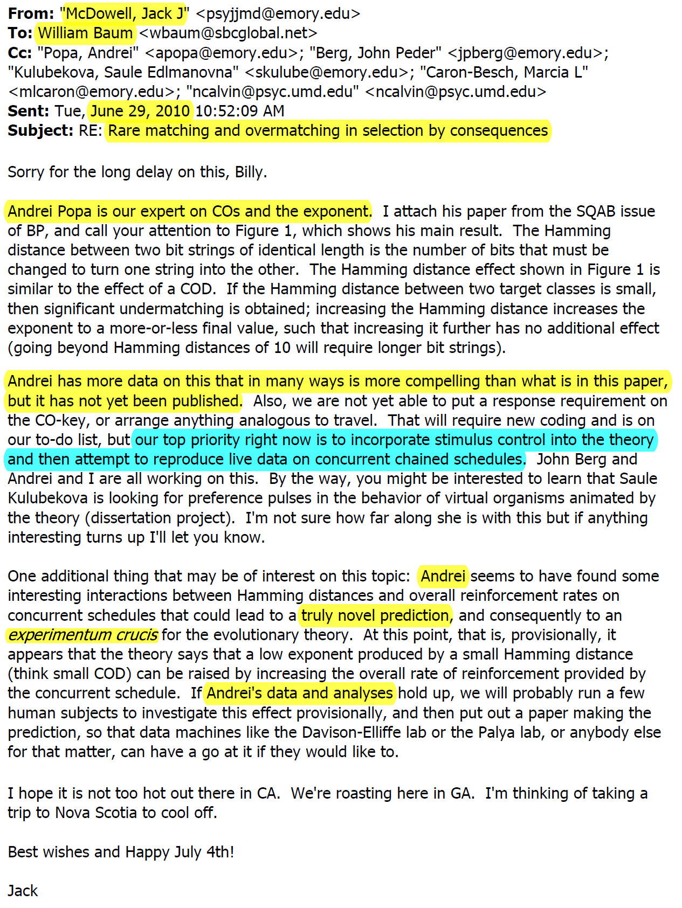
Also included in Hamming Emails

Meanwhile

II. The ADHD connection (2010-2013)
(Popa, 2013; also see Popa & McDowell, 2016)

For my doctoral dissertation, I explored the ADHD connection and I verified and confirmed ETBD’s potential to predict human behavior and to inform clinical research:

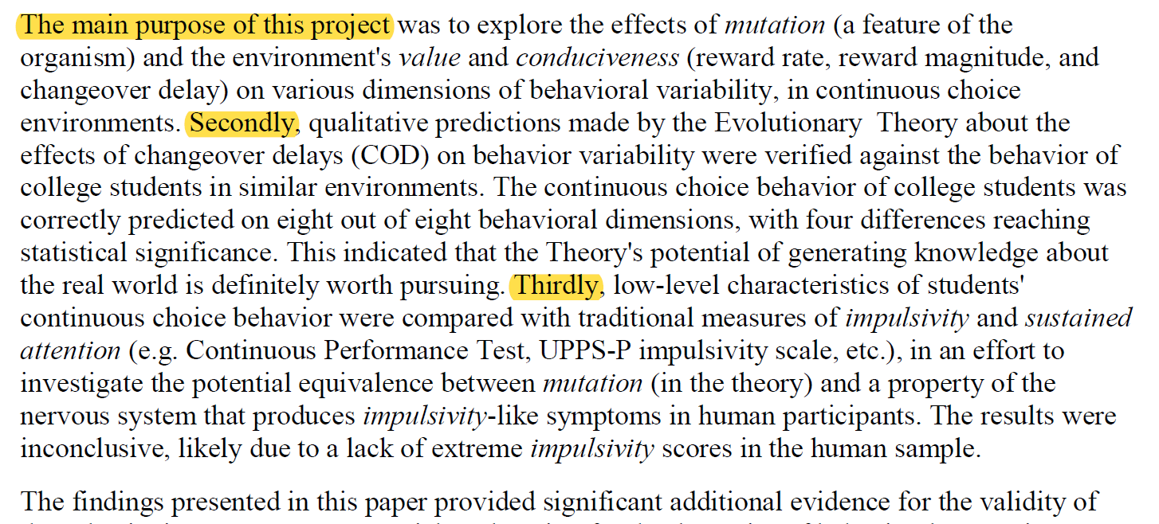
Specific aims (Popa, 2013; Abstract section)

Mutation rate and ADHD

Aim 1 (p. 25 – 50). I measured nine dependent variables, in environments characterized by many combinations of mutation rates, reinforcement rates, reinforcer magnitude, and HD-COD values.

High mutation rates produced symptoms strikingly similar to textbooks descriptions of ADHD:

“…decreased sensitivity to reward, switched more often between activities, engaged less often in continuous-responding, abandoned the task faster, took longer to re-engage, acquired fewer resources, exhibited high levels of topographic variability…”

These symptoms were counteracted by arranging higher reinforcer rates, magnitudes, and HD_COD values. They were made worse when the environment delivered few or weak reinforcers, or when the HD_COD was low. In fact, similar maladaptive outcomes emerged from many combinations of independent variables, also consistent with the ADHD literature.

These variables can affect ETBD outcomes only by altering the structure of the population at each generation. I identified a property shared by the combinations of variables that resulted in maladaptive variability: low likelihood to exhibit consecutive responses in the same target class, which prevents the formation of bouts, which, in the long run, produces disorganized behavioral patterns.

ETBD predicts human behavior

Aim 2 (p. 51 – 60). I programmed and tested a “virtual operant chamber” and I looked at human behavior in two conditions: with and without a changeover delay. The differences between the two groups went in the direction predicted by ETBD; four of eight differences were statistically significant. These results provided further support for the Hamming – COD parallel and showed that ETBD can predict human behavior.

Aim 3 (p. 60 – 74). I looked at the relation between properties of choice behavior in humans, like sensitivity, bout frequency, etc. and measures of inattention and impulsivity (A-ADDES, UPPS-P, SSS V, CPT-IP). The scores on these measures were not variable enough to show anything conclusive; I suggested to try again, with diagnosed participants.

Fast Matching

I made Fast Matching to verify ETBD predictions, in this case, about the effects of a COD on human choice behavior. The version I used in my dissertation entailed five RI RI schedules, unsignaled, each of them in effect for only 200 seconds. The RI schedules within a pair were independent and arranged very high reinforcement rates.

Jack’s reaction to the first datasets, pre-pilot data (October 2010):
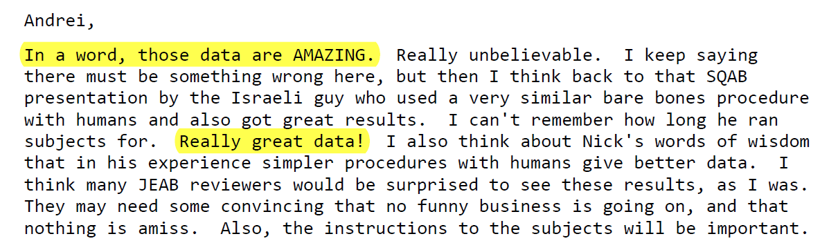

From Jack’s email to my former colleague, Marcia Caron (December 2010):
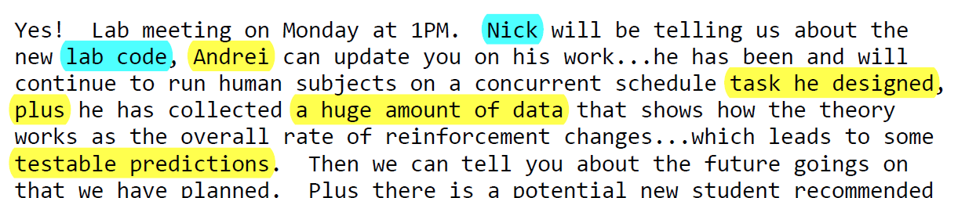

See Fast Matching Emails

What makes Fast Matching valuable

The procedure yielded “typical matching” results in less than 20 minutes, when the rates of reinforcement were very high and quite similar. This led me to suggest that Fast Matching can be used to examine the neuronal underpinnings of behavior (with EEG, fMRI) and cognitive processes like attention (with an Eye Tracker) in real time, while taking advantage of mathematical descriptors like the Matching Law (Popa & McDowell, 2016, p.287-288; see also ADHD_2015, p. 24-25)

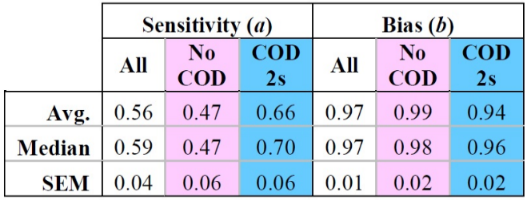 | 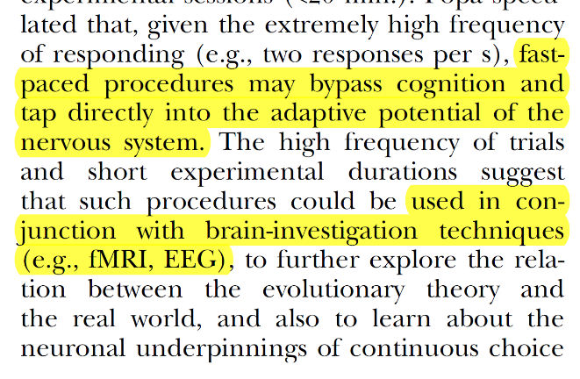
Popa, 2013; from Table 3, page 101 | Popa & McDowell (2016; p. 288)

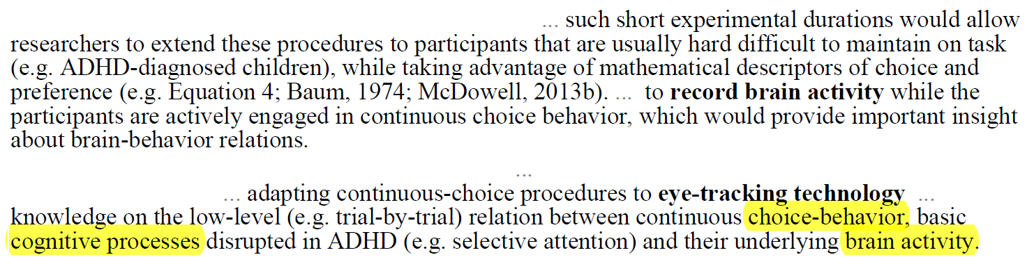
From unpublished “ADHD” manuscript (2015), shared with McDowell and Calvin.

Meanwhile…

In 2007, McDowell was interested in expanding ETBD to aversive conditioning and stimulus control. These developments, however, entailed a significant amount of programming; with Caron, Kulubekova, and Berg graduating and me deep in Hamming Distances, there was literally no one to do the work.

Jack decided to pursue other projects, decision that resulted in three important publications:
- the “Wolfram paper” (McDowell & Popa, 2009);
- the “behavior mechanics paper” (McDowell & Popa, 2010);
- the “Edelman connection” (McDowell, 2010).

In the Spring of 2010, Jack tried, unsuccessfully, to fund the implementation of stimulus control via an NIMH grant (see NIMH_2010); I was his co-investigator on this would-be project, for which I did the literature review.

Things changed in August 2010, when Nick Calvin joined the lab as a 1st year graduate student in Clinical Psychology. Nick had programming experience in VB.Net, same as Jack, and they began implementing punishment and stimulus control immediately. The lab correspondence indicated they were making good progress, on both fronts. See Nick_Programmer, Xxxx_Xxxx

In 2012, Nick decided to focus his research on social interactions, a topic that couldn’t have been investigated without these new developments, as explained by McDowell (2013; Psych Review).

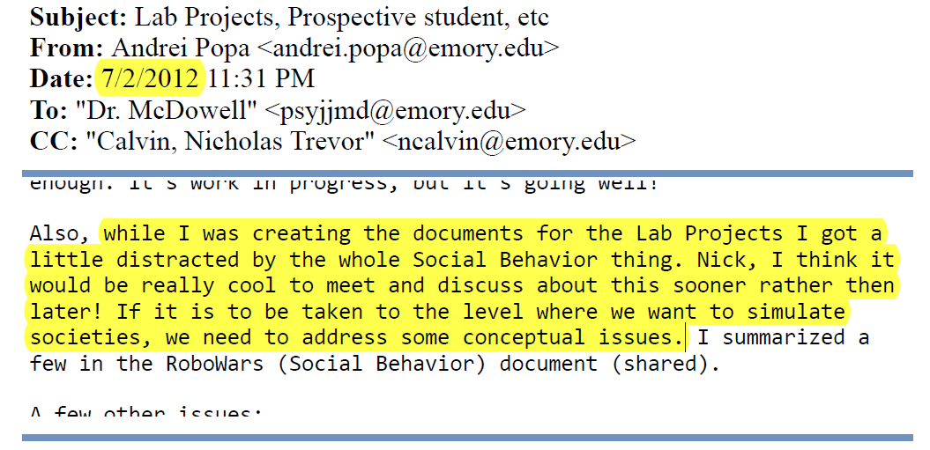
Sent to Jack and Nick in July 2012

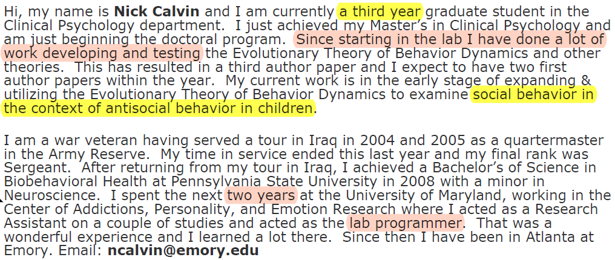
Nick’s bio on the lab’s website, September 2013 - February 2015

McDowell, 2013 (Psych Review)

These three developments were described in McDowell’s review of ETBD, in 2013 (Psych Review, p. 745-746). This paper was submitted in February 2013.

By February 2013, when the paper was submitted, Jack and Nick appeared to have made good progress on punishment and discriminative control; this progress was not mentioned.

My data on the ADHD connection and Fast Matching was also available; it wasn’t mentioned either.

In light of all these omissions, the section on social interactions seems quite long, especially since there were absolutely no results to report. In addition, it is not clear who, if anyone, is pursuing this work.

My work on the Hamming – COD parallel was misrepresented. The “subsequent analyses” on Hamming distances – the ones mentioned in correspondence with Dr. Davison in 2010, was ignored as well.

ETBD in 2013-2014

In August 2013, the McDowell Lab had two graduate students – me and Nick, and two undergraduate research assistants who just joined – Bryan Klapes and Sean Kelly. Calvin was in his 3rd year. According to his website bio, his was working on using ETBD to simulate social interactions. Klapes and Kelly joined McDowell and Calvin in their work on punishment and stimulus control.

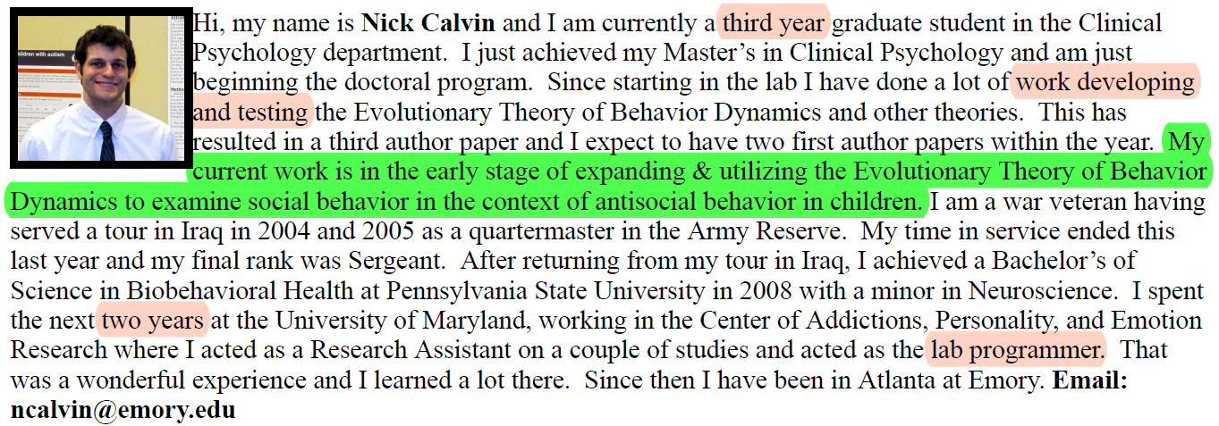

I defended my dissertation on August 22, 2013, with a thesis that showed ETBD’s potential to generate high-level phenotypes with clinical relevance (ADHD), to simulate behavioral interventions, and to predict human behavior (via Fast Matching). I decided to publish these findings as two independent articles and write them in this order:
- The ADHD connection: mutation rate, reinforcement rate and magnitude; equifinality / multifinality; implications for ADHD; the Default Mode Network;
- ETBD predicts human behavior: verify the Hamming-COD parallel via Fast Matching (aim 2 + the Hamming part from aim 1)

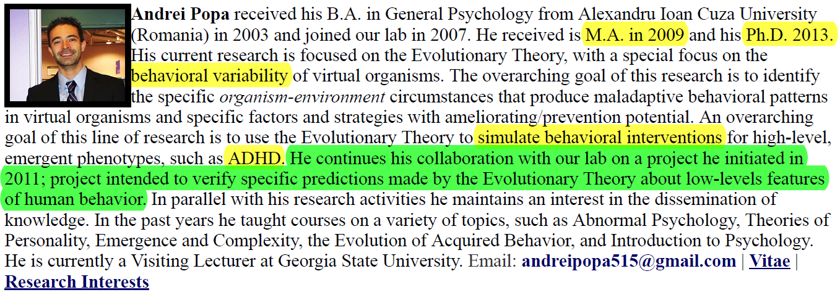

After my defense, I passed on the infrastructure of the human research program to Calvin and Klapes: the hardware and software I used in my experiments, assistance with IRB documentation, ideas, feedback, etc. The idea was to collaborate on expanding this work to stimulus control and punishment.

2014, Year of The Comet

(see 2014_lab_emails)

In May 2014, I presented an outline of the ADHD manuscript at ABAI (Chicago, 2014).

Calvin’s dissertation proposal seemed completed; curiously, it was not on social interactions. In fact, that topic was never heard from again [check].

On September 26, Jack suggested to split the ADHD manuscript in two papers – one on basic science and one on translational implications (ADHD per se), and to submit them together. I took his advice.

Progress on punishment and stimulus control in ETBD seemed excellent throughout the year. On October 16, Jack declared them the lab’s “top priorities”, in anticipation for Kyoto, 2015.

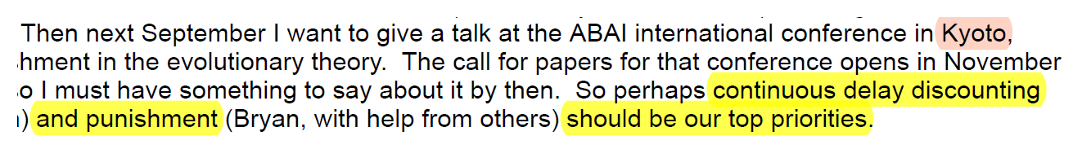

On October 31, Bryan Klapes presented a research poster at SEABA, a regional meeting, relatively small, scheduled on Halloween. The poster, co-authored with Nick Calvin, is described on the next page.

On November 14, I shared with Jack essential insights on human development, now in Popa (2019).

On November 15, Jack was commending Calvin on how his dissertation. I was not aware that he defended his proposal and I did not receive a copy of his thesis. He defended until March 2019.

On December 7, Jack okayed my job application materials, including my research statement.

Fast Matching incidents

Poster SEABA (October 31, 2014)

Society for the Advancement of Behavior Analysis
https://www.seabaonline.org/uploads/4/4/8/1/44816931/seaba_program_2014_final.pdf

The research poster was contributed by Bryan Klapes and Nick Calvin. The presentation itself was delivered by Bryan Klapes on October 31. I became aware of its content on January 10, 2015, after the research grant incident (SABA 2015).

The poster is problematic in multiple ways:

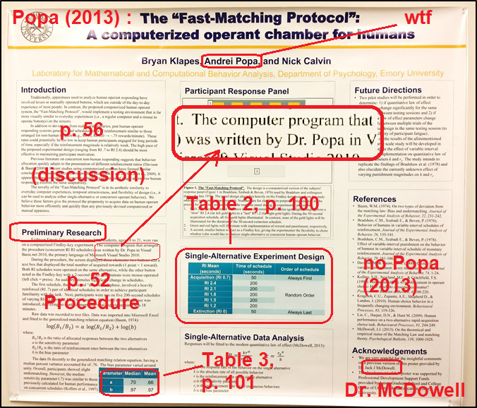

Poster screenshots

Research Grant SABA (January 2015)

On January 9, 2015, Calvin, Klapes, and me were in the lab, for the weekly 3:00 pm meeting.
Jack was a few minutes late. At 3:02 Klapes sent us the “updated” version of his proposal for the SABA’s Innovative Student Research grant: “Fast Matching” rewritten as his original idea.

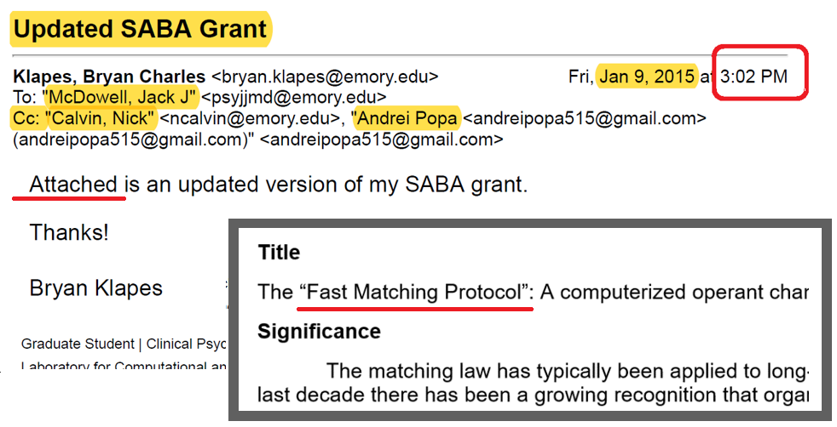

I asked Klapes what’s his name doing on my work, but I couldn’t get a straight answer. Calvin, who was next to Bryan, ignored the exchange. Finally, Jack entered, and the meeting began. Klapes presented the SABA proposal and Jack was pleased. I was just sitting there, trying to wrap my head around this new reality; I left soon after without saying anything to anyone.

On January 10, 2015 – so the next day – Bryan Klapes, endorsed by Dr. McDowell, submitted Fast Matching for SABA’s Innovative Student Research grant (I learned later).

That same day, Jan 10, I went to the lab to pick up my personal belongings and some hardware I left behind for research purposes. That’s when I saw the October 31 poster hanging in a small room I used for data collection.

On May 19, 2015 Jack suggested that I postpone the ADHD paper until I publish the “basic science” paper. Again, I took his suggestion.

On June 10, 2015 I submitted the “basic science” paper to JEAB. Nick Calvin was listed as second author and Jack McDowell was listed as third author.

ORC Complaint (July 2015)

On July 15, 2015 I filed a formal complaint regarding the research poster (SEABA, 2014) and the grant proposal (SABA, 2015). The complaint was forwarded by Dr. Harold Gouzoules to the Office for Research Compliance of Emory University, or ORC (http://compliance.emory.edu).

On August 27, 2015, Emory’s Research Integrity Officer, Ms. Kristin West, J.D., M.S., conducted an initial review of the allegations and “indicated” that there was no evidence of plagiarism. However, instead of throwing the case, an unidentified entity stated that unidentified parties had different views regarding an unidentified “matter” and decided to investigate said “matter”.

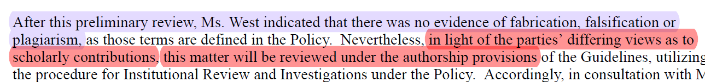

In effect, Ms. West – Emory’s Research Integrity Officer – exonerated McDowell, Calvin, and Klapes, then “someone” brought my authorship into question and decided to review “the matter”, and then Dr. MacBeth, Laney Graduate School Dean for Academic Affairs, appointed a committee of non-specialists to investigate it, “the matter”:

Dr. Michael Sullivan, Associate Professor, Philosophy
Dr. Kimberly Jacob Arriola, Professor, Behavioral Sciences and Health (epidemiology)
Dr. Irene Brown, Associate Professor, Sociology

On August 31, 2015, I communicated to Nick Calvin that I will be removing him as an author. The exchange is under “Calvin Removal”. My email from December 12 articulates exactly why Calvin’s contribution did not meet the criteria for authorship and explains why I included him in the first place.

Go to Fast Matching incidents

2016

In January, I learned that Nick Calvin came out as Olivia Louise Calvin;

Bryan Klapes took a leave of absence…. WHEN?

In February, I presented more of my work on human development (Darwin Days, 2016).

the “basic science” paper was accepted on February 17 (Popa & McDowell, 2016);

On March 14, the investigative committee concluded their activity. They decided that my allegations were brought in good faith, that no plagiarism occurred, and breathed further life into the idea that my authorship is somehow disputable. McDowell’s and Calvin’s involvement was overlooked, and I was reminded of the importance of confidentiality.

Note that in 2015 I voiced these concerns to SEABA and SABA as well. They directed me to the Association for Behavior Analysis International, their parent organization. ABAI directed me to Emory’s ORC. None of them has mechanisms to handle allegations of misconduct.

In April, my mentees presented several projects that used variations of Fast Matching to explore stimulus control and negative reinforcement in humans (see CV - SpARC 2016).

On July 19, my colleagues modified the lab’s website in ways detrimental to my professional persona, such as erasing my bio and using my name like a forged signature is used on a contract. See Lab_Website_2016.

Modifications to the website:

NARRATIVE

NARRATIVE, CONTINUED are these any good?

What you see is not what’s happening.

A graduate advisor holds a lot of power over their students’ careers long after graduation. Applying for jobs without their endorsement can be enough to get an application off the table. And that is not counting all the numerous obstacles an established name like McDowell can put in one’s path.

Jack used his adviser role to trick, threaten, and eventually bully me into inaction, while they – McDowell, Calvin, and Klapes - were taking over my intellectual property. The emails we exchanged between January and July 2015 are textbook examples of the effectiveness of gaslighting, especially when the target is an advisee whose trust was cultivated for six years. The bottom line is that it took me a very, very long time to accept that what I see is exactly what was happening: I’m being cannibalized by my advisor.

KYOTO: The title suggests a general overview, and not the unveiling of a breakthrough:

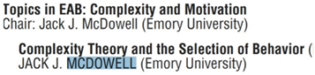
https://www.abainternational.org/media/96776/2015kyotoprogram.pdf

Five years later (McDowell, 2019; p. 141), the implementation of stimulus control was described as “likely to be successful” (left) and the implementation of punishment – as a success, based on unpublished data, with no citation (right).

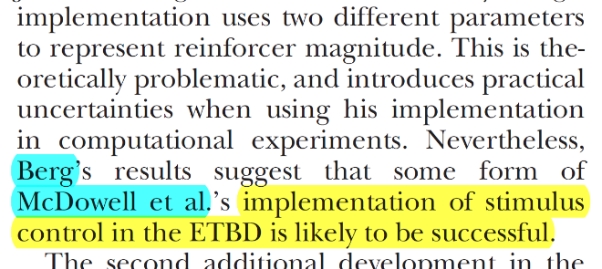  Berg refers to Berg’s dissertation (2011)  McDowell et al (2006) | 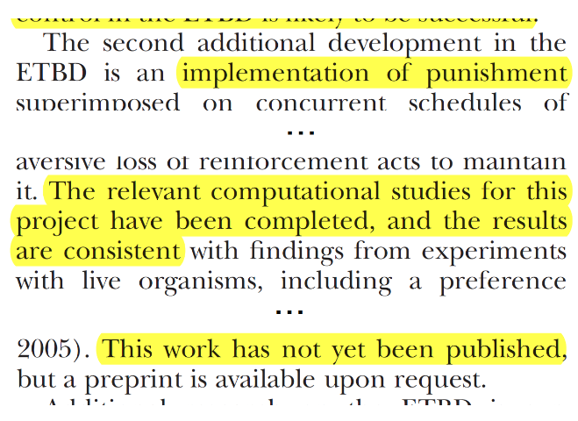

2017

ABAI 2017
https://www.abainternational.org/events/archives.aspx

Both Olivia and I gave talks at ABAI in 2017 (Colorado). I shared a mature version of my account of human development, now Popa (2019); Olivia talked about something else. The organizers grouped us in the same paper session, chaired by Olivia. She was still a student, I had a PhD, she was giving her 1st ABAI talk, I was at my 5th, so this made zero sense; anyway, that was the pretext she used to suggest we meet. We met for coffee and we had a pleasant conversation. I left the coffeeshop thinking that maybe there was room for reconciliation between the two of us, after all.

The next day, McDowell and friends attended my talk. They didn’t say much, which may be why I remember Chi’s question so vividly. He asked about how my idea maps on the brain, and, foolishly, I told them: it maps on the state-changes of a 3D graph made of neurons and synapses.

Go to ABAI_2017

McDowell 2017

McDowell, J. J. (2017). The effect of reinforcement, and the roles of mutation rate and selection pressure, in an evolutionary theory of behavior dynamics. The Behavior Analyst, 40(1), 75-82. https://link.springer.com/article/10.1007/s40614-017-0094-9

[get the fucking document, see if these are true] McDowell (2017) ignored all my work and the knowledge gained from it (Popa, 2013; Popa & McDowell, 2016), like the parallel between mutation rate and the brain’s Default Mode Network (DMN).

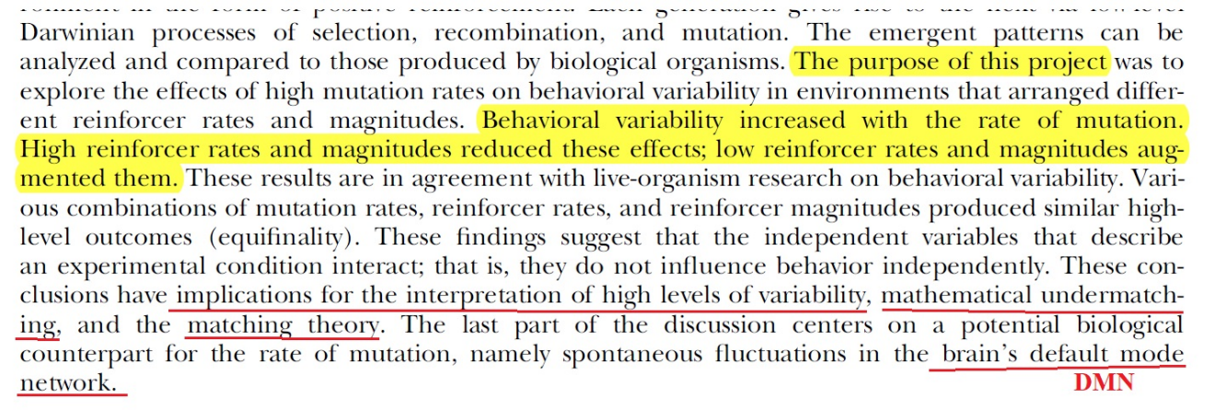
Popa & McDowell (2016) – Abstract (p. 270)

The journal’s chief editor at the time, Dr. Donald Hantula (Temple University), told me to take it up with Jack McDowell who, by the way, was his professor in undergrad. Dr. Newland (XXXXX university) – the new Chief Editor, agreed with Dr. Hantula’s position “completely”.

Go to McDowell_2017

McDowell’s letter

Around that time, I saw Dr. McDowell’s letter of recommendation – a subversive mixture of lies, omissions, and red flags that gets more disgusting with every read.

Here’s a lie:

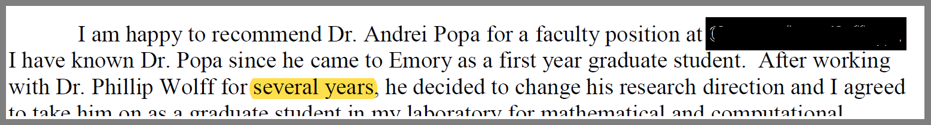

My grad student adventure in August 2005. In April 2006 I took a leave of absence, until August 2007. During the leave, I transferred from Dr. Phil Wolff’s lab to Dr. Jack McDowell’s lab, who was my advisor until I graduated, in December 2013.

Dr. Wolff remained an influential figure in my graduate …

In the seven years we worked together, Jack and I coauthored three research posters, six conference talks, and five research papers. In fact, we collaborated so well that five years after he kicked me to the curb I am still his top coauthor. https://www.researchgate.net/profile/Jack_Mcdowell

Go to McDowell’s Letter.

Back to finish the job

McDowell 2019

McDowell, J. J. (2019). On the current status of the evolutionary theory of behavior dynamics: Status of the Evolutionary Theory. Journal of the Experimental Analysis of Behavior, 111(1), 130-145. https://link.springer.com/article/10.1007/s40614-017-0094-9

This paper, like the SEABA 2014 poster, was designed for dishonest purposes - the most obvious one being the ingestion of the ADHD connection (General Discussion section, p. 141-142). The tactics are familiar by now: suppress references to original work, misrepresent my role, misrepresent the timeline, and so on. In short:

- ETBD’s translational potential was misrepresented as “currently being pursued…” (no citation).
- Popa (2013) was ignored, as were our ABAI talks (2011, 2012, 2014).
- Popa & McDowell (2016) was described as “a study relevant to the connection… “ – wording that logically implies not the connection.

Notably, the Hamming – COD parallel was missing from the Material Equivalences … section (p. 138-140). This omission, I suspect, serves an evil purpose. I’ll explain soon, make a mental note of it.

Also noteworthy was the treatment of punishment and stimulus control (p. 140) - the lab’s “top priorities” in 2014. In McDowell (2019), one is “doable”, the other “a success” (no data or citation).

Additional inconsistencies are addressed in annotations; they concern big claims published on “say so”, chunks of unnecessary content, redundant publication, etc.

I contacted Dr. McDowell and the journal’s chief editor, Dr. Amy Odum (Utah State), and I requested for my contributions to be properly acknowledged. Jack refused, Dr. Odum looked the other way.

Go to McDowell_2019.

Calvin 2019

On March 15, Olivia Calvin emailed me her dissertation. The ADHD-connection was credited to Popa & McDowell (2016), and Fast Matching was ignored when discussing matching in humans. So, she bypassed my dissertation completely. I pointed it out, she apologized, and she told me that she took care of it: informed her dissertation committee about the error, got their approval to correct it, and sent me the updated version.

On July 27, Olivia announced that she accepted a postdoc with Dr. Redish (University of Minnesota). I found it odd, since he’s lab focuses on neuronal dynamics and computational models of mental disorders – topics that was surprising, since her research had nothing to do with this domain.

https://redishlab.umn.edu/about-redish-lab

In the summer – when the dissertation became available in ETD - I realized that Olivia made it all up. Instead of correcting the thesis, she created a different document that correctly reflected the corrections, and she uploaded it in ETD under “supplemental materials”, with the title “word version of my dissertation”. She then converted it to pdf and sent it to me as “updated thesis”. I contacted the department’s chair, Dr. Patricia Brennan, and the rest of Olivia’s dissertation committee (except Dr. McDowell).

Go to Calvin_2019.

Hackett, 2019

On July 24, Ryan Hackett’s dissertation was uploaded in ETD. The full text is not accessible to the public until August 2020. The abstract suggests significant overlap with my own dissertation, specifically, a spin-off on aims 2 and 3, with different variables (Popa, 2013; p. 51-74).

Popa (2013) | Hackett (2019)
aim 1:  ETBD data, Mutation rate, COD, reinforcement rate and magnitude | unclear
aim 2:  high - low COD | high - low reinforcement rate
behavioral and ADHD measures  (via Fast Matching) | behavioral and “attention problems” measures  (via 5 independent, concurrent, RI schedules = Fast Matching)
ETBD findings (aim 1) were confirmed in human participants, for all eight variables; | unclear, but is likely that sensitivity went in the direction predicted by ETBD (2013, aim 1);
aim 3:  … focus on diagnosed participants.…because … variability in ADHD scores was too low… | He examined a sample of diagnosed participants with highly variable scores – as recommended by Popa (2013); he found results “consistent with theory ETBD”, as predicted in 2013, aim 3.

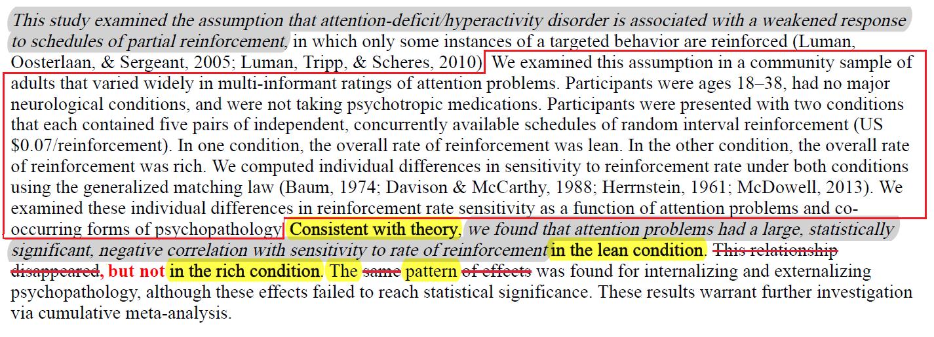

If the thesis is spin-off and my intellectual contributions were not properly acknowledged, it means that Fast Matching and the ADHD connection were both ingested in Mr. Hackett’s dissertation. This would make it a threat to my academic credentials, since two names cannot occupy the same “original contributions”, which is what dissertations are supposed to be.

If the thesis is a spin-off, but my intellectual contributions were properly acknowledged, then its original contributions are …what? Following my recommendation and confirming my prediction? If the end-goal was the one declared in the abstract … what is the goal declared in the abstract?

If this is as bad as it looks, then the Hamming – COD parallel remains the only link between my name and ETBD. Its omission from McDowell (2019), Steve Riley’s overt interest in the Hamming paper (Popa & McDowell, 2010), Jack’s interest in my professional persona - maybe they’re just coincidences, sure; very timely, focused coincidences, that follow five years of dishonest acts and harmful actions.

Psychology 2.0

When I saw Hackett’s abstract, I felt a sense of urgency to protect my intellectual legacy; I removed everything that wasn’t essential, I put my research on hold, and I published the outline on PsyArXiv:

Popa, A. (2019, September 8). Psychology 2.0: The Emergence of Individuality. https://doi.org/10.31234/osf.io/m87an

Jack’s reaction set an alarm, one too many, so I asked him directly if I’ll see my ideas published under his name, twice. I didn’t hear back yet. A few weeks later, I reached out to Cyrus Chi, with a similar question. I felt he deserved the benefit of the doubt, so I inquired. I did not hear back yet.

Check his masters

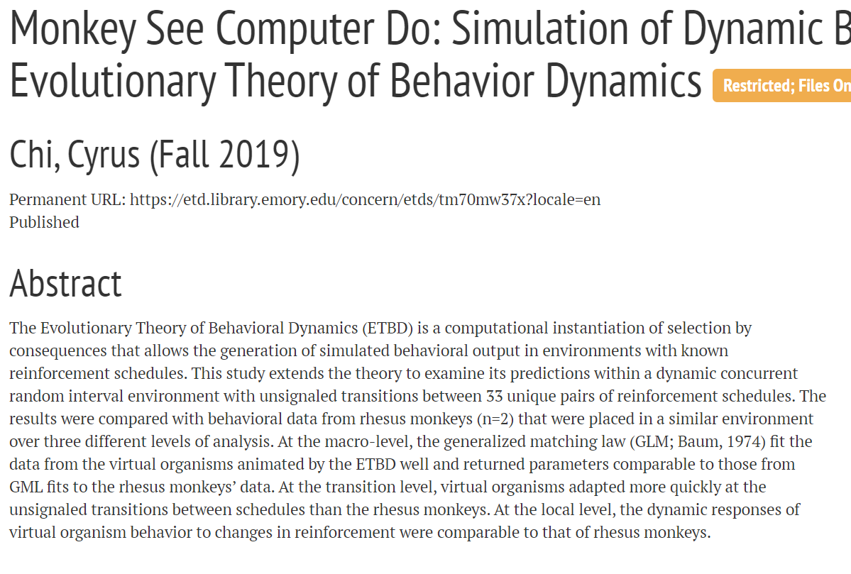

ETBD started as a model, became a theory, and now it’s both a theory and an implementation. Since when “by consequences” and not “evolutionary”? Since he has a good option, that he tries to sell as his theory, inspired by the ETBD implementation or something?

Summary and future directions

– after which I suspect McDowell will attempt to terminate me as a lose end: attack my credentials, my reputation, freedom, etc.

Whatever taints my name and harms aspects of my life would do, and I have no doubt that with this man nothing is off the table if he stands to gain something,

He will not let this go, even if it’s just retribution.

I won’t either, because this is my life, and I’ll die before I give it up.

…

Given my colleagues’ priors, Dr. McDowell’s reaction to the news, and Mr. Chi’s silence when confronted with a direct question, I worry that appropriating Psych 2.0. is either complete or in progress and that Dr. McDowell will use his influence and resources to harm me professionally and socio-economically.

…

… still pursuing the cannibalization campaign started in 2014 and they have no intention to stop until there’s nothing left of my intellectual legacy, and probably not even then.

Society for the Advancement of Behavior Analysis
SEABA = Southeastern Association for Behavior Analysis
SABA = Society for the Advancement of Behavior Analysis
Jack’s lab didn’t offer anything beyond what was offered by the department – paper, clips, paperclips, etc.. Two of the machines I used for data collection were my personal property; the third was donated by a senior colleague; the fourth was salvaged and gifted by a friend.

