User Manual for Associates
Add New User:

- Click on Add new user button.
- Select the Employee type – Analyst , Economist, Sales, Corp Access , Strategist .
- If Employee Type is – Analyst , then selecting a Sector is mandatory.
- List of sectors will be displayed in the dropdown, and user can select any one sectors from the list.
- If same analyst is assigned to multiple sectors, then user will have to add that user multiple times with different sectors.
For Example : Analyst A is assigned to sector Auto, Banks and AGRO
Then user will have to add Analyst A separately for each sector. 3 Records will be displayed in the screen for Analyst A .

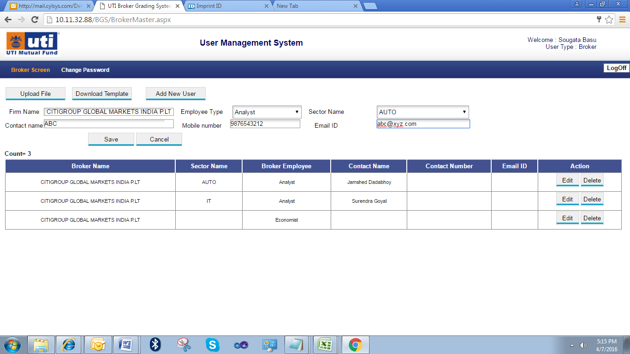
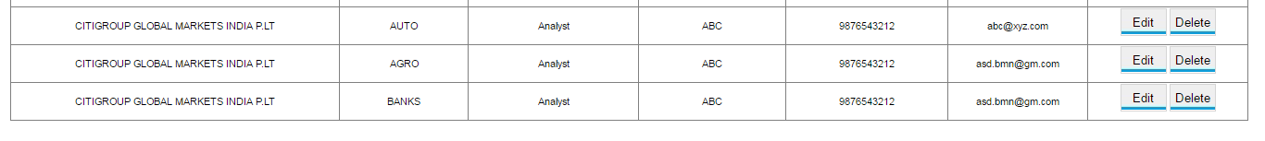

Edit existing User:
- Click on the Edit button given on the right side of the table.
- The selected record will be displayed in Editable mode .
- Edit the required data as shown in picture below, and click on Save button.
- The Record will be Edited and Saved successfully.
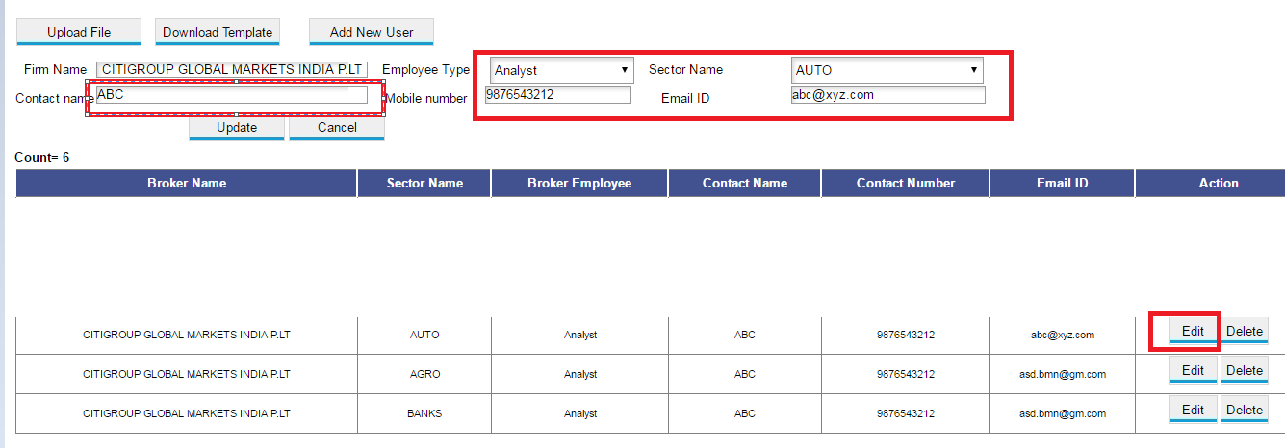

Delete Existing User :

1.Click on Delete button , given on right side of the table.
2.An Alert message will be displayed , for confirming the Delete.
3.If user selects Yes, then the select record will be deleted from the Database , and Voter will not be able to see that record for Voting.

Uploading Excel sheet:

- If user wants to upload multiple records in a excel , then user can download the Excel Template by clicking on Download Template button.
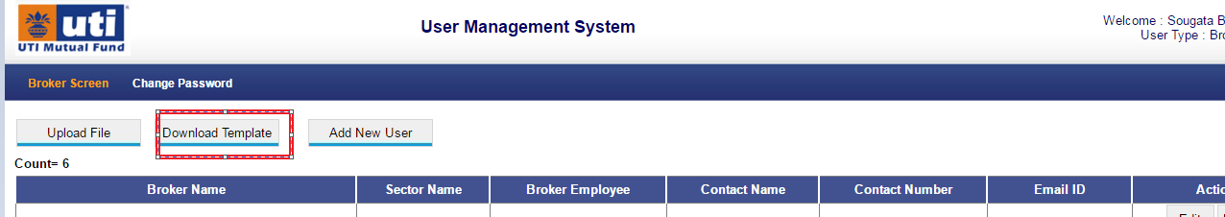
- An excel file named BrokerUploadFormat.xls will be downloaded in the system,it should get downloaded in your default Downloads folder.
- User will open the file, select the Sector from dropdown box given in excel, select the Employee type from dropdown , enter other details of employee.
- Save the excel sheet in same format and same name ie BrokerUploadFormat.xls
- Make sure that all the entries done in excel are correct.
- If any Analyst is added then Sector should also be selected.
- User can not enter any Sector other than specified in the dropdown list.
- If 1 analyst is handling multiple sectors , then multiple rows need to be added for that analyst.
- Only one Analyst per row will be added.
- Only 1 Sector per row will be added.
- Please check the screenshot below:

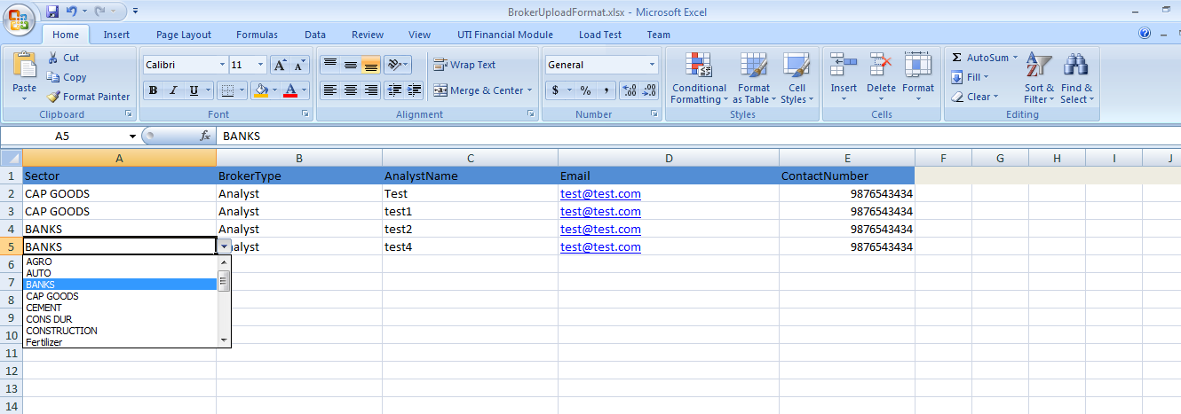

12.Once the Excel sheet is updated properly and Saved in the system.
13 Click on Upload File button.
14.Click on Choose File , and browse the updated BrokerUploadFormat.xls on your local system.
15.Click on Upload file.
16 The file will get uploaded successfully and all the records will be updated in the database.
17.All the records that are upated in system , will be available for Voting.
