
CHINOOK RECORDS
User Guide

Table of Contents
Getting Started - 2 -
Filtering Artists - 3 -
Searching Albums or Artists - 5 -
Sorting - 6 -
Adding New Albums - 7 -
Viewing Track Details - 10 -
Updating Album Details - 11 -
Deleting Albums - 12 -

Getting Started

When you open the application click view records on the home screen to launch the application.

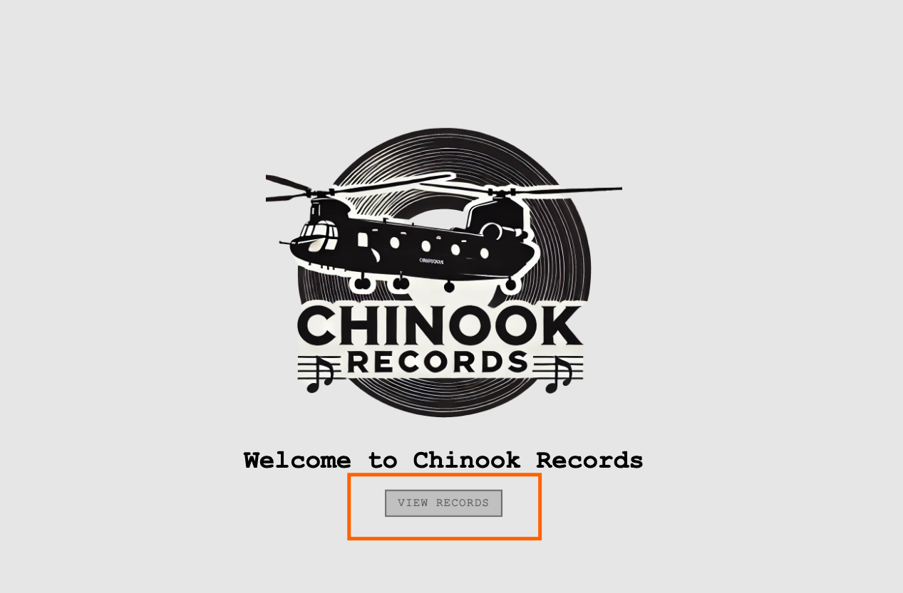

You will then be directed to the main page where you can view, filter, search, sort and add new albums.

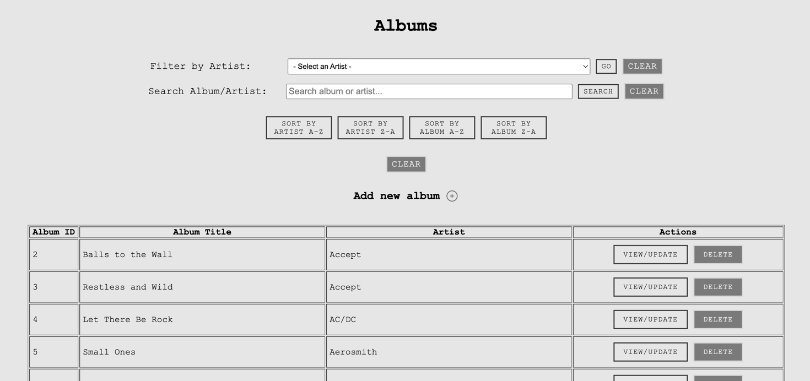

Filtering Artists

If you want to filter by a specific artist this is very easy just click on the arrow to the right of the input box.

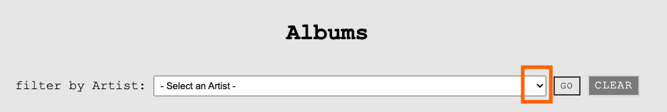

This will then show the full list of the artists names that exist within the database. Select the artist you require then hit GO.

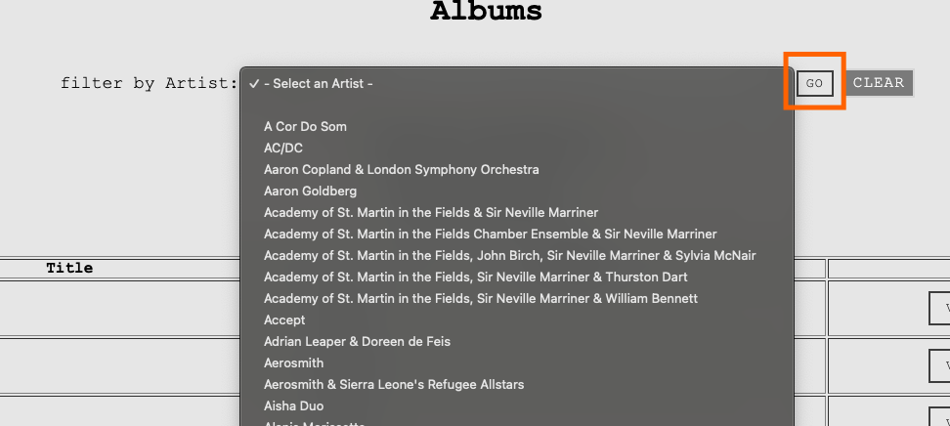

If the artist has an album within the database these will then be shown in the table below, for example filtering by AC/DC gives the below results as they have one album that exists within the database. To clear the filter and return all album details once more click the clear button that is next to GO.

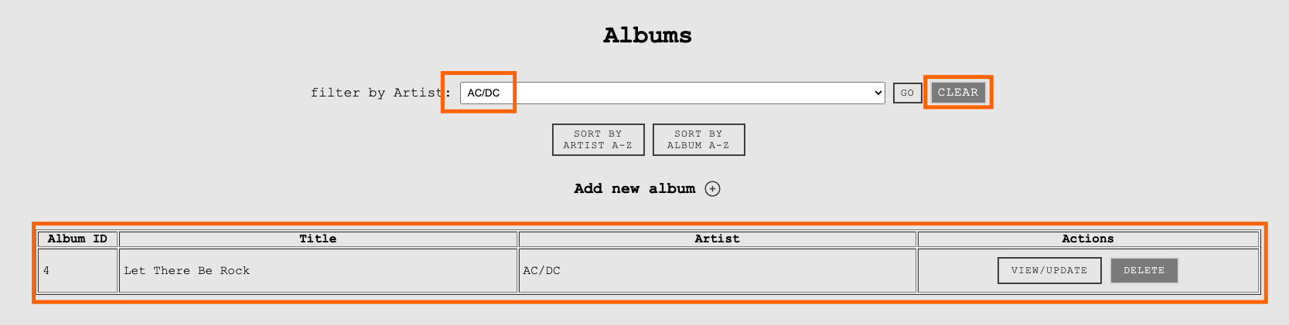

If an artist exists within the database but no album details are held then an error message will be displayed, again to return to all album view click clear.

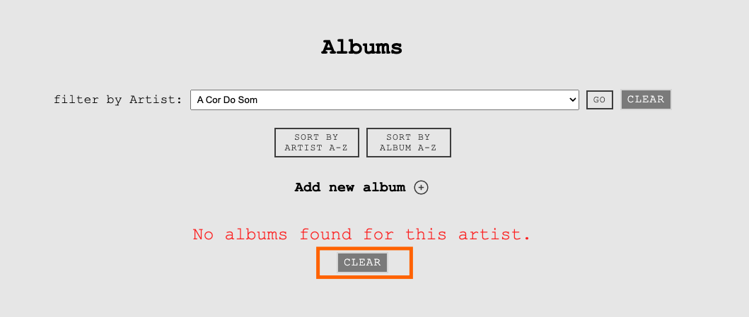

Searching Albums or Artists

To search for a specific album or artist just free type a search term (can be either artist or album) in the Search input.

This will then return in the table below any album or artist that matches that search term.

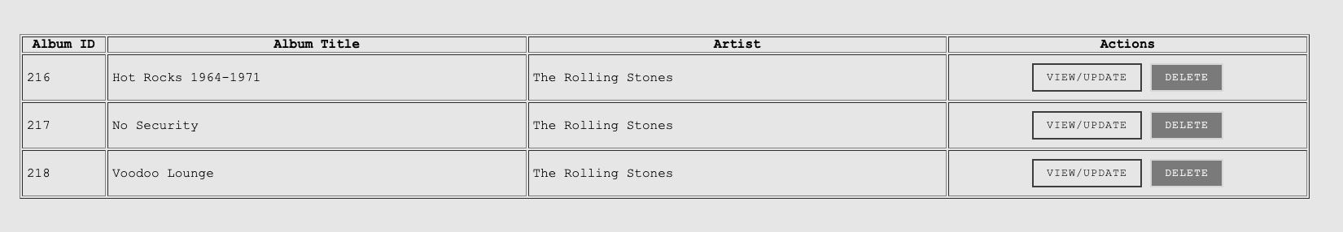

To clear the search just click the CLEAR button.

Sorting

There are basic sort functions allowing the user to sort by Album A-Z or Artist A-Z or vice versa. They are very straightforward to use just click the button you require, and the table will either sort A-Z (or Z-A)on Albums:

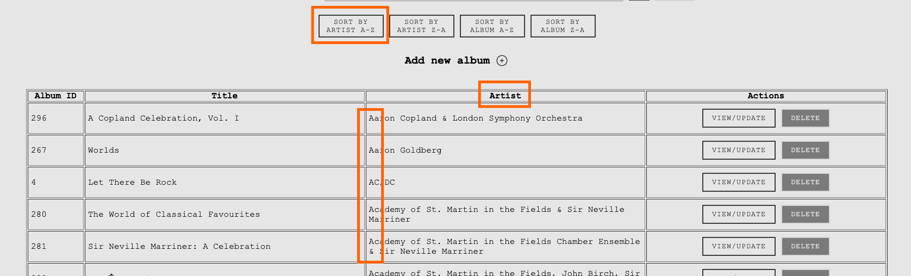

Or Artists (this is sorted Z-A):

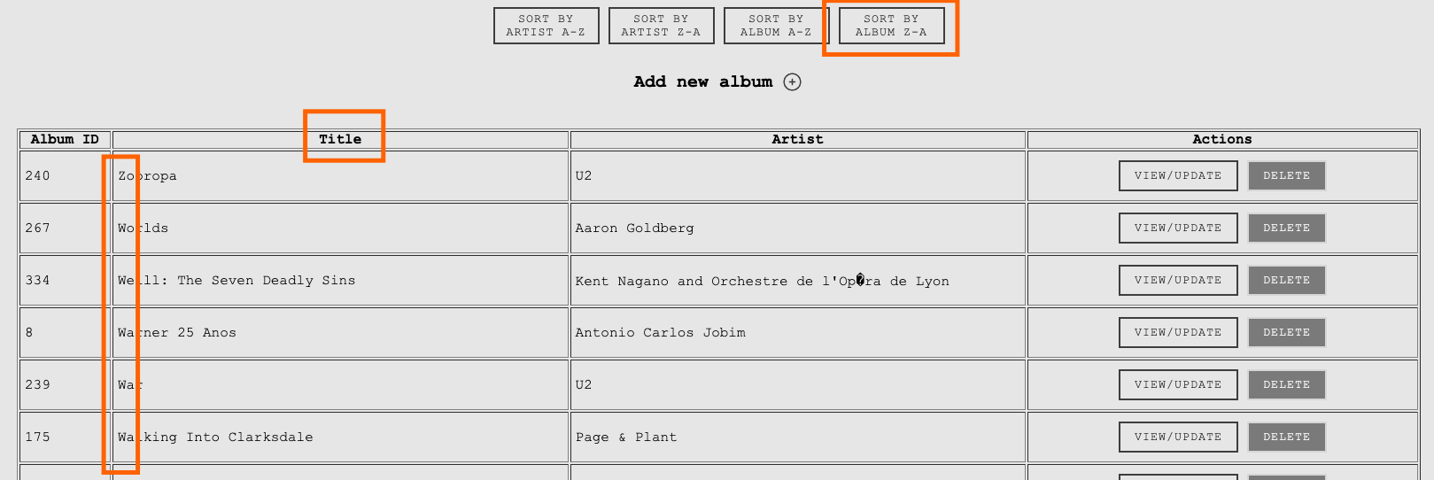

To clear the sort filters just click the CLEAR button.

Adding New Albums

To add a new album click the + icon/

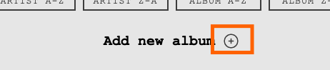

This will reveal the inputs below that are required to create a new entry.

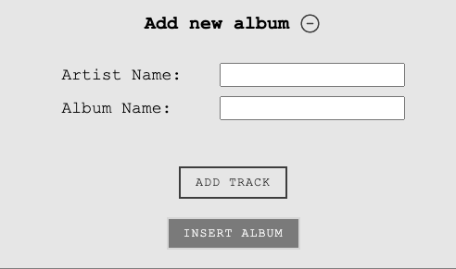

For Artist Name you have an option to select from the list of artists that already exist within the database, or you can free type – this will also filter the names for example writing ‘B’ will then only show artist containing the letter B, adding more letters will further filter. Bear in mind that for data integrity it is best to use the artist’s name if it exists within the database already so multiple instances of the same artist aren’t created.
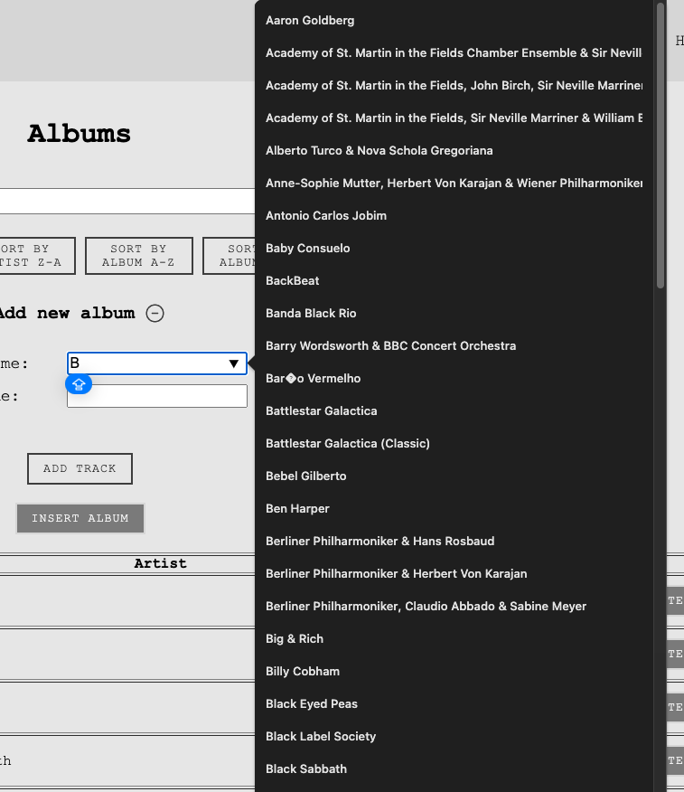
For Album name add this as you would like it to appear in the database. Once you are happy click Add Track.

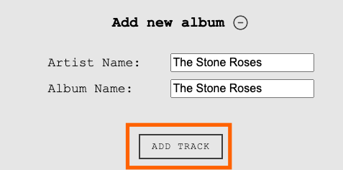

This will create a new input field for the first track name.

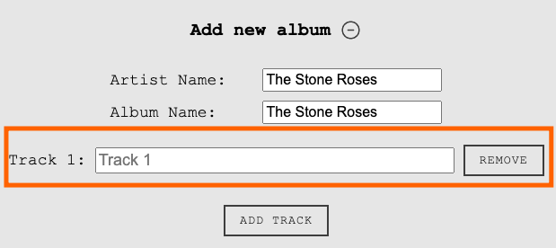

Add the track name and continue to add more tracks until all the tracks are now listed. If at any point you need to remove a track just click the remove button.

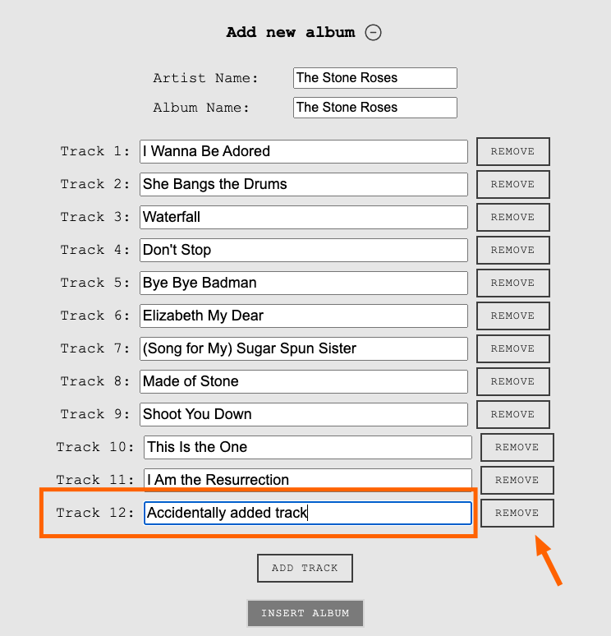
Once you are happy the tracks are correct you are now ready to add the album to the database by clicking Insert Album.

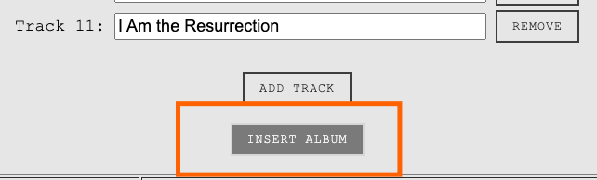

You will get an alert asking whether you are sure you want to insert the album. Click ok if happy, if not cancel and edit.

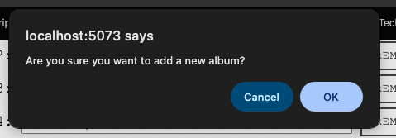

Now if you search for the artist in the filter by artist input, you should see your brand new entry.

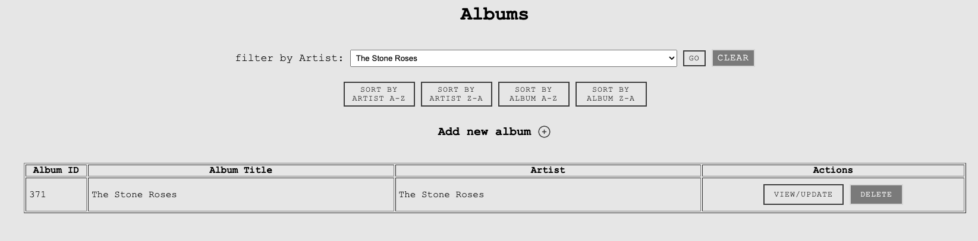

Note that if you try and add a new album without an Artist Name or Album Name then the system won’t allow this to be processed and will prompt you to add.

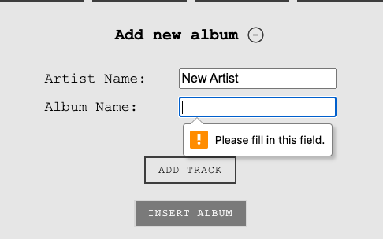

Viewing Track Details

To view the full details of an album with all the tracks listed all you need to do is click VIEW/UPDATE button next to the album you want to view.

This will then take you to a page that list all the track details as well as the artist and album names.

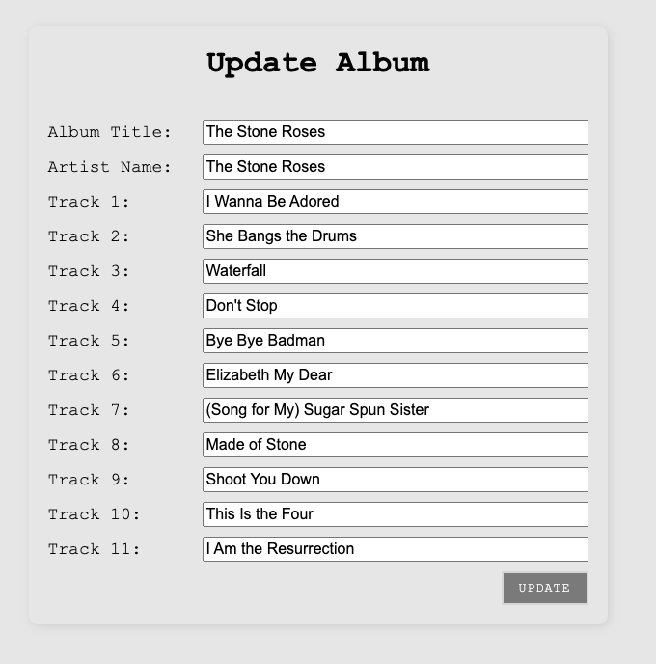

To go back to the main page just select Back to View

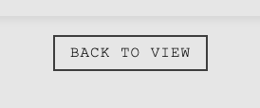

Updating Album Details

If you need to update any album details this can be done in teh same place you view album details. Let say you have made a spelling mistake or entered an incorrect track name and track 10 should be ‘This is the One”

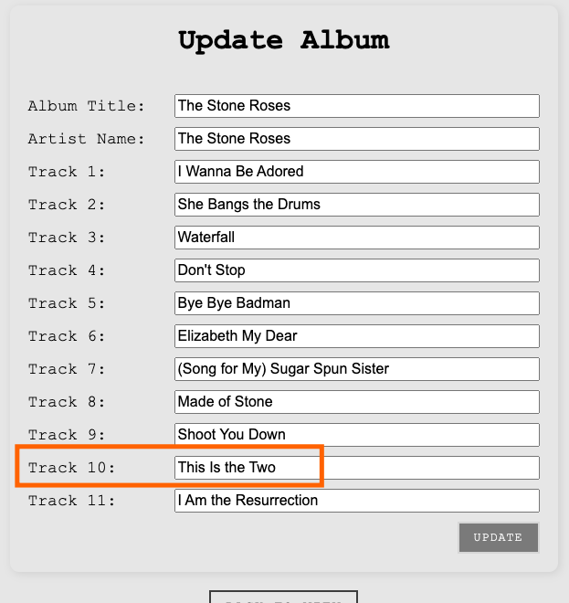

Just overtype what is in the input (ensuring all other inputs remain as is as anything you edit here will update the database).

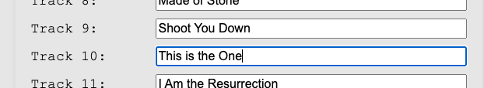

Then click UPDATE. You will get a prompt asking if you are sure, click OK. The data has now been updated in the database.



Deleting Albums

To completely remove an album from the database this can be done from the main view album’s page. Navigate to the album you want to remove using the filters or search.

Then click the Delete button. A prompt will ask if you definitely want to delete as the action can’t be undone.

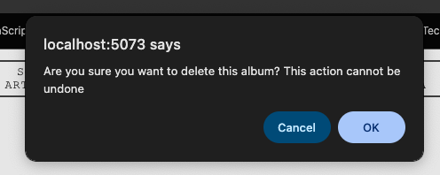

Once removed you should no longer be able to find that album or any related tracks in the database.

