2019 Fall EE5183 FinTech – Homework 3

Convolutional Neural Network for Image Recognition

1. The big stride is lead to the high information loss but also reduce the parameters and computational cost. For the filter size, the small one will treat each pixel as a useful feature so when it come to the object that can be classified by shape use the big filter size will be more suitable cause it will ignore the small detail that can lead our model to overfit with the data.

In the left picture shows the total number of parameters of the model that the Conv layer have strides=1. On the other hand, the right picture set strides=1 for one of the Conv layers which causes the parameters to shrink significantly.

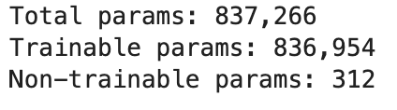

The pictures below shown that bigger strides value give a less detail than the smaller one which help reduce the overfitting of data.

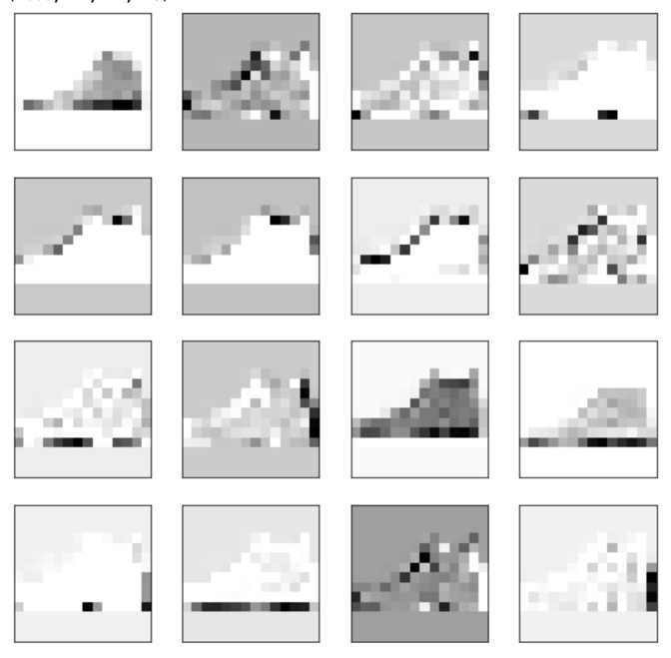

Figure 2: First activation layer, when strides=2

Figure 1: First activation layer, when strides=1

1. Plot the learning curve, accuracy rate of training and test sets.

1. A close up of an animal

   Description automatically generatedActivations of the first layer try to get the rough shape of the image. It tries to detect edges of the picture in different angle.

1. Classify the clothing

