HW2-1

Receive USD currency input from user then compute it to NTD currency.

HW2-2

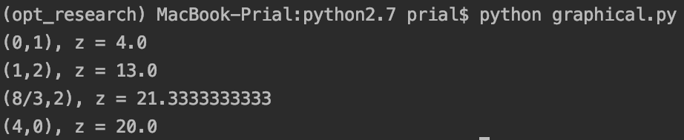

From the graph above, the blue shade area showed the feasible region for the constraints. x1 = 8/3, x2 = 2 are the optimal value for the objective function. (5\*x1 + 4\*x2)

HW2-3

x1, x2, and z are the new value for the new constraint

(6\*x1 + 5\*x2 = 62). Shadow price come from 5300 minus 5221 $\frac{3}{7}$, which 5221 $\frac{3}{7}$ is the value of max ‘ z ‘ when the constraint is 6\*x1 + 5\*x2 = 61.

HW2-4

HW2-5

What I have learned:

HW2-2 make me more familiar with matplotlib. Since I have to calculate the shadow price by using python, it makes me more understand the concept of shadow price. It tells me that how much would we gain for an additional resource (righthand-side values).