ΟΝΟΜΑΤΕΠΩΝΥΜΟ: ___Ρουμελιώτης Κωνσταντίνος__αμ: ap25012________________________________

Wireshark Lab:  IP v8.0  Supplement to Computer Networking: A Top-Down Approach, 8th ed., J.F. Kurose and K.W. Ross  “Tell me and I forget. Show me and I remember. Involve me and I understand.” Chinese proverb  © 2005-2020, J.F Kurose and K.W. Ross, All Rights Reserved | 

In this lab, we’ll investigate the IP protocol, focusing on the IP datagram. We’ll do so by analyzing a trace of IP datagrams sent and received by an execution of the traceroute program (the traceroute program itself is explored in more detail in the Wireshark ICMP lab). We’ll investigate the various fields in the IP datagram, and study IP fragmentation in detail.

1. Capturing packets from an execution of traceroute

In order to generate a trace of IP datagrams for this lab, we’ll use the traceroute program to send datagrams of different sizes towards some destination, X. Recall that traceroute operates by first sending one or more datagrams with the time-to-live (TTL) field in the IP header set to 1; it then sends a series of one or more datagrams towards the same destination with a TTL value of 2; it then sends a series of datagrams towards the same destination with a TTL value of 3; and so on. Recall that a router must decrement the TTL in each received datagram by 1 (actually, RFC 791 says that the router must decrement the TTL by at least one). If the TTL reaches 0, the router returns an ICMP message (type 11 – TTL-exceeded) to the sending host. As a result of this behavior, a datagram with a TTL of 1 (sent by the host executing traceroute) will cause the router one hop away from the sender to send an ICMP TTL-exceeded message back to the sender; the datagram sent with a TTL of 2 will cause the router two hops away to send an ICMP message back to the sender; the datagram sent with a TTL of 3 will cause the router three hops away to send an ICMP message back to the sender; and so on. In this manner, the host executing traceroute can learn the identities of the routers between itself and destination X by looking at the source IP addresses in the datagrams containing the ICMP TTL-exceeded messages.

Download a packet trace file that was captured.

2. A look at the captured trace

In your trace, you should be able to see the series of ICMP Echo Request (in the case of Windows machine) or the UDP segment (in the case of Unix) sent by your computer and the ICMP TTL-exceeded messages returned to your computer by the intermediate routers. In the questions below, we’ll assume you are using a Windows machine; the corresponding questions for the case of a Unix machine should be clear. Whenever possible, when answering a question below you should hand in a printout of the packet(s) within the trace that you used to answer the question asked. When you hand in your assignment, annotate the output so that it’s clear where in the output you’re getting the information for your answer (e.g., for our classes, we ask that students markup paper copies with a pen, or annotate electronic copies with text in a colored font).To print a packet, use File->Print, choose Selected packet only, choose Packet summary line, and select the minimum amount of packet detail that you need to answer the question.

- Select the first ICMP Echo Request message sent by your computer, and expand the Internet Protocol part of the packet in the packet details window.

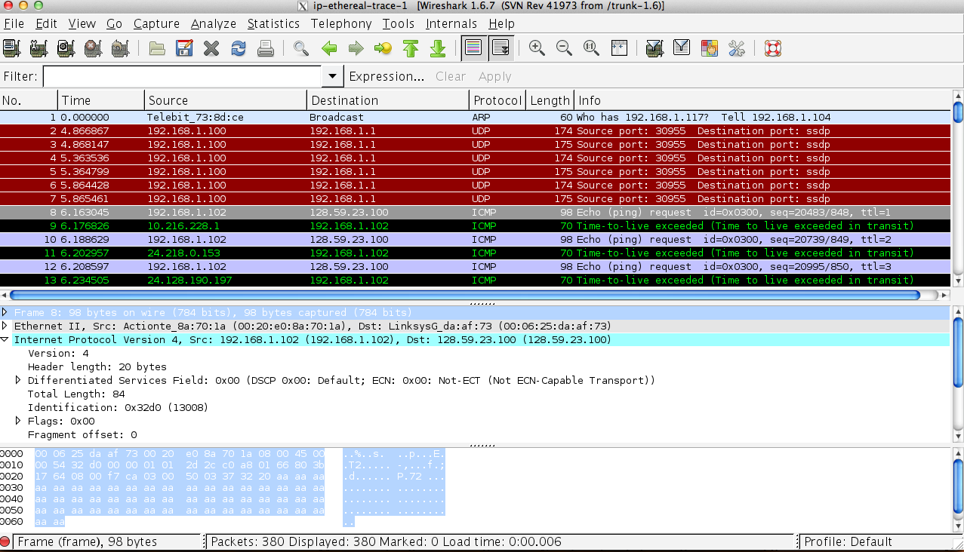
What is the IP address of your computer?
- Within the IP packet header, what is the value in the upper layer protocol field?
- How many bytes are in the IP header? How many bytes are in the payload of the IP datagram? Explain how you determined the number of payload bytes.
- Has this IP datagram been fragmented? Explain how you determined whether or not the datagram has been fragmented.

Next, sort the traced packets according to IP source address by clicking on the Source column header; a small downward pointing arrow should appear next to the word Source. If the arrow points up, click on the Source column header again. Select the first ICMP Echo Request message sent by your computer, and expand the Internet Protocol portion in the “details of selected packet header” window. In the “listing of captured packets” window, you should see all of the subsequent ICMP messages (perhaps with additional interspersed packets sent by other protocols running on your computer) below this first ICMP. Use the down arrow to move through the ICMP messages sent by your computer.

- Which fields in the IP datagram always change from one datagram to the next within this series of ICMP messages sent by your computer?
- Which fields stay constant? Which of the fields must stay constant? Which fields must change? Why?
- Describe the pattern you see in the values in the Identification field of the IP datagram

Next (with the packets still sorted by source address) find the series of ICMP TTL-exceeded replies sent to your computer by the nearest (first hop) router.

- What is the value in the Identification field and the TTL field?
- Do these values remain unchanged for all of the ICMP TTL-exceeded replies sent to your computer by the nearest (first hop) router? Why?

Fragmentation

Sort the packet listing according to time again by clicking on the Time column.

- Find the first ICMP Echo Request message that was sent by your computer after you changed the Packet Size in pingplotter to be 2000. Has that message been fragmented across more than one IP datagram? [Note: if you find your packet has not been fragmented, you should download the zip file http://gaia.cs.umass.edu/wireshark-labs/wireshark-traces.zip and extract the ip-ethereal-trace-1packet trace. If your computer has an Ethernet interface, a packet size of 2000 should cause fragmentation.]
- Print out the first fragment of the fragmented IP datagram. What information in the IP header indicates that the datagram been fragmented? What information in the IP header indicates whether this is the first fragment versus a latter fragment? How long is this IP datagram?
- Print out the second fragment of the fragmented IP datagram. What information in the IP header indicates that this is not the first datagram fragment? Are the more fragments? How can you tell?
- What fields change in the IP header between the first and second fragment?

Now find the first ICMP Echo Request message that was sent by your computer after you changed the Packet Size in pingplotter to be 3500.

- How many fragments were created from the original datagram?
- What fields change in the IP header among the fragments?
Αnswers
Q1 to Q4
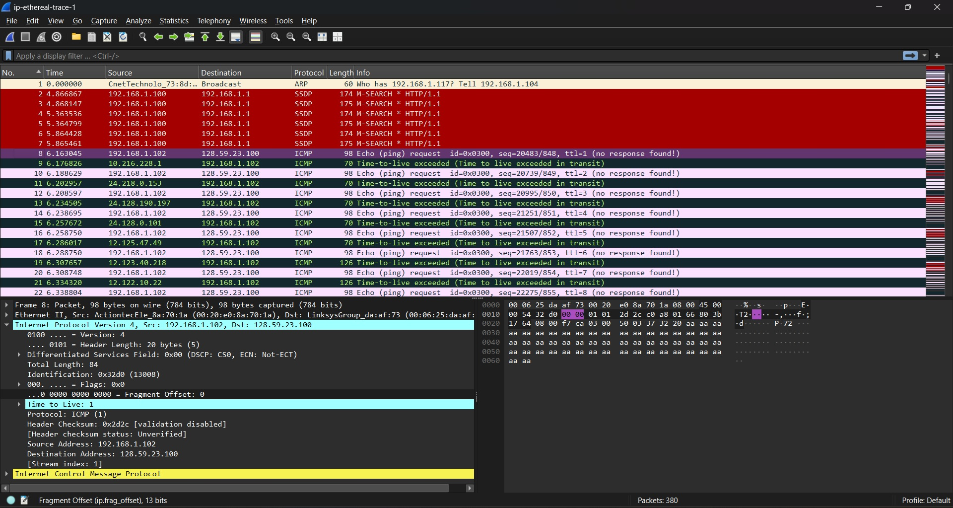
The source IP address on this first packet is 192.168.1.102 and the Upper Layer Protocol field is set to 1 which is the code Wireshark uses for ICMP.
The IP header itself is 20 bytes long, and since the Total Length field says 84 bytes the payload works out to 84 − 20 = 64 bytes.
As for fragmentation this datagram hasn't been split up: the Fragment Offset is 0 and the More Fragments flag isn't set so it's a single complete datagram.
Q5 to Q7
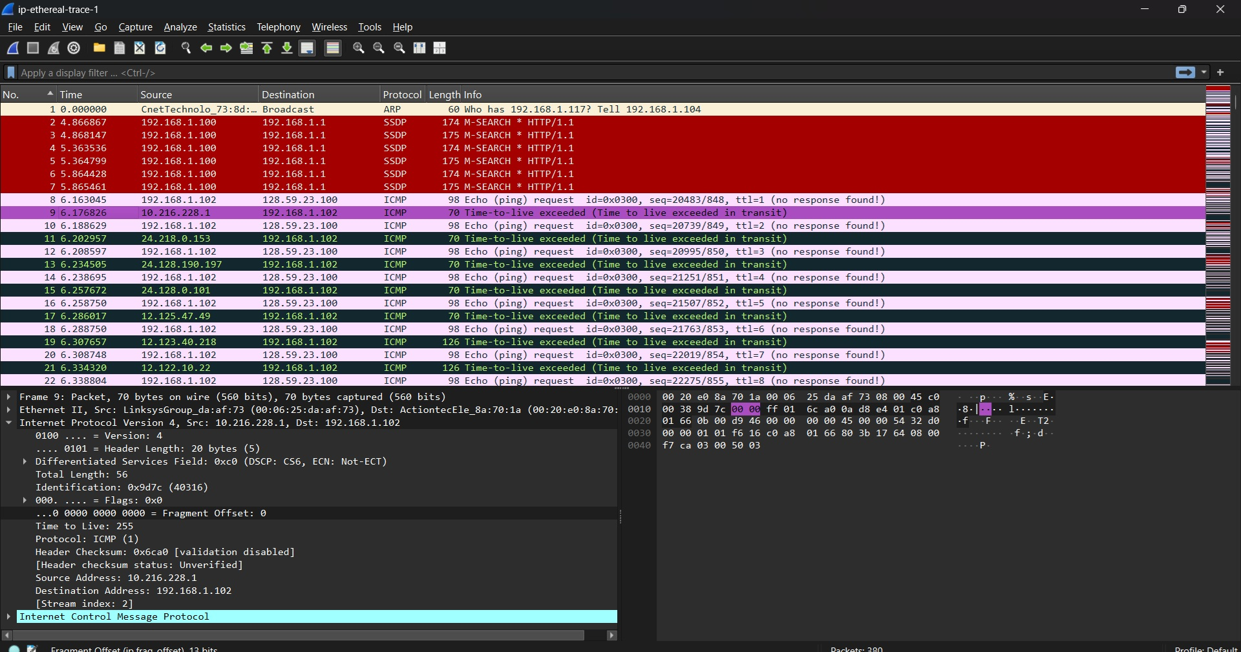
Looking at the successive packets sent by our computer three fields keep changing: TTL, Identification and the Header Checksum.
The Identification field just increases by 1 every time makes sense since the OS tags each new datagram it builds with its own unique number. The Header Checksum has to change too, since it's calculated from the header itself, so any change to TTL or Identification means a different checksum.
Everything else stays the same: Version Header Length, Source IP, Destination IP, and Protocol. That's expected really since it's the same two computers talking using the same protocol for the same purpose the whole time.
Q8 to Q9
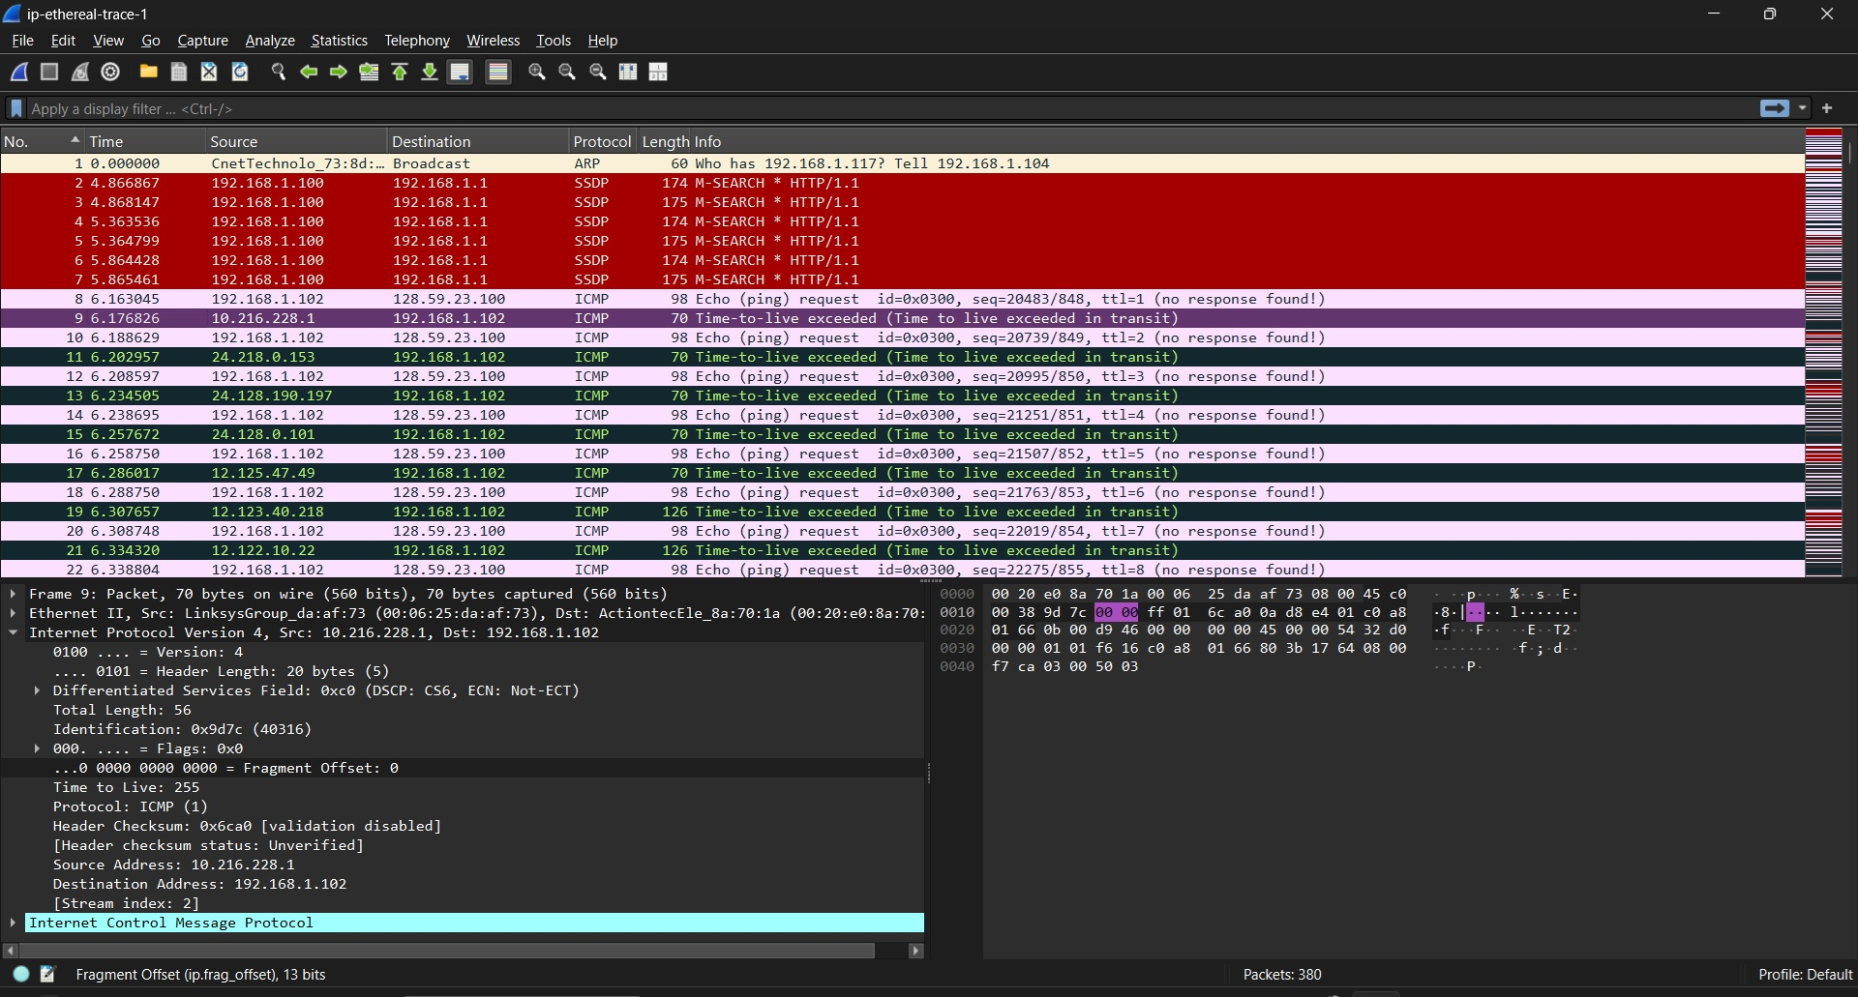
In the first ICMP Time-to-live exceeded packet from the nearest router (10.216.228.1) the Identification field is 0x9d7c (49316) and the TTL is 255.
Across the replies from that same router the TTL stays exactly the same. That makes sense it's always the same router at the same distance from us sending its ICMP reply with the same default starting TTL so it doesn't change from message to message.
The Identification field on the other hand keeps going up. Each reply is a brand new IP datagram as far as the router's concerned so it gets its own Identification number just like any other packet leaving that router.
Q10 to Q13
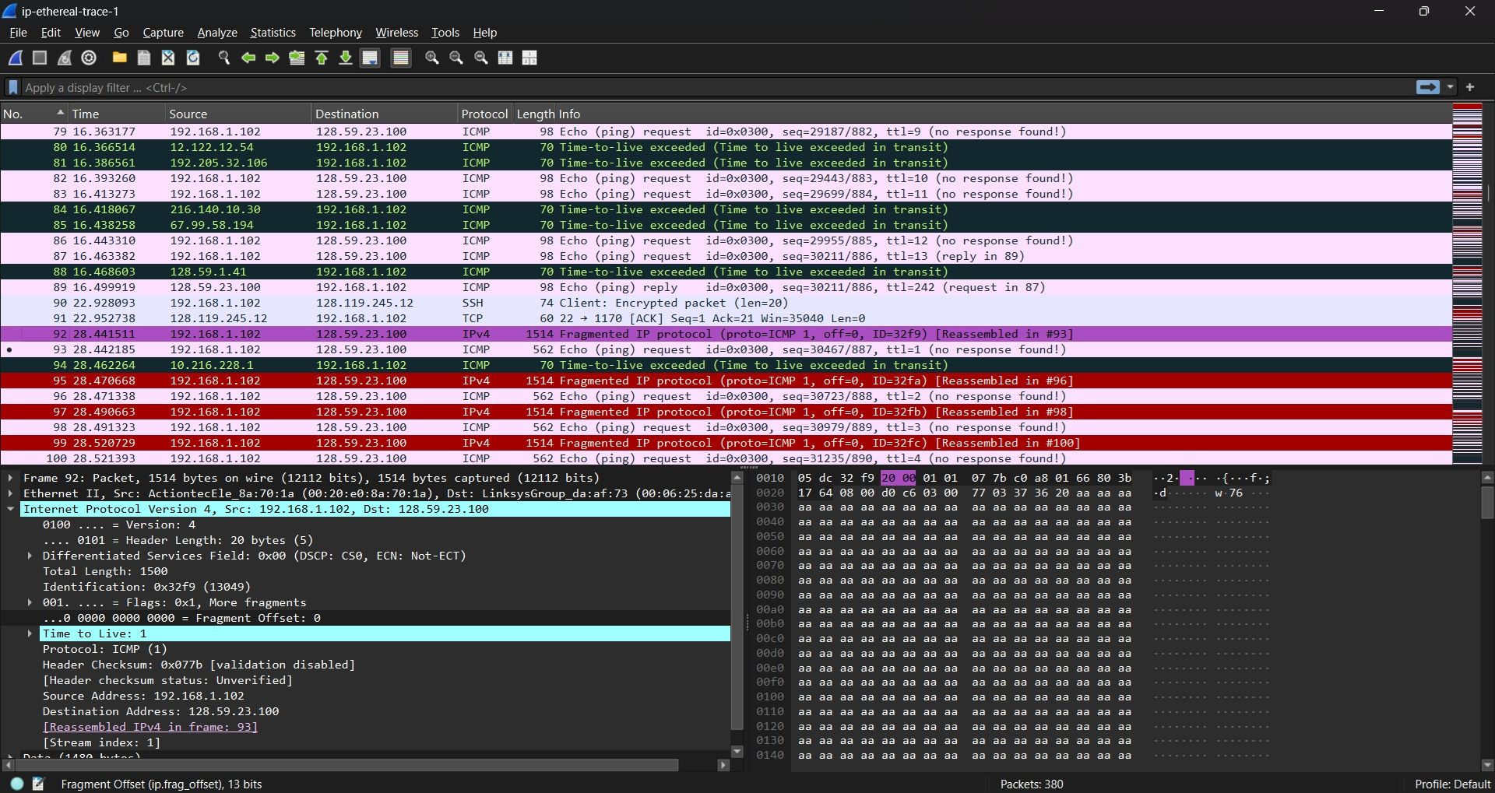
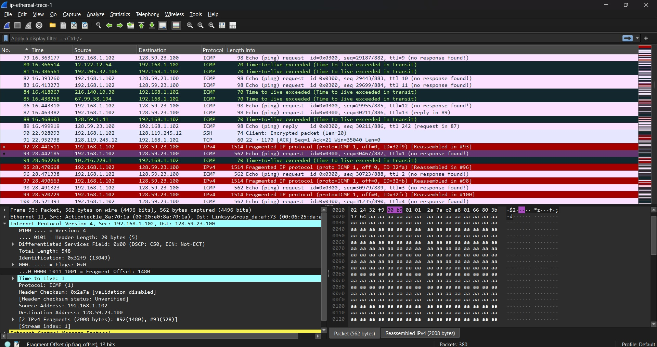
You can tell this datagram got fragmented just by looking at the flags and offset fields on packets 92 and 93.
On packet 92 the Flags field is 0x1 meaning More Fragments is set so this isn't the whole message there's more coming. Its Fragment Offset is 0 which tells us it's the first piece and the Total Length is 1500 bytes right at the MTU for this network.
Packet 93 is the second and last fragment. Its Fragment Offset is 1480 so its data picks up right where the first fragment left off and this time the Flags field is 0x0 meaning no more fragments follow.
Comparing the two: the Total Length drops from 1500 down to 548 bytes since the second fragment only carries what's left over and the Header Checksum is different on each one too since it depends on the Flags/Offset/Length fields which changed. The one thing that stays the same across both is the Identification field that's what lets the receiver know these two pieces belong to the same original datagram and reassemble them properly.
Q14-Q15
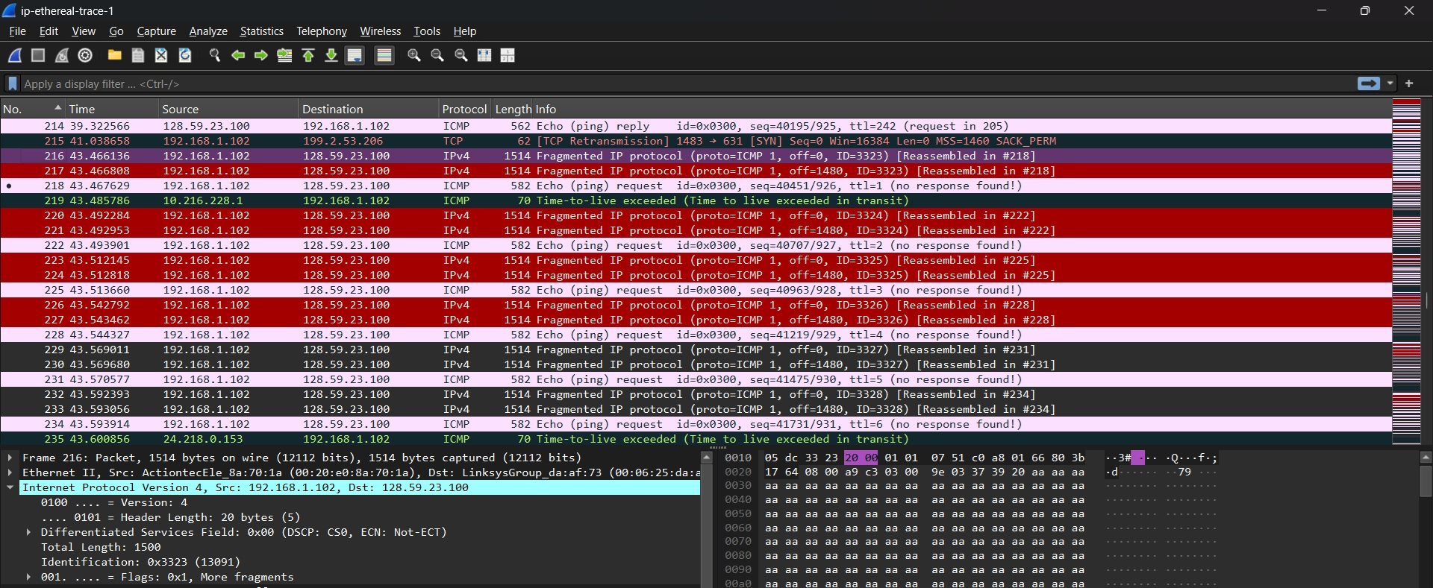
This time the original datagram got split into three fragments instead of two packets 216, 217, and 218. All three share the same Identification number (0x3323) which is how the receiver knows they're all pieces of the same original datagram. Their Fragment Offsets are 0, 1480, and 2960 respectively showing exactly where each piece fits back into the whole message. The Flags field tells you which one is last: packets 216 and 217 both have More Fragments set (0x1) since there's more data coming after them while packet 218 has it cleared (0x0) marking it as the final piece. As for size the first two fragments are both a full 1500 bytes while the third one is smaller at 568 bytes since it's just carrying whatever was left over. And just like before the Header Checksum changes on every fragment because it depends on the Offset, Flags and Total Length fields all of which are different from one fragment to the next.

Download the zip file http://gaia.cs.umass.edu/wireshark-labs/wireshark-traces.zip and extract the file ip-ethereal-trace-1. The traces in this zip file were collected by Wireshark running on one of the author’s computers, while performing the steps indicated in the Wireshark lab. Once you have downloaded the trace, you can load it into Wireshark and view the trace using the File pull down menu, choosing Open, and then selecting the ip-ethereal-trace-1 trace file.
The packets in the ip-ethereal-trace-1 trace file in http://gaia.cs.umass.edu/wireshark-labs/wireshark-traces.zip are all less that 1500 bytes. This is because the computer on which the trace was gathered has an Ethernet card that limits the length of the maximum IP packet to 1500 bytes (40 bytes of TCP/IP header data and 1460 bytes of upper-layer protocol payload). This 1500 byte value is the standard maximum length allowed by Ethernet. If your trace indicates a datagram longer 1500 bytes, and your computer is using an Ethernet connection, then Wireshark is reporting the wrong IP datagram length; it will likely also show only one large IP datagram rather than multiple smaller datagrams.. This inconsistency in reported lengths is due to the interaction between the Ethernet driver and the Wireshark software. We recommend that if you have this inconsistency, that you perform this lab using the ip-ethereal-trace-1 trace file.

