ΟΝΟΜΑΤΕΠΩΝΥΜΟ: _____Ρουμελιώτης Κωνσταντίνος_αμ: ap25012________________________________

Wireshark Lab:  NAT v8.0  Supplement to Computer Networking: A Top-Down Approach, 8th ed., J.F. Kurose and K.W. Ross  “Tell me and I forget. Show me and I remember. Involve me and I understand.” Chinese proverb  © 2005-2020, J.F Kurose and K.W. Ross, All Rights Reserved | 

In this lab, we’ll investigate the behavior of the NAT protocol. This lab will be different from our other Wireshark labs, where we’ve captured a trace file at a single Wireshark measurement point. Because we’re interested in capturing packets at both the input and output sides of the NAT device, we’ll need to capture packets at two locations. Also, because many students don’t have easy access to a NAT device or to two computers on which to take Wireshark measurements, this isn’t a lab that is easily done “live” by a student. Therefore in this lab, you will use Wireshark trace files that we’ve captured for you. Before beginning this lab, you’ll probably want to review the material on NAT section 4.3.4 in the text.

1. NAT Measurement Scenario
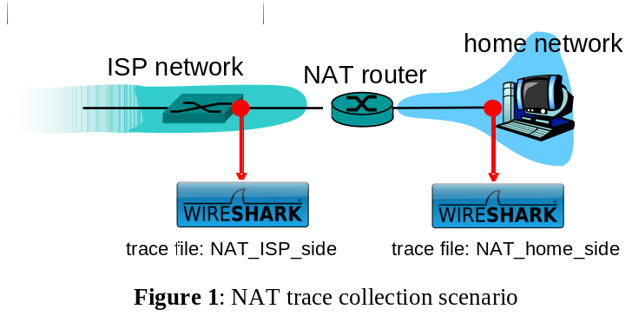
In this lab, we’ll capture packets from a simple web request from a client PC in a home network to a www.google.com server. Within the home network, the home network router provides a NAT service, as discussed in Chapter 4. Figure 1 shows our Wireshark trace-collection scenario. As in our other Wireshark labs, we collect a Wireshark trace on the client PC in our home network. This file is called NAT_home_side. Because we are also interested in the packets being sent by the NAT router into the ISP, we’ll collect a second trace file at a PC (not shown) tapping into the link from the home router into the ISP network, as shown in Figure 1. (The hub device shown on the ISP side of the router is used to tap into the link between the NAT router and the first hop router in the ISP). Client-to-server packets captured by Wireshark at this point will have undergone NAT translation. The Wireshark trace file captured on the ISP side of the home router is called NAT_ISP_side.

Open the NAT_home_side file and answer the following questions. You might find it useful to use a Wireshark filter so that only frames containing HTTP messages are displayed from the trace file.

Whenever possible, when answering a question below, you should hand in a printout of the packet(s) within the trace that you used to answer the question asked. Annotate the printout to explain your answer. To print a packet, use File->Print, choose Selected packet only, choose Packet summary line, and select the minimum amount of packet detail that you need to answer the question

- What is the IP address of the client?
- The client actually communicates with several different Google servers in order to implement “safe browsing.” (See extra credit section at the end of this lab). The main Google server that will serve up the main Google web page has IP address 64.233.169.104. In order to display only those frames containing HTTP messages that are sent to/from this Google, server, enter the expression “http && ip.addr == 64.233.169.104” (without quotes) into the Filter: field in Wireshark .
- Consider now the HTTP GET sent from the client to the Google server (whose IP address is IP address 64.233.169.104) at time 7.109267. What are the source and destination IP addresses and TCP source and destination ports on the IP datagram carrying this HTTP GET?
- At what time is the corresponding 200 OK HTTP message received from the Google server? What are the source and destination IP addresses and TCP source and destination ports on the IP datagram carrying this HTTP 200 OK message?
- Recall that before a GET command can be sent to an HTTP server, TCP must first set up a connection using the three-way SYN/ACK handshake. At what time is the client-to-server TCP SYN segment sent that sets up the connection used by the GET sent at time 7.109267? What are the source and destination IP addresses and source and destination ports for the TCP SYN segment? What are the source and destination IP addresses and source and destination ports of the ACK sent in response to the SYN. At what time is this ACK received at the client? (Note: to find these segments you will need to clear the Filter expression you entered above in step 2. If you enter the filter “tcp”, only TCP segments will be displayed by Wireshark).
- In the following we’ll focus on the two HTTP messages (GET and 200 OK) and the TCP SYN and ACK segments identified above. Our goal below will be to locate these two HTTP messages and two TCP segments in the trace file (NAT_ISP_side) captured on the link between the router and the ISP. Because these captured frames will have already been forwarded through the NAT router, some of the IP address and port numbers will have been changed as a result of NAT translation.
- Open the NAT_ISP_side. Note that the time stamps in this file and in NAT_home_side are not synchronized since the packet captures at the two locations shown in Figure 1 were not started simultaneously. (Indeed, you should discover that the timestamps of a packet captured at the ISP link is actually less that the timestamp of the packet captured at the client PC).
- In the NAT_ISP_side trace file, find the HTTP GET message was sent from the client to the Google server at time 7.109267 (where t=7.109267 is time at which this was sent as recorded in the NAT_home_side trace file). At what time does this message appear in the NAT_ISP_side trace file? What are the source and destination IP addresses and TCP source and destination ports on the IP datagram carrying this HTTP GET (as recording in the NAT_ISP_side trace file)? Which of these fields are the same, and which are different, than in your answer to question 3 above?
- Are any fields in the HTTP GET message changed? Which of the following fields in the IP datagram carrying the HTTP GET are changed: Version, Header Length, Flags, Checksum. If any of these fields have changed, give a reason (in one sentence) stating why this field needed to change.
- In the NAT_ISP_side trace file, at what time is the first 200 OK HTTP message received from the Google server? What are the source and destination IP addresses and TCP source and destination ports on the IP datagram carrying this HTTP 200 OK message? Which of these fields are the same, and which are different than your answer to question 4 above?
- In the NAT_ISP_side trace file, at what time were the client-to-server TCP SYN segment and the server-to-client TCP ACK segment corresponding to the segments in question 5 above captured? What are the source and destination IP addresses and source and destination ports for these two segments? Which of these fields are the same, and which are different than your answer to question 5 above?

Figure 4.25 in the text shows the NAT translation table in the NAT router.
- Using your answers to 1-8 above, fill in the NAT translation table entries for HTTP connection considered the questions above.

Answer
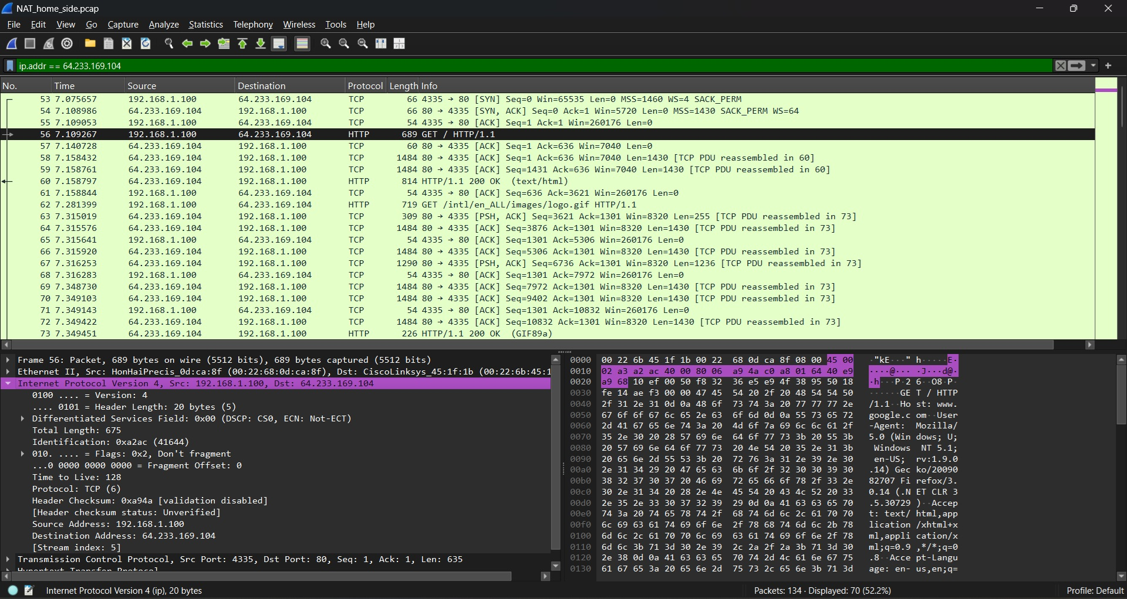
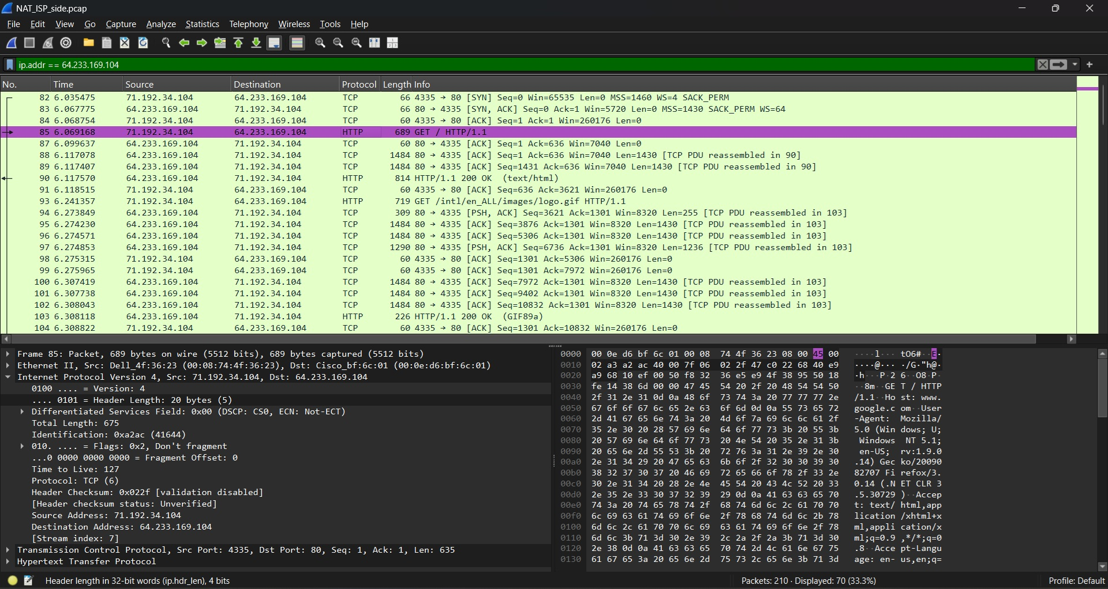
Based on the analysis of the HTTP GET packets in the NAT_home_side and NAT_ISP_side files, the NAT translation table is structured as follows:

WAN Side Address (ISP Side) | LAN Side Address (Local Network Side)
71.192.34.104 : 4335 | 192.168.1.100 : 4335
Explanation: The NAT router received the traffic from the internal IP 192.168.1.100 on port 4335, and translated it to the public IP 71.192.34.104 maintaining the same source port 4335 upon exit to the internet.

References to figures and sections are for the 8th edition of our text, Computer Networks, A Top-down Approach, 8th ed., J.F. Kurose and K.W. Ross, Addison-Wesley/Pearson, 202o.
Download the zip file http://gaia.cs.umass.edu/wireshark-labs/wireshark-traces.zip and extract the files need for this lab.
What do we mean by “annotate”? If you hand in a paper copy, please highlight where in the printout you’ve found the answer and add some text (preferably with a colored pen) noting what you found in what you ‘ve highlight. If you hand in an electronic copy, it would be great if you could also highlight and annotate.
Specify time using the time since the beginning of the trace (rather than absolute, wall-clock time).

