BANKINGDB
Final Project Report
CS631 — Database Systems
A Full-Stack Relational Database Application with PostgreSQL, Docker & Flask
Course | CS631 Database Systems
Database | PostgreSQL 16 via Docker
Backend | Python 3 + Flask + psycopg2
Frontend | HTML5 · CSS3 · Vanilla JavaScript
Deployment | Docker Compose + pgAdmin 4

1. Introduction
BankingDB is a full-stack relational database application developed as the final project for CS631 Database Systems. It models the operations of a multi-branch bank, encompassing branch management, employee hierarchies, customer profiles, a range of account types, loan management, and a complete transaction audit trail.

The project is delivered in two integrated layers:
- A relational database implemented in PostgreSQL 16, containerised with Docker and managed via Docker Compose, adhering to the entity-relationship design produced in Phase I of the project.
- A web application built with Python (Flask) that connects to the live database and provides role-based views for customers and administrators, including real-time account management and financial transaction capabilities.

1.1 Project Objectives
- Design a normalised relational database schema from a given set of business requirements.
- Implement the schema in PostgreSQL 16 using industry-standard DDL, constraints, indexes, and an automated Python deployment pipeline.
- Populate the database with representative seed data and demonstrate data manipulation via INSERT, UPDATE, DELETE, and analytical SQL queries.
- Build a functional web front-end that connects to the live database and supports customer-facing banking operations and administrative oversight.

1.2 Technology Stack
Component | Technology | Purpose
Database | PostgreSQL 16 | Relational DBMS — schema, constraints, queries
Containerisation | Docker + Docker Compose | Isolated, reproducible runtime environment
DB Admin UI | pgAdmin 4 | Visual query and schema management tool
Deploy Script | Python 3 + psycopg2 | Automated schema creation and data seeding
Web Framework | Flask 3 | Lightweight Python WSGI web application
DB Adapter | psycopg2-binary | PostgreSQL driver for Python
Frontend | HTML5 / CSS3 / JS | Templated UI via Jinja2; no external frameworks
Version Control | Git | Source code and configuration management

2. System Requirements

2.1 Business Requirements
The following requirements were derived from the specification provided in Phase I:

Branches
- Each branch has a unique ID, name, city, street address, and tracked asset value.
- Each branch has exactly one manager and one assistant manager, both of whom are bank employees. The circular foreign key dependency between Branch and Employee is resolved using DEFERRABLE INITIALLY DEFERRED constraints.

Employees
- Identified by SSN (validated by regex CHECK constraint); store first and last name, start date, branch, and direct manager (self-referential FK).
- Multi-valued attributes — phone numbers and dependent names — are stored in separate relations (Employee_Phone, Employee_Dependent).

Customers
- Identified by SSN; store full name, composite address, phone number, associated branch, and assigned personal banker.
- Customers can hold multiple accounts and take out loans (managed as account subtypes).

Accounts
- Four types implemented via IS-A class-table inheritance: Savings (fixed rate), Checking (overdraft), Money Market (variable rate + timestamp), and Loan (amount, fixed rate, monthly repayment, originating branch).
- Accounts can be shared across customers — the M:N Customer_Account junction table records last_access_date per (customer, account) pair.

Transactions
- Every financial operation (deposit, withdrawal, transfer, send, loan payment) is logged in Transaction_Log with a code, description, date, time, amount, and account reference.
- Chargeable transactions reference a secondary fee row via parent_transaction_id (self-referential FK).

2.2 Design Additions
- Loan as Account Subtype: Loans are modelled as a fourth IS-A subtype of Account, consistent with the specification's statement that loans are "managed as accounts." This eliminates a separate CUSTOMER_LOAN table and allows loans to be queried uniformly through Customer_Account.
- phone_number on Customer: Added to enable Zelle-style peer-to-peer transfers between customers by phone lookup, mirroring real-world banking practice.
- app_users table: Created at web-app startup to store web login credentials (username, hashed password, role, customer SSN link) separately from banking data.
- Transaction codes SND/RCV: Added for phone-based send payments, distinguishable from internal transfers (TRO/TRI) and admin transfers in the audit log.

3. Entity-Relationship Design

3.1 Entities and Attributes
Entity | Primary Key | Key Attributes | Notes
Branch | branch_id (SERIAL) | branch_name, city, address, assets, manager_ssn, asst_manager_ssn | Deferred FK to Employee
Employee | ssn (CHAR 11) | first_name, last_name, start_date, branch_id, manager_ssn | Self-referential manager FK
Employee_Phone | (ssn, phone_number) | — | Multi-valued — separate table
Employee_Dependent | (ssn, dependent_name) | — | Multi-valued — separate table
Customer | ssn (CHAR 11) | first_name, last_name, address, phone_number, branch_id, personal_banker_ssn | phone_number enables peer payments
Account | account_no (SERIAL) | account_type (ENUM), balance, open_date | Supertype — 4 subtypes below
Savings_Account | account_no (FK) | interest_rate | Fixed rate; CHECK > 0
Checking_Account | account_no (FK) | overdraft_amount | CHECK >= 0
MoneyMarket_Account | account_no (FK) | current_interest_rate, last_rate_update | Variable rate; TIMESTAMPTZ
Loan_Account | account_no (FK) | amount, interest_rate, monthly_repayment, branch_id | Originating branch FK
Customer_Account | (customer_ssn, account_no) | last_access_date | M:N junction with date
Transaction_Log | transaction_id (SERIAL) | code, name, date, time, amount, account_no, is_chargeable, charge_amount, parent_transaction_id | Self-ref FK for fee rows

3.2 Entity-Relationship Diagram
The diagram below presents the complete ER model using Chen notation. Rectangles represent entities, ellipses represent attributes (double ellipse = multi-valued), diamonds represent relationships (double diamond = relationship with its own attribute), and green entities are IS-A subtypes of Account. Cardinality labels appear in red.


Figure 1 — BankingDB Entity-Relationship Diagram (Chen Notation)

3.3 Key Design Decisions

Decision 1 — Loan as a Subtype of Account
The specification states loans are "managed as accounts" and given a number "similar to an account number." Loan is therefore the fourth IS-A subtype of Account rather than a separate entity. This means customers access loans through the same Customer_Account junction table, last_access_date is tracked uniformly, and all account queries span every type without a separate join path.

Decision 2 — IS-A with Class-Table Inheritance
Each account subtype has a dedicated table sharing Account's primary key. This eliminates NULL columns (a single-table design would require NULL interest_rate, overdraft_amount etc. on every row), allows subtype-specific CHECK constraints, and keeps subtype queries focused and fast.

Decision 3 — last_access_date on the HOLDS Relationship
The specification requires "the most recent date on which the account was accessed by each customer holding the account." This is a property of the (customer, account) pair — not of either entity alone — so it belongs in Customer_Account and is updated on every transaction affecting that pairing.

Decision 4 — Deferred Circular FK
Branch.manager_ssn → Employee.ssn and Employee.branch_id → Branch.branch_id form a cycle. Both FK constraints on Branch are declared DEFERRABLE INITIALLY DEFERRED. The deployment script inserts Branch rows first (manager_ssn = NULL), inserts Employee rows, then updates Branch with manager SSNs — the constraint is only verified at COMMIT.

4. Relational Logical Database Design
The schema is implemented in PostgreSQL 16 using native features: SERIAL for auto-increment PKs, a custom ENUM type for account categories, BOOLEAN for is_chargeable, TIMESTAMPTZ for time-zone-aware timestamps, and regex-based CHECK constraints for SSN format validation.

4.1 Schema Overview
Table | Rows (seed) | PK Type | Key Constraints
Branch | 5 | SERIAL | UNIQUE(branch_name); CHECK(assets>=0); deferred FK to Employee
Employee | 12 | CHAR(11) SSN | regex CHECK; self-ref FK(manager_ssn); ON UPDATE CASCADE
Employee_Phone | 7 | composite | ON DELETE CASCADE from Employee
Employee_Dependent | 6 | composite | ON DELETE CASCADE from Employee
Customer | 8 | CHAR(11) SSN | regex CHECK; phone_number VARCHAR(20)
Account | 12 | SERIAL | ENUM(SAVINGS,CHECKING,MONEY_MARKET,LOAN); CHECK(balance>=0)
Customer_Account | 17 | composite | ON DELETE CASCADE both sides
Savings_Account | 3 | FK→Account | CHECK(interest_rate>0)
Checking_Account | 3 | FK→Account | CHECK(overdraft_amount>=0)
MoneyMarket_Account | 2 | FK→Account | TIMESTAMPTZ last_rate_update; CHECK(rate>0)
Loan_Account | 4 | FK→Account | FK to Branch; CHECK amount/rate/repayment > 0
Transaction_Log | 16+ | SERIAL | self-ref FK(parent_transaction_id)

4.2 Key DDL
Account ENUM and supertype:
CREATE TYPE account_type_enum AS ENUM (
'SAVINGS', 'CHECKING', 'MONEY_MARKET', 'LOAN'
);

CREATE TABLE Account (
account_no SERIAL PRIMARY KEY,
account_type account_type_enum NOT NULL,
balance NUMERIC(18,2) NOT NULL DEFAULT 0.00,
open_date DATE NOT NULL DEFAULT CURRENT_DATE,
CONSTRAINT chk_balance CHECK (balance >= 0)
);

Customer with phone_number:
CREATE TABLE Customer (
ssn CHAR(11) PRIMARY KEY,
first_name VARCHAR(60) NOT NULL,
last_name VARCHAR(60) NOT NULL,
apt_no VARCHAR(10),
street_no VARCHAR(10) NOT NULL,
street_name VARCHAR(100) NOT NULL,
city VARCHAR(60) NOT NULL,
state CHAR(2) NOT NULL,
zip_code CHAR(10) NOT NULL,
phone_number VARCHAR(20),
branch_id INTEGER REFERENCES Branch(branch_id) ON UPDATE CASCADE,
personal_banker_ssn CHAR(11) REFERENCES Employee(ssn) ON DELETE SET NULL,
CONSTRAINT chk_cust_ssn CHECK (ssn ~ '^\d{3}-\d{2}-\d{4}$')
);

Transaction_Log with self-referential FK:
CREATE TABLE Transaction_Log (
transaction_id SERIAL PRIMARY KEY,
transaction_code CHAR(3) NOT NULL,
transaction_name VARCHAR(80) NOT NULL,
tran_date DATE NOT NULL,
tran_time TIME NOT NULL,
amount NUMERIC(18,2) NOT NULL,
account_no INTEGER NOT NULL REFERENCES Account(account_no),
is_chargeable BOOLEAN NOT NULL DEFAULT FALSE,
charge_amount NUMERIC(10,2),
parent_transaction_id INTEGER REFERENCES Transaction_Log(transaction_id),
CONSTRAINT chk_txn_amount CHECK (amount > 0)
);

4.3 Indexes
Index | Column(s) | Rationale
idx_employee_branch | Employee(branch_id) | List all employees per branch
idx_customer_branch | Customer(branch_id) | Filter customers by branch
idx_customer_banker | Customer(personal_banker_ssn) | Banker workload queries
idx_account_type | Account(account_type) | Filter/group by account type
idx_txn_account_date | Transaction_Log(account_no, tran_date) | Per-account date-range statements
idx_txn_code | Transaction_Log(transaction_code) | Filter by transaction type (FEE, SND, etc.)
idx_loan_branch | Loan_Account(branch_id) | Branch-level loan reporting

5. SQL Implementation

5.1 Data Insertion
101 rows of seed data were inserted across all 12 tables in FK-safe order. The circular Branch↔Employee dependency is resolved by inserting Branch first (manager_ssn = NULL), inserting all employees, then updating Branch with the correct SSNs within the same deferred transaction.
Table | Rows | Notes
Branch | 5 | Inserted without managers; managers assigned via UPDATE
Employee | 12 | Branch managers first, then subordinates
Employee_Phone | 7 | Two numbers for branch manager (Alice Morgan)
Employee_Dependent | 6 | Two dependents for Alice Morgan
Customer | 8 | Across 4 cities; phone numbers included
Account | 12 | 3 SAVINGS, 3 CHECKING, 2 MONEY_MARKET, 4 LOAN
Customer_Account | 17 | Multiple holders on accounts 2, 6, 7, 9, 12
Savings_Account | 3 | Fixed rates 1.50%–2.00%
Checking_Account | 3 | Overdrafts $0–$50
MoneyMarket_Account | 2 | Variable rates 4.10%–4.25%
Loan_Account | 4 | Loans $8k–$150k across 4 branches
Transaction_Log | 16 | 3 chargeable pairs; LP/CD/TR entries

5.2 Analytical Queries
Ten analytical queries of medium-to-high complexity were written and executed against the live PostgreSQL database. A representative selection is shown below.

Q1 — Customer Portfolio (4-table join with ordering)
SELECT c.first_name || ' ' || c.last_name AS customer_name,
a.account_no, a.account_type::TEXT, a.balance, ca.last_access_date
FROM Customer c
JOIN Customer_Account ca ON c.ssn = ca.customer_ssn
JOIN Account a ON ca.account_no = a.account_no
ORDER BY customer_name, a.account_type;

Q3 — Monthly Statement with Running Balance (Window Function)
SELECT tl.transaction_id, tl.tran_date, tl.transaction_code,
tl.amount, tl.is_chargeable,
SUM(CASE tl.transaction_code
WHEN 'CD' THEN tl.amount
WHEN 'WD' THEN -tl.amount
WHEN 'FEE' THEN -tl.amount
ELSE 0 END)
OVER (PARTITION BY tl.account_no ORDER BY tl.tran_date, tl.tran_time)
AS running_balance
FROM Transaction_Log tl
WHERE tl.account_no = 2
AND tl.tran_date BETWEEN '2026-03-01' AND '2026-03-31'
ORDER BY tl.tran_date, tl.tran_time;

Q8 — Annual Interest Projection for Savings Accounts
SELECT a.account_no,
c.first_name || ' ' || c.last_name AS account_holder,
a.balance,
(sa.interest_rate * 100) || '%' AS annual_rate,
ROUND(a.balance * sa.interest_rate, 2) AS projected_annual_interest
FROM Account a
JOIN Savings_Account sa ON a.account_no = sa.account_no
JOIN Customer_Account ca ON ca.account_no = a.account_no
JOIN Customer c ON ca.customer_ssn = c.ssn
ORDER BY projected_annual_interest DESC;

5.3 Live Database Verification — pgAdmin Screenshots
The following screenshots confirm the schema, seed data, and queries were executed successfully against the live PostgreSQL 16 database via pgAdmin 4.

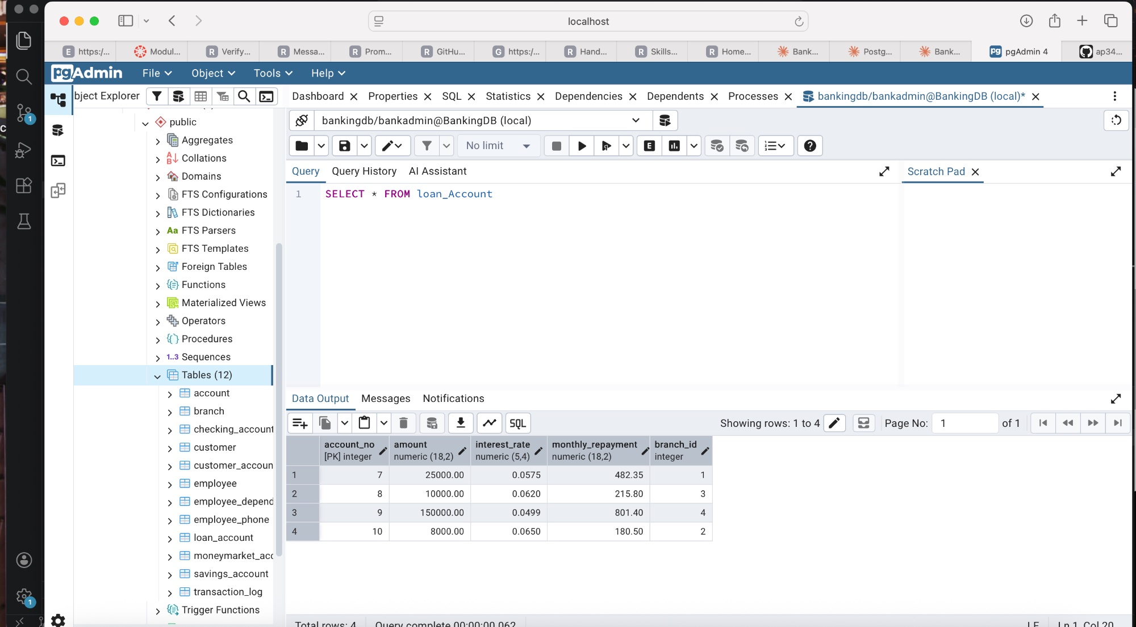
Figure 2 — pgAdmin 4: SELECT * FROM loan_account — 4 rows; all 12 tables visible in Object Explorer

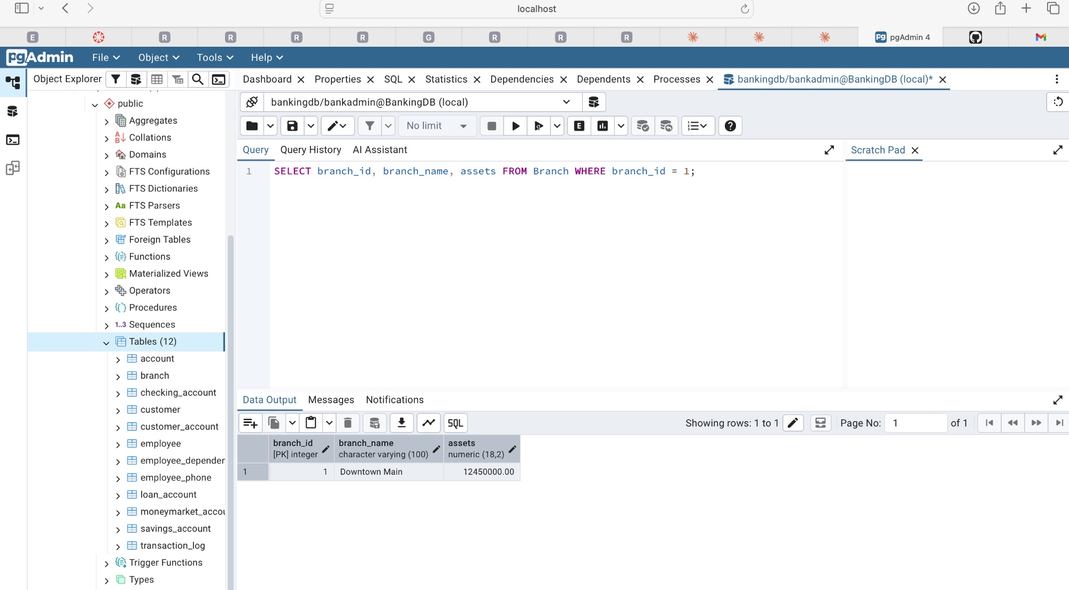
Figure 3 — pgAdmin 4: Branch table filtered query confirming assets value after UPDATE

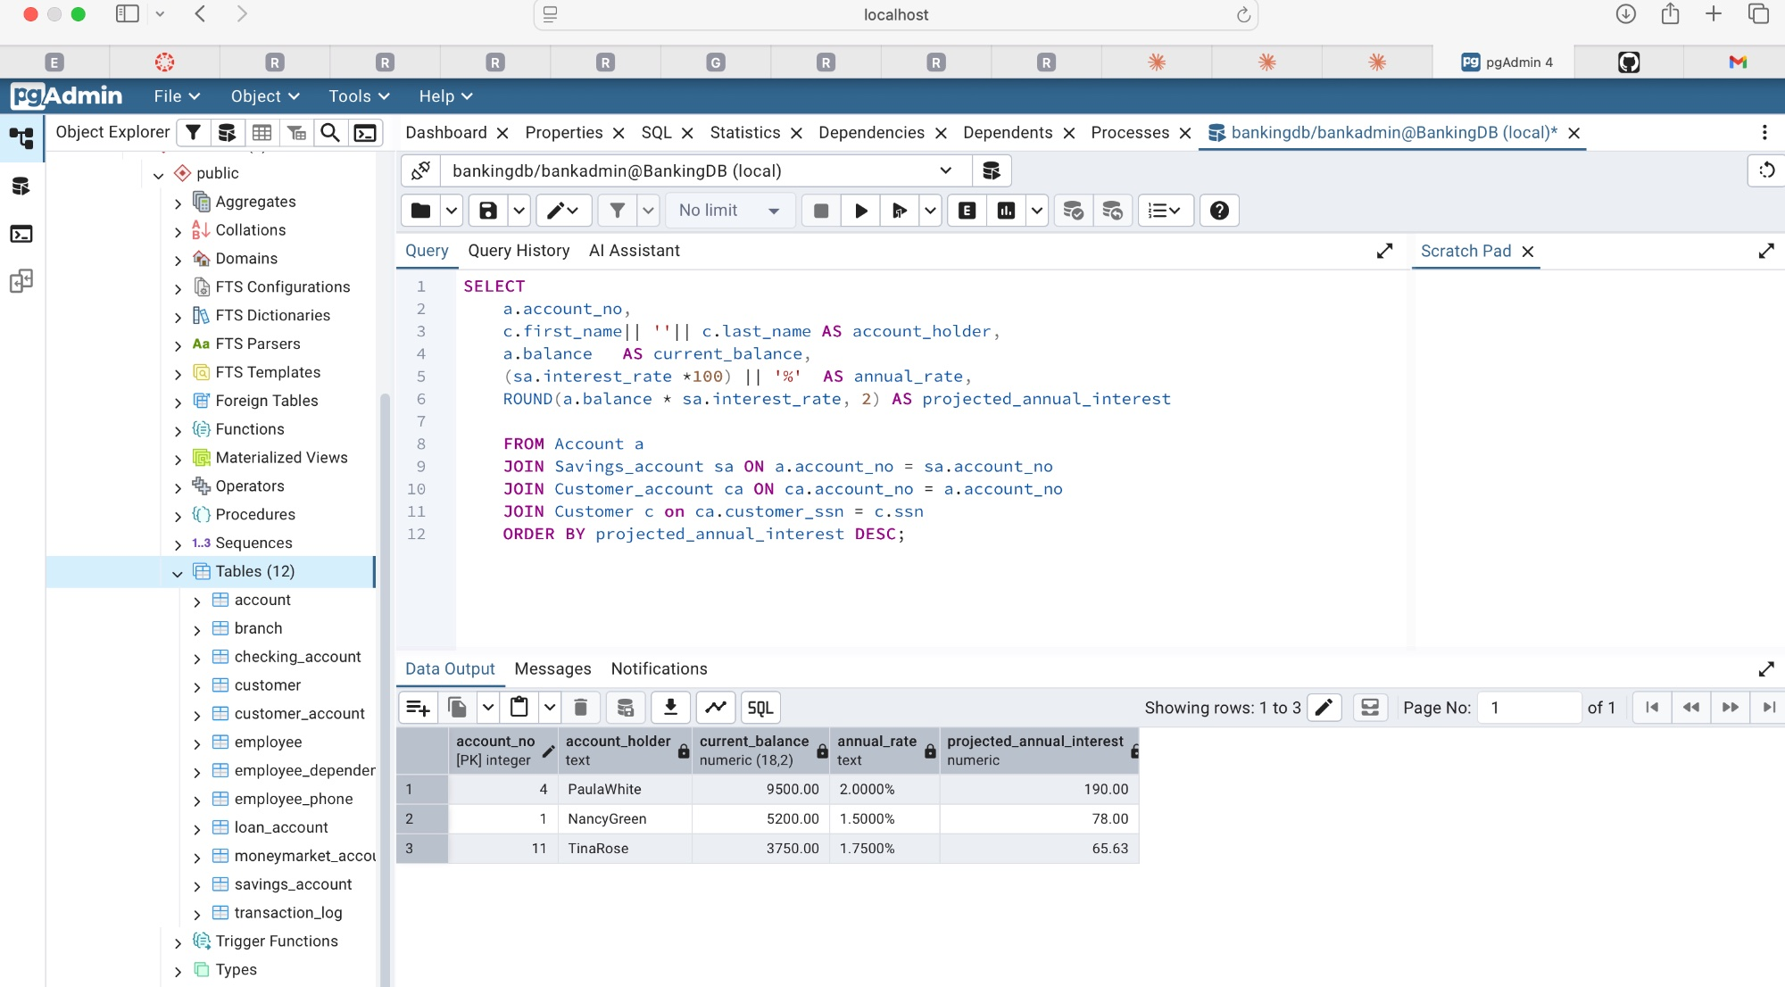
Figure 4 — pgAdmin 4: Savings account annual interest projection (Q8) — 3 rows returned

6. Deployment Architecture
The database and admin UI are containerised using Docker Compose, providing a reproducible, portable runtime environment. A Python script orchestrates the full deployment lifecycle.

6.1 Docker Compose Services
Service | Image | Port | Purpose
bankingdb | postgres:16 | 5433 → 5432 | PostgreSQL 16 database with health check
pgadmin | dpage/pgadmin4 | 5050 → 80 | Web-based SQL query and schema browser

Both services share a bridge network (banking_net). Data is persisted in a named volume (bankingdb_data) so it survives container restarts. pgAdmin is pre-configured with a server entry via pgadmin_servers.json and authenticates automatically using a pgpass file mounted into the container.

6.2 deploy_bankingdb.py — Automated Deploy Script
The Python deploy script (deploy_bankingdb.py) performs five automated steps:
- Validate docker-compose.yml is present; auto-create pgpass if missing.
- Run docker compose up -d — detect already-running containers and handle HTTP 304 gracefully.
- Poll localhost:5433 until PostgreSQL accepts connections; detect stale-volume authentication failures immediately and offer auto-reset.
- Execute all 21 DDL statements in FK-safe order: DROP existing objects → CREATE ENUM → CREATE 12 tables → ADD deferred FK constraints → CREATE 7 indexes.
- Insert 101 rows of seed data in dependency order; print a row-count verification table.

Deploy commands:
pip install psycopg2-binary # only dependency
python deploy_bankingdb.py # full deploy
python deploy_bankingdb.py --reset # wipe volume + redeploy
python deploy_bankingdb.py --stop # stop containers

7. Web Application (Front-End)
A Flask web application provides a browser-based interface to the live BankingDB database. It uses psycopg2 to connect directly to the PostgreSQL container and renders all views using Jinja2 HTML templates. No external JavaScript frameworks are used — all interactivity is vanilla JS.

7.1 Architecture
Layer | Technology | Detail
Web server | Flask 3 (Python) | WSGI app; debug mode; host 0.0.0.0 port 5055
DB connection | psycopg2 + RealDictCursor | Per-request connection stored on flask.g; auto-closed
Auth | Session-based (Flask sessions) | SHA-256 hashed passwords; role stored in session
Templates | Jinja2 (HTML5 + CSS3) | 8 templates; shared base.html layout
Frontend interactivity | Vanilla JavaScript | Async fetch for phone lookup; live balance preview
Credentials | app_users table in bankingdb | Created on first run; links username → customer SSN

7.2 Routes and Views

Customer Routes
Route | Method | View / Purpose
/login | GET · POST | Login form with SHA-256 password check
/customer | GET | Dashboard: profile banner, account cards, summary stats, recent transactions
/account/<no> | GET | Account detail: balance hero, holders list, full transaction history
/deposit | GET · POST | Deposit funds into a non-loan account; quick-amount buttons; balance preview
/send | GET · POST | Phone-based send (Zelle-style): async phone lookup, recipient confirmation, amount entry
/send/lookup | POST (JSON) | AJAX endpoint: looks up customer by phone_number; returns name + SSN
/transfer | GET · POST | Transfer between own non-loan accounts with live balance validation

Admin Routes
Route | Method | View / Purpose
/admin | GET | Dashboard: bank-wide stats, account type breakdown, branch summary, all customers, recent transactions
/admin/accounts | GET | All accounts with search (by customer name) and filter (by type)
/admin/customer/<ssn> | GET | Customer profile: details, accounts, Transfer Funds button
/admin/transfer | GET · POST | Two-step transfer on behalf of any customer: select customer → select accounts + amount

7.3 Transaction Codes
Code | Name | Trigger | Fee?
CD | Customer Deposit / description | Deposit form | No
WD | Withdrawal | Direct withdrawal | Yes (FEE row)
FEE | Service Charge / ATM Fee | Chargeable transaction | No (fee row itself)
LP | Loan Payment | Loan payment | No
TRO | Transfer Out (/ Admin) | Own-account transfer | No
TRI | Transfer In (/ Admin) | Own-account transfer | No
SND | Sent to [Name] — [note] | Phone-based send | No
RCV | Received from [Name] — [note] | Phone-based send | No
TR | Transfer Out (legacy) | Existing seed data | No

7.4 Role-Based Access Control
On login, the user's role (customer or admin) is stored in the Flask session. All routes are protected by decorator-based guards:
- @login_required — redirects unauthenticated users to the login page.
- @admin_required — redirects non-admin users to their dashboard.
- Customer account ownership — all customer routes validate that the requested account_no appears in Customer_Account for the logged-in SSN before displaying data.
- Send lookup — the /send/lookup endpoint explicitly excludes the logged-in customer's own SSN so customers cannot send money to themselves.

7.5 Key Front-End Features

Phone-Based Send (Zelle-Style)
The Send Money flow uses an asynchronous JavaScript fetch() call to /send/lookup to find a recipient by phone number without a page reload. On success, a confirmation card appears showing the recipient's name and initials. The send button dynamically updates to display "Send $X.XX to [Name] →" and is only enabled when a valid recipient and positive amount within the sender's balance are both set. Funds are credited to the recipient's primary non-loan account automatically.

Live Balance Preview
The Deposit and Send forms both show a live balance preview card that updates as the user types an amount, showing the current balance and the projected balance after the transaction. The Transfer form additionally hides the selected source account from the destination dropdown and vice versa.

Admin Transfer — Two-Step Workflow
The admin transfer page uses a two-step GET/POST pattern: Step 1 presents a dropdown of eligible customers (those with 2+ non-loan accounts). Selecting a customer and clicking "Load Accounts" reloads the page via GET with the customer's SSN, revealing Step 2 — the transfer form pre-populated with that customer's accounts. The admin customer detail page also includes a direct "Transfer Funds" button that deep-links to Step 2 with the SSN pre-selected.

8. Conclusion
BankingDB successfully demonstrates the full lifecycle of a relational database application, from initial entity-relationship design through normalised schema implementation, automated deployment, and a production-grade web front-end.

The project achieved all stated objectives:
- A 3NF-compliant schema with 12 tables, 1 custom ENUM type, 7 indexes, and carefully designed constraints including DEFERRABLE foreign keys, regex CHECK constraints, and cascading deletes.
- A fully automated Python deploy script that provisions the database, creates the schema, and seeds 101 rows of representative data in a single command.
- Ten analytical SQL queries of medium-to-high complexity, including window functions, multi-table joins, aggregation with HAVING, date arithmetic with AGE() and INTERVAL, and self-joins on the employee reporting hierarchy.
- A web application supporting customer self-service (account viewing, deposit, phone-based peer payments, own-account transfers) and administrative oversight (full bank dashboard, all-account search, customer profiles, admin-initiated transfers).
- A Zelle-style peer payment feature implemented via an async JavaScript phone-lookup endpoint backed by a PostgreSQL REGEXP_REPLACE query, demonstrating integration between the front-end and a live relational database.

The modular architecture — with the Flask app, Docker services, and deploy script as independent but coordinated components — means the system can be reproduced on any machine with Docker Desktop and Python installed using a single command, making it straightforward to demonstrate, extend, or hand off.

Appendix — Project File Reference
File / Folder | Purpose
docker-compose.yml | Defines bankingdb (PostgreSQL 16) and pgadmin services with volumes, health checks, and networking
deploy_bankingdb.py | Python script — full deploy lifecycle: compose up, schema creation, seed data, verification
add_phone_number.sql | Migration SQL — adds phone_number column to existing Customer table and populates all 8 values
pgpass | PostgreSQL password file mounted into pgAdmin for auto-authentication
pgadmin_servers.json | Pre-configured pgAdmin server entry pointing at the BankingDB container
requirements.txt (root) | psycopg2-binary — only dependency for deploy script
banking_app/app.py | Flask application — all routes, DB helpers, auth decorators, template filters
banking_app/requirements.txt | Flask + psycopg2-binary
templates/base.html | Shared layout — navigation, CSS variables, flash messages
templates/login.html | Split-panel login page
templates/customer_dashboard.html | Customer home — profile, stat cards, account cards, recent transactions
templates/account_detail.html | Account detail — balance hero, holders, full transaction history
templates/deposit.html | Deposit form — account select, quick amounts, live balance preview
templates/send.html | Zelle-style send — async phone lookup, 3-step UI, live send button
templates/transfer.html | Own-account transfer — from/to selects, live balance validation
templates/admin_dashboard.html | Admin home — bank stats, breakdowns, all customers, recent transactions
templates/admin_accounts.html | All accounts — search by name, filter by type
templates/admin_customer_detail.html | Admin customer profile — details, accounts, transfer button
templates/admin_transfer.html | Admin 2-step transfer on behalf of customer

— End of Report —

