**TITLE OF PROJECT REPORT**

Face Recognition Attendance System

**DSBDAL MINI PROJECT REPORT (SEMESTER -II)**

**NAME OF THE CANDIDATE(S)**

Vishal Gangurde (33125)  
Urvashi Katile (33137)   
Rashi Khandelwal (33139)   
Ashish Patil (33156)

**THIRD-YEAR ENGINEERING**

**INFORMATION TECHNOLOGY**



Society for Computer Technology and Research

PUNE INSTITUTE OF COMPUTER TECHNOLOGY

DHANKAWADI, PUNE — 43

A.Y. 2021-22

Guided By

**Mrs. D.D. Londhe**

**Abstract**

The student attendance management system deals with the maintenance of the student’s attendance details. It generates the attendance of the student based on their presence in the class. Machine learning helps you in doing this. Taking offline attendance and maintaining it manually is a bit difficult. It also creates confusion and many times; a proxy attendance is also given. To make the task easier and remove confusion, a face recognition system is designed and built to take the attendance of the students by recognizing their faces only if they are present physically. The system is an online website based on the technologies such as HTML, CSS, Bootstrap, Flask, Mongo DB and various Python libraries, especially Open CV, for recognizing faces to maintain students’ daily attendance online and remove various anomalies which happen by taking attendance offline.

**TABLE OF CONTENT**

|  |  |  |
| --- | --- | --- |
| **Chapter No.** | **Title** | **Page**  **No** |
| 1) | INTRODUCTION | 1 |
| 2) | LITERATURE SURVEY | 2 |
| 3) | IMPLEMENTATION DETAILS | 4 |
| 4) | OUTPUT SCREENSHOTS | 5 |
| 5) | CONCLUSION AND FUTURE SCOPE | 9 |

**INTRODUCTION**

Attendance Management System is a software developed for daily student attendance in schools, colleges, and institutes. It facilitates to access the attendance information of a particular student in a particular class. The information is sorted by the operators, which will be provided by the teacher for a particular class. This system will also help in determining the eligibility criteria of a student.

**PURPOSE**

The purpose of developing a face recognition attendance management system is to computerize the traditional way of taking attendance and ensuring that students are actually getting attendance only in their presence. Another purpose of developing the software is to generate the reports automatically at the end or in between sessions.

**SCOPE**

The scope of the project is limited to localhost as of now, but it can be modified by deploying it to a full-fledged website, integrating a face recognition system with it, and adding some more features to it.

**LITERATURE SURVEY**

**A Survey on Smart Attendance Management System using RFID:[1]**In this Smart Attendance System, RFID ID cards are provided to the students. In that RFID Cards, a Unique ID is stored. So, whenever a student taps that card on the RFID reader module reads that card and gets an id. Then this id will be sent to the server for verification purposes. If any student came late or is absent from a specific lecture, then an SMS will be sent to their parents regarding the same. With this server-side dashboard, staff can extract the student’s data sheet in various formats like PDF for further processing purposes.

**Literature Survey on Attendance Monitoring and Access Control System: [2]**Many organizations and institutions waste a lot of time and effort daily recording of attendance and providing access to each individual. The use of an attendance tracking, and access control system is vital in providing high security to places like educational institutions. Physical access control systems are a key for the protection of infrastructure systems, where timely access, maintenance of attendance, and the security of sensitive areas are essential.

**SURVEY- STUDENT ATTENDANCE MANAGEMENT SYSTEM: [3]**The whole world and managements of Educational Institutions are worried about the consistency of student attendance, which affects their complete academic performance and finally affects the development of education in students’. Presently the conventional method for taking attendance is calling name their name/roll no or by signing on a paper, which is practically time-consuming and less secure also since there are many chances of proxy attendance. Hence, there is a necessity for a computer-based student attendance supervision system that will assist the faculty in preserving attendance. The paper reviews several computerized attendance supervision systems which are being developed by using different techniques.

**ADVANTAGES:**

* Less usage of Pen-Paper
* Easy storage, retrieval, management, and access of data
* Saves time and money
* Calculating attendance and maintaining individual records becomes much simpler
* Attendance is given to only those who are present.

**DISADVANTAGES:**

* Online internet connectivity is required every time.
* If the backup is not maintained properly, all the data can get vanished.
* If the website is not secured, the data can be hacked
* Naïve users can get confused if the website is not designed in an interactive way.

**IMPLEMENTATION DETAILS**

**Front end**: Html, CSS, Bootstrap

**Backend**: Flask, Mongo DB, Open CV library

**Dataset**: One time registration of student’s data:

Registration details: Mongo DB

Student’s Photos: Local Folder

Attendance record: .csv file

**MODULES**

1. Signup/Login page

2. Take attendance feature

3. Check the attendance feature – name wise and date wise.

**OUTPUT SCREENSHOTS**

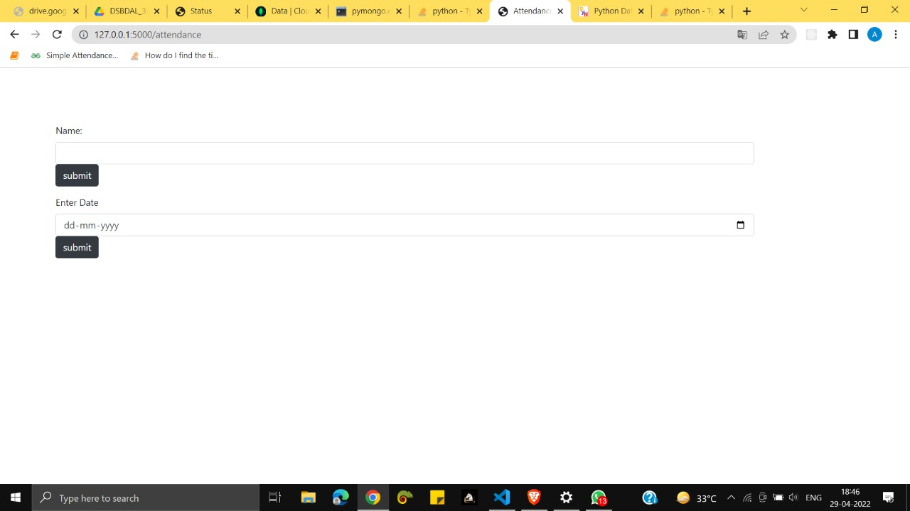

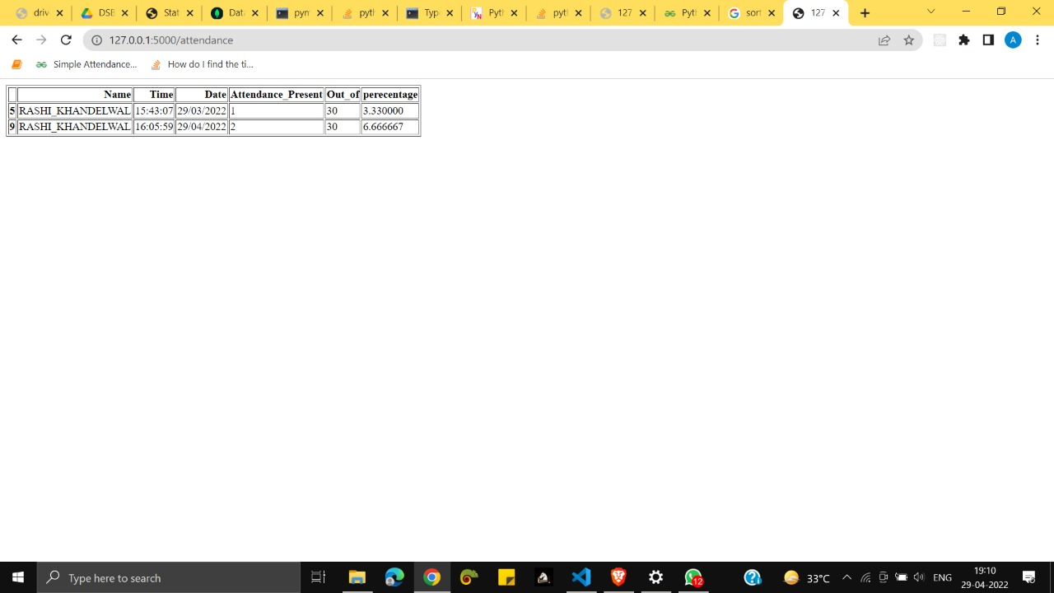

**CONCLUSION and FUTURE WORK**

We have implemented a face recognition attendance system website that allows the users (teachers in this case) to create their accounts on the portal and register the students online. The platform allows users to have one-time student registration for setting up the database and saving it for the future. The dataset has been successfully created using the Open CV library of Python. The student’s attendance automatically increments by recognizing their face. We have also implemented the search attendance and take attendance feature after logging in to the portal.

**FUTURE SCOPE:**

1. The system is working fine, but there are still some limitations to it. We are planning to add some more features and structure to the portal in the future.
2. Instead of a student registering to the portal and then getting the attendance, we will make a class login wherein all the students of the class will have to do one-time registration and then the subject-wise attendance will be taken by the respective subject teacher.
3. The control of the portal will be completely in the hands of the teacher.
4. The subject teacher will open that subject tab and will click on the take attendance button; a camera will pop up and will take the real-time pictures of students and increment the attendance count.
5. The webpage will display subject-wise attendance if requested to the server.

**References:**  
[1] A Survey on Smart Attendance Management System using RFID Ashwini Dhumal, Pradnya Jagtap, Aishwarya Mohite, Shamali Pawar, Prof. Monica Waghmare, Dept. of Computer Engineering, Someshwar Engineering College, Someshwarnagar, Maharashtra 412306, India. Assistant Professor, Dept. of Computer Engineering, Someshwar Engineering College, Someshwarnagar, Maharashtra 412306, India.  
  
[2] Literature Survey on Attendance Monitoring and Access Control System by Aishwarya. R, Supriya. S, Sushmitha. R, Vandana. K, Mrs. Bhargavi Ananth  
  
[3] SURVEY - STUDENT ATTENDANCE MANAGEMENT SYSTEM Suyash Bharambe, Shubham Patil, Omkar Dixit, Vyaqti Vikas Singh, Santwana Gudadhe BE Student, Department Of Computer Engineering, Pimpri Chinchwad College of Engineering, Pune, Maharashtra, India Assistant Professor, Department Of Computer Engineering, Pimpri Chinchwad College of Engineering, Pune, Maharashtra, India  
  
[4] <https://youtu.be/iGeRZNuCOqg>  
  
[5] <https://youtu.be/rE_bJl2GAY8>  
  
[6] https://github.com/ageitgey/face_recognition