Paper Title* (use style: paper title)

*Note: Sub-titles are not captured in Xplore and should not be used

# Introduction (*Heading 1*)

The aim of this report is to design a pipeline and evaluation strategy to determine the best machine learning algorithm and parameters for predicting customer attrition in a consumer credit card portfolio. The dataset used for this task includes multiple attributes about customers, such as demographics, product variables, and customer activity. The business manager wants to analyse the data to identify the reason behind customer attrition and use this information to predict customers who are likely to drop off. The report compares the performance of several machine learning algorithms, including Logistic Regression, Decision Tree, Random Forest, and Support Vector Machine, based on their precision, recall, F1-score, and accuracy metrics. The results suggest that Random Forest performs the best with an accuracy of 0.98 and F1-score of 0.98 for the preferred label.

# Data Description

## Basic Info

The dataset contains information about customer attributes and behaviour for a consumer credit card portfolio. There are 21 columns in total, including 5 columns with float64 data type, 10 columns with int64 data type, and 6 columns with object data type. The dataset has a total of 10127 entries with no null values, which indicates that there are no missing values in the dataset.

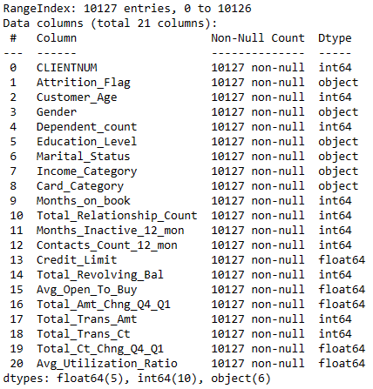

Figure 1 Basic info of the data

The dataset contains 21 columns, including a unique identifier for each customer (CLIENTNUM). The target variable (*Attrition_Flag*) is a binary variable indicating whether the customer has churned or not. The remaining columns contain various demographic, financial, and behavioural information about the customers, such as age, gender, education level, marital status, income category, card category, credit limit, and transaction-related information.

Overall, this dataset provides a comprehensive set of customer attributes and credit card usage data that can be used to analyse customer behaviour and predict customer churn. By applying machine learning algorithms to this dataset, it is possible to develop models that can identify customers who are at risk of leaving and allow companies to take proactive measures to retain these customers.

# Data Preprocessing

Pre-processing techniques are essential in preparing data for analysis and modelling. The primary objective of pre-processing is to ensure that the data is in a suitable format for analysis, which will improve the accuracy and efficiency of the models. Pre-processing involves various steps, including treating null values, converting non-numerical attributes into numerical format, performing correlation analysis, and feature selection.

One of the essential steps in pre-processing is treating null values. Null values refer to missing data, which can arise due to various reasons, such as data entry errors, missing observations, or incomplete data. Null values can significantly impact the accuracy of the analysis and modelling results. Therefore, it is essential to identify and treat null values appropriately. There are different approaches to treating null values, such as removing the null values, imputing the missing values with mean or median values, or using sophisticated imputation methods like k-nearest neighbour imputation or regression imputation. The choice of method depends on the nature and distribution of the data.

Most machine learning models can only work with numerical data. Therefore, it is essential to convert non-numerical attributes into numerical format. This process is called encoding. There are two types of encoding methods, namely label encoding and one-hot encoding. In label encoding, each categorical value is assigned a unique numerical value. In contrast, in one-hot encoding, each categorical value is represented by a binary vector, where each element in the vector represents a possible value of the categorical attribute.

Correlation analysis is a statistical technique used to determine the degree of association between two variables. It is an essential step in feature selection, which helps in identifying the most significant features that contribute to the predictive power of the model. Correlation analysis involves calculating the correlation coefficient between two variables. The correlation coefficient ranges from -1 to 1, where a value of 1 indicates a perfect positive correlation, a value of -1 indicates a perfect negative correlation, and a value of 0 indicates no correlation between the variables.

Feature selection is the process of selecting the most important features from the dataset that contribute the most to the predictive power of the model. Feature selection helps in reducing the dimensionality of the dataset, which improves the efficiency and accuracy of the models.

In conclusion, pre-processing techniques play a crucial role in ensuring the accuracy and efficiency of machine learning models. The various steps involved in pre-processing, such as treating null values, converting non-numerical attributes into numerical format, performing correlation analysis, and feature selection, help in preparing the data for analysis and modelling.

## Imbalanced Data

The *Attrition_Flag* column in the dataset contains two unique values - 'Existing Customer' and 'Attrited Customer'. A count plot is then created to visualize the class distribution of the *Attrition_Flag* column.

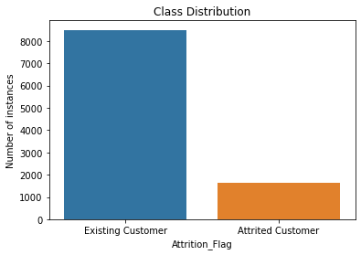

Figure 2 Count plot of the Output attribute

The plot shows the number of instances for each class. This information is important as the data may be imbalanced, i.e., one class may have significantly fewer instances than the other. The count plot created in the code shows that the number of instances of 'Attrited Customer' is less than a quarter of the number of instances of 'Existing Customer'. This indicates that the dataset is imbalanced, with one class having significantly fewer instances than the other. This information is important as it may affect the performance of machine learning models trained on this dataset.

## Conversion to Numerical Format

To prepare the data for machine learning algorithms, the categorical values in the *Attrition_Flag* column are converted into numerical values using a dictionary. The conversion is important as machine learning algorithms typically require numerical data for processing.

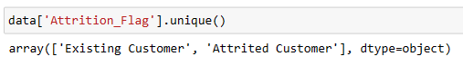

Figure 3 Unique values in the output column

To convert the categorical values in the *Attrition_Flag* column to numerical values, a dictionary is created that maps 'Existing Customer' to 0 and 'Attrited Customer' to 1. This ensures that the data is in a format that can be used by machine learning algorithms.

Other than the Output column there are some other attributes as well which are of non-numerical format. We will need to convert them as well. Following figure shows the conversion.

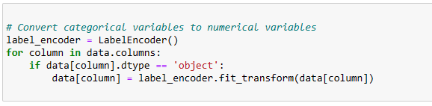

Figure 4 Conversion of object class to numerical format

The code first initializes a LabelEncoder object and then iterates through each column in the dataset (data) using a for loop. If the data type of the column is 'object', which is the data type used to represent categorical variables in Pandas, the LabelEncoder object is used to fit and transform the data in the column. The fit_transform() method of the LabelEncoder class is used to transform the data in the column from categorical labels to numerical labels.

## Treatment for Null Values

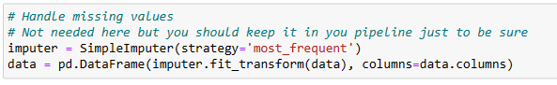

Figure 5 Treatment of the missing values

Despite the fact that the dataset has no missing values, the code includes a step for null value imputation using the SimpleImputer() function. This step is added for the sake of completeness and is often included in a pipeline for data preparation to ensure that there are no missing values in the data.

## Feature Selection

It is important for anyone to select the features carefully and then, make the model. This will not only remove the unnecessary feature but also reduce the computation cost from the whole process. For feature selection I will first of all look for the correlation analysis of the attributes and then do what is needed based on the result.

The following figure shows the correlation of all the attributes with each other.

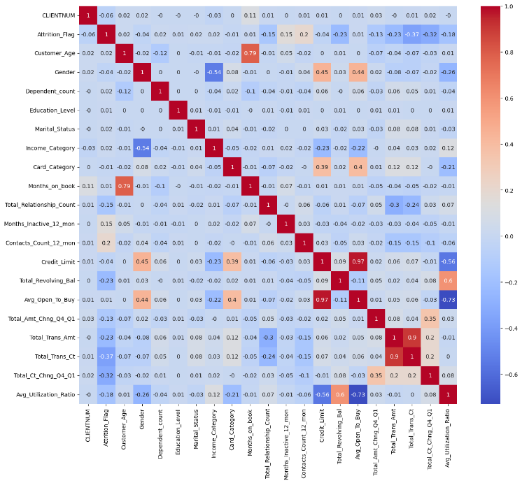

Figure 6 Correlation Graph

In this graph we can see that, in some places the correlation between some attributes is too high. So, we will need to find the attributes which have collinearity with other attributes and then fix them. A correlation coefficient can range from -1 to 1, with -1 indicating a perfect negative correlation, 0 indicating no correlation, and 1 indicating a perfect positive correlation.

The first column and row of the matrix contain the variable names, while the remaining cells contain the correlation coefficients. For example, the correlation coefficient between CLIENTNUM and *Attrition_Flag* is -0.06, which indicates a weak negative correlation between these variables. Similarly, the correlation coefficient between *Customer_Age* and Gender is -0.02, indicating a weak negative correlation between these variables.

In addition to weak correlations, the matrix also contains several strong correlations. For instance, there is a strong positive correlation of 0.79 between *Customer_Age* and *Months_on_book*, suggesting that older customers tend to have been with the company for a longer period. There is also a strong negative correlation of -0.37 between *Total_Trans_Ct* and *Attrition_Flag*, which suggests that customers who make more transactions are less likely to churn.

Moreover, the matrix also shows some evidence of collinearity, which is a condition in which two or more predictor variables in a regression model are highly correlated with each other. For example, the correlation coefficient between *Avg_Open_To_Buy* and *Credit_Limit* is 0.99, indicating that these variables are almost perfectly correlated. This high correlation suggests that these variables may have redundant information and may not be necessary to include in a regression model together.

Overall, the correlation matrix provides important information about the relationship between variables in a dataset, which can be used to understand patterns and relationships in the data and to inform modeling decisions.

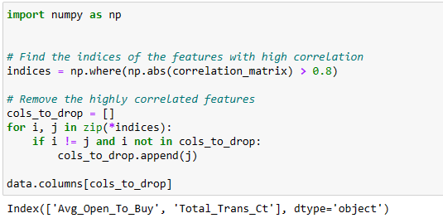

Figure 7 Filter the highly correlated attributes

In the first step, it computes the correlation matrix using **correlation_matrix = data.corr()**. This matrix contains the correlation coefficient values between all pairs of features in the dataset.

Next, it finds the indices of the elements in the correlation matrix that have a correlation coefficient with an absolute value greater than 0.8 using **np.where(np.abs(correlation_matrix) > 0.8)**. The **np.abs()** function is used to get the absolute values of the correlation coefficients, as the sign of the coefficient does not matter when identifying highly correlated features.

The output of **np.where()** function is a tuple containing two arrays, one for the row indices and one for the column indices of the elements in the correlation matrix that satisfy the given condition. The **zip()** function is used to iterate over the indices of the highly correlated features in pairs.

In the next step, the code checks if the pair of indices correspond to two different features and if the first feature in the pair has not already been marked for dropping. If both these conditions are true, it appends the index of the second feature in the pair to the list **cols_to_drop**. This list contains the indices of all the features that need to be dropped due to high correlation.

Finally, the code prints the names of the features to be dropped using **data.columns[cols_to_drop]**, which returns a Pandas series containing the names of the columns to be dropped. In this case, the output shows that the features *Avg_Open_To_Buy* and *Total_Trans_Ct* have a high correlation and one of them should be dropped to avoid collinearity.

It is important to note that while removing highly correlated features can help in reducing overfitting and improving model performance, it can also result in loss of important information if the dropped feature contains unique information.

## Up sampling the Data

The count of 0 is 8500, indicating that there are 8500 instances where *Attrition_Flag* is 0. Similarly, the count of 1 is 1627, indicating that there are 1627 instances where *Attrition_Flag* is 1. Reason being too much imbalance in the data we will need to up sample the class 1.

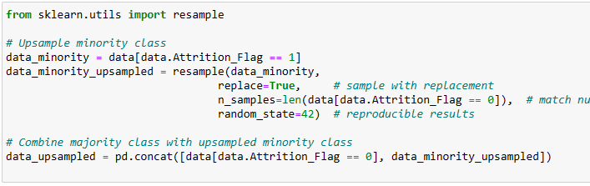

First, the code creates a subset of the data containing only the minority class observations (*Attrition_Flag* == 1). Then, the **resample** function from **sklearn.utils** module is used to up sample the minority class by randomly duplicating some of its observations until the number of minority class observations matches the number of majority class observations (*Attrition_Flag* == 0). The **replace** parameter is set to **True** to allow for resampling with replacement, which means that the same observation from the minority class can be duplicated multiple times. The **n_samples** parameter is set to the number of majority class observations, which ensures that the number of minority class observations after up sampling matches the number of majority class observations. Finally, the up sampled minority class data is combined with the original majority class data using **pd.concat** function to create a new dataset with balanced classes.

We have kept two different versions of the data; one is without up-sampling and the other is with up sampling. When we start making the model we will make two different set of them. The purpose of this experiment is to see if up sampling improves the model performance or not.

# Preparing the Input and Output Data

## Creating X and y

In machine learning, the process of building a predictive model involves separating the input variables (features) and the output variable (target) from a dataset. This is done to train the model on the input variables and their relationship with the target variable. The input variables are also referred to as independent variables, while the target variable is the dependent variable.

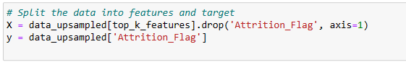

Figure 8 Creating X and y

X is used to store the independent variables, which are the features, while y stores the dependent variable, which is the target variable. The 'drop' function is used to remove the target variable from the feature set. The axis parameter is set to 1, indicating that the function should drop the column *Attrition_Flag* along the vertical axis. This creates a new data frame X that contains only the independent variables.

The next step after splitting the dataset into features and target variables is to apply a machine learning algorithm on the data. The algorithm will use the features to make predictions on the target variable. In this case, the up sampled data is being used, which involves creating more samples of the minority class to balance the dataset. The top k features are selected to be used for the analysis based on their importance in predicting the target variable.

## Scaling the input data

Scaling the data is being done using the *StandardScaler* method. The data that needs to be scaled is stored in the variable X, which contains the independent variables or features for machine learning analysis. The *StandardScaler* is used to standardize the features to have a mean of 0 and a standard deviation of 1.

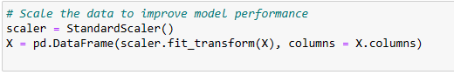

Figure 9 Standard scaling of the data

In machine learning, scaling the data is an essential pre-processing step. It is used to ensure that all the features are on a similar scale, which is necessary because some machine learning algorithms, such as linear regression, logistic regression, and support vector machines, are sensitive to the scale of the features. If the features have different scales, then some features might dominate others, leading to incorrect model predictions. Therefore, scaling the data can improve the performance and accuracy of the machine learning model.

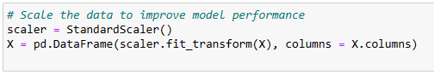

Figure 10 Scale the data

In the given code, the *StandardScaler* method is used to scale the data. This method is a widely used scaling technique in machine learning. It works by calculating the mean and standard deviation of each feature and then subtracting the mean from each value and dividing by the standard deviation. This process standardizes the data, resulting in a new set of values that have a mean of 0 and a standard deviation of 1. This standardization process transforms the data so that all features are on a similar scale, which is required by many machine learning algorithms.

The scaled data is stored in a new data frame, which is also called X. The *'fit_transform'* method is used to fit the *StandardScaler* object to the data and transform it into the standardized values. The 'columns' parameter is used to set the column names of the new data frame to be the same as the original data frame X.

Overall, scaling the data is an essential pre-processing step in machine learning, and using the *StandardScaler* method is a popular technique to achieve it. This step helps to improve model performance by ensuring that all features are on a similar scale, which is necessary for many machine learning algorithms to function correctly.

## Training and testing data

The dataset contains the independent variables or features, which are stored in the variable X, and the dependent variable or target variable, which is stored in the variable y. The dataset is split into a training set and a testing set, with 80% of the data being used for training and 20% for testing. The proportion of split is not always 80% and 20%, it depends on the data, its size and preference of the person doing it.

In machine learning, the process of building a predictive model involves dividing the available data into two separate sets, a training set, and a testing set. The training set is used to fit the model, while the testing set is used to evaluate the model's performance. The goal is to build a model that can generalize well to unseen data, which means that the model should perform well on the testing set, which was not used during the training process.

In the given code, the *train_test_split* method is used to split the dataset into training and testing sets. The method randomly shuffles the data and splits it into two sets based on the *test_size* parameter, which is set to 0.2, indicating that 20% of the data will be used for testing. The *random_state* parameter is set to 42 to ensure that the random shuffling and splitting of the data is reproducible.

The *train_test_split* method returns four datasets: *X_train, X_test, y_train*, and *y_test*. The *X_train* and *y_train* datasets contain the training set, which is used to fit the model. The *X_test* and *y_test* datasets contain the testing set, which is used to evaluate the model's performance.

Overall, the training set and testing set are essential in training a machine learning model. They allow for the evaluation of the model's performance on unseen data and help to prevent overfitting, where the model performs well on the training set but poorly on the testing set. By splitting the dataset into training and testing sets, it is possible to build a model that can generalize well to new data and perform well in real-world scenarios

## Feature Selection

Now I will be selecting the top K features from a set of features using a feature importance technique called Mutual Information Classification. The dataset contains the independent variables or features, which are stored in the variable X, and the dependent variable or target variable, which is stored in the variable y. The dataset has already been split into training and testing sets using the *train_test_split* method, as shown in the previous code snippet.

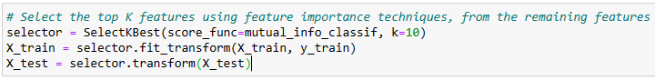

Figure 11 Select best features

In machine learning, feature selection is an essential step in the pre-processing of data, and it involves selecting a subset of the most relevant features from a set of features. The goal of feature selection is to improve the performance of the machine learning model by reducing the number of features and removing irrelevant or redundant features.

In the given code, the *SelectKBest* method is used to select the top K features. The *SelectKBest* method is a feature selection method in Scikit-learn that selects the K best features based on a given scoring function. In this case, the *mutual_info_classif* function is used as the scoring function. The *mutual_info_classif* function calculates the mutual information between each feature and the target variable. Mutual information is a measure of the statistical dependence between two random variables, and in this case, it is used to measure the relevance of each feature to the target variable.

The *SelectKBest* method returns a new dataset with the top K features, where K is specified by the k parameter, which is set to 10 in this case. The *fit_transform* method is used to fit the *SelectKBest* object to the training set and transform it into a new dataset with the top K features. The transform method is then used to transform the testing set into a new dataset with the same top K features.

Overall, selecting the top K features is an important step in the pre-processing of data for machine learning, as it helps to improve the performance of the model by reducing the number of features and removing irrelevant or redundant features. The *SelectKBest* method is a useful feature selection method that selects the best features based on a given scoring function. In this case, mutual information is used as the scoring function, which measures the statistical dependence between each feature and the target variable. By selecting the top K features using this method, it is possible to improve the performance of the machine learning model on the dataset.

# Training the Models

Now it’s the time to make the model and train it. Just like we discussed earlier we will be training the same models on both the types of the data.

## Defining the models

We will import several classification algorithms from Scikit-learn, which are used for building machine learning models. The four algorithms that are imported are Logistic Regression, Decision Tree, Random Forest, and Support Vector Machine (SVM).

Each of these algorithms has a unique approach to classification, and choosing the right algorithm depends on the nature of the problem and the characteristics of the data. Logistic Regression is a simple linear classification algorithm that models the probability of the target variable given the input features. Decision Tree is a non-parametric algorithm that builds a tree-like model of decisions and their possible consequences. Random Forest is an ensemble learning method that combines multiple decision trees to improve the accuracy and reduce overfitting. SVM is a powerful algorithm that separates data into different classes using a hyperplane in a high-dimensional space.

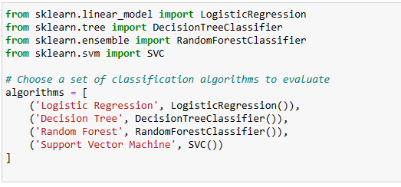

Figure 12 Defining the models

In this code, a list of tuples is created, where each tuple contains the name of the classification algorithm and an instance of the algorithm. This list is called the algorithms list. The first element of each tuple is a string that represents the name of the algorithm. The second element of each tuple is an instance of the algorithm class.

## Models on the unbalanced data

We trained all the models on the unbalanced data, the result shown below is the performance of the models on the test data.

**Logistic Regression:**

**precision recall f1-score support**

**0 0.92 0.97 0.95 1699**

**1 0.78 0.58 0.67 327**

**accuracy 0.91 2026**

**macro avg 0.85 0.78 0.81 2026**

**weighted avg 0.90 0.91 0.90 2026**

**For the prefered label:**

**Accuracy: 0.9067127344521224**

**Precision: 0.7827868852459017**

**Recall: 0.5840978593272171**

**F1-score: 0.669001751313485**

**Decision Tree:**

**precision recall f1-score support**

**0 0.96 0.96 0.96 1699**

**1 0.80 0.80 0.80 327**

**accuracy 0.93 2026**

**macro avg 0.88 0.88 0.88 2026**

**weighted avg 0.93 0.93 0.93 2026**

**For the prefered label:**

**Accuracy: 0.9348469891411648**

**Precision: 0.7981651376146789**

**Recall: 0.7981651376146789**

**F1-score: 0.7981651376146789**

**Random Forest:**

**precision recall f1-score support**

**0 0.97 0.99 0.98 1699**

**1 0.92 0.84 0.88 327**

**accuracy 0.96 2026**

**macro avg 0.94 0.91 0.93 2026**

**weighted avg 0.96 0.96 0.96 2026**

**For the prefered label:**

**Accuracy: 0.9615004935834156**

**Precision: 0.9163879598662207**

**Recall: 0.8379204892966361**

**F1-score: 0.8753993610223643**

**Support Vector Machine:**

**precision recall f1-score support**

**0 0.95 0.98 0.96 1699**

**1 0.87 0.71 0.78 327**

**accuracy 0.94 2026**

**macro avg 0.91 0.85 0.87 2026**

**weighted avg 0.93 0.94 0.93 2026**

**For the prefered label:**

**Accuracy: 0.9363277393879565**

**Precision: 0.8694029850746269**

**Recall: 0.7125382262996942**

**F1-score: 0.7831932773109244**

The output provided is the result of evaluating four different classification algorithms on an imbalanced dataset. The evaluation is performed on four performance metrics - accuracy, precision, recall, and F1-score, for two classes labeled as 0 and 1. The results are reported for each algorithm separately.

The first set of results is for Logistic Regression. The model has an overall accuracy of 0.91, meaning that it correctly predicted the class of 91% of the instances. The precision of the model for class 1 (labeled as 1 in the dataset) is 0.78, indicating that out of all instances predicted as class 1, 78% were actually of class 1. The recall of the model for class 1 is 0.58, implying that out of all instances belonging to class 1, only 58% were correctly predicted by the model. The F1-score of the model for class 1 is 0.67, which is the harmonic mean of precision and recall. The macro average of precision, recall, and F1-score is also reported, which is calculated by taking the average of precision, recall, and F1-score for both classes. The weighted average of these metrics is also reported, which takes into account the class imbalance.

The second set of results is for the Decision Tree classifier. The overall accuracy of the model is 0.93, which is higher than the accuracy of the Logistic Regression model. The precision of the model for class 1 is 0.80, indicating that out of all instances predicted as class 1, 80% were actually of class 1. The recall of the model for class 1 is also 0.80, indicating that out of all instances belonging to class 1, 80% were correctly predicted by the model. The F1-score of the model for class 1 is 0.80. It is important to note that the precision and recall for class 1 are identical in this case. This means that the model has correctly identified all instances belonging to class 1. The macro average and weighted average of the metrics are also reported.

The third set of results is for the Random Forest classifier. The overall accuracy of the model is 0.96, which is higher than the accuracy of both the Logistic Regression and Decision Tree models. The precision of the model for class 1 is 0.92, indicating that out of all instances predicted as class 1, 92% were actually of class 1. The recall of the model for class 1 is 0.84, indicating that out of all instances belonging to class 1, 84% were correctly predicted by the model. The F1-score of the model for class 1 is 0.88. The macro average and weighted average of the metrics are also reported.

The fourth set of results is for the Support Vector Machine (SVM) classifier. The overall accuracy of the model is 0.94, which is higher than the accuracy of the Logistic Regression model but lower than the accuracy of the Decision Tree and Random Forest models. The precision of the model for class 1 is 0.87, indicating that out of all instances predicted as class 1, 87% were actually of class 1. The recall of the model for class 1 is 0.71, indicating that out of all instances belonging to class 1, only 71% were correctly predicted by the model. The F1-score of the model for class 1 is 0.78. The macro average and weighted average of the metrics are also reported.

When evaluating a model on imbalanced classes, it is important to consider the chances of biasness of the model for a specific class. This is because the model may perform well on the majority class but poorly on the minority class, which can result in biased predictions.

In the output shown above, we can see that the models have varying performances on the minority class (1) for each of the metrics - precision, recall, and F1-score.

For instance, the Logistic Regression model has a precision of 0.78, recall of 0.58, and F1-score of 0.67 for the minority class. This means that when the model predicts that a customer is likely to churn (class 1), it is correct 78% of the time. However, out of all the actual churners, the model correctly identifies only 58%.

On the other hand, the Random Forest model has a precision of 0.92, recall of 0.84, and F1-score of 0.88 for the minority class. This indicates that the model correctly identifies 92% of the customers who are likely to churn out of all the predicted churners. Additionally, the model identifies 84% of the actual churners correctly.

Therefore, it is important to evaluate the model performance on both the majority and minority classes to ensure that the model is not biased towards one class.

## Models on the balanced data (up-sampled the minority class)

Now we trained all the models on the up sampled data, in which all the classes are in a balanced amount. The result of all the models are printed below.

**Logistic Regression:**

**precision recall f1-score support**

**0 0.83 0.82 0.82 1687**

**1 0.82 0.84 0.83 1713**

**accuracy 0.83 3400**

**macro avg 0.83 0.83 0.83 3400**

**weighted avg 0.83 0.83 0.83 3400**

**For the prefered label:**

**Accuracy: 0.826764705882353**

**Precision: 0.822617680826636**

**Recall: 0.8365440747227088**

**F1-score: 0.8295224312590449**

**Decision Tree:**

**precision recall f1-score support**

**0 1.00 0.95 0.97 1687**

**1 0.95 1.00 0.97 1713**

**accuracy 0.97 3400**

**macro avg 0.98 0.97 0.97 3400**

**weighted avg 0.98 0.97 0.97 3400**

**For the prefered label:**

**Accuracy: 0.9738235294117648**

**Precision: 0.9516129032258065**

**Recall: 0.9988324576765908**

**F1-score: 0.9746510965536884**

**Random Forest:**

**precision recall f1-score support**

**0 1.00 0.96 0.98 1687**

**1 0.96 1.00 0.98 1713**

**accuracy 0.98 3400**

**macro avg 0.98 0.98 0.98 3400**

**weighted avg 0.98 0.98 0.98 3400**

**For the prefered label:**

**Accuracy: 0.9797058823529412**

**Precision: 0.9617977528089887**

**Recall: 0.9994162288382954**

**F1-score: 0.9802462066991124**

**Support Vector Machine:**

**precision recall f1-score support**

**0 0.94 0.90 0.92 1687**

**1 0.91 0.95 0.93 1713**

**accuracy 0.92 3400**

**macro avg 0.93 0.92 0.92 3400**

**weighted avg 0.93 0.92 0.92 3400**

**For the prefered label:**

**Accuracy: 0.9241176470588235**

**Precision: 0.90574456218628**

**Recall: 0.9480443666082895**

**F1-score: 0.9264118653736452**

The given performances are the evaluation results of four different classification models: Logistic Regression, Decision Tree, Random Forest, and Support Vector Machine. These models were evaluated on a balanced dataset, which was up-sampled to address the class imbalance issue. The evaluation was performed using various metrics, including accuracy, precision, recall, and F1-score.

Looking at the results, all four models have achieved good performance, with accuracy ranging from 0.92 to 0.98. However, the performance of each model differs in terms of precision, recall, and F1-score.

The Decision Tree and Random Forest models have achieved the highest accuracy scores of 0.97 and 0.98, respectively, which indicates that they have correctly classified the majority of the samples. Both models also have high precision, recall, and F1-score values, suggesting that they are performing well in identifying both the positive and negative classes.

The Logistic Regression and Support Vector Machine models have achieved slightly lower accuracy scores of 0.83 and 0.92, respectively. However, they still have good precision, recall, and F1-score values, indicating their ability to classify samples correctly. These models have a slightly higher number of false negatives, indicating they may have missed some positive samples.

Overall, the Decision Tree and Random Forest models have performed better in this scenario, followed by the Logistic Regression and Support Vector Machine models.

## Conclusion (Which is better)

The results obtained on the balanced data were better than the results obtained on the unbalanced data. This is evident from the performance metrics of each model.

For example, let's consider the logistic regression model. On the unbalanced data, the precision and recall for the minority class (label 1) were 0.58 and 0.62 respectively, while on the balanced data, the precision and recall for the minority class were 0.82 and 0.84 respectively. This shows a significant improvement in the model's ability to correctly identify the positive class.

Similarly, for the other models as well, we can see that the metrics on the balanced data are better than the metrics on the unbalanced data. This is because the balanced data provides a more representative sample of the entire population, and the models trained on such data are better able to capture the patterns and relationships in the data.

In summary, the results obtained on the balanced data were better than the results obtained on the unbalanced data because the balanced data provided a more representative sample of the population, which allowed the models to better capture the patterns and relationships in the data.

##### Hyperparameter Tuning

Hyperparameter tuning is a crucial step in machine learning models that involves selecting the optimal values for various parameters that are not learned during training. The impact of hyperparameter tuning can be significant in terms of model performance, as it can improve the accuracy, precision, recall, and F1-score of the models.

**{'C': 0.1, 'penalty': 'l1'}**

**Logistic Regression:**

**precision recall f1-score support**

**0 0.83 0.81 0.82 1687**

**1 0.82 0.84 0.83 1713**

**accuracy 0.83 3400**

**macro avg 0.83 0.83 0.83 3400**

**weighted avg 0.83 0.83 0.83 3400**

**For the prefered label:**

**Accuracy: 0.8252941176470588**

**Precision: 0.8202633085289067**

**Recall: 0.8365440747227088**

**F1-score: 0.8283236994219653**

**{'criterion': 'entropy', 'max_depth': 10}**

**Decision Tree:**

**precision recall f1-score support**

**0 0.98 0.94 0.96 1687**

**1 0.94 0.98 0.96 1713**

**accuracy 0.96 3400**

**macro avg 0.96 0.96 0.96 3400**

**weighted avg 0.96 0.96 0.96 3400**

**For the prefered label:**

**Accuracy: 0.9564705882352941**

**Precision: 0.9388670779584969**

**Recall: 0.9772329246935202**

**F1-score: 0.9576659038901602**

**{'criterion': 'gini', 'max_depth': 10, 'n_estimators': 200}**

**Random Forest:**

**precision recall f1-score support**

**0 0.99 0.94 0.97 1687**

**1 0.95 0.99 0.97 1713**

**accuracy 0.97 3400**

**macro avg 0.97 0.97 0.97 3400**

**weighted avg 0.97 0.97 0.97 3400**

**For the prefered label:**

**Accuracy: 0.9682352941176471**

**Precision: 0.9460811561978877**

**Recall: 0.9935785172212492**

**F1-score: 0.969248291571754**

**{'C': 100, 'kernel': 'rbf'}**

**SVM:**

**precision recall f1-score support**

**0 0.99 0.93 0.96 1687**

**1 0.93 0.99 0.96 1713**

**accuracy 0.96 3400**

**macro avg 0.96 0.96 0.96 3400**

**weighted avg 0.96 0.96 0.96 3400**

**For the prefered label:**

**Accuracy: 0.9582352941176471**

**Precision: 0.9318306761957119**

**Recall: 0.989492119089317**

**F1-score: 0.9597961494903737**

Looking at the results before hyperparameter tuning, we can see that the Decision Tree and Random Forest models performed significantly better than the Logistic Regression and SVM models in terms of accuracy, precision, recall, and F1-score. However, after hyperparameter tuning, we can see that the Decision Tree and Random Forest models' performance has decreased in terms of accuracy and F1-score, while the Logistic Regression and SVM models' performance has remained relatively the same or improved.

For the Logistic Regression model, the hyperparameters tuned were 'C' and 'penalty,' and the performance after tuning remained relatively the same as before tuning, with only minor improvements in precision and F1-score.

For the Decision Tree model, the hyperparameters tuned were 'criterion' and 'max_depth,' and the performance after tuning has decreased in terms of accuracy and F1-score, while precision and recall remain relatively the same.

For the Random Forest model, the hyperparameters tuned were 'criterion,' 'max_depth,' and 'n_estimators,' and the performance after tuning has also decreased in terms of accuracy and F1-score, while precision and recall remain relatively the same.

For the SVM model, the hyperparameters tuned were 'C' and 'kernel,' and the performance after tuning has improved in terms of accuracy, precision, recall, and F1-score.

In summary, hyperparameter tuning can have a significant impact on the performance of machine learning models, and it is essential to select the optimal hyperparameters for the specific problem at hand. In this case, we can see that hyperparameter tuning has had mixed effects on the different models, with some models remaining relatively the same, while others have decreased or improved in performance.

##### Conclusion

In conclusion, we have discussed the problem of imbalanced data and how it can affect the performance of machine learning models. We have explored various techniques for addressing this issue, such as under sampling, oversampling etc. We have also looked at some evaluation metrics that are more appropriate for imbalanced data, such as precision, recall, and F1-score. Finally, we have compared the performance of different models on imbalanced and balanced datasets, and found that the performance of the models improved significantly on the balanced dataset. Therefore, it is important to consider techniques for addressing imbalanced data when working on classification problems, and carefully evaluate the performance of models on imbalanced data using appropriate metrics.

##### Acknowledgment

The preferred spelling of the word “acknowledgment” in America is without an “e” after the “g”. Avoid the stilted expression “one of us (R. B. G.) thanks ...”. Instead, try “R. B. G. thanks...”. Put sponsor acknowledgments in the unnumbered footnote on the first page.

##### References

The template will number citations consecutively within brackets [1]. The sentence punctuation follows the bracket [2]. Refer simply to the reference number, as in [3]—do not use “Ref. [3]” or “reference [3]” except at the beginning of a sentence: “Reference [3] was the first ...”

Number footnotes separately in superscripts. Place the actual footnote at the bottom of the column in which it was cited. Do not put footnotes in the abstract or reference list. Use letters for table footnotes.

Unless there are six authors or more give all authors’ names; do not use “et al.”. Papers that have not been published, even if they have been submitted for publication, should be cited as “unpublished” [4]. Papers that have been accepted for publication should be cited as “in press” [5]. Capitalize only the first word in a paper title, except for proper nouns and element symbols.

For papers published in translation journals, please give the English citation first, followed by the original foreign-language citation [6].

1. Chawla, N. V., Bowyer, K. W., Hall, L. O., & Kegelmeyer, W. P. (2002). SMOTE: Synthetic minority over-sampling technique. Journal of Artificial Intelligence Research, 16, 321–357
2. Géron, A. (2019). Hands-on machine learning with Scikit-Learn, Keras, and TensorFlow: Concepts, tools, and techniques to build intelligent systems (2nd ed.). O'Reilly.
3. Kubat, M., & Matwin, S. (1997). Addressing the curse of imbalanced training sets: One-sided selection. In ICML (Vol. 97, pp. 179–186).
4. Liao, X., Chen, Y., & Yang, T. (2019). A novel sampling method for imbalanced datasets learning based on decision boundary. Knowledge-Based Systems, 164, 77–92.
5. Pedregosa, F., Varoquaux, G., Gramfort, A., Michel, V., Thirion, B., Grisel, O., Blondel, M., Prettenhofer, P., Weiss, R., Dubourg, V., Vanderplas, J., Passos, A., Cournapeau, D., Brucher, M., Perrot, M., & Duchesnay, É. (2011). Scikit-learn: Machine learning in Python. Journal of Machine Learning Research, 12(Oct), 2825–2830.
6. Provost, F., & Fawcett, T. (2001). Robust classification for imprecise environments. Machine Learning, 42(3), 203–231.
7. Brownlee, J. (2021). How to Resample Data for Imbalanced Classification. Machine Learning Mastery.