 ASSIGNEMENT-2
PORTFOLIO
CODE:-

<html>
<head>
<head> PORTFOLIO </head>
<h1> self introduction </h1>
<p1> my self Abhishek Pandey, i am 18 years old, i had done my school from ssv-3 school in Vadodara</p1>
<h2> qualifications </h2>
<p2> I had completed my 10th boards form my shannen school Vadodara and score 80% after that i shifted to ssv-3 school Vadodara and score 70% in my 12th boards. </P2>
<h3> hobbies </h3>
<p3> my hobbies are playing table tennis, badminton, sketching, and learning productive skills. </p3>

</html>

OUTPUT:-

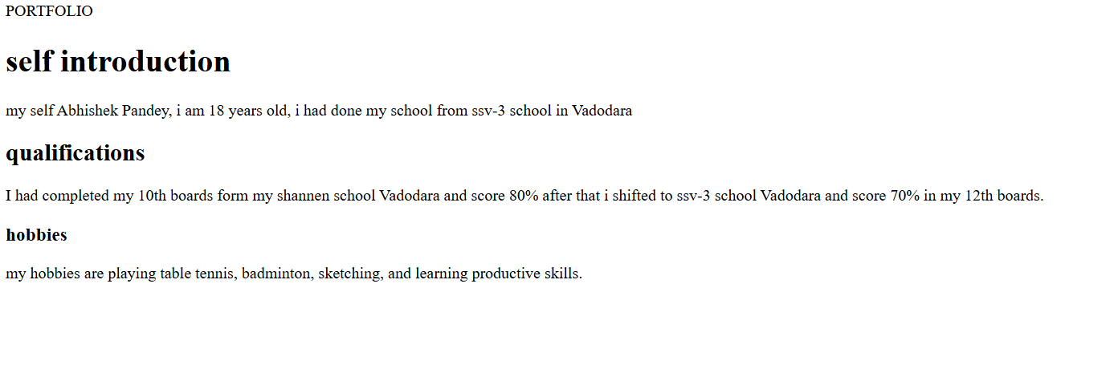

NAME:-Abhishek Pandey
Cse core-1st sem
Sub code:-web technologies(C2111C3)

