SAATHI

Product Requirements Document (PRD)
Version: 1.0
Stage: Buildathon MVP

Tagline
Personalised learning for every underserved learner.

1. Executive Summary

Vision
Empower every underserved learner to achieve their full potential through personalised, accessible and inclusive education.
We envision a future where every learner, regardless of their economic background, learning abilities, disabilities or access to educational resources, receives the support they need to learn confidently and independently.

Mission
Build an AI-powered adaptive learning platform that personalises education through curriculum-aware teaching, accessibility-first design and engaging learning experiences, enabling every learner to progress at their own pace.

Problem
Despite significant improvements in school enrolment, millions of students continue to face barriers to quality education. Many learners struggle because they lack access to personalised academic support, quality teachers or affordable tutoring.
The challenge is even greater for underserved learners, including students from economically disadvantaged communities, learners with disabilities and neurodiverse learners whose educational needs are often overlooked by traditional education systems.
Existing digital learning platforms primarily focus on content delivery through videos or generic AI conversations. While these platforms improve access to information, they rarely provide structured, adaptive and curriculum-aware learning journeys tailored to each learner.
Parents also want to support their children's education but often lack the time, subject expertise or visibility into their child's learning progress.

Proposed Solution
Saathi is an AI-powered adaptive learning platform that delivers structured, personalised and inclusive learning experiences.
Rather than functioning as a generic AI chatbot, Saathi guides learners through a curriculum-aware journey consisting of:
- Structured curriculum pathways
- Bite-sized concept lessons
- Context-aware AI tutoring
- Guided practice
- Chapter assessments
- Progress tracking
- Habit-building experiences
- Parent engagement
- Human mentor escalation when additional support is needed

Buildathon MVP
To validate the core learning experience, the Buildathon MVP intentionally focuses on one subject while building a scalable foundation.
Target Users
- Students studying NCERT Mathematics (Classes 6–8)
- Parents supporting their learning journey
Core Features
- Curriculum-based chapter learning
- AI Tutor
- Guided Practice
- Chapter Quiz
- Progress Tracking
- Daily Learning Streak
- Parent Progress Summary
- Request a Human Mentor
The architecture is designed to scale across additional subjects, grades and accessibility requirements in future releases.

Success Criteria
The MVP aims to validate the following hypotheses.
- Students complete structured learning journeys more consistently.
- Context-aware AI explanations improve conceptual understanding.
- Immediate practice improves learning outcomes.
- Parent engagement improves learner consistency.
- Human mentor requests identify situations where AI support alone is insufficient.
- Habit-forming mechanisms improve learner retention.

2. Problem Statement

Background
Education is one of the strongest drivers of long-term social and economic mobility. While India has significantly improved school enrolment, learning outcomes continue to remain a challenge, particularly among underserved learners.
Students often progress through school without mastering foundational concepts because of overcrowded classrooms, limited teacher attention and the absence of personalised academic support beyond school hours.
For many families, private tuition remains financially inaccessible. Students who struggle in classrooms frequently have no reliable source of academic guidance once they return home.
Parents want to support their children but often face their own constraints, including limited subject knowledge, work commitments and uncertainty about their child's learning progress.
Recent advances in Artificial Intelligence have made personalised education technically feasible. However, most AI-powered tools remain generic—they answer questions but do not understand the learner's curriculum, learning history or conceptual gaps.

Problem Statement
Underserved learners need an affordable learning companion that understands what they are learning, adapts to their pace, and supports them throughout their educational journey rather than simply providing answers.
Parents need meaningful visibility into their child's learning progress so they can provide encouragement and timely support without requiring subject expertise.
Some learners may also require human intervention when AI alone is unable to resolve conceptual or motivational barriers.

Why Existing Solutions Fall Short
Current educational products solve only fragments of the learning journey.
- Video platforms deliver content but cannot personalise teaching.
- Generic AI assistants answer questions but lack curriculum awareness.
- Practice platforms assess performance but rarely adapt instruction.
- Private tutoring provides personalisation but remains expensive and difficult to scale.
- Parent communication is often limited to examination results instead of continuous learning progress.
Learners require a unified experience that combines personalised teaching, practice, motivation and family engagement.

Opportunity
The convergence of AI, increasing smartphone adoption and structured digital curricula presents an opportunity to build an adaptive learning platform that makes personalised education affordable, inclusive and scalable.
By combining AI with structured curriculum, parent engagement and optional human mentorship, Saathi can support learners across diverse educational needs.

3. Market Validation

Key Insights
The product direction is informed by educational research and observed gaps in existing learning platforms.
Observation | Product Decision
Foundational learning gaps remain significant despite improved school enrolment. | Focus on concept mastery rather than syllabus completion.
Smartphone availability among school-age learners has increased considerably. | Design a mobile-first experience.
Students benefit from personalised instruction and immediate feedback. | Position AI as a contextual tutor instead of a generic chatbot.
Learning consistency is often a bigger challenge than content availability. | Introduce streaks, progress tracking and habit-building mechanisms.
Parents significantly influence learning habits but often lack visibility into progress. | Build parent-facing progress summaries and recommendations.
AI cannot solve every learning challenge independently. | Provide optional human mentor escalation for learners requiring additional support.
Existing platforms either provide structured content or AI assistance but rarely integrate both. | Differentiate through curriculum-aware adaptive learning.

Product Hypotheses
The Buildathon MVP will validate the following hypotheses.
H1: Structured chapter-based learning improves learning consistency.
H2: Curriculum-aware AI explanations improve conceptual understanding.
H3: Guided practice immediately after learning improves mastery.
H4: Parent engagement improves learner accountability and consistency.
H5: Learners who remain stuck are willing to request human mentor support.
H6: Progress tracking and streaks improve learner retention.

4. Market Opportunity
Saathi is designed as a long-term adaptive learning platform for underserved learners.
The Buildathon MVP validates one focused learning journey while establishing the foundation for future expansion.
Market | Scope
Total Addressable Market (TAM) | Learners requiring personalised, accessible and inclusive education.
Serviceable Available Market (SAM) | School-going students following NCERT and State Board curricula across India.
Serviceable Obtainable Market (SOM) | Initial pilots with government schools, NGOs, CSR-led education programmes and community learning centres.

Why Start with Mathematics?
Although Saathi's long-term vision spans multiple subjects and learner groups, the MVP focuses on Mathematics for Classes 6–8 because:
- Mathematical learning gaps are measurable.
- Concept mastery can be objectively assessed.
- AI explanations and guided practice provide immediate value.
- NCERT provides a structured curriculum suitable for rapid validation.
This focused scope allows the team to validate the core product experience while building an architecture capable of expanding across subjects, grades and learner needs.

Product Roadmap

Phase 1 – Buildathon MVP
- NCERT Mathematics (Classes 6–8)
- AI Tutor
- Guided Practice
- Chapter Quiz
- Progress Tracking
- Parent Progress Summary
- Request Human Mentor

Phase 2 – Product Expansion
- Additional subjects
- More grade levels
- Regional language support
- Personalised learning paths
- Parent recommendations
- Teacher dashboard
- NGO dashboard

Phase 3 – Inclusive Learning Platform
Expand Saathi into an accessibility-first learning platform supporting:
- Learners with visual impairments
- Learners with hearing impairments
- Learners with speech impairments
- Neurodiverse learners (e.g. ADHD, Dyslexia)
- Voice-first learning
- Offline learning
- AI-powered accessibility features
- Verified mentor network

5. Target Users

Primary Persona — Student

Aarav (Representative Persona)
Attribute | Details
Age | 11–14 years
Grade | Classes 6–8
Curriculum | NCERT Mathematics
Device | Shared or personal Android smartphone
Background | Underserved learner with limited access to personalised academic support
Goals | Understand concepts, improve confidence, complete homework and perform better in school
Frustrations | Classroom teaching moves too quickly, doubts remain unresolved, tuition is unaffordable, and motivation decreases over time

Student Needs
- Curriculum-aligned learning
- Personalised explanations
- Immediate doubt resolution
- Guided practice
- Motivation to learn consistently
- Confidence building
- Access to human support when AI is insufficient

Secondary Persona — Parent / Guardian
Parents are active participants in the learner's educational journey.
Attribute | Details
Role | Support, encourage and monitor learning
Goals | Understand learning progress, build consistent study habits and intervene early when required
Challenges | Limited time, limited subject expertise and limited visibility into daily learning
Needs | Simple progress updates, recommendations, learning insights and milestone notifications

Parent Value Proposition
Saathi empowers parents to actively support learning without requiring them to teach the curriculum.
Parents can:
- Monitor chapter completion
- Track learning consistency
- Understand strengths and improvement areas
- Celebrate milestones
- Receive recommendations for supporting their child
- Respond when a learner requests additional human support

Future Personas
As Saathi evolves, the platform will expand to support additional learner groups and institutional stakeholders.

Learners
- Students with visual impairments
- Students with hearing impairments
- Students with speech impairments
- Neurodiverse learners (e.g. ADHD, Dyslexia)
- Adult literacy learners

Institutional Users
- Teachers
- Government schools
- NGOs
- CSR education programmes
- Volunteer mentors

Product Principles
Every experience within Saathi is guided by six principles:
- Inclusive — Education should adapt to every learner.
- Personalised — Every learner progresses at their own pace.
- Curriculum-Aware — AI teaches within the learner's educational context.
- Human-Centred — AI scales learning, while human mentors provide support when needed.
- Engaging — Positive reinforcement builds consistent learning habits.
- Accessible — Every feature is designed to reduce barriers to quality education.

6. Jobs To Be Done (JTBD)
The Jobs-to-be-Done (JTBD) framework captures the functional, emotional and social outcomes Saathi aims to deliver for each user group. These jobs guide feature prioritisation and product decisions.

6.1 Student JTBD

Primary JTBD
When I struggle to understand a concept, I want personalised explanations, guided practice and continuous feedback so that I can confidently master the topic independently.
Job Type | Jobs
Functional | Learn concepts aligned to my school curriculum.
Functional | Ask questions whenever I get stuck.
Functional | Practise concepts until I understand them.
Functional | Assess my understanding through quizzes.
Functional | Resume learning from where I left off.
Emotional | Feel confident while learning independently.
Emotional | Stay motivated to continue learning regularly.
Social | Improve my academic performance and share progress with my parents.

6.2 Parent / Guardian JTBD

Primary JTBD
When my child is learning independently, I want meaningful progress updates and actionable recommendations so that I can support their learning without teaching every concept myself.
Job Type | Jobs
Functional | Monitor my child's learning progress.
Functional | Identify learning gaps early.
Functional | Encourage consistent learning habits.
Emotional | Feel confident that my child is progressing.

6.3 Future JTBD – Human Mentor

Primary JTBD
When a learner requests support, I want sufficient learning context so that I can provide meaningful guidance quickly.

7. Solution Overview

7.1 Learning Journey
Home
↓
Choose Chapter
↓
Micro Lesson
↓
AI Tutor
↓
Guided Practice
↓
Chapter Quiz
↓
Learning Insights
↓
Continue Learning
If repeated learning difficulties are detected:
AI Tutor
↓
Repeated Struggles Detected
↓
Request Human Mentor
Parents receive personalised progress summaries throughout the learner journey.

7.2 Product Architecture
The MVP consists of five primary capabilities.
Capability | Purpose
Curriculum Engine | Organises learning by grade, subject, chapter and lesson.
Learning Intelligence Engine | Personalises learning using learner behaviour and performance.
Learning Experience | Delivers lessons, AI tutoring, practice and quizzes.
Parent Companion | Provides progress updates and recommendations.
Human Mentor Escalation | Enables learners to request additional support when required.

7.3 Learning Intelligence Engine
The Learning Intelligence Engine powers all adaptive experiences across Saathi.
Rather than functioning as a standalone feature, it continuously analyses learner behaviour to personalise every stage of the learning journey.

Learner Context
The engine maintains:
- Grade
- Subject
- Chapter
- Current lesson
- Completed lessons
- Quiz history
- Practice history
- Incorrect concepts
- Frequently asked doubts
- Learning pace
- Learning streak
- Preferred explanation complexity

Intelligence Capabilities
The engine continuously:
- Recommends the next lesson
- Personalises AI explanations
- Adapts practice difficulty
- Suggests revision topics
- Generates learner insights
- Creates parent summaries
- Detects repeated struggles
- Recommends human mentor support

AI Design Principles
Principle | Description
Curriculum-Aware | AI always understands where the learner is in the curriculum.
Context-Aware | Responses consider previous interactions and learner history.
Adaptive | Explanations and practice adjust based on learner performance.
Supportive | AI guides learners with hints before revealing answers.
Escalation-Aware | AI recommends mentor support when repeated struggles are detected.

8. User Stories
User | User Story
Student | As a student, I want to browse chapters so I know what to learn next.
Student | As a student, I want concise lessons so that I understand one concept at a time.
Student | As a student, I want contextual AI explanations so that I can continue learning independently.
Student | As a student, I want adaptive practice questions so that I strengthen weak concepts.
Student | As a student, I want quizzes after every chapter so that I can measure my understanding.
Student | As a student, I want personalised learning recommendations so I always know what to study next.
Parent | As a parent, I want meaningful progress summaries so that I know when my child needs encouragement.
Student | As a student, I want to request a mentor whenever AI is unable to resolve my doubts.

9. Feature Specifications

Prioritisation Framework
Features are prioritised using the MoSCoW Framework. Every feature must directly satisfy one or more Jobs-to-be-Done.
Feature | User Problem | JTBD | User Story | Acceptance Criteria | Priority | Success Metric
Curriculum Dashboard | Students don't know where to start. | Learn chapter-by-chapter. | Browse curriculum and continue learning. | Displays class, chapters, lesson progress and recommended next lesson. | Must | Lesson Start Rate
Micro Lessons | Long lessons reduce engagement. | Learn concepts in manageable steps. | Learn one concept at a time. | Lessons are concise, structured and curriculum-aligned. | Must | Lesson Completion Rate
AI Tutor | Doubts remain unresolved after class. | Get personalised explanations. | Ask contextual questions. | Maintains lesson context and provides adaptive explanations. | Must | AI Resolution Rate
Guided Practice | Students forget concepts quickly. | Reinforce learning through practice. | Practise immediately after learning. | Practice adapts to learner performance and provides instant feedback. | Must | Practice Completion Rate
Chapter Quiz | Students cannot assess mastery. | Measure understanding. | Complete quizzes after each chapter. | Quiz records mastery level and recommends revision. | Must | Quiz Completion Rate
Learning Intelligence Engine | Learning is identical for every student. | Receive personalised learning. | Get recommendations tailored to my learning journey. | Generates lesson recommendations, adaptive explanations, revision plans and learning insights. | Must | Recommendation CTR, Repeat Learning Rate
Progress & Streaks | Students lose motivation over time. | Stay consistent. | Track achievements and learning streaks. | Displays progress, streaks, achievements and milestones. | Must | 7-Day Retention
Parent Companion | Parents lack visibility into learning. | Monitor and support learning. | Receive learner insights and recommendations. | Weekly progress summaries and personalised parent recommendations. | Should | Parent Engagement Rate
Human Mentor Request | AI cannot solve every learning challenge. | Request additional support. | Escalate to a human mentor. | Mentor request captures learner context and question history. | Should | Mentor Request Rate

10. MVP Prioritisation
Priority | Capability | Validation Objective
Must Have | Curriculum Dashboard | Validate structured curriculum navigation.
Must Have | Micro Lessons | Validate bite-sized learning.
Must Have | AI Tutor | Validate contextual AI teaching.
Must Have | Guided Practice | Validate concept reinforcement.
Must Have | Chapter Quiz | Validate concept mastery.
Must Have | Learning Intelligence Engine | Validate personalised learning recommendations and adaptive behaviour.
Must Have | Progress & Streaks | Validate learner retention and habit formation.
Should Have | Parent Companion | Validate parent engagement.
Should Have | Human Mentor Request | Validate demand for human intervention and identify scenarios where AI alone is insufficient.
Could Have | Regional Language Support | Improve accessibility and reach.
Could Have | Adaptive Learning Paths | Expand personalisation across the curriculum.
Won't Have (MVP) | Teacher Dashboard | Planned for institutional users.
Won't Have (MVP) | NGO Dashboard | Planned for partner organisations.
Won't Have (MVP) | Accessibility Modes (e.g. screen reader optimisation, sign-language support) | Planned for future inclusive learning releases.

11. Success Metrics
This answers: How will we measure product success?

North Star Metric (NSM)
Weekly Learning Minutes per Active Learner (WLMAL)
Why this NSM?
- Measures meaningful engagement instead of app opens.
- Rewards consistent learning behaviour.
- Aligns with the mission of improving learning outcomes.
- Less vulnerable to vanity metrics than downloads or registrations.

Supporting Metrics
Objective | KPI | Why it Matters
Acquisition | New learner registrations | Measures reach.
Activation | % learners completing their first lesson | Indicates successful onboarding.
Engagement | Lessons completed per learner/week | Measures ongoing usage.
Learning Outcomes | Chapter quiz mastery rate | Indicates concept understanding.
Retention | Day-7 and Day-30 learner retention | Measures long-term value.
Personalisation | Recommendation acceptance rate | Validates AI recommendations.
AI Effectiveness | AI doubt resolution rate | Measures usefulness of AI Tutor.
Parent Engagement | Weekly summary open rate | Indicates parent involvement.
Learning Support | Mentor request rate | Identifies where AI is insufficient.

12. Analytics & MVP Validation Plan
This section is one of your differentiators.

Product Hypotheses
ID | Hypothesis | Success Indicator
H1 | Learners prefer conversational explanations over static content. | High AI Tutor adoption.
H2 | Personalised recommendations increase lesson completion. | Higher recommendation acceptance rate.
H3 | Immediate practice improves concept mastery. | Higher quiz scores after practice.
H4 | Parents engage when progress summaries are simple and actionable. | Parent summary open rate.
H5 | Some learners require human support beyond AI. | Mentor request patterns identify genuine learning gaps.

Key Product Events
Event | Purpose
Learner Registered | Acquisition
Lesson Started | Activation
Lesson Completed | Engagement
AI Question Asked | AI usage
Practice Started | Learning behaviour
Practice Completed | Reinforcement
Quiz Submitted | Mastery
Recommendation Clicked | Personalisation
Parent Summary Viewed | Parent engagement
Mentor Request Submitted | Human support demand

MVP Success Criteria
Goal | Target
First lesson completion | ≥70% of new learners
Lesson completion | ≥60%
AI Tutor adoption | ≥50% of active learners
Practice completion | ≥70%
Recommendation acceptance | ≥30%
Day-7 retention | ≥25%
Parent summary open rate | ≥40%
These targets are initial benchmarks for evaluating product direction during the MVP phase and should be refined as real user data becomes available.

13. High-Level Technical Architecture
Keep this at the product level rather than the implementation level.
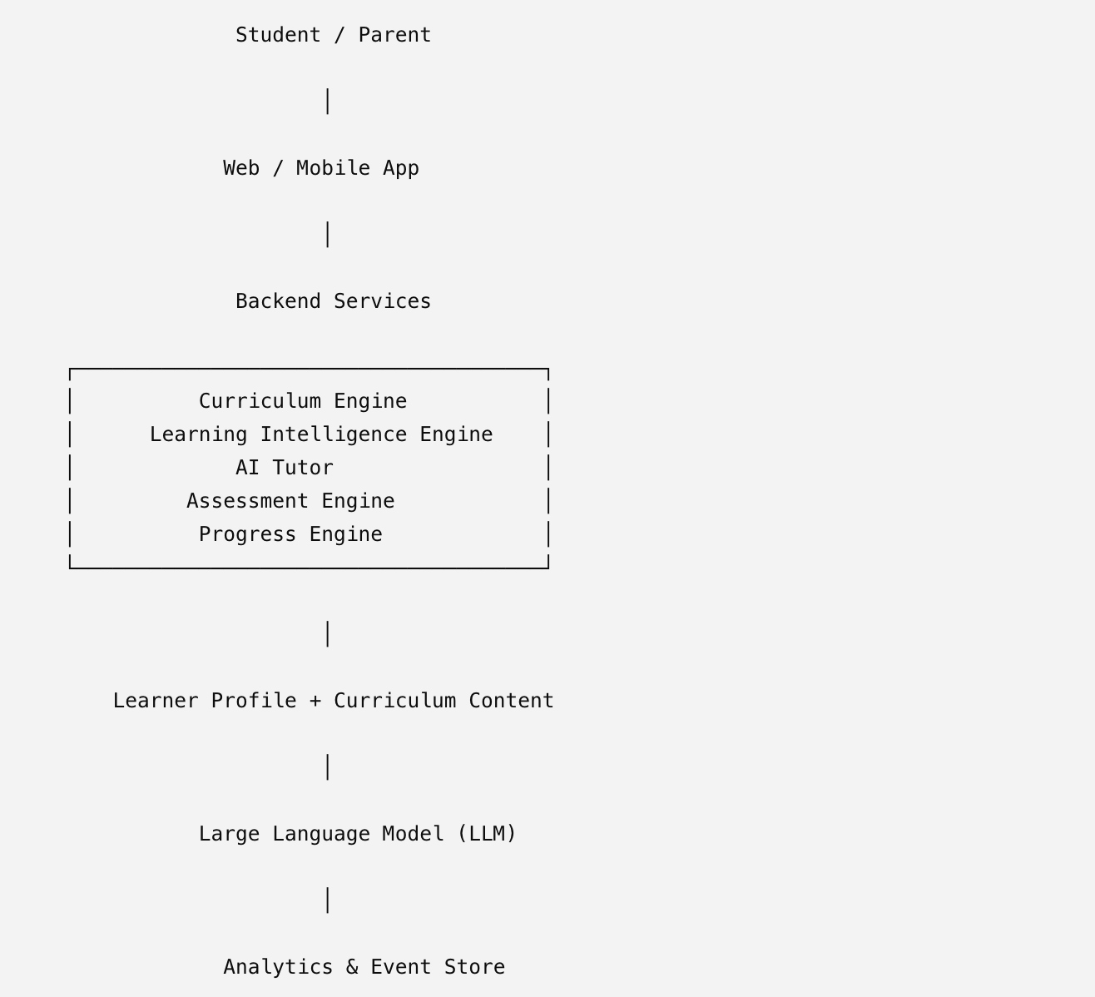

Core Components
Component | Responsibility
Curriculum Engine | Organises learning content by curriculum structure.
Learning Intelligence Engine | Maintains learner profiles and generates personalised recommendations.
AI Tutor | Provides contextual explanations and guidance.
Assessment Engine | Delivers and evaluates practice and quizzes.
Progress Engine | Tracks learner progress, mastery and consistency.
Analytics Layer | Captures product events for continuous improvement.

14. Risks, Assumptions & Mitigations
Risk | Assumption | Mitigation
AI explanations may be inaccurate. | Curriculum-grounded prompts improve reliability. | Review prompts, validate responses and include feedback mechanisms.
Learners may lose motivation over time. | Progress visibility encourages consistency. | Use streaks, milestones and personalised reminders.
Parents may not engage regularly. | Simple insights are easier to consume than detailed reports. | Deliver concise weekly summaries with clear next steps.
AI may not resolve every doubt. | Complex cases benefit from human support. | Provide Learning Support Network escalation.
Limited MVP usage may reduce confidence in results. | Early users still provide valuable behavioural insights. | Focus on qualitative feedback alongside analytics and iterate quickly.

15. Product Roadmap
Phase | Focus | Key Deliverables
Phase 1 – MVP | Validate core learning experience | Curriculum Dashboard, AI Tutor, Practice, Quiz, Progress, Parent Connect, Learning Support Network
Phase 2 – Intelligence | Improve personalisation | Adaptive learning paths, multilingual support, voice interactions, AI revision plans
Phase 3 – Scale | Expand reach and accessibility | Additional subjects, teacher dashboard, NGO dashboard, accessibility features, offline learning, CSR partnerships

16. Appendix

Key Assumptions
- Learners have access to a smartphone or web browser.
- NCERT curriculum provides sufficient structure for the MVP.
- AI responses are grounded in curriculum content.
- Parents are willing to receive periodic progress updates.
- Human support is limited and used only for escalation.

Experiment Backlog
Experiment | Hypothesis | Success Metric
Adaptive recommendations | Personalisation increases lesson completion. | Recommendation acceptance rate
AI-generated practice | Adaptive practice improves learning outcomes. | Quiz mastery rate
Parent Connect | Parent engagement improves learner consistency. | Weekly active learners with engaged parents
Learning Support Network | Human intervention improves outcomes for struggling learners. | Completion rate after mentor requests

