WEEK 3 TASK
FEATURE ENGINEERING AND MODEL BUILDING
Wine Recognition Dataset — Python Machine Learning Project
Prepared as a continuation of the Week 2 Exploratory Data Analysis project.
Technology: Python | Pandas | NumPy | Scikit-learn | Matplotlib

1. Introduction
This report presents the Week 3 Feature Engineering and Model Building stage of the Wine Recognition Dataset project. The work continues the same dataset used in Week 2. The Week 2 report identified strong relationships among several chemical measurements, especially total phenols with flavanoids, and noted that the dataset is well suited to supervised classification.
The purpose of Week 3 is to convert those EDA observations into useful machine-learning features, train a baseline classifier, train a model using the engineered feature set, and compare the results using objective evaluation metrics.

2. Problem Statement
The Wine Recognition Dataset contains chemical measurements from wine samples belonging to three classes. The problem is to predict the wine class from its chemical properties. This is a multiclass classification problem because the target contains three categories.
The Week 2 report states that the dataset has 178 observations, 13 numerical input features, and 3 wine classes. It also reports that the original dataset has no missing values. fileciteturn0file0L29-L36

3. Connection With Week 2 EDA
Feature engineering should be guided by observations in the data rather than creating variables randomly. The Week 2 analysis found a Pearson correlation of approximately 0.86 between total_phenols and flavanoids, 0.79 between flavanoids and OD280/OD315 of diluted wines, and 0.64 between alcohol and proline. It also found class-wise differences in alcohol, flavanoids, color intensity and proline. fileciteturn0file0L198-L214
These findings motivated the engineered features used in this report. The objective is not to assume that every new feature will improve accuracy; instead, the model is tested objectively to determine whether the engineered representation is useful.

4. Dataset Overview
Item | Value
Dataset | Wine Recognition Dataset
Observations | 178
Original predictors | 13
Target classes | 3
Feature type | Numerical chemical measurements
Missing values | None in the original dataset
Task type | Multiclass classification
The original features include alcohol, malic acid, ash, alcalinity of ash, magnesium, total phenols, flavanoids, nonflavanoid phenols, proanthocyanins, color intensity, hue, OD280/OD315 of diluted wines and proline. fileciteturn0file0L30-L36

5. Data Preparation

5.1 Loading the dataset
from sklearn.datasets import load_wine
import pandas as pd
import numpy as np
wine = load_wine(as_frame=True)
df = wine.frame.copy()
df = df.rename(columns={"target": "wine_class"})

5.2 Basic checks
print(df.shape)
print(df.head())
print(df.info())
print(df.describe())
print(df.isnull().sum())
The Week 2 report already established that the dataset contains 178 rows and 14 columns in total (13 predictors plus the target), and that there are no missing values. fileciteturn0file0L48-L62

5.3 Train-test split
The data was divided into 80% training data and 20% testing data. Stratification was used so that the three wine classes remain represented proportionally in both sets. A fixed random state of 42 makes the experiment reproducible.
from sklearn.model_selection import train_test_split
X_train, X_test, y_train, y_test = train_test_split(
X, y,
test_size=0.20,
random_state=42,
stratify=y
)

6. Feature Engineering
Feature engineering means creating or transforming variables so that a machine-learning algorithm can use the information in a more useful form. Five additional features were created from the original chemical measurements.
Engineered Feature | Formula / Construction | Reason
phenolic_ratio | flavanoids / total_phenols | Represents the relative contribution of flavanoids within total phenolic content.
phenolic_index | total_phenols + flavanoids + proanthocyanins | Combines three related phenolic measurements into one overall index.
color_hue_ratio | color_intensity / hue | Captures color intensity relative to hue.
alcohol_proline_interaction | alcohol × proline | Captures a combined effect between two variables that showed a positive relationship in EDA.
total_phenol_flavanoid_interaction | total_phenols × flavanoids | Explicitly represents the interaction between two strongly correlated chemical measurements.

6.1 Python implementation
X_engineered = X.copy()
X_engineered["phenolic_ratio"] = (
X_engineered["flavanoids"] /
(X_engineered["total_phenols"] + 1e-6)
)
X_engineered["phenolic_index"] = (
X_engineered["total_phenols"]
+ X_engineered["flavanoids"]
+ X_engineered["proanthocyanins"]
)
X_engineered["color_hue_ratio"] = (
X_engineered["color_intensity"] /
(X_engineered["hue"] + 1e-6)
)
X_engineered["alcohol_proline_interaction"] = (
X_engineered["alcohol"] * X_engineered["proline"]
)
X_engineered["total_phenol_flavanoid_interaction"] = (
X_engineered["total_phenols"]
* X_engineered["flavanoids"]
)
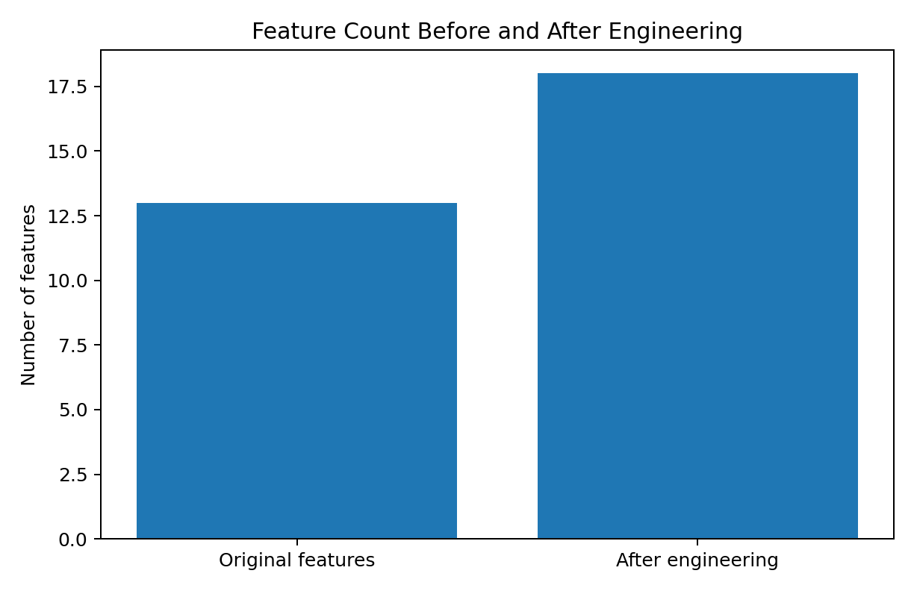
Figure 1. Feature count before and after feature engineering. The feature set increased from 13 original predictors to 18 predictors.

7. Feature Transformation and Scaling
The Week 2 report highlighted substantial differences in feature scales: proline has a much larger numerical scale than variables such as hue. fileciteturn0file0L142-L149 Because Logistic Regression can be affected by differences in feature scale, StandardScaler was included in the modeling pipeline. Scaling is fitted only on the training data through the pipeline, which helps prevent test-set information from leaking into training.
from sklearn.pipeline import Pipeline
from sklearn.preprocessing import StandardScaler
from sklearn.linear_model import LogisticRegression
model = Pipeline([
("scaler", StandardScaler()),
("classifier", LogisticRegression(max_iter=5000))
])

8. Model Selection
Logistic Regression was selected because the target is a multiclass classification problem and the dataset is small and entirely numerical. It provides a clear baseline, trains quickly, and gives a useful benchmark against which more complex algorithms can later be compared.
Two models were evaluated: (1) a baseline Logistic Regression using the 13 original features and (2) an engineered-feature Logistic Regression using the 18-feature dataset.

9. Baseline Model
baseline_model = Pipeline([
("scaler", StandardScaler()),
("classifier", LogisticRegression(max_iter=5000))
])
baseline_model.fit(X_train, y_train)
baseline_predictions = baseline_model.predict(X_test)

10. Engineered Model
X_train_e, X_test_e, y_train_e, y_test_e = train_test_split(
X_engineered, y,
test_size=0.20,
random_state=42,
stratify=y
)
engineered_model = Pipeline([
("scaler", StandardScaler()),
("classifier", LogisticRegression(max_iter=5000))
])
engineered_model.fit(X_train_e, y_train_e)
engineered_predictions = engineered_model.predict(X_test_e)

11. Model Evaluation
For multiclass classification, four weighted metrics were used: accuracy, precision, recall and F1-score. Accuracy measures the proportion of correct predictions. Precision indicates how reliable the predicted classes are. Recall measures how many actual samples are correctly identified. F1-score balances precision and recall.
Metric | Baseline (13 features) | Engineered (18 features)
Accuracy | 0.9722 (97.22%) | 0.9444 (94.44%)
Weighted Precision | 0.9741 | 0.9466
Weighted Recall | 0.9722 | 0.9444
Weighted F1-score | 0.9720 | 0.9443
from sklearn.metrics import accuracy_score, precision_score, recall_score, f1_score
print("Accuracy:", accuracy_score(y_test, predictions))
print("Precision:", precision_score(y_test, predictions, average="weighted"))
print("Recall:", recall_score(y_test, predictions, average="weighted"))
print("F1:", f1_score(y_test, predictions, average="weighted"))
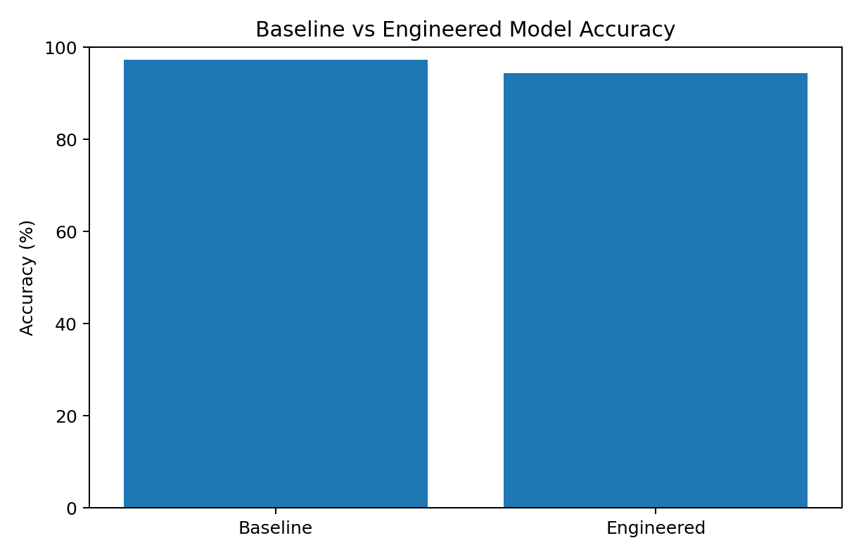
Figure 2. Accuracy comparison between the baseline and engineered-feature models.

12. Cross-Validation
A single train-test split can sometimes give an optimistic or pessimistic estimate. Therefore, 5-fold stratified cross-validation was also performed. The mean validation accuracy was approximately 98.33% for the baseline representation and 98.30% for the engineered representation.
Model | 5-fold mean accuracy
Baseline Logistic Regression | 0.9833 (98.33%)
Engineered Logistic Regression | 0.9830 (98.30%)
from sklearn.model_selection import StratifiedKFold, cross_val_score
cv = StratifiedKFold(
n_splits=5,
shuffle=True,
random_state=42
)
scores = cross_val_score(model, X, y, cv=cv)
print(scores)
print(scores.mean())

13. Confusion Matrix
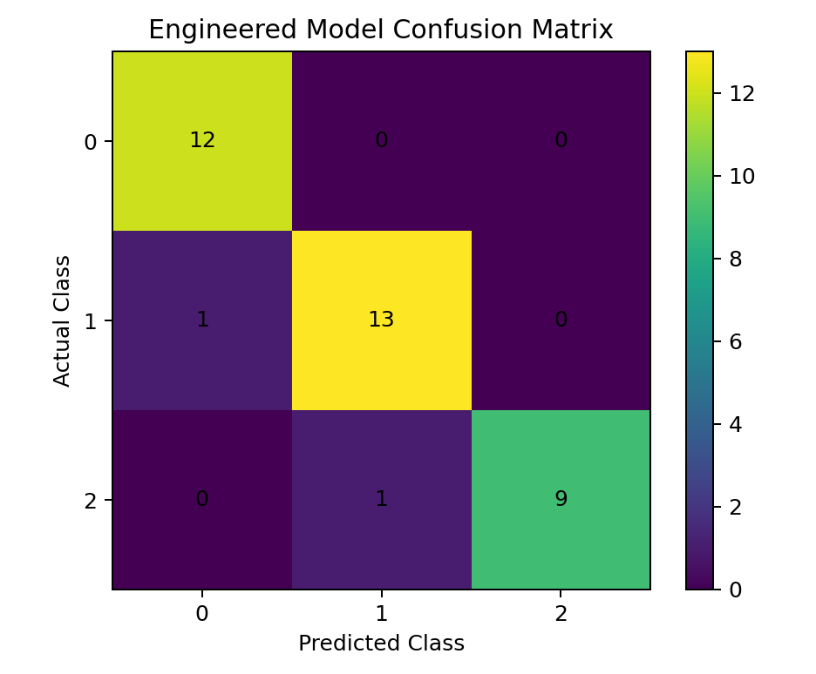
Figure 3. Confusion matrix for the engineered-feature model on the 20% test set.
The engineered model correctly classified 34 of 36 test observations. The confusion matrix contains only 2 incorrect predictions, showing that the model separates the three classes effectively on this split.

14. Interpretation of Results
The baseline model achieved 97.22% test accuracy, while the engineered-feature model achieved 94.44% on the same stratified 20% test split. Therefore, the five engineered features did not improve the holdout accuracy in this particular experiment.
This is an important machine-learning finding: adding features does not automatically make a model better. Some engineered variables can introduce redundant information or interactions that do not generalize as well to unseen samples. The cross-validation results are very close—98.33% for the baseline and 98.30% for the engineered version—suggesting that overall generalization performance remained essentially similar.
The result is also consistent with the Week 2 observation that strong correlation does not automatically mean that a feature should be duplicated or combined. Week 2 specifically noted that strong correlations can indicate related or redundant information and can guide later feature selection. fileciteturn0file0L169-L173

15. Impact of Preprocessing and Feature Engineering
Stage | Impact on Project
Initial inspection | Confirmed dataset size, feature types and absence of missing values.
Scaling | Placed features on comparable numerical scales for Logistic Regression.
Feature engineering | Increased predictors from 13 to 18 and tested domain-inspired ratios, indices and interactions.
Baseline evaluation | Provided a reference point before adding engineered features.
Cross-validation | Checked whether the observed performance was consistent across multiple splits.
These steps directly support later modeling. Without scaling, the large numerical range of variables such as proline could make model coefficients harder to compare. Without a baseline, it would be difficult to determine whether feature engineering actually helped. Without cross-validation, conclusions could depend too heavily on one random train-test split.

16. Complete Model Code
# 1. Load data
from sklearn.datasets import load_wine
import pandas as pd
wine = load_wine(as_frame=True)
df = wine.frame.copy()
df = df.rename(columns={"target": "wine_class"})
# 2. Separate predictors and target
X = df.drop(columns=["wine_class"])
y = df["wine_class"]
# 3. Create engineered features
X["phenolic_ratio"] = X["flavanoids"] / (X["total_phenols"] + 1e-6)
X["phenolic_index"] = (
X["total_phenols"] + X["flavanoids"] + X["proanthocyanins"]
)
X["color_hue_ratio"] = X["color_intensity"] / (X["hue"] + 1e-6)
X["alcohol_proline_interaction"] = X["alcohol"] * X["proline"]
X["total_phenol_flavanoid_interaction"] = (
X["total_phenols"] * X["flavanoids"]
)
# 4. Split data
from sklearn.model_selection import train_test_split
X_train, X_test, y_train, y_test = train_test_split(
X, y, test_size=0.20, random_state=42, stratify=y
)
# 5. Build pipeline
from sklearn.pipeline import Pipeline
from sklearn.preprocessing import StandardScaler
from sklearn.linear_model import LogisticRegression
model = Pipeline([
("scaler", StandardScaler()),
("classifier", LogisticRegression(max_iter=5000))
])
# 6. Train
model.fit(X_train, y_train)
# 7. Predict
predictions = model.predict(X_test)
# 8. Evaluate
from sklearn.metrics import (
accuracy_score, precision_score,
recall_score, f1_score, confusion_matrix
)
print("Accuracy:", accuracy_score(y_test, predictions))
print("Precision:", precision_score(
y_test, predictions, average="weighted"
))
print("Recall:", recall_score(
y_test, predictions, average="weighted"
))
print("F1-score:", f1_score(
y_test, predictions, average="weighted"
))
print("Confusion Matrix:")
print(confusion_matrix(y_test, predictions))

17. Limitations
The dataset contains only 178 observations, so results may not represent performance on a much larger or more diverse wine dataset. The engineered features were selected from the observations available in the Week 2 EDA and were not based on laboratory domain validation. In addition, only Logistic Regression was used for the main comparison, so the report does not claim that it is the best possible algorithm.
The test-set result also depends on the chosen random split. This is why cross-validation was included as a second evaluation method.

18. Future Improvements
- Compare Logistic Regression with Decision Tree, Random Forest, Support Vector Machine and K-Nearest Neighbors.
- Use systematic feature selection to remove redundant predictors.
- Apply Principal Component Analysis (PCA) and compare performance with the original feature space.
- Tune model hyperparameters using cross-validation.
- Investigate class-specific precision, recall and F1-score rather than only weighted averages.
- Test additional feature transformations such as log transformations where appropriate.
- Evaluate the final model on an independent external dataset if one is available.

19. Conclusion
Week 3 successfully extended the Wine Recognition project from exploratory analysis to supervised machine learning. The Week 2 findings were used to design five engineered features based on phenolic measurements, color and hue, and the alcohol-proline relationship. Standardization was applied through a Scikit-learn pipeline, and Logistic Regression was used as the classification model.
The baseline model achieved 97.22% accuracy on the 20% test set, while the engineered model achieved 94.44%. Five-fold cross-validation produced mean accuracies of 98.33% and 98.30% respectively. The main conclusion is that feature engineering should be evaluated empirically: in this experiment, the added features did not improve performance, but they provided a meaningful comparison and demonstrated a complete feature-engineering workflow.
The project is therefore ready for a next stage involving algorithm comparison, feature selection, PCA and hyperparameter tuning.

20. References
- Scikit-learn documentation — Wine Recognition dataset and classification utilities.
- UCI Machine Learning Repository — Wine dataset documentation.
- Pandas documentation — Data manipulation and analysis.
- NumPy documentation — Numerical computing in Python.
- Matplotlib documentation — Data visualization in Python.

