Gora's DynamoDB datastore
Project Description

Amazon DynamoDB is a fast, highly scalable, highly available, cost-effective, non-relational database service. Amazon DynamoDB removes traditional scalability limitations on data storage while maintaining low latency and predictable performance. The gora-dynamodb comprises an Amazon DynamoDB module for Gora which will allow users to utilize the expressiveness offered from the Gora framework in conjunction with Amazon DynamoDB. This includes persisting data to the Dynamo store and analyzing it.

Checklist:

- Test suite is completed for now. The necessary GoraDrivers have been implemented in order to test DynamoDB functionality from the test suite, but there are many other tests that should probably be implemented in the future when new functionality gets added to the Gora-DynamoDB module.
- The DynamoDBKey class has been created to assist the creation of composite primary keys. This is because every DynamoDB table which uses a range key must also use a hash key to determine where this range condition can be applied. It makes necessary the creation of an encapsulating class for a DynamoDB primary key.
- All serialization is done through Amazon Java SDK annotations. This makes serialization process a simpler and more efficient process. The only disadvantage is that we make the new Gora-Compile a more important piece.
- GoraCI has been studied to determine how much it would cost to run similar tests on Amazon DynamoDB. GoraCI test module consists in creating linked lists containing 25 million nodes and using a Map Reduce job to verify that these linked lists have no holes on them. The conclusions about this suite are:
  - GoraCI module writes a million of nodes, then flushes them into disk to then write a different million of nodes referencing the first ones. The problem with this is Gora-DynamoDB module does not flushes batches of writes into the back end but it writes the items directly to Amazon DynamoDB. This was implemented this way because of the throughput offered by Amazon (less than 10 milliseconds per operation [1]). Batch writes or reads weren't envisioned at a initial step to make a “flush” functionality.
  - Amazon solves the “noisy neighbor problem” by restricting the maximum capacity used by every user. This is great but this also imposes some challenges e.g. batch writes are able to encapsulate up to 25 read or write operations. So for our GoraCI testing module we could use one million batch write operations to write our 25 million nodes using Gora-DynamoDB module.
  - The main problem lies in looking for holes within the linked lists. This is because GoraCI performs this verification using Map Reduce jobs; ability which Amazon DynamoDB does not have. Amazon DynamoDB has a workaround through Hadoop Hive, but this means we would have to export the data to Amazon S3 and implement parallel reads ourselves, or to create several DynamoDB tables to represent different Hive partitions and then query this data through Hadoop Hive.
  - The approximate costs are:

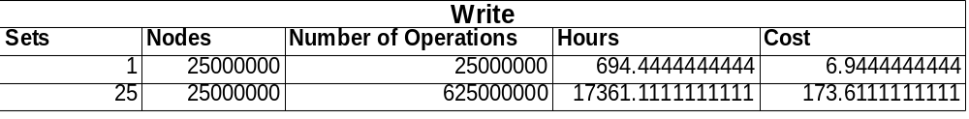
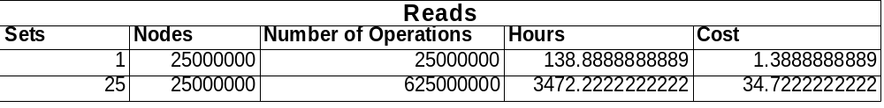
N.B. Unit fro Cost is $US

This is considering that:

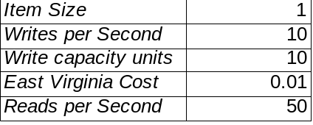

So we would be writing at most 10 items per second, and reading 50 items per second. Using this assumption we calculate the number of hours that it would take to process all this information and then calculate the total amount of money the tests would require. We should seriously consider using BatchWriteItem because the number of write operations would decreased in 25% and so would our costs.

Next Steps:

- Write the compiler class for DynamoDB. This will help us creating schemas with only the XML mapping file. I will encapsulate the actual Gora Compiler, so it can determine on runtime what it is compiling just by using a different set of parameters.
- Study the DynamoDB's BatchWriteItem[2] functionality to determine whether or not this is a good option for GoraCI testing module.
- Study Map Reduce jobs' performance to write directly to Amazon DynamoDB. This is because all these jobs would have to have Amazon Java SDK jars inside to be able to write directly to Amazon DynamoDB.

[1] http://aws.amazon.com/dynamodb/
[2] http://docs.amazonwebservices.com/amazondynamodb/latest/developerguide/API_BatchWriteItem.html

Supervisors Comments

The initial aim was for this report to set the base for running the dynamodb module against Keith Turner's GoraCI testing suite. Since initially receiving this report from Renato we have discussed that these figures are unacceptable and have therefore drawn the following assertions/suggestions.
- Provisioned throughput for both reads and writes in gora-dynamodb needs to be better than 50 and 10 respectively. Current levels do not scale and therefore are not adequate for Gora. The BatchWriteItem API is something which needs to be implemented most certainly.
- We are currently working towards a more realistic overview of exactly how long and how much the GoraCI suite would take to run against gora-dynamodb. Once we have a clearer picture of this we will report this.

We are now nearing the end of the GsoC program for 2012 and we have a final stop date of 23rd August (as of writing it is 12th) therefore it is the intention for the project to come to a close in the next fortnight or so.
I am happy with this timeframe and look forward to working with Renato on Gora once the GsoC program is finished. During the program Renato has expressed an interest to continue working on Gora and I am very happy for this to be the case.

Signed: lewismc

