Gora's DynamoDB datastore

Project Description

Amazon DynamoDB is a fast, highly scalable, highly available, cost-effective, non-relational database service. Amazon DynamoDB removes traditional scalability limitations on data storage while maintaining low latency and predictable performance. The gora-dynamodb comprises an Amazon DynamoDB module for Gora which will allow users to utilize the expressiveness offered from the Gora framework in conjunction with Amazon DynamoDB. This includes persisting data to the Dynamo store and analyzing it.

Checklist:

- Redesign the class structure for gora-core had. We decided to separate the Hadoop based datastores from any other type of data stote. This was because of the Avro dependency inside Gora's core which created a problem for any other type of datastore which was not Avro dependent. This redesign is shown on the class diagram below.
- Fix Amazon Java SDK dependency. The compilation process was having some difficulties due to the lack of the correct dependency to the Amazon Java SDK. After asking Gora's community and getting help from them I got this fixed. The issue was related to a misunderstanding regarding the availability of the Amazon SDK Maven dependency. This has now been added to parent pom.xml and inherited by gora-dynamodb/pom.xml
- I started coding the following classes from their own packages:
  - org.apache.gora.dynamodb.query
    - DynamoDBColumn
    - DynamoDBQuery
    - DynamoDBResult
    - DynamoDBResultSet
    - DynamoDBRow
  - org.apache.gora.dynamodb.store
    - DynamoDBStore
- We decided to use a different abstraction layer between Gora's core module and the DynamoDB datastore in order to make Gora extensible to other cloud based datastore such as [1, 2] among others.

Next Steps:

- Finish coding the classes from the DynamoDB module. In this manner, we will be able to start coding the tutorial example using the DynamoDB datastore and this would give us a good understanding on what we should be testing.
- Start designing DynamoDB test suite. After coding the tutorial example, the DynamoDB test suite should be straight forward to implement, and with this we could start thinking on different types of testing scenarios using a cloud based datastore.
- Test DynamoDBMapper from the com.amazonaws.services.dynamodb.datamodeling package to use instead of Spring library used.
- A test suite has to be designed so we can get some help from Apache Infra to use Amazon Web Services classes. Maybe the easiest thing to do here will be to simulate the tutorial using DynamoDB datastore, and later on think on creating a Nutch-DynamoDB component.

[1] https://developers.google.com/appengine/docs/java/datastore/
[2] http://msdn.microsoft.com/en-us/library/windowsazure/dd179423.aspx

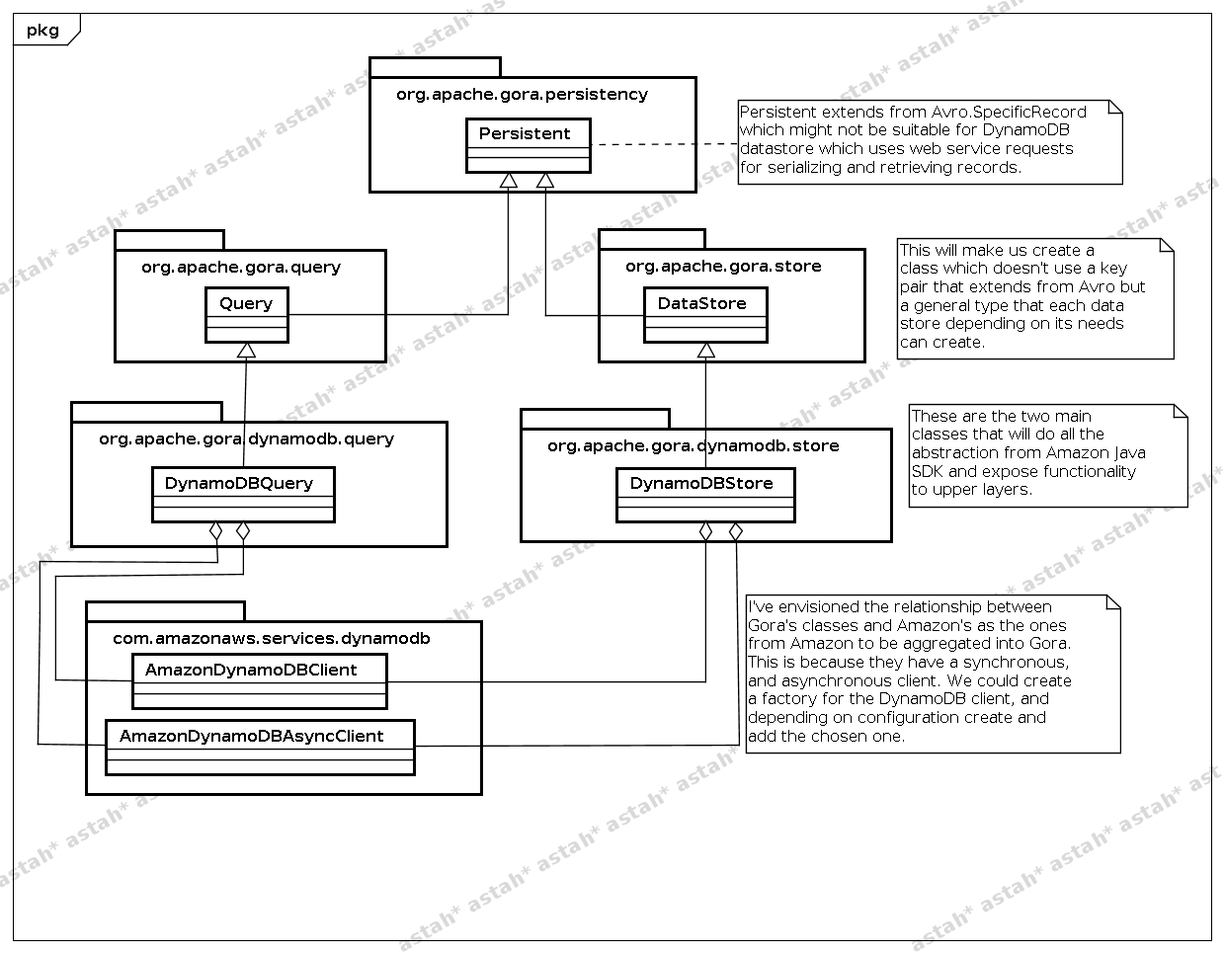

Supervisors Comments

Having successfully agreed the agenda moving forward within Report1 (last report) Renato's approach to the work has increased in focus and direction consistently. Having recently committed his work on Phase 1 of the project we are in agreement about the coding within Phase 2.
Phase 2 will comprise Renato writing the implementations for the DynamoDB store before progressing to begin work on either an examples module or the test suite. To date out discussions regarding Phase 2 coding have surrounded an example scenario typically representing an Amazon/Ebay online store situation where many types/categories of products are available at different prices etc. These products can then be stored within Amazon DynamoDB and queried using the Gora API from within the example classes. We have also been involved in ongoing discussion with ASF Infra@ about getting the available resources for a larger Continuous Integration cloud platform for testing throughput within the goraci testing suite produced by Keith Turner.

Renato has thought very responsibly about the restructuring of the gora-core module, opening this up to other web services reliant platforms. Although this was not 'planned' as such, during various project related discussions we decided that the restructuring was not only necessary but essential for the project as a whole.

We have mid term reporting on the 9th of July, therefore I will be critically and publicly commenting on Renato's progress within the GsoC program this year and how he has been communicating with the Gora community as a whole.

I will finish by saying that I am again happy with Renato's progress since his last reporting session. I wish for this to continue and will work with him diligently to meet this aim.

Signed off: lewismc

