Gora's DynamoDB datastore

Project Description

Amazon DynamoDB is a fast, highly scalable, highly available, cost-effective, non-relational database service. Amazon DynamoDB removes traditional scalability limitations on data storage while maintaining low latency and predictable performance. The gora-dynamodb comprises an Amazon DynamoDB module for Gora which will allow users to utilize the expressiveness offered from the Gora framework in conjunction with Amazon DynamoDB. This includes persisting data to the Dynamo store and analyzing it.

Checklist:

- Started designing the test suite. We've decided to start on working on the test suite in order to determine how this new web service backed datastore will function. I am using the HBase test suite as reference to model DynamoDB test suite and to make tests coherent to Gora's objectives.
- We are deciding on how the tutorial will work. An Amazon product dataset will be created and that will be loaded and queried using the DynamoDB abstraction.
- All the new patches will be made on the branch created for web based datastores [1]. This will help us on automating the build process [2].
- The class diagram showed below explains the changes done inside Gora's core. The main change is the separation of Avro as persistency layer and an actual abstract persistency layer. This needed to be done to allow web based datastores such as [3, 4] to be part of Gora, and to allow developers to use popular datastores.

This “new” abstract interface is “Persistent.java” from org.apache.gora.persistency. It is the same interface as before but this does not extend from Avro anymore which makes it the perfect start point for different abstractions that other datastores might need. Now all the specific abstraction classes are inside their specific packages e.g. the org.apache.gora.persistency.impl contains all the abstract classes which are file based datastores such as Cassandra, HBase, among others. And the org.apache.gora.persistency.ws.impl package contains all the abstract classes which are web service based datastores such as DynamoDB, Google's AppEngine Datastore, Microsoft Azure, and others that Gora might include in the future.
All the other modules have to extend from those two specific packages depending on their own design. That is one of the changes made to Cassandra, Acumulo, HBase, SQL modules. They now extend a PersistentBase class which comes from Avro, but in the other hand, the DynamoDB module comes directly from the Persistent class which does not use Avro. In the future, we might want to abstract more similar functionalities from the different web service datastores to improve this layer.

Next Steps:

- Finish coding the classes from the DynamoDB module. In this manner, we will be able to start coding the tutorial example using the DynamoDB datastore and this would give us a good understanding on what we should be testing.
- Test DynamoDBMapper from the com.amazonaws.services.dynamodb.datamodeling package to use instead of Spring library used.
- Explain to the community the changes done inside the Gora Amazon branch.

[1] http://svn.apache.org/repos/asf/gora/branches/goraamazon/
[2] https://builds.apache.org/job/goraamazon_branch
[3] https://developers.google.com/appengine/docs/java/datastore/overview
[4] http://www.windowsazure.com/en-us/home/features/data-management/

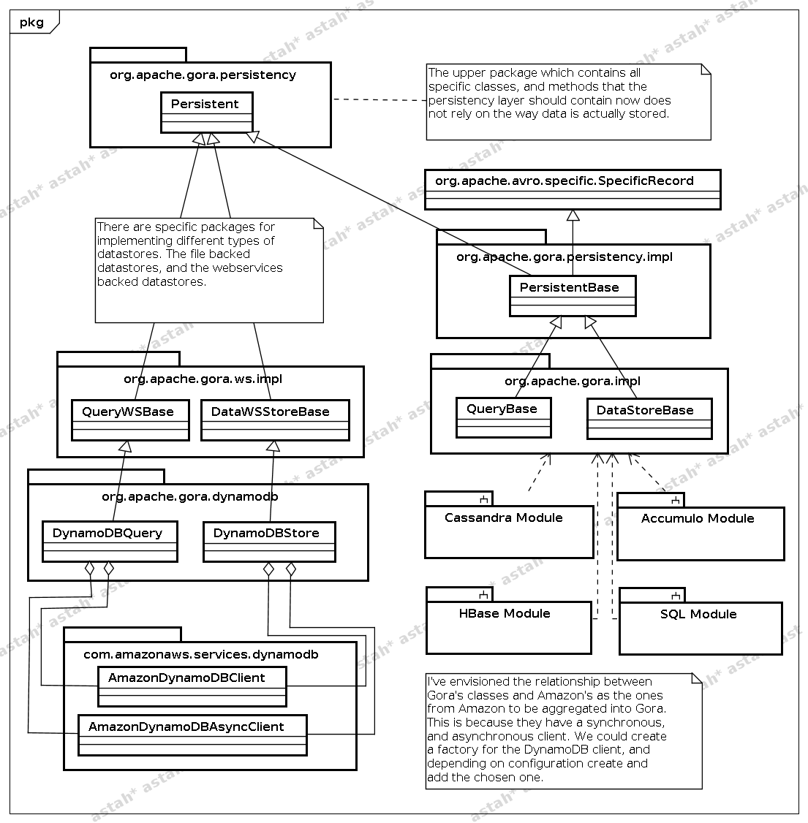

Supervisors Comments

I am happy that Renato has taken a more pragmatic stance within this particular report. The fact he explicitly mentions direct engagement with the Gora community is excellent. This is not only important to explain the changes brought about within the goraamazon branch e.g. the restructuring of the persistency package to accommodate the required separation enabling web services integration but also as the changes are pretty radical in comparison to other changes made in the last while to the Gora code base. Inevitably substantial changes to the structure of the gora-core module will require thorough examination for the Gora community, but based on the thought process behind the proposal I am confident that we can work towards the goal of obtaining community backing as we move forward.

I also appreciate Renato's use of annotations within his reports, this plays a key role in clearly communicating his efforts and also removes a significant area within which uncertainty or confusion may arise to his intention for the restructuring of the existing codebase and addition of new functionality.

As we move forward we are clear about the test suite and are currently in discussions regarding the format of utility drivers for the gora-dynamodb test suite. This will aid us in extending the existing gora Unit tests to the dynamodb module.

Signed: lewismc

