Gora's DynamoDB datastore

Project Description

Amazon DynamoDB is a fast, highly scalable, highly available, cost-effective, non-relational database service. Amazon DynamoDB removes traditional scalability limitations on data storage while maintaining low latency and predictable performance. The gora-dynamodb comprises an Amazon DynamoDB module for Gora which will allow users to utilize the expressiveness offered from the Gora framework in conjunction with Amazon DynamoDB. This includes persisting data to the Dynamo store and analyzing it using Hadoop (MapReduce).

Checklist:

- Review Amazon DynamoDB data model. Amazon DynamoDB data model resembles similarities to Apache Cassandra's data model however in Amazon DynamoDB, a database is a collection of tables. A table is a collection of items, and each item is a collection of attributes. The attributes are key value pairs.
- Review Amazon Java SDK [1]. This was accomplished but there were some problems whilst doing it. The available code [1] presented errors while compiling. These were solved using [2] and [3] as references, so a maven artifact was manually generated. This will represent a problem in the future because we will need a place from where to get the maven artifact and the places that contain it have different versions of it.
- Run examples on Amazon's DynamoDB. This was done by installing an Eclipse plugin[4], and it will help to create a test suite without worrying too much about dependencies.
- Create file structure for the Gora-DynamoDB module. My mentor and me decided that this should be exactly the same as the other modules.
- Start coding some of the classes. I started coding the DynamoDBQuery, DynamoDBStore but there are many classes from Gora-Core that will need to be changed e.g. org.apache.gora.query.Query, org.apache.gora.store.DataStore, among others.
- Create the necessary classes for abstracting Amazon DynamoDB functionality. Most of the functionality is abstracted and used by Amazon Java SDK

Next Steps:

- Decide on whether or not classes like CassandraColumn, CassandraRow, CassandraSuperColumn, etc. should be created for the DynamoDB datastore i.e. DynamoDBTable, DynamoDBItem, DynamoAttribute. This is because all these abstractions reside within com.amazonaws.services.dynamodb.model e.g. AttributeValue, Key, TableDescription and by including the AmazonDBClient we would be using all of them.
- Decide if we require another persistence layer to be created within the Gora-Core module because DynamoDB does not persist objects using Avro but marshaling them using web service requests. The class diagram below shows how this would be done i.e. by generalizing the Store and Query classes from Gora-Core so the DynamoDB classes can also extend them, and continue being coherent with the rest of the data stores.
- There is a class called DynamoDBMapper inside the com.amazonaws.services.dynamodb.datamodeling package which we will be able to use instead of the mapping beans from Spring we were using, but we also need to decide on this.
- A test suite has to be designed so we can get some help from Apache Infra to use Amazon Web Services classes. Maybe the easiest thing to do here will be to simulate the tutorial using DynamoDB datastore, and later on think on creating a Nutch-DynamoDB component.

[1] https://github.com/amazonwebservices/aws-sdk-for-java
[2] https://github.com/itoshkov/aws-sdk-for-java/commit/ee866471a49bed68630b573a06e3f7a9202ff4c6#diff-0
[3] https://forums.aws.amazon.com/thread.jspa?messageID=353772&#353772
[4] http://aws.amazon.com/eclipse

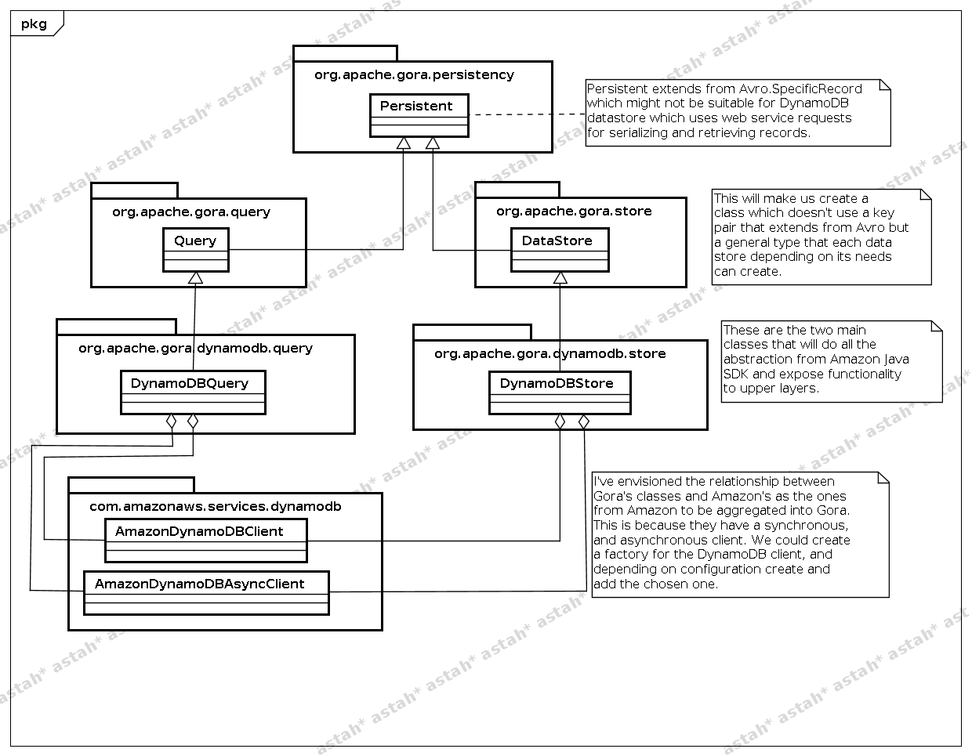

Supervisors Comments

- In establishing the correct module structure (4 Checklist) we now need to iron out some high level probelms w.r.t the maven dependencies (2 Checklist). As the Amazon SDK is not available on Maven Central, an immediate workaround which springs to mind would be to include the library in the $GORA_HOME/gora-dynamodb/lib-ext directory, this would then be made available at runtime. Although this would mean distributing Gora with the library, currently it is ASLv2 licensed so this would not be an issue.
- Renato has been getting to grips with the Amazon SDK examples (3 Checklist) which is enouraging.
- Based on Renato's ongoing investigation of the SDK and the applicability of API usage within the traditional $gora-moduleStore, $gora-moduleQuery, $gora-moduleClient, etc. We need to fully establish the discrete differences and anomalies presented by the DynamoDB architecture and therefore how we must communicte with it through the Gora API. More work needs to be done here and this will be a key deliverable within the next report. Additionally we also need to substantiate on how gora-core can accomodate/needs to change to provide a marriage between the new module. This is also critical and should be contained within the next reporting session. (5 Checklist, 1 & 2 Next Steps)
- W.r.t (4 Next Steps), we have been discussing the adaption of an existing testing suite for Cassandra [5], which we may possibly be able to partly convert to run the Gora Unit tests on. Although this has still to be fully investigated, the test driven aspect of progressing with this module should be treated with utmost importance and priority. It would be excellent for Renato to have a fully functioning test suite for the next reporting session. This would not only mark a 1st milestone, but would also enable us to commit code to the branch [6] we recently established.

Generally speaking I am happy with Renato's approach to the project, I am not concerned about the fact that our first GSoC commit has still to materialise as there was a substantial learning curve over the last month or so mainly focused around getting to grips with the Amazon SDK.
Now that Renato and myself have established a firm reporting schedule as well as a direction for the immediate future we are well on our way to succesfully reporting when mid session reporting is due in mid July. In the interm we have lotsof work to do. It is also very encouraging to see that Renato has been in contact with the Amazon community as well as the Gora one.

Supervisor: lewismc

[5] http://svn.apache.org/repos/asf/cassandra/branches/cassandra-0.8/test/distributed/
[6] http://svn.apache.org/repos/asf/gora/branches/goraamazon/

