GuvnorTest Plan

Version 1.0
July 28, 2010

Table of Contents
Table of Contents 2
Introduction 3
Overview 3
Audience 3
Scope and Purpose 3
Revision History 3
Related Documents 3
Assumptions 3
Features to be Tested 3
Features not to be tested 3
Testing Tools 3
Approach 4
Test Deliverables 4
Testing Tasks 4
Environment 4
Test Outline 5
Test Details 6

Introduction

Overview
This document discusses the test strategy, testing limits, and overall scope of testing scheduled for Guvnor. Since Guvnor is expected to evolve rapidly, we can also expect the nature of the testing approach to evolve also.

Audience
This information is targeted toward the Guvnor team, and anyone else who may be interested in understanding how we perform our testing.

Scope and Purpose
This plan covers the functional testing approach of Guvnor.

Revision History
Date | Author | Description
2010/07/28 | Jervis Liu | Initial documentation

Related Documents
Document | Description
BRMS 5.1 Test Plan

Assumptions

Features to be Tested

Features not to be tested

Testing Tools

Approach

Test Deliverables

Testing Tasks

Environment
Testing will be completed on several systems and may change over time. It is therefore, much more important to list the minimum machine requirements as well as required software.

Server – JBOSS AS 5.5/Tomcat 5.5, JDK 1.5
Windows/Linux

Client: Windows/Linux, IE6, IE7, IE8, IE9, Firefox.

Test Outline
- Installation, initial configuration.
- Documentation is current, accurate and complete
  - All documentation files are present
  - Release notes are current
  - Version number is correct
- Install is available for download
- Downloaded drools-guvnor.war is installed into server container without errors. No error message on server's console, no error message in server's log file.
- Log in without input user name and password, verify this works.
- Verify “Samples” are installed correctly.
- Click “About”, verify the version number.
- Export a Guvnor dump from an older version Guvnor, import the dump into Guvnor, verify it works.

- Authentication, role based authorization.
- Configure Guvnor to use JAAS.
- Log in with incorrect user name and password, verify it does not work. Log in with configured user name and password, verify it works.
- Give one user Administrator permission.
- Configure Guvnor to enable role based authorization. Log out.
- Log in with a user name who has Administrator permission. Create users with package admin permission, package readonly permission, category analyst permission.
- Log in with package admin, verify permission.
- Log in with package readonly, verify permission.
- Log in with analyst, verify analyst can only see assets under categories. Verify analyst can update/save/verify/validate/view source/change status/rename/archive, but can not copy/Prompt to Global.

- InBox.
  - Log in , edit an asset, open “Inbox - > Recently Opened” and “Inbox - > Recently Edited”, verify that the asset appears under those two boxes.
  - Log in as user A, edit an asset. Log out then log in as user B. Edit the same asset as user A just edited. Log out and log in as user A again, verify the asset appears under “Inbox - > Incoming changes”.

- Find.
  - Name search: input “Pricing” in the search box,verify the result returns two assets: “Pricing low end” and “Pricing loans ”
  - Text search: TODO
  - Attribute search:

- REST interface and RSS Feed.
  - Open package editor: “Knowledge bases - > packages - > mortgages”, verify all URLs actually work.
  - Open package editor: “Knowledge bases - > packages - > mortgages”, scroll down to the “Version history” section, click the “Version feed”, verify it works.
  - Open “Knowledge bases - > packages - > mortgages - > Business rule assets”, click the RSS Feed icon, verify it works.
  - Open an asset, open “Attribute” tab view, click the RSS Feed icon under the Discussion section, verify it works.
  - Open an asset, open “Attribute” tab view, scroll down to the “Version history” section, click the “Version feed”, verify it works.

- Global area
  - Use “Promote to Global” to promote an asset from package to Global area. Verify that the asset now belongs to Global area.
  - Open asset in Global area, click “Promote to Global” menu, verify it returns an error message.
  - Create an asset in Global area. Then create a new asset in a package which is imported from the asset in Global area. Build the package, verify everything works.

- Package editor
  - Open package editor: “Knowledge bases - > packages - > mortgages”, click the “Attribute” tab, verify there are three sections displayed: Metadata, Version history and Description.
  - Verify you can edit the text in the description text box.
  - Refresh: Click “Save changes” menu. Verify “Last modified” attribute is refreshed after save. Verify “Current version number” is refreshed after save.
  - Verify all menus work.
  - Verify “Built-in” selector works.
  - Verify version history: TODO.

- Creating, updating and deleting categories
  - Start Guvnor with no previous repository installed.
  - Create three categories, tg1, testGategory2, removeMeTestCategory3
  - Remove removeMeTestCategory3
  - Try to add another tg1, verify get an error popup saying that “Sorry, an item of that name already exists in the repository. Please choose another. “

- Creating, updating and deleting packages
  - Create three new packages, tp1,testPackage2 and removeMeTestPackage3
  - Add few dummy rules to each
  - Archive removeMeTestPackage3
  - Verify that the removeMeTestPackage3 and the dummy assets it had are in Admin->Archived
  - Restore removeMeTestPackage3
  - Verify that the dummy assets were archived with the package
  - Archive removeMeTestPackage3
  - Delete removeMeTestPackage3 and see that the dummy rules are deleted with it

- Models
  - Open the package view
  - Create two model jars with different facts
  - Upload the first model jar to Guvnor
  - Verify that the fact types are imported in the package view imports, do not refresh or close the package view. This should happen automatically.
  - Upload the seconds model jar to Guvnor
  - Verify that the fact types are added and the previous one were not removed. Again do not close or refresh
  - Add a fact to the second jar and upload it again
  - Verify that the new fact type was added to the package view imports and that there are no duplicates
  - Remove the first jar
  - Verify that the imports for the removed jar were removed

- Declarative Models
  - Create a new model
  - Add Pet model:
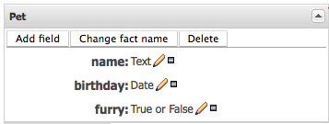
  - Press “Validate” and verify that there are no issues
  - Press “Save changes”
  - Close the tab
  - Open the Model asset again and verify that the changes where saved
  - Add two new models Cheese and Person:
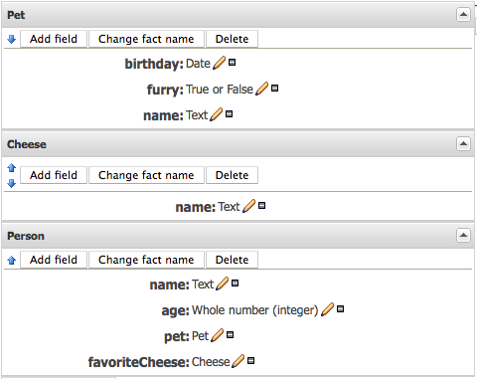
  - Move Pet fact to the bottom with the green arrows and back to the top again. Verify that there are no errors and that the top and bottom models have only one arrow visible.
  - Press “Validate” and verify that there are no issues
  - Press “Save changes”
  - Close the tab
  - Reopen the tab and verify that the changes were saved

- Declarative Models – Type extension

  - Create a new package, “p1”
  - Create a new declared type “F1” with field “field1” of type “Text”
  - Create a new declared type “F2” extending “F1” with field “field2” of type “Text”

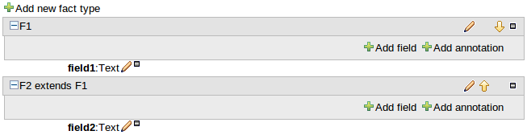
  - Create a rule “r1”
  - Add facts “F1” and “F2”
  - Check “F1” has field field “field1”
  - Check “F2” has fields “field1” and “field2”

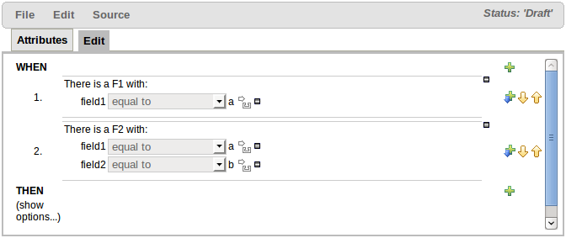
  - Create a new package, “p2”
  - Upload a POJO model containing a type that can be extended (i.e. has at least one field with a “getter” and “setter”).
  - Check package “p2” imports the POJO type correctly
  - Create a new empty declared type of the same name as the POJO type
  - Create a new declared type extending the POJO type, adding a new field

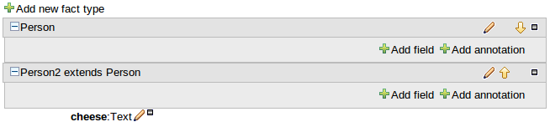
  - Create a rule “r1”
  - Add facts for the POJO type and declared extending type
  - Check the POJO type has applicable fields
  - Check the declared extending type has applicable fields (including the POJO type's)

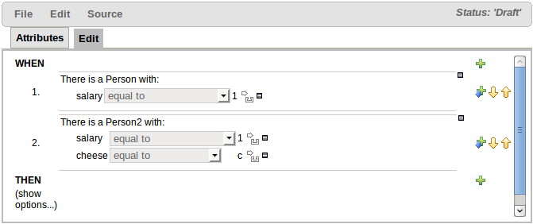
- Special widgets for different value types
  - Create new rule
  - Create or reuse the test models Pet, Cheese and Person from previous test
  - Create the following rule:
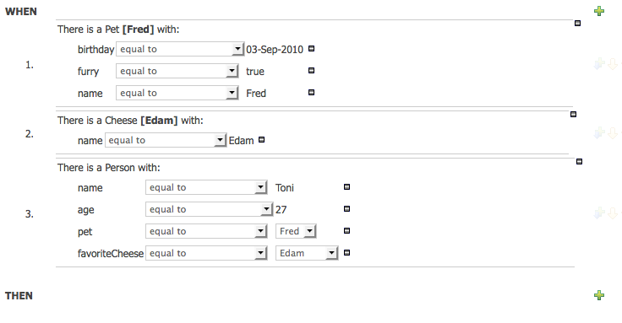
  - Change the Pet fact variable name to “Rodi” and verify that the Person.pet=fred changes to “Rodi” too
  - Change the Rodi:Pet( name == “Fred” ) to “Rodi” and verify that you get the text editor widget:
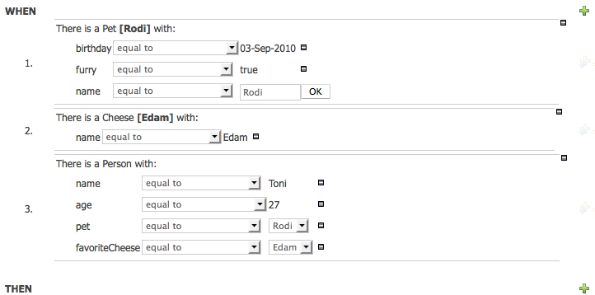
  - Verify that the Pet fields birthday and furry have the following editor widgets:
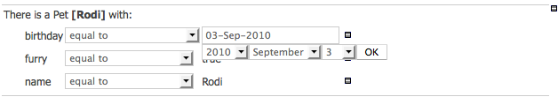
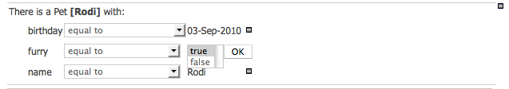

  - Press “Save and close”
  - Reopen the rule and verify that the changes were saved

- FactPattern and Constraint binding
  - These tests check that binding of FactPatterns and field constraint values works.
  - Create a declarative fact model (or upload a POJO) that has the following:-

- An integer field
- A boolean field
- A date field
- A text field
- An enum field for an enum, say called MyEnum1
- An enum field for another enum, say called MyEnum2
- A child field of another fact type

These fields will be used to check only variables bound to certain data-types can be bound to other fields of the same data-types. Two enums are required as Guvnor natively considers all enums to be of the same type but we have special code to differentiate between them.

  - Create a rule as below; binding each of the different data-types to a different variable and then re-using the applicable variable in another FactPattern.

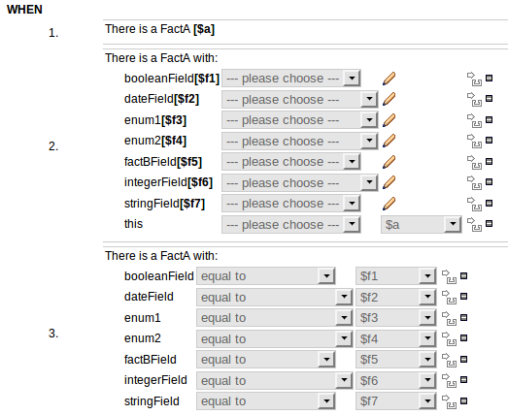

  - Create the “then” part of the rule as below; having a different section for each of:-

- Modify an existing FactPattern
- Set fields on an existing FactPattern
- Create a new Object of the applicable FactPattern

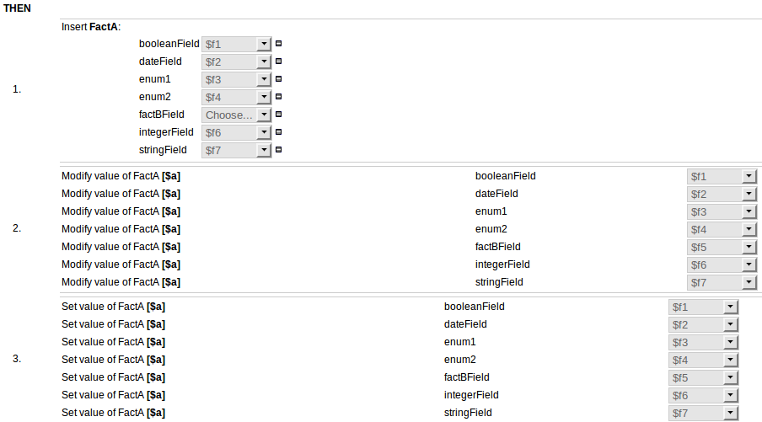
- CEP Operators
  - These tests check that CEP operators work correctly.
  - Create a declarative fact model (or upload a POJO) that has the following:-

- A FactPattern with a date field, say called FactA
- Another FactPattern that has been annotated to be an event, say called FactB

These facts and fields will be used to check CEP operators are correctly available for events and data fields when used in conjunction with events.

  - Create a rule as below, binding the date field on the non-event FactPattern for use in the event FactPattern. In example given FactPattern FactA is a non-event whereas FactPattern FactB is an event.

- The operator on the FactB (the event) field constraints should include 13 CEP operators.
- The operator on FactA comparing the date field to the previously bound date field should include 3 CEP operators (“after”, “before” and “coincides”).

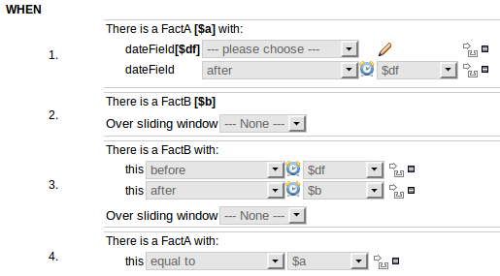

- Rules and Test Scenarios
  - Create a new guided rule with the editor to fit the following DRL:
rule “test rule”
when
(AND Person(name == “Toni” ) Person( name =”Jervis”))
then
insert( new SuperDevsExist() )
end
  - Verify that all the components are drawn correctly and the rule can be created
  - Create the following Test Scenario for this rule:

Create asset, make changes, press save and then close, open and see if the changes were made
Create asset, make changes, press save and close, reopen the asset to see if changes were made
Decision tables, open, edit, verification
Verification QA
Build all
Create new Decision tables, make changes, close and open to see if changes where made
Edit existing Decision table.

- Test scenario
  - Run all test scenarios in mortgage example. Verify they works.

- Template rules
  - Setup declarative model as follows:-
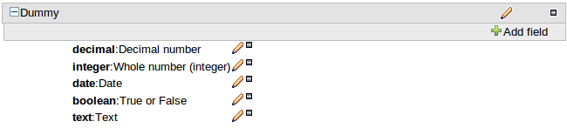
  - Create “New Rule Template” as follows (ALL values are “Literals”):-

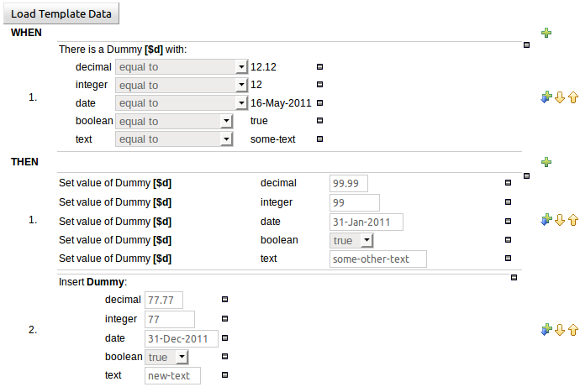
  - Check DRL is correctly formatted for data-types:-

rule "t1_0"
dialect "mvel"
when
$d : Dummy( decimal == 12.12 , integer == 12 , date == "16-May-2011" , boolean == true , text == "some-text" )
then
java.text.SimpleDateFormat sdf = new java.text.SimpleDateFormat("dd-MMM-yyyy");
$d.setDecimal( 99.99 );
$d.setInteger( 99 );
$d.setDate( sdf.parse("31-Jan-2011") );
$d.setBoolean( true );
$d.setText( "some-other-text" );
Dummy fact0 = new Dummy();
fact0.setDecimal( 77.77 );
fact0.setInteger( 77 );
fact0.setDate( sdf.parse("31-Dec-2011") );
fact0.setBoolean( true );
fact0.setText( "new-text" );
insert(fact0 );
end

  - Create “New Rule Template” as follows (ALL values are “Template Keys”):-

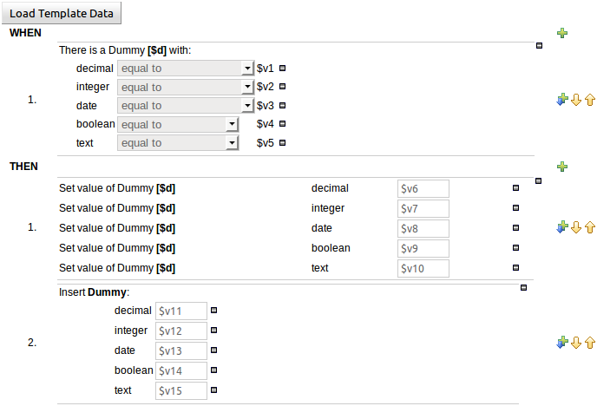
  - Click “Load Template Data”
  - Enter data for each Template Key
  - Ensure the pop-up for each Template Key is correct for the data-type
  - Check DRL is correctly formatted for data-types:-

rule "t2_0"
dialect "mvel"
when
$d : Dummy( decimal == 55.55 , integer == 55 , date == "01-May-2011" , boolean == true , text == "text" )
then
java.text.SimpleDateFormat sdf = new java.text.SimpleDateFormat("dd-MMM-yyyy");
$d.setDecimal( 66.66 );
$d.setInteger( 66 );
$d.setDate( sdf.parse("02-May-2011") );
$d.setBoolean( false );
$d.setText( "text2" );
Dummy fact0 = new Dummy();
fact0.setDecimal( 77.77 );
fact0.setInteger( 77 );
fact0.setDate( sdf.parse("03-May-2011") );
fact0.setBoolean( true );
fact0.setText( "text3" );
insert(fact0 );
end

- Guided Decision Table rules
  - Setup model as follows:-

  - Create new rule using Guided Decision table
    - Add columns as follows:-
      - All Condition columns are literals bound to the same fact pattern.
      - All Action columns set values on the existing bound pattern.

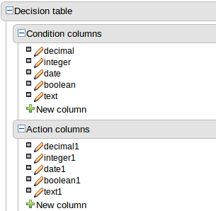
    - Add a row
    - Enter values for each column
    - Ensure the pop-up for each Column is correct for the data-type
    - Check DRL is correctly formatted for data-types:-

#from row number: 1
rule "Row 1 dt1"
dialect "mvel"
when
$d : Dummy( decimal == 11.11 , integer == 11 , date == "16-May-2011" , boolean == true , text == "text" )
then
java.text.SimpleDateFormat sdf = new java.text.SimpleDateFormat("dd-MMM-yyyy");
$d.setDecimal( 22.22 );
$d.setInteger( 22 );
$d.setDate( sdf.parse("17-May-2011") );
$d.setBoolean( false );
$d.setText( "text2" );
end

  - Create new rule using Guided Decision table
    - Add columns as follows:-
      - All Condition columns are literals bound to the same fact pattern.
      - All Action columns set values on a new fact instance.

    - Add a row
    - Enter values for each column
    - Ensure the pop-up for each Column is correct for the data-type
    - Check DRL is correctly formatted for data-types:-

#from row number: 1
rule "Row 1 dt2"
dialect "mvel"
when
$d : Dummy( decimal == 11.11 , integer == 11 , date == "16-May-2011" , boolean == true , text == "text" )
then
java.text.SimpleDateFormat sdf = new java.text.SimpleDateFormat("dd-MMM-yyyy");
Dummy $d2 = new Dummy();
$d2.setDecimal( 22.22 );
$d2.setInteger( 22 );
$d2.setDate( sdf.parse("17-May-2011") );
$d2.setBoolean( false );
$d2.setText( "text2" );
insert($d2 );
end

  - Create new rule using Guided Decision table
    - Add columns as follows:-
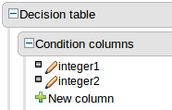
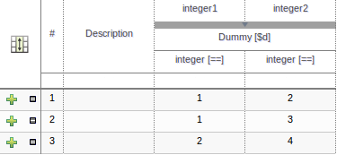
    - Add data as follows:-

    - Click “toggle grouping” icon:-

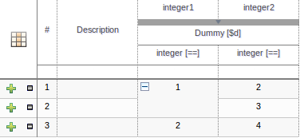
    - Collapse cell containing “1”:-

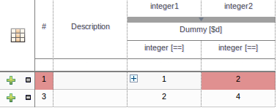
    - Change value of cell containing “1”
    - Expand cell containing new value (used to be “1”)
    - Check value has replicated to both grouped cells

  - Create new rule using Guided Decision table
    - Add columns as follows:-

    - Add data as follows:-

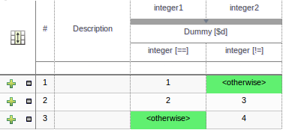
    - Check DRL is correct for “Otherwise”:-

#from row number: 1
rule "Row 1 dt3"
dialect "mvel"
when
$d : Dummy( integer == 1 , integer in ( 3, 4 ) )
then
end

#from row number: 2
rule "Row 2 dt3"
dialect "mvel"
when
$d : Dummy( integer == 2 , integer != 3 )
then
end

#from row number: 3
rule "Row 3 dt3"
dialect "mvel"
when
$d : Dummy( integer not in ( 1, 2 ) , integer != 4 )
then
end

  - General testing:-
    - Check columns resize
    - Check header expands and collapses
    - Check rows can be added at the end
    - Check rows can be added midway using [+] icons
    - Check rows can be deleted using [-] icons
- Enumerations
  - Upload a Java POJO Model file
    - POJO Model to contain one Java enumeration
    - POJO Model to contain one primitive field (to map Guvnor enum to)
  - Create a Guvnor enum for primitive field, e.g.:-

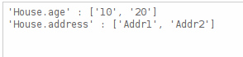
  - Create a “New Rule Template” using both Java and Guvor enums:-

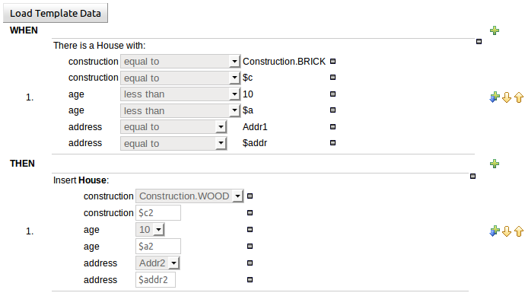
    - Load Template Data
    - Enter values for enumerations
    - Check generated DRL is correct:-

rule "t1_0"
dialect "mvel"
when
House( construction == Construction.BRICK , construction == Construction.BRICK , age < 10 , age < 20 , address == "Addr1" , address == "Addr1" )
then
House fact0 = new House();
fact0.setConstruction( Construction.WOOD );
fact0.setConstruction( Construction.WOOD );
fact0.setAge( 10 );
fact0.setAge( 10 );
fact0.setAddress( "Addr2" );
fact0.setAddress( "Addr2" );
insert(fact0 );
end

  - Create a new “Guided Decision Table” rule using both Java and Guvnor enums:-

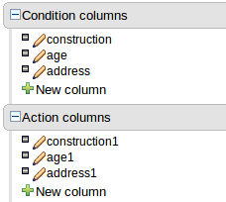
  - Enter values in table for enumerations
  - Check generated DRL is correct:-

#from row number: 1
rule "Row 1 dt1"
dialect "mvel"
when
$h : House( construction == Construction.BRICK , age == 10 , address == "Addr1" )
then
$h.setConstruction( Construction.WOOD );
$h.setAge( 20 );
$h.setAddress( "Addr2" );
end

- The Eclipse Guvnor tools (EGT) plugin
  - Install EGT plugin. Verify the installation process works.
1. Open Eclipse.
2. Open the menu "Help", menu item "Install new software..."
3. Click on the button "Add..." to add a new software site.
4. Fill in the name "drools local update site"
5. Click on the button "Local..." and select "droolsjbpm-tools/drools-eclipse/org.drools.updatesite/target/site/"
6. Select all the plugins. Click the buttons "Next" and "Finish".
  - Open "Guvnor Repository Exploring" perspective.
  - Add a Guvnor repository connection. Use default values. (Make sure you have started Guvnor application). Verify you can connect to Guvnor repository.
  - Verify you can read and modify files from Guvnor repository.

- The Drools plugin
  - Install Drools plugin. Verify the installation process works.
1. Open Eclipse.
2. Open the menu "Help", menu item "Install new software..."
3. Click on the button "Add..." to add a new software site.
4. Fill in the name "drools local update site"
5. Click on the button "Local..." and select "droolsjbpm-tools/drools-eclipse/org.drools.updatesite/target/site/"
6. Select all the plugins. Click the buttons "Next" and "Finish".
  - Create a new Drools project.
  - Configure Drools runtime.
  - Verify project and files are generated successfully. Verify the project builds successfully.

- Drools Expert examples.
a. Run example using runExamples.bat or runExamples.sh. Verify all examples run successfully
b. Build example using pom provided: mvn clean install
c. Generate Eclipse project: mvn eclipse:eclipse
d. Import example project into Eclipse. Verify all examples compile. Verify all examples run successfully
e. Verify debug:
1. Set a break point in Helloworld.drl. Uncomment the logger in HelloWorldExample.java
- Debug HelloWorldExample as Drools Application. Verify Agenda view and Audit view.

- jbpm-integration examples.
a. Run example using runExamples.bat or runExamples.sh. Verify all examples run successfully
b. Build example using pom provided: mvn clean install
c. Generate Eclipse project: mvn eclipse:eclipse
d. Import example project into Eclipse. Verify all examples compile. Verify all example run successfully.
e. Verify can debug and break on a process execution:
1. Put a break point in numberguess example
2. Verify can open the process and it shows the current "wait" points, where it is in the process. And should allow to inspect the working memory

Test Details

