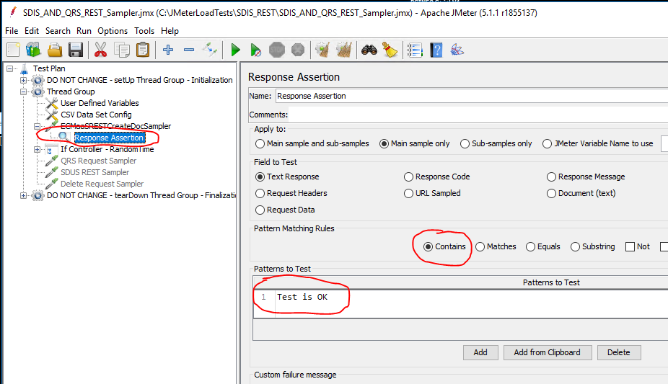

I ran a fresh test for 10 minutes. It successfully generates the JTL report but fails to generate the dashboard report. The generated report file contains over 182000 entries. I am attaching the report file (JTLreport.log) which contains only few success entries and few failed entries. I am also attaching the jmeter.log file. As I set the log level to ERROR the log is short.

Test started: 2019/07/31 17:16:26.502

Test ended: 2019/07/31 17:26:47.420

Exception for dashboard report thrown at 2019-07-31 17:27:03,538

I am attaching jmeter.properties, user.properties used for this test.

The test plan has an Assertion as above.

I am pasting the below from previous comment here as reference.

**It looks to me as you are trying to send data inside the 'message' (Successfully performed action: HOST_IPADDRESS =10.89.8.21,10.89.8.21-Thread Group 1-13,,true,). In the case of an exception those entries are MISSING (You could set an error message with the missing entries yourself though). As you are using the same delimiter for /your/ message as the data for JMeter, JMeters parser will fail.**

Please note I changed the Assertion string to “Test is OK” from “Successfully performed action” and in my code to make the record short. The code chunk is below.

The characters of /and / (/Test is OK/) are put by JMeter in the report file as in the following record taken from the report file. My code does not add the / and / characters around assertion string.

2019/07/31 17:16:49.822,21033,ECMaaSRESTCreateDocSampler,500,Failed,10.89.8.21-Thread Group 1-6,,false,Test failed: text expected to contain /Test is OK/,6,0,15,15,null,0,0,0

**Test Failed scenario**

The following code is executed when the test fails. The Response data & Response Message are set as below. In failed cases the assertion fails as the Response does not contain “Test is OK”

} **catch** (Exception e) {

sampleResult.setResponseCode("500");

sampleResult.setSuccessful(**false**);

sampleResult.setResponseMessage("Failed");

sampleResult.setResponseData("Failed", **null**);

}

**Test Success Scenario**

In success cases the assertion passes as the Response does contain “Test is OK”

sampleResult.setSuccessful(**true**);

sampleResult.setResponseCodeOK();

sampleResult.setResponseData("Test is OK \n Document Created, GUID: " + guid + "; HOST_IPADDRESS =" + hostIPAddress , **null**);

sampleResult.setResponseMessage("Test is OK : HOST_IPADDRESS =" + hostIPAddress);