**I have 3 test Plans to run in parallel**

***Test plan 1: (10 users – Execution time : 2 min - Target throughput 1 request per second )***

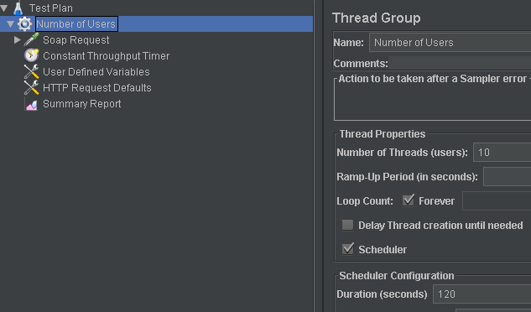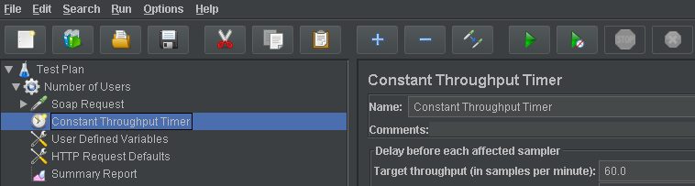

***expected result:*** 1200 Requests

***measured result:***



***Test plan 2: (10 users – Execution time : 2 min - Target throughput 1 request per second )***

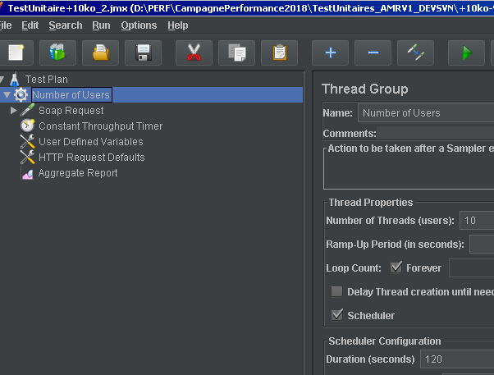

***expected result:*** 1200 Requests

***measured result:***



***Test plan 3: (2 users – Execution time : 2 min - Target throughput 1 request per second )***

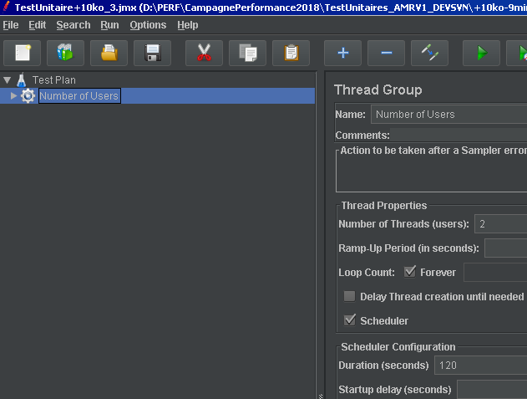

***expected result:*** 240 Requests

***measured result:***



***Machine configuration:***

***CPU***

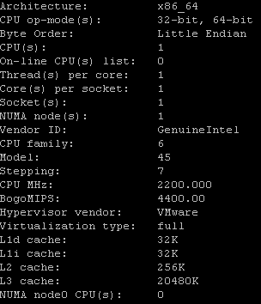

***Memory:***

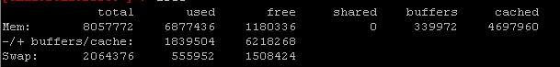

***OS:***

***Red Hat Enterprise Linux Server release 6.4 (Santiago)***