**During Distributed Testing(remote) mode(2 bugs: logging bug & report files bug)**

1. Logging bug: when I test using my custom java sampler in distributed mode the log4j log statements are not printed to log. In standalone mode those log statements are printed.
2. report files bug(in distributed testing mode):
   1. User defined variables for report files.

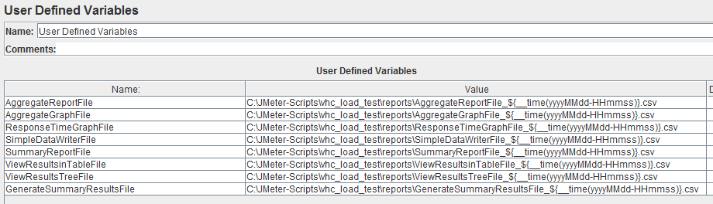

* 1. Using Custom Java Sampler

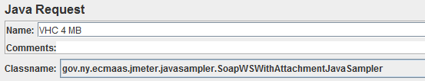

* 1. Using of above variables for Listeners.

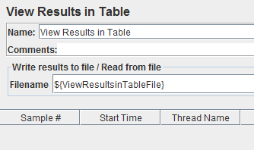

Files are created in JMETER_HOME\bin using the variables names itself, variables are not evaluated.

