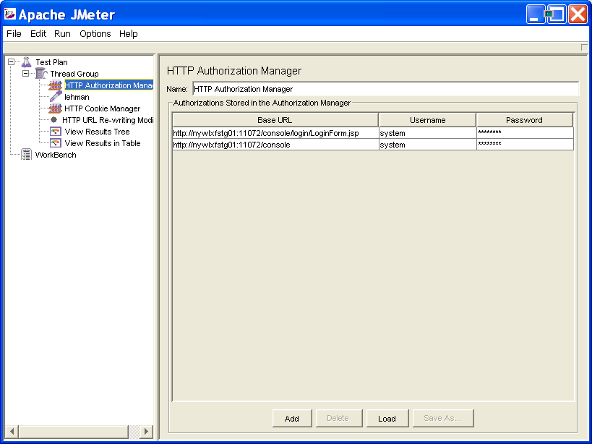

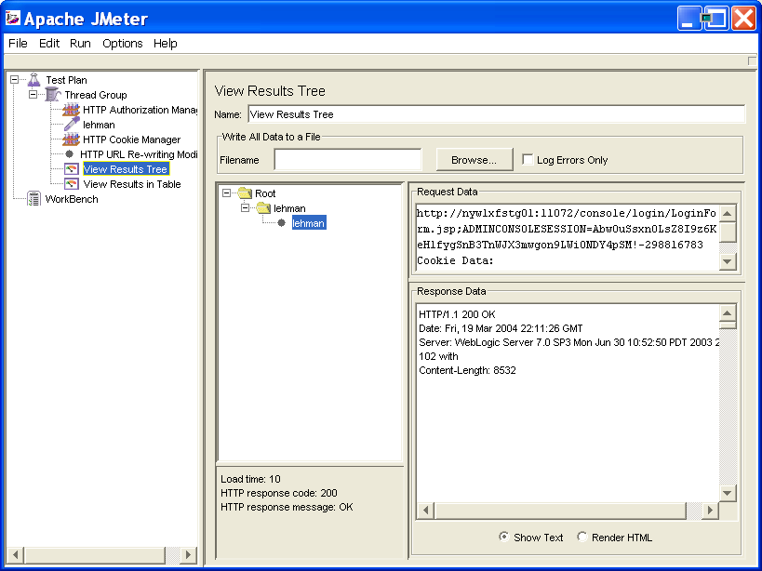

Response Data:

HTTP/1.1 200 OK
Date: Fri, 19 Mar 2004 22:11:26 GMT
Server: WebLogic Server 7.0 SP3 Mon Jun 30 10:52:50 PDT 2003 273102 with
Content-Length: 8532

<html xmlns="http://www.w3.org/1999/xhtml">

<HEAD>
<META HTTP-EQUIV="content-type" CONTENT="text/html" charset="null">
<STYLE TYPE="text/css" MEDIA="screen">

.top-background {
COLOR: white; BACKGROUND-COLOR: #608c8c
}
.sidenav {
BACKGROUND-COLOR: white
}
.content-background {
BACKGROUND-COLOR: white
}
.top-info-background {
COLOR: yellow; BACKGROUND-COLOR: black
}
.behind-main-tabs-background {
BACKGROUND-COLOR: #e8f7f7;
}
.tab-selected {
FONT-WEIGHT: bold;
MARGIN: 0px;
CURSOR: default;
COLOR: white;
FONT-FAMILY: Arial, Helvetica;
BACKGROUND-COLOR: #608c8c
}
.tab {
MARGIN: 0px;
CURSOR: default;
FONT-FAMILY: Arial, Helvetica;
color: black;
BACKGROUND-COLOR: #b8cece;
TEXT-DECORATION: none;
}
.subtab-selected {
FONT-WEIGHT: bold;
MARGIN: 0px;
CURSOR: default;
FONT-FAMILY: Arial, Helvetica;
COLOR: black;
BACKGROUND-COLOR: white
}
.subtab {
MARGIN: 0px;
CURSOR: default;
FONT-FAMILY: Arial, Helvetica;
COLOR: black;
BACKGROUND-COLOR: #b8cece;
TEXT-DECORATION: none;
}
.tab-dropshadow {
BACKGROUND-COLOR: black
}

/* style used for content/page heading */
.pageheader{
FONT-FAMILY:Arial,Helvetica,Tahoma,Verdana,sans-serif;
MARGIN-BOTTOM: 4pt; MARGIN-TOP: 0pt;
FONT-SIZE:120%;
FONT-WEIGHT:bold;
TEXT-ALIGN: center;
COLOR: #325e5e;
}
.instructions {
FONT-STYLE: normal; /* using 'italic' to test */
}
.spacer {
FONT-SIZE: 30%;
}

BODY {
BORDER-RIGHT: 0px; PADDING-RIGHT: 0px; BORDER-TOP: 0px; PADDING-LEFT: 0px; PADDING-BOTTOM: 0px;
MARGIN: 0px; BORDER-LEFT: 0px; PADDING-TOP: 0px; BORDER-BOTTOM: 0px; FONT-FAMILY: Arial, Helvetica; BACKGROUND-COLOR: #ffffff
}

/* ======= top nav bar ======= */
.topbarbig{
FONT-FAMILY:Arial,Helvetica,Tahoma,Verdana,sans-serif;
LINE-HEIGHT:22px;
COLOR:white;
FONT-SIZE:18px;
FONT-WEIGHT:bold;
}

/* style for first line of the product name in the top nav bar */
.topbarsmall{
FONT-FAMILY:Arial,Helvetica,Tahoma,Verdana,sans-serif;
LINE-HEIGHT:16px;
FONT-SIZE:14px;
COLOR:white;
}

/* style for white text */
.WHITETEXT {
FONT-FAMILY:Arial,Helvetica,Tahoma,Verdana,sans-serif;
LINE-HEIGHT:16px;
FONT-SIZE:12px;
COLOR:#FFFFFF;
}

A:link {
BACKGROUND: none transparent scroll repeat 0% 0%; COLOR: #0000aa; FONT-FAMILY: Arial, Helvetica
}
A:active {
BACKGROUND: none transparent scroll repeat 0% 0%; COLOR: #0000aa; FONT-FAMILY: Arial, Helvetica
}
A:visited {
BACKGROUND: none transparent scroll repeat 0% 0%; COLOR: #0000aa; FONT-FAMILY: Arial, Helvetica
}
A:hover {
BACKGROUND: none transparent scroll repeat 0% 0%; COLOR: #aa00aa; FONT-FAMILY: Arial, Helvetica
}

td, li, dl, ol, ul, blockquote,span,br,p
{
FONT-FAMILY: Arial,Helvetica,Tahoma,Verdana,sans-serif;
}

CODE {
FONT-FAMILY: Courier
}
PRE {
MARGIN: 12pt
}
.log
{
font-size: 10pt
}
DIV.content {
PADDING-RIGHT: 4pt;
PADDING-LEFT: 4pt;
PADDING-BOTTOM: 4pt;
PADDING-TOP: 4pt;
MARGIN: 4pt;
FONT-FAMILY: Arial, Helvetica
}
P.content {
PADDING-RIGHT: 4pt; PADDING-LEFT: 4pt; PADDING-BOTTOM: 4pt; MARGIN: 4pt; PADDING-TOP: 4pt; FONT-FAMILY: Arial, Helvetica
}
span.banner
{
FONT-FAMILY: Arial, Helvetica;
font-size: 110%;
font-weight: bold;
color: white;
}
.title {
color: white;
}

.heading{
FONT-FAMILY:Arial,Helvetica,Tahoma,Verdana,sans-serif;
FONT-SIZE: 100%;
FONT-WEIGHT:bold;
BACKGROUND-COLOR: #b8cece;
}
.sub-heading{
FONT-FAMILY:Arial,Helvetica,Tahoma,Verdana,sans-serif;
FONT-SIZE: 90%;
FONT-WEIGHT:bold;
}

P.headerlink {
PADDING-RIGHT: 0pt; PADDING-LEFT: 0pt; PADDING-BOTTOM: 0pt; MARGIN: 0pt 0pt 0pt 8pt; PADDING-TOP: 0pt; FONT-FAMILY: Arial, Helvetica; HEIGHT: 0pt
}
P.dialoglink {
PADDING-RIGHT: 0pt; PADDING-LEFT: 0pt; PADDING-BOTTOM: 0pt; MARGIN: 0pt; COLOR: red; PADDING-TOP: 0pt; FONT-FAMILY: Arial, Helvetica; HEIGHT: 0pt
}
SPAN.copyright {
FONT-SIZE: 80%; FONT-FAMILY: Arial, Helvetica
}
SPAN.headerstatus {
FONT-SIZE: 80%; COLOR: #ffffff; FONT-FAMILY: Arial, Helvetica
}
span.bannerstatus {
FONT-FAMILY: Arial,Helvetica,Tahoma,Verdana,sans-serif;
COLOR: #FFFFFF;
FONT-SIZE: 80%;
}
span.smallHyperlinks {
FONT-FAMILY: Arial,Helvetica,Tahoma,Verdana,sans-serif; FONT-SIZE: 70%
}
.column-header {
FONT-WEIGHT: bold; MARGIN: 0px;
FONT-FAMILY: Arial, Helvetica;
BACKGROUND-COLOR: #b8cece
}
span.error {
FONT-FAMILY: Arial,Helvetica,Tahoma,Verdana,sans-serif;
font-color: red;
font-weight: bold;
margin: 0;
}

SPAN.dialog-label {
FONT-WEIGHT: bold; FONT-FAMILY: Arial, Helvetica
}
span.group-link {
FONT-FAMILY: Arial,Helvetica,Tahoma,Verdana,sans-serif;
font-weight: bold;
}
SPAN.dialog-label-small {
FONT-WEIGHT: bold; FONT-SIZE: 90%; FONT-FAMILY: Arial, Helvetica
}
SPAN.dialog-content {

}
SPAN.dialog-units {
FONT-WEIGHT: bold; MARGIN: 0px; FONT-FAMILY: Arial, Helvetica
}
SPAN.alert {
FONT-WEIGHT: bold; FONT-SIZE: 80%; COLOR: red; FONT-FAMILY: Arial, Helvetica
}
SPAN.message {
FONT-SIZE: 80%; FONT-FAMILY: Arial, Helvetica
}

</STYLE>
<TITLE>WebLogic Server 7.0 - Console Login</TITLE>
</HEAD>

<BODY leftmargin="0" rightmargin="0" marginwidth="0" marginheight="0">

<TABLE border="0" cellspacing="0" cellpadding="0" width="100%" class="top-background">
<TR>
<TD valign="middle" align="left" nowrap>
&nbsp;&nbsp;&nbsp;
<span class="topbarsmall">Administration Console&nbsp;&nbsp&nbsp;&nbsp&nbsp;&nbsp&nbsp;&nbsp</span>
<BR>&nbsp;&nbsp;&nbsp;
<span class="topbarbig">BEA WebLogic Server 7.0&nbsp;&nbsp&nbsp;&nbsp&nbsp;&nbsp&nbsp;&nbsp</span>
</TD>
<TD valign="top" align="right" width=83 height=46 nowrap><img src="/console/login/bea_logo.gif" width="83" height="46" alt="BEA logo" border="0"></TD>
</TR>
<TR class="top-info-background">
<TD colspan="2">&nbsp;</TD>
</TR>
</TABLE>

<TABLE border="0" cellspacing="0" cellpadding="5" align="left" width ="100%">
<TR>
<TD width="150" nowrap>&nbsp;&nbsp;&nbsp;</TD>
<TD valign="top" align="left" width="400" nowrap>
<BR>
<BR>
<span class="sub-heading">Welcome to the WebLogic Server!</span><BR>
<span class="instructions">Sign in to work with the server etgwlss_11072_a</span><BR><BR><BR>

<FORM name="loginData" method="POST" action="/console/j_security_check" onSubmit="return doSubmit()">
<TABLE border="0" cellspacing="0" cellpadding="5" width="100">
<TR>
<TD align="right" valign="middle" nowrap><span class="fieldlabel">Username:</span></TD>
<TD colspan="2" align="left" valign="middle"><input type="text" name="j_username" size="25" value=></TD>
</TR>
<TR>
<TD align="right" valign="middle" nowrap><span class="fieldlabel">Password:</span></TD>
<TD colspan="2" align="left" valign="middle"><input type="password" name="j_password" size="25" value=></TD>
</TR>
<TR>
<TD>&nbsp;</TD>
<TD align="right" nowrap><input type="submit" value="Sign In"></TD>
</TR>
</TABLE>
</FORM>

<TD width="100%" nowrap>&nbsp;</TD>
</TR>
</TABLE>
</BODY>

</HTML>

<script>

function doSubmit() {
var username = document.loginData.j_username.value;
var oneWeek = 7 * 24 * 60 * 60 * 1000;
var expireTime = new Date();
if (cookiesDisabled()) {
alert("The WebLogic Server administration console requires that browsers support session cookies.\nPlease update the browser configuration and try again.");
return false;
}
if (username.length > 0) {
expireTime.setTime(expireTime.getTime() + oneWeek);
document.cookie = "BEAWLSConsoleLastUsername="+username+";expires=" + expireTime.toGMTString() + ";";
}
return true;
}

function cookiesDisabled() {
var result=true;
// some browser versions support this - use it if possible
if (navigator.cookiesEnabled)
return false;

// else try to set and read a cookie
document.cookie = "testcookie=yes;";
var cookieSet = document.cookie;
if (cookieSet.indexOf("testcookie=yes") > -1) {
result=false;
}
document.cookie = "testcookie=;expires=;";
return result;
}

</script>

