Apache JMeter HTTP(S) Test Script Recorder

This tutorial attempts to explain the exact steps for recording HTTP/HTTPS. For those new to JMeter, one easy way to create a test plan is to use the Recorder.

Jmeter configuration
Since JMeter 2.10, recording has been improved to better handle embedded resources and creation of certificates on the fly.
To enable these features, JMeter uses keytool utility (available in JDK) so you need to ensure your configuration is correct, read this wiki page before starting:
- https://wiki.apache.org/jmeter/TestRecording210

Note that recording is more powerful with a JDK 7.

Basic Instructions

- Go to JMETER_HOME/bin and start JMeter with jmeterw.cmd on Windows and jmeter on Linux/Unix
- Select “Test Plan” on the tree
- Right click on the “Test Plan” and add a new thread group: Add > Threads (Users) > Thread Group
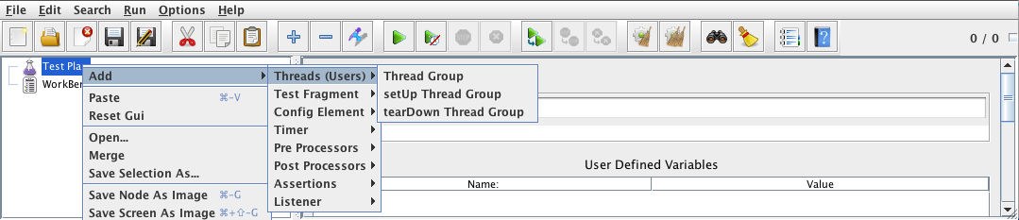
- Select the Thread Group
- Right click “Add -> Config Element -> HTTP Request Defaults”
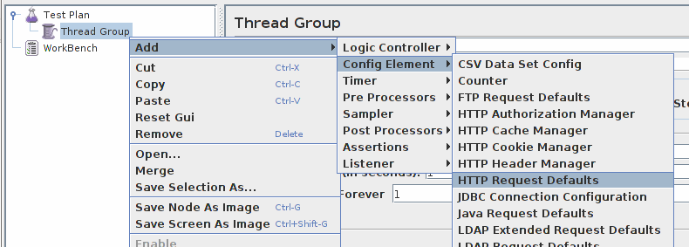
- In new HTTP Request Defaults element: Server name – enter “jmeter.apache.org”
- Path – leave blank
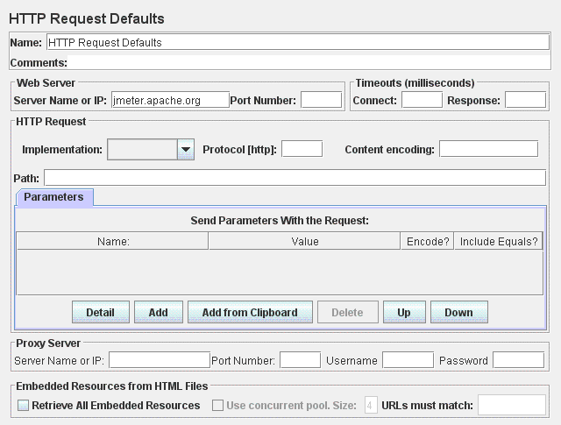
- Right click on the “Thread Group” and add a recording controller: Add > Logic Controller > Recording Controller
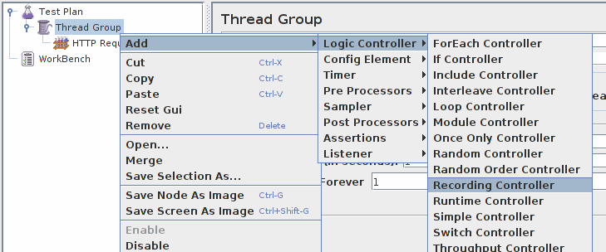
- Next, select WorkBench
- Right click on WorkBench and add the recorder: Add -> Non-Test Elements -> HTTP(S) Test Script Recorder
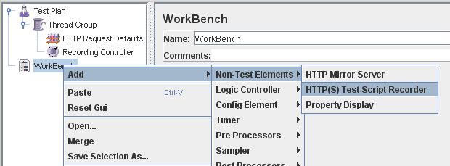
- On HTTP(S) Test Script Recorder, click the “Add” button in “URL Patterns to Include”. This will create a blank entry; enter “.*\.html”.

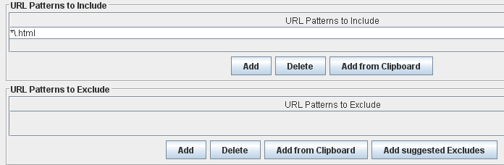

- Right click on “HTTP(S) Test Script Recorder” and add a listener: Add -> Listener -> View Results Tree
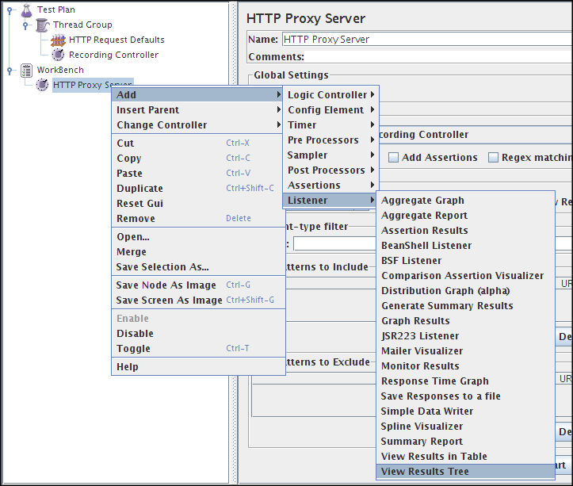
- Return to HTTP(S) Test Script Recorder, and click the “Start” button at the bottom.

This will start the JMeter proxy server which is used to intercept the browser requests.
A file called ApacheJMeterTemporaryRootCA.crt will be generated in jmeter/bin folder. Install this certificate in your browser, if you don't know how to do it, read “Installing the JMeter CA certificate for HTTPS recording” in :
- http://jmeter.apache.org/usermanual/component_reference.html#HTTP%28S%29_Test_Script_Recorder

Configure your browser to use the JMeter Proxy
At this point, JMeter's proxy is running. For this exercise, we will use Iceweasel/Firefox to view some pages on the JMeter website.

- Start Iceweasel/Firefox, but do not close JMeter.
- From the tool bar, click “Edit -> Preferences” (or “Tools > Preferences”). This should bring up the options.
- Select the “Advanced” tab, and “Network” tab
- Click “Settings” button near the bottom.
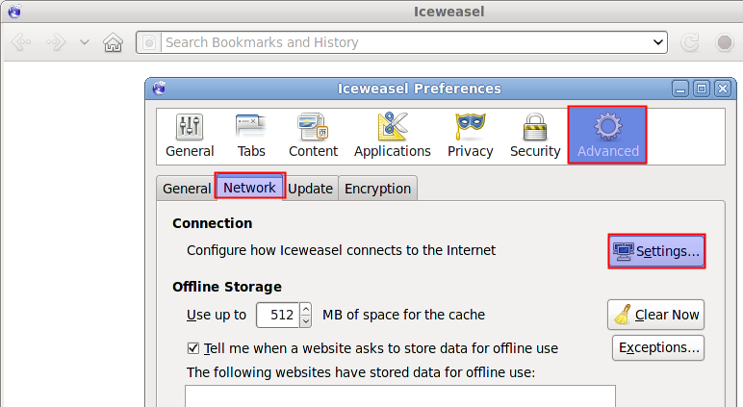
- On the new pop-up, check “Manual proxy configuration”. The address and port fields should be enabled now.
- Address – enter “localhost” or the IP address of your system
- Port – enter “8080”.
- Check “Use this proxy server for all protocols”
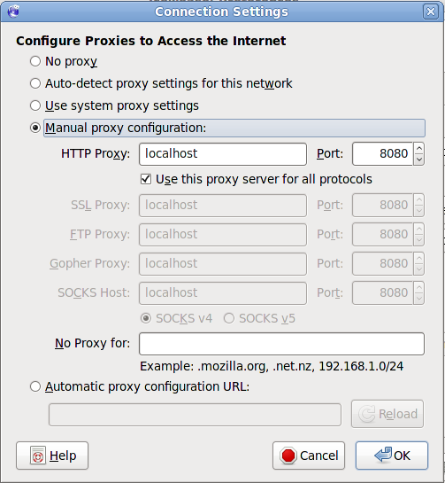
- Click “OK” button
- Click “OK” button again. This should return you to the browser

Record your navigation
- With your browser, in the “Address” bar at the top, enter “http://jmeter.apache.org/index.html” and hit the “enter” key.
- Click on a few links on JMeter's pages.
- Close your browser and bring up the JMeter window.

Expand the thread group and there should be several samplers. At this point, the test plan can be saved as is. If you forget to add default HTTP Request settings, you will have to manually delete the server name, and port.
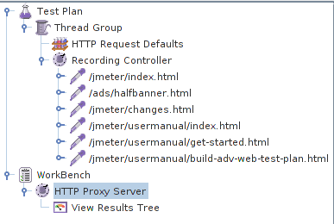

In this sample, there aren't any default request parameters. If a particular request parameter is required by all pages, the request defaults is where one would add the entries.
- Select “Thread Group”
- Right click “Add -> Listener -> Summary Report” to add an summary listener.

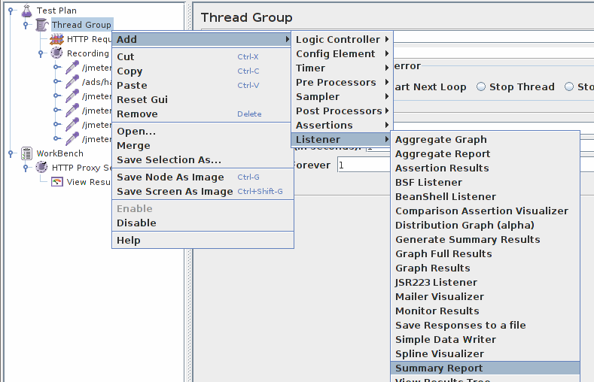
- The summary listener will show some basic statistics.
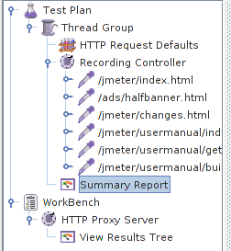
- Select “Thread Group”
- Number of Threads – enter “5”
- Ramp up Period – do not change
- Loop Count – enter 100

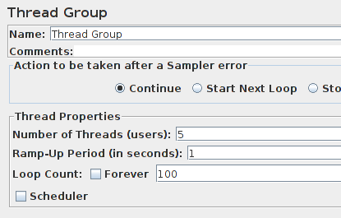

Start the test
At this point, we are ready to run our test plan and see what happens. Save the test plan. When you're ready to run the test, there's two ways:

- Run -> Start
- Ctrl–R

Before you start the test, select “Summary Report”. As the test runs, the statistics will change until the test is done. At the end of the test, the summary report should look like this.

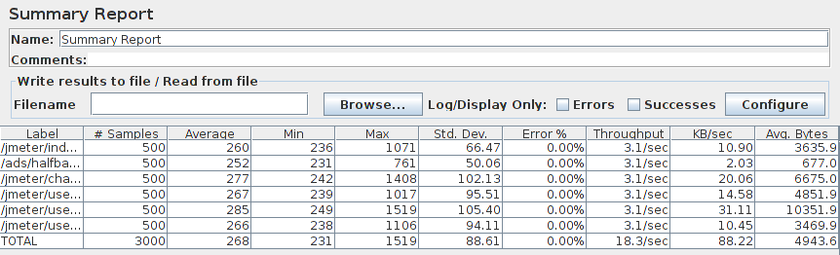

While the test is running, in the upper right-hand corner, there should be a green square. When the test is done, the box should be grey.

