Overview

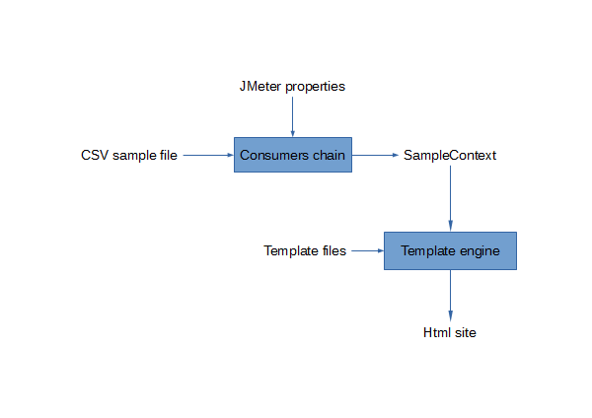Illustration 1: Dashboard generation overview

To produce the dashboard, the generator begins by building a chain of consumers that process samples from a CSV sample file. The chain is built using JMeter properties (prefixed by « jmeter.reportgenerator ») in order to enable the user to customize it.

During the sample processing each graph consumer publishes data in the sample context. Then this context is used to produce data for the template engine.

At last, this one processes the input template files and injects produced data to generate a HTML site structure.

Consumers chain details

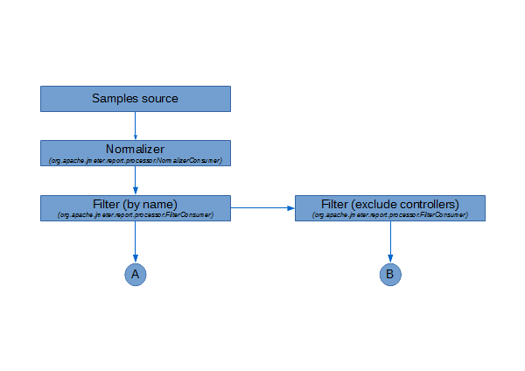Illustration 2: Consumers chain
The chain begins with a normalizer consumer in charge of standardize the time stamp of each sample. Then a filter consumer keeps or discards samples depending on the “jmeter.reportgenerator.sample_filter” property. Another filter is plugged to discard controller samples.

Depending on the property jmeter.reportgenerator.graph.<graph_id>.exclude_controllers, the graph consumer matching the graph_id identifier will be plugged in position A or B.
Limitations and outlooks

Till now, there is only one samples source implementation which is strongly coupled with the CSV file format, we should allow other kinds of source by using a sample source interface.

To add customized graph, users must extends the AbstractGraphConsumer or use one of the implementations provided in the package “org.apache.jmeter.report.processor.graph.impl”. This could be enhanced by making concrete the base class and give public access to additional properties (like selectors). But first we have to resolve the issue of shared properties (E.g : over time graphs must dispatch the same granularity property to the keys selector and time rate aggregator).

The chain building is dispatched between the org.apache.jmeter.report.dashboard.ReporGenerator.generate method and the implementation of the consumers. So the code in charge of the building is splitted and furthermore some consumers can be redundants and harm the performance. (E.g: Each LatencyVSRequestGraphConsumer and ResponseTimeVSRequestGraphConsumer instances use an embedded consumer that could be shared depending on granularity and exclude_controllers properties). So we should enable the consumers to define the chain they require and provide a single chain builder that processes these chain requirements to instantiate needed consumers on demand. I.e, for the same chain requirement declaration, the same consumer instances are used. Otherwise if the declaration differs a new branch of consumer is created.

Fow now, consumers are in charge of the data transformation from the sample context to the data context used by freemarker (via the exportData method). It should be the sole responsablity of the template engine to transform the data. So the stored data in the sample context should implement a common interface or be compatible with standard serialization pratices.

There is only one implementation of template engine (tied to freemarker). We should provide a template engine interface to enable the use of alternate engines.

