CCCA Case Study Template

1. Basic Information
Project | The Gandé Reserve
Location | Gandé village, Moudéry (rural community), Bakel Département (county), Senegal  Gandé is located in Bakel which is in East Senegal on the border to Mauritania. In Bakel Gandé is on the border to Matam, the neighboring Department (country) (see map and photos in appendix).
Date of visit | 18 April 2009
Local Contact(s) | Abdoulaye Ndiaye - CVD – Village Development Committee (Chairman)  Dembo Drame - CVD (Secretary General)

2. About the case study
What is the issue? | In the mid nineties local communities in and around Gandé noticed changes to the environment of their area. The following was noticed in particular: total disappearance of the bigger trees, lack of any forest floor, new ravines and patches of erosion, disappearance of ponds and expansion of creeks, and decreased amount of land for post-flood crops. These changes led to agricultural and animal husbandry activities being downscaled due to lack of vegetation, fewer fishing opportunities due to little or no water in the river most of the year and land right conflicts as the area is on the border where population groups have different relations to the land (esp. villages in the region of Matam)
Why is it an issue? | - Vulnerability to food insecurity is increasing in the area,  - Conflicts between different users of the resources occur; first among local populations, then between local people and those in the neighbouring Matam region and between local populations and those of neighbouring Mauritania.
How is this issue related to the main project objectives? | The challenges in and around Gandé are common to all of the target CCCA communities. How the issues are being addressed are of key interest to the project, along with how this learning can be replicated in other areas, and how current activities to combat the challenges can further incorporate the further challenges of climate change. Thus the project is not only learning from how the community is facing the issues, but also hoping to strengthen the community activities and disseminate their knowledge.  The project is especially involved with the local actors in the project to examine how they understand climate change, and how they adapt to the recent changes to their environment.  How relevant is the issue in relation to climate change adaptation?  In terms of biological diversity, the area used to fare very well. Indeed, both humans and animals could find the resources and conditions they required.  Since 1989, when members of the Fulani ethnic group were sent back to Mauritania, the area has gone through change connected to the pressure exerted by people on nature. The situation got worse in 1993, a year of drought when resources became scarce and the pressure exacerbated around the area. Then strong winds swept away the remaining forest floor. The following year, the river banks got gullied as a result of speeding runoff rainwater. Since then most parts of the region are still facing these ever changing conditions.
Who are the key stakeholders? | The Gande Reserve fencing project is an initiative led by local people who realised the challenges to their local environment early on, and have thus established the reserve with a local code of conduct for which they are the guarantor.  In addition to local residents, the state technical departments and financial partners support the project and have for example mobilised resources for fencing and tools.  The partners who provided some support for the experiment include: The Senegal - Mauritania Biodiversity Project with micro-grants from FEM; and the GEF/BFS Project (a project concerned with the water resources of the River Senegal basin).  To these should be added the Forestry Commission (ARD technical assistance) which helped with the management of associations, and the Rural Council who provided some institutional support.
What is the initiative or response to the issue? | The key project initiatives in Gandé are as follows:  - Fencing to protect the reserve area  - Official registration of the reserve area through legislation concerning the allocation/distribution of lands  - Aiding the restoration of the plant and animal biodiversity  - Protecting the regeneration of the natural resources  - Creation of village committee to manage the area and ensure implementation of the local code of conduct  - To seek technical and financial partners to make the necessary investments to enable the project to succeed (monitoring of fencing, firewalls, development and implementation of simple management plan)  - Development of income generating activities
How would you assess the impact of the initiatives in this location? | The impacts have been such as:  - The gradual return of fauna and flora,  - Improved conditions for livestock rearing (small ruminants reproduce twice annually compared to max 1 before, increased production of milk and meat)  - Increase in the diversity of products gathered (fruits, honey etc)  - The increase in cash income from the exploitation of natural resources of the reserve,  - The area is less exposed to wind ( and erosion), due to increased vegetation  - The soil has been recovered  Today, the area of Gande is on the route to recovery. Recently, on the Forestry Commission’s authorisation, the association has harvested 400 ha of wood, for sale to the population and the trees in the reserve have reached the production stage: for instance, fruit producers give cfa 500 to the Committee in order to harvest for three days within the reserve.  Cattle-breeders are allowed to take turns to send in their herds by virtue of a zoning-related authorisation, but only when the fodder gets scarce. Thanks to this opportunity, they can get healthier cattle that produce more milk and meat, while increasing the herd by producing 2 calves every year. All these opportunities exist thanks to the presence of vegetation.  The area is witnessing the revival of biodiversity since, in addition to the vegetation, one can see some wild fowl and animals that, a few years back, could not be seen there; plus some reptiles and insects. So the area now is a better place for wild animas and plants, while in the surrounding area the lands have become more fertile and woody.
Are there any specific attributes to the location? | The land on which the reserve can be found has been given to the CVD (Village Development Committee) by the Rural Council. The CVD ensures the management of the area and organises the activities towards the preservation and restoration of the area, and establishes the rules of exploitation of the available resources
3. Learning
What have the local stakeholders learnt from this initiative / issue? | The local stakeholders of this project have learned that:  - Locally initiated and managed projects can preserve their local environment to achieve sustainable development, without the need for external funding or management.  - The fight against the negative effects of climate change is best done through local community groups, incorporating all stakeholders, that are able to adapt quickly to sudden changes in the environment  - The local economy should be based on a rational exploitation of natural resources and preserving the resources ensures sustainable development and safeguards the future generations.
What environmental learning can be drawn from this initiative / issue? | In regard to the environment, experiences in Gandé has furthered knowledge regarding:  - The techniques of conservation and restoring the environment.  - Environmental management methods.  - Seed production techniques.  - The techniques of processing collected natural resources  - Management and preservation.  - The usefulness of having a local code of conduct.  - The relationship between the local code of conduct and written laws
What social learning can be drawn from this initiative / issue? | The relations both within and between community and ethnic groups have improved through the existence of the reserve. There is improved dialogue across the border to Mauritania and to the communities in Matam bordering the reserve. Instead of being in competition over the resources in the area, they have a common interest in upholding the local code.  Thanks to the participatory style of management and the communication system which has been put in place (dissemination of the agreement; radio broadcasts on the reserve’s objectives; local authorities’ and people’s testimonies on the status and positive results of the project) everybody living in the area feels compelled to comply with the local code.
What policy / governance learning can be drawn from this initiative / issue? | - The need to establish a collaborative and participatory management structure recognised and accepted by the affected communities.  - The importance of creating awareness of the obligation to respect the laws (Forestry Code, environmental laws, laws on the transfer of powers) and the reasons why the laws are relevant to the communities  - The need for communities and local authorities to work in partnership (elected representatives, technical services) as to achieve the best results.  - Preservation and restoration requires participatory planning to succeed. Missing the inclusion of just one stakeholder can bring imbalance to the system

4. Learning about Leadership
Who are the leaders of this project/site? | The key leaders of the initiative are members of CVD in Gandé.  They operate according to rules established by the villages and reports to the villages and technical and financial partners.
How have they demonstrated leadership on this specific issue? | Their first challenge and where leadership was especially important, was to ensure that the communities adhere to the local code in and around the reserve, especially in the early stages of establishing the reserve. This challenge has been overcome through ensuring continued awareness-raising of possible long-term results, involvement of all stakeholder groups and continued support from the authorities.
Were there any key obstacles that have been overcome? If so what and how? | Key obstacles can be summarized as:  •The attitude and behaviour of nomadic cattle raisers  • The conflict between resource users;  • Land allocation/distribution by the Rural Council.  These obstacles have been overcome through:  • Raising awareness  • Compliance with the Local Code of Conduct  • Social mediation sessions  Thanks to the project, Gandé has become a prime case study of local natural resource management. The local agreement has paved the way for peaceful co-existence, since its observance helps prevent any conflict, even with cattle-breeders in Mauritania.  Each year, a conference involving the people from the local villages, Matam and Mauritania makes it possible to produce a report and to work out strategies to build on achievements made in the environmental, social and economic areas. The conference is chaired by local and administrative officials.

5. Additional Comments

Photos
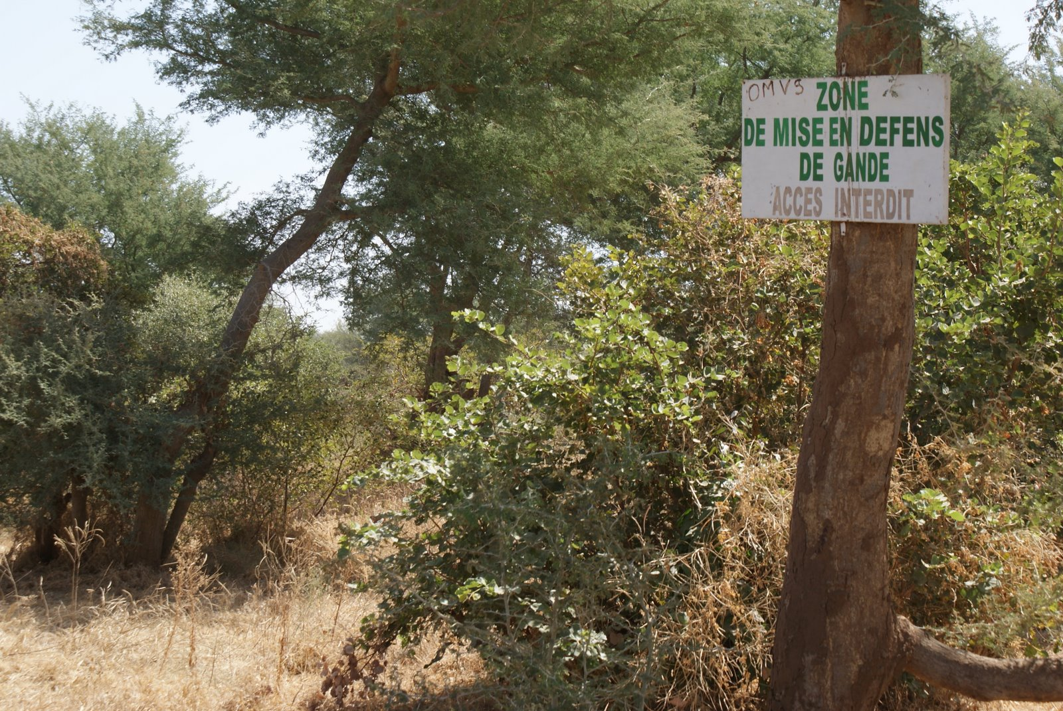
1. Gandé reserve: Sign showing that this is a reserve and that access is
prohibited’

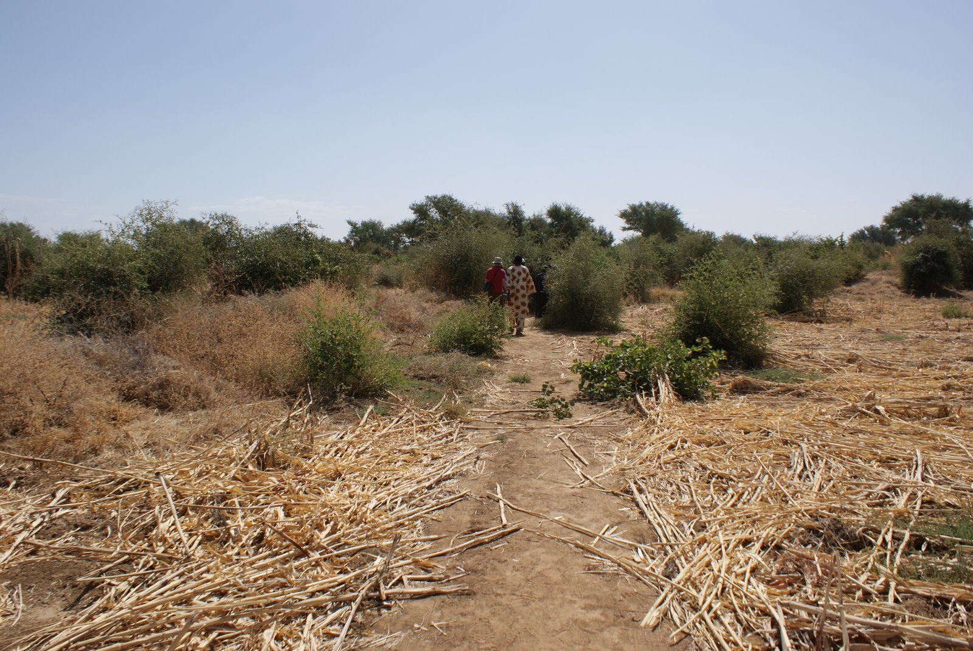
2. Recently harvested area within the reserve. The harvesting is controlled and only permitted at certain times of the year
Maps
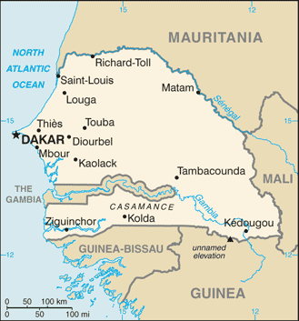
The Gande reserve is located on the border to Mauritania on the Senegal river. It belongs to the Moudery local community which is on the map below.

