CCCA Case Study Template

1. Basic Information
Project | The Falémé river association
Location | The Falémé river is located in the Tambacounda region in Senegal and Mali  Association de Lutte Anti-Erosive de la FALEME (ALAEF) operates in villages located in the district of Bakel (in the rural community of Bélé and the rural community of Ballou) and in villages in Mali.  (See map and photos in appendix).
Date of visit | On 22 January 2009
Local Contact(s) | Demba Niang: President. ALAEF  Saïdou Barry: Program Manager ALAEF

2. About the case study
What is the issue? | During the last decade erosion has become an ever increasing challenge around the Falémé river, threatening livelihoods, the land and wildlife alike.  The communities in the area have seen changes to the area such as:  - Landslide on the banks of the river,  - Reduced post-flood lands (Falo)  - Loss of buildings (schools, houses along the shore),  - Threat to cemetery lands. (Runoff water remove soil)  - Isolation of the area by new ravines and gullies  - Reduced mobility of people in the rainy season due to impassable trails  - Silting of the river bed mainly from sand from the brooks, leading to water scarcity most of the year.  The Association de Lutte Anti-Erosive de la FALEME (ALAEF) was created by Demba Niang (President of the Association) and other community members in 1990 to respond to this situation.
Why is it an issue? | - The erosion around the river makes it difficult to use the land for cultivation (Steep slopes, deposits of low grade silt)  - Silting of the river has removed the perennial water thereby reducing the potential for irrigation because of the water being available for only 3 months during the rainy season.  - Erosion has caused gullies and ravines that are difficult to pass during the rainy season, which furthermore makes evacuation of the sick and the supply of food and distribution of products difficult.  - The speed of runoff water, rids the land of the surface layer which fertilize the soil, thus leading to declining yields  - The silting of the water has caused some plant species and animals (aquatic plants, fish, turtles etc) to disappear  - The production of rice in shallow waters, formerly practised by women, is now impossible because of reduced water in the river (Valley)  - The lack of vegetation in some places increases competition for the use of resources (fodder, land and fishing ground).  - The settlement of nomadic pastoralists and others around water points leads to silting of the water due to for example the activities of the animals and removal of vegetation,  - Some activities such as agriculture and river transport have disappeared because of these phenomena.
How this issue is related to the main project objectives? | The issues facing the Falame river area are similar to what is happening in all the districts in the main project area. How the issues are being addressed are of key interest to the project, along with how this experience can be replicated in other areas, and how current activities to combat the challenges can further incorporate the anticipated challenges of climate change. Thus the project is not only learning from how the community is facing the issues, but also hoping to strengthen their activities and disseminate their knowledge.
Who are the key stakeholders? | The key stakeholders are the members of the association representing villages alongside the Falémé river. The association is headed by a committee and each village is represented in this committee by one village delegate. To manage the activities, an annual work program is prepared and this program is implemented by the committee, who then report back to the association at monthly meetings.  Other stakeholders are the villages that benefit from the association activities and local authorities that are involved and consulted for all planning and implementation.
What is the initiative or response to the issue? | - Information and awareness raising on the current environmental impacts and implications from these around the Falémé river  - Introducing restoration methods such as stone barriers, micro dams, filters etc.  - Planting trees (species adapted to the environment)  - Creating a nursery of fruit trees  - Filling in gullies and ravines  - Delivering training to local technicians.  - Organising exchange visits to and from Mali and Burkina  - Contracting with partners to support the project activities.  .
How would you assess the impact of the initiatives in this location? | Implementing the measures mentioned above has resulted in impacts such as:  - The soil being restored in many locations through preventive (stone barriers, dikes) and remedial methods (stone plugs, filters, etc)  - Gradual recovery of farmland through for example development of ponds and filling in gullies and ravines.  - Reduction in vulnerability to food insecurity due to new farming techniques (composting, engines, equipment, pest control)  - Strengthening of relations between the Senegalese and Malian villages and Soninke and Pular.  - Creation of mechanisms of consultation that ensure peaceful relations between states  - The establishment of a mode of governance based on consultation, participation, local democracy in accordance with customs and traditions.
Are there any specific attributes to the location? | Local community members have been granted, through the association, the management rights to the lands and own the related facilities and equipment
3. Learning
What have the local stakeholder learnt from this initiative / issue? | The local stakeholders have primarily learnt that the only way of preserving and improving the local environment is by working together towards common goals. Temporary projects from outside are just that: temporary. They have seen that it is in best interest of all to continue the cooperation, as individual action only causes imbalance and little or no results.
What environmental learning can be drawn from this initiative / issue? | The initiative has shown the various environmental and restoration initiatives that can be implemented without great cost, such as:  The use of water levels, the technique of weaving gabion, nursery techniques, construction of bunds and stone bunds, composting techniques, techniques of fodder conservation, planting and maintenance techniques and awareness through literacy on environmental issues
What social learning can be drawn from this initiative / issue? | The initiative has again shown that by incorporating all stakeholders and their views and needs, real results can be achieved. Ensuring that the stakeholders are aware of their common interest and the creation of solidarity where it may not be present, especially when the issue is across borders, is essential as part of any initiative.
What policy / governance learning can be drawn from this initiative / issue? | - The need for a local code of conduct towards the environment. This code needs to include the needs of all stakeholders and should be ‘owned’ by the communities.  - Balanced natural resource management can only be achieved through the involvement of all stakeholders, including the existing methods of managing resources.  - Local authorities should enable stakeholder groups/associations such as these to implement natural resource activities, as they are better placed and representative of the communities. If there is a feeling that initiatives are not benefiting or involving some groups these will possibly cause imbalance in the local area and conflict over the available resources. Any project, be it government or externally funded and initiated, should go through inclusive bodies such as this association.

4. Learning about Leadership
Who are the leaders of this project/site? | The Executive Board including village delegates leads the activities on the basis of rules of operation. They are then relayed on the basis of specifications by management committees or persons responsible for specific chapters.  Demba Niang, the founder of the association, can be described as the ‘real’ leader of the initiative. After returning home from 9 years in France, he observed the changes that had occurred to the environment in his absence, and the impact that it was having on livelihoods, and realised the need for the communities to take action. The activities started first in one village and were later expanded and now cover 7 villages in Senegal and Mali. The association was initiated and he has been the key leader to push the initiative and ensure the continued implementation of activities.
How have they demonstrated leadership on this specific issue? | The key area where the association has demonstrated leadership was to create cross-border dynamics that helped establish actions to conserve and restore the environment, and to promote a culture of peace and dialogue between the people of the two countries.
Where there any key obstacles that have been overcome? If so what and how? | The main obstacle has been the lack of financial resources to deliver the identified solutions (management, dredging of ponds, and lack of appropriate equipment etc). A further key obstacle has been the continued mobilization of local actors.  Initially the obstacle of lack of equipment was addressed by a French organisation, who supplied the needed tools.  The current challenge is to secure further funding for the activities, as much of the equipment is getting old, and talks with local government to this end are ongoing.  Initiatives are being implemented by the association to ensure continued exchange and discussion between the communities, as to ensure the continued mobilisation of local actors. Again the means to mobilise is a constant challenge that continues today, but as with the supply of equipment, talks with local government are trying to address these challenges.

5. Additional Comments
Any relevant information or personal comments not already been covered in this document | The ALAEF has brought hope and fostered a culture of dialogue in the region. It has helped to protect the river banks and facilitated the mobility of the population.  It now not only coordinates practical activities towards combating erosion, but also provides human resource management programs and anti-erosion and development literacy education capable of responding to the demands of the ALAEF programs. It has established a strategy for sustainability of achievements through infrastructure (local) and equipment and a decentralized financial system through the cash-based savings and micro credit system (CLEC).

Photos
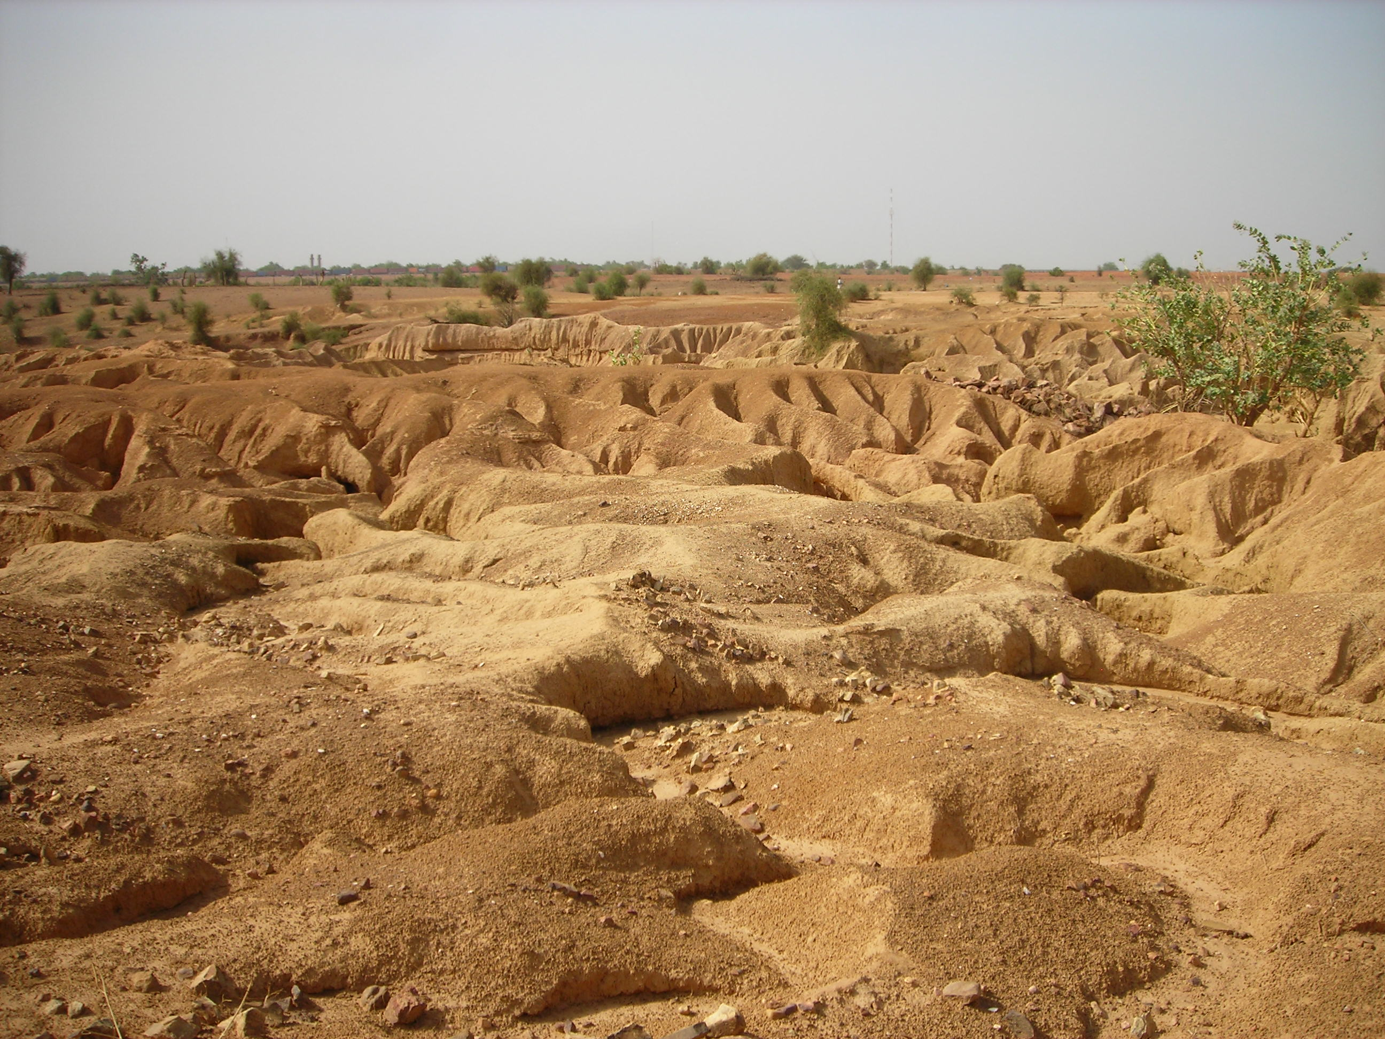
1. Land erosion around the Bakel district close to the Falémé river
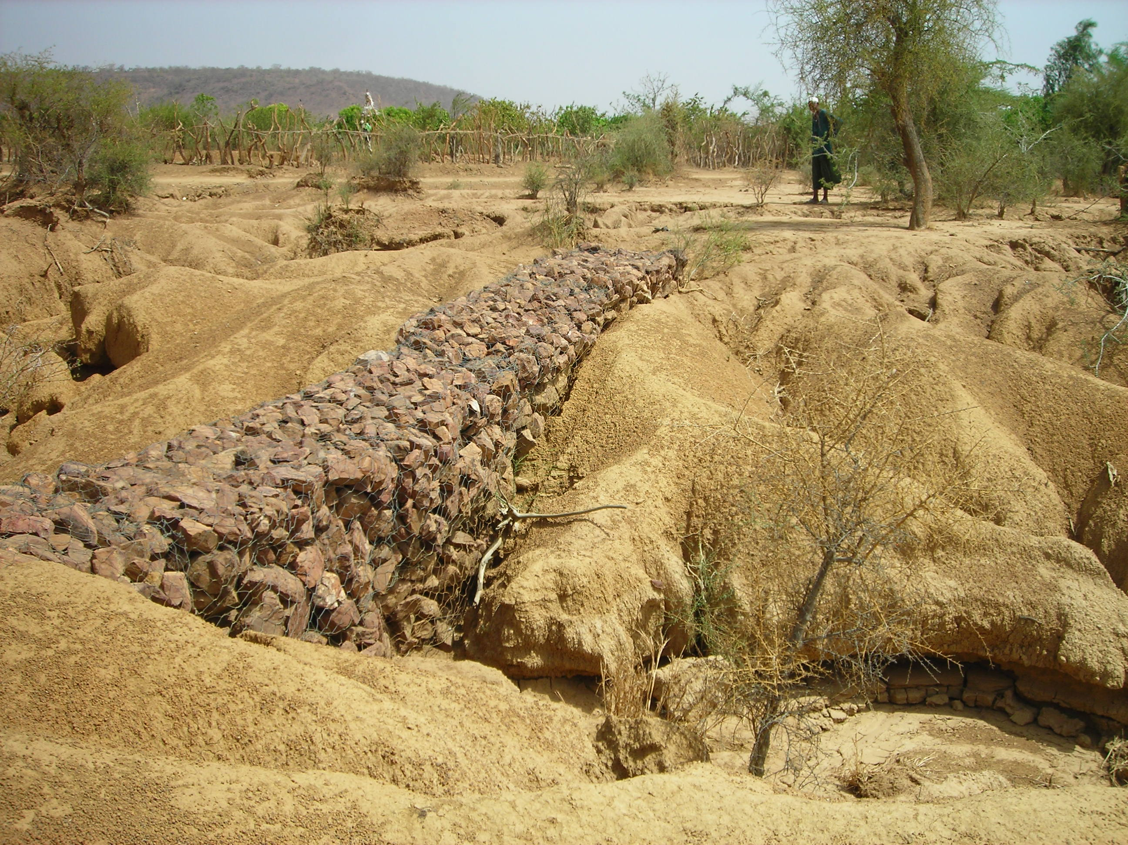
2. Stone wall to slow water run off

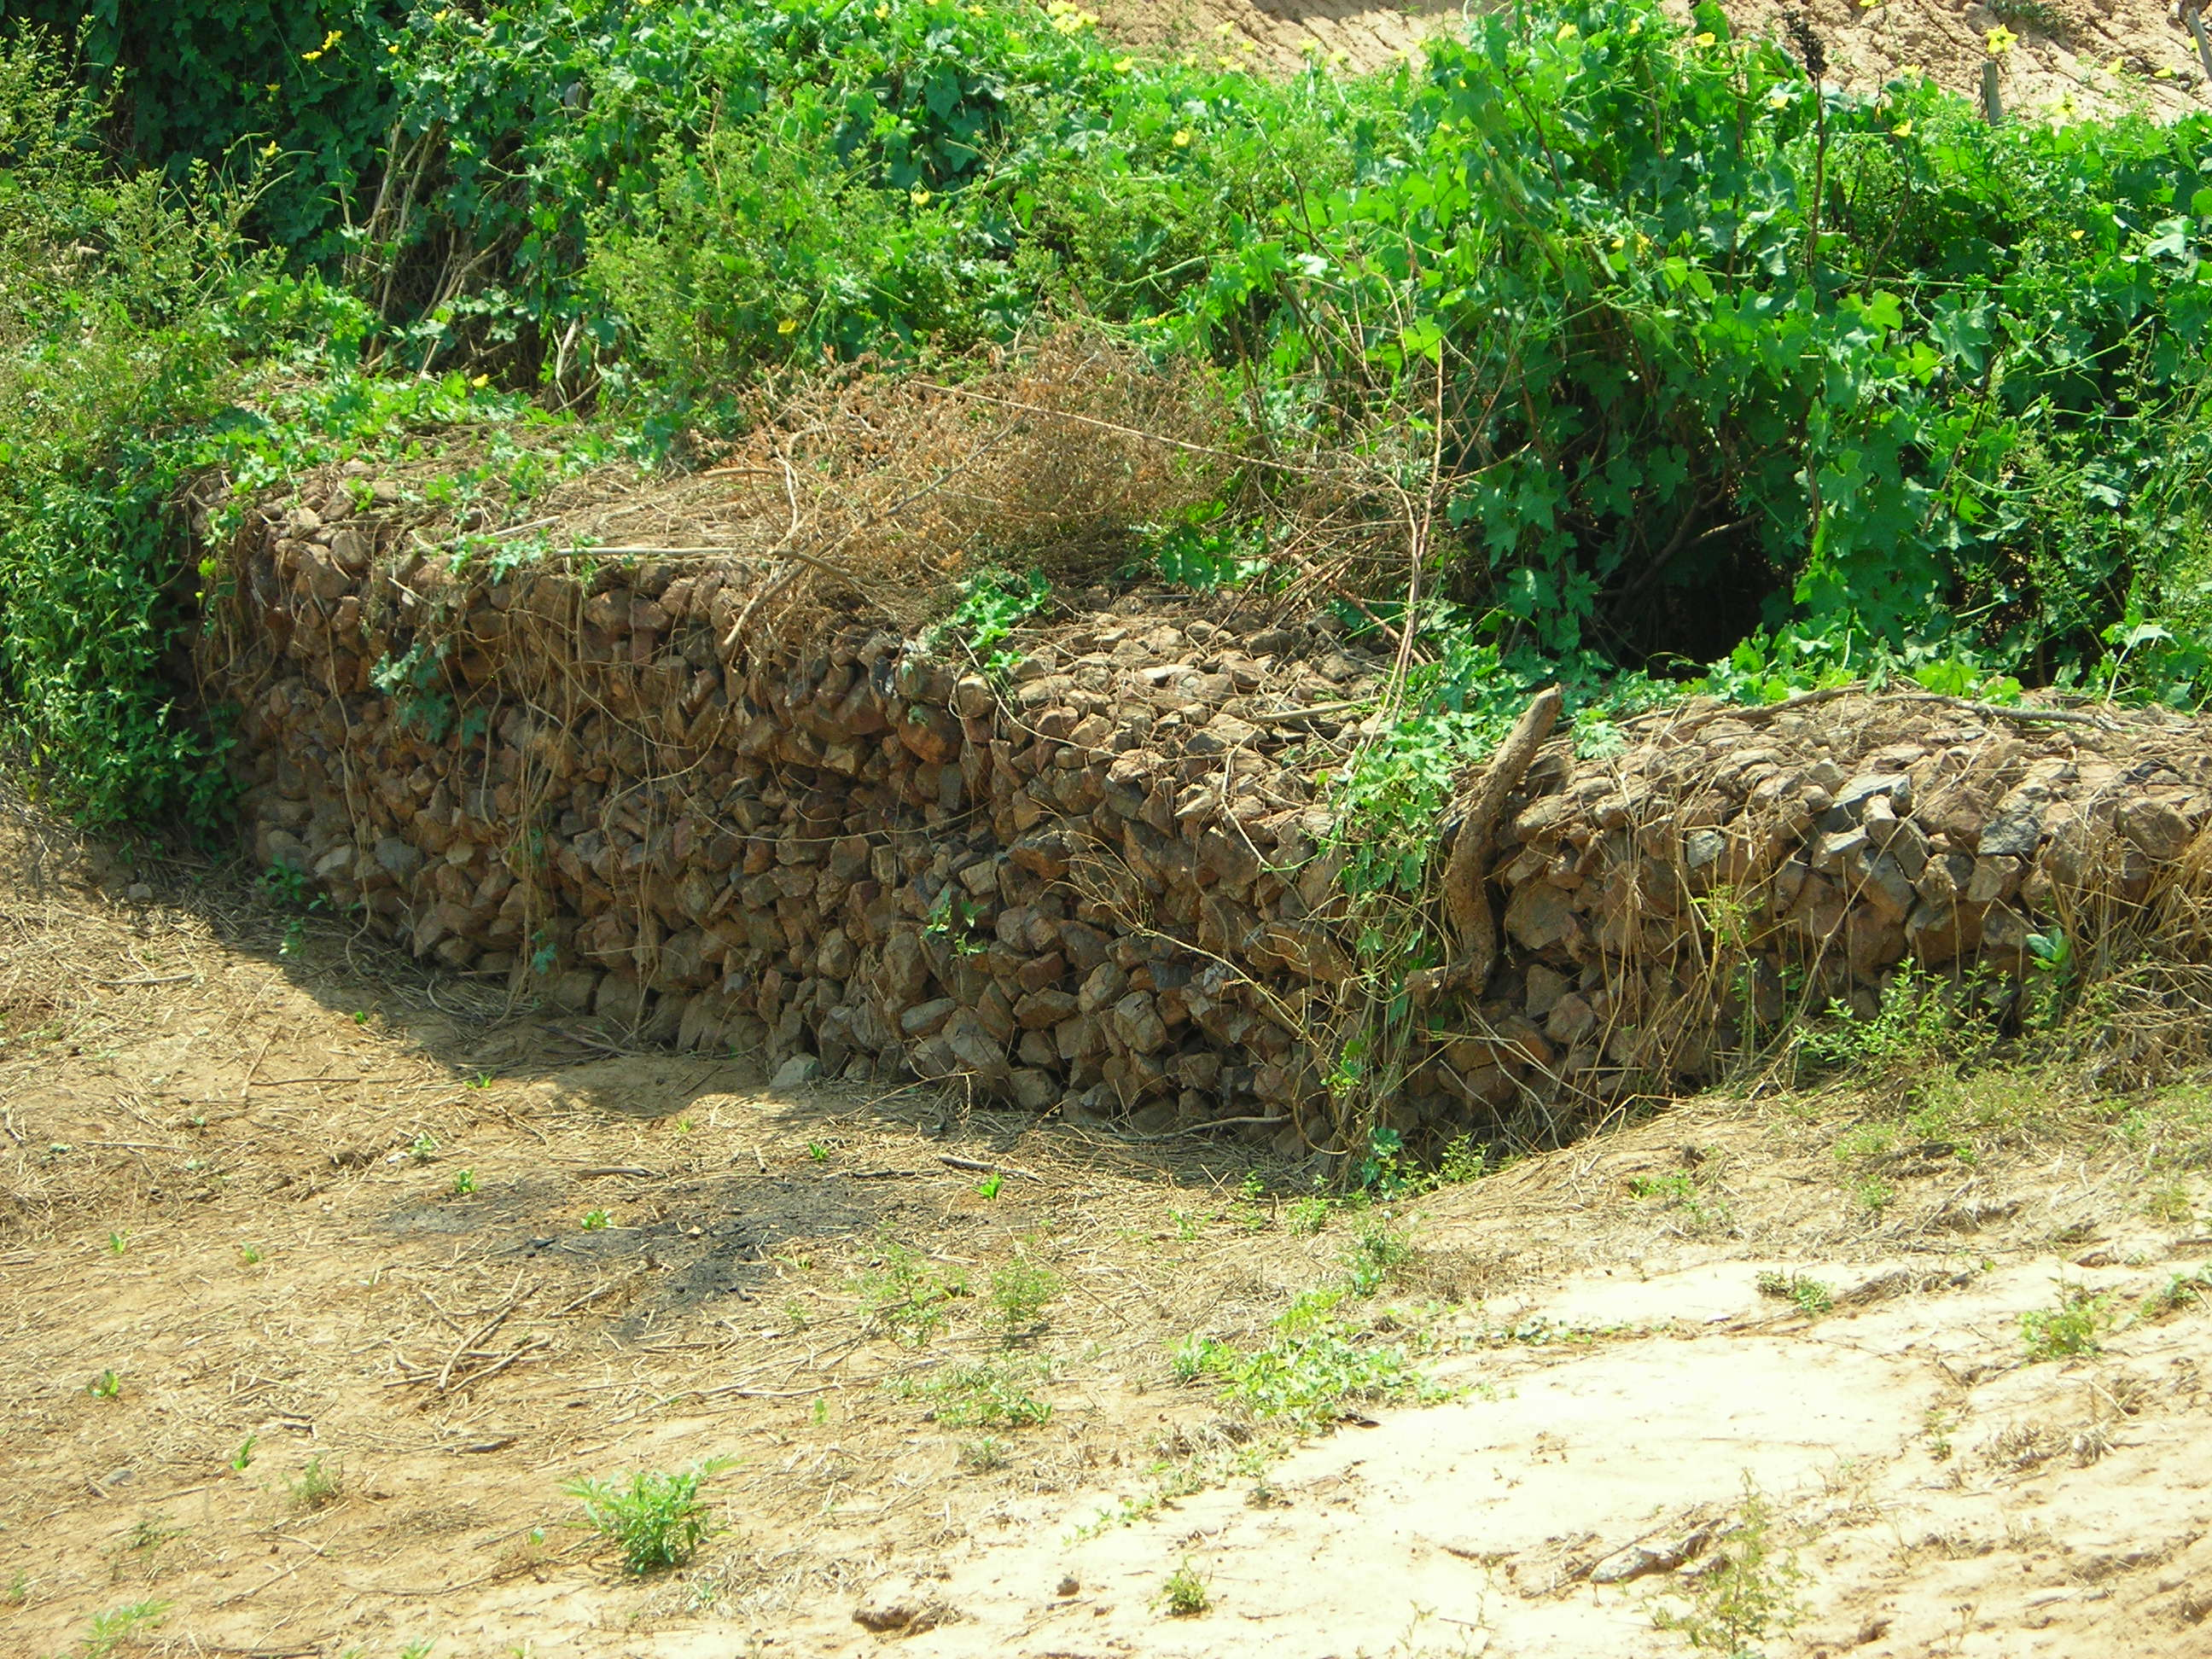
3. Planting next to stone wall
Maps
