Chapter 5
Getting Started with Impress

What is Impress?
Impress is the presentation (slide show) program included in Apache OpenOffice. You can create slides that contain many different elements, including text, bulleted and numbered lists, tables, charts, and a wide range of graphic objects such as clipart, drawings and photographs. Impress also includes a spelling checker, a thesaurus, text styles, and background styles.
This chapter includes instructions, screenshots, and hints to guide you through the Impress environment while designing your presentations. Although more difficult designs are mentioned throughout this chapter, explanations for creating them are in the Impress Guide. If you have a working knowledge of how to create slide shows, we recommend you use the Impress Guide for your source of information.
To use Impress for more than very simple slide shows requires some knowledge of the elements which the slides contain. Slides containing text use styles to determine the appearance of that text. Creating drawings in Impress is similar to the Draw program included in Apache OpenOffice. For this reason, we recommend that you also see Chapter 2 (Using Styles and Templates) and Chapter 6 (Getting Started with Draw) in this book. You may also wish to consult the Draw Guide for more details on how to use the drawing tools.

Starting Impress
You can start Impress in several ways:
- From the Apache OpenOffice Start Center, if no component is open, click on the Presentation icon.
- From the system menu, the standard menu from which most applications are started. On Windows, it is called the Start menu or use the Apache OpenOffice Quickstarter. On Gnome, it is called the Applications menu. On KDE it is identified by the KDE logo. On Mac OS X, it is the Applications menu. Details vary with your operating system; see Chapter 1 (Introducing Apache OpenOffice).
- From any open component of AOO. Click the triangle to the right of the New icon on the main toolbar and select Presentation from the drop-down menu or choose File > New > Presentation from the menu bar.
Note | When AOO was installed on your computer, in most cases a menu entry for each component was added to your system menu. The exact name and location of these menu entries depend on the operating system and graphical user interface.
When you start Impress for the first time, the Presentation Wizard is shown. Here you can choose from the following options:
- Empty presentation, which gives you a blank document
- From template, which is a presentation designed with a template of your choice
- Open existing presentation
- Click Create to open the main Impress window.
For detailed instructions about how to use the Presentation Wizard, see “Error: Reference source not found” on page Error: Reference source not found.
If you prefer not to use the Presentation Wizard in future, you can select Do not show this wizard again. You can enable the wizard again later under Tools > Options > OpenOffice Impress > General > New document, and select the Start with wizard option.

The main Impress window
The main Impress window has three parts: the Slides pane, Workspace, and Tasks pane. Additionally, several toolbars can be displayed or hidden during the creation of a presentation.
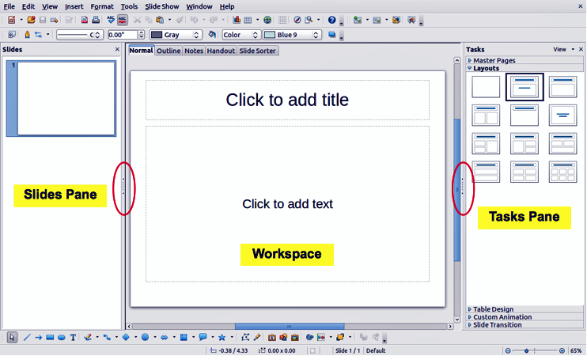
Figure 104: Main window of Impress; ovals indicate the Hide/Show markers
Tip | You can close the Slides pane or the Tasks pane by clicking the X in the upper right corner of the pane or by choosing View > Slide Pane or View > Tasks Pane to deselect the pane. To reopen a pane, choose View > Slide Pane or View > Tasks Pane again.  You can also maximize the Workspace area by clicking on the Hide/Show marker in the middle of the vertical separator line (indicated by ovals in Figure 104). Using the Hide/Show marker hides, but does not close, the Slides and Tasks panes. To restore the pane, click again on its Hide/Show marker.

Slides pane
The Slides pane contains thumbnail pictures of the slides in your presentation, in the order they will be shown unless you change the slide show order. Clicking a slide in this pane selects it and places it in the Workspace. When a slide is in the Workspace, you can make changes any way you like.
Several additional operations can be performed on one or more slides simultaneously in the Slides pane:
- Add new slides to the presentation.
- Mark a slide as hidden so that it will not be shown as part of the presentation.
- Delete a slide from the presentation if it is no longer needed.
- Rename a slide.
- Duplicate a slide (copy and paste) or move it to a different position in the presentation (cut and paste).
It is also possible to perform the following operations, although there are more efficient methods than using the Slides pane:
- Change the slide transition following the selected slide or after each slide in a group of slides.
- Change the sequence of slides in the presentation.
- Change the slide design.
- Change slide layout for a group of slides simultaneously.

Tasks pane
The Tasks pane has five sections. To expand the section you wish to use, click on the title bar of each section. Only one section at a time can be expanded.
Master Pages
Here you define the page (slide) style for your presentation. Impress includes several designs of Master Pages (slide masters). One of them—Default—is blank, and the rest have background and styled text.
Tip | Press F11 to open the Styles and Formatting window, where you can modify the styles used in any slide master to suit your purpose. This can be done at any time.
Layout
The layouts included in Impress are shown here. You can choose the one you want and use it as it is, or you can modify it to meet your own requirements. However, it is not possible to save custom layouts.
Table Design
The standard table styles are provided in this section. You can further modify the appearance of a table with the options to show or hide specific rows and columns, or to apply a banded appearance to the rows and columns.
Custom Animation
A variety of animations can be used to emphasize or enhance different elements of each slide. The Custom Animation section provides an easy way to add, change, or remove animations.
Slide Transition
The Slide Transition section provides access to a number of slide transition options. The default is set to No Transition, in which the following slide simply replaces the existing one. However, many additional transitions are available. You can also specify the transition speed (slow, medium, fast), choose between an automatic or manual transition, and choose how long the selected slide should be shown (automatic transition only).

Workspace
The Workspace (normally in the center) has five tabs: Normal, Outline, Notes, Handout, and Slide Sorter. These five tabs are called View buttons. The Workspace below the View buttons changes depending on the chosen view. The workspace views are described in detail on page Error: Reference source not found.
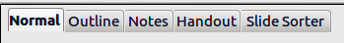
Figure 105: Workspace tabs

Toolbars
Many toolbars can be used during slide creation; they can be displayed or hidden by clicking View > Toolbars and selecting from the menu.
You can also select the icons that you wish to appear on each toolbar. For more information, refer to Chapter 1 (Introducing Apache OpenOffice) in this book.
Many of the toolbars in Impress are similar to the toolbars in Draw. Refer to the Draw Guide for details on the functions available and how to use them.

Status bar
The Status bar, located at the bottom of the Impress window, contains information that you may find useful when working on a presentation. For details on the contents and use of these fields, see Chapter 1 (Introducing Apache OpenOffice).
Note | The sizes are given in the current measurement unit (not to be confused with the ruler units). This unit is defined in Tools > Options > OpenOffice Impress > General.
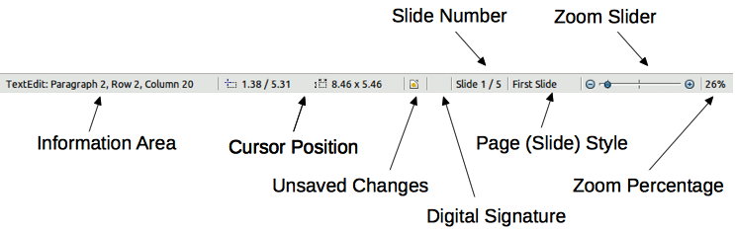
Figure 106: Status bar
From left to right, you will find:
- Information area, which changes depending on the selection. For example:
Example selection | Examples of information shown
Text area | Text Edit: Paragraph x, Row y, Column z
Charts, spreadsheets | Embedded object (OLE) “ObjectName” selected
Graphics | Bitmap with transparency selected
- Cursor position—the position of the cursor or of the top left corner of the selection measured from the top left corner of the slide, followed by the width and height of the selection or text box where the cursor is located.
- Unsaved changes—an icon indicating that the file needs saving. Double clicking on this flag opens the file save dialog.
- Digital signature—an icon indicating whether the document is digitally signed. After the file has been saved, double clicking on this flag opens the digital signatures dialog.
- Slide number—the slide number currently displayed in the Workspace and the total number of slides in the presentation.
- Page (slide) style—the style associated with the slide, handout, or notes page currently in the Workspace. Double clicking on the style name opens the slide design dialog.
- Zoom slider—adjusts the zoom percentage of the Workspace displayed.
- Zoom percentage—indicates the zoom percentage of the Workspace displayed. Double clicking on zoom percentage opens the zoom and layout dialog.
You can hide the information in the Status Bar by selecting View > Status Bar from the main menu.

Navigator
The Navigator displays all objects contained in a document. It provides another convenient way to move around a document and find items in it. To display the Navigator, click its icon on the Standard toolbar, choose View > Navigator on the menu bar, or press Ctrl+Shift+F5.
The Navigator is more useful if you give your slides and objects (pictures, spreadsheets, and so on) meaningful names, instead of leaving them as the default “Slide 1” and “Shape 2”.
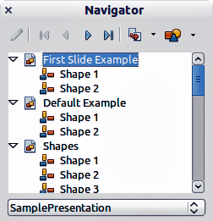
Figure 107: Navigator

Workspace views
Each of the workspace views is designed to ease the completion of certain tasks; it is therefore useful to familiarize yourself with them in order to quickly accomplish those tasks.
Note | Each Workspace view displays a different set of toolbars when selected. These toolbar sets can be customized by going to View > Toolbars, then check or uncheck the toolbar you want to add or remove.

Normal view
Normal view is the main view for working with individual slides. Use this view to format and design and to add text, graphics, and animation effects.
To place a slide in the slide design area (Normal view), click the slide thumbnail in the Slides pane or double-click it in the Navigator (page Error: Reference source not found).

Outline view
Outline view contains all the slides of the presentation in their numbered sequence. It shows topic titles, bulleted lists, and numbered lists for each slide in outline format. Only the text contained in the default text boxes in each slide is shown, so if your slide includes other text boxes or drawing objects, the text in these objects is not displayed. Slide names are also not included.

Figure 108: Outline view
Use Outline view for the following purposes.
- Making changes in the text of a slide:
  - Add and delete the text in a slide just as in the Normal view.
  - Move the paragraphs of text in the selected slide up or down by using the up and down arrow buttons (Move Up or Move Down) on the Text Formatting toolbar (highlighted in Figure 109).
  - Change the outline level for any of the paragraphs in a slide using the left and right arrow buttons (Promote or Demote) on the Text Formatting toolbar.
  - Both move a paragraph and change its outline level using a combination of these four arrow buttons.
- Compare slides with your outline (if you have prepared one in advance). If you notice from your outline that another slide is needed, you can create it directly in the Outline view or you can return to the Normal view to create it.
Figure 109: Text Formatting toolbar

Notes view
Use the Notes view (Figure 110) to add notes to a slide. These notes are not seen when the presentation is shown.
- Click the Notes tab in the Workspace.
- Select the slide to which you want to add notes.
  - Click the slide in the Slides pane, or
  - Double-click the slide’s name in the Navigator.
- In the text box below the slide, click on the words Click to add notes and begin typing.
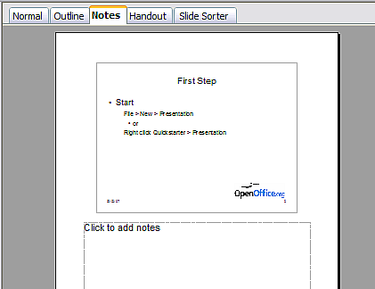
Figure 110: Notes view
You can resize the Notes text box using the colored resizing handles which appear when you click on the edge of the box. You can also move the box by placing the pointer on the border, then clicking and dragging. To make changes in the text style, press the F11 key to open the Styles and Formatting window.

Handout view
Handout view is for setting up the layout of your slide for a printed handout. Click the Handout tab in the workspace, then choose Layouts in the Tasks pane. You can then choose to print 1, 2, 3, 4, 6, or 9 slides per page.
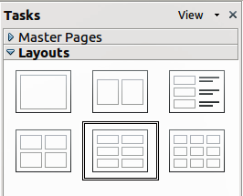
Figure 111: Handout layouts
Use this view also to customize the information printed on the handout. Refer to Chapter 10 of the Impress Guide for instructions on printing slides, handouts, and notes.
Select from the main menu Insert > Page Number or Insert > Date and Time and in the dialog box that opens click on the Notes and Handouts tab. Use this dialog to select the elements you want to appear on each handout page and their contents. More details on how to use this dialog are provided in the Impress Guide.
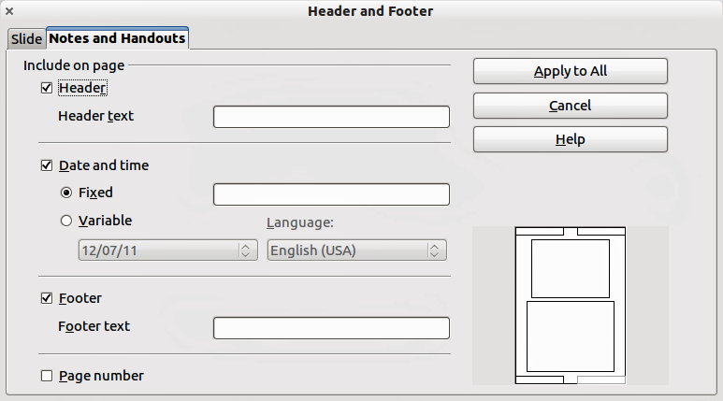
Figure 112: Dialog to set the page information for handouts and notes

Slide Sorter view
Slide Sorter view contains all of the slide thumbnails. Use this view to work with a group of slides or with only one slide.
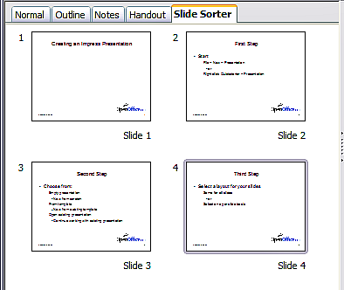
Figure 113: Slide Sorter view

Customizing Slide Sorter view
To change the number of slides per row:
- Check View > Toolbars > Slide Sorter and Slide View to show or hide the slide sorter and view toolbars.
- Adjust the number of slides (up to a maximum of 15).
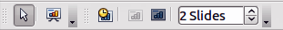
Figure 114: Slide Sorter and Slide View toolbars

Moving a slide using Slide Sorter
To move a slide in a presentation in the Slide Sorter:
- Click the slide and the slide is highlighted (see Figure 113).
- Drag and drop it to the location you want.

Selecting and moving groups of slides
To select a group of slides, use one of these methods:
- Use the Control (Ctrl) key: Click on the first slide and, while pressing the Control key, select the other desired slides.
- Use the Shift key: Click on the first slide, and while pressing the Shift key, select the final slide in the group. This selects all of the other slides between the first and the last.
- Use the mouse: Click slightly to one side (left or right) of the first slide to be selected. Hold down the left mouse button and drag the mouse pointer until all of the slides you want selected are highlighted.
To move a group of slides:
- Select a group of slides.
- Drag and drop the group to their new location.

Working in Slide Sorter view
You can work with slides in the Slide Sorter view just as you can in the Slide pane.
To make changes, right-click a slide and choose any of the following from the pop-up menu:
- Add a new slide after the selected slide.
- Delete Slide: deletes the selected slide.
- Rename Slide: allows you to rename the selected slide.
- Slide Layout: allows you to change the layout of the selected slide.
- Slide Transition: allows you to change the transition of the selected slide.
- For one slide, click the slide to select it and then add the desired transition.
- For more than one slide, select the group of slides and add the desired transition.
- Hide Slide: hidden slides are not shown in the slide show.
- Cut: removes the selected slide and saves it to the clipboard.
- Copy: copies the selected slide to the clipboard without removing it.
- Paste: inserts a slide from the clipboard. This option will also allow you to specify whether you want to paste the copied slide Before or After the selected slide.

Creating a new presentation
This section describes how to start a new presentation using the Presentation Wizard.
Tip | The first thing to do is decide on the purpose of the presentation and plan the presentation. Although you can make changes as you go, having an idea of who the audience will be, the structure, the content, and how the presentation will be delivered, will save you a lot of time from the start.
When you start Impress, the Presentation Wizard appears.
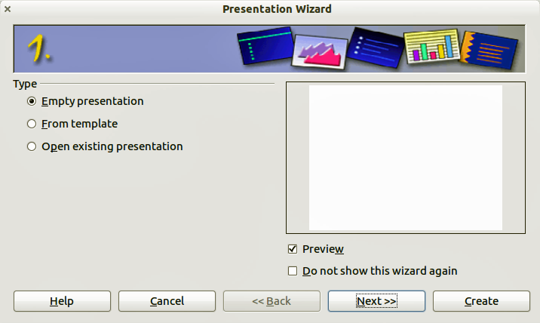
Figure 115. Choosing the type of presentation
- Under Type, choose one of the options. These options are covered in the Impress Guide.
  - Empty presentation creates a blank presentation.
  - From template uses a template design already created as the basis for a new presentation. The wizard changes to show a list of available templates. Choose the template you want.
  - Open existing presentation continues work on a previously created presentation. The wizard changes to show a list of existing presentations. Choose the presentation you want.
- Click Next. Figure 116 shows the Presentation Wizard step 2 as it appears if you selected Empty Presentation at step 1. If you selected From template, an example slide is shown in the Preview box.
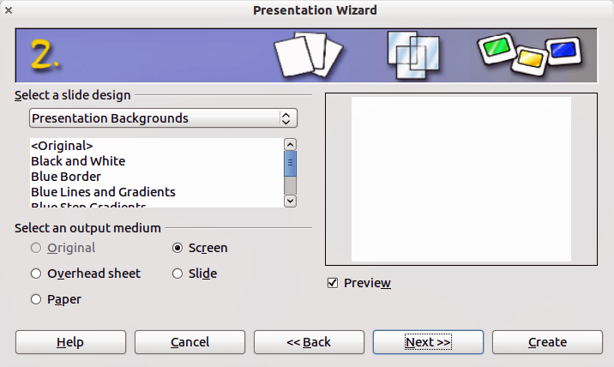
Figure 116. Selecting a slide design
- Choose a design under Select a slide design. The slide design section gives you two main choices: Presentation Backgrounds and Presentations. Each one has a list of choices for slide designs. If you want to use one of these other than <Original>, click it to select it.
  - The types of Presentation Backgrounds are shown in Figure 116. By clicking an item, you will see a preview of the slide design in the Preview window. Impress contains three choices under Presentations: <Original>, Introducing a New Product, and Recommendation of a Strategy.
  - <Original> is for a blank presentation slide design.
  - Both Introducing a New Product and Recommendation of a Strategy have their own prepackaged slide designs. Each design appears in the Preview window when its name is clicked.
Note | Introducing a New Product and Recommendation of a Strategy can also be used to create a presentation by choosing From template in the first step (Figure 115).
- Select how the presentation will be used under Select an output medium. Most often, presentations are created for computer screen display. Select Screen. You can change the page format at any time.
Note | The Screen page is optimized for a 4:3 display (28cm x 21cm) so it is not suitable for modern widescreen displays. You can change the slide size at any time switching to Normal view and selecting Format > Page.
- Click Next. The Presentation Wizard step 3 appears (Figure 117).
  - Choose the desired slide transition from the Effect drop-down menu.
  - Select the desired speed for the transition between the different slides in the presentation from the Speed drop-down menu. Medium is a good choice for now.
- Click Create. A new presentation is created.
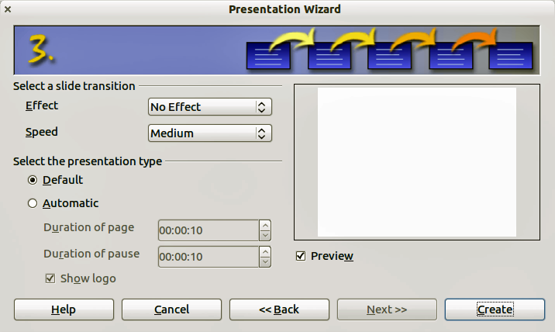
Figure 117: Selecting a slide transition effect
Tip | You can accept the default values for both Effect and Speed unless you are skilled at creating presentations. Both of these values can be changed later while working with Slide transitions and animations. These two features are explained in more detail in Chapter 9 of the Impress Guide.
Note | If you selected From template on step 1 of the Wizard, the Next button will be active on step 3 and other pages will be available. These pages are not described here.
Caution   | Remember to save frequently while working on the presentation, to prevent any loss of information should something unexpected occur. You might also want to activate the AutoRecovery function (Tools > Options > Load/Save . General). Make sure Save AutoRecovery information every is selected and that you have entered a recovery frequency.

Formatting a presentation
A new presentation contains only one empty slide. In this section we will start adding new slides and preparing them for the intended contents.

Inserting slides
This can be done in a variety of ways; take your pick.
- Insert > Slide.
- Right-click on the present slide, and select Slide > New Slide from the pop-up menu.
- Click the Slide icon In the Presentation toolbar.
Sometimes, rather than starting from a new slide you want to duplicate a slide you have already inserted. To duplicate a slide, select the slide you want from the Slides pane and then choose Insert > Duplicate Slide.

Selecting a layout
In the Tasks pane, select the Layout drawer to display the available layouts. The Layouts differ in the number of elements a slide will contain, from a blank slide to a slide with six contents boxes and a title.
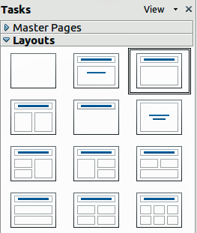
Figure 118: Available slide layouts
The first slide in a presentation is normally a title slide. The Title Slide (which also contains a section for a subtitle) or Title Only are suitable layouts for the first slide, while for most of the slides you will probably use the Title, Contents layout.
To create the title, click on Click to add title (assuming the Blank Slide layout was not used) and then type the title text. To adjust the formatting of the title, modify the Title presentation style; see Chapter 2 in the Impress Guide for instructions.
If you are using the Title Slide layout, click on Click to add text to add a subtitle. Proceed as above to make adjustments to the formatting if required modifying the Subtitle presentation style instead.
Note | Text and graphic elements can be readjusted at any time during the preparation of the presentation, but changing the layout of a slide that already contains some contents can have a dramatic effect. It is therefore recommended that you pay particular attention to the layout you select. If you do need to change the layout after contents have been added, the contents are not lost though they may need to be reformatted.
Tip | To view the names for the included layouts, use the Tooltip feature: position the cursor on an icon in the Layout section (or on any toolbar icon) and its name will be displayed in a small rectangle.  If tooltips are not enabled, choose Tools > Options > OpenOffice > General > Help and select the Tips option. If the Extended tips option is also selected, you will get more detailed tooltip information, but the tooltip names themselves will not be provided.
To select or change the layout, place the slide in the work area and select the desired layout from the layout drawer in the Task Pane.
Several layouts contain one or more content boxes. Each of these boxes can be configured to contain one of the following elements: Text, Movie, Picture, Chart or Table.
You can choose the type of contents by clicking on the corresponding icon that is displayed in the middle of the contents box as shown in Figure 119. If instead you intend to use the contents box for text, just click anywhere on the box to get a cursor.
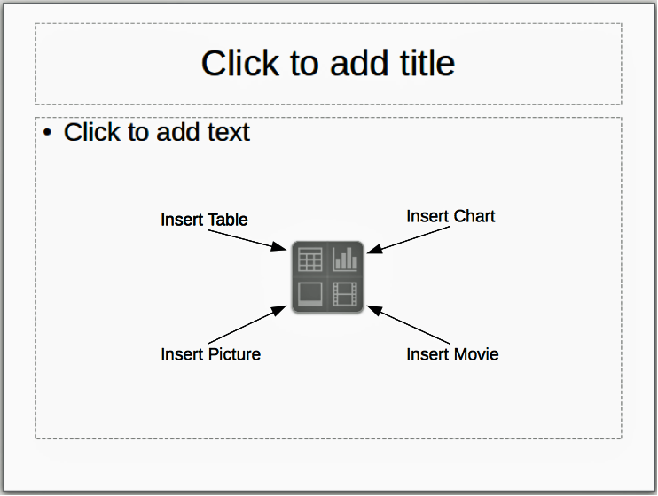
Figure 119: Selecting contents type
To select or change the layout, place the slide in the work area and select the desired layout from the layout drawer in the Task Pane.
If you have selected a layout with one or more contents boxes, this is a good time to decide what type of contents you want to insert.

Modifying the slide elements
At this stage, the slide contains elements that were included in the slide master, as well those elements included in the selected slide layout. It is however unlikely that the predefined layouts will suit all your needs. You may want to remove any elements that are not required or insert objects such as text and graphics.
Although Impress does not have the functionality to create new layouts, it allows you to resize and move the layout elements. It is also possible to add slide elements without being limited to the size and position of the layout boxes.
To resize a contents box, click on the outer frame so that the 8 resizing handles are displayed. To move it place the mouse cursor on the frame so that the cursor changes shape. You can now click the left mouse button and drag the contents box to its new position on the slide.
To remove any unwanted elements, do this:
- Click the element to highlight it. The colored resizing handles show it is highlighted.
- Press the Delete key to remove it.
Caution | Changes to any of the layouts included in Impress can only be made using View > Normal, which is the default. Attempting any changes by modifying a slide master, although possible, may result in unpredictable results and requires extra care as well as a certain amount of trial and error.

Adding text to a slide
To add text to a slide that contains a text frame, click on Click to add text in the text frame and then type your text. The Outline styles are automatically applied to the text as you insert it. You can change the outline level of each paragraph as well as its position within the text by using the arrow buttons on the Text Formatting toolbar (see “Error: Reference source not found” on page Error: Reference source not found). For more information on text, see “Error: Reference source not found” on page Error: Reference source not found.

Adding pictures or objects to a slide
To add any pictures or objects to a slide, for example a picture, clipart, drawing, photograph, or spreadsheet, click on Insert then select from the drop down menu what type of insert you require. For more information, see “Error: Reference source not found” on page Error: Reference source not found.

Modifying the appearance of all slides
To change the background and other characteristics of all slides in the presentation, you need to modify the master page or choose a different master page as explained in “Error: Reference source not found” on page Error: Reference source not found.
A Slide Master is a slide with a specified set of characteristics that acts as a template and is used as the starting point for creating other slides. These characteristics include the background, objects in the background, formatting of any text used, and any background graphics.
Note | Apache OpenOffice uses three interchangeable terms for this one concept. Master slide, slide master, and master page. These terms all refer to a slide that is used to create other slides. This guide, however, uses only the term slide master, except when describing the user interface.
Impress has included a range of slide masters, found in the Master Pages section of the Tasks pane. You can also create and save additional slide masters or add more from other sources. See Chapter 2 in the Impress Guide for information on creating and modifying slide masters.
If all you need to do is to change the background, you can take a shortcut:
- Select Format > Page and go to the Background tab.
- Select the desired background between solid color, gradient, hatching and bitmap.
- Click OK to apply it.
A dialog box will open asking if the background should be applied to all the slides. If you click yes, Impress will automatically modify the master page for you.
Note | Inserting and correctly formatting a background is beyond the scope of this chapter, but you can find all the information you need in Chapter 4 of the Draw Guide or in Chapter 6 of the Impress Guide.

Modifying the slide show
By default the slide show will display all the slides in the same order as they appear in the slide sorter, without any transition between slides, and you need some keyboard or mouse interaction to move from one slide to the next.
You can use the Slide Show menu to change the order of the slides, choose which ones are shown, automate moving from one slide to the next, and other settings. To change the slide transition, animate slides, add a soundtrack to the presentation, and make other enhancements, you need to use functions in the Task pane. See the Impress Guide for details on how to use all of these features.

Adding and formatting text
Many of your slides are likely to contain some text. This section gives you some guidelines on how to add text and how to change its appearance. Text in slides is contained in text boxes. For more information on adding and formatting text, see Chapter 3 in the Impress Guide.
There are two types of text boxes that you can add to a slide:
- Choose a predefined layout from the Layouts section of the Tasks pane and do not select any special contents type. These text boxes are called AutoLayout text boxes.
- Create a text box using the text tool in the Drawing toolbar or the Text toolbar.

Using text boxes created from the Layout pane
Make sure Normal view is selected:
- Click in the text box that reads Click to add text.
- Type or paste your text in the text box.
These text boxes are known as AutoLayout text boxes.

Using text boxes created from the text tool
Make sure Normal view is selected:
- Click on the Text icon on the Drawing toolbar or press F2. If the Drawing toolbar with the text icon is not visible, choose View > Toolbars > Drawing.
- Click and drag to draw a box for the text on the slide. Do not worry about the vertical size and position as the text box will expand if needed as you type.
- Release the mouse button when finished. The cursor appears in the text box, which is now in edit mode (gray hashed border shown in Figure 120).
- Type or paste your text in the text box.
- Click outside the text box to deselect it.
You can move, resize, and delete text boxes. For more information, see Chapter 3 in the Impress Guide.
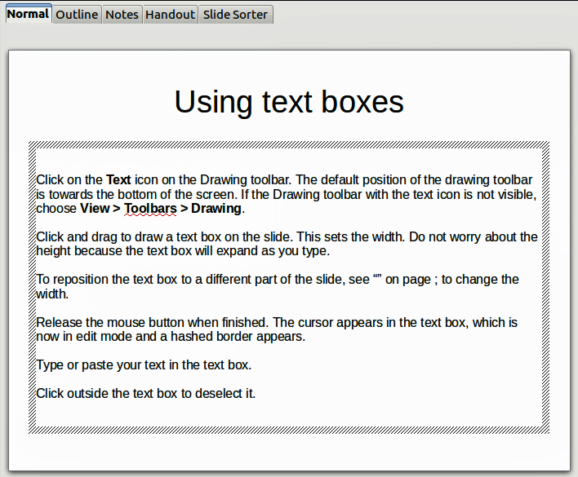
Figure 120: Creating and editing text boxes

Using text boxes created from the Text toolbar
Make sure Normal view is selected:
- Click on the Text icon on the Text toolbar (Figure 121). If the Text toolbar with the text icon is not visible, choose View > Toolbars > Text.
- Click and drag to draw a text box on the slide. This sets the width. Do not worry about the height because the text box will expand as you type.
- Release the mouse button when finished. The cursor appears in the text box, which is now in edit mode (a hashed border; see Figure 120).
- Type or paste your text into the text box.
- Click outside the text box to deselect it.
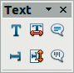
Figure 121: Text toolbar
Note | In addition to the normal text boxes where text is horizontally aligned, it is possible to insert text boxes where the text is aligned vertically. This choice is available only when Asian languages are enabled in Tools > Options > Language Settings > Languages. Click on the button in the drawing toolbar or text toolbar to create a vertical text box.

Quick font resizing
Impress has icons on the Text Formatting toolbar to increase or decrease font size of selected text. The amount by which the font size changes depends on the standard sizes available for the font in use.

Pasting text
Text may be inserted into the text box by copying it from another document and pasting it into Impress. However, the pasted text will probably not match the formatting of the surrounding text or that of the other slides in the presentation. This may be what you want on some occasions; however in most cases you want to make sure that the presentation style is consistent and does not become a patchwork of different paragraph styles, font types, bullet points and so on. There are several ways to ensure consistency; these methods are explained below.

Pasting unformatted text
It is normally good practice to paste text without formatting and apply the formatting later. To paste without formatting, either press Control+Shift+V and then select Unformatted text from the dialog that appears, or click on the small black triangle next to the paste symbol in the standard toolbar and select Unformatted text. The unformatted text will be formatted with the outline style at the cursor position in an AutoLayout text box or with the default graphic style in a normal text box.

Formatting pasted text
If you are pasting the text into an AutoLayout area, you need to apply the appropriate outline style to the text to give it the same look and feel as the rest of the presentation.
- Paste the text in the desired position. Do not worry if it does not look right; it will in a minute.
- Select the text you have just pasted.
- Select Format > Default formatting from the menu bar.
- Use the four arrow buttons in the Text Formatting toolbar (highlighted in Figure 109) to move the text to the appropriate position and give it the appropriate outline level. The button with the arrow pointing left promotes the list entry by one level (for example from Outline 3 to Outline 2), the right arrow button demotes the list entry by one level, the up and down arrow buttons move the list entry.
- Apply manual formatting as required to sections of the text (to change font attributes, tabs, and so on).
If you are pasting text in a text box, you can still use styles to quickly format the text. Note that one and only one graphic style can be applied to the copied text. To do that:
- Paste the text in the desired position.
- Select the text you have just pasted.
- Select the desired graphic style.
- Apply manual formatting as required to sections of the text.

Creating bulleted and numbered lists
The procedure to create a bulleted or numbered list is quite different depending on the type of text box used, although the tools to manage the list and customize the appearance are the same.
In text boxes created automatically by Impress (called AutoLayout), the outline styles available are by default bulleted lists, while for normal text boxes an additional step is required to create a bulleted list.

Creating lists in AutoLayout text boxes
Every text box included in the available layouts is already formatted as a bulleted list, therefore to create a bulleted list the only necessary steps are:
- From the Layout pane, choose a slide design that contains a text box. Those are easily recognizable from the thumbnail.
- Click in the text box that reads Click to add an outline.
- Type the text, then press Enter to start a new bulleted line.
The methods for switching between bulleted and numbered lists are explained in “Error: Reference source not found” on page Error: Reference source not found.
Tip | Press Shift + Enter to start a new line without creating a new bullet or number. The new line will have the same indentation of the previous line. To switch off bullets altogether, click the bullets button on the text formatting toolbar. If the text formatting toolbar is not showing, enable it selecting View > Toolbar > Text Formatting on the menu bar.

Creating lists in other text boxes
To create a list in a text box, follow these steps:
- Place the cursor in the text box.
- Click the Bullets On/Off button on the text formatting toolbar.
- Type the text and press Enter to start a new bulleted line.
- The default list type is a bulleted list. Methods for changing the appearance of the list are explained on page Error: Reference source not found.

Creating a new outline level
- If necessary, press Enter to begin a new line.
- Press Tab or click the indentation arrows in the text formatting toolbar. Each time you press Tab or click the right arrow, the line indents to the next outline level. Pressing Enter creates a new line at the same level as the previous one. To return to the previous level, press Shift+Tab or click the left arrow.
In the AutoLayout text boxes, promoting or demoting an item in the list corresponds to applying a different outline style, so the second outline level corresponds to Outline 2 style, the third to Outline 3 style, and so on. As a consequence, a change in the level also produces other changes (for example font size, bullet type, and so on).
Note | Do not try to change the outline level by selecting the text and then clicking the desired outline style as you would in Writer. Due to the way that presentation styles work, it is not possible to apply them in this way.

Changing the appearance of the list
You can fully customize the appearance of a list, changing the bullet type or numbering for the entire list or for single entry. All of the changes can be made using the Bullets and Numbering dialog, which is accessed by selecting Format > Bullets and Numbering or by clicking on the Bullets and Numbering icon on the text formatting toolbar.
For the entire list:
- Select the entire list or click on the gray border of the text box so that the colored resizing handles are displayed.
- Select Format > Bullets and Numbering or click on the Bullets and Numbering icon on the text formatting toolbar.
- The Bullets and Numbering dialog contains five tabs: Bullets, Numbering type, Graphics, Position, and Customize.
  - If a bullet list is needed, select the desired bullet style from the default styles available on the Bullets page.
  - If a graphics style is needed, select one from those available on the Graphics page.
  - If a numbered list is needed, select one of the default numbering styles on the Numbering type page.
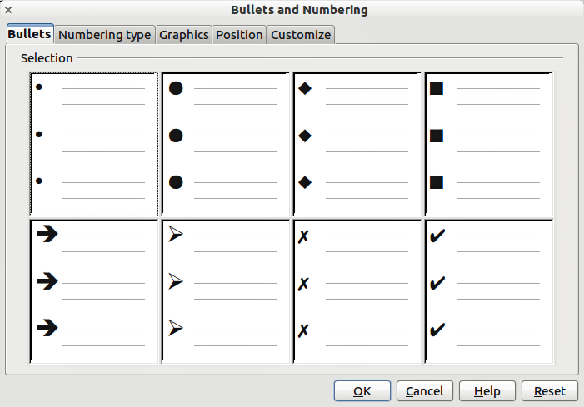
Figure 122: Bullets and Numbering dialog
For a single line in the list, click anywhere in the line to place the cursor in it and then follow steps 2 and 3 in the previous instruction set.
If the list was created in an AutoLayout text box, then an alternative way to change the entire list is to modify the Outline styles. Changes made to the outline style will apply to all the slides using them. Sometimes this is what you want; sometimes it is not, so some care must be taken.

Adding pictures, tables, charts, media files, and other objects
As we have seen, in addition to text, a contents box can contain also pictures, tables, charts, and movies. This section provides a quick overview of how to work with these objects; for a more detailed description, you are invited to consult the Impress Guide.

Adding pictures
To add a picture to a contents box:
- Go to Insert > Picture on the main menu bar and then select either From file or Scan.
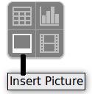
- Alternatively, and after inserting a new slide, click the Insert Picture icon and select the file from the Insert Picture dialog that opens. To see a preview of the picture, check Preview at the bottom of the Insert Picture dialog (Figure 123).
- Move the picture to the desired location.
The picture will resize itself to fill the area of the contents box. Follow the directions in the Caution note below when manually resizing a graphic.

Figure 123. Insert picture dialog
Caution | When resizing a graphic, right-click the picture. Select Position and Size from the context menu and make sure that Keep ratio is selected. Then adjust the height or width to the size you need. (As you adjust one dimension. both dimensions will change.) Failure to do so will cause the picture to become distorted. Remember also that resizing a bitmap image will reduce its quality; it is better to create an image of the desired size outside of Impress.

Adding tables
For displaying tabular data, you can insert basic tables directly into your slides by choosing the Table contents type. It is also possible to add a table outside a contents box in a number of ways:
- Go to Insert > Table on the main menu bar.
- Click on the Table icon on the main toolbar or table toolbar.
- After inserting a new slide, click the Insert Table icon.
- Select a style option from the Table Design section of the Tasks pane.
- Alternatively, click on the Table Design icon on the table toolbar to open the Table Design section of the Tasks pane and then select a style.
The first three methods above opens the Insert Table dialog, where you can select the required number of columns and rows. Alternatively, clicking on the black arrow next to the Table icon displays a graphic allowing you to drag and select the number of required rows and columns for your table.
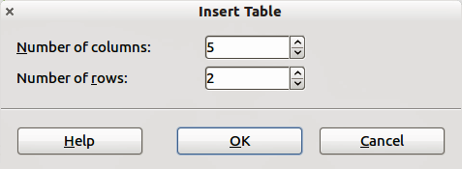
Figure 124. Creating a table with the Insert Table dialog
Note | Selecting from any of the styles in the Table Design section of the Tasks pane creates a table based on that style. If you create a table by another method, you can still apply a style of your choice later.
With the table selected, the Table toolbar should appear. If it does not, you can access it by selecting View > Toolbars > Table. The Table toolbar offers many of the same icons as the table toolbar in Writer, with the exception of functions like Sort and Sum for performing calculations. For those functions, you need to use a spreadsheet inserted from Calc (discussed Error: Reference source not found).
After the table is created, you can modify it in much the same way as you would modify a table in Writer: adding and deleting rows and columns, adjusting width and spacing, adding borders, background colors and so on. Detailed information on working with tables and the Table Properties dialog can be found in Chapter 3 of the Impress Guide and Chapter 9 of the Writer Guide.
By modifying the style of the table from the Table Design section of the Tasks pane, you can quickly change the appearance of the table or any newly created tables based on the Style options you select. You can choose to add emphasis to a header and total row as well as the first and last columns of the table, and apply a banded appearance to the rows and columns.
Having completed the table design, entering data into the cells is similar to working with text box objects. Click in the cell you wish to add data to, and begin typing. To move around cells quickly, use the following key options:
- The arrow keys move the cursor to the next table cell if the cell is empty, otherwise they move the cursor to the next character in the cell.
- The Tab key moves to the next cell, skipping over the contents of the cell; Shift+Tab move backwards from cell to cell.

Adding charts
To insert a chart in a slide you can either use Insert > Chart from the main menu bar, clicking on the Chart icon in the main toolbar, or, after inserting a new slide, clicking on the Insert Chart icon. Impress will insert a default chart and open the Chart dialog. To modify the chart type, insert your own data and change the formatting refer to the Impress Guide.

Adding media files
You can insert various types of media files, such as music and movie clips, into your slide by selecting the Insert Movie icon in an empty contents box. A media player will open at the bottom of the screen and you can preview the media. When an audio file is inserted, the contents box will show a loudspeaker image.
Caution | In Linux-based systems such as Ubuntu, media files do not work straight out of the box. You need to download the Java Media Framework API (JMF) and add the path to jmf.jar to the Class Path in Tools > Options > OpenOffice > Java.

Adding graphics, spreadsheets, and other objects
Graphics, such as shapes, callouts, arrows, and so on, are often useful to complement the text on a slide. These objects are handled much the same way as graphics in Draw. For more information, see Chapter 6 (Getting Started with Draw) in this book, the Draw Guide, or Chapters 4, 5, and 6 in the Impress Guide.
Spreadsheets embedded in Impress include most of the functionality of spreadsheets in Calc and are therefore capable of performing extremely complex calculations and data analysis. If you need to analyze your data or apply formulas, these operations are best performed in a Calc spreadsheet and the results displayed in an embedded Impress spreadsheet or even better in a native Impress table.
Alternatively, choose Insert > Object > OLE Object from the menu bar. This opens a spreadsheet in the middle of the slide and the menus and toolbars change to those used in Calc so that you can start adding data, though you may first need to resize the visible area on the slide. You can also insert an already existing spreadsheet and use the viewport to select the data that you want to display on your slide.
Impress offers the capability of inserting in a slide various other types of objects such Writer documents, Math formulas, or even another presentation. For details on using these objects, refer to Chapter 7 of the Impress Guide.

Working with master pages and styles
A slide master is a slide that is used as the starting point for other slides. It is similar to a page style in Writer and it controls the basic formatting of all slides based on it. A slide show can have more than one slide master.
Note | Apache OpenOffice uses three terms for a slide that is used to create other slides: master slide, slide master, and master page. This book uses the term slide master, except when describing the user interface.
A slide master has a defined set of characteristics, including the background color, graphic, or gradient; objects (such as logos, decorative lines, and other graphics) in the background; headers and footers; placement and size of text frames; and the formatting of text.

Styles
All of the characteristics of slide masters are controlled by styles. The styles of any new slide you create are inherited from the slide master from which it was created. In other words, the styles of the slide master are available and applied to all slides created from that slide master. Changing a style in a slide master results in changes to all the slides based on that slide master, but you can modify individual slides without affecting the slide master.
Note | Although it is highly recommended to use the slide masters whenever possible, there are occasions where manual changes are needed for a particular slide, for example to enlarge the chart area when the text and chart layout is used.
Slide masters have two types of styles associated with them: presentation styles and graphic styles. The prepackaged presentation styles can be modified, but new presentation styles cannot be created. In the case of graphic styles, you can modify the prepackaged ones and also create new ones.
Presentation styles affect three elements of a slide master: background, background objects (such as icons, decorative lines, and text frames), and text placed on the slide. Text styles are further divided into Notes, Outline 1 through Outline 9, Subtitle, and Title. The outline styles are used for the different levels of the outline to which they belong. For example, Outline 2 is used for the sub-points of Outline 1, and Outline 3 is used for the sub-points of Outline 2.
Graphic styles affect many of the elements of a slide. Notice that text styles exist in both the presentation and graphic style selections.

Slide masters
Impress comes with a collection of slide masters. These slide masters are shown in the Master Pages section of the Tasks pane (Figure 125). This section has three subsections: Used in This Presentation, Recently Used, and Available for Use. Click the + sign next to the name of a subsection to expand it to show thumbnails of the slides, or click the – sign to collapse the subsection to hide the thumbnails.
Each of the slide masters shown in the Available for Use list is from a template of the same name. If you have created your own templates, or added templates from other sources, slide masters from those templates will also appear in this list.
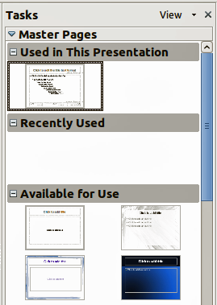
Figure 125: Available master pages (slides masters)

Creating a slide master
You can create a new slide master is similar to modifying the default slide master.
To start, enable editing of slide masters by selecting View > Master > Slide Master and the Master View toolbar opens. You can also right-click on the slide master in the Master Pages section of the tasks pane and select Edit Master to open the Master View toolbar. On the Master View toolbar, click the New Master icon (highlighted in Figure 126).
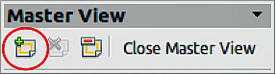
Figure 126: Master View toolbar
A second slide master appears in the Slides pane. Modify this slide master to suit your requirements. It is also recommended that you rename this new slide master: right-click on the slide in the Slides pane and select Rename master from the pop-up menu. When you are done, close the Master View toolbar to return to normal slide editing mode.

Applying a slide master
In the Tasks Pane, make sure the Master Pages section is showing (Figure 125).
To apply one of the slide masters to all slides in your presentation, click on it in the list.
To apply a different slide master to one or more selected slides:
- In the Slide Pane, select the slides you want to change.
- In the Tasks Pane, right-click on the slide master you want to apply to the selected slides, and click Apply to Selected Slides on the pop-up menu.

Loading additional slide masters
Sometimes, in the same set of slides, you may need to mix multiple slide masters that may belong to different templates. For example, you may need a completely different layout for the first slide of the presentation, or you may want to add to your presentation a slide from a different presentation (based on a template available on the hard disk).
The Slide Design dialog makes this possible. Access this dialog either from the menu bar (Format > Slide design) or from the pop-up menu that appears when right-clicking on a slide in the Slides pane.
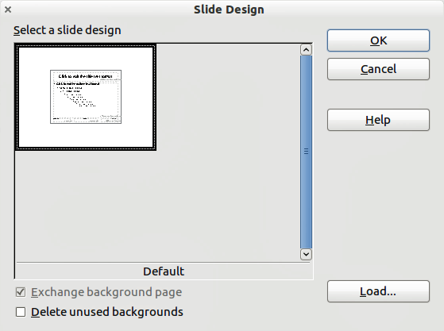
Figure 127: Slide Design
The main window in the dialog shows the slide masters already available for use. To add more:
- Click the Load button.
- Select in the Load Slide Design dialog (Figure 128) the template from which to load the slide master and click OK.
- Click OK again to close the slide design dialog.
The slide masters in the template you selected are now shown also in the Master Pages section of the Tasks pane in the Available for use subsection.
Note | The slide masters you have loaded will also be available the next time you load the presentation. If you want to delete the unused slide masters, click the corresponding checkbox in the Slide Design dialog. If the slide master was not used in the presentation, it is removed from the list of available slide masters anyway.
Tip | To limit the size of the presentation file, you may want to minimize the number of slide masters used.
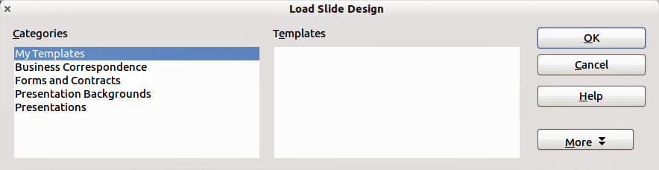
Figure 128: Load Slide Design dialog for selecting templates

Modifying a slide master
The following items can be changed on a slide master:
- Background (color, gradient, hatching, or bitmap)
- Background objects (for example, add a logo or decorative graphics)
- Size, placement, and contents of header and footer elements to appear on every slide
- Size and placement of default frames for slide titles and content
Before working on the slide master, make sure that the Styles and Formatting dialog is open.
To select the slide master for modification:
- Select View > Master > Slide Master from the menu bar. This unlocks the properties of the slide master so you can edit it.
- Click Master Pages in the Tasks pane. This gives you access to the slide masters.
- Click on the slide master you want to modify among the ones available.
- Make changes as required, then click the Close Master View icon on the Master View toolbar. For details, see Chapter 2 of the Impress Guide.
- Save the file before continuing.
Caution | Any changes made to one slide when in Master View mode will appear on all slides using this slide master. Always make sure you close Master View and return to Normal view before working on any of the presentation slides. Select View > Normal from the menu bar, or clicking Close Master View in the Master View toolbar to return to the normal slide view.
The changes made to one of the slides in Normal view (for example, changes to the bullet point style, the color of the title area, and so on) will not be overridden by subsequent changes to the slide master. There are cases, however, where it is desirable to revert a manually modified element of the slide to the style defined in the slide master: to do that, select that element and choose Format > Default Formatting from the menu bar.

Using a slide master to add text to all slides
Some of the supplied slide masters have text objects in the footer. You can add other text objects to the master page for your slides to act as a header or a footer.
- Choose View > Master > Slide Master from the menu bar.
- On the Drawing toolbar, select the Text icon or press F2.
- Click once and drag in the master page to draw a text object, and then type or paste your text into the object or add fields as described below.
- Choose View > Normal when you are finished.
The Impress slide master comes with three pre-configured areas: for date, footer, and slide number.
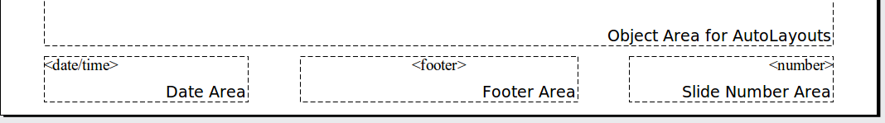
To add page (slide) numbers or date and time to the slide footers in your presentation, select Insert > Page Number or Insert > Date and Time to open the Header and Footer dialog (Figure 129) where you can select and configure these areas on the slide.
Tip | To change the number format (1,2,3 or a,b,c or i,ii,iii, etc.) for the page number field, choose Format > Page and then select a format from the list in the Layout Settings area.  To change the paragraph style, modify the Background Objects Presentation style.
To add other information, such as the author of the presentation or the name of the file, use Insert > Fields and select the required field from the submenu. If you want to edit this field in your slide, select it and choose Edit > Fields. See Chapter 2 (Adding and Formatting Text) in the Impress Guide for more information.
Tip | To change the author information, go to Tools > Options > OpenOffice > User Data.
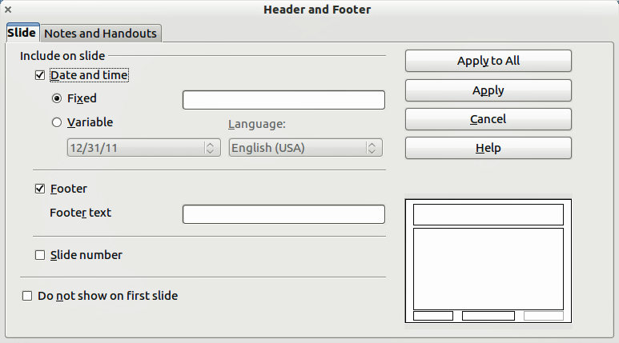
Figure 129: Configuring the slide footer areas
The fields you can use in Impress are:
- Date (fixed)
- Date (variable): updates automatically when you reload the file
- Time (fixed)
- Time (variable): updates automatically when you reload the file
- Author: first and last names listed in the OpenOffice user data
- Page number (slide number)
- File name

Adding comments to a presentation
Impress supports comments similar to those in Writer and Calc.
In Normal View, choose Insert > Comment from the menu bar. A small box containing your initials appears in the upper left-hand corner of the slide, with a larger text box beside it. Impress automatically adds your name and the current date at the bottom of the text box.
Type or paste your comment into the text box. You can optionally apply some basic formatting to the comment by selecting it, right-clicking, and choosing from the pop-up menu. From this menu, you can apply formatting to selected text, delete the current comment, delete all comments from the same author, or delete all comments in the presentation.
You can move the small comment markers to anywhere you wish on the slide. Typically you might place it on or near an object you refer to in the comment.
To show or hide the comment markers, choose View > Comments.
Select Tools > Options > User Data to configure the name you want to appear in the Author field of the comment, or to change it.
If more than one person edits the document, each author is automatically allocated a different background color for their comments.
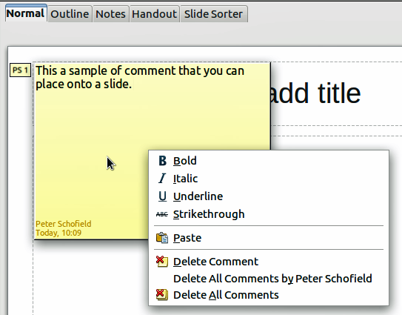
Figure 130: A comment

Setting up the slide show
As mentioned in “Error: Reference source not found” on page Error: Reference source not found, Impress allocates reasonable default settings for slide shows, while at the same time allowing for customizing many aspects of the slide show experience. This section covers only some aspects; advanced techniques are explained in Chapter 9 (Slide Shows) in the Impress Guide.
Most of the tasks are best done in Slide Sorter view where you can see most of the slides simultaneously. Choose View > Slide Sorter from the menu bar or click the Slide Sorter tab at the top of the workspace.

One slide set – multiple presentations
In many situations, you may find that you have more slides than the time available to present them or you may want to provide a rapid overview without dwelling on the details. Rather than having to create a new presentation, you can use two tools that Impress offers: hiding slides and custom slide shows.
To hide a slide, right-click on the slide thumbnail either in the Slide pane or in the Workspace area. If you are using the Slide Sorter view and choose Hide Slide from the pop-up menu. Hidden slides are marked by a slashed slide number.
If you want to reorder the presentation, choose Slide Show > Custom Slide Show. Click on the New button to create a new sequence of slides and save it.
You can have as many slide shows as you want from a single slide set.

Slide transitions
Slide transition is the animation that is played when a slide is changed for the next slide in the presentation. You can configure the slide transition from the Slide Transition drawer in the Tasks pane. Select the desired transition, the speed of the animation, and whether the transition should happen when you click the mouse (preferred) or automatically after a certain number of seconds. Click Apply to all slides unless you prefer to have different transitions in the presentation.
Tip | The Slide transition section has a very useful choice: Automatic preview. Select its checkbox and when you make any changes in a slide transition, the new slide is previewed in the Slide Design area, including its transition effect.

Automatic slides advance
You can set the presentation to automatically advance to the next slide after a set amount of time from the Slide Transition section in the Task pane. Go to Advance slide and select Automatically after, then choose the required amount of time in seconds that each slide will be displayed. Click on the Apply to All Slides button to apply the same display time to all slides.
To apply a different display time to each slide in your presentation, choose Slide Show > Rehearse Timings. Start the slide show and a small timer is displayed in the bottom left corner. When you are ready to advance to the next slide, mouse click on the display background or press the right arrow on your keyboard. Impress will memorize the timings for each slide and advance to the slide automatically after each timing ends when you run the slide show.
To automatically restart a slide show after the last slide has been displayed, go to Slide Show > Slide Show Settings on the menu bar. Select Auto and the timing of the pause between slide shows. Click OK when you have finished.

Running a slide show
To run a slide show, do one of the following:
- Click Slide Show > Slide Show on the menu bar.
- Click the Slide Show icon on the Presentation toolbar.
- Press F5 on the keyboard.
If the slide transition is Automatic after x seconds, let the slide show run by itself.
If the slide transition is On mouse click, do one of the following to move from one slide to the next:
- Use the arrow keys on the keyboard to go to the next slide or to go back to the previous one.
- Click the mouse to move to the next slide.
- Press the spacebar on the keyboard to advance to the next slide.
Right-click anywhere on the screen to open a menu from which you can navigate the slides and set other options.
To exit the slide show at any time including at the end, press the Esc key.

