Chapter 12
Tables of Contents, Indexes, and Bibliographies

Introduction
This chapter describes how to create and maintain a table of contents (TOC), an index, and a bibliography for a text document using Apache OpenOffice Writer. To understand the instructions, you need to have a basic familiarity with Writer and styles (see Chapters 6 and 7).
This chapter does not cover all the possible ways to use the features available through the TOC/Index dialog boxes in Writer., but some common usage examples are given that cover a wide range of needs.

Tables of Contents
Writer’s table of contents feature lets you build an automated table of contents from the headings in your document. Whenever changes are made to the text of a heading in the body of the document or the page on which the heading appears, those changes automatically appear in the table of contents when it is next updated.
Before you start, make sure that the headings are styled consistently. For example, you can use the Heading 1 style for chapter titles and the Heading 2 and Heading 3 styles for chapter subheadings.
This section shows you how to:
- Create a table of contents quickly, using the defaults.
- Customize a table of contents.
Note | You can use any style for the different levels you want to include in the table of contents. But, for the sake of simplicity, most of this chapter uses the default Heading [x] styles.

Creating a Table of Contents Quickly
Most often, you'll find the default table of contents to be what you need. Inserting a default TOC is simple:
- When you create your document, use the following paragraph styles for different heading levels (such as chapter and section headings): Heading 1, Heading 2, and Heading 3. These are what will appear in your TOC, since Writer can evaluate up to ten levels of headings.
- Click in the document where you want the TOC to appear.
- Choose Insert > Indexes and Tables > Indexes and Tables.
- Click OK. The result will be a typical table of contents.
Some tips you may find useful:
- If some of your headings do not show up in the table of contents, check that the headings have been tagged with the correct paragraph style. If a whole level of headings does not show up, check the settings in Tools > Outline Numbering. See “Defining a hierarchy of headings” in Chapter 6 (Introduction to Styles) for more information.
- The TOC appears with a gray background. This background is there to remind you that the text is generated automatically. It is not printed and does not appear if the document is converted to a PDF. To turn off this gray background, go to Tools > Options > OpenOffice > Appearance, then scroll down to the Text Document section and deselect the option for Index and table shadings.
This change may leave a gray background showing behind the dots between the headings and the page numbers, because the dots are part of a tab. To turn that shading off, go to Tools > Options > OpenOffice Writer > Formatting Aids and deselect the option for Tabs.
- If you cannot place the cursor in the TOC, choose Tools > Options > OpenOffice Writer > Formatting Aids, and then select Enable in the Cursor in protected areas section.
If you add or delete text (so that headings move to different pages) or you add, delete, or change headings, you need to update the table of contents. To do this:
- Click anywhere in the TOC.
- Right-click and select Update Index/Table from the pop-up menu.

Customizing a Table of Contents
Almost every aspect of the table of contents can be customized to suit the style and requirements of your document. However, this flexibility also carries some complexity; it's good to have in mind the desired end result.
Start by clicking in the document where you want the table of contents to appear and choose Insert > Indexes and Tables > Indexes and Tables to open the Insert Index/Table dialog box shown in Figure 1.
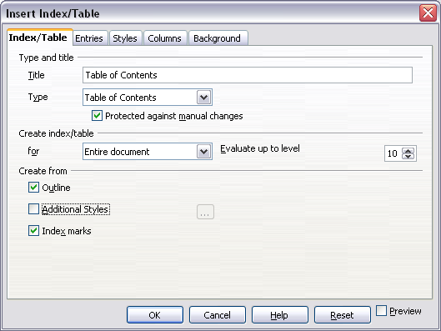
Figure 1. Index/Table page of Insert Index/Table dialog box
You can also access this dialog box at any time by right-clicking anywhere in an existing table of contents and choosing Modify from the pop-up menu.
The Insert Index/Table dialog box has five tabs. Each of them covers a different aspect of the TOC structure and appearance:
- Use the Index/Table tab to set the attributes of the TOC, most importantly the type of index.
- Use the Entries and Styles tabs to format the entries in the TOC.
- Use the Columns tab to put the TOC into more than one column.
- Use the Background tab to add color or a graphic to the background of the TOC.
You can display a preview box, located on the left-hand side of each page, to show as you work how the TOC will look. (If you do not see the preview box, select the Preview option in the lower right-hand corner of the dialog box.) The illustrations in this chapter show the dialog box as it appears with the preview box hidden.
After making all your changes, click OK to apply them. If you need to revert to the default settings, click the Reset button.

Index/Table Tab
Use the Index/Table tab, pictured in Figure 1, to set the attributes of the TOC.

Changing the Title
To give the table of contents a different title, type it in the Title field. To delete the title, clear the Title field.

Setting the Type of Index
In computer terminology, a table of contents is one of several types of indexes. Be sure the Type of Index is set to Table of Contents. See “Figure 2: Specifying an outline level on the Outline & Numbering page for a paragraph style” on page 5 and “Figure 3. Entries page of Insert Index/Table dialog box” on page 7 for more about creating other types of indexes.
Note | You can only change the type of index when you first create it. Once you define an index type (for example, a table of contents) you cannot change the type.

Protecting against Manual Changes
To prevent the TOC from being changed accidentally, select Protected against manual changes. If this option is selected, the TOC can only be changed by using the right-click menu or the Insert Table/Index dialog box. If the option is not selected, the TOC can be changed directly on the document page, just like other text. However, any manual changes will be lost when you update it.

Changing the Number of Levels Included
Writer uses 10 levels of headings when it builds the table of contents (or the number of levels used in the document, whichever is smaller). To change the number of levels included, enter the required number in the Evaluate up to level box. For example, the TOC in this book includes only the first four heading levels.

Choosing the Scope of the Table of Contents
The for drop-down list in the Create index/table area, allows you to select whether the TOC will cover all the document's headings (Entire document) or just the headings of the chapter where it is inserted. Writer identifies a “chapter” as all the headings between two first level outline headings (normally Heading 1).

Creating a Table of Contents from an Outline
The third section of the Index/Table page is used to determine what Writer should use to create the TOC. The available choices (not mutually exclusive) are:
- Outline
- Additional styles
- Index marks
By default, Writer uses the outline levels; that is, paragraphs formatted with the paragraph styles associated with outline levels in Tools > Outline Numbering. In the default document, Heading 1 has outline level 1, Heading 2 outline level 2 and so on up to Heading 10.
You can change the paragraph styles included in the outline as described in “Defining a hierarchy of headings” in Chapter 6 of this guide. You can include other paragraph styles in the TOC by assigning an outline level to those styles. To do this, modify the paragraph style definition: go to the Outline & Numbering tab for the style, and select the required outline level. Click OK to save the change.
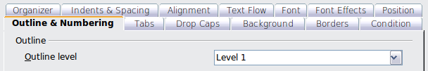Figure 2: Specifying an outline level on the Outline & Numbering page for a paragraph style

Creating from Additional Styles
By selecting the Additional Styles option on the Index/Table tab, you can add more paragraph styles to the TOC. This can be useful when you want to include an appendix in the TOC. If the Outline option is also selected, the additional styles will be included in the table of contents together with the ones defined in the outline numbering.

Creating from Index Marks
This selection adds any index entries that you have inserted into the document by using Insert > Indexes and Tables > Entry. Normally you would not use this selection for a table of contents. However, if you do wish to use it, be sure to select Table of Contents from the drop-down list in the Insert Index Entry dialog box (see Figure 3) when you are entering the index entries for use in a TOC, so that Writer can distinguish between them and any index entries intended for inclusion in an alphabetic index.

Entries Page
Use the Entries page to define and format the entries in the TOC. Each outline level can be styled independently of the other levels by adding and deleting elements.
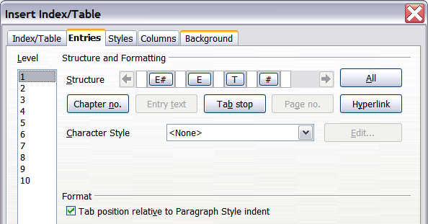
Figure 3. Entries page of Insert Index/Table dialog box
Click on a number in the Level column to select the outline level whose elements you want to format. This will display the Structure line which contains the elements included in the entries for that level. The available elements are displayed just below the structure line, and are grayed out if already included:
- The E# button represents the “chapter number”, which means the heading number, not just for chapters but also for other levels of headings.
- The E button represents the chapter (or sub-chapter) heading text.
- The T button represents a tab stop.
- The # button represents the page number.
- The LS button represents the start of a hyperlink. (This button does not appear on the default Structure line.)
- The LE button represents the end of a hyperlink. (This button does not appear on the default Structure line.)
Each white field on the Structure line represents a blank space. You can add custom text if you desire.
Note | If the chapter number defined for your document includes the word “Chapter” before the number itself, then the E# field in the TOC will also include the word “Chapter”. If you want to include the chapter number with the page number (for example, in the style “1-1, 1-2, …”) , you will find that the page number appears in the TOC as “Chapter 1-1”, which is probably not what you want.

Adding Elements
To add an element to the Structure line:
- Click in the white field where you want to insert the element.
- Click one of the five buttons just below the Structure line. (For example, to add a tab, click the Tab stop button.) A button representing the new element appears on the Structure line.
- To add custom text, such as the word Chapter, type the text in the white field.

Changing Elements
To change an element in the Structure line, click the button representing that element and then click the element that you want to substitute in the row of buttons just below the Structure line. For example, to change a chapter number to a tab stop, click the E# button on the Structure line (it shows then as being pressed) and then click the Tab stop button in the row of available elements.

Applying Changes to All Outline Levels
To apply the displayed structure and formatting to all outline levels, click the All button.

Deleting Elements
To delete an element from the Structure line, click the button representing that element and then press the Delete key on your keyboard. For example, to delete a tab stop, click the T button and then press the Delete key (Function+Delete on a Mac).

Hyperlinking an Entry
To change the default Structure line so that the chapter number and the entry text form a hyperlink, follow these steps:
- On the Structure line, place the cursor in the white field to the left of the E# button.
- Click the Hyperlink button. An LS button, representing the start of the hyperlink, appears on the Structure line.
- On the Structure line, place the cursor in the white field to the right of the E button.
- Click the Hyperlink button again. An LE button, representing the end of the hyperlink, appears on the Structure line.
Figure 4 represents the completion of the above steps. The number and the text of the entries on that level will now be hyperlinks.
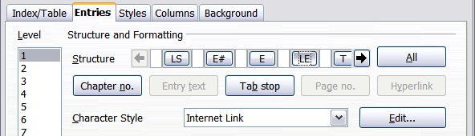
Figure 4: Hyperlink in table of contents

Applying Character Styles
You might want an element to be a bit different from the rest of the line. For example, you might want the page number to be bold. To apply a character style to an element:
- Be sure you have defined a suitable character style.
- On the Structure line, click the button representing the element to which you want to apply a style.
- From the Character Style drop-down list, select the desired style.
To view or edit the attributes of a character style, select the style from the Character Style drop-down list and then click the Edit button.
Tip | The default character style for hyperlinks is Internet Link, which by default is underlined and shown in blue. If you want the TOC entries to work as hyperlinks, but not appear underlined and blue, you can change the attributes of the Internet Link character style. However, this changes the attributes of all hyperlinks in the document.  If you want other hyperlinks (for example, website addresses) to remain in the default style, select the LS button on the Structure line and change the character style selection for TOC entries to Index Link. If necessary, change the attributes for Index Link to what you want.

Tab Position Relative to Paragraph Style Indent
When this option is selected, entries are indented according to the settings of their individual formats. Where a paragraph style specifies an indent on the left, tab stops are relative to this indent. If this option is not selected, tab stops are relative to the left margin position.

Styles Tab
Use the Styles tab, pictured in Figure 5, to change which paragraph style is assigned to each level in the table of contents. In most cases, the best strategy is to keep the assigned styles, but change their settings as needed to make the TOC look as you've imagined.
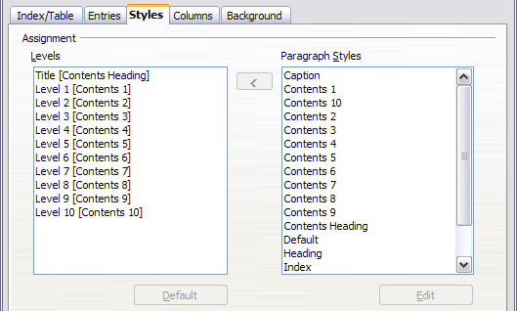Figure 5. Styles page of Insert Index/Table dialog box
To apply a custom paragraph style to an outline level:
- In the Levels list box, select the outline level.
- In the Paragraph Styles list box, click the desired paragraph style.
- Click the < button to apply the selected paragraph style to the selected outline level.
The style assigned to each level appears in square brackets in the Levels list.
To remove paragraph styling from an outline level, select the outline level in the Levels list box, and then click the Default button.
To view or edit the attributes of a paragraph style, click the style in the Paragraph Styles list box, and then click the Edit button.
Note | Be careful; changes to a paragraph style will affect any text in the document that is formatted using this style, not just the format of the table of contents.

Columns Tab
Use the Columns tab to change the number of columns for the TOC. Multiple columns are more likely to be used in indexes than in a TOC, so this page is described in the section on indexes. See Error: Reference source not found.

Background Tab
Use the Background tab to add color or a graphic to the background of the TOC.
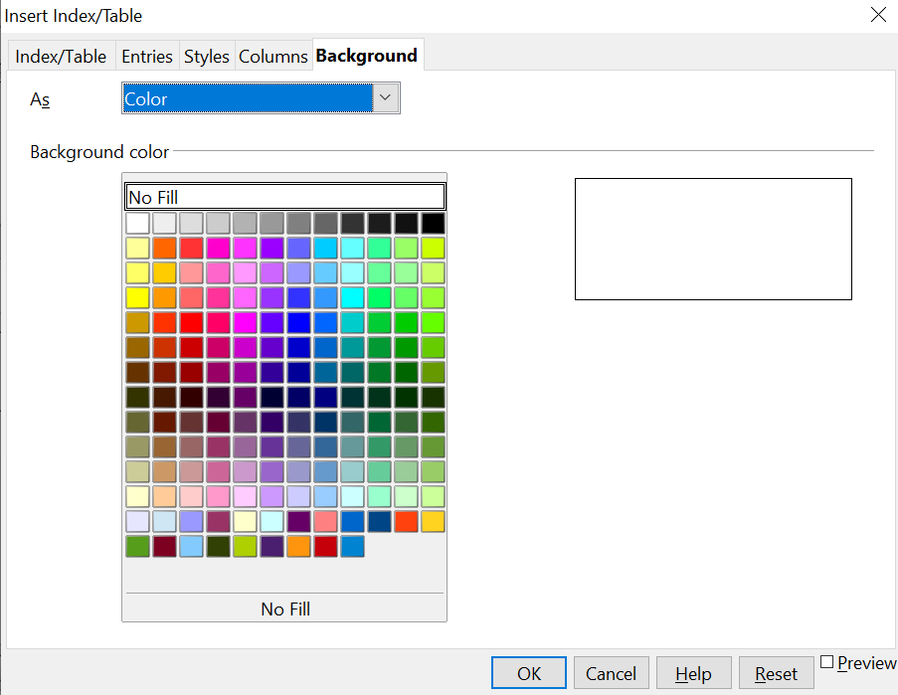

Figure 6: Background page, showing Color choices.

Adding Color
To add color to the background of the table of contents, select from the color grid.
Note | Even though the TOC may have a shade behind it while editing, it is actually not shaded by default. It appears shaded because it is a field and will appear to have the same shading all fields have.

Adding a Graphic
To add a graphic to the background of the table of contents:
- From the As drop-down list, select Graphic. The Background tab now displays the graphics options, as shown below.
- Click the Browse button. The Find graphics dialog box opens.
- Find the graphic file you want and then click the Open button. The Find graphics dialog box closes and the selected graphic appears in the graphic preview box on the right-hand side of the Background tab. (If you do not see the graphic, select the Preview checkbox.)
- To embed the graphic in your document, clear the Link checkbox. To link the graphic to the document but not embed it, select the Link checkbox.
- In the Type area of the Background tab, choose how you want the background graphic to appear:
  - To position the graphic in a specific location, select Position and then click the desired location in the position grid.
  - To stretch the graphic to fill the entire background area, select Area.
  - To repeat the graphic across the entire background area, select Tile.
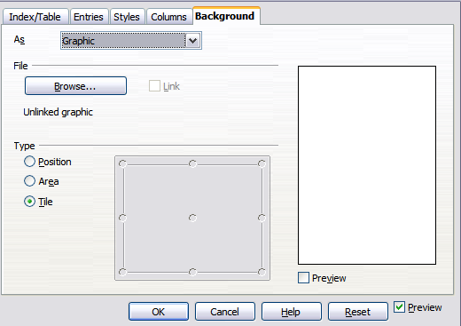Figure 7: Graphic options on the Background tab of the Insert Index/Table dialog box

Deleting a Color or Graphic
To delete color or a graphic from the table background:
- From the As drop-down list, select Color.
- Click No Fill on the color grid.

Maintaining a Table of Contents
This section shows you how to:
- Edit an existing TOC
- Update a TOC when changes are made to the document
- Delete a TOC

Editing a table of contents
To edit an existing TOC:
- Right-click anywhere in the TOC.
- From the pop-up menu, choose Edit Index/Table. The Insert Index/Table dialog box (Figure 9 on page Error: Reference source not found) opens, and you can edit and save the table as described in the previous section.
Tip | If you cannot click in the TOC, it is probably because it is protected. To disable this protection, choose Tools > Options > OpenOffice Writer > Formatting Aids, and then select Enable in the Cursor in protected areas section. If you wish to edit the TOC without enabling the cursor, you can access it from the Navigator.

You can also access the Index/Table dialog box from the Navigator (Figure 8 ).
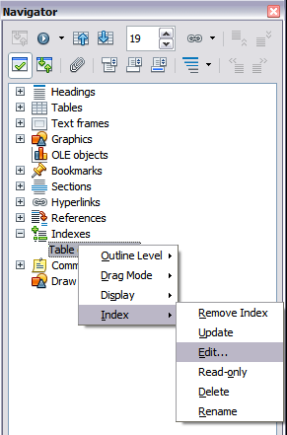
Figure 8: Access an index from the Navigator
- Open the Navigator deck in the Sidebar or press F5.
- Click the expansion symbol (+ sign or triangle) next to Indexes.
- Right-click on Table of Contents1 and choose Index > Edit.

Updating a Table of Contents
Writer does not update the TOC automatically, so after any changes to the headings, you must update it manually. To update a TOC when changes are made to the document:
- Right-click anywhere in the TOC.
- From the pop-up menu, choose Update Index/Table. Writer updates the TOC to reflect the changes in the document.
You can also update the index from the Navigator by right-clicking on Indexes > Table of Contents1 and choosing Index > Update.

Deleting a Table of Contents
To delete the TOC from a document:
- Right-click anywhere in the TOC.
- From the pop-up menu, choose Delete Index/Table. Writer deletes the TOC.
Note | Since Writer will not prompt you to confirm the delete, use caution when deleting a TOC!

You can also delete the index from the Navigator by selecting Index > Delete from the menu shown in Figure 13.

Alphabetic Indexes
An alphabetical index (referred to as an index) is a list of keywords or phrases used throughout a document that, if listed in order with page numbers, may help the reader find information quickly. Generally an index is found in the back of a book or document.
This section describes how to:
- Add index entries.
- Create an alphabetic index quickly.
- Customize the display of index entries.
- Customize the appearance of the index.
- View and edit existing index entries.

Adding Index Entries
Before you can create an index, you must create some index entries.
- Either highlight the word or phrase to add to the index or place the cursor at the beginning of the word or phrase. (If you want to add multiple words as one entry it will generally be better to highlight the entire phrase.)
- Choose Insert > Indexes and Tables > Entry to display a dialog box similar to that shown in Figure 14. You can accept the word or phrase shown in the Entry box or change it to whatever you want. If you placed the cursor at the beginning of a word, clicking on the Entry text box inserts the word into the text box.
- Click Insert to create the entry.
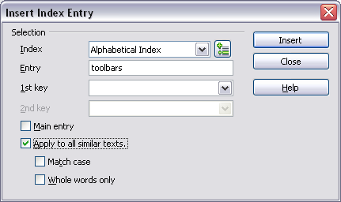Figure 9. Inserting an index entry
See “Figure 10. Entry icon on Insert toolbar” on page 13 for an explanation of the fields on this dialog box.
You can create multiple entries without closing the dialog box. For each one:
- Click at the location in the document that you want to index.
- Click again on the dialog box.
- Change the entry if needed, and click Insert.
- Repeat steps 1–3 until you have finished with the entries, then click Close.
Note | If field shading is active (see View > Field Shadings and Tools > Options > OpenOffice > Appearance > Text Document > Field shadings), when a selected word or phrase has been added to the index, it is shown in the text with a gray background. Index entries whose text is different from the text in the document are marked by a small gray rectangle.

Tip | You can also open the Insert Index Entry dialog box by clicking the Entry icon on the Insert toolbar, as shown in Figure 11.

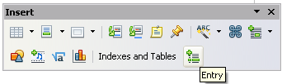Figure 10. Entry icon on Insert toolbar

Creating an Alphabetic Index Quickly
Now that you have some index entries, you can create the index.
Although indexes can be customized extensively in Writer, most of the time you need to make only a few choices.
To create an index quickly:
- Click in the document where you want to add the index and click Insert > Indexes and Tables > Indexes and Tables.
- In the Type box on the Index/Table page (Error: Reference source not found), select Alphabetical Index.
- In the Options section, you may want to uncheck Case sensitive (so that capitalized and lower-case words are treated as the same word) and uncheck Combine identical entries with p or pp.
- Click OK. The result will be a typical index.
Writer does not update an index automatically. If you add, delete, or change the text of index entries, you need to update the index. To do this, follow the steps outlined in “Error: Reference source not found” on page Error: Reference source not found.

Customizing Index Entries
Below is a brief explanation of the fields in the Insert Index Entry dialog box and how to use them.
Index
The type of index this entry is for. The default is Alphabetical Index, but you can use this field to create extra entries for a table of contents or user-defined indexes or lists of almost anything. For example, you might want an index containing only the scientific names of species mentioned in the text, and a separate index containing only the common names of species. See “Other Types of Indexes” on page 20.
Entry
The word or phrase to be added to the selected index. This word or phrase does not need to be in the document itself; you can add synonyms and other terms that you want to appear in the index.
1st key
An index key is an entry that has no associated page number and has several subentries that do have page numbers. Using keys is a useful way of grouping related topics. (See “Example of Using an Index Key” on page 15.)
2nd key
You can have a three-level index, where some first-level keys have level-2 entries that are also keys (without page numbers). This degree of index complexity is not often necessary.
Main entry
When the same term is indexed on several pages, often one of those pages has more important or detailed information on that topic, so you want it to be the main entry. To make the page number for the main, or most significant, entry stand out, select this option and then define the character style for the page number of a main index entry to be bold, for example.
Apply to all similar texts
Select this option to have Writer automatically identify and mark any other word or phrase that matches the current selection. The Match case and Whole words only options become available if this option is selected. Use this option with care, as it may result in many unwanted page numbers (for minor uses of a word) being listed in the index.

Example of Using an Index Key
An index key is a primary entry under which subentries are grouped. For example, you might want to create a grouping similar to this:
OpenOffice
Calc 10
Impress 15
Writer 5
In this example, OpenOffice is the 1st key. The subentries (with the page numbers showing) are the indexed entries. To insert an index entry for the topic Writer, on the Insert Index Entry dialog box (Error: Reference source not found on page Error: Reference source not found), type Writer in the Entry box and OpenOffice in the 1st key box.

Customizing the Appearance of an Index
To customize an existing index, right-click anywhere in the index and choose Modify from the pop-up menu.
The Insert Index/Table dialog box (Error: Reference source not found) has five tabs. Any or all of them can be used to customize the appearance of an index.
- Use the Index/Table page to set the attributes of the index.
- Use the Entries and Styles tabs to format the entries in the index.
- Use the Columns tab to put the index into more than one column.
- Use the Background tab to add color or a graphic to the background of the index.
The preview box, located on the left-hand side of the dialog box, shows as you work how the index will look. (If you do not see the preview box, select Preview in the lower right-hand corner of the dialog box.)
After making your changes, click OK to save the index, so it appears in your document.

Index/Table Page
Use the Index/Table page (Error: Reference source not found) to set the basic attributes of the index.
- To give the Index a different title, type it in the Title field. To delete the title, clear the Title field.
- Be sure the Type of Index is set to Alphabetic Index.
- To prevent the index from being changed accidentally, select Protected against manual changes. If this option is selected, the index can only be changed using the right-click menu or the Insert Table/Index dialog box. If the option is not selected, the index can be changed directly on the document page, just like other text, but any manual changes to an index are lost when you update it.
- From the drop-down list in the Create index/table area, select Entire document. You can also choose to create an index for just the current chapter.
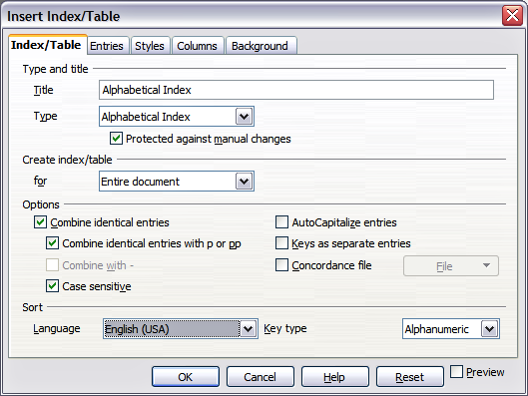
Figure 11. Index/Table page of Insert Index/Table dialog box
- Various other options determine how the index handles entries:
  - Combine identical entries. Defines how identical entries are dealt with. Normally each page number of an indexed word or phrase will be shown in the index; however these can be combined using the Combine identical entries with p or pp option. If you want a page range displayed, select Combine with – (which will produce something similar to 23–31). If you want different entries based on what letters are capitalized, select Case sensitive.
  - AutoCapitalize entries. Automatically capitalizes the first letter of each entry regardless of how they show within the document itself.
  - Keys as separate entries. For the keys to have their own page numbers, select this option.
  - Concordance file. Enables a list of words in an external file to be imported (select using the File button) and then used within the index. The concordance file has a special file format; for further information, refer to concordance file in Help > OpenOffice Help. Using a concordance file can speed up production of an index, but unless the words are very carefully selected, and you edit the index afterward, the resulting index can be full of entries for minor mentions of a term, making it less useful than a more selective index.
  - Sort. Defines how the entries are sorted when displayed. The only option is alphanumeric, but you can define which language alphabet will be used.

Entries Tab
Use the Entries tab to set exactly how and what will be displayed for each of the entries. The page is similar to Figure 12.
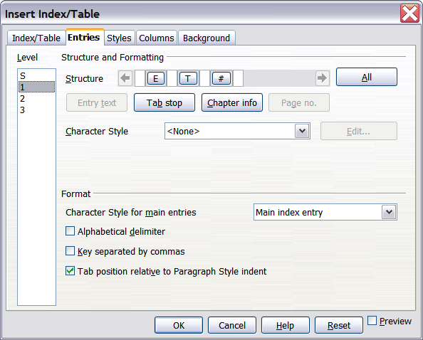
Figure 12. Entries page for creating an alphabetical index
To begin, click a number in the Level column to select the index level whose elements you want to format. (You will be able to apply your changes to all index levels later.) The Structure line displays the elements for entries in that level. Each button on the Structure line represents one element:
- The E button represents the entry text.
- The T button represents a tab stop.
- The # button represents the page number.
- The CI button represents chapter information. This may not be displayed immediately, but can be added.
Each white field on the Structure line represents a blank space. You can add custom text if you desire.

Adding Elements
To add an element to the Structure line:
- Place the cursor in the white field to the left of where you want to insert the element.
- Click one of the buttons below the Structure line. (For example, to add a tab stop, click the Tab stop button.) A button representing the new element appears on the Structure line.

Changing Elements
To change an element in the Structure line, click the button representing that element and then click the element that you want to substitute in the row of buttons just below the Structure line. For example, to change entry text to a tab stop, click the E button on the Structure line (it shows then as being pressed) and then click the Tab stop button in the row of available elements.

Deleting Elements
To delete an element from the Structure line, click the button that represents that element, and then press the Delete key. For example, to delete a tab stop, click the T button and then press the Delete key, or Function+Delete on a Mac.

Applying Character Styles
Each of the items that can be added to the Structure line may have additional formatting. For example, you may want the page number to be a different size from the rest of the index text. To do this, apply a character style to one of the elements in the Structure line.
To apply a character style to an element:
- On the Structure line, click the button representing the element to which you want to apply a style.
- Select the desired style from the Character Style drop-down list. Writer applies the style to the selected element.
To view or edit the attributes of a character style, select the style from the Character Style drop-down list and then click the Edit button.

Formatting Entries
Apply additional formatting using the options in the Format section.
- Alphabetical delimiter. This separates the index entries into blocks that start with the same first letter, using that letter as a header. For example, if your index begins:
apple, 4
author, 10
break, 2
bus, 4
then selecting this option will give you:
A
apple, 4
author, 10

B
break, 2
bus, 4
- Key separated by commas. Arranges the entries in the index on the same line but separated by commas.
- Tab position relative to Paragraph Style indent. When checked, entries are indented according to the settings of their individual formats. Where a paragraph style with an indent on the left is in use, tab stops will be relative to this indent. If this option is not selected, tab stops will be relative to the left margin position.

Styles, and Background Tabs
Refer to “Styles Tab” on page 8 and “Background Tab” on page 9.

Columns Tab
Use the Columns tab (Figure 13) to change the number of columns for the index.
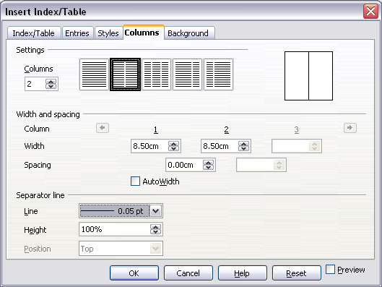
Figure 13. Columns page of the Insert Index/Table dialog box

Adding Multiple Columns
To display the index in more than one column:
- Either enter the number of columns desired in the box labeled Columns or select the icon representing the number of columns.
- To evenly distribute the columns according to the page width, check the AutoWidth box. If it is unchecked, you can manually set either or both of the following:
  - Width between each of the columns
  - Spacing between each of the columns
- You can choose to have a separator line between the columns:
  - Line: The width (thickness) of the line.
  - Height: The height of the line.
  - Position: Position of the line relative to the columns (top, middle, or bottom) if the height is less than 100%.

Maintaining an Index
To modify the appearance of an index:
- Right-click anywhere in the index.
- From the pop-up menu, choose Edit Index/Table. The Insert Index/Table dialog box opens, and you can edit and save the index using the five tabs described in the previous section.
To update or delete an index, follow the process described in the sections “Updating a Table of Contents” and “Deleting a Table of Contents” on page 11.

Viewing and Editing Existing Index Entries
Once you have added the initial entries, you can make changes, or add new entries. You can view and edit either of these using the following steps:
- Ensure that field shading is active (Tools > Options > OpenOffice> Appearance > Text Document > Field shadings and View > Field Shadings), so you can locate index entries more easily.
- Place the cursor immediately to the left of an existing index entry in the body of your document and select Edit > Index Entry. Alternatively, right-click on the word or phrase and from the pop-up menu select Index Entry.
- A dialog box similar to Figure 14 appears. You can move through the various index entries using the forward and back arrow buttons. If there is more than one entry for a single word or phrase, then you can scroll through each of the entries.
- Make the necessary modifications or additions to the index entries and, when finished, click OK.
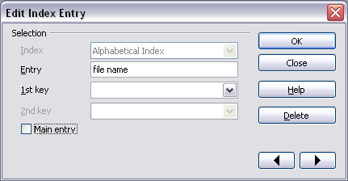Figure 14. Viewing and editing index entries

Other Types of Indexes
An alphabetical index is not the only type of index Writer can build. Other types of indexes supplied with Writer include those for illustrations, tables, and objects. You can even create a user-defined index. Because,they're numerous, this chapter can't give examples of all possibilities.
To create other indexes:
- Place the cursor where you want the index created.
- Select Insert > Indexes and Tables > Indexes and Tables from the menu bar.
- On the Insert Index/Table dialog box, in the Type drop-down list, select the index wanted.
- Modify the various pages, which are very similar to those discussed in previous sections.
- Select OK when everything has been set.

Example: Creating an Index of Figures
Creating an index (list) of figures or tables is easy if the figure captions were created using the menu Insert > Caption or manually using a number range variable as described in Chapter 14 (Working with Fields).
- On the Insert Index/Table dialog box, in the Type drop-down list, choose Illustration Index. You can change the title of the index to something else; we have used Table of Figures as our title.
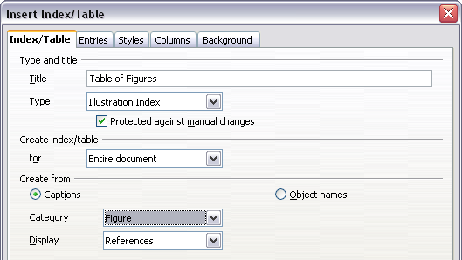
Figure 15. Creating other types of indexes
- Be sure Captions is selected in the Create from section, and choose the category of caption. The default category is Illustration; in our example we have used Figure for the figure captions.
(The category Figure is not supplied with AOO; however, if you have defined it when creating a caption in your document, it will appear on this list. See Chapter 8, Working with Graphics, for more about creating captions.)
- Under Display, you can choose References (to include the category, number, and caption text), Category and Number, or Caption Text. We have selected References.
- On the Entries tab, notice that hyperlinking from the index to the body of the document is not available, but you can make some other selections.
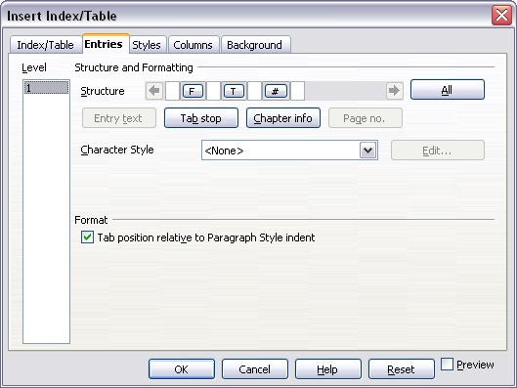Figure 16: Entries tab for Illustration Index
- Click OK. The result is shown below.
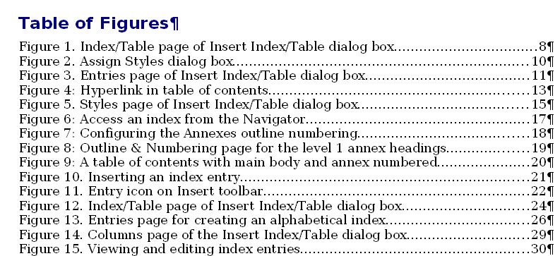Figure 17: Resulting index of illustrations

Bibliographies
A bibliography is useful for displaying references that occur throughout a document. These references are either stored in a bibliographic database or within the document itself.
This section shows you how to:
- Create a bibliographic database; add and maintain entries.
- Add a reference into a document.
- Format the bibliography.
- Update and edit an existing bibliography.
For most of this section, the database table used is the sample one that comes with Writer. For information on creating a new table in the bibliographic database, see Chapter 8 (Getting Started with Base) in the Getting Started guide.

Creating a Bibliographic Database
Although you can create references within the document itself, creating a bibliographic database allows reuse in other documents and saves a lot of time.
Select Tools > Bibliography Database. A window similar to that in Figure 18 is shown.
You can use the top portion of this window to:
- Filter for specific records within the database (see “Filtering Records” below).
- Change some details of columns in the database (see “Changing Column Details”).
- Select an alternative data source (another database or table) or change details of the fields in the database.
The middle portion of the window shows each of the records in a table layout similar to that of a spreadsheet. Additional fields can be viewed by scrolling the table to the right.
The bottom portion of the window shows the contents of the selected record.
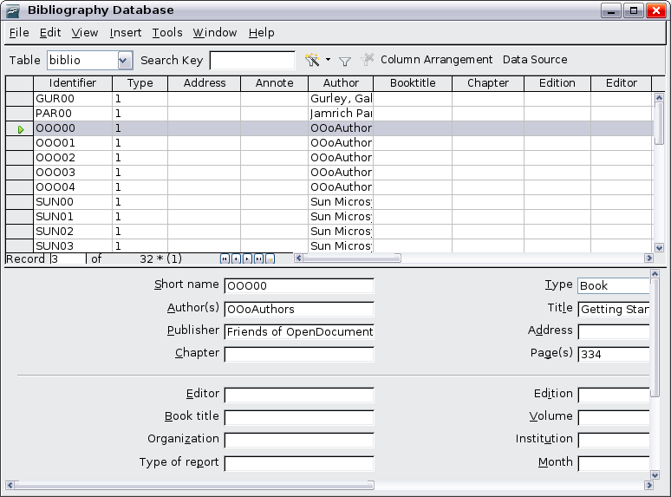
Figure 18. Bibliography Database main window

Filtering Records
To set up a filter for specific records within the bibliographic database, select Tools > Filter from the Bibliographic Database menu bar. On the Standard Filter dialog box (Figure 19), choose the fields, conditions, and values for the filter and click OK.
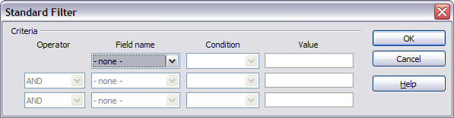
Figure 19. Setting up a filter for the bibliographic database

Changing Column Details
To change the details of columns in the bibliographic database, click the Column Arrangement button near the top of the window. The Column Layout for Table biblio dialog box (Figure 20) is displayed.
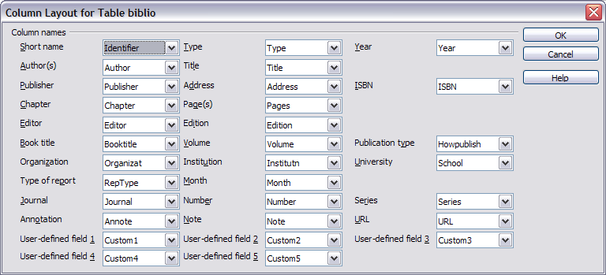
Figure 20. Changing column layout for bibliographic database

Changing the Data Source
To change the data source in use (for example, if you have more than one bibliographic database for different purposes), click the Data Source button near the top of the window. The Choose Data Source dialog box (Figure 21) is displayed.
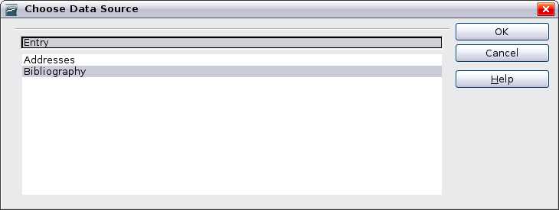Figure 21: Choosing a different data source for the bibliographic database

Changing Field Details
You can make changes to the bibliography database (for example, rename fields or change the length of fields) by doing the following:
- In the main document (not the Bibliography Database window), press F4 or click View > Data Sources to open the data source window, similar to Figure 22.
- Make sure that the Bibliography database is selected as well as the correct table. You may have to expand some levels to be able to select the correct ones.
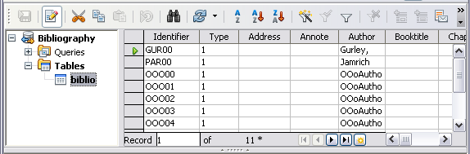
Figure 22. Data Source view of Bibliography database
- Right-click on the table entry (biblio in the example) and select Edit Database File from the pop-up menu. This opens a window similar to Figure 23, which is the main menu for Base, the database component of OpenOffice.
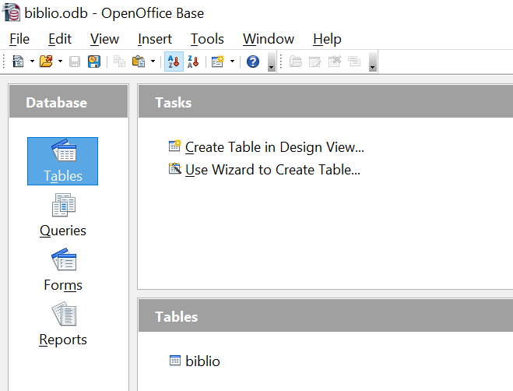

Figure 23. Main window for working with databases
- If Tables (under the Database view) is not selected, select it now.
- Right-click on the biblio table name in the Tables section and select Edit from the pop-up menu to display a window similar to that in Error: Reference source not found.
- You can now select each of the rows and modify the Field Properties as required.
- When finished, confirm that you want the changes saved.
Note | For more information on how to use AOO’s database features, see Chapter 8 (Getting Started with Base) in the Getting Started guide.
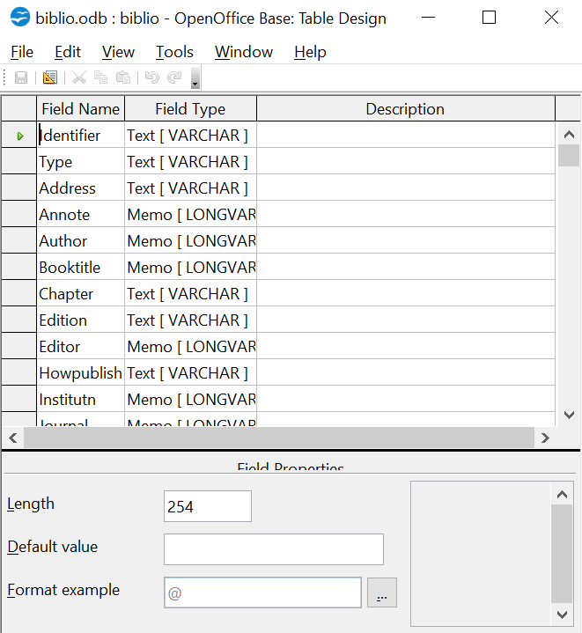

Figure 24. Modify table properties window

Adding Entries to the Database
To add entries to the database:
- You can add records directly into the database using the lower portion of the window shown in Figure 24 on page 26.
- Complete each of the fields as required. Use the Tab key to move between fields.
- It is best to use a unique name in the Short name field. This is used when inserting entries into documents.
- To complete the entry, move to the last field and press Tab once more.
Note | The Identifier column in the upper portion of the Bibliography Database window is labeled Short name in the lower portion of the window.
If your document requires [Author, date] style citations, use the Identifier (Short name) field of the database to record the information in the required format. If you are using a simple citation numbering system (for example, [1],[2],...), use a unique reference of some sort in the Identifier (Short name) field. Writer will auto-number entries based on the position within the document.

Maintaining Entries in the Database
To maintain entries in the database, use the Bibliography Database window as in the previous section. Click on the appropriate field and modify the text as appropriate.
Modified entries are saved automatically to the database when the cursor moves off the record.

Adding a Reference (Citation) into a Document
Writer supports two ways of showing references (citations) in the text of a document:
- Using authors’ names and dates of the referenced documents, for example [Smith, 2004], as recorded in the Identifier (Short name) of each bibliographic entry.
- By numbering the referenced documents in the sequence they occur in the text, for example [1].
Tip | To specify which citation style is used in the document, use the Index/Table tab on the Insert Index/Table dialog, described on page 5.
To add references from the bibliographic database into a document:
- Place the cursor where you want the reference to appear.
- From the main menu, choose Insert > Indexes and Tables > Bibliographic entry.
- In the Insert Bibliographic Entry dialog box, shown in Figure 26, choose From bibliography database at the top of the dialog box. (You can also insert a reference from the document itself by selecting From document content, but that method is not covered in this chapter.)
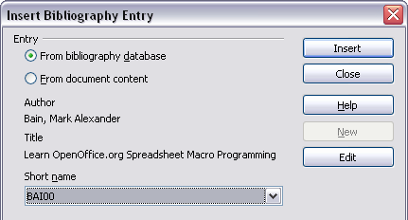
Figure 25. Inserting bibliographic entries into a document
- Select the reference from the Short name drop-down list near the bottom of the dialog box. The Author and Title of the selected reference are shown in the middle of the dialog box, to help you verify that it is the reference you want.
- To insert the reference into the document, click Insert.
- You can keep the dialog box open and insert another reference into the document; you don’t need to close and reopen it.
- When you have finished inserting all the references, select Close.

Formatting the Bibliography
Formatting the bibliography involves choices made in two places:
- Insert Index/table dialog (covered in this section)
- Bibliography 1 paragraph style (see page 30)
To create the bibliography:
- Place the cursor at the point where you wish to insert the bibliography.
- Select Insert > Indexes and Tables > Indexes and Tables and change the Type to Bibliography, to see a dialog box similar to that shown in Figure 26.
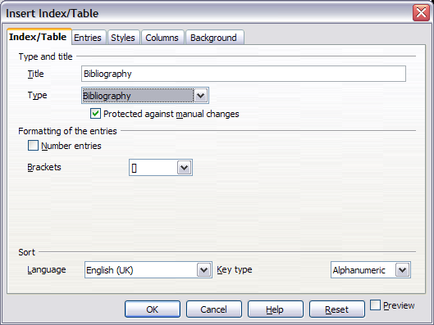Figure 26. Inserting a bibliography
The Insert Index/Table dialog box has five pages.

Index/Table tabs
The basic settings are selected on this page.
- While a title for a bibliography isn't required, you can supply one by entering it in the Title field.
- You can protect the bibliography from being changed accidentally, by checking Protected against manual changes. If this option is selected, the bibliography can only be changed using the right-click menu or the Insert Table/Index dialog. If the option is not selected, the bibliography can be changed directly on the document page, just like other text, but any manual changes will be lost when you update the bibliography.
- To have the bibliographic entries numbered within the body of the document (for example, [1], [2], …), select Number entries. If, however, you wish to have the field Identifier (from the database) appear in the document, deselect the Number Entries option.
- Select the type of brackets that you want for the referenced entries shown within the body of the document.
- Define the sorting you require. Currently, only alphanumeric sorting is supported. Sorting by the sequence that entries appear in the text is done on the Entries page.

Entries Tab
The structure of this tab is similar to that for tables of contents and indexes (see Figure 3).
You can define how the entry will appear based on the Type of the entry, or simply apply the same format to all entries by selecting the All button.
The Structure of the entry is based on the fields available in the bibliographic database. The ones shown by default are:
- Au—Author
- Ti—Title
- Ye—Year
To determine how entries are sorted, modify the Sort by options. To sort by the sequence that entries appear in the text, choose Document position. To sort alphanumerically, select Content. Use Sort keys to group similar references.
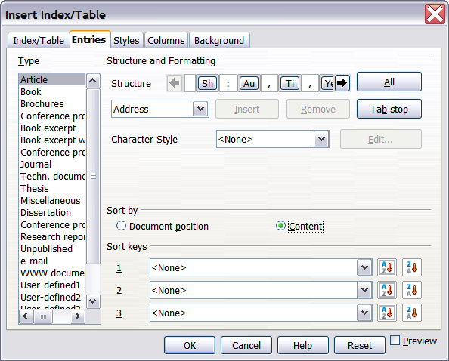
Figure 27. Entries page for bibliographies

Styles, Columns and Background tabs
Refer to “Figure 28: Specifying square brackets before and after the number in a list” on page 31 and “Figure 29: Setting the spacing between the margin and the text” on page 31 and Figure 30: Applying a numbering style to a paragraph style on page 32.

Generating the Bibliography
To generate a bibliography so that it appears in your document, click OK. The Insert Index/Table dialog box closes and the bibliography appears in your document.

Defining the Paragraph Style for the Bibliography
You can modify the Bibliography 1 paragraph style to suit your requirements. For example, to number the entries in the bibliography list, you need to define a numbering style and link that numbering style to the Bibliography 1 paragraph style. To do this:
- On the Styles and Formatting deck of the Sidebar, click on the List Styles icon. You can either define a new list style or modify one of those supplied. In this example, we will modify the Numbering 1 style. Right-click on Numbering 1 and choose Modify from the pop-up menu.
- On the Numbering Style dialog, go to the Options tab. In our example we want to have the numbers enclosed in square brackets. To do this, type [in the Before box and] in the After box, as shown in Figure 28.
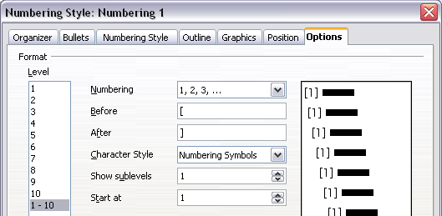
Figure 28: Specifying square brackets before and after the number in a list
- Now go to the Position tab of the Numbering style dialog. In the Spacing to text box, specify how much indentation you want for the second and following lines of any item in the bibliography list of your document. Often you will need to experiment a bit to see what is the best setting. In our example (Figure 29), we have chosen 1 cm.
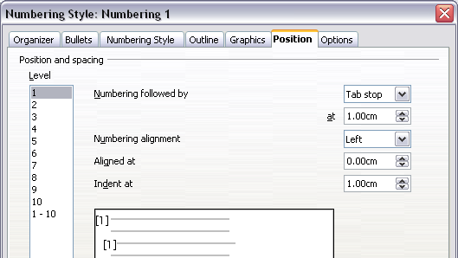
Figure 29: Setting the spacing between the margin and the text
- Click OK to save these settings and close the Numbering Style dialog. Return to the Styles and Formatting window, click on the Paragraph Styles icon, choose All Styles from the list at the bottom of that window, then right-click on Bibliography 1 and choose Modify.
On the Paragraph Style dialog, go to the Numbering tab and select Numbering 1 from the drop-down list. (See Figure 30.) Click OK to save this change to the Bibliography 1 paragraph style.
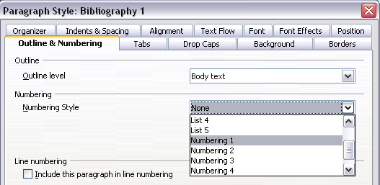
Figure 30: Applying a numbering style to a paragraph style
Now when you generate the bibliography, the list will look something like the one shown in Figure 31.

Figure 31: Result of settings for Bibliography 1 paragraph style

Updating and Editing an Existing Bibliography
To modify the display of bibliography entries:
- Right-click anywhere in the bibliography.
- From the pop-up menu, choose Edit Index/Table. The Insert Index/Table dialog box opens, and you can edit and save the table using the five tabs described in Error: Reference source not found on page Error: Reference source not found.
To update or delete the bibliography, follow the same process as described in the sections “Updating a Table of Contents” and “Deleting a Table of Contents” on page 12.

Referenced

