Preface

Who Is This Book For?
Anyone who wants to get up to speed quickly with Apache OpenOffice will find this book valuable. You may be new to office software, or you may be familiar with another office suite.

What's in This Book?
This book introduces the main components of Apache OpenOffice:
- Writer (word processing)
- Calc (spreadsheets)
- Impress (presentations)
- Draw (vector graphics)
- Base (database)
- Math (equation editor)
It also covers some features common to all components, including setup and customization, styles and templates, and printing.

Where to Get More Help
This book, the built-in Help system, and user support systems assume that you are familiar with your computer and basic functions such as starting a program, opening and saving files.

Help System
Apache OpenOffice comes with an extensive Help system. This is your first line of support for using the program.
To display the full Help system, press F1 or select OpenOffice Help from the Help menu. In addition, you can choose whether to activate Tips, Extended tips, and the Help Agent (using Tools > Options > OpenOffice > General).
If Tips are enabled, place the mouse pointer over any of the icons to see a small box (“tooltip”) with a brief explanation of the icon’s function. For a more detailed explanation, select Help > What's This? and hold the pointer over the icon.

Free Online Support
The Apache OpenOffice community not only develops software, but provides free, volunteer-based support. See this web page: https://www.openoffice.org/support/index.html
Users can get comprehensive online support from the community through the mailing list at users@openoffice.apache.org and the Apache OpenOffice Community Forum at https://forum.openoffice.org/en/forum/. The forum requires a subscription before questions can be posted, though they can be viewed by anyone. The subscription is need to control spamming and is not used for any other purpose.

What You See May Be Different
Apache OpenOffice runs on Windows, Linux, and macOS operating systems, each of which has several versions and can be customized by users (fonts, colors, themes, window managers).
The pictures in this book were taken from a variety of computers and operating systems. Some pictures will therefore not look exactly like what you see on your computer.

What Are All These Things Called?
The terms used in Apache OpenOffice for most parts of the user interface (the parts of the program you see and use, in contrast to the behind-the-scenes code that actually makes it work) are the same as for most other programs.
A dialog is a special type of window. Its purpose is to inform you of something, or request input from you, or both. It provides controls for you to use to specify how to carry out an action. The technical names for common controls are shown in Figure 1; not shown is the list box (from which you select an item). In most cases we do not use the technical terms in this book, but it is useful to know them because the Help and other sources of information often use them.
In most cases, you can interact only with the dialog (not the document itself) as long as the dialog remains open. When you close the dialog after use (usually, clicking OK or another button saves your changes and closes the dialog), then you can again work with your document.
Some dialog windows can be left open as you work, so you can switch back and forth between the dialog and your document. An example of this type is the Find & Replace dialog.
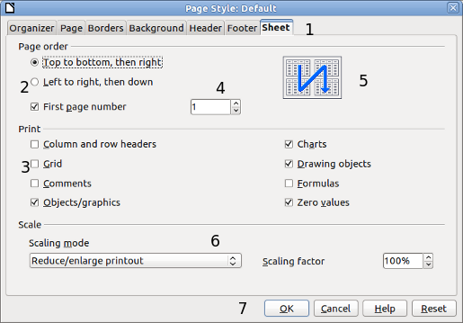
Figure 1: Dialog showing common controls:
1 = Tabbed page (not strictly speaking a control)
2 = Radio buttons (only one can be selected at a time)
3 = Checkbox (more than one can be selected at a time)
4 = Spin box (click the up and down arrows to change the number shown in the text box next to it, or type in the text box)
5 = Thumbnail or preview
6 = Drop-down list from which to select an item
7 = Push buttons

Using Apache OpenOffice on macOS
Some keystrokes and menu items are different on macOS from those used in Windows and Linux. The table below gives some common substitutions for the instructions in this book. For a more detailed list, see the application Help.
Windows or Linux | macOS equivalent | Effect
Tools > Options menu selection | OpenOffice > Preferences | Access setup options
Right-click | Control+click | Open a context menu
Ctrl (Control) | z (Command) | Used with other keys
F11 | z+T | Open the Styles and Formatting window

