Apache Open Office
Version 4.1
Impress Guide
AOO Documentation Team

Chapter 8
Adding and Formatting Slides, Notes, and Handouts

Copyright
This document is Copyright © 2024 by the Apache Software Foundation®. You may distribute it and/or modify it under the terms of the Creative Commons Attribution License (http://creativecommons.org/licenses/by/3.0/), version 3.0 or later.
All trademarks within this guide belong to their legitimate owners.

Feedback
Please direct any comments or suggestions about this document to:
doc@openoffice.apache.org
Acknowledgments
This document is updated from a previous version by OOoAuthors.

Publication Date and Software Version
Published <date>. Based on Apache OpenOffice 4.1 .

Note for Mac Users
Some keystrokes and menu items are different on a Mac from those used in Windows and Linux. The table below gives some common substitutions for the instructions in this chapter. For a more detailed list, see the application Help.
Windows/Linux | Mac equivalent | Effect
Tools > Options menu selection | OpenOffice.org > Preferences | Access setup options
Right-click | Control+click | Open context menu
Ctrl (Control) | z (Command) | Used with other keys
F5 | Shift+z+F5 | Open the Navigator
F11 | z+T | Open Styles & Formatting window

Contents
Copyright 2
Note for Mac users 2
Introduction 4
Adding, renaming, and removing slides 5
Adding a new slide 5
Inserting a slide from another presentation 5
Duplicating a slide 6
Renaming a slide 7
Expanding a slide 7
Creating a summary slide 8
Deleting a slide 8
Creating slides from an outline 9
Sending an outline from Writer to Impress 9
Sending an AutoAbstract from Writer to Impress 10
Copying and pasting an outline 11
Modifying slides 11
Formatting the slide or page area 11
Printing slides 12
Choosing a slide master from the list 13
Changing the background of a slide 13
Choosing a slide layout from the list 13
Adding comments 14
Editing, deleting and replying to comments 15
Adding and formatting notes 16
Adding notes to a slide 16
Formatting notes 17
Formatting the Notes page 17
Setting automatic layout options 18
Text formatting 19
Advanced Notes formatting 19
Printing notes 19
Exporting notes to PDF 20
Creating handouts 20
Changing the layout 21
Formatting handouts 22
Formatting the page 22
Setting automatic layout options 22
Moving thumbnails and adding graphics 22
Printing handouts 23
Exporting handouts to PDF 23

Introduction
This chapter describes how to add new slides to the presentation and how to format them. It also explains how to format both the Notes and Handouts views. Notes are generally used as prompts for the person giving the presentation. Handouts are normally used for providing a printout of the slides to your audience.
Two pop-up menus are quite useful when performing the operations on the slides described in this chapter. One menu (shown in Figure 1) is displayed by right-clicking on a slide in Normal view and then selecting Slide. The other menu appears by right-clicking on the slide thumbnail in the Slides pane, as shown in Figure 2.
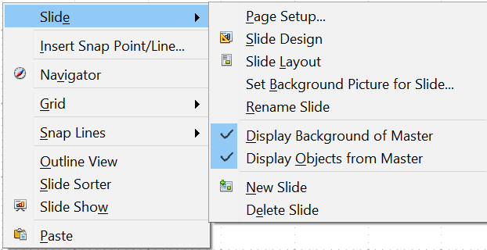

Figure 1: Slide pop-up submenu
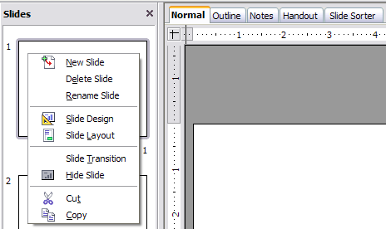
Figure 2: (Left) Pop-up menu on the Slides Pane

Adding, Renaming, and Removing Slides

Adding a New Slide
There are several equivalent ways to add a slide to a presentation:
- Select Insert > Slide (works in Normal, Outline and Slide Sorter view).
- Right-click on the Slides pane and select New Slide from the pop-up menu (works in Normal, Outline, and Notes view).
- Right-click on the main work area while in Slide Sorter view and select New Slide from the pop-up menu.
- On the work area in Normal view, right-click on the active slide and select Slide > New Slide.
The new slide is inserted after the current slide or in the position where the mouse was clicked.
If multiple slide masters are used in the presentation, the new slide will apply the master of the previous slide in the sequence.

Inserting a Slide from Another Presentation
You can insert slides from other presentations in three ways:
- Using Insert > File. With this method, you can optionally link the slides instead of copying (embedding) them into the presentation. For more information on the difference between linked and embedded files, see Chapter 4 (Adding and Formatting Pictures).
- Copying and pasting.
- Dragging and dropping, to copy or move slides.
To insert a slide from another presentation:
- In Normal view, select the slide after which you want to insert the new slide, then choose Insert > File from the menu bar.
- In the file browser, locate the file containing the slide that you want to insert, and click Insert.
- In the Insert Slides/Objects dialog (Figure 3), click the plus sign next to the icon for the presentation file, and then select the slides that you want to insert.
Tip | Figure 3 highlights the importance of giving descriptive names to the slides in the presentation. Refer to “Renaming a Slide” on page 7 for the instructions on how to perform this operation.
- If desired, select the Link option.
- Click OK. The slides are inserted after the selected slide in the presentation.
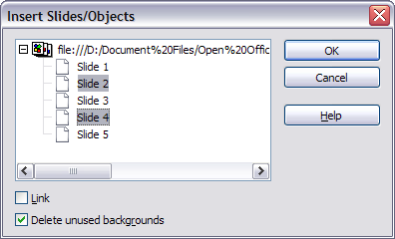
Figure 3: Inserting slides from another presentation
To copy and paste slides between presentations:
- Open the presentations that you want to copy from and paste into.
- In the presentation containing the slides that you want to copy, choose View > Slide Sorter.
- Select the slides, and then choose Edit > Copy, or click the Copy button on the main toolbar, or press Control+C.
- Change to the presentation where you want to paste the slides, and then choose View > Normal.
- Select the slide that you want the copied slides to follow, and then choose Edit > Paste, or click the Paste button on the main toolbar, or press Control+V.
To move slides between presentations:
- Open both presentations. Arrange the windows so both presentations are visible. Choose View > Slide Sorter in each window.
- In the presentation containing the slides that you want to move, select the required slides. To move the slides, drag and drop them into the other presentation.
Tip | If you hold down the Control key while dragging and dropping, the slide gets copied in the target presentation.

Duplicating a Slide
Duplicating a slide is a convenient way to add slides, since the new slide will inherit formatting, layout and animations from the selected slide. To duplicate a slide:
- Go to Normal view either by clicking on the tab on the work area or selecting View > Normal from the menu bar.
- Make sure that the slide to be duplicated is on the work area.
- Select Insert > Duplicate Slide from the menu bar.
The duplicated slide is inserted after the original slide and is displayed in the work area.
Tip | Duplicating a slide is a good way to prevent having slides with too much information crowded on them. Try duplicating the “busy” slide and split the points over two or more slides. All the formatting, backgrounds, and so on will be preserved.

Renaming a Slide
To rename a slide, do one of the following:
- Right-click on the slide thumbnail in the Slides pane or in the main area when in Slide Sorter view and select Rename Slide from the pop-up menu.
- In Normal view, right-click on the slide in the work area, then select Slide > Rename Slide from the pop-up menu.
In the Rename Slide dialog box, type a new name for the slide and then click OK.

Expanding a Slide
Sometimes you will have a slide with too many sub-points to fit in the space available. Instead of reducing the font size or using other methods to squeeze more text into the space, it is usually better to subdivide the contents of the slide into two or more slides.
As mentioned in the Tip above, you can duplicate the slide and manually split the points. Another way is to “expand” the contents of the slide. To do this:
- [optional] Duplicate the slide (in case it is needed later).
- Choose Insert > Expand Slide from the menu bar. Impress creates a new slide for each instance of the highest outline level. The outline text becomes the title of the new slide. Outline points below the top level on the original slide are moved up one level on the new slide.
- If required, repeat steps 2 and 3 on any slide where level 2 entries of the outline exist, to expand those as well.
Figure 4 shows a slide with an outline consisting of three high level points and two second-level points under bullet point 2. The Expand command has generated three slides, each having as title the first level outline and (if present) the second level points in the text area.
Caution   | For the Expand command to work, ensure that the slide layout contains only one text AutoLayout box. If the layout of the slide is not suitable for expansion, the menu item is grayed out.
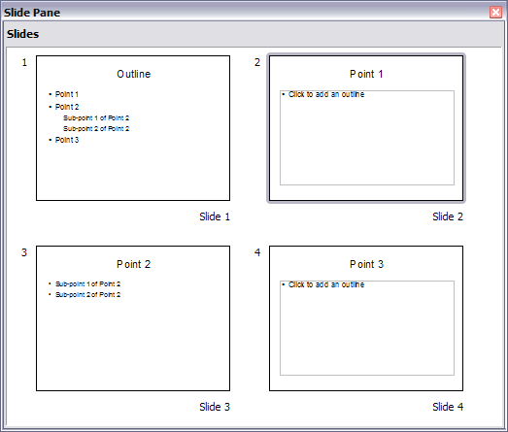Figure 4: Slide 1 is expanded in slides 2, 3 and 4

Creating a Summary Slide
It is also possible to “reverse” the Expand operation to create summaries. The Summary command is useful to create an agenda for the presentation.
- Select the slide that will be the first one to appear in the summary. Do this by clicking on it in the Slides Pane or in Slide Sorter view.
- Select Insert > Summary Slide. Impress creates a new slide at the end of the presentation where all the titles of the slides from the selected one to the last slide are written as bullet points in the body of the slide.
- Move this slide to wherever you want it to appear in the presentation.

Deleting a Slide
To delete a slide, use the most convenient among these methods:
- In Normal, Outline or Slide Sorter view, select a slide and then click Edit > Delete Slide or press the Delete key.
- In the Slides Pane (not available in Slide Sorter view) select the slide to be deleted and right-click it and select Delete Slide from the pop-up menu, otherwise just select the slide and then press the Delete key.
- In Normal view, right-click on the work area, then select Slide > Delete Slide from the pop-up menu.
Tip | When working in the Slide sorter view (View > Slide sorter) it is possible to delete multiple slides simultaneously by selecting them with the mouse and pressing the Delete key.

Creating Slides from an Outline
When planning a presentation it is may be useful to develop an outline using AOO Writer. Once the outline is ready, you will probably want to create one or more separate slides for each of the top level outline elements. You can do this in several ways:
- Sending the outline from Writer to Impress (creates a new presentation)
- Sending an AutoAbstract from Writer to Impress (creates a new presentation)
- Copying and pasting the outline from Writer to Impress

Sending an Outline from Writer to Impress
If a text document in Writer contains headings formatted with the default Heading paragraph styles, you can choose File > Send > Outline to Presentation to create a new presentation containing the headings as an outline.
The new presentation opens in Outline view, as shown in Figure 5.
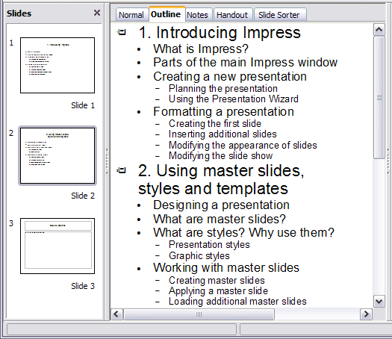Figure 5: Outline created from a Writer document
Click on the Normal tab to populate the slides in the Slides pane.
As shown in Figure 6, some outline levels may have too many points to fit on one slide. You can expand those slides as described in “Expanding a Slide” on page 7, or duplicate the slides and manually change their contents, as described in “Duplicating a Slide” on page 6.
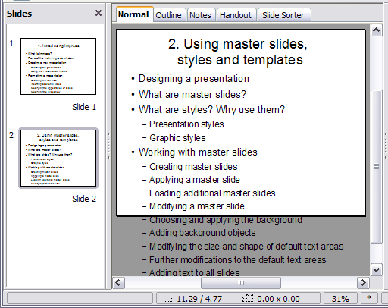
Figure 6: Slides created from an outline may have too many points to fit the space

Sending an AutoAbstract from Writer to Impress
To send an AutoAbstract from Writer to Impress, the text must contain headings formatted with the default Heading paragraph styles. Use the AutoAbstract feature to copy the headings and a number of subsequent paragraphs to a new presentation. You can specify the number of outline levels as well as the number of paragraphs displayed.
- Choose File > Send > AutoAbstract to Presentation.
- On the Create AutoAbstract dialog (Figure 7), choose the number of outline levels to be copied to the presentation. For example, if you choose 4 levels, all paragraphs formatted with Heading 1 to Heading 4 are included, along with the number of paragraphs specified in Subpoints per level.
- The new presentation opens in Outline view. Click on the Normal tab to populate the slides in the Slides pane.
- If an outline has too many points to fit on one slide, see “Expanding a Slide” on page 7 or duplicate the slides and manually change their contents as described in “Duplicating a Slide” on page 6.
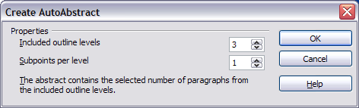
Figure 7: Choosing outline levels for an autoabstract

Copying and Pasting an Outline
Use this method to add slides from an outline to an existing presentation.
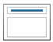
- Create a new slide and choose the “Title, Content” layout (see “Choosing a Slide Layout from the List” on page 13).
- Paste in the text area the outline created with Writer. Do not worry if the text does not fit the space on the slide.
- When pasting, the hierarchical structure of the outline may be lost. If necessary, use the Demote button on the Text Formatting toolbar to recreate it so that the outline points are at the correct hierarchical level.
Tip | It may be useful to open the Style and Formatting window at the Presentation styles page to track the outline level of each item.
If some outline levels have too many points to fit on one slide, see “Duplicating a Slide” or “Expanding a Slide” on page 6.

Modifying Slides
Use slide masters to avoid manually changing the formatting of individual slides. Multiple slide masters can be used in a single presentation to avoid modifying slide backgrounds or other features. See Chapter 2 (Slide Masters, Styles, and Templates) for details about using slide masters.

Formatting the Slide or Page Area
The Page Setup dialog (Figure 8) can be used to set up the page layout for different views in Impress such as Notes or Handouts (see pages 17 and 20).
Note | Any changes to the page format (size, margins, orientation, and so on) apply to all slides in the presentation. You cannot define more than one page style in Impress, as you can in Writer or Calc.  You can change the background of individual slides, as described on page 13.
To start, click the Normal tab in the main work area or select View > Normal in the menu bar. Select Format > Page from the menu bar, or right-click and choose Page Setup to open the Page Setup dialog shown in Figure 8. The Page tab has three sections: Paper format, Margins, and Layout settings. Settings on this tab affect all slides in the presentation.
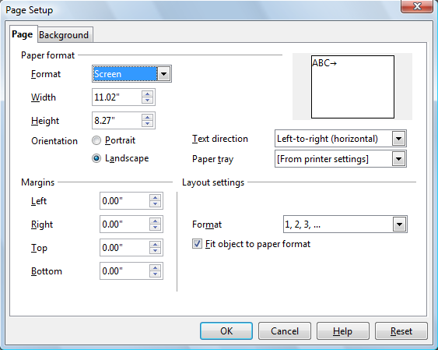Figure 8: The Page Setup dialog box
In the Paper format section, select the preferred Paper format from the drop-down list. The dimensions change automatically when a standard format is selected. The list contains selections for displaying the slides as well as printing them on paper.
The default values for the Screen settings are optimized for screen presentation (4:3 ratio). If your computer uses a wide-screen monitor, you may wish to take advantage of that by selecting the User format and editing the Width and Height manually.
In the Margins section, change the spacing between the edges of the page and the contents of the slide.
In the Layout settings section, select the page number format in the Format drop-down list. To allow resizing the slide objects and fonts to fit the paper, select the Fit object to paper format checkbox.

Printing Slides
You can also select the orientation of the slide or paper (Portrait or Landscape) and the paper tray to be used. Note that in Impress you cannot specify different trays for different pages (slides), as you can in Writer; however, you can specify different trays for printing slides, notes, and handouts. For more about printing presentations, see Chapter 10.

Choosing a Slide Master from the List
In the Sidebar, select the Master Pages deck.
To apply one of the slide masters to all slides in your presentation, click on it in the Available for Use list.
To apply a different slide master to one or more selected slides:
- In the Slide Pane or the Slide Sorter view, select the slides you want to change.
- In the Sidebar, right-click on the slide master you want to apply to the selected slides, and click Apply to Selected Slides on the pop-up menu.
Chapter 2 (Slide Masters, Styles, and Templates) discusses slide masters (also called “master slides” and “master pages”) in detail.

Changing the Background of a Slide
This section describes how to modify the background of a single slide.
Tip | For easy maintenance it is recommended that slide masters are used to modify the slides background by creating additional slide masters as required.
Note | Applying a background to individual slides is no different from filling the area of a shape. See Chapter 6 (Formatting Graphic Objects) for detailed instructions.
To change the background for a slide:
- Switch to Normal view by clicking the tab in the main work area or select View > Normal.
- Select the slide you want to change.
- Select Format > Page from the menu bar, or right-click and choose Slide > Page Setup to open the Page Setup dialog. Choose the Background tab.
- Follow the instructions in “Formatting Areas” in Chapter 6.
- Click OK to save the changes. A pop-up message asks if you want to change the background on all slides. To change only the selected slide, click No. If you press Yes, Impress will apply the new background to all the slides used in the presentation.

Choosing a Slide Layout from the List
After creating a new slide, decide what this slide will contain and what layout is most suitable for the purpose. Impress offers various types of predefined layouts that can be applied to a slide; these layouts are shown in Figure 9.
To apply a layout to a slide:
- In the Sidebar, select the Properties deck and make sure nothing is selected in the slide so that the Layouts deck is displayed.
- Hover the mouse cursor over the layout thumbnail to get a tooltip with a summary of the contents included in the layout.
- Click on the selected layout to apply it to the slide.
Note | If the layout is changed when the slide already contains contents, Impress will not delete the contents but just reposition it according to the chosen layout. This may cause slide elements to overlap.
If these layouts do not fit the presentation style, the elements can be rearranged on an individual slide and duplicated as often as needed by copying to another presentation or saving as a template.
All the techniques in Chapter 3 (Adding and Formatting Text) for working with text boxes can be applied to the Title and AutoLayout text elements of the slide, while the placeholder for images can be moved and resized as discussed in Chapter 4 (Adding and Formatting Pictures). Chapter 7 describes how to include and modify spreadsheets, charts, and other objects.
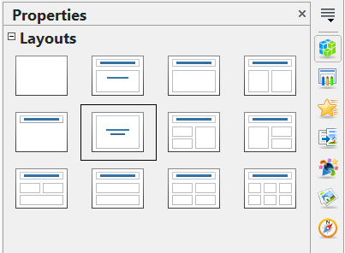
Figure 9: Automatic layouts for slides

Adding Comments
When creating a presentation in a collaborative environment, it is often useful to add comments to the presentation for the benefit of the other people working on it.
To add a comment, switch to Normal view and select the slide where you want the comment to appear. Select Insert > Comment from the main menu to display the comment box of Figure 10 in the top left corner of the slide. Once you are finished typing your comment you can close the comment box by clicking anywhere outside the comment box.
Each comment is color coded and marked with the initials of the author as well as a sequential number and is shown in the top left corner of the slide in Normal view. Clicking on a comment box displays the full text of the comment. The size of the comments box is fixed and scroll bars are included when needed.
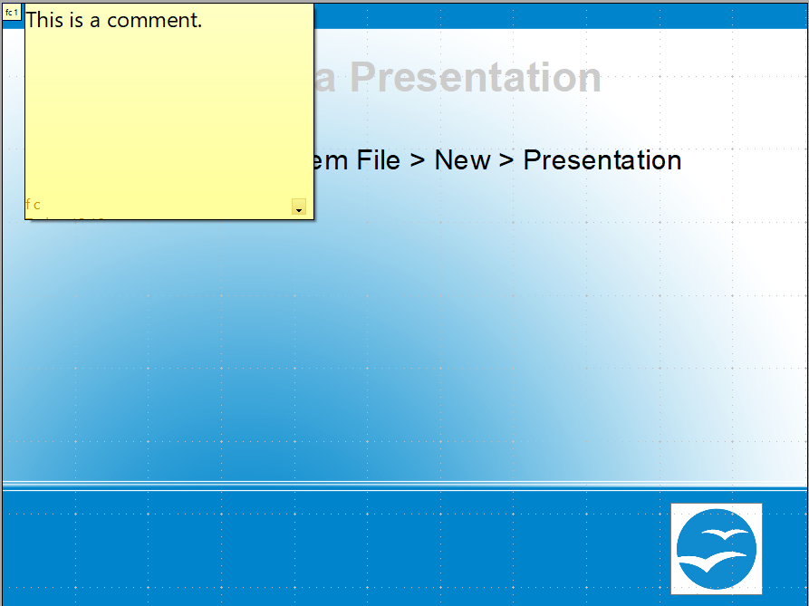

Figure 10: Comments text box in action

Editing, Deleting and Replying to Comments
You can only edit comments if you created them. You can reply to a comment created by a different person by selecting Reply from the comments menu described below.
A limited set of options is available for formatting the comment text; these can be accessed by right-clicking on the comment box. Use the pop-up menu to apply one or more font attributes (bold, italic, underline, strikethrough) and to paste the contents of the clipboard.
When a comment box is open, you can click on the small triangle pointing down in the lower right part of the comments box to display the comments menu shown in Figure 11. Use this menu to delete the current comment, delete all the comments from the author of the selected comment, or delete all the comments in the presentation. If the comment you opened was created by a different author the menu also displays the option to reply to the comment.
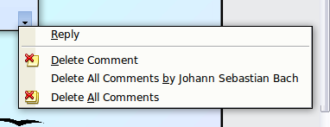Figure 11: Comments menu

Adding and Formatting Notes
Notes view provides a convenient way to create reminders or add extra information to the slides in the presentation. Notes are not displayed during a slide show, so with the dual monitor support feature, you can use notes as a presentation cue. You can also print the notes pages and use them as handouts.
Note | If you regularly give presentations in public using a projector, you may want to consider installing the Sun Presenter Console, an extension that allows you to display on your screen the slide notes, the next slide and other useful information while only the slide is shown through the projector. This extension can be downloaded from http://extensions.services.openoffice.org/en/project/presenter-screen

Adding Notes to a Slide
To add notes to a slide:
- In the Slides pane, select the slide to which you want to add notes.
- Switch to Notes view by clicking the tab in the main work area or select View > Notes.
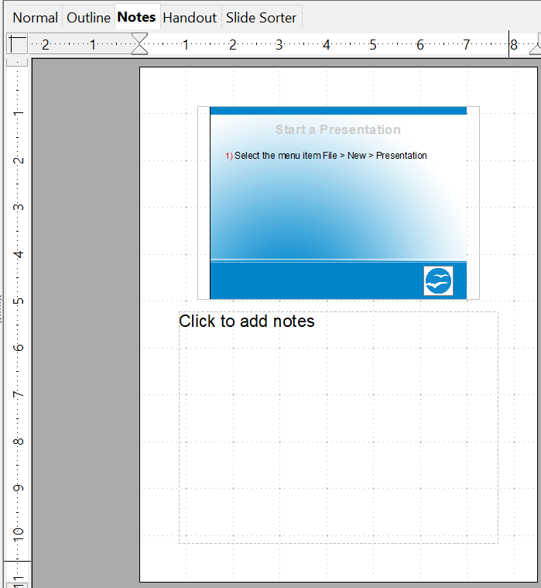
Figure 12: The work area in Notes view
- Click in the text box showing “Click to add notes” and type or paste text or graphics as needed.
- To add notes to another slide, select it in the Slides pane. The Notes view changes to show the selected slide.
- When done entering notes, return to Normal view.

Formatting Notes
It is highly recommended to use the Notes Master and the Notes Presentation style to format the appearance of notes, rather than formatting them for each slide individually.
All the formatting guidelines given in this section can be applied to either the Notes Master or to the Notes Presentation style.
To open the Notes Master, choose View > Master > Notes Master from the menu bar.
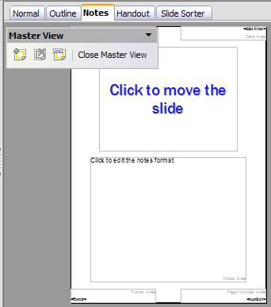
Figure 13: Notes Master View

Formatting the Notes Page
To format the Notes page:
- Switch to Notes view by clicking the tab in the main work area or select View > Notes.
- Select Format > Page from the menu bar, or right-click and choose Slide > Page Setup to open the Page Setup dialog box, shown in Figure 14.
- Set the desired parameters. The Page Setup dialog for notes is the same as the dialog for slides. Refer to “Formatting the Slide or Page Area” on page 11 for a description of this dialog box. The only difference is that by default the Notes page orientation is set to portrait.
- Click OK to close the dialog box.
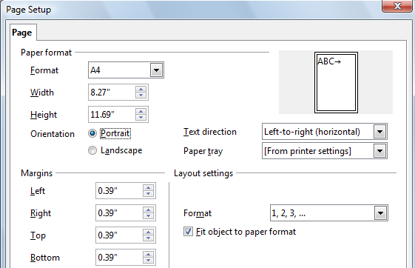Figure 14: The Page Setup dialog for notes

Setting Automatic Layout Options
In Notes view, Impress provides four areas to input information about the presentation:
- Header area
- Date and Time area
- Footer area
- Page number area
To customize these fields, proceed as follows:
- Switch to Notes view from the corresponding tab in the work area or by selecting View > Notes from the main menu, or open the Notes Master (View > Master > Notes Master).
- Choose Insert > Date and Time for the Date and time. Choose between Fixed (enter in the edit box the date and time that should be displayed) or Variable (the date and time of the slide creation will be inserted in the notes pages). Use the two drop-down menus to select the format of the date and the language.
- Choose Insert > Page Number from the main menu to display the Header and Footer dialog box. Select the Notes and Handouts tab (Figure 15).
- Select the checkboxes to activate the corresponding areas. For the Header and Footer, type the text in the edit fields.
If the Page number checkbox is activated, to format the type of numbering refer to “Formatting the Notes Page” on page 17).
- Click the Apply to All button to save these settings and close the dialog box.
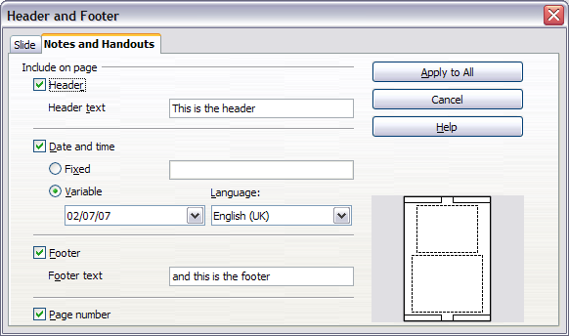
Figure 15: The dialog to set up header and footer for notes

Text Formatting
When text is inserted in the Notes text box, it is automatically formatted using the predefined Notes style that you can find in the Presentation styles. The best way to format the notes text is therefore to modify this style to suit your needs. Refer to Chapter 2 (Slide Masters, Styles, and Templates) to learn how to work with styles.
If manual formatting is required, for example to highlight a particular section of the notes, the guidelines given in Chapter 3 (Adding and Formatting Text) apply.

Advanced Notes Formatting
You can make other changes to the Notes pages. For example, you can:
- Move the text box and the slide image around the page
- Resize the slide image and text box (only from the Slide Master view).
- Add other text boxes to the page.

Printing Notes
- Choose File > Print from the menu bar.
- On the Print dialog box, in the Print section of the General tab, select Notes from the Document list.
- Make any other needed changes and then click OK to print.
For more about printing slides, notes, and handouts, see Chapter 10.
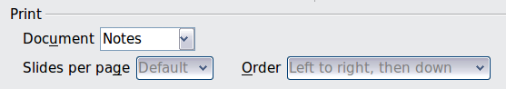
Figure 16: Select Notes for printing

Exporting Notes to PDF
- Choose File > Export as PDF from the menu bar.
- In the PDF Options dialog box, choose the General tab.
- Under General, make sure that Export notes pages is checked, and then click OK.
- In the Export dialog box, give the file and name, select the folder in which to save it, and click Export.
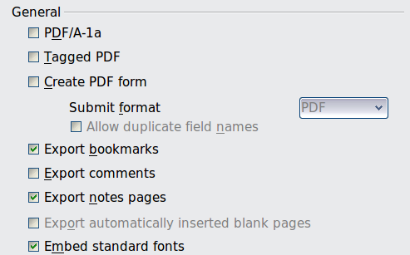
Figure 17: Exporting Notes to PDF
The Notes pages follow the presentation in the PDF (that is, if your presentation has 10 slides, the PDF contains 20 pages: 10 pages of individual slides, followed by 10 pages with notes formatted for paper). If you want only the Notes pages, you will need to use some other program to remove the unwanted pages of slides from the PDF.

Creating Handouts
A handout is a special view of the presentation suitable to be printed and distributed to the audience. Each handout page contains from one to nine thumbnails of the slides so that the audience can follow what is presented as well as use it as reference. This section explains how to customize the handout page. An example is shown in Figure 18.
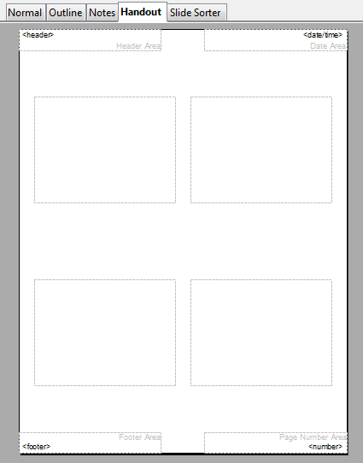
Figure 18: Example of handout with four slide thumbnails
Note that the Handout view consists of only one page regardless of the number of slides in the presentation or the number of pages of slides that will be printed.

Changing the Layout
When creating handouts, first decide how many slide thumbnails you want printed on each handout page.
- Select the Handout view either by clicking on the tab in the work area or by selecting View > Handout Page from the menu bar.
- If the Sidebar is not visible, select View > Sidebar from the menu bar.
- In the Sidebar select the Properties deck and expand the Layouts pane, which looks like Figure 19 in Handout view.
- Choose the preferred layout. The main work area changes to reflect the choice.
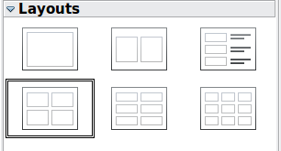
Figure 19: Layouts for handouts

Formatting Handouts
You can format several aspects of the handout, from the page style to the elements that appear on the page. You cannot format individual handout pages; any changes apply to all handouts in the presentation file.

Formatting the Page
To format the handout pages:
- Be sure you are in Handouts view. Click the Handouts tab in the work area or select View > Handout Page from the menu bar.
- Select Format > Page from the main menu, or right-click on the handout and select Slide > Page Setup from the pop-up menu.
- On the Page Setup dialog (Figure 14 on page 18), set the paper size, orientation (portrait or landscape), margins, and other parameters. Click OK.

Setting Automatic Layout Options
In Handout view, as in Notes view, Impress creates four areas where you can put information about the presentation:
- Header area
- Date and Time area
- Footer area
- Slide number area
Note | The information in these areas does not show in Handout view, but it does appear correctly on the printed handouts.
The way to access and customize these areas is the same as for the Notes and uses the same dialog box. Refer to “Setting Automatic Layout Options” on page 18 for information.

Moving Thumbnails and Adding Graphics
You can move (but not resize) the slide thumbnails and add lines, boxes, and other graphic elements to the handouts. See Chapter 5 (Managing Graphic Objects) for instructions on using the graphics tools.
Tip | After designing a handout, you may wish to save it in a template so you can reuse it whenever you want. See “Working with templates” in Chapter 2 (Slide Masters, Styles, and Templates) for instructions on saving templates and starting a new presentation from a template.
Caution | If you click on one of the other handout layouts and then return to the one you have reformatted, the slide thumbnails return to their original positions, although any lines or other graphics you have added remain where you put them. You will need to move the thumbnails back to where you want them.

Printing Handouts
- Choose File > Print from the menu bar.
- On the General page of the Print dialog box, in the Print section, select Handouts in the Document list. Specify the number of slides per page and the order in which to print multiple slides.
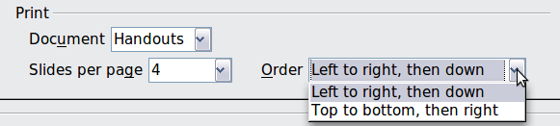
Figure 20: Select Handouts for printing
- To select which slides to include in the handouts, in the Range and copies section of the General page, select Slides and specify the slide numbers to be included.
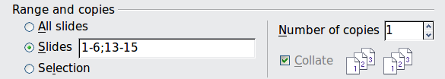
Figure 21: Choose which slides to print
For more about printing slides, notes, and handouts, see Chapter 10.

Exporting Handouts to PDF
At present there is no way to export handouts to PDF; if you try, you get the slides (one per page) instead. However, you can print to a PostScript file (if you have a suitable printer driver installed) and then use another program (such as Ghostscript or Adobe Distiller) to create a PDF from the PostScript file.
To create a PostScript file, follow the steps below:
- Choose File > Print.
- On the General page, choose Handouts in the Print section (see Figure 20) and choose the range of handouts (slides) to be included (Figure 21).
- On the Options page, select the Print to file option. The Print button changes to Print to File.
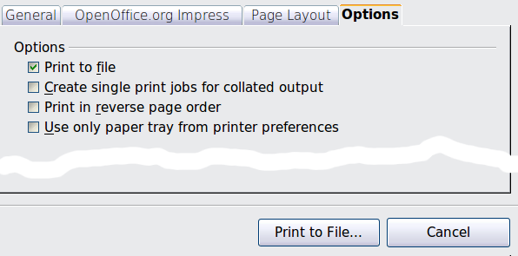
Figure 22: Printing to a PostScript file
- Click the Print to File button. In the Save as dialog box, specify where to save the file. Make sure PostScript is selected as the file type. Click Save.
- You may see the following message regarding transparencies. Confirm either Yes or No for whether transparencies should be reduced. The file will then be created and given an extension of .ps.
