Apache OpenOffice
Version 4.1
Getting Started

AOO Documentation Team

Copyright
This document is Copyright © 2022 by Apache OpenOffice. You may distribute it and/or modify it under the terms of the Creative Commons Attribution License, version 3.0 or later (https://creativecommons.org/licenses/by/3.0/).
Apache, Apache OpenOffice, and OpenOffice.org are trademarks of the Apache Software Foundation. Used with permission. No endorsement by The Apache Software Foundation is implied by the use of these marks. All other trademarks mentioned in this guide belong to their respective owners.
Acknowledgments
This book is updated from Taming Apache OpenOffice 3.4 (by Jean Hollis Weber), which was adapted from Getting Started with OpenOffice.org 3.3 (by the OOoAuthors team) with additional material adapted from Getting Started with LibreOffice 3.4 (by the ODF Authors Team).
Publication date and software version
Published October 2022. Based on Apache OpenOffice 4.1.

Contents
Preface 4
Who Is This Book For? 4
What's in This Book? 4
Where to Get More Help 4
What You See May Be Different 5
What Are All These Things Called? 5
Using Apache OpenOffice on macOS 6
Chapter 1
Introducing Apache OpenOffice 7
What Is Apache OpenOffice? 7
Advantages of Apache OpenOffice 8
Minimum Requirements 9
How to Get and Install the Software 10
Extensions and Add-Ons 10
Starting Apache OpenOffice 10
Parts of the Main window 12
Starting a New Document 17
Opening an Existing Document 18
Saving a Document 19
Password Protection 19
Using the Navigator 20
Using the Open and Save As Dialogs 22
Undoing and Redoing Changes 23
Reloading a Document 24
Closing a Document 24
Closing Apache OpenOffice 25
Chapter 2
Using Styles and Templates 26
What Is a Template? 26
What Are Styles? 26
Applying Styles 28
Modifying Styles 30
Creating New (Custom) Styles 31
Copying and Moving Styles 33
Deleting Styles 35
Using a Template to Create a Document 35
Creating a Template 36
Adding Templates Using the Extension Manager 38
Editing a Template 39
Changing the Template Assigned to a Document 40
Setting a Default Template 40
Organizing Templates 41
Examples of Style Use 42

Preface

Who Is This Book For?
Anyone who wants to get up to speed quickly with Apache OpenOffice will find this book valuable. You may be new to office software, or you may be familiar with another office suite.

What's in This Book?
This book introduces the main components of Apache OpenOffice:
- Writer (word processing)
- Calc (spreadsheets)
- Impress (presentations)
- Draw (vector graphics)
- Base (database)
- Math (equation editor)
It also covers some features common to all components, including setup and customization, styles and templates, and printing.

Where to Get More Help
This book, the built-in Help system, and user support systems assume that you are familiar with your computer and basic functions such as starting a program, opening and saving files.

Help System
Apache OpenOffice comes with an extensive Help system. This is your first line of support for using the program.
To display the full Help system, press F1 or select OpenOffice Help from the Help menu. In addition, you can choose whether to activate Tips, Extended tips, and the Help Agent (using Tools > Options > OpenOffice > General).
If Tips are enabled, place the mouse pointer over any of the icons to see a small box (“tooltip”) with a brief explanation of the icon’s function. For a more detailed explanation, select Help > What's This? and hold the pointer over the icon.

Free Online Support
The Apache OpenOffice community not only develops software, but provides free, volunteer-based support. See this web page: https://www.openoffice.org/support/index.html
Users can get comprehensive online support from the community through the mailing list at users@openoffice.apache.org and the Apache OpenOffice Community Forum at https://forum.openoffice.org/en/forum/. The forum requires a subscription before questions can be posted, though they can be viewed by anyone. The subscription is need to control spamming and is not used for any other purpose.

What You See May Be Different
Apache OpenOffice runs on Windows, Linux, and macOS operating systems, each of which has several versions and can be customized by users (fonts, colors, themes, window managers).
The pictures in this book were taken from a variety of computers and operating systems. Some pictures will therefore not look exactly like what you see on your computer.

What Are All These Things Called?
The terms used in Apache OpenOffice for most parts of the user interface (the parts of the program you see and use, in contrast to the behind-the-scenes code that actually makes it work) are the same as for most other programs.
A dialog is a special type of window. Its purpose is to inform you of something, or request input from you, or both. It provides controls for you to use to specify how to carry out an action. The technical names for common controls are shown in Figure 1; not shown is the list box (from which you select an item). In most cases we do not use the technical terms in this book, but it is useful to know them because the Help and other sources of information often use them.
In most cases, you can interact only with the dialog (not the document itself) as long as the dialog remains open. When you close the dialog after use (usually, clicking OK or another button saves your changes and closes the dialog), then you can again work with your document.
Some dialog windows can be left open as you work, so you can switch back and forth between the dialog and your document. An example of this type is the Find & Replace dialog.
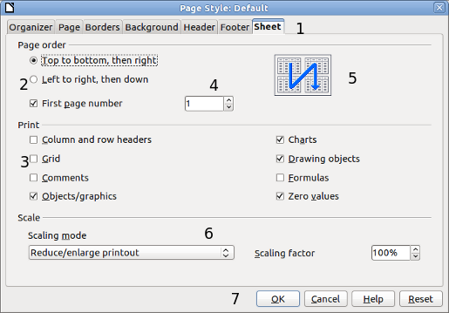
Figure 1: Dialog showing common controls:
1 = Tabbed page (not strictly speaking a control)
2 = Radio buttons (only one can be selected at a time)
3 = Checkbox (more than one can be selected at a time)
4 = Spin box (click the up and down arrows to change the number shown in the text box next to it, or type in the text box)
5 = Thumbnail or preview
6 = Drop-down list from which to select an item
7 = Push buttons

Using Apache OpenOffice on macOS
Some keystrokes and menu items are different on macOS from those used in Windows and Linux. The table below gives some common substitutions for the instructions in this book. For a more detailed list, see the application Help.
Windows or Linux | macOS equivalent | Effect
Tools > Options menu selection | OpenOffice > Preferences | Access setup options
Right-click | Control+click | Open a context menu
Ctrl (Control) | z (Command) | Used with other keys
F11 | z+T | Open the Styles and Formatting window

Chapter 1
Introducing Apache OpenOffice

What Is Apache OpenOffice?
Apache OpenOffice is a freely available, full-featured office productivity suite. Its native file format is OpenDocument, an open standard format that is supported by several office suites but is not controlled by any one company and has been adopted by some governments (e.g., the United Kingdom) as a required file format for publishing and accepting documents. Apache OpenOffice can also open and save documents in many other formats, including those used by various versions of Microsoft Office.
Apache OpenOffice includes the following components.

Writer (word processor)
Writer is a feature-rich tool for creating letters, books, reports, newsletters, brochures, and other documents. You can insert graphics and objects from other components into Writer documents. Writer can export files to several versions of Microsoft Word files, Adobe’s Portable Document Format (PDF), HTML and other formats.

Calc (spreadsheet)
Calc has all the advanced analysis, charting, and decision-making features expected from a high-end spreadsheet. It includes over 300 functions for financial, statistical, and mathematical operations, among others. The Scenario Manager provides “what if” analysis. Calc generates 2-D and 3-D charts, which can be integrated into other Apache OpenOffice documents. You can also open and work with Microsoft Excel workbooks and save them in some Excel formats. Calc can also export spreadsheets to PDF and HTML.

Impress (presentations)
Impress provides all the common multimedia presentation tools, such as special effects, animation, and drawing tools. It is integrated with the advanced graphics capabilities of Apache OpenOffice’s Draw and Math components. Slide shows can be further enhanced with Fontwork’s special effects text, as well as sound and video clips. Impress is compatible with Microsoft’s PowerPoint file format and can also save your work in numerous graphics formats.

Draw (vector graphics)
Draw is a vector drawing tool that can produce everything from simple diagrams or flowcharts to 3-D artwork. Its Smart Connectors feature allows you to define your own connection points. You can use Draw to create drawings for use in any of Apache OpenOffice’s other components, and you can create your own clip art and add it to the Gallery. Draw can import graphics from many common formats and save them in over 20 formats, including PNG, HTML, and PDF.

Base (database)
Base provides tools for day-to-day database work within a simple interface. It can create and edit forms, reports, queries, tables, views, and relations, so that managing a connected database is much the same as in other popular database applications. Base provides many features, such as the ability to analyze and edit relationships from a diagram view. In its default configuration, Base uses HSQLDB, which is included in Apache OpenOffice, as its database engine and stores the database tables in the Base document. It can also use dBASE, Microsoft Access, MySQL, Oracle, or any ODBC compliant or JDBC compliant database engine and connect to external tables.

Math (formula editor)
Math is Apache OpenOffice’s formula or equation editor. You can use it to create complex equations that include symbols or characters not available in standard font sets. While it is most commonly used to create formulas in other documents, such as Writer and Impress files, Math can also work as a standalone tool. You can save formulas in the standard Mathematical Markup Language (MathML) format for inclusion in web pages and other documents not created by Apache OpenOffice.

Advantages of Apache OpenOffice
Here are some of the advantages of Apache OpenOffice over proprietary office suites:
- No licensing fees. Apache OpenOffice is free for anyone to use and distribute at no cost. There are no hidden charges now or in the future.
- Open source. You can distribute, copy, and modify the software as much as you wish, in accordance with the Apache 2 license.
- Cross-platform. Apache OpenOffice runs on several hardware architectures and under multiple operating systems, such as Microsoft Windows, macOS, and Linux.
- Extensive language support. The user interface for Apache OpenOffice is available in several languages, along with spelling, hyphenation, and thesaurus dictionaries. It supports bidirectional text and complex text layout for many scripts.
- Consistent user interface. All the components have a similar “look and feel,” making them easy to use and master.
- Integration. The components of Apache OpenOffice are well integrated with one another.
  - All the components share a common spelling checker and other tools, which are used consistently across the suite. For example, the drawing tools available in Writer are also found in Calc, with similar but enhanced versions in Impress and Draw.
  - You do not need to know which application was used to create a particular file. For example, you can open a Draw file from Writer; it will open automatically in Draw.
- Granularity. Usually, if you change an option, it affects all components. However, Apache OpenOffice options can be set at a component level or even document level.
- File compatibility. In addition to its native OpenDocument formats, Apache OpenOffice includes support for opening and saving files in many common formats including Microsoft Office (does not include saving in the newer formats DOCX, XLSX for example), HTML, XML and PDF (export only).
- No vendor lock-in. Apache OpenOffice uses OpenDocument, an XML (eXtensible Markup Language) file format developed as an industry standard by OASIS (Organization for the Advancement of Structured Information Standards). These files can easily be unzipped and read by any text editor, and their framework is open and published.
- You have a voice. Enhancements, software fixes, and release dates are community-driven. You can join the community and affect the course of the product you use.

Minimum Requirements
Apache OpenOffice 4.1 requires one of the following operating systems:
- Microsoft Windows XP, 2003, 2012, Vista, 7, 8, 8.1, 10 or 11
- GNU/Linux Kernel version 2.6 and glibc 2.5 or higher
- macOS 10.7 (Lion) or higher
For more details, see https://www.openoffice.org/dev_docs/source/sys_reqs_aoo41.html
Some features (wizards, some accessibility features, and the HSQLDB database engine) require that a Java Runtime Environment (JRE) be installed on your computer. Although Apache OpenOffice will work without Java support, those features will not be available. The current versions of Apache OpenOffice work reliably with a variety of JREs including Oracle Java, versions 6, 7 and 8, openJDK, versions 6, 7 and 8 and AdoptOpenJDK, versions 8 and 11. You should use the most recent version of whichever JRE you choose for the best security and reliability.
Note | For Microsoft Windows 32-bit JRE MUST be installed, even on a 64-bit machine

How to Get and Install the Software
You can download the installation package (approximately 150 MB) from the project’s website, https://www.openoffice.org/download/index.html. The download process automatically redirects to a SourceForge web page which starts the download without the need to take any action on that page.
To install Apache OpenOffice, follow the same procedure that you used to install other software.

Extensions and Add-Ons
Extensions and add-ons that enhance Apache OpenOffice are collected in the official extensions repository, https://extensions.openoffice.org/. Most are free, but some are not. See Chapter 11 (Setting up and Customizing Apache OpenOffice) for more information.

Starting Apache OpenOffice
In general, you start Apache OpenOffice the same way you start any other program on your computer.
On Windows and Linux, entries for Apache OpenOffice and each of its components appear in the system menu of your computer. On macOS, only an entry for Apache OpenOffice is added to the Applications menu. You can make a desktop icon for Apache OpenOffice or a component in the same way you can make a desktop icon for any other program; see your operating system’s help for how to do this.
- Clicking on the Apache OpenOffice menu entry, desktop icon, or tile opens the Apache OpenOffice Start Center (Figure 14 on page 18) from where you can select the individual components. You can also choose to open an existing file or use a template.
- On Windows, you can use the Quickstarter (see below).
- You can double-click on the filename of a document with an OpenDocument extension such as .odt, .ods, .odp in a file manager such as Windows Explorer, Finder on macOS, or Nautilus on Linux. The appropriate component will start, and the document will be loaded.

Note for Windows Users
If you have associated Microsoft Office file types with Apache OpenOffice, then when you double-click on a *.doc (Word) file, it opens in Writer; *.xls (Excel) files open in Calc, and *.ppt (PowerPoint) files open in Impress.
If you did not associate the file types, then when you double-click on a Microsoft Word document, it opens in Microsoft Word (if Word is installed on your computer), Excel files open in Excel, and PowerPoint files open in PowerPoint.
You can search the Windows help for Default Apps to see how to associate each file type with OpenOffice. In addition to associating Microsoft Office file types with OpenOffice, it may also be necessary to reestablish the association between OpenOffice and its native file formats when a Windows update causes Microsoft Office to claim those file types.

Using the Quick-Starter Under Windows
The Quick-starter is an icon that is placed in the Windows system tray during system startup. It indicates that Apache OpenOffice has been loaded and is ready to use. (The Quickstarter shortens the startup time for Apache OpenOffice components by about half.) If the Quickstarter is disabled, see “Reactivating the Quick-Starter” if you want to enable it.

Using the Quick-Starter Icon
Right-click the Quick-starter icon in the system tray to open a pop-up menu (Figure 2) from which you can open a new document, open the Templates and Documents dialog, or choose an existing document to open. You can also double-click the Quickstarter icon to directly open the Templates and Documents dialog.
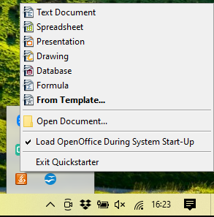Figure 2: Quickstarter pop-up menu

Disabling the Quick-Starter
To close the Quickstarter, right-click on the icon in the system tray, and then click Exit Quickstarter on the pop-up menu. The next time the computer is restarted, the Quick-starter will be loaded again.
To prevent Apache OpenOffice from loading during system startup, deselect the Load OpenOffice during system start-up item on the pop-up menu. You might want to do this if your computer has insufficient memory, for example.

Reactivating the Quick-Starter
If the Quickstarter has been disabled, you can reactivate it by selecting the Load OpenOffice during system start-up checkbox in Tools > Options > OpenOffice > Memory.

Using the Quick-Starter in Linux and macOS
Apache OpenOffice under Linux has a Quick-starter that looks and acts like the one described above for Windows. (The checkbox on the Memory page is labeled Enable systray quickstarter. If you do not have this checkbox, the Quick-starter module is not installed on your system.)
macOS provides similar functionality through a pop-up menu from the dock.

Parts of the Main window
The main window is similar in each component of Apache OpenOffice, although some details vary. See the chapters in this book about Writer, Calc, Draw, and Impress for descriptions of those details.
Common features include the menu bar, the standard toolbar, and the formatting toolbar at the top of the window and the status bar at the bottom.

Figure 3: Elements of the main Writer window

Menu Bar
The Menu bar is located across the top of the Apache OpenOffice window, just below the Title bar. (On macOS it is at the top of the screen in the same location as the menu bar for other programs.) When you choose one of the menus listed below, a sub-menu drops to show commands.
- File contains commands that apply to the entire document such as Open, Save, and Export as PDF.
- Edit contains commands for editing the document such as Undo: xxx (where xxx is the command to undo) and Find & Replace. It also contains commands to cut, copy, and paste selected parts of your document.
- View contains commands for controlling the display of the document such as Zoom and Web Layout.
- Insert contains commands for inserting elements into your document such as Header, Footer, and Picture.
- Format contains commands, such as Styles and Formatting and AutoCorrect, for formatting the layout of your document.
- Table shows all commands to insert and edit a table in a text document.
- Tools contain functions such as Spelling and Grammar, Customize, and Options.
- Window contains commands for the display window.
- Help contains links to the OpenOffice Help file, What’s This?, and information about the program.

Toolbars
Apache OpenOffice has several types of toolbars: docked, floating, and tear-off. Docked toolbars can be moved to different locations or made to float, and floating toolbars can be docked.
The top docked toolbar is called the Standard toolbar. The Standard toolbar is consistent across the OpenOffice applications.
The second toolbar at the top is the Formatting toolbar. It is a context-sensitive bar that shows the relevant tools in response to the cursor’s current position or selection. For example, when the cursor is on a graphic, the Formatting bar provides tools for formatting graphics; when the cursor is in text, the tools are for formatting text.

Displaying or Hiding Toolbars
To display or hide toolbars, choose View > Toolbars, then click on the name of a toolbar in the list. An active toolbar shows a check mark beside its name. Tear-off toolbars are not listed in the View menu.

Submenus and Tear-Off Toolbars
Toolbar icons with a small triangle to the right will display submenus, tear-off toolbars, and other ways of selecting things, depending on the icon.
Figure 4 shows a tear-off toolbar from the Drawing toolbar.
The tear-off toolbars can be floating or docked along an edge of the screen or in one of the existing toolbar areas. To move a floating tear-off toolbar, drag it by the title bar. See “Moving Toolbars” below.
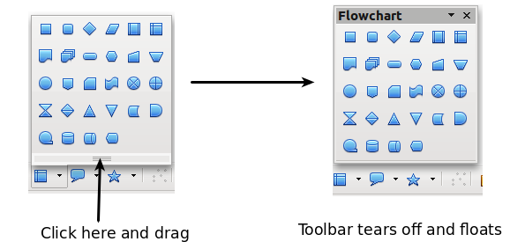
Figure 4: Example of a tear-off toolbar

Floating Toolbars
Apache OpenOffice includes several additional context-sensitive toolbars, whose defaults appear as floating toolbars in response to the cursor’s current position or selection. For example, when the cursor is in a table, a floating Table toolbar appears, and when the cursor is in a numbered or bullet list, the Bullets and Numbering toolbar appears. You can dock these toolbars to the top, bottom, or side of the window, if you wish (see “Moving Toolbars” below).

Moving Toolbars
To move a docked toolbar, place the mouse pointer over the toolbar handle (the small vertical bar to the left of the toolbar), hold down the left mouse button, drag the toolbar to the new location, and then release the mouse button (Figure 5). To move a floating toolbar, click on its title bar and drag it to a new location (Figure 6).
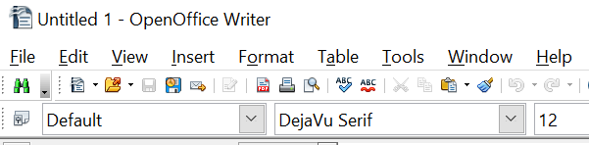

Figure 5: Moving a docked toolbar
Handles of docked toolbars

Figure 6: Moving a floating toolbar

Docking Floating Windows and Toolbars
Toolbars and some windows, such as the Navigator and the Styles and Formatting window, are dock-able. You can move, resize, or dock them to an edge.
To dock a window or toolbar, hold down the Ctrl key and double-click on the frame of the floating window (or in a vacant area near the icons at the top of the floating window) to dock it in its last position.
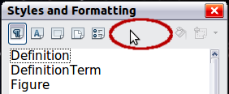Figure 7: Ctrl+click to dock or undock
To undock a window, hold down the Ctrl key and double-click on the frame (or a vacant area near the icons at the top) of the docked window.

Customizing Toolbars
You can customize toolbars in several ways, including choosing which icons are visible and locking the position of a docked toolbar. You can also add icons and create new toolbars, as described in Chapter 11.
To access a toolbar’s customization options, use the down-arrow at the end of the toolbar or on its title bar.

Figure 8: Customizing toolbars
To show or hide icons defined for the selected toolbar, choose Visible Buttons from the drop-down menu. Visible icons are indicated by an outline around the icon. Click on icons to hide or show them on the toolbar.
Figure 9: Selection of visible toolbar icons

Right-Click (context) Menus
You can quickly access many menu functions by right-clicking on a paragraph, graphic, or other object. A context menu will pop up. Often the context menu is the fastest and an easier way to reach a function. If you are not sure where a function is located in the menus or toolbars, you can frequently find it by right-clicking.

Status Bar
The status bar is located at the bottom of the workspace. It provides information about the document and convenient ways to quickly change some features. It is similar in Writer, Calc, Impress, and Draw, although each component includes some component-specific items.

Figure 10: Left end of status bar in Writer
Figure 11: Right end of status bar in Writer
Common status bar items are described below.
Page, sheet, or slide number
Shows the current page, sheet, or slide number and the total number of pages, sheets, or slides in the document. Double-click on this field to open the Navigator. Other uses of this field depend on the component.
Page style or slide design
Shows the current page style or slide design. To edit the current page style or slide design, double-click on this field.
Unsaved changes
An asterisk (*) appears here if changes to the document have not been saved.
Digital signature
If the document has been digitally signed, an icon shows here. You can double-click the icon to view the certificate.
Object information
Displays information relevant to the cursor’s position or the selected element of the document. Double-clicking in this area usually opens a relevant dialog.
Zoom slider and percent
To change the view magnification, drag the Zoom slider, or click on the + and — signs, or right-click on the zoom level percent to pop up a list of magnification values from which to choose. Double-clicking on the zoom level percent opens the Zoom & View Layout dialog.

Sidebar
The Sidebar (Figure 12) is located on the right side of the edit views of Writer, Calc, Impress, and Draw. It contains one or more decks, based on the current document context. Decks are organized into panels. A tab bar on the right side of the sidebar allows you to switch between different decks.
All four components contain the Properties, Styles, Gallery, and Navigator decks. Some components have additional decks, such as Master Pages, Custom Animation, and Slide Transition for Impress and Functions for Calc.
A panel is like a combination of a toolbar and a dialog. For example, you can freely mix working on the text in the main edit window and using the Styles panel in the sidebar to change text attributes.
Toolbars and Sidebar panels share many functions. For example, the buttons for making text bold or italic exist are in both the Formatting toolbar and the Properties panel.
If the Sidebar is not visible, you can show it by using View > Sidebar on the menu bar. To hide the Sidebar, click on the gray Hide button on the left. Click on the same button to show the Sidebar again.
To undock the Sidebar and make it floating, and to dock a floating Sidebar, use the Sidebar settings drop-down list at the top of the tab bar (see Figure 12 ). From the same list you can choose which items to show in the Sidebar.

Figure 12: Properties panel of Sidebar in Writer
Settings
Tabs
Tab Title
Panel Title
Panel Contents
Deck
MoreOptions


Figure 13: Floating (undocking) or docking the Sidebar

Starting a New Document
You can start a new, blank document in Apache OpenOffice in several ways.
When Apache OpenOffice is open, but no document is open (for example if you close all the open documents but leave the program running), the Start Center is shown. Click one of the icons to open a new document of that type, or click the Templates icon to start a new document using a template.
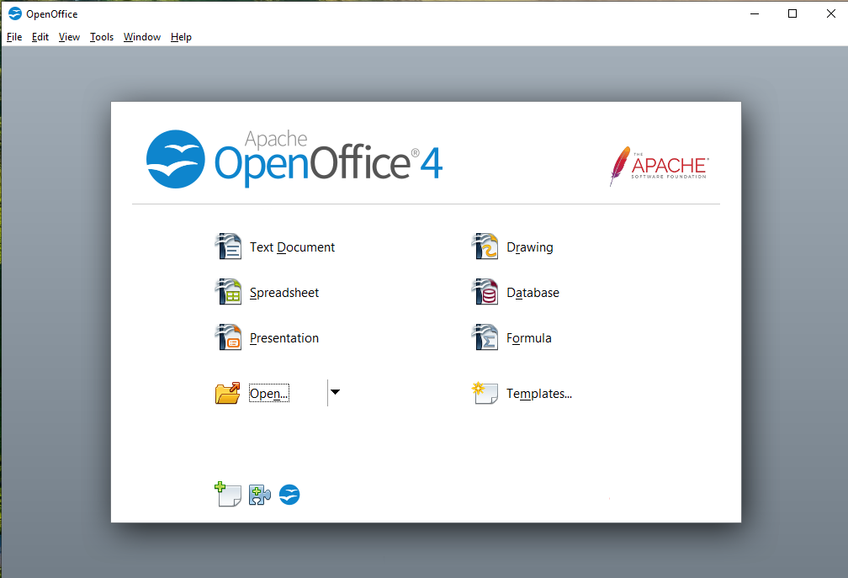 Figure 14: Apache OpenOffice Start Center
You can also start a new document in one of the following ways.
- Use File > New and choose the type of document.
- Use the arrow next to the New button on the main toolbar. From the drop-down menu, select the type of document to be created.
- Press Ctrl+N on the keyboard.
- Use File > Wizards for some special types of documents.
If a document is already open in Apache OpenOffice, the new document opens in a new window.

Opening an Existing Document
When no document is open, the Start Center provides an icon for opening an existing document or choosing from a list of recently-edited documents.
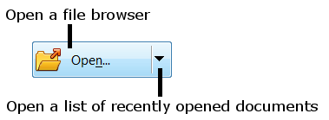
You can also open an existing document in one of the following ways.
- Choose File > Open.
- Click the Open button on the main toolbar.
- Press Ctrl+O on the keyboard.
In each case, the Open dialog appears. Select the file you want, and then click Open. If a document is already open in Apache OpenOffice, the second document opens in a new window.
In the Open dialog, you can reduce the list of files by selecting the type of file you are looking for. For example, if you choose Text documents as the file type, you will only see documents Writer can open (including .odt, .doc, .txt); if you choose Spreadsheets, you will see .ods, .xls, and other files that Calc opens.
You can also open an existing document that is in an OpenDocument format by double-clicking on the file’s icon on the desktop or in a file manager such as Windows Explorer.
If you have associated Microsoft Office file formats with Apache OpenOffice, you can also open these files by double-clicking on them.

Saving a Document
To save a new document, do one of the following:
- Press Ctrl+S.
- Choose File > Save from the menu bar.
- Click the Save button on the main toolbar.
When the Save As dialog appears, enter the file name, verify the file type (if applicable), and click Save.
To save an open document with the current file name, choose File > Save. This will overwrite the last saved state of the file.

Password Protection
To protect an entire document from being viewable without a password, use the option on the Save As dialog to enter a password.
- On the Save As dialog, select the Save with password option, and then click Save. You will receive a prompt (Figure 15).
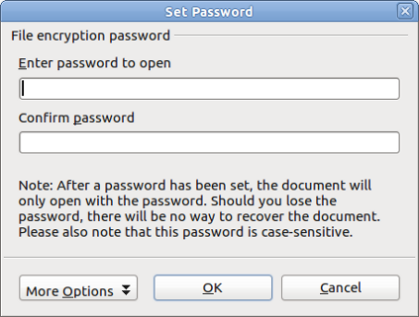
Figure 15: Entering a password for a document
- Type the same password in both fields, and then click OK. If the passwords match, the document is saved password protected. If the passwords do not match, you receive an error message. Close the message box to return to the Set Password dialog and enter the password again.
Caution   | Apache OpenOffice uses a very strong encryption mechanism that makes it almost impossible to recover the contents of a document if you lose the password.
Writer and Calc provide a second level of protection, which allows a file to be viewed but not changed without a password; that is, the file opens in read-only mode.
To protect a document from being changed:
- Choose More Options from the Set Password dialog.
- Enter the password in the Enter password to allow editing field. Repeat the password in the Confirm password field. Click OK.

Saving a Document Automatically
You can choose to have Apache OpenOffice save a temporary version of your file automatically. This temporary version is stored separately from the original file, and it allows AutoRecovery if the program should crash. However, automatic saving does not overwrite the last saved state of the file and does not substitute for periodically saving your work. To set up automatic file saving:
- Choose Tools > Options > Load/Save > General.
- Mark Save AutoRecovery information every, and set the time interval.

Using the Navigator
The Navigator lists objects contained in a document, collected into categories. For example, in Writer it shows Headings, Tables, Text frames, Comments, Graphics, Bookmarks, and other items, as shown in Figure 16. In Calc it shows Sheets, Range Names, Database Ranges, Graphics, Drawing Objects, and other items. In Impress and Draw it shows Slides, Pictures, and other items.
To open the Navigator, click its icon on the sidebar or the Standard toolbar, or press F5, or choose View > Navigator on the menu bar. The Sidebar is often the most convenient location for the Navigator.
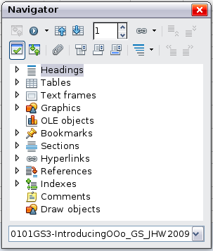
Figure 16: The Navigator
Click the marker (+ or triangle) by any of the categories to display the list of items in that category.
To hide the list of categories and show only the toolbars at the top, click the List Box On/Off icon . Click this icon again to show the list box.
The Navigator provides several convenient ways to move around a document and find items in it:
- When a category is showing the list of objects in it, double-click on an object to jump directly to that object’s location in the document.
- Objects are easier to find if you have given them names when creating them, instead op keeping Apache OpenOffice’s default graphics1, graphics2, Table1, Table2, and so on—which may not correspond to the position of the object in the document.
- If you only want to see the content in a certain category, highlight the category and click the Content View icon . Until you click the icon again, only the objects of that category will be displayed.
- Click the Navigation icon to display the Navigation toolbar (Figure 17). Here you can pick one of the categories and use the Previous and Next icons to move from one item to the next. This is particularly helpful for finding items like bookmarks and indexes, which can be difficult to see.
- The names of the icons (shown in the tooltips) change to match the selected category; for example, Next Graphic or Next Bookmark.
- To jump to a specific page in the document, type its page number in the box at the top of the Navigator.
A bit of experimentation with the other icons will demonstrate their functions. Some component-specific uses are described in the chapters on Writer and the other components.
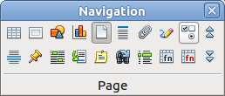
Figure 17: Navigation toolbar

Using the Open and Save As Dialogs
You can choose whether to use the OpenOffice Open and Save As dialogs or the ones provided by your operating system.
To view or change which type of dialog OpenOffice uses:
- Choose Tools > Options > OpenOffice > General.
- Select the Use OpenOffice dialogs option.
This section discusses the OpenOffice Open and Save As dialogs. Figure 18 shows the Save As dialog; the Open dialog is similar.
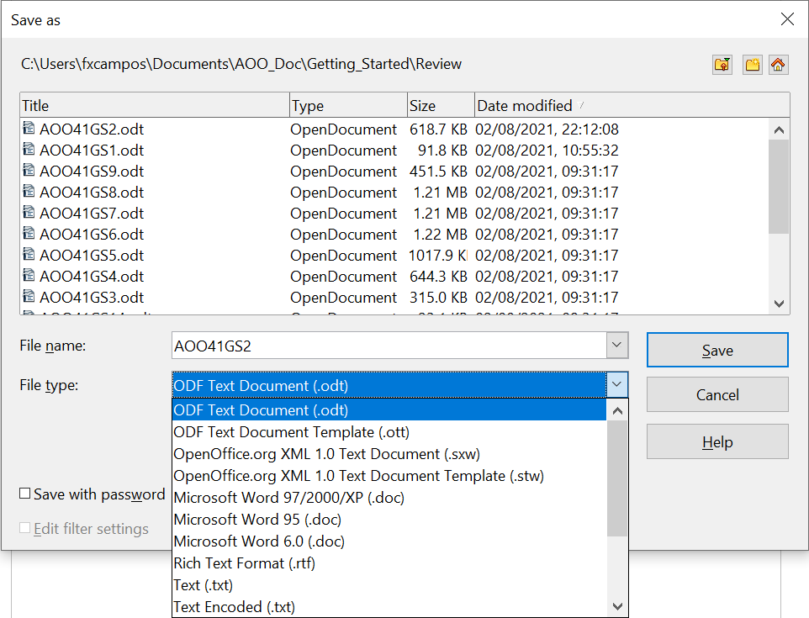

Figure 18: The OpenOffice Save As dialog
The three buttons in the top right of the OpenOffice Open and Save As dialogs are, from left to right:
- Go Up One Level in the folder (directory) hierarchy. Click and hold this button for a second to open a list of higher level folders; to go to one of the folders on the list, move the mouse pointer over its name and release the mouse button.
- Create New Folder.
- Default Directory.
For documents (in OpenDocument format) that have been saved with more than one version, use the Version drop-down to select which version you wish to open in read-only mode. For Microsoft Office documents, only the current version can be opened.
Use the File type field to specify the type of file to be opened or the format of the file to be saved.
The Read-only option on the Open dialog opens the file for reading and printing only. Consequently, most of the toolbars disappear, and most menu options are disabled. An Edit File button is displayed on the Standard toolbar to open the file for editing.
You can open files from the Web by typing a URL in the File name field on the Open dialog.

Undoing and Redoing Changes
To undo the most recent change, press Ctrl+Z, or click the Undo icon on the Standard toolbar, or choose Edit > Undo from the menu bar.
The Edit menu shows the latest change that can be undone (see below for an example from Writer).
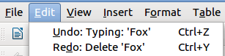
Figure 19: Edit > Undo last action
Click the small triangle to the right of the Undo icon to get a list of all the changes that can be undone. You can select multiple changes and undo them at the same time.
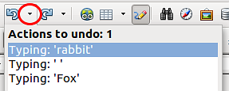
Figure 20: List of actions that can be undone
After changes have been undone, Redo becomes active. To redo a change, select Edit > Redo, or press Ctrl+Y or click on the Redo icon. As with Undo, click on the triangle to the right of the arrow to get a list of the changes that can be reapplied.
To modify the number of changes Apache OpenOffice remembers, choose Tools > Options > OpenOffice > Memory and in the Undo section change Number of steps. Be aware that asking Apache OpenOffice to remember more changes consumes more computer memory.

Reloading a Document
Reloading is useful in two situations.
- You may want to discard all the changes made in an editing session after the last document save.
- You may have made some formatting changes that do not show until the document has been closed and reopened; reloading has the same result.
To reload a document, go to File > Reload on the Menu bar. If you have made changes to a file since the last save, a confirmation dialog will warn you that reloading will discard your last changes. Choose whether to save or discard the changes.
On reloading the document, the File dialog does not open, because the file is already selected.

Closing a Document
To close a document, choose File > Close.
You can also close a document by clicking on the Close icon on the document window. This button may look like the X shown in Figure 21. It may be in a different location on your operating system.

Figure 21. Close icons
In Windows and Linux, if more than one OpenOffice window is open, each window looks like the sample shown on the left in Figure 21. Closing this window leaves the other OpenOffice windows open.
If only one OpenOffice window is open, it looks like the sample shown on the right in Figure 21. Notice the small X below the large X. Clicking the small X closes the document but leaves OpenOffice open. Clicking the large X closes Apache OpenOffice completely.
If the document has not been saved since the last change, a message box is displayed. Choose whether to save or discard your changes.
- Save: The document is saved and then closed.
- Discard: The document is closed, and all modifications since the last save are lost.
- Cancel: Nothing happens, and you return to the document.
Caution | Not saving your document could result in the loss of recently made changes, or worse still, your entire file.

Closing Apache OpenOffice
To close Apache OpenOffice completely, choose File > Exit, or close the last open document as described in “Closing a Document” above.
If all the documents have been saved, Apache OpenOffice closes immediately. If any documents have been modified but not saved, a warning message appears. Follow the procedure in “Closing a Document” to save or discard your changes.

Chapter 2
Using Styles and Templates

What Is a Template?
A template is a model document that you use to create other documents. For example, you can create a template for business reports that has your company’s logo on the first page and has the fonts, paragraph layout, footer content and any other details needed to meet corporate requirements. New documents created from this template will have a consistent and compliant appearance automatically.
Templates can contain anything that regular documents can contain, such as text, graphics, a set of styles, and user-specific setup information such as measurement units, language, the default printer, and toolbar and menu customization.
All documents in Apache OpenOffice are based on templates. You can create, or download and install, as many templates as you wish, and you can specify a template as the default for each type of document (text, spreadsheet, drawing, presentation). If you do not choose a template when you start a new document, then the new document is based on the default template for that type of document. If you have not specified a default template, Apache OpenOffice uses the blank template for that type of document that is installed with Apache OpenOffice. See “Setting a Default Template” on page 40 for more information.

What Are Styles?
A style is a set of formats that you can apply to selected elements such as pages, paragraphs, characters, frames, cells, and other elements in a document to quickly set or change their appearance. When you apply a style, you apply a whole group of formats at the same time.
Many people manually format paragraphs, words, tables, page layouts, and other parts of their documents without paying any attention to styles. For example, they might specify the font family, font size, and any formatting such as bold or italic.
Using styles means that instead of applying “font size 14pt, Times New Roman, bold, centered”, you can apply (for example) a “Title” style, if you have defined the “Title” style to have those characteristics. In other words, using styles means that you shift the emphasis from what the text (or page, or other element) looks like, to what the text is.

Using Styles Is Highly Recommended
Apache OpenOffice is a styles-based program. Using styles effectively requires some planning, but the time spent in planning can save time and effort over the longer term.
Because styles apply whole groups of formats at the same time, you can easily format a document consistently and change the formatting of an entire document with minimal effort. For example, the font family, size, and color of the headings in this document are set with a style. If you want to change those characteristics, editing the style takes a few seconds. If those headings had been formatted manually, changing them would require selecting every heading and applying the new settings. In addition, styles are used by Apache OpenOffice for many processes, even if you are not aware of them. For example, Writer relies on heading styles (or other styles you specify) when it compiles a table of contents. Some common examples of style use are given in “Examples of Style Use” on page 42.

Type of Styles in Apache OpenOffice
Apache OpenOffice supports the following types of styles:
- Page styles include margins, headers and footers, borders and backgrounds. In Calc, page styles also include the sequence for printing sheets.
- Paragraph styles control all aspects of a paragraph’s appearance, such as text alignment, tab stops, line spacing, and borders, and can include character formatting.
- Character styles affect selected text within a paragraph, such as the font and size of text, or bold and italic formats.
- Frame styles are used to format graphic and text frames, including wrapping type, borders, backgrounds, and columns.
- Numbering styles apply similar alignment, numbering or bullet characters, and fonts to numbered or bulleted lists.
- Cell styles include fonts, alignment, borders, background, number formats (for example, currency, date, number), and cell protection.
- Graphics styles in drawings and presentations include line, area, shadowing, transparency, font, connectors, dimensioning, and other attributes.
- Presentation styles include attributes for font, indents, spacing, alignment, and tabs.
Different styles are available in the various components of Apache OpenOffice, as listed in Table 1.
Apache OpenOffice comes with many predefined styles. You can use the styles as provided, modify them, or create new styles, as described in this chapter.
Table 1. Styles available in Apache OpenOffice components
Style Type | Writer | Calc | Draw | Impress
Page | X | X
Paragraph | X
Character | X
Frame | X
Numbering | X
Cell |  | X
Presentation |  |  | X | X
Graphics | (included in Frame styles) |  | X | X

Applying Styles
Apache OpenOffice provides several ways for you to apply styles:
- Styles and Formatting deck in the Sidebar
- Fill Format Mode
- Apply Style list on the Formatting toolbar (Writer)
- Keyboard shortcuts

Using the Styles Deck in the Sidebar
- You can open the Styles and Formatting deck on the Sidebar in several ways: click the icon on the Sidebar, or choose Format > Styles and Formatting from the Menu bar, or press F11, or click the Styles and Formatting icon located at the left-hand end of the Formatting toolbar. Some of these methods will bring up the Styles and Formatting deck as a floating toolbar even if the sidebar is docked.
The Styles and Formatting deck shows the types of styles available for the Apache OpenOffice component you are using. Figure 22 shows the window for Writer, with Page Styles visible.
- Click on one of the icons at the top left of the Styles and Formatting deck to display a list of styles in that category.
- To apply an existing style (except for character styles), position the insertion point in the paragraph, frame, or page, and then double-click on the name of the style in one of these lists. To apply a character style, select the characters first.
Tip | At the bottom of the Styles and Formatting deck is a dropdown list. In Figure 22 the deck shows Automatic, meaning the list includes only styles applied automatically by Apache OpenOffice. You can choose to show all styles or other groups of styles, for example only custom styles.

Figure 22: The Styles and Formatting window for Writer, showing paragraph styles

Using Fill Format Mode
Use Fill Format to apply a style to many areas quickly without having to go back to the Styles and Formatting deck and double-click every time. This method is quite useful when you need to format many scattered paragraphs, cells, or other items with the same style.
- Open the Styles and Formatting deck and select the style you want to apply.
- Click the Fill Format mode icon . The cursor shape will change to resemble the icon.
To apply a paragraph, page, or frame style, hover the mouse over the paragraph, page, or frame and click.
To apply a character style, hold down the mouse button while selecting the characters. Clicking on a word applies the character style to that word.
- Repeat step 3 until you made all the changes for that style.
- To quit Fill Format mode, click the Fill Format mode icon again or press the Esc key.

Using the Apply Style List in Writer
In Writer, after you have used a style at least once in a document, the style name appears on the Apply Style list at the left-hand end of the Formatting toolbar, next to the Styles and Formatting icon.
You can open this list and click once on the style you want, or you can use the up and down arrow keys to move through the list and then press Enter to apply the highlighted style.
Tip | Select More… at the bottom of the list to open the Styles and Formatting deck.
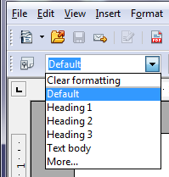
Figure 23: The Apply Style list on the Formatting toolbar

Using Keyboard Shortcuts
Some keyboard shortcuts for applying styles are predefined. For example, in Writer Ctrl+0 applies the Text body style, Ctrl+1 applies the Heading 1 style, and Ctrl+2 applies the Heading 2 style. You can modify these shortcuts and create your own; see Chapter 11 (Setting up and Customizing Apache OpenOffice) for instructions.

Modifying Styles
Apache OpenOffice provides several ways to modify styles (both the predefined styles and custom styles that you create):
- Change a style using the Style dialog
- Update a style from a selection
- Use AutoUpdate (paragraph and frame styles only)
- Load or copy styles from another document or template
Tip | Any changes you make to a style are effective only in the current document. To change styles in more than one document, you need to change the template or copy the styles into the other documents as described on page 33.

Changing a Style Using the Style Dialog
To change an existing style using the Style dialog, right-click on the required style in the Styles and Formatting deck and select Modify from the pop-up menu. In Writer, you can also right-click in a paragraph and choose Edit Paragraph Style from the context menu.
The Style dialog displayed depends on the type of style selected. Each style dialog has several tabs. For example, in Writer the Paragraph Style dialog includes tabs for Indents & Spacing, Font, Borders, Background, Outline & Numbering, and others.

Updating a Style from a Selection
To update a style from a selection:
- Open the Styles and Formatting deck in the Sidebar.
- In the document, select an item that has the format you want to adopt as a style.
Caution | Make sure that there are unique properties in this paragraph. For example, if there are two different font sizes or font styles, that particular property will remain the same as before.
- In the Styles and Formatting deck, select the style you want to update (single-click, not double-click), then click on the arrow next to the New Style from Selection icon and click on Update Style.

Figure 24: Updating a style from a selection

Using AutoUpdate (Writer)
AutoUpdate applies to paragraph and frame styles only. If the AutoUpdate option is selected on the Organizer page of the Paragraph Style or Frame Style dialog, applying direct formatting to a paragraph or frame using this style in your document automatically updates the style itself.
Tip | If you are in the habit of manually overriding styles in your document, be sure that AutoUpdate is not enabled.

Updating Styles from a Document or Template
You can update styles by copying or loading them from a template or another document. See “Copying and Moving Styles” on page 33.

Creating New (Custom) Styles
You may want to add some new styles. You can do this in two ways:
- Using the Style dialog
- From a selection

Creating a New Style Using the Style Dialog
To create a new style using the Style dialog, open the Sidebar Styles and Formatting deck and select the category of the style you wish to create by clicking one of the icons at the top of the deck. Then right-click and select New from the pop-up menu. If you want the new style to be linked with an existing style, first select that style and then right-click and select New.
If you link styles, the new style will inherit characteristics from the style that you selected. If you later change the base style (for example, by changing the font from Times to Helvetica), all the linked styles will change as well. Sometimes this is exactly what you want; other times you do not want the changes to apply to all the linked styles. It pays to plan ahead.
The dialog and choices are the same for defining new styles and for modifying existing styles.

Creating a New Style from a Selection
You can create a new style by copying an existing manual format. This new style applies only to this document; it will not be saved in the template.
- Open the Styles and Formatting window and choose the type of style you want to create.
- In the document, select the item you want to save as a style.
- In the Styles and Formatting window, click on the New Style from Selection icon.
- In the Create Style dialog, type a name for the new style. The list shows the names of existing custom styles of the selected type. Click OK to save the new style.

Figure 25: Naming a new style created from a selection

Dragging and Dropping to Create a Style (Writer and Calc)
You can drag and drop a text selection into the Styles and Formatting deck to create a new style.
Writer
Select some text and drag it to the Styles and Formatting window. If Paragraph Styles are active, the paragraph style will be added to the list. If Character Styles are active, the character style will be added to the list.
Calc
Drag a cell selection to the Styles and Formatting deck to create cell styles.

Copying and Moving Styles
You can copy or move styles from one template or document into another template or document, in two ways:
- Using the Template Management dialog
- Loading styles from a template or document

Using the Template Management Dialog
To copy or move styles using the Template Management dialog:
- Click File > Templates > Organize.
- In the Template Management dialog (Figure 26), set the lists at the bottom to either Templates or Documents, as needed. The default is Templates on the left and Documents on the right.
Tip | To copy styles from a file that is not open, click the File button. When you return to this dialog, both lists show the selected file and all the currently open documents.

Figure 26: Choosing to copy styles from a document, not a template
- Open the folders and find the templates from and to which you want to copy. Double-click on the name of the template or document, and then double-click the Styles icon to show the list of individual styles (Figure 27).
- To copy a style, hold down the Ctrl key and drag the name of the style from one list to the other.
Caution | If you do not hold down the Ctrl key when dragging, the style will be moved from one list to the other. The style will be deleted from the list you are dragging it from.
- Repeat for each style you want to copy. If the receiving template or document has many styles, you may not see any change unless you scroll down in the list. When you are finished, click Close.
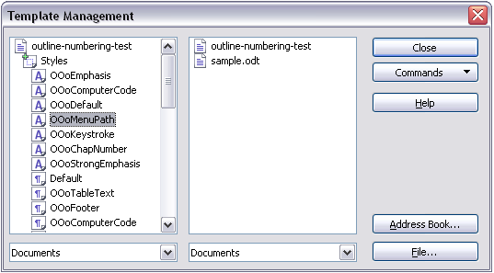
Figure 27: Copying a style from one document to another

Loading Styles from a Template or Document
You can copy styles by loading them from a template or another document:
- Open the document you want to copy styles into.
- In the Styles and Formatting deck, click on the arrow next to the New Style from Selection icon, and then click on Load Styles (see Figure 24).
- On the Load Styles dialog (Figure 28), find and select the template you want to copy styles from.

Figure 28. Copying styles from a template into the open document
- Select the categories of styles to be copied. Select Overwrite if you want the styles being copied to replace any styles of the same names in the document you are copying them into.
- Click OK to copy the styles. You will not see any change on screen.
Note | To copy the styles from another document, click the From File button to open a window from which you can select the required document.

Deleting Styles
You cannot remove (delete) any of Apache OpenOffice’s predefined styles from a document or template, even if they are not in use.
You can remove any user-defined (custom) styles; but before you do, you should make sure the styles are not in use. If an unwanted style is in use, you will want to replace it with a substitute style.
To delete unwanted styles, right-click on them (one at a time) in the Styles and Formatting window and click Delete on the pop-up menu.
If the style is in use, you receive a warning message.
If the style is not in use, you receive a confirmation message; click Yes.

Using a Template to Create a Document
To use a template to create a document:
- From the main menu, choose File > New > Templates and Documents. The Templates and Documents dialog (Figure 29) opens.
- In the box on the left, click the Templates icon if it is not already selected. A list of template folders appears in the center box.
- Double-click the folder that contains the template that you want to use. A list of all the templates contained in that folder appears in the center box.
- Select the template that you want to use. You can preview the selected template or view the template’s properties using the icons just below the title bar and slightly to the right of center:
  - To preview the template, click the Preview icon . A preview of the template appears in the box on the right.
  - To view the template’s properties, click the Document Properties icon . The template’s properties appear in the box on the right.
- Click Open. The Templates and Documents dialog closes and a new document based on the selected template opens in Apache OpenOffice.
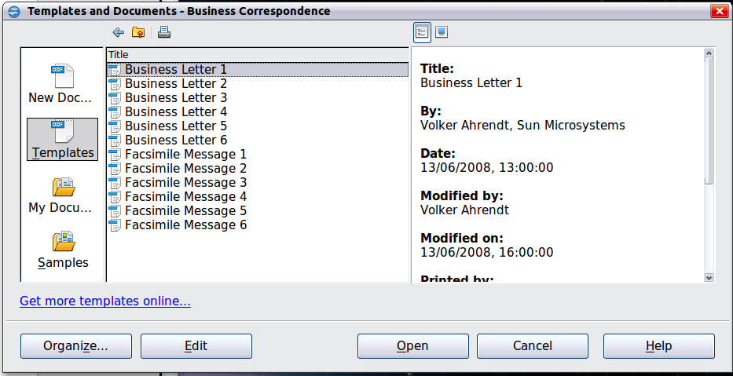
Figure 29: Templates and Documents window

Creating a Template
You can create your own templates in two ways: from a document or (in Writer) by using a wizard.

Creating a Template from a Document
In addition to formatting, any settings that can be added to or modified in a document can be saved in a template. For example, below are some settings (although not a full list) that can be included in a Writer document and then saved as a template for later use:
- Printer settings: which printer, single sided / double-sided, and paper size, and so on
- Styles to be used, including character, page, frame, numbering, and paragraph styles
- Format and settings regarding indexes, tables, bibliographies, table of contents
Templates can also contain predefined text, saving you from having to type it every time you create a new document. For example, a letter template may contain your name, address, and salutation.
You can also save menu and toolbar customizations in templates; see Chapter 11 (Setting Up and Customizing Apache OpenOffice) for more information.
To create a template from a document:
- Open a new or existing document of the type you want to make into a template (text document, spreadsheet, drawing, presentation).
- Add the content and styles that you want.
- From the main menu, choose File > Templates > Save. The Templates' dialog opens (see Figure 30).
- In the New template field, type a name for the new template.
- In the Categories list, click the category to which you want to assign the template. The category you choose has no effect on the template itself; it is simply the folder in which you save the template.
- Selecting an appropriate category makes it easier to find the template when you want to use it. For example, you might save Impress templates under the Presentations category.
- To learn more about template folders, see “Organizing Templates” on page 41.
- Click OK to save the new template.
Figure 30: Saving a new template

Creating a Template Using a Wizard
In Writer, you can use wizards to create templates for letters, faxes, agendas, presentations, and Web pages.
For example, the Letter Wizard guides you through the following choices:
- Type of letter (business, formal personal or personal)
- Document elements like the return address, subject line (business letter), salutation, and complementary close
- Options for sender and recipient information (business letter)
- Text to include in the footer (business letter)
To create a template using a wizard:
- From the main menu, choose File > Wizards > [type of template required] (see Figure 31).
- Follow the instructions on the pages of the wizard. This process is slightly different for each type of template, but the format is very similar.
- In the last section of the wizard, you can specify the name and location for saving the template. The default location is your user templates directory, but you can choose a different location if you prefer.
- Finally, you have the option of creating a new document from your template immediately, or manually changing the template. For future documents, you can re-use the template created by the wizard, just as you would use any other template.

Figure 31. Creating a template using a wizard

Adding Templates Using the Extension Manager
The Extension Manager provides an easy way to install collections of templates, graphics, macros, or other add-ins that have been “packaged” into files with a .OXT extension. See Chapter 11 (Setting up and Customizing Apache OpenOffice) for more about the Extension Manager.
This Web page lists many of the available extensions: https://extensions.openoffice.org/. Others may be available from third-party websites.
To install an extension, follow these steps:
- Download an extension package and save it anywhere on your computer.
- In Apache OpenOffice, select Tools > Extension Manager from the menu bar. In the Extension Manager dialog, click Add.
- A file browser window opens. Find and select the package of templates you want to install and click Open. The package begins installing. You may be asked to accept a license agreement.
- When the package installation is complete, the templates are available for use through File > New > Templates and Documents and the extension is listed in the Extension Manager.
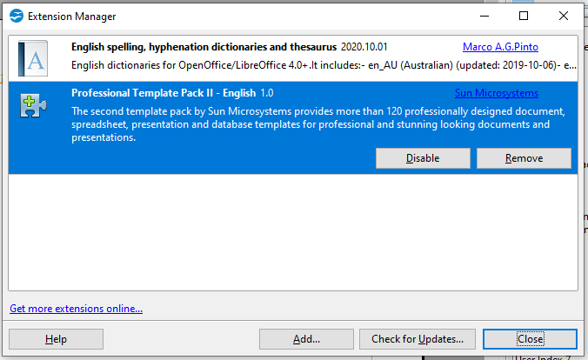
Figure 32: Newly-added package of templates

Editing a Template
You can edit a template’s styles and content, and then, if you wish, you can reapply the template’s styles to documents that were created from that template. You cannot reapply content.
To edit a template:
- From the main menu, choose File > Templates > Edit. A file browser window opens.
- Select the template that you want to edit and click Open.
- Edit the template as you would edit any other document. To save your changes, choose File > Save from the main menu.

Updating a Document from a Changed Template
The next time you open a document that was created from the changed template, a confirmation message appears.
Click Update Styles to apply the template’s changed styles to the document, or click Keep Old Styles if you do not want to apply the changed styles to the document.
Caution | If you choose Keep Old Styles, the document is no longer connected to the template, even though the template is still listed under File > Properties > General. To connect the document to the template again, use the procedure described in “Changing the Template Assigned to a Document” below.

Changing the Template Assigned to a Document
You can change the template assigned to a document, or reconnect a document to a template, in two ways: manually or using the Template Changer extension to OpenOffice.
To change or reassign a template manually, first create a new, blank document from the required template, as described on page 35. Then copy the contents of the old document into the new document.
To use the Template Changer extension, first you need to download and install it, then restart OpenOffice to activate it. After that, you can open the document and use File > Templates > Change Template (current document) from the main menu.
The Template Changer extension works with Writer, Calc, Draw, and Impress.

Setting a Default Template
If you create a document by choosing File > New > Text Document (or Spreadsheet, Presentation, or Drawing) from the main menu, Apache OpenOffice creates the document from the Default template for that type of document. You can, however, set a custom template to be the default. You can reset the default later if you decide.

Setting a Template as the Default
You can set any template to be the default, as long as it is in one of the folders displayed in the Template Management dialog.
To set a custom template as the default:
- From the main menu, choose File > Templates > Organize. The Template Management dialog opens.
- In the box on the left, select the folder containing the template that you want to set as the default, then select the template.
- Click the Commands button and choose Set As Default Template from the drop-down menu.
The next time that you create a document by choosing File > New, the document will be created from this template.
Although many important settings can be changed in the Options dialog (see Chapter 11), for example default fonts and page size, more advanced settings (such as page margins) can only be changed by replacing the default template with a new one.

Resetting the Default Template
To re-enable Apache OpenOffice’s Default template for a document type as the default:
- In the Template Management dialog, click any folder in the box on the left.
- Click the Commands button and choose Reset Default Template from the drop-down menu.
The next time that you create a document by choosing File > New, the document will be created from Apache OpenOffice’s Default template for that document type.

Organizing Templates
Apache OpenOffice can only use templates that are in Apache OpenOffice template folders. You can create new Apache OpenOffice template folders and use them to organize your templates. For example, you might have one template folder for report templates and another for letter templates. You can also import and export templates.
To begin, choose File > Templates > Organize from the main menu. The Template Management dialog opens.
Note | All the actions made by the Commands button in the Template Management dialogue can be made as well by right-clicking on the templates or the folders.

Creating a Template Folder
To create a template folder:
- In the Template Management dialog, click any folder.
- Click the Commands button and choose New from the drop-down menu. A new folder called Untitled appears.
- Type a name for the new folder, and then press Enter. Apache OpenOffice saves the folder with the name that you entered.

Deleting a Template Folder
You cannot delete template folders supplied with Apache OpenOffice or installed using the Extension Manager; you can only delete template folders that you have created.
To delete a template folder that you have created:
- In the Template Management dialog, select the folder that you want to delete.
- Click the Commands button and choose Delete from the drop-down menu. A message box appears and asks you to confirm the deletion. Click Yes.

Moving a Template
To move a template from one template folder to another template folder:
- In the Template Management dialog, double-click the folder that contains the template you want to move. A list of the templates contained in that folder appears underneath the folder name.
- Click the template that you want to move and drag it to the desired folder. If you do not have the authority to delete templates from the source folder, this action copies the template instead of moving it.

Deleting a Template
You cannot delete templates supplied with Apache OpenOffice or installed using the Extension Manager; you can only delete templates that you have created or imported.
To delete a template:
- In the Template Management dialog, double-click the folder that contains the template you want to delete. A list of the templates contained in that folder appears underneath the folder name.
- Click the template that you want to delete.
- Click the Commands button and choose Delete from the drop-down menu. A message box appears and asks you to confirm the deletion. Click Yes.

Importing a Template
If the template that you want to use is in a different location, you must import it into an Apache OpenOffice template folder.
To import a template into a template folder:
- In the Template Management dialog, select the folder into which you want to import the template.
- Click the Commands button and choose Import Template from the drop-down menu. A standard file browser window opens.
- Find and select the template that you want to import and click Open. The file browser window closes and the template appears in the selected folder.
- If you want, type a new name for the template, and then press Enter.

Exporting a Template
To export a template from a template folder to another location:
- In the Template Management dialog, double-click the folder that contains the template you want to export. A list of the templates contained in that folder appears underneath the folder name.
- Click the template that you want to export.
- Click the Commands button and choose Export Template from the drop-down menu. The Save As window opens.
- Find the folder into which you want to export the template and click Save.

Examples of Style Use
The following examples of common use of page and paragraph styles are taken from Writer. There are many other ways to use styles; see the guides for the various components for details.

Defining a Different First Page for a Document
Many documents, such as letters and reports, have a first page that is different from the other pages in the document. For example, the first page of a letter typically has a different header, or the first page of a report might have no header or footer, while the other pages do. With Apache OpenOffice, you can define the page style for the first page and specify the style for the following pages to be applied automatically.
As an example, we can use the First Page and Default page styles that come with Apache OpenOffice. Figure 25 shows what we want to happen: the first page is to be followed by the default page, and all the following pages are to be in the Default page style. Details are in Chapter 4 (Formatting Pages) in the Writer Guide.

Figure 33: Flow of page styles

Dividing a Document into Chapters
Similarly, you can divide a document into chapters. Each chapter might start with the First Page style, with the following pages using the Default page style, as above. At the end of the chapter, insert a manual page break and specify the next page to have the First Page style to start the next chapter, as shown in Figure 23.

Figure 34: Dividing a document into chapters using page styles

Changing Page Orientation Within a Document
A Writer document can contain pages in more than one orientation. A common scenario is to have a landscape page in the middle of a document, where the other pages are in a portrait orientation. This can be done with page breaks and page styles. Position the cursor at the point where you want to start the new (landscape) page. Click Insert > Manual Break on the main menu. In the Insert Break dialog, select Page Break under Type, and select a page style with landscape orientation in the Page Style list. Click OK to insert the page. To go back to the portrait page style, insert another page break and select the portrait page style you are using (which may be Default Page Style, if you haven’t selected or created a different one).

Different Headers on Right and Left Pages
Page styles can be set up to have the facing left and right pages mirrored or only right (first pages of chapters are often defined to be right-page only) or only left. When you insert a header on a page style set up for mirrored pages or right-and-left pages, you can have the contents of the header be the same on all pages or be different on the right and left pages. For example, you can put the page number on the left-hand edge of the left pages and on the right-hand edge of the right pages, put the document title on the right-hand page only, or make other changes.

Controlling Page Breaks Automatically
Writer automatically flows text from one page to the next. If you do not like the default settings, you can change them. For example, you can require a paragraph to start on a new page or column and specify the style of the new page. A typical use is for chapter titles to always start on a new right-hand (odd-numbered) page.

Compiling an Automatic Table of Contents
To compile an automatic table of contents, first apply styles to the headings you want to appear in the contents list, then use Tools > Outline Numbering to tell Writer which styles go with which level in the table of contents. See Chapter 3 for more information.

Defining a Sequence of Styles
You can set up one paragraph style so that when you press Enter at the end of that paragraph, the following paragraph automatically has the style you wish applied to it. For example, you could define a Heading 1 paragraph to be followed by a Text Body paragraph. A more complex example would be: Title followed by Author followed by Abstract followed by Heading 1 followed by Text Body. By setting up these sequences, you can often avoid manually applying styles.

Chapter 3
Getting Started with Writer

What Is Writer?
Writer is the word processor component of Apache OpenOffice. In addition to the usual features of a word processor (spelling check, thesaurus, hyphenation, autocorrect, find and replace, automatic generation of tables of contents and indexes, mail merge and others), Writer provides these important features:
- Templates and styles (see Chapter 2)
- Page layout methods, including frames, columns, and tables
- Embedding or linking of graphics, spreadsheets, and other objects
- Built-in drawing tools
- Master documents—to group a collection of documents into a single document
- Change tracking during revisions
- Database integration, including a bibliography database
- Export to PDF, including bookmarks (see Chapter 9)
- And many more
These features are covered in detail in the Writer Guide.

The Writer Interface
The main Writer workspace is shown in Figure 35. The menus and toolbars are described in Chapter 1 (Introducing Apache OpenOffice).
Some other features of the Writer interface are covered in this chapter.
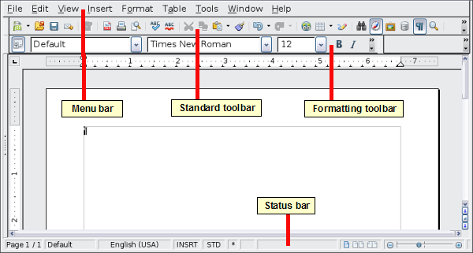
Figure 35: The main Writer workspace in Print Layout view

Status Bar
The Writer status bar provides information about the document and convenient ways to quickly change some document features.
Figure 36: Left end of status bar
Page number
Shows the current page number, the sequence number of the current page (if different), and the total number of pages in the document. For example, if you restarted page numbering at 1 on the third page, its page number is 1 and its sequence number is 3.
If any bookmarks have been defined in the document, a right-click on this field pops up a list of bookmarks; click on the required one.
To jump to a specific page in the document, double-click on this field. The Navigator opens. Click in the Page Number field and type the sequence number of the required page. After a brief delay, the display jumps to the selected page.
Page style
Shows the style of the current page. To change the page style, right-click on this field. A list of page styles pops up; choose a different style by clicking on it.
To edit the current page style, double-click on this field. The Page Style dialog opens.
Language
Shows the language for the selected text.
Click to open a menu where you can choose another language for the selected text or for the paragraph where the cursor is located. You can also select None (Do not check spelling) to exclude the text from a spelling check or select More… to open the Character dialog.
Insert mode
Click to toggle between Insert and Overwrite modes when typing.
Selection mode
Click to toggle between STD (Standard), EXT (Extend), ADD (Add) and BLK (Block) selection. EXT is an alternative to Shift+click when selecting text. See “Working with Text” on page 51 for more information about ADD and BLK.
Unsaved changes
An asterisk (*) appears here if changes to the document have not been saved.
Figure 37: Right end of status bar
Digital signature
If the document has been digitally signed, an icon shows here. You can double-click the icon to view the certificate.
Section or object information
When the cursor is on a section, heading, or list item, or when an object (such as a picture or table) is selected, information about that item appears in this field. Double-clicking in this area opens a relevant dialog. For details, consult the Help or the Writer Guide.
View layout
Click an icon to change between single page, side-by-side, and book layout views. The effect varies with the combination of window width and zoom factor in use. You can edit the document in any view.
Figure 38: View layouts: single, side-by-side, book.
Zoom
To change the view magnification, drag the Zoom slider, or click on the + and — signs, or right-click on the zoom level percent to pop up a list of magnification values from which to choose. Zoom interacts with the selected view layout to determine how many pages are visible in the document window.

Changing Document Views
Writer has several ways to view a document: Print Layout, Web Layout, and Full Screen. To access these and other choices, go to the View menu and click on the required view. (When in Full Screen view, press the Esc key to return to either Print or Web Layout view.)
When in Print Layout, you can use both the Zoom slider and the View Layout icons on the status bar. In Web Layout, you can use the Zoom slider.
You can also choose View > Zoom from the menu bar to display the Zoom & View Layout dialog, where you can set the same options as on the Status bar. In Web Layout view, most of the choices are not available.
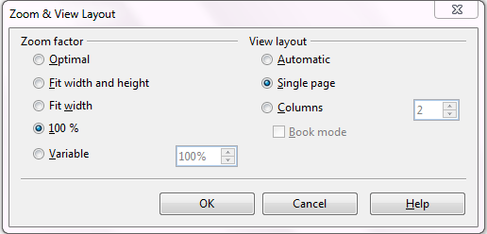
Figure 39: Choosing Zoom and View Layout options.

Moving Quickly through a Document
In addition to the navigation features of the Status bar (described above), you can use the Navigator deck in the Sidebar and the Navigation toolbar as described in Chapter 1 (Introducing Apache OpenOffice).
In Writer, you can also display the Navigation toolbar by clicking on the small Navigation icon near the lower right-hand corner of the window below the vertical scroll bar, as shown in Figure 40.

Figure 40: Navigation icons
The Navigation toolbar (Figure 41) shows icons for all the object types shown in the Navigator, plus some extras (for example, the results of a Find command).
Figure 41: Navigation toolbar
Click an icon to select that object type. Now all the Previous and Next icons (in the Navigator itself, in the Navigation Toolbar, and on the scroll bar) will jump to the next object of the selected type. This is particularly helpful for finding items like index entries, which can be difficult to see in the text. The names of the icons (shown in the tooltips) change to match the selected category; for example, Next Graphic, Next Bookmark, or Continue search forward.
For more uses of the Navigator in Writer, see the Writer Guide.

Working with Documents
Chapter 1 (Introducing Apache OpenOffice) includes instructions on starting new documents, opening existing documents, saving documents, and password-protecting documents. Chapter 2 (Using Styles and Templates) covers how to create a document from a template.

Saving as a Microsoft Word File
If you need to exchange files with users of Microsoft Word who are unwilling or unable to receive *.odt files, you can save a document as a Microsoft Word file.
- Important—First save your document in the file format used by Writer (.odt). If you do not, any changes you made since the last time you saved will appear only in the Microsoft Word version of the document.
- Then choose File > Save As. On the Save As dialog, in the File type (or Save as type) drop-down menu, select the type of Word format you need. Click Save.
Caution | Some formatting may be lost when you save in formats other than OpenDocument Formats. You may wish to test some typical files to see if yours save correctly in other formats.
Figure 42. Saving a file in Microsoft Word format
From this point on, all changes you make to the document will occur only in the Microsoft Word document. You have changed the name and file type of your document. If you want to go back to working with the .odt version of your document, you must open it again.
Tip | To have Apache OpenOffice save documents by default in the Microsoft Word file format, go to Tools > Options > Load/Save. See “Choosing options for loading and saving documents” in Chapter 11 (Setting Up and Customizing Apache OpenOffice).

Working with Text
Working with text (selecting, copying, pasting, moving) in Writer is similar to working with text in any other program. Apache OpenOffice also has some convenient ways to select items that are not next to each other, select a vertical block of text, and paste unformatted text.

Selecting Items That Are Not Consecutive
To select nonconsecutive items (as shown in Figure 43) using the mouse:
- Select the first piece of text.
- Hold down the Ctrl key and use the mouse to select the next piece of text.
- Repeat as often as needed.
Now you can work with the selected text (copy it, delete it, change the style, or whatever).
Note | Macintosh users: substitute the Command key when instructions in this chapter say to use the Ctrl key.

Figure 43: Selecting items that are not next to each other
To select nonconsecutive items using the keyboard:
- Select the first piece of text. (For more information about keyboard selection of text, see the topic “Navigating and selecting with the keyboard” in the Help.)
- Press Shift+F8. This puts Writer in “Add” mode. The word ADD appears on the status bar.
- Use the arrow keys to move to the start of the next piece of text to be selected. Hold down the Shift key and select the next piece of text.
- Repeat as often as needed.
Now you can work with the selected text. Press Esc to exit from this mode.

Selecting a Vertical Block of Text
You can select a vertical block or “column” of text that is separated by spaces or tabs (as you might see in text pasted from e-mails, program listings, or other sources), using Writer’s block selection mode. To change to block selection mode, use Edit > Selection Mode > Block Area, or click several times in the status bar on STD until it changes to BLK.
Now highlight the selection, using the mouse or keyboard, as shown below.

Figure 44: Selecting a vertical block of text

Cutting, Copying, and Pasting Text
Cutting and copying text in Writer is similar to cutting and copying text in other applications. You can use the mouse or the keyboard for these operations. You can copy or move text within a document, or between documents, by dragging or by using menu selections, icons, or keyboard shortcuts. Likewise, you can also copy text from other sources such as Web pages and paste it into a Writer document.
To move (cut and paste) selected text using the mouse, drag it to the new location and release it. To copy selected text, hold down the Ctrl key while dragging. The text retains the formatting it had before dragging.
When you paste text, the result depends on the source of the text and how you paste it. If you click on the Paste icon, any formatting the text has (such as bold or italics) is retained. Text pasted from Websites and other sources may also be placed into frames or tables. If you do not like the results, click the Undo icon or press Ctrl+Z.
To make the pasted text take on the formatting of the surrounding text where it is being pasted:
- Choose Edit > Paste Special, or
- Click the triangle to the right of the Paste icon, or
- Click the Paste icon without releasing the left mouse button.
Then select Unformatted text from the resulting menu.
The range of choices on the Paste Special menu varies depending on the origin and formatting of the text (or other object) to be pasted. See Figure 45 for an example with text on the clipboard.
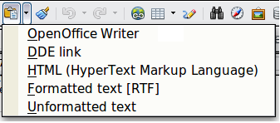Figure 45: Paste Special menu

Finding and Replacing Text and Formatting
Writer has two ways to find text within a document: the Find toolbar for fast searching and the Find & Replace dialog. In the dialog, you can:
- Find and replace words and phrases
- Use wildcards and regular expressions to fine-tune a search
- Find and replace specific formatting
- Find and replace paragraph styles


Using the Find Toolbar
If the Find toolbar is not visible, you can display it using View > Toolbars > Find.
To use the Find toolbar, click in the box and type your search text, then press Enter to find the next occurrence of that term. Click the Find Next or Find Previous buttons (up and down arrows) as needed.

Using the Find & Replace dialog
To display the Find & Replace dialog, use the keyboard shortcut Ctrl+F or choose Edit > Find & Replace from the menu bar. Optionally, click the More Options button to expand the dialog; the button changes to Fewer Options.

Figure 46: Expanded Find & Replace dialog
To use the Find & Replace dialog:
- Type the text you want to find in the Search for box.
- To replace the text with different text, type the new text in the Replace with box.
- You can select various options such as matching the case, matching whole words only, or doing a search for similar words.
- When you have set up your search, click Find. To replace text, click Replace instead.
Apache OpenOffice uses Regular Expression to perform wildcard searches. This is a powerful tool that can do complex text matching. See the Help for a brief introduction and there are many web resources that provide in depth tutorials.
For more information on using Find & Replace, see the Writer Guide.
Tip | If you click Find All, Writer selects all instances of the search text in the document. Similarly, if you click Replace All, Writer replaces all matches.
Caution | Use Replace All with caution; otherwise, you may end up with some hilarious (and highly embarrassing) mistakes. A mistake with Replace All might require a manual, word-by-word, search to fix.

Inserting Special Characters
A special character is one not found on a standard English keyboard. For example, © ¾ æ ç ñ ö ø ¢ are all special characters. To insert a special character:
- Place the cursor where you want the character to appear.
- Choose Insert > Special Character to open the Special Characters dialog.
- Select the characters (from any font or mixture of fonts) you wish to insert, in order, then click OK. The selected characters are shown in the lower left of the dialog. As you select a character, it is shown on the lower right, along with its numerical code.
Note | Different fonts include different special characters. If you do not find a particular special character, try changing the Font selection.

Figure 47: The Special Characters dialog, where you can insert special characters

Inserting Dashes and Non-breaking Spaces and Hyphens
To prevent two words from being separated at the end of a line, press Ctrl+Shift+space bar after the first word to insert a non-breaking space.
In cases where you do not want the hyphen to appear at the end of a line, for example in a number such as 123-4567, you can press Ctrl+Shift+minus sign to insert a non-breaking hyphen.
To enter en and em dashes, you can use the Replace dashes option on the Options tab under Tools > AutoCorrect Options. This option replaces two hyphens, under certain conditions, with the corresponding dash.
– is an en-dash; that is, a dash the width of the letter “n” in the font you are using. Type at least one character, a space, one or two hyphens, another space, and at least one more letter, then a space. The one or two hyphens will be replaced by an en-dash.
— is an em-dash; that is, a dash the width of the letter “m” in the font you are using. Type at least one character, two hyphens, and at least one more character, then a space. The two hyphens will be replaced by an em-dash.
The key difference is that an en-dash is written with spaces around it and an em-dash is not. See the Help for more details. For other methods of inserting dashes, see the Writer Guide.

Setting Tab Stops and Indents
The horizontal ruler shows both the default tab stops and any tab stops that you have defined. Tab settings affect indentation of full paragraphs (using the Increase Indent and Decrease Indent icons on the Formatting toolbar) as well as indentation of parts of a paragraph (by pressing the Tab key on the keyboard).
Using the default tab spacing can cause formatting problems if you share documents with other people. If you use the default tab spacing and then send the document to someone else who has chosen a different default tab spacing, tabbed material will change to use the other person’s settings. This may cause major formatting issues. Instead of using the defaults, define your own tab settings, as described in this section.
To define indents and tab settings for one or more selected paragraphs, double-click on a part of the ruler that is not between the left and right indent icons to open the Indents & Spacing page of the Paragraph dialog. Double-click anywhere between the left and right indent icons on the ruler to open the Tabs page of the Paragraph dialog.
A better strategy is to define tabs for the paragraph style. See Chapters 6 and 7 in the Writer Guide for more information.
Tip | Using tabs to space out material on a page is not recommended. Depending on what you are trying to accomplish, a table is usually a better choice.

Changing the Default Tab stop Interval
Note | Any changes to the default tab setting will affect the existing default tab stops in any document you open afterward, as well as tab stops you insert after making the change.
To set the measurement unit and the spacing of default tab stop intervals, go to Tools > Options > OpenOffice Writer > General.

Figure 48: Selecting a default tab stop interval
You can also set or change the measurement unit for rulers in the current document by right-clicking on the ruler to open a list of units. Click on one of them to change the ruler to that unit. The selected setting applies only to that ruler.
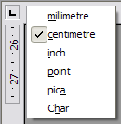
Figure 49: Changing the measurement unit for a ruler

Checking Spelling and Grammar
Writer provides a spelling checker, which can be used in two ways.
AutoSpellcheck checks each word as it is typed and displays a wavy red line under any misspelled words. When the word is corrected, the line disappears.
To perform a separate spelling check on the document (or a text selection) click the Spelling and Grammar button. This checks the document or selection and opens the Spelling and Grammar dialog if any misspelled words are found.
Here are some more features of the spelling checker:
- You can right-click on a word with a wavy underline to open a context menu. If you select from the suggested words on the menu, the selection will replace the misspelled word in your text. Other menu options are discussed below.
- You can change the dictionary language (for example, Spanish, French, or German) on the Spelling and Grammar dialog.
- You can add a word to the dictionary. Click Add in the Spelling and Grammar dialog and pick the dictionary to add it to.
- Click the Options button on the Spelling and Grammar dialog to open a dialog similar to the one in Tools > Options > Language Settings > Writing Aids described in Chapter 11. There you can choose whether to check uppercase words and words with numbers, and you can manage custom dictionaries, that is, add or delete dictionaries and add or delete words in a dictionary.
- On the Font tab of the Paragraph Styles dialog, you can set paragraphs to be checked in a specific language (different from the rest of the document). The font of a Character Style can also be set to its own language. See Chapter 7 (Working with Styles) in the Writer Guide for more information.
Writer does not include a grammar checker, but you can install an extension such as LanguageTool (from https://www.languagetool.org/) and access it from Tools > Spelling and Grammar. (See Chapter 11 for more about installing extensions.)
LanguageTool adds a new menu item and sub-menu to the Tools menu, from which you can configure the tool and check or recheck the document.

Using Built-in Language tools
Writer provides some tools that make your work easier if you mix multiple languages within the same document or if you write documents in various languages.
The main advantage of changing the language is that you can then use the correct dictionaries to check spelling and apply the localized versions of AutoCorrect replacement tables, thesaurus, and hyphenation rules.
You can also set the language for a paragraph or a group of characters as None. This option is especially useful when you insert text such as web addresses or programming language snippets that you do not want to check for spelling.
Specifying the language in character and paragraph styles is the preferred method, because styles allow a greater level of control and make changing the language much faster. On the Font tab of the Paragraph Styles dialog, you can specify that certain paragraphs be checked in a language that is different from the language of the rest of the document. See Chapter 7 (Working with Styles) in the Writer Guide for information on how to manage the language settings of a style.
You can set the language for the whole document, for individual paragraphs, or even for individual words and characters, all from Tools > Language on the menu bar.
Another way to change the language of a whole document is to use Tools > Options > Language Settings > Languages. In the Default languages for documents section of the Options dialog, you can choose a different language for all the text.
The spelling checker works only for those languages in the list that have the symbol next to them. If you do not see the symbol next to your preferred language, you can install the additional dictionary using Tools > Languages > More dictionaries online.
The language used for checking spelling is also shown in the status bar, next to the page style in use.

Using AutoCorrect
Writer’s AutoCorrect function has a long list of common misspellings and typing errors, which it corrects automatically. For example, “hte” will be changed to “the”.
Choose Tools > AutoCorrect Options to open the AutoCorrect dialog. There you can define on the Replace tab which strings of text are corrected and how. In most cases, the defaults are fine.
AutoCorrect is turned on when Writer is installed. To turn it off, uncheck Format > AutoCorrect > While Typing.
To stop Writer replacing a specific spelling, go to the Replace tab, highlight the word pair, and click Delete.
To add a new spelling to the list, type it into the Replace and With boxes on the Replace tab, and click New.
See the different tabs of the dialog for the wide variety of other options available to fine-tune AutoCorrect.
Tip | AutoCorrect can be used as a quick way to insert special characters. For example, (c) will be autocorrected to ©. You can add your own special characters.

Using Word Completion
If Word Completion is enabled, Writer tries to guess which word you are typing and offers to complete the word for you. To accept the suggestion, press Enter. Otherwise, continue typing.
To turn off Word Completion, select Tools > AutoCorrect Options > Word Completion and deselect Enable word completion.
You can customize word completion from the Word Completion page of the AutoCorrect dialog:
- Add (append) a space automatically after an accepted word
- Show the suggested word as a tip (hovering over the word) rather than completing the text as you type
- Change the maximum number of words remembered for word completion and the length of the smallest words to be remembered
- Delete specific entries from the word completion list
- Change the key that accepts a suggested entry—the options are Right arrow, End key, Return (Enter), and Space bar
Note | Automatic word completion only occurs after you type a word for the second time in a document.

Using AutoText
Use AutoText to store text, tables, graphics, and other items for reuse and assign them to a key combination for easy retrieval. For example, rather than typing “Senior Management” every time you use that phrase, you can set up an AutoText entry to insert those words when you type “sm” and press F3.

Creating AutoText
To store some text as AutoText:
- Type the text into your document.
- Select the text.
- Choose Edit > AutoText (or press Ctrl+F3).
- In the AutoText dialog, type a name for the AutoText in the Name box. Writer will suggest a one-letter shortcut, which you can change.
- In the large box to the left, choose the category for the AutoText entry, for example My AutoText.
- Click the AutoText button on the right and select New (text only) from the menu.
- Click Close to return to your document.
Tip | If the only option under the AutoText button is Import, either you have not entered a name for your AutoText or there is no text selected in the document.
AutoText is especially powerful when assigned to fields. See Chapter 14 (Working with Fields) in the Writer Guide for more information.

Inserting AutoText
To insert AutoText, type the shortcut and press F3.

Formatting Text

Using Styles Is Recommended
Styles are central to using Writer. Styles enable you to easily format your document consistently, and to change the format with minimal effort. A style is a named set of formatting options. Writer defines several types of styles, for different types of elements: characters, paragraphs, pages, frames, and lists. See Chapter 2 (Using Styles and Templates) in this book and Chapters 6 and 7 in the Writer Guide.

Formatting Paragraphs
You can apply many formats to paragraphs using the buttons on the Formatting toolbar. Figure 50 shows the Formatting toolbar as a floating toolbar, customized to show only the icons for paragraph formatting. The appearance of the icons may vary with your operating system and the selection of icon size and style in Tools > Options > OpenOffice > View.

1 | Open Styles and Formatting Window | 5 | Align Right | 10 | Numbering On/Off
 | Open Styles and Formatting Window | 6 | Justified | 11 | Bullets On/Off
2 | Apply Style | 7 | Line Spacing: 1 | 12 | Decrease Indent
3 | Align Left | 8 | Line Spacing: 1.5 | 13 | Increase Indent
4 | Centered | 9 | Line Spacing: 2 | 14 | Paragraph format dialog
Figure 50: Formatting toolbar, showing icons for paragraph formatting

Formatting Characters
You can apply many formats to characters using the buttons on the Formatting toolbar. Figure 51 shows the Formatting toolbar, customized to include only the icon for character formatting.
The appearance of the icons may vary with your operating system and the selection of icon size and style in Tools > Options > OpenOffice > View.
1 | Open Styles and Formatting Window | 6 | Italic | 12 | Font Color
 | Open Styles and Formatting Window | 7 | Underline | 13 | Highlighting
2 | Apply Style | 8 | Superscript | 14 | Background Color
3 | Font Name | 9 | Subscript | 15 | Open Character Format Dialog
4 | Font Size | 10 | Increase Font |  | Open Character Format Dialog
5 | Bold | 11 | Reduce Font
Figure 51: Formatting toolbar, showing icons for character formatting
Tip | To remove manual formatting, select the text and choose Format > Default Formatting, or right-click and choose Default Formatting.

Auto-formatting
You can set Writer to automatically format parts of a document according to the choices made on the Options page of the AutoCorrect dialog (Tools > AutoCorrect Options).
Tip | If you notice unexpected formatting changes occurring in your document, this is the first place to look for the cause.
Some common unwanted or unexpected formatting changes include:
- Horizontal lines. If you type three or more hyphens (---), underscores (___) or equal signs (===) on a line and then press Enter, the paragraph is replaced by a horizontal line as wide as the page. The line is actually the lower border of the preceding paragraph.
- Bulleted and numbered lists. A bulleted list is created when you type a hyphen (-), star (*), or plus sign (+), followed by a space or tab at the beginning of a paragraph. A numbered list is created when you type a number followed by a period (.), followed by a space or tab at the beginning of a paragraph. Automatic numbering is only applied to paragraphs formatted with the Default, Text body or Text body indent paragraph styles.
To turn auto-formatting on or off, choose Format > AutoCorrect and select or deselect the items on the list.

Creating Numbered or Bulleted Lists
There are several ways to create numbered or bulleted lists:
- Use auto-formatting, as described above.
- Use list (numbering) styles, as described in Chapters 6 (Introduction to Styles) and 7 (Working with Styles) in the Writer Guide.
- Use the Numbering and Bullets icons on the paragraph formatting toolbar (see Figure 52): select the paragraphs in the list, and then click the appropriate icon on the toolbar.
Note | It is a matter of personal preference whether you type your information first, then apply Numbering/Bullets, or apply them as you type.

Using the Bullets and Numbering Toolbar
You can create nested lists (where one or more list items has a sub-list under it, as in an outline, by using the buttons on the Bullets and Numbering toolbar (Figure 52). You can move items up or down the list, or create sub-points, and even change the style of bullets. Use View > Toolbars > Bullets and Numbering to see the toolbar.
The appearance of the icons may vary with your operating system and the selection of icon size and style in Tools > Options > OpenOffice > View.

1 | Bullets On/Off | 6 | Promote One Level with Sub-points | 10 | Move Down
2 | Numbering On/Off | 6 | Promote One Level with Sub-points | 11 | Move Up with Subpoints
3 | Numbering Off | 7 | Demote One Level with Sub-points | 12 | Move Down with Subpoints
4 | Promote One Level | 8 | Insert Unnumbered Entry | 13 | Restart Numbering
5 | Demote One Level | 9 | Move Up | 14 | Bullets and Numbering
Figure 52: Bullets and Numbering toolbar
Note | If numbering or bullets are being applied automatically in a way that you find inappropriate, you can switch them off temporarily by unchecking Format > AutoCorrect > While Typing.

Hyphenating Words
You have several choices regarding hyphenation: let Writer do it automatically (using its hyphenation dictionaries), insert conditional hyphens manually where necessary, or don’t hyphenate at all.
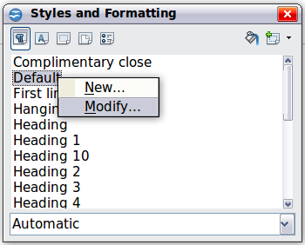Figure 53: Modifying a style

Automatic Hyphenation
To turn automatic hyphenation of words on or off:
- Press F11 (z+T on Mac) to open the Styles and Formatting window or go to the Styles deck of the Sidebar.
- On the Paragraph Styles page (Figure 53), right-click on Default and select Modify.
- On the Paragraph Style dialog (Figure 54), go to the Text Flow page.
- Under Hyphenation, select or deselect the Automatically option. Click OK to save.
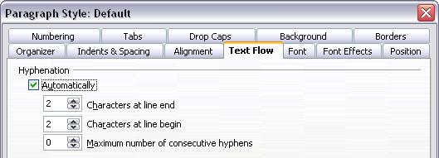
Figure 54: Turning on automatic hyphenation
Note | Turning on hyphenation for the Default paragraph style affects all other paragraph styles that are based on Default. You can individually change other styles so that hyphenation is not active; for example, you might not want headings to be hyphenated. Any styles that are not based on Default are not impacted. See Chapter 2 (Styles and Templates) for more about styles based on other styles)
You can also set hyphenation choices through Tools > Options > Language Settings > Writing Aids. In Options, near the bottom of the dialog, scroll down to find the hyphenation settings.

Figure 55: Setting hyphenation options
To change the minimum number of characters for hyphenation, the minimum number of characters before a line break, or the minimum number of characters after a line break, select the item, and then click the Edit button in the Options section.
Hyphenation options set on the Writing Aids dialog are effective only if hyphenation is turned on through paragraph styles.

Manual Hyphenation
To manually hyphenate words, do not use a normal hyphen, which will remain visible even if the word is no longer at the end of a line when you add or delete text or change margins or font size. Instead, use a conditional hyphen, which is visible only when required.
To insert a conditional hyphen inside a word, click where you want the hyphen to appear and press Ctrl+hyphen. The word will be hyphenated at this position when it is at the end of the line, even if automatic hyphenation for this paragraph is switched off.

Formatting Pages
Writer provides several ways for you to control page layouts: page styles, columns, frames, tables, and sections. For more information, see Chapter 4 (Formatting Pages) in the Writer Guide.
Tip | Page layout is usually easier if you show text, object, table, and section boundaries in Tools > Options > OpenOffice > Appearance, and paragraph ends, tabs, breaks, and other items in Tools > Options > OpenOffice Writer > Formatting Aids. These last items will appear when View > Nonprinting Characters is selected.

Which Layout Method to Choose?
The best layout method varies depending on what the final document should look like and what sort of information will be in the document. Here are some examples.
For a book similar to this user guide, with one column of text, some figures without text beside them, and some other figures with descriptive text, use page styles for basic layout, and tables to place figures beside descriptive text when necessary. | 
For an index or other document with two columns of text, where the text continues from the left-hand column to the right-hand column and then to the next page, all in sequence (also known as “snaking columns” of text), use page styles (with two columns). If the title of the document (on the first page) is full-page width, put it in a single-column section. | 
For a newsletter with complex layout, two or three columns on the page, and some articles that continue from one page to some place several pages later, use page styles for basic layout. Place articles in linked frames and anchor graphics to fixed positions on the page if necessary. | 
For a document with terms and translations to appear side-by-side in what appear to be columns, use a table to keep items lined up, and so you can type in both “columns”. | 

Creating Headers and Footers
A header is an area that appears at the top of a page. A footer appears at the bottom of the page. Information such as page numbers inserted into a header or footer displays on every page of the document with that page style.
To insert a header, choose Insert > Header > Default (or the page style, if not Default).
Other information, such as document titles and chapter titles, is often put into the header or footer. These items are best added as fields. That way, if something changes, the headers, and footers are updated automatically. Here is one common example.
To insert the document title into the header:
- Choose File > Properties > Description and type a title for your document.
- Add a header (Insert > Header > Default).
- Place the cursor in the header part of the page.
- Choose Insert > Fields > Title. The title should appear on a gray background (which does not show when printed and can be turned off).
- To change the title for the whole document, go back to File > Properties and select the Description Tab.
Fields are covered in detail in Chapter 14 (Working with Fields) in the Writer Guide.
For more about headers and footers, see Chapter 4 (Formatting Pages) and Chapter 6 (Introduction to Styles) in the Writer Guide.

Numbering Pages
To automatically number pages:
- Insert a header or footer, as described in “Creating Headers and Footers” on page 65.
- Place the cursor in the header or footer where you want the page number to appear and choose Insert > Fields > Page Number.

Including the Total Number of Pages
To include the total number of pages (as in “page 1 of 12”):
- Type the word “page” and a space, then insert the page number as above.
- Press the space bar once, type the word “of” and a space, then choose Insert > Fields > Page Count.
Note | The Page Count field inserts the total number of pages in the document, as shown on the Statistics tab of the document’s Properties window (File > Properties). If you restart page numbering anywhere in the document, then the total page count may not be what you want. See Chapter 4 (Formatting Pages) in the Writer Guide for more information.

Restarting Page Numbering
Often you will want to restart the page numbering at 1, for example on the page following a title page or a table of contents. In addition, many documents have the “front matter” (such as the table of contents) numbered with Roman numerals and the main body of the document numbered in Arabic numerals, starting with 1.
You can restart page numbering in two ways.
Method 1:
- Place the cursor in the first paragraph of the new page.
- Choose Format > Paragraph.
- On the Text Flow tab of the Paragraph dialog, select Breaks.
- Select Insert and then With Page Style and specify the page style to use.
- Specify the page number to start from, and then click OK.
Tip | Method 1 is also useful for numbering the first page of a document with a page number greater than 1. For example, you may be writing a book, with each chapter in a separate file. Chapter 1 may start with page 1, but Chapter 2 could begin with page 25 and Chapter 3 with page 51.
Method 2:
- Insert > Manual Break.
- By default, Page break is selected on the Insert Break dialog (Figure 56).
- Choose the required page Style.
- Select Change page number.
- Specify the page number to start from, and then click OK.
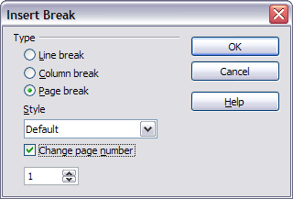
Figure 56: Restarting page numbering after a manual page break

Changing Page Margins
You can change page margins in two ways:
- Using the page rulers—quick and easy, but does not have fine control
- Using the Page Style dialog—can specify margins to two decimal places
Note | If you change the margins using the rulers, the new margins affect the page style and will be shown in the Page Style dialog the next time you open it.  Because the page style is affected, the changed margins apply to all pages using that style.
To change margins using the rulers:
- The gray sections of the rulers are the margins. Put the mouse cursor over the line between the gray and white sections. The pointer turns into a double-headed arrow.
- Hold down the left mouse button and drag the mouse to move the margin.

Figure 57: Moving the margins
Tip | The small arrows on the ruler are used for indenting paragraphs. They are often in the same place as the page margins, so you need to be careful to move the margin marker, not the arrows. Place the mouse pointer between the arrows and, when the pointer turns into a double-headed arrow, you can move the margin (the indent arrows will move with it).
To change margins using the Page Style dialog:
- Right-click anywhere on the page and select Page from the pop-up menu.
- On the Page tab of the dialog, type the required distances in the Margins boxes.

Adding Comments to a Document
Authors and reviewers often use comments (formerly called “notes”) to exchange ideas, ask for suggestions, or mark items needing attention.
To insert a comment in the text, place the cursor in the place the comment refers to and choose Insert > Comment or press Ctrl+Alt+C. The anchor point of the comment is connected by a dotted line to a box on the right-hand side of the page where you can type the text of the comment. Writer automatically adds at the bottom of the comment the author’s name and a time stamp indicating when the comment was created. Figure 58 shows an example of text with comments from two different authors.
Figure 58: Example of comments
Choose Tools > Options > User Data to configure the name you want to appear in the Author field of the comment, or to change it.
If more than one person edits the document, each author is automatically allocated a different background color.
Right-clicking on a comment pops up a menu where you can delete the current comment, all the comments from the same author, or all the comments in the document. From this menu, you can also apply some basic formatting to the text of the comment. You can also change the font type, size, and alignment from the main menu.
To navigate from one comment to another, open the Navigator (F5) or go to the Navigator deck of the Sidebar, expand the Comments section, and click on the comment text to move the cursor to the anchor point of the comment in the document. Right-click on the comment to quickly edit or delete it.
You can also navigate through the comments using the keyboard. Use Ctrl+Alt+Page Down to move to the next comment and Ctrl+Alt+Page Up to move to the previous comment.

Creating a Table of Contents
Writer’s table of contents feature lets you build an automated table of contents from the headings in your document. Before you start, make sure that the headings are styled consistently. For example, you can use the Heading 1 style for chapter titles and the Heading 2 and Heading 3 styles for chapter subheadings.
Although tables of contents can be customized extensively in Writer, often the default settings are all you need. Creating a quick table of contents is simple:
- When you create your document, use the following paragraph styles for different heading levels (such as chapter and section headings): Heading 1, Heading 2, Heading 3, and so on. These are what will appear in your table of contents.
- Place the cursor where you want the table of contents to be inserted.
- Choose Insert > Indexes and Tables > Indexes and Tables.
- Change nothing in the Insert Index/Table dialog. Click OK.
If you add or delete text (so that headings move to different pages) or you add, delete, or change headings, you need to update the table of contents.
To do this:
- Place the cursor within the table of contents.
- Right-click and choose Update Index/Table from the pop-up menu.
Note | If you cannot place your cursor in the table of contents, choose Tools > Options > OpenOffice Writer > Formatting Aids, and then select Enable in the Cursor in protected areas section.
You can customize an existing table of contents at any time. Right-click anywhere in it and choose Edit Index/Table from the pop-up menu. Chapter 12 (Creating Tables of Contents, Indexes, and Bibliographies) of the Writer Guide describes in detail all the customizations you can select.

Creating Indexes and Bibliographies
Indexes and bibliographies work similarly to tables of contents. Chapter 12 (Creating Tables of Contents, Indexes, and Bibliographies) in the Writer Guide describes the process in detail.
In addition to alphabetical indexes, other types of indexes supplied with Writer include those for illustrations, tables, and objects, and you can even create a user-defined index. For example, you might want an index containing only the scientific names of species mentioned in the text, and a separate index containing only the common names of species. Before creating some types of indexes, you first need to create index entries embedded in your Writer document.

Adding Images and Other Graphics
Graphics in Writer are of three basic types:
- Image files, including photos, drawings, scanned images, and others
- Diagrams created using Apache OpenOffice’s drawing tools
- Charts created using Apache OpenOffice’s Chart facility
See Chapter 10 (Graphics, the Gallery, and Fontwork) in this book and Chapter 8 (Working with Graphics) in the Writer Guide.

Adding Tables, Spreadsheets, and Charts
Tables are a useful way to organize and present large amounts of information. They can often be used as an alternative to spreadsheets. Tables can also be used as a page layout tool to position text in areas of a document, as described in Chapter 4 (Formatting Pages) of the Writer Guide.
To insert a new table, position the cursor where you want the table to appear, then use any of the following methods to open the Insert Table dialog, where you can specify the properties for the new table:
- From the main menu, choose Insert > Table.
- From the main menu, choose Table > Insert > Table.
- Press Ctrl+F12 on the keyboard.
- From the Standard toolbar, click the Table icon
You can also click the small arrow to the right of the Table icon and select the number of cells to directly insert a table with the default table properties.
You can create a table from text, or convert a table to text, using Table > Convert from the menu bar.
You can edit the contents of these tables in the same way as you edit any other text.
A possible source of confusion is the Number Recognition feature of a table. If it is turned on, numbers and dates will be automatically formatted. If this is not desired, select the table cells you want to affect, then right click and deselect Number Recognition.
Chapter 9 (Working with Tables) in the Writer Guide describes how to format tables, add or delete columns and rows, merge and split tables and cells, add and sort data, and perform basic spreadsheet functions in a table of data.

Creating a Table from a Calc Spreadsheet
You can insert a table from a Calc spreadsheet into a Writer document:
- Open the Calc spreadsheet containing the cell range that you want to insert.
- In the spreadsheet, select the cells.
- Choose Edit > Copy or press Ctrl+C.
- In the Writer document, choose Edit > Paste or press Ctrl+V. The cell range is pasted as an object.
Alternatively, you can open both the Calc and Writer documents and drag and drop the cells from Calc to Writer:
- In the spreadsheet, select the cells.
- Click and hold the mouse button in the selected cells.
- Drag the selected cells into the text document.
To edit a table created from a Calc spreadsheet, double-click on it. The table opens in Calc.

Creating a Chart
You can create a chart in three ways:
- Insert a chart based on data from cells in Calc or Writer.
These charts update automatically when the source data changes.
- Insert a chart with a default data set, and then use the Data Table dialog to enter your own data for that chart.
These charts can be created in Writer, Impress, and Draw.
- Copy a chart from Calc or Writer into another document.
These charts are snapshots of the data at the time of copying. They do not change when the source data changes.
To create a chart based on the values in a Writer table:
- Click inside the Writer table.
- Choose Insert > Object > Chart. A chart preview and the Chart Wizard are displayed.
- Follow the instructions in the Chart Wizard to create the chart.
To create a chart based on values of its own:
- If you have not selected any cells, choose Insert > Object > Chart to insert a chart with default data.
- You can change the default data values by double-clicking on the chart and then choosing View > Chart Data Table.
For more about working with charts, see the Calc Guide.

Adding a Movie or Sound
To insert a movie or sound file into your document:
- Click where you want to insert the file.
- Choose Insert > Movie and Sound.
- In the File Open dialog, select the file that you want to insert.
The file types listed in this dialog are not supported by all operating systems.
- Click Open.
Alternatively, you can choose Tools > Media Player to open the Media Player. Use the Media Player to preview all supported media files. Click the Apply button in the Media Player window to insert the current media file into your document.
To play a movie or sound file:
- Click the object icon for the movie or sound file in your document.
If the icon is arranged on the background, hold down Ctrl while you click.
- The Media Playback toolbar is shown. Click Play.
You can also use the Media Playback toolbar to pause, stop, or loop, as well as to adjust the volume or mute the playback of the file. For movie files, the toolbar also provides a slider for selecting the zoom factor for the playback.

Printing
See Chapter 9 (Printing, Exporting, and E-mailing) in this book and Chapter 5 (Printing, Exporting, Faxing, and E-mailing) in the Writer Guide for details on previewing pages before printing, selecting print options, printing in black and white on a color printer, printing brochures, and other printing features.

Using Mail Merge
Writer provides very useful features to create and print:
- Multiple copies of a document to send to a list of different recipients (form letters)
- Mailing labels
- Envelopes
All these facilities use a registered data source (a spreadsheet or database containing the name and address records and other information).
Chapter 11 (Using Mail Merge) in the Writer Guide describes the process.

Tracking Changes to a Document
You can use several methods to keep track of changes made to a document.
- Make your changes to a copy of the document (stored in a different folder, or under a different name, or both), then use Writer to combine the two files and show the differences. Choose Edit > Compare Document. This technique is particularly useful if you are the only person working on the document, as it avoids the increase in file size and complexity caused by the other methods.
- Save versions that are stored as part of the original file. However, this method can cause problems with documents of non-trivial size or complexity, especially if you save a lot of versions. Avoid this method if you can.

- Use Writer’s change marks (often called “red lines” or “revision marks”) to show where you have added or deleted material, or changed formatting. Choose Edit > Changes > Record. Later, you or another person can review and accept or reject each change. Right-click on an individual change and decide Accept Change or Reject Change from the pop-up menu, or choose Edit > Changes > Accept or Reject to view the list of changes and accept or reject them. Details are in the Writer Guide.
Tip | Not all changes are recorded. For example, changing a tab stop from align left to align right, and changes in formulas (equations) or linked graphics are not recorded.

Using Fields
Fields are extremely useful features of Writer. They are used for data that changes in a document (such as the current date or the total number of pages) and for inserting document properties such as name, author, and date of last update. Fields are the basis of cross-referencing (see below); automatic numbering of figures, tables, headings, and other elements; and a wide range of other functions—far too many to describe here. See Chapter 14 (Working with Fields) in the Writer Guide for details.

Linking to Another Part of a Document
If you type in cross-references to other parts of a document, those references can easily get out of date if you reorganize the order of topics, add or remove material, or reword a heading. Writer provides two ways to ensure that your references are up-to-date, by inserting links to other parts of the same document or to a different document:
- Hyperlinks
- Cross-references
The two methods have the same result if you Control+click the link when the document is open in Writer: you are taken directly to the cross-referenced item. However, they also have major differences:
- The text in a hyperlink does not automatically update if you change the text of the linked item (although you can change it manually), but changed text does automatically update in a cross-reference.
- When using a hyperlink, you do not have a choice of the content of the link (for example text or page number), but when using a cross-reference, you have several choices, including bookmarks.
- To hyperlink to an object such as a graphic, and have the hyperlink show useful text such as Figure 6, you need to either give such an object a useful name instead of leaving it as the default name (Graphics6), or you need to use the Hyperlink dialog to modify the visible text. In contrast, cross-references to figures with captions automatically show useful text, and you have a choice of several variations of the name.
- If you save a Writer document to HTML, hyperlinks remain active, but cross-references do not. (Both remain active when the document is exported to PDF.)

Using Hyperlinks
The easiest way to insert a hyperlink to another part of the same document is by using the Navigator:
- Open the document containing the items you want to cross-reference.
- Open the Navigator by clicking its icon, going to the Navigator deck in the Sidebar, choosing View > Navigator, or pressing F5.
- Click the arrow next to the Drag Mode icon, and choose Insert as Hyperlink.
- In the list at the bottom of the Navigator, select the document containing the item that you want to cross-reference.
- In the Navigator list, select the item that you want to insert as a hyperlink.
- Drag the item to where you want to insert the hyperlink in the document. The name of the item is inserted in the document as an active hyperlink.
You can also use the Hyperlink dialog to insert and modify hyperlinks within and between documents.
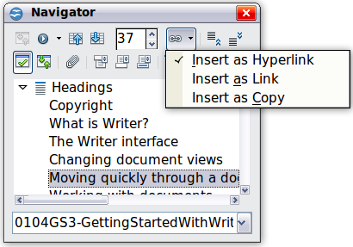
Figure 59: Inserting a hyperlink using the Navigator

Using Cross-References
If you type in references to other parts of the document, those references can easily get out of date if you reword a heading, add or remove figures, or reorganize topics. Replace any typed cross-references with automatic ones and, when you update fields, all the references will update automatically to show the current wording or page numbers. The Cross-references tab of the Fields dialog lists some items, such as headings, bookmarks, figures, tables, and numbered items such as steps in a procedure. You can also create your own reference items; see “Setting References” in Chapter 14 (Working with Fields) in the Writer Guide for instructions.
To insert a cross-reference to a heading, figure, bookmark, or other item:
- In your document, place the cursor where you want the cross-reference to appear.
- If the Fields dialog is not open, click Insert > Cross-reference. On the Cross-references tab, in the Type list, select the type of item to be referenced (for example, Heading or Figure). You can leave this page open while you insert many cross-references.
- Click on the required item in the Selection list, which shows all the items of the selected type. In the Format list, choose the format required. Usually this will be Reference (to insert the full text of the heading or caption), Category and Number (to insert the word “Figure” or “Table” and its number, but without the caption text), Numbering (to insert only the figure or table number, without the word “Figure” or “Table”), or Page (to insert the number of the page the referenced text is on). Click Insert.

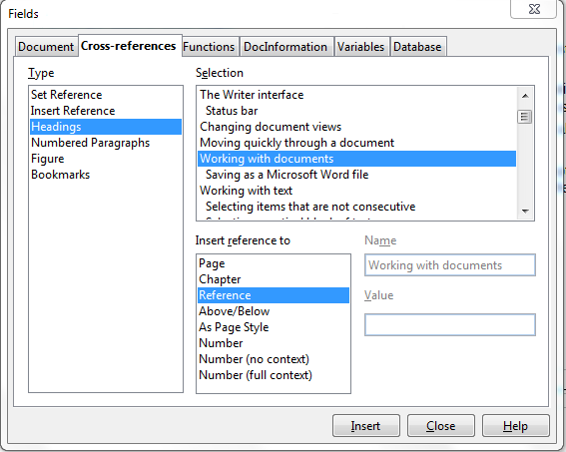Figure 60: The Cross-references tab of the Fields dialog

Using Bookmarks
Bookmarks are listed in the Navigator and can be accessed directly from there with a single mouse click. You can cross-reference to bookmarks and create hyperlinks to bookmarks, as described above.
- Select the text you want to bookmark. Click Insert > Bookmark.
- On the Insert Bookmark dialog, the larger box lists any previously defined bookmarks. Type a name for this bookmark in the top box, and then click OK.
Figure 61: Inserting a bookmark

Using Master Documents
Master documents are typically used for producing long documents such as a book, a thesis, or a long report; or when different people are writing different chapters or other parts of the full document, so you don’t need to share files. A master document joins separate text documents into one larger document, and unifies the formatting, table of contents (TOC), bibliography, index, and other tables or lists.
Yes, master documents do work in Writer. However, until you become familiar with them, you may think that master documents are unreliable or difficult to use. See Chapter 13 (Working with Master Documents) in the Writer Guide.

Creating Fill-in Forms
A standard text document displays information: a letter, report, or brochure, for example. Typically, the reader may edit everything or nothing in any way. A form has sections that are not to be edited, and other sections that are designed for the reader to make changes. For example, a questionnaire has an introduction and questions (which do not change) and spaces for the reader to enter answers.
Forms are used in three ways:
- To create a simple document for the recipient to complete, such as a questionnaire sent out to a group of people who fill it in and return it.
- To link into a database or data source and allow the user to enter information. Someone taking orders might enter the information for each order into a database using a form.
- To view information held in a database or data source. A librarian might call up information about books.
Writer offers several ways to fill information into a form, including check boxes, option buttons, text boxes, pull-down lists and spinners. See Chapter 15 (Using Forms in Writer) in the Writer Guide.

