Apache OpenOffice
Version 4.1
Calc Guide
AOO Documentation Team

Chapter 4
Using Styles and Templates in Calc
Bringing uniformity to your spreadsheets

Copyright
This document is Copyright © 2025 by The Apache Software Foundation. You may distribute it and/or modify it under the terms of the Creative Commons Attribution License, version 3.0 or later (https://creativecommons.org/licenses/by/3.0/).
Apache, Apache OpenOffice, and OpenOffice.org are trademarks of the Apache Software Foundation. Used with permission.
Acknowledgments
This document is updated from a previous version by the OOoAuthors team. The AOO Documentation Team appreciates the many contributions of Michael Scarborough and Michele Petrovsky.
Publication date and software version
Published August 25, 2025. Based on Apache OpenOffice 4.1.
Note for Mac Users
Some keystrokes and menu items differ on a Mac from those used in Windows and Linux. The table below gives some common substitutions for the instructions in this chapter. For a more detailed list, see the application Help.
Windows/Linux | Mac equivalent | Effect
Tools > Options menu selection | OpenOffice > Preferences | Access setup options
Right-click | Control+click | Open context menu
Ctrl (Control) | z (Command) | Used with other keys
F5 | Shift+z+F5 | Open the Navigator
F11 | z+T | Open Styles & Formatting window

Contents
Chapter 4
Using Styles and Templates in Calc 1
What is a Template? 4
What are Styles? 4
Types of Styles in Calc 4
Cell Styles 5
Page Styles 5
Accessing Styles 5
Applying Cell Styles 6
Using the Styles and Formatting Window 6
Using Fill Format Mode 6
Using the Apply Style List 7
Assigning Styles to Shortcut Keys 7
Applying Page Styles 8
Modifying Styles 8
Style Organizer 8
Cell Style Options 9
Page Style Options 10
Creating New (Custom) Styles 12
Creating a New Style Using the Style Dialog 12
Creating a New Style from a Selection 13
Creating a New Style by Dragging and Dropping 13
Copying and Moving Styles 13
Deleting Styles 15
Creating a Spreadsheet from a Template 15
Creating a Template 16
Editing a Template 17
Updating a Spreadsheet from a Changed Template 18
Adding Templates Using the Extension Manager 19
Setting a Default Template 19
Setting a Custom Template as the Default 20
Resetting the Default Template 20
Associating a Spreadsheet with a Different Template 20
Organizing Templates 21
Creating a Template Folder 21
Deleting a Template Folder 21
Moving a Template 21
Deleting a Template 21
Importing a Template 22
Exporting a Template 22

What is a Template?
A template is a model used to create other documents. For example, you can build an invoice template that places your company’s logo and address at the top of the page. Therefore, new spreadsheets created from this template will all have your company’s logo and address on their first page.
Templates can contain anything that regular documents can contain:
- text
- graphics
- styles
- user-specific setup information such as measurement units, language, the default printer, and toolbar and menu customization
All documents in Apache OpenOffice (AOO) are based on templates. You can create or download and install as many templates as you wish. If you do not specify a template when you start a new spreadsheet, the new spreadsheet is based on the default template for spreadsheets. If you have not specified a default template, AOO uses the blank spreadsheet template installed with AOO. See “Setting a Default Template” on page 19.

What are Styles?
A style is a set of formats you can apply to selected elements in a document, to control or quickly change their appearance. When you apply a style, you apply a whole group of formats simultaneously.
Many people manually format spreadsheet cells and pages without paying attention to styles. They are used to formatting documents according to physical attributes. For example, for the contents of a cell, you might specify the font family, font size, and any formatting, such as bold or italic.
Styles are logical attributes. Using styles means that you stop saying “font size 14pt, Times New Roman, bold, centered” and you start saying “Title” because you have defined the “Title” style to have those characteristics. In other words, 'styles' means shift the emphasis from what the page or other elements look like to what it is.
Styles help improve consistency in a document and can greatly speed up formatting. They also make major formatting changes easy. For example, you may decide to change the appearance of all subtotals in your spreadsheet to 10 pt. Arial instead of 8 pt. Times New Roman after you have created a 15-page spreadsheet, you can change all of the subtotals in the document by simply changing the properties for the subtotal style.
Page styles assist with printing, so you don’t need to define margins, headers and footers, and other printing attributes each time you print a spreadsheet.

Types of Styles in Calc
While some components of AOO offer many style types, Calc offers only two:
- Cell styles include fonts, alignment, borders, background, number formats (currency, date, number), and cell protection.
- Page styles include margins, headers and footers, borders and backgrounds, the sequence for printing sheets.
Tip | The page size, orientation, and other attributes of a page style apply only when a spreadsheet is printed; they are not displayed onscreen.

Cell Styles
Like paragraph styles in AOO Writer, cell styles are the most basic type of style in Calc. When you apply a cell style to a cell, that cell will follow the formatting rules of the style. Five cell styles are supplied with AOO: Default, Heading, Heading1, Result, and Result2.
Initially, the styles are configured so that if you change the font family of Default, all of the other styles will change to match. We will discuss how to set this up in “Creating New (Custom) Styles” on page 12. The five standard styles can be seen in Figure 1.
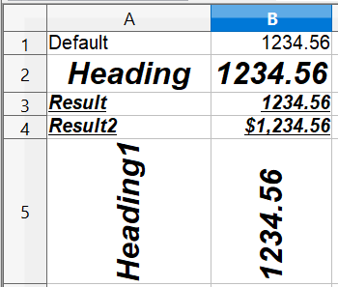

Figure 1: Calc cell style types

Page Styles
Page styles in Calc are applied to sheets. Although one sheet may print on several printer pages, only one page style can be applied to a sheet. If a spreadsheet file contains more than one sheet, the different sheets can have different page styles applied to them. So, for example, a spreadsheet might contain one sheet to be printed in landscape orientation (using the Default page style) and another sheet to be printed in portrait orientation (using the Report page style).
Two page styles are supplied with Calc: Default and Report. You can adjust many settings using page styles. You can also define as many page styles as you wish.
Because spreadsheets are primarily used onscreen and not printed, Calc does not display the page style on the screen. If you want a spreadsheet to fit a particular page size, you can set this up on the Sheet tab of the Page Style dialog or using View > Page Break Preview and adjusting the column and row sizes.

Accessing Styles
Styles are most frequently accessed through the Styles and Formatting deck of the Sidebar or the Styles and Formatting dialog. The tools for using styles are identical in the Sidebar and the dialog, shown in Figure 2. To avoid repeating "the Sidebar deck or the dialog," we will refer to both as the Styles and Formatting window; use whichever you prefer.
You can open the dialog in several ways.
- Keyboard: Press the F11 key.
- Menu: Choose Format > Styles and Formatting.
- Toolbar: Click the icon on the far left of the Formatting toolbar.
If the Sidebar is not visible, it can be opened with View > Sidebar. Once the Sidebar is visible, you can select the Styles and Formatting deck by clicking the Styles and Formatting icon 
The first button on the top left of the window, , is for cell styles, and the second, , is for page styles.
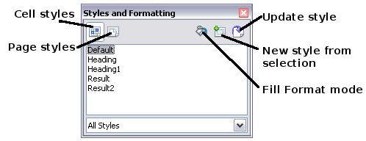
Figure 2: Styles and Formatting window

Applying Cell Styles
Calc provides several ways to apply cell styles:
- Using the Styles and Formatting window
- Using Fill Format mode
- Using the Apply Style list
- Assigning styles to shortcut keys

Using the Styles and Formatting Window
- Access the Styles and Formatting window using one of the methods above. Choose the Cell Styles list by clicking the  icon.
- Highlight the cell or group of cells to which the styles should be applied.
- Double-click on the cell style name.

Using Fill Format Mode
This method is quite useful for applying the same style to many scattered cells.
- Open the Styles and Formatting window and select the style you want to apply.
- Click the Fill Format mode icon . The mouse pointer changes to this icon.
- Position the icon on the cell to be styled and click the mouse button.
- To quit Fill Format mode, click the Fill Format mode icon again or close the Styles and Formatting window.
Caution   | When this mode is active, a right-click anywhere in the document undoes the last Fill Format action. Be careful not to accidentally right-click and thus undo actions you want to keep.

Using the Apply Style List
You can also add an Apply Style drop-down list to the Formatting toolbar and select a style from the list to apply to the selected cells:
- Click the down arrow at the right-hand end of the Formatting toolbar. On the drop-down menu, click Visible Buttons.
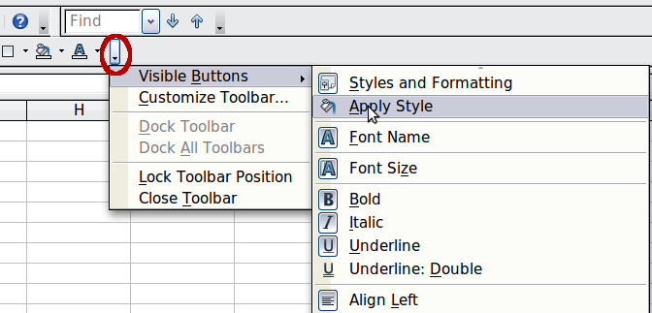
Figure 3: Adding an Apply Style list to the Formatting toolbar
- On the submenu, click Apply Style. The menus close, and the Apply Style list now appears on the toolbar between the Styles and Formatting icon and the Font Name list.
- Select the cells to which you want to apply a style. Then select the style name from the Apply Style list.

Assigning Styles to Shortcut Keys
You can create keyboard shortcuts that can apply commonly used cell or page styles, including custom styles you have created. See Chapter 14 (Setting up and Customizing Calc) for instructions.

Applying Page Styles
- Select the sheet to be styled (click on its sheet tab at the bottom of the screen).
- In the Styles and Formatting window, choose the Page Styles list by clicking the icon. Double-click on the required page style.
To find out which page style is in use for a selected sheet, look in the status bar.
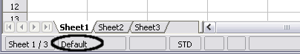
Figure 4: Status bar showing location of page style information below the sheet tabs.

Modifying Styles
To modify a style, right-click on its name in the Styles and Formatting window and choose Modify. Make the changes in the Style dialog and click OK to save the changes.
You can also modify a current cell style by selecting an already-formatted cell and clicking the Update Style button on the top right-hand corner of the Styles and Formatting window.

Style Organizer
Right-click on the name of a style in the Styles and Formatting window. Then click Modify to open a Style dialog like the one shown in Figure 5.
The Style dialog has several tabs. The Organizer tab, shown in Figure 5 for cell styles, is found in all components of AOO. It provides basic information about the style. The Organizer tab for page styles is similar to the one shown for cell styles.
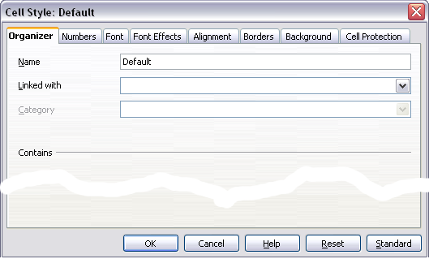
Figure 5: Organizer tab of Cell Style dialog
Name
This is the style’s name. You cannot change the name of a built-in style, but you can change the name of a custom style.
Linked with
This option is only available for cell styles; page styles cannot be linked. If you link cell styles, then when you change the base style (for example, by changing the font from Times to Helvetica), all the linked styles will also change. Sometimes, this is exactly what you want; other times, you do not want the changes to apply to all the linked styles. It pays to plan ahead.
For example, you can make a new style called red, in which the only change you want to make is for the cell text to be red. To ensure that the rest of the text characteristics are the same as the default style, you can link red with default. Then, any changes you make to default will be automatically applied to red.
Category
In Calc, the only option in this drop-down box is Custom styles.

Cell Style Options
When editing or creating cell styles, you can set several options similar to those used for directly formatting cells. A more detailed coverage of cell formatting is given in Chapter 2 (Entering, Editing, and Formatting Data). A brief summary is provided here.

Numbers
On the Numbers tab, you can control the behavior of the data in a cell with this style. This includes specifying the type of data, the number of decimal places, and the language.

Font
Use the Font tab to choose the font for the cell’s contents.

Font Effects
The Font Effects tab offers more font options, including underlining, strikethrough, and color.

Alignment
Use the Alignment tab to set the horizontal and vertical alignment for the data in the cells and rotate the text.

Borders
Use the Borders tab to set the borders for the cells, along with a shadow.

Background
Use the Background tab to choose the background color for a cell.

Cell Protection
Use the Cell Protection options to protect cells against certain types of editing. The cell protection is only in effect when the sheet is also protected with Tools > Protect Document > Sheet.

Page Style Options
Several of the page style options are described in more detail in Chapter 6 (Printing, Exporting, and E-mailing) because manually formatting a sheet at print time (using Format > Page) actually modifies the page style.

Page
Use the Page tab to edit the overall appearance of the page and its layout. The available options are shown in Figure 6.
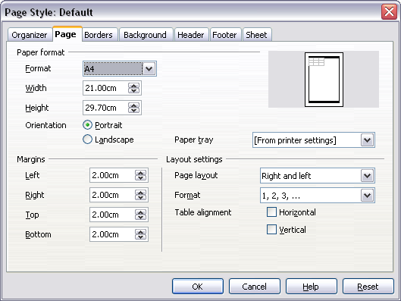
Figure 6: Page Style: Page tab
Paper format
Here, you can set a generic paper type to be used. Letter or A4 are the most commonly used, but you can also try legal, tabloid, envelope sizes, or user-defined paper types. In addition, you can define the orientation of the page and which print tray the paper will come from, if your printer has more than one tray.
Margins
This allows you to set the margins for the page.
Layout settings: Page layout
Here you can specify whether to apply the formatting to right (odd) pages only, left (even) pages only, or both right and left pages that use the current page style.
Mirrored formats the pages as if you want to bind the printed pages like a book.
The first page of a document is assumed to be an odd page.
Layout settings: Format
This area specifies the page numbering style for this page style.
Layout settings: Table alignment
This option specifies the alignment options for the cells on a printed page, either horizontal or vertical.

Borders
The Border and Background tabs for pages duplicate the tabs of the same name on cell styles and are overridden by the cell style or manual settings. You may ignore the Border and Background tabs altogether in page styles. Both tabs are illustrated with helpful diagrams.
As with formatting a cell style, we can use the Borders tab to choose whether the page should have borders, how large they should be, and how far the text will be from them.

Background
Use this tab to specify the background for this page style. You can apply either a solid color or a picture as a background.

Header
Use this tab to design and apply the header for this page style. For more detailed instructions on formatting the header, see Chapter 6 (Printing, Exporting, and E-mailing).

Footer
Use this tab to design and apply the footer for this page style. For more detailed instructions on how to format the footer, see Chapter 6.

Sheet
By far, the most important settings for Calc page styles are on the Sheet tab. Although the Sheet tab includes an option that sets the first page option, most of its settings involve exactly how your spreadsheet will print. See Chapter 6.

Creating New (Custom) Styles
You may want to add some new styles. You can do this in two ways:
- Creating a new style using the Style dialog
- Creating a new style from a selection
Note | New styles apply only to this document; they are not saved in the template. To save new styles in a template, see “Copying and Moving Styles“ on page 13 and “Creating a Template” on page 16.

Creating a New Style Using the Style Dialog
To create a new style using the Style dialog, right-click in the Styles and Formatting window and choose New from the pop-up menu.
(Cell styles only) If you want your new style to be linked with an existing style, select that style, right-click, and choose New.

Tip | If you link styles, when you change the base style (for example, by changing the font from Times to Helvetica), all the linked styles will change as well. Sometimes this is exactly what you want; at other times you don't want the changes to apply to all the linked styles. It pays to plan ahead.

The dialogs and choices are the same for defining new styles and for modifying existing styles.

Creating a New Style from a Selection
You can create a new cell style by copying an existing manual format.
- Open the Styles and Formatting window and choose the type of style you want to create.
- Select the formatted cell in the document you want to save as a style.
- In the Styles and Formatting window, click on the New Style from Selection icon .
- In the Create Style dialog, type a name for the new style. The list shows the names of existing custom styles of the selected type. Click OK to save the new style.

Figure 7: Naming a new style created from a selection

Creating a New Style by Dragging and Dropping
Select a cell and drag it to the Styles and Formatting window.

Copying and Moving Styles
Use the Template Management dialog to copy a style from one spreadsheet to another or between a spreadsheet and a template instead of recreating it in the second spreadsheet.
- Click File > Templates > Organize.
- In the Template Management dialog (Figure 8), set the lists at the bottom to either Templates or Documents, as needed. The default is Templates on the left and Documents on the right.

Figure 8: Choosing to copy styles from a document, not a template.
Tip | To copy styles from a file that is not open, click the File button. When you return to this dialog, both lists show the selected file and all currently open documents.

- Open the folders and find the templates from and to which you want to copy. Double-click on the template or document name, then double-click the Styles icon to show the list of individual styles (Figure 9).
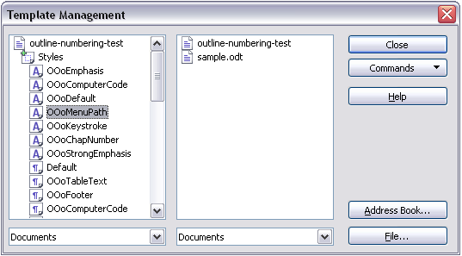
Figure 9: Copying a style from one document to another.
- To copy a style, hold down the Ctrl key and drag the name of the style from one list to the other.
- Repeat these steps for each style you want to copy. If the receiving template or document has many styles, you may have to scroll down the list to find a specific item. When you are finished, click Close.

Deleting Styles
You cannot remove (delete) any of Calc’s predefined styles, even if you are not using them. However, you can remove any user-defined, custom styles. Before you do, be sure the styles in question are not in use. If an unwanted style is in use, replace it with a substitute.
Replacing styles, and then deleting the unwanted ones, can be very useful if you're dealing with a spreadsheet that several people have worked on.
To delete unwanted styles, right-click on them, one at a time, in the Styles and Formatting window. Then click Delete on the pop-up menu. Choose Yes in the confirmation pop-up.

Creating a Spreadsheet from a Template
To create a spreadsheet from a template:
- From the main menu, choose File > New > Templates and Documents. The Templates and Documents dialog opens.
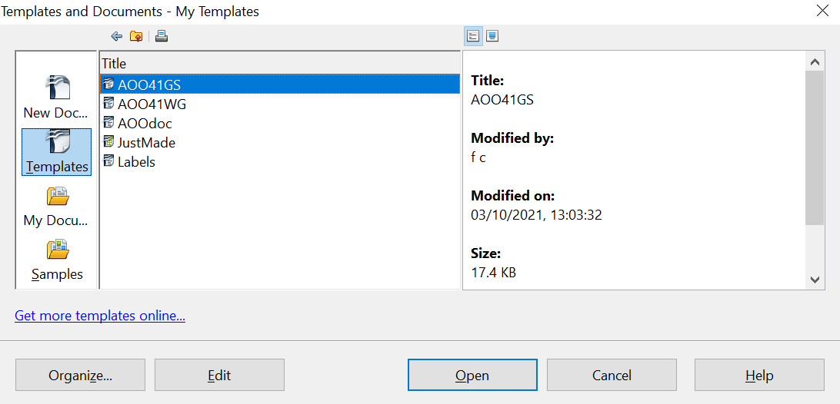

Figure 10: Templates and Documents dialog
- In the box on the left, click the Templates icon if it has not already been selected. A list of template folders appears in the center box.
- Double-click the folder holding the template you want to use. A list of all templates contained in that folder appears in the center box.
- Select the template that you want to use. You can preview the selected template or view the template’s properties:
- To preview the template, click the Preview icon. A preview of the template appears in the box on the right.
- To view the template’s properties, click the Document Properties icon. The template’s properties appear in the box on the right.
- Click Open. The Templates and Documents dialog closes, and a new document based on the selected template opens in Calc. You can then edit and save the new document as you would any other document.

Creating a Template
You can create a template from a document.
- Open a new or existing document of the type you want to make into a template (text document, spreadsheet, drawing, presentation).
- Add the content and styles that you want.
- From the main menu, choose File > Templates > Save. The Templates dialog opens.
- In the New template field, type a name for the new template.
- In the Categories list, click the category to which you want to assign the template. The category you choose does not affect the template itself; it is simply the folder in which you save the template. Choosing an appropriate folder (category) makes it easier to find the template when you want to use it. You may wish to create a folder for Calc templates.
To learn more about template folders, see “Organizing Templates” on page 21.
- Click OK to save the new template.
Figure 11: Saving a new template
Any settings that can be added to or modified in a document can be saved in a template. For example, below are some of the settings (although not a full list) that can be included in a Calc document and then saved as a template for later use:
- Printer settings: which printer, single-sided / double-sided, paper size, and so on
- Cell and page styles to be used
Templates can also contain predefined text, saving you from having to type it every time you create a new document. For example, an invoice template might contain your company’s name, address, and logo.
You can also save menu and toolbar customizations in templates; see Chapter 14 (Setting up and Customizing Calc) for more information.

Editing a Template
You can edit a template’s styles and content, and then, if you wish, you can reapply the template’s styles to documents created from that template.

Note | You can only reapply styles. You cannot reapply content.

To edit a template:
- From the main menu, choose File > Templates > Organize. The Template Management dialog opens.
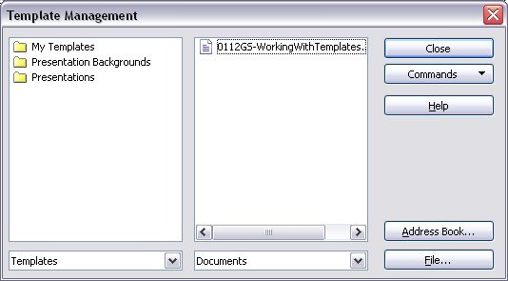Figure 12: Template management dialog
- In the box on the left, double-click the folder containing the template that you want to edit. A list of all the templates contained in that folder appears underneath the folder name.
- Select the template that you want to edit.
- Click the Commands button and choose Edit from the drop-down menu.
- Edit the template just as you would any other document. To save your changes, choose File > Save from the main menu.

Updating a Spreadsheet from a Changed Template
The next time you open a spreadsheet created from the changed template, a message similar to the following appears.
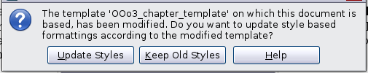
Figure 13: Update styles message
Click Update Styles to apply the template’s changed styles to the spreadsheet. Click Keep Old Styles if you do not want to apply the template’s changed styles to the spreadsheet (see Caution notice below).
Caution | If you choose Keep Old Styles in the message box shown in Figure 13, that message will not appear again the next time you open the document after changing the template it is based on. You will not get another chance to update the styles from the template, although you can use the macro given in the Note below to re-enable this feature.

Note | To re-enable updating from a template:  - Use Tools > Macros > Organize Macros > OpenOffice Basic. Select the document from the list, click the expansion symbol (+ or triangle), and select Standard. If Standard has an expansion symbol beside it, click that and select a module.  - If the Edit button is active, click it. If the Edit button is not active, click New.  - In the Basic window, enter the following:  Sub FixDocV3  ' set UpdateFromTemplate  oDocSettings = ThisComponent.createInstance( _  "com.sun.star.document.Settings" )  oDocSettings.UpdateFromTemplate = True  End Sub 'FixDocV3  - Click the Run BASIC icon, then close the Basic window.  - Save the document.  Next time when you open this document, you will have the update from template feature back.

Adding Templates Using the Extension Manager
The Extension Manager provides an easy way to install collections of templates, graphics, macros, or other add-ins that have been “packaged” into files with a .OXT extension. See Chapter 14 (Setting Up and Customizing Calc) for more about the Extension Manager.
This Web page lists many of the available extensions: https://extensions.openoffice.org/.
To install an extension, follow these steps:
- Download an extension package and save it anywhere on your computer.
- In AOO, choose Tools > Extension Manager from the menu bar. In the Extension Manager dialog, click Add.
- A file browser window opens. Find and select the package of templates you want to install and click Open. The package begins installing. You may be asked to accept a license agreement.
- When the package installation is complete, the templates are available for use through File > New > Templates and Documents, and the extension is listed in the Extension Manager.
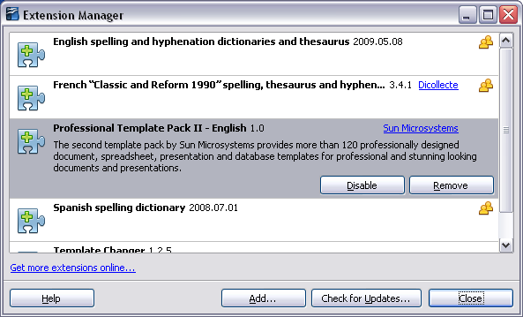
Figure 14: Newly-added package of templates

Setting a Default Template
If you create a document by choosing File > New > Spreadsheet from the main menu, AOO creates the document from the Default template for spreadsheets. You can, however, set a custom template as the default; you can reset the default later if you choose.

Setting a Custom Template as the Default
You can set any template as the default as long as it is in one of the folders displayed in the Template Management dialog.
To set a custom template as the default:
- From the main menu, choose File > Templates > Organize. The Template Management dialog opens.
- In the box on the left, select the folder containing the template you want to set as the default, then select the template.
- Click the Commands button and choose Set As Default Template from the drop-down menu.
The next time you create a document by choosing File > New, the document will be created from this template.

Resetting the Default Template
To re-enable AOO’s default template for a document type as the default:
- In the Template Management dialog, click any folder in the box on the left.
- Click the Commands button and choose Reset Default Template > Spreadsheet from the drop-down menu.
The next time you create a spreadsheet by choosing File > New, it will be created from AOO’s default template for spreadsheets.

Associating a Spreadsheet with a Different Template
Sometimes, you might want to associate a spreadsheet with a different template. Or perhaps you’re working with a spreadsheet that did not start from a template, but you now want it associated with one.
One significant advantage of using templates is ease of updating styles in multiple documents, as described on page 18. If you update styles by copying them from a different template (as described on page 13), the document has no association with the template from which the styles were loaded—so you cannot use this method. What you need to do is to associate the document with a different template.
For best results, the styles' names should be the same as those in the existing document and the new template. If they are not, you will need to use Search and Replace to replace the old styles with new ones. See Chapter 2 (Entering, Editing, and Formatting Data) for more about replacing styles using Find and Replace.
- Use File > New > Templates and Documents. Choose the template you want. A new file, based on the template, opens. If the template contains unwanted text or graphics, delete them.
- Open the spreadsheet you want to change. (It opens in a new window.) Press Control+A to select everything in the spreadsheet.
- Switch to the window containing the blank spreadsheet created in Step 1, and paste the content into that spreadsheet.
- Save the file under a new name.

Organizing Templates
AOO can only use templates that are in AOO template folders. You can create new AOO template folders and use them to organize your templates, and import templates into those folders. For example, you might have one template folder for report templates and another for letter templates. You can also export templates.
To begin, choose File > Templates > Organize from the main menu. The Template Management dialog opens.
Note | All the actions made by the Commands button in the Template Management dialog can be made as well by right-clicking on the templates or the folders.

Creating a Template Folder
To create a template folder:
- In the Template Management dialog, click any folder.
- Click the Commands button and choose New from the drop-down menu. A new folder called Untitled appears.
- Type a name for the new folder, and then press Enter. AOO saves the folder with the name that you entered.

Deleting a Template Folder
You cannot delete template folders supplied with AOO or installed using the Extension Manager. You can only delete template folders that you have created.
To delete a template folder:
- In the Template Management dialog, select the folder you want to delete.
- Click the Commands button and choose Delete from the drop-down menu. A message box will appear asking you to confirm the deletion. Click Yes.

Moving a Template
To move a template from one template folder to another template folder:
- In the Template Management dialog, double-click the folder that contains the template you want to move. A list of the templates contained in that folder appears underneath the folder name.
- Click the template you want to move and drag it to the desired folder. If you do not have the authority to delete templates from the source folder, this action copies the template instead of moving it, leaving it in its original folder and placing a copy in the new folder.

Deleting a Template
You cannot delete templates supplied with AOO or installed using the Extension Manager. You can only delete templates that you have created or imported.
To delete a template:
- In the Template Management dialog, double-click the folder containing the template you want to delete. A list of the templates in that folder appears underneath the folder name.
- Click the template that you want to delete.
- Click the Commands button and choose Delete from the drop-down menu. A message box will appear asking you to confirm the deletion. Click Yes.

Importing a Template
If the template that you want to use is in a different location, you must import it into an AOO template folder.
To import a template into a template folder:
- In the Template Management dialog, select the folder into which you want to import the template.
- Click the Commands button and choose Import Template from the drop-down menu. A standard file browser window opens.
- Find and select the template you want to import, then click Open. The file browser window closes, and the template appears in the selected folder.
- If you like, type a new name for the template and then press Enter.

Exporting a Template
To export a template from a template folder to another location:
- In the Template Management dialog, double-click the folder that contains the template you want to export. A list of the templates contained in that folder appears underneath the folder name.
- Click the template that you want to export.
- Click the Commands button and choose Export Template from the drop-down menu. The Save As window opens.
- Find the folder into which you want to export the template. Then click Save.

