
Math Guide

The OpenOffice.org Equation Editor

Copyright
This document is Copyright © 2005–2011 by its contributors as listed below. You may distribute it and/or modify it under the terms of either the GNU General Public License (http://www.gnu.org/licenses/gpl.html), version 3 or later, or the Creative Commons Attribution License (http://creativecommons.org/licenses/by/3.0/), version 3.0 or later.
All trademarks within this guide belong to their legitimate owners.
Contributors
Daniel Carrera
Agnes Belzunce
TJ Frazier
Peter Kupfer
Ian Laurenson
Janet M. Swisher
Jean Hollis Weber
Michele Zarri
Feedback
Please direct any comments or suggestions about this document to: authors@documentation.openoffice.org
Publication date and software version
Published 28 April 2011. Based on OpenOffice.org 3.3.

Note for Mac users
Some keystrokes and menu items are different on a Mac from those used in Windows and Linux. The table below gives some common substitutions for the instructions in this chapter. For a more detailed list, see the application Help.
Windows/Linux | Mac equivalent | Effect
Tools > Options menu selection | OpenOffice.org > Preferences | Access setup options
Right-click | Control+click | Open context menu
Ctrl (Control) | z (Command) | Used with other keys
F5 | Shift+z+F5 | Open the Navigator
F11 | z+T | Open Styles & Formatting window

Contents
Note for Mac users 2
What is Math? 4
Getting started 4
Entering a formula 5
The Elements window 5
Right-click (context) menu 7
Markup 7
Greek characters 8
Customizations 10
Formula editor as a floating window 10
How can I make a formula bigger? 11
Formula layout 12
Brackets are your friends 12
Equations over more than one line 12
How do I add limits to my sum/integral? 12
Brackets with matrices look ugly! 13
How do I make a derivative? 14
How do I align my equations at the equals sign? 14
Numbering equations 15
Math commands - Reference 17
Unary / binary operators 17
Relational operators 18
Set operations 19
Functions 20
Operators 21
Attributes 22
Miscellaneous 23
Brackets 24
Formats 25
Characters – Greek 26
Characters – Special 26

What is Math?
Math is OpenOffice.org (OOo)’s component for writing mathematical equations. It is most commonly used as an equation editor for text documents, but it can also be used with other types of documents or stand-alone. When used inside Writer, the equation is treated as an object inside the text document.
Note | The equation editor is for writing equations in symbolic form, as in equation 1. If you want to evaluate a numeric value, see the Calc Guide.

(1)

Getting started
To insert an equation, go to Insert > Object > Formula.
The equation editor opens at the bottom of the screen, and the floating Elements window (called “Selection” before Math 3.2 and “Formula Elements” in Math 3.2) may appear. You will also see a small box with a gray border in your document, where the formula will be displayed, as shown in Figure 1.
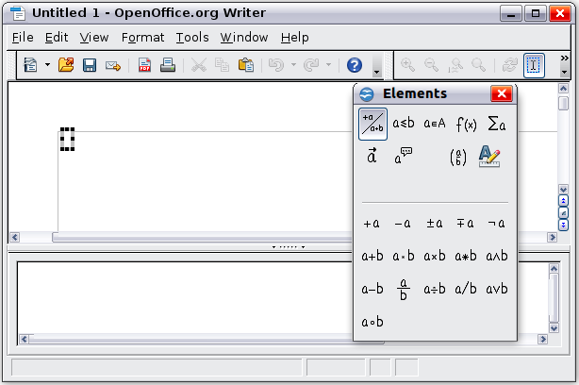
Figure 1: Equation Editor, Elements window, and location of resulting equation

Entering a formula
The equation editor uses a markup language to represent formulas. For example, %beta creates the Greek character beta (). This markup is designed to read similar to English whenever possible. For example, a over b produces a fraction: .
You can enter a formula in three ways:
- Select a symbol from the Elements window.
- Right-click on the equation editor and select the symbol from the context menu.
- Type markup in the equation editor.
The context menu and the Elements window insert the markup corresponding to a symbol. This provides a convenient way to learn the OOo Math markup.
Note | Click on the document body to exit the formula editor.  Double-click on a formula to enter the formula editor again.

The Elements window
The simplest method for entering a formula is the Elements window.
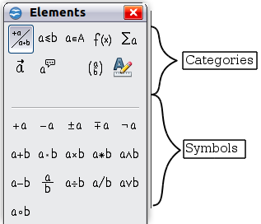
Figure 2: Symbols are divided into categories
The Elements window is divided into two main parts.
- The top shows the symbol categories. Click on these to change the list of symbols.
- The bottom shows the symbols available in the current category.
Tip | You can hide or show the Elements window with View > Elements.

Example 1:
For this example we will enter a simple formula:. On the Elements window:
- Select the top-left button of the categories (top) section.
- Click on the multiplication symbol.
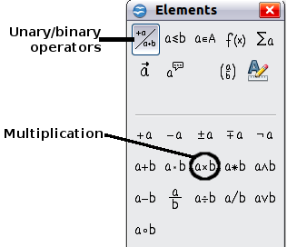
Figure 3: Selecting the multiplication symbol
When you select the multiplication symbol on the Elements window, two things happen:
- The equation editor shows the markup:
- The body of the document shows a gray box like this:
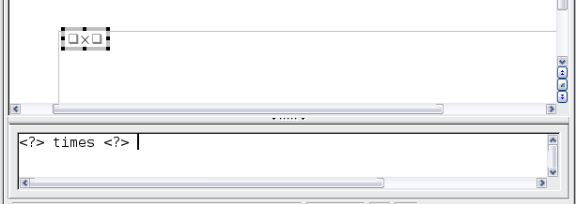
Figure 4: Result of selecting the multiplication symbol
The <?> symbols shown in Figure 4 are placeholders that you can replace by other text, for example 5 and 4. The equation will update automatically, and the result should resemble Figure 5.
Tip | To keep the equation from updating automatically, select View >AutoUpdate display. To update a formula manually, press F9 or select View > Update.
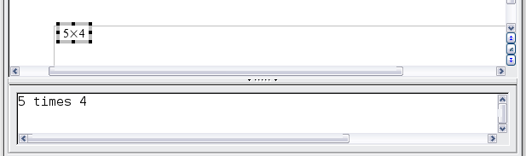
Figure 5: Result of entering 5 and 4 next to the times operator

Right-click (context) menu
Another way to access mathematical symbols is to right-click on the equation editor. This pops up the menu shown in Figure 6. The items in this menu correspond exactly to those in the Elements window.
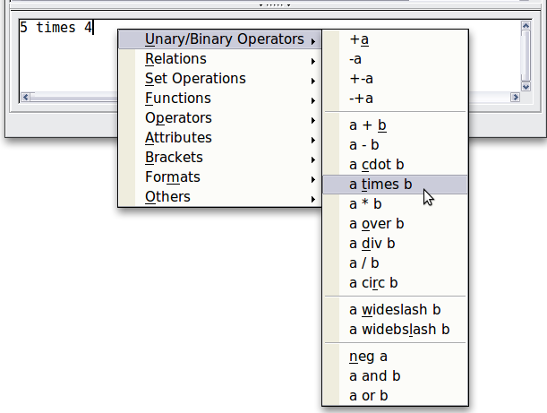
Figure 6: Right-click (context) menu

Markup
You can type the markup directly in the equation editor. For example, you can type 5 times 4 to obtain . If you know the markup, this can be the fastest way to enter a formula.
Tip | The formula markup resembles the way the formula reads in English.
Below is a short list of common equations and their corresponding markup.
Display | Command | Display | Command
 | a = b |  | sqrt {a}
 | a^2 |  | a_n
 | int f(x) dx |  | sum a_n
 | a <= b |  | infinity
 | a times b |  | x cdot y

Greek characters
Greek characters (, etc) are common in mathematical formulas. These characters are not available in the Elements window or the right-click menu. Fortunately, the markup for Greek characters is simple: Type a % sign followed by the name of the character, in English.
- To write a lowercase character, type the name of the character in lowercase.
- To write an uppercase character, type the name of the character in uppercase.
A complete table of Greek characters is provided on page 26. See the table below for some examples.
Lowercase | Uppercase
%alpha | %ALPHA
%beta | %BETA
%gamma | %GAMMA
%psi | %PSI
%phi | %PHI
%theta | %THETA
Another way to enter Greek characters is by using the Symbols catalog window. Choose Tools > Catalog. This window is shown in Figure 7. Under Symbol set, select Greek and double-click on a Greek letter from the list. The markup name of the character is shown below the list window.
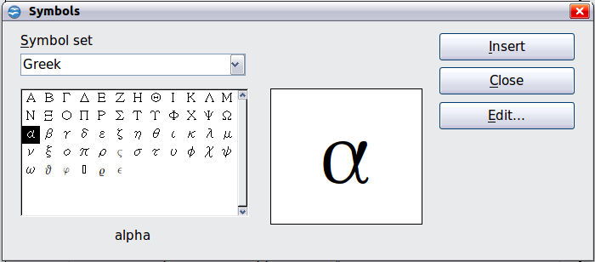
Figure 7: Symbols catalog, used for entering Greek characters and some special symbols

Example 2:
For this example we will suppose that:
- We want to enter the above formula (the value of pi rounded to 5 decimal places).
- We know the name of the Greek character (pi).
- But we do not know the markup associated with the symbol.
Step 1: Type % followed by the text pi. This displays the Greek character .
Step 2: Open the Elements window (View > Elements).
Step 3: The symbol is a relation, so we click on the Relations button. If you hover the mouse over this button you see the tooltip Relations (Figure 8).
Figure 9 shows the Selection window after clicking the Relations button. The symbol we want is circled.
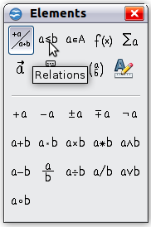  Figure 8: Tooltip indicates the Relations button | 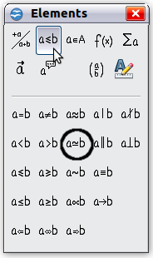  Figure 9: After selecting Relations
Step 4: Click on the ab symbol. The equation editor now shows the markup %pi<?> simeq <?>.
Step 5: Delete the <?> text and add 3.14159 at the end of the equation. We end up with the markup %pi simeq 3.14159. The result is shown in Figure 10.
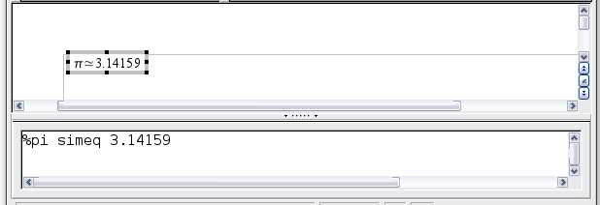
Figure 10. Final result

Customizations

Formula editor as a floating window
The formula editor can cover a large part of the Writer window. To turn the formula editor into a floating window, do this:
- Hover the mouse over the editor frame, as shown in Figure 11.
- Hold down the Control key and double-click.
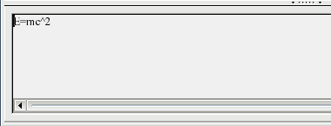

Figure 11: Turning the formula editor into a floating window
Figure 12 shows the result. You can dock the floating window again by using the same steps. Hold down the Control key and double-click the window frame.
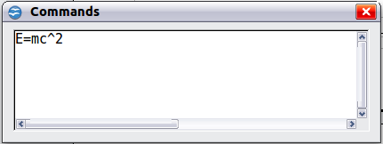
Figure 12: Formula editor as a floating window

How can I make a formula bigger?
This is one of the most common questions people ask about OOo Math. The answer is simple, but not intuitive:
- Start the formula editor and choose Format > Font size.
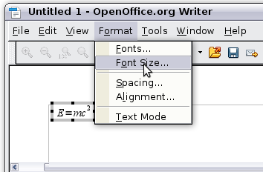
Figure 13: Changing the font size for a formula
- Select a larger font size under Base size (top-most entry)
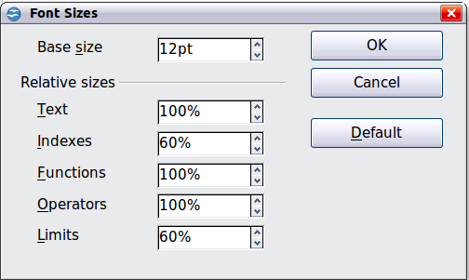
Figure 14. Edit Base size (top) to make a formula bigger
The result of this change is illustrated in Figure 15.
Figure 15. Result of changing the base font size

Formula layout
The most difficult part of using OOo Math comes when writing complicated formulas. This section provides some advice.

Brackets are your friends
OOo Math knows nothing about order of operation. You must use brackets to state the order of operations explicitly. Consider the following example.
Markup | Result
2 over x + 1
2 over {x + 1}

Equations over more than one line
Suppose you want to type an equation covering more than one line. For example:
Your first reaction would be to simply press the Enter key. However, if you press the Enter key, though the markup goes to a new line, the resulting equation does not. You must type the newline command explicitly. This is illustrated in the table below.
Markup | Result
x = 3
y = 1
x = 3 newline
y = 1

How do I add limits to my sum/integral?
The sum and int commands can (optionally) take the parameters from and to. These are used for lower and upper limits respectively. These parameters can be used singly or together. Limits for integrals are usually treated as subscripts and superscripts.
Markup | Result
sum from k = 1 to n a_k
int from 0 to x f(t) dt  or  int_0^x f(t) dt | or
int from Re f
sum to infinity 2^{-n}
Note | For more details on integrals and sums, see page 21.

Brackets with matrices look ugly!
For background, we start with an overview of the matrix command.
Markup | Result
matrix { a # b ## c # d }
Note | Rows are separated by two #’s and entries within each row are separated by one #.
The first problem people have with matrices is that brackets do not scale with the matrix:
Markup | Result
( matrix { a # b ## c # d } )
OOo Math provides scalable brackets. That is, the brackets grow in size to match the size of their contents. Use the commands left( and right) to make scalable brackets.
Markup | Result
left( matrix { a # b ## c # d } right)
Tip | Use left[ and right] to obtain square brackets.

How do I make a derivative?
Making derivatives essentially comes down to one trick: Tell OOo it’s a fraction.
In other words, you have to use the over command. Combine this with either the letter d (for a total derivative) or the partial command (for a partial derivative) to achieve the effect of a derivative.
Note | Notice that we have to use braces (squiggly brackets) to make the derivative.
Markup | Result
{df} over {dx}
{partial f} over {partial y}
{partial^2 f} over {partial t^2}

How do I align my equations at the equals sign?
OOo Math does not have a command for aligning equations on a particular character, but you can use a matrix to do this, as shown below.
Markup | Result
matrix{
alignr x+y # {}={} # alignl 2 ##
alignr x # {}={} # alignl 2-y
}
The empty braces around = are necessary because = is a binary operator and thus needs an expression on each side.
You can reduce the spacing around = if you change the inter-column spacing of the matrix:
- With the equation editor open, choose Format > Spacing from the menu bar.
- In the Spacing dialog (Figure 16), click the Category button and select Matrices in the drop-down menu.
- Enter 0% for Column spacing and click OK.
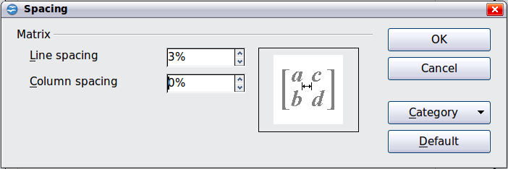
Figure 16: Changing spacing in a matrix formula

Numbering equations
Equation numbering is one of OOo Math’s best hidden features. The steps are simple, but obscure:
- Start a new line.
- Type fn and then press F3.
The fn is replaced by a numbered formula:
(2)
Now you can double-click on the formula to edit it. For example, here is the Riemann Zeta function:
(3)
You can reference an equation (“as shown in Equation (2)”) with these steps:
- Choose Insert > Cross-reference from the menu bar.
- On the Cross-references tab (Figure 17), under Type, select Text.
- Under Selection, select the equation number.
- Under Format, select Reference.
Click Insert.
Done! If you later add more equations to the paper before the referenced equation, all the equations will automatically renumber and the cross-references will update.
Tip | To insert the equation number without parentheses around it, choose Numbering instead of Reference under Format.
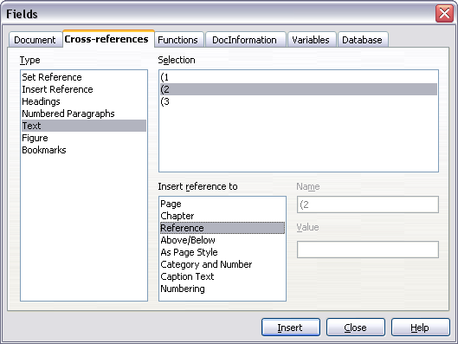
Figure 17. Inserting a cross-reference to an equation number

Math commands - Reference

Unary / binary operators
Operation | Command | Display
+sign | +1
–sign | –1
+/– sign | +–1
–/+ sign | –+1
Boolean not | neg a
Addition + | a + b
Dot product | a cdot b
Multiplication (X) | a times b
Multiplication (asterisk) | a * b
Boolean ‘and’ | a and b
Subtraction (–) | a – b
Division (as a fraction) | a over b
Division (as an operator) | a div b
Division (with a slash) | a / b
Boolean ‘or’ | a or b
Concatenation | a circ b

Relational operators
Operation | Command | Display
Is equal | a = b
Is not equal | a <> b
Approximately | a approx 2
Divides | a divides b
Does not divide | a ndivides b
Less than | a < 2
Greater than | a > 2
Similar to or equal | a simeq b
Parallel | a parallel b
Orthogonal to | a ortho b
Less than or equal to | a leslant b
Greater than or equal to | a geslant b
Similar to | a sim b
Congruent | a equiv b
Less than or equal to | a <= b
Greater than or equal to | a >= b
Proportional | a prop b
Toward | a toward b
Arrow left | a dlarrow b
Double arrow left and right | a dlrarrow b
Arrow right | a drarrow b

Set operations
Operation | Command | Display
Is in | a in B
Is not in | a notin B
Owns | A owns b
Empty set | emptyset
Intersection | A intersection B
Union | A union B
Difference | A setminus B
Quotient | A slash B
Aleph | aleph
Subset | A subset B
Subset or equal to | A subseteq B
Superset | A supset B
Superset or equal to | A supseteq B
Not subset | A nsubset B
Not subset or equal | A nsubseteq B
Not superset | A nsupset B
Not superset or equal | A nsupseteq B
Set of natural numbers | setN
Set of integers | setZ
Set of rational numbers | setQ
Set of real numbers | setR
Set of complex numbers | setC

Functions
Operation | Command | Display
Exponential | func e^{a}
Natural logarithm | ln(a)
Exponential function | exp(a)
Logarithm | log(a)
Power | a^{b}
Sine | sin(a)
Cosine | cos(a)
Tangent | tan(a)
Cotangent | cot(a)
Square root | sqrt{a}
Arcsine | arcsin(a)
Arc cosine | arccos(a)
Arctangent | arctan(a)
Arc cotangent | arccot(a)
n^{th} root | nroot{a}{b}
Hyperbolic sine | sinh(a)
Hyperbolic cosine | cosh(a)
Hyperbolic tangent | tanh(a)
Hyperbolic cotangent | coth(a)
Absolute value | abs{a}
Arc hyperbolic sine | arsinh(a)
Arc hyperbolic cosine | arcosh(a)
Arc hyperbolic tangent | artanh(a)
Arc hyperbolic cotangent | arcoth(a)
Factorial | fact{a}

Operators
All operators can be used with the limit functions (“from” and “to”).
Operation | Command | Display
Limit | lim{a}
Sum | sum{a}
Product | prod{a}
Coproduct | coprod{a}
Upper and lower bounds shown with integral | int from {r_0} to {r_t} a
Integral | int{a}
Double integral | iint{a}
Triple integral | iiint{a}
Lower bound shown with summation symbol | sum from{3}b
Contour integral | lint a
Double curved integral | llint a
Triple curved integral | lllint a
Upper bound shown with product symbol | prod to{3} r

Attributes
Operation | Command | Display
Acute accent | acute a
Grave accent | grave a
Reverse circumflex | check a
Breve | breve a
Circle | circle a
Vector arrow | vec a
Tilde | tilde a
Circumflex | hat a
Line above | bar a
Dot | dot a
Wide vector arrow | widevec abc
Wide tilde | widetilde abc
Wide circumflex | widehat abc
Double dot | ddot a
Line over | overline abc
Line under | underline abc
Line through | overstrike abc
Triple dot | dddot a
Transparent (useful to get a placeholder of a given size) | phantom a
Bold font | bold a
Italic font | ital “a”
Resize font | size 16 qv
Following item in sans serif font | font sans qv
Following item in serif font | font serif qv
Following item in fixed font | font fixed qv
Make color of following text cyan | color cyan qv
Make color of following text yellow | color yellow qv
Make color of following text white | color white qv
Make color of following text green | color green qv
Make color of following text blue | color blue qv
Make color of following text red | color red qv
Make color green returns to default color black | color green X qv
Brace items to change color of more than one item | color green {X qv}

Miscellaneous
Operation | Command | Display
Infinity | infinity
Partial | partial
Nabla | nabla
There exists | exists
For all | forall
H bar | hbar
Lambda bar | lambdabar
Real part | re
Imaginary part | im
Weierstrass p | wp
Left arrow | leftarrow
Right arrow | rightarrow
Up arrow | uparrow
Down arrow | downarrow
Dots at bottom | dotslow
Dots at middle | dotsaxis
Dots vertical | dotsvert
Dots diagonal upward | dotsup
Dots diagonal downward | dotsdown

Brackets
Operation | Command | Display
Round Brackets | (a)
Square Brackets | [b]
Double Square Brackets | ldbracket c rdbracket
Single line | lline a rline
Double line | ldline a rdline
Braces | lbrace w rbrace
Angle Brackets | langle d rangle
Operator Brackets | langle a mline b rangle
Group brackets (used for program control) | {a}
Scalable round brackets  (add the word “left” before a left bracket and “right” before a right bracket) | left ( stack{a # b # z} right )
Square brackets scalable  (as above) | left [ stack{ x # y} right ]
Double square brackets scalable | left ldbracket c right rdbracket
Line scalable | left lline a right rline
Double line scalable | left ldline d right rdline
Brace scalable | left lbrace e right rbrace
Angle bracket scalable | left langle f right rangle
Operator brackets scalable | left langle g mline h right rangle
Over brace scalable | {The brace is above} overbrace a
Under brace scalable | {the brace is below}underbrace {f}

Formats
Operation | Command | Display
Left superscript | a lsup{b}
Center superscript | a csup{b}
Right superscript | a^{b}
Left subscript | a lsub{b}
Center subscript | a csub{b}
Right subscript | a_{b}
Align character to left (text is aligned center by default) | stack { Hello world # alignl (a) }
Align character to center | stack{Hello world # alignc(a)}
Align character to right | stack { Hello world # alignr(a)}
Vertical stack of 2 | binom{a}{b}
Vertical stack, more than 2 | stack{a # b # z}
Matrix | matrix{  a # b ##  c # d  }
Equations aligned at '=' (using 'matrix') | matrix{  a # "=" # alignl{b} ##  {} # "=" # alignl{c+1}  }
Equations aligned at '=' (using 'phantom') | stack{  alignl{a} = b #  alignl{phantom{a} = c+1}  }
New line | asldkfjo newline sadkfj
No gap | nospace { x + y }
Normal | x+y
Small gap (grave) | stuff `stuff
Large gap (tilde) | stuff~stuff

Caution   | In localized versions of Writer, the markup names of Greek and special characters are localized. If this document is not localized to the same language, then the names below may not work for input. You may still use the Symbol catalog (Figure 7) to select the desired character by its glyph. This will also display the character's localized markup name.  Once entered, the characters will display properly in any language.

Characters – Greek
%ALPHA |  | %BETA |  | %GAMMA |  | %DELTA |  | %EPSILON
%ZETA |  | %ETA |  | %THETA |  | %IOTA |  | %KAPPA
%LAMBDA |  | %MU |  | %NU |  | %XI |  | %OMICRON
%PI |  | %RHO |  | %SIGMA |  | %TAU |  | %UPSILON
%PHI |  | %CHI |  | %PSI |  | %OMEGA
%alpha |  | %beta |  | %gamma |  | %delta |  | %epsilon
%varepsilon |  | %zeta |  | %eta |  | %theta |  | %vartheta
%iota |  | %kappa |  | %lambda |  | %mu |  | %nu
%xi |  | %omicron |  | %pi |  | %varpi |  | %rho
%varrho |  | %sigma |  | %varsigma |  | %tau |  | %upsilon
%phi |  | %varphi |  | %chi |  | %psi |  | %omega

Characters – Special
%and | %angle | %element | %identical
%infinite | %noelement | %notequal | %or
%perthousand | %strictlygreaterthan | %strictlylessthan | %tendto

Index
B
brackets (Math) 12
brackets commands (Math) 24
C
characters – special (Math) 26
characters – Greek (Math) 26
D
derivative markup (Math) 14
E
equation
inserting 4
numbering 15
equation editor 4
equation editor
brackets 12
derivative markup 14
Elements window 5
equations over more than one line 12
floating window 10
font size 11
formula layout 12
limits to sum/integral 12
markup 7
matrix markup 13
right-click menu 7
F
formats commands (Math) 25
formula editor
See: equation editor 10
formula layout 12
function commands (Math) 20
L
limits to sum/integral 12
M
mathematical equations 4
mathematical markup 7
mathematical symbols 5
matrix markup (Math) 13
miscellaneous commands (Math) 23
N
numbering equations 15
R
relational operator commands (Math) 18
U
unary / binary operator commands (Math) 17

Unquoted text that is not a command is considered to be a variable. Variables are, by default, italicized.
There are three custom fonts: sans serif (without kicks), serifs (with kicks), and fixed (non-proportional). To change the actual fonts used for custom fonts and the fonts used for variables (unquoted text), numbers and functions, use Format > Fonts.
For all coloring, the color will apply only to the text immediately following the command until the next space is encountered. In order to have the color apply to more characters, place the text you want in color in curly brackets.

