Apache OpenOffice
Version 4.1
Program Guide

AOO Documentation Team

Copyright
This document is Copyright © 2025 by The Apache Software Foundation. You may distribute it and/or modify it under the terms of the Creative Commons Attribution License, version 3.0 or later (https://creativecommons.org/licenses/by/3.0/).
Apache, Apache OpenOffice, and OpenOffice.org are trademarks of the Apache Software Foundation.
Acknowledgments
This book is updated from a previous version (by the OOoAuthors team). with additional material adapted from Getting Started with LibreOffice 3.4 (by the ODF Authors Team).
Publication date and software version
Published Day Month Years. Based on Apache OpenOffice 4.1.

Contents
Chapter 1
Introducing Writer 6
What is Writer? 6
Parts of the Main Writer Window 7
Changing Document Views 15
Starting a New Document 15
Opening an Existing Document 17
Saving a Document 18
Password Protection 20
Closing a Document 21
Closing OpenOffice 21
Using the Navigator 22
Getting Help 27
What Are All These Things Called? 27
Undoing and Redoing Changes 28
Using Writer on a Mac 29
Chapter 2
Setting up Writer 30
Choosing Options that Affect all of AOO 30
Choosing Options for Loading and Saving Documents 42
Choosing Options for Writer 47
Choosing Options for HTML Documents 57
Choosing Language Settings 58
Controlling Writer’s AutoCorrect Functions 60
Chapter 3
Working with Text 62
Introduction 62
Selecting Text 63
Cutting, Copying, and Pasting Text 64
Finding and Replacing Text 65
Inserting Special Characters 68
Formatting Paragraphs 70
Formatting Characters 73
Autoformatting 75
Creating Numbered or Bulleted Lists 76
Using Footnotes and Endnotes 79
Checking Spelling and Grammar 81
Using Built-in Language Tools 83
Using Synonyms and the Thesaurus 85
Hyphenating Words 86
Using AutoCorrect 88
Using Word Completion 89
Using AutoText 90
Line Numbering 92
Tracking Changes to a Document 93
Adding Other Comments 97
Linking to Another Part of a Document 98
Switching Between Insert and Overwrite Mode 102
Counting the Words in a Selection 103
Changing the Case of Selected Text 103
Chapter 4
Formatting Pages 104
Introduction 104
Choosing a Layout Method 105
Setting up Basic Page Layout Using Styles 107
Changing Page Margins 111
Using Columns to Define the Page Layout 112
Using Frames for Page Layout 116
Using Tables for Page Layout 121
Using Sections for Page Layout 124
Updating Links 131
Creating Headers and Footers 132
Numbering Pages 137
Defining Borders and Backgrounds 146
Chapter 5
Printing, Exporting, Faxing, and E-Mailing 150
Introduction 150
Quick Printing 150
Controlling Printing 150
Printing Envelopes 157
Printing Labels 159
Exporting to PDF 161
Exporting to XHTML 167
E-mailing Writer Documents 167
Digital Signing of Documents 171
Removing Personal Data 171
Chapter 6
Introduction to Styles 173
What Are Styles? 173
The Styles and Formatting Window 174
Applying Styles 179
Modifying Styles 185
Creating Custom Paragraph Styles: Examples 189
Copying and Moving Styles 193
Deleting styles 195
Assigning Styles to Shortcut Keys 195
Defining a Hierarchy of Headings 196
Chapter 7
Working with Styles 204
Introduction 204
Creating Custom (New) Styles 204
Working with Paragraph Styles 208
Working with Conditional Paragraph Styles 219
Working with Character Styles 221
Working With Frame Styles 223
Working With Page Styles 225
Working with List Styles 232
Chapter 8
Working with Graphics 240
Graphics (images) in Writer 240
Creating and Editing Images 240
Adding Images to a Document 242
Modifying an Image 246
Using Writer’s Drawing Tools 254
Positioning Graphics within the Text 257
Adding Captions to Graphics 265
Creating an Image Map 268
Adding an Image to the Gallery 270

Chapter 1
Introducing Writer

What is Writer?
Writer is the word processor component of Apache OpenOffice (AOO). It provides the usual features of a word processor: enter and edit text, check spelling, thesaurus, hyphenation, autocorrect, find and replace, automatic generation of tables of contents and indexes, mail merge, and others.
In addition, Writer provides these important features:
- Templates and styles
- Page-layout methods, including frames, columns, and tables
- Embedding or linking of graphics, spreadsheets, and other objects
- Built-in drawing tools
- Master documents—to group a collection of documents into a single document
- Change tracking during revisions
- Database integration, including a bibliography database
- Export to PDF, including bookmarks
- And many more
Styles are central to using Writer. Using styles, you can easily format your document consistently and change the format with minimal effort. A style is a named set of formatting options. Writer defines several types of styles, for different types of elements: characters, paragraphs, pages, frames, and lists. Often, you are using styles whether you realize it or not. The use of styles is described in more detail in Chapter 6 (Introduction to Styles) and Chapter 7 (Working with Styles).
The other features of Writer listed above are covered in other chapters of this guide.

Parts of the Main Writer Window
The main Writer workspace is shown in Figure 1. Its features are described in this section.

Title Bar
The Title bar, located at the top of the Writer window, shows the file name of the current document. When the document is newly created, the document name will appear as Untitled X, where X is a number.

Menus
The Menu bar is located just below the Title bar. When you choose one of the menus listed below, a submenu drops to show commands.
- File contains commands that apply to the entire document such as Open, Save, Print, and Export as PDF.
- Edit contains commands for editing the document such as Undo: xxx (where xxx is the command to undo) and Find & Replace. It also contains commands to cut, copy, and paste selected parts of your document.
- View contains commands for controlling the display of the document such as Zoom and Web Layout.
- Insert contains commands for inserting elements into your document such as headers, footers, and pictures.
- Format contains commands, such as Styles and Formatting, Paragraph, and Bullets and Numbering, for formatting the layout of your document
- Table shows all commands to insert and edit a table in a text document.
- Tools contains functions such as Spelling and Grammar, Customize, and Options. (On macOS, Options is under OpenOffice > Preferences)
- Window contains commands for the display window.
- Help contains links to the OpenOffice Help file, What’s This?, and information about the program. See “Getting Help” on page 27.

Figure 1: Main Writer workspace in Print view
`
Standard
Toolbar
Formatting
Toolbar
Status Bar
Menus
Rulers
Title bar
Sidebar

Toolbars
Writer has several types of toolbars: docked (fixed in place), floating, and tear-off. Docked toolbars can be moved to different locations or made to float, and floating toolbars can be docked.
The top toolbar, just under the Menu bar, is called the Standard toolbar. It is consistent across the OpenOffice applications (Writer, Calc, Draw, Impress).
The second toolbar at the top is the Formatting bar. It is context-sensitive; that is, it shows the tools relevant to the cursor’s current position or selection. For example, when the cursor is on a graphic, the Formatting bar provides tools for formatting graphics; when the cursor is in text, the tools are for formatting text.

Displaying or Hiding Toolbars
To display or hide toolbars, choose View > Toolbars, then click on the name of a toolbar in the list. An active toolbar shows a check mark beside its name. Tear-off toolbars are not listed in the View menu.

Submenus and Tear-off Toolbars
Toolbar icons with a small triangle to the right will display submenus, tear-off toolbars, and other ways of selecting things, depending on the icon.
An example of a tear-off toolbar is shown in Figure 2. Tear-off toolbars can be floating or docked along an edge of the screen or in one of the existing toolbar areas. To move a floating tear-off toolbar, drag it by the title bar, as shown in Figure 4.


Figure 2: Example of a tear-off toolbar

Moving Toolbars
To move a docked toolbar, place the mouse pointer over the toolbar handle, hold down the left mouse button, drag the toolbar to the new location, and then release the mouse button.
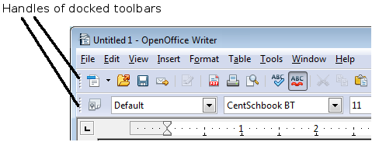
Figure 3: Moving a docked toolbar
To move a floating toolbar, click on its title bar and drag it to a new location.

Figure 4: Moving a floating toolbar

Floating Toolbars
Writer includes several additional context-sensitive toolbars, whose defaults appear as floating toolbars in response to the cursor’s current position or selection. For example, when the cursor is in a table, a floating Table toolbar appears, and when the cursor is in a numbered or bullet list, the Bullets and Numbering toolbar appears. You can dock these toolbars to the top, bottom, or side of the window, if you wish (see “Moving Toolbars” on page 9).

Docking/Floating Windows and Toolbars
Toolbars and some windows, such as the Navigator and the Styles and Formatting window, are dockable. You can move, resize, or dock them to an edge.
To dock a window or toolbar, hold down the Control key and double-click on the frame of the floating window (or in a vacant area near the icons at the top of the floating window) to dock it in its last position.

Figure 5: Control+click to dock or undock
To undock a window, hold down the Control key and double-click on the frame (or a vacant area near the icons at the top) of the docked window.

Customizing Toolbars
You can customize toolbars in several ways, including choosing which icons are visible and locking the position of a docked toolbar.
To access a toolbar’s customization options, use the down-arrow at the end of the toolbar or on its title bar (Figure 6).

Figure 6: Customizing toolbars
To show or hide icons defined for the selected toolbar, choose Visible Buttons from the drop-down menu. Visible icons are indicated by a border around the icon (Figure 7). Click on icons to hide or show them on the toolbar.
You can also add icons and create new toolbars, as described in Chapter 16.
Figure 7: Selection of visible toolbar icons

Right-click (Context) Menus
Right-click on a paragraph, graphic, or other object to open a context menu. Often, the context menu is the fastest and easiest way to reach a function. If you’re not sure where in the menus or toolbars a function is located, you can typically find it by right-clicking.

Rulers
To show or hide rulers, choose View > Ruler. To enable the vertical ruler, select Tools > Options > OpenOffice Writer > View and select Vertical ruler.

Figure 8. Turning on the vertical ruler

Status Bar
The Writer status bar is located at the bottom of the workspace. It provides information about the document and convenient ways to quickly change some document features.
Figure 9: Left end of status bar
Figure 10: Right end of status bar
Page number
Shows the current page number, the sequence number of the current page (if different from the page number), and the total number of pages in the document. For example, if a document has 14 pages, and you restarted page numbering at 1 on the third page, its page number is 1, its sequence number is 3, and the total number of pages is 14; this field would show 1 3/14.
If any bookmarks have been defined in the document, a right-click on this field pops up a list of bookmarks; click on the required one to go to the bookmark.
To jump to a specific page in the document, double-click on this field. The Navigator opens (see page 22). Click in the Page Number field in the Navigator and type the sequence number of the required page. After a brief delay, the display jumps to the selected page.
Page style
Shows the style of the current page. To change the page style, right-click on this field. A list of page styles pops up; choose a different style by clicking on it.
To edit the current page style, double-click on this field. The Page Style dialog box opens. See Chapter 6 and 7 in this book for more information about styles.
Language
Shows the language for the selected text.
Click to open a menu where you can choose another language for the selected text or for the paragraph where the cursor is located. You can also select None (Do not check spelling) to exclude the text from a spelling check or pick More to open the Character dialog box. See Chapter 3 (Working with Text) for more information.
Insert mode
Click to toggle between Insert and Overwrite modes when typing. In Insert mode, any text after the cursor position moves forward to make room for the text you type; in Overwrite mode, text after the cursor position is replaced by the text you type.
Selection mode
Click to toggle between STD (Standard), EXT (Extend), ADD (Add) and BLK (Block) selection. EXT is an alternative to Shift+click when selecting text. See Chapter 3 (Working with Text) for more information about these modes.
Unsaved changes
An asterisk (*) appears here if changes to the document have not been saved.
Digital signature
If the document has been digitally signed, an icon shows here. To view the certificate, double-click the icon.
Section or object information
When the cursor is in a section, heading, or list item, or when an object (such as a picture or table) is selected, information about that item appears in this field. Double-clicking in this area opens a relevant dialog box.
Object | Information shown | Dialog box opened
Picture | Size and position | Format Picture
List item | Level and list style | Bullets and Numbering
Heading | Outline numbering level | Bullets and Numbering1
Table | Name or number and cell reference of cursor | Table Format
Section | Name of section | Edit Sections
Other | (Blank) | Fields (Cross-References page)
View layout
Click an icon to change between single page, side-by-side, and book layout views. (See Figure 11.) You can edit the document in any view. Zoom settings (see below and next page) interact with the selected view layout to determine how many pages are visible in the document window.
Figure 11. View layouts: single, side-by-side, book
Zoom
To change the view magnification, drag the Zoom slider, or click on the + and – signs, or right-click on the zoom level percent to pop up a list of magnification values from which to choose.

Sidebar
The Sidebar brings together many functions that are otherwise available on several toolbars or menus. Its details are shown in Figure 12. It contains one or more decks, based on the current document context. Decks are organized into panels. A tab bar on the right side of the sidebar allows you to switch between different decks. The decks in Writer provide access to Properties, Styles, the Gallery, and the Navigator. More information about using these decks is provided in the appropriate chapters.
A panel is like a combination of a toolbar and a dialog. For example, you can freely mix working on the text in the main edit window and using the panels in the Properties or Styles decks in the Sidebar to change text attributes. The view of the Properties deck shown in Figure 12 is what appears when working with text. If you were to select a figure or a drawing shape, the panels would change to display properties such as position or fill colors that are appropriate for those objects.
Toolbars and Sidebar panels share many functions. For example, the buttons for making text bold or italic are in both the Formatting toolbar and the Properties panel.
If the Sidebar is not visible, you can show it by using View > Sidebar on the menu bar. To hide the Sidebar, click on the gray Hide button on the left. Click on the same button to show the Sidebar again.
To undock the Sidebar and make it floating, and to dock a floating Sidebar, use the Sidebar settings drop-down list at the top of the tab bar (see Figures 12 and 13). From the same list you can choose which items to show in the Sidebar.


Figure 12: Properties panel of Sidebar in Writer
Settings
Tabs
Tab Title
Panel Title
Panel Contents
Deck
MoreOptions



Figure 13: Floating (undocking) or docking the Sidebar

Changing Document Views
Writer has three ways to view a document: Print Layout, Web Layout, and Full Screen. To change the view, go to the View menu and click on the required view.
Print Layout is the default view in Writer. In this view, you can use the Zoom slider and the View Layout icons on the Status bar to change the magnification.
You can also choose View > Zoom from the menu bar to display the Zoom & View Layout dialog box (see Figure 14), where you can set the same options as on the Status bar.
Figure 14. Choosing Zoom and View Layout options
In Web Layout view, you can use the Zoom slider; the View Layout buttons on the Status bar are disabled, and most of the choices on the Zoom & View Layout dialog box are not available.
In Full Screen view, the document is displayed using the zoom and layout settings previously selected. To exit Full Screen view and return to either Print or Web Layout view, press the Esc key or click the Full Screen icon in the top left-hand corner. You can also use Ctrl+Shift+J to enter or exit Full Screen view.

Starting a New Document
You can start a new, blank document in Writer in several ways.
- From the operating system menu, in the same way that you start other programs. When AOO was installed on your computer, in most cases a menu entry for each component was added to your system menu. If you are using a Mac, you should see the OpenOffice icon in the Applications folder. When you double-click this icon, AOO opens at the Start Center (Figure 16).
- From the Quickstarter, which is found on Windows, some Linux distributions, and (in a slightly different form) in macOS. The Quickstarter is an icon that is placed in the system tray or the dock during system startup. It indicates that OpenOffice has been loaded and is ready to use.
Right-click the Quickstarter icon (Figure 15) in the system tray to open a pop-up menu from which you can open a new document, open the Templates and Documents dialog box, or choose an existing document to open. You can also double-click the Quickstarter icon to display the Templates and Documents dialog box.
See Chapter 1 (Introducing OpenOffice) in the Getting Started guide for more information about starting Writer and using the Quickstarter.

Figure 15: Quickstarter pop-up menu on Windows 10
- From the Start Center. When AOO is open, but no document is open (for example, if you close all the open documents but leave the program running), the Start Center is shown. Click one of the icons to open a new document of that type, or click the Templates icon to start a new document using a template. If a document is already open in AOO, the new document opens in a new window.
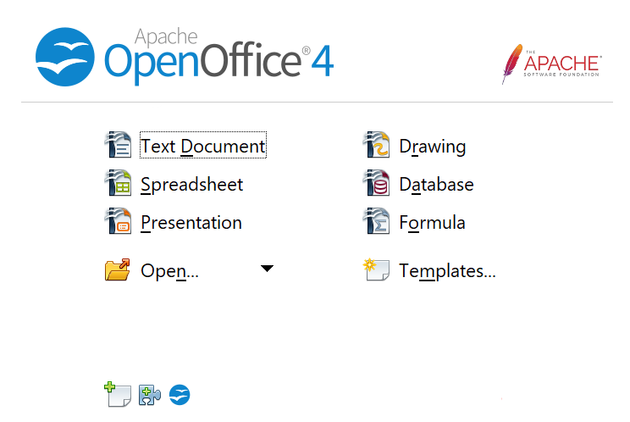

Figure 16: Apache OpenOffice Start Center
When AOO is open, you can also start a new document in one of the following ways.
- Press the Control+N keys.
- Use File > New > Text Document.
- Click the New button on the main toolbar.

Starting a New Document from a Template
You can use templates to create new documents in Writer. A template is a set of predefined styles and formatting. Templates serve as the foundation of a set of documents, to make sure they all have a similar layout. For example, all the documents of the Writer Guide are based on the same template. As a result, all the documents look alike; they have the same headers and footers, use the same fonts, and so on.
A new OpenOffice installation does not contain many templates. It is possible for you to add new templates to your installation and use them for new documents. This is explained in Chapter 10 (Working with Templates). Many templates can be downloaded from https://extensions.openoffice.org/, and you can easily make your own.
Once you have templates on your system, you can create new documents based on them by using File > New > Templates and Documents. This opens a window where you can choose the template you want to use for your document.
The example shown in Figure 17 uses a template called “AOO41GS” in the My Templates folder. Select it, then click the Open button. A new document is created based on the styles and formats defined in the template.
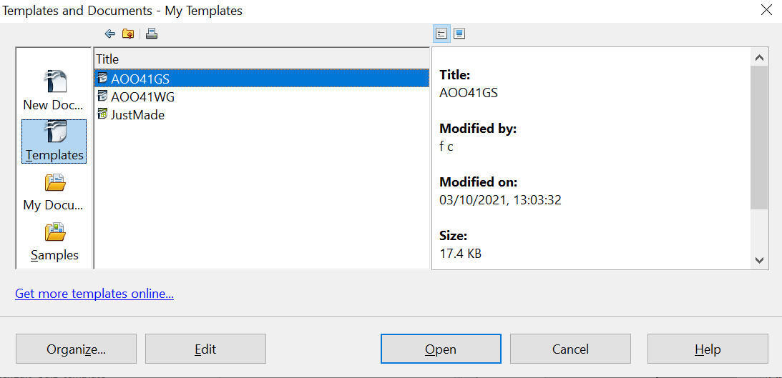

Figure 17. Creating a document from a template

Opening an Existing Document
When no document is open, the Start Center (Figure 16) provides an icon for opening an existing document or choosing from a list of recently-edited documents.

You can also open an existing document in one of the following ways. If a document is already open in AOO, the second document opens in a new window.
- Choose File > Open….
- Click the Open button on the main toolbar.
- Press Control+O on the keyboard.
- Use the Open Document or Recent Documents selections on the Quickstarter.
In each case, the Open dialog box appears. Select the file you want, and then click Open.
In the Open dialog box, you can reduce the list of files by selecting the type of file you are looking for. For example, if you choose Text documents as the file type, you will only see documents Writer can open (including *.odt, *.doc, *.txt). This method opens Word (*.doc) files as well as AOO files and other formats.
You can also open an existing Writer document using the same methods you would use to open any document in your operating system.
If you have associated Microsoft Office file formats with OpenOffice, you can also open these files by double-clicking on them.

Saving a Document
To save a new document in Writer, do one of the following:
- Press Control+S.
- Choose File > Save.
- Click the Save button on the main toolbar.
When the Save As dialog box appears, enter the file name, verify the file type (if applicable), and click Save.
To save an open document with the current file name, choose File > Save. This will overwrite the last saved state of the file.

Saving a Document Automatically
You can choose to have Writer save a recovery copy of your document automatically at regular intervals. Automatic saving, unlike manual saving, does not overwrite the last saved state of the file. It saves a temporary version that can be recovered in case of a program crash. Using this feature does not replace periodically saving your work. To set up automatic file saving:
- Select Tools > Options > Load/Save > General.
- Click on Save AutoRecovery information every and set the time interval. The default value is 15 minutes. Enter the value you want by typing it or by pressing the up or down arrow keys.

Saving as a Microsoft Word Document
If you need to exchange files with users of Microsoft Word, they may not know how to open and save .odt files. Any version of Microsoft Word since Microsoft Office 2007 with Service Pack 2 (SP2) can do this.
Some users of Microsoft Word may be unwilling to work with *.odt files. In this case, you can save a document as a Microsoft Word file.
- Important—First save your document in the file format used by AOO Writer, *.odt. If you do not, any changes you made since the last time you saved will only appear in the Microsoft Word version of the document.
- Then click File > Save As in the Save As dialog box, in the File type (or Save as type) drop-down menu, select the type of Word format you need.
- Click Save.
From this point on, all changes you make to the document will occur only in the Microsoft Word document. You have changed the name and file type of your document. If you want to go back to working with the *.odt version of your document, you must open it again.
Tip | To have Writer save documents by default in the Microsoft Word file format, go to Tools > Options > Load/Save > General. In the section named Default file format and ODF settings, under Document type, select Text document, then under Always save as, select your preferred file format. Saving in a foreign format may lead to the loss of formatting, particularly with complex documents.



Figure 18. Saving a file in Microsoft Word format

Password Protection
Writer provides two levels of document protection: read-protect (file cannot be viewed without a password) and write-protect (file can be viewed in read-only mode but cannot be changed without a password). Thus, you can make the content available for reading by a selected group of people and for reading and editing by a different group.
- Use File > Save As when saving the document. (You can also use File > Save the first time you save a new document.)
- On the Save As dialog box, select the Save with password option, and then click Save.

- The Set Password dialog box opens.

Figure 19: Two levels of password protection
Here you have several choices:
- To read-protect the document, type a password in the two fields at the top of the dialog box.
- To write-protect the document, click the More Options button and select the Open file read-only checkbox.
- To write-protect the document but allow selected people to edit it, select the Open file read-only checkbox and type a password in the two boxes at the bottom of the dialog box.
- Click OK to save the file. If either pair of passwords do not match, you receive an error message. Close the message box to return to the Set Password dialog box and enter the password again.
Caution | AOO uses a very strong encryption mechanism that makes it almost impossible to recover the contents of a document if you lose the password.

Closing a Document
To close a document, choose File > Close or click the Close icon on the document window. On Windows, this icon looks like the X in the red box shown in Figure 20.
If more than one AOO window is open, each window looks like the sample shown on the left in Figure 20. Closing this window leaves the other AOO windows open.
If only one AOO window is open, it looks like the sample shown on the right in Figure 20. Notice the small black X below the larger X in the red box. Clicking the small black X closes the document but leaves AOO open. Clicking the larger X closes AOO completely.

Figure 20. Close icons
If the document has not been saved since the last change, a message box is displayed. Choose whether to save or discard your changes.
- Save: The document is saved and then closed.
- Discard: The document is closed, and all modifications since the last save are lost.
- Cancel: Nothing happens, and you return to the document.

Closing OpenOffice
To close AOO completely, click File > Exit, or close the last open document as described in “Closing a Document” above.
If all the documents have been saved, Writer closes immediately. If any documents have been modified but not saved, a warning message appears. Follow the procedure in “Closing a Document” to save or discard your changes.

Using the Navigator
In addition to the Page Number field on the Status bar (described on page 11), Writer provides other ways to move quickly through a document and find specific items by using the many features of the Navigator, the Navigation toolbar, and related icons.
The Navigator lists all the headings, tables, text frames, graphics, bookmarks, and other objects contained in a document.
To open the Navigator, click its icon from the Sidebar tabs or on the Standard toolbar, or press F5, or choose View > Navigator on the menu bar, or double-click on the Page number field on the status bar. If the Navigator is displayed separately from the Sidebar, you can dock the Navigator to either side of the main Writer window or leave it floating (see “Docking/Floating Windows and Toolbars” on page 9).
To hide the list of categories and show only the icons at the top, click the List Box On/Off icon . This icon is not available in the Sidebar display of the Navigator since it is unnecessary. Click this icon again to show the list. Click the + sign by any of the lists to display the contents of the list.
Table 1 summarizes the functions of the icons at the top of the Navigator.
Note | The Navigator has different functions in a master document. See Chapter 13 (Working with Master Documents).

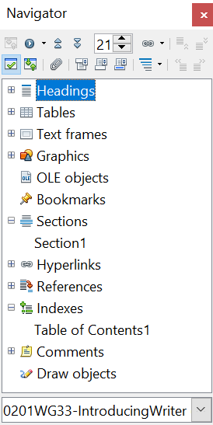

Figure 21. The Navigator
Table 1: Function of icons in the Navigator
 | Toggle: Not active in ordinary documents (left image). In a master document (right image), switches between the master document file and its subdocuments.
 | Navigation: Opens the Navigation toolbar (see page 24).
 | Previous, Next: Jumps to the previous or next item in the selected category (page, graphic, hyperlink, comment, and so on). To select the category of items, see “Using the Navigation Toolbar“ on page 24.
 | Page number: Jumps to the page sequence number showing in the box. Type the required page number or select it using the up and down arrows.
 | Drag Mode: Select Hyperlink, Link, or Copy. See “Choosing Drag Mode” on page 26 for details.
 | List Box On/Off: Shows or hides the list of categories.
 | Content View: Switches between showing all categories and showing only the selected category.
 | Set Reminder: Inserts a reminder (see page 26).
 | Header/Footer: Jumps between the text area and the header or footer area (if the page has them).
 | Anchor <–> Text: Jumps between a footnote anchor and the corresponding footnote text.
 | Heading Levels Shown: Choose the number of heading levels to be shown.

Moving Quickly through a Document
The Navigator provides several convenient ways to move around a document and find items in it:
- To jump to a specific page in the document, type its sequence number in the box at the top of the Navigator.
- When a category is showing the list of items in it, double-click on an item to jump directly to that item’s location in the document. For example, you can jump directly to a selected heading, graphic, or comment by using this method.
To see the content in only one category, highlight that category and click the Content View icon. Click the icon again to display all the categories. You can also change the number of heading levels shown when viewing Headings.
- Use the Previous and Next icons to jump to other objects of the type selected in the Navigation toolbar. (See below for details.)

Tip | Objects are much easier to find if you have given them names when creating them, instead of keeping AOO’s default names of graphics1, graphics2, Table1, Table2, and so on—which may not correspond to the position of the object in the document.  To rename an image, right-click on the image, select Picture > Options, and then edit the name in the dialog box. Similarly, to rename a table, right-click on the table, select Table > Table, and then edit the name.

Note | A hidden section (or other hidden object) in a document appears gray in the Navigator, and displays the word “hidden” as a tooltip. For more about hidden sections, see Chapter 4 (Formatting Pages).
Using the Navigation Toolbar
To display the Navigation toolbar (Figure 22), click the Navigation icon (second icon from the left at the top of the Navigator, Figure 21) or the small Navigation icon near the lower right-hand corner of the window below the vertical scroll bar (Figure 23).
Figure 22: Navigation toolbar

Figure 23: Previous, Navigation, and Next icons
The Navigation toolbar shows icons for all the object types shown in the Navigator, plus some extras (for example, the results of a Find command).
Click an icon to select that object type. Now all the Previous and Next icons (in the Navigator itself, in the Navigation Toolbar, and on the scroll bar) will jump to the previous or next object of the selected type. This is particularly helpful for finding items like index entries, which can be difficult to see in the text. The names of the icons (shown in the tooltips) change to match the selected category; for example, Next Graphic or Next Bookmark.

Rearranging Chapters Using the Navigator
You can rearrange chapters and move headings in the document by using the Navigator.
- Click the Content View icon to expand the headings, if necessary.
- (Optional) If you have several subheading levels, you can more easily find the headings you want, by changing the Heading Levels Shown selection to show only 1 or 2 levels of headings.
- Click on the heading of the block of text that you want to move and drag the heading to a new location on the Navigator, or click the heading in the Navigator list, and then click either the Promote Chapter or Demote Chapter icon shown in Figure 24. All the text and subsections under the selected heading move with it.
To move only the selected heading and not the text associated with the heading, hold down Control, and then click the Promote or Demote icon.
Tip | The tooltips Promote Chapter and Demote Chapter can be misleading; all headings—whether at Level 1 (chapter) or lower—can be rearranged using this function; and the feature might be better described as Move Up or Move Down (within the document, without changing the heading level) to distinguish it more clearly from Promote Level and Demote Level, which change the heading level within the document (see below).

- To quickly change the outline level of a heading and its associated subheadings, select the heading in the Navigator, and then click either the Promote Level or Demote Level icon. This action does not change the location of the heading, only its level.
To increase the outline level of only the selected heading, but not its associated subheadings, hold down Control, and then click the icon.

Figure 24. Reorganizing with the Navigator

Setting Reminders
One of the little-known features of Writer that you may find quite useful is the possibility of jumping between reminders. Reminders let you mark places in your document that you want to return to later on, to add or correct information, make some other change, or simply mark where you finished editing. The possible uses of reminders are limited only by your imagination.
To set a reminder at the cursor's current location, click on the icon in the Navigator. You can set up to 5 reminders in a document; setting another causes the first to be deleted.
Reminders are not highlighted in any way in the document, so you cannot see where they are, except when you jump from one to the next—the location of the cursor then shows the location of the reminder.
To jump between reminders, first select the Reminder icon on the Navigation toolbar. Then click the Previous and Next icons.

Choosing Drag Mode
To select the drag and drop options for inserting items such as other documents and images, into a document using the Navigator, choose one of the following from the drop-down menu of the Drag Mode icon .
Insert As Hyperlink
Creates a hyperlink when you drag and drop an item into the current document.
Insert As Link
Inserts the selected item as a link where you drag and drop in the current document. Text is inserted as protected sections. However, you cannot create links for graphics, OLE objects, references, or indexes using this method.
Insert As Copy
Inserts a copy of the selected item where you drag and drop in the current document. You cannot drag and drop copies of graphics, OLE objects, or indexes.

Getting Help
Writer provides several forms of help. In addition to a full Help file (reached by pressing F1 or choosing Help > OpenOffice Help from the menu bar), you can choose whether to activate tooltips, extended tips, and the Help Agent from Tools > Options > OpenOffice > General.
Placing the mouse pointer over any of the icons displays a small box, called a tooltip. It gives a brief explanation of the icon’s function. For a more detailed explanation, select Help > What’s This? and hold the mouse pointer over the icon you need more help with.

What Are All These Things Called?
The terms used in OpenOffice for most parts of the user interface (the parts of the program you see and use, in contrast to the behind-the-scenes code that actually makes it work) are the same as for most other programs.
A dialog box is a special type of window. Its purpose is to inform you of something, or request input from you, or both. It provides controls for you to use to specify how to carry out an action. The technical names for common controls are shown in Figure 25; not shown is the list box (from which you select an item). In most cases we do not use the technical terms in this book, but it is useful to know them because the Help and other sources of information often use them.
In most cases, you can interact only with the dialog box (not the document itself) as long as the dialog box remains open. When you close the dialog box after use (usually, clicking OK or another button saves your changes and closes the dialog box), then you can again work with your document.
Some dialog boxes can be left open as you work, so you can switch back and forth between the dialog box and your document. An example of this type is the Find & Replace dialog box. The Sidebar also remains visible unless you choose to hide it.

Figure 25: Dialog box (not from Writer) showing common controls:
1=Tabbed page (not strictly speaking a control)
2=Radio buttons (only one can be selected at a time)
3=Checkbox (more than one can be selected at a time)
4=Spin box (click the up and down arrows to change the number
shown in the text box next to it, or type in the text box)
5=Thumbnail or preview
6=Drop-down list from which to select an item
7=Push buttons

Undoing and Redoing Changes
When a document is open, you can undo the most recent change by pressing Control+Z, or clicking the Undo icon on the Standard toolbar, or choosing Edit > Undo from the menu bar.
The Edit menu shows the latest change that can be undone. Click the small triangle to the right of the Undo icon to get a list of all the changes that can be undone. You can select multiple changes and undo them at the same time.

Figure 26: List of actions that can be undone
After changes have been undone, Redo becomes active. To redo a change, select Edit > Redo, or press Control+Y or click on the Redo icon . As with Undo, click on the triangle to the right of the arrow to get a list of the changes that can be reapplied.

Using Writer on a Mac
Some keystrokes and menu items are different on a Mac from those used in Windows and Linux. The following table gives some common substitutions for the instructions in this book. For a more detailed list, see the application Help.
Windows/Linux | Mac equivalent | Effect
Tools > Options menu selection | OpenOffice > Preferences | Access setup options
Right-click | Control+click | Open context menu
Ctrl (Control) | z (Command) | Used with other keys
F5 | Shift+z+F5 | Open the Navigator
F11 | z+T | Open the Styles and Formatting window

Chapter 2
Setting up Writer
Choosing Options to Suit the Way You Work

Choosing Options that Affect all of AOO
This section covers some of the settings that apply to all the components of AOO and are particularly important when using Writer. Other general options are discussed in Chapter 2 (Setting Up OpenOffice) in the Getting Started guide.
Click Tools > Options (on macOS use OpenOffice > Preferences). The list on the left-hand side of the Options—OpenOffice dialog box varies depending on which component of AOO is open. The illustrations in this chapter show the list as it appears when a Writer document is open.
Click the expansion symbol (+ sign or triangle) by OpenOffice on the left-hand side. A list of pages drops. Selecting an item in the list causes the right-hand side of the dialog box to display the relevant page.
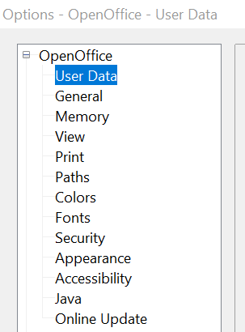

Figure 27: OpenOffice options
Note | The Back button has the same effect on all pages of the Options dialog box. It resets options to the values that were in place when you opened AOO.

User Data Options
Because Writer uses the name or initials stored in the OpenOffice—User Data page for several things, including document properties (created by and last edited by information) and the name of the author of notes and changes, you will want to ensure that the correct information appears here.
Fill in the form (shown inFigure 27) or amend or delete any existing incorrect information.
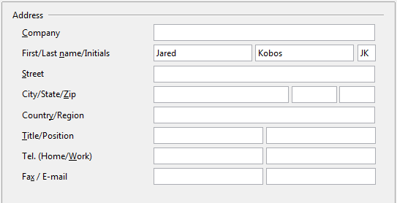
Figure 28: Filling in user data

General Options
The options on the OpenOffice—General page are described below.
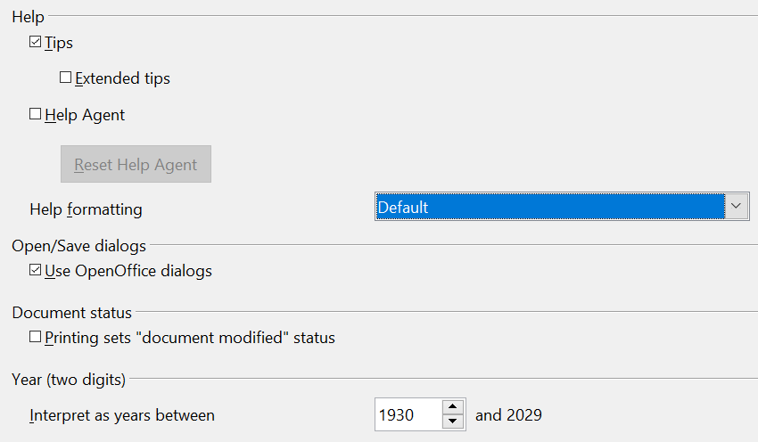
Figure 29: Setting general options for OpenOffice
Help—Tips
When Tips is active, one or two words will appear when you hold the mouse pointer over an icon or field, without clicking.
Help—Extended tips
When Extended tips are active, a brief description of the function of a particular icon or menu command or a field on a dialog box appears when you hold the mouse pointer over that item.
Help—Help Agent
To turn off the Help Agent, deselect this option. To restore the default behavior, click Reset Help Agent.
Help—Help formatting
High contrast is an operating system setting that changes the system color scheme to improve readability. To display Help in high contrast (if your computer’s operating system supports this), choose one of the high-contrast style sheets from the pull-down list.
High-contrast style | Visual effect
Default | Black text on white background
High Contrast #1 | Yellow text on black background
High Contrast #2 | Green text on black background
High Contrast Black | White text on black background
High Contrast White | Black text on white background
Open/Save dialogs
To use the standard Open and Save dialog boxes for your operating system, deselect the Use OpenOffice dialogs option. When this option is selected, the Open and Save dialog boxes supplied with OpenOffice will be used. This book uses the AOO Open and Save dialog boxes in illustrations.
Document status
If this option is selected, then the next time you close the document after printing, the print date is recorded in the document properties as a change, and you will be prompted to save the document again, even if you did not make any other changes.
Year (two digits)
Specifies how two-digit years are interpreted. For example, if the two-digit year is set to 1930, and you enter a date of 1/1/30 or later into your document, the date is interpreted as 1/1/1930 or later. An “earlier” date is interpreted as being in the following century; that is, 1/1/20 is interpreted as 1/1/2020.

Memory Options
In the Options dialog, click OpenOffice > Memory. Some considerations:
- More memory can make OpenOffice faster and more convenient (for example, more undo steps require more memory); but the trade-off is less memory available for other applications, and you could run out of memory altogether.
- If your documents contain a lot of objects such as images, or the objects are large, AOO’s performance may improve if you increase the memory for AOO or the memory per object. If you find that objects seem to disappear from a document that contains a lot of them, increase the number of objects in the cache. (The objects are still in the file even if you cannot see them on screen.)
- To load the Quickstarter (an icon on the desktop or in the system tray) when you start your computer, select the option near the bottom of the dialog. This makes OpenOffice start faster; the trade-off is that AOO uses some memory even when not being used. This option (sometimes called Enable systray quickstarter) is not available on all operating systems.
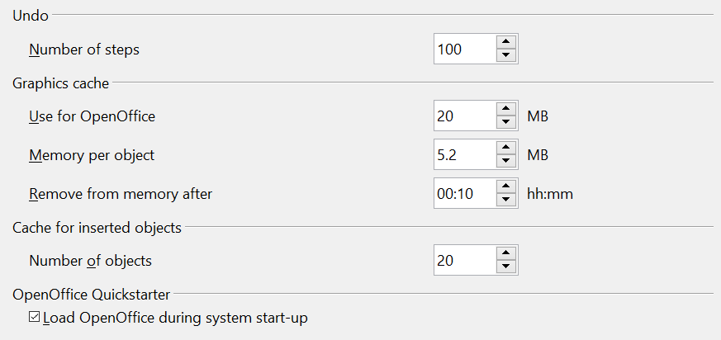
Figure 30: Choosing Memory options for the OpenOffice applications

View Options
The options on the OpenOffice— View page affect the way the document window looks and behaves. Some of these options are described below. Set them to suit your personal preferences.
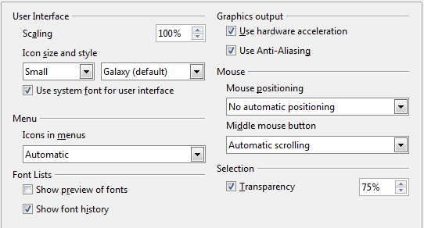
Figure 31: Choosing View options for OpenOffice applications
User Interface—Scaling
If the text in the help files or on the menus of the AOO user interface is too small or too large, you can change it by specifying a scaling factor. Sometimes a change here can have unexpected results, depending on the screen fonts available on your system. However, it does not affect the font size of the text in your documents.
User Interface—Icon size and style
The first box specifies the display size of toolbar icons (Automatic, Small, or Large); the Automatic icon size option uses the setting for your operating system. The second box specifies the icon style (theme); here the Automatic option uses an icon set compatible with your operating system and choice of desktop: for example, KDE or Gnome on Linux.
User Interface—Use system font for user interface
If you prefer to use the system font (the default font for your computer and operating system) instead of the font provided by AOO for the user interface, select this option.
User interface—Screen font Anti-Aliasing
(Not available in Windows; not shown in Figure 31.) Smooths the screen appearance of text. Enter the smallest font size to apply anti-aliasing.
Menu—Icons in menus
Causes icons as well as words to be visible in menus.
Font Lists—Show preview of fonts
Causes the font list to look like Figure 32, Left, with the font names shown as an example of the font; with the option deselected, the font list shows only the font names, not their formatting (Figure 32, Right). The fonts you will see listed are those that are installed on your system.
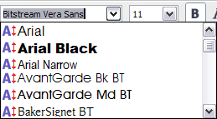 | 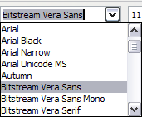
Figure 32: Font list (Left) showing preview; (Right) without preview
Font Lists—Show font history
Causes the last five fonts you have assigned to the current document to be displayed at the top of the font list.
Graphics output—Use hardware acceleration
Directly accesses hardware features of the graphical display adapter to improve the screen display. Not supported on all operating systems and AOO distributions.
Graphics output—Use Anti-Aliasing
Enables and disables anti-aliasing, which makes the display of most graphical objects look smoother and with fewer artifacts. Not supported on all operating systems and AOO distributions.
Tip | Press Shift+Control+R to restore or refresh the view of the current document.

Mouse positioning
Specifies if and how the mouse pointer will be positioned in newly opened dialog boxes.
Middle mouse button
Defines the function of the middle mouse button.
- Automatic scrolling – dragging while pressing the middle mouse button shifts the view.
- Paste clipboard – pressing the middle mouse button inserts the contents of the “Selection clipboard” at the cursor position.
The “Selection clipboard” is independent of the normal clipboard that you use by Edit > Copy/Cut/Paste or their respective keyboard shortcuts. The clipboard and “Selection clipboard” can contain different contents at the same time.
Function | Clipboard | Selection clipboard
Copy content | Edit > Copy Control+C | Select text, table, or object.
Paste content | Edit > Paste Control+V pastes at the cursor position. | Clicking the middle mouse button pastes at the mouse pointer position.
Pasting into another document | No effect on the clipboard contents. | The last marked selection is the content of the selection clipboard.

Print Options
On the OpenOffice—Print page, set the print options to suit your default printer and your most common printing method.
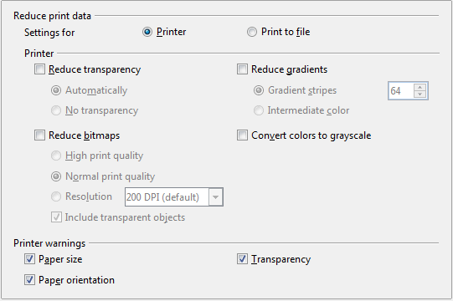
Figure 33: Choosing general printing options to apply to all AOO components
In the Printer warnings section near the bottom of the page, you can choose whether to be warned if the paper size or orientation specified in your document does not match the paper size or orientation available for your printer. Having these warnings turned on can be quite helpful, particularly if you work with documents produced by people in other countries where the standard paper size is different from yours.
Tip | If your printouts are incorrectly placed on the page or chopped off at the top, bottom, or sides or the printer is refusing to print, the most likely cause is page-size incompatibility.

Path Options
On the OpenOffice—Paths page, you can change the location of files associated with, or used by, AOO to suit your working situation. In a Windows system, for example, you might want to store documents by default somewhere other than Documents.
To make changes, select an item in the list shown in Figure 34 and click Edit. On the Select Paths dialog (not shown), add or delete folders as required, and then click OK to return to the Options dialog. Note that many items can have at least two paths listed: one to a shared folder (which might be on a network) and one to a user-specific folder (normally on the user’s personal computer).
Tip | You can use the entries in the OpenOffice—Paths dialog to compile a list of files, such as those containing AutoText, that you need to back up or copy to another computer.

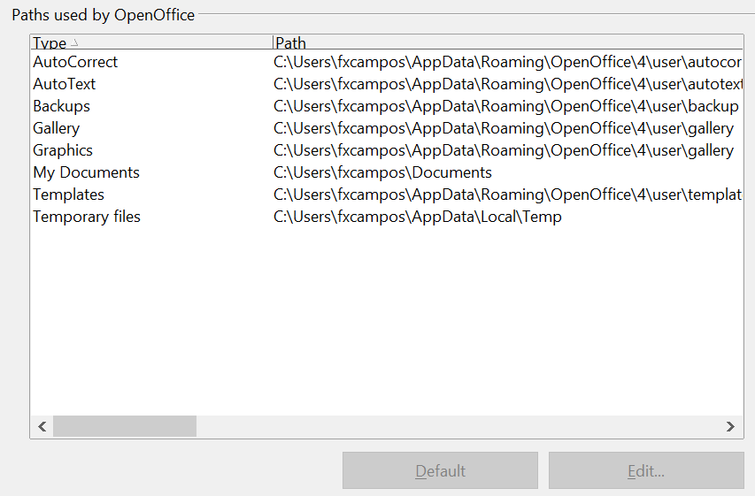
Figure 34: Viewing the paths of files used by AOO

Color Options
On the OpenOffice—Colors page, you can specify colors to use in AOO documents. You can select a color from a color table, edit an existing color, or define new colors. These colors will then be available in color selection palettes in AOO.
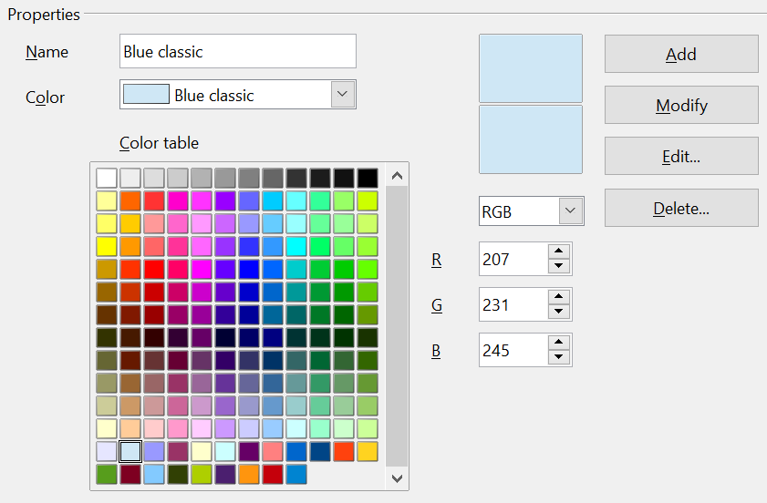
Figure 35: Defining colors to use in color palettes in AOO
To modify a color:
- Select the color to modify from the list or the color table.
- Enter the new values that define the color. If necessary, change the settings from RGB (Red, Green, Blue) to CMYK (Cyan, Magenta, Yellow, Black) or vice versa. The changed color appears in the lower of the two color preview boxes at the top.
- Modify the Name as required.
- Click the Modify button. The newly defined color is now listed in the Color table.
Alternatively, click the Edit button to open the Color dialog, shown in Figure 36. Here you can select a color from the color window in the upper area, or you can enter values on the right using your choice of RGB, CMYK, or HSB (Hue, Saturation, and Brightness) values.
The upper color window is linked directly with the color input fields; as you choose a color in the upper window, the numbers change accordingly. The two color fields at the bottom show the appearance of the adjusted color on the left and the original color on the right.
Modify the color components as required and click OK to exit the dialog. The newly defined color now appears in the lower of the color preview boxes shown in Figure 35. Type a name for this color in the Name box, then click the Add button. A small box showing the new color is added to the Color table.
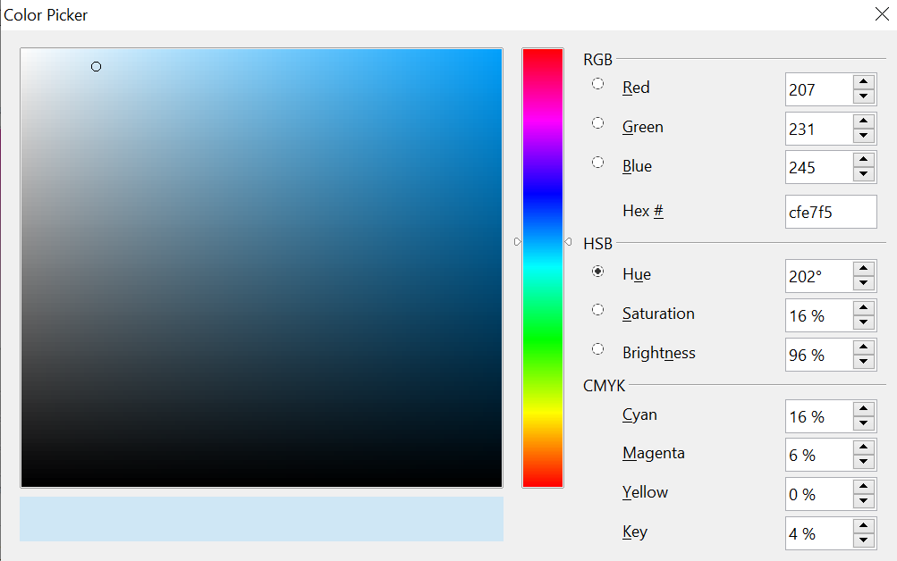
Figure 36: Editing colors
Another way to define or alter colors is through the Colors page of the Area dialog, where you can also save and load palettes, a feature that is not possible here. In Writer, draw a temporary draw object and use the context menu of this object to open the Area dialog.

Font Options
You can define replacements for any fonts that might appear in your documents. If you receive from someone else a document containing fonts that you do not have on your system, AOO will substitute fonts for those it does not find. You might prefer to specify a different font from the one the program chooses.
On the OpenOffice—Fonts page:
- Select Apply Replacement Table option.
- Select or type the name of the font to be replaced in the Font box. (If you do not have this font on your system, it will not appear in the drop-down list in this box, so you need to type it in.)
- In the Replace With box, select a suitable font from the drop-down list of fonts installed on your computer.
- The check mark to the right of the Replace with box turns green. Click on this check mark. A row of information now appears in the larger box below the input boxes. Select the boxes under Always and Screen.
- In the bottom section of the page, you can change the typeface and size of the font used to display source code such as HTML and Basic (in macros).
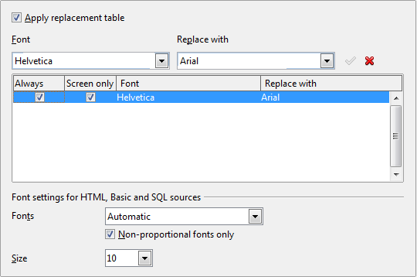
Figure 37: Defining a font to be substituted for another font

Security Options
Use the OpenOffice—Security page to choose security options for saving documents and for opening documents that contain macros.
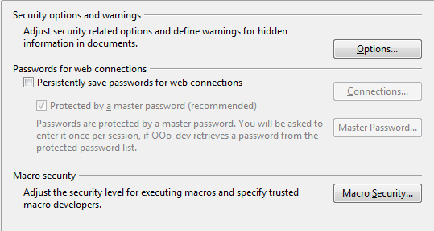
Figure 38: Choosing security options for opening and saving documents
Security Options and warnings
If you record changes, save multiple versions, or include hidden information or notes in your documents, and you do not want some recipients to see that information, you can set warnings to remind you to remove it, or you can have AOO remove some of it automatically. Note that (unless removed) much of this information is retained in a file whether the file is in OpenOffice’s default OpenDocument format, or has been saved to other formats, including PDF.
Click the Options button to open a separate dialog with specific choices (Figure 38).
Remove personal information on saving. Select this option to always remove user data from the file properties when saving the file. To manually remove personal information from specific documents, deselect this option and then use the Delete button under File > Properties > General.
Figure 39: Security options and warnings dialog box
Ctrl-click required to follow hyperlinks. Many people find creating and editing documents easier when accidental clicks on links do not activate the links.
The other options on this dialog should be self-explanatory.
Macro security
Click the Macro Security button to open the Macro Security dialog, where you can adjust the security level for executing macros and specify trusted sources.

Appearance Options
Writing, editing, and (especially) page layout are often easier when you can see the page margins (text boundaries), the boundaries of tables and sections, grid lines, and other features. In addition, you might prefer to use colors that are different from AOO’s defaults for such items as note indicators or field shadings.
On the OpenOffice—Appearance page, you can specify which items are visible, and the colors used to display various items.
- To show or hide items such as text boundaries, select or deselect them.
- To change the default colors for items, click the down-arrow in the Color setting column by the name of the item and select a color from the pop-up box.
- To save your color changes as a color scheme, type a name in the Scheme box and click Save.
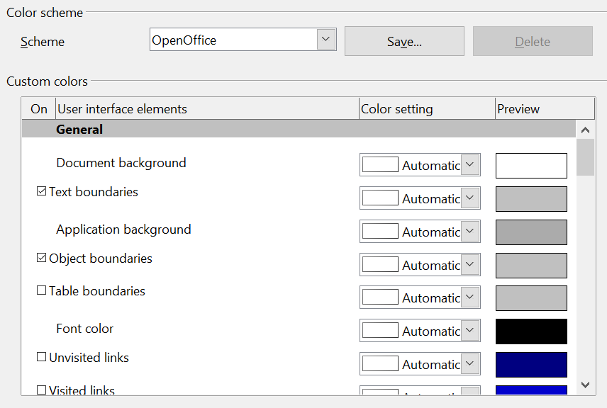
Figure 40: Showing or hiding text, object, and table boundaries

Choosing Options for Loading and Saving Documents
You can set the Load/Save options to suit the way you work.
If the Options dialog is not already open, click Tools > Options. Click the expansion symbol (+ sign or triangle) to the left of Load/Save.
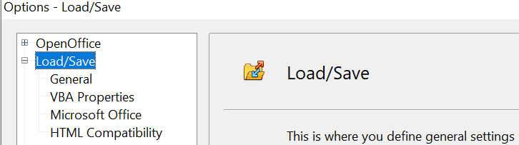
Figure 41: Load/Save options

General Load/Save Options
Most of the choices on the Load/Save—General page (Figure 37) are familiar to users of other office suites. Some items of interest are described below.
Load user-specific settings with the document
When you save a document, certain settings are saved with it. Some settings (printer name, data source linked to the document) are always loaded with a document, whether this option is selected. If you select this option, these document settings are overruled by the user-specific settings of the person who opens it. If you deselect this option, the user’s personal settings do not overrule the settings in the document. For example, your choice (in the options for AOO Writer) of how to update links is affected by the Load user-specific settings option.
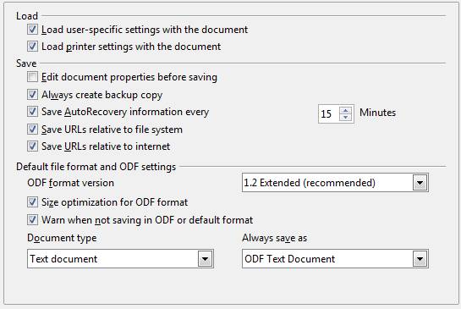
Figure 42: Choosing Load and Save options
Load printer settings with the document
If this option is not selected, the printer settings that are stored with the document are ignored when you print it using the Print File Directly icon. The default printer in your system is used instead.
Edit document properties before saving
If this option is selected, the Document Properties dialog pops up to prompt you to enter relevant information the first time you save a new document (or whenever you use Save As).
Save AutoRecovery information every __ Minutes
Choose whether to enable AutoRecovery and how often to save the information used by the AutoRecovery process. AutoRecovery in OpenOffice does not overwrite the original file; it saves a temporary version.
Note | Using this option is not a substitute for regularly saving your work.

Save URLs relative to file system / internet
Relative addressing to a file system is only possible if the source document and the referenced document are both on the same drive. A relative address always starts from the directory in which the current document is located. It is recommended to save relatively if you want to create a directory structure on an Internet server.
Default file format and ODF settings
ODF format version. OpenOffice by default saves documents in Open Document Format (ODF) version 1.2. This format has been the default for many years and only very old versions of OpenOffice or other software would not be able to handle such documents.
Size optimization for ODF format. OpenOffice's documents are XML files. When you select this option, AOO writes the XML data without indents and line breaks. If you want to be able to read the XML files in a text editor in a structured form, deselect this option.
Document type. If you routinely share documents with users of Microsoft Word, you might want to change the Always save as attribute for text documents to one of the Word formats.
Note | Although Writer can open files in the .docx format produced by Microsoft Word, it cannot save in .docx format.

VBA Properties Load/Save Options
On the Load/Save—VBA Properties page, you can choose whether to keep any macros in Microsoft Office documents that are opened in OpenOffice. These macros are disabled in AOO.
If you choose Load Basic code, you can edit the macros in AOO. The changed code is saved in an AOO document but is not retained if you save into a Microsoft Office format.
If you choose Save original Basic code, the macros are retained unchanged if you save the file into Microsoft Office format.
Save original Basic code takes precedence over Load Basic code. If both options are selected, and you edit the disabled code in AOO, the original Microsoft Basic code will be saved when saving in a Microsoft Office format.
To remove any possible macro viruses from the Microsoft Office document, deselect Save original Basic code. The document will be saved without the Microsoft Basic code.
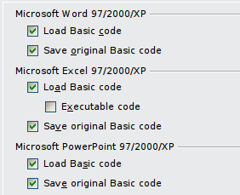
Figure 43: Choosing Load/Save VBA Properties

Microsoft Office Load/Save Options
On the Load/Save—Microsoft Office page, you can choose what to do when importing and exporting Microsoft Office OLE objects (linked or embedded objects or documents such as spreadsheets or equations).
Select the [L] check boxes to convert Microsoft OLE objects into the corresponding OpenOffice OLE objects when a Microsoft document is loaded into AOO (mnemonic: “L” for “load”).
Select the [S] check boxes to convert OpenOffice OLE objects into the corresponding Microsoft OLE objects when a document is saved in a Microsoft format (mnemonic: “S” for “save”).
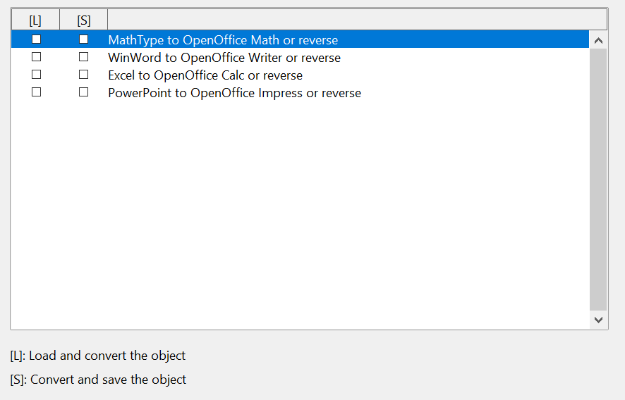
Figure 44: Choosing Load/Save Microsoft Office options

HTML Compatibility Load/Save Options
Choices made on the Load/Save—HTML Compatibility page affect HTML pages imported into OpenOffice and those exported from AOO. See HTML documents; importing/exporting in the Help for more information.
Font sizes
Use these fields to define the respective font sizes for the HTML <font size=1> to <font size=7> tags, if they are used in the HTML pages. (Many pages no longer use these tags.)
Import—Use 'English (USA)' locale for numbers
When importing numbers from an HTML page, the decimal and thousands separator characters differ according to the locale of the HTML page. The clipboard, however, contains no information about the locale. If this option is not selected, numbers will be interpreted according to the Language—Locale setting in Tools > Options > Language Settings > Languages (see page 58). If this option is selected, numbers will be interpreted as for the English (USA) locale.
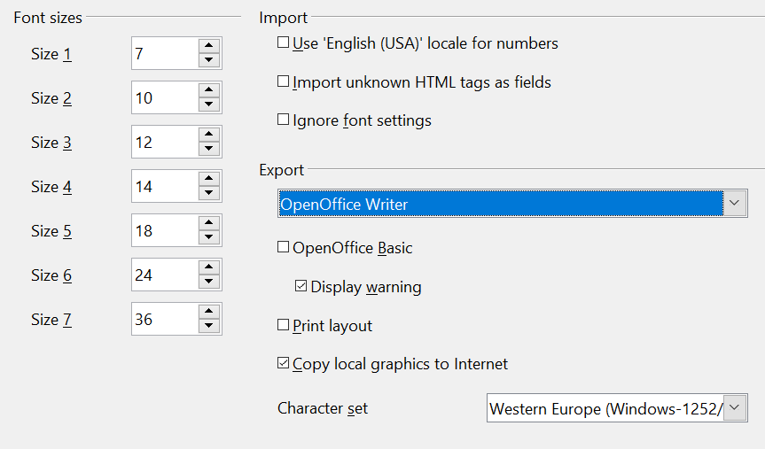
Figure 45: Choosing HTML compatibility options
Import—Import unknown HTML tags as fields
Select this option if you want tags that are not recognized by AOO to be imported as fields. For an opening tag, an HTML_ON field will be created with the value of the tag name. For a closing tag, an HTML-OFF will be created. These fields will be converted to tags in the HTML export.
Import—Ignore font settings
Select this option to have AOO ignore all font settings when importing. The fonts that were defined in the HTML Page Style will be used.
Export
To optimize the HTML export, select a browser or HTML standard from the Export box. If OpenOffice Writer is selected, specific OpenOffice Writer instructions are exported.
Export—OpenOffice Basic
Select this option to include AOO Basic macros (scripts) when exporting to HTML format. You must activate this option before you create the OpenOffice Basic macro; otherwise the script will not be inserted. OpenOffice Basic macros must be located in the header of the HTML document. Once you have created the macro in the OpenOffice Basic IDE, it appears in the source text of the HTML document in the header.
If you want the macro to run automatically when the HTML document is opened, choose Tools > Customize > Events.
Export—Display warning
When the OpenOffice Basic option (see above) is not selected, the Display warning option becomes available. If the Display warning option is selected, then when exporting to HTML a warning is shown that OpenOffice Basic macros will be lost.
Export—Print layout
Select this option to export the print layout of the current document as well.
The HTML filter supports CSS2 (Cascading Style Sheets Level 2) for printing documents. These capabilities are only effective if print layout export is activated.
Export—Copy local graphics to Internet
Select this option to automatically upload the embedded pictures to the Internet server when uploading using FTP.
Export—Character set
Select the appropriate character set for the export.

Choosing Options for Writer
Settings chosen on the pages in the OpenOffice Writer section of the Options dialog box determine how your Writer documents look and behave while you are working on them.
If the Options dialog box is not already open, click Tools > Options.
Click the expansion symbol (+ sign or triangle) by OpenOffice Writer on the left-hand side of the Options—OpenOffice dialog box. A list of pages appears.
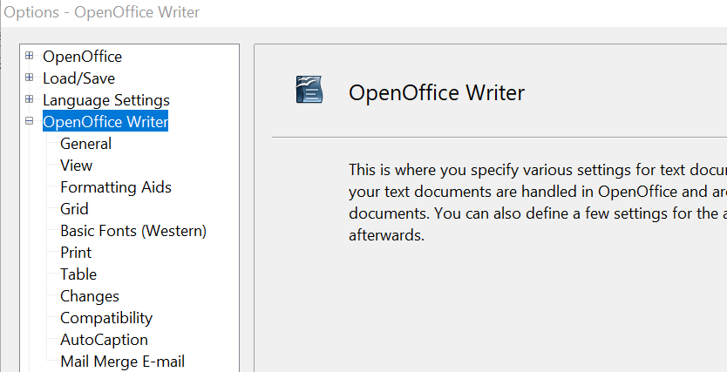
Figure 46: OpenOffice Writer options

General Options
The choices on the OpenOffice Writer—General page affect the updating of links and fields, the units used for rulers and other measurements, and the default tab stop positions.
Update links when loading
Depending on your work patterns, you may not want links to be updated when you load a document. For example, if your file links to other files on a network, you won’t want those links to update when you are not connected to the network.
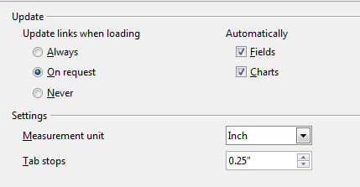
Figure 47: Choosing general options for Writer
Update fields and charts automatically
You may not want fields or charts to update automatically when you are working, because that slows down performance.
Settings—Tab stops
The Tab stops setting specifies the distance the cursor travels for each press of the Tab key. This setting is also used for the indent distance applied by the Increase Indent and Decrease Indent buttons on the Formatting Bar, which affect the indentation of entire paragraphs.
Using the default tab stops to space out or indent material on a page is not recommended. If you use the default tab interval and then send the document to someone who uses a different default tab interval, then your tabbed material will be displayed using the other person’s default tab settings. In addition, any changes to the default tab stops will change the existing default tab stops in any document you open afterward, as well as tab stops you insert after making the change.
To avoid these unwanted changes, define your own tabs in paragraph styles or individual paragraphs (see “Defining your own tab stops and indents” in Chapter 3, Working with Text).

View Options
Two pages of options set the defaults for viewing Writer documents: View (described here) and Formatting Aids (described below).
If the items on the OpenOffice Writer—View page are not self-explanatory, you can easily test their effects in a blank document.
This is a good page to check if, for example, you cannot see graphics on the screen, or you see field codes instead of the text or numbers you are expecting.
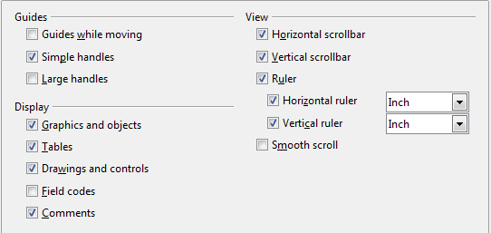
Figure 48: Choosing View options for Writer

Formatting Aids Options
The display of symbols such as paragraph ends and tabs helps you when writing, editing, and doing page layout. For example, you might want to know if any blank paragraphs or tabs are included or if any tables or graphics are too wide and intrude into the margins of the page.
On the OpenOffice Writer—Formatting Aids page, select the required options.
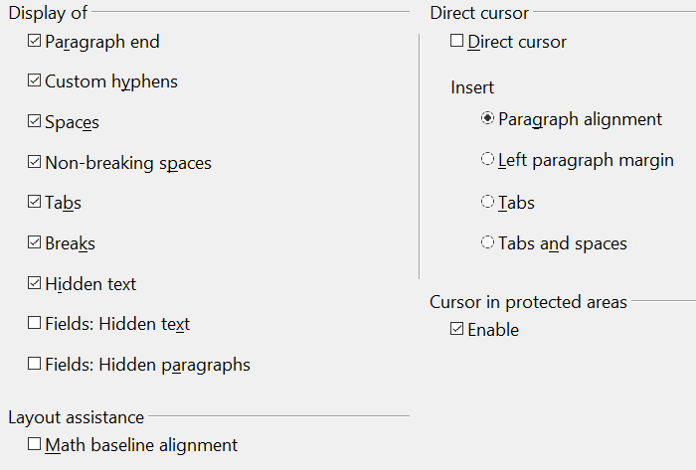
Figure 49: Choosing Formatting Aids options
Note | Direct cursor lets you enter text, images, tables, frames, and other objects in any blank area in your document. Writer inserts blank paragraphs and tabs to position the text or objects.  This feature is incompatible with rigorous use of styles and can lead to many formatting oddities, so it should be avoided by professional writers.

Grid Options
Specifying “snap to grid” can be very helpful when you are trying to align several objects such as graphics or tables.
On the OpenOffice Writer—Grid page, you can choose whether to enable this feature and what grid intervals to use. If the grid intervals (subdivisions) are too large, you may find that you do not have enough control in placing the objects.
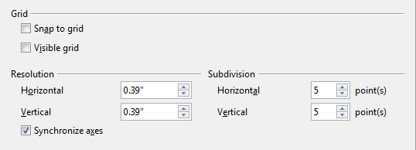
Figure 50: Choosing Grid options

Default Fonts
The default fonts specified on the OpenOffice Writer—Basic Fonts (Western) page apply to both Writer documents and HTML (Web) documents.
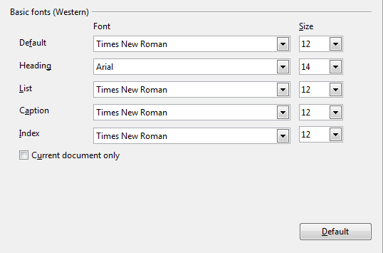
Figure 51: Choosing default fonts
- If you want to change the defaults, do so on this page. You can, of course, choose other fonts for use in specific documents, either by applying direct formatting or by defining and applying styles in those documents.
- When choosing fonts on this page you are not limited to single fonts or to the ones shown in the drop-down list. You can specify a “font family” as a comma separated set of fonts that includes those suitable for Windows, Macintosh, Linux, and other operating systems. These choices are particularly important in HTML documents.
- If the document is viewed on a system that does not have the first font specified, it will use one of the other fonts if that one is available. Otherwise, it will substitute a font that is available on the system.
- Type the list of fonts, separated by commas, in the boxes. If you want these defaults to apply to the current document only, select that option. The Default button resets the values on this page to the defaults installed with OpenOffice.

Print Options
On the OpenOffice Writer—Print page (Figure 28), you can choose which items are printed with the document by default. These options are in addition to those on the OpenOffice—Print page (Figure 33).
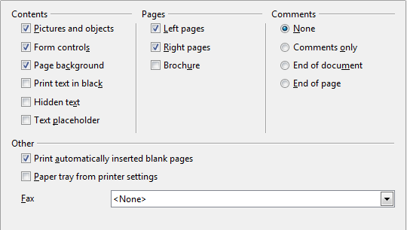
Figure 52: Choosing Print options for Writer
Some considerations:
- When you are working on drafts, and you want to save printer ink or toner, you might want to deselect some items in the Contents section.
- The Print text in black selection causes colored text (but not graphics) to print as black on a color printer; on a black-and-white printer, this option causes color text to print as solid black instead of shades of gray (dithered).
- The Print text in black option has a different effect than the Convert colors to gray scale on the Options—OpenOffice—Print page (Figure 29), which prints all graphics as gray scale on color printers. (On black-and-white printers, color in graphics normally prints as gray scale.)
- If you are printing double-sided on a non-duplexing printer, you might choose to print only left or right pages, then turn the stack over and print the other pages.
- Depending on how your printer ejects pages (face up or face down), you might need to print the pages in reverse order, so they stack in the correct order as they are printed.
Tip | You can override any of these defaults when printing a document. Click File > Print, then click the Options button on the Print dialog box. The Printer Options dialog box that appears is similar to the one shown in Figure 28.

Default Table Options
On the OpenOffice Writer—Table page, you can specify the default behavior of tables.
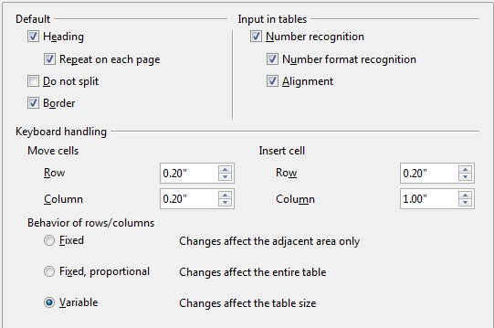
Figure 53: Choosing default Table options
Some considerations:
- If most of your tables will require borders or headings, select those options. If most of your tables are used for page layout, deselect borders and headings.
- Number recognition can be very useful if most of your tables contain numerical data; Writer will recognize dates or currency, for example, and format the numbers appropriately. However, if you want the numbers to remain as ordinary text, this feature can be quite irritating, so you will want to deselect it.
- The Keyboard handling section specifies the distances that cells move when you use keyboard shortcuts to move them and the size of rows and columns inserted using keyboard shortcuts.
- The choices in the Behavior of rows/columns section determine the effects that changes to rows or columns have on adjacent rows or columns and the entire table. You might need to test these selections to fully understand the effects.

Change Tracking Options
If you plan to use the change-tracking feature of Writer, use the OpenOffice Writer—Changes page to choose the way inserted and deleted material is marked, whether and how attribute changes are marked, and whether and how change bars are marked in the margins.
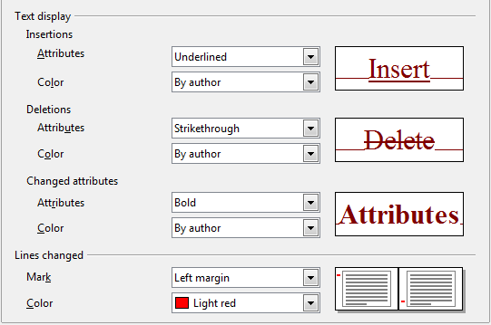
Figure 54: Choosing options for tracking changes

Compatibility Options
Do you need to import Microsoft Word documents into AOO Writer? If so, you might want to select some or all of the settings on the OpenOffice Writer—Compatibility page. If you are not sure about the effects of these settings, leave them as the defaults provided by AOO. For information about the settings not described below, see the Help.
Use printer metrics for document formatting
If this option is selected, the printer specified for the document determines how the document is formatted for viewing on screen. The line breaks and paragraph breaks you see on screen match those that apply when the document is printed on that printer.
This setting can be useful when several people are reviewing a document that will eventually be printed on a specific printer or when the document is exported to PDF (a process that uses “Adobe PDF” as the printer).
If this option is not selected, a printer-independent layout will be used for screen display and printing.
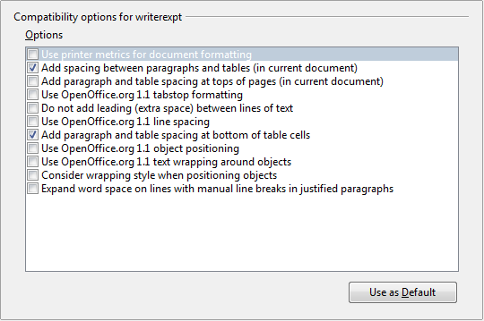
Figure 55: Choosing compatibility options
Add spacing between paragraphs and tables (in current document)
In OpenOffice Writer, paragraph spacing is defined differently than it is in MS Word documents. If you have defined spacing between two paragraphs or tables, spacing is also added in the corresponding MS Word documents.
If this option is selected, MS Word-compatible spacing is added between paragraphs and tables in OpenOffice Writer documents.
Add paragraph and table spacing at tops of pages (in current document)
You can define paragraphs to have space appear before (above) them. If this option is selected, any space above a paragraph will also appear if the paragraph is at the beginning of a page or column, if the paragraph is positioned on the first page of the document, or after a manual page break.
If you import an MS Word document, the spaces are automatically added during the conversion.
Add paragraph and table spacing at bottom of table cells
Specifies that the bottom spacing is added to a paragraph, even when it is the last paragraph in a table cell.
Use as Default
Click this button to use the current settings on this page as the default in OpenOffice.

AutoCaption Options
Do you want AOO to automatically insert captions for tables, pictures, frames, and OLE objects that have been inserted in a Writer document?
Note | You may not always want captions for every table, for example, if you use tables for layout as well as for tables of data. You can always add captions to individual tables, graphics, or other objects (right-click > Caption).

If you do want automatic captions on one or more object types:
- Choose OpenOffice Writer > AutoCaption on the Options dialog box.
- On the OpenOffice Writer—AutoCaption page (Figure 30), select the checkbox next to an object you want to be automatically captioned (Picture in the example shown).
- With the item highlighted, specify the characteristics of the caption. The supplied categories for captions are Drawing, Illustration, Table, and Text. However, you are not limited to the supplied categories. If you want to use another name (for example, Figure) for the caption label, type the required term in the box. In the example shown, I have added the category “Figure” to the list.
Additional information about numbering captions by chapter, character styles, frame styles, and other items on the AutoCaption page, is given in later chapters in the Writer Guide.
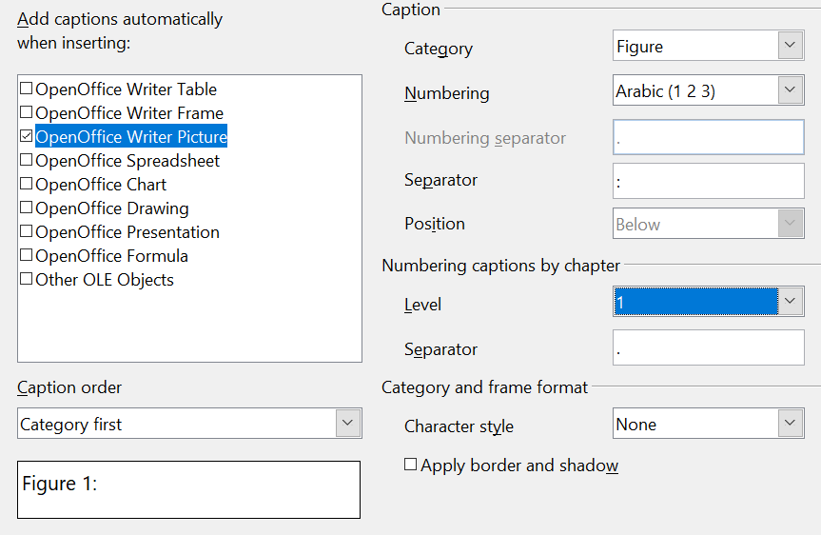
Figure 56: Setting up a new category for automatic captions on graphics

Mail Merge E-mail Options
You can produce form letters using Writer and then use the mail merge function to personalize those letters and send them to a number of addresses taken from a data source, such as an address book. Mail merged documents can be printed and mailed, or sent by e-mail.
Use the OpenOffice Writer—Mail Merge E-mail page to set up the user and server information for sending form letters by e-mail. If you are not sure what information to put in any of the fields, consult your e-mail program or your Internet service provider.
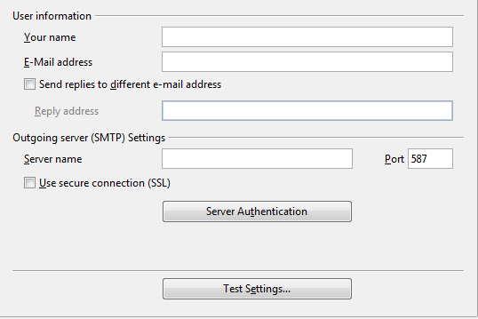
Figure 57: Specifying settings for use when e-mailing mail-merged form letters

Choosing Options for HTML Documents
You can configure OpenOffice to treat HTML documents in Writer differently than regular documents.
- If the Options dialog box is not already open, click Tools > Options.
- Click the expansion symbol (+ sign or triangle) by OpenOffice Writer/Web on the left-hand side of the Options—OpenOffice dialog box. A list of pages drops.
Here you can customize settings related to printing, formatting aids, view options, table defaults, the grid, and a default background for HTML documents you're working with in Writer.
Note | Many of the options available under Options—OpenOffice Writer/Web are identical to the settings under Options—OpenOffice Writer but will only affect HTML documents opened in Writer. The previous sections contain detailed discussion on these options.

Choosing Language Settings
You may need to do several things to set the language settings to what you want:
- Install the required Language Pack
- Install the required dictionaries
- Change some locale and language settings
- Choose spelling options

Install the Required Language Pack
If you need to change the language of the user interface so that menus, dialogs, the Help files and so on are in a different language than your current installation, you must download a Language Pack. These are available at the same web page as the full installation of OpenOffice, https://www.openoffice.org/download/index.html. Choose your operating system, language, and software version and click the Download language pack button. A page at SourceForge will automatically open, and the download will start automatically after a few seconds. Navigate to the folder you saved the download in and install the Language Pack in the same way that you installed OpenOffice. The Language Pack does not include a dictionary.

Install the Required Dictionaries
OpenOffice automatically installs several dictionaries with the program. To add other dictionaries, be sure you are connected to the Internet, and then use Tools > Language > More Dictionaries Online. AOO will open your default web browser to a page containing links to additional dictionaries that you can install. Follow the prompts to select and install the ones you want.

Change Some Locale and Language Settings
You can change some details of the locale and language settings that AOO uses for all documents or for specific documents.
In the Options dialog box, choose Language Settings > Languages.
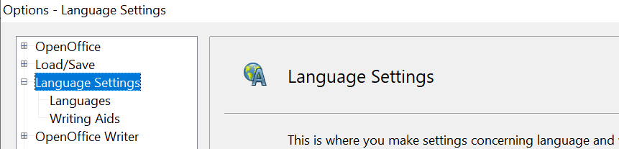
Figure 58: OpenOffice language options
On the right-hand side of the Language Settings—Languages page (Figure 39), change the User interface, Locale setting, Default currency, and Default languages for documents as required. In the example, English (USA) has been chosen for all the appropriate settings.
If you want the language (dictionary) setting to apply to the current document only, instead of being the default for all new documents, select For the current document only.
If necessary, select the options to enable support for Asian languages (Chinese, Japanese, Korean) and support for CTL (complex text layout) languages such as Hindi, Thai, Hebrew, and Arabic. If you choose either of these options, the next time you open this page, you will see some extra pages under Language Settings, as shown in Figure 40. These pages (Searching in Japanese, Asian Layout, and Complex Text Layout) are not discussed here.
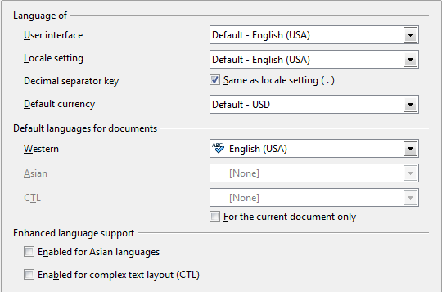
Figure 59: Choosing language options
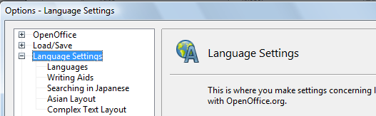
Figure 60: Extra pages available when enhanced language support options are selected

Choose Spelling Options
To choose the options for checking spelling, choose Language Settings > Writing Aids. In the Options section of the page, select the settings that are useful for you.
Some considerations:
- If you do not want spelling checked while you type, deselect Check spelling as you type.
- If you use a custom dictionary that includes words in all uppercase and words with numbers (for example, AS/400), select Check uppercase words and Check words with numbers.
- Check special regions includes headers, footers, frames, and tables when checking spelling.
Here you can also check which of the user-defined (custom) dictionaries are active, or you can add or remove dictionaries by clicking the New or Delete buttons.
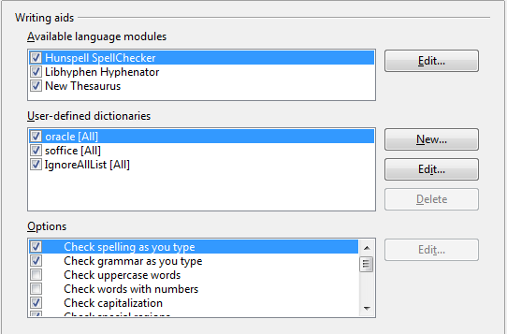
Figure 61: Choosing languages, dictionaries, and options for checking spelling
Note | OpenOffice does not have a grammar checker, but you can install a grammar checker extension such as LanguageTool and access that tool from Tools > Spelling and Grammar. See Chapter 14 for more about installing extensions.

Controlling Writer’s AutoCorrect Functions
Some people find some or all of the items in Writer’s AutoCorrect feature annoying because Writer changes what you type when you do not want it changed. Many people find some AutoCorrect functions quite helpful; if you do, then select the relevant options. But if you find unexplained changes appearing in your document, this is a good place to look to find the cause.
To open the AutoCorrect dialog box, choose Tools > AutoCorrect Options. (You need to have a document open for this menu item to appear.) In Writer, this dialog box has five tabs. Many of the options are described in Chapter 3 (Working with Text) in this book.
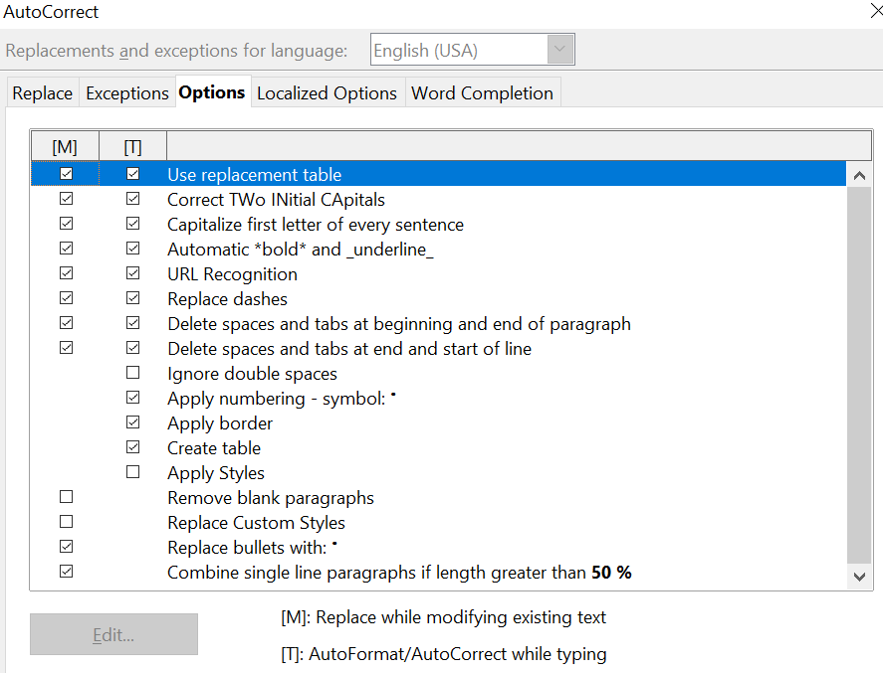
Figure 62: The AutoCorrect dialog box in Writer, showing the five tabs and some of the choices on the Options tab

Chapter 3
Working with Text

Introduction
This chapter covers the basics of working with text in Writer, the word-processing component of Apache OpenOffice (AOO). It assumes that you are familiar with the use of a mouse and keyboard and that you have read about Writer’s menus and toolbars and other topics covered in Chapter 1 (Introducing Writer).
We recommend that you also follow the suggestions in Chapter 2 (Setting up Writer) about displaying formatting aids, such as end-of-paragraph marks, and selecting other setup options.
When you have read this chapter, you should know how to:
- Select, cut, copy, paste, and move text
- Find and replace text
- Insert special characters
- Format paragraphs and characters
- Create numbered or bulleted lists
- Check spelling, use the thesaurus, and choose hyphenation options
- Use the autocorrection, word completion, autotext, and line numbering features
- Track changes, undo and redo changes, and insert notes
- Link to other parts of a document

Selecting Text
Before you can do anything with text, you need to select it. Selecting text in Writer is similar to selecting anything, whatever the application.
In addition to selecting blocks of text, you can select items that are not consecutive, as well as columns (vertical blocks) of text.

Selecting Items that are not Consecutive
To select nonconsecutive items (as shown in Figure 63) using the mouse:
- Select the first piece of text.
- Hold down the Control (Ctrl) key and use the mouse to select the next piece of text.
- Repeat as often as needed.
Now you can work with the selected text (copy it, delete it, change the style, and so on).
To select nonconsecutive items using the keyboard:
- Select the first piece of text. (For more information about keyboard selection of text, see the topic “navigating;in text, with keyboard” in the OpenOffice Help (F1).
- Press Shift+F8. This puts Writer in “ADD” mode. The word ADD appears on the Status Bar.
- Use the arrow keys to move to the start of the next piece of text to be selected. Hold down the Shift key and select the next piece of text.
- Repeat as often as required.
Now you can work with the selected text.
Press Esc to exit from this mode.
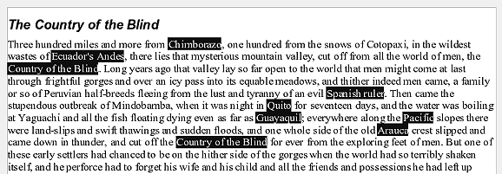Figure 63: Selecting items that are not next to each other

Selecting a Vertical Block of Text
You can select a vertical block or “column” of text that is separated by spaces or tabs (as you might see in text pasted from e-mails, program listings, or other sources), using AOO’s block selection mode. To change to block selection mode, use Edit > Selection Mode > Block Area, or click several times in the status bar on STD until it changes to BLK.
Now you can highlight the selection, using mouse or keyboard, as shown in Figure 64.
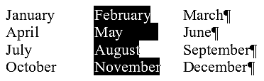
Figure 64: Selecting a vertical block of text

Cutting, Copying, and Pasting Text
Cutting and copying text in Writer is similar to cutting and copying text in other applications. You can copy or move text within a document, or between documents, by dragging or by using menu selections, icons, or keyboard shortcuts. You can also copy text from other sources such as Web pages and paste it into a Writer document.
To move (cut and paste) selected text using the mouse, drag it to the new location and release it. To copy selected text, hold down the Control key while dragging. The text retains the formatting it had before dragging.
When you paste text, the result depends on the source of the text and how you paste it. If you click on the Paste icon, then the pasted text keeps its original formatting (such as bold or italics). Text pasted from Websites and other sources may also be placed into frames or tables. If you do not like the results, click the Undo icon or press Control+Z.
To make the pasted text take on the formatting of the text surrounding where it is pasted, you can:
- Edit > Paste Special, or
- Click the triangle to the right of the Paste icon, or
- Click the Paste icon without releasing the left mouse button.
Then select Unformatted text from the resulting menu.
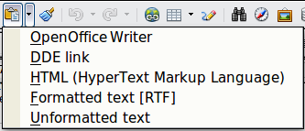
Figure 65: Paste Special menu
The range of choices on the Paste Special menu varies depending on the origin and formatting of the text (or other object) to be pasted. See Figure 65 for an example with text on the clipboard.
This example includes the formatting option DDE link. DDE is an acronym for Dynamic Data Exchange, a mechanism whereby selected data in document A can be pasted into document B as a linked, ‘live’ copy of the original. It would be used, for example, in a report written in Writer containing time varying data, such as sales results sourced from a Calc spreadsheet. The DDE link ensures that, as the source spreadsheet is updated so is the report, thus reducing the scope for error and reducing the work involved in keeping the Writer document up to date.

Finding and Replacing Text
Writer has two ways to find text within a document: the Find toolbar for fast searching and the Find & Replace dialog box. In the dialog box, you can:
- Find and replace words and phrases
- Use wildcards and regular expressions to fine-tune a search
- Find and replace specific formatting
- Find and replace paragraph styles
If the Find toolbar is not visible, you can display it using View > Toolbars > Find.

To display the Find & Replace dialog box, use the keyboard shortcut Control+F or choose Edit > Find & Replace from the menu bar. Figure 66 shows the dialog as it appears after clicking the More Options button.

Figure 66: Expanded Find & Replace dialog box
- Type the text you want to find in the Search for box.
- To replace the text with different text, type the new text in the Replace with box.
- You can select various options, such as matching the case, matching whole words only, or doing a search for similar words. (See below for some other choices.)
- When you have set up your search, click Find. To replace text, click Replace instead.
Tip | If you click Find All, Writer selects all instances of the search text in the document. Similarly, if you click Replace All button, Writer replaces all matches.

Caution | Use Replace All with caution; otherwise, you may end up with some hilarious (and highly embarrassing) mistakes. A mistake with Replace All might require a manual, word-by-word search to fix, if not discovered in time to undo.

Find and Replace Specific Formatting
A very powerful use of Find & Replace takes advantage of the format option. For example, you might want to replace underlined words with italics.
On the Find & Replace dialog box (with More Options displayed, as in Figure 66):
- To search for text with specific formatting, enter the text in the Search for box. To search for specific formatting only, delete any text in the Search for box.
- Click Format to display the Text Format (Search) dialog box. The tabs on this dialog box are similar to those on the Paragraph format and Paragraph Style dialog boxes.
- Choose the formats you want to search for and then click OK. The names of selected formats appear under the Search for box. For example, you might search for all text in 14-point bold Times New Roman.
- To replace text as well as formatting, type the replacement text in the Replace with box.
To search for specific text with specific formatting (for example, the word hello in bold), specify the formatting, type the text in the Search for box and leave the Replace with box blank.
To remove specific character formatting, select the Replace with box then click Format, select the Font tab, then select the opposite format (for example, No Bold). The No Format button on the Find & Replace dialog box clears all previously selected formats.
- Click Find, Find All, Replace, or Replace All.
Tip | Unless you plan to search for other text using those same attributes, click No Format to remove the attributes after completing your search. If you forget to do this, you may wonder why your next search fails to find words you know are in the document.

Find and Replace Paragraph Styles
If you combine material from several sources, you may discover that lots of unwanted paragraph styles have suddenly shown up in your document. To quickly change all the paragraphs from one (unwanted) style to another (preferred) style:
- On the expanded Find & Replace dialog box (Figure 66), select Search for Styles. (If you have attributes specified, this option is labeled Including Styles.) The Search for and Replace with boxes now contain a list of styles.
- Select the styles you want to search for and replace.
- Click Find, Find All, Replace, or Replace All.
Repeat steps 2 and 3 for each style that you want to replace.

Use Wildcards (regular expressions)
Wildcards (also known as regular expressions) are combinations of characters that instruct AOO how to search for something. Regular expressions are very powerful but not very intuitive. They can save time and effort by combining multiple finds into one.

Table 2 shows a few of the regular expressions used by AOO.

Tip | The online help describes many more regular expressions and their uses. There are also many online tutorials available.

Note | To search for a character that is defined as a wildcard, type a backslash (\) before the character. For example, to find the text $5.00, you would conduct a search using \$5\.00.

To use wildcards and regular expressions when searching and replacing:
- On the Find & Replace dialog box, click More Options to see more choices. On this expanded dialog box (Figure 66), select the Regular expressions option.
- Type the search text, including the wildcards, in the Search for box and the replacement text (if any) in the Replace with box. Not all regular expressions work as replacement characters.
- Click Find, Find All, Replace, or Replace All (not recommended).
Table 2. Examples of search wildcards (regular expressions)
To find | Use this expression | Examples and comments
Any single character | . | b.d finds bad, bud, bid, and bed.
One of the specified characters | [xyz] | b[iu]n finds bin and bun.
Any single character in this range | [x-y] | [r-t]eed finds reed, seed, and teed; ranges must be in alphabetically ascending order.
Any single character except the characters inside the brackets | [^x] | p[^a]st finds post and pest, but not past.
The beginning of a word | \<start | \<log finds logbook and logistics, but not catalog.
The end of a word | end\> | log\> finds catalog, but not logistics.
A paragraph marker | $ | Does not work as a replacement character. Use \n instead.
A line break | \n | Finds a line break that was inserted with Shift+Enter. When used as a replacement character, it inserts a paragraph marker.

Inserting Special Characters
A “special” character is one not found on a standard keyboard. For example, © ¾ æ ç ñ ö ø ¢ are all special characters in English. To insert a special character:
- Place the cursor in your document where you want the character to appear.
- Click Insert > Special Character to open the Special Characters dialog box.
- Select the characters (from any font or mixture of fonts) you wish to insert in order; then click OK. The selected characters are shown in the lower left of the dialog box. As you select each character, it is shown on the lower right, along with the numerical code for that character.
Figure 67: The Special Characters dialog box, where you can insert special characters
Tip | Notice that the characters selected appear in the bottom-left corner of the dialog box.

Note | Different fonts include different special characters. If you do not find a particular special character you want, try changing the Font selection.

Inserting Non-breaking Spaces and Hyphens
Non-breaking spaces
To prevent two words from being separated at the end of a line, press Control+space bar after the first word.
Non-breaking hyphen
You can use a non-breaking hyphen in cases where you do not want the hyphen to appear at the end of a line, for example in a number such as 123-4567. To insert a non-breaking hyphen, press Shift+Control+minus sign.

Inserting en and em Dashes
To enter en and em dashes, you can use the Replace dashes option under Tools > AutoCorrect Options (Figure 102). This option replaces two hyphens, under certain conditions, with the corresponding dash.
In the following table, the A and B represent text consisting of letters A to z or digits 0 to 9.
Another means of inserting en or em dashes is through the Insert > Special Characters menu. Select the U+2013 or U+2014 character, respectively.
A third method uses keyboard shortcuts. These shortcuts vary depending on your operating system.
Text that you type: | Result
A - B (A, space, minus, space, B) | A – B (A, space, en-dash, space, B)
A -- B (A, space, minus, minus, space, B) | A – B (A, space, en-dash, space, B)
A--B (A, minus, minus, B) | A—B (A, em-dash, B)
A-B (A, minus, B) | A-B (unchanged)
A -B (A, space, minus, B) | A -B (unchanged)
A --B (A, space, minus, minus, B) | A –B (A, space, en-dash, B)
Tip | You can also record macros to insert en and em dashes and assign those macros to unused key combinations, for example Ctrl+Shift+N and Ctrl+Shift+M. For more information, see Chapter 17 (Customizing Writer).
Windows
Hold down one of the Alt keys and type on the numeric keypad: 0150 for an en dash or 0151 for an em dash. The dash appears when you release the Alt key.
Linux
Hold down the Compose key and type two hyphens and a period for an en dash, or three hyphens for an em dash. The dash appears when you release the Compose key.
Tip | The key that operates as a Compose key varies with the Linux distribution. It is usually one of the Alt or Win keys, but may be another key, and should be user selectable.
macOS
Hold down the Option (Alt) key and type a hyphen for an en dash. For an em dash, the combination is Shift+Option+Hyphen.

Formatting Paragraphs
You can apply many formats to paragraphs using the Sidebar's Properties deck or the buttons on the Formatting toolbar. Figure 103 shows the Paragraph panel of the Properties deck of the Sidebar when the cursor is in a text area. In addition to the controls shown, the complete paragraph formatting dialog can be called using the tiny More Options button at the top right of the pane.
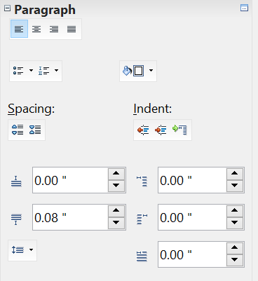

Figure 68: Paragraph panel of the Sidebar Properties pane
Alignment: Left, Center,
Right, Justify
Bullets and Numbering
Background color
Paragraph Spacing/Indent:
AboveBefore
BelowAfter
First Line
Buttons to adjust
paragraph indentation
Line spacing
More options
Buttons to adjust
paragraph spacing
Figure 69 shows the Formatting toolbar as a floating toolbar, customized to show only the buttons for paragraph formatting.
Tip | It is highly recommended that you use paragraph styles rather than manually formatting paragraphs, especially for long or standardized documents. For information on the advantages of styles and how to use them, see Chapters 6 and 7.


1 | Open Styles and Formatting Window | 5 | Align Right | 10 | Numbering On/Off
 | Open Styles and Formatting Window | 6 | Justified | 11 | Bullets On/Off
2 | Apply Style | 7 | Line Spacing: 1 | 12 | Decrease Indent
3 | Align Left | 8 | Line Spacing: 1.5 | 13 | Increase Indent
4 | Centered | 9 | Line Spacing: 2 | 14 | Paragraph format dialog box
Figure 69: Formatting toolbar, showing icons for paragraph formatting
Figure 70 shows examples of the text alignment options.
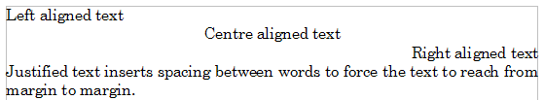Figure 70: Text alignment options
When using justified text, the last line is by default aligned to the left; however, if so desired, you can also align the last line to the center of the paragraph area or justify it so that spaces are inserted between the words in order to fill the whole line. In the case where the last line consists of a single word, you can also have this word stretched to cover the entire line. Figure 71 shows an example of the effect obtained when setting each of these options.
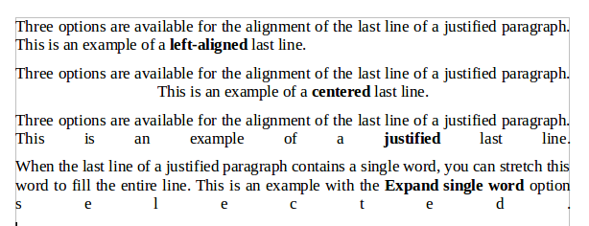
Figure 71: Four choices for the last line of a justified paragraph
These options are controlled in the Alignment page of the Format > Paragraph dialog box shown in Figure 72.
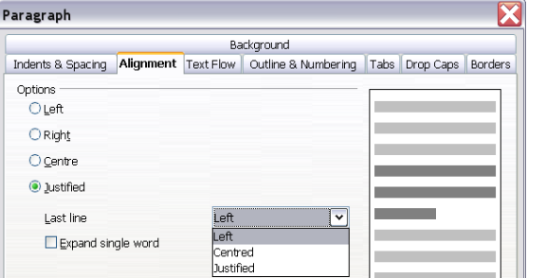
Figure 72: Options for the last line of a justified paragraph

Setting Tab Stops and Indents
The horizontal ruler shows both the default tab stops and any tab stops that you have defined. Tab settings affect indentation of full paragraphs (using the Increase Indent and Decrease Indent icons on the Formatting toolbar) as well as indentation of parts of a paragraph (by pressing the Tab key on the keyboard).
Using the default tab spacing can cause formatting problems if you share documents with other people. If you use the default tab spacing and then send the document to someone else who has chosen a different default tab spacing, tabbed material will change to use the other person’s settings. Instead of using the defaults, define your own tab settings, as described in this section.
To define indents and tab settings for one or more selected paragraphs, double-click on a part of the ruler that is not between the left and right indent icons to open the Indents & Spacing page of the Paragraph dialog box. Double-click anywhere between the left and right indent icons on the ruler to open the Tabs page of the Paragraph dialog box shown in Figure 73.
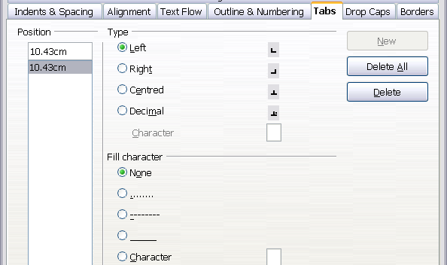
Figure 73: Specifying tab stops and fill characters
A better strategy is to define tabs for the paragraph style. Refer to Chapters 6 and 7 for more about paragraph styles.
Tip | Using tabs to space out material on a page is not recommended. Depending on what you are trying to accomplish, a table is usually a better choice.

Changing the Default Tab Stop Interval
Note | Any changes to the default tab setting will affect the existing default tab stops in any document you open afterward, as well as tab stops you insert after making the change.

To set the measurement unit and the spacing of default tab stop intervals, go to Tools > Options > OpenOffice Writer > General and make changes in the Settings area shown in Figure 74.

Figure 74: Selecting a default tab stop interval
You can also set or change the measurement unit for rulers in the current document by right-clicking on the ruler to open a list of units, as shown in Figure 75. Click on one of them to change the ruler to that unit. The selected setting applies only to that ruler.
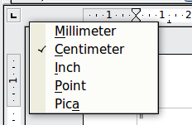
Figure 75: Changing the measurement unit for a ruler

Formatting Characters
You can apply many formats to characters using the buttons on the Text panel of the Properties deck of the Sidebar or the Formatting toolbar.
Figure 102 shows the Sidebar's Text panel with the controls labeled.

Figure 76: Text panel of the Sidebar
Figure 77 shows the Formatting toolbar as a floating toolbar, customized to show only the buttons for character formatting.
It is highly recommended that you use character styles rather than manually formatting characters. For information on styles and how to use them, see Chapters 6 and 7.
1 | Open Styles and Formatting Window | 6 | Italic | 12 | Font Color
 | Open Styles and Formatting Window | 7 | Underline | 13 | Highlighting
2 | Apply Style | 8 | Superscript | 14 | Background Color
3 | Font Name | 9 | Subscript | 15 | Open Character Format dialog box
4 | Font Size | 10 | Increase Font |  | Open Character Format dialog box
5 | Bold | 11 | Reduce Font
Figure 77: Formatting toolbar, showing icons for character formatting
Tip | To remove manual formatting, select the text and choose Format > Default Formatting from the main menu bar, or right-click and choose Default Formatting from the pop-up menu.

Autoformatting
You can set Writer to automatically format parts of a document according to the choices made on the Options page of the AutoCorrect dialog box (Tools > AutoCorrect Options) shown in Figure 78.
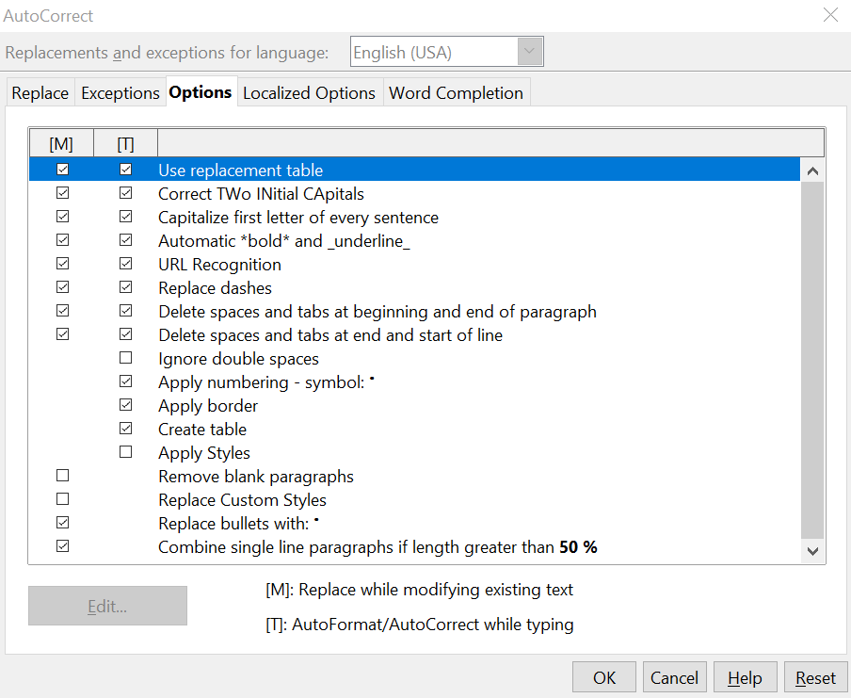
Figure 78: Autoformat choices on the Options page of the AutoCorrect dialog box
The Help describes each of these choices and how to activate the autoformats. Some common unwanted or unexpected formatting changes include:
- Horizontal lines. If you type three or more hyphens (---), underscores (___) or equal signs (===) on a line and then press Enter the paragraph is replaced by a horizontal line as wide as the page. The line is actually the lower border of the preceding paragraph.
- Bulleted and numbered lists. A bulleted list is created when you type a hyphen (-), asterisk (*), or plus sign (+), followed by a space or tab at the beginning of a paragraph. A numbered list is created when you type a number followed by a period (.), followed by a space or tab at the beginning of a paragraph. Automatic numbering is only applied to paragraphs formatted with the Default, Text body or Text body indent paragraph styles.
Tip | If you notice unexpected formatting changes occurring in your document, this is the first place to look for the cause.

To automatically format the file according to the options you have set, choose Format > AutoCorrect and select or deselect the items on the submenu.
While Typing
Automatically formats the document while you type.
Apply
Automatically formats the document.
Apply and Edit Changes
Automatically formats the file and then opens a dialog box where you can accept or reject the changes.
AutoCorrect Options
Opens the AutoCorrect dialog (Figure 78).

Creating Numbered or Bulleted Lists
There are several ways to create numbered or bulleted lists:
- Use autoformatting, as described above.
- Use list styles, as described in Chapter 7 (Working with Styles).
- Use the Numbering and Bullets icons on the paragraph formatting toolbar (see Figure 79). This method is described here.
To produce a numbered or bulleted list, select the paragraphs in the list and then click on the appropriate icon on the toolbar.
Note | It is a matter of personal preference whether you type your information first, then apply Numbering/Bullets or apply these as you type.

Using the Bullets and Numbering Toolbar
You can create a nested list (where one or more list items has a sublist under it, as in an outline) by using the buttons on the Bullets and Numbering toolbar (Figure 79). You can move items up or down the list, create subpoints, and even change the style of bullets.
Tip | It is possible to move a list entry up, together with all of its sub-entries. Do this by clicking the Promote One Level With Subpoints button.


1 | Bullets On/Off | 6 | Promote One Level with Subpoints | 10 | Move Down
2 | Numbering On/Off | 6 | Promote One Level with Subpoints | 11 | Move Up with Subpoints
3 | Numbering Off | 7 | Demote One Level with Subpoints | 12 | Move Down with Subpoints
4 | Promote One Level | 8 | Insert Unnumbered Entry | 13 | Restart Numbering
5 | Demote One Level | 9 | Move Up | 14 | Bullets and Numbering
Figure 79: Bullets and Numbering toolbar
If you create a nested list using the predefined styles, all the levels of the list (up to 10) apply the same numbering (or bullet). However, in many circumstances you will want to use a combination of numbering formats and bullets when creating nested lists. Such lists, with a mixture of numbering formats and bullets, can be easily configured as described in the following example. Additional information on lists, in particular the technique to create your own list style, is described in Chapter 7 (Working with Styles).
Tip | When creating nested lists, one option is to enter all the list paragraphs first and apply the levels afterward.  You can use keyboard shortcuts to move paragraphs up or down the outline levels. Place the cursor at the beginning of the numbered paragraph and press:  Tab Down a level  Shift+Tab Up a level  To insert a tab stop at the beginning of a numbered paragraph (that is, after the number but before the text), press Control+Tab.

Example: Configuring a Nested List
We will use a numbering style to produce the following effect:
I. Level-1 list item
A. Level-2 list item
i. Level-3 list item
a) Level-4 list item
This example uses one of the supplied styles, Numbering 1, however if you intend to reuse this type of nested list you can also create a new style as illustrated in Chapter 7 (Working with Styles).
- In the SideBar, select the Styles and Formatting deck and click the List Styles icon at the top. Right-click on the Numbering 1 style and choose Modify from the pop-up menu as shown in Figure 80.
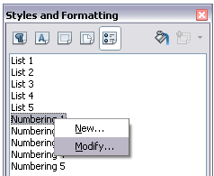
Figure 80: Modifying a list style
- On the Numbering Style dialog box, go to the Outline tab (Figure 81), where you will find that one style matches our requirements. Click once on that style.
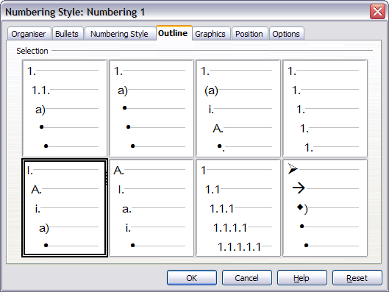
Figure 81: Choosing a predefined outline-numbering style
- To modify the layout of the list, use the Options tab (Figures 82 and 83). Notice that the preview on the right shows the outline selected. In the Level box on the left, select 1, then 2, 3, and 4 and see how the information in the Numbering and After boxes changes.
Use the Options page to set different punctuation; for example, a period (full stop) after “a” on level 4 instead of a parenthesis.
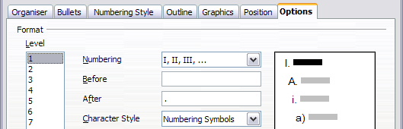
Figure 82: Checking the outline numbering for level-1 list items
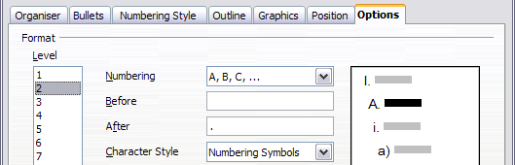
Figure 83: Numbering style for level-2 list items
To make the indentation at each level greater or less than the default, change it on the Position tab. Select the level, then make any changes in the indentation, spacing, or numbering alignment.
- Repeat for each level as required, then click OK.
Tip | With outline numbering you can define different bullet styles for the different levels of a bullet list. Use the Bullets tab of the Bullets and Numbering dialog box (not shown) to select the basic style. Return to the Options tab to customize the bullet for each indent level. Here you can set bullets to any character. See the Graphics tab for more bullets.

Using Footnotes and Endnotes
Footnotes appear at the bottom of the page on which they are referenced. Endnotes are collected at the end of a document.
To work effectively with footnotes and endnotes, you need to:
- Insert footnotes.
- Define the format of footnotes.
- Define the location of footnotes on the page, as described in Chapter 4 (Formatting Pages).

Inserting Footnotes/Endnotes
To insert a footnote or an endnote, put the cursor where you want the footnote/endnote marker to appear. Then select Insert > Footnote/Endnote from the menu bar or click the Insert Footnote/Endnote Directly or Insert Endnote Directly icon on the Insert toolbar shown in Figure 84.
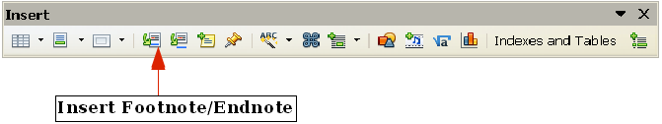
Figure 84: Using the Insert Footnote Directly icon on the toolbar
A footnote or endnote marker is inserted in the text and, depending on your choice, the cursor is relocated either to the footnote area at the bottom of the page or to the endnote area at the end of the document. Type the footnote or endnote content in this area.
If you use Insert > Footnote/Endnote, the Insert Footnote/Endnote dialog box (Figure 85) is displayed. Here you can choose whether to use the automatic numbering sequence specified in the footnote settings and whether to insert the item as a footnote or an endnote.
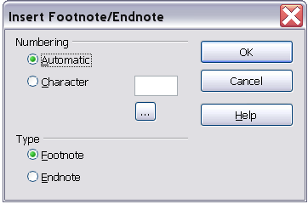
Figure 85: Inserting a footnote/endnote directly
If you use the Insert Footnote/Endnote Directly or Insert Endnote Directly icon, the footnote, or endnote automatically takes on the attributes previously defined in the Footnote Settings dialog box.
You can edit an existing footnote or endnote the same way you edit any other text.
To delete a footnote or endnote, delete the footnote marker. The contents of the footnote or endnote are deleted automatically, and the numbering of other footnotes or endnotes is adjusted automatically.

Defining the Format of Footnotes/Endnotes
To format the footnotes themselves, click Tools > Footnotes/Endnotes. On the Footnote Settings dialog box (Figure 86), choose settings as required. The Endnotes page has similar choices.
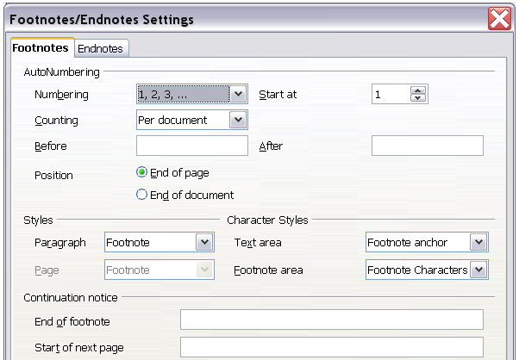
Figure 86: Defining footnote formatting

Checking Spelling and Grammar
Writer provides a spelling checker, which can be used in two ways.
AutoSpellcheck checks each word as it is typed and displays a wavy red line under any misspelled words. When the word is corrected, the red wavy line disappears.
To perform a separate spelling check on the document (or a text selection) click this button. This checks the document or selection and opens the Spelling and Grammar dialog box (Figure 87) if any misspelled words are found.
Here are some more features of the spelling checker:
- You can right-click on a word with a wavy underline, to open a powerful context menu. If you select from the suggested words on the menu, the selection will replace the misspelled word in your text. Other menu options are discussed below.
- You can change the dictionary language (for example, Spanish, French, or German) on the Spelling and Grammar dialog box.
- You can add a word to a dictionary. Click Add in the Spelling and Grammar dialog box and pick the dictionary to add it to.
- Click the Options button on the Spelling and Grammar dialog box to open a dialog box similar to the one in Tools > Options > Language Settings > Writing Aids described in Chapter 2. There you can choose whether to check uppercase words and words with numbers, and you can manage custom dictionaries, that is, add or delete dictionaries and add or delete words in a dictionary.
Writer does not include a grammar checker, but you can install an extension such as LanguageTool and access it from Tools > Spelling and Grammar. (See Chapter 17 for more about installing extensions.)
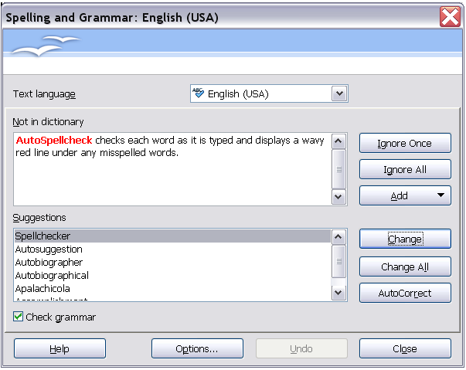
Figure 87: Selecting a word from dictionary using the Spelling and Grammar dialog box
LanguageTool adds a new menu item and submenu to the Tools menu, from which you can configure the tool and check or recheck the document. Figure 88 shows an example of the LanguageTool extension in use.
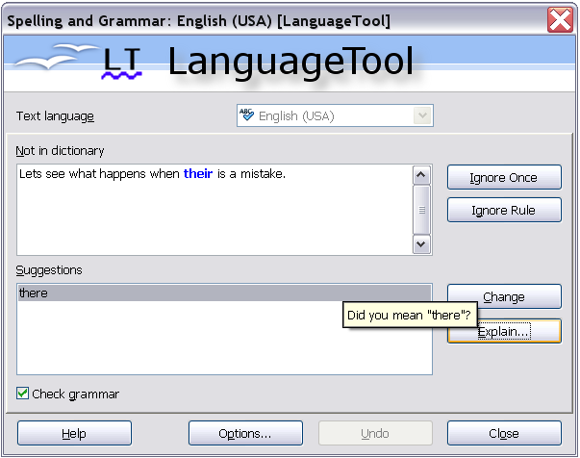
Figure 88: The LanguageTool extension

Using Built-in Language Tools
Writer provides some tools that make your work easier if you mix multiple languages within the same document or if you write documents in various languages:
- Paragraph and character styles
- Using Tools > Language
- Using language settings in Options
- Using the status bar
The main advantage of changing the language for a text selection is that you can then use the correct dictionaries to check spelling and apply the localized versions of AutoCorrect replacement tables, thesaurus, and hyphenation rules.
You can also set the language for a paragraph or a group of characters as None (Do not check spelling). This option is especially useful when you insert text such as web addresses or programming language snippets that you do not want to check for spelling.

Using Paragraph and Character Styles
Specifying the language in character and paragraph styles is the preferred method, because styles allow a greater level of control and make changing the language much faster. On the Font tab of the Paragraph Styles dialog box, you can specify that the paragraphs using that style be checked in a language that is different from the language of the rest of the document. See Chapter 7 (Working with Styles) for information on how to manage the language settings of a style.

Using Tools > Language
You can also set the language for the whole document, for individual paragraphs, or even for individual words and characters, all from Tools > Language on the menu bar.
For Selection
Applies a specified language to the selected text (the selection can be as short as a few characters or as long as several paragraphs).
For Paragraph
Select this option to apply the specified language to the paragraph where the cursor is located.
For all Text
Select this option to apply the specified language to all the document.

Using Language Settings in Options
Another way to change the language of a whole document is to use Tools > Options > Language Settings > Languages. In the Default languages for documents section (Figure 89), you can choose a different language for all the text.
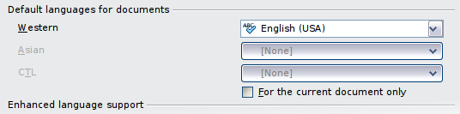
Figure 89: Options available in the Languages settings
Caution | Unlike the menu tool that applies to the individual document, a change in the default language from the Options dialog box is a general change of settings of AOO and will therefore apply to all the documents created in the future. If you want to change the language for the current document only, be sure to select the For the current document only option.
The spelling checker works only for those languages in the list which have the symbol next to them. If you do not see this symbol next to your preferred language, you can install the dictionary using Tools > Languages > More dictionaries online.

Using the Status Bar
The language used for checking spelling is also shown in the status bar, next to the page style in use as shown in Figure 90. You can change the language for the paragraph or the entire document; click on the language in the status bar to pop up a menu of choices.
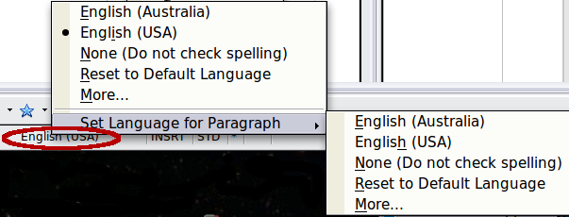
Figure 90: Language choices on the status bar
Notice the Reset to Default Language option on the menu and submenu. This is the fastest way to return a paragraph or the entire document to the default language set in Tool > Options (described above).

Using Synonyms and the Thesaurus
You can access a short list of synonyms from the context menu:
- Select a word or phrase, right-click, and point to Synonyms on the pop-up menu. A submenu of alternative words and phrases is displayed.
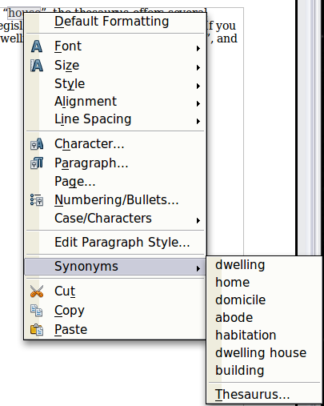
Figure 91: Synonyms on the context menu
- Click on a word or phrase to select it and replace the highlighted word or phrase in the document.
The thesaurus gives a more extensive list of alternative words and phrases. To use the thesaurus:
- Select a word or phrase, and then choose Tools > Language > Thesaurus, or press Control+F7, or right-click and choose Thesaurus from the pop-up menu.
- In the dialog box, click on a meaning to show alternative words and phrases for that meaning of the word.
For example, when given the word house, the thesaurus offers several meanings, including dwelling, legislature, sign of the zodiac, and others. If you click on dwelling, you will see dwelling, home, domicile, abode, and other alternatives, as shown in Figure 92.

Note | If the current language does not have a thesaurus installed, this feature is disabled.

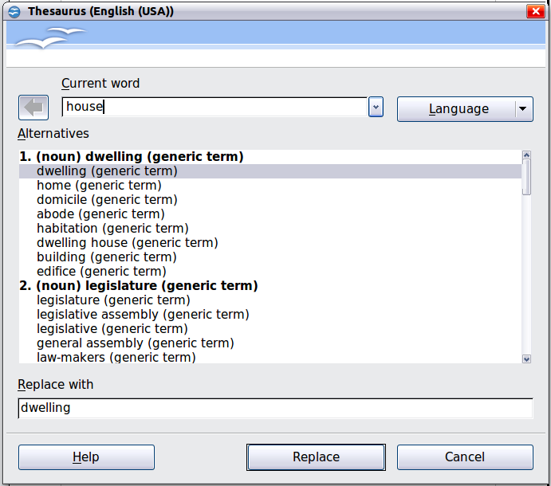
Figure 92: The thesaurus offers alternatives to words

Hyphenating Words
You have several choices regarding hyphenation: let Writer do it automatically (using its hyphenation dictionaries), insert conditional hyphens manually where necessary, or don’t hyphenate at all. Each choice has its pros and cons.

Automatic Hyphenation
To turn automatic hyphenation of words on or off:
- Choose the Styles and Formatting deck of the Sidebar or Press F11 to open the Styles and Formatting window. On the Paragraph Styles tab, right-click on Default and select Modify as shown in Figure 93.
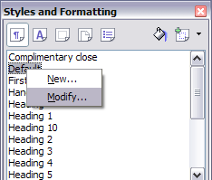
Figure 93: Modifying a paragraph style
- On the Paragraph Style dialog box, select the Text Flow tab.
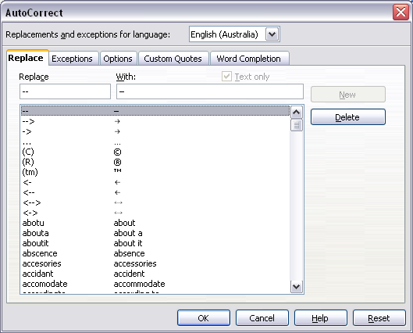Figure 94: Turning on automatic hyphenation
- Under Hyphenation, select or deselect the Automatically option.
- Click OK to save.
Note | Turning on hyphenation for the Default paragraph style affects all other paragraph styles that are based on Default. You can individually change other styles so that hyphenation is not active; for example, you might not want headings to be hyphenated. Any styles that are not based on Default are not impacted. For more on paragraph styles, see Chapter 6 (Introduction to Styles) and Chapter 7 (Working with Styles).

You can also set hyphenation choices through Tools > Options > Language Settings > Writing Aids. In Options, near the bottom of the dialog box, scroll down to find the hyphenation settings as shown in Figure 95.
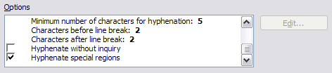
Figure 95: Setting hyphenation options
To change the minimal number of characters for hyphenation, the minimum number of characters before a line break, or the minimum number of characters after a line break, select the item, and then click the Edit button in the Options section.
Hyphenate without inquiry
Specifies that you will never be asked to manually hyphenate words that the hyphenation dictionary does not recognize. If this box is not selected, when a word is not recognized, a dialog box will open where you can manually enter hyphens.
Hyphenate special regions
Specifies that hyphenation will also be carried out in footnotes, headers, and footers.
Hyphenation options set on the Writing Aids dialog box are effective only if hyphenation is turned on through paragraph styles.
Choices on the Writing Aids dialog box for Characters before line break and Characters after line break override settings in paragraph styles for Characters at line end and Characters at line begin.

Manual Hyphenation
To manually hyphenate words, do not use a normal hyphen, which will remain visible even if the word is no longer at the end of a line when you add or delete text or change margins or font size. Instead, use a conditional hyphen, which is visible only when required.
To insert a conditional hyphen inside a word, click where you want the hyphen to appear and press Control+hyphen. The word will be hyphenated at this position when it is at the end of the line, even if automatic hyphenation for this paragraph is switched off.

Using AutoCorrect
Writer’s AutoCorrect function has a long list of common misspellings and typing errors, which it corrects automatically. For example, “the” will be changed to “the.”
Select Tools > AutoCorrect Options to open the AutoCorrect dialog box. There you can define what strings of text are corrected and how. In most cases, the defaults are fine.
AutoCorrect is turned on when Writer is installed. To turn it off, uncheck Format > AutoCorrect > While Typing.
To stop Writer replacing a specific spelling, go to the Replace tab, highlight the word pair, and click Delete.
To add a new spelling to the list, type it into the Replace and With boxes on the Replace tab, and click New.
See the different pages of the dialog box (Figure 96) for the wide variety of other options available to fine-tune AutoCorrect.
Tip | AutoCorrect can be used as a quick way to insert special characters. For example, (C) will be autocorrected to ©. You can add your own special characters.

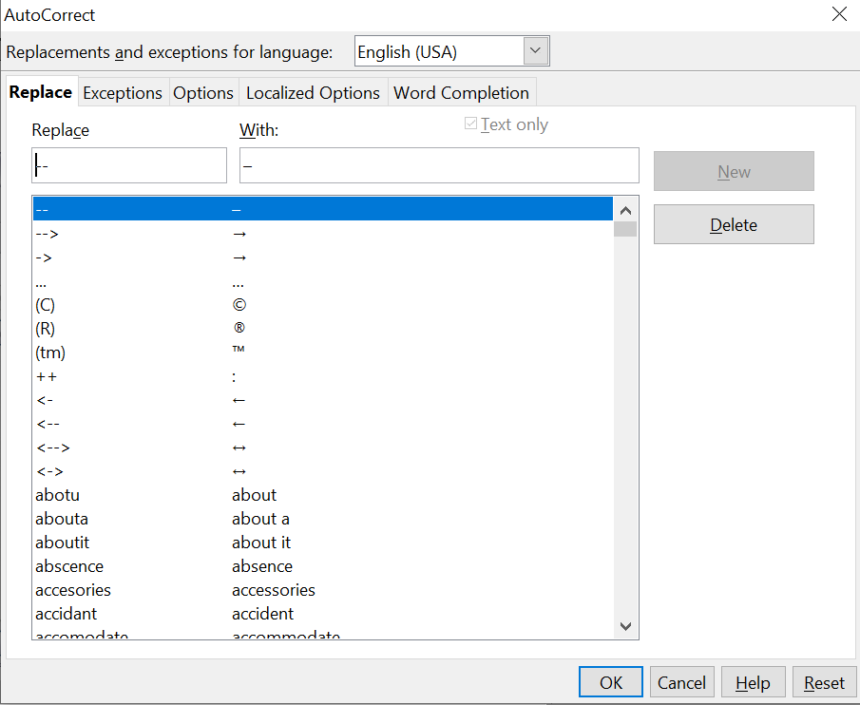
Figure 96: Replace tab of AutoCorrect dialog box

Using Word Completion
If Word Completion is enabled, Writer tries to guess which word you are typing and offers to complete the word for you. To accept the suggestion, press Enter. Otherwise, continue typing.
To turn off Word Completion, select Tools > AutoCorrect Options > Word Completion and deselect Enable word completion.
You can customize word completion from the Word Completion page of the AutoCorrect dialog, shown in Figure 97.
- Add (append) a space automatically after an accepted word.
- Show the suggested word as a tip (hovering over the word) rather than completing the text as you type.
- Collect words when working on a document, and then either save them for later use in other documents or select the option to remove them from the list when closing the document.
- Change the maximum number of words remembered for word completion and the length of the smallest words to be remembered.
- Delete specific entries from the word completion list.
- Change the key that accepts a suggested entry—the options are Right arrow, End key, Enter (Return), Space bar, and Tab.
Note | Automatic word completion only occurs after you type a word for the second time in a document.

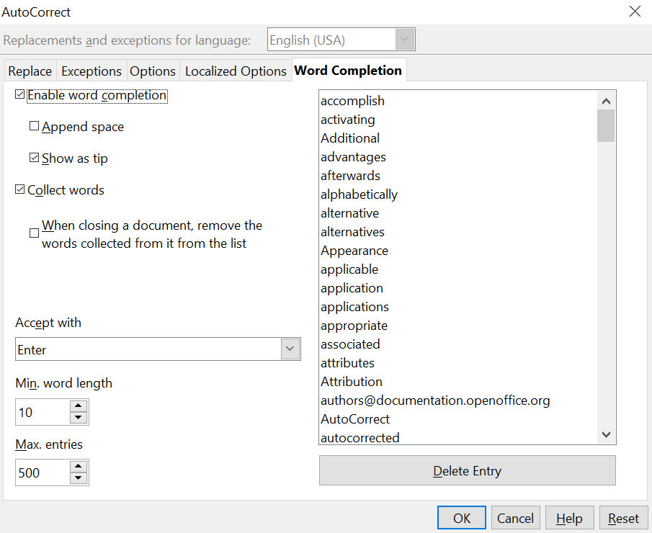
Figure 97: Customizing word completion

Using AutoText
Use AutoText to store text, tables, fields, and other items for reuse and assign them to a key combination for easy retrieval. For example, rather than typing “Senior Management” every time you use that phrase, you can set up an AutoText entry to insert those words when you type “sm” and press F3.
AutoText is especially powerful when used with fields. See Chapter 14 (Working with Fields) for more information.

Creating AutoText
To store some text as AutoText:
- Type the text into your document.
- Select the text.
- Go to Edit > AutoText (or press Control+F3).
- In the AutoText dialog box (Figure 98), type a name for the AutoText in the Name box. Writer will suggest a one-letter shortcut, which you can change.
- In the large box to the left, choose the category for the AutoText entry, for example My AutoText.
- Click the AutoText button on the right of the dialog box and select New (text only) from the menu (to have the AutoText take on the formatting where it is inserted into a document) or select New (to have the AutoText retain specific formatting no matter where it is inserted).
- Click Close to return to your document.
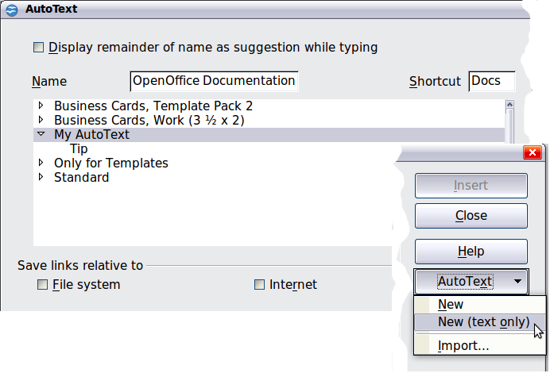
Figure 98: Defining a new AutoText entry
Tip | If the only option under the AutoText button is Import, either you have not entered a name for your AutoText or there is no text selected in the document.

To save a table (such as the formatted Tip on this page) as AutoText:
- Create a table and format it the way you want.
- Select the table.
- Go to Edit > AutoText (or press Control+F3).
- Type a name for the AutoText, optionally amend the suggested shortcut, and choose the category for the AutoText entry.
- Click the AutoText button and select New (because you want the formatting of the table preserved).
- Click Close to return to your document.

Inserting AutoText
To insert AutoText, type the shortcut and press F3.

Printing a List of AutoText Entries
- Choose Tools > Macros > Organize Macros > OpenOffice Basic.
- In the Macro from list, choose OpenOffice Macros > Gimmicks.
- Select AutoText and then click Run. A list of the current AutoText entries is generated in a separate text document. You can then print this document.
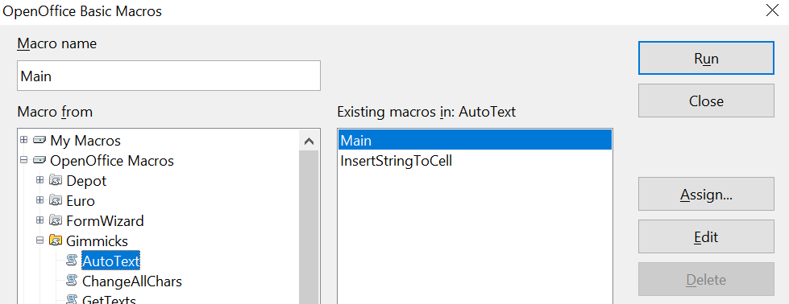

Line Numbering
Line numbering puts line numbers in the margin. The line numbers are displayed on screen and are printed. Figure 99 shows an example with numbering on every line.
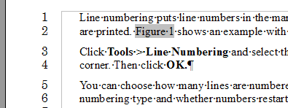Figure 99: Line numbering example
Click Tools > Line Numbering and select the Show numbering option in the top left corner of the Line Numbering dialog box (Figure 100). Then click OK.
You can choose how many lines are numbered (for example, every line or every tenth line), the numbering type and whether numbers restart on each page. In addition, a text separator (any text you select) can be set on a different numbering scheme (one every 12 lines, for example).
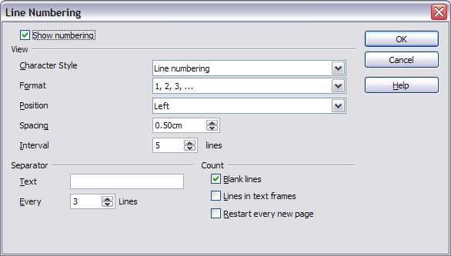Figure 100: The Line Numbering dialog box

Tracking Changes to a Document
You can use several methods to keep track of changes made to a document.
- Make your changes to a copy of the document (stored in a different folder, under a different name, or both), then use Writer to combine the two files and show the changes you made. Click Edit > Compare Document. This technique is particularly useful if you are the only person working on the document, as it avoids the increase in file size and complexity caused by the other methods.
- Save versions that are stored as part of the original file. However, this method can cause problems with documents of nontrivial size or complexity, especially if you save a lot of versions. Avoid this method if you can.
- Use Writer’s change marks (often called “redlines” or “revision marks”) to show where you have added or deleted material or changed formatting. Later, you or another person can review and accept or reject each change.
Tip | Not all changes are recorded. For example, changing a tab stop from align left to align right and changes in formulas (equations) or linked graphics are not recorded.

Preparing a Document for Review
When you send a document to someone else to review or edit, you may want to prepare it first so that the editor or reviewer does not have to remember to turn on the revision marks. After you have protected the document, any user must enter the correct password in order to turn off the function or accept or reject changes.
- Open the document. To check whether it contains multiple versions, click File > Versions. If multiple versions are listed, save the current version as a separate document with a different name and use this new document as the review copy.
- With the review copy open, make sure that change recording is turned on. The Edit > Changes > Record menu item has a check mark next to it when recording is turned on.
- Click Edit > Changes > Protect Records. On the Enter Password dialog box, type a password (twice) and click OK.
Tip | A slightly faster alternative to steps 2 and 3 above is to choose File > Properties > Security tab, click Protect, and enter the password.

Recording Changes
See Chapter 2 (Setting up Writer) for instructions on setting up how your changes will be displayed.
- To begin tracking (recording) changes, click Edit > Changes > Record. To show or hide the display of changes, click Edit > Changes > Show.
Tip | Hold the mouse pointer over a marked change; you will see a Help Tip showing the type of change, the author, date, and time of day for the change. If Extended Tips are enabled, you will also see any comments recorded for this change.

- To enter a comment on a marked change, place the cursor in the area of the change and then click Edit > Changes > Comment. A dialog similar to Figure 101 will appear. In addition to being displayed as an extended tip, the comment is also displayed in the list in the Accept or Reject Changes dialog box (Figure 91).
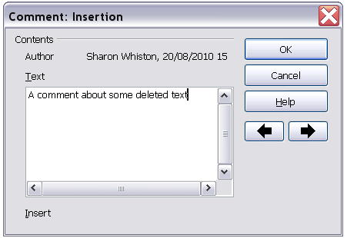
Figure 101: Inserting a comment during change recording
To move from one marked change to the next, use the arrow buttons. If no comment has been recorded for a change, the Text field is blank.

Tip | See also “Adding Other Comments” on page 97 for a way to annotate text that is not associated with a recorded change.

- To stop recording changes, click Edit > Changes > Record again.

Accepting or Rejecting Changes
To accept or reject recorded changes, use either of these methods:
- Right-click (context) menu
- Accept or Reject Changes dialog box
The results of accepting or rejecting a change are as follows:
- Accepting an insertion removes the change indicator (usually a color) from the inserted text.
- Rejecting an insertion removes the text from the document.
- Accepting a deletion removes the text from the document.
- Rejecting a deletion removes the change indicator and restores the text to the document.
Right-click (context) menu
- If recorded changes are not showing, click Edit > Changes > Show.
- Hover the mouse pointer over a recorded change. A box appears with information about the type of change, who made it, and the date and time.
- Right-click on the changed text. In the pop-up (context) menu, choose Accept Change or Reject Change.
Accept or Reject Changes dialog box
- Click Edit > Changes > Accept or Reject. The Accept or Reject Changes dialog box (Figure 91) opens.
- When you select a change in the dialog box, the actual change is highlighted in the document, so you can see what the editor changed.
- Click Accept or Reject to accept or reject the selected change. You can also click Accept All or Reject All if you do not want to review the changes individually.
Changes that have not yet been accepted or rejected are displayed in the list.
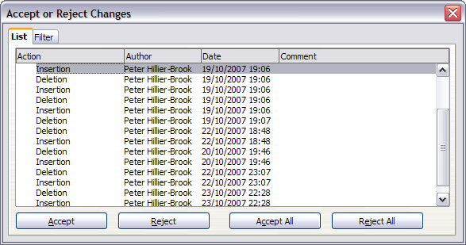
Figure 102: The List tab of the Accept or Reject Changes dialog box
To show only the changes of certain people or only the changes on specific days or various other restrictions, use the Filter tab (Figure 94) on the Accept or Reject Changes dialog box. After specifying the filter criteria, return to the List tab to see those changes that meet your criteria.
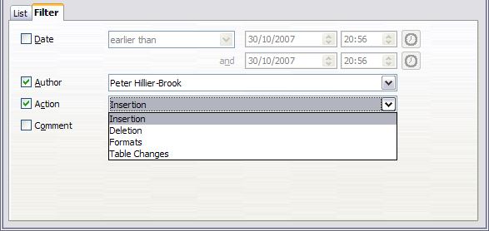
Figure 103: The Filter page of the Accept or Reject Changes dialog box

Merging Modified Documents
The processes discussed to this point are effective when you have one reviewer at a time. Sometimes, however, multiple reviewers all return edited versions of a document at the same time. In this case, it may be quicker to review all of these changes at once, rather than one review at a time. For this purpose, you can merge documents in Writer.
To merge documents, all the edited documents need to have recorded changes in them.
- Open one copy.
- Click Edit > Changes > Merge Document and select and insert another copy of the document to be merged with the first.
- After the documents merge, the Accept or Reject Changes dialog box opens, as in Figure 91, showing changes by more than one reviewer. If you want to merge more documents, close the dialog box, and then repeat step 2.
- Repeat until all copies are merged.
All recorded changes are now included in the open copy. Save this file under another name.

Comparing Documents
Sometimes reviewers may forget to record the changes they make. This is not a problem with Writer because you can find the changes if you compare documents.
In order to compare documents, you need to have the original document and the one that is edited. To compare them:
- Open the edited document. Select Edit > Compare Document.
- The Insert dialog box appears. Select the original document and click Insert.
Writer finds and marks the changes and displays the Accept or Reject Changes dialog box. From this point, you can go through and accept or reject changes as described earlier.

Adding Other Comments
Writer provides another type of comments (formerly called “notes”), which authors and reviewers often used to exchange ideas, ask for suggestions, or brainstorm during the review process.
To insert a comment in the text, place the cursor in the place the comment refers to and select Insert > Comment or press Ctrl+Alt+C. The anchor point of the comment is connected by a dotted line to a box on the right-hand side of the page where you can type the text of the comment. Writer automatically adds at the bottom of the comment the author’s name and a time stamp indicating when the comment was created. Figure 67 shows an example of text with comments from two different authors.
Select Tools > Options > OpenOffice > User Data to configure the name you want to appear in the Author field of the comment, or to change it.
If more than one person edits the document, each author is automatically allocated a different background color.
Figure 104: Comments in AOO
Right-clicking on a comment pops up a menu where you can delete the current comment, all the comments from the same author, or all the comments in the document. From this menu, you can also apply some basic formatting to the text of the comment. You can also change font type, size, and alignment from the main menu.
To navigate from one comment to another, open the Navigator in the Sidebar or press F5, expand the Comments section, and click on the comment text to move the cursor to the anchor point of the comment in the document. Right-click on the comment to quickly edit or delete it.
You can also navigate the comments using the keyboard. Use Ctrl+Alt+Page Down to move to the next comment and Ctrl+Alt+Page Up to move to the previous comment.

Linking to Another Part of a Document
If you type in references to other parts of the document, those references can easily get out of date if you reorganize the order of topics, add or remove material, or reword a heading, Writer provides two ways to ensure that your references are up-to-date, by inserting links to other parts of the same document or to a different document:
- Hyperlinks
- Cross-references
The two methods have the same result if you Control+click the link when the document is open in Writer: you are taken directly to the cross-referenced item. However, they also have major differences:
- The text in a hyperlink does not automatically update if you change the text of the linked item (although you can change it manually), but changed text does automatically update in a cross-reference.
- When using a hyperlink, you do not have a choice of the content of the link (for example text or page number), but when using a cross-reference, you have several choices, including bookmarks.
- To hyperlink to an object such as a graphic, and have the hyperlink show useful text such as Figure 6, you need to either give such an object a useful name instead of leaving it as the default name (“Graphics6”), or you need to use the Hyperlink dialog to modify the visible text. In contrast, cross-references to figures with captions automatically show useful text, and you have a choice of several variations of the name.
- If you save a Writer document to HTML, hyperlinks remain active, but cross-references do not. (Both remain active when the document is exported to PDF.)

Using Cross-References
To ensure that references update if you reword a heading, caption, or other linked item, use automatic cross-references. See “Using automatic cross-references” in Chapter 14 (Working with Fields) for details.

Using Bookmarks
Bookmarks are listed in the Navigator and can be accessed directly from there with a single mouse click. In HTML documents, bookmarks are converted to anchors that you can jump to by hyperlink. For more about bookmarks, see “Using bookmarks” in Chapter 14 (Working with Fields).

Using Hyperlinks
When you type text (such as website addresses or a URL) that can be used as a hyperlink, and then press the space bar or the Enter key, Writer automatically creates the hyperlink and applies formatting to the text (usually a color and underlining).
If this does not happen, you can enable this feature using Tools > AutoCorrect > Options and selecting the URL Recognition option.
If you do not want Writer to convert a specific URL to a hyperlink, choose Edit > Undo Insert from the menu bar or press Control+Z immediately after the formatting has been applied.
You can also insert hyperlinks using the Navigator and the Hyperlink dialog, and you can modify all hyperlinks using the Hyperlink dialog, as described in this section.
Note | Hyperlinks between documents can be set as relative or absolute, using the Save URLs relative to option in Tools > Options > Load/Save > General.  Relative linking is only possible when the document you are working on and the link destination are on the same drive, and you need to create the same directory structure on your hard disk as will apply on the destination website.  AOO uses absolute path names internally, so when you move your mouse cursor over a hyperlink, the tooltip displays the absolute reference even when it is set to be a relative link.

Inserting Hyperlinks Using the Navigator
The easiest way to insert a hyperlink to another part of the same document is by using the Navigator:
- Open the document containing the items you want to cross-reference.
- Open the Navigator (by clicking its icon in the Sidebar or the Standard toolbar, choosing View > Navigator, or pressing F5).
- Click the arrow next to the Drag Mode icon, and select Insert as Hyperlink.
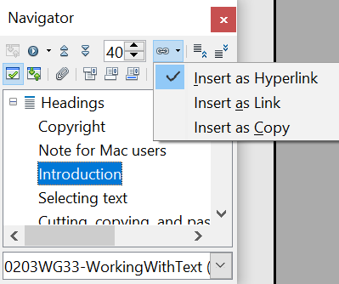

Figure 105: Inserting a hyperlink using the Navigator
- In the list at the bottom of the Navigator, select the document containing the item that you want to cross-reference.
- In the Navigator list, select the item that you want to insert as a hyperlink.
- Drag the item to where you want to insert the hyperlink in the document. The name of the item is inserted in the document as an active hyperlink.
You can also use the Hyperlink dialog to insert and modify hyperlinks within and between documents (see next page).

Inserting Hyperlinks Using a Dialog Box
To display the Hyperlink dialog box (Error: Reference source not found), click the Hyperlink icon on the Standard toolbar or choose Insert > Hyperlink from the menu bar. To turn existing text into a link, highlight it before opening the dialog box.
On the left-hand side, select one of the four types of hyperlink:
- Internet: a web address, normally starting with HTTP:// or HTTPS://
- Mail & News: for example an email address.
- Document: the hyperlink points to another document or to another place in the present document.
- New document: the hyperlink creates a new document.
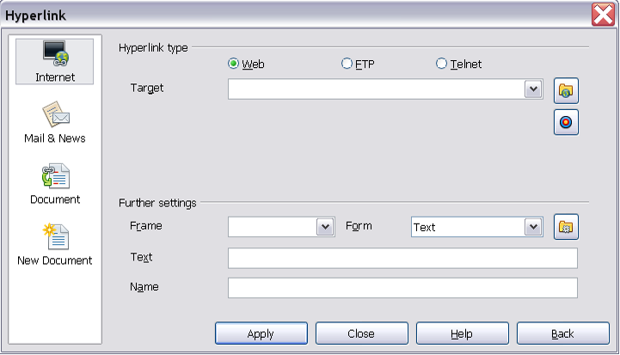
Figure 106. Hyperlink dialog box showing details for Internet links
The top right part of the dialog box changes according to your choice for the hyperlink type. A full description of all the choices, and their interactions, is beyond the scope of this chapter. Here is a summary of the most common choices.
For an Internet type hyperlink, choose the type of hyperlink (choose between Web, FTP or Telnet), and enter the required web address (URL).
For a Mail and News type hyperlink, specify whether it is a mail or news link, the receiver address and for email, also the subject.
For a Document type hyperlink, specify the document path (the Open File button opens a file browser); leave this blank if you want to link to a target in the same document. Optionally specify the target in the document (for example a specific heading). Click on the Target icon to open the Navigator where you can select the target, or if you know the name of the target, you can type it into the box.
For a New Document type hyperlink, specify whether to edit the newly created document immediately or just create it (Edit later) and the type of document to create (text, spreadsheet, etc.). For a presentation, Edit now is the more likely choice. The Select path button opens a directory picker.
The Further settings section in the bottom right part of the dialog box is common to all the hyperlink types, although some choices are more relevant to some types of links.
- Set the value of Frame to determine how the hyperlink will open. This applies to documents that open in a Web browser.
- Form specifies if the link is to be presented as text or as a button.
- Text specifies the text that will be visible to the user.
- Name is applicable to HTML documents. It specifies text that will be added as a NAME attribute in the HTML code behind the hyperlink.
- Event button: this button will be activated to allow AOO to react to events for which the user has written some code (macro). This function is not covered in this book.

Editing Hyperlinks
To edit a hyperlink, click anywhere in the link text and then open the Hyperlink dialog box by clicking the Hyperlink icon on the Standard toolbar or choosing Edit > Hyperlink from the menu bar. Make your changes and click Apply. If you need to edit several hyperlinks, you can leave the Hyperlink dialog box open until you have edited all of them. Be sure to click Apply after each one. When you are finished, click Close.
The standard (default) behavior for activating hyperlinks within AOO is to use Ctrl+click. This behavior can be changed in Tools > Options > OpenOffice > Security > Options, by deselecting the option Ctrl-click required to follow hyperlinks. If clicking in your links activates them, check that page to see if the option has been deselected.
To change the color of hyperlinks, go to Tools > Options > OpenOffice > Appearance, scroll to Unvisited links and/or Visited links, select those options, pick the new colors and click OK.
Caution | This will change the color for all hyperlinks in all components of OpenOffice—this may not be what you want.

In Writer and Calc (but not Draw or Impress), you can also change the Internet link character style or define and apply new styles to selected links.

Switching Between Insert and Overwrite Mode
With the keyboard, press Insert to toggle between overwrite mode and insert mode. In insert mode, any text after the cursor position moves forward to make room for the text you type; in overwrite mode, text after the cursor position is replaced by the text you type. The current mode is displayed on the Status Bar.
With the mouse, click in the area on the Status Bar that indicates the current mode in order to switch to the other mode.

Counting the Words in a Selection
Select a block of text and choose Tools > Word Count. AOO displays the number of words and characters in the selection as well as the number of words in the document. You can also see the number of words and characters (and other information) in the entire document in File > Properties > Statistics.

Changing the Case of Selected Text
To quickly change the case of text, select it, choose Format > Change Case from the menu bar, and then choose one of the following:
- Sentence case, where only the first word (and any proper nouns) is capitalized
- lower case, where no words (except proper nouns) are capitalized
- UPPER CASE, where all letters are capitalized
- Capitalize Every Word, where every word is capitalized
- tOGGLE cASE, which changes every letter to the opposite case
Writer does not have an automated way to do Title Case, where all words are capitalized except for certain subsets defined by rules that are not universally standardized.

Chapter 4
Formatting Pages
Using Page Styles, Tables, Frames, Columns, and Sections

Introduction
Writer provides several ways for you to control page layouts:
- Page styles
- Columns
- Frames
- Tables
- Sections
This chapter describes these methods, and some associated things:
- Headers and footers
- Numbering pages
- Changing page margins
Tip | Page layout is usually easier if you select the options to show text, object, table, and section boundaries in Tools > Options > OpenOffice > Appearance and if you select the options for paragraph ends, tabs, breaks, and other items in Tools > Options > OpenOffice Writer > Formatting Aids.

Choosing a Layout Method
The best layout method depends on what the final document should look like and what sort of information will be in the document. Here are some examples. Do not worry if all this does not mean much to you now. The techniques mentioned are all described in this chapter.
For a book similar to this user guide with one column of text, some figures without text beside them, and some other figures with descriptive text, use page styles for basic layout, and use tables to place figures beside descriptive text, where necessary. | 
Use page styles (with two columns) for an index or other document with two columns of text where the text continues from the left-hand column to the right-hand column and then to the next page, all in sequence (also known as snaking columns of text). If the title of the document (on the first page) is full-page width, put it in a single-column section. | 
For a newsletter with a complex layout, two or three columns on the page, and some articles that continue from one page to some place several pages later, use page styles for basic layout. Place articles in linked frames and anchor graphics to fixed positions on the page, if necessary. | 
For a document with terms and translations to appear side-by-side in what appear to be columns, use a table to keep items lined up, so you can type in both “columns”. | 

Setting up Basic Page Layout Using Styles
In Writer, page styles define the basic layout of all pages, including page size, margins, the placement of headers and footers, borders and backgrounds, number of columns, and so on.
Writer comes with several page styles, which you can build on or modify, and you can define new (custom) page styles. You can have one or many page styles in a single document.
Note | All pages in a Writer document are based on styles. If you do not specify a page style, Writer uses the Default page style.
To change the layout of individual pages, either define a new page style or use one of the techniques (sections, frames, or tables) described later in this chapter.
This chapter describes some uses of page styles. Some other uses are discussed in Chapter 6 (Introduction to Styles). The Page Style dialog box is covered in detail in Chapter 7 (Working with Styles).
Tip | Any modifications of page styles, including the Default page style, apply only to the document you are working on. If you want the changes to be the default for all documents, you need to put the changes into a template and make that template the default template. See Chapter 10 (Working with Templates) for details.

Inserting a Page Break without Switching the Style
In many documents (for example, a multipage report), you may want the text to flow from one page to the next as you add or delete information. Writer does this automatically, unless you override the text flow using one of the techniques described earlier.
If you do want a page break in a particular place, for example, to put a heading at the top of a new page, here is how to do it:
- Position the cursor in the paragraph you want to be at the start of the next page. Right-click and choose Paragraph in the pop-up menu.
- On the Text Flow page of the Paragraph dialog box (Figure 107), in the Breaks section, select Insert. Do not select With Page Style.
- Click OK to position the paragraph at the start of the next page.
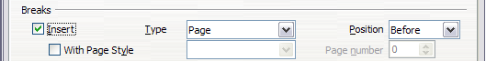Figure 107: Inserting a manual page break

Defining a Different First Page for a Document
Many documents, such as letters and reports, have a first page that is different from the other pages in the document. For example, the first page of a letterhead typically has a different header, as shown in Figure 108, or the first page of a report might have no header or footer, while the other pages do. With Writer, you can define the style for the first page and specify the style for the following page to be applied automatically.
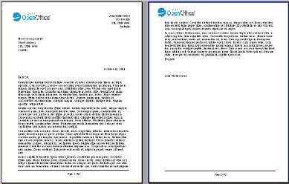Figure 108: Letterhead with different page styles for first and following pages
As an example, we can use the First Page and Default page styles that come with Writer. Figure 109 shows what we want to happen: the first page is to be followed by the default page, and all the following pages are to be in the Default page style.
Figure 109: Flow of page styles
To set up this sequence:
- Open the Styles and Formatting window. (Do one of the following: select the Styles and Formatting deck of the Sidebar, click the Styles and Formatting icon located at the left-hand end of the Formatting toolbar, choose Format > Styles and Formatting, or press F11.)
- On the Styles and Formatting window, click on the Page Styles icon to display a list of page styles.
- Right-click on First Page and select Modify from the pop-up menu.
- On the Organizer page of the Page Style dialog box, look at the Next Style property. This property defines what the page style for the next page will be. It should be set to Default, but if it is not, you can change the next style by clicking on the drop-down button and choosing Default from the list of page styles, as shown in Figure 110
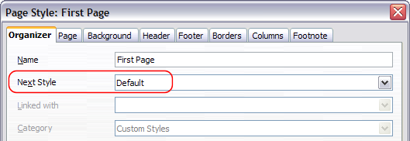Figure 110: Set the Next Style property for a page style
- On the other pages of this dialog box, you can turn on or off the header and footer for the first page and define other characteristics, such as columns, a page border, or a page background. For more information, see Chapter 7 (Working with Styles).
- Click OK to save the changes.
Note | You can override the Next Style property by manually inserting a page break and specifying a page style or by starting a page with a paragraph or table that has its own page style property defined. These techniques are described in “Inserting a Landscape Page into a Portrait Document” on page 110.

Changing Page Orientation within a Document
A document can contain pages in more than one orientation. A common scenario is to have a landscape page in the middle of a document, whereas the other pages are in a portrait orientation. Here are the steps to achieve it.

Setting Up a Landscape Page Style
- Note the page style that is current and the margin settings. (You can find the margin settings on the Page tab of the Page Style dialog box, as shown in Figure 112.)
- Create a new style. (Right-click on the current page style in the Styles and Formatting window and choose New from the pop-up menu)
- On the Organizer tab of the Page Style dialog box (Figure 111), name (by typing in the Name field) this new style Landscape and set the Next Style property to Landscape (to allow for having more than one sequential landscape page). If a style named Landscape already exists, you can choose any other name and use it in all the following commands.
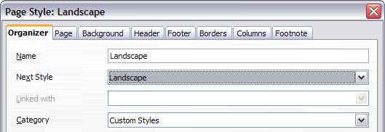
Figure 111: Name the new style and set the next page style to Landscape
- On the Page tab of the Page Style dialog box (Figure 112), set the Orientation to Landscape. The width and height attributes of the page will automatically change.
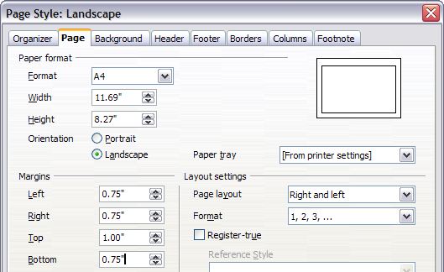
Figure 112: Set orientation and margins for a landscape page
- Change the margins so that they correspond with the margins of the portrait page. That is, the portrait top margin becomes the landscape left margin, and so on. Click OK to save the changes.

Inserting a Landscape Page into a Portrait Document
Now that you have defined the Landscape page style, here is how to apply it.
- Position the cursor in the paragraph or table at the start of the page that is to be set to landscape. Right-click and choose Paragraph or Table, respectively, in the pop-up menu.
- On the Text Flow tab of the Paragraph dialog box (Figure 114) or the Table Format dialog box (Figure 113), select Insert (or Break for a table) and With Page Style. Set the Page Style property to Landscape. Click OK to close the dialog box and to apply the new page style.
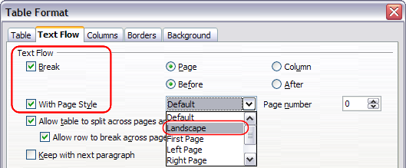Figure 113: Specifying a page break before a table
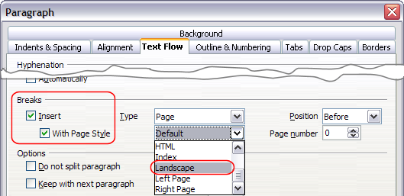Figure 114: Specifying a page break before a paragraph
- Position the cursor in the paragraph or table where the page is to return to portrait orientation and change the properties of that paragraph or table properties so that With Page Style is the portrait page style that was used before the Landscape page style.
- Click OK to return to the previous portrait page style.
Tip | If you need the headers or footers on the landscape pages to be in portrait orientation, see “Portrait Headers on Landscape Pages” on page 134.

Changing Page Margins
You can change page margins in two ways:
- Using the page rulers—quick and easy, but does not have fine control.
- Using the Page Style dialog box—can specify margins to two decimal places.

Note | If you change the margins using the rulers, the new margins affect the page style and will be shown in the Page Style dialog box the next time you open it.
To change margins using the rulers:
- The shaded sections of the rulers are the margins (see Figure 115). Put the mouse cursor over the line between the gray and white sections. The pointer turns into a double-headed arrow.
- Hold down the left mouse button and drag the mouse to move the margin.
Tip | The small arrows on the ruler are used for indenting paragraphs. They are often in the same place as the page margins, so you need to be careful to move the margin marker, not the arrows. Place the mouse pointer between the arrows and, when the pointer turns into a double-headed arrow, you can move the margin (the indent arrows will move with it).

Figure 115: Moving the margins
To change margins using the Page Style dialog box (Figure 112):
- Right-click anywhere on the page and select Page from the pop-up menu.
- On the Page tab of the dialog box, type the required distances in the Margins boxes.

Using Columns to Define the Page Layout
You can use columns for page layout in these ways:
- Define the number of columns and their layout on a page, using page styles.
- Change the number of columns for existing text.

Defining the Columns on a Page
It is a good idea to define your basic page style (such as Default) with the most common layout to be used in your document, either single-column or multiple-column. You can then either define extra page styles for pages with different numbers of columns or use sections (described in “Using Sections for Page Layout” starting on page 124) for pages or parts of pages with different numbers of columns.
To define the number of columns on a page, as shown in Figure 116:
- Choose Format > Columns or go to the Columns page of the Page Style dialog box,
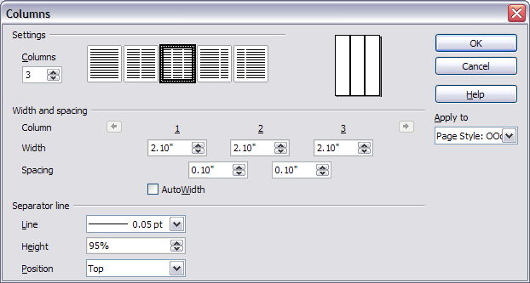Figure 116: Defining the number of columns on a page
- In the Settings area, choose the number of columns and specify any spacing between the columns and whether you want a vertical separator line to appear between the columns. You can use one of Writer’s predefined column layouts, or you can create a customized column layout. The preview box, located to the right of the Settings area, shows how the column layout will look.
- Notice the Apply to box on the right-hand side of the dialog box. In this case, the changes are being applied to the OOoDefault page style.
- Click OK to save the changes.

Specifying the Number of Columns
The Settings area displays five predefined column layouts. To use one of them, click the desired layout.
If you prefer to create a customized column layout, you must specify the number of columns that you want by entering the desired number in the Columns box.

Formatting Column Width and Spacing
To create evenly-spaced columns that are all the same width, select the AutoWidth option in the Width and Spacing area.
To customize the width and spacing of the columns, follow these steps:
- In the Width and Spacing area, deselect the AutoWidth option.
- On the Width line, enter a width for each column.
- On the Spacing line, enter the amount of space that you want between each pair of columns.
If you specify more than three columns, use the arrow keys on the Column line to scroll among the columns.

Formatting Separator Lines
To display separator lines between the columns:
- Six separator line options exist: None or various lines of thicknesses ranging from 0.05 to 5 pt (2.37 l). From the Line drop-down list in the Separator line area, select the type of line that you want. (1 pt = 1 point = 1/12 pica = 1/72 inch = 127/360 mm = 0.3527 mm.)
- The default format is for the separator lines to have the same height as the columns. If you want the separator lines to be shorter than the columns, use the Height box to enter the height of the separator lines as a percentage of the height of the columns. For example, if you enter 50%, the separator lines will be half as high as the columns.
- If you entered a height of less than 100%, use the Position drop-down list to select a vertical alignment for the separator lines. The vertical-positioning options are: Top, Centered, or Bottom.

Reverting to a Single-Column Layout
To revert to a single-column layout for the page style, go to the Settings area and either reset the number in the Columns box to 1 or click the single-column layout icon.

Changing the Number of Columns for Existing Text
You might want some parts of a page to have one column and other parts of the page to have two or more columns. For example, you might have a page-width headline over a three-column news story.
You can create columns and then type or paste text into them, or you can select some existing text and change the number of columns for displaying it.
When you select text and change the number of columns for that text, Writer turns the selected text into a section, as described in “Using Sections for Page Layout” on page 124.
To apply columns to selected text, use the menu Format > Columns. Figure 117 shows the Columns dialog box for a selection. The Apply to box on the right-hand side has Selection highlighted and an extra option (Evenly distribute contents to all columns) appears in the upper left-hand part of the dialog box.
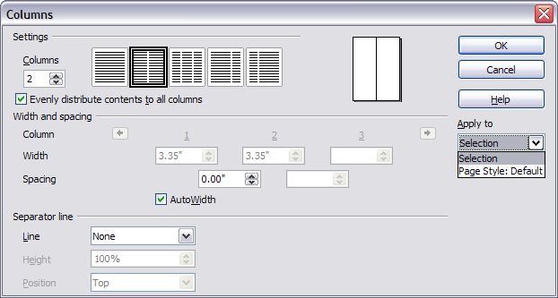Figure 117: Specifying columns for a selection
Tip | You cannot select text on a two-column page and change it to a single column using this method. Instead, you need to define a single-column page and then select the text you want to be in a two-column section.

Distributing Text Across Columns
As you add text to the section, you will see that the text flows from one column to the next. You can distribute text across the columns in one of two ways:
- Evenly—Writer adjusts the length of the columns to the amount of text, so that all the columns are approximately the same height. As you add or delete text, the columns readjust.
- Newspaper-style—Writer fills the columns one at a time, beginning with the first column. The last column may be shorter than the others.
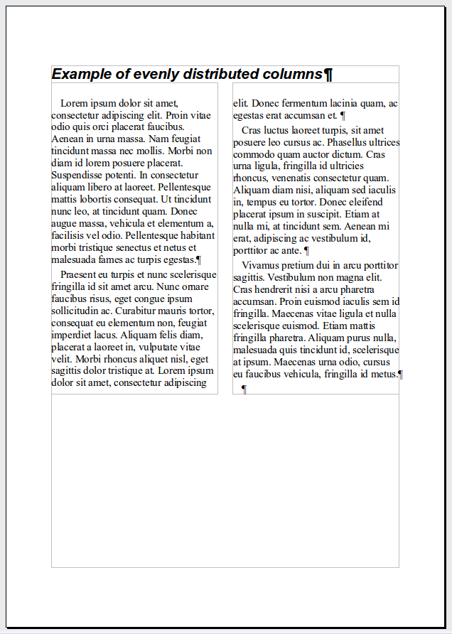 | 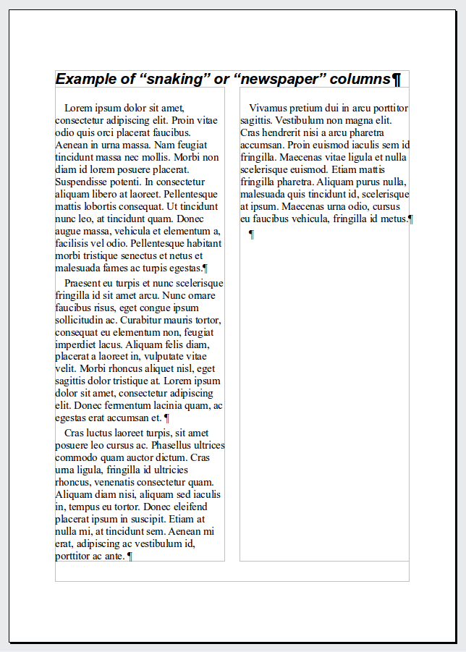
Figure 118: (Left) Evenly distributed columns; (Right) Newspaper-style columns.
To distribute text evenly, select the Evenly distribute contents to all columns option in the Settings area. Deselect this option if you want to distribute text newspaper-style.
Tip | Choose View > Nonprinting Characters (or press Ctrl+F10) to display end of paragraph markers (¶). Often, unexpected behavior of columns is due to extra paragraphs that are normally invisible to the user but are taking up space.

Using Frames for Page Layout
Frames can be very useful when producing a newsletter or other layout-intensive documents. Frames can contain text, tables, multiple columns, pictures, and other objects.
Use frames when you need to:
- Position something in a particular place on a page, for example, a logo or a “stop press” news box in one corner of a page.
- Allow text on one page to continue on another page, somewhere more distant than the next one, by linking the content of one frame to another so the contents flow between them as you edit the text.
- Wrap text around an object, such as a photograph.
Because OpenOffice does not allow you to define page styles with recurring frames, consider doing some quick sketches of the basic page layouts you need, indicating the approximate positions of different frames and their purposes. Try to keep the number of different page layouts as low as possible in order to avoid chaos in your design.
Pay special attention to the positioning of frames. Many of the predefined styles default to a center alignment. Although centering all frames looks reasonably good in most cases, it is rarely the best choice.
One of the most visually effective ways to position a frame is to align its left margin with that of the paragraph above it. To achieve this effect, insert the frame in a blank paragraph of the same style as the paragraph above. Then, select Insert > Frame > Type > Position > Horizontal > From Left to position the frame exactly where you want it.
You also should think about the type of wrap and the spacing between the frame and text. Instead of cramming a frame close to the text, use the Wrap tab to place some white space between them.
You can format frames individually or define and apply frame styles—see Chapter 7 (Working with Styles).
Example: Using a frame to center text on a page
Although you can center text horizontally as part of a paragraph style or by using manual formatting, those methods do not work for vertical centering. To center text vertically, you need to place the text in a frame, anchor the frame to a page or a paragraph, and then center the frame vertically on the page. See “Anchoring Frames” on page 119.

Creating Frames
However, you create a frame, it is a good idea to give it a meaningful name using the Options page of the Frame dialog (Figure 123). This will make it easier to use the Navigator to select a desired frame.
You can create a frame in several ways, depending on your needs.
- Choose Insert > Frame) to create an empty frame. The Frame dialog box (Figure 120) appears. You can click OK and come back to customize it later, or you can set the frame’s characteristics at this stage.
- Select text or a graphic, choose Insert > Frame, and click OK to create a frame containing the selection. The selected text is automatically deleted from the normal text flow and inserted into the frame, and the Frame dialog box appears.
- Insert a picture or other object by selecting Insert > Picture > From file or Insert > Object to start the process to insert a picture or object. The item inserted automatically appears in a frame, but the Frame dialog box does not appear.
- Use the Insert Frame Manually 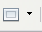 button on the Insert toolbar (go to View > Toolbars > Insert to display it), select the number of frames in the drop-down menu, and drag the mouse to draw the frame.
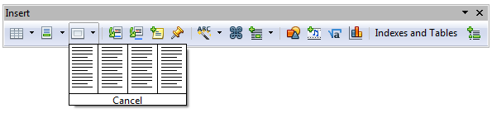
Figure 119: Using an icon on the Insert toolbar to create a frame
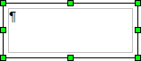
When you release the mouse button, a box appears where the cursor is located in the document. This box represents the frame: an area isolated from the main document.
To add content to a frame, first deselect the frame by clicking somewhere else on the page. Then, click inside the frame so that the cursor shifts its focus there. Now add content just like you would on the main page. When you are done, deselect the frame.

Moving, Resizing, and Changing Frame Attributes
When an object is added to Writer, it is automatically enclosed in a frame of a predetermined type. The frame sets how the object is placed on the page, as well as how it interacts with other elements in the document. You can edit the frame by modifying the frame style it uses or by using a manual override when a frame is added to the document. Frame styles are discussed in Chapter 7 (Working with Styles).
To change the size or location of a frame, first select the frame, then use either the mouse or the Frame dialog box (Figure 120). Using the mouse is faster but less accurate. You might want to use the mouse for gross layout and the dialog box for fine-tuning.
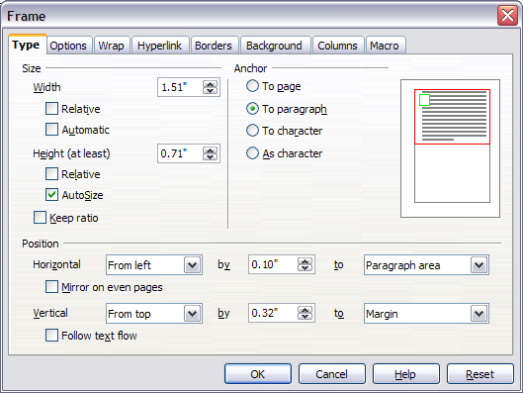Figure 120: Frame dialog box
You can resize the frame manually (by clicking on the green squares and dragging to the appropriate size) or start adding content to it (the frame will resize automatically if, for example, you add a large picture to it) or go back to the Frame dialog box and set the size and other characteristics.
To change the location of the frame using the mouse, drag and drop one of the edges or put the cursor anywhere within the frame. (The I-bar cursor changes to a four-headed arrow when properly positioned for a drag-and-drop move.)
To change the size of the frame, drag one of the handles. Drag a handle on one of the sides to enlarge or reduce the text frame in one dimension only; drag a corner handle to enlarge or reduce it in both dimensions.
These resizing actions distort the proportions of the frame. Holding down the Shift key while dragging one of the handles makes the frame keep the same proportions.
You can open the Frame dialog box at any time by selecting the frame, right-clicking, and choosing Frame from the pop-up menu.
To remove the default border on a newly created frame, as shown in Figure 121, open the Frame dialog box, go to the Borders page, and under Line Style, select None. Alternatively, you can assign a borderless style to the frame; see the Chapter 7 (Working with Styles) for information on frame styles.
Tip | Do not confuse a frame’s border with the text boundaries that are made visible using the View menu (by selecting View > Text Boundaries).

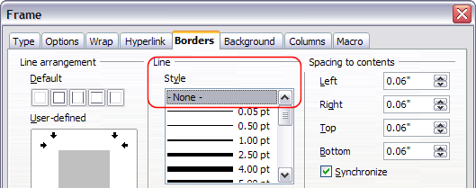Figure 121: Removing the border from a frame

Anchoring Frames
Using the Frame dialog box (or by right-clicking and pointing to Anchor), you can anchor a frame to a page, paragraph, or character, or you can anchor it as a character.
To Page
The frame keeps the same position in relation to the page margins. It does not move as you add or delete text. This method is useful when the frame does not need to be visually associated with a particular piece of text. It is often used when producing newsletters or other documents that are very layout-intensive. This method is also used to center text on a page.
To Paragraph
The frame is associated with a paragraph and moves with the paragraph. It may be placed in the margin or another location. This method is useful as an alternative to a table for placing icons beside paragraphs. It is also used to center text on a page in documents which will be used in a master document (frames anchored to pages will disappear from the master document).
To Character
The frame is associated with a character but is not in the text sequence. It moves with the paragraph but may be placed in the margin or another location. This method is similar to anchoring to a paragraph.
As Character
The frame is placed in the document like any other character and, therefore, affects the height of the text line and the line break. The frame moves with the paragraph as you add or delete text before the paragraph. This method is useful for adding a small icon in sequence in a sentence. It is also the best method for anchoring a graphic to an empty paragraph, so it does not move around the page in unexpected ways.

Linking Frames
You can link frames to each other even when they are on different pages of a document. The contents will automatically flow from one to the next. This technique is very useful when designing newsletters, where articles may need to be continued on a different page.
Note | You cannot link from a frame to more than one other frame.
To link one frame to another:
- Select the frame to be linked from.
- Click the Link Frames icon on the Formatting bar.
- Click the next frame in the series (which must be empty).

When a linked frame is selected, any existing links are indicated by a faint connecting line, as shown in Figure 122. Note that any frame-linking line may not be as clear as illustrated in the figure if there is other content on the page.
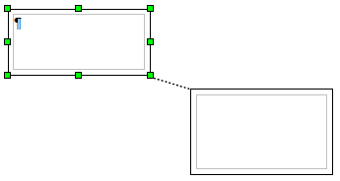Figure 122: Linked frames
The height of a frame that is being linked from is fixed; you can change this height manually or by using the Frame dialog box, but it does not automatically adjust to the size of the contents (that is, the AutoHeight attribute is disabled). Only the last frame of a chain can adapt its height to the content.
The Options tab of the Frame dialog box (Figure 123) shows the names of the selected frame and any frames it is linked to or from. You can change this information here. On this page, you can also select options to protect the contents, position, and size of the frame.
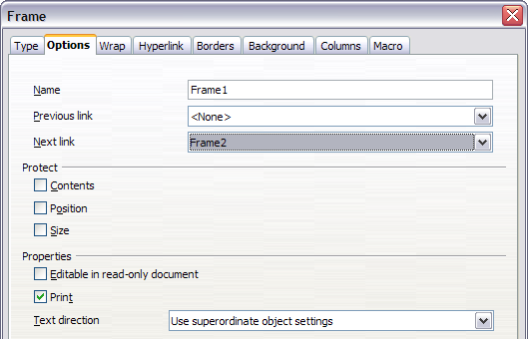Figure 123: Options page of the Frame dialog box

Other Frame Options
On the Hyperlink tab (Figure 124), you can specify the file for the hyperlink to open. This file can be on your machine, a network, or the Internet.
The Wrap, Borders, Background, Columns, and Macro tabs of the Frame dialog box are the same as those for frame styles. Refer to the Chapter 7 (Working with Styles) for details.
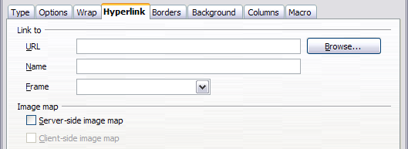Figure 124: Hyperlink page of the Frame dialog box

Using Tables for Page Layout
Writer’s tables can serve several purposes, such as holding data as you might see it in a spreadsheet, lining up material, and creating more complex page layouts. For information about using tables of data, see Chapter 9 (Working with Tables).
This topic describes how to achieve some common layouts by using tables.

Example: Creating Sideheads Using Tables
Sideheads and marginal notes are commonly used in documents from resumes to computer user guides. The main body of the text is offset to leave white space (usually on the left-hand side) in which the sideheads or notes are placed. The first paragraph is aligned beside the sidehead, as in Figure 125.
Example of a sidehead | In some cases you may want to put only one or two paragraphs in the table itself and the rest of the text and graphics in ordinary paragraphs (formatted to line up with the paragraphs in the table) so that text and graphics will flow more easily from one page to another when you add or delete material.  In other cases, you might put each paragraph in a separate row of the table and allow the table to break between pages.
Figure 125: Example of a sidehead
Note | Sideheads can also be created by placing text in a frame using the Marginalia frame style, as described in the Chapter 7 (Working with Styles).
To create a table for use with a sidehead:
- Place the cursor where you want the table to appear and choose Insert > Table (Ctrl+F12).
- In the Insert Table dialog box (Figure 159), define a one-row, two-column table with no border and no heading. Click OK to create the table.
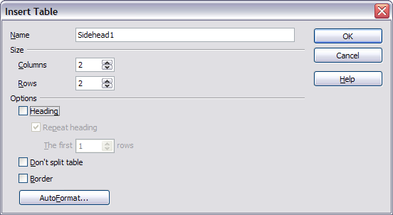Figure 126: Defining a two-column borderless table with no header
- Right-click on the table and choose Table from the pop-up menu. On the Columns tab of the Table Format dialog box, shown in Figure 127, make the columns the required width.
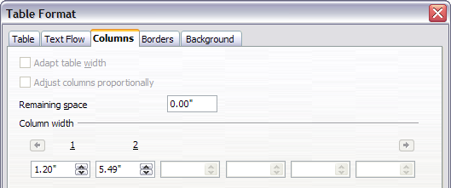
Figure 127: Defining a two-column table to line up with text offset at 1.2 inches
- On the Table tab of the Table Format dialog box (Figure 128), in the Spacing section, make the Above and Below values the same as the Top and Bottom spacing you have defined for ordinary paragraphs of text. Click OK to save your settings.
Tip | To check the top and bottom spacing for ordinary paragraphs:  - Position the cursor in a paragraph and select the Styles and Formatting deck of the Sidebar. Check that the Styles and Formatting window shows paragraph styles (top left button).  - The current style should be highlighted. If no paragraph style is highlighted, select All Styles in the bottom drop-down list. Right-click on it and select Modify from the pop-up list.  - Go to the Indents & Spacing page and look in the Spacing area for the values in Above paragraph and Below paragraph.
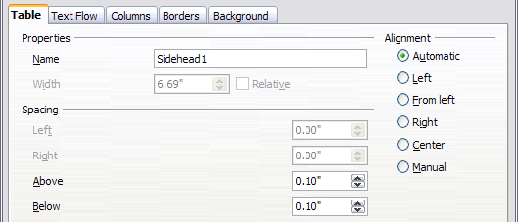
Figure 128: Defining the space above and below a table
You may also want to turn off number recognition so that Writer will not try to format numbers if you want them to be plain text. To turn number recognition off:
- Right-click in the table and then click Number Format on the pop-up menu.
- On the Number Format dialog box, make sure the Category is set to Text (Figure 129). Click OK.
Tip | If you use this table format often, you may want to save it as AutoText, as described in Chapter 3 (Working with Text). Select the table (not just the contents) to assign the shortcut.
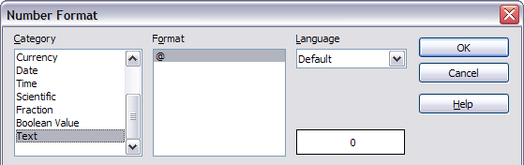Figure 129: Setting number format to Text

Using Sections for Page Layout
A section is a block of text that has special attributes and formatting. You can use sections to:
- Write-protect text
- Hide text
- Dynamically insert the contents of another document
- Add columns, margin indents, a background color, or a background graphic to a portion of your document
- Customize the footnotes and endnotes for a portion of your document

Creating Sections
To create a section:
- Place the cursor at the point in your document where you want to insert the new section. Or, select the text that you want to place in the new section.
- From the main menu, choose Insert > Section. The Insert Section dialog box opens.
- Click the Section tab, if it is not already displayed.
The Insert Section dialog box shown in Figure 130 has five tabbed pages.
- Use the Section tad to set the section’s attributes.
- Use the Columns tab to format the section into columns.
- Use the Indents tab to set indents in the right and left margins of the section.
- Use the Background tab to add color or a graphic to the section’s background.
- Use the Footnotes/Endnotes tab to customize the section’s footnotes and endnotes.
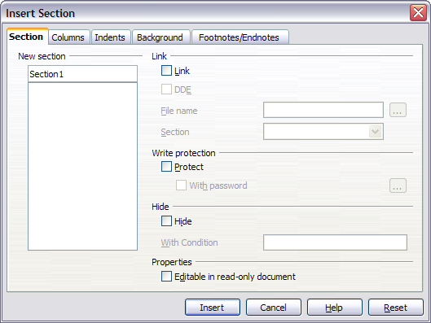Figure 130: Inserting a section using the Insert Section dialog box
At any time, you can reset a tabbed page to its default settings by clicking the Reset button. (Note, however, that you cannot reset the Section tab. If you wish to undo changes to the Section page, you must do so manually.)
Use the Section page to set the attributes of the current section.

Naming Sections
Writer automatically enters a name for the current section in the top box of the New section area. To change the name, select it and type over it. The name is displayed in the Sections category of the Navigator window. If you give your sections meaningful names, you can navigate to them more easily.

Linking Sections
You can insert the contents of another document into the current section and then have Writer update the section whenever the other document is updated. This is called linking the section to the other document.
To link the current section to another document, follow these steps:
- In the Link area (Figure 131), select the Link option.
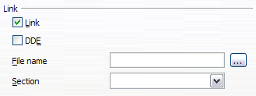Figure 131: Linking sections
- Click the (…) button to the right of the File name field. The Insert dialog box opens.
- Find and select the document you want to insert and then click the Insert button. The Insert dialog box closes and the name of the selected document appears in the File name field.
- If you want to insert only a section of the selected document, select the desired section from the Section drop-down list.
Note | The section must already exist in the selected document. You cannot create a section in the selected document at this point.
You can update links automatically or manually. See “Updating Links” on page 131.

Write Protecting Sections
To protect the current section so that its contents cannot be edited, select the Protected option (Figure 132) in the Write protection area.
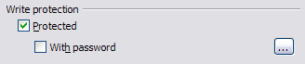Figure 132: Write protecting sections
Note | Write protection protects only the section’s contents, not its attributes or format.

Password Protecting Sections
To prevent others from editing the section’s attributes or format, protect the section with a password, as follows:
- Select the With password option. The Enter Password dialog box shown in Figure 133 opens.
- Type a password in the Password field and then confirm the password by typing it again in the Confirm field.
- Click OK. The Enter Password dialog box closes. Anyone who tries to edit the section’s attributes or format will be prompted to enter the password.
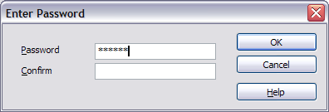Figure 133: Password protecting a section
Note | Passwords must contain at least five characters. The OK button remains inactive until you have typed five characters.

Hiding Sections
You can hide the current section so that it will not be displayed on the screen or printed. You can also specify conditions for hiding the section. For example, you can hide the section only from certain users.
Note | You cannot hide a section if it is the only content on the page or if the section is in a header, footer, footnote, endnote, frame, or table cell.
To hide a section, select the Hide option in the Hide area (Figure 134).
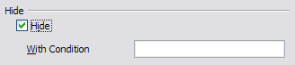Figure 134: Hiding sections
To hide the section only under certain conditions, enter the desired conditions in the With Condition field. The syntax and operators that you use to enter conditions are the same ones that you use to enter formulas. For syntax and a list of operators, see Writer’s online help under conditions.
If the section is write-protected with a password, the password must be entered to hide or reveal the text.
Note | Hiding text is not a secure way to stop someone else reading it. It will stop the casual reader but will not prevent someone who actively wants to find out what you have hidden―even if it is password protected.

Formatting a Section into Columns
Use the Columns tab of the Insert Section dialog box to format the current section into columns. This page is very similar to the Columns dialog box shown in Figure 117 on page 114. Please refer to that topic for details.

Indenting the Section from Margins
Use the Indents tab, pictured in Figure 135, to set indents in the right and left margins of the current section.
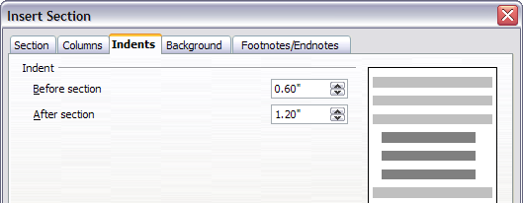Figure 135: Indenting sections
Enter the desired left-margin indent in the Before section box. Enter the desired right-margin indent in the After section box. The preview box on the right-hand side of the page shows you how the section will look with the indents applied.

Changing the Background of the Section
Use the Background page to add color or a graphic to the background of the current section. This page is similar to the Background pages for paragraphs, frames, tables, and other objects in AOO. For more information, refer to Chapter 7 (Working with Styles).

Customizing Footnotes and Endnotes in a Section
Use the Footnotes/Endnotes tab, pictured in Figure 136, to customize the current section’s footnotes and endnotes.
Customizing footnotes
If you want the current section’s footnotes to appear separately from the other footnotes in the document, select the Collect at end of text option in the Footnotes area.
To number the current section’s footnotes separately from the other footnotes in the document, follow these steps:
- In the Footnotes area, make sure that the Collect at end of text option is selected.
- Select the Restart numbering option.
- If you want the section’s footnotes to start at a number other than 1, enter the desired starting number in the Start at spin box.
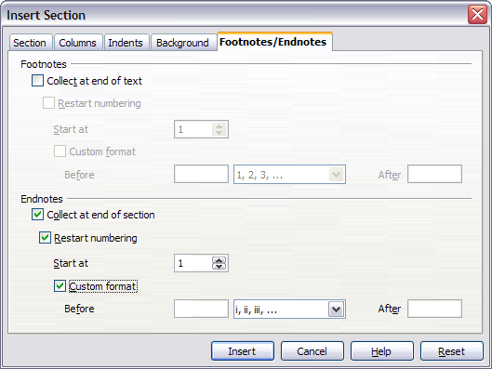Figure 136: Setting footnotes and endnotes for sections
To edit the format of the section’s footnotes, follow these steps:
- In the Footnotes area, make sure that the Collect at end of text and Restart numbering options are selected.
- Select the Custom format option.
- From the drop-down list under and to the right of the Custom format option, select a numbering format for the footnotes.
- To add text to the selected numbering format, use the Before and After fields. For example, if you want the footnote numbers to be preceded by the word “Note” and followed by a colon, fill the Before and After fields like this:
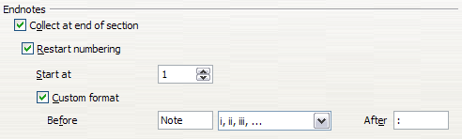Figure 137: Numbering footnotes for sections
Customizing endnotes
If you want the current section’s endnotes to appear at the end of the section rather than at the end of the document, select the Collect at end of section option in the Endnotes area.
To number the current section’s endnotes separately from the other endnotes in the document, follow these steps:
- In the Endnotes area (Figure 158), make sure that the Collect at end of section option is selected.
- Select the Restart numbering option.
- If you want the section’s endnotes to start at a number other than 1, enter the desired starting number in the Start at spin box.
To edit the format of the section’s endnotes, follow these steps:
- In the Endnotes area, make sure that the Collect at end of section and Restart numbering options are selected.
- Select the Custom format option.
- From the drop-down list under and to the right of the Custom format option, select a numbering format for the endnotes.
- To add text to the selected numbering format, use the Before and After fields, as shown above for footnotes (Figure 158).

Saving a New Section
To save a new section so that it appears in your document, click the Insert button. The Insert Section dialog box closes and the new section appears in your document.

Editing and Deleting Sections
You can edit a section’s attributes and formatting, or delete sections, by using Format > Sections.
To select the section that you want to edit or delete, follow these steps:
- From the main menu, choose Format > Sections. The Edit Sections dialog box shown in Figure 138 opens.
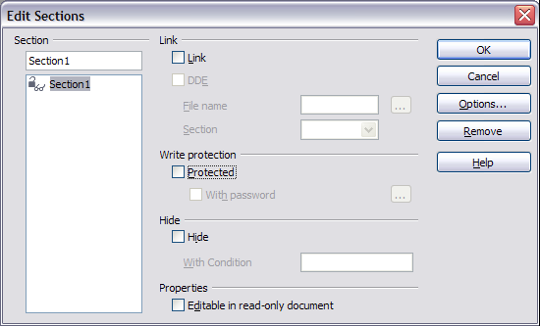Figure 138: Edit Sections dialog box
- The name of the current section appears in the Section area, in the field above the list box. If you want to edit or delete a different section, click the name of the desired section in the list. The selected section becomes the current section, and its name appears in the field above the list box.

Deleting Sections
To delete the current section, click the Remove button.
Note | Writer will not prompt you to confirm the delete! To undo a delete, click the Cancel button.

Editing Section Attributes
To rename the current section, simply type over its name in the Section area.
From the Edit Sections dialog box, you can also edit the current section’s link, write-protect, and hide attributes. To learn how to edit these attributes, see:
“Linking Sections” on page 125.
“Write Protecting Sections” on page 126.
“Hiding Sections” on page 127.

Editing the Format of a Section
To edit the format of the current section, click the Options button.
The Options dialog box (Figure 139) has four tabbed pages: Columns, Indents, Background, and Footnotes/Endnotes. The use of these pages is described earlier in this topic.
To reset a page to its most recently saved settings, click the Reset button.
To save your Options settings and return to the Edit Sections dialog box, click OK.
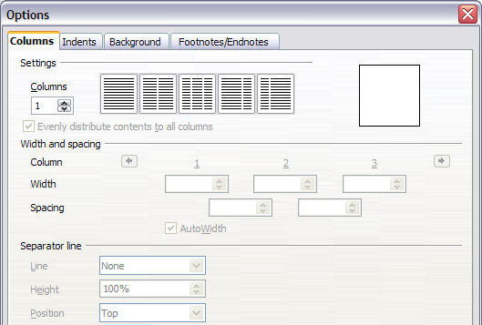Figure 139: Options dialog box for sections

Updating Links
You can set Writer to update linked sections automatically, and you can also update links manually.

Updating Links Automatically
To set Writer to update links without prompting you, or to turn off automatic updating, follow these steps:
- Choose Tools > Options > OpenOffice Writer > General. The dialog box displays general text document settings.
- In the Update area, under Update links when loading, select one of the following three options:
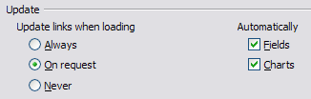
  - Select Always if you want Writer to update links automatically, without prompting you, whenever you open a document that contains links.
  - Select On request if you want Writer to prompt you before updating links.
  - Select Never if you do not want Writer to update links.
- Click OK to save your settings. The Options dialog box closes.

Updating Links Manually
To update a link manually:
- Open the document that contains the link.
- Choose Edit > Links. The Edit Links dialog box (Figure 140) opens.
- The list in the Edit Links dialog box displays the names of all the files that are linked to the current document. Click the file that corresponds to the link that you want to update.
- Click the Update button. The most recently saved contents of the linked file appear in the current document.
- To close the Edit Links dialog box, click Close.
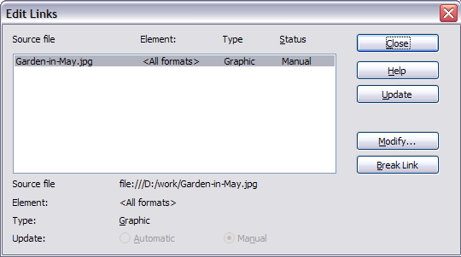Figure 140: Edit Links dialog box

Creating Headers and Footers
Headers are portions of a document that always appear at the top of a page; footers appear at the bottom of a page. Typically, headers display the title or chapter name of a document.
In AOO, headers are specified by page styles; therefore, when inserted, all the pages with the same page style will display the same header. Chapter 7 describes how to format a header as part of the page style formatting. For the purpose of this example, we will insert a header in the Default pages using manual formatting.
Select from the main menu Insert > Header > [Page Style]. The submenu lists the page styles used in your document. In addition, the submenu includes the entry All, which activates headers on all the pages of the document regardless of their page style.
For our example, select the Default menu item to activate the headers only on the pages that use the Default page style. Similarly, to insert a footer, choose Insert > Footer.
Caution | The Insert Menu can also be used for deleting a preexisting header or footer for a page style. If that page style has a check mark in front of it, clicking on it opens an AOO dialog box warning about this and asking whether you want to delete the header or footer for that particular page style.
Depending on which option you choose, an area such as that in Figure 141 will appear at the top or bottom of the page. In this area you can enter text and graphics that will appear on every page.
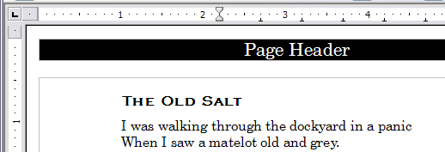Figure 141. A page with a page header
Items such as document titles, chapter titles, and page numbers, which often go into headers and footers, are best added as fields. That way, if something changes, the headers, and footers are all updated automatically.
Fields are covered in Chapter 14 (Working with Fields), but one example here may be useful. To insert the document title into the header:
- Select File > Properties > Description, enter a title for your document in the Title area, and click OK to close the dialog box.
- Add a header (Insert > Header > Default).
- Place the cursor in the header part of the page.
- Select Insert > Fields > Title. The title should appear on a gray background (which does not show when printed and can be turned off).
- To change the title for the whole document, choose File > Properties > Description.

Formatting Headers and Footers
In Writer, headers and footers are considered paragraphs, and therefore you can format the header or footer text using the same techniques you use for formatting text in the main body of the document.
Tip | You can define styles for headers and footers so that you can quickly obtain a consistent formatting in case you use several page styles. Writer includes three predefined header styles and three footer styles: generic ones, for left pages, and for right pages. You can also add custom header and footer styles.

Portrait Headers on Landscape Pages
When you define a header and footer on a landscape page, they will be aligned with the long side of the page. If your landscape pages are going to be inserted between portrait pages, you might want the headers and footers to be on the short sides of the landscape pages, so the final printed product looks like the contents of the landscape pages have been rotated 90 degrees on portrait pages.
You can set up portrait headers and footers on landscape pages by using a trick involving frames. These are a bit tedious to set up, but once you have done so, you can copy and paste them to other landscape pages. There does not appear to be a way to make this part of the landscape page style.
To set up portrait headers and footers on landscape pages:
- Calculate the required margins, so the text area of the landscape page is the same size as the text area on the portrait pages, taking into account the space for headers and footers on the portrait pages.
For example, consider a book which uses the margins shown in the following table. The landscape right and left margins are 1 cm larger than the portrait top and bottom margins, respectively. This difference accounts for the extra space used by the portrait header and footer (0.5 cm for the height of the header or footer and a 0.5 cm gap between the header or footer and the main text).
Portrait page (right page) |  | Landscape page (right page)
Top margin | 1.5 cm | Right margin | 2.5 cm
Bottom margin | 1.5 cm | Left margin | 2.5 cm
Left (inner) margin | 2.8 cm | Top margin | 2.8 cm
Right (outer) margin | 1.8 cm | Bottom margin | 1.8 cm
- Create the Landscape page style.
- Measure the distance from the upper and left edges of the page to the upper left-hand corner of the space where you want the footer to appear. Measure the width and length of the space the footer will occupy (to match footers on portrait pages). (See Figure 142.)
- In a blank paragraph in the text, type the footer text or insert fields such as the page number or the chapter number and name—to match the footer text and fields on the portrait pages. Assign the Footer style to this paragraph so the typeface, font size, and tab settings match those of the footers on the portrait pages.
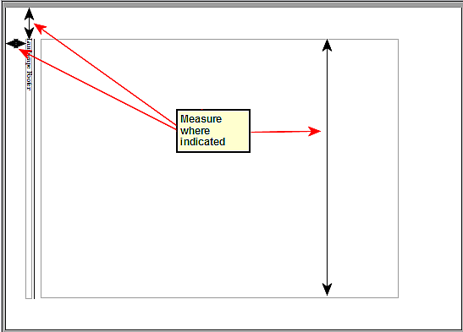Figure 142: Measuring the location and size of the footer frame
- Select the text (including the fields) you just entered. Choose Format > Character. On the Character dialog box, select the Position tab (Figure 143) and set Rotation / scaling to 270 degrees (counterclockwise). Click OK.
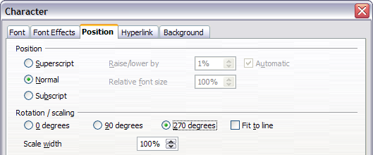Figure 143: Rotating the footer text 270 degrees
- With the text still selected, choose Insert > Frame. In the Frame dialog box (Figure 144), pick the Type tab and enter the width, height, and horizontal and vertical position for the footer.
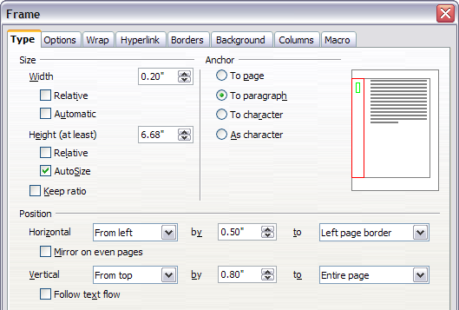
Figure 144: Defining the size and position of the footer frame
- If your footer has a line above the text, as in this book, on the Borders tab (Figure 145), select a right border and specify the line width and spacing to the frame’s contents.
- Click OK to save these settings. The footer should now appear in the required position and orientation.
Repeat these steps (using appropriate measurements) to set up a portrait header on the landscape page.
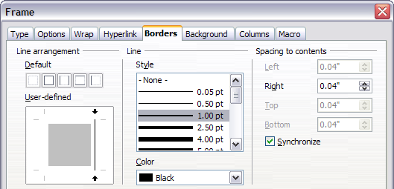Figure 145: Specifying the border position, line width, and spacing to contents

Numbering Pages
This section describes techniques to insert page numbers and related information in a document. Some basic knowledge of page styles, which are fully described in chapters 6 and 7, may be needed to follow some examples given.

Preliminaries: Fields
OpenOffice uses fields to manage page numbers. To insert a page number field, position the cursor where you want to insert the number and choose Insert > Fields > Page Number. The page number appears with a gray background. The gray background denotes a field.
Note | The gray background is simply there to denote a field. This background is not printed. If you wish to turn this feature off, choose View > Field Shadings (or press Ctrl+F8).
The page number field always displays the page number for the page where it is placed. If you see the words “Page number” instead of a number, press Ctrl+F9. This shortcut key toggles AOO between displaying the field’s contents (what the field is for) and the field’s results (what the field creates).
Note | For a full introduction to fields, see Chapter 14 (Working with Fields).

Preliminaries: Insert and Format a Header
For the purpose of this example, we will insert a header in the Default page style pages using manual formatting. See “Creating Headers and Footers” on page 132.

Simple Page Numbering
The simplest case is to have the page number at the top of every page and nothing more. To do this, put the cursor on the header (Figure 146) and select Insert > Fields > Page Number.
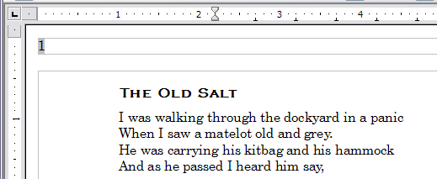Figure 146: Page number inserted in the header
Now the correct page number appears on every page.

Combining Header Text and Page Number
There are a lot of interesting variations that you can apply without further knowledge of page styles. Here are some suggestions:
- Right-align the header to make the page number appear on the top-right.
- Type the word page before the page number field, so the header reads page 1, page 2, and so on. This also requires using the Page Number field, discussed earlier (page 137).
- Add the document title, so the header reads, for example: Peter's favorite poems, left justified, and page x with right justification, where x is the value of the Page Number field. Consider using a (right-aligned) tab to separate the title from the page number.
- AOO also has a Page Count field (Insert > Fields > Page Count). Using it, you could, for example, have a header that reads page 2 of 12.
These variations are all illustrated in Figure 147.
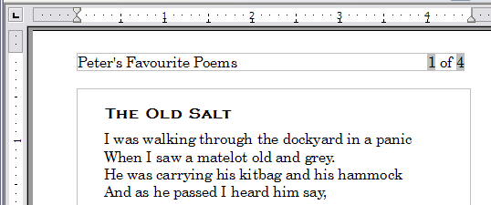Figure 147: Variations on the simple page numbering method

Changing the Number Format
Many more variations are possible. For example, you can set the page number to display in Roman numerals. To do that, you could double-click on the page number and select the desired format; however, a better choice is to specify the format of numbers in the page style as explained here.
In the Styles and Formatting window (select its Sidebar icon or press F11 if not already displayed) select the Page Styles icon and right-click on the highlighted entry for the current style. Select Modify, which opens the Page Style dialog box.
On the Page tab of the Page Style dialog box, in the Layout settings section, select i, ii, iii, … from the Format drop-down list.
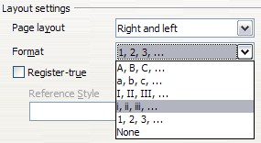Figure 148: Changing format of page numbers

Numbering the First Page Something Other than 1
Sometimes you may want to start a document with a page number greater than 1. For example, you may be writing a book, with each chapter in a separate file. Chapter 1 may start with page 1, but Chapter 2 could begin with page 25 and Chapter 3 with page 51.
Follow these instructions to start the page numbering in a document at a number greater than 1. (These instructions are for a page number in a footer, but you could use a header instead.)
Tip | Do not set a starting page number that is an even number because you will end up with a blank page before the first page when you print the file or export it as a PDF.
- Choose Insert > Footer > [page style] to activate the footer. (If the page style is already selected in the Footer menu, point to it and click OK in the dialog box that appears. Then point to that page style again to select it.)
- The cursor is now in the footer. To insert the page number, choose Insert > Fields > Page Number. The page number will be 1.
- Click in the first paragraph in the text area or type a paragraph of text.
- Choose Format > Paragraph (or right-click and choose Paragraph from the pop-up menu) to display the Paragraph dialog box.
- On the Text Flow tab, in the Breaks section, select Insert and select Page in the Type drop-down list. Select With Page Style and the page style you are using for the first page of the document.
- The Page number field is now active. Type the page number you want to start with. Click OK to close the Paragraph dialog box.

Numbering Pages by Chapter
Technical documents often include the chapter number with the page number in the header or footer. For example, 1-1, 1-2, 1-3, …; 2-1, 2-2, 2-3, …
To set up this type of page numbering in AOO, you need to do three things:
- Ensure that your chapter titles are all identified by the same paragraph style, for example, the Heading 1 style.
- Use Tools > Outline Numbering (Figure 149) to tell AOO what paragraph style you are using for Level 1 in your outline, and specify “1,2,3” in the Number box.
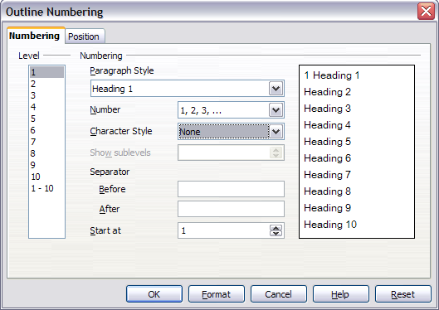Figure 149: Specifying paragraph style and numbering for chapter titles
- Insert the chapter number in your document. To do this:
    - Place the cursor in the header or footer just before the page number you inserted earlier, and choose Insert > Fields > Other from the menu bar.
    - On the Fields dialog (Figure 150), go to the Document tab. Select Chapter in the Type list, Chapter number in the Format list, and 1 in the Level box. Click Insert.
    - Type a hyphen or other punctuation between the chapter number and the page number.
For more information, see “Choosing paragraph styles for outline levels” and “Including chapter or section information in page headers” in Chapter 7 (Working with Styles).
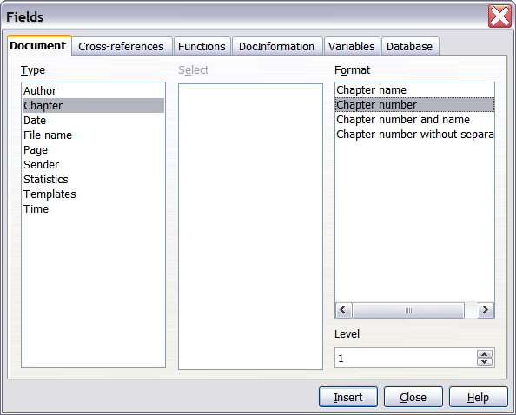
Figure 150: Inserting a chapter number field

Restarting Page Numbering
Often you will want to restart the page numbering at 1, for example, on the page following a title page or a table of contents. In addition, many documents have the front matter (such as the table of contents) numbered with Roman numerals and the main body of the document numbered in Arabic numerals, starting with 1.
You can restart page numbering in two ways.
Method 1:
- Place the cursor in the first paragraph of the new page.
- Choose Format > Paragraph.
- On the Text Flow tab of the Paragraph dialog box (Figure 114 on page 111), select Insert in the Breaks area.
- In the Type drop-down list, select Page.
- In the Position drop-down list, select Before or After to position where you want to insert the page break.
- Select With Page Style and specify the page style to use.
- Specify the page number to start from and then click OK.
Method 2:
- Place the cursor in the first paragraph of the new page.
- Choose Insert > Manual break.
- Page break is the default selected on the Insert Break dialog box shown in Figure 151.
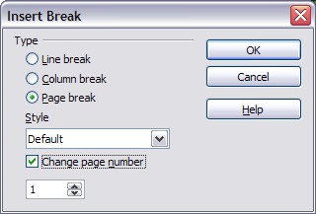
Figure 151: Restarting page numbering after a manual page break
- Choose the required page style in the Style drop-down list.
- Select Change page number.
- Specify the page number to start from and then click OK.

Example: Restart Page Numbering: a Preface
A standard preface has the following properties:
- Page numbers are displayed in Roman numerals (i, ii, iii, iv, …).
- After the preface, the document starts on a Default page.
- The page number resets to 1, and the number format becomes Arabic (1, 2, 3, 4, …).
Resetting the page number requires page breaks.
First, let’s get the preliminary work done for the Preface style:
- Create a new page style and name it Preface.
- Set its Next Style to Preface because a preface could span multiple pages.
- Add a header to Preface and insert the Page Number field. Make the page numbers display as Roman numerals, as in Figure 152 (i, ii, iii, iv, …):
    - Open the page style window for Preface (if not already open) and click the Header tab. Select Header on under Header.
    - Click the Page tab. Under Layout settings, in the Format drop-down list, set the format to i, ii, iii, …. Click OK to close the dialog box.
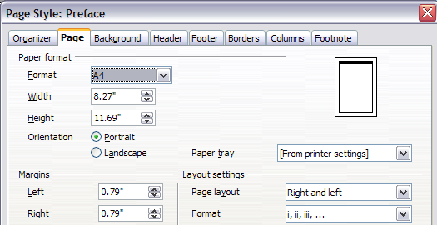Figure 152. Set page number format to Roman numerals.
After the preface is written, we are ready to restart the page numbering in the main body of the document to Arabic numerals. Follow these steps:
- Make an empty paragraph at the very end of the preface.
- Put the cursor on the blank line.
- Choose Insert > Manual Break.
- Select Page break and choose the Default style.
- Select the Change page number option and set the new value to 1. Click OK to close the dialog box.
These settings are shown in Figure 153.
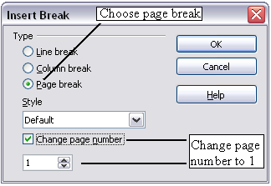
Figure 153: Set the new page number to 1 and the page style to Default.
Note | You cannot assign an odd page number to a left page or an even page number to a right page. AOO strongly adheres to the convention that odd page numbers go on right-hand pages and even page numbers on left-hand pages.
This change is also reflected on the status bar. The Page section of the status bar (Figure 154) now includes both the total page count and the entry of the page number field.
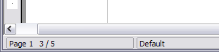
Figure 154: Page number in the status bar

Problems with Restarting Page Numbering
Restarting page numbering may lead to two problems.
- The Statistics page in the document’s Properties (File > Properties) always displays the total number of pages in the document, which may not be what you want to appear in the Page Count field.
- When page numbering is restarted, AOO always makes odd-numbered pages to be on the right and even-numbered pages to be on the left. It does this by inserting a blank page, if necessary. Sometimes this blank page is not desired, particularly when creating PDFs or when printing single sided.

Solving the page count problem
Suppose you know exactly how many pages are not to be included in the page count. (You want one page to be excluded in the page count for the following example.)
Instead of inserting a Page Count field, you can do the following:
- Position the cursor where you want the page count to appear.
- Press F2 to open the formula bar, just above the horizontal ruler in the main Writer window (see Figure 155).
- After the equal sign, type page –1. If you want to exclude several pages, substitute the number of excluded pages for 1 in the formula.
- Press Enter to close the formula bar and insert the resulting field into the document.
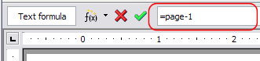Figure 155: Formula bar
If you do not know the total number of pages in advance, then one approach is to create a bookmark on the last page and then insert a cross-reference to it.
To create a bookmark on the last page:
- Go to the last page (Ctrl+End).
- Choose Insert > Bookmark.
- In the Insert Bookmark dialog (Figure 156), type a name for the bookmark, for example LastPage. Click OK.
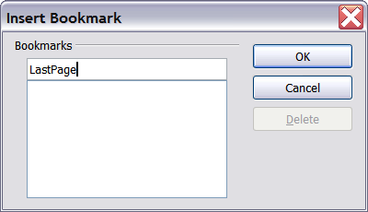
Figure 156: Inserting a bookmark
To insert a cross-reference to the last page in the header or footer where you want to refer to the total number of pages:
- Position the cursor at the desired location—for example after the space added after of in the header or footer, as in page xx of yy.
- Choose Insert > Cross-reference.
- On the Cross-references tab of the Fields dialog box, (Figure 157) select Bookmarks in the Type column and LastPage in the Selection column. LastPage now appears in the Name box.
- In the Insert Reference to box, select As page style. Click Insert.
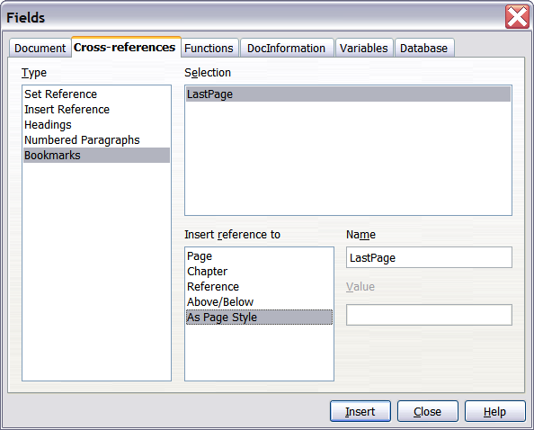
Figure 157: Inserting a cross-reference to a bookmark on the last page of a document
Note | Do not delete the bookmark at the end of the document. If you do, the cross-reference will not work.  If a field, such as a cross-reference, does not automatically update, select the text containing the field and press F9.

Numbering Portrait and Landscape Pages
To create page numbers on portrait and landscape pages in the same place and orientation:
- Refer to “Portrait Headers on Landscape Pages” on page 134 to create a landscape page style and landscape header or footer styles. When creating the page style, select the Use dynamic spacing option in the Spacing area in the Header or Footer pages of the Page Style dialog box.
- Insert the page break and choose the landscape page style; do not change the page numbering.
- In the relevant header or footer, insert the page number field (Insert > Fields > Page Number).

Defining Borders and Backgrounds
You can apply borders and backgrounds to many elements in Writer. Paragraphs, pages, frames, sections, page styles, paragraph styles, and frame styles can include both borders and backgrounds; character styles, tables of contents, and indexes can include backgrounds only.
The dialog box pages for borders and backgrounds are similar in each case. To illustrate their use, we will define a border and background for a text frame.
Tip | Page backgrounds fill only the area within the margins, including the header or footer (if any). To extend the background color or graphic into the margins, you need to define a frame of appropriate size and position, anchor it to the page or a paragraph, and send it to the background. For more about anchoring frames, see Chapter 8 (Working with Graphics).

Adding a Border
To begin, select the frame, right-click, and choose Frame from the pop-up menu. Select the Borders tab shown in Figure 148.
Borders have three components: where they go, what they look like, and how much space is left around them.
- Line arrangement specifies where the borders go. Writer provides five default arrangements, but you can just as easily click on the line you want to customize in the User-defined area to get exactly what you want. Each line can be individually formatted.
- Line specifies what the border looks like: the style and color. There are a number of different styles and colors to choose from. The Line Style and Color will apply to those borders highlighted by a pair of black arrows in the User-defined map on the left-hand side of the dialog box.
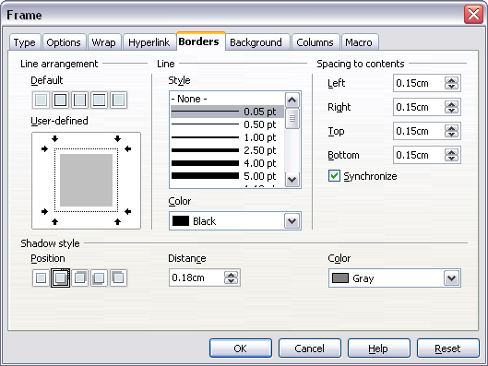
Figure 158: Frame dialog box: Borders page
- Spacing to contents specifies how much space to leave between the border and the contents of the element. Spaces can be specified to the left, right, above, and below. Check Synchronize to have the same spacing for all four sides. This spacing is like a padding, and it is not factored in when calculating the text measurements.
- Shadow style properties always apply to the whole element. A shadow has three components: where it is, how far from the element it is cast, and what color it is.

Adding Color to the Background
In the Frame dialog box, choose the Background page (Figure 119). Here you can add color or a graphic.
To add color to the background, select from the color grid. You can adjust the transparency of the color to make any text easier to read.

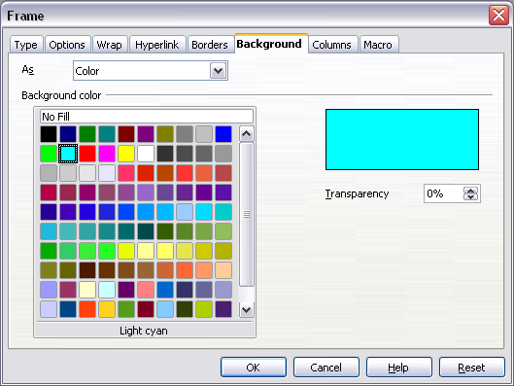
Figure 159: Frame dialog box: Background page showing color choices

Adding a Graphic to the Background
To add a graphic to the background:
- From the As drop-down list on the Background page, select Graphic. The page now displays the graphics options, as shown in Figure 118.
- Click the Browse button. The Find Graphics dialog box opens.
- Find the file you want and then click the Open button. The Find Graphics dialog box closes and the selected graphic appears in the preview box on the right-hand side of the Background tab. (If you do not see the graphic, select the Preview option.)
- To embed the graphic in your document, deselect Link. To link the graphic to the document but not embed it, select Link. For more about linking graphics, see Chapter 8 (Working with Graphics).
- In the Type area, choose how you want the background graphic to appear:
  - To position the graphic in a specific location, select Position and then click the desired location in the position grid.
  - To stretch the graphic to fill the entire background area, select Area.
  - To repeat the graphic across the entire background area, select Tile.
- In the Transparency area, you can adjust the transparency of the graphic. This adjustment is often necessary to make any text easier to read.

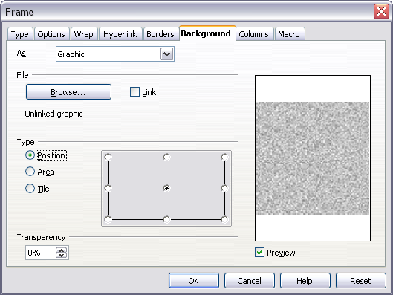Figure 160: Graphic options on the Background page of the Frame dialog box

Deleting Color or Graphics from the Background
To delete color or graphics from the background:
- From the As drop-down list, select Color.
- Click No Fill on the color grid.

Chapter 5
Printing, Exporting, Faxing, and E-Mailing

Introduction
General information about printing and faxing documents from AOO is provided in the Getting Started guide. This chapter describes some items of particular interest to users of Writer.

Quick Printing
Click the Print File Directly icon to send the entire document to the default printer defined for your computer.
Note | You can change the action of the Print File Directly icon to send the document to the printer defined for the document instead of the default printer for the computer. Go to Tools > Options > Load/Save > General and select the Load printer settings with the document option.

Controlling Printing
For more control over printing, use the Print dialog box (File > Print or Ctrl+P).
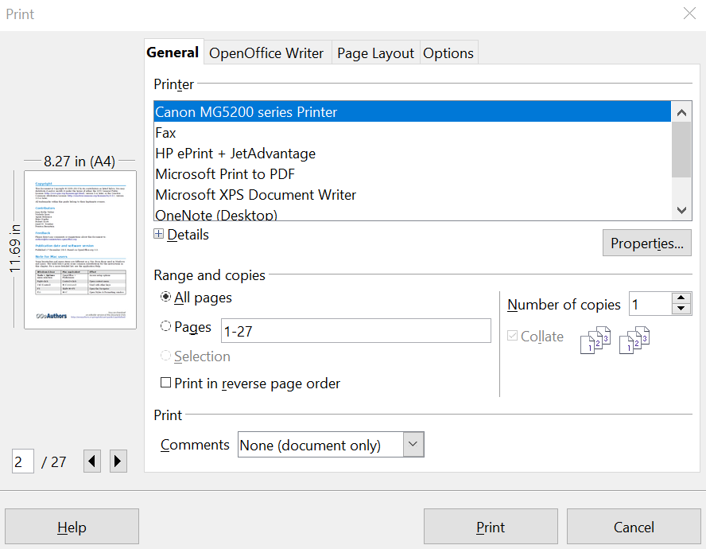

Figure 161: The Print dialog General page

The Print dialog box has four tabs, from which you can choose a range of options, as described in the following sections.
Note | The options selected on the Print dialog box apply to this printing of this document only.  To specify default printing settings for AOO, go to Tools > Options > OpenOffice – Print and Tools > Options > OpenOffice Writer – Print. See Chapter 2 (Setting Up Writer) for more details.

Selecting General Printing Options for a Document
On the General tab of the Print dialog box, you can choose:
- The printer (from the printers available)
- Which pages to print, the number of copies to print, and whether to collate multiple copies (Range and copies section)
- Whether to print any comments that are in the document, and where to print the comments.
Figure 162: Choosing whether and where to print comments
Select the Properties button to display a dialog box where you can choose portrait or landscape orientation, which paper tray to use, and the paper size to print on.
On the Options tab of the Print dialog box, you can choose various other options for printing.
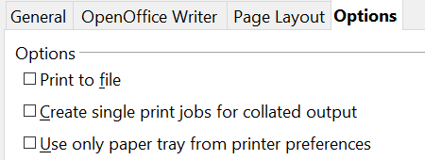

Figure 163: General print options

Printing Multiple Pages on a Single Sheet of Paper
You can print multiple pages of a document on one sheet of paper. To do this:
- In the Print dialog box, select the Page Layout tab (Figure 162).
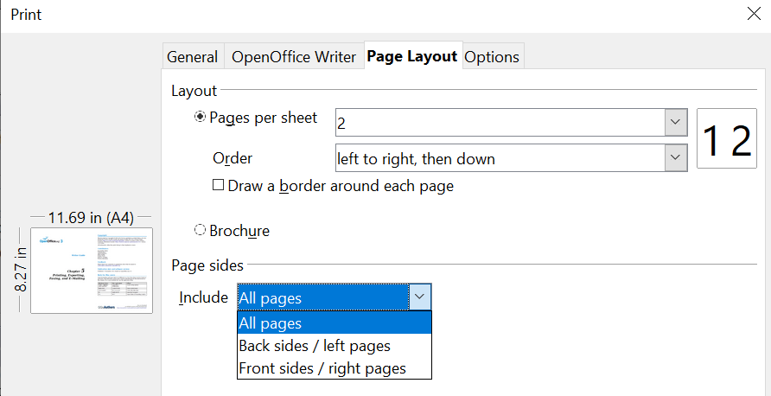
Figure 164: Printing multiple page per sheet of paper
- In the Layout section, select from the drop-down list the number of pages to print per sheet. The preview panel on the left of the Print dialog box shows how the printed document will look.
When printing more than 2 pages per sheet, you can choose the order in which they are printed across and down the paper. The two pictures below show the difference.
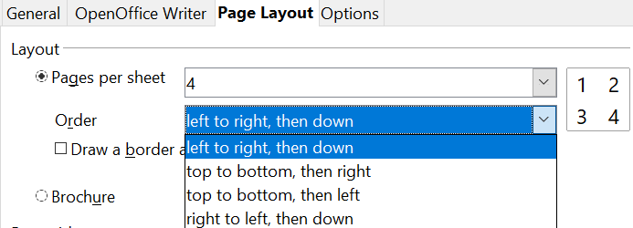

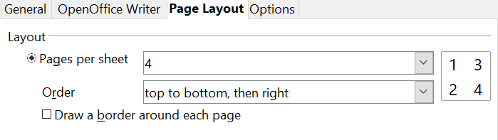
- In the Page sides section, select whether to print all pages or only some pages.
- Click the Print button.
Tip | To print two pages per sheet in “facing pages” (book layout) style, print from Print Preview instead. See page 156.

Selecting What to Print
In addition to printing a full document, you can choose to print individual pages, ranges of pages, or a selection of a document, as described in this section.
Printing an individual page:
- Choose File > Print from the menu bar.
- On the Print dialog box, select the page to print.
  - In the Ranges and copies section of the General page, select the Pages option.
  - Enter the sequence number of the page you want to print. The preview box changes to show the selected page.
If you have restarted page numbering within the document, the sequence number is not the same as the page number.

- Click the Print button.
Printing a range of pages:
- Choose File > Print from the menu bar.
- On the Print dialog box, select the range of pages to print.
  - In the Ranges and copies section of the General page, select the Pages option.
  - Enter the sequence numbers of the pages to print (for example, 1–4 or 1,3,7,11).
- Click the Print button.
Printing a selection of text:
- In the document, select the material (text and graphics) to print.
- Choose File > Print from the menu bar.
- The Ranges and copies section of the Print dialog box now includes a Selection option and the preview box shows the selected material. See Figure 165.
- Click the Print button.
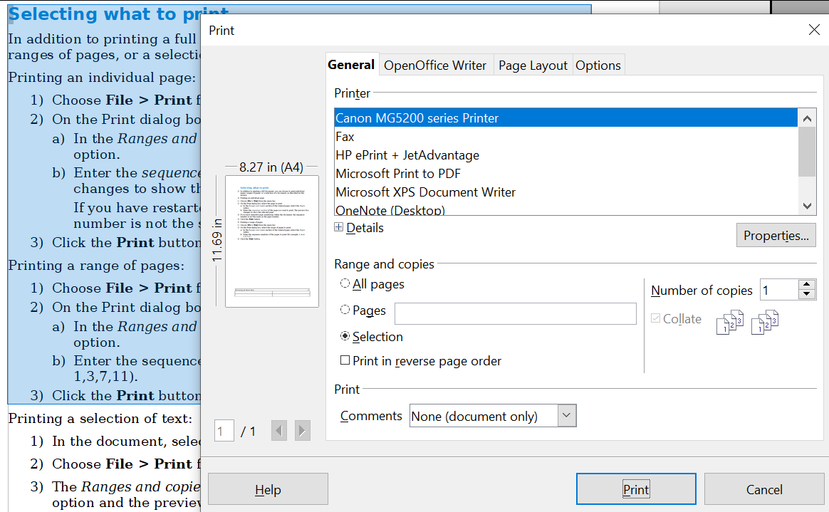

Figure 165: Printing a selection of text

Printing a Brochure
In Writer, Impress, and Draw, you can print a document with two pages on each side of a sheet of paper, arranged so that when the printed pages are folded in half, the pages are in the correct order to form a booklet or brochure.
Tip | Plan your document so it will look good when printed half size; choose appropriate margins, font sizes, and so on. You may need to experiment.

To print a brochure on a single-sided printer:
- Choose File > Print.
- In the Print dialog box, click Properties.
- Check if the printer is set to the same orientation (portrait or landscape) as specified in the page setup for your document. Usually the orientation does not matter, but it does for brochures. Click OK to return to the Print dialog box.
- Select the Page layout tab in the Print dialog box.
- Select the Brochure option.
- In the Page sides section, select Back sides / left pages option from the Include drop-down list.
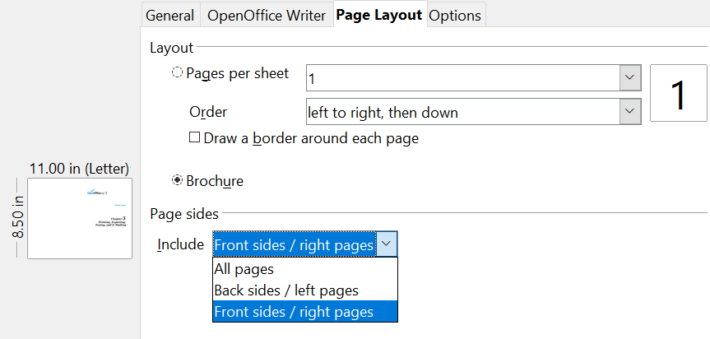

- Click the Print button.
- Take the printed pages out of the printer, turn the pages over, and put them back into the printer in the correct orientation to print on the blank side. You may need to experiment a bit to find out what the correct arrangement is for your printer.
- On the Print dialog box, in the Page sides section, select Front sides / right pages option from the Include drop down box.
- Click the Print button.
Tip | If your printer can print double-sided automatically, choose All pages.

Printing in Black and White (on a Color Printer)
You may wish to print documents in black and white on a color printer. Several choices are available. Please note that some color printers may print in color regardless of the settings you choose.
Change the printer settings to print in black and white or gray scale:
- Choose File > Print to open the Print dialog box.
- Click Properties to open the Properties dialog box for the printer. The available choices vary from one printer to another, but you should find options for the Color settings. See your printer’s help or user manual for more information.
- The choices for color might include black and white or gray scale. Choose the required setting.
- Click OK to confirm your choice and return to the Print dialog box,
- Click the Print button to print the document.
Tip | Gray scale is best if you have any graphics in the document.
Change the AOO settings to print all color text and graphics as gray scale:
- Choose Tools > Options > OpenOffice > Print.
- Select the Convert colors to gray scale option. Click OK to save the change.
- Open the Print dialog box (File > Print).
- Click the Print button to print the document.
Change the AOO Writer settings to print all color text as black, and all graphics as gray scale:
- Choose Tools > Options > OpenOffice Writer > Print.
- Under Contents, select the Print text in black option. Click OK to save the change.
- Open the Print dialog box (File > Print).
- Click the Print button to print the document.

Previewing Pages Before Printing
The normal page view in Writer shows you what each page will look like when printed, and you can edit the pages in that view. If you are designing a document to be printed double-sided, you may want to see what facing pages look like. Writer provides two ways to do this:
- View Layout (editable view): use the Facing Pages (Book Preview) button on the status bar.
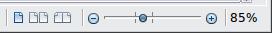
- Page Preview (read-only view).
To use Page Preview:
- Choose File > Page Preview (or click the Page Preview button on the Standard toolbar). Writer now displays the Page Preview toolbar instead of the Formatting toolbar.
Figure 166. Page Preview toolbar (Writer)
- Select the required preview icon: Two Pages (), Multiple Pages () or Book Preview ().
- To print the document from this view, click the Print document icon() to open the Print dialog box.
- Choose the print options and click the Print button.

Printing Envelopes
Printing envelopes involves two steps: setup and printing.
To set up an envelope to be printed by itself or with your document:
- Click Insert > Envelope from the menu bar.
- In the Envelope dialog box, start with the Envelope tab. Verify, add, or edit the information in the Addressee and Sender boxes (the “from” on the envelope).
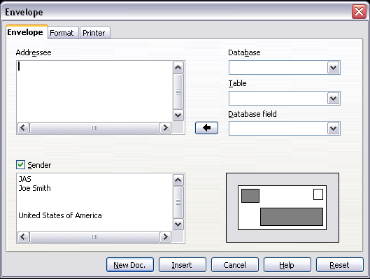
Figure 167. Choosing addressee and sender information for an envelope
You can type information directly into the Addressee and Sender boxes, or use the right-hand drop-down lists to select the database or table from which you can draw the envelope information, if desired. See Chapter 11 (Using Mail Merge) for details on how to print envelopes from a database.
- On the Format page, verify or edit the positioning of the addressee and the sender information. The preview area on the lower right shows the effect of your positioning choices.
- To format the text of these blocks, click the Edit buttons to the right. In the drop-down list you have two choices: Character and Paragraph.
- In Character, you can choose Fonts (Sizes…), Fonts Effects (Underlining, Color…), Position (Rotating/scaling…), Hyperlink, Background and more.
- In Paragraph, you can choose Indents & Spacing, Alignment, Text Flow, Tabs, Drop Caps, Borders and Backgrounds.
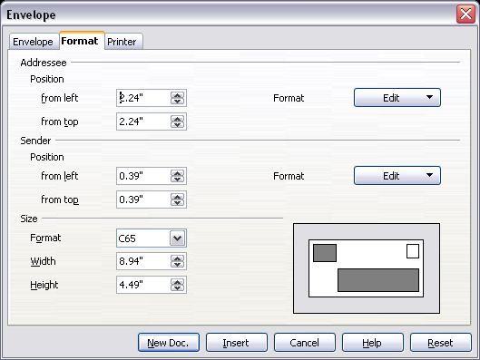
Figure 168. Choosing positioning and size of elements for an envelope
- In the lower left of this page, choose the envelope format from the drop-down list. The width and height of the selected envelope then show in the boxes below the selected format. If you selected a preexisting format, just verify these sizes. If you picked User defined in the Format list, then you can edit the sizes.
- After formatting, go to the Printer page to choose printer options such as envelope orientation and shifting. You may need to experiment a bit to see what works best for your printer. You can also decide on a different printer or alter the printer setup (for example, specify the tray that holds envelopes) for this print job.
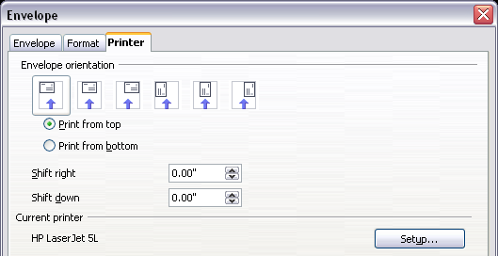
Figure 169. Choosing printer options for an envelope
- When you have finished formatting and are ready to print, click either the New Doc or Insert button to finish. New Doc makes only an envelope or starts a new document with the envelope. Insert puts the envelope into your existing document as page 1. To not proceed with this envelope, click Cancel or press the Esc key. You can also click Reset to remove your changes and return to the original settings when the dialog box opened.
When the Envelope dialog box closes, you are returned to your document, which now has the envelope in the same file as the document. Save this file before you do anything else.
To print the envelope:
- Choose File > Print from the menu bar.
- On the Print dialog box, under Print range, choose Pages and type 1 in the box. Click OK to print.

Printing Labels
Labels are commonly used for printing address lists (where each label shows a different address), but they can also be used for making multiple copies of one label only, for example return-address stickers.
To print labels:
- Choose File > New > Labels on the menu bar. The Labels dialog box opens.
- On the Labels tab, fill in your own label text in the Inscription box, or use the Database and Table drop-down lists to choose the required information, as described in Chapter 11 (Using Mail Merge).
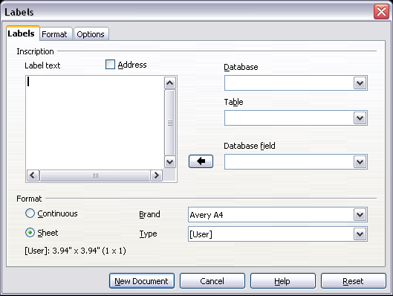
Figure 170. Labels dialog box, Labels page
- Select the label stock in the Brand drop-down list. The types for that brand then appear in the Type drop-down list. Select the size and type of labels required. You can also select User in the Type drop-down list and then make specific selections on the Format page.
- On the Format page, choose the pitch, sizes, margins, columns, and rows for user-defined labels, or just verify with a brand of label stock you have loaded into the printer.
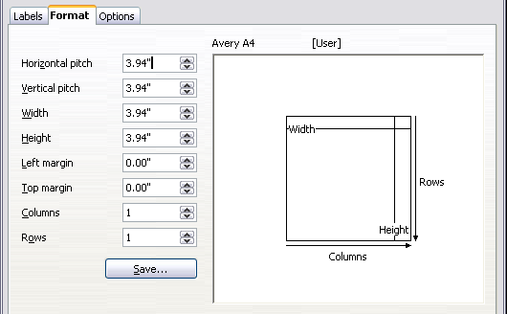
Figure 171. Labels dialog box, Format page
- Click Save to save your new format.
- On the Options tab, choose to print the entire page of labels or one single label, then select which one by the column and row. You can also change printer setup.
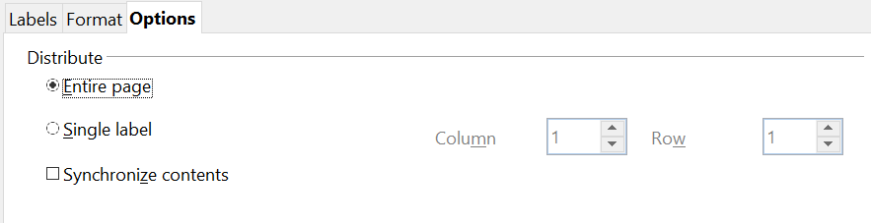

Figure 172. Labels dialog box, Options page
- When you have finished formatting, click New Document to make your sheet of labels or click Cancel (or press the Esc key). You can also click Reset to remove your changes and return to the original settings when the dialog box opened.
- You can print using the Print File Directly icon on the toolbar or by choosing File > Print from the menu bar, or you can save the file to print later.

Exporting to PDF
OpenOffice can export documents to PDF (Portable Document Format). This industry-standard file format for file viewing is ideal for sending the file to someone else to view using Acrobat Reader or other PDF viewers. Unlike exporting to other formats, PDF documents will look exactly as the document appears on your screen. The only limitation of PDF is that the recipient will not be able to edit the document.

Quick Export to PDF
Click the Export Directly as PDF icon to export the entire document using the default PDF settings. You are asked to enter the file name and location for the PDF file, but you do not get a chance to choose a page range, the image compression, or other options.

Controlling PDF Content and Quality
For more control over the content and quality of the resulting PDF, use File > Export as PDF. The PDF Options dialog box opens. This dialog box has five tabs (General, Initial View, User Interface, Links, and Security). Make your selections, and then click Export. Then you are asked to enter the location and file name of the PDF to be created, and click Save to export the file.

General tab of PDF Options Dialog Box
On the General tab (Figure 168), you can choose which document pages to include in the PDF, the type of compression to use for images (which affects the quality of images in the PDF), and other options.
Range section
- All: Exports the entire document.
- Pages: To export a range of pages, use the format 3-6 (pages 3 to 6). To export single pages, use the format 7;9;11 (pages 7, 9, and 11). You can also export a combination of page ranges and single pages, by using a format like 3-6;8;12.
- Selection: Exports whatever material is selected.
Images section
- Lossless compression: Images are stored without any loss of quality. Tends to make large files when used with photographs. Recommended for other kinds of images or graphics.
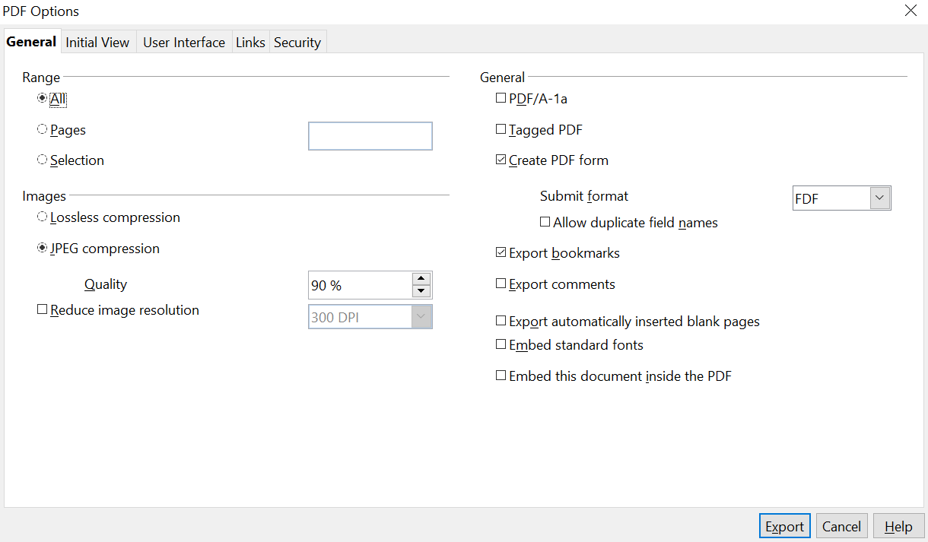

Figure 173: General page of PDF Options dialog box
- JPEG compression: Allows for varying degrees of quality. A setting of 90% works well with photographs (small file size, little perceptible loss of quality).
- Reduce image resolution: Lower-DPI (dots per inch) images have lower quality. For viewing on a computer screen generally a resolution of 72dpi (for Windows) or 96dpi (GNU/Linux) is sufficient, while for printing it is generally preferable to use at least 300 or 600 dpi, depending on the capability of the printer. Higher dpi settings greatly increase the size of the exported file.
Note | EPS images with embedded previews are exported only as previews. EPS images without embedded previews are exported as empty placeholders.

General section
- PDF/A-1: PDF/A is an ISO standard for long-term preservation of documents, by embedding all the information necessary for faithful reproduction (such as fonts) while forbidding other elements (including forms, security, and encryption). PDF tags are written. If you select PDF/A-1a, the forbidden elements are grayed-out (not available).
- Tagged PDF: Tagged PDF contains information about the structure of the document’s contents. This can help to display the document on devices with different screens, and when using screen reader software. Some tags that are exported are the table of contents, hyperlinks, and controls. This option can increase file sizes significantly.
- Create PDF form—Submit format: Choose the format of submitting forms from within the PDF file. This setting overrides the control’s URL property that you set in the document. There is only one common setting valid for the whole PDF document: PDF (sends the whole document), FDF (sends the control contents), HTML, and XML. Most often you will choose the PDF format.
- Export bookmarks: Creates PDF bookmarks (a table of contents list displayed by most PDF viewers) for all outline paragraphs and for all table of contents entries for which you assigned hyperlinks.
- Export comments: Exports comments as PDF notes.
- Export automatically inserted blank pages: If selected, automatically inserted blank pages are exported to the PDF. This is best if you are printing the PDF double-sided. For example, books usually have chapters set to always start on an odd-numbered (right-hand) page. When the previous chapter ends on an odd page, AOO inserts a blank page between the two odd pages. This option controls whether to export that blank page.
- Embed standard fonts: You can choose to embed the standard fonts (Times, Helvetica, Courier, Symbol, and ZapfDingbats) in all PDF documents created by AOO to enhance display accuracy in PDF viewers.

Initial View Tab of PDF Options Dialog Box
On the Initial View page (Figure 167), you can choose how the PDF opens by default in a PDF viewer. The selections should be self-explanatory.

User Interface Tab of PDF Options Dialog Box
On the User Interface tab (Figure 166), you can choose more settings to control how a PDF viewer displays the file. Some of these choices are particularly useful when you are creating a PDF to be used as a presentation or a kiosk-type display.
Window options section
- Resize window to initial page. Causes the PDF viewer window to resize to fit the first page of the PDF.
- Center window on screen. Causes the PDF viewer window to be centered on the computer screen.
- Open in full screen mode. Causes the PDF viewer to open full-screen instead of in a smaller window.
- Display document title. Causes the PDF viewer to display the document’s title in the title bar.

Figure 174: Initial View page of PDF Options dialog box

Figure 175: User Interface page of PDF Options dialog box
User interface options section
- Hide menu bar Causes the PDF viewer to hide the menu bar.
- Hide toolbar. Causes the PDF viewer to hide the toolbar.
- Hide window controls. Causes the PDF viewer to hide other window controls.
Bookmarks
Select how many heading levels are displayed as bookmarks, if Export bookmarks is selected on the General page.

Links Tab of PDF Options Dialog Box
On this page you can choose how links in documents are exported to PDF.

Figure 176: Links page of PDF Options dialog box
Export bookmarks as named destinations
If you have defined Writer bookmarks, this option exports them as “named destinations” to which Web pages and PDF documents can link.
Convert document references to PDF targets
If you have defined links to other documents with OpenDocument extensions (such as .ODT, .ODS, and .ODP), this option converts the files names to .PDF in the exported PDF document.
Export URLs relative to the file system
If you have defined relative links in a document, this option exports those links to the PDF.
Cross-document links
Set up the behavior of the PDF links to other files. Select one among the following alternatives:
- Default mode: The PDF links will be handled as specified in your operating system.
- Open with PDF reader application: Use the same application used to display the PDF document to open linked PDF documents.
- Open with Internet browser: Use the default Internet browser to display linked PDF documents.

Security Tab of PDF Options Dialog Box
PDF export includes options to encrypt the PDF (so it cannot be opened without a password) and apply some digital rights management (DRM) features.
- With an open password set, the PDF can only be opened with the password. Once opened, there are no restrictions on what the user can do with the document (for example, print, copy, or change it).
- With a permissions password set, the PDF can be opened by anyone, but its permissions can be restricted. See Figure 164.
- With both the open password and permission password set, the PDF can only be opened with the correct password, and its permissions can be restricted.
Note | Permissions settings are effective only if the user’s PDF viewer respects the settings.

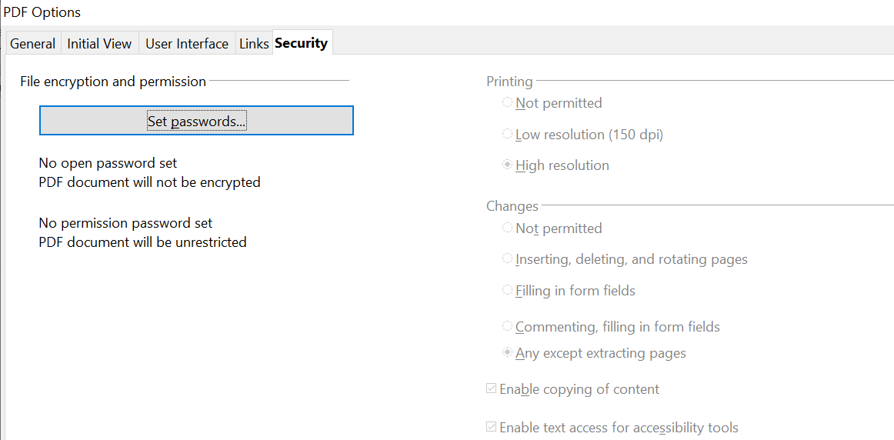

Figure 177: Security page of PDF Options dialog box
Figure 164 shows the pop-up dialog box displayed when you click the Set passwords button on the Security page of the PDF Options dialog box.
After you set a password for permissions, the other choices on the Security page (shown in Figure 163) become available. These selections should be self-explanatory.
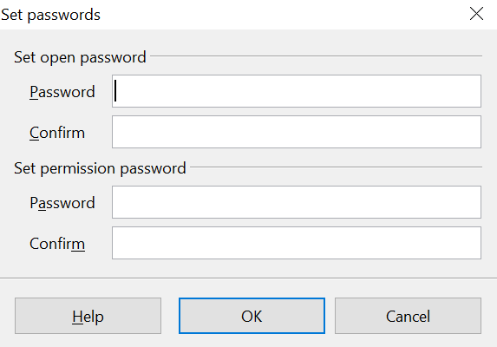
Figure 178: Setting a password to encrypt a PDF

Exporting to XHTML
AOO uses the term “export” for some file operations involving a change of file type. AOO can export files to XHTML. Other formats may be made available through extensions.
To export to XHTML, choose File > Export. On the Export dialog box, specify a file name for the exported document, then select the XHTML in the File format list and click the Export button.

E-mailing Writer Documents
AOO provides several ways to quickly and easily send a Writer document as an e-mail attachment in one of three formats: .ODT (OpenDocument Text, Writer’s default format), .DOC (Microsoft Word format), or PDF. These options are available if you have an email program installed on your computer. If you only use an internet service accessed through a browser, you must go to that service and simply attached your saved document to a message.
To send the current document in .ODT format:
- Choose File > Send > Document as E-mail. Writer opens your default e-mail program. The document is attached.
- In your e-mail program, enter the recipient, subject, and any text you want to add, then send the e-mail.
File > Send > E-mail as OpenDocument Text has the same effect.
If you choose E-mail as Microsoft Word, Writer first creates a .DOC file and then opens your e-mail program with the .DOC file attached. Similarly, if you select E-mail as PDF, Writer first creates a PDF using your default PDF settings (as when using the Export Directly as PDF toolbar button) and then opens your email program with the .PDF file attached.

E-mailing a Document to Several Recipients
To e-mail a document to several recipients, you can use the features in your e-mail program, or you can use AOO’s mail merge facilities to extract email addresses from an address book.
Note | Documents can only be sent from the AOO mail merge wizard if a mail profile has been set up in Tools > Options > OpenOffice Writer > Mail Merge E-mail.

You can use AOO’s mail merge to send e-mail in two ways:
- Use the Mail Merge Wizard to create the document and send it. See Chapter 11 (Using Mail Merge) for details.
- Create the document in Writer without using the Wizard, then use the Wizard to send it. This method is described here.
To use the Mail Merge Wizard to send a previously-created Writer document:
- Open the document in Writer. Click Tools > Mail Merge Wizard. On the first page of the wizard, select Use the current document and click Next.
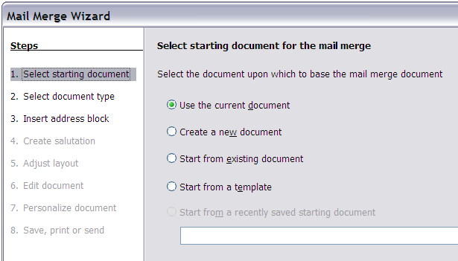Figure 179: Select starting document
- On the second page, select E-mail message and click Next.
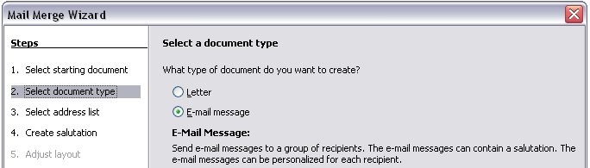
Figure 180: Select document type
- On the third page, click the Select Address List button. Select the required address list (even if only one is shown) and then click OK. (If the address list you need is not shown here, you can click Add to find and add it to the list.)
Figure 181: Selecting an address list
- Back on the Select address list page, click Next. On the Create salutation page, deselect the checkbox by This document should contain a salutation.
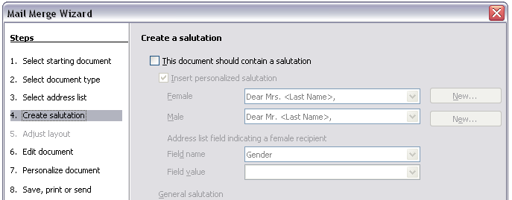Figure 182: Deselecting a salutation
- In the left-hand list, click 8. Save, print or send. AOO displays a “Creating documents” message and then displays the Save, print or send page of the Wizard.
- Select Send merged document as E-Mail. The lower part of the page changes to show e-mail settings choices.
- Type a subject for your email and click Send documents. AOO sends the e-mails.
Figure 183: Sending a document as an email message

Digital Signing of Documents
To sign a document digitally, you need a personal key, also known as a certificate. A personal key is stored on your computer as a combination of a private key, which must be kept secret, and a public key, which you add to your documents when you sign them. You can get a certificate from a certification authority, which may be a private company or a governmental institution.
When you apply a digital signature to a document, a kind of checksum is computed from the document’s content plus your personal key. The checksum and your public key are stored together with the document.
When someone later opens the document on any computer with OpenOffice, the program will compute the checksum again and compare it with the stored checksum. If both are the same, the program will signal that you have the original, unchanged document. In addition, the program can show you the public key information from the certificate. You can compare the public key with the public key that is published on the website of the certificate authority.
Whenever someone changes something in the document, this change breaks the digital signature.

To sign a document:
- Choose File > Digital Signatures.
- If you have not saved the document since the last change, a message box appears. Click Yes to save the file.
- After saving, you see the Digital Signatures dialog box. Click Add to add a public key to the document.
- In the Select Certificate dialog box, select your certificate and click OK.
- You return to the Digital Signatures dialog box, where you can add more certificates if you want. Click OK to add the public key to the saved file.
A signed document shows an icon in the status bar. You can double-click the icon to view the certificate.

Removing Personal Data
You may wish to ensure that personal data, versions, notes, hidden information, or recorded changes are removed from files before you send them to other people or create PDFs from them.
In Tools > Options > OpenOffice > Security > Options, you can set AOO to remind (warn) you when files contain certain information and remove personal information automatically on saving.
To remove personal and some other data from a file, go to File > Properties. On the General tab, uncheck Apply user data and then click the Reset button. This removes any names in the created and modified fields, deletes the modification and printing dates, and resets the editing time to zero, the creation date to the current date and time, and the version number to 1.
To remove version information, either go to File > Versions, select the versions from the list and click Delete, or use Save As and save the file with a different name

Chapter 6
Introduction to Styles

What Are Styles?
Most people are used to writing documents according to physical attributes. For example, you might specify the font family, font size, and weight (for example: Helvetica 12pt, bold).
Styles are logical attributes. We use styles every day. For example, there are two styles of personal computer: desktop and laptop. Each has its own distinctive set of properties. You never say “my computer is a low-weight, one-piece unit with an LCD screen attached to a rectangular casing containing the computing components and the keyboard”. Instead, you could say that you have a laptop.
OpenOffice (AOO) styles are a way to do the same thing for your document. Using styles means that you could stop saying “font size 14pt, Times New Roman, bold, centered” and start saying “title” for describing that particular font usage. In other words, styles mean that you shift the emphasis from what the text looks like to what the text is.

Why Use Styles?
Styles help improve consistency in a document. They also make major formatting changes easy. For example, you might decide to change the indentation of all paragraphs or change the font of all titles. For a long document, this simple task could be prohibitive. Styles make the task easy.
The time is 9:50 AM, and Jane is finishing the 30-page paper for school that is due at 10:00 AM. She looks over the assignment one more time, and suddenly she realizes that:
- The text must use Arial font instead of Times New Roman.
- The headings must be dark blue and indented.
- The title must appear at the top-right of every page except the first.
- Even-numbered pages must have a wider right margin, and odd-numbered pages must have a wider left margin.
Thankfully, Jane used AOO Writer and styles. She makes all the changes in only two minutes and hands in the paper on time.

Style Categories
AOO Writer has five style categories:
- Paragraph styles affect entire paragraphs represented with those styles.
- Character styles affect a block of text inside a paragraph.
- Page styles affect page formatting (page size, margin, and the like).
- Frame styles affect frames and graphics.
- List styles affect outlines, numbered lists, and bulleted lists.
In the same way that characters are the building blocks for creating words, paragraphs are the building blocks of every document. Headings (subheads) are paragraphs; headers, footers, and numbered lists are also paragraphs. Paragraph styles are, therefore, the most frequently used styles and are the ones treated in more detail in this and the next chapter.

The Styles and Formatting Window
Styles are available through the Sidebar's Styles and Formatting deck or a floating/ dockable window called Styles and Formatting, shown in Figure 184. This window is at the center of styles management. Do not worry if, at first, some contents of this section seem obscure while progressing through this or the next chapter. This guide describes how to use all these functions.

Figure 184: Styles and Formatting window buttons
To open the Styles and Formatting window, do any one of the following:
- Click the Styles and Formatting icon of the Sidebar.
- Click on the icon located at the left-hand end of the Formatting toolbar.
- Select Format > Styles and Formatting.
- Press F11.
Tip | We will emphasize using the Sidebar but the floating Styles and Formatting window has the same appearance and functions. Which you use is a matter of preference.

Tip | You can move the Styles and Formatting window to a convenient position on the screen or dock it to an edge. The Sidebar is docked at the right edge by default.

Style Selection Basics
The first five icons at the top of the Styles and Formatting window select the category of styles to work on. Click on one of these icons to display a list of styles in that category, such as paragraph or character styles, in the main window.
To apply a character style to existing text, select the text and then double-click on the name of the style in the Character Styles list. To apply any other style, put the cursor in the paragraph, frame, or page you want to modify and double-click on the name of the style in the corresponding section. You can select more than one paragraph or frame and apply the same style to all of them at the same time.

Using Fill Format Mode
The sixth icon at the top of the Styles and Formatting window activates the Fill Format mode. Use Fill Format to apply a style to many areas quickly without having to go back to the Styles and Formatting window and double-click every time. This method is useful for formatting many scattered paragraphs, words, or other items with the same style, and it may be easier to use than making multiple selections first and then applying a style to all of them.
- Open the Styles and Formatting window (Figure 184) and select a style.
- Click the Fill Format Mode icon .
- To apply a paragraph, page, or frame style, hover the mouse over the paragraph, page, or frame and click. To apply a character style, hold down the mouse button while selecting the characters. Clicking on a word applies the character style to that word.
- Repeat step 3 until you have made all the changes for that style.
- To quit the Fill Format mode, click the icon again or press the Esc key.
Caution | When this mode is active, a right-click anywhere in the document undoes the last Fill Format action. Be careful not to accidentally right-click and mistakenly undo actions you want to keep.

New Style from Selection, Update Style, and Load Styles Functions
The last button in the toolbar of the Styles and Formatting window is a multipurpose button that gives access to three different functions: New Style from Selection, Update Style, and Load Styles.

Using New Style from Selection
Use the first function of the multipurpose button to create a new style from the formatting of an object in the current document. For instance, you can change the formatting of a paragraph or frame until it appears as you like, and then you can turn that object’s formatting into a new style. This procedure can save time because you do not have to remember all the formatting settings you want, as is necessary when creating a new style with the Style dialog box. Besides, unlike when setting the formatting parameters in dialog box pages as you will learn to do later, you can immediately see how the objects will look when formatted with the style you are creating.
Follow these steps to create a new style from a selection:
- Change the formatting of the object (paragraph, frame, etc.) to your liking.
- From the icons at the top of the window, choose the type of style to create (paragraph, character, and so on).
- In the document, select the item to save as a style.
- Go back to the Styles and Formatting window and click the New Style from Selection icon.
In the Create Style dialog box, enter a name for the new style. The list shows the names of existing custom styles of the selected type, if any. Click OK to save the new style.
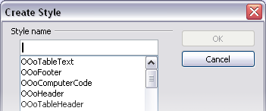
Figure 185: Dialog to name a new style from selection

Update Style (from a selection)
Let’s use paragraph styles as an example.
- Create a new paragraph (or modify an existing paragraph) and edit all the properties you want to go into the style (such as indentation, font properties, alignment, among others).
Caution | Make sure that there are unique properties in this paragraph. For example, if there are two different font sizes in the paragraph selected to update the style, that particular property will not be updated.

- Select the paragraph by clicking anywhere in the paragraph.
- In the Styles and Formatting window, select the style you want to update (single-click, not double-click) and then click on the New Style from Selection icon and select Update Style.

Figure 186: Updating a style from a selection
The procedure to update another type of style (character, page, or frame styles) is the same. Just select the item in question, select the style you want to update, and choose Update Style.

Load Styles (from a template or document)
The last option in the New Style from Selection icon is used to copy styles into the current document by loading them from a template or another document. This method copies all styles, or groups of styles, at one time.
- Open the document to copy styles into.
- In the Styles and Formatting window, click on the New Style from Selection icon and then on Load Styles (see Figure 186).
- In the Load Styles dialog box (Figure 187), find and select the template to copy styles from. Click on the From File button if the styles you want are contained in a text document rather than a template. In this case, a standard file selection dialog box opens up, allowing you to select the desired document.
- Select the checkboxes for the types of styles to be copied. If you select Overwrite, the styles being copied will replace any styles of the same names in the target document.
- Click OK to copy the styles.
Figure 187: Loading styles from a template

Using the Visible Styles Filters
At the bottom of the Styles and Formatting window, use the drop-down menu to select a filtering criterion for the contents of the main body of the window. Normally, you will find that only a handful of styles are needed in any given document, and it makes sense to have only these styles shown.
So, at the beginning of the writing process, you may want to have access to all the available styles (by selecting All Styles). However, as the document develops, it is useful to reduce the size of the list displayed to only the styles already in use (by selecting Applied Styles). If you work on a document where you want to apply special-purpose styles only (such as those styles used in writing this user guide), select instead Custom Styles. The Hierarchical Styles view is most useful when modifying styles as it reveals which styles are linked together. This topic is discussed in more detail in Chapter 7 (Working with Styles).

Drag-and-Drop a Selection to Create a Style
Another little known property of the Styles and Formatting window is the capability of creating a new style with a simple drag-and-drop of a text selection into the Styles and Formatting window.
- Open the Styles and Formatting window.
- Select the style category you are going to create (for example a character style) using one of the five icons in the top left part of the window.
- Select the object you want to base the style on and drag it to the Styles and Formatting window. The cursor changes its shape indicating whether the operation is possible or not.
- In the Create Style dialog box (Figure 185), enter a name for the new style. The list shows the names of existing custom styles of the selected type, if any. Click OK to save the new style.
Note | You cannot use the drag-and-drop method to create a custom page style.

Applying Styles
Styles can easily be applied by means of the Styles and Formatting window. However, alternative ways exist to apply certain styles, as explained in this section.

Applying Paragraph Styles
The style family most used when drafting a document is the paragraph style. AOO offers two quick alternatives to the Styles and Formatting window to apply this category of style: the Apply Style menu and the Format Paintbrush icon.
When a paragraph style is in use in a document, the style name appears on the Apply Style menu near the left end of the formatting bar, to the right of the Styles and Formatting icon. You can select styles from this menu, just as you can from the Styles and Formatting window.
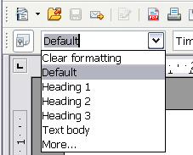Figure 188: Apply Style menu
To apply a style from this menu, click on the desired style or use the up or down arrow keys to move through the list, then press Enter to apply the highlighted style.

Tip | Select More… at the bottom of the list to open the Styles and Formatting window.
The format paintbrush can be used to apply a certain paragraph style to another paragraph (or group of paragraphs). Start by placing the cursor inside the paragraph you want to copy, then press the Format Paintbrush icon in the standard toolbar. The cursor changes into an ink bottle. Select now the paragraphs to which you want to apply the copied style. Note that it is not required to select the whole paragraph.

Example: Applying a Paragraph Style
Let's see the three methods described above in action with an example.
- Create a new document (choose File > New > Text Document or press Control+N).
- Type the words Heading 1 in the new document, but do not press Enter so that the cursor remains in that same line where you typed.
- Click the Styles and Formatting icon on the Sidebar to display the Styles and Formatting deck. This is shown as a floating window in (Figure 189) but it is normally docked.
- Make sure the window is showing the Paragraph Styles section—click on the top-left icon of the Styles and Formatting window.
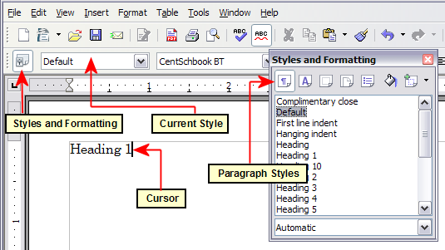
Figure 189: Click on the Styles and Formatting icon to bring up the window
Double-click the Heading 1 entry of Styles and Formatting (Figure 190). This does two things:
- Gives the line (actually, its entire paragraph) you typed the Heading 1 style.
- Adds Heading 1 to the Apply Style menu.
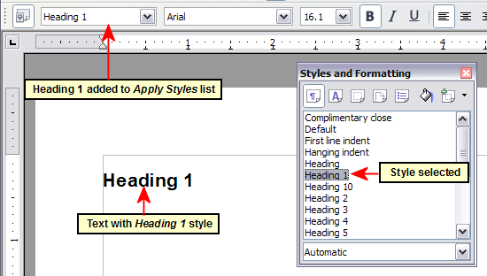
Figure 190: Applying paragraph styles
To use the Apply Styles drop-down menu (Figure 224):
- Move the cursor to a new line or create a new line by pressing the Enter key at the end of the previous line and type some text.
- Keeping the cursor on the same paragraph, select Heading 1 in the Apply Styles list.
The text acquires the properties of the Heading 1 style. If the paragraph style you want is not in the Apply Style list, select More to bring up the Styles and Formatting window. If the Styles and Formatting window is still open, you may notice that the Heading 1 style is also highlighted in the main window, as shown in Figure 190.
Finally, try the Format Paintbrush:
- Move the cursor to a new line or create a new line by pressing the Enter key at the end of the previous line and type some text.
- Move the cursor to one of the two paragraphs with style Heading 1 and select the Format Paintbrush icon to activate it (the cursor changes shape).
- Move the cursor over the paragraph you have created and click the left mouse button.
The cursor shape changes back to the normal one, and the text acquires the properties of the Heading 1 style.
If the Styles and Formatting window is open, you may notice that the Heading 1 style is also highlighted in the main window.

Applying Character Styles
Select the Styles and Formatting deck on the Sidebar and click the second button in the top bar. The list of available character styles is displayed. To apply a character style, follow these steps:
- Select the block of text where you wish to apply the style.
- Double-click the appropriate character style in the Styles and Formatting window.
Some examples include:
This example uses the AOO-supplied Strong Emphasis character style.
Definition: A statement describing the meaning of a word or phrase.
Note | One difference between character styles and paragraph styles is the need for selecting text (highlighting). Character styles require you to select the text you want to apply them to; paragraph styles do not.

Unset/Undo Character Styles
Sometimes, you will want to remove the formatting from a block of text. You must resist the temptation to do this manually. This will only cause trouble down the road. There are four easy ways to remove character formatting after you select the text:
- Right-click and choose Default Formatting.
- Choose Format > Default Formatting from the menu bar.
- Press the keys Ctrl + M.
- If you have the Styles and Formatting deck visible, double-click the Default character style.
Note | The first three methods also work for removing manual formatting.

Applying Frame Styles
Whenever you insert an object, such as a picture, into a document, it will automatically have a frame around it. Some designers like to add frame styles to introduce variety. For example, you could have two different frame styles for graphics: one that is centered for small graphics and another that is left-aligned for graphics that take up the entire width of the main frame. In such a case, you need to add at least one frame style.
To apply a style to a frame:
- Select the frame.
- Bring up the Styles and Formatting deck in the Sidebar.
- Click the Frame Styles icon (the third one from the left).
- Double-click the frame style you want.
Tip | When a frame is selected, the Frame toolbar replaces the Formatting toolbar. Then, the Apply Style list at the left of the Frame toolbar displays frame styles. You can use this to change the style of a frame.

Most of a frame’s design can be set in a style. However, the following options must be set manually:
- Anchoring: how the frame is positioned in relation to the rest of the page’s contents (Format > Anchor).
- Arrangement: the frame’s position in a stack of objects (Format > Arrange).
- Adding a hyperlink: so that a click on the frame opens a Web page or another document in an HTML file (Insert > Hyperlink).
The right-click menu also has items for anchoring and arrangement, as well as for wrap and alignment.

Applying Page Styles
To apply a page style, place the cursor anywhere on the page to which the style should be applied. You can easily check which page style is applied because it is shown on the status bar.
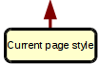

Figure 191: The current page style is displayed on the status bar
If you want to apply a different style, you can either right-click on the style in the status bar and select a new style from the pop-up menu, or you can open the Styles and Formatting deck, select the page style icon at the top of the window (fourth icon), and then double-click on the desired style.
Caution | Changing a page style will usually cause the style of all other pages to change as well. The results may not be what you want. To change the style of only one page, you may need to insert a manual page break, as described below.

As discussed in Chapter 7 (Working with Styles), a correctly set up page style will, in most cases, contain information on what the page style of the next page should be. For example, when you apply a Left page style to a page, you can indicate in the style settings that the next page has to apply a Right page style, a First page style could be followed by either a Left page style or a Default page style, and so on.
Another very useful mechanism to change the page style is to insert a manual page break and specify the style of the subsequent page. The idea is simple: you break a sequence of page styles and start a new sequence. To insert a page break, choose Insert > Manual Break and choose Page break. This section illustrates two common scenarios where page breaks are useful.

Example: Chapters
A possible scenario: You are writing a book that is divided into chapters. Each chapter starts with a page style called New Chapter. The following pages use the Default page style. At the end of each (except the last) chapter, we return to the New Chapter page style for the first page of the next chapter.
Figure 192 illustrates the flow of page styles when using page breaks.
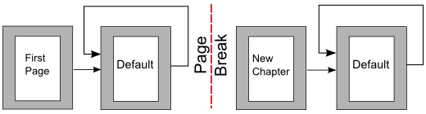Figure 192: Page style flow using a page break
AOO doesn’t have a predefined New Chapter style, so you must create a custom style (see Chapter 7). Let’s suppose that you already have the page styles with the following properties:
Page style | Next Style
New Chapter | Default
Default | Default
At some point, you will want to start a new chapter. Follow these steps:
- Put the cursor at the end of the chapter, on a blank line (empty paragraph) of its own.
- Choose Insert > Manual Break. The Insert Break dialog box (Figure 193) appears.
- Under Type, choose Page break and under Style, select New Chapter.
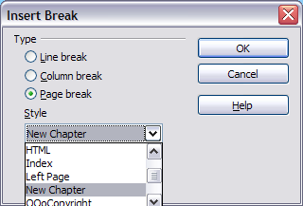
Figure 193: Choose Page break and select the New Chapter page style

Example: Page with Special Formatting
Sometimes you may need to insert a page with special formatting, for example a landscape page or a page with more columns. This can also be done with page breaks. Suppose that the current page has the Default page style.
- Choose Insert > Manual Break.
- Select the desired page style (say, Special Page) in the Insert Break dialog box.
- Fill in the contents for this page.
- Insert another page break and select Default as the style. The pagination continues on as normal, except that one page has been replaced by a different page style.
This concept is illustrated in Figure 194.
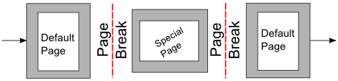
Figure 194: Inserting a page with special formatting

Applying List Styles
List styles define properties such as indentation, numbering style (for example, 1,2,3; a, b, c; or bullets), and punctuation after the number, but they do not by themselves define properties such as font, borders, text flow, and so on. The latter are properties of paragraph styles.
If you need your list to have specific paragraph-style properties, you should embed the list style into paragraph styles, as explained in Chapter 7. You can then create a numbered list by applying paragraph styles alone.
Each of the list styles predefined in Writer has four associated paragraph styles. For example, the Numbering 1 list style is associated with four paragraph styles:
- Numbering 1
- Numbering 1 Cont.
- Numbering 1 End
- Numbering 1 Start
Numbering 1 is a default paragraph style to which you can attach a list style. If you want to make exclusive use of paragraph styles and never use the Formatting toolbar when creating a numbered list, you could use the other three styles. All you need to do is to create a suitable list style and set up the Next Style property in the Organizer page of the Paragraph Style dialog box so that the Numbering 1 Start paragraph is followed by the Numbering 1 Cont. style, while the Numbering 1 End paragraph style is followed by a default style paragraph.
If you only want to apply a list style (that is, the numbering or bullet symbol and the indentation) then, when the cursor is on the paragraph to be numbered, double-click on the desired list style.
When creating a list style, you can define up to ten levels of depth for nested lists. Switch from one level to the other with either the Promote or the Demote buttons on the Bullets and Numbering toolbar or by pressing the Tab key (one level down) or Shift+Tab key combination (one level up) or by right-clicking on the list element and select Up One Level or Down One Level from the pop-up menu.

Restarting the Numbering
When creating more than one numbered list of the same type within the same chapter, Writer applies progressive numbering to all the lists. Sometimes this is exactly what you want, while at other times you want to restart the numbering. To do so, either click on the Restart numbering icon on the Bullets and Numbering toolbar or right-click on the first element of the list and select Restart numbering.

Modifying Styles
Writer provides several predefined styles, but you may find that they do not fit your preferences. You can build your own library of custom styles to use in place of the predefined ones, or you can modify the existing styles. AOO offers four mechanisms to modify both predefined and custom (user-created) styles:
- Update a style from a selection.
- Load or copy styles from another document or template.
- Change a style using the Style dialog box.
- Use AutoUpdate (paragraph and frame styles only).
The first two methods are discussed in “Update Style (from a selection)” on page 177 and “Load Styles (from a template or document)” on page 177, while Chapter 7 (Working with Styles) discusses at length the process of creating a new style.
This section shows how you can quickly make simple modifications to existing paragraph styles using the same tools you would use for applying formatting manually.
Tip | Any changes made to a style are effective only in the current document. If you want to reuse modified or new styles in other documents, you need either to save the styles in a template—see Chapter 10 (Working with Templates)—or copy the styles into the other documents, as described in “Copying and Moving Styles” on page 193.

Changing a Style Using the Style Dialog Box
To change an existing style using the Style dialog box, right-click on the style in the Styles and Formatting deck and select Modify from the pop-up menu.
The dialog box displayed depends on the type of style selected. Figure 195 shows an example of the dialog box for a paragraph style. Each style’s dialog box has several tabs. The various properties on these dialog boxes are described in the next chapter.
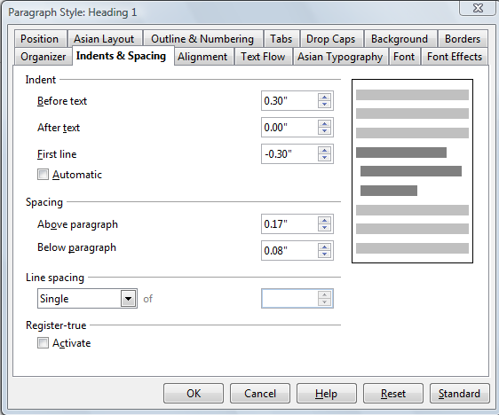
Figure 195: Example of the Paragraph Style dialog box
Move to the page where the setting you want to modify is specified and input the new value. You can click the Help button at any time to bring up the online guide where all the options of the current page are briefly described. When you are done, click OK to close the dialog box. As discussed above, the great advantage of styles is that all the instances of such style in your document are now modified to your liking.

Examples: Modifying Paragraph Styles
For this example, we need three lines of text with three AOO-supplied paragraph styles: Heading 1, Heading 2, and Heading 3. These paragraph styles could be used in formatting headings (subheads) in the framework for a document that will be “fleshed out” afterward.
Open a new text document for this exercise and type Title on the first line, click the Paragraph Styles icon on the Styles and Formatting deck, and double-click Heading 1 in the drop-down list. Repeat this procedure for the other entries of Figure 197, using the proper paragraph style for each: the Heading 1 style for the paragraph containing the word Title, Heading 2 for Subtitle 1, and so on.
Your document should resemble Figure 196.
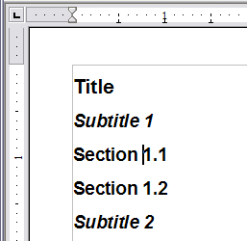
Figure 196: Headings 1–3 with default styles
Suppose you decide to make some changes to these styles, namely:
- Heading 1 should be centered.
- Heading 3 should be indented.

Center Heading 1
On the Styles and Formatting deck, select the Paragraph Styles icon (if it isn’t already chosen), right-click on Heading 1, and choose Modify.
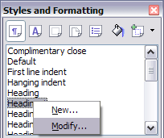
Figure 197: Modifying a style
After the Paragraph Style window opens, choose the Alignment tab, select Center (as shown in Figure 198), and click OK.
Now, every paragraph marked as Heading 1 will be centered (as shown in Figure 200). If you make another Heading 1 entry, it will be centered as well.
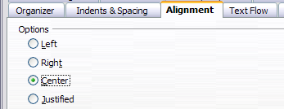
Figure 198: Center Heading 1
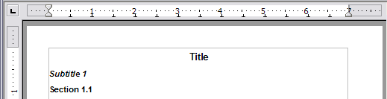
Figure 199: The text Title, which is formatted as a centered Heading 1 style

Indent Heading 3
On the Styles and Formatting deck, right-click on the Heading 3 paragraph style and choose Modify, as before. After the Paragraph Style dialog box opens, follow the steps below:
- Click the Indents & Spacing tab.
- Under the Indent section, set the indentation before the text to 0.60", as shown in Figure 200. Your display might be different, depending upon what measurement unit was set in the options (Tools > OpenOffice Writer > General > Settings).
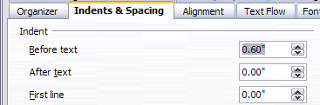
Figure 200: Set indentation
The result should resemble Figure 201.
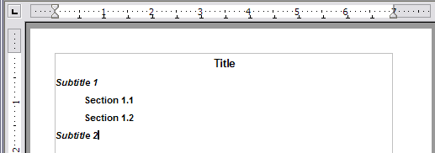
Figure 201: The text formatted as Heading 3 style is now indented

Using AutoUpdate
On the Organizer page of the Paragraph Style dialog box there's a checkbox labeled AutoUpdate (Figure 202). It is intended for paragraph and frame styles only. If this checkbox is selected, then AOO will apply, to the style itself, any modification made manually to a paragraph formatted with that style.
Caution | If you are in the habit of manually overriding styles in your document, be sure that AutoUpdate is not enabled, or you will suddenly find whole sections of your document reformatting unexpectedly.

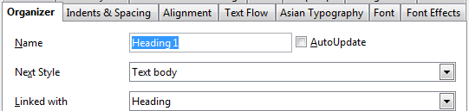
Figure 202: The Organizer page of the Paragraph Style dialog box

Creating Custom Paragraph Styles: Examples
You have seen that the Styles and Formatting window provides several predefined styles, such as Heading 1 and Text body. But what if you need something different, like a poem style, that is not in Styles and Formatting? With Writer, you can make your own styles to suit your needs.
Chapter 7 (Working with Styles) describes in detail the options on the various pages of the Paragraph Style dialog box. This section provides an example of a typical use of custom paragraph styles.
We create a Poem paragraph style and a Poem Header paragraph style, with the following properties:
- Poem: Centered, with a font size of 10pt.
- PoemHeading: Centered, bold, with a 12pt font size.
In addition, a PoemHeading style is to be followed by a Poem style. In other words, when you press Enter, the next paragraph style in the document changes to Poem.
Note | You may have noticed this behavior already. After you enter a heading using a Heading paragraph style and press Enter, the next style automatically switches to Text body.

Creating the Poem Paragraph Style
Our next example uses the Poem style. We will use the Default style as a starting point.
- Select the Styles and Formatting deck of the Sidebar.
- Click the Paragraph Styles icon (first from the left).
- Right-click Default and choose New.
This opens the Paragraph Style dialog box, with the Organizer page selected. To create a custom style, you have to understand and configure the top three entries.
Style fields | Description
Name | This is the name of the style itself, like Heading 1 or Text body.  Set (type in the text box) the name to Poem.
Next Style | This is the default style for the paragraph that follows the Poem style. When you press Enter while typing text in the Poem style, this style is used.  Set this value to Poem. When you press Enter, the text will remain in the Poem style.
Linked with | If the Poem style is linked with another, say Default, then any change in Default will affect Poem, just as you saw with Heading in the previous section.  For our example, this is not the behavior we want. Set this entry to – None –. This means that Poem is not linked with any other style.
After making these changes, your dialog box should look like Figure 203.
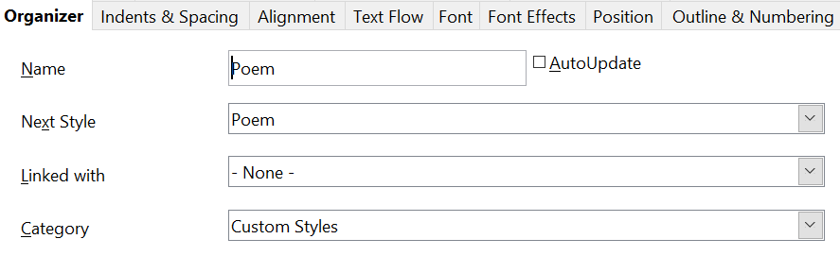
Figure 203: Initial configuration for the Poem style. Set the first three entries as shown.
The next step is to configure the alignment and font properties of this style.
- On the Alignment page, select the Center option.
- On the Font page, select the 10pt font size.
Click OK to save the new Poem style.

Creating the PoemHeading Style
Create a new PoemHeading style. Use the same procedure as before, with these changes:
- Next Style: Select Poem, not PoemHeading.
- Linked with: Heading.
The dialog box should look like Figure 204.
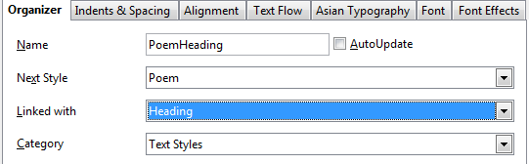

Figure 204: Settings for the PoemHeading style
Edited Entries
Now set the settings of the new style:
- On the Alignment tab, select Center.
- On the Font tab, choose Bold and size 12pt.
Click OK to save the new PoemHeading style.

Sample Poem
It is a good idea to test out your new styles to see if you're happy with them. Typing a poem using the styles we have just defined should produce the results in Figure 205.

Changing the Formatting of Your Styles
One of the main advantages of styles is that they allow the document formatting to be changed after the content has been written. For example, suppose you have written a 100-page book of poetry. Then you change your mind about the way the poems should look.
To learn about reconfiguring styles, we add an indentation to the Poem style instead of centering it.
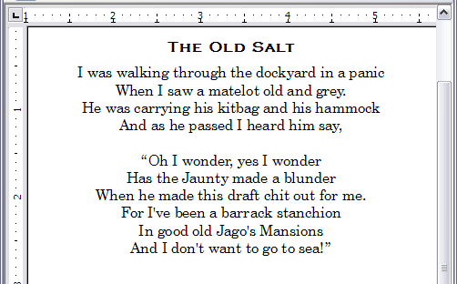
Figure 205: Sample poem

Indent Poem
First, set the Poem style to left alignment:
- In the Styles and Formatting deck, select Poem and right-click and select Modify.
- On the Alignment tab, select Left.
Set the indentation:
- Click the Indents & Spacing tab.
- Under Indent, set the indentation before the text to 5 cm (or about 2 in).
Repeat the steps above for the PoemHeading style.
Done! Click OK, and you should see the text change.

Final result
After all these changes, the poem should look similar to Figure 206. Note in the figure that a third style has been created for the author of the poem.
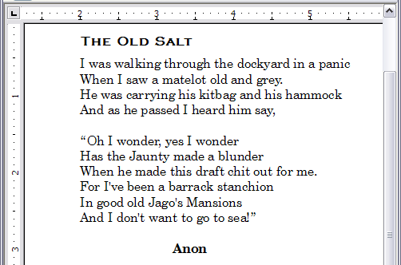
Figure 206: Final result, using three custom styles

Copying and Moving Styles
Styles are part of a document's properties. Therefore changes made to a style, or new styles you create, are only available within the document to which they belong. Styles always stay with a document. So, for example, if you e-mail a document to another person, the styles go with it.
If you want to reuse modified or new styles in other documents, you need either to:
- save the styles in a template (see Chapter 10), or
- copy the styles into the document in which you want to use them.
You can copy or move styles from one template or document to another in two ways:
- Using the Template Management dialog box.
- Loading styles from a template or document (see page 177).
To copy or move styles using the Template Management dialog box:
- Click File > Templates > Organize.
- At the bottom of the Template Management dialog box, choose either Templates or Documents, as needed. For example, if you are copying styles between two documents, both entries should say Documents.
Figure 207: Choosing to copy styles from a document, not a template
- To load styles from a file, click the File button. When you return to this window, both lists show the selected file, and all the currently open documents.
- Double-click on the name of the template or document and then double-click the Styles icon to show the list of individual styles.
- To copy a style, hold down the Control key and drag the name of the style from one list to the other.
- Repeat for each style you want to copy or move. When you're finished, click Close.
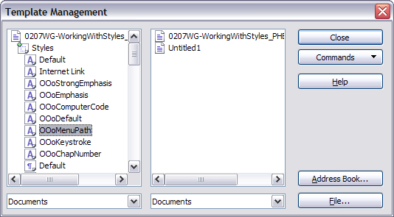
Figure 208: Copying a style from one document to another
Caution | If you do not hold down the Control key when dragging, the style will be physically moved from one list to the other. In other words, the style will be deleted from the list you are dragging it from.

Deleting styles
It is not possible to delete AOO’s predefined styles from a document or template, even if they are not in use. However, custom styles can be deleted.
To delete an unwanted style, right-click on it in the Styles and Formatting window and choose Delete. If the style is in use, the message shown in Figure 209 appears.
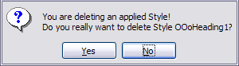
Figure 209: Deleting an applied style
Caution | Make sure the style is not in use before deletion. Otherwise, all objects with that style will return to the Default style and retain their formatting as manual formatting. This can be very problematic in a long document.

Tip | If an unwanted style is in use, use Find & Replace to replace it with a substitute style before deleting it.

If the style is not in use, the message shown in Figure 210 appears.
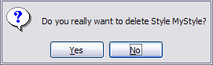
Figure 210: Deleting a style that is not in use

Assigning Styles to Shortcut Keys
You can configure shortcut keys to quickly assign styles in your document. Some shortcuts are predefined, such as Ctrl+1 for the Heading 1 paragraph style and Ctrl+2 for Heading 2. You can modify these shortcuts and create your own. See Chapter 17 (Customizing Writer) for details.

Defining a Hierarchy of Headings
Tools > Outline Numbering defines the hierarchy of headings in a document. Headings can be numbered or not; typically the first-level headings in a book-length document are the next level of headings after the chapter titles, which may be numbered, but lower-level headings are not numbered. Some chapter title and heading styles (such as those commonly used in engineering documents) number each chapter and heading level, for example 1, 1.1, 1.2, 2, 2.1, and so on. When chapters or sections are added or deleted, the numbering is automatically changed.
Paragraph styles are the key to AOO’s outline numbering feature. The default paragraph styles assigned to outline levels are the heading styles supplied with AOO: Heading 1, Heading 2, and so on. However, you can substitute any styles you wish, including custom (user-defined) styles.
The headings defined using the outline numbering feature can be used for more than the table of contents (described in Chapter 12). For example, fields are commonly used to display headings in headers and footers of pages (see Chapter 14, Working with Fields), and Writer can send the outline to Impress to use as the basis for a presentation (see the Impress Guide for details).

Choosing Paragraph Styles for Outline Levels
If you are using the default heading styles for the headings in your outline, and you do not want to use heading numbering, you do not need to do anything on the Outline Numbering dialog box. The default outline numbering scheme uses the default heading styles (Heading 1, Heading 2, and so on).
To use custom styles in place of one or more of the default heading styles:
- Choose Tools > Outline Numbering to open the Outline Numbering dialog box (Figure 211).
- Click the number in the Level box that corresponds to the heading you want to use to change the paragraph style.
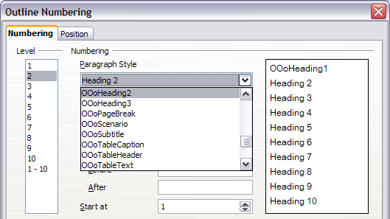
Figure 211: Choosing paragraph styles for outline levels
- In the Numbering: Paragraph Style section, choose the paragraph style you want to assign to that heading level from the drop-down list . For example, when setting up a chapter in the Writer Guide, you would click Level 1 and select OOoHeading1 (a custom style defined for the project) to replace Heading 1 and for Level 2, OOoHeading2 to replace Heading 2.
- Repeat for each outline level that you want to change. Click OK when done.

Assigning Outline Levels to Other Styles
You can assign an outline level to any paragraph style. This feature enables you to create a table of contents that includes those headings along with the headings using styles listed in the Outline Numbering dialog box. For example, you might use a different sequence of styles for annexes (appendixes), but you want the annex headings and subheadings to appear in the TOC at the same levels as the chapter headings and subheadings.
To assign an outline level to a paragraph style, go to the Outline & Numbering tab for the style, and select the required outline level. Click OK to save this change.
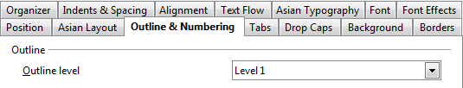
Figure 212: Specifying an outline level on the Outline & Numbering page for a paragraph style

Setting Heading Numbering
If you want one or more heading levels to be numbered, many choices are available; this example defines a scheme to create headings that look like those in Figure 213.
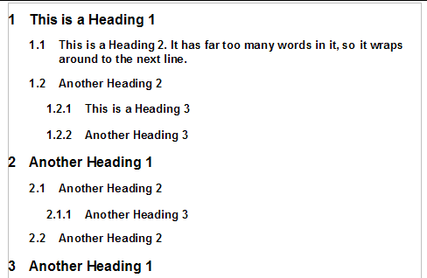
Figure 213: The numbering scheme to be set up.
Use the Numbering page of the Outline Numbering dialog box to define the numbering scheme and its appearance. Use Tools > Outline Numbering to access this dialog. Figure 214 shows the default settings.
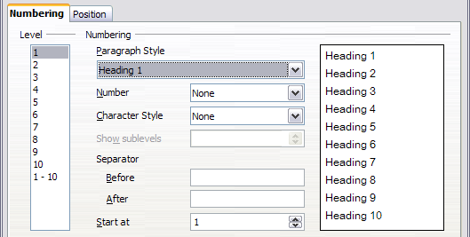
Figure 214: Default settings on the Outline Numbering dialog box.
- In the Level list, choose 1. In the Number list, choose 1, 2, 3, …. The result is shown in the preview box on the right in Figure 215.
- In the Level list, choose 2. In the Number list, select 1, 2, 3, …. The Show sublevels list is now active; it should show 2 (if not, select 2). The result is shown in Figure 216.
- In the Level list, choose 3. In the Number list, pick 1, 2, 3, …. The Show sublevels list should show 3 (if not, pick 3). The result is shown in Figure 217.
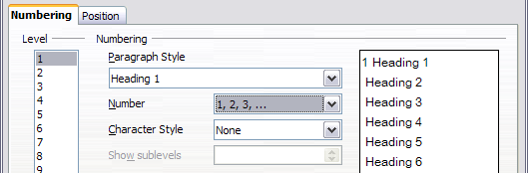
Figure 215: Specifying numbering of Level 1 headings.
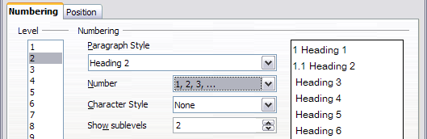
Figure 216: Specifying numbering of Level 2 headings.
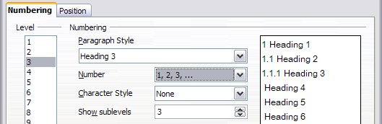
Figure 217: Specifying numbering of Level 3 headings.
These choices produce the layout shown in Figure 218.
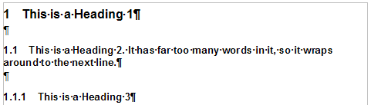
Figure 218: Results of numbering choices for headings

Setting Up the Indentation of Headings
Even when headings are numbered, you may want to change some of their formatting. For example, you may want the second-level and third-level headings to be indented from the margin. For numbered headings, you may also want the second line of long headings to line up with the first word of the heading, not the number. For such changes, use the Position page of the Outline Numbering dialog box.

Tip | OpenOffice documents created before version 3 display a different Position page. See the section Positioning in AOO3.x and AOO4.x Documents immediately below.

Positioning in AOO3.x and AOO4.x Documents
Figure 219 shows the Position page as it appears for documents created in OOo3.x.
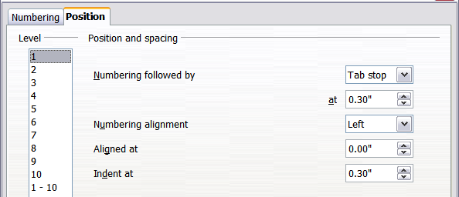
Figure 219: Setting up the position of level 1 headings
- In the Level list on the left, choose 2. Change the values for Numbering followed by… at and Aligned at, as shown in Figure 220. You may want to use a different value. This indents the entire heading but does not affect the way long headings wrap around (see Figure 221).
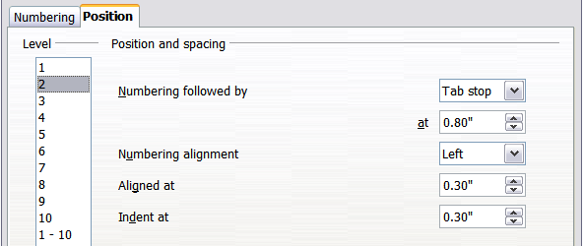
Figure 220: Indenting Level 2 headings
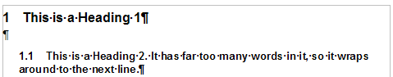
Figure 221: Result of changes to indentation of Level 2 headings
- To change the wrapping behavior of long headings, change Indent at to a larger value, as shown in Figure 222. The result is shown in Figure 212.
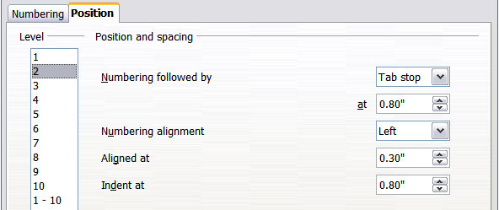Figure 222: Wrapping long headings
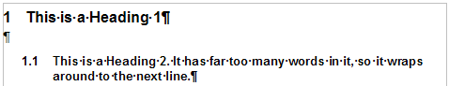
Figure 223: Result of changing Indent at value
- In the Level list, choose 3. Change the values for Numbering followed by… at, Aligned at, and Indent at, as shown in Figure 223. The final result is shown in Figure 212.
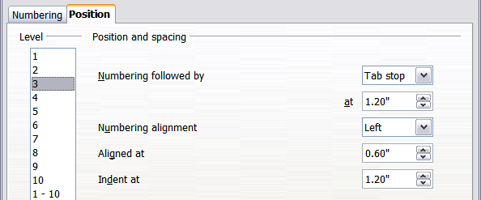Figure 224: Indenting level 3 headings

Positioning in older documents
Figures 208, 207, 199, and 191 show the Position page as it appears for documents created in earlier versions of AOO and opened in AOO4.x.
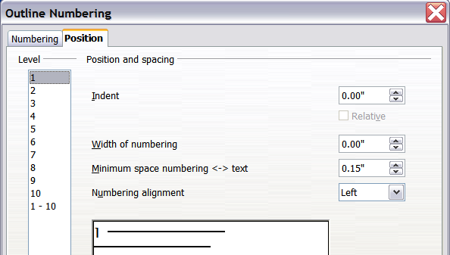
Figure 225: Setting up level 1 headings
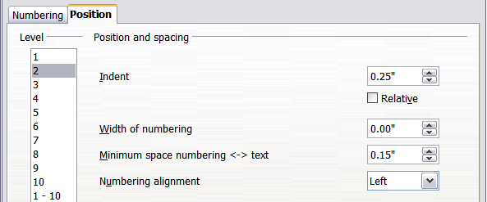
Figure 226: Indenting Level 2 headings
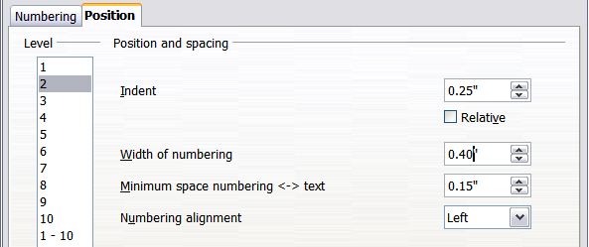
Figure 227: Changing the Width of numbering value to wrap long headings
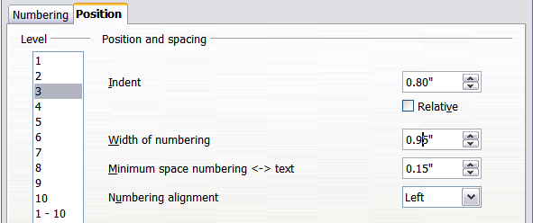
Figure 228: Indenting Level 3 headings

Chapter 7
Working with Styles

Introduction
Chapter 6 (Introduction to Styles) described the basics of using, applying, and managing styles. This chapter gives a more detailed description of creating or modifying styles, using the many options available on the various tabs of the Style dialogue. You will learn how these options affect the appearance of the style, and how to use them efficiently. Examples and hints are also provided.
The Style dialogues share many of the same pages as the manual formatting dialogues, so you can also use this chapter to help you apply manual formatting, though that may not be needed if you use styles.

Creating Custom (New) Styles
In addition to using the predefined styles provided by AOO, you can add new custom user-defined styles. In Chapter 6, two methods were given for creating a new style: the drag-and-drop approach and the New Style from Selection icon in the Styles and Formatting window.

These methods are very convenient, because they make it possible to check immediately the visual effects that the style produces, even before creating it. However, they may require you to access several menus, and you have a somewhat reduced amount of control of the style (particularly when it comes to organizing them). The method described in this chapter, therefore, concerns only the use of the Style dialog.

The Style Dialog
Open the Styles and Formatting deck of the Sidebar or the Styles and Formatting window. Select first the category of style you want to create by clicking on the appropriate icon in the top part of the Styles and Formatting window. For example, select the third icon from the left if you want to create a new frame style.
Right-click on the main window and select New from the pop-up menu. If you right-click on an existing style, the new style will be linked to the style you clicked on. If you right-click on an empty area, then the initial settings of the style are copied from the Default style of the corresponding category.
The dialog that is displayed depends on the type of style you selected. Many of the tabs are the same as those that are displayed when manual formatting is applied. Therefore, if you are familiar with manual formatting, you will find that you already know how to use most of the options. The dialog used to create a new style and to modify an existing one is exactly the same.
Tip | An exception to the above rule is conditional styles, which have a different dialog. See “Working with Conditional Paragraph Styles” on page 219.

The Organizer Tab
When creating a new style, the first tab you need to set up is the Organizer, which is shown in Figure 229. This tab is common to all style categories. Therefore, we'll describe it only once.

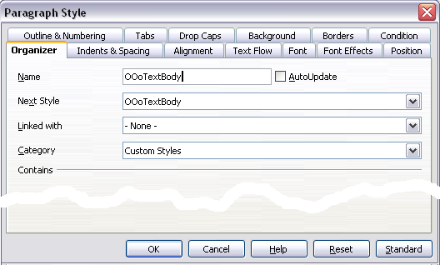
Figure 229: The Organizer tab displayed when a new style is created.
Depending on the style you are creating, you will find the following information on this tab:
- Name: present on all the categories—use this field to give a name to the style you are creating.
- AutoUpdate: only present for paragraph and frame styles. If it is checked, then Writer will apply any modification made manually to a paragraph formatted with that style to the style itself.

Caution | If you manually override styles in your document, be sure that AutoUpdate is not enabled. Neglecting this step may suddenly reformat whole sections of your document unexpectedly.

- Next Style: only available for paragraph and page styles. Use it to specify which style will be applied to the next element. It is customary, for example, to have a left page style followed by a right page, a first page followed by a left page, a heading followed by body text, and so on. You will see in a later example how this property is used. Predefined paragraph styles for lists or bullets also make large use of the Next Style property.
- Linked with: available for paragraph, character, and frame styles; it determines the position of the style in the hierarchy. When creating a new style and linking it to an existing style, all the starting properties of the style are copied from the linked style. Refer to “Understanding Linked Styles” on page 207 for further information on how linked styles work.
- Category: available for all styles; use it to associate the new style with one of the categories. Note that you cannot change the category of the predefined styles. Setting this field is useful when filtering the contents of the Styles and Formatting window.
- Contains: shows a summary of the properties of the style.

Understanding Linked Styles
When creating a new paragraph or a new character style, you may use an existing style as a starting point. In this sense, AOO links the styles together.
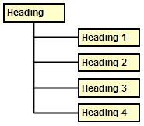Figure 230: Hierarchical view of linked styles.
When styles are linked, a change in the parent style affects every style linked to it. You can easily visualize the connections between styles by switching to the Hierarchical view in the Styles and Formatting window filter.
For example, every Heading style (such as Heading 1, Heading 2) is linked with a style called Heading. This relationship is illustrated in Figure 245.
Linking styles is a very powerful method to create “families” of styles, and allows you to change their properties simultaneously. For example, if you decide that all the headings should be blue (such as in this guide), you only need to change the font color of the parent style to achieve the desired result. Note however, that changes made to a parameter of the parent style do not override changes previously made to the same parameter in the child styles. For example, if you changed the Heading 2 font color to green, a change of the font color of the Heading style (the parent style) to red will not affect the Heading 2 font color.
You can easily check which properties are specific to a style by looking at the Contains section of the Organizer tab. In case you want to reset the properties of a child style to that of the parent style, click the Standard button located at the bottom of each Paragraph and Character style dialog tab.
Note | You cannot define a hierarchical style structure for Page, Frame, and List styles.

Creating a Linked Style
To create a linked style, you can either specify the parent style (the “linked with” style) in the Organizer tab of the Style dialog, or you can start creating a new style by right-clicking in the Styles and Formatting window on the style to be linked with and selecting New from the drop-down menu.

Example: Changing a Property of a Parent Style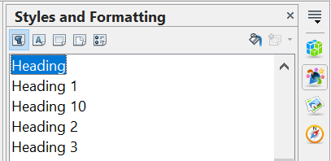

Figure 231: Select Heading style.
Suppose that you want to change the font of not only Heading 1 or Heading 2, but all headings. The easiest way to do that is to take advantage of linking.
Select the Sidebar's Styles and Formatting deck and select Heading.
Open the Paragraph Style dialog for the Heading style (right-click > Modify) and select the Font tab. Select a font and click OK (Figure 239).
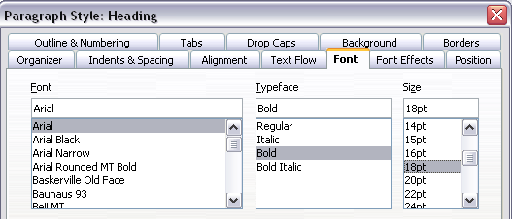
Figure 232: Select the heading font.
Now, the fonts of all the heading styles (Heading 1 through Heading 10) are changed in a single operation. Figure 233 shows on the left a document using the headings 1, 2 and 3 and on the right the same document after changes have been made to the Heading style.
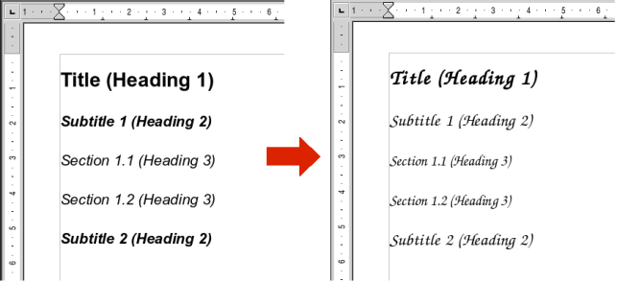
Figure 233: Effects of changing the Heading style font.

Working with Paragraph Styles
Although this section describes most of the parameters scattered over the twelve tabs shown in Figure 229, you do not need to configure them all. In fact, in the vast majority of cases it is sufficient to modify only a few attributes, particularly if you make use of the linking properties of styles or when basing the new style on one which is already similar.

Settings on the Indents & Spacing Tab
On the Indents & Spacing tab, you can set up the parameters that affect the position of the paragraph on the page, and the spacing between lines and between this paragraph and the paragraphs nearby. The right-hand side of the tab shows a preview of the applied settings.
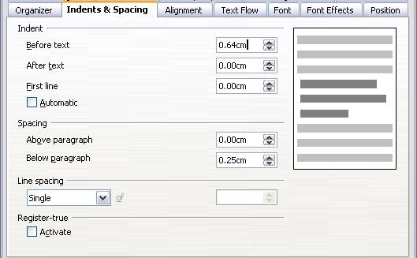
Figure 234: Settings on the Indents and Spacing tab of a paragraph style
Use the Indent section of the page to set up the indentation, using these parameters:
- Before text: controls the space in the selected unit of measurement between the left margin of the page and the leftmost part of the paragraph area. Entering a negative value results in the text starting on the left of the margin. This may be useful in situations where your left margin is quite wide, but you want the headings to be centered in the page.
- After text: controls the space in the selected unit of measurement between the right margin of the page and the rightmost part of the paragraph area. Entering a negative value results in the text extending into the right margin of the page.
- First line: enter into this box the offset (either positive or negative) of the first line of the paragraph relative to the paragraph area. A positive value increases the indentation of the first line, while a negative value makes the first line start to the left of the paragraph area.
- Automatic: check this box to allow Writer to automatically control the indentation of the first line. The value is calculated by Writer on the basis of the font size and other parameters.
Use the Spacing section of the tab to determine the amount of vertical space above and below the paragraph. It is customary to include some “space above” in heading styles, so that they are separated from the text body of the previous section without the need to insert empty paragraphs. Spacing between paragraphs is also normal in certain types of documents. For instance, the body text style of this guide is configured to leave some space between consecutive paragraphs.
The spacing between paragraphs does not affect the spacing between lines, which is instead controlled using the drop-down box in the Line spacing section. You can select one of the following values:
- Single: the default setting—applies a single line spacing to the paragraph. This is calculated automatically based on the font size.
- 1.5 lines: sets the line spacing to 1.5 lines.
- Double: sets the line spacing to 2 lines.
- Proportional: this value activates the edit box next to the drop-down list where you can enter a percentage value. 100% means a single line spacing, 200% double line spacing and so on.
- At least: this choice activates the edit box next to the drop-down list, where you can enter the minimum value (in your selected unit of measurement) to be used for the line spacing.
- Leading: if this value is selected, you can control the height of the vertical space inserted between two lines (from the bottom of the font of the line above to the top of the font of the line below). See Figure 237.
- Fixed: this choice activates the edit box next to the drop-down list, where you can enter the exact value of the line spacing.
Tip | When using different font sizes in the same paragraph, the line spacing will be uneven, as Writer automatically calculates the optimal value. To obtain evenly spaced lines, select Fixed or At least in the drop-down list and a value that is large enough to create a spacing between the lines sufficient to account for the largest font size used.

The last parameter that can be set in this tab is Register-true. If you have activated the Register-true for the page style in use (refer to “General Settings for the Page Style” on page 226) then the Reference style and all the styles hierarchically dependent on it will have the Register-True box selected, you may want however, to activate the vertical grid also for other styles (or not apply it to styles dependent on the reference style) and this is where this can be done.

Settings on the Alignment Tab
Use the Alignment page to modify the horizontal alignment of the text, choosing between Left, Right, Center, and Justified. The results of the selection are shown in a preview window on the right-hand side of the page.
When selecting the Justified alignment, you can also decide how Writer should treat the last line of the paragraph. By default, Writer aligns the last line to the left, but you can choose to align it to the center or to justify it, meaning that the words on the last line will be spaced in order to occupy it fully. If you select the Expand single word option, whenever the last line of a justified paragraph consists of a single word, this word will be stretched by inserting spaces between characters so that it occupies the full length of the line.
The alignment tab is also used to control the Text to Text vertical alignment—useful when you have mixed font sizes on the same row. Choose the element of the fonts on the line that will be aligned between Automatic, Baseline, Top, Middle, Bottom. Refer to Figure 235 for a graphical representation of these reference points.
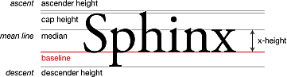
Figure 235: Typographic measurements (from Wikipedia.org)

Text Flow Options for Paragraph Styles
The tab of the dialog controlling the text flow options is shown in Figure 236. This tab is divided into three parts: Hyphenation, Breaks, and Options.
In the Hyphenation section, you can change three parameters:
- Characters at line end: controls the minimum number of characters to be left on a line before inserting a hyphen.
- Characters at line begin: controls the minimum number of characters that can be placed at the beginning of a new line following a hyphen.
- Maximum number of consecutive hyphens: controls the number of consecutive lines that terminate with a hyphen.
If you prefer Writer to automatically control the hyphenation, select the Automatically option.
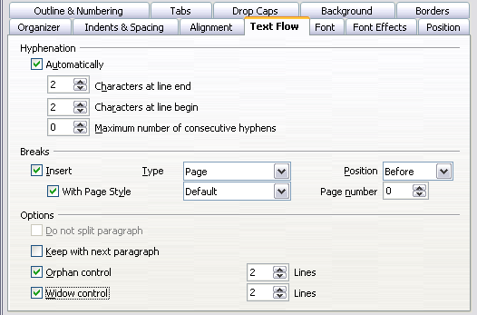Figure 236: The options on the Text Flow tab of the Paragraph dialog
In the Breaks section, you can require a paragraph to start on a new page or column, as well as specify the position of the break, the style of the new page, and the new page number. A typical use for this option is to ensure that the first page of a new chapter always starts on a new (usually right-hand) page.
To always start a style on a new page, choose the following settings on the Text Flow tab of the Paragraph Style dialog:
- In the Breaks section, select Insert. Make sure that Type is set to Page and Position is set to Before.
- Select With Page Style and choose the page style from the list.
- To continue page numbering from the previous chapter, leave Page number set at 0. To restart each chapter’s page numbering at 1, set Page number to 1. Click OK.
Note | If you want the first page of a new chapter to always start on a right page, make sure that the page style for the first chapter page is set for the right page only by making this selection in the Layout settings field on the Page tab of the Page Style dialog. Also note that a page that is intended to be read first is called a recto.

The Options section of the Text Flow tab provides settings to control what happens when a paragraph does not fit on the bottom of a page:
- Do not split paragraph means that the paragraph is never split across two pages. If it does not fit on the bottom of one page, the entire paragraph moves to the top of the next page.
- Keep with next paragraph is appropriate for headings or the lead-in sentence to a list, to ensure that it is not the last paragraph on a page.
- Orphan control and Widow control. Widows and orphans are typographic terms. An orphan is the first line of a paragraph alone at the bottom of a page or column. A widow is the last line of a paragraph that appears alone at the top of the next page or column. Use these options to allow paragraphs to split across pages or columns but require at least two or more lines to remain together at the bottom or top of a page or column. You can specify how many lines must remain together.

Font Options for the Paragraph Style
Three tabs of the Paragraph Style dialog are dedicated to settings controlling the appearance of the font, namely, the Font, Font Effects, and Position tabs. The use of the first two pages is straightforward. Many of the options used when creating a character style are discussed in “Figure 236: The options on the Text Flow tab of the Paragraph dialog” on page 211. Options that can be used when creating a paragraph style are described here.

Specifying a Relative Font Size
If you are creating a style based on another style (linked style), you can specify a font size relative to that other style—either as a percentage or as a plus or minus point value (–2pt or +5pt). Relative font sizes are commonly used for Web pages.
For example, the paragraph style Heading 1 is based on the paragraph style Heading. The font size of the paragraph style Heading is 14pt, and the font size of paragraph style Heading 1 is specified as 115%. Thus, the resultant font size of text in a paragraph formatted with the Heading 1 paragraph style is 14pt times 115% = 16.1pt.
To specify a percentage font size: in the Paragraph Style dialog, select the Font tab. In the Size box, enter the percentage amount followed by the symbol % (see Figure 237). Similarly, you can enter a plus or minus sign followed by the number of points to be added or subtracted from the base font size.
To change from a relative font size back to an absolute font size, enter the desired font size in points followed by the letters pt.
It is also possible to use a Percentage Font size for character styles.
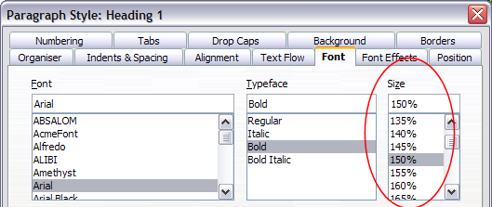Figure 237: Selecting a type size based on a percentage

Selecting a Language for a Paragraph Style
The language you select for a document (on Tools > Options > Language Settings > Languages) determines the dictionary used for spell checking, thesaurus, hyphenation, the decimal, and thousands delimiter used, and the default currency format.
Within the document, you can apply a separate language to any paragraph style. This setting has priority over the language of the whole document. On the Font tap of the Paragraph Style dialog, languages with installed dictionaries are marked in the Language list by a small ABC icon (Figure 238). When checking spelling, Writer will use the correct dictionary for paragraphs with this style. If you write documents in multiple languages, you can use the linked styles to create two paragraph styles that differ only in the language option. If you then want to change some other properties of the paragraph style, all you need do is to change the parent style.
To insert occasional words in a different language and avoid their being picked by mistake with the check-spelling function, it is more convenient to use a character style, as discussed in “Working with Character Styles” on page 221.
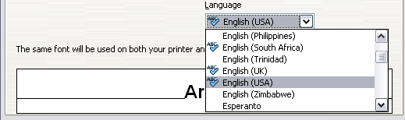Figure 238: Selecting a language for a paragraph style

Options for Positioning Text
The Position tab of the Paragraph Style dialog collects all the options that affect the position of the text on the screen or printed page. This tab is divided into three sections, plus a preview area. They are: Position, Rotation, and Scaling.
Use the Position section to control the appearance of superscripts and subscripts. However, you will normally apply superscript and subscripts to groups of characters, rather than to entire paragraphs. Therefore, it is strongly recommended to change these parameters only when defining a character style and, instead, leave the default settings for the paragraph styles.
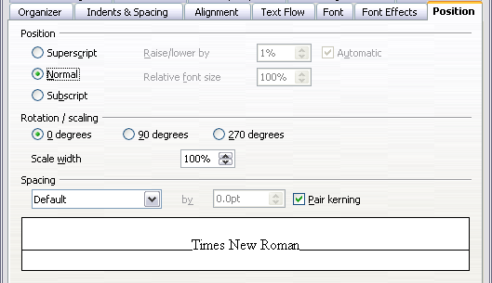Figure 239: The position tab of the Paragraph Style (default options)
The second section of the Position tab controls the rotation of the paragraph area. Two common uses for rotated paragraphs are:
- To put portrait headers and footers on a landscape page
- To fit headings above narrow table columns (as shown in Figure 240)
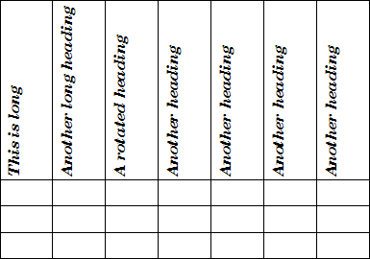Figure 240: A table with rotated headings
The Scale width box controls the percentage of the font width by which to compress or stretch the rotated text horizontally.
Chapter 4 (Formatting Pages) describes how to create portrait headers and footers on landscape pages by rotating characters. You can achieve the same effect by defining a separate header or footer paragraph style specifically for landscape pages.

Example: Rotating the Text in a Paragraph Style
As an example, we will apply rotated table headings to a preexisting table.
- Create a new paragraph style. Name it Table Heading Rotated.
- On the Position page of the Paragraph Style dialog, in the Rotation / scaling section, select 90 degrees. Click OK to save the new style.
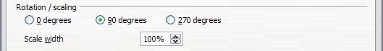Figure 241: Rotating a paragraph 90 degrees
- Select the heading row of the table and apply the new style. Any text in the cells of the heading row is now rotated.
- If the headings are aligned to the top of the cells, you may want to change the alignment to the bottom of the cells, as shown in Figure 240. To do this, click the Bottom button on the Table toolbar or select Format> Alignment > Bottom from the main menu.

Spacing Options
Use the Spacing section of the Position page to control the spacing between individual characters in the paragraph. When selecting an option other than default in the drop-down menu, use the edit box to enter the value in points by which you want to expand or condense the text.
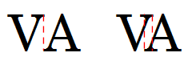Figure 242: Kerning disabled (left) and enabled (right).
The Pair Kerning option (selected by default) increases or decreases the amount of space between certain pairs of letters to improve the overall appearance of the text. Kerning automatically adjusts the character spacing for specific letter combinations. Kerning is only available for certain font types and, for printed documents, only works if your printer supports it.

Controlling Tab Stops
Although borderless tables are generally considered a much better solution to space out material across a page, in many situations tabs are sufficient to do what you need, with the added advantages of being simpler to manage and quicker to apply.
Tip | If you need to use tabs, and you will be sending a document to other people, do not use the default tab stops. If the recipients of the document have defined default tab stops that are different from the ones you use, the paragraph may look very different on their machines. Instead, define the tab stops explicitly in the paragraph or the paragraph style. That way, you can be sure that everyone will see the same layout.

To define tab stops in your paragraph style, use the tab shown in Figure 243. Here you can choose the type of tab: left, right, centered, or decimal; the character to be used as a decimal point; and the fill character—the characters that appear between the end of the text before the tab and the beginning of the text after the tab. You can also create a custom fill character by entering it in the corresponding box. Common use of a fill character is adding dots between a heading and a page number in a table of contents, or using the underscore character when creating a form to fill in.
Creating a new tab stop, therefore, is just a matter of deciding its position relative to the left margin, the type, the fill character and clicking the New button. The tab stop will be entered in the Position list on the left-hand side. Unfortunately, the only way to modify the position of a tab stop is to create a new one in the desired position, and then delete the old one using the buttons on the right-hand side of the page.
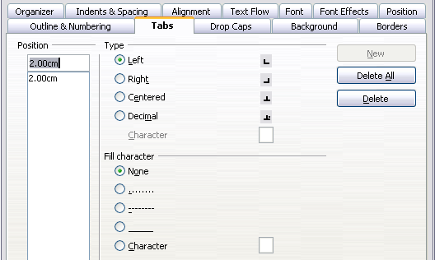Figure 243: Specifying tab stops for a paragraph style
Note that it is not possible to define tabs that exceed the page margin. In the rare cases where that may be needed, use a borderless table instead.

Using the Outline & Numbering Tab
Use the Outline & Numbering tab if you want to number the paragraph, for example if this style is to be used for a heading or list item.
You can assign an outline level to any paragraph style. This feature enables you to create a table of contents that includes those headings along with the headings using styles listed in Tools > Outline Numbering. For example, you might use a different sequence of styles for appendixes, but you want the headings and subheadings to appear in the TOC at the same levels as the chapter headings and subheadings.
To assign an outline level to a paragraph style, go to the Outline & Numbering tab for the style, and select the required outline level. Click OK to save this change.
This tab should be used in combination with list styles when you need to associate a certain paragraph style with a list style. Refer to “Combining List and Paragraph Styles” on page 237 for additional information on how to use this page, as well as an example.
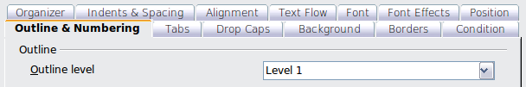Figure 244: Specifying an outline level on the Outline & Numbering tab for a paragraph style

Setting Up a Drop Cap
If you want your paragraph to use drop caps (usually this is suitable for a first paragraph style), then you can predefine the properties in the Drop Caps tab of the paragraph style dialog. Selecting the option to display drop caps enables the subsequent options where you can fine tune the appearance: the number of lines occupied, the number of characters to enlarge (if you want the whole first word, check the corresponding box), and the space between the drop caps and the text.
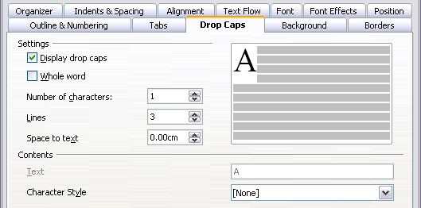
Figure 245: Options for adding a drop cap to the paragraph style

Drop caps use the same font and have the same properties as the rest of the paragraph. However, you can easily modify their appearance by creating a specific character style and using it. For example, you may want the drop caps to be of a different color or apply an outline effect. Select the character style you want to use in the corresponding drop-down menu.

Setting Up Paragraph Background and Borders
Adding a background color and a border to a paragraph is a good way to make it stand out without having to insert a frame. You can customize the background and border of the paragraph areas using the corresponding tabs of the paragraph style dialog. In addition to highlighting, borders are also often used to separate header and footer areas from the main text area (such as in this guide) as well as to provide decorative elements in some heading styles.
The two tabs are fairly intuitive. You may want to pay attention to the following points when working with the Background page:
- In case you do not find the desired color in the list of predefined ones, you can define your own by selecting Tools > Options > OpenOffice > Colors.
- You can use a graphic instead of a solid color as background. In the As drop-down list, select Graphic, then select the graphic object you want to use and adjust the parameters, as required. Detailed instructions on working with graphic backgrounds can be found in the Impress Guide.
- The background is applied only to the paragraph area. If you have defined an indented paragraph, the space between the paragraph and the margin does not have the paragraph’s background color.
On the Borders tab, the following points are worth considering:
- Watch out for the effects on indentations and tabulations that the spacing between borders and paragraph area produces,.
- If you want the border to be drawn around multiple paragraphs, leave the Merge with next paragraph option at the bottom of the tab marked.

Working with Conditional Paragraph Styles
A conditional paragraph style is another way of formatting text differently in different parts of a document. In some cases, you may find it saves time to use conditional styles rather than switching between styles as you type.
Making a paragraph style conditional means it changes its formatting depending on where it is used. For example, you may want the style MyTextBody to be black by default but turn white when inside a frame with a blue background.
Probably the most common use for conditional formatting is with single-style outlining. Single-style outlining is a type of outline numbering designed with a Numbering style, rather than with Tools > Outline Numbering. Instead of using different styles, it changes the number formatting whenever you press the Tab key to create a subordinate heading.
The only trouble with single-style outlining is that all levels look the same. This is where a conditional paragraph style comes in handy. Assign the paragraph style to an outline numbering style in the Outline & Numbering tab and then open the Condition page. There, you can assign the levels of the outline numbering style to other paragraph styles. Then, when you press the Tab key while using the paragraph style, each level of the outline takes on different formatting, making single-style outlining even more convenient than it is on its own.
Note | Predefined styles (other than Text body) such as Default, Heading 1, and Heading 2 cannot be defined as conditional.

Caution | If you want to make a style conditional, you have to do it while the style window is still open for the first time. After the window closes, the Condition tab no longer appears in the window.

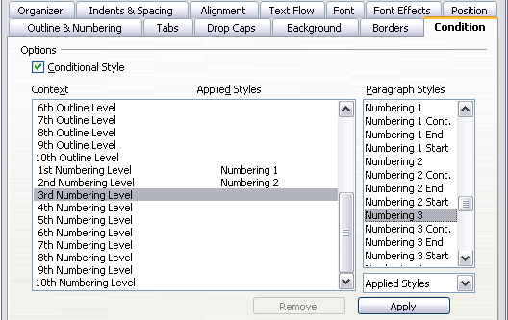Figure 246: Condition page for paragraph styles
When you create a conditional style, you are saying “in this condition, make this style look like that other style”. For example, “When typing into a footer, make this style look like the my_footer paragraph style; when typing into a table, make this style look like the table_text paragraph style”.
In addition to setting the normal (unconditional) properties of the style, you need to define which other style it will look like in different situations. You do this on the Condition tab.
To set up a conditional paragraph style:
- Define a new paragraph style.
- Select all the paragraph properties for the style. Do not click OK!
- Click the Condition tab.
- Select the Conditional Style option.
- Select the first condition in the Context list (left side of the dialog) and select the style you want for this condition in the Paragraph Styles list on the right-hand side.
- Click Apply. The name of the paragraph style appears in the middle list.
- Repeat steps 5 and 6 for each condition you want to link to a different style.
- Click OK.
When the style is selected, you will see that the formatting of your text depends on the context.

Working with Character Styles
Character styles complement paragraph styles and are applied to groups of characters, rather than whole paragraphs. They are mainly used when you want to change the appearance or attributes of parts of a paragraph without affecting other parts. Examples of effects that can be obtained by means of character styles are bold or italic typeface or colored words.
Two of the character styles used in this document are:
- Keystrokes use the custom OOoKeyStroke style.
  - For example:to set Writer to full screen, press Control+Shift+J.
- Menu paths use the custom OOoMenuPath style.
  - For example: to turn field shadings on or off, choose View > Field Shadings
Other ways of using character styles are described elsewhere in the Writer Guide. These uses include making chapter numbers, page numbers, or list numbers larger than the surrounding text and formatting hyperlinks. When inserting words in different languages, or words you don't want the spell checker to detect as mistakes (for example names in some programming languages for structures they support), character styles are quite useful, because you can define the language to be applied in the character-style properties.

Why Use Character Styles?
Beginning Writer users often wonder, “Why use character styles?” or “How is this different from clicking the bold icon to change the font typeface?” The following real-life event illustrates the difference.
Jean is a technical writer from Australia. She learned the value of character styles after her publisher told her to unbold menu paths in her 200-page book. Jean had not used character styles. She had to edit all 200 pages by hand, with some help from Find & Replace. This was the last time Jean failed to used character styles.
Character styles do not have as many options as paragraph styles or page styles. Their benefits are of a different nature:
- Formatting changes
As Jean’s story illustrates, the ability to make formatting changes throughout a document can be important. Character styles provide this.
- Consistency
Character styles help ensure that typesetting guidelines are applied consistently.
- Focus on content
“Was I supposed to bold keystrokes? How about menus?”
A writer should not have to remember the answers to these questions. Typesetting details distract you from the real content of your work. A properly named custom character style (such as OOoKeyStroke or OOoMenuPath) will remove this burden from you.

Creating a New Character Style
This section illustrates the use of the style dialog for creating a new character style.
The pages used to configure the character style have already been seen in the previous section on paragraph styles. Therefore, once you are familiar with creating paragraph styles, it will only take a few minutes to create a character style.
- Use the Organizer to set up the hierarchical level of the new character style (if needed) and to give it a name.
- Use the Font tab to determine the font, typeface, and size for your character style. As with paragraph styles, you can specify the size as a percentage rather than providing the absolute value. For example, 150% means that when the character style is applied to a 10pt font size, the new font size will be 15pt, while if applied to a 14pt font size, the new size will be 21pt. You can also specify the Language of the text to which a certain character style is applied, so you can insert words in a different language and have them spell checked using the correct dictionary.
- In the Font Effects tab, you can set up attributes such as font color, underlining, relief, or other effects. If you frequently use hidden text, for example, it is very convenient to define a character style where the Hidden option is marked. This way you only need a few mouse clicks to hide text. Relief effects may be appropriate for a drop cap or to give more emphasis to the chapter number or other parts of the title.
- You can use the Position page to create a subscript in case you are not satisfied with the default one or even a sub-subscript which may be useful for certain scientific publications. In the same page, you can create rotated, condensed, or expanded text.
Note | When rotating a group of characters, you also need to specify whether the rotated text should fit in the line or if, instead, it is allowed to expand above and below the line. This property only becomes active for character styles.

- Finish creating a character style by assigning a background, if so desired. Applying a background to a character style yields the same effect as using the highlighting tool on the standard toolbar.

Migrating to Character Styles
For people accustomed to formatting text manually, character styles may take some getting used to. Here are suggestions for making the transition easier:
- Never mix character styles and manual formatting. Manual formatting supersedes character styles. If you combine them, you may end up wasting hours in frustration trying to figure out why your character styles don’t work.
- Right-clicking and choosing Default Formatting removes any text formatting (both manual and character styles).
- Realize that clicking the Bold icon in the toolbar is not easier than double-clicking on a character style that is preset for bolding the font typeface.
- Use the Sidebar's Styles and Formatting deck to make character styles easy to access.

Working With Frame Styles
Frames are often used as containers for text or graphics. To provide consistency in the appearance of frames used for related purposes, it's a good idea to define styles for frames. For example, you might want photographs to be enclosed in a frame with a drop-shadowed border, line drawings in a frame with a plain border, marginal notes in a frame without a border but with a shaded background, and so on.
Writer provides several predefined frame styles, which you can modify as needed, and you can define new frame styles. The technique for defining and applying frame styles is similar to that for other styles.
Tip | There is considerable overlap between the uses of frames and of sections for some page layout purposes. You may find it useful to take a look at Chapter 4 (Formatting Pages) for information about the use of frames and sections.

How Frame Styles Work
When an object is added to Writer, it is automatically enclosed in a frame of a predetermined type. The frame sets how the object is placed on the page, as well as how it interacts with other elements in the document. You can edit the frame by modifying the frame style it uses or by using a manual override when a frame is added to the document.
Because frames and objects are used together, it is sometimes easy to forget they are separate elements. In some cases, such as charts, you can edit the frame and object separately, so the distinction is worth remembering.
Unlike other elements that use styles, frames, because their use can vary so much, can be defined only partly by their style. Several elements of frames, such as the anchor and protected elements, need to be defined manually for individual frames.
You can format a frame manually when you select Insert > Frame. The dialog that opens contains all the settings available when frame styles are set up, as well as some only available when the frame is inserted. As with other styles, the most efficient way to format frames is in the Styles and Formatting deck of the Sidebar.

Planning the Styles
If you are using a mix of graphics, you may want to define two related styles, one with a borderline for graphics with white backgrounds, and another without a border, for all other backgrounds. You also may want to design one or more frames for text only.
Otherwise, the default frame styles (listed in Table 3) cover most users’ needs. The only significant addition that many users might need is one or more styles for text frames.

Creating New Frame Styles
You can access frame settings by selecting New or Modify in the Styles and Formatting window for a frame style.
Table 3. Various frame styles and their uses
Style | Comments and Use
Formula | The frame style used for formulas. The default includes AutoSize, which adjusts the size of the frame to the formula.
Frame | The default frame style.
Graphics | The default style for graphics. The defaults include autosizing to fit the graphic, no text wrap, and a thin border around the frame. These are reasonable defaults, except for the border. Unless the background of the graphic is white and the document’s background also is white, the border usually is unnecessary.
Labels | The default style for use with File > New > Labels. It seems to be used by OpenOffice automatically and is not intended for users at all.
Marginalia | A style for placing a frame beside the left margin. As the name suggests, the Marginalia style is intended for comments added in the margin of text. The style also is useful for creating sideheads—headings against the left margin, which often are used in technical documentation. To set up sideheads, create body-text paragraph styles with two inches or more indentation from the left. Then, place the cursor at the start of a body-text paragraph, add the frame, and apply the Marginalia style.
OLE | The default style for OLE objects and floating frames. The default places the frame at the top and center of a body of text.
Watermark | The default style for a watermark, a graphic placed as the background to a body of text. The default is a Through wrap, with text passing over the frame and anything in it. The graphic should be faint enough that text still is readable over top of it.
Frame settings are available from the following tabs:
- Type tab: sets the size and position of the frame. One of the most useful options here is AutoSize, which automatically adjusts the frame to the object it contains. If the frame style is one used automatically, then this option should be selected.
- Options tab: sets whether the contents of the frame are printed and able to be edited in a read-only document. This page also sets the text direction, which is useful if you are using the frame for contents in a language that uses right-to-left text direction.
- Wrap tab: sets how text is positioned in relation to the frame and how close text comes to a frame. If you want the frame contents to stand out from the surrounding paragraphs, set the wrap to None. This probably is the single most important page for frames.
- Background tab: sets the background color or graphic. This page is useful mostly for text frames in complex page layouts, in which a text frame has an appearance different from the general background of the page.
- Border tab: sets the line around the frame, if any. Many beginning designers make the mistake of adding a border to every frame. However, when a colored background distinctly marks the division between the frame’s contents and the rest of the page, borders are unnecessary.
- Columns tab: this page can be ignored unless the frame is being used for text. The page is the same as is used to set up a page style, and its parameters are described in the section “Columns Tab” on page 228.
- Macro tab: sets a macro to use with the frame in order to trigger an action when the user interacts with the frame.

Working With Page Styles
Page styles control page properties (margins, page size, header and footers, among others). However, unlike paragraphs, which can have directly applied properties, pages only have a page style and no directly applied properties.
Christian is a lawyer from California. For his letters, the first page has his letterhead, and subsequent pages only identify the recipient, the date, and the page number. Christian accomplishes this with page styles. He also uses page styles to comply with the spacing requirements (such as margins) for legal briefs in California State courts.
This section describes how to create a new page style, explains the meaning of some options in the Page style dialog, and illustrates their usage.

Creating a New Page Style
Unlike other styles, page styles can be created or modified only by using the Styles and Formatting tool. Open the Styles and Formatting deck or window and click the Page Styles icon . Right-click anywhere in the main window and select New.
The Page Style dialog consists of the eight tabs.
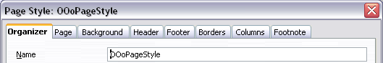Figure 247: The tabs for the Page Style dialog

The Next Style Property
As for the other styles, use the Next style property (described in “The Organizer Tab” on page 205) to specify the style for the subsequent pages. This property is particularly important for a page style, as the following example demonstrates.

Setting Up a Title Page
Consider a common scenario: you want the document to have a title page that is different from the rest of the document:
- It should not have a header or page number.
- The left and right margins should be the same.
For the title page, we can use the predefined First Page page style that comes with AOO, and for the rest of the document, we can use the Default page style.
Figure 244 shows the required flow of page styles. On the Organizer page of the Default page style, leave the Next Style property set to Default. On the Organizer page of the First Page style, make sure that the Next Style property is set to Default.
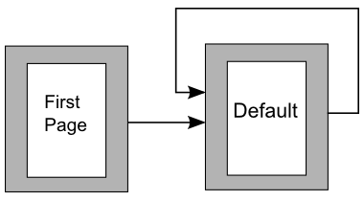Figure 248: Flow of page styles

General Settings for the Page Style
The Page tab of the Page Style dialog is where you can control the general settings of the page. The tab consists of three sections, plus a preview area in the top right corner.
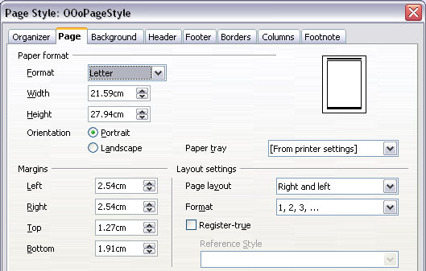
Figure 249: The Page tab for the Page Style dialog
In the Paper format section, you can specify the size of the paper, choosing from one of the many predefined formats. Selecting “user”, you can use the Width and Height fields to define your own paper size. If using a predefined format, select the orientation of the paper between portrait and landscape. If your printer has more than one tray, you can specify the tray from which to print pages in the new page style.
In the Margins section, specify the size of the margins in your preferred unit of measurement. If you select Mirrored margins in the Page layout settings, the left margin becomes the Inner margin, while the right margin becomes the Outer margin.
In the Layout settings section, choose the desired Page layout from the four available options. Decide whether the page style being defined applies to both left and right pages (default) or if instead it should be applied only to left pages, only to right pages, or be used in a mirrored layout. Some considerations:
- If you plan to bind printed pages that use this style like a book, select a mirrored layout.
- Use the Format drop-down menu to determine the page numbering style to apply to this page style.
- A common practice in page layouts is to have asymmetrical page margins—both for left and right margins and for top and bottom margins. There are various schemes for accomplishing this. The most frequently used follow these two general rules for printed page layouts: (a) The outer margin (right margin on a right-hand page) would have a wider margin than an inner margin (left margin on a right-hand page); (b) The bottom margin would be larger than a top margin. The rationale for an asymmetrical page layout is allowing more space for readers to place their hands while holding the books or other printed documents.
- If you want the first page of a new chapter to always start on a right (recto) page, make sure that the page style for the first chapter page is set for the right page only by making this selection in the Layout settings field. The typical procedure for the rest of a chapter is to define a single “mirrored” page style for both left and right pages. A mirrored page can have different headers and footers. If done this way, every chapter will use two page styles.
- You can choose to define separate page styles for left and right pages, if you want the pages to be very different in appearance (for example, different margins or headers and footers only on right pages but not on left pages; imagine a book with a full-page photograph on the left pages and text on the right pages). In that case, make sure that the Next Style field for the first page style is then set for a left-only page, which, in turn, is then set to be followed by a right-only page style. If done this way, every chapter will use three page styles. A hypothetical case might have these page-style names: First page, Left, and Right.
If you check the Register-true box, Writer will create a vertical grid on the page with a spacing between grid points that depends on the selected Reference Style. The vertical grid makes sure that text printed on adjacent columns, opposite pages, or even both sides of the same sheet of paper, is aligned—making it easier to read and being more pleasant to see.

Background and Border Tabs
Use the Background tab to apply a background or the Border tab to draw a border around text area of the page. You can choose between a solid color or a graphic image for the background and several styles of line for the borders. Note that the page area affected by these changes does not include the area outside the margins. If you plan to print on colored paper and want to have a feel of the final result you will obtain or want to use a light color for the font, rather than changing the background, then go to Tools > Options > OpenOffice and in the Appearance section, change the Document background color.

Header and Footer Tabs
You can associate a different header or footer to each page style. This property makes it very easy to have different headers on left and right pages, to avoid headers on pages at the start of a new chapter, and so on.
Setting up the header and footer pages is straightforward. The instructions here refer to the header, but the footer page has the same options. Activate the input boxes by selecting Header on, then specify the left margin, right margin, and spacing to the main text area. For the height of the header area, you can either select the AutoFit height box, which will make Writer adapt the size to the contents, or specify the height manually. Clicking More opens a new dialog, where you can set the borders and background of the header area.
If you deselect the Same content left/right box, you can specify a different header for left or right pages, even if you use a single style for both as shown here.
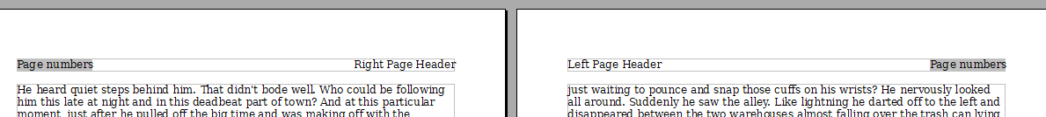
Figure 250: Different content on left and right pages

Columns Tab
Use this tab to create the desired column layout for the page style. The page is subdivided into three sections: Settings, Width and Spacing and Separator Line. The Settings section contains thumbnails of predefined columns settings you can select, as well as a text box where you can enter the desired number of columns if you need to create a customized one.
After you select more than one column, the Width and Spacing section becomes active. If you are not satisfied with the predefined settings (equally spaced columns), deselect the AutoWidth option and enter the parameters manually. When you work with multiple columns per page, you can also fine tune the position and size of a separator line between the columns.

Footnote Tab
Use this page to adjust the appearance of the footnotes. Keeping the default setting Not larger than page area, the footnotes area is calculated automatically on the basis of the number of footnotes. If you prefer to control manually the maximum space that footnotes can take, select the Maximum footnote height option and enter the value in the preferred unit of measurement. Use the second section of the page to customize the separator between the footnotes and the main area.

Example: A Book Chapter Sequence of Pages
Book chapters typically start on a right-hand page, with the first page of the chapter having a different layout from the rest of the pages. The other pages in the chapter are “mirrored” for double-sided printing. For example, page numbers in the header or footer may be positioned on the outside edge of pages and a wider margin (allowing for binding) may be placed on the inside edge.
Table 4 shows the properties of two page styles (Right Page and Default) set up for a typical book chapter’s sequence of pages.
Table 4. Properties of customized page styles for book chapter
Page Style | Desired effect |  | Property: setting
Right Page | First page always on the right (an odd-numbered page) | Page > Page layout > Only right
Right Page | No header or footer | Header > Header > Header on: Not selected
Right Page | Top margin of page larger than on other pages | Page > Margins > Top: 6.00 cm
Default | Mirrored margins | Page > Page layout: Mirrored
Default | Header with page number on the top outside of the page and chapter title in the top center of the page | Header > Header on: Selected  Header > Header > Same content left/right: Not selected
Figure 244 illustrates the transitions from the Right Page to Default page styles, with the change of header between left and right pages shown by the # symbol.
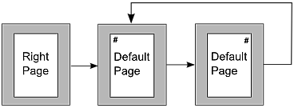
Figure 251: Right Page and then the Default page style with different headers for alternate pages.
Step 1. Set up the Right Page style.
- On the Styles and Formatting deck, click the Page Styles icon to display a list of page styles.
- Right-click on Right Page and select Modify from the pop-up menu.
- On the Organizer tab of the Page Style: Right Page dialog, change Next Style to Default.
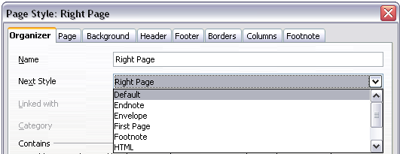
Figure 252: Specifying the next style after the first page of a chapter
- On the Page tab, specify a larger left margin for binding, and a larger top margin to move the chapter title down the page.
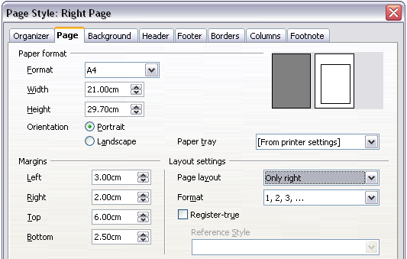
Figure 253: Setting page margins and layout for the Right Page style
- On the Header and Footer tabs, be sure the Header on and Footer on options are not selected. Click OK to save your changes.
Step 2. Set up the Default page style.
- On the Styles and Formatting deck, in the list of page styles, right-click on Default and select Modify from the pop-up menu.
- On the Organizer tab of the Page Style: Default dialog, be sure Next Style is set to Default.
- On the Page tab of the Page Style: Default dialog, select Mirrored for Page layout and set the Inner and Outer margins to the same width as the Left and Right margins, respectively, on the Right Page style.
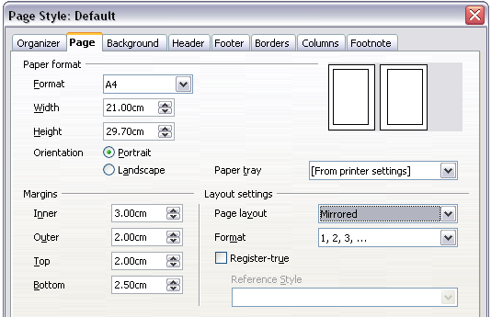Figure 254: Setting page margins and layout for the Default page style
- On the Header tab of the Page Style: Default dialog, select the Header on option and deselect the Same content left/right option. Click OK to save your changes.
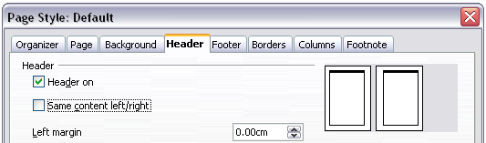Figure 255: Setting up the header properties for the Default page style
Step 3. Set up the Heading 1 paragraph style to start on a new right-hand page.
- In the Styles and Formatting deck, on the Paragraph Styles page, right-click on Heading 1 and select Modify.
- On the Text Flow tab of the Paragraph Style dialog, in the Breaks section, select Insert, With Page Style, and Right Page. The Type box should be set to Page and the Position should be Before. Click OK to save your changes.
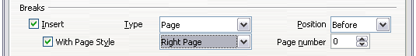Figure 256: Setting a paragraph style to start on a page of a selected style
Step 4. Start a new chapter.
Apply the Heading 1 paragraph style to the first paragraph, which is the title of the chapter.
Note | By default, the Heading 1 paragraph style is assigned to Outline Level 1. The assignment of paragraph styles to outline levels is done through Tools > Outline Numbering.

Step 5. Set up the page headers.
- On a left page, put the cursor in the header and insert a page number field on the left (Insert > Fields > Page Number).
- Press Tab to put the cursor in the middle of the page.
- Press Control+F2 (or choose Insert > Fields > Other from the menu bar) to display the Fields dialog (Figure 241).
- On the Document tab, for Type, select Chapter and for Format, select Chapter name. Make sure that Level is set to 1 and then click Insert.
- On a right page, put the cursor in the header, press the Tab key, insert a Chapter reference, press Tab again, and insert a page number field.
- If you need to adjust tab stops for the header, modify the Header paragraph style; don't manually adjust the tab stops.
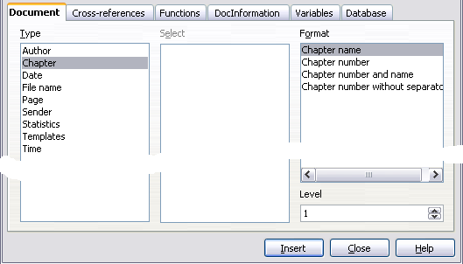Figure 257: Inserting a chapter title into the header of a page

Working with List Styles
List styles (also called numbering styles) work together with paragraph styles. They define indentation, alignment, and the numbering or bullet characters used for list items. You can define many list styles, from simple bulleted lists to complex multi-level (nested) lists.
As with other styles, the main reasons for using list styles are consistency and speeding up your work. Although you can create simple lists quickly by clicking the Numbering On/Off or Bullets On/Off icons on the Formatting toolbar, and create quite complex nested lists using the icons on the Bullets and Numbering toolbar, the appearance of the resulting lists may not be what you want—and you might want to have more than one style of list. You can use the Bullets and Numbering choice on the Format menu to manually format the appearance of some or all of the lists, but if you later need to change their appearance, you will have a lot of manual work to do.
Note | AOO uses the terms “numbering style” and “list style” inconsistently, but they are the same thing. For example, the tooltip in the Styles and Formatting window says “List Styles”, but its style dialog says “Numbering Style”.

Defining the Appearance of a Nested List
A nested list is a numbered or bulleted list with subordinate (usually indented) numbered or bulleted lists. Rather than just a list of numbered items (1,2,3…), a nested list may have item 1, then indented items numbered a, b, c or i, ii, iii or some other numbering method before the main number 2. With numbering styles, you can achieve any combination of numbering formats you want. A nested list may even combine numbered items with bulleted items.
There is no difference between defining a nested list style or a simple list, although nested lists require more work. An example of a nested list is given in Chapter 3 (Working with Text). In that case, the list was built using one of the predefined outline schemes as a starting point, while in this section we follow a more general approach so that the list can more fully suit your needs.

Creating a New List Style
The dialog to create a new list style consists of six tabs, in addition to the usual Organizer page discussed in “The Organizer Tab” on page 205. Bring up the dialog by right clicking in the Styles and Formatting window and selecting New. If you right click on a style name, the new style will be linked to the existing style. Right click on an empty area to make an independent style.

Bullets, Numbering Styles, and Graphics Tabs
The Bullets, Numbering Style, and Graphics tabs contain predefined formatting for list item symbols (bullets or numbers). To use one of them for your style, click on the image. A thick border indicates the selection. The bullets on the Bullets tab are font characters; those on the Graphics tab are graphics.
If you choose a graphics bullet, you can select the Link Graphics option to create a link to the graphic object rather than embedding it in the document. If you decide to link the graphic, keep in mind that the bullet will not be displayed when the document is opened on a different computer (unless the same graphic file is located in the same location on both computers) or if the graphic file used is moved to a different location on the originating computer.

Outline Tab
Use the Outline page to select from eight predefined nested lists. You can also select one and use it as a starting point for your own style, customizing the list using the Position tab and the Options tab, as described below.

Position Tab
Use the Position tab to fine tune the indentation and spacing of the list item symbol and the text of the list item. This tab is particularly effective when used in combination with the Options page.
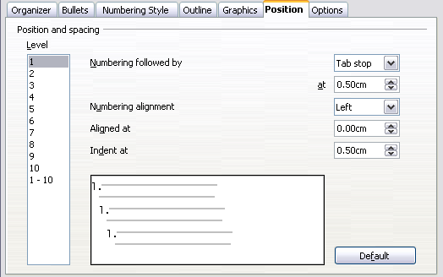Figure 258: Position settings for a List style
You can adjust the following settings for each individual level, or all at once to make them all the same. It is generally easier to adjust the settings in the order given below, instead of the order on the dialog. That is, start from the overall indentation for the list elements, then fix the position of the symbols, and finally adjust the alignment of the symbols.
- Numbering followed by: the character to follow the numbering symbol (plus any characters—for example a punctuation mark—chosen on the Options page to appear after the number). Decide between a tab stop, a space, or nothing. If you select the tab stop, you can specify the position of the tab.
- Indent at: how much space is reserved for the numbering symbol, measured from the left page margin. The alignment of the first line of the list is also affected by any tab you may have set to follow the numbering.
- Aligned at: the position of the numbering symbol, measured from the left margin of the page.
- Numbering alignment: how the numbering (including any text before or after as set in the Options page) will be aligned. The Aligned at value determines the symbol alignment.

Note | When defining an indentation different from 0, the position of the tabulation is not considered.

Tip | In normal circumstances, setting the Numbering followed by distance to be equal to the Indent at distance works well. See Figure 232 for a graphic representation of the effects of the above parameters.

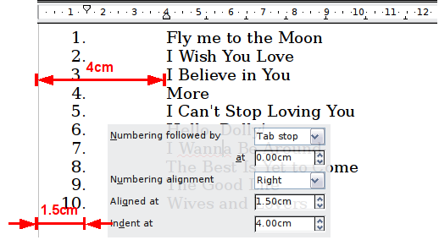
Figure 259: A numbered list of music tracks highlighting the various elements

Position Tab for Earlier Versions of AOO
If your document was created with an early version of AOO, or if the document was saved using the ODF file format version 1.1 or earlier, the position dialog will appear as in Figure 239.
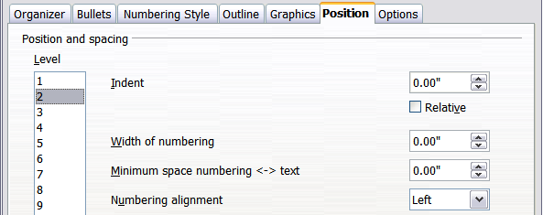
Figure 260: The Position tab for documents created with earlier versions of AOO
In this case you can adjust the following settings:
- Indent: the indentation of the number or bullet area, measured from the left margin of the paragraph linked to the numbering style. In other words, if the paragraph style already has an indentation, when the list style is applied the indentations are added together.
For any level other than Level 1, the Relative option causes the indentation to be measured from the start of the previous level rather than from the page margin.
- Width of numbering: how much space is used by the numbering symbol. Writer reserves this space, even if only part of it is used.
- Minimum spacing numbering <-> text: the spacing between the right edge of the numbering symbol and the text. If the spacing to text is not sufficient, Writer will honor this setting by expanding the numbering area. Setting the minimum spacing between numbering and text is very useful when right-aligning the numbering or when there is much text before or after the numbering.
- Numbering alignment: how the numbering (including any text before or after) will be aligned.
Tip | To fully appreciate how Numbering alignment works, try to create a numbered list with more than ten elements, making sure there's enough room for numbers with two or more digits. You may also wish to right-align numbers 10 or greater, as in Figure 234 on page 209.

Options Tab
Use the Options page to define the style of the outline levels. The options available on this depend on the type of marker selected for the list. First, on the left side, select the level you want to modify. To modify all ten levels at once, select 1-10 as the level. If you started from a predefined outline, some levels will already have settings.
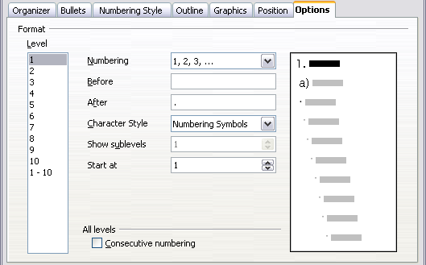Figure 261: The Options tab for a list style
Depending on the numbering style selected in the Numbering box (bullet, graphic, numbering), some of the following options become available on the page:
- Before: any text to appear before the number (for example, Step).
- After: any text to appear after the number (for example, a punctuation mark).
- Color: the color for the list marker (number or bullet character).
- Relative size: the size of the number relative to the size of the characters in the paragraph of the list.
- Start at: the first value of the list (for example, you might want the list to start at 4 instead of 1).
- Character Style: the style to be used for the number or bullet.
- Character button: click to select the character for the bullet.
- Graphics selection button: opens a list of available graphics (Gallery) or allows the selection of a file to be used as the list marker.
- Width and Height: the dimensions of the graphic marker.
- Alignment: the alignment of the graphic object.
- Keep ratio option: fixes the ratio between the width and the height of the graphic marker.
The right-hand side of the dialog shows a preview of the modifications made.
To revert to the default values, click the Reset button in the bottom right corner. Finally, if you wish to use consecutive numbers regardless of the outline level, check the Consecutive numbering box at the bottom of the page.

Combining List and Paragraph Styles
When applying a list style, the underlying paragraph style remains unchanged. If your list must also have a certain font size, indentations, and so on, you might expect to first apply a paragraph style and then a list style (or vice versa). However, you can embed a list style in a paragraph style using the Numbering page of the Paragraph Style dialog, and then apply only the paragraph style to the list.
This section gives an example of combining list and paragraph styles.
- Create a list style you want to use for the paragraph. For example: MyNumberedList.
- Create a new paragraph style.
- On the Organizer tab of the Paragraph Style dialog:
  - Give the new paragraph style a name, say NumberedParagraph.
  - For the Next Style, choose NumberedParagraph (this will make the following paragraph also be in this style, until you choose a different style).
  - In Linked with, choose None.
  - Leave Custom Styles, in the Category field.
- Set up this paragraph style to your liking. Because the indentation is controlled by the List style, to avoid undesired interactions do not change the indent settings on the Indents & Spacing page. (You might want to change the spacing above and below the paragraph.)
- On the Outline & Numbering page, choose the MyNumberedList style created in step 1.
- Click OK to save this style.
To accomplish full control of your lists, it is common practice to define three base paragraph styles for them: List Start for the first element of the list, List Continue for the subsequent elements of the list, and List End for the last element of the list. You should also define a paragraph style to be used for unnumbered list items (one for each nested level you intend to use) as well as an introductory style for the paragraph preceding the start of the list (to allow for keeping the introductory paragraph with the first list item, or for specifying spacing before the first list item that is different from the spacing between other paragraphs).

Example: Creating a Simple List Style
In this example, we will create a numbered list that is used to number the songs on a play list. The numbers are right aligned, and some space is left between the number and the title of the track.
As we want to reuse the same numbered list for other play lists, we will define a new list style and then apply it to the tracks list.

Creating the Tracks Numbered List
As for the previous example, start by clicking the List Styles icon (fifth from the left) in the Styles and Formatting deck. Then right-click anywhere in the list box and choose New.
The Numbering style dialog is displayed. For the Tracks style, we need to customize fields in the Organizer, the Options, and the Position tabs.
Style fields | Description
Name | Enter Tracks
Category | Custom styles will be OK for us.
Modify the options of the Options tab as follows:
- In the Level box, choose 1.
- In the Numbering list, choose 1, 2, 3, ….
- Leave the Before and After boxes empty.
- Leave the Character Style field as None.
- Show sub-levels should be grayed out.
- Make sure Start at is set to 1.
- Do not select Consecutive numbering.
As discussed above, the numbering list will adopt settings of the underlying paragraph style. If you want to use a special font, size, or color for the numbering, you can create a character style and apply it in the Options page.
If you want the word Track to appear before the number, just add it to the Before field in the Options dialog tab. Do not forget to add a space character to separate the word from the number.
Set up the final parameters of the Tracks list style in the Position tab.
- In the Level box, choose 1.
- For Numbering followed by, choose tab stop and set it at 4.0cm.
- For Numbering alignment, choose Right.
- For Aligned at choose 1.5 cm. (this refers to the alignment of the numbers)
- For Indent at choose 4.0 cm. (This sets the indentation of the whole list.) Click OK to finish.

Applying the List Style
Now that the list style is available, it can be quickly applied to any list in the document:
- If starting a new list, before pressing Enter to start a new line, double-click on the desired list style name in the Styles and Formatting deck.
- If you already have a list, select it and then double-click on the desired list style name in the Styles and Formatting deck.
Tip | Remember that applying a list style does not affect the characteristics of the underlying paragraph; therefore you may want to check if you are satisfied with the paragraph style before applying the list style.

If you have more than one list in a document, the second and subsequent lists with the same style continue their numbering from the previous list. To restart at 1, place the cursor anywhere in the paragraph you want numbered 1, right-click, and choose Restart numbering.
To stop using numbering, press the Numbering On/Off icon on the Standard toolbar. The final result is illustrated in Figure 232.

Chapter 8
Working with Graphics

Graphics (images) in Writer
When you create a text document using Apache OpenOffice (AOO) Writer, you may want to include illustrations. Graphics are added to documents for a wide variety of reasons: from supporting the description provided in the text—as used in this Guide—to providing an immediate visual representation of the contents, like those often found in a newspaper.
Graphics in Writer are of three basic types:
- Image files, such as photos, drawings, and scanned images
- Diagrams created using AOO’s drawing tools
- Charts created using AOO’s Chart facility
This chapter covers images and diagrams.
More detailed descriptions on working with drawing tools can be found in the Draw Guide and Impress Guide. Instructions on how to create charts are given in the Calc Guide.

Creating and Editing Images
You might create images, sometimes also called pictures in OpenOffice using a graphics program, scan them, or download them from the Internet.

Tip | If you download images from the Web, be careful to adhere to copyright. In other words, make sure you have permission to use such material.

Writer can import various vector (line drawing) and raster (bitmap) file formats. The most common are GIF, JPG, PNG, and BMP.
Some things to consider when choosing or creating pictures include image quality and whether the picture will be printed in color or black and white (gray scale).
Writer's image manipulation tools have the power and quality needed for everyday tasks like internal business documents or personal work. If illustrations of the highest quality are needed, it is better to use other software to prepare the images. To edit photos and other bitmap images, use a bitmap editor. To edit line drawings, use a vector drawing program. You do not need to buy expensive programs. Open-source (and usually no-cost) tools such as Gimp, a bitmap editor, and Inkscape, a vector drawing program, are excellent. For many graphics, AOO Draw is sufficient. These and many other programs work on Windows, Macintosh OS X, and Linux.
For best results:
- Create images that have the exact dimensions required for the document, or use an appropriate graphics package to scale photographs and large drawings to the appropriate dimensions.
- Do any other image manipulation (brightness and contrast, color balance, cropping, conversion to gray scale, and so on) in a graphics package.
- If the document is meant for screen use only, there is no need to use high resolution images of 300 or more dpi (dots per inch). Most computer monitors work at between 72 and 96 dpi; reducing the resolution (and the file size) has no negative impact on what is displayed but does make Writer more responsive.

Preparing images for black-and-white printing
If color images are to be printed in gray scale, check that any adjacent colors have good contrast and print dark enough. Test by printing on a black-and-white printer using a gray scale setting. Better still: change the “mode” of the image to gray scale, either in a photo editor or in Writer itself (see “Graphics Mode ” on page 247).
For example, the following diagram looks good in color. The circle is dark red and the square is dark blue. In gray scale, the difference between the two is not at all clear. The third element in the diagram, the yellow arrow, is almost invisible in gray scale.
Original drawing in color |   Drawing printed in gray scale
Changing the colors of the circle and the arrow improves the contrast and visibility of the resulting gray scale image.
  Original drawing in color | 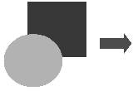  Drawing printed in gray scale
If the document will be available in black-and-white print only, a better result can often be obtained by choosing gray scale fills, not color fills. This choice ensures you won’t have to guess and test to see if you’ve made good choices.

Adding Images to a Document

Images can be added to a document in several ways: by inserting an image file, directly from a graphics program or a scanner, or from the AOO gallery.

Inserting an Image File
When the image is in a file stored on the computer, you can insert it into an AOO document using either of the following methods.

Drag and Drop
- Open a file-browser window and locate the image you want to insert.
- Drag the image into the Writer document and drop it where you want it to appear. A faint vertical line marks where the image will be dropped.
This method embeds (saves a copy of) the image file in the Writer document. To link the file instead of embedding it, hold down the Control+Shift keys while dragging the image.

Insert Picture Dialog
- Click in the AOO document where you want the image to appear.
- Choose Insert > Picture > From File from the menu bar.
- On the Insert Picture dialog, navigate to the file to be inserted, select it, and click Open.
At the bottom of the dialog are two options, Preview and Link. Select Preview to view a thumbnail of the selected image on the right, so you can verify that you have the correct file. See below for the use of Link.

Figure 262. Insert picture dialog

Linking an Image File
If the Link option in the Insert picture dialog is selected, AOO creates a link to the file containing the image instead, of saving a copy of the image in the document. The result is that the image is displayed in the document, but when the document is saved, it contains only a reference to the image file—not the image itself. The document and the image remain as two separate files, and they are merged together only when you open the document again.
Linking an image has two advantages and one disadvantage:
- Advantage – Linking can reduce the size of the document when it is saved, because the image file itself is not included. File size is usually not a problem on a modern computer with a reasonable amount of memory, unless the document includes many large graphics files; AOO can handle quite large files.
- Advantage – You can modify the image file separately without changing the document because the link to the file remains valid, and the modified image will appear when you next open the document. This can be a big advantage if you (or someone else, perhaps a graphic artist) is updating images.
- Disadvantage – If you send the document to someone else, or move it to a different computer, you must also send the image files, or the receiver will not be able to see the linked images. You need to keep track of the location of the images and make sure the recipient knows where to put them on another machine, so the document can find them. For example, you might keep images in a subfolder named Images, under the folder containing the document. The recipient of the file needs to put the images in a subfolder with the same name, again under the folder containing the document.
Note | When inserting the same image several times in the document it might appear beneficial to create multiple links. But this isn't necessary. AOO embeds only one copy of a given image file in the document.

Embedding Linked Images
If you originally linked images, you can easily embed one or more of them later if you wish. To do so:
- Open the document in OpenOffice and choose Edit > Links.
- The Edit Links dialog shows all the linked files. In the Source file list, select the files you want to change from linked to embedded.
- Click the Break Link button.
- Save the document.
Note | Going the other way, from embedded to linked, is not so easy. You must delete and reinsert each image, one at a time, selecting the Link option every time you do so.

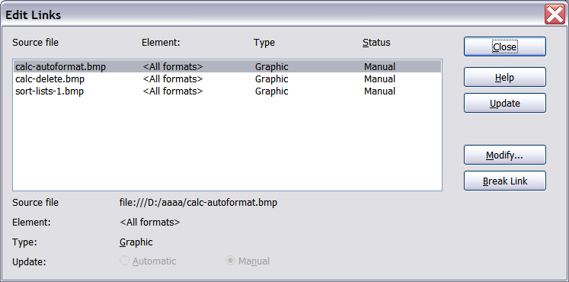
Figure 263: The Edit Links dialog

Inserting an Image from the Clipboard
Using the clipboard, you can copy images into an AOO document from another AOO document and from other programs. To do this:
- Open both the source document and the target document.
- In the source document, select the image to be copied.
- Press Control+C to copy the image to the clipboard.
- Switch to the target document.
- Click to place the cursor where the graphic is to be inserted.
- Press Control+V to insert the image.
Caution | If the application from which the graphic was copied is closed before the graphic is pasted into the target, the image stored on the clipboard could be lost.

Inserting an Image Using a Scanner
If a scanner is connected to your computer, AOO can call the scanning application and inserted the scanned item into the AOO document as an image. To start this procedure, click where you want the graphic to be inserted and select Insert > Picture > Scan > Select Source.
Although this practice is quick and easy, it is unlikely to result in a high-quality image of the correct size. You may get better results by scanned the desired material into a graphics program, and then cleaning it up, before inserting the resulting image into AOO.

Inserting an Image from the Gallery
The Gallery provides a convenient way to group reusable objects, such as graphics and sounds, that you can insert into your documents. The Gallery is available in all components of AOO. It doesn't provide many graphics, but you can add your own pictures or find extensions containing more graphics. The Gallery is explained in more detail in Chapter 11 (Graphics, the Gallery, and Fontwork) in the Getting Started guide. For more about extensions, see Chapter 17 (Customizing Writer) in this book.
This section explains the basics of inserting a Gallery image into a Writer document:
- To open the Gallery, click on the Gallery icon on the Sidebar or the Gallery icon of the Standard toolbar or choose Tools > Gallery from the menu bar.
- Navigate through the Gallery to find the desired picture.
- To insert the picture, click and drag it from the Gallery into the Writer document. You can also right-click on the picture and choose Insert > Copy.
Figure 264 shows an example of an image dragged from the Gallery.
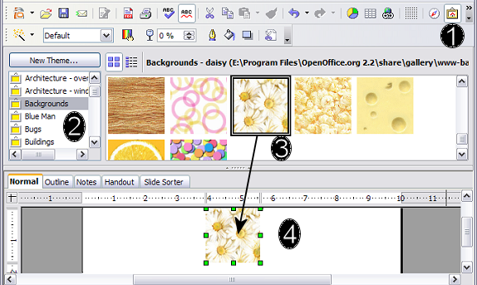
Figure 264. Inserting an image from the Gallery
The Gallery is most conveniently placed when it is accessed though the Sidebar, If the Gallery is opened from the Standard toolbar or the menu bar, by default it is docked above the Writer workspace. To expand the Gallery, position the pointer over the line that divides it from the top of the workspace. When the pointer changes to parallel lines with arrows, click and drag downward. The workspace resizes in response.
To expand the Gallery without affecting the workspace, undock it, so it floats over the workspace. To do so, hold down the Control key and double-click on the upper part of the Gallery next to the View icons. Double-click in the same area while holding down the Control key to dock it again (restore it to its position over the workspace).
When the Gallery is docked, to hide it and view the full Writer workspace, click the Hide/Show button in the middle of the thin bar separating the Gallery from the workspace.
To close the Gallery, choose Tools > Gallery to uncheck the Gallery entry, or click on the Gallery icon again.

Modifying an Image
When you insert a new image, you may need to modify it to suit the document. The placement of the picture relative to the text is discussed in “Positioning Graphics within the Text” on page 257. This section describes the use of the Picture toolbar, resizing, cropping, and a workaround to rotate a picture.
Writer provides many tools for working with images. These tools are sufficient for most people’s everyday requirements. However, for professional results it is generally better to use an image manipulation program such as GIMP to modify images (for example, to crop, resize, rotate, and change color values) and then insert the result into Writer.

Using the Picture Toolbar
When you insert an image or select one already present in the document, the Picture toolbar appears. You can set it to always be present (View > Toolbars > Picture). Picture control buttons from the Picture toolbar can also be added to the Standard toolbar. See Chapter 17 (Customizing Writer) for more information.
This toolbar can be either floating or docked. Figure 265 shows what the Picture toolbar looks like when it is floating.
Two other toolbars can be opened from this one: the Graphic Filter toolbar, which can be torn off and placed elsewhere on the window, and the Color toolbar, which opens as a separate floating toolbar.
From these three toolbars, you can apply small corrections to a graphic, or obtain special effects.
Many of the controls in the Picture and Color toolbars are available on the Graphic panel of the Sidebar's Properties deck when an image is selected. Figure 280 displays the panel. The functions provided by the Graphic Filter toolbar are not available on the Sidebar.

Graphics Mode
You can change color images to gray scale by selecting the image and then selecting Gray scale from the Graphics mode list.

Flip Vertically or Horizontally
To flip an image vertically or horizontally, select the image, and then click the relevant icon.

Filters
Table 5 provides a short description of the available filters. But as is so often the case, the best way to understand them is to see them in action. Feel free to experiment with the different filters and filters settings, remembering that you can undo all the changes by pressing Ctrl+Z or Alt+Backspace or by selecting Edit > Undo.
The Picture and Color toolbars
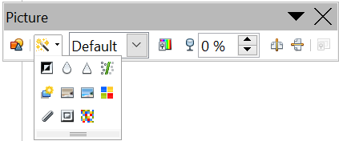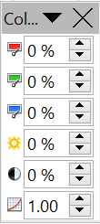  1  4  3  5  2  6  7  8  9  10  11  12  13  14  15  16  17  18  19  20  21  22  23  24  25  Note: Graphics mode (3) can be Default, Gray scale, Black/White, or Watermark.  Figure 265. Picture toolbar plus tear-off Graphic Filter toolbar and floating Color toolbar. | 1 | From File
 | 2 | Filter
 | 3 | Graphics mode
 | 4 | Color
 | 5 | Transparency
 | 6 | Flip Horizontally
 | 7 | Flip Vertically
 | 8 | Frame Properties
 | 9 | Invert
 | 10 | Smooth
 | 11 | Solarization
 | 12 | Aging
 | 13 | Charcoal Sketch
 | 14 | Relief
 | 15 | Mosaic
 | 16 | Posterize
 | 17 | Pop Art
 | 18 | Sharpen
 | 19 | Remove Noise
 | 20 | Red
 | 21 | Green
 | 22 | Blue
 | 23 | Brightness
 | 24 | Contrast
 | 25 | Gamma
The Graphic panel of the Sidebar's Properties deck
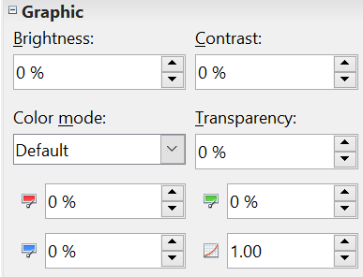  Figure 266: Sidebar Picture and Color controls | Color mode in the Sidebar is the same as Graphics mode in the Picture toolbar
 | See the note in Figure 265

Color
Use this toolbar or the same tools in the Sidebar to modify the individual RGB color components of the image as well as the brightness, contrast, and gamma of it.

Note | RGB is shorthand for red, green, and blue - the three colors of light which can be mixed to produce any other color

Note | Gamma refers to the fact that computer monitors produce light intensity which may not be in sync with the value expected by the computer's display. So, to arrive at precise colors, a process called gamma correction might be used.

If the result is not satisfactory, you can press Control+Z to restore the default values.
Table 5: Graphic filters and their effects
Icon | Name | Effect
 | Invert | Inverts the color values of a color image or the brightness values of a gray scale image.
 | Smooth | Softens the contrast of an image.
 | Sharpen | Increases the contrast of an image.
 | Remove noise | Removes single pixels from an image.
 | Solarization | Mimics the effects of too much light in a picture. A further dialog box opens to adjust the parameters.
 | Aging | Simulates the effects of time on a picture. Can be applied several times. A further dialog box opens to adjust the aging level.
 | Posterize | Makes a picture appear like a painting by reducing the number of colors used.
 | Pop Art | Modifies the picture dramatically.
 | Charcoal | Displays the image as a charcoal sketch.
 | Relief | A dialog box is displayed to adjust the light source that will create the shadow and, hence, the relief effect.
 | Mosaic | Joins groups of pixels into a single area of one color.

Transparency
Modify the percentage value in the Transparency box on the Picture toolbar or the Sidebar to make the image more transparent. This is particularly useful when creating a watermark or when wrapping the image in the background.

Using the Formatting Toolbar and Picture Dialog
When an image is selected, you can customize some of how it looks using the tools available on the Formatting toolbar (shown in Figure 270) as well as in the dialog that is shown.

To make this work, you should click on the More Options icon at the right edge of the title area of the Position and Size panel on the Sidebar, or right-click on the image and select Picture. You can, for example, create a border around the image, selecting style and color; or you can (in the Borders page of the Picture dialog) add a shadow to the image.

Cropping Images
When you are only interested in a section of the image for the purpose of your document, you may wish to crop (cut off) parts of it.
Note | If you crop an image in Writer, the picture itself is not changed. If you export the document to HTML, the original image is exported, not the cropped image.

To start cropping the image, click on the More Options icon of the Sidebar's Position and Size panel or right-click on it and select Picture from the pop-up menu. In the Picture dialog box, select the Crop page.
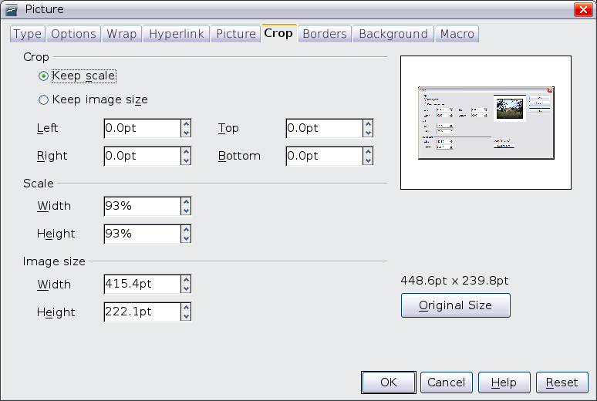

Figure 267: The options available when cropping a picture
In the Crop page, you can control the following parameters:
Keep scale / Keep image size
When Keep scale is selected (default), cropping the image does not change the scale of the picture.
When Keep image size is selected, cropping produces enlargement (for positive cropping values), shrinking (for negative cropping values), or distortion of the image so that the image size remains constant.
Left, Right, Top, and Bottom
The image is cropped by the amount entered in these boxes. For example, a value of 3 cm in the Left box cuts 3 cm from the left side of the picture.
- When Keep scale is selected, the size of the image also changes, so in this example the width will be reduced by 3 cm.
- When Keep image size is selected, the remaining part of the image is enlarged, if you've entered positive values, or shrunk if you enter negative values, so that the overall width and height of the image remains unchanged.
Width and Height
The Width and Height fields under either Scale or Image size change as you enter values in the Left, Right, Top, and Bottom fields. The thumbnail of the image at the top right of the dialog will show where the image will be cropped.

Resizing an Image
The inserted image might not fit perfectly into the document if it is too big or too small. In these cases you can use Writer to resize the image.
- Click the picture, if necessary, to show the green resizing handles.
- Position the pointer over one of the green resizing handles. The pointer changes shape giving a graphical representation of the direction of the resizing.
- Click and drag to resize the picture.
- Release the mouse button when satisfied with the new size.
The corner handles resize both the width and the height of the graphic object simultaneously, while the other four handles only resize one dimension at a time.
Tip | To retain the original proportions of the graphic, Shift+click one of the corner handles, then drag. Be sure to release the mouse button before releasing the Shift key.

Be aware that re-sizing a bit-mapped (raster) image will adversely affect the resolution, causing some degree of blurring. It is better to externally size your picture correctly before insertion into your presentation, if possible.

Note | A bit-mapped image is one in which each pixel displayed on the monitor screen corresponds directly to one or more bits in the computer's video memory.

Figure 268 shows three examples of an image inserted into a document and resized.
Example 1:  This is an image from the Gallery inserted without modification. | 
Example 2:
The image has been proportionally resized by dragging a corner handle while holding the Shift key.
Example3:
The image has been resized by dragging handles but not holding the Shift key, causing the proportions to change.

Figure 268. Three examples of resized images, plus the original image
For more accurate resizing, use either the Crop page of the Picture dialog box (Figure 267) or, for images, the Type page of the Picture dialog box. On the Crop page you can either adjust the following settings or use the settings in the Crop section as described on page 250.
- Scale Width and Height: specify in percentages the scaling of the picture. The size of the image changes accordingly. For a scaled resizing, both values should be identical.
- Image size: specify the size of the image in your preferred unit of measurement. The image enlarges or shrinks accordingly.
- Original size button: when clicked, restores the image to its original size.
In the Type page of the Picture dialog box, select the Relative option to toggle between percentage and actual dimension. For a scaled resizing, select the Keep ratio option. As for the Crop page, clicking on the Original Size button restores the original image size.

Rotating a picture
Writer does not provide a tool for rotating a picture; however, there is a simple workaround:
- Open a new Draw or Impress document (File > New > Drawing or File > New > Presentation).
- Insert the image you want to rotate. You can use any of the mechanisms described in “Adding Images to a Document” on page 242, although there are some slight variations in the position of the menu entries and icons.
- Select the image, then in the Drawing toolbar (shown by default at the bottom of the window in Impress and Draw), select the Rotate icon 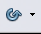 from the Effects tear-off toolbar .
- Rotate the image as desired. Use the red handles at the corners of the picture and move the mouse in the direction you wish to rotate. By default, the picture rotates around its center (indicated by a black crosshair), but you can change the pivot point by moving the black crosshair to the desired rotation center.
Tip | To restrict the rotation angle to multiples of 15 degrees keep the Shift key pressed while rotating the image.

- Select the rotated picture by pressing Ctrl+A, then copy the image to the clipboard with Ctrl+C.
- Finish by going back to the location of the Writer document where the image is to be inserted and pressing Ctrl+V.

Other Settings
The Picture dialog box (Figure 267) consists of nine pages. The Crop page was described on page 250, while the use of the Type and the Wrap pages is explained in “Positioning Graphics within the Text” on page 257. The other pages serve the following purposes:
- Options: use this page to give the picture a descriptive name (as you want it to appear in the Navigator), display alternative text when the mouse hovers over the picture, and protect some picture settings from accidental changes. You can also prevent the picture from being printed by deselecting the corresponding option.
- Borders: use this page to create borders around the picture. The Borders dialog box is the same as the one used for defining table or paragraph borders. Should you wish, you can also add a shadow to the image.
- Background: use this page to change the background color of the picture. This setting produces the desired results only for images with a transparent color.
- Hyperlink: use this page to associate a hyperlink to the picture. You can also create an image map so that only certain areas of the picture respond to a mouse click by opening the associated URI (Uniform Resource Identifier) in the default browser. More information on image maps can be found in the Impress Guide.
- Picture: use this page to flip the picture as well as to display the original location of the file in case the image is linked rather than embedded.
- Macro: allows you to associate a macro to the picture. You can choose among the predefined macros or write your own.

Deleting a Picture
To delete a picture:
- Click on the picture, to show the green resizing handles.
- Press Delete.

Using Writer’s Drawing Tools
You can use Writer’s drawing tools to create graphics that rely on rectangles, circles, lines, text, and other predefined shapes. You can also group several drawing objects, to make sure they maintain their relative position and proportion.
You can place the drawing objects directly on a page in your document, or you can insert them into a frame.
You can also use the drawing tools to annotate photographs, screen captures, or other illustrations produced by other programs, but this is not recommended because:
- You cannot include images in a group with drawing objects, so they may get out of alignment in your document.
- If you convert a Writer document to another format, such as HTML, the drawing objects and the graphics will not remain associated; they are saved separately.
In general, if you need to create complex drawings, OpenOffice Draw, may better meet your needs. Draw includes many features such as layers, styles, and so on.

Creating Drawing Objects
To begin using the drawing tools, display the Drawing toolbar (Figure 269), by clicking View > Toolbars > Drawing.
If you are planning to use the drawing tools repeatedly, you can tear off this toolbar and move it to a convenient place on the window.

1 | Select | 5 | Free form Line | 9 | Symbol Shapes | 13 | Stars
2 | Line | 6 | Text | 10 | Block arrows | 14 | Points
3 | Rectangle | 7 | Callouts | 11 | Flowcharts | 15 | Fontwork Gallery
4 | Ellipse | 8 | Basic Shapes | 12 | Callouts | 16 | From File
 |  |  |  |  |  | 17 | Extrusion On/Off
Figure 269. The Drawing toolbar
To use a drawing tool:
- Click in the document where you want the drawing to be anchored. You can change the anchor later, if necessary.
- Select the tool from the Drawing toolbar (Figure 269). The mouse pointer changes to a drawing-functions pointer .
- Move the cross-hair pointer to the place in the document where you want the graphic to appear and then click-and-drag to create the drawing object. Release the mouse button. The selected drawing function remains active, so you can draw another object of the same type.
- To cancel the selected drawing function, press the Esc key or click on the Select icon (the arrow) on the Drawing toolbar.
- You can now change the properties (fill color, line type and weight, anchoring, and others) of the drawing object using either the Properties deck of the Sidebar, the Drawing Object Properties toolbar (Error: Reference source not found) or the choices and dialog boxes reached by right-clicking on the drawing object.

Set or Change Properties for Drawing Objects
To set the properties for a drawing object before you draw it:
- On the Drawing toolbar (Error: Reference source not found), click the Select tool.
- On the Sidebar or the Drawing Object Properties toolbar (Figure 270), click on the icon for each property and select the value you want for that property.
- For more control, or to define new attributes, you can click on the Area or Line icons on the toolbar or the More Options icons of the Sidebar to display detailed dialog boxes.
The default you set applies to the current document and session. It is not retained when you close the document or close Writer, and it does not apply to any other document you open. The defaults apply to all the drawing objects except text objects.
1 | Line | 5 | Line Color | 9 | To Foreground | 13 | Alignment
2 | Arrow Style | 6 | Area | 10 | To Background | 14 | Change Anchor
3 | Line Style | 7 | Area Style / Filling | 11 | Bring to Front | 15 | Ungroup
4 | Line Width | 8 | Rotate | 12 | Send to Back | 16 | Group
Figure 270. Drawing Object Properties toolbar
To change the properties for an existing drawing object:
- Select the object.
- Continue as described above.
You can also specify the position and size, rotation, and slant and corner radius properties of the drawing object:
- Right-click on the drawing object and then click Position and Size from the pop-up menu. The Position and Size dialog box is displayed.
- Choose any properties, as required.

Resizing a Drawing Object
The same considerations for resizing an image apply to resizing an object. Select the object, click on one of the eight handles around it and drag it to its new position. For a scaled resizing, select one of the corner handles and keep the Shift key pressed while dragging the handle to its new position.
For more sophisticated control of the size of the object, select Format > Object > Position and Size from the menu bar. Use the Position and Size dialog box to set the width and height independently. If the Keep ratio option is selected, then the two dimensions change so that the proportion is maintained, allowing for a scaled resizing.

Grouping Drawing Objects
To group drawing objects:
- Select one object, then hold down the Shift key and select the others you want to include in the group. The bounding box expands to include all the selected objects.
- With the objects selected, hover the mouse pointer over one of the objects and choose Format > Group > Group from the menu bar or right-click and choose Group > Group from the pop-up menu.
Note | You cannot include an embedded or linked graphic in a group with drawing objects.

Positioning Graphics within the Text
When you add a graphic to a text document, you need to choose how to position it with respect to the text and other graphics. The positioning of graphics is often rather time-consuming, and may be very frustrating for both inexperienced and experienced users. As Writer is a word processor rather than a desktop publishing program, there are some limitations to its flexibility in positioning images; it takes time to get things exactly as you would like them.
Positioning of a graphic is controlled by four settings:
- Arrangement refers to the placement of a graphic on an imaginary axis perpendicular to the plane of the page. Arrangement controls how graphics are stacked upon each other or relative to the text.
- Alignment refers to the vertical or horizontal placement of a graphic in relation to the chosen anchor point.
- Anchoring refers to the reference point for the graphics. This point could be the page, or frame where the object is, a paragraph, or even a character. An image always has an anchor point.
- Text wrapping refers to the relation of graphics to the surrounding text, which may wrap around the graphic on one or both sides, be overprinted behind or in front of the graphic, or treat the graphic as a separate paragraph or character.
The settings can be accessed in a number of ways, depending on the nature of the graphics:
- From the Format menu, where you can find Alignment, Arrange, Wrap, and Anchor (both for images and drawing objects).
- From the pop-up menu displayed when you right-click on the graphic.
- From the Object toolbar shown in Figure 271.
- For images, from the Type and Wrapping pages of the Picture dialog box. Note that you cannot control the arrangement using the dialog box. To open the Picture dialog box, click on the image to select it and then choose Format > Picture or right-click on the graphic and choose Picture on the pop-up menu.
- For drawing objects, from the Position and Size page of the Position and Size dialog box. To open the Position and Size dialog box, click on the drawing object to select it and then choose Format > Object > Position and Size or right-click on the graphic and choose Position and Size on the pop-up menu. Note that you can only control the alignment and anchoring.
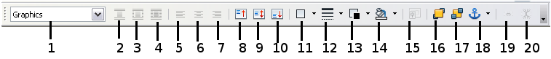
1 | Apply Style | 6 | Center Horiz. | 11 | Borders | 16 | Bring to Front
2 | Wrap Off | 7 | Align Right | 12 | Line Style | 17 | Send to Back
3 | Page Wrap | 8 | Top | 13 | Line Color (of border) | 18 | Change Anchor
4 | Wrap Through | 9 | Center | 14 | Background Color | 19 | Link Frames
5 | Align Left | 10 | Bottom | 15 | Frame Properties | 20 | Unlink Frames
Figure 271. Object toolbar (graphical control of positioning for images)

Arranging Graphics
Arranging a graphic object means to determine its position stacked in the plane of the page relative to other graphic objects or text. Arranging is only relevant when objects are overlapping. You can choose between four settings, plus a special setting for drawing objects:
Bring to Front
Places the graphic on top of any other graphics or text.
Bring Forward
Brings the graphic one level up in the stack (z-axis). Depending on the number of overlapping objects, you may need to apply this option several times to obtain the desired result.
Send Backward
The opposite of Bring Forward; sends the selected graphic one level down in the object stack.
Send to Back
Sends the selected graphic to the bottom of the stack, so that other graphics and text cover it.
To Background / To Foreground
Only available for drawing objects; moves the drawing object behind or in front of the text respectively.– e.g., Bring to Front vs Bring Forward ...

Anchoring Graphics
You can anchor graphics as individual characters, or to a page, paragraph, or character. You can also place graphics in a frame and anchor the frame to a page, paragraph, or character. Which method you choose depends on what you are trying to achieve.
Here are the ways you can anchor graphics or drawing objects:
To Page
The graphic keeps the same position in relation to the page margins. It does not move as you add or delete text or other graphics. This method is useful when the graphic does not need to be visually associated with a particular piece of text. It is often used when producing newsletters or other documents that are very layout intensive, or for placing logos in letterheads.
Caution | If you plan to use a document within a master document, do not anchor graphics To Page because the graphics will disappear from the master document. See Chapter 13 (Working with Master Documents) for more information.
To Paragraph
The graphic is associated with a paragraph and moves with the paragraph. It may be placed in the margin or another location. This method is useful as an alternative to a table for placing icons beside paragraphs.
To Character
The graphic is associated with a character but is not in the text sequence. It moves with the paragraph but may be placed in the margin or another location. This method is similar to anchoring to a paragraph but cannot be used with drawing objects.
As Character
The graphic is placed in the document like any other character and, therefore, affects the height of the text line and the line break. The graphic moves with the paragraph as you add or delete text before the paragraph. This method is useful for keeping screenshots in sequence in a procedure (by anchoring them as a character in a blank paragraph) or for adding a small (inline) icon in sequence in a sentence.
To Frame
If the graphic has been placed in a frame, you can anchor the graphic in a fixed position inside the frame. The frame can then be anchored to the page, a paragraph, or a character, as required.

Aligning Graphics
Once you have established the anchor point of the graphic, you can decide the position of the graphic relative to this anchor. That is, you can then align the graphic. Choose from six options: three for aligning the graphic horizontally (left, center, right) and three for aligning the graphic vertically (top, center, bottom). Horizontal alignment is not available for images anchored as character.
For finer control of the alignment, use the Position options on the Type page of the Picture dialog box, shown in Figure 272.
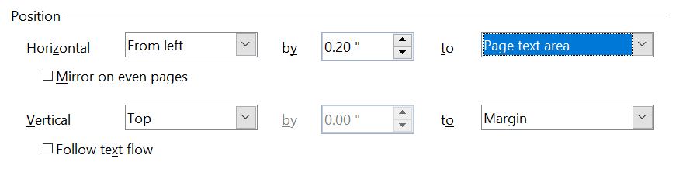

Figure 272: Fine tuning the alignment
For both the horizontal and vertical position, start by picking the reference point in the right-hand side drop down menu, then select in the first drop-down menu among Left, Right, or Center. If you select the value From left (or From top for the vertical positioning) you can specify the amount in your selected unit of measurement. In the example in Figure 272, the upper-left corner of the image will be placed at 0.2 in. from the left margin of the page horizontally and on the top margin vertically.

Wrapping Text Around Graphics
The Wrap setting determines the relation between the text and the graphic. Several possibilities are provided:
No Wrap
With this option the text is placed above and below the image but not around it. This is the wrapping type used for most of the figures in this guide.
Page Wrap or Optimal Page Wrap
The text flows around the image. Moving the image around the page causes the text to be rearranged to fill the space to the left and right of it. Optimal Page Wrap prevents text from being placed to the side of the image if the spacing between the image and the margin is less than 2 cm.
Wrap Through
Superimposes the image on the text. That is, the image is above the text. This option must be used in conjunction with the image-transparency setting in order to make the text under the picture visible.
In Background
Similar to Wrap Through, but the image is placed below the text so there may be no need to change the transparency to make the text visible.
Note | The No Wrap option found in the pop-up menu of a picture is equivalent to the Wrap Off menu item in the Format > Wrap menu.

The wrap format is normally selected after the anchoring and the alignment of the picture have been decided. To set the position of an image to the the desired wrap format, follow these steps:
- Select a graphic by clicking on it.
- Right-click to display the pop-up menu and move the mouse pointer to Wrap to display the available wrap formats. Alternatively you can select Format > Wrap from the main menu or use the Wrap panel on the Properties deck of the Sidebar.
- Select the desired wrap format.
Note | When anchoring a graphic as character, you can adjust the distance between the image and the text, but no wrapping option is available.
To fine tune the wrapping options, open the Picture dialog box and select the Wrap page shown in Figure 273. For images, you can open this dialog box by selecting Format > Picture from the main menu or right-click and select Picture from the pop-up menu. For drawing objects, you can access the Wrap page by selecting Format > Wrap > Edit in the main menu or right-click and select Wrap > Edit from the pop-up menu.
This page is divided into three sections. In the top part you can select among the wrap types mentioned above, plus two additional wrap formats that prevent the text from filling the area to the left (After) or to the right (Before) of the picture. Use the Spacing section of the page to adjust the spacing between the image and the text. The contents of the Options section of the page may change depending on the selected wrap format.
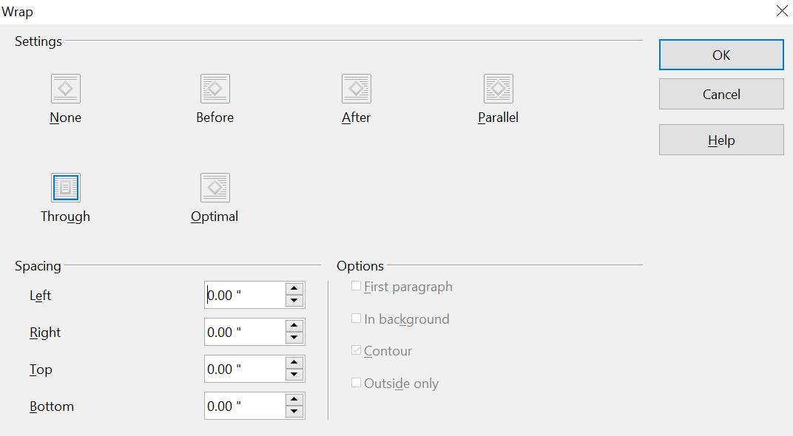

Figure 273: The advanced wrap format options
First paragraph
Check this box if you want AOO to start a new paragraph after the image, even if it could still wrap around the image.
In background
This option becomes available if Through Wrap is selected; it moves the image in the background.
Contour
Wraps the text around a custom contour rather than around the edge of the picture. This option is only available for Page or Optimal Page Wrap.
Outside only
Forces the text to wrap on the outside of the image, even if the contour contains open areas within the shape.

Editing the Contour
This option is only available for image wrapping. If you select wrapping around a drawing object, AOO automatically creates a contour. You can access the Contour Editor by selecting Format > Wrap > Edit Contour or from the right-click menu.
The dialog box of Figure 274 opens with the image loaded in the main window. Use the tools to draw the region of the image you do not want to be covered by the text—such area will be shaded.
Some familiarity with drawing tools is required to create complex contours; however, in most circumstances there is no need for high accuracy. Figure 274 shows the actual contour used for “Example 2: Simple Contour Wrapping in Action” and as you can see the shape of the line around the edge of the sphere is far from perfect.
When you are done, click on the Apply button to save the contour. If you are not satisfied with the result, you can select the contour line and press the Delete key to restart. You can also undo the previous steps, or you can select the Edit Points button and adjust the contour shape point by point.
For simple images, the AutoContour button does a decent job. If the contour has to be drawn around an area with the same or a similar color, you can select this region using the eyedropper. Select this tool, then click on a point in the image having the desired color. AOO automatically selects all the points which have the same or a similar color. The similarity level can be changed by modifying the value in the tolerance box (100% = perfect match).
Note | While all the positioning techniques discussed in this section apply equally to frames, contour wrapping is not possible.

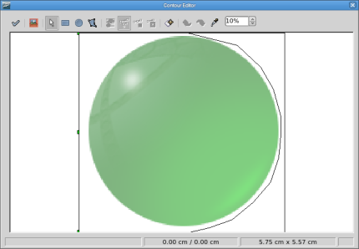
Figure 274: The Contour Editor in action

Example 1: Page Wrapping
Figure 275 shows an example of page wrapping in action.
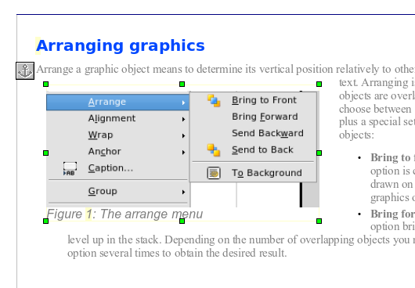

Figure 275: Example of image with Page Wrap formatting
Margin to image distance
Spacing image to text
Image anchor
The process to obtain this is the following:
- Insert the image into the document, then anchor it to the first paragraph. To move the anchor, select the image and move it until the anchor symbol is at the beginning of the paragraph. Do not worry about the position as that will be fixed in the next step.
- Align the image so that the left margin of the image is in line with the paragraph indentation. This can be done with the mouse or using the advanced settings. In the example, the image is placed 1 cm from the left margin.
- Change the wrap to Page Wrap. It starts out OK; however, there is still too little space between the image and the text. To correct it, access the Wrap page of the Picture dialog box and set the gap between the image and text to 0.2 cm in the Right and Bottom boxes.
- The last touch is to change the position so that the image is below the first line of the paragraph. Again, you can use the mouse to drag the image or use the advanced settings, which require a bit of trial and error. The line height used in this guide—0.75 cm from the top margin of the paragraph—is a good value.

Example 2: Simple Contour Wrapping in Action
In this example we again apply page wrapping as in example 1, but this time using the contour option. We will work on an image and on a drawing object as the contour option works slightly differently in the two cases.
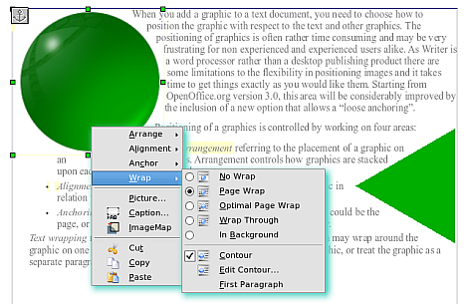
Figure 276: Image and drawing object with contour wrapping
The example of Figure 276 was built with the steps below,; use them to practice.
- Create some text (a very quick way to do that is to use the dummy text AutoText. That is, type DT and then press the F3 key).
- Insert an image of your choice and anchor it to the first paragraph. Adjust the alignment as desired, then change the wrap type to Page Wrap.
- Right-click on the picture to select the option Wrap > Contour, then right-click again and select Wrap > Edit Contour from the pop-up menu.
- Use the technique discussed in “Editing the Contour” on page 261 to create a custom contour and click Apply. If needed, adjust the spacing between the edge of the image and the text.
- Insert an AutoShape of your choice (a rotated triangle in the example) and proceed as in step 2 above.
- Enable the contour wrap by selecting Format > Wrap > Contour from the main menu. As discussed previously, AOO automatically generates the contour. You may need to adjust the distance between the drawing object and the text.

Example 3: Wrap Through and In Background
This example shows how to use an image as a watermark by wrapping it through the text and adjusting the transparency. This is not the best way to create watermarks; it's presented here only for purposes of illustration. If you need to create a watermark, it is best to use a Fontworks object wrapped in the background.
The Wrap Through option inserts an image overlapping the text which as a result will be hidden. To make the text appear, change the transparency of the picture; although the words under the image become visible, they may be difficult to read and will appear lighter than the rest of the text.
To reproduce the example of Figure 277, first create some dummy text. Then insert the image of your choice. Anchor the image (to the page in the example) and select the wrap through option from the Format > Wrap menu or right-clicking on the image and selecting Wrap > Wrap Through from the pop-up menu. Move the image into the desired position. The Picture toolbar should be displayed when the image is selected. Change the transparency to a suitable value (in the example this is 60%) so that the text can be read. In the example, a shadow effect is applied to the text (Format > Character then select Shadow in the Font Effects page).
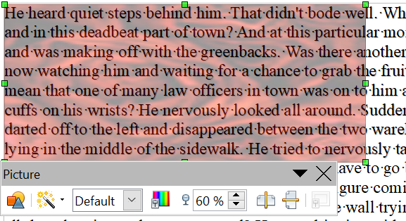

Figure 277: Transparent image added over the text
You can obtain a better result if you set a graphic’s wrap to In Background. In this case all the text will be clearly readable, with characters that have the same intensity as long as the background is not too dark. Also in this case you may want to adjust the transparency of the image.

Adding Captions to Graphics
You can add captions to graphics in three ways: automatically, by using the Caption dialog box, or manually.

Adding Captions Automatically
You can set up AOO to add captions automatically whenever you insert a graphic, a table, or other objects into a document. You can choose which objects are captioned automatically, what the sequence name is for each caption (for example, “Table” or “Illustration”), and the position of the caption.
To set up automatic captions:
- Click Tools > Options. On the Options dialog box, click on the + sign next to OpenOffice Writer to show a list of options.
- Select AutoCaption. Now you can see several choices at the right of the dialog box for adding captions automatically.
- Choose which objects you want to be automatically captioned and specify the characteristics of the captions.
For more information, see “AutoCaption options” in Chapter 2 (Setting up Writer).
When you insert a graphic, if automatic captioning is enabled, the graphic is placed in a frame along with a caption containing the default sequence name for graphics―Illustration. Position the cursor in the caption area and type the text for the caption. You can change the sequence name by selecting one from the drop-down Category list.
Note | You can specify where to place an automatic caption for any object except a picture; picture captions can only be automatically placed below the picture. If you need a caption above the picture (for example, for data plots in scientific publications), you must add the captions manually, as described in “Adding Captions Manually” on page 267.

Tip | A common sequence name—Figure—is not one of the names provided: <None>, Drawing, Illustration, Table, and Text. If you want the name “Figure” or any other custom name for your graphics, do the following:  - Open the Options – OpenOffice Writer – AutoCaption dialog box, as described above.  - In the Add captions automatically when inserting section, select OpenOffice Writer Picture. This activates the Caption area in the dialog box for pictures (graphics).  - Under the Category drop-down list, enter the name that you want added (say, Figure), by overwriting any sequence name in the list. (Overwriting a term does not delete it from the drop-down list.) You can also set some options for the number style and for a separator between the name and the number, if desired. Click OK to save the changes.

Using the Caption Dialog Box
To add captions using the Caption dialog box:
- Insert the graphic, then select it and click Insert > Caption.
- Under Properties on the Caption dialog box (Figure 278), make your selections for the Category, Numbering, and Separator fields (Illustration, Arabic (1 2 3), and a colon (:), respectively, for the example in Figure 278 and type your caption text in the Caption text box at the top. Whatever text you enter for the caption appears in the box at the bottom, after the sequence name, number, and separator.
- Click OK. The graphic and its caption are placed in a frame, as shown in Figure 279.
Tip | In the Category box, you can type any name you want, for example, Figure. AOO will create a numbering sequence using that name.

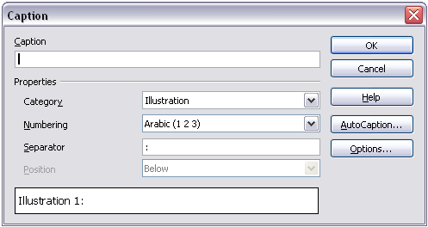
Figure 278. Defining the caption for an illustration
Illustration 1. An example
Figure 279. An example of a graphic and its caption contained in a frame. The outer box shows the edge of the frame; this border is normally set to be invisible.

Overriding the Default Positioning of Captions
The default positioning for picture captions is Below, and that position cannot be changed using the Caption dialog. However, you can override the positioning manually, as follows:
- Follow the instructions in “Using the Caption Dialog Box” on page 266 to create the caption.
- Right-click on the picture (not the frame surrounding picture and caption) and make sure that Anchor > To paragraph is selected.
- Left-click on the picture and drag it below the caption.
Tip | You may wish to adjust the spacing above and below the caption text, to fine-tune the appearance of the picture and its caption.

Adding Captions Manually
If you need to save as *.doc files or export in other formats, you may find that captions applied as described above (either automatically or using the Caption dialog box) are lost during the export. To avoid export problems, or as another way to put captions above pictures or below them (the usual case), you can add a caption manually, in either of two ways:
- Place the graphic and its caption in separate paragraphs.
- Use a table.

Place the Graphic and Its Caption in Separate Paragraphs
Insert the graphic and anchor it to its paragraph as a character. Press Enter to create a new paragraph for the caption.
- In the caption paragraph, type, for example, Figure and add a space.
- To insert the figure number automatically, click Insert > Fields > Other (Control + F2) and select the Variables tab.
- Select Number range in the Type list. Select Figure in the Selection list and choose, for example, Arabic (1 2 3) in the Format drop-down list. Click the Insert button.
- A number will appear after the word “Figure” in the caption. Now, type the text of the caption.
Tip | If you are manually adding captions to a lot of figures using this method, you might want to make an AutoText entry containing, for example, Figure and a space, the figure-number field, and an optional separator and a space after it.  To ensure the picture and its caption stay together on the page: if the picture is going above the caption, define the text flow of the Figure paragraph style as Keep with next paragraph and the next style as Caption. Conversely, if the caption is going above, define the Caption paragraph style as Keep with next paragraph and the next style as Figure.

Use a Table
Create a one-column, two-row table. Place the picture in one row and type the caption in the other row—or use two or more rows for the caption and other text. This method can be especially useful for pictures with numbered legends, such as Figure 271 in this chapter.

Creating an Image Map
An image map defines areas of an image, called hotspots, with hyperlinks to web addresses, other files on the computer, or parts of the same document. Hotspots are the graphic equivalent of text hyperlinks (described in Chapter 12). Clicking on a hotspot causes AOO to open the linked page in the appropriate program (for example, the default browser for an HTML page; AOO Calc for a .ODS file; a PDF viewer for a PDF file). You can create hotspots of various shapes and include several hotspots in the same image.
To use the image map editor:
- In your AOO document, select the picture where you want to define the hotspots.
- Choose Edit > ImageMap from the menu bar. The ImageMap Editor (Figure 263) opens.
- Use the tools and fields in the dialog (described on the next page) to define the hotspots and links necessary.
- Click the Apply icon to apply the settings.
- When done, click the Save icon to save the imagemap to a file, then click the X in the upper right corner to close the dialog.
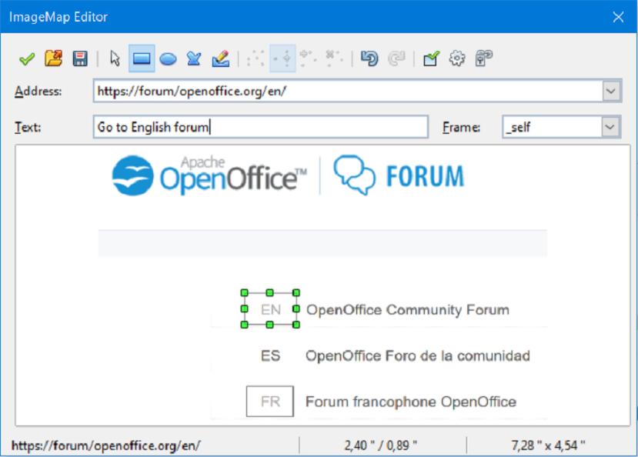Figure 280: The dialog to create or edit an image map
The main part of the dialog shows the image on which the hotspots are defined. A hotspot is identified by a line indicating its shape.
The toolbar at the top of the dialog contains the following tools:
- Apply button: click this button to apply the changes.
- Load, Save, and Select icons.
- Tools for drawing a hotspot shape: these tools work in exactly the same way as the corresponding tools in the Drawing toolbar.
- Edit, Move, Insert, Delete Points: advanced editing tools to manipulate the shape of a polygon hotspot. Select the Edit Points tool to activate the other tools.
- Active icon: toggles the status of a selected hotspot between active and inactive.
- Macro: associates a macro with the hotspot instead of just associating a hyperlink.
- Properties: sets the hyperlink properties and adds the Name attribute to the hyperlink.
Below the toolbar, specify for the selected hotspot:
- Address: the address pointed by the hyperlink. You can also point to an anchor in a document; to do this, write the address in this format (where <path> is the full directory path to the file): file:///<path>/document_name#anchor_name
- Text: type the text that you want to be displayed when the mouse pointer is moved over the hotspot.
- Frame: where the target of the hyperlink will open: pick among _blank (opens in a new browser window), _self (opens in the active browser window), _top or _parent.
Tip | The value _self for the target frame will work just fine in the vast majority of occasions. It is therefore not recommended to use the other choices unless absolutely necessary.

Adding an Image to the Gallery
You may wish to add to the Gallery any images that you use frequently, for example, a company logo. You can then very easily insert these graphics into a document later.
To add images to the Gallery, proceed as follows:
- Open the Gallery in the Sidebar.
- Select the theme to which you want to add images, or create a new theme. Note that you can add images only to “My Theme” or to any other theme that you have created; these are indicated by a green icon in the list of themes. You cannot add images to the built-in themes, indicated by an icon of another color.
To create a new theme:
  - Click the New Theme button above the list box of Themes. The Properties of New Theme dialog box opens, which is similar to the one shown in Figure 262.
  - Select the General tab (not shown) and type a name for the new theme in the text box.
  - Select the Files tab, skip step 3, and continue with step 4.
- Right-click on the desired theme and select Properties in the pop-up menu. You'll then see a window from which you can select the files to be added.
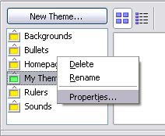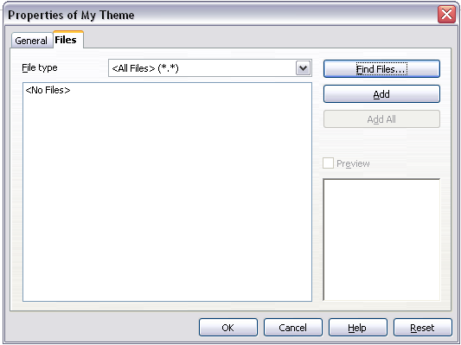

Figure 281. Gallery properties dialog box
- On the Files page, click the Find Files button. The Select path dialog box opens.
- You can enter the path for the file’s directory in the Path text box, or you can navigate to locate the file’s directory. Use the File type drop-down list to help limit the search.
- Click the Select button to start the search. A list of graphic files is then displayed in the window. You can use the File type filter again to further limit the search.
- Select the files to add. To select more than one file, hold the Control key down while you click on each file.
- Finally, click Add.
Note | This procedure assumes that graphic files for the themes already exist. You may need to import some, or to create your own, if the existing files are insufficient.

Note | Similar to the file search function on various operating systems, Find Files searches for graphic files in any subfolders of the directory selected in step 5.

If a list style was used with a list item or heading, no dialog box appears.

