
Calc Guide

Chapter 12
Calc Macros
Automating repetitive tasks

Copyright
This document is Copyright © 2005–2011 by its contributors as listed below. You may distribute it and/or modify it under the terms of either the GNU General Public License (http://www.gnu.org/licenses/gpl.html), version 3 or later, or the Creative Commons Attribution License (http://creativecommons.org/licenses/by/3.0/), version 3.0 or later.
All trademarks within this guide belong to their legitimate owners.
Contributors
Andrew Pitonyak
Gary Schnabl
Jean Hollis Weber
Claire Wood
Martin Fox
Feedback
Maintainer: Andrew Pitonyak [andrew@pitonyak.org]
Please direct any comments or suggestions about this document to: authors@documentation.openoffice.org
Publication date and software version
Published 10 March 2011. Based on OpenOffice.org 3.3.

Note for Mac users
Some keystrokes and menu items are different on a Mac from those used in Windows and Linux. The table below gives some common substitutions for the instructions in this chapter. For a more detailed list, see the application Help.
Windows/Linux | Mac equivalent | Effect
Tools > Options menu selection | OpenOffice > Preferences | Access setup options
Right-click | Control+click | Open context menu
Ctrl (Control) | z (Command) | Used with other keys
F5 | Shift+z+F5 | Open the Navigator
F11 | z+T | Open Styles & Formatting window

Contents
Chapter 12
Calc Macros 1
Copyright 2
Note for Mac users 2
Introduction 4
Using the macro recorder 4
Write your own functions 8
Using a macro as a function 10
Passing arguments to a macro 13
Arguments are passed as values 15
Writing macros that act like built-in functions 15
Accessing cells directly 15
Sorting 17
Conclusion 18

Introduction
A macro is a saved sequence of commands or keystrokes that are stored for later use. An example of a simple macro is one that “types” your address. The OpenOffice macro language is very flexible, allowing automation of both simple and complex tasks. Macros are especially useful to repeat a task the same way over and over again. This chapter briefly discusses common problems related to macro programming using Calc.

Using the macro recorder
Chapter 12 of the Getting Started guide (Getting Started with Macros) provides a basis for understanding the general macro capabilities in OpenOffice using the macro recorder. An example is shown here without the explanations in the Getting Started guide. The following steps create a macro that performs paste special with multiply.
- Open a new spreadsheet.
- Enter numbers into a sheet.
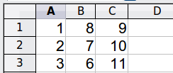
Figure 1: Enter numbers
- Select cell A3, which contains the number 3, and copy the value to the clipboard.
- Select the range A1:C3.
- Use Tools > Macros > Record Macro to start the macro recorder. The Record Macro dialog is displayed with a stop recording button.
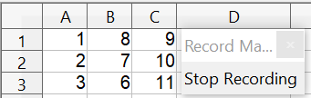

Figure 2: Stop recording button
- Use Edit > Paste Special to open the Paste Special dialog (Figure 3).
- Set the operation to Multiply and click OK. The cells are now multiplied by 3 (Figure 4).
- Click Stop Recording to stop the macro recorder. The Basic Macros dialog (Figure 5) opens.
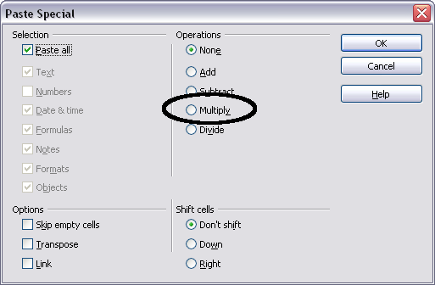
Figure 3: Paste Special dialog
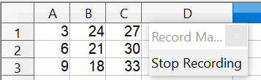
Figure 4: Cells multiplied by 3
- Select the current document (see Figure 5). For this example, the current Calc document is Untitled 1. Existing documents show a library named Standard. This library is not created until the document is saved or the library is needed, so at this point your new document does not contain a library. You can create a new library to contain the macro, but this is not necessary.
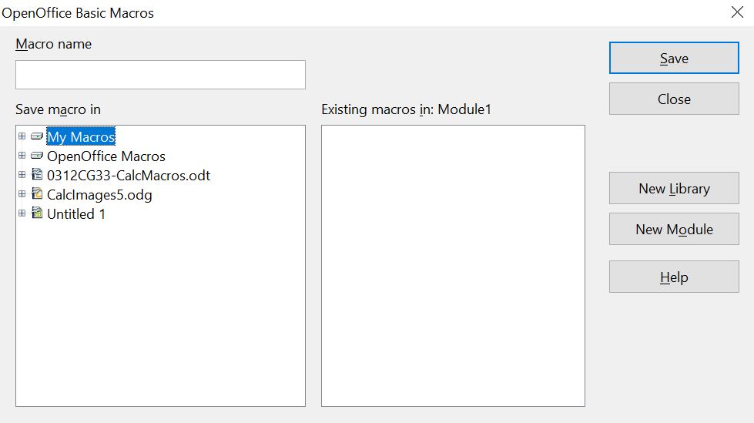

1 | My Macros | 5 | Create new module in library
2 | OpenOffice Macros | 6 | Macros in selected library
3 | Open documents | 7 | Current document
4 | Create new library | 8 | Expand/collapse list
Figure 5: Parts of the Basic Macros dialog
1
2
3
4
5
6
7
8
- Click New Module. If no libraries exist, then the Standard library is automatically created and used. In the New Module dialog, type a name for the new module or leave the name as Module1.
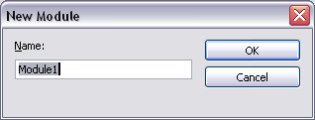
- Click OK to create a new module named Module1. Select the newly created Module1, type PasteMultiply in the Macro name box at the upper left, and click Save. (See Figure 6.)
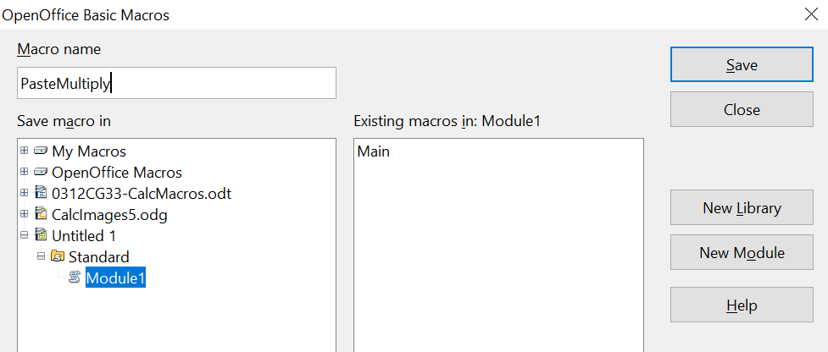

Figure 6: Select the module and name the macro
The created macro is saved in Module1 of the Standard library in the Untitled 1 document. Listing 1 shows the contents of the macro.
Listing 1. Paste special with multiply.
sub PasteMultiply
rem --------------------------------------------------------------
rem define variables
dim document as object
dim dispatcher as object
rem --------------------------------------------------------------
rem get access to the document
document = ThisComponent.CurrentController.Frame
dispatcher = createUnoService("com.sun.star.frame.DispatchHelper")

rem --------------------------------------------------------------
dim args1(5) as new com.sun.star.beans.PropertyValue
args1(0).Name = "Flags"
args1(0).Value = "A"
args1(1).Name = "FormulaCommand"
args1(1).Value = 3
args1(2).Name = "SkipEmptyCells"
args1(2).Value = false
args1(3).Name = "Transpose"
args1(3).Value = false
args1(4).Name = "AsLink"
args1(4).Value = false
args1(5).Name = "MoveMode"
args1(5).Value = 4

dispatcher.executeDispatch(document, ".uno:InsertContents", "", 0, args1())
end sub
More detail on recording macros is provided in Chapter 12 (Getting Started with Macros) in the Getting Started guide; we recommend you read it if you have not already done so. More detail is also provided in the following sections, but not as related to recording macros.

Write your own functions
Calc can call macros as Calc functions. Use the following steps to create a simple macro:
- Create a new Calc document named CalcTestMacros.ods.
- Use Tools > Macros > Organize Macros > OpenOffice Basic to open the Basic Macros dialog. The Macro from box lists available macro library containers including currently open documents. My Macros contains macros that you write or add to OpenOffice. OpenOffice Macros contains macros included with OpenOffice and should not be changed.
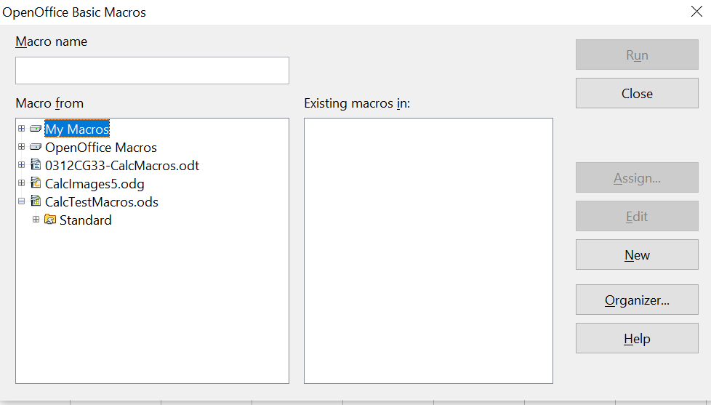

Figure 7: Basic Macros dialog
Open document with library
- Click Organizer to open the Basic Macro Organizer dialog (Figure 8). On the Libraries tab, select the document to contain the macro.
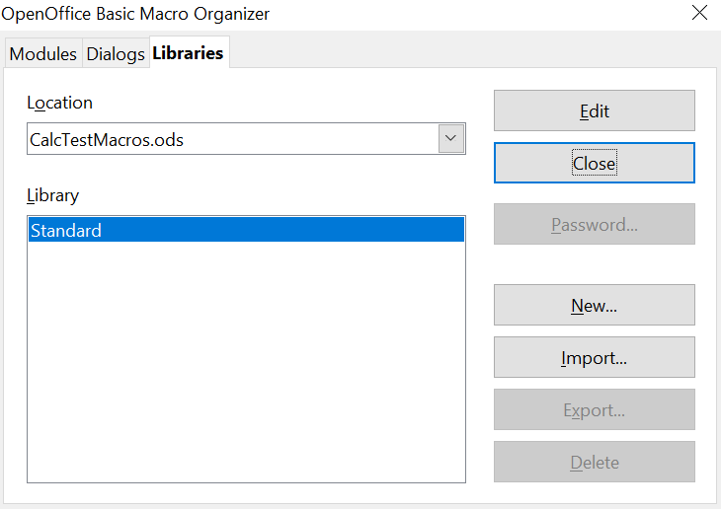

Figure 8: Basic Macro Organizer
Choose the document from the list
List of libraries in the document
- Click New to open the New Library dialog.
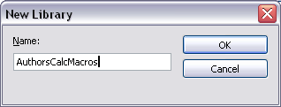
Figure 9: New Library dialog
- Enter a descriptive library name (such as AuthorsCalcMacros) and click OK to create the library. The new library name is shown the library list, but the dialog may show only a portion of the name.
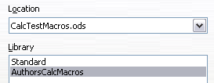
Figure 10: The library is shown in the organizer
- Select AuthorsCalcMacros and click Edit to edit the library. Calc automatically creates a module named Module1 and a macro named Main.
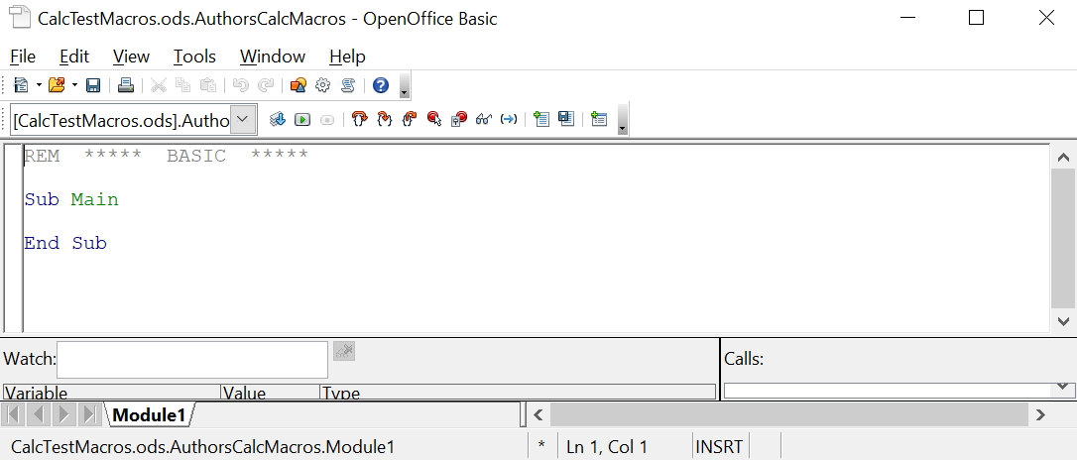

Figure 11: Basic Integrated Development Environment (IDE)
- Modify the code so that it is the same as that shown in Listing 2.The important addition is the creation of the NumberFive function, which returns the number five. The Option Explicit statement forces all variables to be declared before they are used. If Option Explicit is omitted, variables are automatically defined at first use as type Variant.
- Save the modified Module1.
Listing 2. Function that returns five.
REM ***** BASIC *****
Option Explicit

Sub Main

End Sub

Function NumberFive()
NumberFive = 5
End Function

Using a macro as a function
Using the newly created Calc document CalcTestMacros.ods, enter the formula =NumberFive() (see Figure 12). Calc finds the macro and calls it.
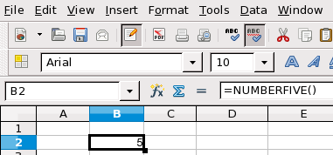
Figure 12: Use the NumberFive() Macro as a Calc function
Tip | Function names are not case sensitive. In Figure 12, you can enter =NumberFive() and Calc clearly shows =NUMBERFIVE().
Save the Calc document, close it, and open it again. Depending on your settings in Tools > Options > OpenOffice > Security > Macro Security, Calc will display the warning shown in Figure 13 or the one shown in Figure 14. You will need to click Enable Macros, or Calc will not allow any macros to be run inside the document. If you do not expect a document to contain a macro, it is safer to click Disable Macros in case the macro is a virus.
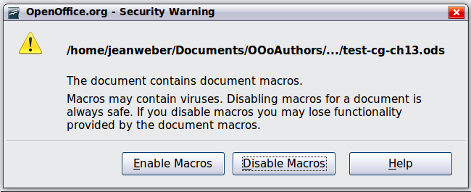
Figure 13: OpenOffice warns you that a document contains macros
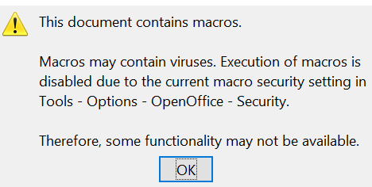
Figure 14: Warning if macros are disabled
If you choose to disable macros, then when the document loads, Calc can no longer find the function.
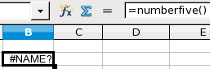
Figure 15: The function is gone
When a document is created and saved, it automatically contains a library named Standard. The Standard library is automatically loaded when the document is opened. No other library is automatically loaded.
Calc does not contain a function named NumberFive(), so it checks all opened and visible macro libraries for the function. Libraries in OpenOffice Macros, My Macros, and the Calc document are checked for an appropriately named function (see Figure 7). The NumberFive() function is stored in the AuthorsCalcMacros library, which is not automatically loaded when the document is opened.
Use Tools > Macros > Organize Macros > OpenOffice Basic to open the Basic Macros dialog (see Figure 16). Expand CalcTestMacros and find AuthorsCalcMacros. The icon for a loaded library is a different color from the icon for a library that is not loaded.
Click the expansion symbol (usually a plus or a triangle) next to AuthorsCalcMacros to load the library. The icon changes color to indicate that the library is now loaded. Click Close to close the dialog.
Unfortunately, the cells containing =NumberFive() are in error. Calc does not recalculate cells in error unless you edit them or somehow change them. The usual solution is to store macros used as functions in the Standard library. If the macro is large or if there are many macros, a stub with the desired name is stored in the Standard library. The stub macro loads the library containing the implementation and then calls the implementation.
- Use Tools > Macros > Organize Macros > OpenOffice Basic to open the Basic Macros dialog. Select the NumberFive macro and click Edit to open the macro for editing.
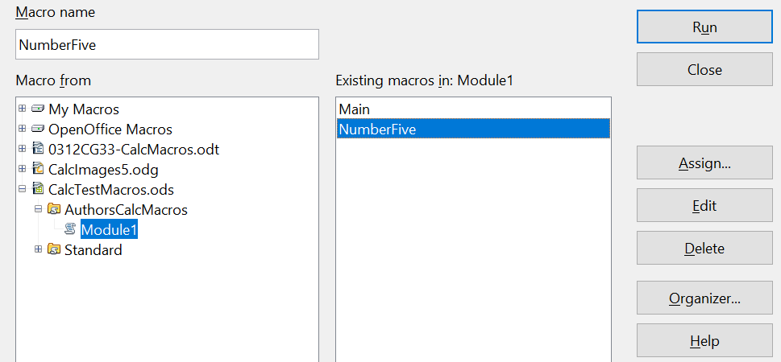

Figure 16: Select a macro and click Edit
- Change the name of NumberFive to NumberFive_Implementation (Listing 3).
Listing 3. Change the name of NumberFive to NumberFive_Implementation
Function NumberFive_Implementation()
NumberFive_Implementation() = 5
End Function
- In the Basic IDE (see Figure 11), hover the mouse cursor over the toolbar buttons to display the tool tips. Click the Select Macro button to open the Basic Macros dialog (see Figure 16).
- Select the Standard library in the CalcTestMacros document and click New to create a new module. Enter a meaningful name such as CalcFunctions and click OK. OpenOffice automatically creates a macro named Main and opens the module for editing.
- Create a macro in the Standard library that calls the implementation function (see Listing 4). The new macro loads the AuthorsCalcMacros library if it is not already loaded, and then calls the implementation function.
- Save, close, and reopen the Calc document. This time, the NumberFive() function works.
Listing 4. Change the name of NumberFive to NumberFive_Implementation.
Function NumberFive()
If NOT BasicLibraries.isLibraryLoaded("AuthorsCalcMacros") Then
BasicLibraries.LoadLibrary("AuthorsCalcMacros")
End If
NumberFive = NumberFive_Implementation()
End Function

Passing arguments to a macro
To illustrate a function that accepts arguments, we will write a macro that calculates the sum of its arguments that are positive —it will ignore arguments that are less than zero (see Listing 5).
Listing 5. PositiveSum calculates the sum of the positive arguments.
Function PositiveSum(Optional x)
Dim TheSum As Double
Dim iRow As Integer
Dim iCol As Integer

TheSum = 0.0
If NOT IsMissing(x) Then
If NOT IsArray(x) Then
If x > 0 Then TheSum = x
Else
For iRow = LBound(x, 1) To UBound(x, 1)
For iCol = LBound(x, 2) To UBound(x, 2)
If x(iRow, iCol) > 0 Then TheSum = TheSum + x(iRow, iCol)
Next
Next
End If
End If
PositiveSum = TheSum
End Function
The macro in Listing 5 demonstrates some important techniques:
- The argument x is optional. When an argument is not optional and the function is called without it, OpenOffice prints a warning message every time the macro is called. If Calc calls the function many times, then the error is displayed many times.
- IsMissing checks that an argument was passed before the argument is used.
- IsArray checks to see if the argument is a single value, or an array. For example, =PositiveSum(A1) or =PositiveSum(A1:A4). In the first case, the value of A1 is passed as a simple number to the argument, and in the second case, the values of A1:A4 are passed as an array to the function.
- If a range is passed to the function, it is passed as a two-dimensional array of values, even if the cells are in a single column or row; for example, =PositiveSum(A2:B5). LBound and UBound are used to determine the array bounds that are used. Although the lower bound is one, it is considered safer to use LBound in case it changes in the future.
Tip | The macro in Listing 5 is careful and checks to see if the argument is an array or a single argument. The macro does not verify that each value is numeric. You may be as careful as you like. The more things you check, the more robust the macro is, and the slower it runs.
Passing one argument is as easy as passing two: add another argument to the function definition (see Listing 6). When calling a function with two arguments, separate the arguments with a semicolon; for example, =TestMax(3; -4).
Listing 6. TestMax accepts two arguments and returns the larger of the two.
Function TestMax(x, y)
If x >= y Then
TestMax = x
Else
TestMax = y
End If
End Function

Arguments are passed as values
Arguments passed to a macro from Calc are always values. It is not possible to know what cells, if any, are used. For example, =PositiveSum(A3) passes the value of cell A3, and PositiveSum has no way of knowing that cell A3 was used. If you must know which cells are referenced rather than the values in the cells, pass the range as a string, parse the string, and obtain the values in the referenced cells.

Writing macros that act like built-in functions
Although Calc finds and calls macros as normal functions, they do not really behave as built-in functions. For example, macros do not appear in the function lists. It is possible to write functions that behave as regular functions by writing an Add-In. However, this is an advanced topic that is not covered here; see
https://wiki.openoffice.org/wiki/SimpleCalcAddIn

Accessing cells directly
You can access the OpenOffice internal objects directly to manipulate a Calc document. For example, the macro in Listing 7 adds the values in cell A2 from every sheet in the current document. ThisComponent is set by OpenOffice Basic when the macro starts to reference the current document. A Calc document has as a sub-object a collection of sheets: ThisComponent.getSheets(). You can get a particular sheet from that collection with the getByIndex() method. (There is also a getByName() method) Use getCellByPosition(col, row) to return a cell at a specific row and column.
Listing 7. Add cell A2 in every sheet.
Function SumCellsAllSheets()
Dim TheSum As Double
Dim i As integer
Dim oSheets
Dim oSheet
Dim oCell

oSheets = ThisComponent.getSheets()
For i = 0 To oSheets.getCount() - 1
oSheet = oSheets.getByIndex(i)
oCell = oSheet.getCellByPosition(0, 1) ' GetCell A2
TheSum = TheSum + oCell.getValue()
Next
SumCellsAllSheets = TheSum
End Function
Tip | A cell object supports the methods getValue(), getString(), and getFormula() to get the numerical value, the string value (what is visible in the cell), or the formula used in a cell. Use the corresponding set functions to set appropriate values.
Use oSheet.getCellRangeByName("A2") to return a range of cells by name. If a single cell is referenced, then a cell object is returned. If a cell range is given, then an entire range of cells is returned (see Listing 8). Notice that a cell range returns data as an array of arrays, which is more cumbersome than treating it as an array with two dimensions as is done in Listing 5.
Listing 8. Add cell A2:C5 in every sheet
Function SumCellsAllSheets()
Dim TheSum As Double
Dim iRow As Integer, iCol As Integer, i As Integer
Dim oSheets, oSheet, oCells
Dim oRow(), oRows()

oSheets = ThisComponent.getSheets()
For i = 0 To oSheets.getCount() - 1
oSheet = oSheets.getByIndex(i)
oCells = oSheet.getCellRangeByName("A2:C5")
REM getDataArray() returns the data as variant so strings
REM are also returned.
REM getData() returns data as type Double, so only
REM numbers are returned.
oRows() = oCells.getData()
For iRow = LBound(oRows()) To UBound(oRows())
oRow() = oRows(iRow)
For iCol = LBound(oRow()) To UBound(oRow())
TheSum = TheSum + oRow(iCol)
Next
Next
Next
SumCellsAllSheets = TheSum
End Function
Tip | When a macro is called as a Calc function, the macro cannot modify any value in the sheet from which the macro was called.

Sorting
Consider sorting the data in Figure 17. First, sort on column B descending and then column A ascending.
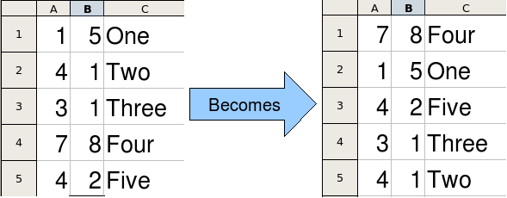
Figure 17: Sort column B descending and column A ascending
The example in Listing 9 demonstrates how to sort on two columns.
Listing 9. Sort cells A1:C5 on Sheet 1.
Sub SortRange
Dim oSheet ' Calc sheet containing data to sort.
Dim oCellRange ' Data range to sort.

REM An array of sort fields determines the columns that are
REM sorted. This is an array with two elements, 0 and 1.
REM To sort on only one column, use:
REM Dim oSortFields(0) As New com.sun.star.util.SortField
Dim oSortFields(1) As New com.sun.star.util.SortField

REM The sort descriptor is an array of properties.
REM The primary property contains the sort fields.
Dim oSortDesc(0) As New com.sun.star.beans.PropertyValue

REM Get the sheet named "Sheet1"
oSheet = ThisComponent.Sheets.getByName("Sheet1")

REM Get the cell range to sort
oCellRange = oSheet.getCellRangeByName("A1:C5")

REM Select the range to sort.
REM The only purpose would be to emphasize the sorted data.
'ThisComponent.getCurrentController.select(oCellRange)

REM The columns are numbered starting with 0, so
REM column A is 0, column B is 1, etc.
REM Sort column B (column 1) descending.
oSortFields(0).Field = 1
oSortFields(0).SortAscending = FALSE

REM If column B has two cells with the same value,
REM then use column A ascending to decide the order.
oSortFields(1).Field = 0
oSortFields(1).SortAscending = True

REM Setup the sort descriptor.
oSortDesc(0).Name = "SortFields"
oSortDesc(0).Value = oSortFields()

REM Sort the range.
oCellRange.Sort(oSortDesc())
End Sub
As this macro is a subroutine, you execute it with Tools > Macros > Run Macro and then open CalcTestMacros > AuthorsCalcMacros > Module1. Click on the macro SortRange and then Run.

Conclusion
This chapter provides a brief overview on how to create libraries and modules, using the macro recorder, using macros as Calc functions, and writing your own macros without the macro recorder. Each topic deserves at least one chapter, and writing your own macros for Calc could easily fill an entire book. In other words, this is just the beginning of what you can learn!

