Apache Open Office
Version 4.1
Draw Guide
AOO Documentation Team

Chapter 4
Changing Object Attributes

Copyright
This document is Copyright © 2024 by the Apache Software Foundation®. You may distribute it and/or modify it under the terms of the Creative Commons Attribution License (http://creativecommons.org/licenses/by/3.0/), version 3.0 or later.
All trademarks within this guide belong to their legitimate owners.

Feedback
Please direct any comments or suggestions about this document to:
doc@openoffice.apache.org
Acknowledgments
This document is updated from a previous version by OOoAuthors.

Publication Date and Software Version
Published <date>. Based on Apache OpenOffice 4.1 .

Note for Mac Users
Some keystrokes and menu items are different on a Mac from those used in Windows and Linux. The table below gives some common substitutions for the instructions in this chapter. For a more detailed list, see the application Help.
Windows/Linux | Mac equivalent | Effect
Tools > Options menu selection | OpenOffice.org > Preferences | Access setup options
Right-click | Control+click | Open context menu
Ctrl (Control) | z (Command) | Used with other keys
F5 | Shift+z+F5 | Open the Navigator
F11 | z+T | Open Styles & Formatting window

Contents
Copyright 2
Toolbars and menus 4
Line and Filling toolbar 4
Text Formatting toolbar 4
The context menu 4
Editing lines and borders 5
Common line properties 6
Drawing arrows 7
Line shadows 8
Customizing line and arrow styles 8
Customizing line styles 8
Customizing arrow styles 9
Editing the inside (fill) of an object 11
Common fill properties 11
Fill with a uniform color 11
Fill with a gradient 12
Fill with a line pattern 12
Fill with an image 12
Adding a shadow to an area 13
Advanced area fill options 13
Creating your own fill color 13
Creating your own gradient 14
Creating your own hatching (line pattern) 15
Creating your own bitmap fill 16
Customizing shadows 17
Adding transparency 18
Using styles 19
Creating a new style 19
Applying a style 19
Modifying a style 20
Special effects 20
Rotating an object 20
Flip an object 21
Mirror copies 21
Distorting an image 22
Distort an object 22
Set in circle (perspective) 22
Set to circle (slant) 23
Dynamic gradients 24

Toolbars and Menus
To change an object’s attributes (such as color or border width) you can use the Properties deck of the Sidebar, the Line and Filling toolbar or the context menu.

Line and Filling Tools
The Line and Area panes of the Sidebar's Properties deck have tools for modifying the most important fill and line properties of an object. If the Sidebar is not visible, select View > Sidebar. You can then choose the Properties icon, which is the topmost of the four icons on the right edge of the Sidebar. The Line and Area panes will be visible when an object is selected.
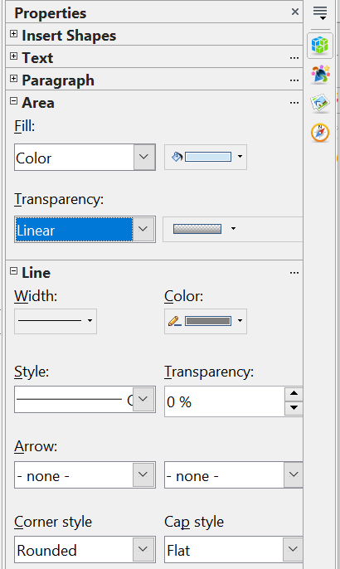

Figure 1: The Area and Line Panes of the Sidebar
The four boxes in the Area pane provide access to a large number of choices. The Fill type, which defaults to Color, can also have the values None, Gradient , Hatching, Bitmap. Each of those choices changes the options in the adjacent drop down list. Similarly, the Transparency list has eight option: None, Solid, Linear, Axial, Radial, Ellipsoid, Quadratic, Square. For most of these, multiple parameters, such as the minimum and maximum transparency, are accessed through the adjacent drop down list.
The tools on the Line pane are self explanatory except that the two boxes under the Arrow heading do not refer to the left and right end of the line. They refer to the beginning and end of the line which are determined when the line is drawn. If you draw the line from right to left, the beginning is on the right.
Most panes in the Sidebar show only the most commonly used tools. The full set of tools can be accessed by clicking the three dots at the top right of each pane to bring up a dialog with all the available settings. In particular, we will refer to the Area dialog and Line dialog several times.
The Line and Filling toolbar provides many of the same tools as the Sidebar panes. If the Line and Filling toolbar is not visible, you can display it using View > Toolbars > Line and Filling. From here you can edit the most common object attributes. You can also open the Line dialog by clicking on the Line icon and the Area dialog by clicking on the Area icon to see more options.
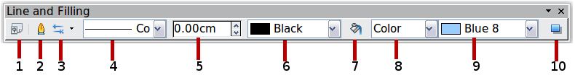
1 Styles and Formatting  2 Line  3 Arrow Style | 4 Line Style  5 Line Width  6 Line Color | 7 Area  8–9 Area Style / Filling  10 Shadow
Figure 2: Line and Filling toolbar

Text Formatting Toolbar
When you select a block of text, the Line and Filling toolbar changes to show text formatting options. You can also display the Text Formatting toolbar by choosing View > Toolbars > Text Formatting.
Figure 3: Text Formatting toolbar (when text is selected)

Since any object can contain text, the Properties pane of the Sidebar always provides the Text and Paragraph panes when an object is selected. These panes have most of the same tools as the Text Formatting Toolbar and, as usual, the full set of tools can be accessed by clicking the three dots at the upper right of each pane.

The Context Menu
When an object is selected, you can right-click on the object to bring up a context menu (Figure 4). The context menu provides additional access to the options shown above and another way to change an object’s attributes. The entries with a small arrow on the right-hand side contain a submenu.
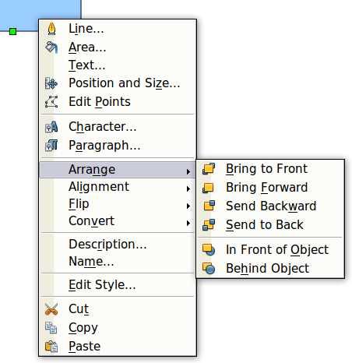
Figure 4: Right-click on an object to see the context menu

Editing Lines and Borders
Lines, arrows, and the borders of an object are all managed through the same dialog (Figure 6) except that the Shadow tab is only available if the selected object is a line. The properties on the other tabs apply to the borders of two dimensional objects, but the shadow is a property of the Area of a two dimensional object.
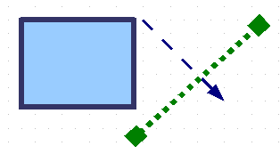
Figure 5: Lines and borders
You can change some properties from the Sidebar or from the Line and Filling toolbar. To see more options, click the three dots at the upper right of the Line pane of the Sidebar or right-click on the object and choose Line from the context menu. This opens the Line dialog.
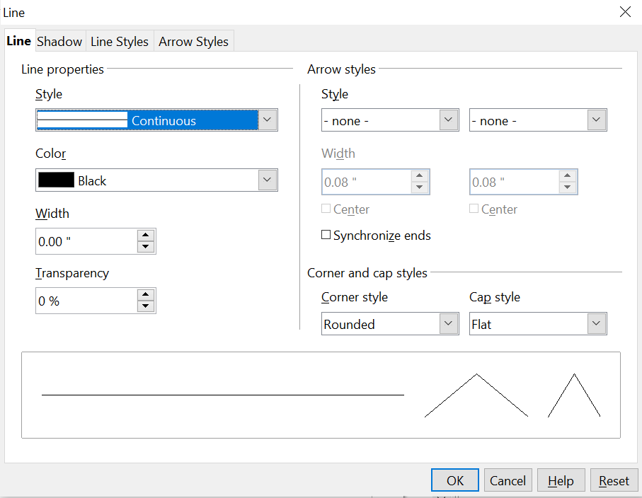
Figure 6: Line dialog .

Common Line Properties
In most cases the property you want to change is the line’s style (solid, dashed, invisible, and so on), its color, or its width. These options are all available from the Sidebar's Line pane (Figure 1) or the Line and Filling toolbar.
Figure 7: Common line options (style, width, color)
You can also edit these properties from the Line dialog. They are on the first tab, left column (see Figure 6). From the Line dialog or the Sidebar you can also change the line’s transparency. Figure 8 illustrates different degrees of transparency.

Figure 8: The vertical lines have different levels of transparency (0%, 25%, and 50%).

Drawing Arrows
Arrowheads, and other line endings usually referred to in this guide as arrows, are a line property. Select a line and click on one of the Arrow drop down boxes in the Sidebar or the Arrow Style icon in the Line and Filling toolbar. This opens the Arrowheads menu.

Figure 9: Arrowheads menu
There are several types of arrowheads available. Each end of a line can have a different arrowhead, or even no arrowhead. Remember that the selection on the left corresponds to the beginning of the line as it was drawn, not to the left end of the line.
Note | Arrowheads are only applicable to lines. They have no effect on the border of an object.
In the Line dialog (Figure 6), Arrow styles on the right-hand side contains a number of options to fine tune the arrow properties. If Synchronize ends is selected, both line endings will have the same appearance. The Center option places the center of the arrow over the end point of the line. If this option is not selected, the line ends at the far edge of the arrow. The following sketch illustrates the difference.
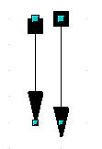
Figure 10: Default arrowheads (left) vs centered arrowheads (right)

Line Shadows
Lines can have a shadow property associated with them.
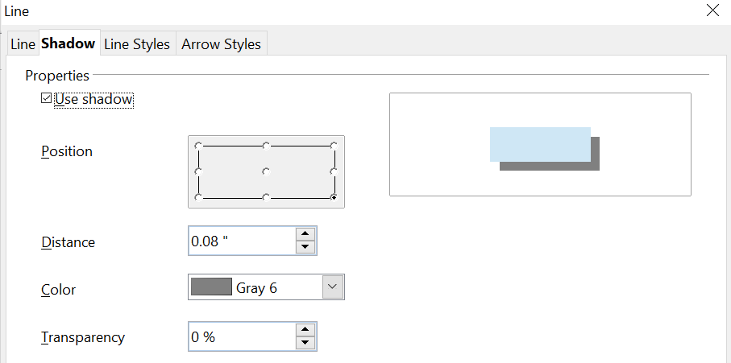
Figure 11: Shadow page of Line dialog
Check the box Use shadow to enable this feature. The properties shown—position, distance, color, and transparency—may be independently adjusted to your choice and the results seen in the preview window. You can also click on the Filling icon on the Line and Filling toolbar—next to the area fill functions – to get a basic shadow.

Customizing Line and Arrow Styles
You are not required to use only the line and arrow styles provided by default in Draw. You can modify the styles and even create your own.

Customizing Line Styles
In the Line dialog, click on the Line Styles tab (see Figure 12). From here you can customize the line styles or create your own by clicking on the Add button. You can change the length of the dashes, the space between them, and several other attributes.
Use the Load Line Style and Save Line Style icons to save a new definition or read one from disk (file extension .sod).
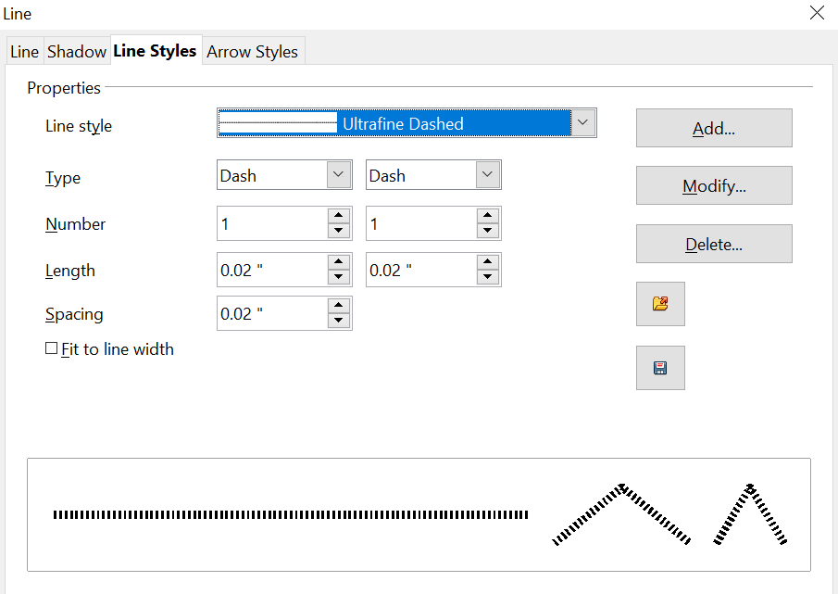

Figure 12: Editing line styles

Customizing Arrow Styles
You can also create your own arrowheads to provide some interesting effects, such as:

The first step is to draw a curve with the shape you want for the arrowhead.
Figure 13: To create your own arrowhead, you must first draw a curve.
Note | The arrowhead must be a curve. A curve is something you could draw without lifting a pencil. For example, is a curve, but is not a curve. You can however draw forms which are not curves and then convert them to a curve.
Select the curve, open the Line dialog, and go to the Arrow Styles page. Click on Add, enter a name for the arrow style and click OK (see Figure 14).
Tip | The part of the shape which should point in the direction of the line must be drawn facing upwards. In Figure 13 the top of the shape will point towards the “outside” of the line.
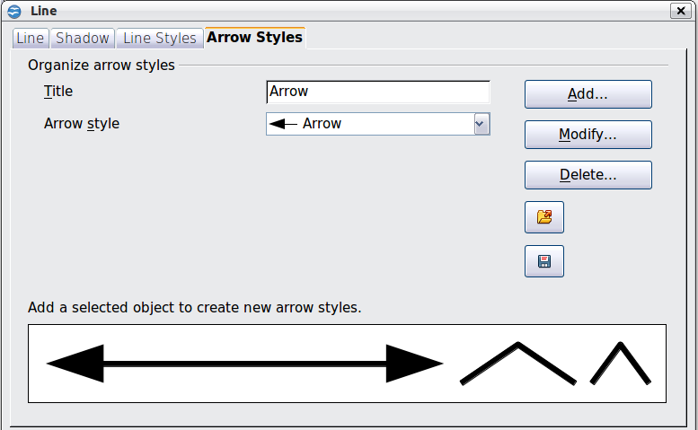
Figure 14: Adding an arrow style
Now you can access the new style from the Arrow style list (Figure 15) or the Arrowheads dialog (Figure 9).
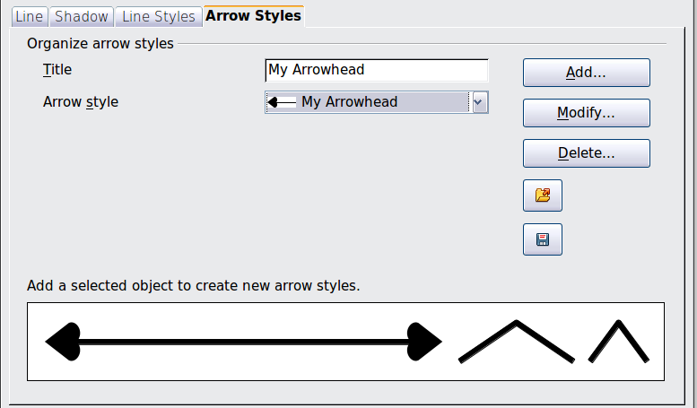
Figure 15: Arrow style list

Editing the Inside (Fill) of an Object
The OpenOffice term for the inside of an object is Area fill. The area fill of an object can be a uniform color, a gradient, a hatching pattern, or an image. It can be made partly or wholly transparent and can throw a shadow.

Figure 16: Different types of area fill

Common Fill Properties
In most cases, you will choose one of the standard fill options, whether it is a color, a gradient or an image. These options are all available from the Area pane of the Sidebar or the Line and Filling toolbar.
If you want no fill at all, select the object you wish to edit and on the Area pane of the Sidebar, set the Fill to None.

Fill with a uniform color
Select the object you wish to edit. On the Area pane, set the Fill to Color or on the Line and Filling toolbar, select Color on the pull down list at the right of the paint can. In either case, choose a color from the right-hand menu.
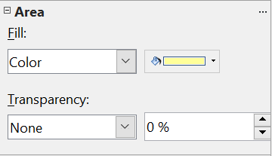

Figure 17: Common fill options in the Sidebar and Line and Filling toolbar

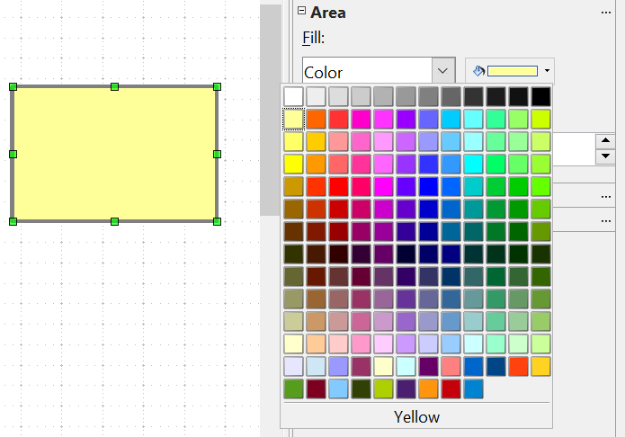
Figure 18: Filling with a color using the Sidebar

Fill with a Gradient
Select the object you wish to edit. Set the Fill type to Gradient and then choose a gradient from the right-hand menu.
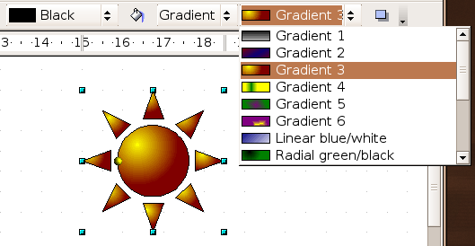
Figure 19: Filling with a gradient using the toolbar

Fill with a Line Pattern or an Image
Objects can also be filled with line patterns or an image. The OpenOffice term for line patterns is Hatching. The images used as a fill pattern must be bitmaps, that is, an image stored as a pattern of pixels rather than as a vector image. Select the object you wish to edit. In the Sidebar or on the Line and Filling toolbar, set the Fill to Hatching or Bitmap. Then choose one of the available patterns from the neighboring drop down list.

Adding a Shadow to an Area
To get the default shadow for an object, click on the Filling icon on the Line and Filling toolbar—next to the area fill functions (Figure 20).
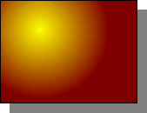
Figure 20: Adding a shadow
You can control the position, distance color and transparency of the shadow on the Shadow tab of the Area dialog. This is identical to the shadow dialog in Figure 11.

Advanced Area Fill Options
From the Area dialog, you can fine tune the area fill of an object in greater detail.

Creating Your Own Fill Color
Click on the Colors tab of the Area dialog (Figure 21). From here, you can modify existing colors or create your own.
Depending on the color model in use (RGB or CMYK can be selected from the pull down menu), you can change the individual values of the constituent colors—Red, Green, and Blue or Cyan, Magenta, Yellow, and Black. Click on Add to add this color to the color table. Clicking on the Modify button will change the values of the current color (here it is Blue 8, shown in the upper rectangle) to those on the screen in the lower rectangle. The Edit button allows you to fine tune the color using a palette with visual feedback.
Further explanation about color palettes can be found in Chapter 8 (Tips and Tricks).
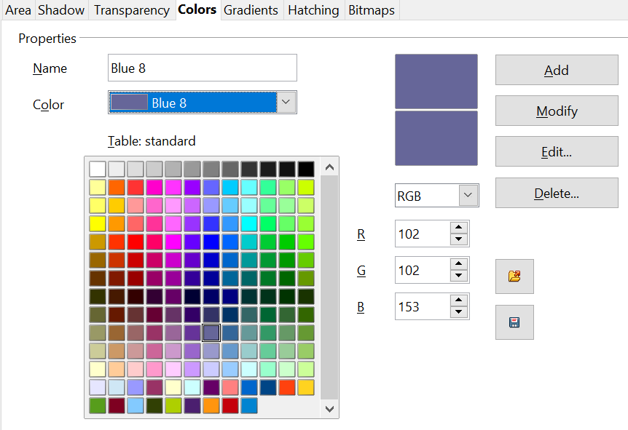
Figure 21: Customizing the color palette

Creating Your Own Gradient
On the Area dialog, click on the Gradients tab. From here you can modify existing gradients or create your own.
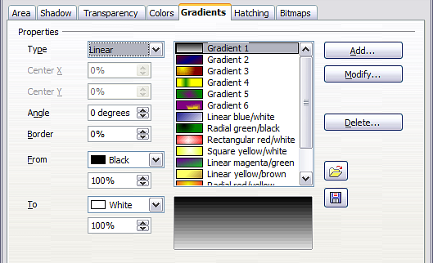
Figure 22: Customizing gradients
A gradient works by creating a smooth transition from one color to another. First, you need to choose two colors (Figure 23).
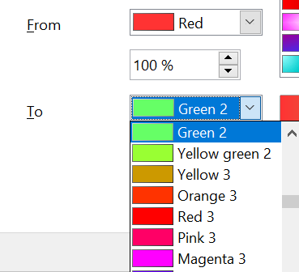

Figure 23: Choosing colors for a gradient
Then choose a type of gradient. There are several available (Linear, Axial, Radial, and so on) and each has up to four different options to specify it in detail. For example, a radial gradient has a center you can specify (Figure 24).
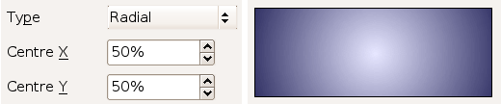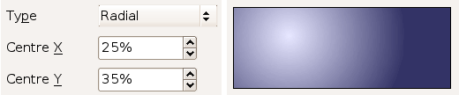

Figure 24: Center option in a radial gradient
Figure 25 shows how an ellipsoid gradient is rotated, moved vertically and horizontally, and the color of the border area varied.
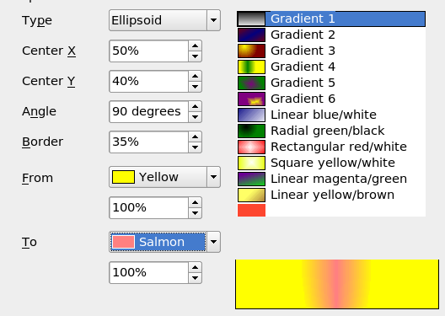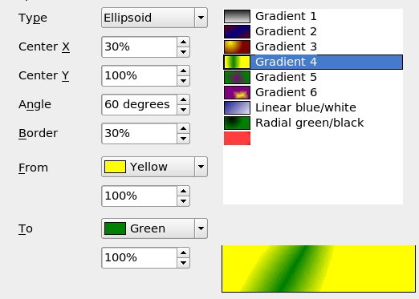Figure 25: Center, Angle, and Border options for a gradient

Creating Your Own Hatching (Line Pattern)
On the Area dialog, click on the Hatching tab (Figure 26). From here you can modify existing hatchings (line patterns) or create your own.
You can customize options like the spacing between lines, the angle and the color of the lines. There is no way to edit the line thickness.
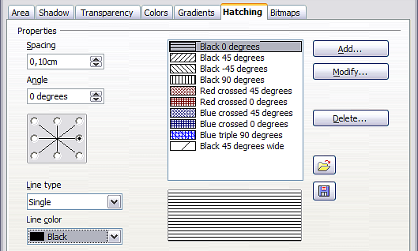
Figure 26: Modifying hatchings

Creating Your Own Bitmap Fill
You can add your own bitmap images to fill an area. First, you need to create the bitmap image. This could be a photo, or a sketch you have created in another program. For example, you can draw something with Draw and export it as a PNG format image file.
To export a PNG image file: Create the image, select it, then choose File > Export, choose PNG from the pull-down list of file formats, give the file a name, and save it.
To use an image as a bitmap fill, open the Area dialog and click on the Bitmaps tab (Figure 27).
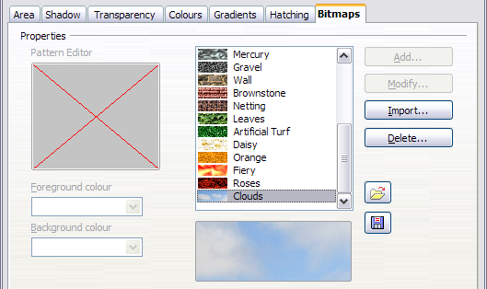
Figure 27: Adding your own bitmap images
From there you can add new bitmap images to serve as area fills. Click on Import and choose a file you previously saved. Give it a name that will make it easy to remember. The last imported image will appear at the bottom of the pull-down list of bitmap fills. Now you can use that image as an area fill.
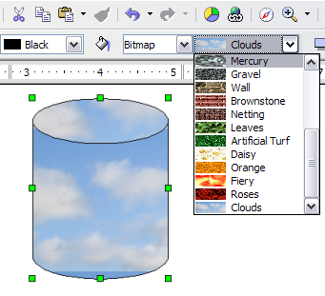
Figure 28: Adding your own bitmap images
Tip | If the imported image seems to be very small in the preview (Figure 26) you probably forgot to select the image before you exported it. In that case, the exported image would be the whole page with a (small) drawing on it.

Customizing Shadows
First, select the object you want to apply a custom shadow to. Open the Area dialog and go to the Shadow tab (Figure 27). There you can customize the shadow’s position, distance and color.
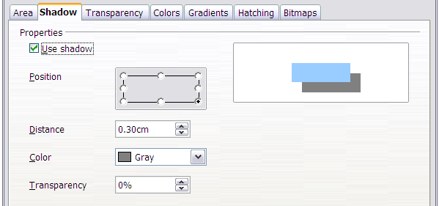Figure 29: Customizing shadows
Shadows can also have transparency, so the shadow does not completely hide objects behind it.
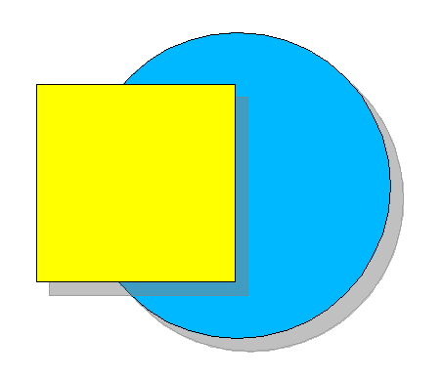
Figure 30: Shadow with 50% transparency

Adding Transparency
You can make objects partly or fully transparent, or even fill them with a varying degree of transparency (as a gradient). This can be done from the Sidebar or from the Area dialog. Figure 31 shows the Area pane of the Sidebar when an object has been selected, the Transparency type has been set to Ellipsoid and the drop down list to the right of the Ellipsoid selection has been clicked. Only the settings that are appropriate for the selected transparency type will be displayed. For example, a Solid transparency has only one setting, the fixed transparency value.

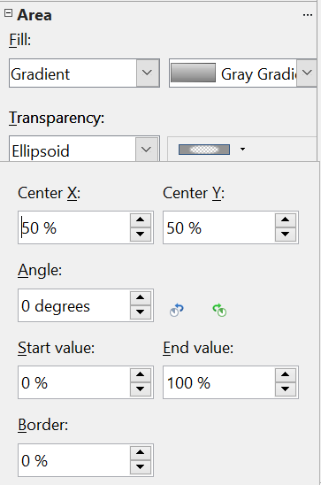Figure 31: Transparency settings on the Sidebar
On the Transparency tab of the Area dialog(Figure 32), choose Transparency (for a uniform transparency) or Gradient for a gradient transparency.
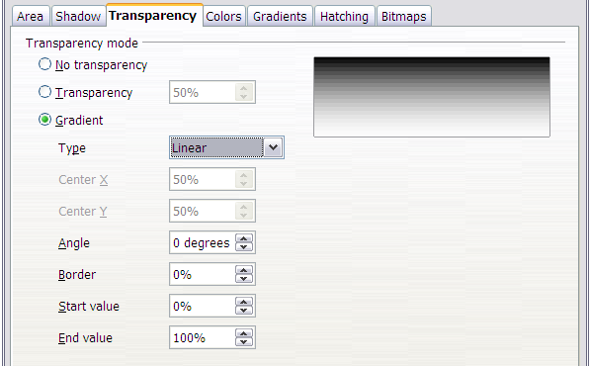Figure 32: Transparency page of Area dialog
An example of gradient transparency is shown in Figure 33. See also “Dynamic Gradients” on page 26.
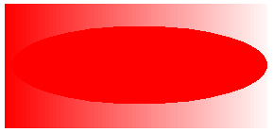
Figure 33: Example of gradient transparency

Using Styles
Suppose that you want to apply the same area fill, line thickness, and border to a set of objects. This repetitive process can be greatly simplified by the use of styles. Styles allow you to define a formatting template, a style, and then to apply that to multiple objects. For more about styles, see Chapter 6 (Introduction to Styles) in the Writer Guide.
There are many ways to access the Styles and Formatting tool:
- Click the Styles and Formatting icon on the Sidebar.
- Click on the Styles and Formatting icon on the Line and Filling toolbar
- Press the F11 key to open the Styles and Formatting window
- Select Format > Styles and Formatting
The tool shown in Figure 34 will be displayed either as a floating window or in the Sidebar. This window can be docked to the left or right side of the main Draw window, if you wish.
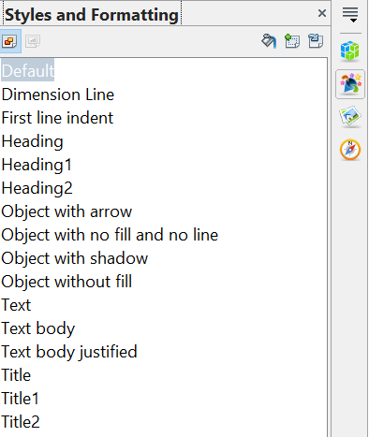
Figure 34: Styles and Formatting window
All of the styles in Draw are Graphics Styles and they share the same properties. Right clicking on a style and selecting Modify opens a dialog with the 14 tabs shown in Figure 35. Each of the supplied styles has a few of the properties modified from the values in the Default style, and the style name hints at what those changes are.

Figure 35: The tabs of the Graphics Style dialog
If you explore the various tabs, you may feel there is an overwhelming number of settings. Keep in mind that for any particular use, you probably only care about the settings of a very few properties.

Creating a New Style
A new style can be defined from the Graphics Style dialog or from an object. To work from the dialog, right click in the Styles and Formatting window either on an empty area or on an existing style. You can then choose New or, perhaps, Modify. The New option brings up the Graphics Styles dialog for a style with the default name Untitled1 and the properties of the style that was clicked or, if no style was chosen, the Default style. You can then set the style name on the Organizer tab and adjust whatever properties you want to set. If you select Modify, the process is the same except that the style will have the name of the chosen style and the settings will overwrite the previous properties of that style. In either case, the changes are effective only in the current document.
To create a style from an object, select an object and customize its properties. When you are satisfied, click on the New Style from Selection icon on the Styles and Formatting window. This defines a new style based on the selected object. Type a name for the new style and click OK.

Applying a Style
Once the new style is defined, you can apply it to other objects. Select another object and double-click on the style name you defined. The new object will acquire the properties of that style.
Tip | Question: What happens if I modify a style after it has been applied?  Answer: Every object with that style is updated automatically!

Special Effects
First make sure that the Drawing toolbar is selected (View > Toolbars > Drawing). On the Drawing toolbar, locate the Effects icon 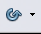. Click on the arrow next to that icon. This opens a submenu with all the special effect tools (see Figure 36).
 | 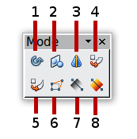
1 Rotate  2 Flip  3 In 3D Rotation Object | 4 Set in Circle (perspective)  5 Set to Circle (slant)  6 Distort | 7 Transparency  8 Gradient
Figure 36: Mode tear-off submenu
The tools are described in the following sections with the exception of the 3D rotation tool, which is described in Chapter 7 (Working with 3D Objects).

Rotating an Object
Click on the Effects icon to select the Rotate tool. Then select an object. The selected object will have red handles instead of the usual green handles.
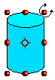 | Grab one of the handles and move it to rotate the object. The black circle in the middle of the object is the pivot, or center of rotation. You can move the location of the pivot with the mouse. | 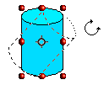

Flip an Object

Select an object and click on the Flip icon . You will see a dashed line through the middle of the object.


This dashed line is the axis of symmetry. The object will be reflected about this line. Move one or both ends of the line with your mouse to set the orientation of the axis.


Then, grab any one of the eight green handles and move it across to the other side of the dashed line. The new position of the figure is shown faintly until the mouse is released.

Note | If you press the Shift key while moving the line, the line will rotate in 45-degree increments.

Mirror Copies
Officially, this useful command does not exist in Draw. It can, however, be easily emulated.
Move the axis of symmetry to the desired location of the mirror axis. Copy the object to the clipboard. Flip the object, then click on an empty area of the Draw screen in order to deselect the object. Paste from the clipboard to put a copy of the object in its original location and now you have a mirror copy.

Figure 37: Making a mirror copy of an object

Distorting an Image
There are three tools on the Effects menu that let you drag the corners and edges of an object to distort the image.
The Distort tool distorts an object in perspective, the Set to Circle (slant) and Set in Circle (perspective) tools both create a pseudo three-dimensional effect.
The results of using these tools are shown in the following figures.

Distort an Object
Select an object and click on the Distort icon . Draw will ask if you want to transform the object to a curve. This is a necessary step before distortion, so click Yes. Then you can move the object handles to stretch it.
The corner handles distort, as shown in Figure 38. The midpoint handles distort the figure either horizontally (handle on vertical side of figure) or vertically (handle on horizontal side of figure).
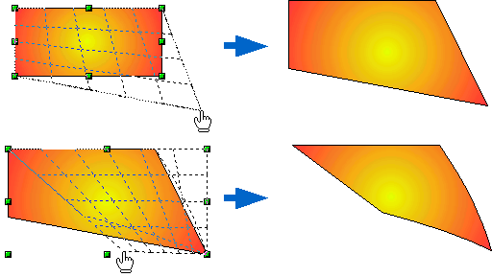Figure 38: Distort an image

Set in Circle (Perspective)
Select an object and click on the Set in Circle (perspective) icon. Draw will ask if you want to transform the object to a curve. This is a necessary step before distortion, so click Yes. Then you can move the object handles to give a pseudo three-dimensional perspective.
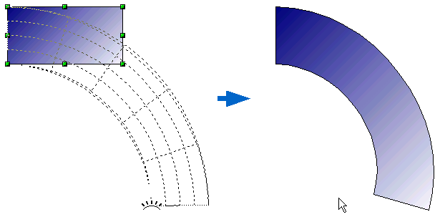
Figure 39: Set an image in a circle with perspective

Set to Circle (Slant)
Select an object and click on the Set to Circle (slant) icon. Draw will ask if you want to transform the object to a curve. This is a necessary step before distortion, so click Yes. Then you can move the object handles to give a pseudo three-dimensional slant perspective.
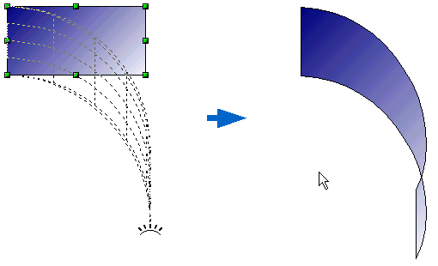
Figure 40: Set an image to a circle with slant perspective
Note | Transforming an object into a curve is a safe operation, but it cannot be reversed other than by clicking the Undo button.

Dynamic Gradients
You can control transparency gradients in the same manner as color gradients. Both types of gradient can be used together. With a transparency gradient, the direction and degree of an object’s fill color changes from opaque to transparent (in a regular gradient, the fill changes from one color to another, but the degree of transparency remains the same).
If you have assigned transparency to an object with a color fill, you can control the transparency by clicking on the Transparency icon . To define a transparent gradient, select an object, choose a transparency fill from the Sidebar or Line and Filling toolbar, The transparency icon is now active. When you click on this icon, a dashed line connecting two squares appears on the object. Move the two squares to modify the gradient. You can define the direction of the gradient (vertical, horizontal, or at any angle) and the spot at which the transparency begins.
A regular color gradient can be defined in the same manner. Select an object, choose a gradient fill from the Sidebar or Line and Filling toolbar. The Gradient icon is now active. When you click on the gradient icon, a dashed line connecting two squares appears on the object, just as it does for a transparency gradient.
In both cases, click outside the object to set the gradient.
Note | If the transparency and gradient icons are not visible, you can display them using View > Toolbars > Mode.  Moving the squares will have different effects, depending on the type of gradient. For example, for a linear gradient, the start and end squares of the gradient will always be situated to either side of the center point of the object.
The three examples in Error: Reference source not found demonstrate how the type and degree of transparency can be controlled.

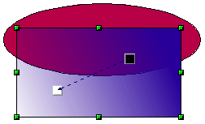 | A single color ellipse and a rectangle with a transparency gradient, covering part of the ellipse.  The gradient can be dynamically adjusted, made more transparent by moving the white square or more opaque by moving the black square.
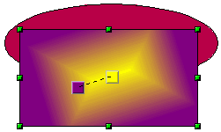 | A rectangle with a color gradient but no transparency, obscuring part of an ellipse.  The gradient is adjusted dynamically by moving the squares – the color of the square relating to the increase or decrease in that color.
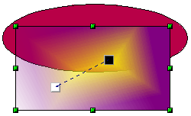 | A rectangle with both color and transparency gradients, partly covering the underlying ellipse.

Figure 41: Dynamic gradients

