Apache OpenOffice
Version 4.1
Calc Guide

AOO Documentation Team
Copyright
This document is Copyright © 2025 by The Apache Software Foundation. You may distribute it and/or modify it under the terms of the Creative Commons Attribution License, version 3.0 or later (https://creativecommons.org/licenses/by/3.0/).
Apache, Apache OpenOffice, and OpenOffice.org are trademarks of the Apache Software Foundation. Used with permission.
Acknowledgments
This book is updated from a previous version by the OOoAuthors team.
Publication date and software version
Published Day Month Years. Based on Apache OpenOffice 4.1.Contents

Contents

Chapter 1
Introducing Calc
Using Spreadsheets in Apache OpenOffice

What is Calc?
Calc is the spreadsheet component of Apache OpenOffice (AOO). In a spreadsheet, you enter data, usually numerical, and then manipulate that data to produce certain results.
Alternatively, you can enter data and then use Calc in a ‘What if…’ manner by changing some data and observing the results, without having to retype the entire spreadsheet.
Other features provided by Calc include:
- Functions, which can create formulas that perform complex calculations on data
- Database functions that arrange, store, and filter data, both numerical and textual
- Dynamic charts: a wide range of 2D and 3D charts that can change as the data upon which they are based changes
- Macros for recording and executing repetitive tasks. The supported programming or scripting languages include OpenOffice Basic, Python, BeanShell, and JavaScript
- Ability to open, edit, and save Microsoft Excel spreadsheets. Files in the more recent XLSX format can be opened, but they'll be saved in the older XLS format.
- Import and export of spreadsheets in multiple formats, including HTML, CSV, PDF, and PostScript
Note | If you want to use macros written in Microsoft Excel using VBA macro code, you must first edit the code in the AOO Basic IDE editor. See Chapter 12 (Calc Macros).

Spreadsheets, Sheets, and Cells
Calc works with entities called spreadsheets. Spreadsheets are not necessarily stand-alone and can be composed of multiple individual sheets, each sheet containing cells organized in rows and columns. A specific cell is identified by its row number and column letter – for instance, D7 for row 7, column D, as in the illustration below.

A1 | B1 | C1 | D1 | E1 | F1 | G1
2
3
4
5
6
7 |  |  | D7
8
Cells hold data, including text, numbers, formulas, and so on, that make up what will be displayed and manipulated.
A spreadsheet can have many sheets, each with many individual cells. Each sheet can have a maximum of 1,048,576 rows and a maximum of 1024 columns.

Parts of the Main Calc Window
When Calc is started, the main window looks similar to Figure 1.
Note | If any part of the Calc window in Figure 1 is not shown, you can display it using the View menu. For example, View > Status Bar will toggle (show or hide) the Status Bar. It is not always necessary to display all the parts as shown; show or hide any of them, as desired.

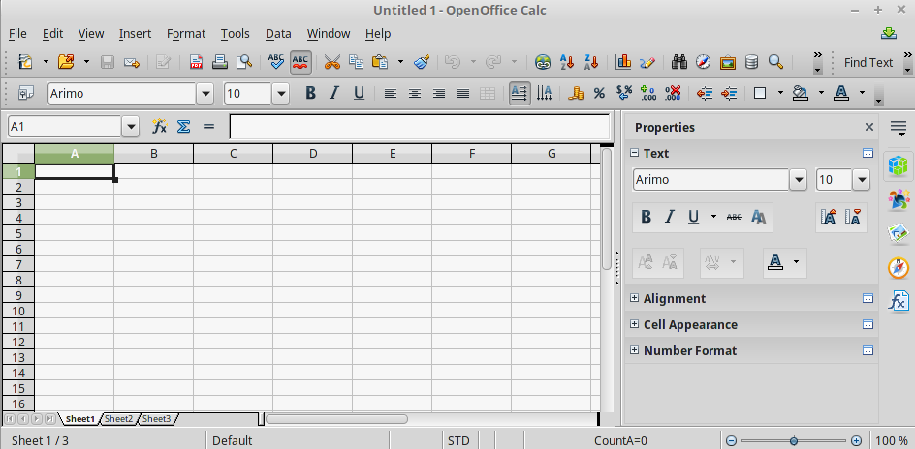
Figure 1: Parts of the Calc window
Title bar
Menu bar
Standard toolbar
Formatting toolbar
Sidebar
Name box
Row headers
Column headers
Active cell
Sheet tabs
Status bar
Formula bar

Title Bar
The Title bar, located at the top, shows the name of the current spreadsheet. When the spreadsheet is newly created, its name is Untitled X, where X is a number. When you save a spreadsheet for the first time, you are prompted to enter a name of your choice.

Menu Bar
Under the Title bar is the Menu bar. When you choose one of the menus, a submenu appears with other options. You can modify the Menu bar, as discussed in Chapter 14 (Setting Up and Customizing Calc).
- File contains commands that apply to the entire document, such as Open, Save, Wizards, Export as PDF, and Digital Signatures.
- Edit contains commands for editing the document, such as Undo, Changes, Compare Document, and Find & Replace.
- View contains commands for modifying how the Calc user interface looks, such as Toolbars, Full Screen, and Zoom.
- Insert contains commands for inserting elements, such as cells, rows, columns, sheets, and pictures into a spreadsheet.
- Format contains commands for modifying the layout of a spreadsheet, such as Styles and Formatting, Page, and Merge Cells.
- Tools contains functions, such as Spelling, Share Document, Cell Contents, Gallery, and Macros.
- Data contains commands for manipulating data in your spreadsheet, such as Define Range, Sort, Filter, and Pivot Table.
- Window contains commands for the display window, such as New Window, Split, and Freeze.
- Help contains links to the Help file bundled with the software, What's This?, Support, and Check for Updates.

Toolbars
Calc has several types of toolbars
- docked, that is, fixed in place
- floating
- tear-off
Docked toolbars can be moved to different locations or made to float, and floating toolbars can be docked.
By default, four toolbars are located under the Menu bar by default: the Standard toolbar, the Find toolbar, the Formatting toolbar, and the Formula Bar.
The icons (buttons) on these toolbars provide a wide range of common commands and functions. As discussed in Chapter 14 (Setting Up and Customizing Calc), you can also modify these toolbars.
Placing the mouse pointer over any toolbar icons will display a small box called a tooltip. It gives a brief explanation of the icon’s function. For a more detailed explanation, choose Help > What’s This? and hover the mouse pointer over the icon. To turn this feature off again, click once or press the Esc key twice. Tips and extended tips can be turned on or off from Tools > Options > OpenOffice > General.

Displaying or Hiding Toolbars
To display or hide toolbars, choose View > Toolbars, then click on the name of a toolbar in the list. An active toolbar shows a check mark beside its name. Tear-off toolbars are not listed in the View menu.

Palettes and Tear-off Toolbars
Toolbar icons with a small triangle to the right display palettes, tear-off toolbars, and other items that can be chosen. Figure 2 shows an example of a palette. It is displayed by clicking the small triangle to the right of the Borders toolbar icon.
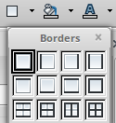

Figure 2: Toolbar palette
Figure 3 shows an example of a tear-off toolbar. Tear-off toolbars can be floating or docked along an edge of the screen or in one of the existing toolbar areas. To move a floating tear-off toolbar, drag it by its title bar.
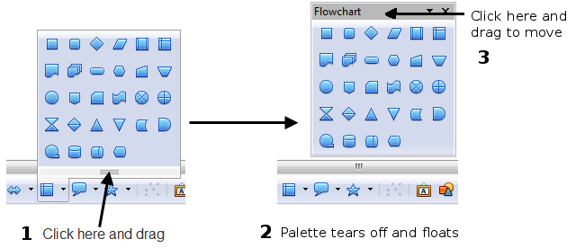
Figure 3: Example of a tear-off toolbar

Moving Toolbars
To move a docked toolbar, place the mouse pointer over the toolbar handle, hold down the left mouse button, drag the toolbar to the new location, and then release the mouse button. Figure 4 illustrates this tactic.
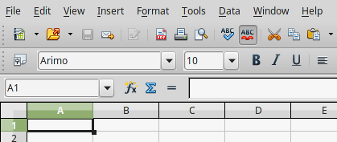

Figure 4: Moving a docked toolbar
Handles of docked
toolbars
To move a floating toolbar, click on its title bar and drag it to a new location, as was shown in Figure 3 for a tear-off toolbar.

Docking/Floating Windows and Toolbars
Toolbars and some windows, such as the Navigator and the Styles and Formatting window, are dockable. You can move, resize, or dock them to an edge.
To dock a window or toolbar, hold down the Control key and double-click on the frame of the floating window (or in a vacant area near the icons at the top of the floating window) to dock it in its last position.
To undock a window, hold down the Control key and double-click on the frame (or a vacant area near the icons at the top) of the docked window.
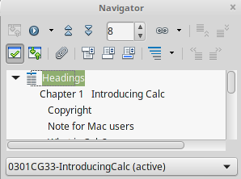

Figure 5: Control+double-click to dock or undock

Customizing Toolbars
You can customize toolbars in several ways, including:
- choosing which icons are visible
- locking the position of a docked toolbar.
To access a toolbar’s customization options, use the down-arrow at the end of the toolbar or on its title bar (Figure 6).
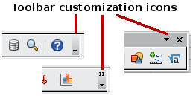
Figure 6: Customizing toolbars
Choose Visible Buttons from the drop-down menu to show or hide icons defined for the selected toolbar. Visible icons are indicated by a border around the icon (Figure 7). Click on icons to hide or show them on the toolbar.
You can also add icons and create new toolbars, as described in Chapter 16.
Figure 7: Selection of visible toolbar icons

Formatting Toolbar
In the Formatting toolbar, the three boxes on the left are the Apply Style, Font Name, and Font Size lists (see Figure 8). They show the current settings for the selected cell or area. (The Apply Style list may not be visible by default.) Click the down-arrow to the right of each box to open the list.
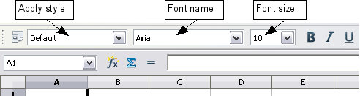
Figure 8: Apply Style, Font Name and Font Size lists

Note | If any of the icons (buttons) in Figure 8 are not shown, you can display it by clicking the small triangle at the right end of the Formatting toolbar, selecting Visible Buttons in the drop-down menu, and selecting the desired icon (for example, Apply Style) in the drop-down list. It is not always necessary to display all the toolbar buttons as shown; show or hide any of them, as desired.

Formula Bar
On the left-hand side of the Formula Bar is a small text box called the Name Box. It contains a letter and number combination such as D7. This combination called the cell reference, is the elected cell's column letter and row number.
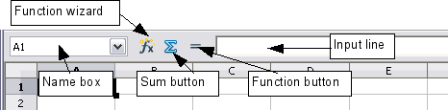
Figure 9: Formula Bar
To the right of the Name Box are the Function Wizard, Sum, and Function buttons.
Clicking the Function Wizard button opens a dialog from which you can search through a list of available functions. This can be very useful; it shows how functions are formatted.
In a spreadsheet, the term function applies to much more than mathematical functions. See Chapter 7 (Using Formulas and Functions) for more details.
Clicking the Sum button inserts a formula into the current cell that will total the numbers in the cells above the current cell. If there are no numbers above the current cell, the values in the cells to the left are placed in the Sum formula.
Clicking the Function button inserts an equal (=) sign into the selected cell and the Input line. That equal sign must be present to allow the cell in question to accept a formula.
When you enter new data into a cell, the Sum and Equals buttons change to Cancel and Accept buttons .
The contents of the current cell, whether data or a formula, are displayed in the Input line, which is the remainder of the Formula Bar. You can either edit the cell contents of the current cell there, or you can do that in the current cell. To edit inside the Input line area, click in the area, then type your changes. To edit within the current cell, double-click the cell.

Sidebar
The Sidebar combines functions from several toolbars and menus into one convenient location. For a thorough description of it, see the Getting Started Guide. Briefly, the Sidebar in Calc has five Decks that can be selected with the colored icons at the right edge of the Sidebar region, as seen in Figure 1. Starting from the top, these icons represent Properties, Styles and Formatting, the Gallery, the Navigator, and the Function Wizard. More details about using the Sidebar are provided in the relevant sections in later chapters. Hiding the Sidebar is sometimes convenient when working with a spreadsheet with many columns. This can be done with the menu View > Sidebar or by double-clicking the Hide button which is a faint series of dots at the left edge in the vertical middle of the Sidebar.

Right-click (Context) Menus
Right-click on a cell, graphic, or other object to open a context menu. Often the context menu is the fastest and easiest way to reach a function. If you’re not sure where a function is located in the menus or toolbars, you may be able to find it by right-clicking.

Individual Cells
The main section of the screen displays the cells in the form of a grid, with each cell being at the intersection of a column and a row.
At the top of the columns and at the left end of the rows are a series of gray boxes containing letters and numbers. These are the column and row headers. The columns start at A and go on to the right, and the rows start at 1 and go down.
These column and row headers form the cell references that appear in the Name Box on the Formula Bar (see Figure 9). You can turn these headers off by selecting View > Column & Row Headers.

Sheet Tabs
Sheet tabs can be found at the bottom of the grid of cells. These tabs enable access to each individual sheet, with the visible, active sheet having a white tab. Clicking on another sheet tab displays that sheet, and its tab turns white. You can also select multiple sheet tabs at once by holding down the Control key while you click the names.
You can choose colors for sheet tabs. Right-click on a tab and select Tab Color from the pop-up menu to open a palette of colors. To add new colors to the palette, see “Color options” in Chapter 14 (Setting up and Customizing Calc).
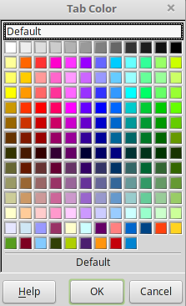
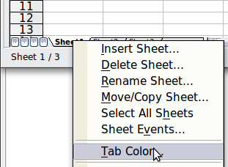
Figure 10: Choose tab color

Status Bar
The Calc status bar provides information about the spreadsheet, and convenient ways to change some of its features.
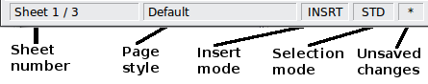
Figure 11: Left end of Calc status bar
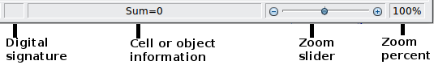
Figure 12: Right end of Calc status bar
Sheet sequence number ()
Shows the sequence number of the current sheet and the total number of sheets in the spreadsheet. The sequence number may not correspond with the name on the sheet tab.
Page style ()
Shows the page style of the current sheet. To edit the page style, double-click on this field. The Page Style dialog opens.
Insert mode ()
Click to toggle between INSRT (Insert) and OVER (Overwrite) modes when typing. This field is blank when the spreadsheet is not in a typing mode (for example, when selecting cells).
Selection mode ()
Click to toggle between STD (Standard), EXT (Extend), and ADD (Add) selection. EXT is an alternative to Shift+click when selecting cells. See page 25 for more information.
Unsaved changes ()
An asterisk (*) appears here if changes to the spreadsheet have not been saved.
Digital signature ()
If the document has not been digitally signed, double-clicking in this area opens the Digital Signatures dialog, with which you can sign the spreadsheet. See Chapter 6 (Printing, Exporting, and E-mailing) for more about digital signatures.
If the document has been digitally signed, an icon shows in this area. You can double-click the icon to view the certificate. Note that a document can be digitally signed only after it has been saved.
Cell or object information ()
Displays information about the selected items. When a group of cells is selected, the sum of the contents is displayed by default; you can right-click on this field and select other functions, such as the average value, maximum value, minimum value, or count (number of items selected).
When the cursor is on an object such as a picture or chart, the information shown includes its size and location.
Zoom ()
To change the view magnification, drag the Zoom slider or click on the + and – signs. You can also right-click on the zoom level percentage to select a magnification value or double-click to open the Zoom & View Layout dialog.

Starting New Spreadsheets
You can start a new, blank document in Calc in several ways.
- From the operating system menu, in the same way that you start other programs. When AOO was installed on your computer, in most cases, a menu entry for each component was added to your system menu. Mac users should see the OpenOffice icon in the Applications folder. When you double-click this icon, AOO opens at the Start Center (Figure 14).
- From the Quickstarter, which is found in Windows, some Linux distributions, and in a slightly different form, in macOS. The Quickstarter is an icon that is placed in the system tray or the dock during system startup. It indicates that OpenOffice has been loaded and is ready to use.
Right-click the Quickstarter icon (Figure 13) in the system tray to open a pop-up menu from which you can open a new document, open the Templates and Documents dialog box, or choose an existing document to open. You can also double-click the Quickstarter icon to display the Templates and Documents dialog box.
See Chapter 1 (Introducing OpenOffice) in the Getting Started guide for more information about using the Quickstarter.
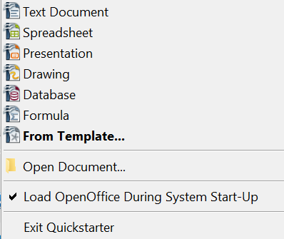

Figure 13: Quickstarter pop-up menu on Windows
- From the Start Center. When AOO is open without any documents open, e.g., if you close all the open documents but leave the program running, the Start Center is shown. Click one of the icons to open a new document of that type, or click the Templates icon to start a new document using a template. If a document is already open in AOO, the new document opens in a new window.
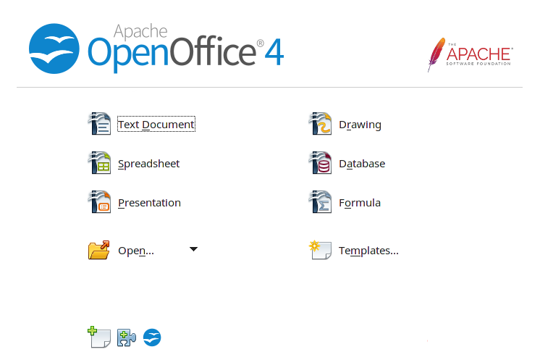

Figure 14: OpenOffice Start Center
When AOO is open, you can start a new document in any of the following ways.
- Press the Control+N keys.
- Use File > New > Spreadsheet.
- Click the New button on the main toolbar.

Starting a New Document from a Template
Calc documents can also be created from templates. Follow the procedures above, but instead of choosing Spreadsheet, choose the Templates icon from the Start Center or File > New >Templates and Documents from the Menu bar or toolbar.
On the Templates and Documents window (Figure 15), navigate to the appropriate folder and double-click on the required template. A new spreadsheet, based on the selected template, opens.
A new OpenOffice installation does not contain many templates, but you can add more by downloading them from https://extensions.openoffice.org and installing them as described in Chapter 14 (Setting Up and Customizing Calc).
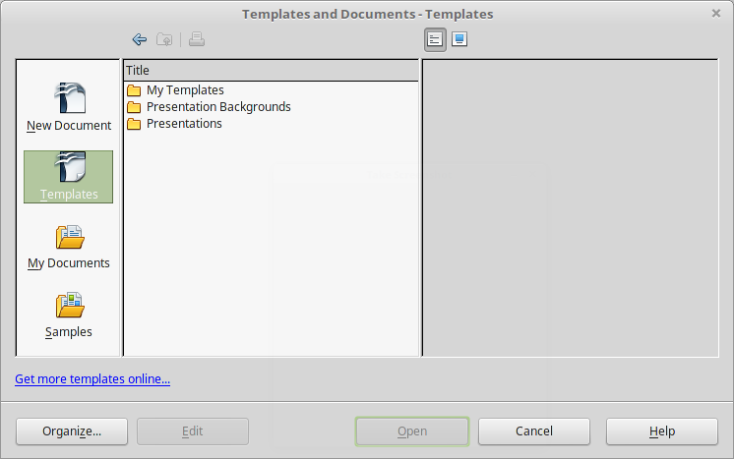

Figure 15: Starting a new spreadsheet from a template

Opening Existing Spreadsheets
When no document is open, the Start Center (Figure 14) provides an icon for opening an existing document, or choosing from a list of recently-edited documents.

You can also open an existing document in one of the following ways.
- Choose File > Open….
- Click the Open button on the main toolbar.
- Press Control+O on the keyboard.
- Use File > Recent Documents to display the last 10 files opened in any of the AOO components.
- Use the Open Document or Recent Documents selections on the Quickstarter.
In each case, the Open dialog box appears. Select the file you want, and then click Open. If a document is already open in AOO, the second document opens in a new window.

Opening CSV Files
Comma-separated-values (CSV) files are text files that contain the cell contents of a single sheet. Each line in a CSV file represents a row in a spreadsheet. Commas, semicolons, or other characters are used to separate the cells. Text is entered in quotation marks; numbers are entered without quotation marks.
To open a CSV file in Calc:
- Choose File > Open.
- Locate the CSV file that you want to open.
- If the file has a *.csv extension, select the file and click Open.
- If the file has another extension (for example, *.txt), select the file, select Text CSV (*csv;*txt) in the File type box (scroll down into the spreadsheet section to find it) and then click Open.
- On the Text Import dialog (Figure 16), select the Separator options to divide the text in the file into columns.
You can preview the layout of the imported data at the bottom of the dialog. Right-click a column in the preview to set the format or hide the column.
If the CSV file uses a text delimiter character not in the Text delimiter list, click in the box, and type the character.
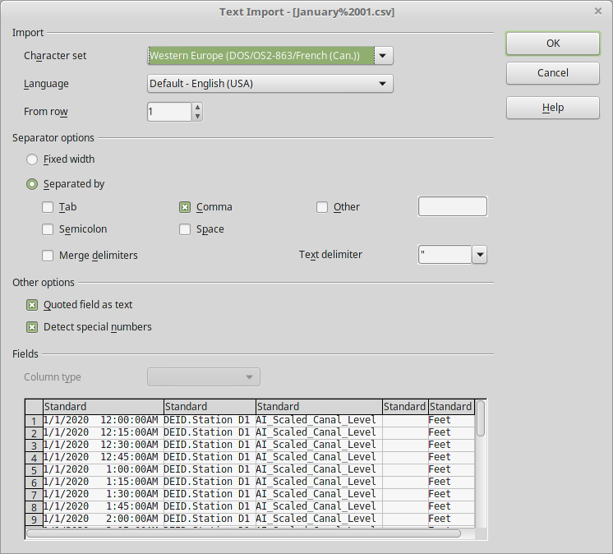
Figure 16: Text Import dialog, with Comma (,) selected as the separator and double quotation mark (“) as the text delimiter.
- The Detect special numbers option is very helpful for importing numbers written with currency symbols or dates that will otherwise be treated as text.
- Click OK to open the file.
Caution   | If you do not select Text CSV (*csv;*txt) as the file type when opening the file, the document opens in Writer, not Calc.

Saving Spreadsheets
Spreadsheets can be saved in three ways.
- Press Control+S.
- Choose File > Save (or Save All or Save As).
- Click the Save button on the main toolbar.
If the spreadsheet has not been saved previously, then these actions will open the Save As dialog. There, you can specify the spreadsheet name and the location to save it.
Note | If the spreadsheet has been previously saved, then saving it using the Save (or Save All) command will overwrite an existing copy. However, you can save the spreadsheet in a different location or with a different name by selecting File > Save As.

Saving as a Microsoft Excel Document
Some users of Microsoft Excel may be unwilling to use *.ods files. In such a case, you can save a document as an Excel file (*.xls). Be aware that some formatting may be lost when saving in a non-AOO format, particularly in complex documents.
- Important—First save your spreadsheet in the file format used by OpenOffice, *.ods. If you do not, any changes you may have made since the last time you saved it will only appear in the Microsoft Excel version of the document.
- Then choose File > Save As.
- On the Save As dialog (Figure 17), in the File type (or Save as type) drop-down menu, select the type of Excel format you need. Click Save.
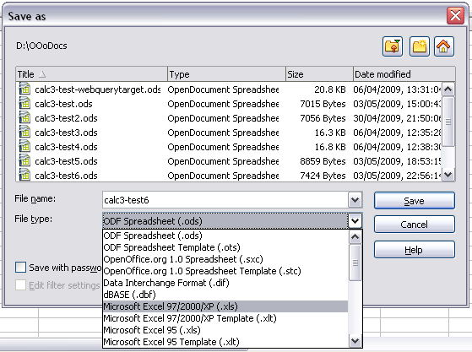
Figure 17. Saving a spreadsheet in Microsoft Excel format
Caution | From this point on, all changes you make to the spreadsheet will occur only in the Microsoft Excel document, since you have changed the name and file type of that document. If you want to go back to working with the *.ods version of your spreadsheet, you must open it again.

Tip | To have Calc save documents by default in a Microsoft Excel file format, go to Tools > Options > Load/Save > General. In the section named Default file format and ODF settings, under Document type, select Spreadsheet, then under Always save as, select your preferred file format.

Saving as a CSV File
To save a spreadsheet as a comma-separated value (CSV) file:
- Choose File > Save As.
- In the File name box, type a name for the file.
- In the File type list, select Text CSV (*.csv) and click Save.
You may see the message box shown below. Click Keep Current Format.

- In the Export of text files dialog, select the options you want and then click OK.
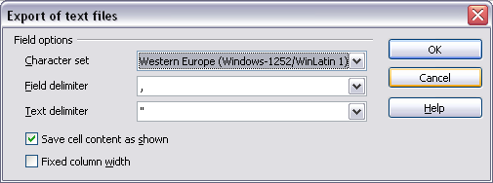
Figure 18: Choosing options when exporting to Text CSV
The CSV file format only stores text and data from a single sheet. Since that's the case, only the active sheet will be saved. Any graphics or charts will not be part of the CSV file.

Saving in Other Formats
Calc can save spreadsheets in various formats, including HTML, through the Save As dialog. Calc can also export spreadsheets to PDF and XHTML file formats. For more information, see Chapter 6 (Printing, Exporting, and E-mailing).

Password Protection
Calc provides two levels of document protection:
- read-protect, under which the file cannot be viewed without a password
- write-protect, with which the file can be viewed in read-only mode but cannot be changed without a password.
The latter method can make content available for reading by a selected group and for reading and editing by a different group.
- Use File > Save As when saving the document. (You can also use File > Save the first time you save a new document.)
- On the Save As dialog, type the file name, select the Save with password option, and then click Save.

- The Set Password dialog opens.
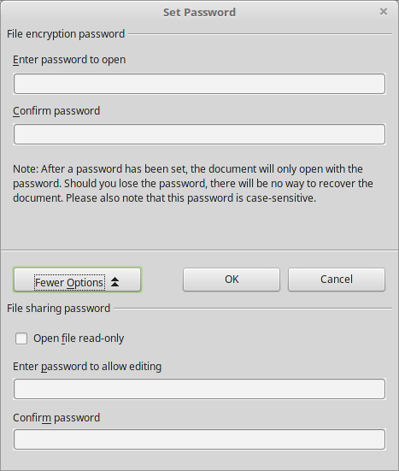

Figure 19: Two levels of password protection
The Set Password dialog offers several choices:
- To read-protect the document, type a password in the two fields at the top of the dialog box.
- To write-protect the document, click the More Options button and select the Open file read-only checkbox.
- To write-protect the document but allow selected people to edit it, select the Open file read-only checkbox and type a password in the two boxes at the bottom of the dialog box.
- Click OK to save the file. If either pair of passwords do not match, you receive an error message. Close the message box to return to the Set Password dialog box and enter the password again.
Caution | AOO uses a very strong encryption mechanism that makes it almost impossible to recover the contents of a document if you lose the password.

Navigating within Spreadsheets
Calc provides many ways to navigate within a spreadsheet, from cell to cell and sheet to sheet. Use the method you prefer!

Going to a Particular Cell
Using the mouse
Place the mouse pointer over the cell and click.
Using a cell reference
Click on the small inverted black triangle just to the right of the Name Box (Figure 9). The existing cell reference will be highlighted. Type the cell reference of the cell you want to go to, and press Enter. Cell references are case insensitive; a3 or A3, for example, are the same. Or just click into the Name Box, backspace over the existing cell reference, type in the cell reference you want, and press Enter.
Using the Navigator
Click on the Navigator button in the Sidebar or the Standard toolbar (or press F5) to display the Navigator. Type the cell reference into the top two fields, labeled Column and Row, and press Enter. In Figure 32 on page 34, the Navigator would select cell A7. For more about using the Navigator, see page 34.

Tip | The Navigator can make your job a lot easier, especially when dealing with crowded spreadsheets. Think of it as Calc's analog to a Star Trek transporter.

Moving from Cell to Cell
In an AOO spreadsheet, one cell normally has a darker black border. This black border indicates where the focus is (see Figure 20). In turn, focus indicates which cell is enabled to receive input. If a group of cells is selected, they have a highlight color (usually gray), with the focus cell having a dark border.
Using the mouse
To move the focus using the mouse, simply move the mouse pointer to the cell where you want it to be and click the left mouse button. This action changes the focus to the new cell and is most useful when the two cells are a large distance apart.
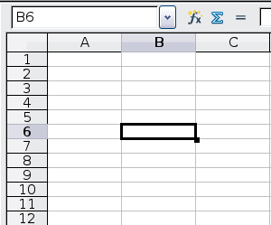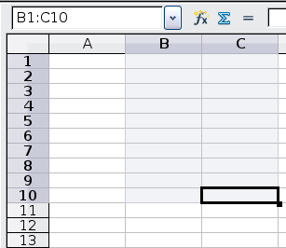
Figure 20. (left) One selected cell and (right) a group of selected cells
Using the Tab and Enter keys
- Pressing Enter or Shift+Enter moves the focus down or up, respectively.
- Pressing Tab or Shift+Tab moves the focus to the right or to the left, respectively.
Using the arrow keys
Pressing the arrow keys on the keyboard moves the focus in the direction of the arrows.
Using Home, End, Page Up, and Page Down
- Home moves the focus to the start of a row.
- End moves the focus to the column furthest to the right that contains data.
- Page Down moves the display down one complete screen; Page Up moves the display up one complete screen.
- Combinations of Control (often represented on keyboards as Ctrl) and Alt with Home, End, Page Down (PgDn), Page Up (PgUp), and the arrow keys move the focus of the current cell in other ways. Table 1 describes the keyboard shortcuts for moving about a spreadsheet.
Tip | Use one of the four Alt+Arrow key combinations to resize a cell's height or width. For example, Alt+↓ increases the height of a cell.

Table 1. Moving from cell to cell using the keyboard
Key Combination | Movement
→ | Right one cell
← | Left one cell
↑ | Up one cell
↓ | Down one cell
Control+→ | To the next column to the right containing data in that row or to the last column (Column AMJ)
Control+← | To the next column to the left containing data in that row or to Column A
Control+↑ | To the next row above containing data in that column or to Row 1
Control+↓ | To the next row below containing data in that column or to Row the last row (1048576)
Control+Home | To Cell A1
Control+End | To lower right-hand corner of the rectangular area containing data
Alt+Page Down | One screen to the right (if possible)
Alt+Page Up | One screen to the left (if possible)
Control+Page Down | One sheet to the right (in sheet tabs)
Control+Page Up | One sheet to the left (in sheet tabs)
Tab | To the next cell on the right
Shift+Tab | To the next cell on the left
Enter | Down one cell (unless changed by user)
Shift+Enter | Up one cell (unless changed by user)

Customizing the Effects of the Enter Key
You can customize the direction in which the Enter key moves the focus by selecting Tools > Options > OpenOffice Calc > General.
The four choices for the direction of the Enter key are shown on the right-hand side of Figure 21. It can move the focus down, right, up, or left. Depending on the file being used or on the type of data being entered, setting a different direction can be useful.
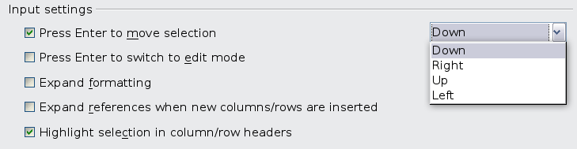
Figure 21: Customizing the effect of the Enter key
The Enter key can also be used to switch into and out of the editing mode. Use the first two options under Input settings in Figure 21 to change the Enter key settings.

Moving from Sheet to Sheet
Each sheet in a spreadsheet is independent of the others, though they can be linked with references from one sheet to another. There are three ways to navigate between different sheets in a spreadsheet.
Using the keyboard
Pressing Control+Page Down moves one sheet to the right, and pressing Control+Page Up moves one sheet to the left.
Using the mouse
Clicking on one of the sheet tabs at the bottom of the spreadsheet selects that sheet.
If you have a lot of sheets, then some sheet tabs may be hidden behind the horizontal scroll bar at the bottom of the screen. If this is the case, then the four buttons at the left of the sheet tabs can move the tabs into view. Figure 22 shows how to do this.
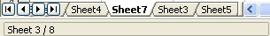

Figure 22. Sheet tab arrows
Move to the first sheet
Move left one sheet
Move right one sheet
Move to the last sheet
Sheet tabs

Note | Notice that sheets are not numbered in order. Sheet numbering is arbitrary; you can identify a sheet however you wish. Also, sheet tab arrows shown in Figure 22 only appear if you have some sheet tabs that can not be seen. Otherwise, they appear faded as in Figure 1.

Selecting Items in a Sheet or Spreadsheet

Selecting Cells
Cells can be selected in a variety of combinations and quantities.
Single cell
Left-click in the cell. The result will look like the left side of Figure 20. You can verify your selection by looking in the Name Box.
Range of contiguous cells
A range of cells can be selected using the keyboard or the mouse.
To select a range of cells by dragging the mouse:
- Click in a cell.
- Press and hold down the left mouse button.
- Move the mouse around the screen.
- Once the desired block of cells is highlighted, release the left mouse button.
To select a range of cells without dragging the mouse:
- Click in the cell which is to be one corner of the range of cells.
- Move the mouse to the opposite corner of the range of cells.
- Hold down the Shift key and click.
Tip | You can also select a contiguous range of cells by first clicking in the STD field on the status bar and changing it to EXT before clicking in the opposite corner of the range of cells in step 3 above. If you use this method, be sure to change EXT back to STD, or you may find yourself extending the selection unintentionally.

To select a range of cells without using the mouse:
- Select the cell that will be one of the corners in the range of cells.
- While holding down the Shift key, use the cursor arrows to select the rest of the range.
The result of these methods looks like the right side of Figure 20.
Tip | You can also directly select a range of cells using the Name Box. Click into the Name Box as described in “Using a cell reference” on page 21. To select a range of cells, enter the cell reference for the upper left-hand cell, followed by a colon (:), and then the lower right-hand cell reference. For example, to select the range that would go from A3 to C6, you would enter A3:C6.

Range of noncontiguous cells
- Select the cell or range of cells using one of the methods above.
- Move the mouse pointer to the start of the next range or single cell.
- Hold down the Control key and click or click-and-drag to select another range of cells to add to the first range.
- Repeat as necessary.
Tip | You can also select a noncontiguous range of cells by first clicking twice in the STD field on the status bar to change it to ADD before clicking on a cell that you want to add to the range of cells in step 3 above. This method works best when adding single cells to a range. If you use this method, be sure to change ADD back to STD, or you may find yourself adding more selections unintentionally.

Selecting Columns and Rows
Entire columns and rows can be selected very quickly in AOO.
Single column or row
To select a single column, click on the column identifier letter (see Figure 1).
To select a single row, click on the row identifier number.
Multiple columns or rows
To select multiple columns or rows that are contiguous:
- Click on the first column or row in the group.
- Hold down the Shift key.
- Click the last column or row in the group.
To select multiple columns or rows that are not contiguous:
- Click on the first column or row in the group.
- Hold down the Control key.
- Click on all the subsequent columns or rows while holding down the Control key.
Entire sheet
To select the entire sheet, click the small box between the A column header and the 1 row header.
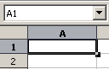

Figure 23. Select All box
Select All
You can also press Control+A to select the entire sheet.

Selecting Sheets
You can select either one or multiple sheets. Selecting multiple sheets can be effective when you want to make changes to them simultaneously.
Single sheet
Click on the tab for the sheet you want to select. The tab of the active sheet becomes white (see Figure 22).
Multiple contiguous sheets
To select multiple contiguous sheets:
- Click on the sheet tab for the first desired sheet.
- Move the mouse pointer over the sheet tab for the last desired sheet.
- Hold down the Shift key and click on the sheet tab.
All the tabs between these two sheets will turn white. Any actions that you perform now will affect all highlighted sheets.
Multiple noncontiguous sheets
To select multiple noncontiguous sheets:
- Click on the sheet tab for the first desired sheet.
- Move the mouse pointer over the sheet tab for the second desired sheet.
- Hold down the Control key and click on the sheet tab.
- Repeat as necessary.
The selected tabs will turn white. Any actions that you perform will now affect all highlighted sheets.
All sheets
Right-click any one of the sheet tabs and choose Select All Sheets from the pop-up menu.

Working with Columns and Rows

Inserting Columns and Rows
Columns and rows can be inserted individually or in groups.
Note | When you insert a single new column, it is inserted to the left of the highlighted column. When you insert a single new row, it is inserted above the highlighted row.  Cells in the new columns or rows are formatted like the corresponding cells in the column or row before (or to the left of) which the new column or row is inserted.
Single column or row
Using the Insert menu:
- Select the cell, column, or row where you want the new column or row inserted.
- Choose either Insert > Columns or Insert > Rows.
Using the mouse:
- Select the cell, column, or row where you want the new column or row inserted.
- Right-click the header of the column or row.
- Choose Insert Rows or Insert Columns.
Multiple columns or rows
Multiple columns or rows can be inserted simultaneously rather than one at a time.
- Highlight the required number of columns or rows by holding down the left mouse button on the first one and then dragging across the required number of identifiers.
- Proceed as for inserting a single column or row above.

Deleting Columns and Rows
Columns and rows can be deleted individually or in groups.
Single column or row
A single column or row can be deleted by using the mouse.
- Select the column or row to be deleted.
- Choose Edit > Delete Cells from the menu bar.
Or,
- Right-click on the column or row header.
- Choose Delete Columns or Delete Rows from the pop-up menu.
Multiple columns or rows
Multiple columns or rows can be deleted at once rather than deleting them one at a time.
- Highlight the required columns or rows by holding down the left mouse button on the first one and then dragging across the required number of identifiers.
- Proceed as for deleting a single column or row above.
Tip | Instead of deleting a row or column, you may wish to delete the contents of the cells, but keep the empty row or column. See Chapter 2 (Entering, Editing, and Formatting Data) for instructions.

Working with Sheets
Like any other Calc element, sheets can be inserted, deleted, and renamed.

Inserting New Sheets
There are several ways to insert a new sheet.
The first step for all such methods is to select the sheets that will be next to the new sheet to be inserted. Then, any of the following options can be used.
- Choose Insert > Sheet from the menu bar.
- Right-click on the sheet tab and choose Insert Sheet.
- Click in an empty space at the end of the line of sheet tabs.
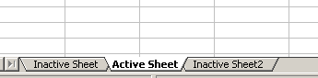

Figure 24. Creating a new sheet
Click here to insert a new sheet
Each method opens the Insert Sheet dialog (Figure 25). From there, you can select whether the new sheet should go before or after the selected sheet and how many sheets you want to insert. If you are inserting only one sheet, you can give the sheet a name.

Deleting Sheets
Sheets can be deleted individually or in groups.
Single sheet
Right-click on the tab of the sheet you want to delete. Then,
- Choose Delete Sheet from the pop-up menu, or
- Choose Edit > Sheet > Delete from the Menu bar.
Either way, an alert will ask if you want to delete the sheet permanently. Click Yes.
Multiple sheets
To delete multiple sheets, select them as described earlier, then either right-click over one of the tabs and choose Delete Sheet from the pop-up menu or choose Edit > Sheet > Delete from the Menu bar.
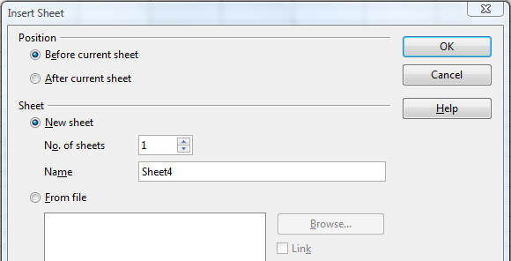Figure 25: Insert Sheet dialog

Renaming Sheets
The default name for a new sheet is SheetX, where X is a number. While this works for a small spreadsheet with only a few components, it becomes awkward when there are many sheets.
To give a sheet a more meaningful name, you can:
- Enter the name in the Name box when you create the sheet, or
- Right-click on a sheet tab and choose Rename Sheet from the pop-up menu; replace the existing name with a different one.
- Double-click on a sheet tab to pop up the Rename Sheet dialog.
Note | Sheet names must start with either a letter or a number. Only letters, numbers, spaces, and underscore characters are allowed after the first character. If you use an invalid name when trying to rename a sheet, Calc will give you an error message.

Viewing Calc

Using Zoom
Use the zoom function to view more or fewer cells in a given window.
In addition to using the Zoom slider on the Status bar (see page 13), you can open the Zoom dialog and make a selection on the left-hand side.
- Choose View > Zoom from the Menu bar, or
- Double-click on the percentage figure in the Status bar at the bottom of the window.
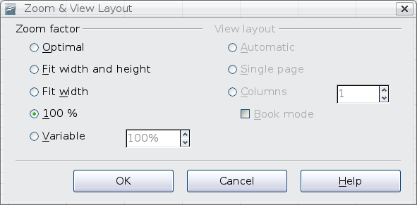
Figure 26. Zoom dialog
Optimal
Resizes the display to fit the width of the selected cells. To use this option, you must first highlight a range of cells.
Fit Width and Height
Displays the entire page on your screen.
Fit Width
Displays the complete width of the document page. The top and bottom edges of the page may not be visible.
100%
Displays the document at its actual size.
Variable
Enter a zoom percentage of your choice.

Freezing Rows and Columns
Freezing locks a number of rows:
- at the top of a spreadsheet
- a number of columns on the left of a spreadsheet
- or both.
After freezing, frozen columns and rows remain in view even when scrolling around within the sheet.
Figure 27 shows some frozen rows and columns. The heavier horizontal line between rows 3 and 14 and the heavier vertical line between columns C and H denote the frozen areas. Rows 4 through 13 and columns D through G have been scrolled off the page. The first three rows and columns remained because they are frozen into place.
You can set the freeze point at one row, one column, or both a row and a column as in Figure 27.
Freezing single rows or columns
- Click on the header for the row below where you want the freeze or for the column to the right of where you want the freeze.
- Choose Window > Freeze.
A dark line appears, indicating where the freeze is put.
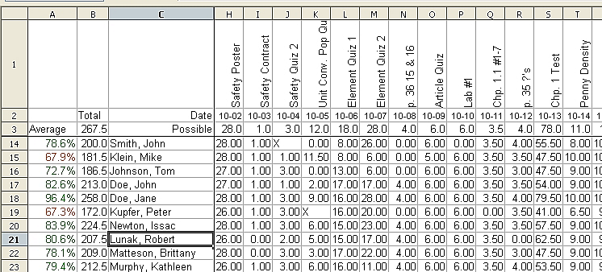
Figure 27. Frozen rows and columns
Freezing a row and a column
- Click into the cell that is immediately below the row you want frozen and immediately to the right of the column you want frozen.
- Choose Window > Freeze.
Two lines appear on the screen, a horizontal line above this cell and a vertical line to the left of this cell. Now as you scroll around the screen, everything above and to the left of these lines will remain in view.
Unfreezing
To unfreeze rows or columns, choose Window > Freeze. The check mark by Freeze will vanish.

Splitting the Screen
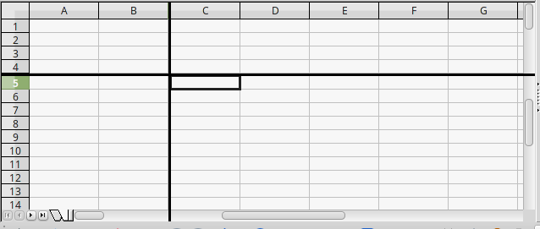

Figure 28. Split screen example
Another way to change the view is by splitting the screen. A screen can be split horizontally, vertically, or both. You can therefore have up to four portions of the spreadsheet in view at any one time.
For example, let's say you're working with a large spreadsheet, one of whose cells contains a number that is used by three formulas in other cells. Splitting the screen allows you to position the cell containing the number in one section, and each of the cells with formulas in the other sections.
That then allows you to change the value in the cell, and observe how it affects each formula.

Splitting the Screen Horizontally
To split the screen horizontally:
- Move the mouse pointer into the vertical scroll bar, on the right-hand side of the screen, and place it over the small button at the top with the black triangle.
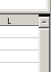

Figure 29. Split screen bar on vertical scroll bar
Split screen bar
- Immediately above this button, you will see a thick black line (Figure 29). Move the mouse pointer over this line, and it turns into a line with two arrows (Figure 30).

Figure 30. Split-screen bar on vertical scroll bar with cursor
- Hold down the left mouse button. A gray line appears, running across the page. Drag the mouse downwards and this line follows.
- Release the mouse button and the screen splits into two views, each with its own vertical scroll bar. You can scroll the upper and lower parts independently.
Tip | You can also split the screen using a menu command. Click in a cell immediately below and to the right of where you wish the screen to be split, and choose Window > Split.

Splitting the Screen Vertically
To split the screen vertically:
- Move the mouse pointer into the horizontal scroll bar at the bottom of the screen and place it over the small button on the right with the black triangle.
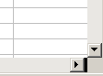

Figure 31: Split bar on horizontal scroll bar
Split screen bar
- Immediately to the right of this button is a thick black line (Figure 31). Move the mouse pointer over this line, and it turns into a line with two arrows.
- Hold down the left mouse button, and a gray line appears, running up the page. Drag the mouse to the left and this line follows.
- Release the mouse button, and the screen is split into two views, each with its own horizontal scroll bar. You can scroll the left and right parts of the window independently.
Figure 28 shows a spreadsheet that has been split both horizontally and vertically. There are four scroll bars, two for each direction, so that regions can be adjusted independently.

Removing Split Views
To remove a split view, do any of the following:
- Double-click on each split line.
- Click on and drag the split lines back to their places at the ends of the scroll bars.
- Choose Window > Split to remove all split lines at the same time.

Using the Navigator
In addition to the cell reference boxes (labeled Column and Row), the Navigator provides several other ways to move quickly through a spreadsheet and to find specific items.
To open the Navigator, click its icon on the Sidebar or the Standard toolbar, press F5, choose View > Navigator on the Menu bar, or double-click on the Sheet Sequence Number in the Status Bar. You can dock the Navigator to either side of the main Calc window or leave it floating. To dock or float the Navigator, hold down the Control key and double-click in an empty area near the icons at the top.
The Navigator displays lists of all the objects in a spreadsheet document, grouped into categories. If an indicator (plus sign or arrow) appears next to a category, at least one object of this kind exists. To open a category and see the list of items, click on the indicator.
To hide the list of categories and show only the icons at the top, click the Contents icon . Click this icon again to show the list.
Table 2 summarizes the functions of the icons at the top of the Navigator.
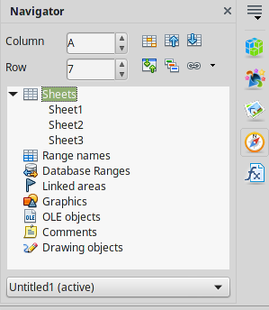
Figure 32: The Navigator in Calc's Sidebar
Table 2: Function of icons in the Navigator
Icon | Action
 | Data Range. Specifies the current data range denoted by the position of the cell cursor.
 | Start/End. Moves to the cell at the beginning or end of the current data range, which you can highlight using the Data Range button.
 | Contents. Shows or hides the list of categories.
 | Toggle. Switches between showing all categories and showing only the selected category.
 | Displays all available scenarios. Double-click a name to apply that scenario. See Chapter 9 (Data Analysis) for more information.
 | Drag Mode. Choose hyperlink, link, or copy. See “Choosing a Drag Mode” for details.

Moving Quickly through a Document
The Navigator provides several convenient ways to move around a document and find items in it.
- To jump to a specific cell in the current sheet, type its cell reference in the Column and Row boxes at the top of the Navigator and press the Enter key; for example, in Figure 32 the cell reference is A7.
- When a category is showing the list of objects in it, double-click on an object to jump directly to that object’s location in the document.
- To see the content in only one category, highlight that category and click the Toggle icon. Click the icon again to display all the categories.
- Use the Start and End icons to jump to the first or last cell in the selected data range.
Tip | Ranges, scenarios, pictures, and other objects are much easier to find if you have given them informative names when creating them. Instead of keeping Calc’s default Graphics 1, Graphics 2, Object 1, and so on, use mnemonics in assigning names, in order to indicate the position of the object in the document.

Choosing a Drag Mode
Sets the drag and drop options for inserting items into a document using the Navigator.
Insert as Hyperlink
Creates a hyperlink when you drag and drop an item into the current document.
Insert as Link
Inserts the selected item as a link where you drag and drop an object into the current document.
Insert as Copy
Inserts a copy of the selected item where you drag and drop in the current document. You cannot drag and drop copies of graphics or OLE objects.

Using Document Properties
To open the Properties dialog for a document, choose File > Properties.
The Properties dialog has six tabs. The information on the General tab and the Statistics tab is generated by the program. Other information (the name of the person on the Created and Modified lines of the General tab) is derived from the User Data page in Tools > Options.
The Internet tab is relevant only to HTML documents. The file sharing options on the Security tab are discussed elsewhere in this book.
Use the Description and Custom Properties pages to hold:
- Metadata to assist in classifying, sorting, storing, and retrieving documents. Some of this metadata is exported to the closest equivalent in HTML and PDF; some fields have no equivalent and are not exported.
- Information that changes. You can store data for use in fields in your document; for example, the title of the document, contact information for a project participant, or the name of a product might change during the course of a project.
This dialog can be used in a template, where the field names can serve as reminders to users of information they need to include.
You can return to this dialog at any time and change the information you entered. When you do so, all the references to that information will change wherever they appear in the document. For example, on the Description tab (Figure 33) you might need to change the contents of the Title field from the draft title to the final title.
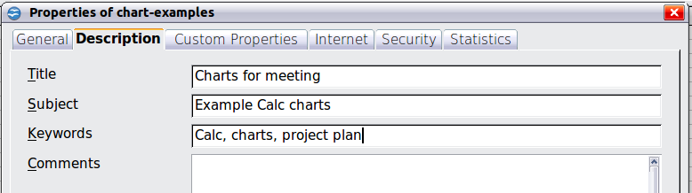
Figure 33: The Description page of the document’s Properties dialog
Use the Custom Properties tab (Figure 34) to store information that does not fit into the fields supplied on the other pages of this dialog box.
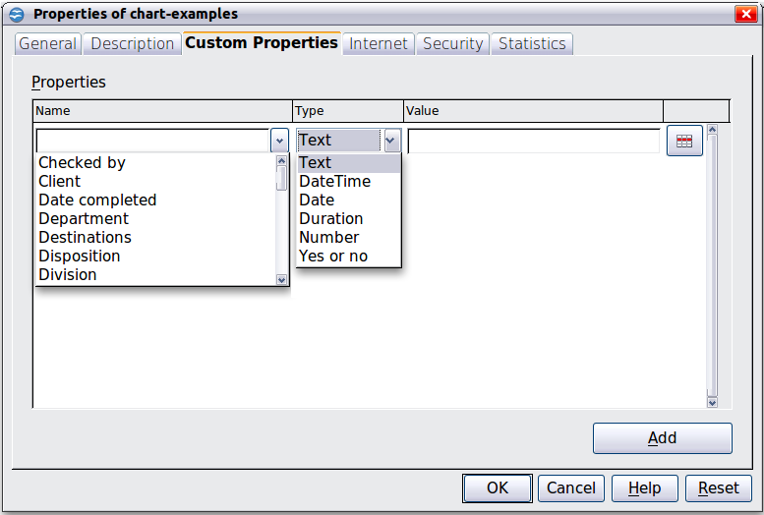
Figure 34: Custom Properties page, showing drop-down lists of names and types
When the Custom Properties tab is first opened in a new document, it may be blank. However, if the new document is based on a template, this page may contain fields.
Click Add to insert a row of boxes into which you can enter your custom properties.
- The Name box includes a drop-down list of typical choices; scroll down to see all the choices. If none of the choices meet your needs, you can type a new name into the box.
- In the Type column, you can choose from text, date+time, date, number, duration, or yes/no for each field. You cannot create new types.
- In the Value column, type or select what you want to appear in the document where this field is used. Choices may be limited to specific data types depending on the selection in the Type column; for example, if the Type selection is Date, the Value for that property is limited to a date.
To remove a custom property, click the button at the end of the row.
Tip | To change the format of the Date value, go to Tools > Options > Languages and change the Locale setting. Be careful! This change affects all open documents, not just the current one.

Chapter 2
Entering, Editing, and Formatting Data

Introduction
You can enter data into Calc in several ways:
- with the keyboard
- with dragging and dropping with the mouse
- with the Fill tool
- with selection lists.
Calc also allows users to enter information simultaneously into multiple sheets of the same document. Data can also be read from a database or text-based files like CSV (comma-separated values).

Entering Data Using the Keyboard
Most data entry in Calc can be accomplished using the keyboard.

Entering Numbers
Click in the cell and type in the number using the number keys on either the main keyboard or the numeric keypad.
To enter a negative number, either type a minus (–) sign in front of it, or enclose it in parentheses (brackets), like this: (1234).
By default, numbers are right-aligned, and negative numbers have a leading minus symbol.

Entering Text
Click in the cell and type the text. Text is left-aligned by default.

Entering Numbers as Text
If a number is entered in the format 01481, Calc will drop the leading 0. (One exception is discussed in the Tip below.) To preserve a leading zero, as some contexts like telephone numbers might require, type an apostrophe before the number, for example, '01481. When you do that, the data in question is treated as text and displayed exactly as entered. Typically, calculations carried out by formulas will treat the entry as a zero or ignore it.
Tip | Numbers can have leading zeros and still be regarded as numbers (as opposed to text) if the cell is formatted appropriately. Right-click on the cell and choose Format Cells > Numbers. Adjust the Leading zeros setting to add leading zeros to numbers.

Note | When a plain apostrophe is used to allow a leading 0 to be displayed, it is not visible in the cell after the Enter key is pressed and it's not treated as part of the cell's contents. For example, it will not be detected by the Find & Replace function. If “smart quotes” are used for apostrophes, the apostrophe remains visible in the cell.  To choose this type of apostrophe, use Tools > AutoCorrect Options > Localized Options. Select the Replace option for apostrophes to activate this function. But be advised that whatever apostrophe type you settle upon will affect both Calc and Writer.

Caution | When a number is formatted as text, take care that the cell containing the number is not used in a formula. In that scenario, Calc will simply ignore the value.

Entering Dates and Times
Select the cell and type the date or time. You can separate the date elements with a slash (/) or a hyphen (–) or use text such as 10 Oct 03. Calc recognizes a variety of date formats. You can separate time elements with colons, such as 10:43:45.

Entering Special Characters
A “special” character is one not found on a standard English keyboard. For example, © ¾ æ ç ñ ö ø ¢ are all special characters. To insert a special character:
- Place the cursor where you want the character to appear in your document.
- Click Insert > Special Character to open the Special Characters dialog (Figure 1).
- Select the characters (from any font or mixture of fonts) you wish to insert in order; then click OK. The selected characters are shown in the bottom left of the dialog. As you select each character, it is shown alone at the bottom right, along with the numerical code for that character.
Note | Different fonts include different special characters. If you do not find a particular special character you want, try changing the Font selection.

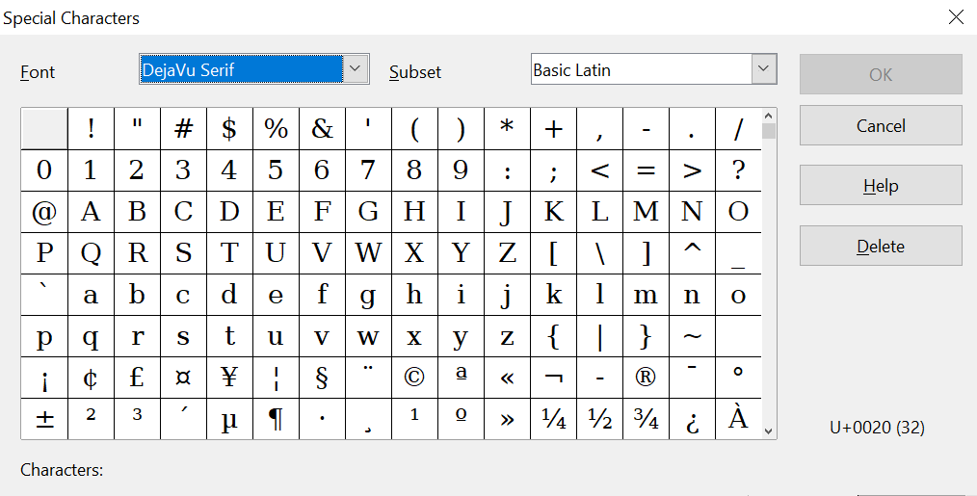

Figure 1: The Special Characters dialog

Inserting Dashes
To enter en and em dashes, you can use the Replace dashes option under Tools > AutoCorrect Options > Options tab. Under certain conditions, this option replaces two hyphens with the corresponding dash.
In the following table, the A and B represent text consisting of letters A to Z or digits 0 to 9.
Text that you type: | Result
A - B (A, space, minus, space, B) | A – B (A, space, en-dash, space, B)
A -- B (A, space, minus, minus, space, B) | A – B (A, space, en-dash, space, B)
A--B (A, minus, minus, B) | A—B (A, em-dash, B)
A-B (A, minus, B) | A-B (unchanged)
A -B (A, space, minus, B) | A -B (unchanged)
A --B (A, space, minus, minus, B) | A –B (A, space, en-dash, B)

Deactivating Automatic Changes
Calc automatically applies many changes during data input unless you deactivate those changes. You can also immediately undo any automatic changes with Ctrl+Z.
AutoCorrect changes
Automatic correction of typing errors, replacement of straight quotation marks by curly (custom) quotes, and starting cell content with an uppercase (capital) letter are controlled by Tools > AutoCorrect Options. Go to the Options or Replace tabs to deactivate any features you do not want. On the Replace tab, you can also delete unwanted word pairs and add new ones as required.
AutoInput
When you are typing in a cell, Calc automatically suggests matching input found in the same column. To turn the AutoInput on and off, set or remove the check mark in front of Tools > Cell Contents > AutoInput.
Automatic date conversion
Calc automatically converts certain entries to dates. To ensure that an entry that looks like a date is interpreted as text type an apostrophe at the beginning of the entry.; the apostrophe is not displayed in the cell.

Speeding up Data Entry
Entering data into a spreadsheet can be labor-intensive, but Calc provides several tools for removing some of the drudgery from input.
The most basic of these is to drop and drag the contents of one cell to another with a mouse. Many people also find AutoInput helpful.
Calc includes several other tools for automating input, especially of repetitive material. They include the Fill tool, selection lists, and the ability to input information into multiple sheets of the same document.

Using the Fill Tool on Cells
At its simplest, the Fill tool duplicates existing content. Start by selecting the cell to copy, then drag the mouse in any direction (or hold down the Shift key and click in the last cell you want to fill), and then choose Edit > Fill and the direction in which you want to copy: Up, Down, Left, or Right.

Caution | Unavailable choices are grayed out, but you can still choose the opposite direction from what you intend. That could cause you to overwrite cells accidentally.

Tip | A shortcut to fill cells is to grab the “handle” in the lower right-hand corner of the cell and drag it in the direction you want to fill. If the cell contains a number, the number will fill in series. If the cell contains text, the same text will fill in the direction you chose. If the cell contains a number and you hold the Ctrl key while dragging the handle, the number will not increment within the fill area.


Figure 2: Using the Fill tool

Using a Fill Series
A more complex use of the Fill tool is to use fill series. The default lists are for the full and abbreviated days of the week and the months of the year, but you can also create your own lists.
To add a fill series to a spreadsheet, select the cells to fill and choose Edit > Fill > Series. In the Fill Series dialog, select AutoFill as the Series type and enter an item from any defined series as the Start value. The selected cells then fill in the other items on the list sequentially, repeating from the top when they reach the end of the list.
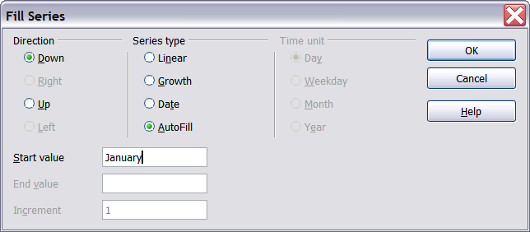
Figure 3: Specifying the start of a fill series (result is in Figure 4)
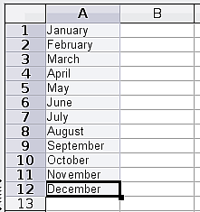
Figure 4: Result of fill series selection shown in Figure 3
You can also use Edit > Fill > Series to create a one-time fill series for numbers by entering the start and end values and the increment. For example, if you entered start and end values of 1 and 7 with an increment of 2, you would get the sequence of 1, 3, 5, 7.
In such cases, the Fill tool creates only a momentary connection between the cells. Once they are filled, the cells have no further connection with one another.

Defining a Fill Series
To define your own fill series, go to Tools > Options > OpenOffice Calc > Sort Lists. This dialog shows the previously defined series in the Lists box on the left and the contents of the highlighted list in the Entries box.
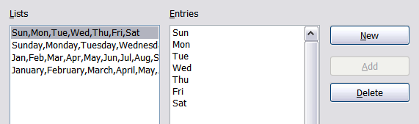
Figure 5: Predefined fill series
Click New. The Entries box is cleared. Type the series for the new list in the Entries box (one entry per line), then click Add.
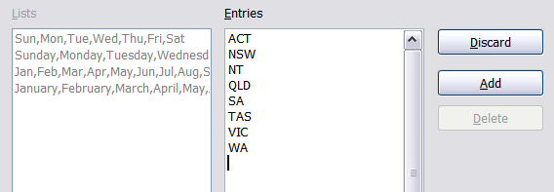
Figure 6: Defining a new fill series

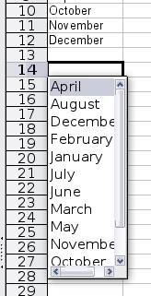
Using Selection Lists
Selection lists are available only for text and are limited to using only text that has already been entered in the same column.
To use a selection list, select a blank cell and press Ctrl+D. A drop-down list appears on any cell in the same column with at least one text character or whose format is defined as text. Click on the entry you require.

Sharing Content between Sheets
You might want to enter the same information in the same cell on multiple sheets, for example, to set up standard listings for a group of individuals or organizations. Instead of entering the list on each sheet individually, you can enter it in all the sheets at once. To do this, select all the sheets with Edit > Sheet > Select and using Shift + Click or Ctrl + Click, then enter the information in the current one.
Caution | This technique overwrites any information already in the cells on the other sheets—without any warning. For this reason:  - be careful with this tool  - when you are finished, be sure to deselect all the sheets except the one you want to edit. (Ctrl+click on a sheet tab to select or deselect the sheet.)

Validating Cell Contents
When creating spreadsheets for other people to use, you may want to make sure they enter data that is valid or appropriate for the cell. You can also use validation in your own work as a guide to entering data that is either complex or rarely used.
Fill series and selection lists can handle some types of data but are limited to predefined information. To validate new data entered by a user, select a cell and use Data > Validity to define the type of contents that can be entered in the cell. For example, a cell might require a date or a whole number, with no alphabetic characters or decimal points, or a cell can be defined so that it cannot be left empty.
Depending on how validation is set up, the tool can also define the range of values that can be entered and provide help messages that:
- explain the content rules you have set up for the cell
- explain what users should do when they enter invalid content.
You can also set the cell to refuse invalid content, accept it with a warning, or—if you are especially well-organized—start a macro when an error is entered.
Validation is most useful for cells containing functions. If cells are set to accept invalid content with a warning, rather than refusing it, you can use Tools > Detective > Mark Invalid Data to find the cells with invalid data. The Detective function marks any cells containing invalid data with a circle.
Note that a validity rule is considered part of a cell’s format. If you select Format or Delete All from the Delete Contents window, the rule is removed. To copy a validity rule with the rest of the cell, use Edit > Paste Special > Paste Formats or Paste All.
Figure 7 shows the choices for a typical validity test. Note the Allow blank cells option under the Allow list.
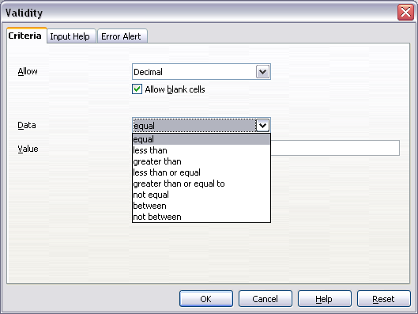
Figure 7: Typical validity test choices
Validity test options vary with the type of data selected from the Allow list. For example, Figure 8 shows the choices when a cell must contain a value from a cell range.
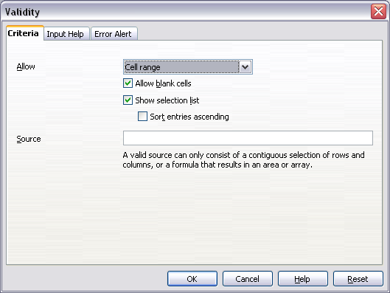
Figure 8: Validity choices for a cell range
To provide input help for a cell, use the Input Help tab of the Validity dialog (Figure 9). To show an error message when an invalid value is entered, use the Error Alert tab (Figure 10). Be sure to write a helpful explanation of what a valid entry should contain. Provide more than just a simple “invalid data—try again” message. To be of real help to users, particularly inexperienced ones, error messages need to provide details not only on what went wrong but also on how to correct it.
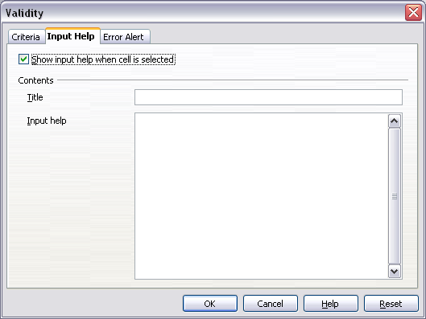
Figure 9: Defining input help for a cell
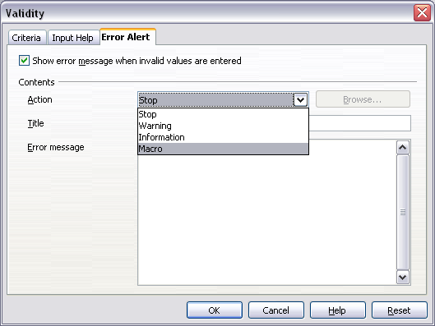
Figure 10: Defining an error message for a cell
with invalid data

Editing Data
Editing data is very similar to entering it. The first step is to select the cell containing the data to be edited.

Removing Data from a Cell
Data can be removed (deleted) from a cell in several ways.
Removing data only
Data can be removed from a cell without removing any of the cell's formatting. Click in the cell to select it; then press the Backspace key.
Removing data and formatting
Data and its formatting can be removed from a cell simultaneously. Press the Delete key (or right-click and choose Delete Contents, or use Edit > Delete Contents) to open the Delete Contents dialog (Figure 11). From this dialog, different aspects of the cell can be deleted. To delete everything in a cell (contents and format), check Delete all.
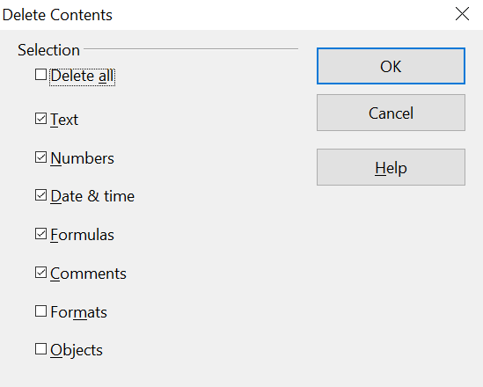

Figure 11: Delete Contents dialog

Replacing All the Data in a Cell
To remove data and insert new items, simply type over the old data. The new data will retain the original formatting.

Changing Part of the Data in a Cell
Sometimes, it's necessary to change the contents of a cell without removing all the contents. As an example, consider the phrase “See Dick run” in a cell that needs to be changed to “See Dick run fast.” It's often useful to do tasks like this without deleting old cell contents first.
The process is similar to the one described above. The difference in this case is that you need to place the cursor inside the cell. You can do this in two ways.
Using the keyboard
After selecting the appropriate cell, press the F2 key, and the cursor will be placed at the end of the cell. Then, use the keyboard arrow keys to move the cursor through the text in the cell.
Using the mouse
Using the mouse, either double-click on the appropriate cell (to select it and place the cursor in it for editing) or single-click to select the cell, move the mouse pointer up to the input line, and click into it to place the cursor for editing.

Formatting Data
The data in Calc can be formatted in several ways. It can be edited as part of a cell style so that it is automatically applied or applied manually to the cell. Some manual formatting can be applied using icons on the Properties deck of the Sidebar or on toolbars. For more control and extra options, select the appropriate cell or cell range and click the More Options icon at the top right of any of the panels of the Sidebar's Properties deck. You can also right-click on the selected cell or cell range and select Format Cells. All of the format options are discussed below.
Note | All the settings discussed in this section can also be set as a part of the cell style. See Chapter 4 (Using Styles and Templates) for more information.

Formatting Multiple Lines of Text
Multiple lines of text can be entered into a single cell using automatic wrapping or manual line breaks. Each of these methods is useful and can be applied to different situations.

Using Automatic Wrapping
To set text to wrap at the end of the cell, right-click on the cell and select Format Cells (or choose Format > Cells from the menu bar, or press Ctrl+1). On the Alignment tab (Figure 13), under Properties, select Wrap text automatically. The results are shown below (Figure 12).
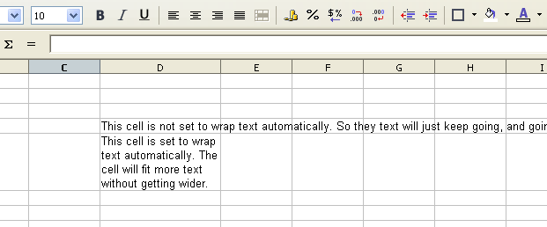

Figure 12: Automatic text wrap
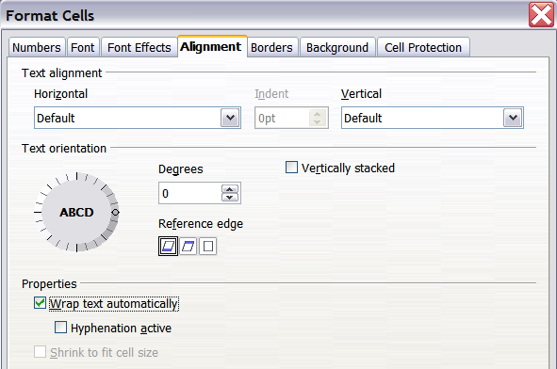
Figure 13: Format Cells > Alignment dialog

Using Manual Line Breaks
To insert a manual line break at the current cursor position while typing in a cell, press Ctrl+Enter. Be aware that this method does not work with the cursor in the input line; you must be typing in the cell. When editing text, first double-click the cell, then single-click at the position where you want the line break.
When a manual line break is entered, the cell width does not change. Figure 14 shows the results of using two manual line breaks after the first line of text.
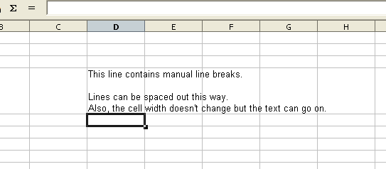

Figure 14: Cell with manual line breaks

Shrinking Text to Fit the Cell
The font size of the data in a cell can automatically adjust to fit in a cell. To do this, select the Shrink to fit cell size option in the Format Cells dialog (Figure 13). Figure 15 shows the results.
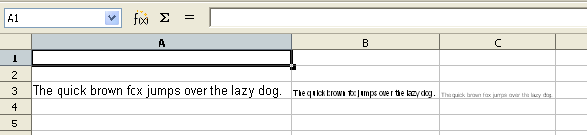

Figure 15: Shrinking font size to fit cells

Formatting Numbers
Several different number formats can be applied to cells using icons on either the Sidebar or the Formatting toolbar. Select the cell, then click the relevant icon. Some icons may not be visible in a default setup; click the down arrow at the end of the Formatting bar and select other icons to display.

Figure 16: Number format icons. Left to right: currency, percentage, date, exponential, standard, add decimal place, delete decimal place.
Use the Numbers tab (Figure 17) of the Format Cells dialog for more control, or to select other number formats.
- Apply any of the data types in the Category list to the data.
- Control the number of decimal places and leading zeros.
- Enter a custom format code.
The Language setting controls the local settings for the different formats, such as the date order and the currency marker.
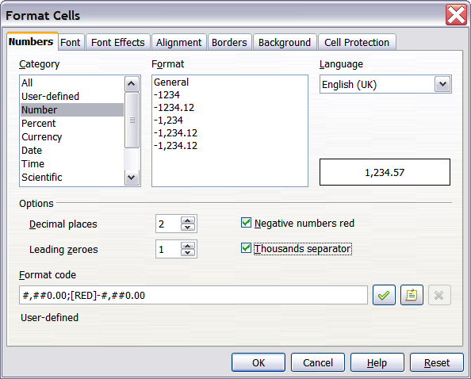
Figure 17: Format Cells > Numbers

Formatting the Font
To quickly choose the font used in a cell:
- select the cell
- click the arrow next to the Font Name box on the Formatting toolbar
- choose a font from the list
Tip | To choose whether to show the font names in their font or in plain text, go to Tools > Options > OpenOffice > View and select or deselect the Show preview of fonts option in the Font Lists section. For more information, see Chapter 14 (Setting Up and Customizing Calc).

To choose font size, click the arrow next to the Font Size box on the Sidebar's Text panel or the Formatting toolbar. For other formatting, you can use the Bold, Italic, or Underline icons.
To choose a font color, click the arrow next to the Font Color icon to display a color palette. Click on the required color.
(To define custom colors, use Tools > Options > OpenOffice > Colors. See Chapter 14 for more information.)
To specify the language of the cell (useful because it allows different languages to exist in the same document and be spell-checked correctly), use the Font tab of the Format Cells dialog. See Chapter 4 for more information.

Choosing Font Effects
The Font Effects tab (Figure 18) of the Format Cells dialog offers more font options.
Overlining and underlining
You can choose from various overlining and underlining options (solid lines, dots, short and long dashes, in various combinations) and the color of the line.
Strikethrough
The strikethrough options include lines, slashes, and Xs.
Relief
The relief options are embossed (raised text), engraved (sunken text), outline, and shadow.
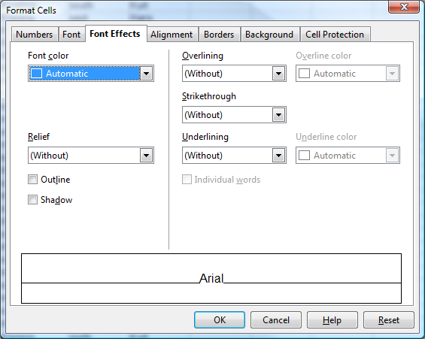

Figure 18: Format Cells > Font Effects

Setting Cell Alignment and Orientation
Some cell alignment and orientation icons are not shown by default on the Formatting toolbar. To show them, click on the small arrow at the right-hand end of the toolbar and select them from the list of icons. Most of the icons are also available on the Sidebar in the alignment panel of the Properties deck.
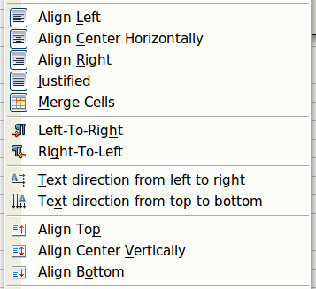
Figure 19: Cell alignment and orientation
Some of the alignment and orientation icons are available only if you have Asian or CTL (Complex Text Layout) languages enabled (in Tools > Options > Language Settings > Languages). If you choose an unavailable icon from the list, it will not appear in the toolbar.
For more control and other choices, use the Alignment tab (Figure 13) of the Format Cells dialog to set the horizontal and vertical alignment and rotate the text. If you have Asian languages enabled, the Text orientation section shows an extra option (labeled Asian layout mode) under the Vertically stacked option, as shown in Figure 20.
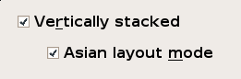
Figure 20: Asian layout mode option
The difference in results between having Asian layout mode on or off is shown in Figure 21.
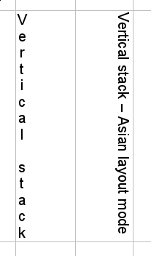
Figure 21: Types of vertical stacking

Formatting the Cell Borders
To choose a line style and color for the borders of a cell quickly, click the small arrows next to the Line Style and Line Color icons on the Cell Appearance panel of the Sidebar. In each case, a palette of choices is displayed. These are also available on the Formatting toolbar. If the Line Style and Line Color icons are not shown in the formatting toolbar, select the down arrow on the right side of the bar, then select Visible Buttons.
For more control, including the spacing between the cell borders and the text, use the Borders tab of the Format Cells dialog. This Dialog also allows you to define a shadow. See Chapter 4 for details.
Note | Cell border properties apply to a cell and can only be changed if you edit that cell. For example, if cell C3 has a top border (which would be equivalent visually to a bottom border on C2), that border can only be removed by selecting C3. It cannot be removed in C2.

Formatting the Cell Background
To quickly choose a background color for a cell, click the small arrow next to the Background Color icon on the Sidebar or the Formatting toolbar. A palette of color choices, similar to the Font Color palette, is displayed.
(To define custom colors, use Tools > Options > OpenOffice > Colors. See Chapter 14 for more information.)
You can also use the Background tab of the Format Cells dialog. See Chapter 4 for details.

Autoformatting Cells and Sheets
Use the AutoFormat feature to quickly and easily apply a set of cell formats to a sheet or a selected cell range.
- Select the cells you want to format, including the column and row headers.
- Choose Format > AutoFormat.
- To select which properties (number format, font, alignment, borders, pattern, autofit width, and height) to include in an AutoFormat, click More. Select or deselect the required options. Click OK.
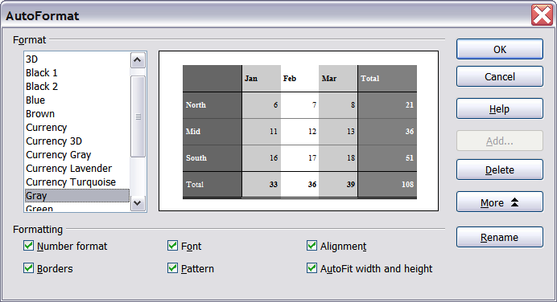
Figure 22: Choosing an AutoFormat
If you do not see any change in the color of the cell contents, choose View > Value Highlighting from the menu bar.
Note | If the selected cell range does not have column and row headers, AutoFormat is not available.

Defining a New AutoFormat
You can define a new AutoFormat that's available to all spreadsheets.
- Format a sheet.
- Choose Edit > Select All.
- Choose Format > AutoFormat. The Add button is now active.
- Click Add.
- In the Name box of the Add AutoFormat dialog, type a meaningful name for the new format.
- Click OK to save. The new format is now available in the Format list in the AutoFormat dialog.

Formatting Spreadsheets Using Themes
Calc comes with a predefined set of formatting themes you can apply to your spreadsheets.
It is not possible to add themes to Calc, and they cannot be modified. However, you can modify the styles of themes after you apply them to a spreadsheet.
To apply a theme to a spreadsheet:
- Click the Choose Themes icon in the Tools toolbar. If this toolbar is not visible, you can show it using View > Toolbars > Tools. The Theme Selection dialog appears. This dialog lists the available themes for the whole spreadsheet.
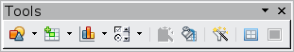
- In the Theme Selection dialog, select the theme you want to apply. As soon as you select a theme, some of the properties of the custom styles are applied to the open spreadsheet and are immediately visible.
- Click OK. You can now go to the Styles and Formatting window to modify specific styles. These modifications do not change the theme; they only change the appearance of this specific spreadsheet document.

Using Conditional Formatting
You can set up cell formats to change based on conditions that you specify. For example, in a table of numbers, you can show all the values above the average in green and all those below the average in red.
Note | To apply conditional formatting, AutoCalculate must be enabled. Choose Tools > Cell Contents > AutoCalculate.

Conditional formatting depends on the use of styles. If you are not familiar with styles, please refer to Chapter 4. An easy way to set up required styles is to format a cell the way you want it and click the New Style from Selection icon in the Styles and Formatting window. You can define new cell styles before setting up conditional formatting or do it from within the conditional formatting dialog.
To set up conditional formatting:
- In your spreadsheet, select the cells to which you want to apply conditional formatting. You may need to know which cell is the active cell to set up the formatting. If you select several cells, note which cell is active afterward.
- Choose Format > Conditional Formatting from the menu bar.
- On the Conditional Formatting dialog (Figure 19), enter the conditions. Click OK to save. The selected cells are now formatted in the relevant style.
Cell value is / Formula is
Specifies whether conditional formatting is dependent on a cell value or formula. If you select cell value is, the Cell Value Condition box is displayed, as shown in the example. With this box, you can choose from conditions including less than, greater than, between, and others.
Parameter field
Enter a cell reference, value, or formula in the parameter field or in both parameter fields if you have selected a condition requiring two parameters. You can also enter formulas containing relative references. The relative references are defined with respect to the active cell if multiple cells are selected. For example, if you selected the range A1:A10 by dragging down from A1, then A10 will be the active cell. Any relative references should be written as would be appropriate for A10. The reference will be adjusted automatically for the other cells in the range.
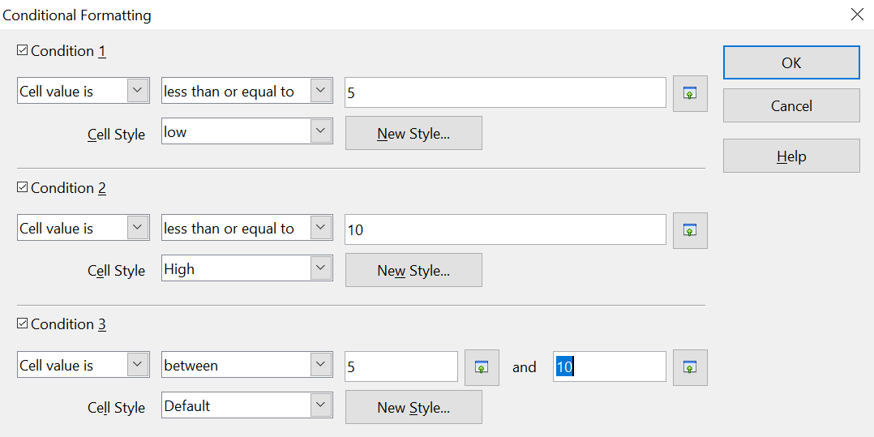

Figure 23: Conditional formatting dialog
Cell style
Choose the cell style to be applied if the specified condition matches. You can define the style by clicking on the New Style button.
See the Help for more information and examples of use.
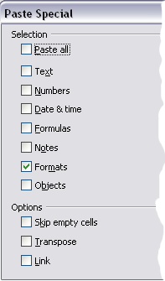
To apply the same conditional formatting later to other cells:
- Select one of the cells that have been assigned conditional formatting.
- Copy the cell to the clipboard.
- Select the cells that are to receive this same formatting.
- Choose Edit > Paste Special.
- On the Paste Special dialog, in the Selection area, select only the Formats option. Make sure all other options are not selected. Click OK.

Hiding and Showing Data
When elements are hidden, they are neither visible nor printed but can still be selected for copying if you select the elements around them. For example, if column B is hidden, it is copied when you select columns A and C. When you need a hidden element again, you can reverse the process and show the element.
To hide or show sheets, rows, and columns, use the options on the Format menu or the right-click (context) menu. For example, to hide a row, select the row and then choose Format > Row > Hide (or right-click and choose Hide).
To hide or show selected cells, choose Format > Cells from the menu bar (or right-click and choose Format Cells). On the Format Cells dialog, go to the Cell Protection tab.
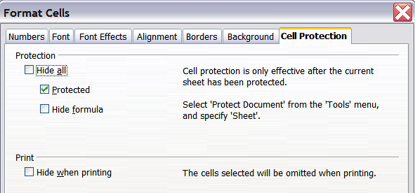
Figure 24: Hiding or showing cells

Outline Group Controls
If you continually hide and show the same cells, you can simplify the process by creating outline groups. These groups add a set of quick-to-use and always-available controls for hiding and showing the cells in the group.
If the contents of cells fall into a regular pattern, such as four cells followed by a total, then you can use Data > Group and Outline > AutoOutline to have Calc add outline controls based on the pattern. Otherwise, you can set outline groups manually by selecting the cells for grouping, then choosing Data > Group and Outline > Group. On the Group dialog, you can choose whether to group the selected cells by rows or columns.
When you close the dialog, the outline group controls are visible between the row or column headers and the edges of the editing window. In appearance, the controls resemble the tree structure of a file manager. They can be hidden by selecting Data > Group and Outline > Hide Details. They are strictly for interactive use and do not print.
The basic outline controls have plus or minus signs at the start of the group to show or hide hidden cells. However, if outline groups are nested, the controls have numbered buttons for hiding the different levels.
If you no longer need a group, place the mouse cursor in any cell and select Data > Group and Outline > Ungroup. To remove all groups on a sheet, select Data > Group and Outline > Remove.

Figure 25: Outline group controls

Filtering Which Cells are Visible
A filter is a list of conditions that each entry must meet to be displayed. You can set three types of filters from the Data > Filter sub-menu.
Automatic filters add a drop-down list to the top row of a selected range, often the whole column, that contains commonly used filters. They are quick, convenient, and almost as useful with text as with numbers because the list includes every unique entry in the selected cells.
In addition to these unique entries, automatic filters include the option to display all entries, the ten highest numerical values, and all cells that are empty or not empty, as well as a standard filter that you can customize (see below). However, they are somewhat limited. In particular, they do not allow regular expressions, so you cannot use them to display cell contents that are similar but not identical.
Standard filters are more complex than automatic filters. You can set as many as three conditions as a filter, combining them with the operators AND and OR. Standard filters are primarily useful for numbers, although a few of the conditional operators, such as = (equal) and <> (not equal) can also be used for text. Regular expressions can be turned on under More Options so that text can be matched very flexibly.
Other conditional operators for standard filters include options to display the largest or smallest values or a percentage of them. Although useful in themselves, standard filters take on added value when they are used to further refine automatic filters.
The results of the Standard filter can be copied to another location, rather than displayed in place, by hiding rows. This is very useful for creating subsets of data.
Advanced filters are structured similarly to standard filters. The differences are that advanced filters are not limited to three conditions, and their criteria are not entered in a dialog. Instead, advanced filters are entered in a blank area of a sheet and then referenced by the advanced filter tool to apply them.
Figure 16 shows a simple data set in columns A through D and filter criteria for it in columns F through I. Filter conditions that appear in the same row are connected by AND, and conditions in different rows are connected by OR. The conditions displayed will get data for (Bob & February & Price >6) OR (Ann & Pear & Price <= 5). The filter is activated with Data > Filter > Advanced Filter, where you can set the cell range containing the filter conditions. The cell range should include the first row with the headers, e.g., F1:I3. Remember that the filter conditions in the figure are positioned so that applying the filter will hide some of the rows displaying the conditions. That does not impair the filter but might prove inconvenient if you want to read the filter conditions.
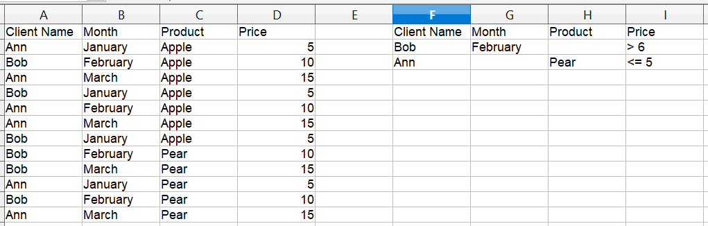

Figure 26: Advanced filter conditions for a data set before applying the filter

Sorting Records
Sorting rearranges the visible cells on the sheet. In Calc, you can sort by up to three criteria applied one after another. Sorts are handy when searching for a particular item and become even more powerful after filtering data.
In addition, sorting can be useful when adding new information. When a list is long, adding new information at the bottom of the sheet is usually easier than inserting rows in the proper places. After you have added the information, you can sort it to update the sheet.
Highlight the cells to be sorted, then select Data > Sort to open the Sort dialog (Figure 6) or click the Sort Ascending or Sort Descending toolbar buttons. Using the dialog, you can sort the selected cells using up to three columns in ascending (A-Z, 1-9) or descending (Z-A, 9-1) order.
Tip | You can define a custom sort order if the supplied alphanumeric ones do not fit your requirements. See “Defining a Fill Series” on page 43 for instructions.

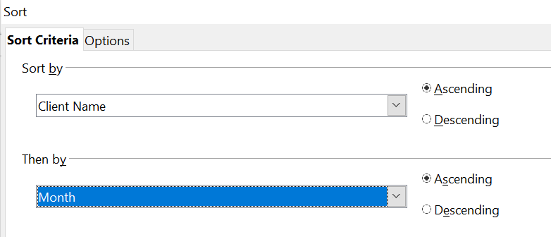

Figure 27: Choosing the criteria and order of sorting
On the Options tab of the Sort dialog (Figure 5), you can choose any of the following:
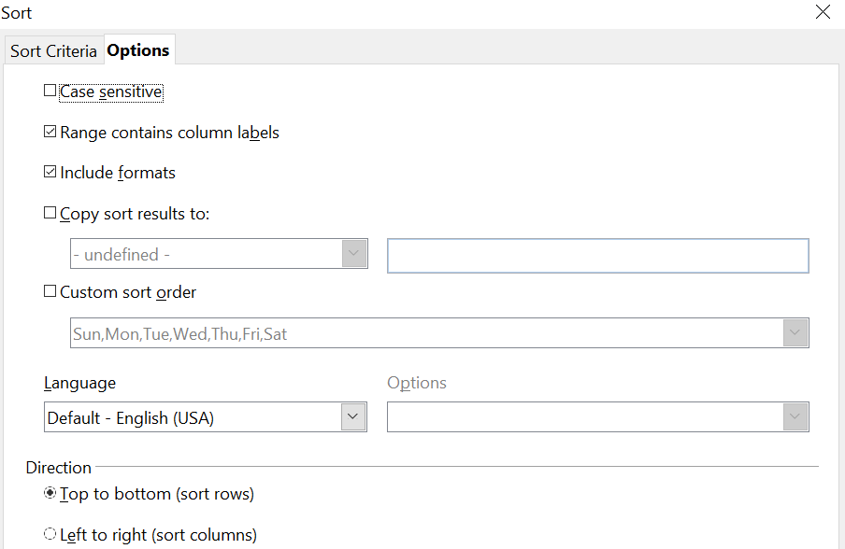

Figure 28: Options for sorting
Case sensitive
If two entries are otherwise identical, one with an upper case letter is placed before one with a lower case letter in the same position if the sort is descending. If the sort is ascending, the entry with an upper case letter is placed after one with a lower case letter in the same position.
Range contains column labels
Does not include the column heading in the sort.
Include formats
A cell's formatting is moved with its contents. If formatting is used to distinguish different types of cells, then use this option.
Copy sort results to
Sets a spreadsheet address to which to copy the sort results. If a specified range does not have the necessary number of cells, cells are added. The sort fails if a range contains cells that already have content.
Custom sort order
Select the box, then choose one of the sort orders defined in Tools > Options > OpenOffice Calc > Sort Lists from the drop-down list.
Direction
Sets whether rows or columns are sorted. The default is to sort rows.

Finding and Replacing in Calc
Calc has two ways to find text within a document:
- the Find toolbar for fast text searching
- the Find & Replace dialog

Using the Find Toolbar
The Find toolbar is located by default on the right-hand end of the Standard toolbar. You can hide or show the Find toolbar using View > Toolbars > Find.

Type a search term in the Find box, and then click the Find Next (down-arrow) or Find Previous (up-arrow) button. To find other occurrences of the same term, continue clicking the button.

Using the Find & Replace Dialog
To display the Find & Replace dialog (Figure 2), use the keyboard shortcut Control+F or choose Edit > Find & Replace from the menu bar.
In spreadsheet documents, you can search for text, formulas, and styles. You can navigate from one occurrence to the next using Find, or you can highlight all matching cells at once using Find All, then apply another format or replace the cell contents with other content.
Text and numbers in cells may have been entered directly or may be the result of a calculation. The search method you use depends on the data type you're searching for.
Tip | Cell contents can be formatted in different ways. For example, a number can be formatted as currency to be displayed with a currency symbol such as the dollar sign ($). You will see the currency symbol in the cell, but you can't search for it.

By default, Calc searches the current sheet. To search through all document sheets, click More Options, then select Search in all sheets option.

Caution | To avoid the possibility of mistakes, use Replace All with caution.  If it's not discovered promptly, a mistake with Replace All might require a laborious, time-consuming, manual, word-by-word search to fix.

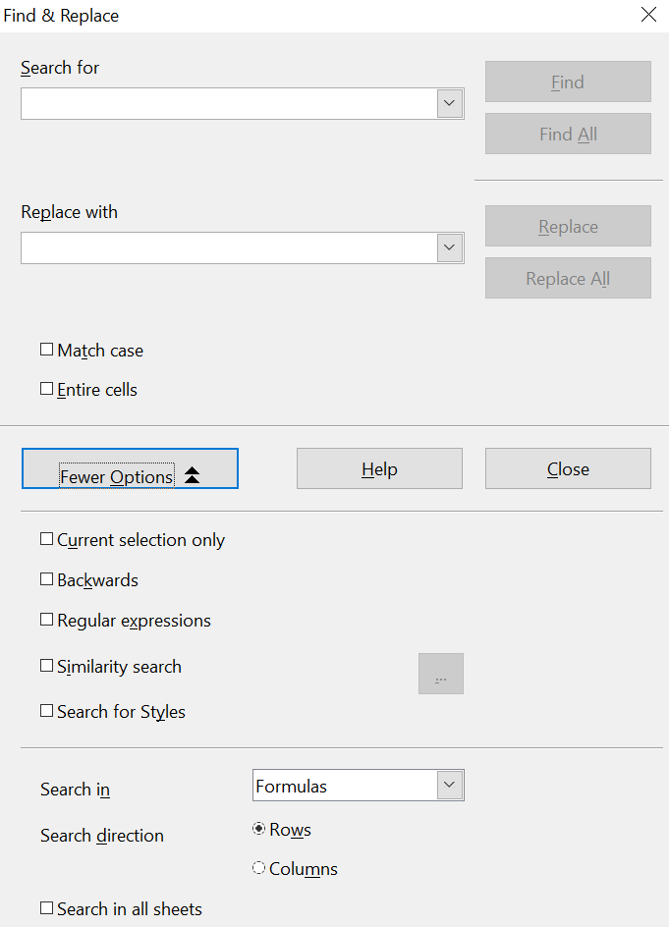

Figure 29: Expanded Find & Replace dialog

Finding and Replacing Formulas or Values
You can use the Find & Replace dialog to search in formulas or the displayed values resulting from a calculation.
- To open the Find & Replace dialog, use the keyboard shortcut Control+F or select Edit > Find & Replace.
- Click More Options to expand the dialog.
- Select Formulas or Values in the Search in drop-down list.
- Formulas finds parts of the formulas.
- Values finds the results of the calculations.
- Type the text you want to find in the Search for box.
- To replace the text with different text, type the new text in the Replace with box.
- When you have set up your search, click Find. To replace text, click Replace instead.

Finding and Replacing Text
- Open the Find & Replace dialog, click More Options to expand the dialog, and select Values or Notes in the Search in drop-down list.
- Type the text you want to find in the Search for box.
- To replace the text with different text, type the new text in the Replace with box.
- Click Find, Find All, Replace, or Replace All.
When you click Find, Calc selects the next cell that contains your text. You can edit the text, then click Find again to advance to the next found cell. If you closed the dialog, you can press Ctrl+Shift+F to find the next cell without opening the dialog.
When you click Find All, Calc selects all cells that contain your entry. Now, you can apply a cell style to all of them simultaneously.

Finding and Replacing Cell Styles
To quickly change all the paragraphs of an unwanted style to another preferred style:
- On the expanded Find & Replace dialog, select Search for Styles. The Search for and Replace with boxes now contain a list of styles.
- Select the styles you want to search for and replace.
- Click Find, Find All, Replace, or Replace All.

Using Wildcards (Regular Expressions)
Wildcards, one form of what's known as regular expressions, are a character or combination of characters that describe to AOO a pattern of text. For example, the regular expression \d represents any of the numeric characters 0 – 9. The full set of regular expressions is too large to explain here, but we'll present a few tips about using them in Calc. The table below describes the regular expressions used in the following examples.

Regular Expression | Meaning
. | Any character
+ | One or more of the preceding character. So, .+ means one or more of any character.
? | Zero or one of the preceding character. The expression an? would match both a and an because the ? allows for zero or one n after the a.
\n | A hard line break within a cell.
$ | The end of a paragraph of text. The expression xls$ matches xls if is at the end of the paragraph, as it would be in a list of filenames with one filename per cell.
^ | The beginning of a paragraph.
& | In the Replace with box of the Find & Replace dialog, this represents the text found by the search.

To use wildcards and regular expressions when searching and replacing:
- On the Find & Replace dialog, click More Options to see more choices. On this expanded dialog, select the Regular expressions option.
- Type the search text, including the wildcards, in the Search for box and the replacement text (if any) in the Replace with box.
- Click Find, Find All, Replace, or Replace All (not recommended).
Tip | The online help describes many of the regular expressions and their uses.

The following points may be of interest to Calc users:
- In Calc, regular expressions are applied separately to each cell. This means that a search for r.d will match red in cell A1 but not r in cell A2 and d (or ed) in cell A3. (The regular expression r.d means the system will try to match r followed by any other character followed by d.)
- When a match is found, the entire cell is highlighted, but only the text found will be replaced. For example, searching for brown will highlight a cell containing redbrown clay, and choosing nothing in the Replace with box leaves the cell containing red clay.
- If Find is used twice in a row, and the second time the Current selection only box is activated, then the second search will evaluate the whole of each selected cell, not just the strings that caused the cells to be selected in the first search. For example, searching for joh?n, then activating Current selection only and searching for sm.th will find cells containing Jon Smith and Smythers, Johnathon.
- If a cell contains a hard line break (entered by Ctrl+Enter), it may be found by using the regular expression \n. For example, if a cell contains red[hard line break]clay, searching for d\nc and entering nothing in the Replace with box leaves the cell containing relay.
- The hard line break acts to mark “end of text” (similar to “end of paragraph” in Writer), found by the regular expression special character $, in addition to the end of text in the cell. For example, if a cell contains red [hard line break] clay, then a search for d$ replacing it with al leaves the cell with real [hard line break] clay. Note that with this syntax, the hard line break is not replaced.
- Using \n in the Replace with box will replace with the literal characters \n, not a hard line break.
- The Find & Replace dialog has an option to search within formulas, values, or notes. This option applies to any search, not just one using regular expressions. Searching with the Formulas option for SUM would find a cell containing the formula =SUM(A1:A6) and a cell containing the simple text SUMMARY. If you search in the Values for SUM, you will find the text SUMMARY but not the cell with the SUM() formula because the cell value will be a number.
- Searching for the regular expression ^$ will not find empty cells. This is intentional to avoid performance issues when selecting a huge number of cells. Note that empty cells will not be found even if you only search a selection.
- Finding cell contents using the regular expression .+ (or similar) and replacing them with & effectively re-enters the cell contents without any formatting. This technique can remove Calc's automatically applied formatting when importing data from the clipboard or badly formatted files. For example, to convert text strings consisting of digits into actual numbers, format the cells as numbers, and then perform the search and replace.
See Chapter 7 (Using Formulas and Functions) for the use of regular expressions within formulas. For now, just know that a regular expression is a sequence of characters that can be used as shorthand for a larger sequence or set of sequences.

Chapter 3
Creating Charts and Graphs
Presenting information visually

Introduction
Charts and graphs can be powerful ways to inform users. OpenOffice Calc offers a variety of chart and graph formats for your data.
With Calc, you can customize charts and graphs considerably, allowing you to present information in the most clear and informative way possible.

Creating a Chart
To demonstrate the process of making charts and graphs in Calc, we will use the small table of data in Figure 1.
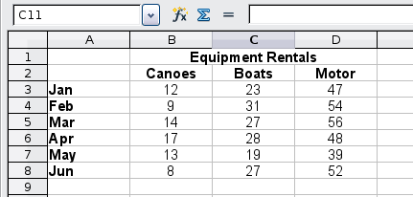
Figure 1: Table of data for charting examples
To create a chart, first highlight (select) the data to be included in the chart. The selection does not need to be in a single block, as shown in Figure 2; you can also choose individual cells or groups of cells (columns or rows). See Chapter 1 (Introducing Calc) for more information about selecting cells and ranges of cells.
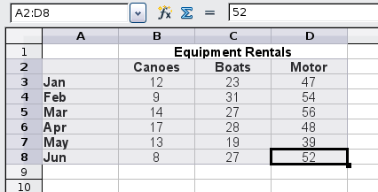
Figure 2: Selecting data for plotting
Next, open the Chart Wizard dialog using one of two methods.
- Choose Insert > Chart from the menu bar.
- Or, click the Chart icon on the main toolbar.
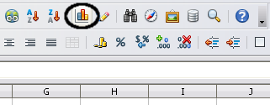
Figure 3: Insert chart from main toolbar
Either method inserts a sample chart on the worksheet, opens the Formatting toolbar, and opens the Chart Wizard, as shown in Figure 4.
Tip | Before choosing the Chart Wizard, place the cursor anywhere in the area of the data. The Chart Wizard will then do a fairly good job of guessing the range of the data. If the Chart Wizard struggles to select the data you want, select the cells manually before starting the Chart Wizard.

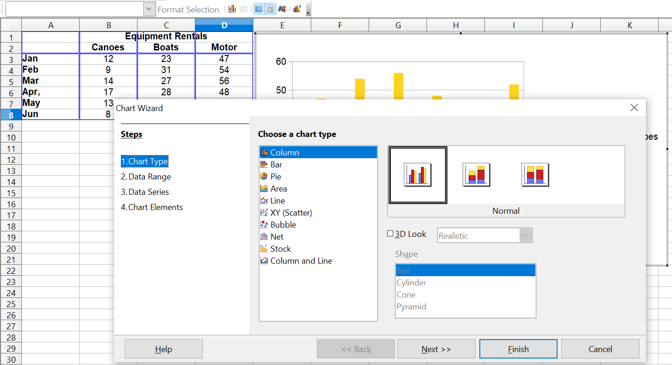

Figure 4: Chart Wizard, Step 1—Choose a chart type

Choosing a Chart Type
The Chart Wizard includes a sample chart with your data. This sample chart updates to reflect your changes in the Chart Wizard.
The Chart Wizard has three main parts:
- a list of steps involved in setting up the chart
- a list of chart types
- the options for each chart type.
At any point, when using Chart Wizard, you can go back to a previous step and change selections.
Calc offers a choice of 10 basic chart types with a few options for each. The options vary according to the type of chart you pick.
The first tier of choice is for two-dimensional (2D) charts. Only those types suitable for 3D (Column, Bar, Pie, and Area) give you the option to select a 3D aspect.
On the Choose a chart type page (Figure 4), select a type by clicking its icon. The preview updates every time you select a different type of chart and provides a good idea of what the finished chart will look like.
The current selection is highlighted (shown with a surrounding box) on the Choose a chart type page. The chart’s name is displayed just below the icons. For now, we will stick to the Column chart and click on Next again.

Changing Data Ranges and Axes Labels
In Step 2, Data Range, you can manually correct any mistakes made in selecting the data.
On this page, you can also change how you plot data by using rows—rather than columns—as data series. The Chart Wizard attempts to set this and the following setups automatically, according to the layout of the data. (This often works, but you may need to correct the default settings.)
Lastly, you can choose to use the first row, first column, or both as labels on the chart's axes.
You can confirm what you have done so far by clicking the Finish button or clicking Next to change some details of the chart.
Now we'll click Next to investigate more changes available to our chart from other areas of the Wizard.
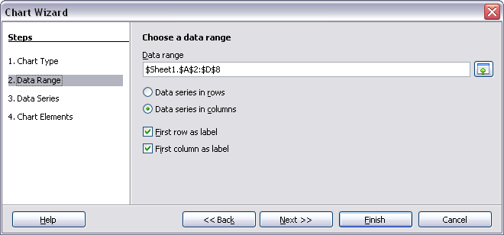
Figure 5: Changing data ranges and axes labels

Selecting Data series
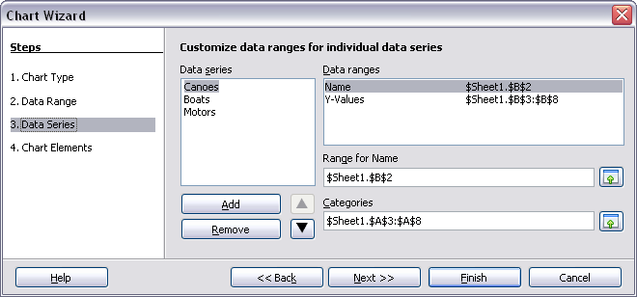
Figure 6: Amending data series and ranges
On the Data Series page, you can fine-tune the data you'd like to include in the chart. Perhaps you've decided that you do not want to include data for canoes. If so, highlight Canoes in the Data series box and click Remove. Each named data series has its ranges and individual Y-values listed. This is useful if you have very specific requirements for data in your chart, as you can include or leave out these ranges. For example, you could use the Add button to include y values from a distinct area, such as H16:H22, by setting the Range for Name to H16 and the Y-Values to H17:H22. This would work as long as the categories of the data in H17:H22 matched the order in A3:A8, where the rest of the data are.
Tip | You can click the Shrink button next to the Range for Name box to work on the spreadsheet itself. This is handy if your data ranges are larger than those in our samples and the Chart Wizard is in the way.

Click Next to deal with titles, legend, and grids.

Adding or Changing Titles, Legend, and Grids
On the Chart Elements page (Figure 7), you can give your chart a title and, if desired, a subtitle. Use a title that draws the viewers’ attention to the purpose of the chart: what you want them to see. For example, a better title for this chart might be The Performance of Motor and Other Rental Boats.
It is almost always beneficial to have labels for the x–axis or the y–axis. That allows you to orient viewers by giving them an idea of the meaning, orientation, and proportion of your data. For example, if we put Thousands in the y–axis label of our graph, it changes the scope of the chart entirely. For ease of estimating data, you can also display the x- or y–axis grids by selecting the Display grids options.
You can omit a chart's legend or include it and place it to the left, right, top, or bottom.
To confirm your selections and complete the chart, click Finish.
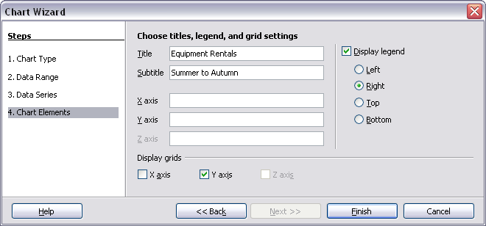
Figure 7: Titles, legend and grids

Editing Charts
After you have created a chart, you may find things you would like to change. Calc provides tools for changing the chart type, chart elements, data ranges, fonts, colors, and many other options through the Insert and Format menus, the right-click (context) menu, and the Chart toolbar.

Changing the Chart Type
You can change the chart type at any time. To do so:
- First, select the chart by double-clicking on it. A gray border should now surround the chart.
- Then do one of the following:
- Choose Format > Chart Type from the menu bar.
- Click the chart type icon on the Formatting toolbar.
- Right-click on the chart and choose Chart Type.
In each case, a dialog similar to the one in Figure 4 opens. See page 69 for more information.

Adding or Removing Chart Elements
Figures 8 and 9 show the elements of 2D and 3D charts.
The default 2D chart includes only two of those elements:
- Chart wall contains the graphic of the chart displaying the data.
- Chart area is the area surrounding the chart graphic. The (optional) chart title and the legend (key) are in the chart area.
The default 3D chart also has the chart floor, which is unavailable in 2D charts.
Chart area
Chart wall
Chart title
Legend
Axis labels
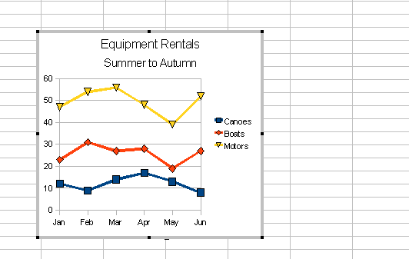Figure 8: Elements of 2D chart
Chart floor
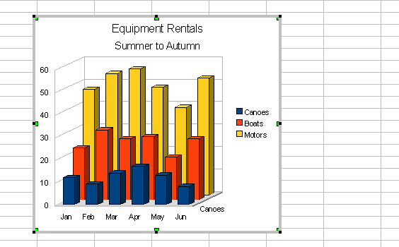Figure 9: Elements of 3D chart
You can add other elements using the commands on the Insert menu. The various choices open dialogs in which you can specify details.
First, select the chart so the green sizing handles are visible. This is done with a single click on the chart.
The dialogs for Titles, Legend, Axes, and Grids are self-explanatory. The others are a bit more complicated, so we’ll look at them now.

Data Labels
Data labels supply information about each data point on the chart. They can be very useful for presenting detailed information, but you need to be careful to avoid creating a chart that is too cluttered to read.
Select the graph with a double click and choose Insert > Data Labels. The options are as follows.
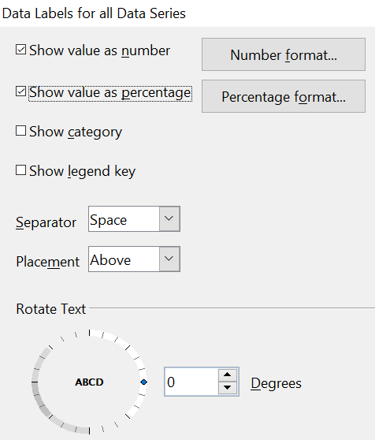

Figure 10: Data Labels dialog
Show value as number
Displays the numeric values of the data points. When selected, this option activates the Number format… button.
Number format...
Opens the Number Format dialog, where you can select the number format. This dialog is very similar to the one for formatting numbers in cells, described in Chapter 2 (Entering, Editing, and Formatting Data).
Show value as percentage
Displays the percentage value of the data points in each column. When selected, this option activates the Percentage format… button.
Percentage format...
Opens the Number Format dialog, where you can select the percentage format.
Show category
Shows the data point text labels.
Show legend key
Displays the legend icons next to each data point label.
Separator
Selects the separator between multiple text strings for the same object.
Placement
Selects the placement of data labels relative to the objects.
Figure 15 on page 82 shows examples of values as text (neither Show value as number nor Show value as percentage selected) and values as percentages, as well as when data values are used as substitutes for legends or in conjunction with them.

Trend Lines
When you have a scattered grouping of points in a graph, you may want to show any relationship among the points. You can use a trend line to do so. Calc has a good selection of regression types for trend lines. These include:
- linear
- logarithm
- exponential
- power
Choose the type that comes closest to passing through all of the points or that represents an expected relationship.

Tip | Logarithmic regression predicts y–values that lie outside points already plotted. Exponential regression is used to model situations in which growth begins slowly and then accelerates rapidly or in which decay begins rapidly and then slows down. Power Regression involves a response variable proportional to a control variable that's been raised to a specific power.

Tip | Regression can be viewed as a functional relationship between two or more variables. That relationship is often determined from data, and used to predict values of one entity when given values of others One example? The statement 'the regression of y on x is linear' means that the value of y depends on the value of x.

To insert trend lines for all data series, double-click the chart to enter edit mode. Choose Insert > Trend Lines, then select the type of trend line from None, Linear, Logarithmic, Exponential, or Power. You can also choose whether to show the equation for the trend line and the coefficient of determination (R2).
To insert a trend line for a single data series, first select the data series in the chart, then right-click and choose Insert > Trend Line from the context menu. The dialog for a single trend line is similar to the one below but has a second tab (Line), where you can choose the line's attributes (style, color, width, and transparency).
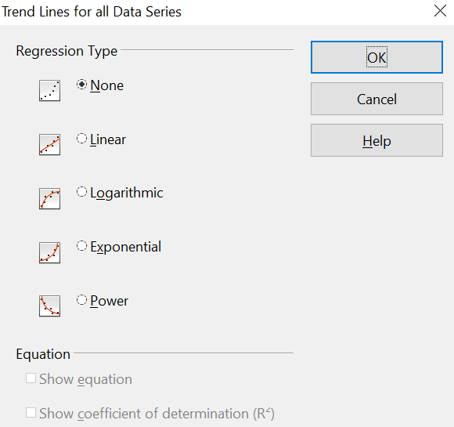

Figure 11: Trend Lines dialog
To delete a single trend line or mean value line, click the line, then press the Del key.
To delete all trend lines, choose Insert > Trend Lines, then select None.
A trend line is shown in the legend automatically.
If you insert a trend line on a chart type that uses categories, such as Line or Column, then the numbers 1, 2, 3, … are used as x-values to calculate the trend line. Such trend lines can be useful visual aids, but the equation of the trend line may not be meaningful.
The trend line has the same color as the corresponding data series. To change the line properties, right-click the trend line and choose Format Trend Line. This opens the Line tab of the Trend Lines dialog.
To show the trend line equation, select the trend line in the chart, right-click to open the context menu, and choose Insert Trend Line Equation.
When the chart is in edit mode, OpenOffice gives you the equation of the trend line and the correlation coefficient. Click on the trend line to see the information in the status bar. To show the equation and the correlation coefficient, select the line and choose Insert R2 and Trend Line Equation.

Tip | We can define a correlation coefficient as a value that describes the degree of correlation between two sets of data or between two random variables.

For more details on the regression equations, see the topic Trend lines in charts in the Help.

Mean Value Lines
If you select the Mean Value Lines dialog from the Insert menu, Calc calculates the average of each selected data series and places a colored line at the correct level in the chart.

Y Error Bars
If you are presenting data that has a known possibility of error, such as social surveys using a particular sampling method, or you want to show the measuring accuracy of the tool you used, you may wish to show error bars on the chart. Select the chart and choose Insert > Y Error Bars.
Several options are provided in the Error Bars dialog. You can only choose one option at a time. You can also choose whether the error indicator shows both positive and negative errors or only positive or only negative.
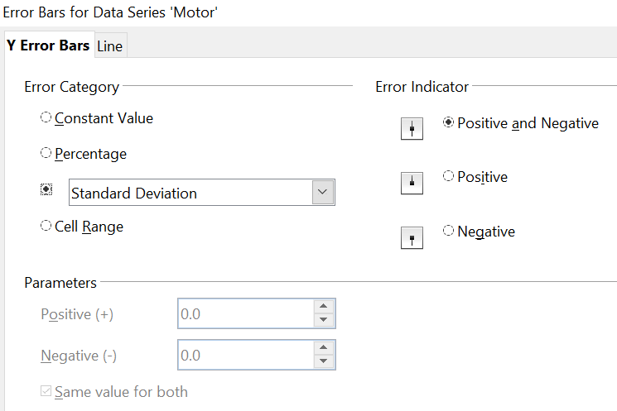

Figure 12: Specifying the parameters of error bars
- Constant Value – you can have separate positive and negative values.
- Percentage – choose the error as a percentage of the data points.
- In the drop-down list:
- Standard Error – calculates the error based on the numerical data you provide in the chart
- Variance – shows error calculated on the size of the biggest and smallest data points
- Standard Deviation – shows error calculated on standard deviation
- Error Margin – you designate the error
- Cell Range – calculates the error based on cell ranges you select. The Parameters section at the bottom of the dialog changes to allow selection of the cell ranges.
Tip | Standard deviation measures how dispersed data is in relation to its mean. Low or small standard deviation indicates data clustered tightly around the mean. High or large standard deviation indicates dispersion that is more spread out.

Formatting Charts
The Format menu has many options for fine-tuning the appearance of your charts.
Double-click the chart so it is enclosed by a gray border indicating edit mode; select the chart element you want to format. Choose Format from the menu bar, or right-click to display a context menu relevant to the selected element. The formatting choices are as follows.
Format Selection
Opens a dialog in which you can specify the area fill, borders, transparency, characters, font effects, and other attributes of the selected element of the chart (see page 83).
Position and Size
Opens a dialog (see page 87).
Arrangement
Provides two choices: Bring Forward and Send Backward, of which only one may be active for some items. Use these choices to arrange overlapping data series.
Title
Formats the titles of the chart and its axes.
Legend
Formats the location, borders, background, and type of the legend.
Axis
Formats the lines that create the chart as well as the font of the text that appears on both the X and Y axes.
Grid
Formats the lines that create a grid for the chart.
Chart Wall, Chart Floor, Chart Area
These functions are described in the following sections.
Chart Type
Changes what kind of chart is displayed and whether it is two- or three-dimensional.
Data Ranges
Explained on page 70 (Figure 5 and Figure 6).
3D View
Formats 3D charts (see page 80).
Note | Chart Floor and 3D View are only available for a 3D chart. These options are unavailable (grayed out) if a 2D chart is selected.

In most cases, you need to select the exact element you want to format. Sometimes this can be tricky to do with the mouse, especially if the chart has many elements, some of which may be small or overlapping. If you have Tooltips turned on (in Tools > Options > OpenOffice > General > Help, select Tips), then as you move the mouse over each element, its name appears in the Tooltip. Once you have selected one element, you can press Tab to move through the other elements until you find the one you want. The name of the selected element appears in the Status Bar.

Moving Chart Elements
You can move or resize individual elements of a chart independent of other such elements. For example, you can move a chart's legend to a different place. Pie charts allow moving individual wedges of the pie (in addition to the choice of “exploding” the entire pie).
- Double-click the chart so that it is enclosed by a gray border.
- Double-click any of the elements—the title, the legend, or the chart graphic. Click and drag to move the element. If the element is already selected, move the pointer over the element to get the move icon (small hand), click, drag, and then move the element.
- Release the mouse button when the element is in the desired position.
Note | If your chart graphic is 3D, round red handles appear which control the three-dimensional angle of the graphic. You cannot resize or reposition the graphic while the round red handles are showing. With the round red handles showing, Shift+Click to get the green resizing handles. You can now resize and reposition your 3D chart graphic. See the following tip.

Tip | You can resize the chart graphic using its green resizing handles (Shift+Click, then drag a corner handle to maintain the proportions). However, you cannot resize the title or the key.

Changing the Chart Area Background
The chart area is the area surrounding the chart graphic, including the (optional) main title and key.
- Double-click the chart so that it is enclosed by a gray border.
- Choose Format > Chart Area or right-click on the chart area and choose Format Chart Area.
- On the Chart Area dialog, choose the desired format settings.
On the Area tab, you can change the color, or choose a hatch pattern, bitmap or preset gradients. Click on the drop-down box to see the options. Patterns are probably more useful than color if you have to print out your chart in black and white.
You can also use the Transparency tab to change the area’s transparency. If you used a preset gradient from the Area tab, you can see the different parameters of which it is composed.
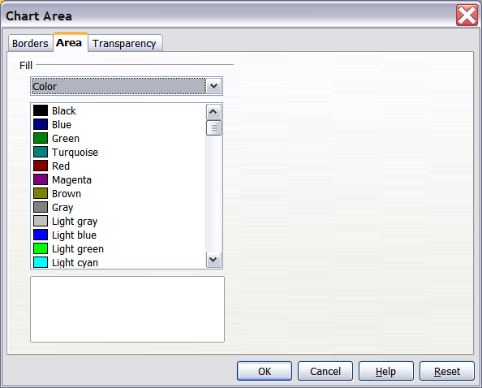
Figure 13: Chart Area dialog

Changing the Chart Graphic Background
The chart wall is the area that contains the chart graphic.
- Double-click the chart so that it is enclosed by a gray border.
- Choose Format > Chart Wall. The Chart Wall dialog has the same formatting options as described in “Changing the Chart Area Background” above.
- Choose your settings and click OK.

Changing Colors
If you need a different color scheme from the default for the charts in all your documents, go to Tools > Options > Charts > Default Colors, which has a much wider range of colors to choose from. Changes made in this dialog affect the default chart colors for any chart you make in the future.

Formatting 3D Charts
Use Format > 3D View to fine-tune 3D charts. The 3D View dialog has three tabs where you can change the perspective of the chart, determine whether the chart uses the simple or realistic schemes or your own custom scheme, and the illumination that controls where the shadows will fall.

Rotation and Perspective
To rotate a 3D chart or view it in perspective, enter the required values on the Perspective tab of the 3D View dialog. You can also rotate 3D charts interactively; see page 83.
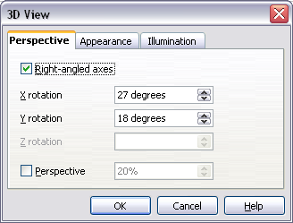
Figure 14: Rotating a chart
Here are some hints for using the Perspective tab:
- Set all angles to 0 for a front view of the chart. Pie charts and donut charts are shown as circles.
- With Right-angled axes enabled, you can rotate the chart contents only in the X and Y directions; parallel to the chart borders.
- An x value of 90, with y and z set to 0, provides a view from the top of the chart. With x set to –90, the view is from the bottom of the chart.
- The rotations are applied in the following order: x first, then y, and z last.
- When shading is enabled, and you rotate a chart, the lights are rotated as if they are fixed to the chart.
- The rotation axes always relate to the page, not to the chart’s axes. This is different from some other chart programs.
- Select the Perspective option to view the chart in central perspective, like through a camera lens, instead of using a parallel projection.
- Set the focus length in the box next to the Perspective option (it becomes active when you select the option). 100% gives a perspective view where a far edge in the chart looks approximately half as big as a near edge.

Appearance
Use the Appearance tab to modify some aspects of a 3D chart’s appearance.
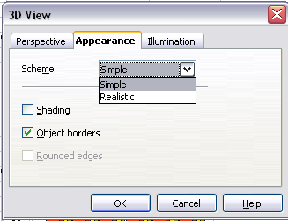Figure 15: Modifying appearance of 3D chart
Select a scheme from the list box. When you select a scheme, the options and the light sources are set accordingly. If you select or deselect a combination of options that are not given by the Realistic or Simple schemes, you can create a Custom scheme.
Select Shading to use the Gouraud method, which applies gradients for a smoother, more realistic look. Otherwise, a flat method is used. The flat method sets a single color and brightness for each polygon. The edges are visible, soft gradients and spotlights are not possible. Refer to the Draw Guide for more details on shading.
Select Object Borders to draw lines along the edges.
Select Rounded Edges to smooth the edges of box shapes. In some cases, this option is not available.

Illumination
Use the Illumination tab (Figure 16) to set the light sources for the 3D view. Refer to the Draw Guide for more details on setting the illumination.
Click any of the eight buttons to switch a directed light source on or off. By default, the second light source is switched on. It is the first of seven normal, uniform light sources. The first light source projects a specular light with highlights.
For the selected light source, you can then choose a color and intensity in the list just below the eight buttons. The brightness values of all lights are added, so use dark colors when you enable multiple lights.
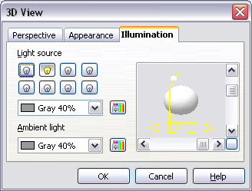Figure 16: Setting the illumination
Initially, each light source always points at the middle of the object. To change the position of the light source, use the small preview inside this tab. It has two sliders to set the selected light source's vertical and horizontal position.
The button in the corner of the small preview switches the internal illumination model between a sphere and a cube.
Use the Ambient light list to specify the nature of light that will shine with uniform intensity from all directions.

Rotating 3D Charts Interactively
In addition to using the Perspective tab of the 3D View dialog to rotate 3D charts, you can also rotate them interactively.
Select the Chart Wall, then hover the mouse pointer over a corner handle or the rotation symbol located in the middle of the chart’s information grid. The cursor changes to a rotation icon.
Press and hold the left mouse button and drag the corner in your desired direction. A dashed outline of the chart appears while you drag to help you visualize the result.

Formatting the Chart Elements
Depending on the purpose of your document, for example, a screen presentation or a printed document for a black-and-white publication, you might wish to use more detailed control over the different chart elements to give you what you need.
To format an element, double-click on the chart to put it in edit mode and then left-click on the element you wish to change, for example, one of the axes. The element will be highlighted with green squares. Then, right-click and choose an item from the context menu. Each chart element has its own selection of items. In the following few sections, we explore some of those options.

Formatting Axes and Inserting Grids
Sometimes you need to have a special scale for one of the axes of your chart, or you need smaller grid intervals, or you want to change the formatting of the labels on the axes. After highlighting the axis you wish to change, right-click and choose one of the items from the pop-up menu.
Choosing Format > Axis > X Axis or Format > Axis > Y Axis opens the dialog shown in Figure 17, which in this case is the Scale tab. The fields available on this dialog depend on the chart type and whether it is 2D or 3D.
On the Scale tab, you can choose a logarithmic or linear scale (default), how many marks you need on the line, where the marks are to appear, and the increments (intervals) of the scale. You must first deselect the Automatic option to modify the value for any scale. Selecting the Reverse direction radial creates a backwards representation of the chart.
On the Label tab (Figure 18), you can choose whether to show or hide the labels and how to handle them when they won’t all fit neatly into one row (for example, if the words are too long).
Not shown here are the tabs with options for choosing a font and specific font effects, formatting the lines, positioning the elements of the line and interval marks, and selecting effects relating to Asian Typography if this function has been activated in Tools > Options > Languages.
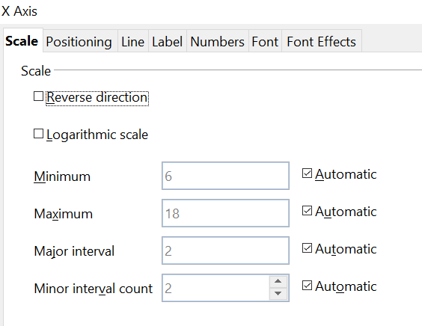

Figure 17: Formatting axis scales
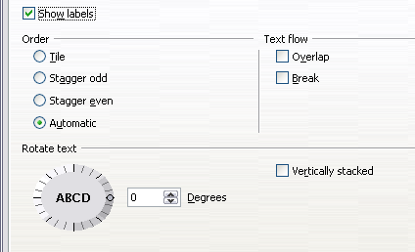
Figure 18: Formatting axis labels

Formatting Data Labels
You can choose properties for the labels of the data series. The labels are inserted with the menu Insert > Data Labels. You can adjust the labels later by right-clicking on the data series and choosing the command Format Data Labels. This opens a dialog with several tabs where you can change the color of the label text, the size of the font, and other attributes. The Data Label tab is shown in Figure 10.
On the Data Label tab, you can choose whether to:
- Show the labels as text
- Show numeric values as a percentage or a number
- Include the legend box as part of the label
The text for labels is taken from column labels; it cannot be changed there. If such text needs to be abbreviated, or if it did not label your graph as expected, you must change it in the original data table.

Hierarchical Axis Labels
The axis labels can be derived from two columns to make a hierarchical label structure. Figure 21 shows how to set up the Data Series step of the Chart Wizard to make an x–axis with two levels of labels. Notice that the cell range in the Categories box spans columns A and B.
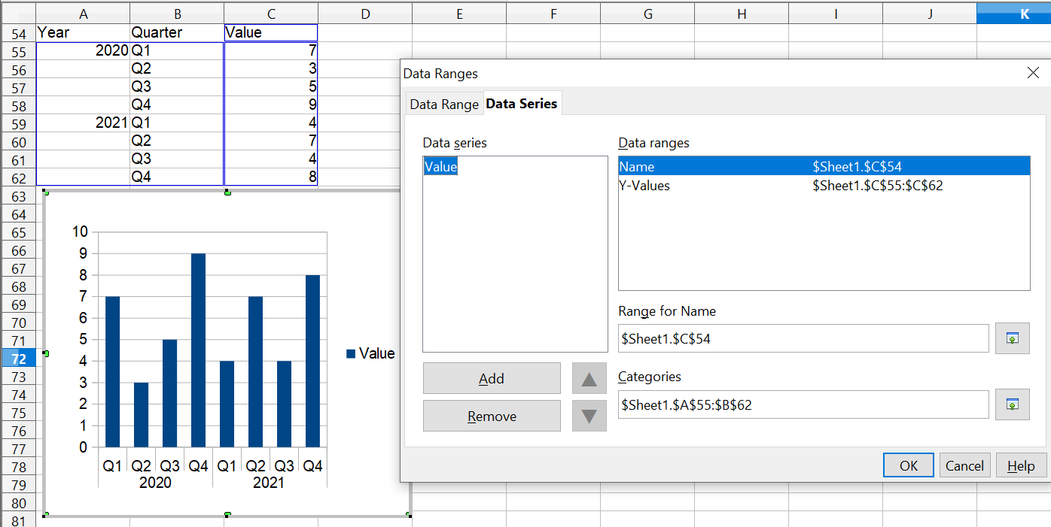

Figure 19: Setting up Hierarchical x–axis labels

Choosing and Formatting Symbols
In line and scatter charts, the symbols representing the points can be changed to a different symbol shape or color through the object properties dialog. Select the data series you wish to change, right-click, and choose Format Data Series from the context menu. You can reach this dialog by double-clicking the area of data you would like to change.
On the Line tab of the Data Series dialog, in the Icon section, choose from the drop-down list Select > Symbols. Here you can choose no symbol, a symbol from a built-in selection, or a more visually interesting range from the gallery. If you have pictures you need to use instead, you can insert them using Select > From file.
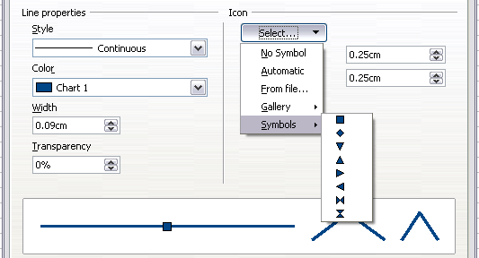
Figure 20: Symbol selection

Adding Drawing Objects to Charts
As in other OpenOffice components, you can use the drawing toolbar to add simple shapes such as lines, rectangles, text objects, or more complex shapes such as symbols or block arrows. This toolbar is located at the bottom of the screen and automatically appears when a chart is generated. Use these additional shapes to add explanatory notes to your chart, as demonstrated in the figure below.
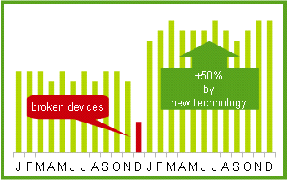
To format the drawing objects, right-click and choose your changes from the context menu.

Resizing and Moving the Chart
You can resize or move all elements of a chart simultaneously, in two ways: interactively or by using the Position and Size dialog. You may use a combination of these methods: interactive for quick and easy changes, and the dialog for precise sizing and positioning.
To resize a chart interactively:
- Click once on the chart to select it. Green sizing handles appear around the chart.
- To increase or decrease the size of the chart, click and drag one of the markers in one of the four corners of the chart. To maintain the correct ratio of the sides, hold the Shift key down while you click and drag.
To move a chart interactively:
- Click on the chart to select it. Green sizing handles appear around the chart.
- Hover the mouse pointer anywhere over the chart. When it changes to the move icon, click and drag the chart to its new location.
- Release the mouse button when the element is in the desired position.

Using the Position and Size Dialog
To resize or move a chart using the Position and Size dialog:
- Click on the chart to select it. Green sizing handles appear around the chart.
- Right-click and choose Position and Size from the pop-up menu.
- Make your choices on this dialog.
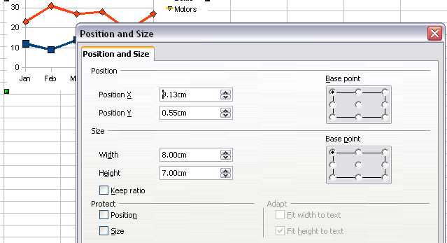
Figure 21: Defining the position and size of an object
Position is defined as an X, Y coordinate relative to a fixed point (the base point), typically located at the upper left of the document. You can temporarily change this base point to simplify positioning or dimensioning (click on the spot corresponding to the location of the base point in either of the two selection windows on the right side of the dialog—upper for positioning or lower for dimensioning).
The possible base point positions correspond to the handles on the selection frame plus a central point. The change in position lasts only as long as the dialog is open; when you close it, Calc resets the base point to the standard position.
Tip | The Keep ratio option is very useful. Select it to keep the ratio of width to height fixed while you change the size of an object.

Size and position can be protected so they can't be accidentally changed. Select the appropriate options.
Tip | If you cannot move an object, check to see if its position is protected.

Gallery of Chart Types
It's important to remember that while your data can be presented with many different charts, the message you want to convey to your audience dictates the chart you ultimately use. The following sections present examples of the types of charts that Calc provides, with some of the tweaks each sort can have and some notes as to what purpose you might have for that chart type. For further details, see the OpenOffice Help index.

Column Charts
Column charts are commonly used for data that come from categories. You might plot sales (numeric) for different companies (categorical). They are also widely used to show data over time if the emphasis is on aggregating data during periods of time. An example of this would be showing sales per month. They are best for charts that have a relatively small number of data points. (For a larger time series, a line chart would be better.) It is the default chart type, as it is one of the most useful and easiest to understand.

Bar Charts
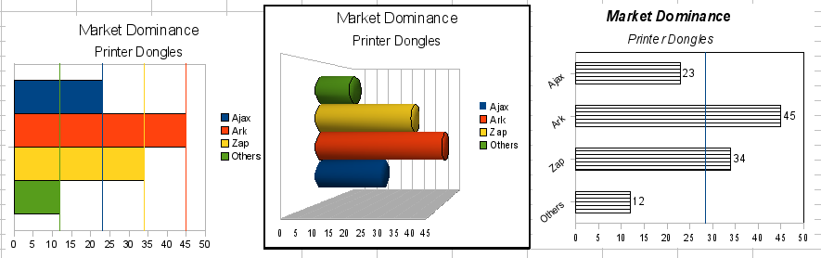
Figure 22: Three bar graph treatments.
Bar charts are column charts with categories on the y–axis. They are excellent for giving an immediate visual impact to data comparisons, especially when time is not an important factor, such as comparing the popularity of a few products in a marketplace.
- The first chart in Figure 20 is achieved quite simply by using the chart wizard with Insert > Grids, deselecting y–axis, and using Insert > Mean Value Lines.
- The second chart in the figure is the 3D option in the chart wizard with a simple border and the 3D chart area twisted around.
- The third chart in the figure has the legend removed, and the labels show the names of the companies on the axis instead. We also changed the colors to a hatch pattern.

Pie Charts
Pie charts are commonly used to compare proportions. For example, a pie chart would be appropriate if you needed to compare departmental spending, such as what a department spent on different items or what different departments spent. These charts work best with smaller numbers of values; no more than about half a dozen should be included because using more can cause the visual impact to fade. At the same time, it's difficult to compare precisely the size of the slices in a pie chart. As a result, this chart type should not be used if small differences are important.
The Chart Wizard guesses the series you want to include in your pie chart. That being the case, you might need to adjust the series initially, on the Wizard’s Data Ranges page, if you know you want a pie chart. This adjustment can also be made by using the Format > Data Ranges > Data Series dialog.
You can do very interesting things with a pie chart, especially if you make it into a 3D chart. After that transformation, it can be tilted, given shadows, and come to resemble a work of art.
You can choose an option in the Chart Wizard to explode the pie chart, but this is an all-or-nothing option. To accentuate one piece of the pie, you can separate out one piece by carefully highlighting it after you have finished with the Chart Wizard and dragging it out of the group. To highlight a piece, click once on its edge to select the whole data series and then again to select the individual piece. The two clicks must be well separated in time. When you reposition the piece, you might need to enlarge the chart area again to regain the original size of the pieces.
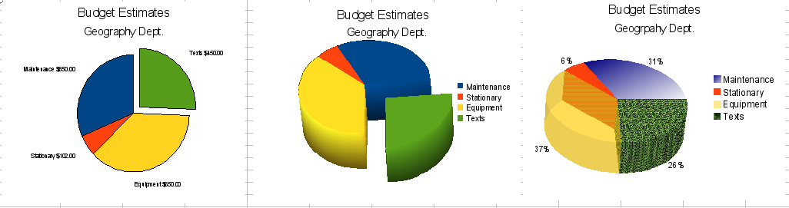
Figure 23: Pie charts
The effects achieved in Figure 15 are explained below.
- The first example is a 2D pie chart with one part of the pie exploded. To produce this type of chart, choose Insert > Legend and deselect Display legend. Choose Insert > Data Labels and choose Show value as number. Then, carefully select the piece you wish to highlight, move the cursor to the edge of the piece, click (the piece will have nine green highlight squares to mark it), and then drag it out from the rest of the pieces. The pieces will decrease in size, so you need to highlight the chart wall and drag it to a corner to increase the size.
- The second example is a 3D pie chart with realistic schema and illumination. With a completed 3D pie chart, choose Format > 3D view > Illumination where you can change the direction of the light, the color of the ambient light, and the depth of the shade. We also adjusted the 3D angle of the disc in the Perspective dialog on the same set of tabs. The chart updates as you make changes, so you can immediately see the effects.
If you want to separate one of the pieces, click on it carefully; you should see a wireframe highlight. Drag it out with the mouse and then, if necessary, increase the size of the chart wall.
- The third example is a 3D pie chart with different fill effects in each portion of the pie. Choose Insert > Data labels and select Show value as percentage. Carefully select each piece so that it has a wireframe, then highlight and right-click to get the object properties dialog. Choose the Area tab. For one of the pieces, we chose a bitmap effect; for another, we selected a gradient feature; for the third, we used the Transparency tab and adjusted the transparency to 50%.

Donut Charts
Donut charts are a variation of the pie chart. To create one, choose Pie in the Chart Type dialog, and choose the third or fourth type of pie chart. For more variety, consider selecting 3D Look.
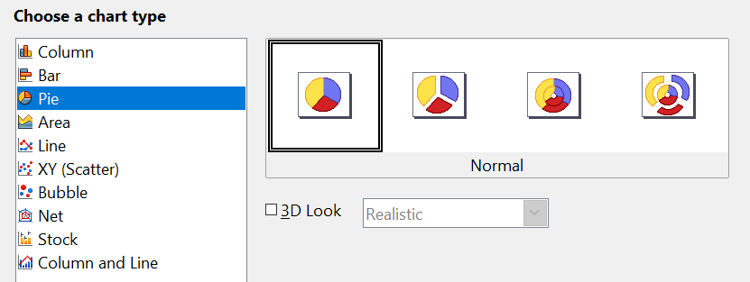

Figure 24: Choosing a donut chart
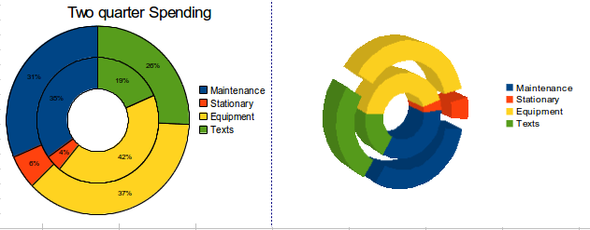Figure 25: Examples of donut charts

Area Charts
An area chart is a version of a line or column graph. It may be useful where you wish to emphasize volume of change. Area charts have a greater visual impact than line charts, but the data you use will make a difference.
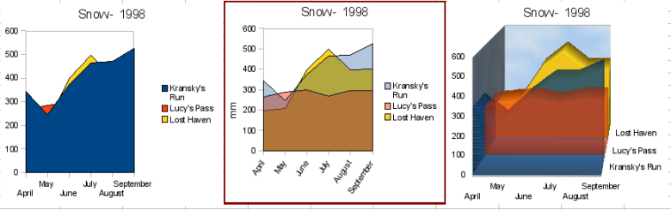
Figure 26: Area charts—the good, the bad, and the ugly
As shown in Figure 14, an area chart is sometimes tricky to use. This may be one good reason to use transparency values in an area chart. After setting up the basic chart using the Chart Wizard, do the following:
- Right-click on the y–axis and choose Delete Major Grid. As the data overlaps, some of it is lost behind the first data series. This is not what you want. A better solution is shown in the highlighted chart and is explained in the next point.
- After deselecting the y–axis grid, right-click on each data series in turn and choose Format Data Series. On the Transparency tab, set Transparency to 50%. The transparency makes it easy to see the data hidden behind the first data series. Now, right-click on the x–axis and choose Format Axis. On the Label tab, choose Tile in the Order section and set the Text orientation to 55 degrees. This places the long labels at an angle.
- To create the third variation, after doing the steps above, right-click and choose Chart Type. Choose the 3D Look option and select Realistic from the drop-down list. We also twisted the chart area around and gave the chart wall a picture of the sky. As you can see, the legend turns into labels on the z–axis. Overall, though it is visually more appealing, it is more difficult to see the point you are trying to make with the data.
Other ways of visualizing the same data series are represented by the stacked area chart or the percentage stacked area chart.
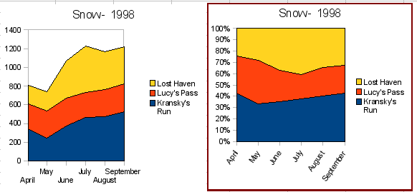
Figure 27: Stacked and percentage stacked area charts
The first does what it says: each number of each series is added to the others so that it shows an overall volume but not a comparison of the data. The percentage stacked chart shows each value in the series as a part of the whole. For example, in June, all three values are added together, and that number represents 100%. The individual values are a percentage of that. Many charts have varieties with this option.

Line Charts
A line chart shows a series of data but with categories rather than numeric values on the x–axis. Line charts are commonly used when time is marked with names of months or quarters or a year. As such, this chart type is ideal for raw data. It's also very effective for charts with lots of data that show trends over time when what you want is to emphasize continuity. It's important to remember that the x–axis shows categories and spaces them equally. If you had month labels of April, May, and July, the axis spacing from April to May would be the same as from May to July. This can produce deceptive interpretations.
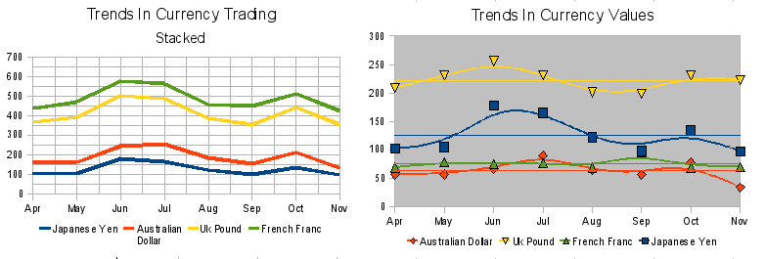
Figure 28: Line charts

Scatter or XY Charts
Scatter charts are great for visualizing data when both axes represent numeric values. A chemical reaction rate measured at different temperatures or income at different ages are examples of such data. The trend line equation inserted with Insert > Trend Lines can be used for quantitative predictions, and the data placement correctly accounts for any irregularity in the values of data points. This type of chart is the best for displaying accurate time series, but the date or time values used must be entered as numeric values. This can be checked with View > Value Highlighting, which will show values in blue if they are numeric.
Scatter charts may surprise those unfamiliar with how they work. While constructing the chart, if you choose Data Range > Data series in rows, the first row of data represents the x–axis. The rest of the rows of data are then compared against the first row data. Figure 13 shows a comparison of three currencies with the Japanese Yen. Even though the table presents the monthly series, the chart does not. In fact, the Japanese Yen does not appear in the legend; it is merely used as the x–axis value that all the other data series are compared against.
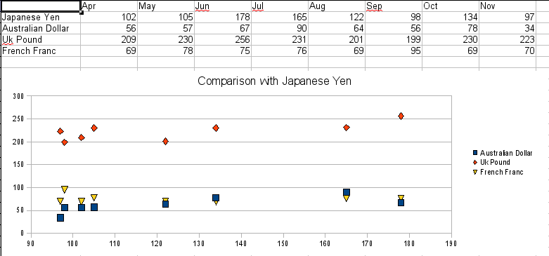
Figure 29: A particularly volatile time in the world currency market.

Bubble Charts
A bubble chart is a variation of a scatter chart in which the data points are replaced with bubbles. It shows the relations of three variables in two dimensions. Two variables are used for the position on the x–axis and y–axis, while the third is shown as the relative size of each bubble. One or more data series can be included in a single chart.
Bubble charts are often used to present financial data. The data series dialog for a bubble chart has an entry to define the data range for the bubbles and their sizes.
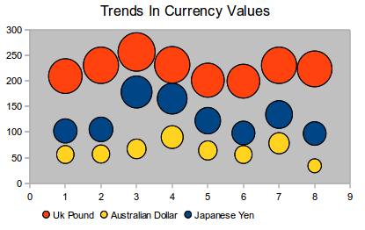
Figure 30: Bubble chart showing three data series

Net Charts
A net chart is similar to a polar or radar chart. It is useful for comparing data that is not a time series but shows different circumstances, such as variables in a scientific experiment or direction. The poles of the net chart are equivalent to the y–axis of other charts. Generally, between three and eight axes are best; any more and this type of chart becomes confusing. Before and after values can be plotted on the same chart, or perhaps expected and real results, to compare differences.
Figure 12 shows two types of net charts:
- (Left): A plain net chart without grids or lines, only points.
- (Right): A net chart with lines, points, and a grid. Axis colors and labels have been changed. The chart area color has been changed with a gradient effect. The points on this graph have been changed to fancy 3D spheres.
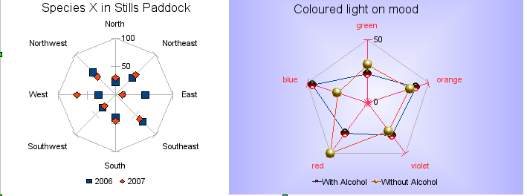
Figure 31: Two net diagrams showing fabricated data from totally fictional experiments.
Other varieties of net charts can be made to show the data series as stacked numbers or stacked percentages. The series can also be filled with a color (Figure 11). Partial transparency is often best for showing all the series at once.
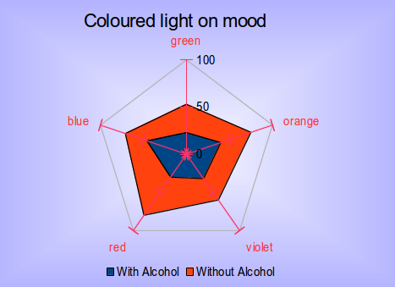
Figure 32: Filled net or radar chart

Stock Charts
A stock chart is a specialized column graph specifically for stocks and shares. You can choose traditional lines, candlestick, and two-column type charts. The data required for these charts is quite specialized, with series for opening price, closing price, and high and low prices. In this type of chart, the x–axis represents a time series.
When you set up a stock chart in the Chart Wizard, the Data Series dialog is very important. You need to tell it which series represents the opening price, the closing price, the high and low price of the stock, and so on.
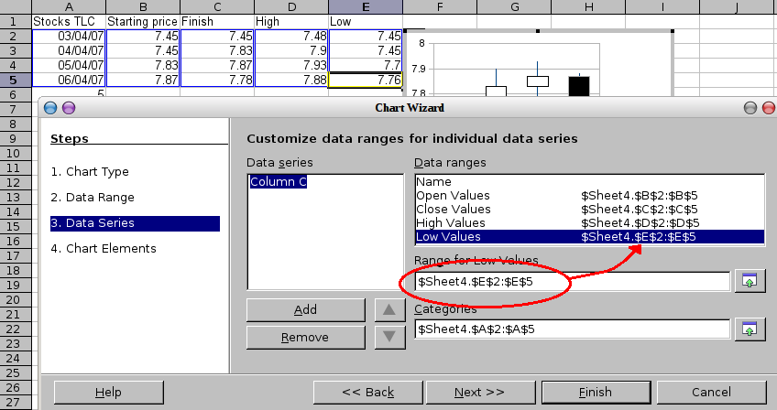Figure 33: Adjusting data series for stock charts.
A nice touch is that OpenOffice stock charts color-code the rising and falling shares: white for rising, black for falling in the candlestick chart, and red and blue in the traditional line chart.

Column and Line Charts
A column and line chart is a combination of two other chart types. It is useful for combining two distinct but related data series like sales over time (column) with a profit margin trends (line).
You can choose the number of columns and lines in the Chart Wizard. For example, you might have two columns with two lines to represent two product lines with the sales figures and profit margins of both.
The chart in Figure 3 shows manufacturing cost and profit data for two products over a period of time (six months in 2007). To create this chart, highlight the table and start the Chart Wizard. Choose the Column and Line chart type with two lines and the data series in rows. Then, give it a title to highlight the aspect you want to show. The lines are different colors at this stage and don’t reflect the product relationships. When you finish with the Chart Wizard, highlight the chart, click on the line, right-click and choose Format Data Series.
On this tab, there are a few things to change: The colors should match the products so both Ark Manufacturing and its profit line are blue and Prall Manufacturing is red. The lines need to be more noticeable, so make them thicker by increasing the width to 0.08.
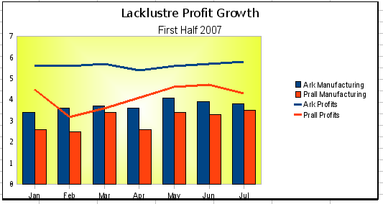
Figure 34: Column and line chart
For the background, highlight the chart wall, right-click it, and choose Format Wall. On the Area tab, change the drop-down box to show Gradient. Choose one of the preset gradient patterns and make it lighter by going to the Transparency tab and making the gradient 50% transparent.
To make the chart look cleaner without the grid, go to Insert > Grids and deselect the X–axis option.

Chapter 4
Using Styles and Templates in Calc
Bringing uniformity to your spreadsheets

What is a Template?
A template is a model used to create other documents. For example, you can build an invoice template that places your company’s logo and address at the top of the page. Therefore, new spreadsheets created from this template will all have your company’s logo and address on their first page.
Templates can contain anything that regular documents can contain:
- text
- graphics
- styles
- user-specific setup information such as measurement units, language, the default printer, and toolbar and menu customization
All documents in Apache OpenOffice (AOO) are based on templates. You can create or download and install as many templates as you wish. If you do not specify a template when you start a new spreadsheet, the new spreadsheet is based on the default template for spreadsheets. If you have not specified a default template, AOO uses the blank spreadsheet template installed with AOO. See “Setting a Default Template” on page 113.

What are Styles?
A style is a set of formats you can apply to selected elements in a document, to control or quickly change their appearance. When you apply a style, you apply a whole group of formats simultaneously.
Many people manually format spreadsheet cells and pages without paying attention to styles. They are used to formatting documents according to physical attributes. For example, for the contents of a cell, you might specify the font family, font size, and any formatting, such as bold or italic.
Styles are logical attributes. Using styles means that you stop saying “font size 14pt, Times New Roman, bold, centered” and you start saying “Title” because you have defined the “Title” style to have those characteristics. In other words, 'styles' means shift the emphasis from what the page or other elements look like to what it is.
Styles help improve consistency in a document and can greatly speed up formatting. They also make major formatting changes easy. For example, you may decide to change the appearance of all subtotals in your spreadsheet to 10 pt. Arial instead of 8 pt. Times New Roman after you have created a 15-page spreadsheet, you can change all of the subtotals in the document by simply changing the properties for the subtotal style.
Page styles assist with printing, so you don’t need to define margins, headers and footers, and other printing attributes each time you print a spreadsheet.

Types of Styles in Calc
While some components of AOO offer many style types, Calc offers only two:
- Cell styles include fonts, alignment, borders, background, number formats (currency, date, number), and cell protection.
- Page styles include margins, headers and footers, borders and backgrounds, the sequence for printing sheets.
Tip | The page size, orientation, and other attributes of a page style apply only when a spreadsheet is printed; they are not displayed onscreen.

Cell Styles
Like paragraph styles in AOO Writer, cell styles are the most basic type of style in Calc. When you apply a cell style to a cell, that cell will follow the formatting rules of the style. Five cell styles are supplied with AOO: Default, Heading, Heading1, Result, and Result2.
Initially, the styles are configured so that if you change the font family of Default, all of the other styles will change to match. We will discuss how to set this up in “Creating New (Custom) Styles” on page 106. The five standard styles can be seen in Figure 1.
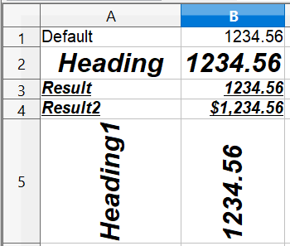

Figure 1: Calc cell style types

Page Styles
Page styles in Calc are applied to sheets. Although one sheet may print on several printer pages, only one page style can be applied to a sheet. If a spreadsheet file contains more than one sheet, the different sheets can have different page styles applied to them. So, for example, a spreadsheet might contain one sheet to be printed in landscape orientation (using the Default page style) and another sheet to be printed in portrait orientation (using the Report page style).
Two page styles are supplied with Calc: Default and Report. You can adjust many settings using page styles. You can also define as many page styles as you wish.
Because spreadsheets are primarily used onscreen and not printed, Calc does not display the page style on the screen. If you want a spreadsheet to fit a particular page size, you can set this up on the Sheet tab of the Page Style dialog or using View > Page Break Preview and adjusting the column and row sizes.

Accessing Styles
Styles are most frequently accessed through the Styles and Formatting deck of the Sidebar or the Styles and Formatting dialog. The tools for using styles are identical in the Sidebar and the dialog, shown in Figure 2. To avoid repeating "the Sidebar deck or the dialog," we will refer to both as the Styles and Formatting window; use whichever you prefer.
You can open the dialog in several ways.
- Keyboard: Press the F11 key.
- Menu: Choose Format > Styles and Formatting.
- Toolbar: Click the icon on the far left of the Formatting toolbar.
If the Sidebar is not visible, it can be opened with View > Sidebar. Once the Sidebar is visible, you can select the Styles and Formatting deck by clicking the Styles and Formatting icon 
The first button on the top left of the window, 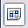, is for cell styles, and the second, , is for page styles.
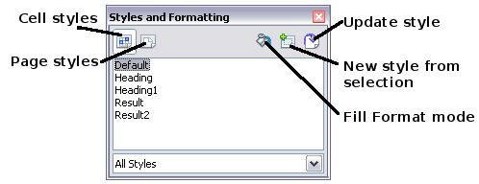
Figure 2: Styles and Formatting window

Applying Cell Styles
Calc provides several ways to apply cell styles:
- Using the Styles and Formatting window
- Using Fill Format mode
- Using the Apply Style list
- Assigning styles to shortcut keys

Using the Styles and Formatting Window
- Access the Styles and Formatting window using one of the methods above. Choose the Cell Styles list by clicking the 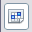 icon.
- Highlight the cell or group of cells to which the styles should be applied.
- Double-click on the cell style name.

Using Fill Format Mode
This method is quite useful for applying the same style to many scattered cells.
- Open the Styles and Formatting window and select the style you want to apply.
- Click the Fill Format mode icon . The mouse pointer changes to this icon.
- Position the icon on the cell to be styled and click the mouse button.
- To quit Fill Format mode, click the Fill Format mode icon again or close the Styles and Formatting window.
Caution | When this mode is active, a right-click anywhere in the document undoes the last Fill Format action. Be careful not to accidentally right-click and thus undo actions you want to keep.

Using the Apply Style List
You can also add an Apply Style drop-down list to the Formatting toolbar and select a style from the list to apply to the selected cells:
- Click the down arrow at the right-hand end of the Formatting toolbar. On the drop-down menu, click Visible Buttons.
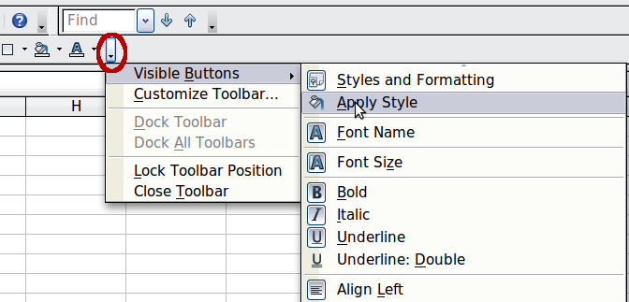
Figure 3: Adding an Apply Style list to the Formatting toolbar
- On the submenu, click Apply Style. The menus close, and the Apply Style list now appears on the toolbar between the Styles and Formatting icon and the Font Name list.
- Select the cells to which you want to apply a style. Then select the style name from the Apply Style list.

Assigning Styles to Shortcut Keys
You can create keyboard shortcuts that can apply commonly used cell or page styles, including custom styles you have created. See Chapter 14 (Setting up and Customizing Calc) for instructions.

Applying Page Styles
- Select the sheet to be styled (click on its sheet tab at the bottom of the screen).
- In the Styles and Formatting window, choose the Page Styles list by clicking the icon. Double-click on the required page style.
To find out which page style is in use for a selected sheet, look in the status bar.
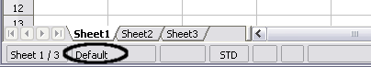
Figure 4: Status bar showing location of page style information below the sheet tabs.

Modifying Styles
To modify a style, right-click on its name in the Styles and Formatting window and choose Modify. Make the changes in the Style dialog and click OK to save the changes.
You can also modify a current cell style by selecting an already-formatted cell and clicking the Update Style button on the top right-hand corner of the Styles and Formatting window.

Style Organizer
Right-click on the name of a style in the Styles and Formatting window. Then click Modify to open a Style dialog like the one shown in Figure 5.
The Style dialog has several tabs. The Organizer tab, shown in Figure 5 for cell styles, is found in all components of AOO. It provides basic information about the style. The Organizer tab for page styles is similar to the one shown for cell styles.
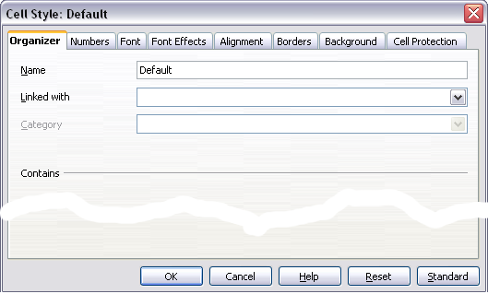
Figure 5: Organizer tab of Cell Style dialog
Name
This is the style’s name. You cannot change the name of a built-in style, but you can change the name of a custom style.
Linked with
This option is only available for cell styles; page styles cannot be linked. If you link cell styles, then when you change the base style (for example, by changing the font from Times to Helvetica), all the linked styles will also change. Sometimes, this is exactly what you want; other times, you do not want the changes to apply to all the linked styles. It pays to plan ahead.
For example, you can make a new style called red, in which the only change you want to make is for the cell text to be red. To ensure that the rest of the text characteristics are the same as the default style, you can link red with default. Then, any changes you make to default will be automatically applied to red.
Category
In Calc, the only option in this drop-down box is Custom styles.

Cell Style Options
When editing or creating cell styles, you can set several options similar to those used for directly formatting cells. A more detailed coverage of cell formatting is given in Chapter 2 (Entering, Editing, and Formatting Data). A brief summary is provided here.

Numbers
On the Numbers tab, you can control the behavior of the data in a cell with this style. This includes specifying the type of data, the number of decimal places, and the language.

Font
Use the Font tab to choose the font for the cell’s contents.

Font Effects
The Font Effects tab offers more font options, including underlining, strikethrough, and color.

Alignment
Use the Alignment tab to set the horizontal and vertical alignment for the data in the cells and rotate the text.

Borders
Use the Borders tab to set the borders for the cells, along with a shadow.

Background
Use the Background tab to choose the background color for a cell.

Cell Protection
Use the Cell Protection options to protect cells against certain types of editing. The cell protection is only in effect when the sheet is also protected with Tools > Protect Document > Sheet.

Page Style Options
Several of the page style options are described in more detail in Chapter 6 (Printing, Exporting, and E-mailing) because manually formatting a sheet at print time (using Format > Page) actually modifies the page style.

Page
Use the Page tab to edit the overall appearance of the page and its layout. The available options are shown in Figure 6.
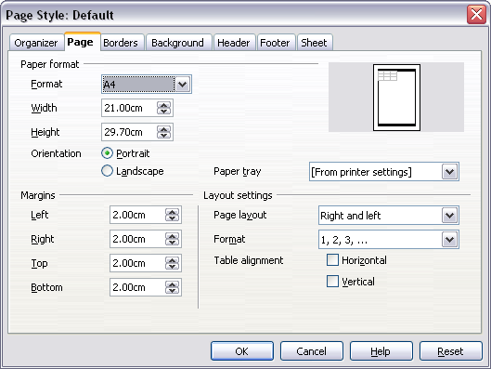
Figure 6: Page Style: Page tab
Paper format
Here, you can set a generic paper type to be used. Letter or A4 are the most commonly used, but you can also try legal, tabloid, envelope sizes, or user-defined paper types. In addition, you can define the orientation of the page and which print tray the paper will come from, if your printer has more than one tray.
Margins
This allows you to set the margins for the page.
Layout settings: Page layout
Here you can specify whether to apply the formatting to right (odd) pages only, left (even) pages only, or both right and left pages that use the current page style.
Mirrored formats the pages as if you want to bind the printed pages like a book.
The first page of a document is assumed to be an odd page.
Layout settings: Format
This area specifies the page numbering style for this page style.
Layout settings: Table alignment
This option specifies the alignment options for the cells on a printed page, either horizontal or vertical.

Borders
The Border and Background tabs for pages duplicate the tabs of the same name on cell styles and are overridden by the cell style or manual settings. You may ignore the Border and Background tabs altogether in page styles. Both tabs are illustrated with helpful diagrams.
As with formatting a cell style, we can use the Borders tab to choose whether the page should have borders, how large they should be, and how far the text will be from them.

Background
Use this tab to specify the background for this page style. You can apply either a solid color or a picture as a background.

Header
Use this tab to design and apply the header for this page style. For more detailed instructions on formatting the header, see Chapter 6 (Printing, Exporting, and E-mailing).

Footer
Use this tab to design and apply the footer for this page style. For more detailed instructions on how to format the footer, see Chapter 6.

Sheet
By far, the most important settings for Calc page styles are on the Sheet tab. Although the Sheet tab includes an option that sets the first page option, most of its settings involve exactly how your spreadsheet will print. See Chapter 6.

Creating New (Custom) Styles
You may want to add some new styles. You can do this in two ways:
- Creating a new style using the Style dialog
- Creating a new style from a selection
Note | New styles apply only to this document; they are not saved in the template. To save new styles in a template, see “Copying and Moving Styles“ on page 107 and “Creating a Template” on page 110.

Creating a New Style Using the Style Dialog
To create a new style using the Style dialog, right-click in the Styles and Formatting window and choose New from the pop-up menu.
(Cell styles only) If you want your new style to be linked with an existing style, select that style, right-click, and choose New.

Tip | If you link styles, when you change the base style (for example, by changing the font from Times to Helvetica), all the linked styles will change as well. Sometimes this is exactly what you want; at other times you don't want the changes to apply to all the linked styles. It pays to plan ahead.

The dialogs and choices are the same for defining new styles and for modifying existing styles.

Creating a New Style from a Selection
You can create a new cell style by copying an existing manual format.
- Open the Styles and Formatting window and choose the type of style you want to create.
- Select the formatted cell in the document you want to save as a style.
- In the Styles and Formatting window, click on the New Style from Selection icon .
- In the Create Style dialog, type a name for the new style. The list shows the names of existing custom styles of the selected type. Click OK to save the new style.

Figure 7: Naming a new style created from a selection

Creating a New Style by Dragging and Dropping
Select a cell and drag it to the Styles and Formatting window.

Copying and Moving Styles
Use the Template Management dialog to copy a style from one spreadsheet to another or between a spreadsheet and a template instead of recreating it in the second spreadsheet.
- Click File > Templates > Organize.
- In the Template Management dialog (Figure 7), set the lists at the bottom to either Templates or Documents, as needed. The default is Templates on the left and Documents on the right.

Figure 8: Choosing to copy styles from a document, not a template.
Tip | To copy styles from a file that is not open, click the File button. When you return to this dialog, both lists show the selected file and all currently open documents.

- Open the folders and find the templates from and to which you want to copy. Double-click on the template or document name, then double-click the Styles icon to show the list of individual styles (Figure 4).
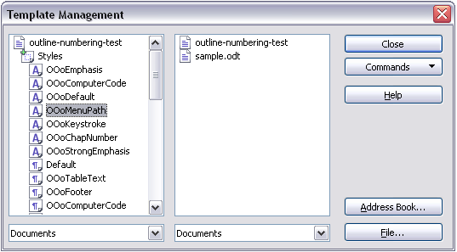
Figure 9: Copying a style from one document to another.
- To copy a style, hold down the Ctrl key and drag the name of the style from one list to the other.
- Repeat these steps for each style you want to copy. If the receiving template or document has many styles, you may have to scroll down the list to find a specific item. When you are finished, click Close.

Deleting Styles
You cannot remove (delete) any of Calc’s predefined styles, even if you are not using them. However, you can remove any user-defined, custom styles. Before you do, be sure the styles in question are not in use. If an unwanted style is in use, replace it with a substitute.
Replacing styles, and then deleting the unwanted ones, can be very useful if you're dealing with a spreadsheet that several people have worked on.
To delete unwanted styles, right-click on them, one at a time, in the Styles and Formatting window. Then click Delete on the pop-up menu. Choose Yes in the confirmation pop-up.

Creating a Spreadsheet from a Template
To create a spreadsheet from a template:
- From the main menu, choose File > New > Templates and Documents. The Templates and Documents dialog opens.
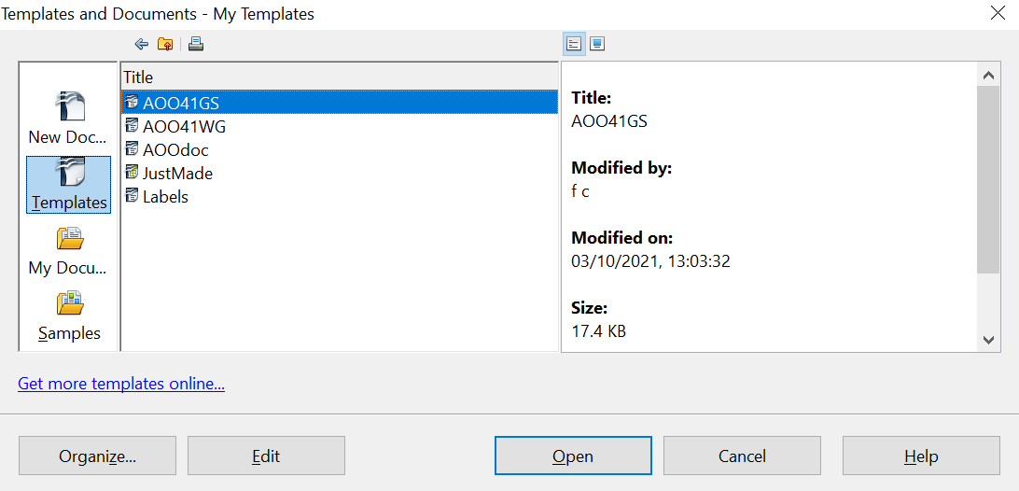

Figure 10: Templates and Documents dialog
- In the box on the left, click the Templates icon if it has not already been selected. A list of template folders appears in the center box.
- Double-click the folder holding the template you want to use. A list of all templates contained in that folder appears in the center box.
- Select the template that you want to use. You can preview the selected template or view the template’s properties:
- To preview the template, click the Preview icon. A preview of the template appears in the box on the right.
- To view the template’s properties, click the Document Properties icon. The template’s properties appear in the box on the right.
- Click Open. The Templates and Documents dialog closes, and a new document based on the selected template opens in Calc. You can then edit and save the new document as you would any other document.

Creating a Template
You can create a template from a document.
- Open a new or existing document of the type you want to make into a template (text document, spreadsheet, drawing, presentation).
- Add the content and styles that you want.
- From the main menu, choose File > Templates > Save. The Templates dialog opens.
- In the New template field, type a name for the new template.
- In the Categories list, click the category to which you want to assign the template. The category you choose does not affect the template itself; it is simply the folder in which you save the template. Choosing an appropriate folder (category) makes it easier to find the template when you want to use it. You may wish to create a folder for Calc templates.
To learn more about template folders, see “Organizing Templates” on page 115.
- Click OK to save the new template.
Figure 11: Saving a new template
Any settings that can be added to or modified in a document can be saved in a template. For example, below are some of the settings (although not a full list) that can be included in a Calc document and then saved as a template for later use:
- Printer settings: which printer, single-sided / double-sided, paper size, and so on
- Cell and page styles to be used
Templates can also contain predefined text, saving you from having to type it every time you create a new document. For example, an invoice template might contain your company’s name, address, and logo.
You can also save menu and toolbar customizations in templates; see Chapter 14 (Setting up and Customizing Calc) for more information.

Editing a Template
You can edit a template’s styles and content, and then, if you wish, you can reapply the template’s styles to documents created from that template.

Note | You can only reapply styles. You cannot reapply content.

To edit a template:
- From the main menu, choose File > Templates > Organize. The Template Management dialog opens.
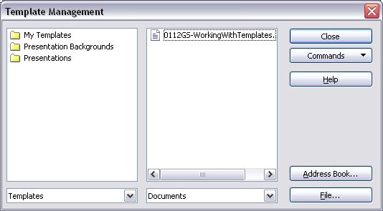Figure 12: Template management dialog
- In the box on the left, double-click the folder containing the template that you want to edit. A list of all the templates contained in that folder appears underneath the folder name.
- Select the template that you want to edit.
- Click the Commands button and choose Edit from the drop-down menu.
- Edit the template just as you would any other document. To save your changes, choose File > Save from the main menu.

Updating a Spreadsheet from a Changed Template
The next time you open a spreadsheet created from the changed template, a message similar to the following appears.
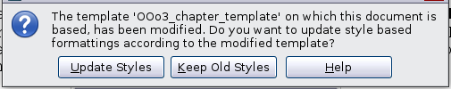
Figure 13: Update styles message
Click Update Styles to apply the template’s changed styles to the spreadsheet. Click Keep Old Styles if you do not want to apply the template’s changed styles to the spreadsheet (see Caution notice below).
Caution | If you choose Keep Old Styles in the message box shown in Figure 3, that message will not appear again the next time you open the document after changing the template it is based on. You will not get another chance to update the styles from the template, although you can use the macro given in the Note below to re-enable this feature.

Note | To re-enable updating from a template:  - Use Tools > Macros > Organize Macros > OpenOffice Basic. Select the document from the list, click the expansion symbol (+ or triangle), and select Standard. If Standard has an expansion symbol beside it, click that and select a module.  - If the Edit button is active, click it. If the Edit button is not active, click New.  - In the Basic window, enter the following:  Sub FixDocV3  ' set UpdateFromTemplate  oDocSettings = ThisComponent.createInstance( _  "com.sun.star.document.Settings" )  oDocSettings.UpdateFromTemplate = True  End Sub 'FixDocV3  - Click the Run BASIC icon, then close the Basic window.  - Save the document.  Next time when you open this document, you will have the update from template feature back.

Adding Templates Using the Extension Manager
The Extension Manager provides an easy way to install collections of templates, graphics, macros, or other add-ins that have been “packaged” into files with a .OXT extension. See Chapter 14 (Setting Up and Customizing Calc) for more about the Extension Manager.
This Web page lists many of the available extensions: https://extensions.openoffice.org/.
To install an extension, follow these steps:
- Download an extension package and save it anywhere on your computer.
- In AOO, choose Tools > Extension Manager from the menu bar. In the Extension Manager dialog, click Add.
- A file browser window opens. Find and select the package of templates you want to install and click Open. The package begins installing. You may be asked to accept a license agreement.
- When the package installation is complete, the templates are available for use through File > New > Templates and Documents, and the extension is listed in the Extension Manager.
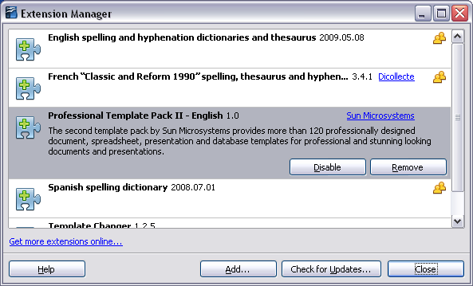
Figure 14: Newly-added package of templates

Setting a Default Template
If you create a document by choosing File > New > Spreadsheet from the main menu, AOO creates the document from the Default template for spreadsheets. You can, however, set a custom template as the default; you can reset the default later if you choose.

Setting a Custom Template as the Default
You can set any template as the default as long as it is in one of the folders displayed in the Template Management dialog.
To set a custom template as the default:
- From the main menu, choose File > Templates > Organize. The Template Management dialog opens.
- In the box on the left, select the folder containing the template you want to set as the default, then select the template.
- Click the Commands button and choose Set As Default Template from the drop-down menu.
The next time you create a document by choosing File > New, the document will be created from this template.

Resetting the Default Template
To re-enable AOO’s default template for a document type as the default:
- In the Template Management dialog, click any folder in the box on the left.
- Click the Commands button and choose Reset Default Template > Spreadsheet from the drop-down menu.
The next time you create a spreadsheet by choosing File > New, it will be created from AOO’s default template for spreadsheets.

Associating a Spreadsheet with a Different Template
Sometimes, you might want to associate a spreadsheet with a different template. Or perhaps you’re working with a spreadsheet that did not start from a template, but you now want it associated with one.
One significant advantage of using templates is ease of updating styles in multiple documents, as described on page 112. If you update styles by copying them from a different template (as described on page 107), the document has no association with the template from which the styles were loaded—so you cannot use this method. What you need to do is to associate the document with a different template.
For best results, the styles' names should be the same as those in the existing document and the new template. If they are not, you will need to use Search and Replace to replace the old styles with new ones. See Chapter 2 (Entering, Editing, and Formatting Data) for more about replacing styles using Find and Replace.
- Use File > New > Templates and Documents. Choose the template you want. A new file, based on the template, opens. If the template contains unwanted text or graphics, delete them.
- Open the spreadsheet you want to change. (It opens in a new window.) Press Control+A to select everything in the spreadsheet.
- Switch to the window containing the blank spreadsheet created in Step 1, and paste the content into that spreadsheet.
- Save the file under a new name.

Organizing Templates
AOO can only use templates that are in AOO template folders. You can create new AOO template folders and use them to organize your templates, and import templates into those folders. For example, you might have one template folder for report templates and another for letter templates. You can also export templates.
To begin, choose File > Templates > Organize from the main menu. The Template Management dialog opens.
Note | All the actions made by the Commands button in the Template Management dialog can be made as well by right-clicking on the templates or the folders.

Creating a Template Folder
To create a template folder:
- In the Template Management dialog, click any folder.
- Click the Commands button and choose New from the drop-down menu. A new folder called Untitled appears.
- Type a name for the new folder, and then press Enter. AOO saves the folder with the name that you entered.

Deleting a Template Folder
You cannot delete template folders supplied with AOO or installed using the Extension Manager. You can only delete template folders that you have created.
To delete a template folder:
- In the Template Management dialog, select the folder you want to delete.
- Click the Commands button and choose Delete from the drop-down menu. A message box will appear asking you to confirm the deletion. Click Yes.

Moving a Template
To move a template from one template folder to another template folder:
- In the Template Management dialog, double-click the folder that contains the template you want to move. A list of the templates contained in that folder appears underneath the folder name.
- Click the template you want to move and drag it to the desired folder. If you do not have the authority to delete templates from the source folder, this action copies the template instead of moving it, leaving it in its original folder and placing a copy in the new folder.

Deleting a Template
You cannot delete templates supplied with AOO or installed using the Extension Manager. You can only delete templates that you have created or imported.
To delete a template:
- In the Template Management dialog, double-click the folder containing the template you want to delete. A list of the templates in that folder appears underneath the folder name.
- Click the template that you want to delete.
- Click the Commands button and choose Delete from the drop-down menu. A message box will appear asking you to confirm the deletion. Click Yes.

Importing a Template
If the template that you want to use is in a different location, you must import it into an AOO template folder.
To import a template into a template folder:
- In the Template Management dialog, select the folder into which you want to import the template.
- Click the Commands button and choose Import Template from the drop-down menu. A standard file browser window opens.
- Find and select the template you want to import, then click Open. The file browser window closes, and the template appears in the selected folder.
- If you like, type a new name for the template and then press Enter.

Exporting a Template
To export a template from a template folder to another location:
- In the Template Management dialog, double-click the folder that contains the template you want to export. A list of the templates contained in that folder appears underneath the folder name.
- Click the template that you want to export.
- Click the Commands button and choose Export Template from the drop-down menu. The Save As window opens.
- Find the folder into which you want to export the template. Then click Save.

Chapter 5
Using Graphics in Calc
Graphics in Calc
Calc is often used to present data and make forecasts and predictions. Effectively using graphics can turn an average document into a memorable one. Calc can import various vector (line drawing) and raster (bitmap) file formats. The most commonly used graphic formats are GIF, JPG, PNG, and BMP. See the Help for a full list of the formats Apache OpenOffice (AOO) can import.

Note | If you are choosing among graphics file formats, you may want to consider the following information.  GIF: a standard for digitized images defined in 1987 by CompuServe.  JPG: an image compression algorithm designed for compressing either full-color or grey-scale digital images. JPEG does not work well on images such as cartoons or line drawings.  PNG: a file format for the lossless, portable, well-compressed storage of raster images; designed especially for online viewing. Note that a raster image is one in which the image is composed of an array of pixels arranged in rows and columns; whereas a vector image is one which represents shapes such as lines, polygons and text, and groups of such objects.  BMP: BMP files contain uncompressed data, making it ideal for storing and displaying high-quality digital images. However, this lack of compression generally creates larger file sizes.

Graphics in Calc are of three basic types:
- Image files, such as photos, drawings, and scanned images
- Diagrams created using AOO’s drawing tools
- Charts and graphs created using AOO’s Chart facility
This chapter covers images and diagrams. Charts are described in Chapter 3 (Creating Charts and Graphs).
Although using graphics in Calc is very similar to using graphics in any other component of AOO, this chapter explains some of the differences in that use. It also covers some more advanced graphics functions and how they can further enhance your spreadsheet.
Note | The term graphics refers to both pictures and drawing objects. Often, the word images is used when referring to pictures and other graphics that were not produced by a drawing application such as OpenOffice Draw.

Adding Graphics (Images)
Images (also called pictures in AOO), such as corporate logos and photographs of people and products, are probably the most common types of graphics added to a Calc document. They may be downloaded from the Internet, scanned, created with a graphics program, or photos taken with a camera.
Images can be inserted in four ways:
- Using the Insert File dialog
- By dragging and dropping a supported file
- From the gallery
- From the clipboard by copying and pasting

Inserting an Image File
Perhaps the most common way to insert graphics is to use an existing file.
To insert an image from a file, use either of the following methods:
- Insert Picture dialog
- Drag and drop

Insert Picture Dialog
- Click on the location in the Calc document where you want the image to appear. Do not worry too much about the exact placement of the image at this stage; placement can be changed easily as described in “Positioning Graphics” on page 135.
- Choose Insert > Picture > From File from the menu bar, or click the Insert Picture icon on the Picture toolbar.
- On the Insert Picture dialog, navigate to the file to be inserted, select it, and click Open.
Note | The picture is inserted into Calc floating above the cells and anchored to the cell in which the cursor was placed. See “Positioning Graphics” on page 135 for more about positioning and anchoring graphics.

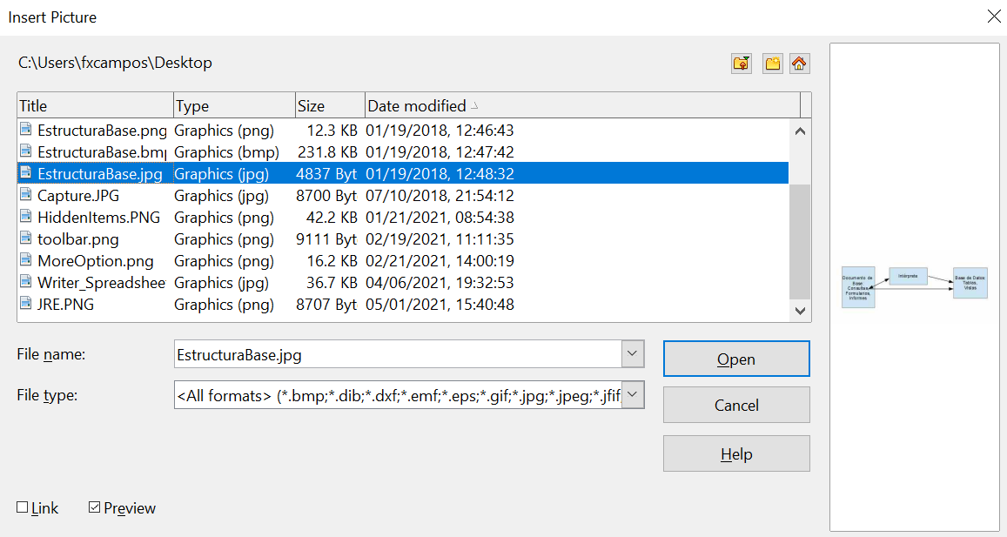

Figure 1: Inserting a picture from a file
At the bottom of the dialog are two options: Preview and Link. Select Preview to view a thumbnail of the selected image on the right so you can verify that you have the correct file. The Link option is discussed on page 120. When the Link option is not selected, the picture is embedded in the Calc document.
Note | Your Insert Picture dialog may look quite different from the one shown here, depending on your operating system and your choice in Tools > Options > OpenOffice > General of whether to use the AOO Open and Save dialogs.

Drag and Drop
- Open a file browser window and locate the image you want to insert.
- Drag the image into the Calc document and drop it where you want it to appear. A faint vertical line marks where the image will be dropped. The picture will be anchored to the cell where it was dropped.
This method always embeds (saves a copy of) the image file in the Calc document.

Linking an Image File
To create a link to the file containing the image instead of saving a copy of the image in the Calc document, use the Insert picture dialog and select the Link option. The image is then displayed in the document, but when the document is saved, it contains only a reference to the image file—not the image itself. The document and the image remain as two separate files, which are merged temporarily only when you open the document again.
Linking an image has two advantages and one disadvantage:
- Advantage – Linking can reduce the document's size when it is saved because the image file itself is not included. File size is usually not a problem on a computer with sufficient memory unless the document includes many large graphics files.
- Advantage – You can modify the image file separately without changing the document because the link to the file remains valid, and the modified image will appear when you next open the document. This can be a big advantage if you (or someone else, perhaps a graphic artist) are updating images.
- Disadvantage – If you send the document to someone else or move it to a different computer, you must also send the image files, or the receiver will not be able to see the linked images. You need to keep track of the location of the images and make sure the recipient knows where to put them on another machine so the Calc document can find them. For example, you might keep images in a subfolder named Images (under the folder containing the Calc document); the recipient of the Calc file needs to put the images in a subfolder with the same name (under the folder containing the Calc document).
Note | When inserting the same image several times in a document, it might seem beneficial to create links. However, this isn't necessary; AOO embeds only one copy of the image file in the document. Deleting one or more of the copies does not affect the others.

Embedding Linked Images
If you originally linked the images, you can easily embed one or more of them in the Calc document later if you wish. To do so:
- Open the document in Calc.
- Choose Edit > Links from the menu bar.
The Edit Links dialog shows all the linked files. In the Source file list, select the files you want to change from linked to embedded.
- Click the Break Link button.
- Save the Calc document.
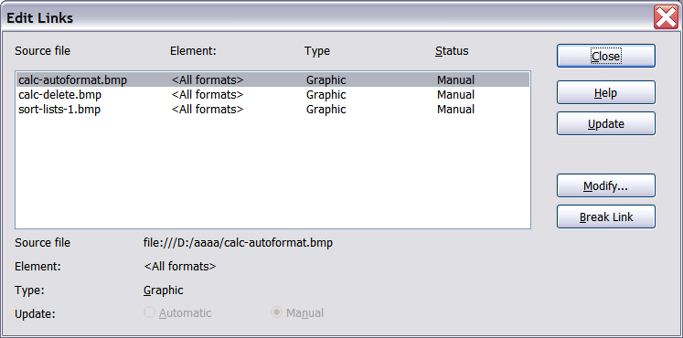
Figure 2: The Edit Links dialog
Note | Going the other way, from embedded to linked, is not simple. You must delete and reinsert each image, one at a time, selecting the Link option when you do so.

Inserting an Image from the Clipboard
With the clipboard, you can copy images into a Calc document from another Calc document, from another component of AOO (Writer, Draw, and so on), and even from other programs.
To do this:
- Open both the source document and the Calc document into which you want to copy the image.
- In the source document, select the image to be copied.
- Press Control+C to copy the image to the clipboard.
- Switch to the Calc window.
- Click to place the cursor where the graphic is to be inserted.
- Press Control+V to insert the image.
Caution | If the application from which the graphic was copied is closed before the graphic is pasted into Calc, the image stored on the clipboard could be lost from the clipboard.

Inserting an Image from the Gallery
The Gallery provides a convenient way to group reusable objects like graphics and sounds, which can then be inserted into documents.
The Gallery is available in all components of AOO. It does not include many graphics, but you can add your own or find extensions that contain more. The Gallery is explained in more detail in Chapter 11 (Graphics, the Gallery, and Fontwork) in the Getting Started guide. For more about extensions, see Chapter 14 (Setting Up and Customizing Calc) in this book.
This section explains the basics of inserting a Gallery image into a Calc document.
- To open the Gallery (Figure 3), select the Gallery deck in the Sidebar, click on the Gallery icon (located on the right side of the Standard toolbar), or choose Tools > Gallery from the menu bar.
- Navigate through the Gallery to find the desired picture.
- To insert the picture, either right-click on the picture and choose Insert > Copy or click and drag the picture from the Gallery into the Calc document.
If your computer has a wide screen, displaying the Gallery in the Sidebar is likely the most convenient option. There are other options for resizing and repositioning the Gallery if you don't plan to place it in the Sidebar. In such cases, the Gallery is docked above the Calc workspace. To expand the Gallery, position the pointer over the line that divides it from the top of the workspace. When the pointer changes to parallel lines with arrows, click and drag downward. The workspace resizes in response.
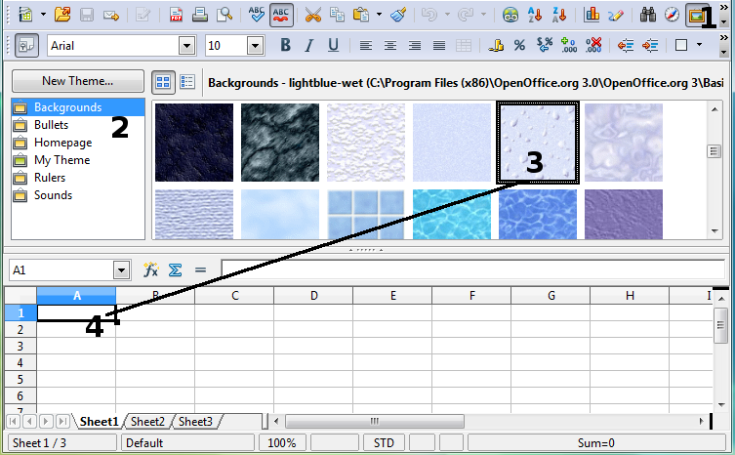
Figure 3: Gallery in Calc
To expand the Gallery without affecting the workspace, undock it so it floats over the workspace. To do so, hold down the Control key and double-click on the upper part of the Gallery next to the View icons. Double-click in the same area while holding down the Control key to dock it again (restore it to its position over the workspace).
When the Gallery is docked, to hide it and view the full Calc workspace, click the Hide/Show button in the middle of the thin bar separating the Gallery from the workspace.
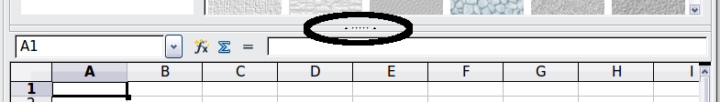
To close the Gallery, choose Tools > Gallery to uncheck the Gallery entry, or click on the Gallery icon again.

Modifying Images
When you insert a new image, you may need to modify it to suit the document. This section describes the use of the Picture toolbar, resizing, cropping, and a workaround for rotating a picture. (Changes made in Calc do not affect the original picture, whether embedded or linked.)
Calc provides many tools for working with images. These tools are sufficient for most people’s everyday requirements. However, for professional results, it is generally better to use an image manipulation program to modify images (for example, to crop, resize, rotate, and change color values) and then insert the result into Calc.

Using the Picture Toolbar
When you insert an image or select one already present in the document, the Picture toolbar appears. You can set it to always be present (View > Toolbars > Picture). Picture control buttons from the Picture toolbar can also be added to the Standard Toolbar. See Chapter 14 (Setting Up and Customizing Calc) for more information.
This toolbar can be either floating or docked. Figure 4 shows the Picture toolbar when it is floating. A brief explanation of the tools is given in Table 3. See the Draw Guide for a more detailed explanation.
Two other toolbars can be opened from this one: the Graphic Filter toolbar, which can be torn off and placed elsewhere on the window, and the Color toolbar, which opens as a separate floating toolbar.
Several of the tools available on the Picture toolbar are also available on the Properties deck of the Sidebar. The Sidebar layout for images is described on page 131.
From these three toolbars, you can apply small corrections to the graphic or obtain special effects.
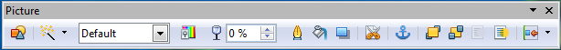
Figure 4: The Picture Toolbar
Table 3: Picture toolbar functions (from left to right)
Icon | Name | Behavior
 | From File | Use of this icon is described in “Inserting an Image File” on page 118.
 | Filter | Displays the Graphic Filter toolbar. See page 125.
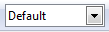 | Graphics Mode | Provides several color modes in the drop-down list. See page 125.
 | Color | Opens the Color toolbar, described on page 126.
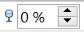 | Transparency | Sets the transparency of the selected image. See page 126.
 | Line | Adjusts the border style of the selected image.
 | Area | Fills an area with the selected color or pattern.
 | Shadow | Adds a drop shadow to the edges of the picture.
 | Crop | Opens the Crop dialog, where you can remove a selected part of the picture. See page 126.
 | Anchor | Toggles between anchoring the image to the cell or to the page. See page 136.
 | Bring to Front | Brings the selected image to the front of the stack. See page 135.
 | Send to Back | Pushes the selected image to the rear of the stack. See page 135.
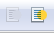 | To Foreground / Background | Allows image to float in the foreground or makes it part of the background (behind the cells). See page 135.
 | Alignment | If two or more pictures are selected, adjusts the horizontal and vertical alignment of the pictures in relation to each other. See page 137.

Choosing a Graphics Mode
You can change color images to grayscale by selecting the image and then selecting Grayscale from the Graphics mode list.
Table 4: Graphics modes
Graphics mode | Behavior
Default | Keeps the picture the same as it was inserted.
Grayscale | Shows the picture in gradual shades of gray.
Black / White | Converts the picture into a monochromatic black and white image.
Watermark | Makes the picture into a watermark that blends into the background.

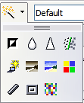
Using Graphic Filters
Click the Filter icon to display the Graphic Filter toolbar, which provides options for applying basic photographic and effect filters to images within Calc. To “tear off” this toolbar and place it anywhere on the screen, click on the three parallel lines and drag it away.
Table 5: Graphic filters and their effects
Icon | Name | Behavior
 | Invert | Inverts the colors in the picture so they resemble a negative.
 | Smooth | Applies a Gaussian blur to the image, which softens edges.
 | Sharpen | Sharpens the image.
 | Remove Noise | Applies crude noise reduction.
 | Solarization | Reverses a portion of the tones, then produces pronounced outlines of the highlights.
 | Aging | Applies a Sepia, that is,a brownish-grey to dark olive brown, filter.
 | Posterize | Opens a dialog to determine the number of poster colors. This effect is based on the reduction of the number of colors. It makes photos look like paintings.
 | Pop Art | Applies a Pop Art style to the image.
 | Charcoal Sketch | Applies a Charcoal Sketch look to the image.
 | Relief | Displays a dialog for creating reliefs. The position of the imaginary light source that determines the type of shadow can be chosen.
 | Mosaic | Joins small groups of pixels into rectangular areas of the same color. The larger the individual rectangles are, the fewer details the graphic image has.

Caution | Applying AOO picture filters to any image consecutively will progressively degrade the quality of the image. The picture filters used in Calc utilize what is known as a Destructive Editing algorithm, whereby each filter is applied to the image immediately, changing the original data of the image. Successive transformations result in less and less original data remaining, thus compromising the quality of the inserted picture. While this might be acceptable for use in simple documents, it is still recommended that dedicated photo or image editing software be used to perform anything but the simplest of manipulations.

Adjusting Colors
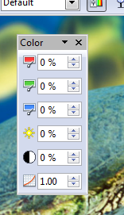
Use the Color toolbar to independently adjust an image’s red, green, and blue channels, as well as its brightness, contrast, and gamma.

Setting Transparency
Modify the percentage value in the Transparency box on the Picture toolbar to make the image more transparent. This is particularly useful when creating a watermark or wrapping an image in the background.

Customizing Lines, Areas, and Shadows
The Line, Area, and Shadow icons open dialogs where you can customize these elements. Details are in the Draw Guide.

Cropping Pictures
When you are only interested in a section of the image for your document, you may wish to crop (cut off) parts of it. The user interface in Calc for cropping an image is not very friendly, so it may be a better choice to use a graphics package.
Click the Crop icon to open a dialog to select which portion of the image you want to remove.
Dealing with cropping images in Calc is unlike what's done on Draw; in Calc, it's impossible to use the mouse to select an area to be cropped. Instead, in the Crop dialog, specify how far from the image's top, bottom, left, and right borders the crop should be, as illustrated in Figure 5. On the thumbnail in the figure, notice that the cropped selection is highlighted with an inner rectangle.
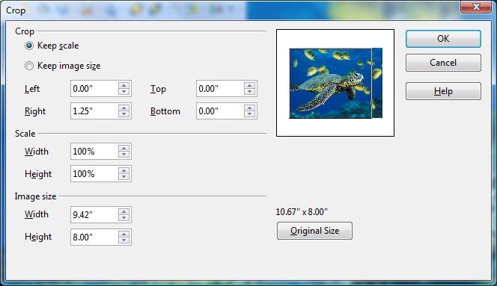

Figure 5: The Crop dialog
On the Crop dialog, you can control the following parameters:
Keep scale / Keep image size
When Keep scale is selected (default), cropping the image does not change the scale of the picture.
When Keep image size is selected, cropping enlarges, for positive cropping values, shrinks, for negative cropping values, or distorts of the image so that the image size remains constant.
Left, Right, Top, and Bottom
The image is cropped by the amount entered in these boxes. For example, a value of 3cm in the Left box cuts 3 cm from the left side of the picture.
- When Keep scale is selected, the size of the image also changes, so in this example, the width will be reduced by 3 cm.
- When Keep image size is selected, the remaining part of the image is enlarged (when you enter positive values for cropping) or shrunk (when you enter negative values for cropping) so that the width and height of the image are not changed.
Width and Height
The Width and Height fields under either Scale or Image size change as you enter values in the Left, Right, Top, and Bottom fields. Use the thumbnail next to these fields to determine the correct amount by which to crop.
The cropped shape is always a rectangle; more complex cropped shapes are impossible in Calc. Instead, use a dedicated photo or image editing software for the job, then import the image into Calc.
Note | If you crop an image in Calc, the picture itself is not changed. If you export the document to HTML, the original image, not the cropped image, is exported.

Resizing an Image
To resize an image.
- Click the picture, if necessary, to show the green resizing handles.
- Position the pointer over one of the green resizing handles. The pointer changes shape, giving a graphical representation of the direction of the resizing.
- Click and drag to resize the picture.
- Release the mouse button when satisfied with the picture's new size.
The corner handles resize the graphic object's width and height simultaneously, while the other four handles only resize one dimension at a time.
Tip | To retain the original proportions of the graphic, Shift+click one of the corner handles, then drag. Be sure to release the mouse button before releasing the Shift key.

Resizing a bit-mapped (raster) image, such as a photograph, adversely affects the resolution, causing some degree of blurring. It's better to use a graphics package to size your picture correctly before inserting it into your document.
For more accurate resizing, use the Position and Size dialog, described on page 129.

Rotating a Picture
Calc provides tools for rotating a picture through the context menu and the Sidebar, as described in the next sections. To use OpenOffice's full capability for rotating pictures interactively, you need to work with the picture in Draw or Impress. To do so:
- Open a new Draw or Impress document.
- Insert the image you want to rotate.
- Select the image, then in the Drawing toolbar (shown by default at the bottom of the window in Impress and Draw), select the Rotate icon .
- Rotate the image as desired. Use the red handles at the corners of the picture and move the mouse in the direction you wish to rotate. By default, the picture rotates around its center (indicated by a black crosshair), but you can change the pivot point by moving the black crosshair to the desired rotation center.
Tip | To restrict the rotation angle to multiples of 15 degrees, keep the Shift key pressed while rotating the image.

- Select the rotated picture by pressing Ctrl+A, then copy the image to the clipboard with Ctrl+C.
- To finish, go back to the Calc document, place the cursor where the image is to be inserted, and press Ctrl+V.

Using the Picture Context Menu
Many options accessible from the Picture toolbar can also be reached by right-clicking on an image to pop up a context menu. Some additional options are only available from the context menu; these are described in this section. Some of these options are also available on the Sidebar.

Text
Opens a dialog where you can set the options for text that goes over a picture. To write text over a graphic, click on the graphic to select it, and then press Enter. There should be a cursor inside the graphic. Any text entered is part of the graphic, so if the graphic is moved the text will move with it.

Position and Size
Opens the dialog shown below, where you can change the size, location, rotation, slant, and corner radius of the image.
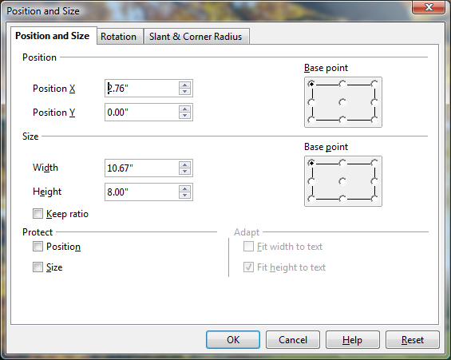

Figure 6: Position and Size dialog
Figure 12 shows the Rotation tab of the Position and Size dialog. You can change the point around which the rotation occurs, as well as the angle. The changes made in the dialog only happen when the dialog is closed. The rotation angle can be changed interactively using the Sidebar, as explained below.
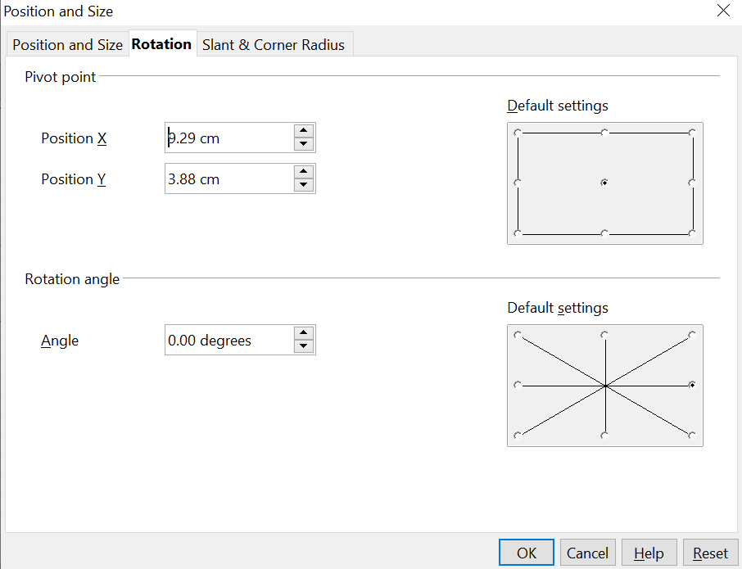

Figure 7: The Rotation tab of the Position and Size dialog

Original Size
Resets the image's dimensions to the values it had when it was initially inserted into the document.

Description
You can add metadata to the image in the form of a title and description. This information is used by accessibility tools (such as screen reader software) and as ALT (alternative) attributes if you export the document to HTML.

Name
You can assign the image a custom name to make it easier to find in the Navigator.
Tip | When collaborating with a team on a large, multi-page publication, it's beneficial to give graphics, figures, and other objects meaningful names and descriptions to aid in clear communication.

Flip
Flips the image either horizontally or vertically.

Assign Macro
Adds programmable functionality to the image. Calc provides rich macro functionality. Macros are introduced in Chapter 12 (Calc Macros).

Group
To group images:
- Select one image, then hold down the Shift key and click in turn on each of the others that you want to include in the group. The invisible “bounding box” with its 8 green handles, expands to include all the selected images.
- With the images selected, choose Format > Group > Group from the menu bar.
Or, hover the mouse pointer over one of the images. When the pointer changes shape from an arrow to a hand, right-click and choose Group > Group from the pop-up menu.
Note | You cannot include drawing objects in a group with pictures.

After images are grouped, the context menu provides other choices (Ungroup and Edit Group), and the Format > Group menu includes Ungroup and Enter Group. For more information about grouping, see the Draw Guide.

Using the Sidebar
When an image is selected, the Sidebar's Properties deck displays three panels: Graphic, Line, and Position and Size. These panels have many of the controls available on the Picture toolbar and the Picture context menu, which were discussed in the previous sections. If the Sidebar is not visible, use View > Sidebar to open it.
Figure 11 shows the three panels expanded individually, with the Graphic panel on the left, the Line panel in the center, and the Position and Size on the right. All of the panels can be expanded at the same time. They are shown individually in the figure to focus on their particular functions.
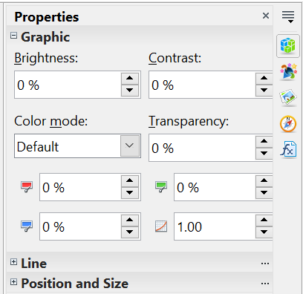
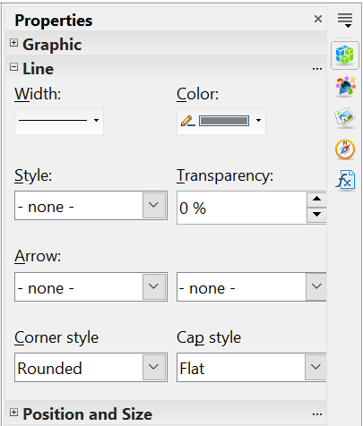
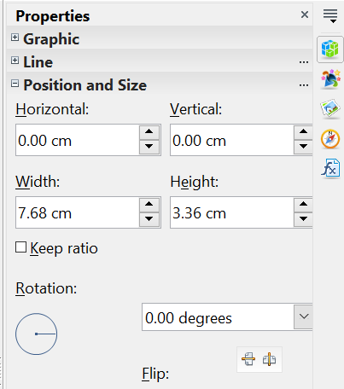

Figure 8: The three panels of the Properties deck for an image.

Graphic Panel
The Graphic panel contains the same controls as the Color toolbar accessed from the Picture toolbar, and also the Color mode (called Graphic mode on the Picture toolbar) and Transparency. The Color mode can be set to Default, Grayscale, Black/White, and Watermark. The Color mode settings are explained in Table 4

Line Panel
The Line panel displays controls for setting the width, color, line style, transparency, arrow properties, and line end properties. In OpenOffice, the term arrow refers not only to typical arrow heads but also circles, squares, and diamonds drawn at the end of the line. The left and right Arrow boxes control the beginning and end of the line, respectively, not necessarily the left and right end. Keep this in mind if you draw the line from right to left.
The dialog for controlling all aspects of a line is available by clicking the three small dots at the right edge of the Line panel's title bar.

Position and Size Panel
The Position and Size panel displays the controls for adjusting the location and size of the image. Making these adjustments through this panel has the advantage that the image changes immediately as the values change, which can be very convenient for fine-tuning an image's position. In addition to x,y, and size adjustments, the image can be rotated and flipped. As with the Line panel, the full Position and Size dialog is available by clicking the three small dots on the panel's title bar.

Using Calc’s Drawing Tools
Calc, like the other components of AOO, has a range of tools to create custom drawings. This chapter covers the default options in Calc. For a more detailed explanation of the drawing tools and their uses, see the Draw Guide.
In general, if you need to create complex drawings, your best choice is to use OpenOffice Draw or a similar drawing program.
To begin using the drawing tools, choose View > Toolbars > Drawing. The Drawing toolbar appears at the bottom of the screen. You can tear off this toolbar and move it to a convenient place on the window.
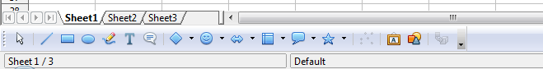
Figure 9: The Drawing toolbar showing default icons
Table 6: Drawing toolbar functions (from left to right)
Icon | Name | Behavior
 | Select | Selects objects.
 | Line | Draws a line.
 | Rectangle | Draws a rectangle. To draw a square, hold down Shift while you drag.
 | Ellipse | Draws an ellipse. To draw a circle, hold down Shift while you drag.
 | Freeform Line | Draws a freeform line.
 | Text | Draws a text box with no border.
 | Callouts | Draws a line that ends in a rectangular callout.
 | Basic Shapes | Opens the Basic Shapes toolbar.
 | Symbol Shapes | Opens the Symbol Shapes toolbar.
 | Block Arrows | Opens the Block Arrows toolbar of shapes.
 | Flowcharts | Opens the Flowchart toolbar of shapes.
 | Callouts | Opens the Callouts toolbar of shapes.
 | Stars | Opens the Stars toolbar of shapes.
 | Points | Allows editing the points of a selected polygon.
 | Fontwork Gallery | Opens the Fontwork Gallery.
 | From File | Inserts a picture using the Insert Picture dialog.
 | Extrusion On/Off | Opens the 3-D Setting toolbar and converts the selected shape (if any) to 3-D.
To display other icons, click the down arrow at the right-hand end of the toolbar, select Visible Buttons, and choose the tools you want to appear on the toolbar.
Icon | Name | Behavior
 | Polygon | Draws a line composed of a series of straight line segments. Hold down the Shift key to position new points at 45 degree angles.
 | Curve | Draws a smooth Bézier curve.
 | Arc | Draws an arc.
 | Ellipse Pie | Draws a filled shape that is defined by the arc of an oval and two radius lines. To draw a circle pie, hold down Shift while you drag.
 | Circle Segment | Draws a filled shape that is defined by the arc of a circle and a diameter line. To draw an ellipse segment, hold down Shift while you drag.
 | Text Animation | Inserts animated text.
If support for Asian languages has been enabled (in Tools > Options > Language Settings > Languages), two more tools can be added to the Drawing toolbar: Vertical Text and Vertical Callouts.
To use a drawing tool:
- Click in the document where you want the drawing to be anchored. If necessary, you can change the anchor later.
- Select the tool from the Drawing toolbar (Figure 9). The mouse pointer changes to a cross-hair pointer.
- Move the cross-hair pointer to the place in the document where you want the graphic to appear, and then click and drag to create the drawing object. Release the mouse button. (Some tools have other requirements; see the Help or the Draw Guide for details.)
The selected drawing function remains active so you can draw another object of the same type.
- To cancel the selected drawing function, press the Esc key or click on the Select icon (the arrow) on the Drawing toolbar.
- You can now change the properties (fill color, line type, weight, anchoring, and others) of the drawing object using the Sidebar, the Drawing Object Properties toolbar (Figure 10), or the choices and dialog boxes reached by right-clicking on the drawing object.

Set or Change Properties for Drawing Objects
To set the properties for a drawing object before you draw it:
- On the Drawing toolbar (Figure 9), click the Select tool.
- On the Drawing Object Properties toolbar (Figure 10), click on the icon for each property and select the value you want for that property.
- For more control or to define new attributes, click on the Area or Line icons on the toolbar to display detailed dialogs.
These default properties are applied only to the current document and session. They are not retained when you close the document, and they do not apply to any other document. The defaults apply to all drawing objects except text objects.
To change the properties for an existing drawing object, select the object and either continue as described above or use the Properties deck of the Sidebar.
Other tools and methods for modifying and positioning graphics are described in “Positioning Graphics” below.
1 | Line | 5 | Line Color | 9 | Change Anchor | 13 | Alignment
2 | Arrow Style | 6 | Area | 10 | Bring to Front
3 | Line Style | 7 | Area Style / Filling | 11 | Send to Back
4 | Line Width | 8 | Rotate | 12 | To Foreground / To Background
Figure 10. Drawing Object Properties toolbar

Resizing a Drawing Object
Select the object, click on one of the eight handles around it, and drag it to its new size. For scaled resizing, select one of the corner handles and keep the Shift key pressed while dragging the handle.
For more control of the size of the object, use the Position and Size dialog (see "Position and Size Panel" on page 132 or “Position and Size” on page 129) to set the width and height independently. If the Keep ratio option is selected, the two dimensions change to maintain the proportion, allowing for scaled resizing.

Grouping Drawing Objects
To group drawing objects:
- Select one object, hold down the Shift key, and select the others you want to include in the group. The bounding box expands to include all selected objects.
- With the objects selected, choose Format > Group > Group from the menu bar or hover the mouse pointer over one of the objects, right-click, and choose Group > Group from the pop-up menu.
Note | You cannot include an embedded or linked graphic in a group with drawing objects.

Positioning Graphics
Graphics can be positioned in AOO Calc to work together and build more complex features.

Arranging Graphics
Graphics in a Calc document are maintained like a deck of cards. As you add more images to the document, each image occupies a new layer at the top of the stack. To arrange graphics, you tell Calc to change the order of layers in the stack.
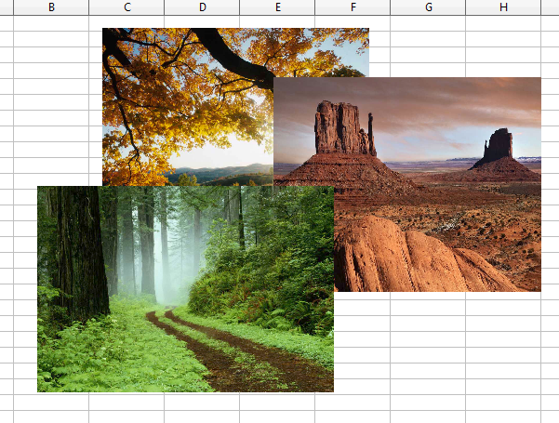
Figure 11: Layering effect
Calc provides five options shown below to re-arrange the order of images. These options can be accessed from both the Picture toolbar and the picture context menu:
Bring to Front
Places the image on top of any other graphics or text.
Bring Forward
Brings the image one level up in the stack (z-axis). Depending on the number of overlapping objects, you may need to apply this option several times to obtain the desired result.
Send Backward
The opposite of Bring Forward; sends the selected image one level down in the object stack.
Send to Back
Sends the selected graphic to the bottom of the stack so that other graphics and text cover it.
To Background and To Foreground
An image or a drawing object can also be sent to the background. This is not the same as Bring Forward and Send Backward, which set the order of several overlapping graphics. This feature pushes a graphic behind the cells, allowing cells to be edited without affecting the graphic.
A graphic in the background will have To Foreground as a menu item instead of To Background.

Anchoring Graphics
Anchors tell a graphic where to stay in relation to other items.
Anchor to page
Anchoring a graphic to the page allows it to be positioned in a specific place. The graphic does not move when cells are added or deleted. This is equivalent to an absolute reference. The graphic will always stay by cell B10 if that is where it is placed.
Anchor to cell
Anchoring a graphic to a cell ensures that it always stays with the content it is originally anchored to. If a graphic is anchored to cell B10 and a new row is inserted, the graphic will then be anchored to cell B11. This is equivalent to a relative reference.
For example, in Figure 6 the normal Otto and Tux picture is anchored To Cell B10 (XXX shows where the picture is anchored). The inverse Otto and Tux picture is anchored to the page.
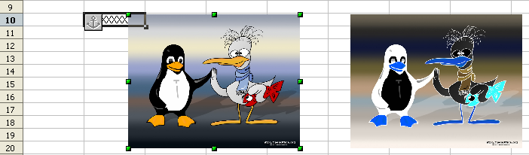
Figure 12: Anchoring 1
If two rows are inserted above the pictures, the normal picture (anchored to cell) will shift down two rows, and the anchor will change. The inverse picture (anchored to page) will not move. This is illustrated in Figure 2. Note that the anchor symbol and the XXX have moved down to cell B12.
.
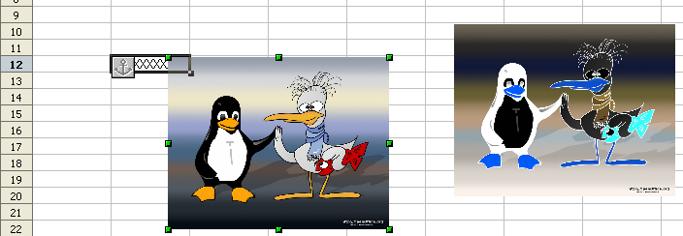
Figure 13: Anchoring

Aligning Graphics
You can align several graphics relative to each other. To do this:
- Select all of the graphics to be aligned (Shift+click on each in turn). The graphics will be surrounded by an invisible bounding box with eight green handles.
- On the Picture toolbar, click the Alignment icon and select one of the six options.
Or, position the mouse pointer over any of the graphics, right-click and choose Alignment, then select from the six options.
The six options include three for aligning the graphics horizontally (left, center, right) and three for aligning the graphics vertically (top, center, bottom).

Creating an Image Map
An image map defines areas of an image called hotspots, associating them with hyperlinks to web addresses, other files on the computer, or parts of the same document. Hotspots are the graphic equivalent of text hyperlinks. Clicking on a hotspot causes Calc to open the linked page in the appropriate program (for example, the default browser for an HTML page; AOO Calc for a .ODS file; a PDF viewer for a PDF file). You can create hotspots of various shapes and include several hotspots in the same image.
To use the image map editor:
- In your spreadsheet, select the picture where you want to define the hotspots.
- Choose Edit > ImageMap from the menu bar. The ImageMap Editor (Figure 1) opens.
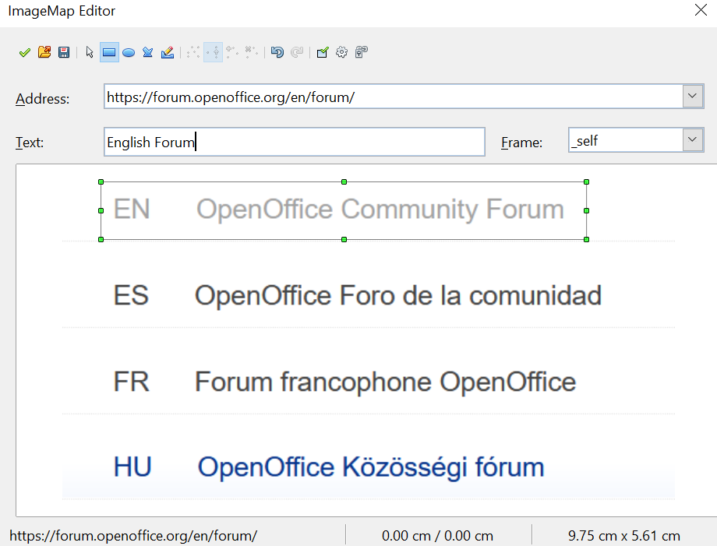

Figure 14: The dialog to create or edit an image map
- Use the tools and fields in the dialog (described below) to define the hotspots and links necessary.
- Click the Apply icon to apply the settings.
- When done, click the Save icon to save the image map to a file, then click the X in the upper right corner to close the dialog.
The main part of the dialog shows the image on which the hotspots are defined. A hotspot is identified by a line indicating its shape.
The toolbar at the top of the dialog contains the following tools:
- Apply button: click this button to apply the changes.
- Load, Save, and Select icons.
- Tools for drawing a hotspot shape: these tools work in exactly the same way as the corresponding tools in the Drawing toolbar.
- Edit, Move, Insert, Delete Points: advanced editing tools to manipulate the shape of a polygon hotspot. Select the Edit Points tool to activate the other tools.
- Active icon: toggles the status of a selected hotspot between active and inactive.
- Macro: associates a macro with the hotspot instead of simply associating it with a hyperlink.
- Properties: sets the hyperlink properties and adds the Name attribute to the hyperlink.
Below the toolbar, specify for the selected hotspot:
- Address: the address pointed by the hyperlink. You can also point to an anchor in a document; to do this, write the address in this format: file:///<path>/document_name#anchor_name
- Text: type the text you want displayed when the mouse pointer is moved over the hotspot.
- Frame: where the target of the hyperlink will open: pick among:
  - _blank (opens in a new browser window)
  - _self (opens in the active browser window
  - _top (opens in the current layer)
  - _parent (opens in the layer preceding the current one)
Tip | The value _self for the target frame will work just fine in most cases. However, while it's not necessary to use the other choices regularly, you may find them effective in specific circumstances. For instance, _blank, which opens the target in a new browser window, helps keep content visually orderly.

Chapter 6
Printing, Exporting, and E-mailing

Quick Printing
Click the Print File Directly icon to send an entire document to the default printer defined for your computer.
Note | You can change the action of the Print File Directly icon to send the document to the printer defined for the document instead of to the computer's default printer. Choose Tools > Options > Load/Save > General and select the Load printer settings with the document option.

Controlling Printing
For additional printing controls, use the Print dialog (File > Print or Ctrl+P).
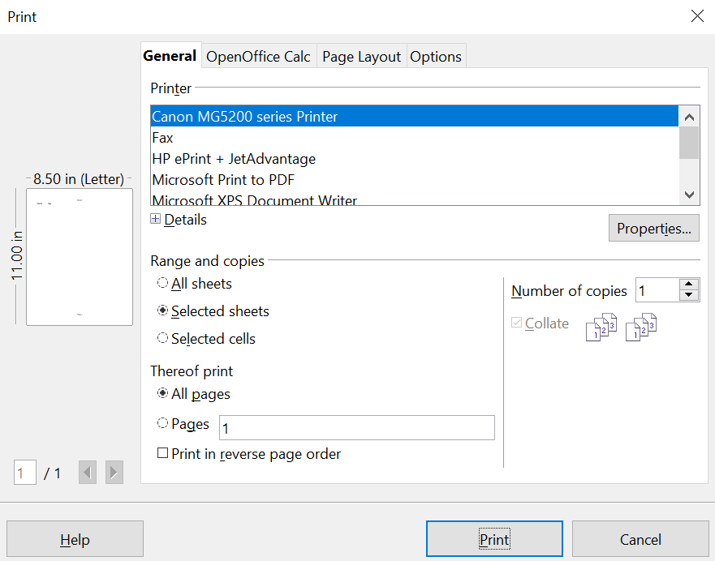

Figure 1. The Print dialog
The Print dialog has four tabs. From these, you can choose a range of options, as described in the following sections.
Note | The options selected on the Print dialog apply to this printing of the current document only.  To specify default printing settings for OpenOffice, go to Tools > Options > OpenOffice – Print and Tools > Options > OpenOffice Calc – Print. See Chapter 14 (Setting Up and Customizing Calc) for details.

Selecting General Printing Options
On the General tab of the Print dialog (Figure 1), you can choose:
- The printer (from the printers available)
- Which sheets and pages to print, the number of copies to print, and whether to collate multiple copies or print the pages in reverse order (Range and copies section)
Select the Properties button to display a dialog to choose portrait or landscape orientation, which paper tray to use, and the paper size to print on.
On the Options tab of the Print dialog (Figure 2), you can choose to print to a file instead of to a printer, or to create a single print job containing several copies of the document, instead of a separate print job for each copy.
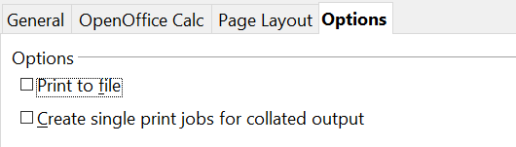

Figure 2: General print options

Printing Multiple Pages on a Single Sheet of Paper
You can print multiple pages of a document on one sheet of paper. To do this:
- In the Print dialog, select the Page Layout tab (Figure 3).
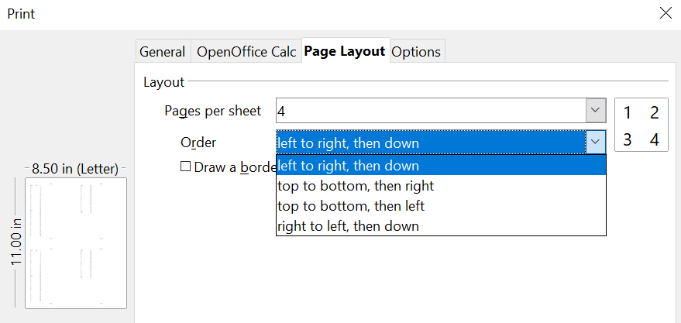

Figure 3: Printing multiple page per sheet of paper
- In the Layout section, choose the number of pages to print per sheet from the drop-down list. The preview panel on the left of the Print dialog shows how the printed document will look.
When printing more than 2 pages per sheet, you can choose the order they print across and down the paper.
- Click the Print button.

Selecting Sheets to Print
In addition to printing an entire document, you can print individual sheets, ranges of sheets, or a selection of a document.

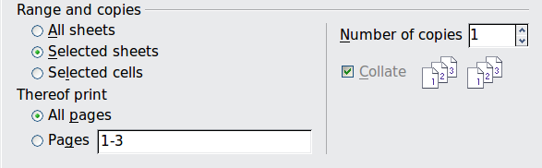
Figure 4: Choosing what to print in Calc
Printing an individual sheet:
- In the spreadsheet, click on the sheet tab to select the sheet you want to print.
- Choose File > Print from the menu bar.
- In the Ranges and copies section of the General tab of the Print dialog, choose the Selected sheets option.
- Click the Print button.
Printing a range of sheets:
- In the spreadsheet, select the sheets to print.
  - Select the first sheet.
  - Hold down the Control key.
  - Click on the additional sheet tabs.
  - Release the Control key when all required sheets are selected.
- Choose File > Print from the menu bar.
- In the Ranges and copies section of the Print dialog, choose the Selected sheets option.
- Click the Print button.
Printing a selection of cells:
- In the document, select the section of cells to print.
  - Select the first cell.
  - Hold down the Control key.
  - Click on the additional desired cells.
  - Release the Control key when all required cells are selected.
- Choose File > Print from the menu.
- In the Ranges and copies section of the Print dialog, select the Selected cells option.
- Click the Print button
Caution | After printing, be sure to deselect the extra sheets. If you keep them selected, the next time you enter data on one sheet, you enter data on all the selected sheets. This might not be desirable.

Using Print Ranges
Print ranges have several uses, including printing only a specific part of the data, or printing selected rows or columns on every page.

Defining a Print Range
To define a new print range or modify an existing print range:
- Highlight the range of cells that comprise the print range.
- Choose Format > Print Ranges > Define.
The page break lines display on the screen.
Tip | You can check the print range by using File > Page Preview. OpenOffice will only display the cells in the print range.

Adding to the Print Range
Even after defining a print range, you can add more cells to it. This allows multiple, separate areas of the same sheet to be printed while not printing the whole sheet. After you have defined a print range:
- Highlight the range of cells to be added to the print range.
- Choose Format > Print Ranges > Add. This adds the extra cells to the print range.
The page break lines no longer display on the screen.
Note | The additional print range will print as a separate page, even if both ranges are on the same sheet.

Removing a Print Range
It may be necessary to remove a defined print range, for example, if the whole sheet needs to be printed later. Choose Format > Print Ranges > Remove. This removes all defined print ranges on the sheet. After the print range is removed, the default page break lines appear on the screen.

Editing a Print Range
At any time, you can directly edit the print range, for example, to remove or resize part of the print range. Choose Format > Print Ranges > Edit. If you have selected a print range, the Edit Print Ranges dialog looks similar to Figure 5.
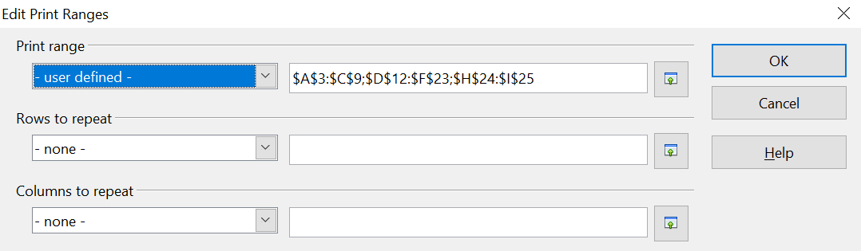
Figure 5: Edit a print range
In this example, three sets of cells are selected, each separated by a semicolon. The first set is in a rectangle from cell A3 ($A$3) in the top left to cell C9 ($C$9) in the bottom right. Clicking anywhere in the text entry box shows the selected print range on the screen, with each set highlighted in a different color, as in Figure 6.
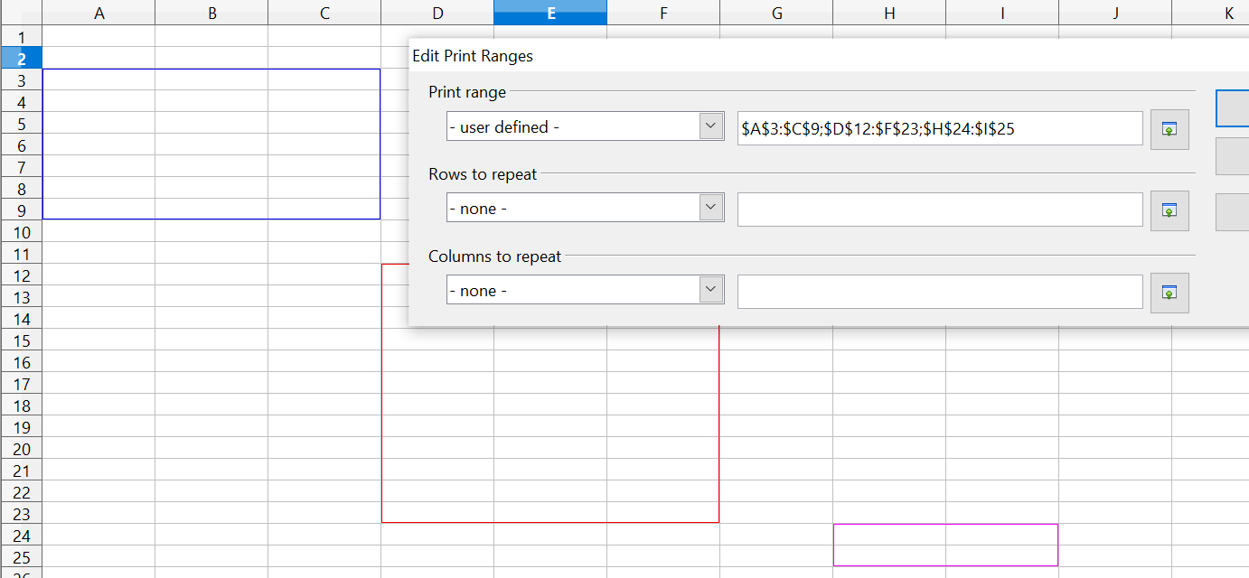

Figure 6: Print range marked by colored boxes
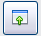
When this dialog is open, you can manually change the data, or select different cells in the spreadsheet. If the dialog covers the required cells, you can move it aside or click the Shrink icon next to the text entry box, select the required cells, then click the icon again to expand the dialog and redisplay the rectangles with their new values.

Printing Rows or Columns on Every Page
If a sheet is printed on multiple pages, you can set up specific rows or columns to repeat on each printed page.
For example, if the top two rows of the sheet, as well as column A, need to be printed on all pages, do the following:
- Choose Format > Print Ranges > Edit. On the Edit Print Ranges dialog, type the rows in the text entry box under Rows to repeat. For example, to repeat rows 1 and 2, type $1:$2. This automatically changes Rows to repeat from - none - to - user defined -.
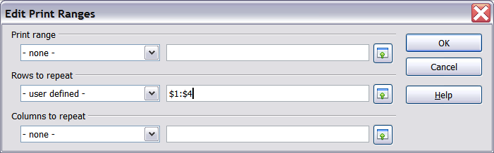
Figure 7: Specifying repeating rows
- To repeat columns, type the columns in the text entry box under Columns to repeat. For example, to repeat column A, type $A. This automatically changes Columns to repeat from - none - to - user defined -.
- Click OK.
Note | You do not need to select the entire range of the rows to be repeated; simply select one cell in each row.

Defining a Custom Print Range
In addition to highlighting a print range for each print job, you can define a range of cells to be used repeatedly. This may be useful if different areas of a large spreadsheet need to be printed for different reports. Several different print ranges can be defined to meet this need.
- To define a print range, use the same procedure as labeling an area of the sheet. Highlight the cells you want to define as a print range and select Insert > Names > Define. (The cells can also be highlighted after opening the Define Names dialog.)
- On the Define Names dialog (Figure 8), type a name for the range in the text box with the blinking cursor. The name of the range cannot contain any spaces.
- Click the More button in the dialog and select the Print range option. Click the Add button.
- To include more than one group of cells in the selection, type in the additional ranges. For example, to select the rectangle with A3 as the top left cell and F20 as the bottom right cell, enter ;$A$3:$F$20 or ;A3:F20 after the initial selection; both work and are equivalent. Make sure that each group of cells is separated with a semicolon.
- Click OK.
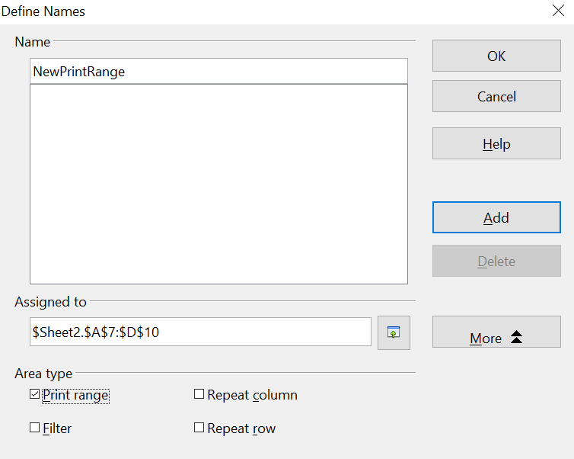

Figure 8: Define Names dialog
To print this range:
- Choose Format > Print Ranges > Edit (Figure 5). The previously defined area now appears in the drop-down box under Print range.
- Select the defined print range and click OK.
This method can be useful to quickly change the print range without highlighting a large area of cells every time.
Note | If the cell range name refers to more than one group of cells, it will not appear in the drop-down list. You will need to type it in or highlight and select it.

Page Breaks
While defining a print range can be a powerful tool, manually adjusting Calc’s printout may sometimes be necessary. To do this, you can use a manual break. A manual break helps to ensure that your data prints properly. You can insert a horizontal page break above or a vertical page break to the left of the active cell.

Inserting a Page Break
To insert a page break:
- Navigate to the cell where the page break will begin.
- Select Insert > Manual Break.
- Select Row Break or Column Break, depending on your need.
The break is now set.

Row Break
Selecting Row Break creates a page break above the selected cell. For example, if the active cell is H15, then the break is created between rows 14 and 15.

Column Break
Selecting Column Break creates a page break to the left of the selected cell. For example, if the active cell is H15, then the break is created between columns G and H.
Tip | To see page break lines more easily on screen, you can change their color. Choose Tools > Options > OpenOffice > Appearance and scroll down to the Spreadsheet section.

Deleting a Page Break
To remove a page break:
- Navigate to a cell next to the break you want to remove.
- Select Edit > Delete Manual Break.
- Select Row Break or Column Break, depending on your need.
The break is now removed.
Note | Multiple manual row and column breaks can exist on the same page. When you want to remove them, you have to remove each one individually. This may be confusing at times because although there may be a column break set on the page, when you go to Edit > Manual Break, the Column break choice may not be available (grayed out).  To remove the break, you have to be in the cell next to the break. For example, if you set the column break while in H15, you can not remove it if you are in cell D15. However, you can remove it from any cell in column H.

Printing Options Setup in Page Styles
The page style for sheets sets several printing options, including the page order, details, and scale to be printed.
Because these options are set in the page style, different page styles can be set up to quickly change the print properties of the sheets in the spreadsheet. See Chapter 4 (Using Styles and Templates in Calc) for more about page styles.
The Sheet tab of the Page Style dialog, Format > Page > Sheet (Figure 9), provides the following options.
Page Order
You can set the order in which pages print. This is especially useful in a large document; for example, controlling the print order can save time if you have to collate the document a certain way.
Where a sheet prints to more than one page of paper, it can be printed either by column, where the first column of pages prints, and then the second column and so on, or by row, as shown in the graphic on the top right of the dialog in Figure 3.
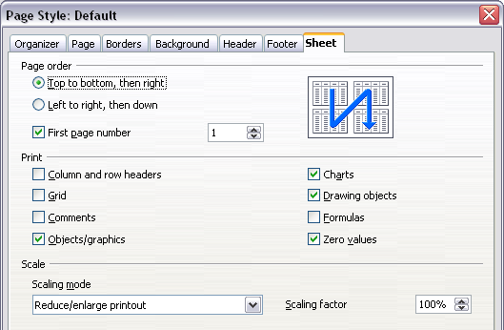
Figure 9. The Sheet tab of the Page Style dialog
Print
You can specify which details to print. These details include:
- Row and column headers
- Sheet grid—prints the borders of the cells as a grid
- Comments—prints the comments defined in your spreadsheet on a separate page, along with the corresponding cell reference
- Objects and graphics
- Charts
- Drawing objects
- Formulas—prints the formulas contained in the cells instead of the results
- Zero Values—prints cells with a zero value
Scale
Use the scale features to control the number of pages the data will print on.
- Reduce/Enlarge printout—scales the data in the printout either larger or smaller. For example, if a sheet would typically print out as four pages (two high and two wide), a scaling of 50% would print as one page (both width and height are halved).
- Fit print range(s) on number of pages—defines exactly how many pages the printout will take up. This option will only reduce a printout, not enlarge it. To enlarge a printout, the reduce/enlarge option must be used.
- Fit print range(s) to width/height—defines how high and wide the printout will be, in pages.

Headers and Footers
Headers and footers are predefined pieces of text printed at the top or bottom of a sheet, outside the sheet area. Headers are set the same way as footers.
Headers and footers are assigned to a page style. You can define more than one page style for a spreadsheet and assign different page styles to different sheets. For more about page styles, see Chapter 4.

Setting a Header or a Footer
To set a header or footer:
- Navigate to the sheet where you want to set the header or footer. Select Format > Page.
- Select the Header (or Footer) tab.
- Select the Header on option.
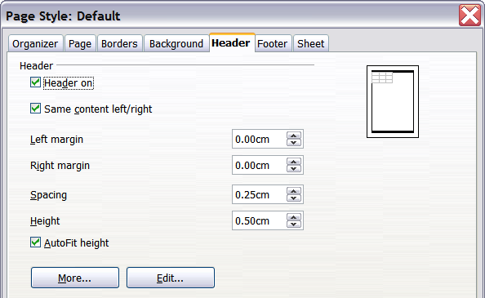
Figure 10: Header dialog
From here, you can also set the margins, the spacing, and height for the header or footer. You can check the AutoFit height box to automatically adjust the height of the header or footer.
Margin
Changing the size of the left or right margin adjusts the distance the header or footer is from that side of the page.
Spacing
Spacing affects how far above or below the sheet the header or footer will print. So, if spacing is set to 1.00", there will be 1 inch between the header or footer and the sheet.
Height
Height affects how big the header or footer will be.

Header or Footer Appearance
To change the appearance of the header or footer, click the More button in the dialog. This opens the Border/Background dialog.
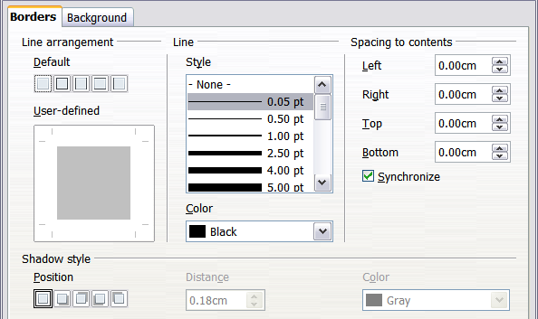
Figure 11: Header/Footer Border/Background dialog
From this window, you can set the background and border style of the header or footer. See Chapter 4 (Using Styles and Templates in Calc) for more information.

Setting the Contents of the Header or Footer
The header or footer of a Calc spreadsheet has three columns for text. Each column can have different contents.
To set the contents of the header or footer, click the Edit button in the header or footer dialog shown in Figure 10 to display the dialog shown in Figure 12.
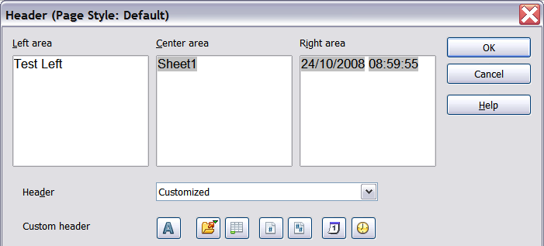
Figure 12: Edit contents of header or footer
Areas
Each area in the header or footer is independent, and can have different information in it.
Header
You can select from several preset choices in the Header drop-down list or specify a custom header using the buttons below the area boxes. The same choices will apply to formatting a footer.
Custom header
Click in the area (Left, Center, Right) you want to customize, then use the buttons to add elements or change text attributes.
Opens the Text Attributes dialog.
Inserts the total number of pages.
Inserts the File Name field.
Inserts the Date field.
Inserts the Sheet Name field.
Inserts the Time field.
Inserts the current page number.

Exporting to PDF
Calc can export documents to PDF (Portable Document Format). This industry-standard file format is ideal for sending the file to someone else to view using Adobe Reader or other PDF viewers.

Quick Export to PDF
Click the Export Directly as PDF icon to export the entire document using your default PDF settings. You are asked to enter the file name and location for the PDF file, but you do not get a chance to choose a page range, the image compression, or other options.

Controlling PDF Content and Quality
For more control over the content and quality of the resulting PDF, use File > Export as PDF. The PDF Options dialog opens. This dialog has five pages (General, Initial View, User Interface, Links, and Security). Select the appropriate settings and click Export. Next, you will be prompted to enter the location and file name of the PDF to be created. Then, click Save to export the file.

General Page of PDF Options Dialog
On the General page (Figure 13), you can choose which pages to include in the PDF, the type of compression to use for images (which affects the quality of images in the PDF), and other options.
Range section
- All: Exports the entire document.
- Pages: To export a range of pages, use the format 3-6 (pages 3 to 6). To export single pages, use the format 7;9;11 (pages 7, 9, and 11). You can also export a combination of page ranges and single pages by using a format like 3-6;8;10;12.
- Selection: Exports whatever content is selected.
Images section
- Lossless compression: Images are stored without any loss of quality. Tends to make large files when used with photographs. Recommended for other kinds of images or graphics.
- JPEG compression: Allows for varying degrees of quality. A setting of 90% works well with photographs (small file size, little perceptible loss).
- Reduce image resolution: Lower-DPI (dots per inch) images have lower quality. For viewing on a computer screen, a resolution of 72dpi (for Windows) or 96dpi (GNU/Linux) is sufficient, while for printing it is generally preferable to use at least 300 or 600 dpi, depending on the printer's capability. Higher dpi settings greatly increase the size of the exported file.
Note | EPS (Encapsulated PostScript) images with embedded previews are exported only as previews. EPS images without embedded previews are exported as empty placeholders.

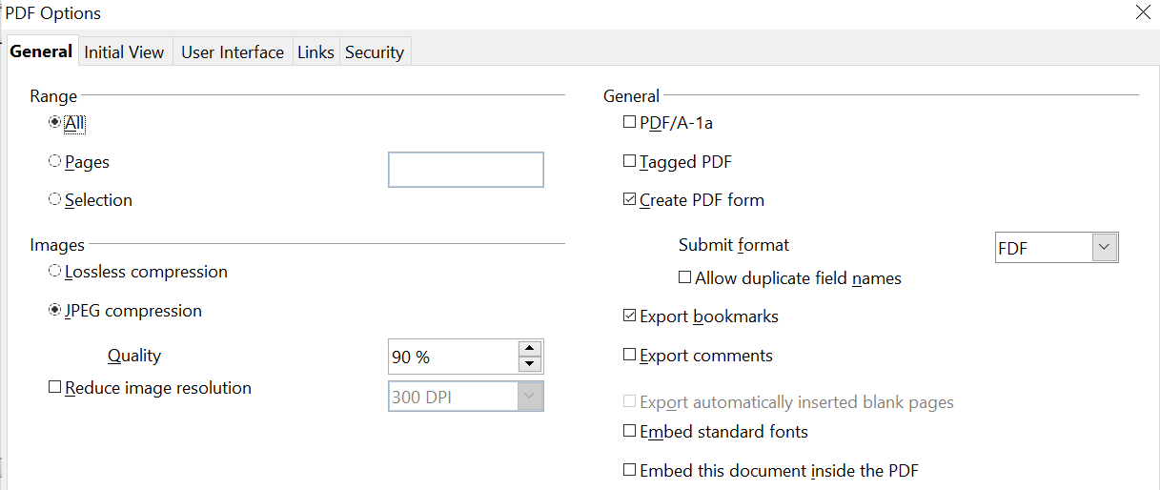

Figure 13: General page of PDF Options dialog
General section
- PDF/A-1a: PDF/A is an ISO standard for long-term preservation of documents by embedding all the information necessary for faithful reproduction (such as fonts) while forbidding other elements (including forms, security, and encryption). PDF tags are written. If you select PDF/A-1a, the forbidden elements are grayed out (not available).
- Tagged PDF: Tagged PDF contains information about the structure of the document’s contents. This can help display the document on devices with different screens and when using screen reader software. Some exported tags are table of contents, hyperlinks, and controls. Be aware that using this option can significantly increase file sizes.
- Create PDF form - Submit format: Choose the format for submitting forms from within the PDF file. This setting overrides the control’s URL property that you set in the document. There is only one common setting valid for the entire PDF document: PDF (sends the entire document), FDF (sends the control contents), HTML, and XML. Most often, you'll choose the PDF format.
- Export bookmarks: Exports sheet names in Calc documents as “bookmarks” (a table of contents list displayed by some PDF readers, including Adobe Reader).
- Export comments: Exports comments in Calc documents as PDF notes. You may not want this!
- Export automatically inserted blank pages: Not available in Calc.
- Embed standard fonts: Embed the standard fonts so they are always available to the user. This improves the accuracy of what the viewer sees compared to the layout you see on your system.
- Embed this document inside the PDF: Embedding the document within the PDF makes it possible to extract and edit the document later. This way, you can make a revised PDF without a PDF editing application.

Initial View Page of PDF Options Dialog
On the Initial View page (Figure 14), you can choose how the PDF opens by default in a PDF viewer. The selections are self-explanatory.

Figure 14: Initial View page of PDF Options dialog

User Interface Page of PDF Options Dialog
On the User Interface page (Figure 11), several settings can control how a PDF viewer displays the file. Some of these choices are particularly useful when creating a PDF for a presentation or a kiosk-type display.

Figure 15: User Interface page of PDF Options dialog
Window options section
- Resize window to initial page: Resizes the PDF viewer window to fit the first page of the PDF.
- Center window on screen: Causes the PDF viewer window to be centered on the computer screen.
- Open in full screen mode: Causes the PDF viewer to open full-screen instead of in a smaller window.
- Display document title: Causes the PDF viewer to display the document’s title in the title bar.
User interface options section
- Hide menubar: Causes the PDF viewer to hide the menu bar.
- Hide toolbar: Causes the PDF viewer to hide the toolbar.
- Hide window controls: Causes the PDF viewer to hide other window controls.
Transitions
Not available in Calc. This setting is appropriate for slide presentations like those made with Impress.
Bookmarks
Select how many heading levels are displayed as bookmarks if Export bookmarks is selected on the General page.

Links Page of PDF Options Dialog
On this page, you can choose how links are exported to PDF.

Figure 16: Links page of PDF Options dialog
Export bookmarks as named destinations
If you have defined Writer bookmarks, Impress or Draw slide names, or Calc sheet names, this option exports them as “named destinations” to which Web pages and PDF documents can link.
Convert document references to PDF targets
If you have defined links to other documents with OpenDocument extensions (such as .ODT, .ODS, and .ODP), this option converts the file names to .PDF in the exported PDF document.
Export URLs relative to file system
If you have defined relative links in a document, this option exports those links to the PDF.
Cross-document links
Defines the behavior of links clicked in PDF files.

Security Page of PDF Options Dialog
PDF export includes options to encrypt the PDF (so it cannot be opened without a password) and apply some digital rights management (DRM) features.
- With an open password set, the PDF can only be opened with the password. Once opened, there are no restrictions on what the user can do with the document (for example, print, copy, or change it).
- With a permissions password set, anyone can open the PDF, but its permissions can be restricted. See Figure 4.
- With both the open password and permission password set, the PDF can only be opened with the correct password, and its permissions can be restricted.
Note | Permissions settings are effective only if the user’s PDF viewer respects the settings.

Figure 7 shows the dialog displayed when you click the Set passwords button on the Security page of the PDF Options dialog.
After setting a password for permissions, the other choices on the Security page (shown in Figure 4) become available. These selections are self-explanatory.
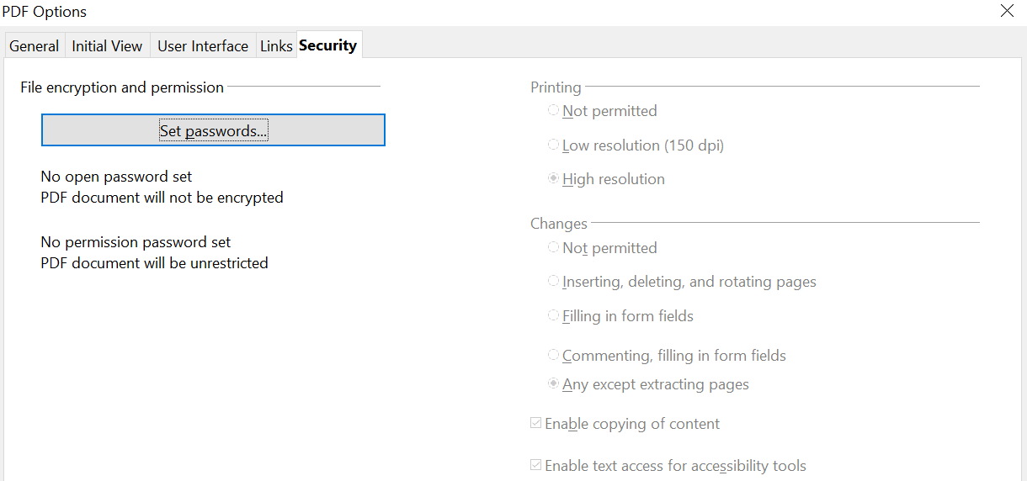

Figure 17: Security page of PDF Options dialog.
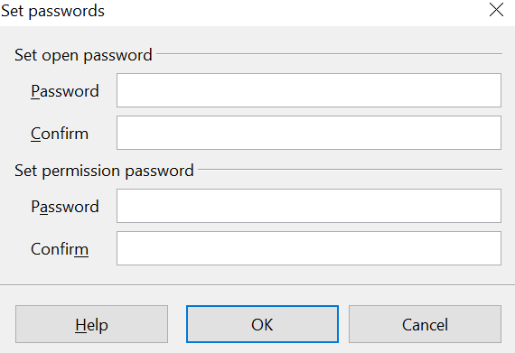

Figure 18: Setting a password to encrypt a PDF

Exporting to XHTML
Calc can export spreadsheets to XHTML. Choose File > Export. On the Export dialog, specify a file name for the exported document, then select the XHTML in the File format list and click the Export button.

Saving as Web Pages (HTML)
Calc can save files as HTML documents. Use File > Save As and select HTML Document, or File > Wizards > Web Page.
If the file contains more than one sheet, sheets will follow one another in the HTML file. Links to each sheet will be placed at the top of the document. Calc also allows the insertion of links directly into the spreadsheet using the Hyperlink dialog.

E-mailing Spreadsheets
OpenOffice provides several quick and easy ways to send spreadsheets as an e-mail attachment in one of three formats: OpenDocument Spreadsheet (OpenOffice’s default format), Microsoft Excel, or PDF.
Note | Documents can only be sent from the OpenOffice menu if a mail profile has been set up and there's an e-mail program available on your computer. If you want to e-mail the spreadsheet using a web service, such as Gmail or the web version of Microsoft Outlook, save the file, then use the web service to attach the document to a message.

To send the current document in OpenDocument format:
- Choose File > Send > Document as E-mail. OpenOffice opens your default e-mail program with the *.ODS document attached.
- In your e-mail program, enter the recipient, subject, and any text you want to add, then send the e-mail.
File > Send > E-mail as OpenDocument Spreadsheet has the same effect.
If you choose E-mail as Microsoft Excel, OpenOffice first creates a file in Excel format and then opens your e-mail program with the *.XLS file attached.
Similarly, if you choose E-mail as PDF, OpenOffice first creates a PDF using your default PDF settings (as when using the Export Directly as PDF toolbar button) and then opens your email program with the *.PDF file attached.

E-mailing a Spreadsheet to Several Recipients
To e-mail a document to several recipients, you can use the appropriate features in your e-mail program or OpenOffice Writer’s mail merge facilities to extract email addresses from an address book.
For details, see Chapter 10 (Printing, Exporting, and E-mailing) in the Getting Started guide.

Digital Signing of Documents
To sign a document digitally, you need a personal key, also known as a certificate. A personal key is stored on your computer as a combination of a private key, which must be kept secret, and a public key, which you add to your documents when you sign them. You can get a certificate from a certification authority, which may be a private company or a governmental institution.
When you apply a digital signature to a document, a checksum is computed from the document’s content plus your personal key. The checksum and your public key are stored together with the document.

Note | A checksum is a value that represents the number of bits in a transmission. Checksums are used to detect potentially damaging errors within data.

When someone later opens the document with OpenOffice, the program will compute the checksum again and compare it with the stored checksum. If both are the same, the program will signal you see the original, unchanged document. In addition, the program can show you the public key information from the certificate. You can compare this key with the public key that is published on the certificate authority website.
Whenever someone changes something in the document, this change breaks the digital signature.
To sign a document:
- Choose File > Digital Signatures.
- If you haven't saved the document since the last change, a message box appears. Click Yes to save the file.
- After saving, you see the Digital Signatures dialog. Click Add to add a public key to the document.
- In the Select Certificate dialog, select your certificate and click OK.
- You will again see the Digital Signatures dialog, where you can add more certificates. Click OK to add the public key to the saved file.
A signed document shows an icon in the status bar. You can double-click the icon to view the certificate.

Removing Personal Data
You may want to remove personal data, versions, notes, hidden information, or recorded changes from files before sending them to other people or creating PDFs from them.
In Tools > Options > OpenOffice > Security > Options, you can set Calc to remind (warn) you when files contain certain information and automatically remove personal information when saving.
To remove personal and some other data from a file, go to File > Properties. On the General tab, uncheck Apply user data and click the Reset button. This removes any names in created and modified fields, deletes the modification and printing dates, and resets the editing time to zero, the creation date to the current date and time, and the version number to 1.
To remove version information, either go to File > Versions, select the versions from the list, and click Delete, or use Save As to save the file with a different name.

Chapter 7
Using Formulas and Functions

Introduction
In previous chapters, we have entered one of two basic data into each cell: numbers or text. However, we may not always know what the contents should be. Often, one cell's contents depend on the contents of other cells. To handle this situation, we use a third type of data: the formula. Formulas are equations that use numbers, text, and variables to get a result. In a spreadsheet, the variables are cell locations that hold the data needed for the equation to be completed.
A function is a predefined calculation entered in a cell. Functions help you analyze or manipulate data in a spreadsheet. All you have to do is add the parameters with which the function will work, and the calculation is automatically made for you. Functions help you create the processing needed to get the results that you're looking for.

Setting Up a Spreadsheet
If you are setting up more than a simple one-worksheet system in Calc, it is worth planning ahead. Avoid the following traps:
- Typing fixed values into formulas
- Not including notes and comments describing what the system does, including what input is required and where the formulas come from (if not created from scratch)
- Not incorporating a system of checking to verify that the formulas do what is intended
- Emphasizing a spreadsheet's appearance more than computational simplicity and flexibility

The Trap of Fixed Values
Many users set up long and complex formulas with fixed values typed directly into the formula.
For example, conversion from one currency to another requires knowledge of the current conversion rate. If you input a formula in cell C1 of =0.75*B1 (for example, to calculate the value in Euros of the USD dollar amount in cell B1), you will have to edit the formula when the exchange rate changes from 0.75 to some other value. It is much easier to set up an input cell with the exchange rate and reference that cell in any formula needing the exchange rate. What-if type calculations are also simplified: what if the exchange rate varies from 0.75 to 0.70 or 0.80? No formula editing is needed, and it is clear what rate is used in the calculations. Breaking complex formulas down into more manageable parts, described below, also helps to minimize errors and aid troubleshooting.

Lack of Documentation
Lack of adequate documentation happens frequently. Many users prepare a simple worksheet that evolves into something much more complicated over time. Without documentation, the original purpose and methodology can be difficult to decipher. In such cases, it's often easier to start again from the beginning, wasting work done previously. If you insert comments in cells and use labels and headings, you or others can later modify a spreadsheet, saving much time and effort.

Error-checking Formulas
Adding up columns of data or selections of cells from a worksheet often results in errors due to omitting cells, specifying a range incorrectly or double-counting cells. It's useful to institute checks in your spreadsheets. For example, set up a spreadsheet to calculate columns of figures and use SUM to calculate the individual column totals. You can check the result by including (in a non-printing column) a set of row totals and adding these together. The two figures—row total and column total—must agree. If they don't, you have an error somewhere.
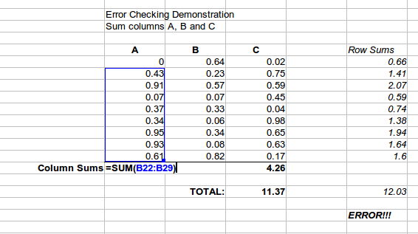
Figure 1: Error checking of formulas
You can even set up a formula to calculate the difference between the two totals and report an error if a non-zero value results, i.e. a result in which there is a difference. (see Figure 1).

Appearance vs. Computation
The most visually appealing and human-readable arrangement of data is often very different than the arrangement that allows the most efficient and flexible computations. The visual clues that help people, such as physical separation between different categories of data or changes to fonts or colors, are irrelevant or even troublesome to the functions that do the calculations. For example, imagine you have one year of data, and want to provide a monthly summary. Many people would place the data for each month on a separate sheet, especially if the monthly data and summary would then fit on the screen. The sheet tabs would then provide easy navigation, and the data and summary could have an appealing, uncluttered layout. However, if a new question is asked of the data, the monthly separation may prove inconvenient. If asked to compare weekday versus weekend data, you would have to write complicated formulas or rearrange the data. A simpler layout with all of the data on one sheet with the date in one column and the measured values in adjacent columns would be less visually appealing but would allow you to use the full power of the functions and tools in Calc. Visually appealing summaries can be made while preserving computational ease. Every situation has its own requirements, but it is usually best to keep data together and use the power of Calc to extract subsets or summaries.

Creating Formulas
You can enter formulas in two ways: directly into the cell itself or at the input line. Either way, you need to start a formula with one of the following symbols: =, +, or –. Starting with anything else causes the formula to be treated as if it were text.

Operators in Formulas
Each cell on the worksheet can be used either to hold data, or as a place for data calculations. Entering data is accomplished simply by typing in the cell and moving to the next cell or pressing Enter. With formulas, the equals sign indicates that the cell will be used for a calculation. A mathematical calculation like 15 + 46 can be accomplished, as shown in Figure 2.
While the calculation on the left was accomplished in only one cell, the real power is shown on the right, where the data is placed in cells, and the calculation is performed using references back to the cells. In this case, cells B3 and B4 were the data holders, with B5 the cell where the calculation was performed. Notice that the formula was shown as =B3+B4. The plus sign indicates that the contents of cells B3 and B4 are to be added together and then have the result in the cell holding the formula. All formulas build upon this concept. Examples of formulas are shown in Table 7.
These cell references allow formulas to use data from anywhere in the worksheet being worked on or from any other worksheet in the open spreadsheet. If the data needed were in different worksheets, they would be referenced by referring to the name of the worksheet, for example, =SUM(Sheet2.B12+Sheet3.A11).
Note | To enter the = symbol for a purpose other than creating a formula as described in this chapter, type an apostrophe or single quotation mark before the =. For example, in the entry '= means different things to different people, Calc treats everything after the single quotation mark—including the = sign—as text.

Simple Calculation in 1 Cell | Calculation by Reference
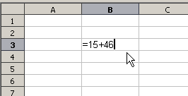 | 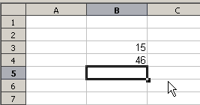
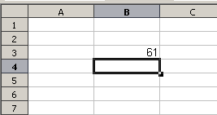 | 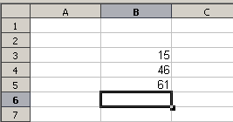
 | 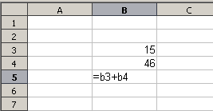
Figure 2: A simple calculation
Table 7: Examples of formulas
Formula | Description
=A1+10 | Displays the contents of cell A1 plus 10.
=A1*16% | Displays 16% of the contents of A1.
=A1*A2 | Displays the result of the multiplication of A1 and A2.
=ROUND(A1;1) | Displays the contents of cell A1 rounded to one decimal place.
=EFFECTIVE(5%;12) | Calculates the effective interest for 5% annual nominal interest with 12 payments a year.
=B8-SUM(B10:B14) | Calculates B8 minus the sum of the cells B10 to B14.
=SUM(B8;SUM(B10:B14)) | Calculates the sum of cells B10 to B14 and adds the value to B8.
=SUM(B1:B1048576) | Sums all numbers in column B.
=AVERAGE(BloodSugar) | Displays the average of a named range defined under the name BloodSugar.
=IF(C31>140; "HIGH"; "OK") | Displays the results of a conditional analysis of data from two sources. If the contents of C31 are greater than 140, then HIGH is displayed; otherwise, OK is displayed.
Functions can be identified in Table 7 with a word, for example, ROUND, followed by parentheses enclosing parameters fed to the function.
It is also possible to establish ranges for inclusion by naming them using Insert > Names, for example, BloodSugar representing a range such as B3:B10. Logical functions can also be performed as represented by the IF statement. Such a use results in a conditional response based on the data in the identified cell. For example:

=IF(A2>=0;"Positive";"Negative")

produces the display Positive if the value in cell A2 is 3 but Negative if the value there is –9, or any other value less than 0.

Operator Types
You can use the following operators in OpenOffice Calc: arithmetic, comparative, descriptive, text, and reference.

Arithmetic Operators
Addition, subtraction, multiplication, and division operators return numerical results. The negation and percent operators identify a characteristic of the number found in the cell, for example, -37. Exponentiation illustrates how to enter a number multiplied by itself a certain number of times, for example, 23 = 2*2*2.
Table 8: Arithmetical operators
Operator | Name | Example
+ (Plus) | Addition | =1+1
– (Minus) | Subtraction | =2–1
– (Minus) | Negation | –5
* (asterisk) | Multiplication | =2*2
/ (Slash) | Division | =10/5
% (Percent) | Percent | 15%
^ (Caret) | Exponentiation | 2^3

Comparative Operators
Comparative operators result in either a true or false answer. An example using the IF function could be =IF(B6>G12; 127; 0), which, loosely translated, means if the contents of cell B6 are greater than those of cell G12, produce the number 127. Otherwise, display the number 0.
A direct answer, TRUE or FALSE, can be obtained by entering a formula such as =B6>B12. If the value of B6 is greater than that of B12, TRUE is displayed. Otherwise, FALSE is output.
Table 9: Comparative operators
Operator | Name | Example
= (equal sign) | Equal | A1=B1
> (Greater than) | Greater than | A1>B1
< (Less than) | Less than | A1<B1
>= (Greater than or equal to) | Greater than or equal to | A1>=B1
<= (Less than or equal to) | Less than or equal to | A1<=B1
<> (Inequality) | Inequality | A1<>B1

Note | One of the most common errors in programming, and in calculations in general, is mixing up >=, >, <=, <

If cell A1 contains the numerical value 4 and cell B1 has the numerical value 5, the above examples yield results of FALSE, FALSE, TRUE, FALSE, TRUE, and TRUE.

Text Operators
It is common for users to place text in spreadsheets. Text can be joined together in pieces coming from different places on the spreadsheet to provide for variability in what and how this type of data is displayed. Figure 3 shows an example.
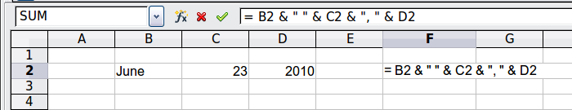
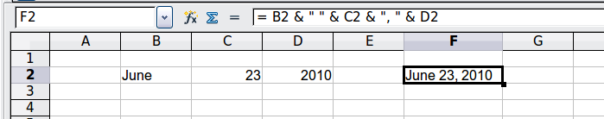
Figure 3: Text concatenation
In this example, specific pieces of the text were found in three different cells. To join these segments, the formula also adds required spaces and punctuation enclosed within quotation marks, resulting in a formula of =B2 & " " & C2 & ", " & D2. The result is the concatenation into a date formatted in a particular sequence. The & operator concatenates and glues together pieces of text.
Calc has a CONCATENATE function, which performs the same operation.
Taking this example further, if the result cell is defined as a name, then text concatenation is performed using this defined name. This process is demonstrated in Figures 4, 5, and 6, where the cell with the date is named “WizardDay” and subsequently used in a formula in another cell.
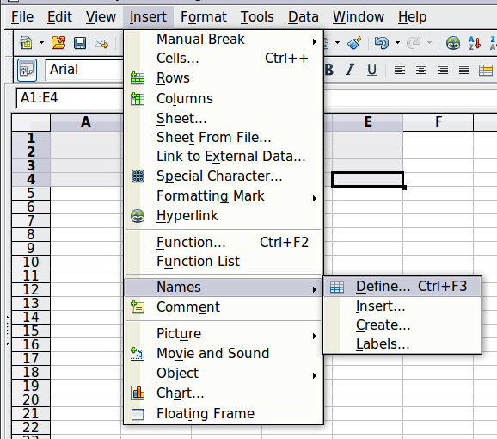
Figure 4: Defining a name for a range of cells
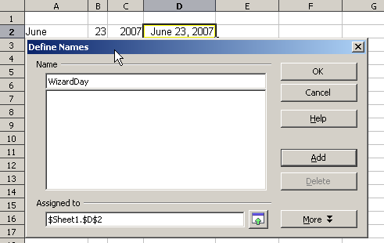
Figure 5: Naming a cell or range of cells for inclusion in a formula
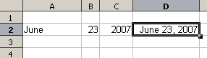
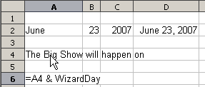
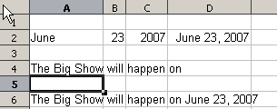
Figure 6: Defining Names on a worksheet

Reference Operators
In its simplest form, a reference points to a single cell, but references can also apply to a rectangle or cuboid as a range or a reference in a list of references. To build such lists, you need reference operators.
An individual cell is identified by the column identifier (letter) located along the top of the columns, and a row identifier (number) found along the left-hand side of the spreadsheet. On spreadsheets read from left to right, the upper left cell is A1.

Range Operator
The range operator is written as a colon. An expression using the range operator has the following syntax:
reference left : reference right
The range operator builds a reference to the smallest range, including both the cells referenced with the left reference and the cells referenced with the right reference.

Figure 7: Reference Operator for a range
In the upper left corner of Figure 7, the reference A1:D12 is shown, corresponding to the cells included in the drag operation with the mouse to highlight the range.
Examples
A2:B4 | Reference to a rectangle range with 6 cells, 2 column width × 3 row height. When you click on the reference in the formula in the input line, a border indicates the rectangle.
(A2:B4):C9 | Reference to a rectangle range with cell A2 top left and cell C9 bottom right. So the range contains 24 cells, 3 column width × 8 row height. This method of addressing extends the initial range from A2:B4 to A2:C9.
Sheet1.A3:Sheet3.D4 | Reference to a cuboid range with 24 cells, 4 column width × 2 row height × 3 sheets depth.
When you enter B4:A2 or A4:B2 directly, Calc will turn it into A2:B4, with the left top cell of the range left of the colon and the bottom right cell right of the colon. But if you name the cell B4, for example, as _start and A2 as _end, you can use _start:_end without any error.
Calc, unlike some other spreadsheet programs, cannot reference a whole column of unspecified length using A:A or a whole row using 1:1.

Reference Concatenation Operator
The concatenation operator is written as a tilde. An expression using the concatenation operator has the following syntax:
reference left ~ reference right
The result of such an expression is an ordered list of references. Some functions, such as SUM, MAX, or INDEX can take a reference list as an argument.
Reference concatenation is sometimes called 'union'. But it's not the union of 'reference left' and 'reference right.' COUNT(A1:C3~B2:D2) displays 12 (=9+3), but it has only 10 cells when considered the union of the two sets of cells.

Intersection Operator
The intersection operator is written as an exclamation mark. An expression using the intersection operator has the following syntax:
reference left ! reference right
If the references refer to single ranges, the result is a reference to a single range containing all cells in both the left reference and the right reference.
If the references are reference lists, then each list item from the left is intersected with each one from the right, and these results are concatenated into a reference list. The order is to first intersect the first item from the left with all items from the right, then intersect the second item from the left with all items from the right, and so on.
Examples
A2:B4 ! B3:D6
This results in a reference to the range B3:B4 because these cells are inside A2:B4 and B3:D4.
(A2:B4~B1:C2) ! (B2:C6~C1:D3)
First the intersections A2:B4!B2:C6, A2:B4!C1:D3, B1:C2!B2:C6 and B1:C2!C1:D3 are calculated. This results in B2:B4, empty, B2:C2, and C1:C2. Then, these results are concatenated, dropping empty parts. The final result is the reference list B2:B4 ~ B2:C2 ~ C1:C2.
You can use the intersection operator to refer to a cell in a cross tabulation in an understandable way. If you have columns labeled 'Temperature' and 'Precipitation' and rows labeled 'January,' 'February,' 'March,' and so on, then the following expression
'February' ! 'Temperature'
will refer to the cell containing the temperature in February.
The intersection operator (!) should have a higher precedence than the concatenation operator (~), but do not rely on precedence. By precedence, we mean the order in which operations are performed within an expression. Some operations, like multiplication and division, are done before addition and subtraction. To enforce another order, we must use parentheses.
Tip | Always put the part that is to be calculated first in parentheses.

Relative and Absolute References
References are the way that we refer to the location of a particular cell in Calc and can be either relative (to the current cell) or absolute (a fixed location).

Relative Referencing
An example of a relative reference will illustrate the difference between a relative reference and absolute reference using the spreadsheet from Figure 8.
- Type the numbers 4 and 11 into cells C3 and C4, respectively, of that spreadsheet.
- Copy the formula in cell B5, which is = B3 + B4, to cell C5. You can do this by using a simple copy and paste or click and drag B5 to C5, as shown below.
- Click in cell C5. The formula bar shows =C3+C4 rather than =B3+B4, and the value in C5 is 15, the sum of 4 and 11, which are the values in C3 and C4.
In cell B5, the references to cells B3 and B4 are relative references. This means that Calc interprets the formula in B5 as "sum the cells two and one rows above the cell containing this formula," applies it to the cells in the B column, and puts the result in the cell holding the formula. When you copied the formula to another cell, the same procedure was used to calculate the value to put in that cell. This time, the formula in cell C5 referred to cells C3 and C4.
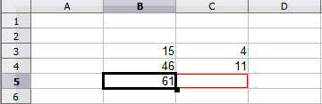
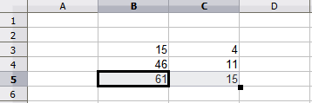Figure 8: Relative references

Absolute Referencing
You may want to multiply a column of numbers by a fixed amount. A column of figures might show amounts in US Dollars. To convert these amounts to Euros, it is necessary to multiply each dollar amount by the exchange rate. $US10.00 would be multiplied by 0.75 to convert to Euros, in this case Eur7.50. The following example shows how to input an exchange rate and use that rate to convert amounts in a column from USD to Euros.
- Input the exchange rate Eur:USD (0.75) in cell D1. Enter amounts (in USD) into cells D2, D3, and D4, for example, 10, 20, and 30.
- In cell E2, enter the formula =D2*D1. The result is 7.5, correctly shown.
- Copy the formula in cell E2 to cell E3. The result is 200, clearly wrong! Calc has copied the formula using relative addressing - the formula in E3 is =D3*D2 and not what we want, which is =D3*D1.
- In cell E2, edit the formula to be =D2*$D$1. Copy it to cells E3 and E4. The results are now 15 and 22.5, which are correct.
Steps 2: Setting the exchange rate of Eur at 7.5, then copying it to E3
Copying formula from E2 to E3 & changing the formula to read absolute reference
Applying the correct formula from E2 to E3
Figure 9: Absolute References
The $ signs before the D and the 1 convert the reference to cell D1 from relative to absolute or fixed. If the formula is copied to another cell, the second part will always show $D$1. The interpretation of the formula =D2*$D$1 in E2 is “take the value in the cell one column to the left in the same row and multiply it by the value in cell D1”.
Cell references can be shown in four ways.

Reference | Explanation
D1 | Relative, from cell E3 it is the cell one column to the left and two rows above
$D$1 | Absolute, from cell E3, or any other cell, it is the cell D1
$D1 | Partially absolute, from cell E3 it is the cell in column D and two rows above
D$1 | Partially absolute, from cell E3 it is the cell one column to the left and in row 1

Tip | To change references in formulas, highlight the cell and press Shift+F4 to cycle through the four different types of references. But be aware that this is of limited value in more complicated formulas since it is usually quicker to edit the formula by hand.

Knowledge of the use of relative and absolute references is essential if you want to copy and paste formulas, and link spreadsheets.

Order of Calculation
Order of calculation refers to the sequence in which numerical operations are performed. Division and multiplication are performed before addition or subtraction. There is a common tendency to expect calculations to be done from left to right, as the equation would be read in English. Calc evaluates the entire formula. Then, based upon programming precedence, Calc breaks the formula down, carrying out operations in the order described in Table 4, executing:
- exponentiation (raising to a power)
- multiplication and division
- addition and subtraction
For this reason, when creating formulas, test them to ensure you get the correct result. Following is an example of the order of calculation in operation.
Table 10 – Order of Calculation
Left To Right Calculation | Ordered Calculation
1+3*2+3 = 11  1+3=4, then 4 X 2 = 8, then 8 + 3 = 11 | =1+3*2+3 result 10  3*2=6, then 1 + 6 + 3 = 10
Another possible intention could be:  1+3*2+3 = 4 * 5 = 20 | The program resolves the multiplication of 3 X 2 before dealing with the numbers being added.
If you intend the result to be either of the two possible solutions on the left, the way to achieve these results would be to order the formula as:
((1+3) * 2)+3 = 11 | (1+3) * (2+3) = 20

Note | Use parentheses to group operations in the order you intend; for example, =B4+G12*C4/M12 might become =((B4+G12)*C4)/M12.

Calculations Linking Sheets
Another powerful feature of Calc is its ability to link data through several worksheets. The names of worksheets help identify where specific data may be found. For example, a name such as Payroll or Boise Sales is much more meaningful than Sheet1.

Note | The function SHEET() returns the sheet number in the collection of spreadsheets. There are several worksheets in each book; numbered from the left: Sheet1, Sheet2, and so forth. If you drag the worksheets to different locations among the tabs, SHEET() returns the number referring to the current position of this worksheet.

Consider a business setting in which revenues and costs of each of its branch operations are combined into a single worksheet.
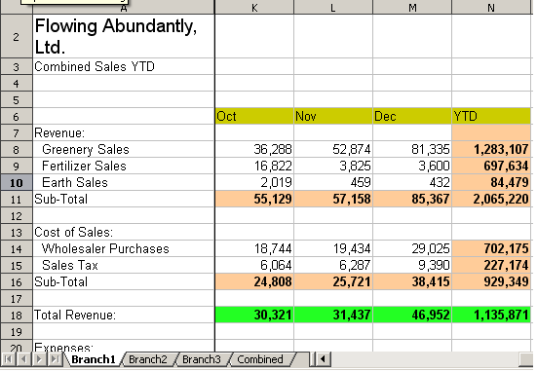 | Sheet containing data for Branch 1.
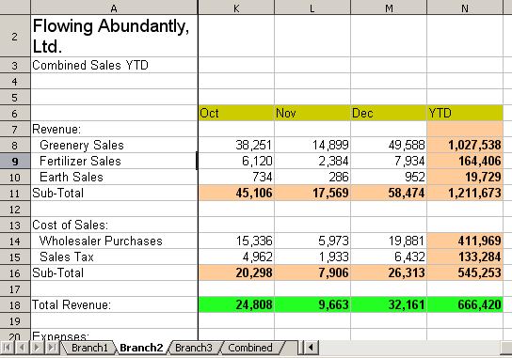 | Sheet containing data for Branch 2.
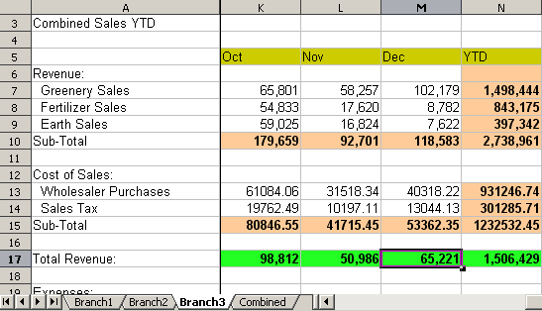 | Sheet containing data for Branch 3.
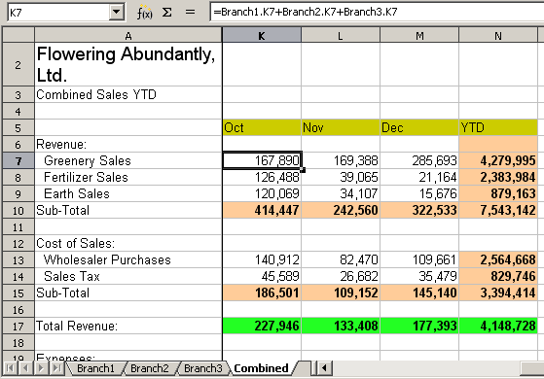 | Sheet containing combined data for all branches.
Figure 10: Combining data from several sheets into a single sheet
These hypothetical spreadsheets have been configured to have identical structures by setting up the first Branch spreadsheet in preparation for:
- inputting data
- formatting cells
- preparing the formulas for the various sums of rows and columns

- On the worksheet tab, right-click and select Rename Sheet. Type Branch1. Right-click on the tab again and select Move/Copy Sheet.
- In the Move/Copy Sheet dialog, select the Copy option and select Sheet 2 in the area Insert before. Click OK, right-click on the tab of the sheet Branch1_2, and rename it to Branch2. Repeat to produce the Branch3 and Combined worksheets.
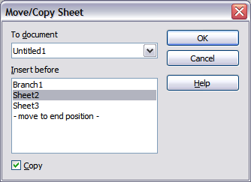Figure 11: Copying a worksheet
- Enter the data for Branch 2 and Branch 3 into the respective sheets. Each sheet stands alone and reports the results for the individual branches.
- In the Combined worksheet, click on cell K7. Type =, click on the tab Branch1, click on cell K7, press +, repeat for sheets Branch2 and Branch3, and press Enter. You now have a formula in cell K1 that adds the revenue from Greenery Sales for the 3 Branches.
Figure 12: Combined worksheet showing linking between branch sheets
- Copy the formula, highlight the range K7..N17, click Edit > Paste Special, uncheck the Paste all and Formats boxes in the Selection area of the dialog box, and click OK. You will see the following message:
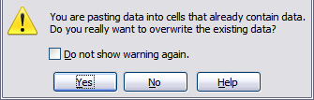
Figure 13: Linking sheets: pasting a formula to a cell range
- Click Yes. You have now copied the formulas into each cell while maintaining the format you set up in the original worksheet. Of course, in this example, you would have to tidy the worksheet up by removing the zeros in the non-formatted rows.
Figure 14: Linking Sheets: Copy Paste Special from K7...N17
Note | OpenOffice's default is to paste all the attributes of the original cell(s) - formats, notes, objects, text strings, and numbers.

The Function Wizard can also be used to accomplish such linking. The use of this Wizard is described in detail in the section on Functions.

Understanding Functions
Calc includes over 350 functions that help you analyze and reference data. Many of these functions are for use with numbers, but others can be used with dates and times or even text. A function may be as simple as adding two numbers together or finding the average of a list of numbers. Alternatively, it may be as complex as calculating the standard deviation of a sample or a hyperbolic tangent of a number.
Typically, the name of a function is an abbreviated description of what the function does. For instance, the FV function gives the future value of an investment, while BIN2HEX converts a binary number to a hexadecimal number. By tradition, functions are entered entirely in upper case letters, although Calc will read them correctly if they are in lower or mixed case.
A few basic functions are somewhat similar to operators. Examples:
+ | This operator adds two numbers together for a result. SUM() adds individual cells or cell ranges together.
* | This operator multiplies two numbers together for a result. PRODUCT() does the same for multiplying that SUM() does for adding.
Each function has a number of arguments used in the calculations. These arguments may or may not have their own name. Your task is to enter the arguments needed to run the function. In some cases, the arguments have predefined choices, and you may need to refer to the online help or Appendix B (Description of Functions) in this book to understand them. More often, however, an argument is a value you enter manually or one already entered in a cell or range of cells on the spreadsheet. In other words, an argument is what the function must work on. In Calc, you can enter values from other cells by typing their name or range or by selecting cells with the mouse. If the values in the cells change, the result of the function is automatically updated.
For compatibility, functions and their arguments in Calc have almost identical names to their counterparts in Microsoft Excel. However, both Excel and Calc have functions that the other lacks. Occasionally, functions with the same names in Calc and Excel have different arguments or slightly different names for the same argument—neither of which can be imported to the other. However, most functions can be used in both Calc and Excel without any change.

Understanding the Structure of Functions
All functions have a similar structure, which is worth knowing to be able to troubleshoot.
To give a typical example, the structure of a function to count cells that match entered search criteria is:
= DCOUNT (Database;Database field;Search_criteria)
Since a function cannot exist independently, it must always be part of a formula. Consequently, even if the function represents the entire formula, there must be an = sign at the start of the formula. Regardless of where in the formula a function is, the function will start with its name, such as DCOUNT, in the example above. After the name of the function comes its arguments; all arguments are required unless specifically listed as optional.
Arguments are added within the parentheses and are separated by semicolons.
Note | OpenOffice uses the semicolon as an argument list separator, unlike Excel, which uses a comma. OpenOffice uses the semicolon because the comma is the decimal mark in numbers in many locales.

Many arguments are a number. A Calc function can take up to thirty numbers as an argument. That may not sound like much at first. However, when you realize that the number can be not only a number or a single cell but also an array or range of cells containing several or even hundreds of cells, the apparent limitation vanishes.
Depending on the nature of the function, arguments may be entered as follows:
"text data" | The quotes indicate text or string data is being entered.
9 | The number nine is being entered as a number.
"9" | The character nine is being entered as text
A1 | The address for whatever is in Cell A1 is being entered

Nested Functions
Functions can also be used as arguments within other functions. These are called nested functions.
=SUM(2;PRODUCT(5;7))
Imagine that you are designing a self-directed learning module. During the module, students do three quizzes and enter the results in cells A1, A2, and A3. In A4, you can create a nested formula that begins by averaging the results of the quizzes with the formula =AVERAGE(A1:A3). The formula then uses the IF function to give the student feedback that depends upon the average grade on the quizzes. The entire formula would read:
=IF(AVERAGE(A1:A3) >85; "Congratulations! You are ready to advance to the next module"; "Failed. Please review the material again. If necessary, contact your instructor for help")
Depending on the average, the student would receive the message for either congratulations or failure.
Notice that the nested formula for the average does not require its own equal sign. The one at the start of the equation is enough for both formulas.
We've used simple examples to explain the concept more clearly, but a Calc formula can quickly become complex through nesting of functions. You should be careful not to overuse nesting; it can be difficult to find errors in a heavily nested function. Particularly while developing a calculation, it is often easier to place parts of the calculation in different cells and bring the final calculation together through cell references. That makes it easier to see the source of an unexpected result.
Note | Calc keeps the syntax of a formula displayed in a tool-tip next to the cell as a handy memory aid as you type.

Remembering the name and syntax of each function can be difficult. Calc provides a Function List panel (Figure 15) in the Sidebar that organizes and briefly describes the available functions. The panel is selected by clicking the icon in the Sidebar.
The Function List includes a brief description of each function and its arguments; highlight the function and look at the bottom of the pane to see the description. If necessary, hover the cursor over the division between the list and the description; when the cursor becomes a two-headed arrow, drag it upwards to increase the space for the description. Double-click on a function’s name to add it to the current cell, together with placeholders for each of the function’s arguments. In the example shown, the MAX function has been inserted, and its argument is shown as number. Of course, you would not want to enter just one number, and the function description section of the Sidebar shows that multiple numbers can be entered, separated by semicolons. Rather than a plain number, you would usually enter one or more cell ranges containing numbers.
Using the Function List is almost as fast as manual entry and has the advantage of not requiring you to memorize a function you want to use. In theory, it should also be less error-prone. In practice, some users may fumble when replacing the placeholders with values. Another feature is the ability to display the last functions used. You can see in Figure 15 the drop-down list set to Last Used. This same list can be used to display categories of functions such as Mathematical, Date & Time, and Financial, among others, which can be very helpful in finding a function among the many available options.
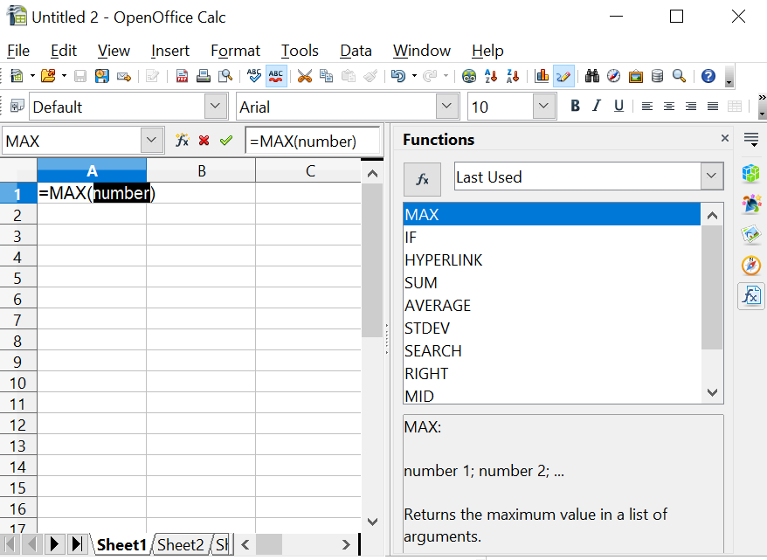

Figure 15: Function List docked to right side of Calc window

Function Wizard
A more elaborate tool for inputting functions is available in the Function Wizard (Figure 16). To open the Function Wizard, either choose Insert > Function or click the  button on the Function toolbar or press Ctrl+F2. Once open, the Function Wizard provides the same help features as the Function List but adds fields in which you can see the result of a completed function, and the result of any larger formula of which it is a part.
Select a category of functions to shorten the list. Then scroll down through the named functions and select the required one. When you select a function, its description appears on the right-hand side of the dialog. Double-click on the required function. Figure 16 shows the Function Wizard after double-clicking on the SUM entry in the Function list.
The Wizard now displays an area to the right where you can enter data manually in text boxes or click the Shrink button to shrink the wizard so you can select cells from the worksheet. Figure 14 shows the Function Wizard after shrinking.
Figure 16: Function Wizard after shrinking
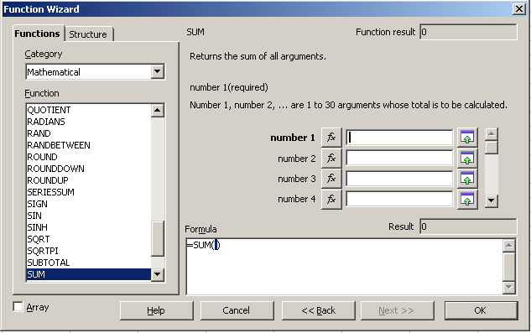Figure 17: Functions tab of Function Wizard.
To select cells, click the cell directly or hold down the left mouse button and drag to select the required area.
When the area has been selected, click the Shrink button again to return to the wizard.
If multiple arguments are needed, select the next text box below the first, and repeat the selection process for the next cell or range of cells. Repeat this process as often as required. The Wizard will accept up to 30 ranges or arguments in the SUM function.
Click OK to accept the function and add it to the cell to get the result.
You can also select the Structure tab (Figure 13) to see a tree view of the parts of the formula. The main advantage over the Function List is that each argument is entered in its own field, making it easier to manage. The price of this reliability is slower input. That's often a small price to pay since precision is generally more important than speed when creating a spreadsheet.
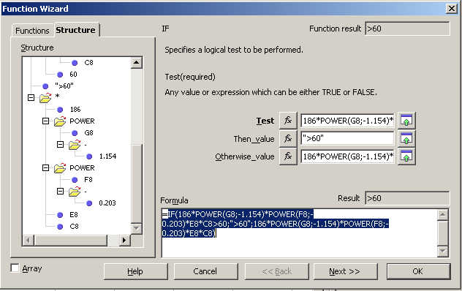Figure 18: Structure tab of Function Wizard

Entering Formulas in Cells or the Input Line
Formulas can also be entered directly into cells or the Input line. Start the entry with an equal sign and type the required numbers, text, and functions. Calc will provide tips for the function arguments. You can use the mouse to select cell ranges via click & drag. After you enter a function on the Input line, press the Enter key or click the Accept button on the Function toolbar to add the function to the cell and get its result.

1 | Name Box showing list of common functions
2 | Function Wizard | 4 | Accept
3 | Cancel | 5 | Input Line
Figure 19: The Function toolbar
If you see the formula in the cell instead of the result, then Formulas are selected for display in Tools > Options > OpenOffice Calc > View > Display. Deselect Formulas, and the result will display. However, you can still see the formula in the Input line.

Strategies for Creating Formulas and Functions
You can take several broad approaches when creating a formula. In deciding which approach to take, consider how many other people will need to use the worksheets, the life of the worksheets, and the variations that could be encountered in use of the formula.
If people other than yourself will use the spreadsheet, make sure that it is easy to see what input is required, and where. Explanation of the purpose of the spreadsheet, basis of calculation, input required, and output(s) generated are often placed on the first worksheet.
A spreadsheet you build today, with many complicated formulas, may not be quite so obvious in its function and operation in 6 or 12 months. Use comments and notes liberally to document your work.
You might be aware that you cannot use negative values or zero values for a particular argument, but if someone else inputs such a value, will your formula be robust or simply return a standard (and often not too helpful) Err: message? It is a good idea to trap errors using some form of logic statements or conditional formatting.

Place a Unique Formula in Each Cell
The simplest approach is to write formulas for complete calculations in whichever cells are convenient. This is often a sufficient strategy for simple calculations. For example, a personal budget might have columns for the date, transaction type, and amount, with income as positive numbers and costs as negative numbers. A SUM() formula could then return the change in the account balance. Though this approach would probably not suffice for even a tiny business, it will work if you just want to track at a high level how closely your expenses match your income. There are many cases where the input data and the questions to be answered are uncomplicated, and there is no need for a more elaborate spreadsheet. The disadvantage of doing complete calculations in one cell is that it rapidly becomes difficult to understand and troubleshoot formulas as they become more complicated.

Break Formulas into Parts and Combine the Parts
The second strategy is similar to the first, but instead, you break down longer formulas into smaller parts and then combine the parts into the whole. Many examples of this type exist in complex scientific and engineering calculations, where interim results are used in several places in the worksheet. Whenever you start nesting functions, that is, using functions within functions, you should consider breaking the calculation into parts.
A very simple example is shown in Figure 12. The price of a product is calculated based on the color, minimum temperature, and square meters required. Three quantities are multiplied to get the final answer. The left side of the figure shows a successful calculation using an "all-in-one" method in cell A9 and a combination of sub–formulas in A16. The formulas used in each cell of A9, A12:A14, and A16 are shown in the neighboring column B cells. You would not typically include the text in column B in a spreadsheet. It is included here to make the figure easier to understand.
Don't worry if you don't understand what each formula does. The important point is that cells A12:A14 calculate parts of the larger formula in A9 and these parts are combined in A16. An advantage of combining sub–formulas can be seen on the right side of the figure. A negative number has been entered in cell A2, and this causes the SQRT() function to return the error message Err:502. This causes the all-in-one formula to also return that error message, but it is unclear what part of the formula causes the error. The combined result in A16 also returns the error, but looking at the sub–formulas in A12:A14, it is clear that the SQRT() function is the culprit.
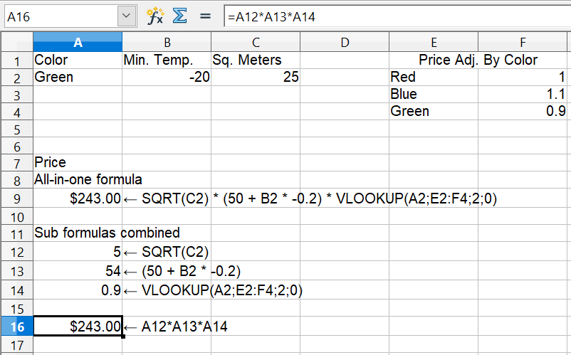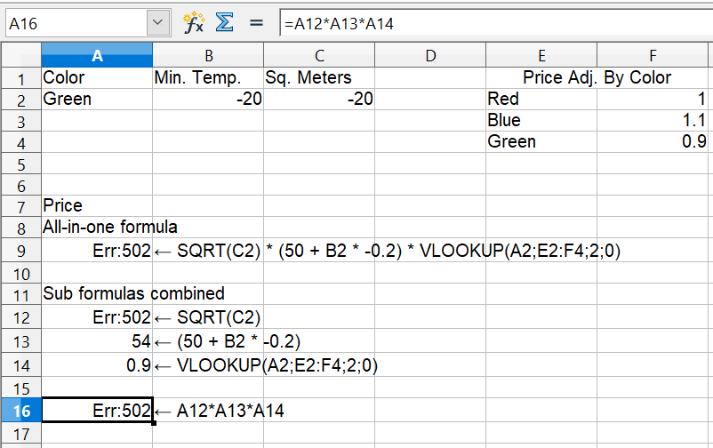

Figure 20: Calculation and errors with all-in-one or combined formulas
Breaking out parts of the calculation helps in tracking errors and unexpectedly large or small results. It is generally much easier to troubleshoot a calculation that uses several quantities if the individual values can be easily seen. This requires using more cells, but it can save a lot of time.

Use the Basic Editor to Create Functions
A third strategy is to use the Basic editor to create your own functions and macros. This approach can be used where the result would greatly simplify the use of the spreadsheet and keep the formulas simple, with a better chance of avoiding errors. This approach can also make maintenance easier by keeping corrections or updates in one central location. The use of macros is described in Chapter 12 of this book and is a specialized topic. The danger of overusing macros and custom functions is that the principles upon which the spreadsheet is based become much more difficult for users other than the original author to see.

Finding and Fixing Errors
It is common to find situations where errors are displayed. Even with all the tools Calc has that help you enter formulas, making mistakes is easy. Many people find inputting numbers difficult, and may make a mistake about the kind of entry a function's argument needs. In addition to correcting errors, you may want to find the cells used in a formula to change their values or to check the answer.
Calc provides three tools for investigating formulas and the cells that they reference: error messages, color coding, and the Detective.

Error Messages
Error messages are Calc's most basic tool for locating and correcting errors. Error messages display in a formula’s cell or in the Function Wizard instead of the result.
An error message for a formula is usually a three-digit number from 501 to 527 or sometimes unhelpful text such as #NAME?, #REF, or #VALUE. The error number appears in the cell, and a brief explanation of the error is displayed on the right side of the status bar.
Most error messages indicate a problem with how the formula was input, although several indicate that you have run up against a limitation of either Calc or its current settings.
Error messages are not at all user-friendly and may intimidate some users. However, they are valuable clues to correcting mistakes. You can find detailed explanations of them by searching for error codes; list of in the OpenOffice Calc help file. A few of the most common are shown in the following table.
#NAME? (525) | No valid reference exists for the argument.
#REF (525) | The column, row, or sheet for the referenced cell is missing.
#VALUE (519) | The value for one of the arguments is not the type that the argument requires. The value may be entered incorrectly; for example, double quotation marks may be missing around the value. At other times, a cell or range may have the wrong kind of value, such as text instead of numbers.
509 | An operator such as an equals sign is missing from the formula.
510 | An argument is missing from the formula.
502 | Function argument is not valid, for example, a negative number for the root function.

Examples of Common Errors

Err:532 #DIV/0!
This error results from dividing a number by either the number zero (0) or a blank cell. There is an easy way to avoid this problem. When you have a zero or blank cell displayed, use a conditional function. Figure 11 shows the result of dividing column A by column B when some cells in B contain zero or are blank.
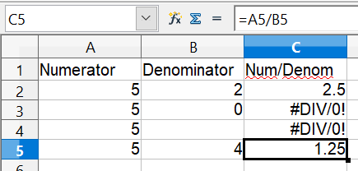

Figure 21: Examples of #DIV/0!, Division by zero
It's common to find errors like this in situations in which data was not reported or was reported incorrectly. When such an error is possible, an IF function can be used to display the data correctly. The formula
=IF(B2 <>0;A2/B2;"Zero Denom.")
can be entered. The formula is then copied over the remainder of Column C. This formula roughly means: “If B2 is not 0, then compute A2 divided by B2; otherwise, display ‘Zero Denom.’”. Note that the operator <> means not equal to.
It is also possible for the last parameter to use empty double quotes for a blank to be entered or a different formula with a standardized number being substituted for the lower number.
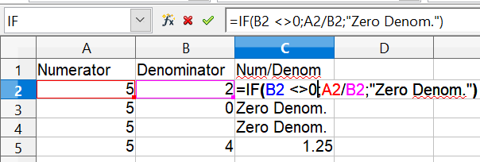

Figure 22: Division by zero solution

#VALUE Non-existent Value and #REF! Incorrect References
The non-existent value error is also very common, appearing frequently when a user copies a formula over a selected area. When copying, it is typical for the program to increment the represented cells. If you were copying downward from cell B3, the program would automatically substitute cell B4 into the next lower cell, and so on, until the end of the copying process. If that next cell contains text or a value inappropriate for the formula, this error may result. The difficulty often occurs when one or more of the parameters in the formula need to be fixed.
Note | If you need to keep a reference to B3 fixed while copying a formula, you can give the cell B3 a name such as TotalExpenses. In that way, the program will carry that name to each succeeding formula being copied. Alternatively, use an absolute reference, $B$3.

Color Coding for Input
Another useful tool when reviewing a formula is color coding for input. When you select a formula that has already been entered by double-clicking in the cell or editing the formula in the Input line, the cells or ranges used for each argument in the formula are outlined in color. This can be very helpful in confirming that the formula references the intended cells.
Calc uses eight colors for outlining referenced cells, starting with blue for the first cell and continuing with red, magenta, green, dark blue, brown, purple, and yellow before cycling through the sequence again.

The Detective
In a long or complicated spreadsheet, color coding becomes less useful. In these cases, consider using the submenu under Tools > Detective. The Detective is a tool for checking which cells are used as arguments by a formula (precedents) and which other formulas it appears in (dependents). It can also be used for tracing errors, flagging invalid data (information in cells that is not proper for a function’s argument), or even removing precedents and dependents.
To use the Detective, select a cell with a formula, then start the Detective. The spreadsheet shows lines ending in circles to indicate precedents and lines ending in arrows for dependents. The lines show the flow of information.
Use the Detective to assist in following the precedents referred to in a formula in a cell. By tracing these precedents, you can frequently find the source of the errors. Place the cursor in the cell in question and then choose Tools > Detective > Trace Precedents from the menu bar or press Shift+F7. Figure 10 shows a simple example of tracing precedents.
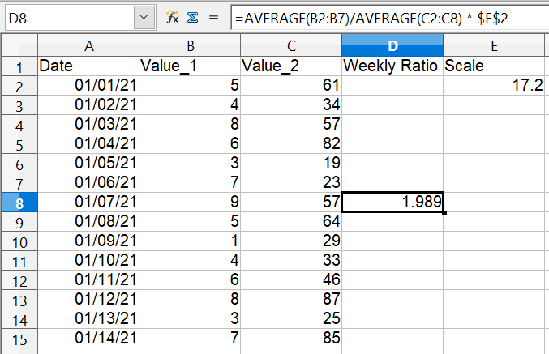
Cursor placed in cell
Figure 23: Tracing precedents using the Detective
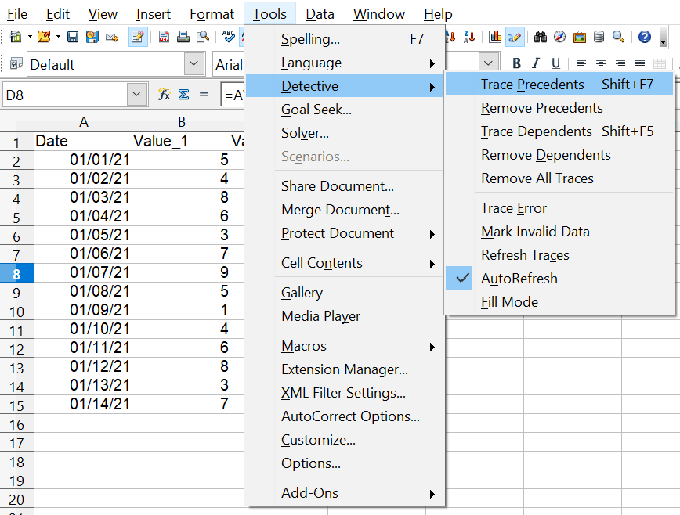
a) Initiate trace by clicking Trace Precedents
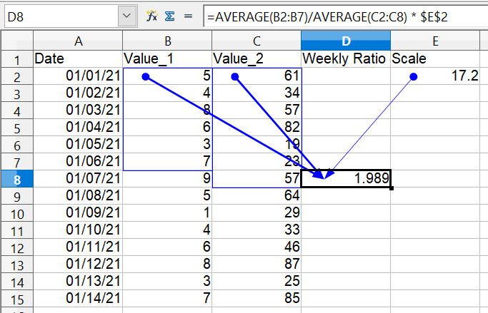
b) Source area highlighted in Blue, with arrows pointing to the calculation cell
(continued): Tracing precedents using the Detective
We are concerned that the number shown in Cell D8 is incorrectly stated. The cause can be seen in the highlighted cells. The ranges spanned in columns B and C are different, with column B missing the last day of the week.
In other cases, we must trace the error. Use the Trace Error function under Tools > Detective > Trace Error to find the cells that cause the error.

Examples of Functions
For novices, functions are among the most intimidating features of OpenOffice's Calc. New users quickly learn that functions are an important feature of spreadsheets, but there are almost four hundred, and many require input that assumes specialized knowledge. Fortunately, Calc includes dozens of functions that anyone can use.

Basic Arithmetic and Statistic Functions
The most basic functions create formulas for basic arithmetic or for evaluating numbers in a range of cells.

Basic Arithmetic
The simple arithmetic functions are addition, subtraction, multiplication, and division.
Except for subtraction, each of these operations has its own function:
- SUM for addition
- PRODUCT for multiplication
- QUOTIENT for integer division. This may not do what you expect, as explained below.
Traditionally, subtraction does not have a function.
SUM and PRODUCT are useful for entering ranges of cells in the same way as any other function, with arguments in parentheses after the function name.
However, for basic equations using only a few values, many users prefer the time-honored computer symbols for these operations, using the plus sign (+) for addition, the hyphen (–) for subtraction, the asterisk (*) for multiplication, and the forward-slash (/) for division. These symbols are quick to enter and don't require your hands straying from the keyboard.
A similar choice is also available if you want to raise a number by the power of another. Instead of entering =POWER(A1;2), you can enter =A1^2.
Moreover, arithmetic operators have this advantage. You enter them in a way and an order that closely approximates human–readable format, more so than the spreadsheet-readable format used by the equivalent function. For instance, instead of entering =SUM (A1:A2), or possibly =SUM (A1;A2), you enter =A1+A2. This almost-human-readable format is especially useful for compound operations, where writing =A1*(A2+A3) is briefer and easier to read than =PRODUCT(A1;SUM(A2:A3)).
The main disadvantage of using arithmetical operators is that you cannot directly use a range of cells. In other words, to enter the equivalent of =SUM (A1:A5), you would need to type =A1+A2+A3+A4+A5. This rapidly becomes impractical.
Otherwise, whether you use a function or an operator is mainly up to you. However, suppose you use spreadsheets regularly in a group setting such as a class or an office. In that case, you might want to standardize on an entry format so that everyone who handles a spreadsheet becomes accustomed to a standard input.
The QUOTIENT function returns only the integer part of the division. For example, QUOTIENT(18; 5) returns 3, not 3.6. Also, the function does not accept cell ranges since sequentially doing integer division is not useful. Normal division is done with the / operator.

Simple Statistics
Another common use for spreadsheet functions is to extract summary information from a list, such as a series of test scores in a class or a summary of earnings per quarter for a company.
You can scan a list of figures if you want basic information, such as the highest or lowest entry or the average. The only trouble is that the longer the list, the more time you'll spend, and the more likely you will miss what you’re looking for. Instead, it is usually quicker and more efficient to enter a function. Such reasons explain the existence of a function like COUNT, which does no more than give the total number of numeric entries in the designated cell range.
Similarly, to find the highest or lowest entry, you can use MIN or MAX. For each of these formulas, all arguments are either a range of cells or a series of cells entered individually.
Each also has a related function, MINA or MAXA, which performs the same function but treats a cell formatted for text as having a value of 0 (The same treatment of text occurs in any variation of another function that adds an "A" to the end). For example, if you have four cells containing 5, 7, 3, and Z, the MIN function will return 3, ignoring the text Z, and the MINA function will return 0, treating the text Z as a zero.
For more flexibility in similar operations, you could use LARGE or SMALL, both of which add a specialized argument of rank. If the rank is 1 with LARGE, you get the same result as with MAX. However, if the rank is 2, then the result is the second largest result. Similarly, a rank of 2 with SMALL returns the second–smallest number. LARGE and SMALL are handy as permanent controls since you can quickly scan multiple results by changing the rank argument.
You would need to be an expert to find the Poisson Distribution (a mathematical model of the number of outcomes obtained in a suitable interval of time and space) of a sample or to find the skew or negative binomial of a distribution. (If you are, you'll find functions in Calc for such things.). However, for the rest of us, there are simpler statistical functions that you can quickly learn to use.
In particular, if you need an average, you have more than one to choose from. You can find the arithmetical means—that is, the result when you add all entries in a list and then divide by the number of entries by entering a range of numbers when using AVERAGE or AVERAGEA to include text entries and to give them a value of zero.
In addition, you can get other information about the data set:
- MEDIAN: The number for which half the values in the list are higher and half are lower.
- MODE: The most common entry in a list of numbers.
- QUARTILE: The entry at a set position in the array of numbers. Besides the cell range, you enter the type of Quartile: 0 for the lowest entry, 1 for the value of 25%, 2 for the value of 50%, 3 for 75%, and 4 for the highest entry. Note that the result for types 1 through 3 may not represent an actual item entered.
- RANK: The sorted position of a given entry in the entire list, in ascending or descending order. You need to enter the value for the entry, the range of entries, and the type of rank (0 for the rank in descending order or 1 for the rank in ascending order). For example, if A1:A4 contain 5, 7, 8, 2, RANK(5, A1:A4;0) returns 3 because 5 is the third element if the values are sorted in descending order.
Some of these functions overlap; for example, MIN and MAX are both covered by QUARTILE. In other cases, a custom sort or filter might give much the same result. Which you use depends on your preferences and your needs. Some might prefer to use MIN and MAX because they are easy to remember, while others might prefer QUARTILE because it is more versatile.

Rounding off Numbers
For statistical and mathematical purposes, Calc includes a variety of ways to round off numbers. You may also be familiar with some of these methods if you’re a programmer. However, you don’t need to be a specialist to find some of them helpful. You may want to round off for billing purposes or because decimal places don’t translate well into the physical world—for instance, if the parts you need come in packages of 100, then the fact you only need 66 becomes irrelevant. You need to round up for ordering. By learning the options for rounding up or down, you can make your spreadsheets more immediately useful.
When you use a rounding function, you have two choices about how to set up your formulas. If you choose, you can nest a calculation within one of the rounding functions. For instance, the formula =ROUND((SUM(A1;A2)) adds the figures in cells A1 and A2, then rounds the result off to the nearest whole number. However, even though you don’t need to work with exact figures daily, you may still want to refer to them occasionally. If that is the case, you are probably better off separating the two functions, placing =SUM(A1;A2) in cell A3 and =ROUND (A3) in A4, and clearly labeling each function.

Rounding Methods
Some examples of all of the functions mentioned in the following paragraphs are shown below in Table 8. The table includes some comments highlighting the functions' behavior with negative numbers since the results may not be what you expect.
ROUND
Syntax: ROUND(Number; Count)
The most basic function for rounding numbers in Calc is ROUND. If used without the optional Count argument, this function will round off a number according to the usual rules of symmetric arithmetic rounding: a decimal place of .4 or less gets rounded down, while one of .5 or more gets rounded up. Using the Count argument, you can specify the number of decimal places to include. For instance, if Count was set to 1, 48.65 would round to 48.7. Negative values of Count cause rounding to multiples of positive powers of 10. Rounding 48.65 with Count set to -1 returns 50.
ROUNDUP or ROUNDDOWN
Syntax: ROUNDUP(Number; Count); ROUNDDOWN(Number; Count)
These functions set the direction of rounding. If you are one of those contractors who bills a full hour for any fraction of an hour you work, you always want to round up so you don’t lose any money. Conversely, you might round down to give a slight discount to a long-established customer. As with the ROUND function, the Count argument sets the number of decimal places. With negative numbers, these functions treat UP as away from zero and DOWN as towards zero.
TRUNC
Syntax: TRUNC(Number; Count)
This function works the same as ROUNDDOWN, rounding positive and negative numbers to the next integer in the direction towards zero.
INT
Syntax: INT(Number)
For positive numbers, the INT function behaves like ROUNDDOWN and TRUNC, rounding to the next smallest integer. For negative numbers, it behaves differently, rounding away from zero. INT(-24.4) returns -25.
ODD and EVEN
Syntax: ODD(Number); EVEN(Number)
These functions round to the next odd or even number in the direction away from zero. ODD(23.5) returns 25. ODD(-23.5) returns -25.
CEILING and FLOOR
Syntax: CEILING(Number; Significance; Mode);
Floor(Number; Significance; Mode)
For positive numbers, these functions round numbers up (CEILING) or down (FLOOR) to the nearest multiple of the Significance argument, and the Mode argument has no effect. For negative numbers, if Mode is zero, CEILING rounds towards zero, and FLOOR rounds away from zero. For any other value of Mode, the direction of rounding negative numbers is reversed. The sign of Significance must match the sign of Number in all cases.
MROUND
Syntax: MROUND(number; Multiple)
MROUND rounds numbers to the nearest multiple of the Multiple argument.

One last point is worth mentioning: If you are working with more than two decimal places, don't be surprised if you don’t see the same number of decimal places on the spreadsheet as you do on the function wizard. If you don’t, the reason is that Tools > Options > OpenOffice Calc > Calculate > Decimal Places defaults to 2. Change the number of decimal places, and, if necessary, uncheck the Precision as shown box on the same page, and the spreadsheet will display as expected.
Function with arguments | Result | Comment
ROUND(Number; Count)
=ROUND(123.456; 0) | 123
=ROUND(123.456; 2) | 123.46
=ROUND(123.456; -1) | 120
=ROUND(-123.456; 0) | -123
=ROUND(-123.456; 2) | -123.46
=ROUND(-123.456; -1) | -120
ROUNDUP(Number; Count)
=ROUNDUP(123.456;0) | 124
=ROUNDUP(123.454;2) | 123.46
=ROUNDUP(123.456;-1) | 130
=ROUNDUP(-123.456;0) | -124 | "Up" is away from zero
=ROUNDUP(-123.454;2) | -123.46 | "Up" is away from zero
=ROUNDUP(-123.456;-1) | -130 | "Up" is away from zero
ROUNDDOWN(Number; Count)
=ROUNDDOWN(123.456;0) | 123
=ROUNDDOWN(123.456;2) | 123.45
=ROUNDDOWN(126.456;-1) | 120
=ROUNDDOWN(-123.456;0) | -123 | "Down" is towards zero
=ROUNDDOWN(-123.456;2) | -123.45 | "Down" is towards zero
=ROUNDDOWN(-123.456;-1) | -120 | "Down" is towards zero
TRUNC(Number; Count)
=TRUNC(123.456;0) | 123
=TRUNC(123.456;2) | 123.45
=TRUNC(126.456;-1) | 120
=TRUNC(-123.456;0) | -123 | Moves less negative. Compare to INT()
=TRUNC(-123.456;2) | -123.45
=TRUNC(-123.456;-1) | -120
INT(Number)
=INT(123.456) | 123
=INT(-123.456) | -124 | Moves more negative. Compare to TRUNC()
ODD(Number)
=ODD(123.456) | 125 | Rounds up
=ODD(-123.456) | -125 | Rounds away from zero
EVEN(Number)
=EVEN(122.456) | 124 | Rounds up
=EVEN(-122.456) | -124 | Rounds away from zero
CEILING(Number; Significance; Mode)
=CEILING(77;5;0) | 80 | Mode argument has no effect on Positive Numbers
=CEILING(77;5;1) | 80 | Mode argument has no effect on Positive Numbers
=CEILING(-77;-5;0) | -75 | Mode argument changes the direction of rounding.
=CEILING(-77;-5;1) | -80 | Mode argument changes the direction of rounding.
FLOOR(Number; Significance; Mode)
=FLOOR(77;5;0) | 75 | Mode argument has no effect on Positive Numbers
=FLOOR(77;5;1) | 75 | Mode argument has no effect on Positive Numbers
=FLOOR(-77;-5;0) | -80 | Mode argument changes the direction of rounding.
=FLOOR(-77;-5;1) | -75 | Mode argument changes the direction of rounding.
MROUND(number; multiple)
=MROUND(15.3;5) | 15
=MROUND(-15.3;5) | -15
Table 11: Examples of positive and negative numbers and rounding functions

Using Regular Expressions in Functions
A number of functions in Calc allow the use of regular expressions: SUMIF, COUNTIF, MATCH, SEARCH, LOOKUP, HLOOKUP, VLOOKUP, DCOUNT, DCOUNTA, DSUM, DPRODUCT, DMAX, DMIN, DAVERAGE, DSTDEV, DSTDEVP, DVAR, DVARP, DGET.
Whether or not regular expressions are used is selected on the Tools > Options > OpenOffice Calc > Calculate dialog.
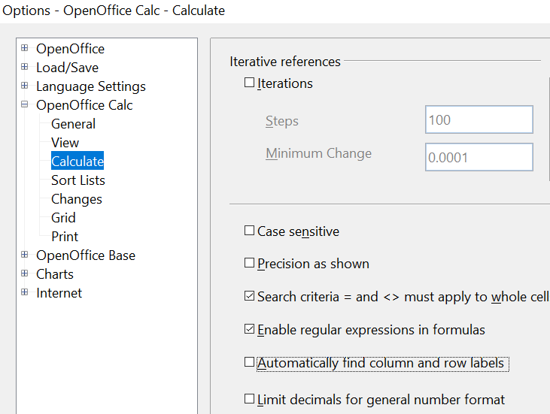

Figure 24: Enabling regular expressions in formulas
For example =COUNTIF(A1:A6;"r.d") with Enable regular expressions in formulas selected will count cells in A1:A6 which contain red and ROD.
Additionally, if Search criteria = and <> must apply to whole cells is not selected, then Fred, bride, and Ridge will also be counted. If that setting is selected, it can be overcome by wrapping the expression thus: =COUNTIF(A1:A6;".*r.d.*").
Figure 25: Using the COUNTIF function

Note | Regular expressions will not work in simple comparisons. For example, A1="r.d" will always evaluate to FALSE if A1 contains red, even if regular expressions are enabled. It will only test as TRUE if A1 contains r.d (r then a dot then d). If you wish to test using regular expressions, try the COUNTIF function: COUNTIF(A1; "r.d") will return 1 or 0, interpreted as TRUE or FALSE in formulas like =IF(COUNTIF(A1; "r.d"); "hooray"; "boo").

Regular expression searches within functions are always case insensitive, irrespective of the setting of the Case sensitive checkbox on the dialog in Figure 9—so red and ROD will always be matched in the above example. This case-insensitivity also applies to the regular expression structures ([:lower:]) and ([:upper:]), which match characters irrespective of case.

Activating the Enable regular expressions in formulas option means all the above functions will require any regular expression special characters (such as parentheses) used in strings within formulas to be preceded by a backslash despite not being part of a regular expression. These backslashes will need to be removed if the setting is later deactivated.

Advanced Functions
Like other spreadsheet programs, OpenOffice Calc can be enhanced by user-defined functions or add-ins. You can set up user-defined functions either by using the Basic IDE or by writing separate add-ins or extensions.
The basics of writing and running macros is covered in Chapter 12 (Calc Macros). Macros can be linked to menus or toolbars for ease of operation or stored in template modules to make the functions available in other documents.
Calc Add-Ins are specialized office extensions that can extend the functionality of OpenOffice with newly built-in Calc functions. Writing add-ins requires knowledge of the C++ language and the OpenOffice SDK, and is for experienced programmers. More information is available on the OpenOffice wiki page at https://wiki.openoffice.org/wiki/Calc/Add-In/Simple_Calc_Add-In. Several extensions for Calc have been written, and these can be found on the extensions site at https://extensions.openoffice.org/. Refer to Chapter 14 (Setting up and Customizing Calc) for more details.

Chapter 8
Using Pivot Tables

Introduction
Many requests for software support result from complicated formulas and solutions that try to solve simple day-to-day problems. Another solution is to use a Pivot Table, a tool for easily combining, comparing, and analyzing large amounts of data. With a Pivot Table, you can summarize the same source data in a variety of ways, displaying the details of areas of interest and creating reports.
This chapter is divided into two sections:
- “Examples with Step-by-Step Descriptions” uses three typical cases to demonstrate the advantages and applications of a Pivot Table. Follow the examples to learn how easy it is to use this tool.
- “Functions in Detail,” on page 218, describes the use of Pivot Tables in detail. You can use this part to look up how a function is used, and it is not necessary to understand or even read through all of this section to use Pivot Tables effectively.

Examples with Step-by-Step Descriptions
This section demonstrates some of the possibilities of Pivot Tables. By following the step-by-step description, you can recreate the examples and learn about the power of this tool.

Note | In several places in the following examples, there is an instruction to "select a cell." It can be very important that only a single cell be selected.

Example 1: Sales Volume Overview
A typical introductory example in instructional materials for beginners with spreadsheets is a simple sales volume overview.
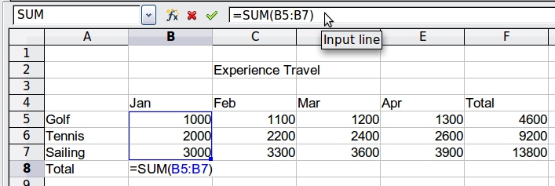
Figure 1: Typical example for beginners
This example demonstrates the user interface, and how to insert text and numbers into cells. Useful aids like AutoFill and drag and drop have been demonstrated in other chapters. The most important point here is the connection formulas establish between cells. As an example, consider that we can do addition with either the plus operator or the SUM function.
This small exercise might be useful for a first contact with the program, but it shows only a very small fraction of the tasks in an office. To create such a sales overview, you also need the original data. That is, before you can use a spreadsheet to create a sales overview, you need to add the single purchases from different lists and then enter the sums into the relevant cells B5 to F7.

Practical Problems and Questions
- To display additional values for May, June, July, and so on, you need to add extra columns; that is, you have to change the structure of the calculation sheet. This is not only somewhat inefficient from a workflow point of view, but it also raises some practical questions: How do references react if you add more columns or rows to the sum formulas?
- The layout, where the timeline is displayed horizontally, is less convenient if you want to add more months. A vertical layout might be a more efficient use of space. How can the table be transposed? Do you have to enter everything again?
- What if management asks unexpected questions or adds additional subdivisions? In such cases, you again have to manually add all the sums and create different tables with many variations.
- The automated categorization and calculation provided by a Pivot Table is faster and less error-prone than manually entering values or formulas in a table. This is true even if the calculation is only done once. If the calculation must be done frequently, the benefits of automated processing become even greater.

Solution
The most important part of your task in the example is the addition of the Total sales per month cells, which had to be done manually. To do this automatically with the program, just get the data into Calc. You can enter the single numbers by hand or you can import a file from your bookkeeping software. In any case we assume a continuous table that keeps track of all sales in a simple form shown in Figure 2.
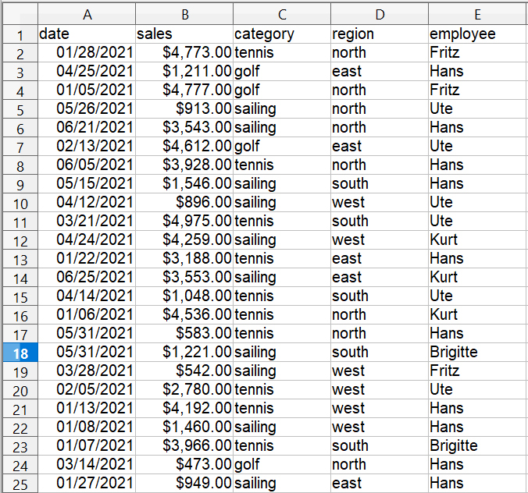

Figure 2: Basic data in Calc
You can create the sales volume overview by following these instructions:
- Select the cell A1 (or any other single cell within the list).
- Select Data > Pivot Table > Create. On the Select Source dialog, choose Current selection and click OK.
- The Pivot Table dialog (Figure 3) has four white layout areas and several fields resembling buttons. These small fields are the titles of the different columns of your list.
  - Drag and drop with the mouse to move the date field into the Column Fields area.
  - Move the sales field into the Data Fields area.
  - Move the category field into the Row Fields area.
- Click More to see more options in the lower part of the dialog.
- In the Results to drop-down list, select – new sheet –.
- Click OK.
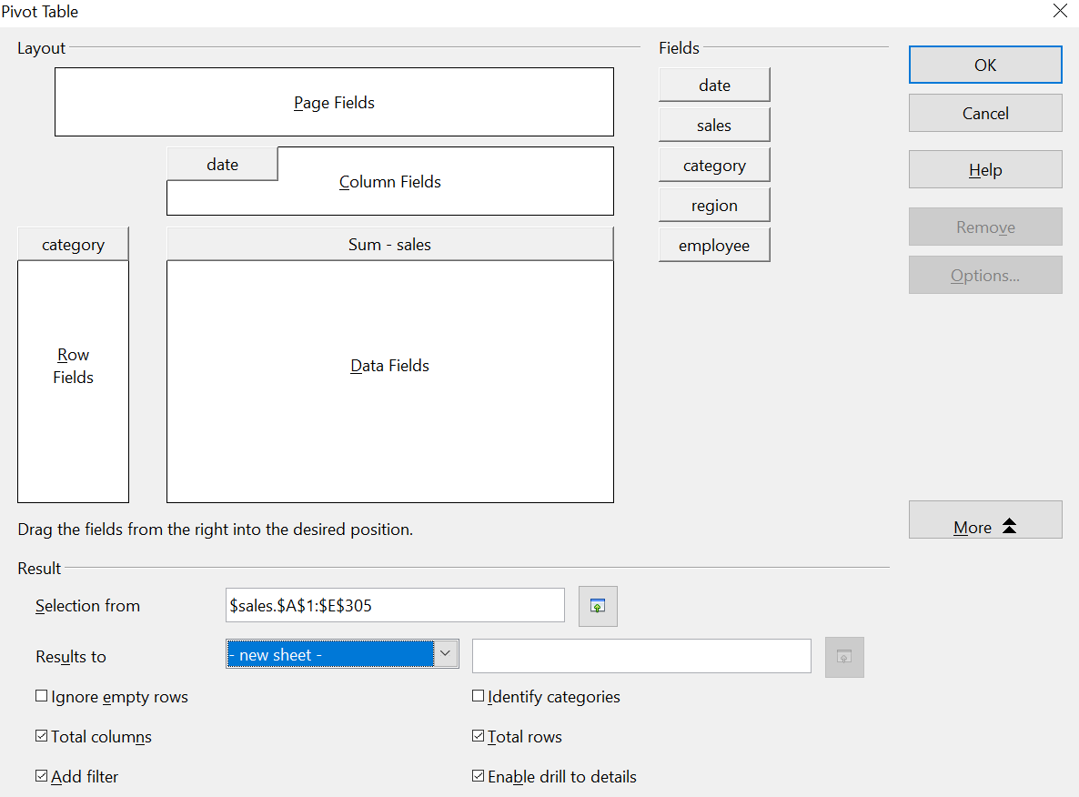

Figure 3: Pivot Table dialog
- The result appears on a new sheet. It has the desired structure, but the columns are not yet grouped into months.
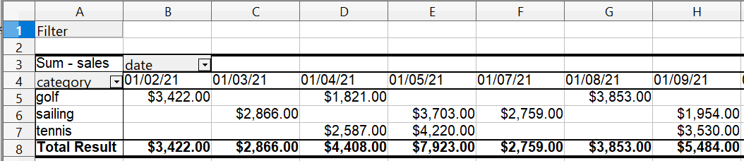

Figure 4: Pivot Table result without grouping
- To group the columns, select cell B4 or any other cell that contains a date. Then select Data > Group and Outline > Group. On the Grouping dialog (Figure 5), make sure Intervals and Months are selected in the Group by section, and click OK. The result is now grouped for months (Figure 6).
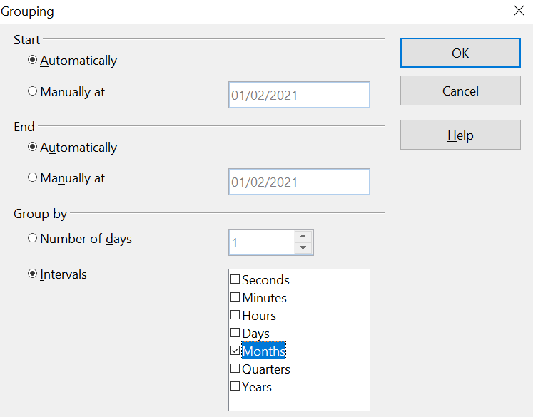

Figure 5: Grouping on months
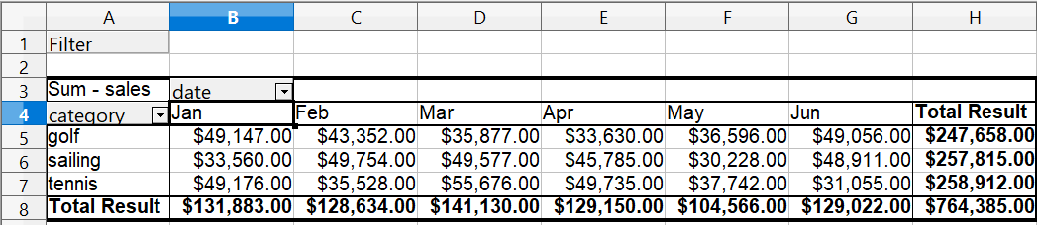

Figure 6: Pivot Table grouped for months
You can recognize the beginners’ example in this result. It is very easy to produce without any further knowledge about the spreadsheet. You do not have to enter any formulas, and the data region was selected automatically when you selected a single cell in the data region and started the Pivot Table process.

Advantages
- No manual entering or adding of any values is necessary. That means less work and fewer errors.
- The layout is very flexible: months are horizontal, and categories vertical or vice versa, in two mouse clicks.
- Additional differentiating factors are immediately available.
- Many types of evaluation are possible; for example, number or average instead of sum, accumulated values, comparisons, and so on.
- If more data are inserted into the original data set, the Pivot Table can be updated with two clicks.
We will now demonstrate some of these advantages.
Starting with the result of Figure 6, use the mouse to drag the Date field under the Category field, as shown in Figure 7.

Figure 7: Drag Date field under Category field
Now the summary is as shown in Figure 8.
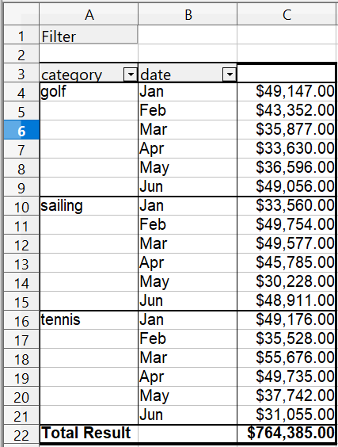
Figure 8: Changed layout
To transpose the table completely, just drag the Category field above the area of the displayed values, to cell C3 (see Figure 9). The result of this action is shown in Figure 10.

Figure 9: Reposition Category field
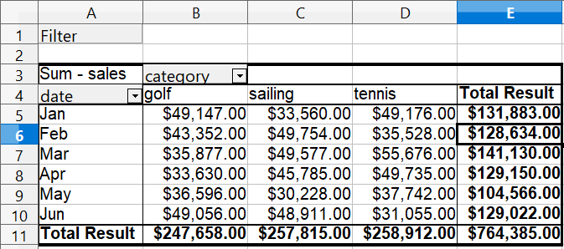

Figure 10: Transposed layout of Figure 8
In contrast to the beginners’ example in Figure 1, viewing or adding different aspects of the underlying data is now very simple. For example, to see the values for different regions, do the following:
- Select the cell A3 (or any other single cell that is part of the Pivot Table result).
- Select Data > Pivot Table > Create to start the Pivot Table again.
Drag the Region field into the Row Fields area. Depending on the order you choose for the row fields, the result is either regions with date subdivisions or vice versa.
- Click OK. The result is shown in Figure 11.
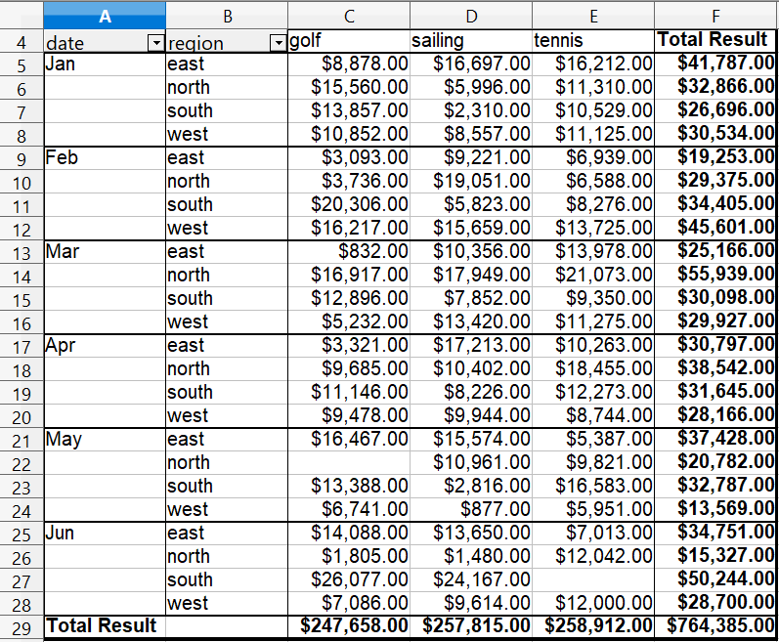
Figure 11: Additional subdivision into regions, added later
In another variation, you may want to add the ability to select data about individual employees.
- Select the cell A3 (or any other single cell that is part of the Pivot Table result).
- Select Data > Pivot Table > Create to start the Pivot Table again.
  - You do not need the Region field in this case. Drag it out of the layout area.
  - Drag the Employee field into the Page Fields area.
- Click OK. The result is shown in Figure 12.
Fields you use as page fields are placed in the result above the summary with the name Filter. You then have a drop-down list that you can use to show only the sums of a given employee.
The following examples will show you more of the powerful features of Pivot Tables.
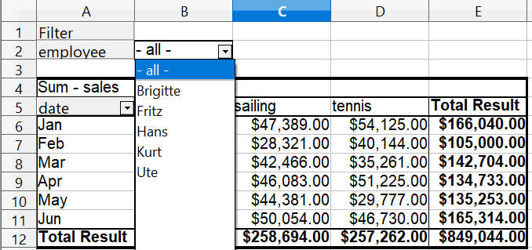

Figure 12: Selection of subtotals for an employee.

Example 2: Timekeeping
This example is often used by consultants and in several variations in user support. The task is to provide a means for one or more users to keep track of working hours.
Note | In the real world, timekeeping requires tracking working time on individual projects. Specialized database software is often used, but for simple applications in a small company, a Calc spreadsheet and a Pivot Table might suffice.

A typical way of doing this is to create a spreadsheet per month and a sum sheet with all the results of one year. For each employee, there is one file (see Figures 13 and 14 for examples of two pages from the file for one employee).

Practical Problems and Questions
- It is very difficult and time-consuming to create the timekeeping table: 12 sheets that have to be copied from a raw template and adjusted for each month, and a sheet with all the yearly sums with references to all the other sheets. Users often search for a macro to make the creation easier.
- The file shown contains only the data of one employee. How can you get all the data for all the employees to summarize all the work hours from all employees of a department or the whole company?
- How can you compare employees and/or departments?
- The file shown contains data for one year. How can you compare it with the data of the previous years?
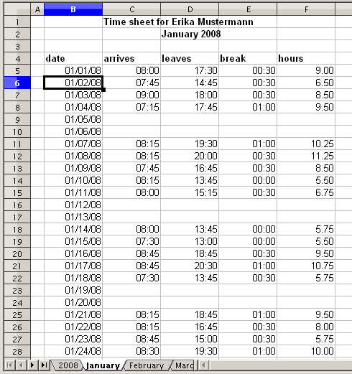
Figure 13: One month of timekeeping for one employee
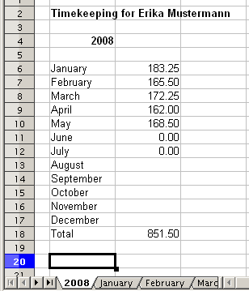
Figure 14: Yearly sums for one employee

Solution
To use a Pivot Table for this task, collect all the data into one table. This is an important step, often missed by novices. It seems convenient to have separate sheets for each person or each month, but the full power of a spreadsheet becomes available when all the data is in a single table. Then, tools like Pivot Tables can be used to filter and summarize the data, and new data can be added very easily.
In very simple cases, each employee takes care of their own working hours. If you need calculations that cover several employees, departments, or the whole company, just copy everything into one huge table (Figure 15).
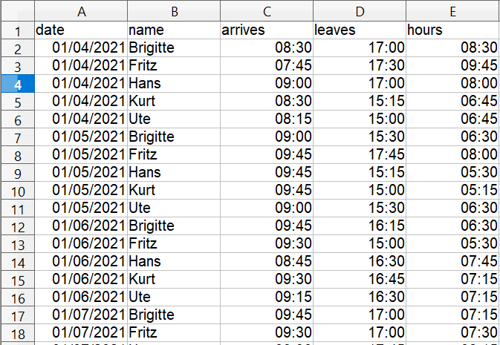

Figure 15: Employee time in Calc
Using a Pivot Table requires only 12 mouse clicks and gives you a nice overview within seconds:
- Select the cell A1 (or any other single cell within the data).
- Choose Data > Pivot Table > Create and click OK.
- On the Pivot Table dialog (Figure 16):
  - Drag date into the Row Fields area.
  - Drag hours into the Data Fields area. Notice that it becomes Sum – hours.
  - Drag name into the Column Fields area.
- Click More to show more options in the lower part of the dialog.
- Choose – new sheet – for Results to.
- Click OK.
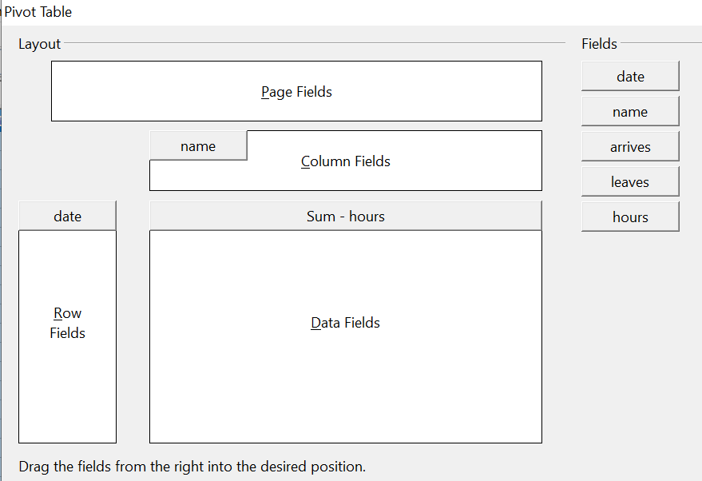

Figure 16: Part of the Pivot Table dialog
The result appears on a new sheet (Figure 17).
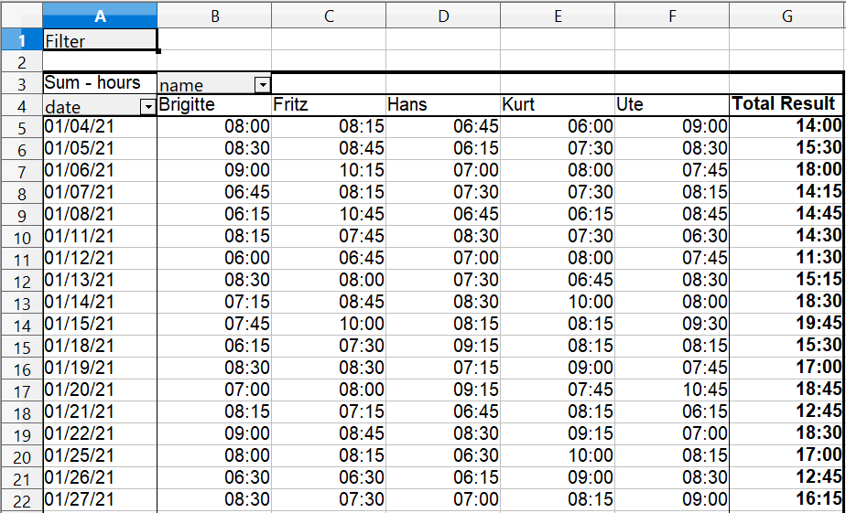

Figure 17: The evaluation, done within seconds with a Pivot Table
The result is much more powerful than is possible with the classic formula-based calculation. For example, you can summarize the daily results into a monthly result very easily:
- To group together the rows, select the cell A5 (or any other cell that contains a date).
- Choose Data > Group and Outline > Group. On the Grouping dialog, leave Start and End as Automatically; in the Group by section, choose Intervals and Months. Click OK. The result is now grouped into months.
- You may have to set the format of the cells to display values of hours larger than 24. This can be done with the menu Format > Cells and choosing a Time format whose format code has the hours in brackets: [HH]:MM.
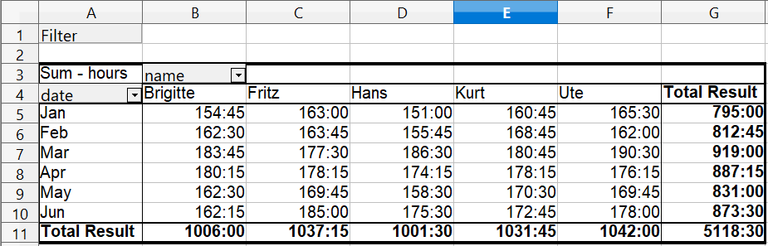

Figure 18: Monthly sums
If you need a result with a percentage, start with the Pivot Table from Figure 18.
- Select the cell A3 (or any other single cell that contains a result of the Pivot Table).
- Choose Data > Pivot Table > Create.
- Double-click Sum – hours to open the Data Field dialog (Figure 19).
- Click on More to see more options.
- Switch Displayed value > Type to % of column.
- Click OK to return to the Pivot Table dialog, then click OK again.
An example of the output is shown in (Figure 20).
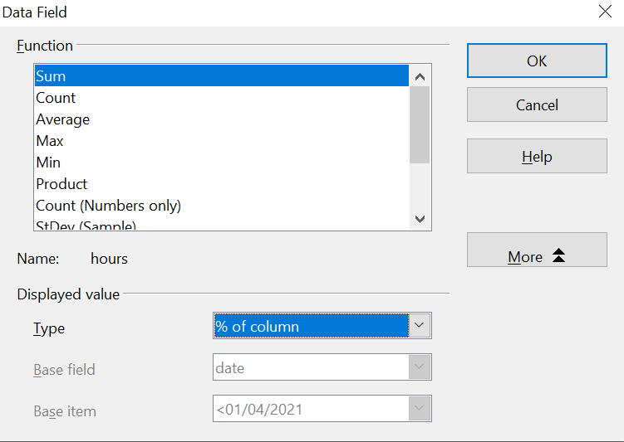

Figure 19: Properties of the data field
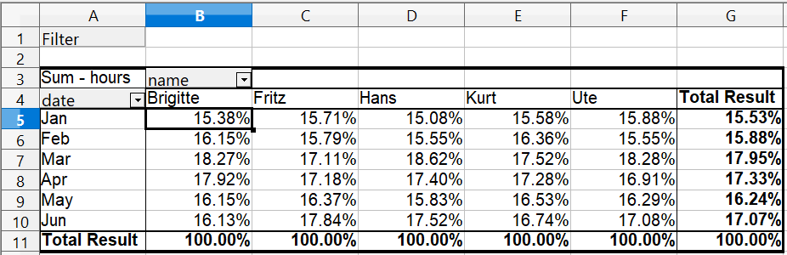

Figure 20: Result with percentages
To get a comparison between employees, start the Pivot Table again from the output sheet:
- Select cell A3 (or any other cell containing a Pivot Table result).
- Choose Data > Pivot Table > Create.
- Double-click on Sum – hours to open the Data Field dialog.
- Click More to see more options.
  - Switch the Type of the displayed value to Difference from.
  - Switch the Base field to name.
  - Switch the Base item to Brigitte.
- Click OK to return to the Pivot Table dialog, then click OK again.
See the comparison in Figure 21.
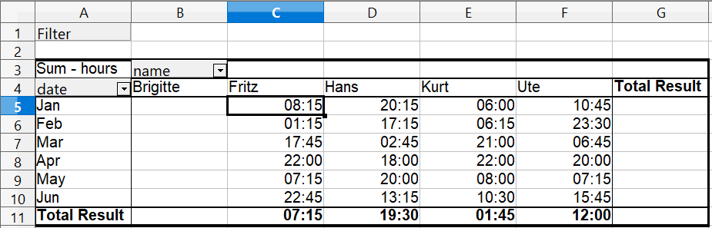

Figure 21: Absolute comparison with Brigitte
As a final example, we switch to an accumulated view, that is, continuing sums of all values:
- Select cell A3 (or any other cell containing a Pivot Table result).Choose Data > Pivot Table > Create.
- Double-click on Sum – hours to open the Data Field dialog.
- Click More to see more options.
  - Switch the type of the displayed value to Running total in.
  - Switch the Base field to Date.
- Click OK to return to the Pivot Table dialog, then click OK again.
The accumulated values are shown in Figure 22.
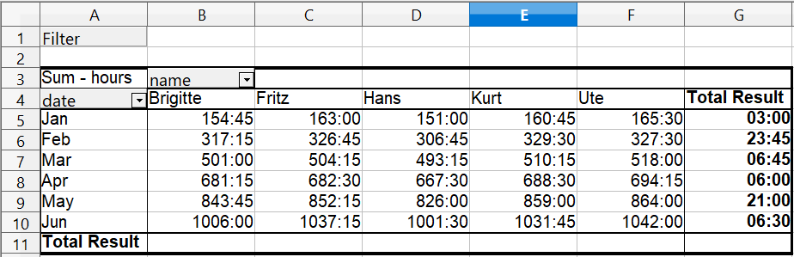
Figure 22: The Pivot Table now shows accumulated values

Differences and Advantages
These examples show an important aspect of Pivot Tables. Normally, you have to collect your data according to how you want the result represented. This means you have to use a specific structure, and you are stuck with it. However, Pivot Table works more like a database. Source data are collected in a single spreadsheet. Only when you want to look at the data in more detail do you select which part of the data you want to use and how to arrange the results.

Example 3: Frequency Distribution
To show the frequency of incidents, Calc uses the function FREQUENCY, an advanced feature. Alternatively, you can use a Pivot Table.
In our example, we want to investigate the number of emails sent to a mailing list. We want to know how the activity on the list is distributed during the day.
The first few rows of data are shown in Figure 23.
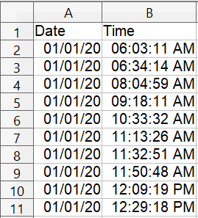
Figure 23: Data in Calc

Solution with an Array Formula
To calculate the frequency, you must create 24 classes, one for each hour. These are in C2:C25 in Figure 24. In the next column, you enter a formula that uses the FREQUENCY function to calculate the number of emails.
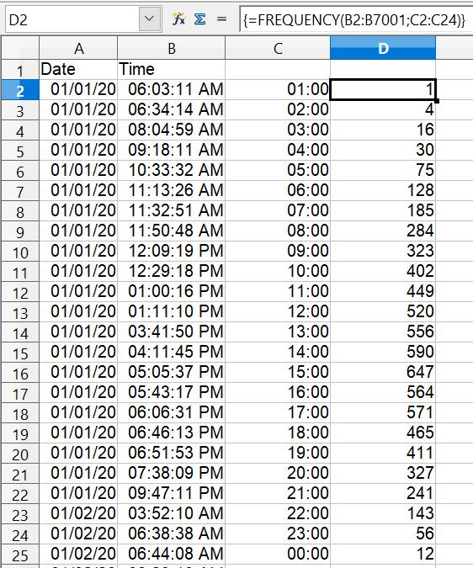

Figure 24: FREQUENCY function in an
array formula
The first argument in the FREQUENCY function is the cell area with the times of all 7000 emails. The second argument is the cell area C2:C25 that describes the frequency classes. Select the cell area F2:F25, and enter the formula. Finish the formula by using the key combination Shift+Ctrl+Enter. This indicates to the program you want to use an array formula. To indicate the array formula, the program uses curly brackets.

Solution with a Pivot Table
Thankfully, a Pivot Table allows you to achieve the same result more quickly and easily. Starting with the raw data (Figure 23), you only need a few mouse clicks.

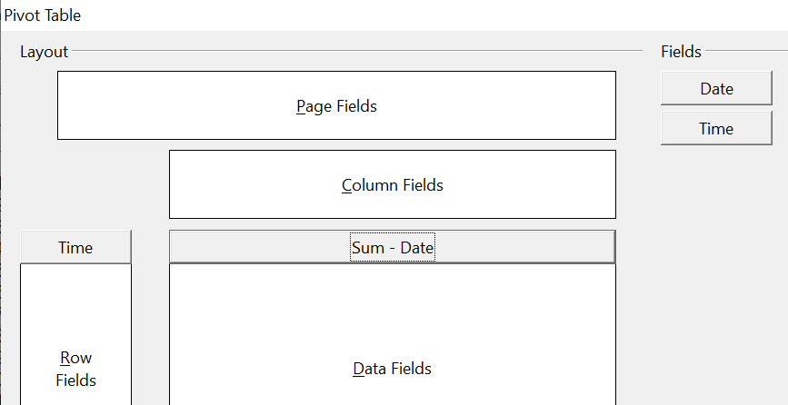
Figure 25: Part of Pivot Table dialog
- Select the cell A1 (or any other cell within the list).
- Choose Data > Pivot Table > Create and click OK.
- In the Pivot Table dialog (Figure 25):
  - Drag Time into the Row Fields area.
  - Drag Date into the Data Fields area.
- Click More to show more options in the lower part of the dialog.
- Choose – new sheet – for Results to.
- In this case, we need to count the number of values, not their sum. Double-click on Sum – Date to open the Data Field dialog and select the function Count (see Figure 26).
- Click OK. As an intermediate result, you get a Pivot Table that has a separate line for every time within the raw data.
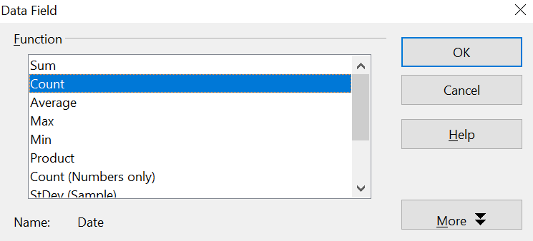

Figure 26: Properties of the data field
Note | This may be a very time-consuming process because of the large number of items. The time does not depend significantly on the number of lines, but rather on the number of rows needed for the table that contains the results.

- To group the rows, select cell A4 or any other cell that contains a time.
- Choose Data > Group and Outline > Group, select Hours for the interval, and click OK (See Figure 27). The result is now grouped according to hours, as shown in Figure 29.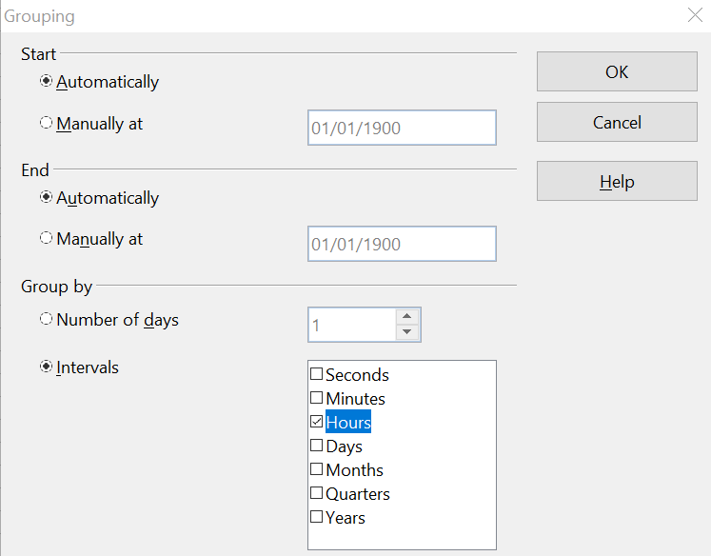

Figure 27: properties for grouping according to hours
- Restart the Pivot Table and double-click on the Count-Date data field. Figure 28 shows the Data Field dialog for the data field Number – Date. Click More and select as type % of column. The result is shown in Figure 30. Figure 29 shows the absolute occurrence.
Whether the relative values are shown as a decimal (0.1) or as a percentage (10%) depends only on the cell formatting.
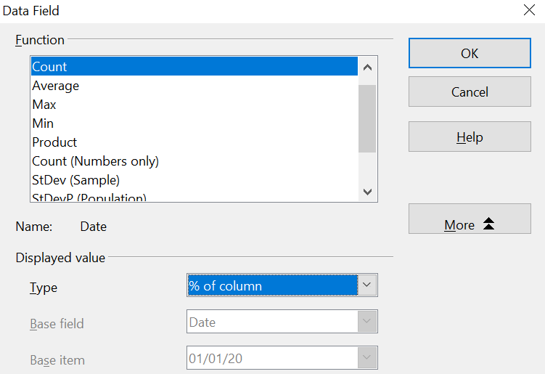

Figure 28: Data Field settings for relative values
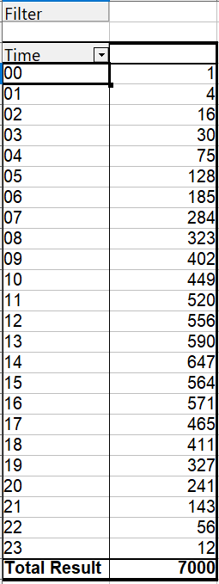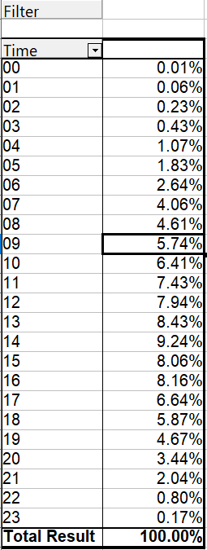

Figure 29: Frequency distribution

Figure 30: Relative occurrence

Functions in Detail
This part of the Calc guide describes in detail the use and options of Pivot Tables. Be aware, though, that those details may go well beyond what an individual user, especially one new to spreadsheets as analytical tools, needs to know in any particular case.

The Database
The first thing we need to have on hand for a Pivot Table is a set of raw data, similar to a database table. Such a set should comprise rows (AKA records) and columns (AKA fields). Moreover, field names must be in the first row of any such list.
Almost anything can serve as a data source – for instance, one can use an external file. In many cases, it is most convenient to use the raw data in the file that will contain the Pivot Table. For processing lists of data, Calc and its Pivot Tables need to know where the list is in the spreadsheet. That can be anywhere in the sheet, in any position; a spreadsheet can even contain several unrelated lists.
Calc recognizes your lists automatically. It uses the following logic:
- You must begin your effort by selecting a cell that is within the range of the items in your list.
- Starting from that cell, Calc checks the surrounding cells in all four directions (left, right, above, below). A border is recognized if the program discovers an empty row or column or if it hits the spreadsheet's first or last row or column.
- This means that the Pivot Table's functions can only work correctly if there are no empty rows or columns in your list. Avoid these; if you want to distinguish regions of the data, format your list by using cell formats.
Caution | Again, be careful - no empty rows or empty columns are allowed within lists.
If you select more than one single cell before creating the Pivot Table, the automatic list recognition is disabled. Calc assumes that the list exactly matches the cells you have selected.
Caution | When using the Pivot Table, always select only one cell or carefully select the entire data set. Failing to do so may result in empty rows or columns.

In addition to these formal aspects, logical structure is very important when using Pivot Tables. When entering data, don't add outlines, groups, or summaries. Here are some mistakes commonly made by inexperienced spreadsheet users:
- You made several sheets, for example, a sheet for each group of articles. Analyses are then possible only within each group. Analyses for several groups would be a lot of work.
- In the Sales list, instead of only one column for the amount, you created a column for each employee's amounts. The amounts had to be entered manually into the appropriate column, making an analysis with a Pivot Table impossible. In contrast, one benefit of a Pivot Table is that you can get results for each employee if you've entered data with the appropriate layout.
- You entered the amounts in chronological order. At the end of each month you made a sum total. In this case, processing the list for different criteria is not possible because the Pivot Table will treat the sum totals the same as any other figure. Getting monthly results is one of the very fast and easy features of Pivot Tables.

Start
Start the Pivot Table with Data > Pivot Table > Create. If the list to be analyzed is in a spreadsheet table, select only one cell within this list (See Figure 31). Calc recognizes and selects the rest of the list automatically.

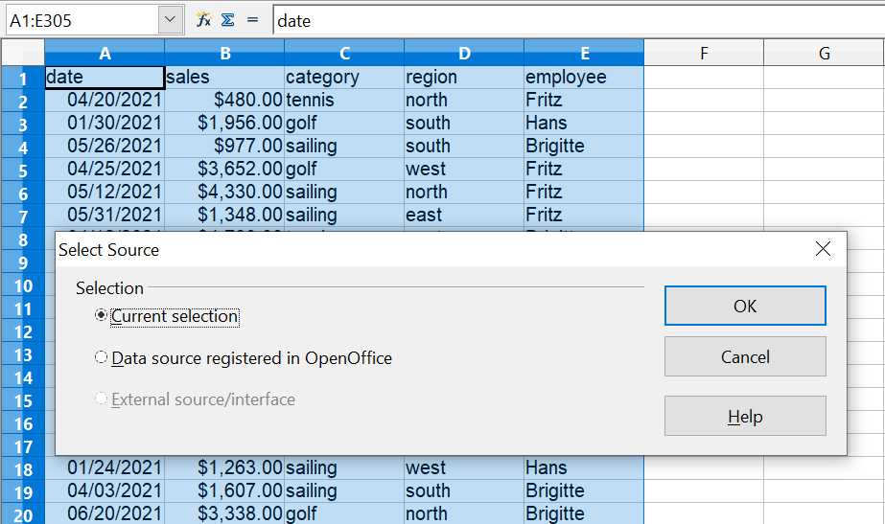

Figure 31: After starting the Pivot Table

Data Sources
There are two possible data sources for a Pivot Table: a Calc spreadsheet or an external data source. If you use the latter, it must be registered in OpenOffice.

Calc Spreadsheet
Analyzing a list in a Calc spreadsheet is the simplest and most frequent use of Pivot Tables. The list might be updated regularly, or its data might be imported from a different application.
For example, a huge list can be copied from a different application and pasted into Calc. The behavior of Calc while inserting the data depends on the format of the data. If the data is in a common spreadsheet format, it is copied directly into Calc. However, if the data is in plain text, the Text Import dialog appears; see Chapter 1 (Introducing Calc) for more information.
Calc can import data from many foreign data formats and other spreadsheets. It can also accept data from databases such as MySQL and even simple text files, including those using CSV formats.

Caution | The drawback of copying or importing foreign data is that it will not update automatically if there are changes in the source file.

Registered Data Source
A data source registered in OpenOffice can act as a connection to data held outside Calc. This means that the data to be analyzed will not be saved in Calc; Calc always uses the original data. Calc is able to use many different data sources, as well as databases that are created and maintained with OpenOffice Base. See Chapter 10 (Linking Calc Data) for more information.

The Pivot Table Dialog
The function of the Pivot Table is managed in two places: first in the Pivot Table dialog and second through manipulations of the result in the spreadsheet. This section describes the dialog in detail.

Basic Layout
In the Pivot Table dialog shown in Figure 32, four white areas show the layout of the result. Next to these white areas are buttons with the names of the fields (columns) in your data source. To choose a layout, drag and drop the field buttons into the white areas.
The Data Fields area in the middle must contain at least one field. If they care to, advanced users can use more than one field here. For each data field, an aggregate function is used. For example, if you move the sales field into the Data Fields area, it appears as Sum – sales.
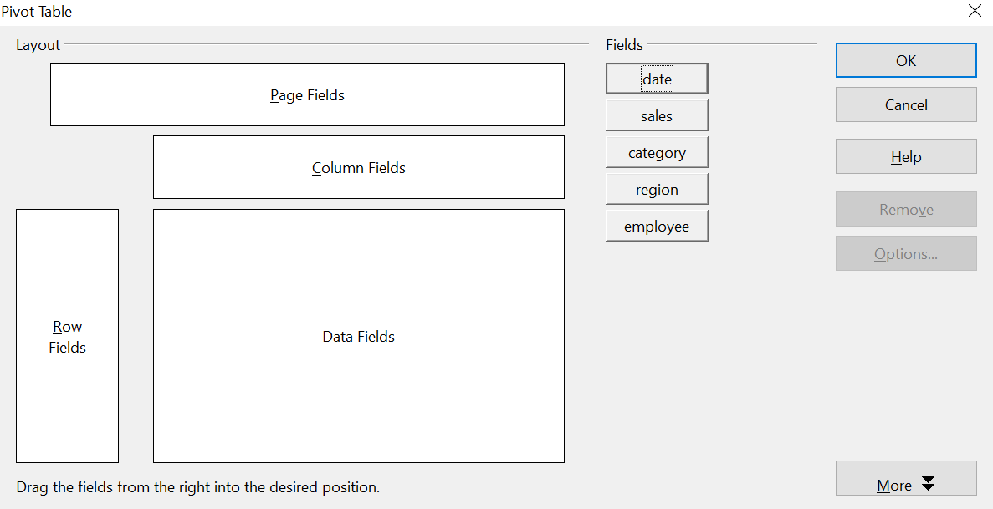

Figure 32: Pivot Table dialog

Row Fields and Column Fields indicate the categories by which the result will be sorted in the rows and columns. If there are no entries in one of these areas, then partial sums will not be provided for the corresponding rows or columns. When more than one field is used simultaneously to get partial sums for rows or columns, the order in which the fields are presented organizes sums from overall to specific.
For example, if you drag region and employee into the Row Fields area, the sum will be grouped first by employees and the listings for different regions are within that.
Fields placed into the Page Fields area appear in the result above as a drop-down list. The summary in your result considers only that part of your data that you have explicitly selected. For example, if you use employee as a page field, you can then filter the result shown for each employee.
To remove a field from the white layout area, drag it to the border and drop it (the cursor will change to a crossed symbol) or click the Remove button.

More Options
Click More to expand the Pivot Table dialog and show additional options. The options revealed by the More button are shown in Figure 33.
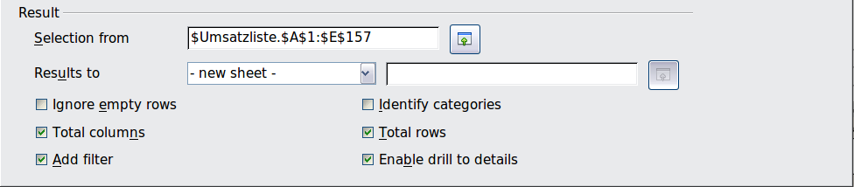
Figure 33: Expanded Pivot Table dialog
Selection from
Shows the range of cells used in the Pivot Table.
Results to
Results to defines where your result will be shown. If you do not enter anything, the Pivot Table result will be below the list that contains your data. Be careful - any data already in that location could be overwritten. To avoid that, choose a named cells range from the list that displays – undefined – or leave Results to as – undefined - and enter a cell reference to tell Calc where to show the results. Another, and probably better, approach is to use - new sheet – to add a new sheet to the spreadsheet file and place the results there.
Ignore empty rows
If the source data is not in the recommended form, this option tells the Pivot Table to ignore empty rows.
Identify categories
If the source data has missing entries in a list and does not meet the recommended data structure (See Figure 34) and this option is chosen, the Pivot Table fills the gaps with the category above that. If this option is not chosen, the Pivot Table inserts (empty). See Figure 36, where (empty) is displayed in the leftmost column.
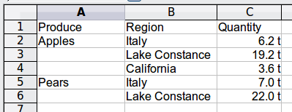
Figure 34: Example of data with missing entries in Column A
The option Identify categories ensures that rows 3 and 4 are added to the product Apples, and row 6 is added to Pears as shown in Figure 35.
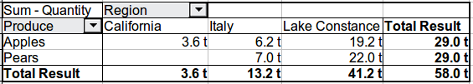
Figure 35: Pivot Table result with Identify categories selected
Keep in mind that without category recognition, a Pivot Table will show an (empty) category.
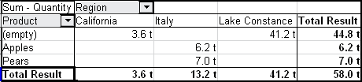
Figure 36: Pivot Table result without Identify categories selected

In most instances, Pivot Tables perform better without category recognition. Also, a list showing missing entries is less useful because you cannot use other functions, such as sorting or filtering.
Total columns / total rows
With this option, you decide whether the Pivot Table will show an extra row with the sums of each column or add a column with the sums of each row to the very right.
Add filter
Use this option to add or hide the cell labeled Filter above the Pivot Table results. This cell is a convenient button for additional filtering options within the Pivot Table.
Enable drill to details
If you double-click on a single cell in the Pivot Table result, this function gives a more detailed listing of an individual entry. If this function is disabled, the double-click will keep its usual edit function within a spreadsheet.

More Settings for the Fields – Field Options
The options discussed in the previous section are generally valid for the Pivot Table. Additionally, you can change settings for every field you have added to the Pivot Table layout. Do this by clicking on the Options button in the Pivot Table dialog or double-clicking on the appropriate field.
The differences between data fields, row or column fields, and page fields of the Pivot Table are outlined below.

Data Fields
Select the Sum function in the Options dialog of a data field to accumulate the values from your data source. You will need the sum function in many cases, but other functions, like standard deviation or simply counting, are also available. For example, the counting function can be useful for non-numerical data fields.
On the Data Field dialog (See Figure 37), click More to see more options.

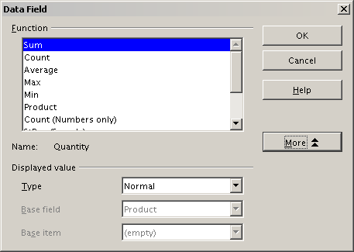
Figure 37: Expanded dialog for a data field
In the Displayed value section, you can choose other possibilities for analysis by using the aggregate function. Depending on the setting for Type, you may have to choose definitions for Base field and Base item. The table below lists the possible types of displayed values and associated base field and item, together with a note on usage.
Type | Base field | Base item | Analysis
Normal | — | — | Simple use of the chosen aggregate function (for example, sum)
Difference from | Selection of a field from the data source of the Pivot Table (for example, employee) | Selection of an item from the selected base field (for example, Brigitte) | Result as difference from the result of the base item (for example, Sales volume of the employees as difference from the sales volume of Brigitte)
% of | Selection of a field from the data source of the Pivot Table (for example, employee) | Selection of an item from the selected base field (for example, Brigitte) | Result as a ratio based on the result of the base item (for example, Sales result of the employee relative to the sales result of Brigitte)
% difference from | Selection of a field from the data source of the Pivot Table (for example, employee) | Selection of an item from the selected base field (for example. Brigitte) | Result as relative difference to the result of the base item (for example, Sales volume of the employees as relative difference of the sales volume of Brigitte)
Running total in | Selection of a field from the data source of the Pivot Table (for example, date) | — | Result as a continuing sum (for example, running sum of the sales volume for days or months)
% of row | — | — | Result as relative part of the result in the whole row (for example the row sum)
% of column | — | — | Result as relative part of the total column (for example, the column sum)
% of total | — | — | Result as relative part of the overall result (for example the total sum)
Index | — | — | Default result x total result / (row result x column result)

Row and Column Fields
In the Options dialog for the row or column fields, you can choose to show partial sums for each category. Be aware that in Calc, partial sums are deactivated by default since they're only useful if the values in one row or column field can be divided into partial sums for another field.
Some examples are shown in the next three figures.

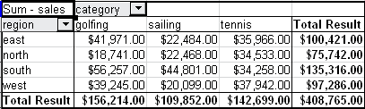
Figure 38: No subdivision with only one row or column field
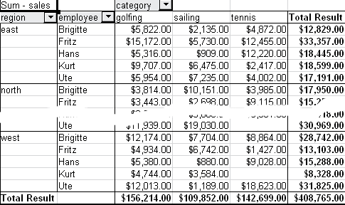
Figure 39: Division of the regions by employees (two row fields) without partial sums
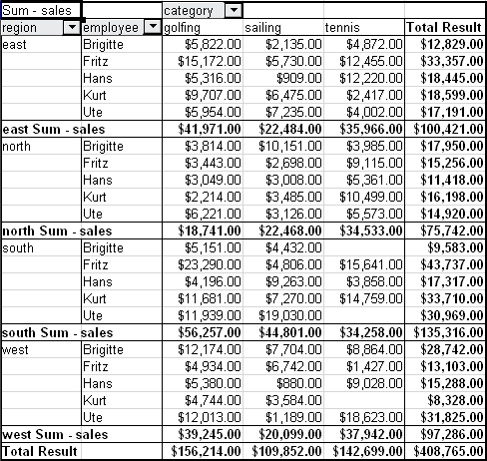
Figure 40: Division of the regions for employees with partial sums (by region)
Choose the option Automatically to activate the aggregate function for partial results that can also be used for data fields. To set up the aggregate function for the partial results independently from the overall settings of the Pivot Table, choose User-defined. See Figure 41.
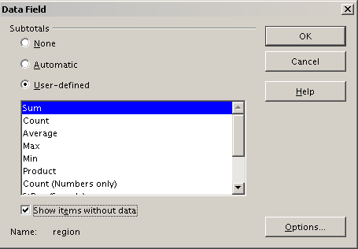
Figure 41: Preferences dialog of a row or column field
Normally, the Pivot Table does not show a row or column for categories with no entries in the underlying database. However, you can force this by choosing the Show items without data option.
For illustration purposes, the data was manipulated so that the employee Brigitte has no sales values for the category golfing. In Figure 42, there is no column for this category, but the column does appear in Figure 43.
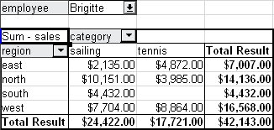
Figure 42: Default setting
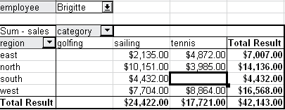
Figure 43: Setting “Show Items without data”

Page Fields
The Options dialog for page fields is the same as for row and column fields. Given the flexibility Pivot Tables provide, you can switch fields between pages, columns, or rows. Doing so still allows fields to keep the settings you made for them. The page field has the same properties as a row or column field, but only when you use such a field not as a page field but as a row or a column field.

Working with the Results of the Pivot Table
As we've mentioned, Pivot Tables are very flexible. An analysis can be totally restructured with only a few mouse clicks. Also, some functions of a Pivot Table can only be used with the results of an analysis.

Start the Dialog
Right-click in the area of the resulting table of the Pivot Table. The command Edit Layout opens the Pivot Table dialog with all current settings.

Change Layout by Using Drag and Drop
The easiest and fastest method of changing the layout of the Pivot Table is to drag and drop. In the the Pivot Table's result table, move one of the page, column, or row fields to a different position.
You can remove a column, row, or page field from the Pivot Table by clicking on it and dragging it completely out of the Pivot Table.

Grouping Rows or Columns
For many analyses or summaries, categories must be grouped. You can merge such results as classes or periods. In a Pivot Table, do a grouping only after making an ungrouped Pivot Table.

Caution | You can access the grouping with the menu entry Data > Group and Outline > Group or by pressing F12. It is important that you select the correct cell area. If you want to group some dates, click on one of the date cells before starting the grouping process. How the grouping function works is determined mainly by the type of values that have to be grouped. You need to distinguish between scalar values, date or time values, or other values, such as text, that you want grouped.

Note | Before you can group, you have to produce a Pivot Table with ungrouped data. The time needed to create a Pivot Table depends mostly on the number of columns and rows in the resulting table, not on the extent of the basic data. By grouping, you can produce a Pivot Table with only a few rows and columns. Pivot Tables can contain many categories, depending on your data source.

Grouping of Categories with Scalar Values
For grouping scalar values, select a single cell in the row or column of the category to be grouped.
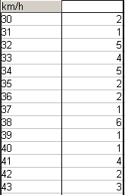
Figure 44: Pivot Table without grouping (frequency of the km/h values of a radar control)
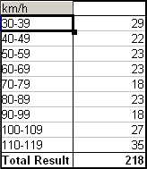
Figure 45: Pivot Table with grouping (classes of 10 km/h each)
Choose Data > Group and Outline > Group from the menu bar or press F12; you get the following dialog.
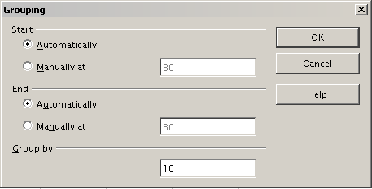
Figure 46: Grouping dialog with scalar categories
You can define in which value range (start/end) the grouping should take place. The default setting is the whole range from smallest to biggest value. In the field Group by you can enter the class size, that is, the interval size - in the example shown in Figures 44, 45, and 46, groups of 10 km/h each were chosen.

Grouping of Categories with Date or Time Values
For grouping date or time values, select a single cell in the column or row of the category to be grouped. This was demonstrated in all three examples in the section Examples with Step-by-Step Descriptions. With the menu entry Data > Group and Outline > Group or by pressing F12, you get the dialog shown in Figure 47.
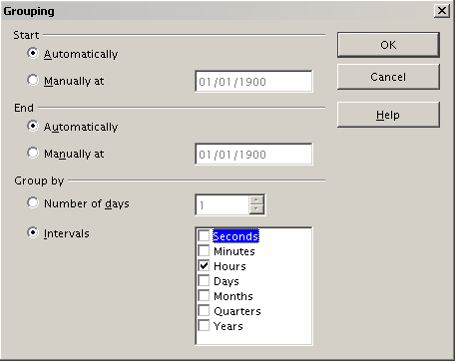
Figure 47: Grouping dialog for categories with dates or times
As this figure illustrates, you can decide the range of dates or times (start/finish) over which grouping should occur. The default setting is the entire period from the earliest to the latest value. In the field Group by, you can enter the class size (interval) which should be used for grouping. Possible intervals are: seconds, minutes, hours, days, months, quarters, and years. These can be combined, for example, by grouping by years and then within each year according to month.
Alternatively, you can enter any number of days as a grouping interval.
Tip | For grouping the output of the Pivot Table in calendar weeks, choose the beginning date on a Sunday or Monday and enter the grouping interval (Number of Days) as 7.

Grouping without the Automatic Creation of Intervals
If your categories contain text fields, the automatic creation of intervals is not possible. But you still can define, for each field, which values you want to put together in one group.
Every time you use the menu entry Data > Group and Outline > Group, or press F12 while you have more than one cell selected, all the cells will be selected as one group.
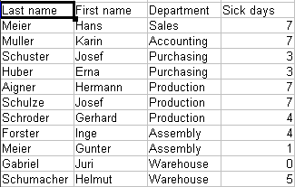
Figure 48: Database with nonscalar categories (departments)
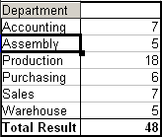
Figure 49: Pivot Table with nonscalar categories
For grouping nonscalar categories, that is, categories based upon text, select all the individual field values you want to put in this one group.
Tip | You can select several non-contiguous cells in one step by pressing and holding the Control key while left-clicking with the mouse.

Given the input data shown in Figure 48, execute the Pivot Table with Department in the Row Field and Sum (Sick Days) in the Data Field. The output should look like that in Figure 49. Next, select the Departments Accounting, Purchasing and Sales, with your mouse.
Choose the Data > Group and Outline > Group from the Menu bar or press F12. The output should now look like that in Figure 50. Repeat this for all groups you want to create from different categories. Start by selecting Assembly, Production, and Warehouse, and Group again. The output should look like Figure 51.
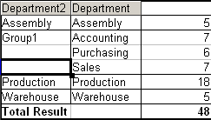
Figure 50: Summary of single categories in one group
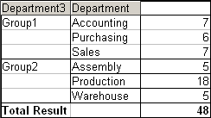
Figure 51: Grouping finished
You can change automatically-given names for groups and for the newly created group field by editing the name in the input field - for example, changing 'Group2' to 'Technical'. The Pivot Table will remember your settings, even if you change the layout later. For the following pictures, the dialog was called again (with a right-click, Edit Layout) and selecting the icon “Department 2”, then Options, and finally, from the preferences menu, Automatic. These choices generated the partial sum results shown in Figure 52. Double-clicking Group 1 and Technical collapses the entries, as shown in Figure 53.
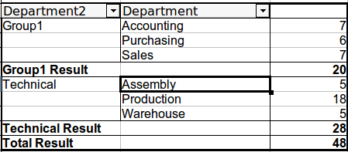
Figure 52: Renamed groups and partial results
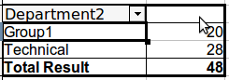
Figure 53: Reduced to the new groups

Sorting the Result
The result of any Pivot Table is sorted (categories) into columns and rows in ascending order. You can change the sorting in three ways:
- Select sort order from drop-down menus on each column heading.
- Sort manually by using drag and drop.
- Sort automatically by choosing the options in the preferences dialog of the row or column field.
Select sort order from drop-down menus on each column heading
The simplest way to sort entries is to click the arrow on the right side of the heading and check the box(es) for the desired sort order. The custom sorting dialog is shown in Figure 54. Additional options exist to show all, only the current item or to hide only the current item.
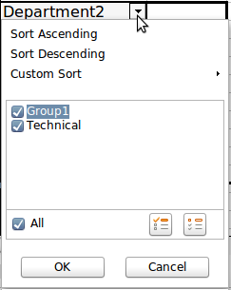
Figure 54: Custom sorting
Sort manually by using drag-and-drop
You can change the order within categories by moving cells with the category values in the result table of the Pivot Table.

Note | Be aware that in Calc a cell must be selected. It is not enough that this cell contains the cursor. The background of a selected cell is marked with a different color. To achieve this, click in one cell with no extra key pressed and redo this by pressing, at the same time, either the Shift or Ctrl key. Another possibility is to keep the mouse button pressed on the cell you want to select, move the mouse to a neighbor cell and move back to your original cell before you release the mouse button.

Sort automatically
To sort automatically, start the options of the row or column field preferences: right-click on the table area with the Pivot Table result and choose Edit Layout to open the Pivot Table dialog (Figure 32). Within the Layout area of the Pivot Table dialog, double-click the field you want to sort. In the Data Field dialog, (Figure 41), click Options to display the Data Field Options dialog (Figure 55).
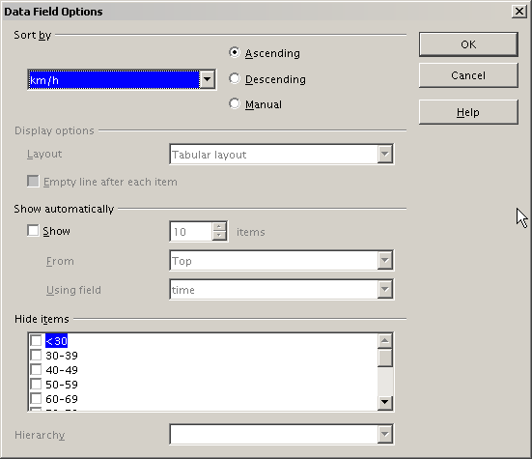
Figure 55: Options for a row or column field
For Sort by, choose either Ascending or Descending. A drop-down list will appear on the left; choose the field this setting should apply to. Note that with this method, you can specify that sorting does not happen according to categories but according to the results of the data field.

Drilling (Showing Details)
Drill Down allows you to show the related detailed data for a single, compressed value in the Pivot Table result. To activate a drill down, double-click on the cell or choose Data > Group and Outline > Show Details. To drill down effectively, you have to distinguish two cases:
- The active cell is the category of a row or column field.
In this case drill down means an additional breakdown into the categories of another field.
For example, double-click on the cell with the value golfing in the row field region (Figure 56). In this case, the values aggregated in the golfing category are subdivided according to another field.
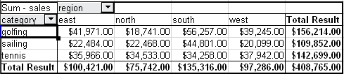
Figure 56: Before the drill down for the category golfing
Since there are more possibilities for subdivision, a dialog appears (Figure 57) so you can choose your setting.
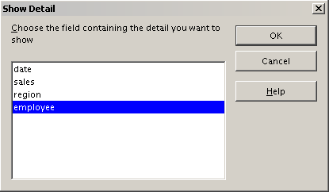
Figure 57: Selection of the field for the subdivision
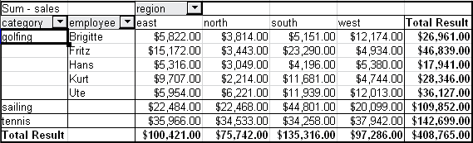
Figure 58: After the drill down
To hide the details again, double-click on the cell golfing (Figure 58) or choose Data > Group and Outline > Hide Details.
The Pivot Table remembers your selection, so the dialog does not appear for the next drill-down for a category in the field region. To remove the selection employee, open the Pivot Table dialog by right-clicking and choosing Edit Layout, then delete the unwanted selection in the row or column field.
- The active cell is a value of the data field.
In this case, drill-down means a listing of all data entries of the data source that aggregates to this value.
Double-click the cell with the value $18,741 from Figure 56. You now have a new list of all data sets included in this value. This list is displayed in a new sheet, as shown in Figure 59.
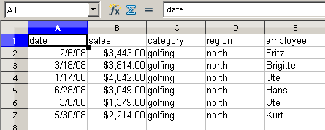
Figure 59: New table sheet after the drill down for a value in a data field

Filtering
To limit the Pivot Table analysis to a subset of the information that is contained in the data basis, you can filter the Pivot Table.
Note | An Autofilter or default filter used on the source data has no effect on the Pivot Table analysis process. The Pivot Table always uses the complete list that was selected when it was started.

To do this, click Filter on the top left side above the results, as seen in Figure 60.
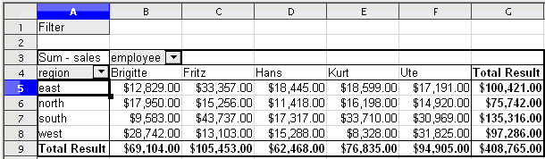
Figure 60: Filter field in the upper left area of the Pivot Table
In the Filter dialog (Figure 61), you can define up to 3 filter options that are used in the same way as Calc’s default filter.
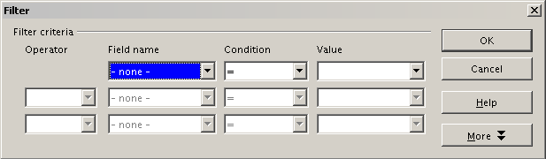
Figure 61: Dialog for defining the filter
Note | Even if they are not called a filter, page fields are a practical way to filter the results. The advantage is that the filtering criteria used are clearly visible.

Updating or Refreshing Changed Values
After creating a Pivot Table, changes in the source data do not cause an automatic update in that table. You have to manually update or refresh the Pivot Table if you've changed any of the underlying data values or added new data rows.
Changes in source data could appear in two ways:
- The content of existing data sets has been changed.
For example, you might have changed a sales value in an existing row of data. To update the Pivot Table, right-click in the result area and choose Refresh (or choose Data > Pivot Table > Refresh from the menu bar).
- You have added or deleted data sets in the original list.
In this case, the Pivot Table has to use a different area of the spreadsheet for its analysis. If you insert data within the currently used data range, for example, by using the menu Insert > Cells, you can update the Pivot Table result using the Refresh option. If you type data into cells outside of the original area, you must redo the Pivot Table from the beginning.

Cell Formatting
Calc automatically formats the cells in the results area of the Pivot Table. You can change this formatting using all the tools in Calc, but remember, if you make changes in the design of the Pivot Table or any updates, the formatting of those features will return to that applied by Calc.
For a number format in the data field, Calc uses the format used in the corresponding cell in the source data. In most cases, this works well. However, if a result is a fraction or a percentage, the Pivot Table does not recognize that this might be a problem; such results must either be without a unit or be displayed as a percentage. While you can correct the number format manually, the correction will remain in effect only until the next update.

Multiple Data Fields
Until now, we have assumed that the layout of the Pivot Table contains only one data field. However, it is possible to have several data fields in the middle of the layout. This makes summaries and analyses of multiple aspects possible.
For example, you could list all the sales values per day and give the number of entries per day. To do this, put the sales and the date fields into the Data Fields area. For the date field, choose the Count option for the aggregate function (see Figure 62).
Since every entry has a specific date, the field, as just described, will give you the number of entries for each date. If you group the values per month, you get an overview with the sales value and the number of closed sales for each category and month (see Figure 63).
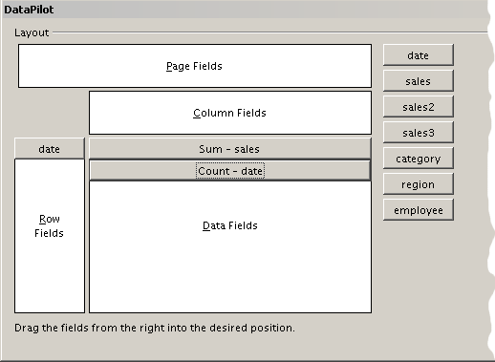
Figure 62: Multiple data fields in the Pivot Table
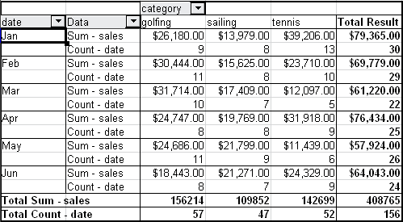
Figure 63: Pivot Table shows sales value and number of entries
When using multiple data fields, the Pivot Table result area contains a field called Data that allows manipulation of the existing data fields. You can move this field like any other row or column field by using drag and drop. This is an easy way to achieve different structures for the results (see Figures 64 and 65); drag and drop the Data field onto the date field label or the category field label.
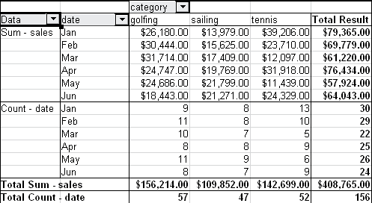
Figure 64: Layout option for presenting the sums and numbers of the sales values
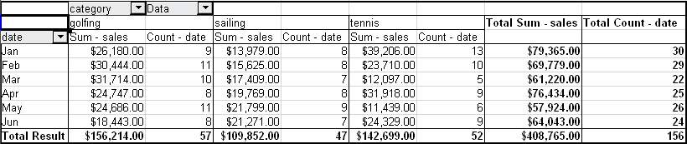
Figure 65: Another layout option for presenting the sums and numbers of the sales values
If you want to put the different data fields in other columns and your Pivot Table does not contain another column field, or if you've sorted data fields in different rows and don’t have another row field (Figure 66), it's helpful to disable viewing for row or column sums (Figure 67). Just drag the category field label up to the Filter area.
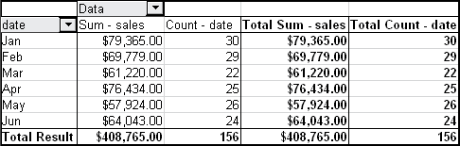
Figure 66: Unnecessary columns
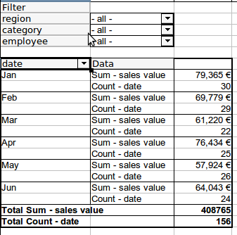
Figure 67: Disabled column sums
A frequent use case for multiple data fields is the aggregation of one value according to different aggregate functions at the same time. For instance, you can create a Pivot Table that shows you the monthly sales values and shows you additionally the smallest and the largest amounts.
To do this during the Pivot Table creation, after you drag the sales button to the Data Fields area, double-click on it to open the Data Field Options dialog. Hold the Ctrl key while you click on the various aggregation functions. Figure 68 shows the selection of the Sum, Max, and Min functions for the sales field.
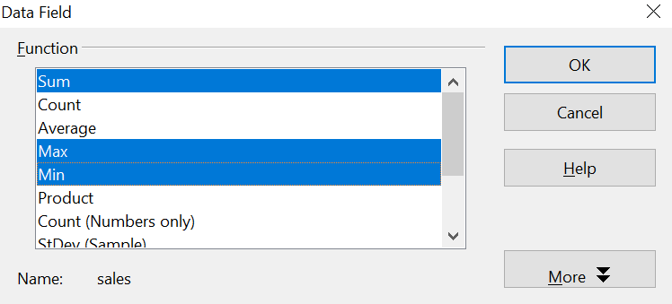

Figure 68: Multiple analyses for the same data field

After you click OK in the Data Field dialog, the Pivot Table dialog will show Result – sales, as shown in Figure 69.
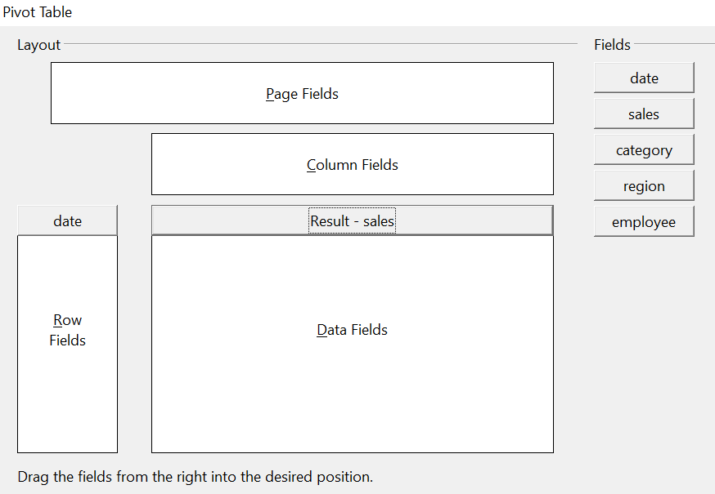
Figure 69: Pivot Table dialog after choosing multiple functions
After grouping by month, the resulting Pivot Table is shown in Figure 71.
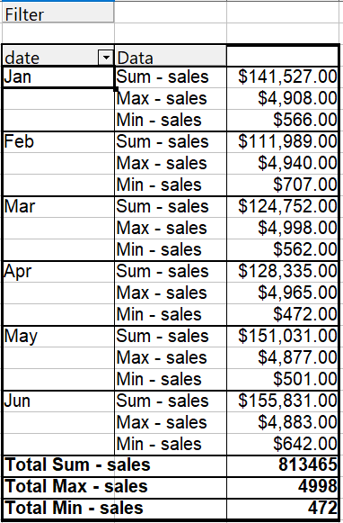

Figure 70: Sum, Max, and Min of the sales data

Shortcuts
If you use Pivot Tables very often, you might find the frequent use of the menu paths (Data > Pivot Table > Create and Data > Group and Outline > Group) inconvenient.
For grouping, a shortcut is already defined: F12. What's more, when creating a Pivot Table, you can define your own keyboard shortcut. If you prefer toolbar icons instead of keyboard shortcuts, you can create a user-defined symbol and add it to either your custom-made toolbar or the Standard toolbar.
For an explanation of how to create keyboard shortcuts or add icons to toolbars, see Chapter 14 (Setting Up and Customizing Calc).

Function GETPIVOTDATA
The function GETPIVOTDATA can be used with formulas in Calc if you need to reuse results from a Pivot Table elsewhere in your spreadsheet.

Difficulty
Normally, you create a reference to a value by entering the address of the cell that contains the value. For example, the formula =C6*2 creates a reference to cell C6 and returns the doubled value.
If this cell is located in the results area of a Pivot Table, it contains the result that was calculated by referencing specific categories of the row and column fields. In Figure 40, cell C6 contains the sum of the sales values of the employee Hans in the Sailing category. The formula in the cell C12 uses this value.
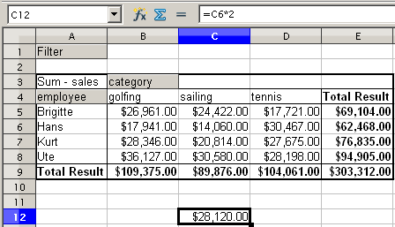
Figure 71: Formula reference to a cell of the Pivot Table
If the underlying data or the layout of the Pivot Table changes, you must be mindful that the sales value for Hans might appear in a different cell. Your formula still references the cell C6 and, therefore, uses the wrong value. The correct value is in a different location. For example, in Figure 39, the location is now C7 because the employee Fritz is included in the Pivot Table.
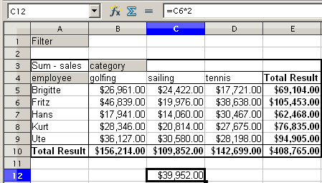
Figure 72: The value that you really want to use can be found now in a different location.
The function GETPIVOTDATA allows you to have a reference to a value inside the Pivot Table by using the specific identifying categories of that value.

Syntax
The syntax has two variations:
GETPIVOTDATA(target field, pivot table; [ Field name / Element; ... ])
GETPIVOTDATA(pivot table; specification)

First Syntax Variation
The target field specifies which data field of the Pivot Table is used within the function. If your Pivot Table has only one data field, this entry is ignored, but you must enter it anyway.
If your Pivot Table has more than one data field, then you must enter the field name from the underlying data source (for example, “sales”) or the field name of the data field itself (for example, “sum – sales”).
The argument pivot table specifies the Pivot Table that you want to use. Your document may contain more than one Pivot Table. In any case, enter a cell reference from within the results area of your Pivot Table.
Example: GETPIVOTDATA("sales";A1)
If you enter only the first two arguments, then the function returns the total result of the Pivot Table (“Sum – sales” as the field will return a value of 408,765).
Add more arguments structured as pairs (field name and item) to retrieve specific partial sums. In the example in Figure 38, if we want to get the partial sum of Hans for sailing, the formula in cell C12 would look like this:
=GETPIVOTDATA("sales";A1;"employee";"Hans";"category";"sailing")
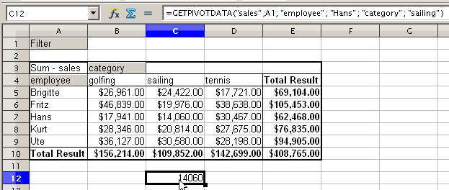
Figure 73: First syntax variation

Second Syntax Variation
The argument pivot table has to be given the same way as the first syntax variation.
For the specifications, enter a list separated by spaces to specify the value you want from the Pivot Table. This list must contain the name of the data field if there is more than one data field, otherwise it is not required. To select a specific partial result, add more entries in the form of Field name[item].
In the example in Figure 4, where we want to get the partial sum of Hans for Sailing, the formula in cell C12 would look like this:
=GETPIVOTDATA(A1;"sales employee[Hans] category[sailing]")
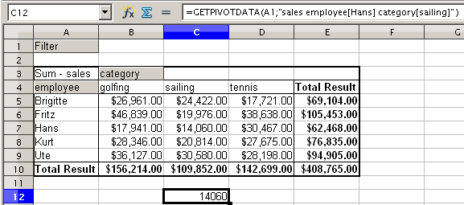
Figure 74: Second syntax variation

Chapter 9
Data Analysis
Using Scenarios, Goal Seek, Solver, and others

Introduction
In addition to its other features, Calc offers several tools that can help you quickly manipulate the information in your spreadsheets. These tools include such tasks as copying and reusing data, creating subtotals automatically, and varying information to help you find the answers you need. All these are divided between the Tools and Data menus.
To a newcomer to spreadsheets, these tools may at first seem overwhelming. If you do not have an immediate need for one of the tools, it is best to focus on what the tool does at a high level and not worry about memorizing the details of its use. When you have a specific problem to solve, you can then work through the details. None of the tools is difficult to use, but even an experienced spreadsheet user is unlikely to remember the details of every tool.
The tools described in this chapter are:
- Consolidate Data – takes groups of similar data and makes a new data set by combining the values from the original groups using functions such as SUM or AVERAGE. The combination can be by position (e. g. combining all the first rows, all the second rows, etc) or by matching labels (e. g. combining rows if they are assigned to the same region or person).
- Subtotals – sorts data by as many as three labels and calculates a value, such as a sum or average, based on all of the values in each group of labels. For example, if data are labeled with the name of a person and a day of the week, you can calculate the sum for each combination of a person and day of the week.
- Scenario – stores a version of a calculation so you can have several Scenarios stored and quickly examine different versions. Imagine you have a budget with several sources of income and expenses. You could make Scenarios for variations in both incomes and expenses and easily examine and discuss each case.
- Multiple Operations – allows you to define a set of values for one or two quantities that go into a calculation and display the calculation's resulting value for each input value. For example, if you calculate a cost that depends on the weight and the length of an item, you could set weights of 1, 2, 3, and 4 grams and lengths of 0.5, 1, 1.5, and 2 cm and get the resulting cost for every combination of the weights and lengths.
- Goal Seek – works backwards from a goal that you set to find the input value that produces the goal. Imagine you have a complex calculation and you want to know what input value produces a certain final value. You could manually adjust the input value until you get close enough to the desired output. Goal Seek automates that process.
- Solver- maximizes, minimizes, or meets a goal with the result of a calculation while respecting constraints that you define. Let's say you have a $1000 credit at a company and you want to spend it on three products: A, B, and C. The products cost $27.45, $13.87, and $54.19, respectively. You have to buy at least 10 of A, 5 of B, and 7 of C to meet your current needs. Your constraints are the minimum number of each item you must buy and the fact that you can only purchase whole numbers of each item. How many of each should you buy to spend exactly $1000? Solver will show you that you can buy 12 of A, 21 of B, and 7 of C to achieve your goal.

If your spreadsheet use is simple, you don't need to master Calc's tools. However, as your data manipulation becomes more sophisticated, those tools can save time when making calculations, especially when you must deal with hypothetical situations. Just as significantly, Calc's tools can help you preserve your work and share it with others —or yourself at a later session.
One function tool not mentioned here is called Pivot Tables. This topic is sufficiently complex that it requires a separate chapter. (See Chapter 8.)

Note | The dialogs used with these tools can block your view of the spreadsheet when you want to select cells with the mouse. To select cells, start by clicking the Shrink/Maximize icon beside the input field to temporarily reduce the size of the tool’s window. That allows you to see the spreadsheet underneath and select the cells required.

Consolidating Data
Data > Consolidate provides a way to combine data from two or more ranges of cells into a new range while simultaneously running one of several functions (such as Sum or Average) on the data. During consolidation, the contents of cells from several sheets can be combined into a single item.
- Open the document containing the cell ranges to be consolidated.
- Choose Data > Consolidate to open the Consolidate dialog. Figure 1 shows this dialog after making the changes described below.
- The Source data range list contains any existing named ranges (created using Data > Define Range) so you can quickly select one to consolidate with other areas.
- If the source range is not named, click in the field to the right of the drop-down list. Then, either type a reference for the first source data range or use the mouse to select the range on the sheet. (You may need to move the Consolidate dialog or click the Shrink icon to reach the required cells.)
- Click Add. The selected range is added to the Consolidation ranges list.
- Select additional ranges and click Add after each selection.
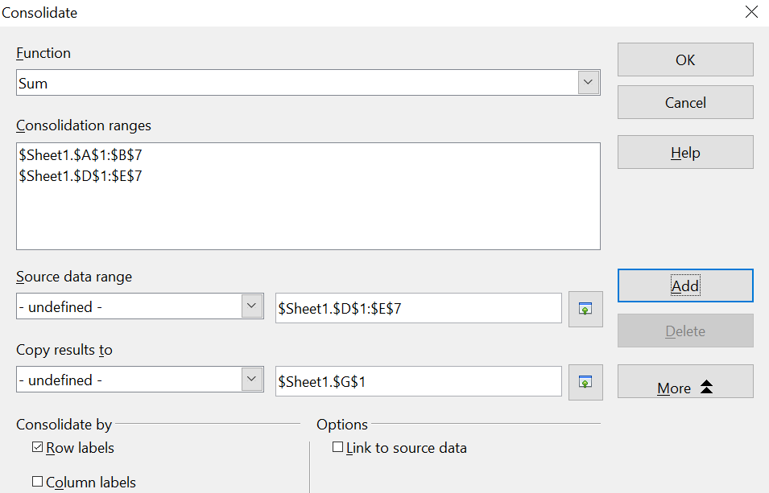

Figure 1: Defining the data to be consolidated
- Specify where to display the result by selecting a target range from the Copy results to drop-down-list.
If the target range is not named, click in the field next to Copy results to and enter the reference of the target range, or select the range using the mouse or position the cursor in the top left cell of the target range. Copy results to uses only the first cell of a target range instead of working with the entire range, as does Source data range.
- Select a function from the Function list to specify how the values of the consolidation ranges will be calculated. The default setting is Sum, which adds the corresponding cell values of the Source data range and gives the result in the target range.
- At this point, you can click More in the Consolidate dialog to access the following additional settings:
  - Select Link to source data to insert formulas that generate results in the target range rather than displaying the actual results. If you link the data, any values subsequently modified in the source range are automatically updated in the target range.
Caution | The corresponding cell references in the target range are inserted in consecutive rows, which are automatically ordered and then hidden from view. Only the final result, based on the selected function, is displayed.

- Under Consolidate by, select either Row labels or Column labels if the cells of the source data range will not be consolidated by the position of the cell in the range but rather according to a matching row label or column label. Moreover, to consolidate by row labels or column labels, the label must be contained in the selected source ranges. The text in the labels must be identical so rows or columns can be accurately matched. If the row or column label of one source data range does not match any existing in other source data ranges, it is added to the target range as a new row or column. An example of using Row labels is shown below.
- Click OK to consolidate the ranges.
- If you are continually working with the same range, you may want to use Data > Define Range to give it a name.
The consolidation ranges and target range are saved as part of the document. If you later open a document in which consolidation has been defined, this data is still available.
Figure 15 shows a simple example of using Data > Consolidate with the choices from Figure 1. The two Consolidation ranges are next to each other for illustration, but they might well be on separate sheets. Having chosen Consolidate by > Row labels in the dialog, the sum of the Values is calculated for each Name.
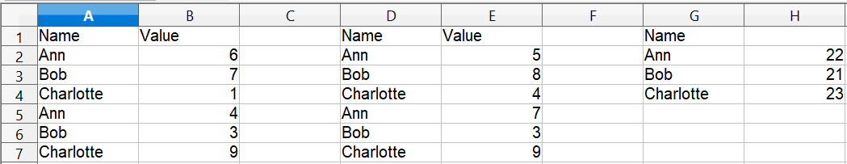

Figure 2: A simple example of Consolidate

Creating Subtotals
SUBTOTAL, listed under the Mathematical category when you use the Function Wizard (Insert > Function)., has a graphical interface accessible from Data > Subtotals.
As the name suggests, SUBTOTAL totals data arranged in an array—that is, a group of cells with labels for columns. Using the Subtotals dialog, you can select up to three arrays and then choose a statistical function to apply to them. When you click OK, Calc adds subtotal and grand total rows to the selected arrays, using the Result and Result2 cell styles to differentiate those entries. By default, matching items throughout your array will be gathered together as a single group above a subtotal.
To insert subtotal values into a sheet:
- Ensure that the columns have labels.
- Select the range of cells you want to calculate subtotals for, and then choose Data > Subtotals.
- In the Subtotals dialog (Figure 3), in the Group by list, select the column by which the subtotals need to be grouped. A subtotal will be calculated for each distinct value in this column.
- In the Calculate subtotals for box, select the columns containing the values for which you want to create subtotals. If the contents of the selected columns change later, the subtotals are automatically recalculated.
- In the Use function box, select the function you want to use to calculate the subtotals.
- Click OK.
If you use more than one group, then you can also arrange the subtotals according to choices made on the dialog’s Options tab (Figure 4), including ascending and descending order or using one of the predefined custom sorts defined in Tools > Options > OpenOffice Calc > Sort Lists.
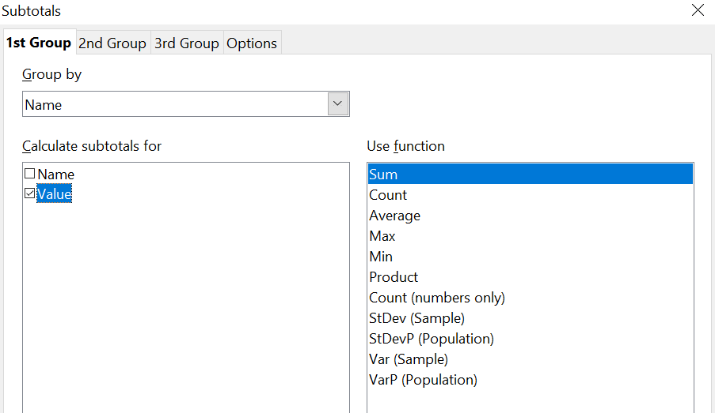

Figure 3: Setting up subtotals
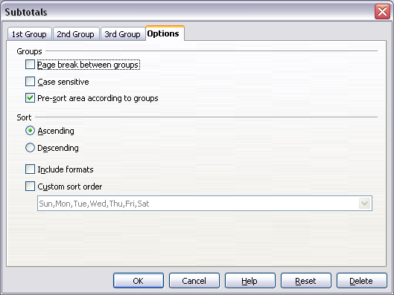
Figure 4: Choosing options for subtotals

Using “What If” Scenarios
Scenarios are a tool to test “what-if” questions. Each scenario is named and can be edited and formatted separately. Only the contents of the currently active scenario are printed when you print the spreadsheet.
A scenario is essentially a saved set of cell values for your calculations. You can easily switch between these sets using the Navigator or a drop-down list, which can be shown beside the changing cells. For example, if you wanted to calculate the effect of different interest rates on an investment, you could add a scenario for each interest rate and quickly view the results. Formulas that rely on values changed by your scenario are updated when the scenario is opened. If all your sources of income used scenarios, you could efficiently build a complex model of your possible income.

Creating Scenarios
Tools > Scenarios opens a dialog with options for creating a scenario.
To create a new scenario:
- Select the cells that contain the values that will change between scenarios. To select multiple ranges, hold down the Ctrl key as you click. Be sure to select at least two cells.
- Choose Tools > Scenarios.
- On the Create Scenario dialog, enter a name for the new scenario that clearly identifies its purpose. For instance, in Figure 5, rather than simply supplying the default name, we could have called the scenario calculate_my_raise.

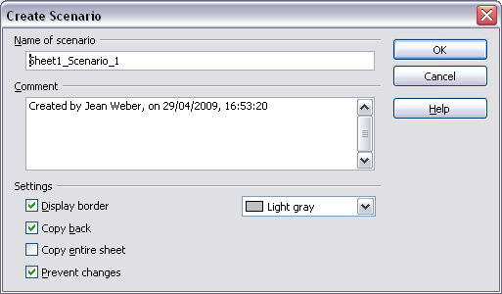
Figure 5: Creating a scenario
- Optionally, you can add information to the Comment box; the example shown uses a default comment. Comment-related information is displayed in the Navigator when you click the Scenarios icon and select the desired scenario.
- Optionally select or deselect the options in the Settings section. See page 252 for more information about these options.
- Click OK to close the dialog. The new scenario is automatically activated.
You can create several scenarios for any given range of cells.

Settings
The lower portion of the Create Scenario dialog contains several options. The default settings, such as Display border shown in Figure 5, are likely suitable in most situations.
Display border
Places a border around the range of cells that your scenario alters. To choose the border color, use the field to the right of this option. The border has a title bar displaying the name of the active scenario. Click the arrow button to the right of the scenario name to open a drop-down list of all the scenarios defined for the cells within the border. You can choose any of the scenarios from this list at any time.
Copy back
Copies any changes you make to the values of scenario cells back into the active scenario. If you do not select this option, the saved scenario values are never changed when you make changes. The actual behavior of the Copy back setting depends on the cell protection, the sheet protection, and the Prevent changes setting (see Table 12 on page 254).
Caution | If you are viewing a scenario which has Copy back enabled and then create a new scenario by changing the values and selecting Tools > Scenarios, you also inadvertently overwrite the values in the first scenario.  This can be avoided. Leave the current values alone, create a new scenario with Copy back enabled, and then change the values only when you are viewing the new scenario.

Copy entire sheet
Adds a sheet to your document that permanently displays the new scenario in full, in addition to creating the scenario and making it selectable on the original sheet.
Prevent changes
Prevents changes to a Copy back-enabled scenario when the sheet is protected but the cells are not. Also prevents changes to the settings described in this section while the sheet is protected. A fuller explanation of the effect this option has in different situations is given below.

Changing Scenarios
Scenarios have two aspects that can be altered independently:
- Scenario properties (the settings described above)
- Scenario cell values (the entries within the scenario border)
The extent to which either of these aspects can be changed is dependent upon both the existing properties of the scenario and the current protection state of the sheet and cells.

Changing Scenario Properties
If the sheet is protected (Tools > Protect Document > Sheet), and Prevent changes is selected then scenario properties cannot be changed.
If the sheet is protected, and Prevent changes is not selected, then all scenario properties can be changed except Prevent changes and Copy entire sheet, which are disabled.
If the sheet is not protected, then Prevent changes does not have any effect, and all scenario properties can be changed.

Changing Scenario Cell Values
Table 12 summarizes the interaction of various settings in preventing or allowing changes in scenario cell values.
Table 12: Prevent changes behavior for scenario cell value changes
Settings | Change allowed
Sheet protection ON  Scenario cell protection OFF  Prevent changes ON  Copy back ON | Scenario cell values cannot be changed.
Sheet protection ON  Scenario cell protection OFF  Prevent changes OFF  Copy back ON | Scenario cell values can be changed, and the scenario is updated.
Sheet protection ON  Scenario cell protection OFF  Prevent changes ON or OFF  Copy back OFF | Scenario cell values can be changed, but the scenario is not updated due to the Copy back setting.
Sheet protection ON  Scenario cell protection ON  Prevent changes ANY SETTING  Copy back ANY SETTING | Scenario cell values cannot be changed.
Sheet protection OFF  Scenario cell protection ANY SETTING  Prevent changes ANY SETTING  Copy back ANY SETTING | Scenario cell values can be changed and the scenario is updated or not, depending on the Copy back setting.

Working with Scenarios Using the Navigator
After scenarios are added to a spreadsheet, you can jump to a particular scenario by selecting it from the list in the Navigator. When you click the Scenarios icon in the Navigator, defined scenarios and any comments entered when the scenarios were created are listed. An example is shown in Figure 6.
- To apply a scenario to the current sheet, double-click the scenario name in the Navigator.
- To delete a scenario, right-click the name in the Navigator and choose Delete.
- To edit a scenario, including its name and comments, right-click the name in the Navigator and choose Properties. The Edit Properties dialog is the same as the Create Scenario dialog (Figure 5).
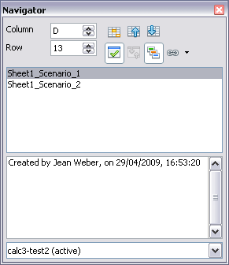
Figure 6: Scenarios in the Navigator

Tracking Values in Scenarios
To learn which values in the scenario affect other values, choose Tools > Detective > Trace Dependents. Arrows point to cells that are directly dependent on the current cell.

Using Other “What If” Tools
Like scenarios, Data > Multiple Operations is a planning tool for “what if” questions. But unlike a scenario, the Multiple Operations tool doesn't present alternate versions in the same cells or with a drop-down list. Instead, the Multiple Operations tool creates a formula array. We call that a separate set of cells showing the results of applying a formula to a list of alternative values for the formula's variables. Even though Multiple Operations isn't listed as a function, it can be considered one. That's because it acts on other functions and thereby allows you to calculate different results without entering and running them separately.
To use the Multiple Operations tool, you need two arrays of cells. The first array contains the original or default values and the formulas applied to them. The formulas must be in a range.
The second array is the formula array. It is created by entering a list of alternative values for one or two original values.
Once alternative values are created, you then use the Multiple Operations tool to specify formulas and the original values used by the formulas. The second array is filled, or in the parlance populated, with the results of using each alternative value instead of the original values.
Multiple Operations can use any number of formulas but only one or two variables. With one variable, the formula array of alternative values for the variables will be in a single column or row. With two variables, you should outline a table of cells such that the alternative values for one variable are arranged as column headings, and the alternative values for the other variable act as row headings.
Setting up multiple operations can be confusing at first. For example, when using two variables, you need to select them carefully to form a meaningful table. Not every pair of variables is useful to add to the same formula array. Yet, even when working with a single variable, a new user can easily make mistakes or forget the relationships between cells in the original array and cells in the formula array. In these situations, Tools > Detective can help to clarify the relations.
Applying some simple design logic can make formula arrays easier to work with. For example, place the original and the formula array close together on the same sheet and use labels for both the rows and columns. These small organizational exercises make working with formula arrays much more comfortable, particularly when correcting mistakes or adjusting results.
Note | If you export a spreadsheet containing multiple operations to Microsoft Excel, the location of the cells containing the formula must be fully defined relative to the data range.

Multiple Operations in Columns or Rows
In your spreadsheet, enter a formula to calculate a result from values that are stored in other cells. Then, set up a cell range containing a list of alternatives for one of the values used in the formula. The Multiple Operations command produces a list of results adjacent to your alternative values by running the formula against each of these alternatives.
Note | Before you choose the Data > Multiple Operations option, be sure to select not only your list of alternative values but also the adjacent cells into which the results should be placed.

In the Formulas field of the Multiple Operations dialog, enter the cell reference to the formula that you wish to use.
The arrangement of your alternative values dictates how you should complete the rest of the dialog. If you have listed them in a single column, you should complete the field for Column input cell. If they are along a single row, complete the Row input cell field. You may also use both in more advanced cases. Both single and double-variable versions are explained below.
The above can be explained best by examples. Cell references correspond to those in the following two figures.
Let’s say you produce toys that you sell for $10 each (cell B1). Each toy costs $2 to make (cell B2), in addition to which you have fixed costs of $10,000 per year (cell B3). How much profit will you make in a year if you sell a particular number of toys?

Calculating with One Formula and One Variable
- To calculate the profit, first, enter any number as the quantity (items sold); in this example, 2000 (cell B4). The profit is found from the formula Profit=Quantity * (Selling price – Direct costs) – Fixed costs. Enter this formula in B5: =B4*(B1-B2)-B3.
- In column D, enter a variety of alternative annual sales figures, one below the other; for example, 500 to 5000, in steps of 500.
- Select the range D2:E11, and thus the values in column D and the empty cells (which will receive the results of the calculations) alongside in column E.
- Choose Data > Multiple Operations.
- With the cursor in the Formulas field of the Multiple operations dialog, click cell B5.
- Set the cursor in the Column input cell field and click cell B4. This means that B4, the quantity, is the variable in the formula, which is to be replaced by the column of alternative values. Figure 7 shows the worksheet and the Multiple operations dialog.
- Click OK. The profits for the different quantities are now shown in column E. See Figure 8.
Tip | You may find it easier to mark the required reference in the sheet if you click the Shrink icon to reduce the Multiple operations dialog to the size of the input field. The icon then changes to the Maximize icon; click it to restore the dialog to its original size.

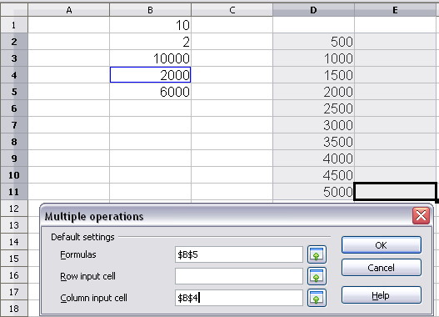
Figure 7: Sheet and Multiple operations dialog showing input
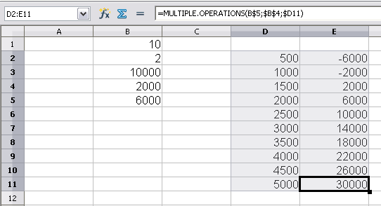
Figure 8: Sheet showing results of multiple operations calculations

Calculating with Several Formulas Simultaneously
- In the sheet from the previous example, delete the contents of column E.
- Enter the following formula in C5: =B5/B4. You are now calculating the annual profit per item sold.
- Select the range D2:F11, thus three columns.
- Choose Data > Multiple Operations.
- With the cursor in the Formulas field of the Multiple operations dialog, select cells B5 and C5.
- Set the cursor in the Column input cell field and click cell B4. Figure 9 shows the worksheet and the Multiple operations dialog.
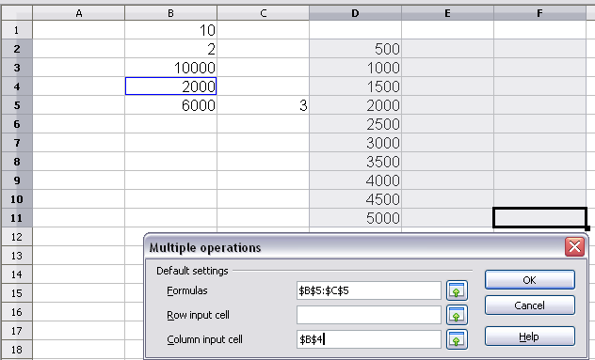
Figure 9: Sheet and dialog showing input
- Click OK. Now, the profits are listed in column E, and the annual profit per item in column F as shown in Figure 10.
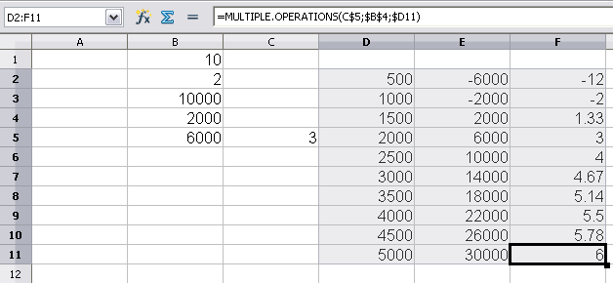
Figure 10: Results of multiple operations calculations

Multiple Operations Across Rows and Columns
You can carry out multiple operations simultaneously for both columns and rows in so-called cross-tables. The formula must use at least two variables, the alternative values for which should be arranged so that one set is along a single row and the other set appears in a single column. These two sets of alternative values will form column and row headings for the results table produced by the Multiple Operations procedure.
Select the range defined by both data ranges (thus including all of the blank cells that are to contain the results) and choose Data > Multiple operations. Enter the cell reference to the formula in the Formulas field. The Row input cell and the Column input cell fields are used to enter the reference to the corresponding cells of the formula.
Caution | The Row input cell field should contain the reference of the variable whose alternative values have been entered along a single row and not the cell reference of the variable which changes down the rows of your results table.

Calculating with Two Variables
You now want to vary not just the quantity produced annually, but also the selling price, and you are interested in the profit in each case.
Expand the table shown in Figure 9. D2 through D11 already contain the numbers 500, 1000 and so on, up to 5000. In E1 through H1 enter the numbers 8, 10, 15 and 20.
- Select the range D1:H11.
- Choose Data > Multiple Operations.
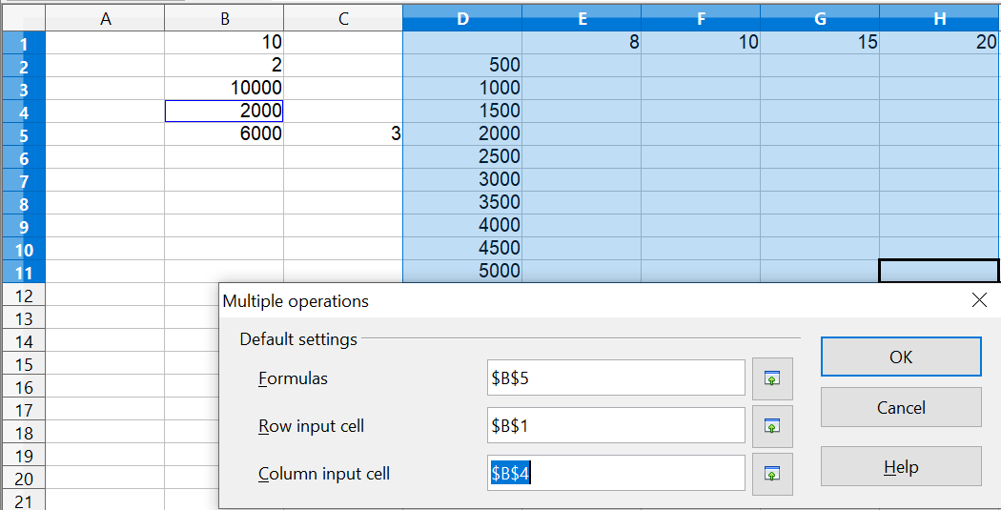
Figure 11: Sheet and dialog showing input
- With the cursor in the Formulas field of the Multiple operations dialog, click cell B5 (profit).
- Set the cursor in the Row input cell field and click cell B1. This means that B1, the selling price, is the horizontally entered variable (with the values 8, 10, 15 and 20).
- Set the cursor in the Column input cell field and click cell B4. This means that B4, the quantity, is the vertically entered variable.
- Click OK. The profits for the different selling prices are now shown in the range E2:H11.
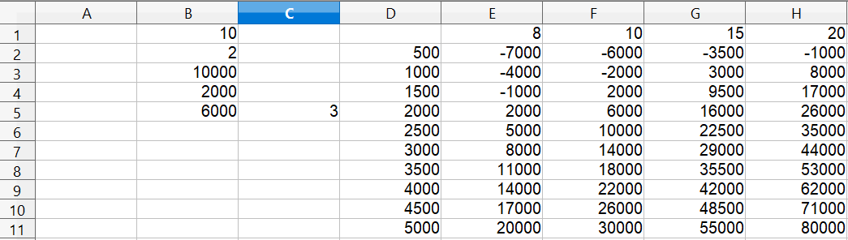
Figure 12: Results of multiple operations calculations

Working Backwards Using Goal Seek
Usually, you create a formula to calculate a result based on existing values. By contrast, using Tools > Goal Seek, you can discover what values will produce the result you want.
To take a simple example, imagine that the Chief Financial Officer of a company is developing sales projections for each quarter of the forthcoming year. She knows what the company’s total income for the year must be to satisfy stockholders. She also has a good idea of the company’s income in the first three quarters because of the contracts that are already signed. For the fourth quarter, however, no definite income is available. So, how much must the company earn in Q4 to reach its goal? The CFO can enter the projected earnings for each of the other three quarters along with a formula that totals all four quarters. Then she runs a goal seek on the empty cell for Q4 sales and receives her answer.
Other uses of goal seek may be more complicated, but the method remains the same. And remember - only one argument can be altered in a single goal seek.

Goal Seek Example
To calculate annual interest (I), create a table with the values for the capital (C), number of years (n), and interest rate (i). The formula is I = C*n*i.
Let us assume that the interest rate i of 7.5% and the number of years n (1) will remain constant. However, you want to know how much the investment capital C would have to be modified to attain a particular return I. For this example, calculate how much capital C would be required if you want an annual return of $15,000.
Enter each of the values mentioned above into adjacent cells (for Capital, C, an arbitrary value like $100,000 or it can be left blank; for number of years, n, 1; for interest rate, i, 7.5%). Enter the formula to calculate the interest, I, in another cell. Instead of C, n, and i, use the reference to the cell with the corresponding value. In our example (Figure 13), this would be =B1*B2*B3.
- Place the cursor in the formula cell (B4) and choose Tools > Goal Seek.
- In the Goal Seek dialog, the correct cell is already entered in the Formula cell field.
- Place the cursor in the Variable cell field. In the sheet, click in the cell that contains the value to be changed; in this example, it is B1.
- Enter the desired result of the formula in the Target value field. In this example, the value is 15000. Figure 13 shows the cells and fields.
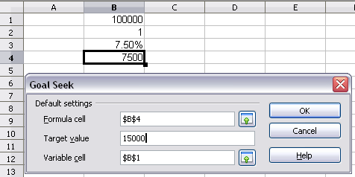
Figure 13: Example setup for goal seek
- Click OK. A dialog appears informing you that the Goal Seek was successful. Click Yes to enter the goal value into the variable cell. The result is shown below.
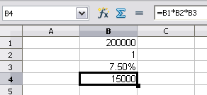
Figure 14: Result of goal seek operation

Using the Solver
Tools > Solver amounts to a more elaborate form of Goal Seek. The difference is that Solver deals with equations with multiple unknown variables. It's specifically designed to minimize, maximize, or reach a target with a result following a set of rules you define.
Each of these rules defines whether an argument in the formula should be greater than, less than, or equal to the figure you enter. If you want the argument to remain unchanged, you must enter a rule that specifically states that the cell should be equal to its current entry. For arguments that you would like to change, you need to have at least one rule for each. If you are trying to maximize or minimize the result, you probably need two rules to define a range of possible values. Otherwise, Solver will use unrealistically large or small values. You can also set constraints that one of the variables or cells must not be bigger than another variable or that one or more variables must be integers (values without decimals) or binary values (where only 0 and 1 are allowed). Without a specific example to think about, setting the constraints in Solver may sound very difficult. In a real situation, the constraints are likely to be obvious. Practical considerations will often be your guide.
Once you have finished setting up the rules, click the Solve button to begin the automatic process of adjusting values and calculating results. Depending on the complexity of the task, this may take some time.

Solver Example
Let's work on the example mentioned in the Introduction: you have a $1000 credit at a company, and you want to spend it on three products: A, B, and C. The products cost $27.45, $13.87, and $54.19, respectively. You have to buy at least 10 of A, 5 of B, and 7 of C to meet your current needs. How many of each product should you buy to spend exactly $1000?
To find the answer using Solver:
- We set up the data as shown in Figure 14. The Solver is flexible enough to accommodate many different data arrangements. Here, there are columns for the Item, Price per item, Quantity, and Cost. The Cost column has an extra cell at the bottom that sums the cost of the individual items. We will want to adjust the quantities in column C to achieve a total cost of $1000.
  - The cells D2:D4 have formulas like =B2 * C2.
  - The cell D5 has the formula =SUM(D2:D4).
- You can enter arbitrary values, which can be 0 or blank, in the cells of column C, the cells whose values will be adjusted. We have chosen to enter the minimum purchase of each product.
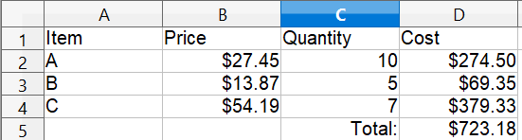

Figure 15: Example setup for Solver
- Choose Tools > Solver. The Solver dialog opens.
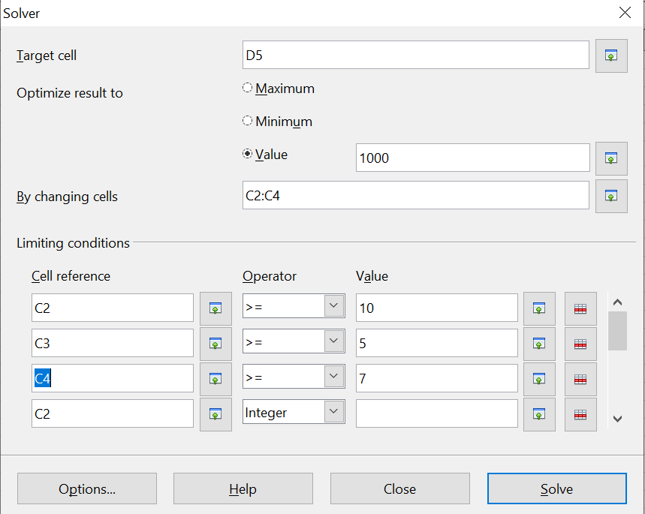

Figure 16: The Solver dialog after filling in values
- Click in the Target cell field. In the sheet, click in the cell that contains the target value or simply type in the cell address. In this example it is cell D5 .
- Select Value of and enter 1000 in the field next to it.
- Click in the By changing cells field and select the cells C2:C4 in the sheet.
- Enter limiting conditions for the variables by selecting the Cell reference, Operator, and Value fields. In this example, we set the cells to be greater than or equal to the minimum order quantity and we have limited C2, C3, and C4 to be integers. Only the integer limitation for C2 is visible in Figure 11, but all three cells have been limited to integers.
- Click OK. A dialog appears informing you that the Solving successfully finished. Click Keep Result to enter the results in the cells with the variable values and the target cell.
Figure 12 shows three different Solver calculations. The first one, in rows 1 – 5, shows the outcome of the process just described. The target value is met exactly with integer quantities in C2:C4.
The calculation in rows 7 – 11 shows the result if the Price of Item C is changed to $54.18. It is no longer possible to meet exactly the $1000 target with integer values in C8:C10. Solver limits two of the Quantities to integers and allows one to take a decimal value to meet the target. You can see that the Item A Quantity is about 20.09.
You can control which Quantity is allowed to take decimal values by changing the specification of the By changing cells box in the Solver dialog shown in Figure 11. In the calculation in rows 7 – 11, the specification was written as C8:C10. Alternatively, you can write each cell address separately, separating them with semicolons. (This is how you would have to enter the cells if they were not contiguous.) The calculation in rows 13 – 17 shows the outcome of specifying C15;C14;C16 in the By changing cells box. Now, the Quantity of Item B, in row 15, is allowed to be a non-integer. The cell that is listed first in the By changing cells specification is the one that takes non-integer values.

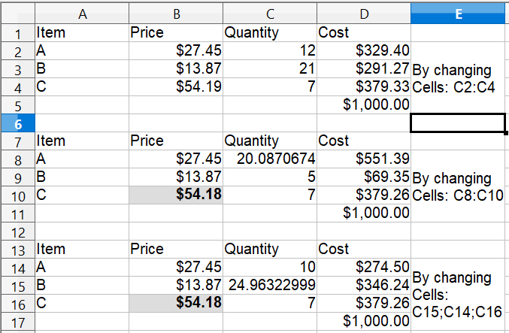

Figure 17: Result of three Solver operations
Note | The default solver supports only linear equations. For nonlinear programming requirements, try the Solver for Nonlinear Programming [Beta]. It is available from the OpenOffice extensions repository. (For more about extensions, see Chapter 14 (Setting up and Customizing Calc.)

Chapter 10
Linking Calc Data
Sharing data in and out of Calc

Why Use Multiple Sheets?
Chapter 1 introduced using multiple sheets in a spreadsheet. Multiple sheets can help keep information organized; once you link those sheets, you unleash the full power of Calc. Consider this case.
John is having trouble keeping track of his personal finances. He has several bank accounts and the information is scattered and disorganized. He can’t get a good grasp on his finances until he can see everything at once.
To resolve this, John decided to track his finances in OpenOffice Calc. John knows Calc can do simple mathematical computations to help him keep a running tab of his accounts, and he wants to set up a summary sheet so that he can see all of his account balances at once.
This can be accomplished easily.
Note | For users with experience using Microsoft Excel, a Calc sheet is called a sheet or worksheet in Excel. What Excel calls a workbook, Calc calls a spreadsheet (the whole document).

Setting Up Multiple Sheets
Chapter 1 gives a detailed explanation of how to set up multiple sheets in a spreadsheet. Here's a quick review.

Identifying Sheets
When you open a new spreadsheet, by default, three sheets are created: Sheet1, Sheet2, and Sheet3. Sheets in Calc are managed using tabs at the bottom of the spreadsheet, as shown below.
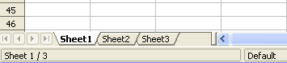Figure 1: Default sheet tabs

Renaming Sheets
Sheets can be renamed at any time. To give a sheet a more meaningful name:
- Enter the name in the name box when you create the sheet, or
- Double-click on the sheet tab, or
- Right-click on a sheet tab, select Rename Sheet from the pop-up menu and replace the existing name.
Note | To save the spreadsheet in Microsoft Excel format, the following characters must not be used in sheet names: \ / ? * [ ] : and ' as the first or last character of the name.

Inserting New Sheets
There are several ways to insert a new sheet. The first step is to select the sheet that precedes or follows the new sheet as shown in Figure 1. Then do any of the following:
- Select Insert > Sheet from the menu bar, or
- Right-click on the tab and select Insert Sheet, or
- Click in an empty space at the end of the line of sheet tabs.

Figure 2: Creating a new sheet
Click here to create a new sheet
Each method opens the Insert Sheet dialog shown below. You can choose to insert the new sheet before or after the selected sheet, name it, and decide how many sheets to insert.
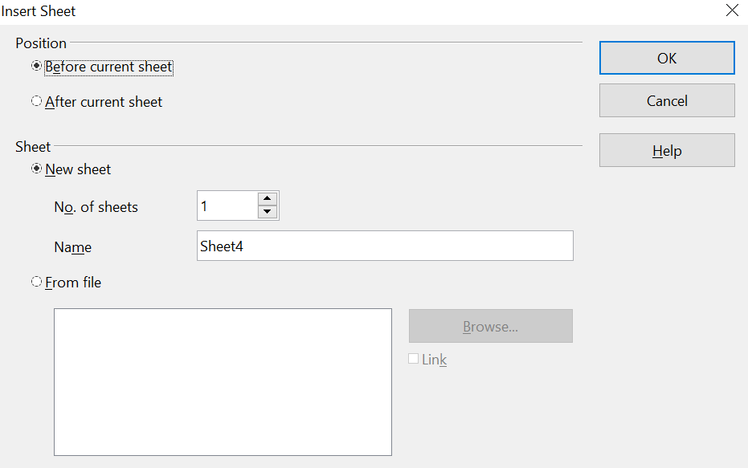
Figure 3. Insert Sheet dialog
To insert just one sheet, choose whether to insert it before or after the currently selected sheet, name the new sheet if desired, and click OK. The new sheet will be selected and visible in the sheet tabs line.
In our example, we need 6 sheets (one for each of the 5 accounts and one as a summary sheet), so we will add 3 more. We also want to name each of these sheets for the account they represent: Summary, Checking Account, Savings Account, Credit Card 1, Credit Card 2, and Car Loan.
We can either insert 3 new sheets and rename all 6 sheets afterward or rename the existing sheets and insert the 3 new sheets individually, renaming each new sheet during the insertion step.
To insert sheets and rename afterwards:
- In the Insert Sheet dialog, choose the position for the new sheets (in this example, we use After current sheet).
- Choose New sheet and 3 as the No. of sheets. (Three sheets are already provided by default.) Because you are inserting more than one sheet, the Name box is unavailable.
- Click OK to insert the sheets.
- For the next steps, see “Renaming Sheets” on page 267.
To insert sheets and name them at the same time:
- Rename the existing sheets Summary, Checking Account, and Savings Account, as described in “Renaming Sheets” on page 267.
- In the Insert Sheet dialog, choose the position for the first new sheet.
- Choose New sheet and 1 as the No. of sheets. The Name box is now available.
- In the Name box, type a name for this new sheet, for example, Credit Card 1.
- Click OK to insert the sheet.
- Repeat steps 1 through 4 for each new sheet, giving them the names Credit Card 2 and Car Loan.
Your sheet tab area should look like Figure 4 below.
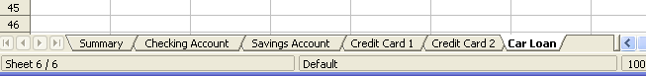Figure 4: Six renamed sheets
Now, we will set up the account ledgers, a simple summary that includes the previous balance plus the current transaction amount. We enter the current transaction for withdrawals as a negative number, so the balance gets smaller. A basic ledger is shown in Figure 5.
This ledger is set up in the sheet named Checking Account. The total balance is added up in cell F3. You can see the equation for it in the formula bar. It is the summary of the opening balance, cell C3, and all subsequent transactions.
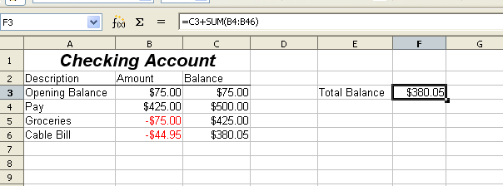Figure 5: Checking ledger

Inserting Sheets From a Different Spreadsheet
On the Insert Sheet dialog, you can add a sheet from a different spreadsheet file by choosing the From file option. Click Browse and select the file; a list of the available sheets will appear in the box. Select the sheet to import. If no sheets appear after having selected the file, you probably selected an invalid file type (not a spreadsheet, for example).
Tip | For a shortcut to inserting a sheet from another file, choose Insert > Sheet from file from the menu bar. The Insert Sheet dialog opens with the From file option preselected, and then the Insert dialog opens on top of it.

The above method adds a sheet from another file as an embedded object – it is contained within the document and is independent of the original sheet. If you prefer, select the Link option to insert the external sheet as a link instead of a copy. This is one of several ways to include “live” data from another spreadsheet. (See also “Linking to External Data” on page 277.) The links can be updated manually to show the current contents of the external file or, depending on the options you have selected in Tools > Options > OpenOffice Calc > General > Updating, whenever the file is opened.
If the sheet is contained in an already open spreadsheet, you can use the Move/Copy command in the other spreadsheet to copy (or move) a sheet to another document.

Referencing Other Sheets in the Spreadsheet
On the Summary sheet, we display the balance from each of the other sheets. If you copy the example in Figure 5 to each account, the current balance will be in cell F3 of each sheet.
There are two ways to enter cell references in other sheets: by entering the formula directly using the keyboard or the mouse. We will look at the mouse method first.

Creating the Reference with the Mouse
On the Summary sheet, set up a place for all five account balances so we know where to put the cell reference. Figure 6 shows a summary sheet with a blank Balance column. We want the reference for the checking account balance in cell B3.
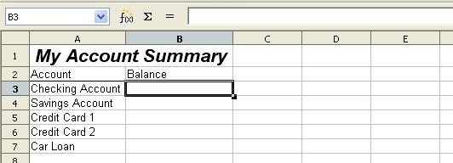Figure 6: Blank summary
To make the cell reference in cell B3, select the cell and follow these steps:
- Click on the = icon next to the input line. The icons change and an equals sign appears in the input line as in Figure 7.
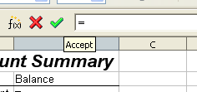
Figure 7: Equal sign in input line
- Now, click on the sheet tab for the sheet containing the cell to be referenced. In this case, that is the Checking Account sheet as shown in Figure 8.
Figure 8: Click on the checking account tab
- Click on cell F3 (where the balance is) in the Checking Account sheet. The phrase ‘Checking Account’.F3 should appear in the input line as in Figure 9.
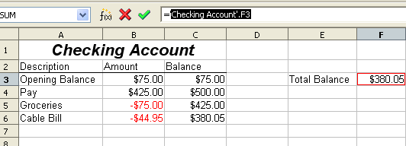Figure 9: Cell reference selected
- Click the green checkmark in the input line to finish.
- The Summary sheet should now look like Figure 10.
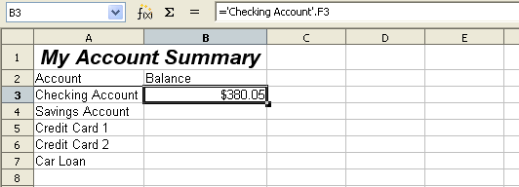Figure 10: Finished checking account reference

Creating the Reference with the Keyboard
From Figure 10, you can deduce how the cell reference is constructed. The reference has two parts: the sheet name (‘Checking Account’) and the cell reference (F3). Notice that they are separated by a period.
Note | The sheet name is in single quotes because it contains a space. The mandatory period (.) always falls outside of any quotes.

You can fill in the Savings Account cell reference simply by typing it in. Assuming the balance is in the same cell (F3) in the Savings Account sheet, the cell reference should be =’Savings Account’.F3 (see Figure 11).
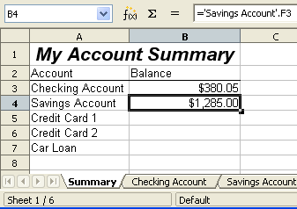Figure 11: Savings account reference

Referencing Other Documents: Links to Sheets in Other Spreadsheets
John decides to keep his family account information in a different spreadsheet file from his own summary. Fortunately, Calc can link different files together. The process is the same as described for different sheets in a single spreadsheet, but we add one more step to indicate which file the sheet is in. For this example, we use two different spreadsheet files.

Creating the Reference Using the Mouse
To create the reference with the mouse, both spreadsheets need to be open. Select the cell in which the formula is going to be entered.
- Click the = icon next to the input line.
- Switch to the other spreadsheet (the process to do this will vary depending on which operating system you are using).
- Select the sheet (Summary) and then the reference cell (B8). See Figure 12.
- Switch back to the original spreadsheet.
- Click on the green check mark on the input line.
Your spreadsheet should now resemble Figure 13.
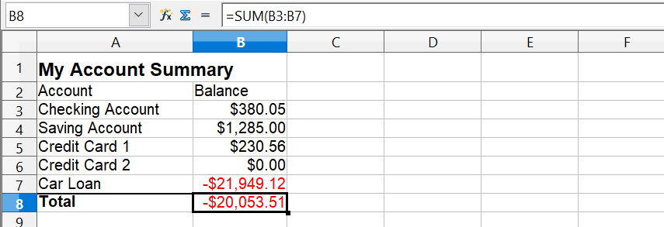

Figure 12: Selecting the Summary reference cell
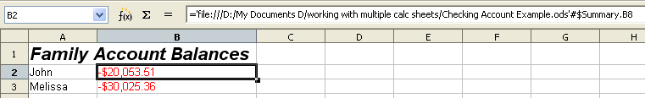Figure 13: Linked files
To better understand the format of the reference, look closely at the input line. Based on this line you can create the reference using the keyboard.

Creating the Reference with the Keyboard
Typing the reference is simple once you know the format the reference takes. The reference has three parts:
- Path and file name
- Sheet name
- Cell
Looking at Figure 13 you can see the general format for the reference is:
=’file:///Path & File Name’#$SheetName.CellName
Note | The reference for a file has three forward slashes /// ; the reference for a hyperlink has two forward slashes //. The format of the path and file name depends on the operating system in use.  If a cell with a reference in it shows #REF it may mean that the link is no longer valid. Check the location of the file and amend the reference to the correct path and name.

Hyperlinks and URLs
Hyperlinks can be used in Calc to jump to a different location from within a spreadsheet to other parts of the current file, to different files, or even to websites.

Relative and Absolute Hyperlinks
Hyperlinks can be stored within your file as either relative or absolute.
A relative hyperlink says, Here is how to get there starting from where you are now (meaning from the folder in which your current document is saved), while an absolute hyperlink says, Here is how to get there no matter where you started.
An absolute link will stop working if the target is moved, but you can move the file containing the link. A relative link will stop working only if the start and target locations change in relation to each other. For instance, if you have two spreadsheets linked to each other in the same folder and you move the entire folder to a new location, a relative hyperlink will not break.
To change the way that OpenOffice stores the hyperlinks in your file, select Tools > Options > Load/Save > General and choose if you want URLs saved relatively when referencing the File System, or the Internet, or both.
Calc will always display an absolute hyperlink. Don’t be alarmed when it does this, even when you have saved a relative hyperlink—this ‘absolute’ target address will be updated if you move the file.
Note | If you save your links as relative to the file system and you are going to upload pages to the Internet, make sure that the folder structure on your computer is the same as the file structure on your web server.

Tip | When you rest the mouse pointer on a hyperlink, a help tip displays the absolute reference since OpenOffice uses absolute path names internally. The complete path and address can only be seen when you view the result of the HTML export (saving the spreadsheet as an HTML file), by loading the HTML file as Text, or by opening it with a text editor.

Creating Hyperlinks
When you type text that can be used as a hyperlink (such as a website address or URL), Calc formats it automatically, creating the hyperlink and applying to the text a color and background shading. If this does not happen, you can enable this feature using Tools > AutoCorrect Options > Options and selecting URL Recognition.
Tip | To change the color of hyperlinks, go to Tools > Options > OpenOffice > Appearance, scroll to Unvisited links and/or Visited links, pick the new colors and click OK. But be very careful. Doing this will change the color for all hyperlinks in all components of OpenOffice—quite possibly not what you want.

You can also insert and modify links using the Hyperlink dialog shown below. To display the dialog, click the Hyperlink icon on the Standard toolbar or choose Insert > Hyperlink from the menu bar. To add a link to existing text, highlight the text before opening the dialog.
On the left side, select one of the four categories of hyperlinks:
- Internet: the hyperlink points to a web address, normally starting with https://
- Mail & News: the hyperlink opens an email message that is pre-addressed to a particular recipient.
- Document: the hyperlink points to a place in either the current document or another existing document.
- New document: the hyperlink creates a new document.
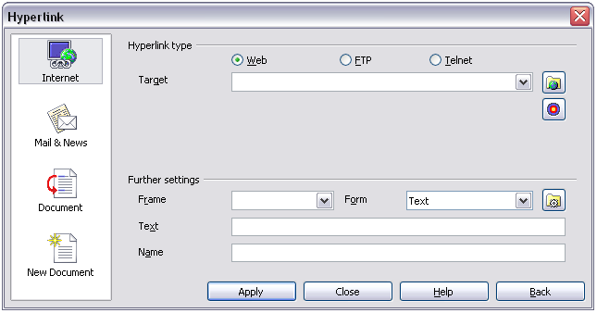
Figure 14. Hyperlink dialog showing details for Internet links
The upper right part of the dialog changes according to the choice made from the left panel for the hyperlink category. While a complete description of all the choices and their interactions is beyond the scope of this chapter, here is a summary of the most common choices used in spreadsheets.
For an Internet hyperlink, choose the type of hyperlink (Web, FTP, or Telnet) and enter the required web address (URL).
For a Mail and News hyperlink, specify whether it is a mail or news link, the receiver address, and the email subject.
For a Document hyperlink, specify the document path (the Open File button opens a file browser); leave this blank if you want to link to a target in the same spreadsheet. Optionally specify the target in the document (for example, a specific sheet). Click on the Target in document icon to open the Navigator, where you can select the target, or if you know the name of the target, you can type it into the box.
For a New Document hyperlink, specify whether to edit the newly created document immediately (Edit now) or create it (Edit later), and enter the file name and the type of document to create (text, spreadsheet, etc.). The Select path button opens a directory picker dialog.
The Further settings section in the bottom right of the dialog is common to all the hyperlink categories, although some choices are more relevant to specific types of links.
- Set the value of Frame to determine how the hyperlink will open. This applies to documents that open in a Web browser.
- Form specifies if the link will be presented as text or as a button. Figure 15 shows a link formatted as a button.
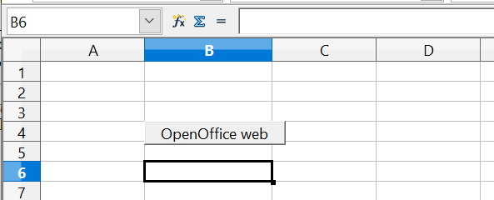
Figure 15: OpenOffice web page hyperlink as button
- Text specifies the text that will be visible to the user. If you do not enter anything here, Calc will use the full URL or path as the link text. Note that if the link is relative and you move the file, this text will not change, though the target will.
- Name is applicable to HTML documents. It specifies text that will be added as a NAME in the HTML code that accomplishes the hyperlink.
- Events button: this button will be activated to allow Calc to react to events for which the user has written a macro. This function is not covered in this chapter.
Note | A hyperlink button is a type of form control. As with all form controls, it can be anchored or positioned by right-clicking on the button in design mode. More information about forms can be found in Chapter 15 of the Writer Guide.  For the button to work , the spreadsheet must not be in design mode. To toggle design mode on and off, view the Form Controls toolbar (View > Toolbars > Form Controls) and click the Design Mode On/Off button . See Chapter 15 of the Writer Guide, Using forms in Writer, for more information on forms and their use in documents.

Editing Hyperlinks
To edit an existing link, place the cursor anywhere in the link and click the Hyperlink icon on the Standard toolbar or select Edit > Hyperlink from the menu bar. The Hyperlink dialog (Figure 14) opens. If the Hyperlink is in button form, the spreadsheet must have Design Mode on to edit the Hyperlink. Make your changes and click Apply. If you need to edit several hyperlinks, you can leave the Hyperlink dialog open until you have edited all of them. Be sure to click Apply after each one. When you are finished, click Close.

Removing Hyperlinks
You can remove the clickable link from hyperlink text—leaving just the text—by right-clicking on the link and selecting Default Formatting. This option is also available from the Format menu. You may then need to re-apply some formatting for it to match the rest of your document.
To completely erase the link text or button from the document, select it and press the Backspace or Delete key.

Linking to External Data
You can insert tables from HTML (web) documents and data located within named ranges from an OpenOffice Calc or Microsoft Excel spreadsheet into a Calc spreadsheet. (To use other data sources, including database files in OpenOffice Base, see “Linking to Registered Data Sources” on page 281.)
You can do this in two ways: using the External Data dialog or using the Navigator. If your file has named ranges or named tables, and you know the name of the range or table you want to link to, using the External Data dialog method is quick and easy. However, if the file has several tables, and you want to pick only one of them, you may not be able to easily determine which is which. In that case, the Navigator method may be easier.

Using the External Data Dialog
- Open the Calc document where the external data will be inserted. This is the target document.
- Select the cell where the upper left-hand cell of the external data will be inserted.
- Choose Insert > Link to External Data.
- On the External Data dialog (Figure 16), type the URL of the source document or click the […] button to open a file selection dialog. Press Enter to get Calc to load the list of available tables.
- In the Available tables/range list, select the named ranges or tables you want to insert. You can also specify that the ranges or tables are updated every (number of) seconds.
- Click OK to close the dialog and insert the linked data.
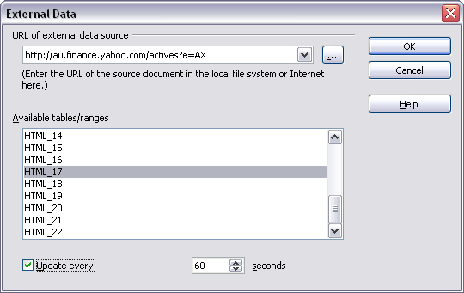Figure 16: Selecting a table or range in a source document from the Web
Note | - The Available tables/ranges list remains empty until you press Enter after typing the URL of the source. If you select the source document using the […] button, pressing Enter is not required.  - The OK button remains unavailable (grayed out) until you select one or more tables/ranges in the list. You can hold down the Ctrl key while clicking on tables/ranges to select more than one.  - No images are imported

Using the Navigator
- Open the OpenOffice Calc spreadsheet in which the external data will be inserted (target document).
- Open the document from which the external data will be taken (source document) using File > Open. If the source document is a Web page, choose Web Page Query (OpenOffice Calc) as the file type. You'll need to scroll down the list of File types to find this entry. (See Figure 17.)
- In the target document, press F5 to open the Navigator.
- At the bottom of the Navigator, select the source document. (In Figure 18, the source is named actives.)
- The Navigator now shows the range names or the tables contained in the source document (the example contains range names; other documents have a list of tables). Click on the + or ▶ next to Range names to display the list.
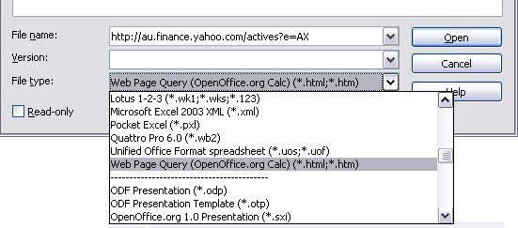
Figure 17: Opening a file using the Web Page Query filter
- In the Navigator, select the Insert as Link drag mode, as shown in Figure 18.
- Select the required range or table and drag it from the Navigator into the target document to the cell where you want the upper left cell of the data range to be.
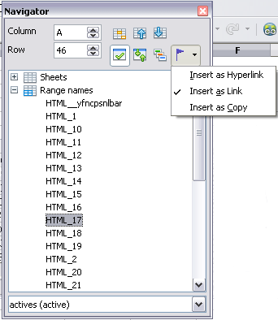
Figure 18: Selecting a data range in a source document, to be inserted as a link
- In the target document, check the Navigator. Instead of a + or ▶ by Range names, it shows a + or ▶ by Linked areas. Click the + or ▶ to see the range name you just dragged into the target document (see Figure 19).
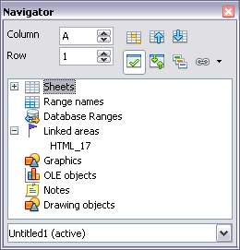
Figure 19: Linked areas in target spreadsheet

How to Find the Required Data Range or Table
The examples above show that the import filter gave names to the data ranges (tables) in the sample web page starting from HTML_1. It also created two additional range names (not visible in the illustration):
HTML_all – designates the entire document
HTML_tables – designates all HTML tables in the document
If the data tables in the source HTML document have been given names (using the ID attribute on the TABLE tag) or the external spreadsheet includes named ranges, those names appear in the list along with the ranges Calc has numbered sequentially. However, if the data range or table you want is not named, how can you tell which one to select?
Go to the source document you opened in Calc. In the Navigator, double-click on a range name or use the Name box, as shown in Figure 20. Using Navigator causes the chosen range to be highlighted on the sheet (see Figure 21).
If the Formula Bar is visible, the range name is also displayed in the Name box at the left-hand end (see Figure 12).
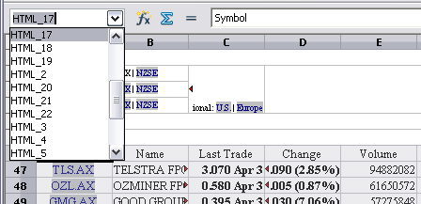
Figure 20: Using the Name box to find a data range name
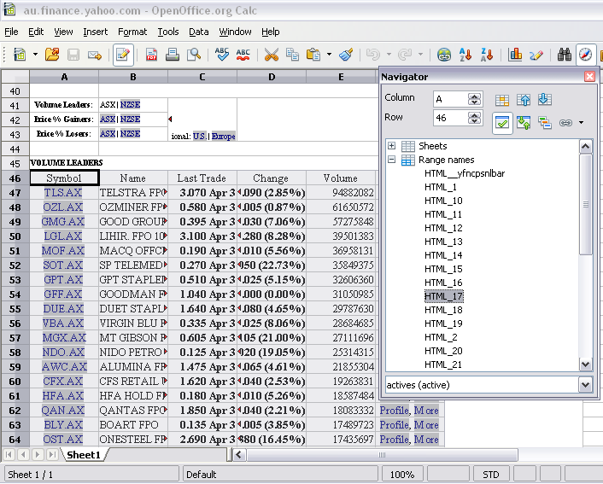

Figure 21: Using the Navigator to find a data range name

Linking to Registered Data Sources
You can access various databases and other data sources and link them to Calc documents.
First, you need to “register” the data source with OpenOffice, which means informing OpenOffice of the data source type and where it's located. The way to do this depends on whether or not the data source is a database in *.odb format.
To register a data source that is in *.odb format:
- Choose Tools > Options > OpenOffice Base > Databases.
- Click the New button (below the list of registered databases) to open the Create Database Link dialog (Figure 22).
- Enter the database file's location or click Browse to open a file browser and select the database file.
- Type a name to use as the registered name for the database and click OK. The database is added to the list of registered databases. The OK button is enabled only when both fields are filled in.
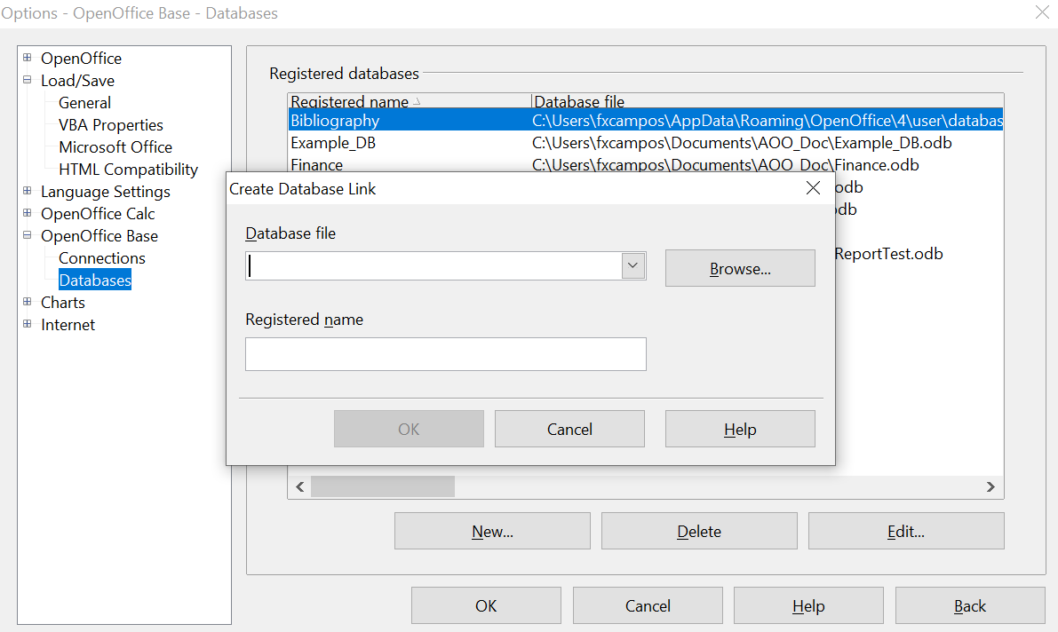

Figure 22: Registering databases
To register a data source that is not in *.odb format:
- Choose File > New > Database to open the Database Wizard.
- Select Connect to an existing database. The choice of database type depends on your operating system. For example, Microsoft Access and other Microsoft products are not available choices when using Linux. In our example, we chose dBASE (See Figure 23).
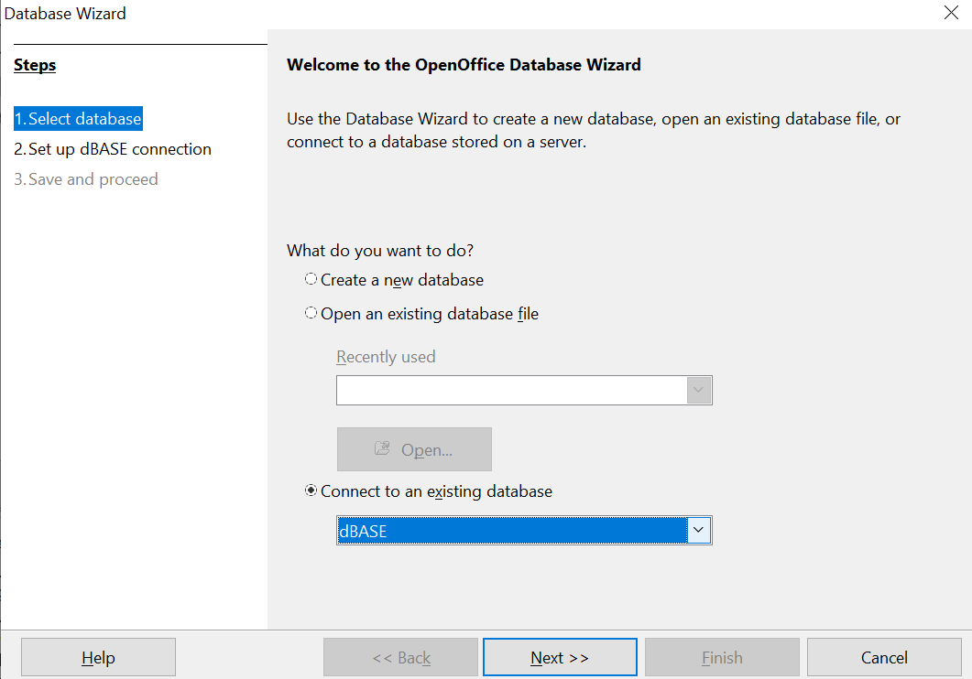

Figure 23: Registering a database using the Database Wizard
- Click Next. Type the path to the database file or click Browse and use the Open dialog to navigate to and select the database file before clicking Open.
- Click Next. Select Yes, register the database for me, but clear the checkbox marked Open the database for editing.
- Click Finish. Name and save the database in the location of your choice. Note: changes made to the *.odb do not affect the original dBASE file.
Once a data source has been registered, it can be used by any OpenOffice component (for example, Calc).

Viewing Data Sources
Open a document in Calc. To view the data sources available, press F4 or select View > Data Sources from the menu bar. The Data Source View pane opens above the spreadsheet. A list of registered databases is in the Data Explorer area on the left. (The built-in Bibliography database is included in the list.)
To view each database, click on the + or ▶ to the left of the name of the database. (This has been done for the Automobile database in Figure 24.) Click on the + or ▶ next to Tables to view the individual tables.
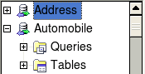
Figure 24: Databases
Now, click on a table to see all the records it contains. The data records are displayed on the right side of the Data Source View pane. To see more columns, click the Explorer On/Off button to hide the Data Explorer area.
At the top of the Data Source View pane, below the Calc toolbars, is the Table Data bar. This toolbar includes buttons for saving records, editing data, finding records, sorting, filtering, and other functions. For more details about this toolbar, see the Help topic in Calc for data source browser.
Below the records is the Form Navigation bar, which shows which record is selected and the total number of records. To the right are five tiny buttons; the first four move backward or forward through the records or to the beginning or end.

Figure 25: Data Source View navigation buttons

Editing Data Sources
Some data sources (such as spreadsheets) cannot be edited in the data source view.
In editable data sources, records can be edited, added, or deleted. If you cannot save your edits, you need to open the database in Base and edit it there; see “Launching Base to Work on Data Sources.” You can also hide columns and make other changes to the display.

Launching Base to Work on Data Sources
You can launch OpenOffice Base from the Data Source View pane. Right-click on a database or the Tables or Queries icons and select Edit Database File. In Base, you can edit, add, and delete tables, queries, forms, and reports.
For more information on using Base, see Chapter 8 (Getting Started with Base) in the Getting Started guide.

Using Data Sources in Calc Spreadsheets
Data from tables in the data source pane can be placed into Calc documents in a variety of ways.
You can select a cell or an entire row in the data source pane and drag and drop the data into the spreadsheet. The data is inserted at the place where you release the mouse button.
An alternative method uses the Data to Text icon and will include the column headings above the data you insert:
- Click the cell of the spreadsheet that you want to be the top left of your data set, including the column names.
- Press F4 to open the database source window and select the table containing the data you want to use.
- Select the rows of data you want to add to the spreadsheet:
  - Click the gray box to the left of the row you want to select if only selecting one row. That row is highlighted.
  - To select multiple adjacent rows, hold down the Shift key while clicking the gray box of the rows you need.
  - To select multiple separate rows, hold down the Control key while selecting the rows. The selected rows are highlighted.
  - To select all the rows, click the gray box in the upper left corner. All rows are highlighted.
- Click the Data to text icon to insert the data into the spreadsheet cells.
You can also drag the data source column headings (field names) onto your spreadsheet to create a form for viewing and editing individual records one at a time. Follow these steps:
- Click the gray box at the top of the column (containing the field name you wish to use) to highlight it.
- Drag and drop the gray box to the cell or cells in the spreadsheet where you want the record to appear.
- Repeat until you have moved all of the fields you need to their appropriate new location.
- Close the Data Source window by pressing F4.
- Save the spreadsheet and click the Edit File button on the Standard toolbar to make the spreadsheet read-only. All of the fields will show the value for the data of the first record you selected.
- Add the Form Navigation toolbar by going to View > Toolbars > Form Navigation. By default this toolbar opens at the bottom of the Calc window, just above the status bar.
- Click the arrows on the Form Navigation toolbar to view the different records in the table. The number in the Record box changes as you move through the records. The data in the fields updates corresponding with the data for that particular record number. You can also search for a specific record, sort and filter records, and do other tasks using this toolbar.

Embedding Spreadsheets
Spreadsheets can be embedded in other OpenOffice files. This is often used in Writer or Impress documents so Calc data can form part of a text document. You can embed the spreadsheet as either an OLE or DDE object. The difference between a DDE object and a Linked OLE object is that a Linked OLE object can be edited from the document in which it is added as a link, but a DDE object cannot. The rest of this chapter discusses the nature of OLE and DDE links.
For example, if a Calc spreadsheet is pasted into a Writer document as a DDE object, the spreadsheet cannot be edited in the Writer document. However, if the original Calc spreadsheet is updated, the changes are automatically made in the Writer document. If the spreadsheet is inserted as a Linked OLE object into the Writer document, then the spreadsheet can be edited in the Writer and in the Calc document, and both documents will remain in sync.

Object Linking and Embedding (OLE)
The major benefit of an OLE (Object Linking and Embedding) object is that its contents are quickly and easily edited by double-clicking on it. You can also insert a link to the object that will appear as an icon rather than an area showing the contents.
OLE objects can be linked to a target document or embedded in the target document. Linking inserts information that will be updated with subsequent changes to the original file, while embedding inserts a static copy of the data. If you want to edit the embedded spreadsheet, double-click on the object.
To embed a spreadsheet as an OLE object in a presentation:
- Place the cursor in the document and location you want the OLE object to be.
- Select Insert > Object > OLE Object. The dialog below opens.
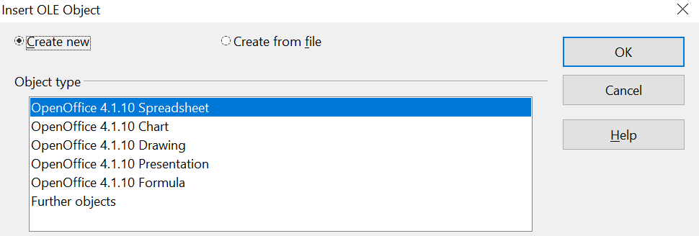
Figure 26: Insert OLE object dialog
- You can either create a new OLE object or create it from a file.
To create a new object:
- Select Create new and select the object type from the available options.
Note | “Further objects” is only available if you are using the Windows operating system.

- Click OK. An empty container is placed in the sheet.
- Double-click on the OLE object to enter the edit mode of the object. The application devoted to handling that type of file will open the object.
Note | If the object inserted is handled by OpenOffice, the transition to the program to manipulate it will be seamless; in other cases, the object opens in a new window, and an option in the File menu becomes available to update the inserted object.

To insert an existing object:
- To create from a file, select Create from file. The dialog changes to look like Figure 27.
- To insert the object as a link, select the Link to file option. Otherwise, the object will be embedded.
- Click Search, select the required file in the Open dialog, then click Open. A section of the inserted file is shown in the document.
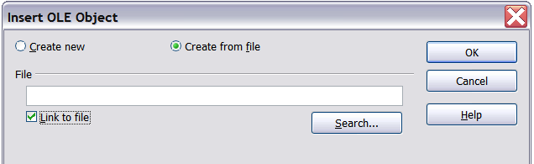Figure 27: Inserting an object as a link

Other OLE Objects
Under Windows, the Insert OLE Object dialog box has an extra entry, Further objects, as shown in Figure 26.
- Double-click on the entry Further objects to open the dialog shown below.
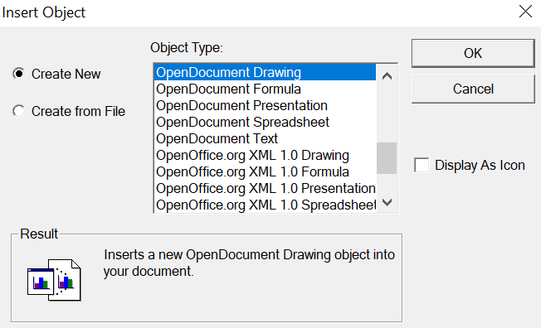
Figure 28: Inserting an OLE object under Windows
- Select Create New to insert a new object of the type selected in the Object Type list or select Create from File to create a new object from a file.
- If you choose Create from File, the dialog shown below opens. Click Browse and choose the file to insert. The inserted file object is editable by the Windows program that created it.
If you want to insert a link to an object instead of inserting an object, select the Display As Icon option.
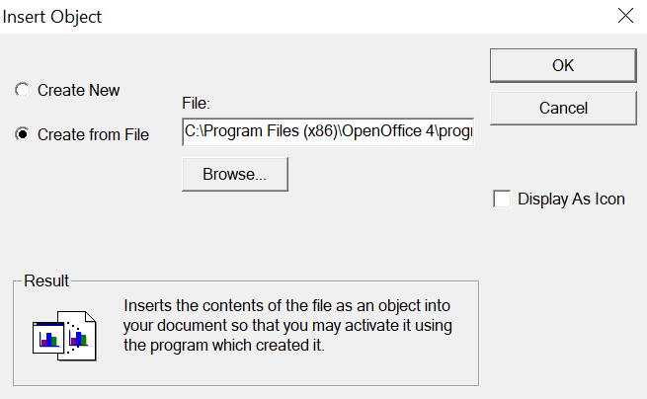
Figure 29: Insert object from a file

Non-linked OLE Object
If the OLE object is not linked, it can be edited in the new document. For instance, if you insert a spreadsheet into a Writer document, you can treat it as a Writer table (with a little more power). To edit it, double-click on it.

Linked OLE Object
When the spreadsheet OLE object is linked, if you change it in Writer, it will change in Calc; if you change it in Calc, it will change in Writer. This can be a very powerful tool if you create reports in Writer using Calc data and want to make a quick change without opening Calc.
Note | You can only edit one copy of a spreadsheet at a time. If you have a linked OLE spreadsheet object in an open Writer document and then open the same spreadsheet in Calc, the Calc spreadsheet will be a read-only copy.

Dynamic Data Exchange (DDE)
DDE is an acronym for Dynamic Data Exchange, a mechanism whereby selected data in document A can be pasted into document B as a linked ‘live’ copy of the original. It would be used, for example, in a report written in Writer containing time-varying data, such as sales results sourced from a Calc spreadsheet. The DDE link ensures that, as the source spreadsheet is updated, so is the report, thus reducing the scope for error and the work involved in keeping the Writer document up to date.
DDE is a predecessor of OLE. With DDE, objects are linked through file reference but not embedded. You can create DDE links within Calc cells in a Calc sheet or in Calc cells in another OpenOffice document, such as in Writer.

DDE Link in Calc
Creating a DDE link in Calc is similar to creating a cell reference. The process is a little different, but the result is the same.
- In Calc, select the cells that you want to make the DDE link to.
- Copy them using Edit > Copy or Ctrl+C.
- Go to the place in the spreadsheet where you want the link to be.
- Select Edit > Paste Special.
- When the Paste Special dialog opens, select the Link option on the bottom left of the dialog (Figure 30). Click OK.
The cells now reference the copied data, and the formula bar shows a reference beginning with {=DDE.
If you now edit the original cells, the linked cells will update.
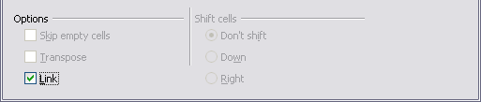
Figure 30: Location of Link option on Paste Special dialog in Calc

DDE Link in Writer
Creating a DDE link from Calc to Writer is similar to creating a link within Calc.
- In Calc, select the cells to make the DDE link to. Copy them.
- Go to the place in your Writer document where you want the DDE link. Select Edit > Paste Special.
- Select DDE Link (Figure 31). Click OK.
Now, the link has been created in Writer. When the Calc spreadsheet is updated, the table in Writer is automatically updated.
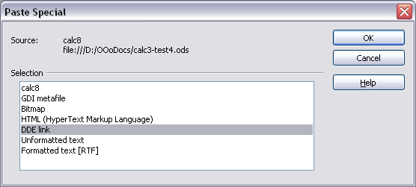Figure 31: Paste Special dialog in Writer, with DDE link selected

Chapter 11
Sharing and Reviewing Documents

Introduction
This chapter covers methods for editing shared documents: sharing (collaboration), recording changes, adding comments, reviewing changes, merging and comparing documents, and saving and using document versions. Basic editing techniques are discussed in Chapter 2 (Entering, Editing, and Formatting Data).

Sharing Documents (Collaboration)
In OpenOffice Writer, Impress, and Draw, only one user at a time can open any document for editing. In Calc, many users can simultaneously open the same spreadsheet for writing.
Each user who wants to collaborate should enter a name on the Tools > Options > OpenOffice > User Data page.
Some menu commands are unavailable (grayed out) when change tracking or document sharing is activated.

Setting up a Spreadsheet for Sharing
You can set up a spreadsheet for sharing with others at any time. With the spreadsheet document open, choose Tools > Share Document to activate the collaboration features for this document. A dialog opens where you can enable or disable sharing, as shown below.
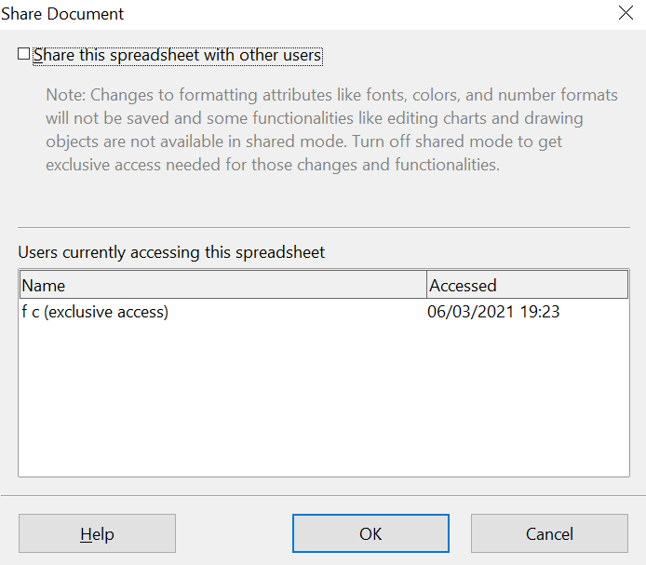

Figure 1: Choosing to share a spreadsheet
To enable sharing, select the box at the top of the dialog, then click OK. A message will state you must save the document to activate shared mode. Click Yes to continue. The word (shared) will appear on the title bar after the document’s title.
The Tools > Share Document command can switch the mode for a document from unshared to shared. However, if you want to use a shared document in unshared mode, you need to save the shared document using another file name or path. This creates a copy of the spreadsheet that is not shared.

Opening a Shared Spreadsheet
When you open a spreadsheet document in shared mode, a message appears stating that the document is in shared mode and that some features are unavailable. After clicking OK, the document opens in shared mode.
The following features are known to be disabled in a shared spreadsheet document:
Menu | Item | Sub Item
Edit | Changes, except for Merge Document
Edit | Compare Document
Edit | Sheet | Move/Copy & Delete
Insert | Cells Shift Cells Down & Shift Cells Right
Insert | Sheet from file
Insert | Names
Insert | Comment
Insert | Picture | From File
Insert | Movie and Sound
Insert | Object
Insert | Chart
Insert | Floating Frame
Format | Sheet | Rename, Tab Color
Format | Merge Cells
Format | Print Ranges
Format | Page (but format in Print Preview is enabled)
Tools | Protect Document
Data | Define Range
Data | Sort
Data | Subtotals
Data | Validity
Data | Multiple Operations
Data | Consolidate
Data | Group and Outline (all)
Data | Pivot Table (all)

Saving a Shared Spreadsheet
When you save a shared spreadsheet, one of several scenarios may occur:
- If the document has not been modified and saved by another user since you opened it, it is saved.
- If the document has been modified and saved by another user since you opened it, one of the following events will occur:
  - If the changes do not conflict, the document is saved, the message below appears, and any cells modified by the other user are shown with a red border.
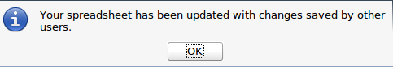
Figure 1: Update message after saving
- If the changes conflict, the Resolve Conflicts dialog is shown (see Figure 1). For each conflict, you must decide which version to keep, yours or the other author’s. When all conflicts are resolved, the document is saved. While you are resolving the conflicts, no other user can save the shared document.
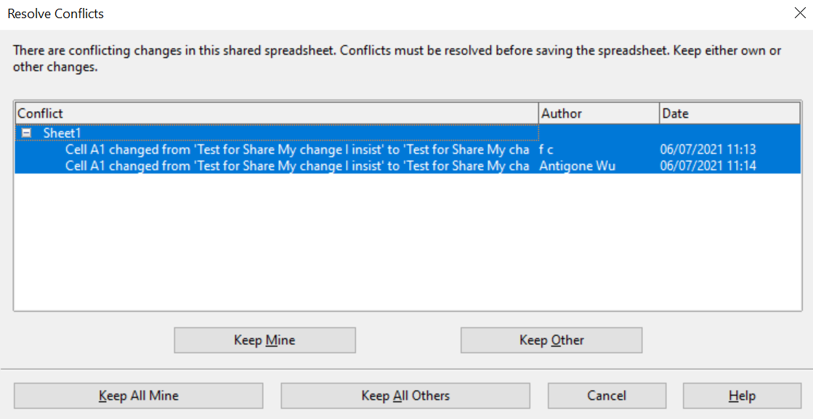

Figure 2: Resolve Conflicts dialog
- If another user tries to save the shared document and resolve conflicts, they receive a message that the shared spreadsheet file is locked due to a merge-in in progress. They can cancel the Save command and retry saving later.
When you successfully save a shared spreadsheet, the document shows the latest version of all changes saved by every user.

Recording Changes
You can use several methods to record and view changes you or others make to a document.
- You can use change marks to show added material, deleted material, and changes to formatting. Later, you or another person can review the document and accept or reject each change.
- If you are not using file sharing, you can make changes to a copy of the document (stored in a different folder, under a different name, or both), then use Calc to compare the files and show the changes. See page 301.
- You can save versions that are stored as part of the original file. See page 302.
Reviewers can leave comments in the document, either attached to specific changes or standalone.

Preparing a Document for Review (Optional)
When you send a document to someone else to review or edit, you may want to protect it first so that the editor or reviewer does not have to remember to turn on revision marks. After you have protected the document, any user must enter the correct password to turn off protection and accept or reject changes.
- Open the document and make sure that the Edit > Changes > Record menu item has a checkmark next to it, indicating that change recording is active.
- (Optional) Click Edit > Changes > Protect Records. On the Protect Records dialog, type a password (twice) and click OK.
Note | It is not necessary to password-protect the document to prepare it for review.

Identifying Copies of Spreadsheets
When not using the document sharing feature, it is important to keep track of all copies of the document. This can be done either with the file name or the file title. If you have not provided a file title in the spreadsheet’s properties, the spreadsheet’s file name is displayed in the title bar. To set the title of the spreadsheet, select File > Properties > Description.

Recording Changes (Tutorial)
For this chapter, we will work with a budget proposal for a baseball team.
You are the sponsor of a youth baseball team. The coach has submitted a budget to you for the season and you need to edit the costs and return it to her.
You are concerned that if you make the changes, the coach won't see the changes you made. You decide to use Calc with the record changes feature turned on so the coach can easily see your changes
Figure 3 shows the budget spreadsheet your coach submitted.
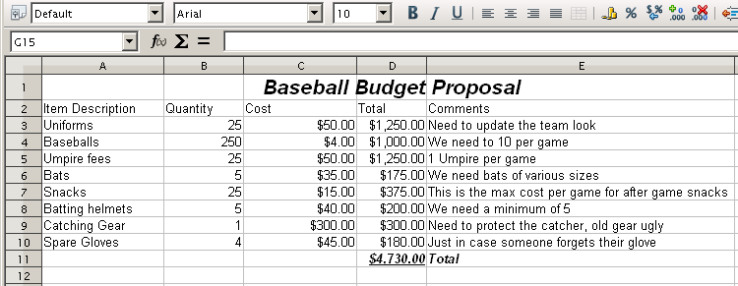Figure 3: Baseball budget spreadsheet
Looking over the figures, you see a few places where money could be saved:
- Parents can buy post-game snacks.
- New uniforms can wait; only buy 10 to replace damaged ones.
- Buy cheaper baseballs.
- Only buy 2 spare gloves.
To make these changes, use the record changes feature in Calc. To start recording changes:
- Open the Budget Spreadsheet.
- Select Edit > Changes > Record from the menu bar.
- Begin editing the document.
A colored border, with a dot in the upper left-hand corner, appears around a cell where changes were made. A comment summarizing the change is added to the cell (Figure 4). This way, other reviewers quickly know which cells were edited. A deleted column or row is marked by a heavy-colored bar.
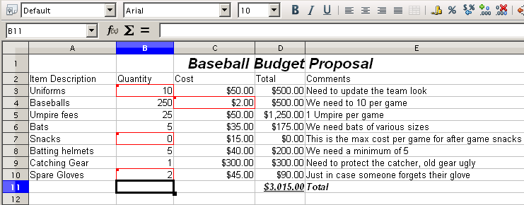Figure 4: Edited document with red border on changed cells
Tip | Some changes, such as cell formatting, are not recorded and marked.
Tip | To change the color that indicates changes, select Tools > Options > OpenOffice Calc > Changes.
When you finish editing the document, you can send it to your coach.
You may want to explain your rationale for changes. You can share your insight by adding comments to the changes you made or adding general comments to the spreadsheet.

Adding Comments to Changes
Calc automatically adds a comment to any recorded change that describes the change (for example, Cell B4 changed from ‘9’ to ‘4’). Reviewers and authors can add their comments to explain their reasons for the changes.
To add a comment to a change:
- Make the change to the spreadsheet.
- Select the cell with the change.
- Choose Edit > Changes > Comments. The dialog shown in Figure 5 appears. Calc automatically adds a comment in the title bar of this dialog that cannot be edited.
- Type your comment and click OK.
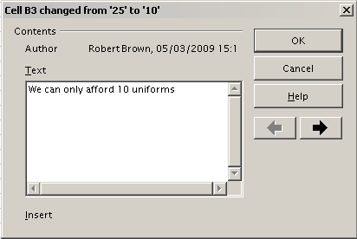Figure 5: Comment dialog
Tip | You can step through your changes individually using the left and right arrows on the right side of the Comment dialog and add comments to each change. The Comment dialog's title bar shows the cell and the change you are commenting on.
After adding a comment to a changed cell, you can see it by hovering the mouse pointer over the cell, as shown in Figure 6.
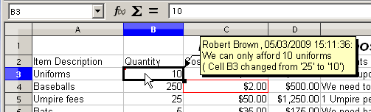Figure 6: Comment added to cell B3
The comment also appears in the dialog when accepting and rejecting changes, as shown in the first line of Figure 11 on page 300.

Editing Change Comments
- Select the cell with the change comment you want to edit.
- Select Edit > Changes > Comments.
- Edit the comment and click OK.
Tip | You can view your comments individually using the left and right arrows located on the right side of the Comment dialog. You do not need to click OK after editing each comment; you can save them all simultaneously after editing.

Adding Other Comments
Calc provides another type of comment often used by authors and reviewers to exchange ideas, ask for suggestions, or brainstorm in the document.
To add a comment:
- Select the cell to which the comment applies.
- Select Insert > Comment or right-click and select Insert Comment. (The latter method does not work if the automatic spelling checker is active and the cell contains a misspelled word.) The box shown in Figure 7 appears.
- Type the text of your comment in the box.
- Click outside the box to close it.
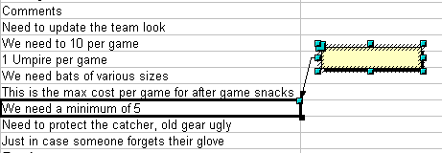Figure 7: Inserting a comment
The cell you added the comment to now has a colored dot in the upper right corner, as shown in Figure 8. It does not have a colored border unless the cell was also changed.
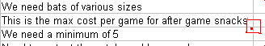
Figure 8: Colored dot in cell containing a comment
Tip | You can change the colors Calc uses for comments by selecting Tools > Options > OpenOffice > Appearance.
To view the comment you just added, hover the mouse pointer over the cell with a comment; the comment will appear, as shown in Figure 9.
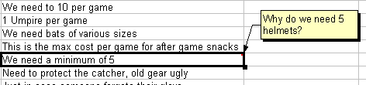Figure 9: Viewing a comment

Editing Comments
You can edit and format the text of a comment as you do with other text.
- Right-click on the cell containing the comment marker and choose Show comment from the pop-up menu.
- Select the comment and double-click it. The cursor changes to the usual blinking text-entry cursor, and the Formatting toolbar changes to show text attributes.
- When done, click outside the comment to deselect it. To hide the comment again, right-click on the cell and deselect Show Comment from the pop-up menu.

Formatting Comments
You can change the background color, border style, transparency, and other attributes of a comment.
- Right-click the cell containing the comment marker and choose Show Comment from the pop-up menu.
- Click on the comment itself. The Formatting toolbar and the Sidebar Properties pane change to show many comment formatting options. These are the same options for formatting graphics; see Chapter 5 (Using Graphics in Calc) for more information.
You can also right-click on the comment to see a menu of choices, some of which lead to dialogs where you can fine-tune the formatting. These dialogs are also discussed in Chapter 5.
- When done, click outside the comment to deselect it. To hide the comment again, right-click on the cell and deselect Show Comment from the pop-up menu.

Finding Comments Using the Navigator
The small comment markers in the corners of cells can be difficult to see. Calc provides another way to find them using the Navigator. If any comments are in the spreadsheet, the Navigator shows a mark (usually a + or an arrow) next to the word Comments. Click on this mark to display a list of comments. Double-click on a comment to jump directly to its associated cell.

Reviewing Changes
At this point, we will change our perspective from the point of view of the team sponsor to that of the coach so we can see how to review and accept or reject the changes to the document the coach originally wrote.
You are the coach of a youth baseball team and you submitted a potential budget created in Calc to your team sponsor.
Your sponsor has reviewed the document using Calc's record changes feature. Now, you want to review those changes and accept or reject the counter proposal.
Because the sponsor recorded changes in Calc, you can easily see what changes were made and decide how to act.

Viewing Changes
Calc gives you tremendous control over what changes you see when reviewing a document. To change the available filters, select Edit > Changes > Show. The dialog shown in Figure 10 opens.
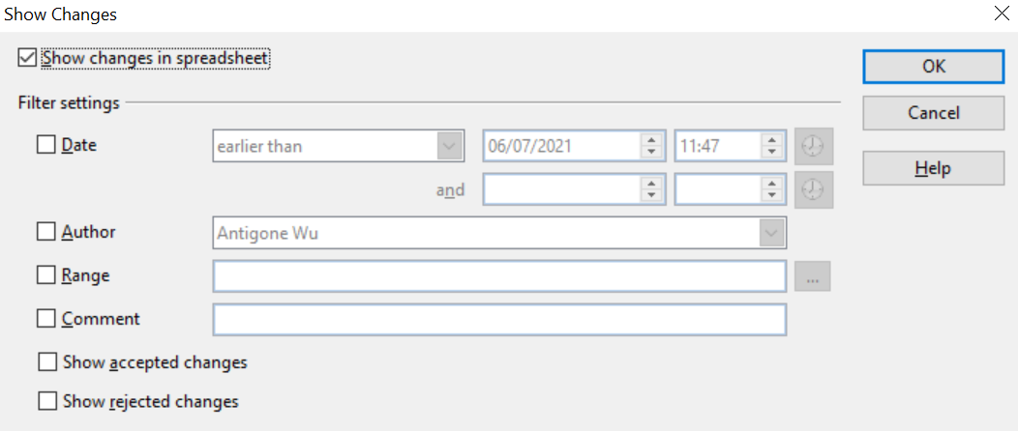

Figure 10: Show changes dialog
You can control which changes appear on the screen using the different settings. You can filter based on:
- Date – Only changes made in a specific time range are displayed.
- Author – Only changes made by a specific author are displayed. This is especially useful if you have multiple reviewers on the document.
- Range – Only changes made in a specific range of cells are displayed. This is especially useful if you have a large spreadsheet and only want to review a part of it.
- Comment – Searches the content of the comments and only displays changes with comments that match the search criteria.
- Show accepted changes – Only changes you accepted are displayed.
- Show rejected changes – Only changes you rejected are displayed.
Note | You can also access the filter control in the Accept or Reject Changes dialog shown in Figure 11. Click the Filter tab to view a set of options similar to those shown in Figure 10.

Accepting or Rejecting Changes
When you receive a document back with changes, the beauty of the recording changes system becomes evident. Now, as the original author, you can step through each change and decide how to proceed. To begin this process:
- Open the edited document.
- Select Edit > Changes > Accept or Reject. The dialog shown in Figure 11 appears.
- Click Accept or Reject to step through the changes one at a time. You can also choose to accept or reject all changes in one step. Calc creates separate lists of Accepted and Rejected changes. Accepting or Rejecting changes is a non-reversible process. You can undo the changes by comparing the current (edited) document with an earlier version (see page 301).
By default, the Comment column contains an explanation of the change that was made. If the reviewer added a comment to the change, it is displayed, followed by the description of the change, as shown in the first line of Figure 11.
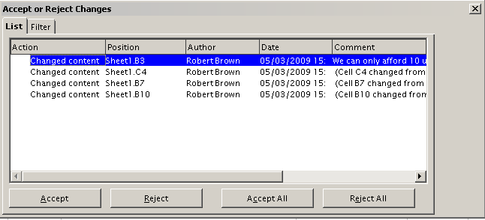Figure 11: Accept or Reject changes dialog
If multiple people have reviewed the document, one reviewer may have modified another reviewer’s change. If so, the changes are hierarchically arranged, with a plus sign to open the hierarchy.
On the Filter tab of this dialog (not shown here), you can choose how to filter the list of changes either by date, author, cell range, or comments containing specific terms. After selecting the filter criteria, switch to the List tab to see the results.

Merging Documents
You submitted your budget proposal to your sponsor and one of your assistant coaches. They both returned their revised budget to you at the same time.
You could review each document and the changes separately, but you want to see both revisions simultaneously to save time.
The processes discussed are effective when you have one reviewer at a time. However, sometimes multiple reviewers all return edited versions of a document simultaneously. In this case, reviewing all of these changes at once may be quicker than one review at a time. For this purpose, you can merge documents in Calc.
To merge documents, all of the edited documents must have recorded changes in them.
- Open the original document.
- Select Edit > Changes > Merge Document.
- A file selection dialog opens. Select a file you want to merge and click OK.
- After the documents merge, the Accept or Reject Changes dialog opens; see Figure 12, which shows changes by more than one reviewer. If you want to merge more documents, close the dialog and repeat steps 2 and 3.
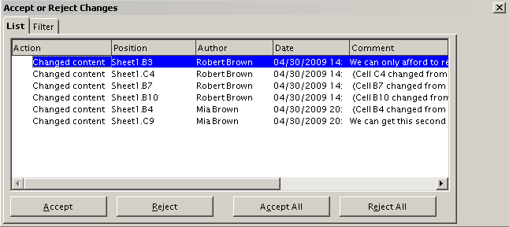Figure 12: Accept or Reject for merged documents
All changes are now combined into one document; you can accept or reject the changes. Changes from different authors appear in different colors in the document, as shown in Figure 13. In this example, Robert's changes are blue, and Mia's are red.
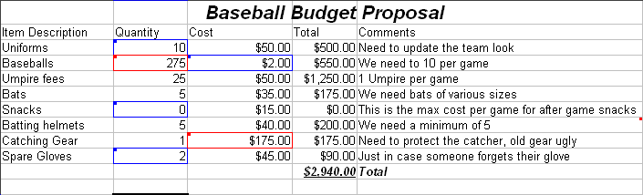
Figure 13: Merged documents with different author colors

Comparing Documents
When sharing documents, reviewers may forget to record their changes. This is not a problem with Calc because it can find the changes by comparing documents.
To compare documents, you need to have the original document and the one that has been edited. To compare them:
- Open the edited document you want to compare with the original document.
- Select Edit > Compare Document.
- An open document dialog appears. Select the original document and click Insert.
Calc finds and marks the changes as follows:
- Data in the edited document that is not in the original is identified as inserted.
- Data in your original document that is not in the edited document is identified as deleted.
- Data that is changed is marked as changed.
You can now go through and accept or reject changes as you normally would.

Saving Versions
Most documents go through several drafts. Often, it is useful to save new versions of a document. You can do this by saving a copy of the document (under a different name) after each revision or by using Calc’s version feature.
Caution | If you do a Save As... of a document with different versions stored within it, the old versions are dropped and the new file contains only the latest version.
To use version management in Calc:
- Choose File > Versions. The Versions dialog opens as shown below in Figure 14.
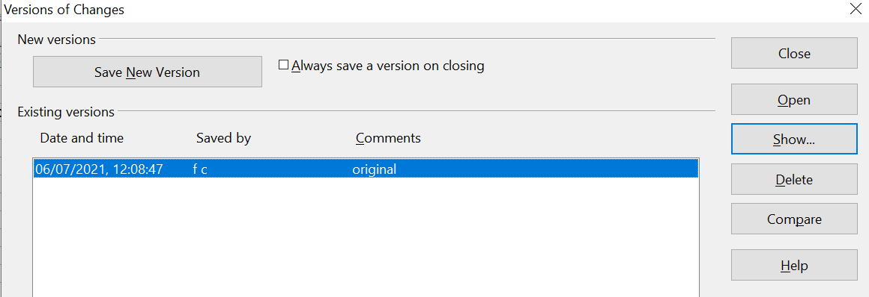

Figure 14: Version management dialog
- Click the Save New Version button to save a new version.
- A dialog (Figure 2) opens where you can enter comments about this version.
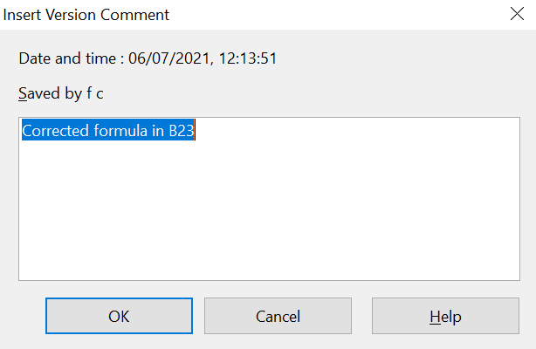
Figure 15: Version comment dialog
- After you enter your comment and click OK, the new version appears in the version list, as shown below in Figure 1.
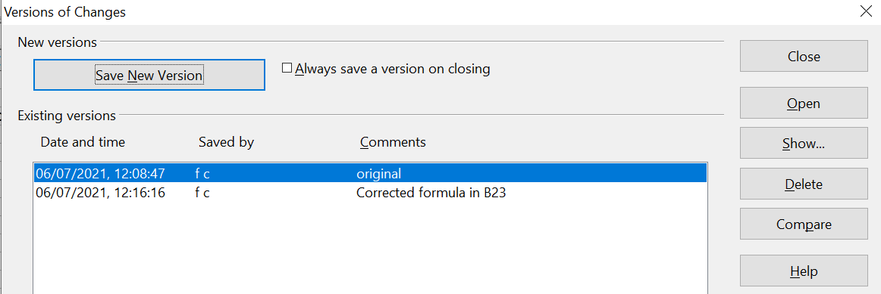

Figure 16: Updated version list
Now, when you save the spreadsheet, both versions are saved in the same physical file. From this point, you can:
- Open an old version – Select the version,click the Open button, and a read-only copy of a previous version opens.
- Compare all versions – Clicking the Compare button performs an action similar to merging documents. An Accept or Reject Changes dialog opens showing all the changes through the different versions.
- Review the comments – Select a version and click the Show button to display the full comments you or other reviewers made.
Note | The new file is larger in size, as two spreadsheets are effectively saved together into a single file.

Chapter 12
Calc Macros
Automating repetitive tasks

Introduction
A macro is a saved sequence of instructions stored for later use. An example of a simple macro is one that “types” your address. OpenOffice macros are very flexible, allowing automation of a range of tasks, from simple to very complex. In the right situation, a macro can improve the speed and accuracy of using a spreadsheet. However, it is important to remember that Calc includes powerful tools like Pivot Tables and Database Ranges. It is wise to investigate whether a built-in tool can do what you need before deciding to make a macro.
Macros are especially useful for repetitive tasks. This chapter briefly discusses common problems related to macro programming using Calc. Macros can be written in several programming languages, but the most common is Basic. Before we get into the details of making Calc macros, we will briefly explain some features of the OpenOffice Basic language.

The OpenOffice Basic Language
OpenOffice Basic is a simple programming language, both in its ease of use and relatively small number of features. It is too large a topic to cover in detail here. An entire top-level section of the Help documentation is devoted to it, just as there are sections for Writer, Calc, and other major applications. A Basic Programming Guide is also linked at the end of this chapter. Here, we will briefly mention a few aspects of Basic to help you understand the macros shown in the rest of this chapter.
Basic was developed in 1964 and is still used today. It allows a programmer to:
- define the type of data being manipulated. A certain value might be defined as an integer, a boolean, or a set of three texts. There are several data types. Such definitions make code easier to read because the intent is clear, which prevents misleading results due to bad inputs.
- define what the manipulation will consist of. A macro may do calculations in a spreadsheet, search text documents for certain words, save copies of the document, or almost anything else you can do with a document manually.
- define what conditions or circumstances will trigger the manipulation. Basic allows the code to take different actions depending on user input or the current content of a document.
The table below shows some keywords you will find in macros. Keywords are discussed in greater detail later in this chapter.
Basic | Means
rem | A remark, that is, internal documentation
dim | Sets up, that is dimensions, the extent or the type of the item being established
double | The double data type can hold 64 bits of decimal numbers, also called floating points
integer | The INTEGER data type stores whole numbers ranging from -2,147,483,647 to 2,147,483,647 for 9 or 10 digits of precision. An INTEGER value is typically used for quantities like counts.
for | A "For" Loop repeats a specific block of code a known number of times. For example, if we want to check the grade of every student in a class, we loop our program instructions to start from 1 and to complete when the correct number is reached.
sub, end sub | Indicators for the beginning and end of a subroutine, a part of a macro

Macros rely on Basic and some of the mechanisms it offers. Below is a macro made with the macro recorder. Notice it begins with sub and ends with end sub. From this example, you learn that lines that start with rem are documentation, and lines that start with dim define the extent or type of a variable. Let's focus on the variable document that will represent a document. First, that variable is defined as the type object. This means the variable will not contain just a number or text but something more complicated, in this case, a whole document.
dim document as object
Later in the code, a comment explains that the next line assigns something (an object) to the document variable, giving the macro access to the OpenOffice document. Then, there is the line that does the assignment.
rem get access to the document
document = ThisComponent.CurrentController.Frame
The final line of the code acts on the document variable, inserting some text.
dispatcher.executeDispatch(document, ".uno:InsertContents", "", 0, args1())

sub EnterMyName
rem -------------------------------------------------------------
rem define variables
dim document as object
dim dispatcher as object
rem -------------------------------------------------------------
rem get access to the document
document = ThisComponent.CurrentController.Frame
dispatcher = createUnoService("com.sun.star.frame.DispatchHelper")

rem -------------------------------------------------------------
dim args1(0) as new com.sun.star.beans.PropertyValue
args1(0).Name = "Text"
args1(0).Value = "Andrew Pitonyak"

dispatcher.executeDispatch(document, ".uno:InsertText", "", 0, args1())
end sub

If you are new to programming, those steps may appear complicated and confusing. However, the basic ideas are simple. You start by defining a variable and its type; then, you assign it a value using the format: variable = Something. Afterward, you do things with that variable using functions formatted as a function name followed by parentheses, like dispatcher.executeDispatch(). (Remember, not everything that has parentheses after it is a function. It might be a collection of values, an array, such as the args1() variable in the code above.)
Basic offers two other programming techniques - conditional statements such as IF, which carry out actions based upon the passing or failing of a test, and loops like FOR – programming instructions that ensure the repetition of an action or actions.
It's unnecessary for users to be proficient in Basic or to use it to create macros like those presented later in this chapter. In many scenarios, users don't need such tools - the macro recorder will be sufficient. The recorder easily handles what Merriam-Webster defines as a macro – a single computer instruction that stands for a sequence of operations.

Using the Macro Recorder
Chapter 12 of the Getting Started guide (Getting Started with Macros) provides a basis for understanding the general macro capabilities in OpenOffice using the macro recorder. An example is shown here without the explanations in the Getting Started guide. The following steps create a macro that performs paste special with multiply.
- Open a new spreadsheet.
- Enter numbers into a sheet, as shown in Figure 1.
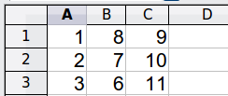
Figure 1: Enter numbers
- Select cell A3, which contains the number 3, and copy the value to the clipboard.
- Select the range A1:C3.
- Use Tools > Macros > Record Macro to start the macro recorder. The Record Macro dialog is displayed with a Stop Recording button (Figure 2).
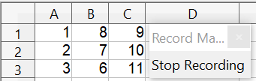

Figure 2: Stop Recording button
- Use Edit > Paste Special to open the Paste Special dialog (Figure 3).
- Set the operation to Multiply and click OK. The cells are now multiplied by 3 (Figure 4).
- Click Stop Recording to stop the macro recorder. The OpenOffice Basic Macros dialog (Figure 5) opens.
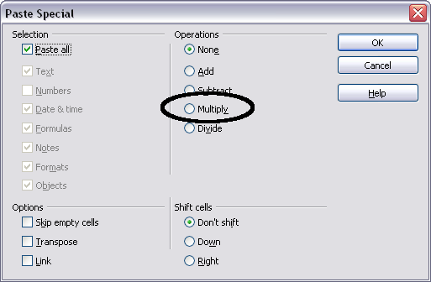
Figure 3: Paste Special dialog
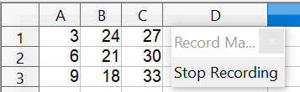
Figure 4: Cells multiplied by 3
- Select the current document (see Figure 5). In this example, the current Calc document is named Untitled 1. Existing documents show a library named Standard. This library is not created until the document is saved or the library is needed, so currently, your new document does not contain a library. You can create a new library containing the macro, but this is unnecessary.
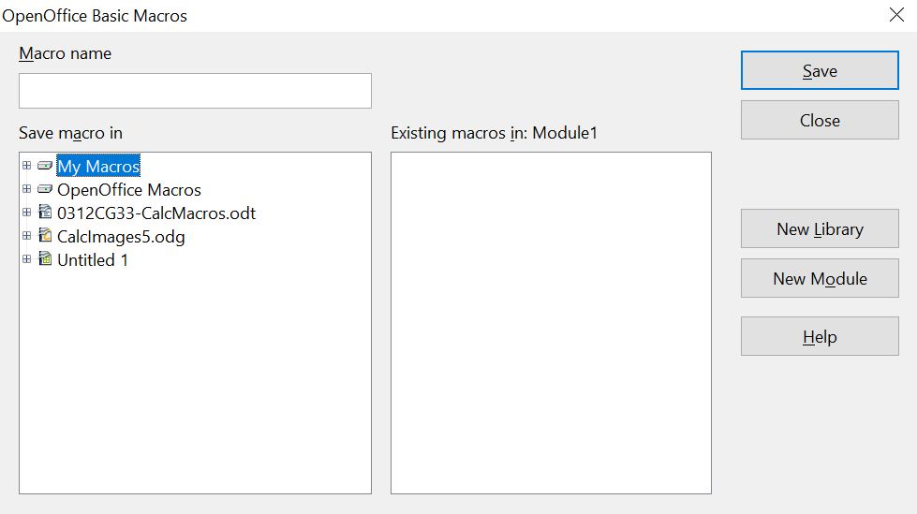

1 | My Macros | 5 | Create new module in library
2 | OpenOffice Macros | 6 | Macros in selected library
3 | Open documents | 7 | Current document
4 | Create new library | 8 | Expand/collapse list
Figure 5: Parts of the OpenOffice Basic Macros dialog
1
2
3
4
5
6
7
8
- Click New Module. If no libraries exist, the Standard library is automatically created and used. In the New Module dialog, type a name for the new module or leave the name as Module1.
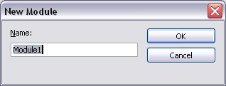
- Click OK to create a new module named Module1. Select the newly created Module1, type PasteMultiply in the Macro name box at the upper left, and click Save. (See Figure 6.)
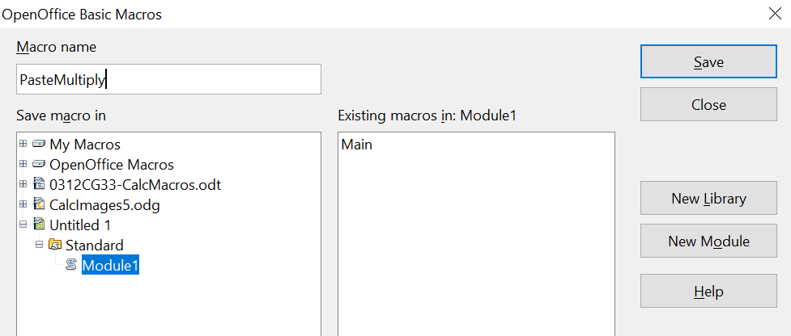

Figure 6: Select the module and name the macro
The created macro is saved in Module1 of the Standard library within the Untitled 1 document. Listing 1 shows the macro's contents.
Listing 1. Paste special with multiply.
sub PasteMultiply
rem --------------------------------------------------------------
rem define variables
dim document as object
dim dispatcher as object
rem --------------------------------------------------------------
rem get access to the document
document = ThisComponent.CurrentController.Frame
dispatcher = createUnoService("com.sun.star.frame.DispatchHelper")

rem --------------------------------------------------------------
dim args1(5) as new com.sun.star.beans.PropertyValue
args1(0).Name = "Flags"
args1(0).Value = "A"
args1(1).Name = "FormulaCommand"
args1(1).Value = 3
args1(2).Name = "SkipEmptyCells"
args1(2).Value = false
args1(3).Name = "Transpose"
args1(3).Value = false
args1(4).Name = "AsLink"
args1(4).Value = false
args1(5).Name = "MoveMode"
args1(5).Value = 4

dispatcher.executeDispatch(document, ".uno:InsertContents", "", 0, args1())
end sub
Chapter 12 (Getting Started with Macros) in the Getting Started guide provides more detail on recording macros; we recommend you read it if you have not already done so. Additional detail is provided in the following sections, but not as related to recording macros.

Write Your Own Functions
Calc can consider and execute macros as Calc functions. Use the following steps to create a simple macro.
- Create a new Calc document named CalcTestMacros.ods.
- Use Tools > Macros > Organize Macros > OpenOffice Basic to open the OpenOffice Basic Macros dialog shown in Figure 7. The Macro from box lists available macro library containers, including currently open documents. My Macros contains macros that you write or add to OpenOffice. OpenOffice Macros contains macros that are included with OpenOffice and should not be changed.
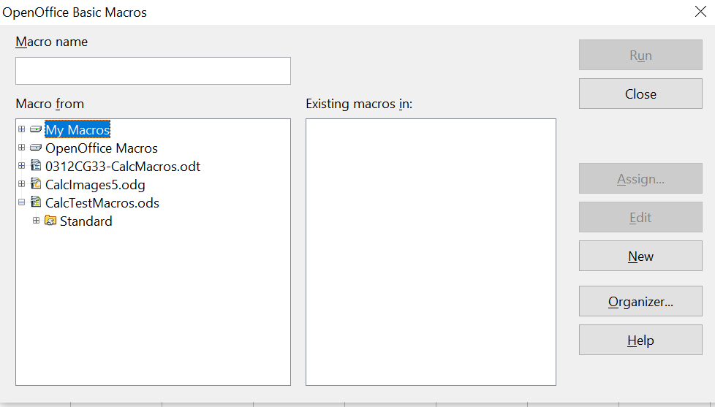

Figure 7: OpenOffice Basic Macros dialog
Open document with library
- Click Organizer to open the Basic Macro Organizer dialog (Figure 8). On the Libraries tab, select the document to contain the macro.
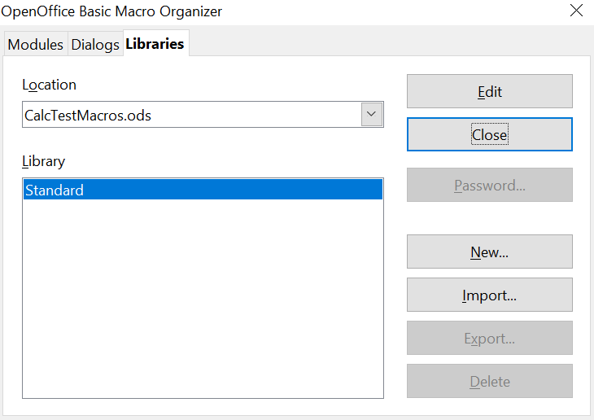

Figure 8: OpenOffice Basic Macro Organizer
Choose the document from the list
List of libraries in the document
- Click New to open the New Library dialog (Figure 9).
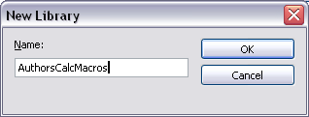
Figure 9: New Library dialog
- Enter a descriptive library name (such as AuthorsCalcMacros) and click OK to create the library. The new library name is shown in the library list, but the dialog may show only a portion of the name (Figure 10).
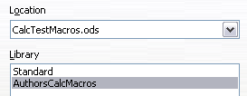
Figure 10: The library is shown in the organizer
- Select AuthorsCalcMacros and click Edit to edit the library. Calc automatically creates a module named Module1 and a macro named Main (Figure 11).
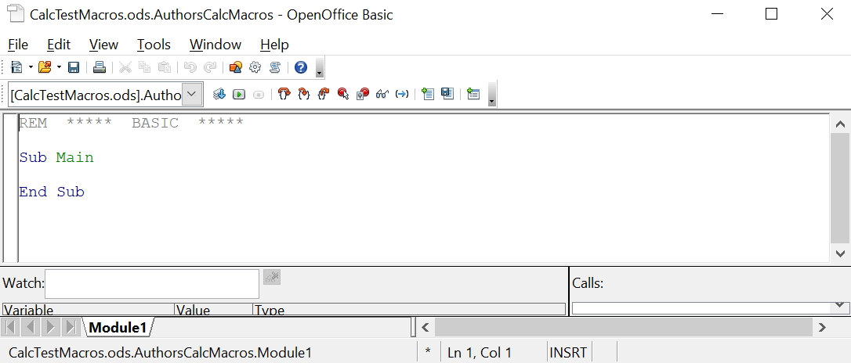

Figure 11: Basic Integrated Development Environment (IDE)
- Modify the code so that it is the same as that shown in Listing 2. The important addition is the creation of the NumberFive function, which returns the number five. The Option Explicit statement forces all variables to be declared before they are used. If Option Explicit is omitted, variables are automatically defined at first use as type Variant.
- Save the modified Module1.
Listing 2. Function that returns five.
REM ***** BASIC *****
Option Explicit

Sub Main

End Sub

Function NumberFive()
NumberFive = 5
End Function

Using a Macro as a Function
Using the newly created Calc document CalcTestMacros.ods, enter the formula =NumberFive() (see Figure 12). Calc finds the macro and calls it.
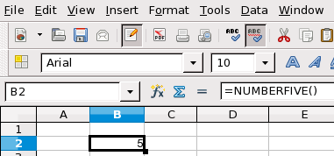
Figure 12: Use the NumberFive() Macro as a Calc function
Tip | Function names are not case-sensitive. In Figure 12, you can enter =NumberFive(), and Calc clearly shows =NUMBERFIVE().

Save the Calc document, close it, and open it again. Depending on your settings in Tools > Options > OpenOffice > Security > Macro Security, Calc will display the warning in Figure 13 or the one in Figure 14. You must click Enable Macros, or Calc will not allow any macros to be run inside the document. If you do not expect a document to contain a macro, it is safer to click Disable Macros in case the macro is a virus.
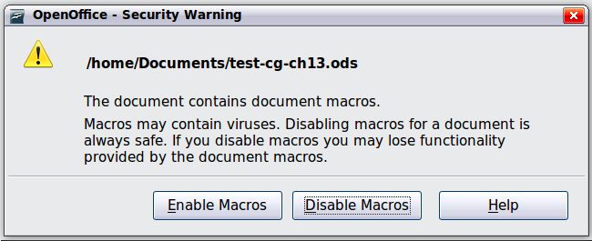
Figure 13: OpenOffice warns you that a document contains macros
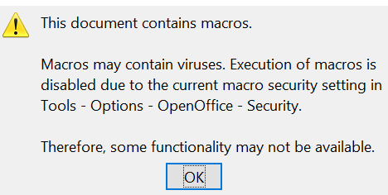
Figure 14: Warning if macros are disabled

Caution! | If you choose to disable macros, when the relevant document loads, Calc will no longer be able to find your function.

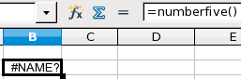
Figure 15: The function is gone
When a document is created and saved, it automatically contains a library named Standard. The Standard library is automatically loaded when the document is opened. No other library is automatically loaded.
Calc does not contain a function named NumberFive() (Figure 15), so it checks all opened and visible macro libraries for the function. Libraries in OpenOffice Macros, My Macros, and the Calc document are checked for an appropriately named function (see Figure 7). The NumberFive() function is stored in the AuthorsCalcMacros library, which is not automatically loaded when the document is opened.
Use Tools > Macros > Organize Macros > OpenOffice Basic to open the Basic Macros dialog (see Figure 16). Expand CalcTestMacros and find AuthorsCalcMacros. The icon for a loaded library is a different color than the icon for a library that is not loaded.
Click the expansion symbol (usually a plus or a triangle) next to AuthorsCalcMacros to load the library. The icon changes color to indicate the library is now loaded. Click Close to close the dialog.

Unfortunately, the cells containing =NumberFive() are in error. Calc does not recalculate cells in error unless you edit or change them. The usual solution is to store macros used as functions in the Standard library. If the macro is large or there are several macros, a stub with the desired name is stored in the Standard library. The stub macro loads the library containing the implementation and then calls the implementation.
- Use Tools > Macros > Organize Macros > OpenOffice Basic to open the Basic Macros dialog (see Figure 16). Select the NumberFive macro and click Edit to open the macro for editing.

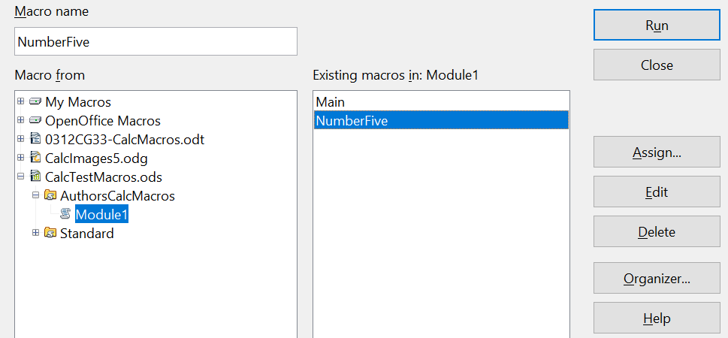

Figure 16: Select a macro and click Edit
- Change the name of NumberFive to NumberFive_Implementation (Listing 3).
Listing 3. Change the name of NumberFive to NumberFive_Implementation
Function NumberFive_Implementation()
NumberFive_Implementation() = 5
End Function
- In the Basic IDE (see Figure 11), hover the mouse cursor over the toolbar buttons to display the tool tips. Click the Select Macro button to open the OpenOffice Basic Macros dialog (see Figure 16).
- Select the Standard library in the CalcTestMacros document and click New to create a new module. Enter a meaningful name, such as CalcFunctions, and click OK. OpenOffice automatically creates a macro named Main and opens the module for editing.
- Create a macro in the Standard library that calls the implementation function (see Listing 4). The new macro loads the AuthorsCalcMacros library if it is not already loaded and then calls the implementation function.
- Save, close, and reopen the Calc document. Now, the NumberFive() function works.
Listing 4. Change the name of NumberFive to NumberFive_Implementation.
Function NumberFive()
If NOT BasicLibraries.isLibraryLoaded("AuthorsCalcMacros") Then
BasicLibraries.LoadLibrary("AuthorsCalcMacros")
End If
NumberFive = NumberFive_Implementation()
End Function

Passing Arguments to a Macro
To illustrate a function that accepts arguments, we will write a macro that calculates the sum of its positive arguments while ignoring arguments that are less than zero (see Listing 5).
Listing 5. PositiveSum calculates the sum of the positive arguments.
Function PositiveSum(Optional x)
Dim TheSum As Double
Dim iRow As Integer
Dim iCol As Integer

TheSum = 0.0
If NOT IsMissing(x) Then
If NOT IsArray(x) Then
If x > 0 Then TheSum = x
Else
For iRow = LBound(x, 1) To UBound(x, 1)
For iCol = LBound(x, 2) To UBound(x, 2)
If x(iRow, iCol) > 0 Then TheSum = TheSum + x(iRow, iCol)
Next
Next
End If
End If
PositiveSum = TheSum
End Function
The macro in Listing 5 demonstrates some important techniques:
- The argument x is optional. When an argument is not optional and the function is called without it, OpenOffice displays a warning message each time the macro is called. Consequently, if Calc calls the function multiple times, the error message appears repeatedly.
- IsMissing checks that an argument was passed before the argument is used.
- IsArray checks if the argument is a single value or an array. For example, =PositiveSum(A1) or =PositiveSum(A1:A4). In the former case, the value of A1 is passed as a simple number to the argument; in the latter, the values of A1:A4 are passed as an array to the function.
- A range of values is passed as a two-dimensional array to the function, even if the cells are in a single column or row, such as =PositiveSum(A2:B5). LBound and UBound are used to determine the array bounds that are used. Although the lower bound is one, it is considered safer to use LBound in case it changes in the future.
Tip | The macro in Listing 5 verifies whether the argument is an array or a single argument. It does not check if each value is numeric. You may be as thorough as you like; adding more checks increases the macro's robustness but may also decrease its performance.

Passing one argument is as easy as passing two: add another argument to the function definition (see Listing 6). When calling a function with two arguments, separate the arguments with a semicolon; for example, =TestMax(3; -4).
Listing 6. TestMax accepts two arguments and returns the larger of the two.
Function TestMax(x, y)
If x >= y Then
TestMax = x
Else
TestMax = y
End If
End Function

Arguments are Passed as Values
Arguments passed to a macro from Calc are always values; it's impossible to know what cells are used. For example, =PositiveSum(A3) passes the value stored in A3. The function PositiveSum has no way of knowing that cell A3 was used. If you must know which cells are referenced, send the range as a string to the function, then determine the value in the referenced cell.

Writing Macros that Act Like Built-in Functions
Although Calc finds and calls macros as normal functions, they do not behave as built-in functions. For instance, macros do not appear in Calc's function list. It is possible to write functions that behave as regular functions by writing an Add-In. However, this is an advanced topic not covered here. For additional information, refer to the following link:
https://wiki.openoffice.org/wiki/SimpleCalcAddIn

Accessing Cells Directly
You can access the OpenOffice internal objects directly to manipulate a Calc document. For example, the macro in Listing 7 adds the values in cell A2 from every sheet in the current document. ThisComponent is set by OpenOffice Basic when the macro starts to reference the current document. A Calc document has, as a sub-object, a collection of sheets: ThisComponent.getSheets(). You can get a particular sheet from that collection using the getByIndex() method. (There is also a getByName() method.) Use getCellByPosition(col, row) to return a cell at a specific row and column.

Listing 7. Add cell A2 in every sheet.
Function SumCellsAllSheets()
Dim TheSum As Double
Dim i As integer
Dim oSheets
Dim oSheet
Dim oCell

oSheets = ThisComponent.getSheets()
For i = 0 To oSheets.getCount() - 1
oSheet = oSheets.getByIndex(i)
oCell = oSheet.getCellByPosition(0, 1) ' GetCell A2
TheSum = TheSum + oCell.getValue()
Next
SumCellsAllSheets = TheSum
End Function
Tip | A cell object supports the methods getValue(), getString(), and getFormula() to get the numerical value, the string value (what is visible in the cell), or the formula used in a cell. Use the corresponding set functions to set appropriate values.

Use oSheet.getCellRangeByName("A2") to return a range of cells by name. If a single cell is referenced, then a cell object is returned. If a cell range is given, then an entire range of cells is returned (see Listing 8). Notice that a cell range returns data as an array of arrays, which is more cumbersome than treating it as an array with two dimensions, as done in Listing 5.
Listing 8. Add cell A2:C5 in every sheet
Function SumCellsAllSheets()
Dim TheSum As Double
Dim iRow As Integer, iCol As Integer, i As Integer
Dim oSheets, oSheet, oCells
Dim oRow(), oRows()

oSheets = ThisComponent.getSheets()
For i = 0 To oSheets.getCount() - 1
oSheet = oSheets.getByIndex(i)
oCells = oSheet.getCellRangeByName("A2:C5")
REM getDataArray() returns the data as variant so strings
REM are also returned.
REM getData() returns data as type Double, so only
REM numbers are returned.
oRows() = oCells.getData()
For iRow = LBound(oRows()) To UBound(oRows())
oRow() = oRows(iRow)
For iCol = LBound(oRow()) To UBound(oRow())
TheSum = TheSum + oRow(iCol)
Next
Next
Next
SumCellsAllSheets = TheSum
End Function
Tip | When a macro is called as a Calc function, the macro cannot modify any value in the sheet except the value of the cell that called the function.

Sorting
Consider sorting the data in Figure 17. First, sort on column B descending, then column A ascending.
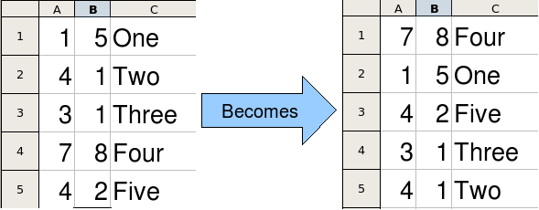
Figure 17: Sort column B descending and column A ascending
The example in Listing 9 demonstrates how to sort on two columns.
Listing 9. Sort cells A1:C5 on Sheet 1.
Sub SortRange
Dim oSheet ' Calc sheet containing data to sort.
Dim oCellRange ' Data range to sort.

REM An array of sort fields determines the columns that are
REM sorted. This is an array with two elements, 0 and 1.
REM To sort on only one column, use:
REM Dim oSortFields(0) As New com.sun.star.util.SortField
Dim oSortFields(1) As New com.sun.star.util.SortField

REM The sort descriptor is an array of properties.
REM The primary property contains the sort fields.
Dim oSortDesc(0) As New com.sun.star.beans.PropertyValue

REM Get the sheet named "Sheet1"
oSheet = ThisComponent.Sheets.getByName("Sheet1")

REM Get the cell range to sort
oCellRange = oSheet.getCellRangeByName("A1:C5")

REM Select the range to sort.
REM The only purpose would be to emphasize the sorted data.
'ThisComponent.getCurrentController.select(oCellRange)

REM The columns are numbered starting with 0, so
REM column A is 0, column B is 1, etc.
REM Sort column B (column 1) descending.
oSortFields(0).Field = 1
oSortFields(0).SortAscending = FALSE

REM If column B has two cells with the same value,
REM then use column A ascending to decide the order.
oSortFields(1).Field = 0
oSortFields(1).SortAscending = True

REM Setup the sort descriptor.
oSortDesc(0).Name = "SortFields"
oSortDesc(0).Value = oSortFields()

REM Sort the range.
oCellRange.Sort(oSortDesc())
End Sub
As this macro is a subroutine, execute it with Tools > Macros > Run Macro and then open CalcTestMacros > AuthorsCalcMacros > Module1. Click on the macro SortRange and then Run.

Conclusion
We briefly covered how macros are organized into libraries and modules, how to use the macro recorder, using macros as Calc functions, and writing macros using the Application Programming Interface (API) rather than the recorder. The macro recorder stores the effects of keystrokes or mouse clicks and can be used without any programming knowledge. It cannot record every possible user action but can often automate tedious, repetitive tasks, saving time and reducing errors. Writing functions and macros using the API are more advanced topics requiring some programming knowledge. They can be used to make very powerful tools but may require spending a lot of time learning the Application Programming Interface , writing code, and testing it. When the situation requires it, OpenOffice provides the infrastructure to implement complex and robust macros.

Chapter 13
Calc as a Simple Database
A guide for users and macro programmers

Introduction
A Calc document has several database-like capabilities, providing sufficient functionality to satisfy the needs of many users for a simple database, without having to master the more complex and much more powerful tools available in OpenOffice Base. This chapter presents the capabilities of a Calc document that make it suitable as a database tool. Where applicable, the functionality is explained using the GUI (Graphical User Interface) and macros. Because macros are a more advanced topic, the uses of the GUI and standard Calc functions are explained first; macros are reserved for the end of the chapter.
In a database, a record is a group of related data items treated as a single unit of information. Each item in the record is called a field. A table consists of records. Each record in a table has the same structure. A table can be visualized as a series of rows and columns. Each row in the table corresponds to a single record, and each column corresponds to the fields. A spreadsheet in a Calc document is similar in structure to a database table. Each cell corresponds to a single field in a database record. For many people, Calc implements sufficient database functionality so that no other database program or functionality is required.

Example Data
Many of the examples in this chapter refer to the data in Table 26. If you are reading this chapter as a Writer document, you can copy the data from Table 1 directly to a spreadsheet. Select the cells containing the data, excluding the headers A-G and the row numbers 1-16, then copy and paste them into a Calc document.
A spreadsheet might be used as a grading program while teaching. Each row represents a single student, and the columns represent the grades received on homework, labs, and tests. The strong calculation capability provided in a spreadsheet makes this an excellent choice.
Table 13. Simple grading spreadsheet
 | A | B | C | D | E | F | G
1 | Name | Test 1 | Test 2 | Quiz 1 | Quiz 2 | Average | Grade
2 | Andy | 95 | 93 | 93 | 92 | 93.25
3 | Betty | 87 | 92 | 65 | 73 | 79.25
4 | Bob | 95 | 93 | 93 | 92 | 93.25
5 | Brandy | 45 | 65 | 92 | 85 | 71.75
6 | Frank | 95 | 93 | 85 | 92 | 91.25
7 | Fred | 87 | 92 | 65 | 73 | 79.25
8 | Ilsub | 70 | 85 | 97 | 79 | 82.75
9 | James | 45 | 65 | 97 | 85 | 73
10 | Lisa | 100 | 97 | 100 | 93 | 97.5
11 | Michelle | 100 | 97 | 100 | 65 | 90.5
12 | Ravi | 87 | 92 | 86 | 93 | 89.5
13 | Sal | 45 | 65 | 100 | 92 | 75.5
14 | Ted | 100 | 97 | 100 | 85 | 95.5
15 | Tom | 70 | 85 | 93 | 65 | 78.25
16 | Whil | 70 | 85 | 93 | 97 | 86.25

Tip | Although the choice to associate a row to a record rather than a column is arbitrary, it is almost universal. In other words, you are not likely to hear someone refer to a column of data as a single database record.

Associating a Range with a Name
In a Calc document, a range refers to a contiguous, that is, a side-by-side group of cells. A range must contain at least one cell. You can associate a meaningful name to a range, which allows you to refer to the range using the meaningful name. You can create either a database range with some database-like functionality or a named range that does not. A name is usually associated with a range for one of three reasons:
- Associating a range with a name enhances readability by using a meaningful name.
- If a range is referenced by name in multiple locations, you can point the name to another location, and all references point to the new location.
- Ranges associated to a name are shown in the Navigator, accessible by pressing the F5 key or clicking on the icon in either the main toolbar or the Sidebar. The Navigator allows for quick navigation to the associated ranges.

Named Range
The most common usage of a named range is, as that wording implies, to associate a range of cells with a meaningful name. For example, create a range named Scores, and then use the following equation: =SUM(Scores). To create a named range, select the range to define. Typically, you would not include a column or row label with this kind of named range, so the SUM function only gets numeric values. Use Insert > Names > Define to open the Define Names dialog (see Figure 1). Use the Define Names dialog to add and modify one named range at a time.
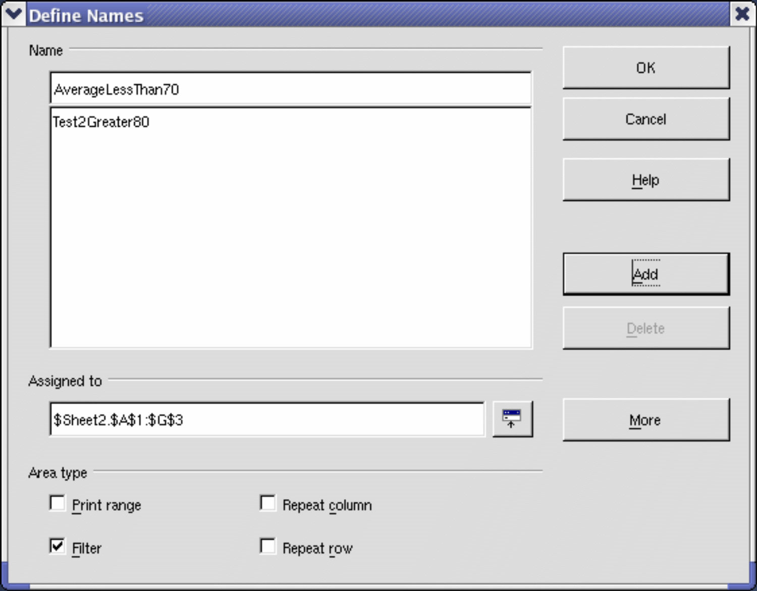
Figure 1. Define a named range.

A set of named ranges can be defined in one step, using the text in the column or row headers as the range names. Select the range including the headers and the data, then use Insert > Names > Create to open the Create Names dialog (see Figure 2), which allows you to simultaneously create multiple named ranges based on the top row, bottom row, right column, or left column. If, for example, you choose to create ranges based on the top row, one named range is created for each column header—the header is not included in the named range. Although the header is not included in the range, the text in the header is used to name the range.
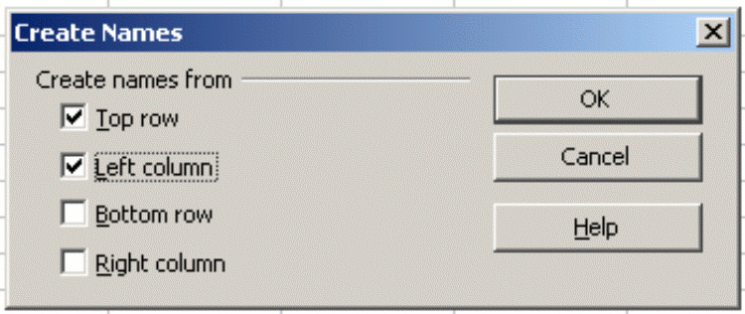Figure 2. Define a named range.

Database Range

A database range provides tools that are useful when performing database-related activities. For example, you can mark the first row as headings. The range will also store the settings of the last sort and filter actions so that these can be repeated without reentering the settings. To create, modify, or delete a database range, use Data > Define Range to open the Define Data Range dialog (see Figure 3). When you first define a range, the Modify button in the example is labeled Add.
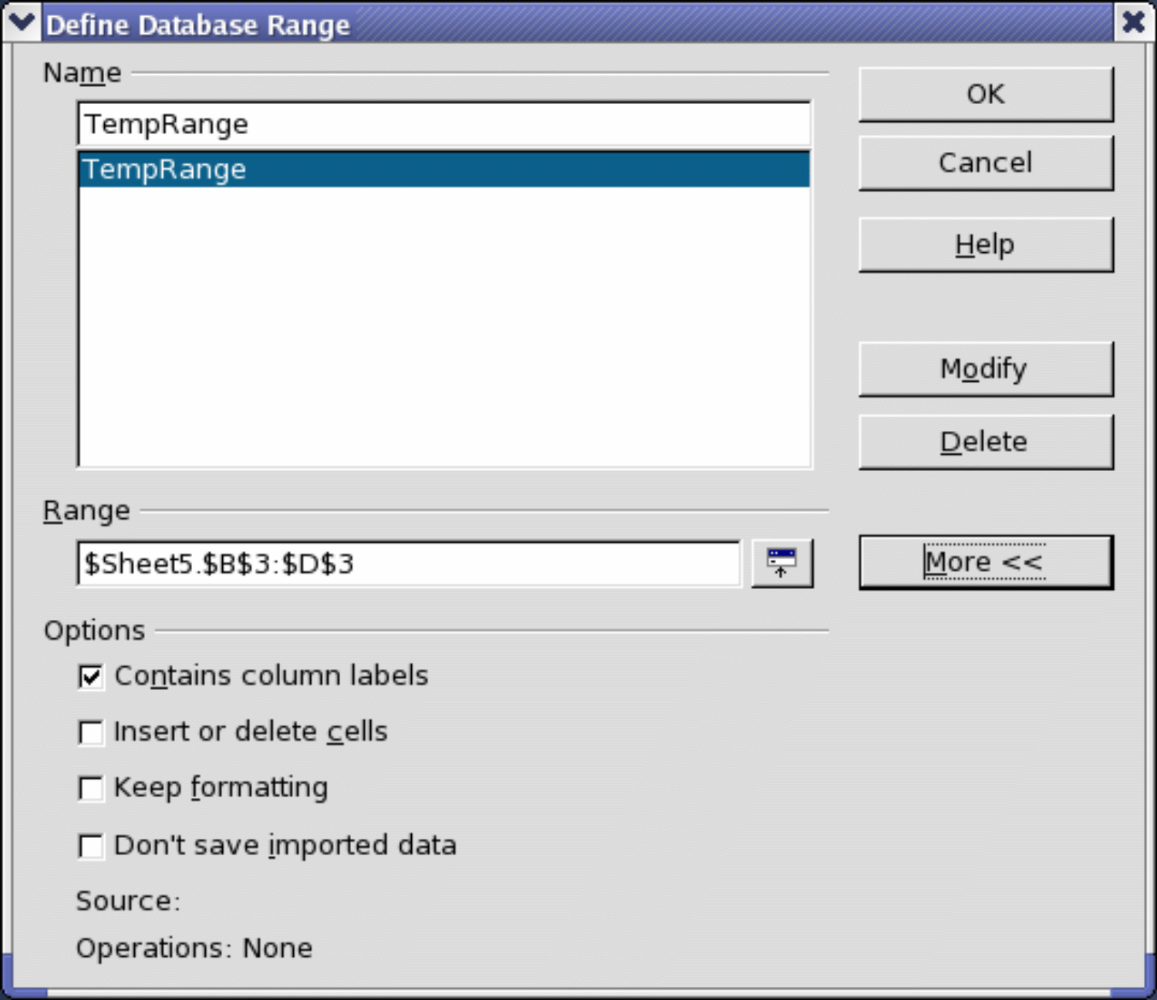Figure 3. Define a database range.

Sorting
The sorting mechanism in a Calc document rearranges the data in the sheet. The first step in sorting data is selecting the data you want to sort. To sort the data in Table 26, select the cells from A1 to G16—if you include the column headers, indicate this in the sort dialog (see Figure 5). Use Data > Sort to open the Sort dialog (see Figure 4). You can sort by up to three columns or rows at a time.
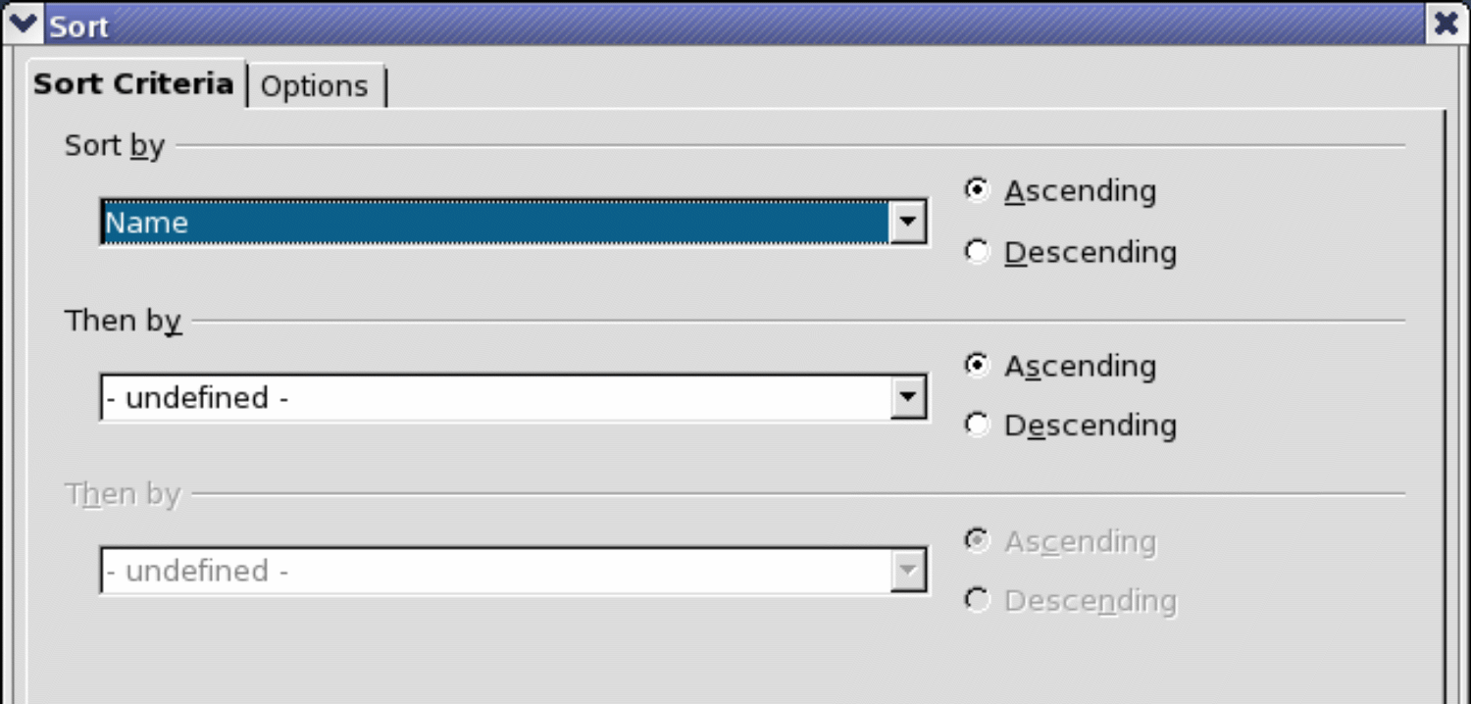Figure 4. Sort by the Name column.
Click on the Options tab (see Figure 5) to set the sort options. Check the Range contains column labels checkbox to prevent column headers from being sorted with the rest of the data. The Sort by list box in Figure 4 displays the columns using the column headers if the Range contains column labels checkbox in Figure 5 is checked. If the Range contains column labels checkbox is not checked however, then the columns are identified by their column name, Column A, for example.
Normally, sorting data replaces existing data with the newly sorted data. The Copy sort results to checkbox, however, leaves the selected data unchanged, and a copy of the sorted data is copied to the specified location. You can directly enter a target address (Sheet3.A1, for example) or select a predefined range.
Check the Custom sort order checkbox to sort based on a predefined list of values. To set predefined lists, use Tools > Options > OpenOffice Calc > Sort Lists and enter your sort lists. Predefined sort lists are useful for sorting lists of data that should not be sorted alphabetically or numerically. For example, sorting days based on their name.
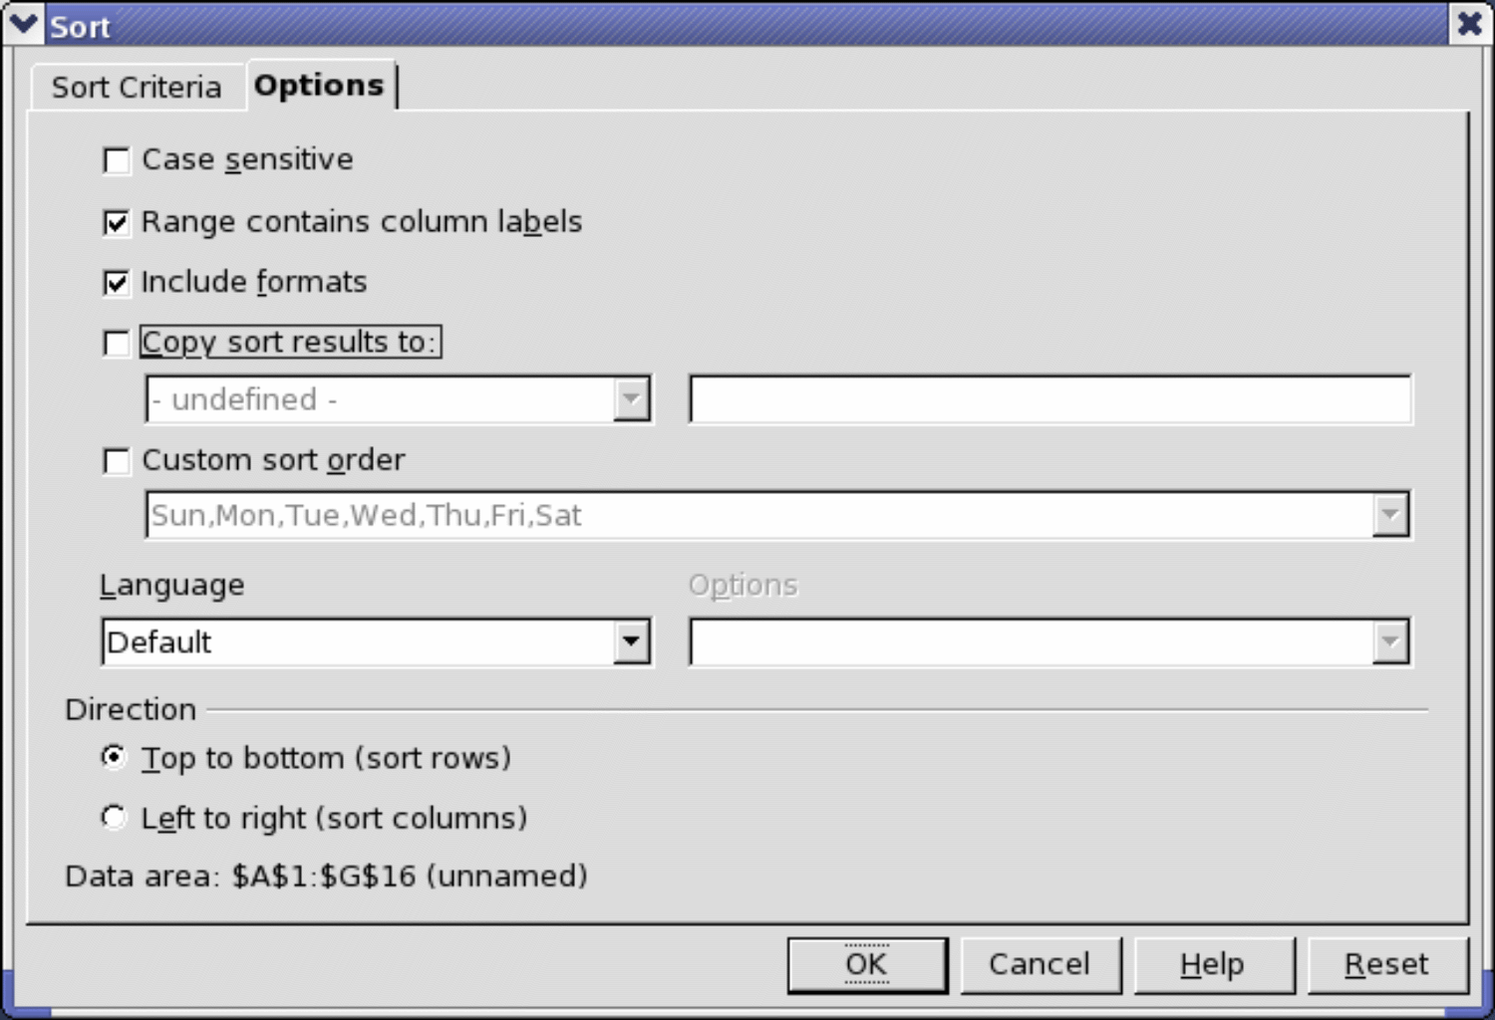Figure 5. Set sort options.
Caution | When a cell is moved during a sort operation, external references to that cell are not updated. If a cell that contains a relative reference to another cell is moved, the reference is relative to the new position when sorting is finished. Know the behavior of references during sorting, and do not be alarmed; this is almost always what you want because the reference is to the right or left in the same row.

Filters
Use filters to limit the visible rows in a spreadsheet. Generic filters, common to all sorts of data manipulations, are automatically provided by the auto filter capability. You can also define custom filters.

Auto Filters
Use auto filters to quickly create easily accessible filters like those commonly used in many different types of applications. After creating an auto filter for a specific column, a combo box is added to the column. The combo box provides quick access to each of the auto filter types.
- The All auto filter causes all rows to be visible.
- The Standard auto filter opens the Standard Filter dialog, which is the same as the standard filter.
- The Top 10 auto filter displays the ten rows with the largest value. If the value 70 is in the top ten values, then all rows containing the value 70 in the filtered column are displayed. In other words, more than ten rows may be displayed.
- An auto filter entry is created for each unique entry in the column.
To create an auto filter, first select the columns to filter. For example, using the data in Table 26, select data in column D. If you do not select the title rows, Calc asks if the title row or the current row should be used. Although you can place the auto filter in any row, only the rows below the auto filter are filtered. Use Data > Filter > AutoFilter to insert the auto filter combo box in the appropriate cell. Finally, use the drop-down arrow to choose an appropriate auto filter (see Figure 6).
You can add an AutoFilter to every column in a cell range by clicking on a single cell in the range and selecting Data > Filter > AutoFilter. Calc will automatically detect the surrounding area of contiguously filled cells and add an AutoFilter to every column.
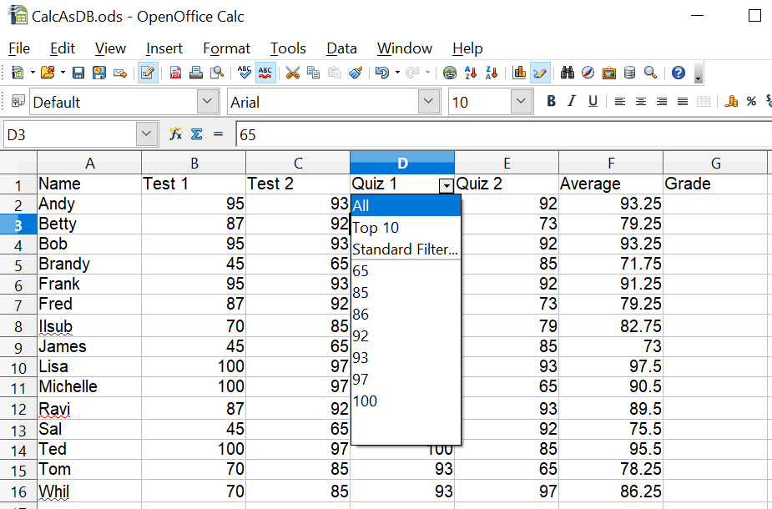
Figure 6: Use an auto filter with column C
Remove an auto filter by repeating the steps to create it—in other words, the menu option acts as a toggle to turn the auto filter on and off. When an auto filter is removed, the combo box is removed from the cell. The menu Data > Filter also has an option to Hide AutoFilter, which also removes the filter's drop-down list.

Standard Filters
Use Data > Filter > Standard Filter to open the Standard Filter dialog (see Figure 7) and limit the view based on one or more filter conditions. Use Data > Filter > Remove Filter to turn off the filter.
You can set multiple conditions referring to one or more columns. The conditions can be linked by either an OR or AND condition. It is important to set the link correctly. In Figure 7, the filter has been set to allow two values for the Quiz 1 column. If these two conditions were linked by AND, the filter would hide every row because a cell cannot have values of 67 and 77 simultaneously.
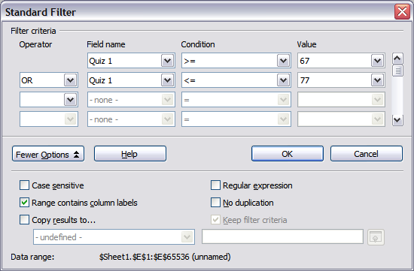
Figure 7: Use the standard filter
Clicking the More Options button in the Standard Filter dialog displays several useful options. Selecting Copy results to... allows you to send the filter results to another location. The Regular expression option allows using wildcard text matching. The No duplication option will display only unique rows if the filter results are sent to a different location.

Advanced Filters
An advanced filter supports up to eight filter conditions. The criteria for an advanced filter is stored in a sheet. The first step in creating an advanced filter is entering the filter criteria into the spreadsheet.
- Select an empty space in the Calc document. The empty space may reside in any sheet in any location in the Calc document.
- Duplicate the column headings from the area to be filtered into the area that will contain the filter criteria.
- Enter the filter criteria underneath the column headings (see Table 25). The criterion in each column of a row is connected with AND. The criteria from each row are connected with OR.
Table 14. Example advanced filter criteria
Name | Test 1 | Test 2 | Quiz 1 | Quiz 2 | Average | Grade
="Andy" |  | >80
 |  |  |  |  | <80

Tip | Define named ranges to reference your advanced filter criteria and any destination ranges for filtered data (see Figure 1). Each appropriately configured named range is available in drop-down list boxes in the Advanced Filter dialog (see Figure 8).
After creating the filter criteria, apply an advanced filter as follows:
- Select the sheet ranges that contain the data to be filtered.
- Use Data > Filter > Advanced Filter to open the Advanced Filter dialog (see Figure 8).
- Select the range containing the filter criteria and any other relevant options.
- Click OK.

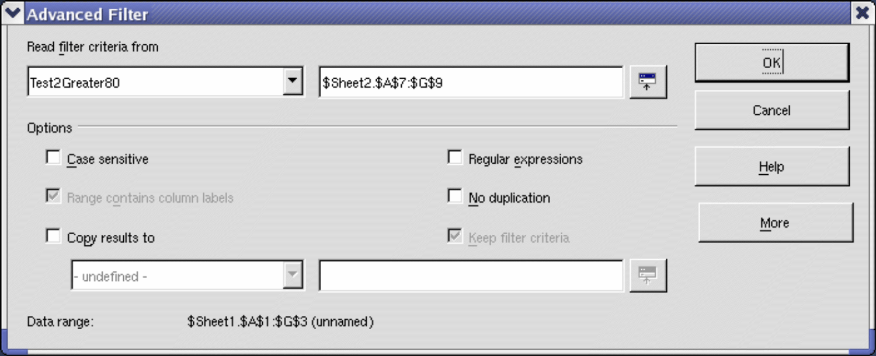 Figure 8. Apply an advanced filter using a previously defined named range.

Manipulating Filtered Data
Filtered data copied to a new location may be selected, modified, and deleted at will. However, data that is not copied requires special attention because rows that do not match the filter criteria are hidden. OpenOffice behaves differently depending on how the cells were hidden and the operation done.
Cells may be hidden using an outline, data filter, or the hide command. When data is moved by dragging or using cut and paste, all of the cells are moved, including the hidden cells. When copying data, however, filtered data includes only the visible cells, and data hidden using an outline or the hide command copies all of the data.

Calc Functions Similar to Database Functions
Although every Calc function can be used for database manipulation, the functions in Table 15 are those most frequently used in that way. Some functions’ names differ only by the letter appended at the end; AVERAGE and AVERAGEA, for example. Functions that do not end with the letter A operate only on numeric values, and cells that contain text or are empty are ignored. The corresponding function, whose name ends with the letter A, treats text values as a number with the value of zero; blank cells are still ignored.
Table 15. Functions frequently used as database functions.
Function | Description
AVERAGE | Return the average. Ignore empty cells and cells that contain text.
AVERAGEA | Return the average. The value of text is 0 and empty cells are ignored.
COUNT | Count the number of numeric entries; text entries are ignored.
COUNTA | Count the number of non-empty entries.
COUNTBLANK | Return the number of empty cells.
COUNTIF  COUNTIFS | Return the number of cells that meet the search criteria. COUNTIF accepts one criterion, COUNTIFS accepts multiple criteria.
HLOOKUP | Search for a specific value across the columns in the first row of an array. Return the value from a different row in the same column.
INDEX | Return the content of a cell, specified by row and column number or an optional range name.
INDIRECT | Return the reference specified by a text string, e.g., "C26".
LOOKUP | Return the contents of a cell either from a one-row or one-column range or from an array.
MATCH | Search an array and return the relative position of the found item.
MAX | Return the maximum numeric value in a list of arguments.
MAXA | Return the maximum numeric value in a list of arguments. The value of text is 0.
MIN | Return the minimum numeric value in a list of arguments.
MINA | Return the minimum numeric value in a list of arguments. The value of text is 0.
MEDIAN | Return the median of a set of numbers.
MODE | Return the most common value in a data set. If several values have the same frequency, it returns the smallest value. An error occurs when all values are unique.
OFFSET | Return a cell range or the value of a single cell offset by a certain number of rows and columns from a given reference point and spanning a given number of rows and columns. In other words, locates a cell or the data in it that lies x rows and y columns away from the starting point you give it.
PRODUCT | Return the product of the cells.
STDEV | Estimate the standard deviation based on a sample.
STDEVA | Estimate the standard deviation based on a sample. The value of text is 0.
STDEVP | Calculate the standard deviation based on the entire population.
STDEVPA | Calculate the standard deviation based on the entire population. The value of text is 0.
SUBTOTAL | Calculate a specified function based on a subset created using AutoFilters.
SUM | Return the sum of the cells.
SUMIF  SUMIFS | Calculate the sum for the cells that meet the search criteria. SUMIF takes one criterion, SUMIFS accepts multiple criteria.
SUMPRODUCT | Can be used to calculate counts or sums that meet multiple criteria. The calculation does element-wise multiplication of the given cell ranges and then sums those products. See below for more details.
VAR | Estimate the variance based on a sample.
VARA | Estimate the variance based on a sample. The value of text is 0.
VARP | Calculate the variance based on the entire population.
VARPA | Calculate the variance based on the entire population. The value of a text is 0.
VLOOKUP | Search for a specific value across the rows in the first column of an array. Returns the value from a different column in the same row.
Most of the functions in Table 15 require no explanation, either because they are well understood (SUM, for example) or because if you need to use them, you know what they are (STDEV, for example). Unfortunately, some of the more useful functions are infrequently used because they are not well understood. For instance, stdev or standard deviation measures how widely a value differs from the average value or mean of the category. Variance and standard deviation are measures of how spread out data points are from the mean, but differ in how they are calculated. Variance is the average of the squared differences from the mean, while standard deviation is the square root of the variance. Essentially, standard deviation is the square root of variance.

Count and Sum Cells that Match Conditions: COUNTIF, COUNTIFS, SUMIF, SUMIFS, and SUMPRODUCT
The COUNTIF, COUNTIFS, SUMIF, and SUMIFS functions calculate their values based on search criteria. The search criteria can be a number, expression, text string, or even a regular expression. The search criteria can be contained in a referenced cell or included directly in the function call.
The COUNTIF function counts the number of cells in a range that match specified criteria. The first argument to COUNTIF specifies the range to search, and the second argument is the search criteria. Table 16 illustrates different search criteria using the COUNTIF function referencing the data shown in Table 26.

Tip | If you want to try the formulas using the data in Table 1 and you are reading this document in Writer, you can copy the data from Table 1 directly to a spreadsheet. Select the cells containing the data, excluding the headers A-G and the row numbers 1-16, then copy and paste them into a Calc document.
The COUNTIFS function works in much the same way, but it accepts multiple criteria. The function syntax accepts the first search range and then the first search condition. This is optionally followed by a second search range and a second condition. Additional ranges and conditions can also be added.
The first two arguments for SUMIF serve the same purpose as the arguments for COUNTIF; the range that contains the cells to search and the search criteria. The third and final argument for SUMIF specifies the range to sum. For each cell in the search range that matches the search criteria, the corresponding cell in the sum range is added to the sum.
To accommodate multiple criteria, the SUMIFS function has the range to sum as the first argument. This is followed by pairs of arguments listing the search ranges and the search conditions. For example,
=SUMIFS(C1:C10;A1:A10; ">2";B1:B10;"<4")
calculates the sum of cells in C1:C10 where the corresponding cells in A1:A10 are greater than 2 and the corresponding cells in B1:B10 are less than 4.
Table 16. Examples of search criteria for the COUNTIF and SUMIF functions.
Criteria Type | Function | Result | Description
Number | =COUNTIF(B1:C16; 95) | 3 | Finds numeric values of 95.
Text | =COUNTIF(B1:C16; "95") | 3 | Finds numeric or text values of 95.
Expression | =COUNTIF(B1:C16; ">95") | 6 | Finds numeric values greater than 95.
Expression | =COUNTIF(B1:C16; 2*45+5) | 3 | Finds only numeric values of 95.
Regular expression | =COUNTIF(B1:C16; "9.*") | 12 | Finds numbers or text that start with 9.
Reference a cell | =COUNTIF(B1:C16; B3) | 3 | Finds a number or a number and text depending on the data type in cell B3.
Regular expression | =SUMIF(A1:A16; "B.*"; B1:B16) | 227 | Sum Column B for names in Col. A starting with the letter B.
SUMPRODUCT can return either a sum or a count, and uses a different syntax from the COUNTIF and SUMIF functions. The basic function of SUMPRODUCT is to do element-wise multiplication of cell ranges and then add those products. For example, the formula =SUMPRODUCT(A1:A3;B1:B3)returns the result of A1*B1 + A2*B2 + A3*B3. That is, the first elements of all the ranges are multiplied, and the second elements of each range are multiplied, continuing to the end of the ranges. Then, the multiplication results are added. The example only has two ranges, but there could be more.
SUMPRODUCT's use for counting and summing relies on the fact that comparisons in Calc return numeric values. If a comparison is TRUE, the value returned is 1. If the comparison is FALSE, the value returned is 0. This is easily seen with a simple formula. If cell B1 contains the formula = A1 < 2, the value will be displayed as either TRUE or FALSE, depending on the value of A1. If you use the menu Format > Cells to format B1 to display an integer, the TRUE and FALSE conditions will be 1 and 0. With SUMPRODUCT, if you write =SUMPRODUCT(A1:A10 > 3), the comparison will return a 1 or a 0 for each position in A1:A10, depending on whether the cell is greater than 3. The ones and zeros are then summed (no multiplication occurs because there is only one range), resulting in a count of how many cells in A1:A10 are greater than 3.
If you use two ranges, as in =SUMPRODUCT(A1:A10 > 3;B1:B10 < 10), the comparison translates the values in the cells into ones and zeros, and then the element-wise multiplication occurs. If either condition is FALSE, the multiplication results in a zero. Only if both (all) conditions are TRUE does the multiplication result in a 1. When the multiplication results are added, we get a count of the rows where all the conditions were true.
To use SUMPRODUCT to compute a conditional sum, all that is required is that the column to be summed without any comparison. Its values then remain as they are, not translated into ones and zeros. Table 17 shows the steps taken in calculating =SUMPRODUCT(A1:A5 > 3; B1:B5 < 10; C1:C5). In a spreadsheet, the intermediate steps happen internally and are not displayed. The spreadsheet would have only the raw data and one cell containing the SUMPRODUCT formula. The intermediate steps are shown only to illustrate the logic of the calculation.
Table 17: Steps for Calculating SUMPRODUCT(A1:A5 > 3; B1:B5 < 10; C1:C5)
Raw Data |  |  | After Comparison
A | B | C | A' | B' | C' | A' * B' * C' | Sum
5 | 9 | 7 | 1 | 1 | 7 | 7 | 13
3 | 8 | 5 | 0 | 1 | 5 | 0 | 13
7 | 12 | 9 | 1 | 0 | 9 | 0 | 13
2 | 18 | 4 | 0 | 0 | 4 | 0 | 13
8 | 5 | 6 | 1 | 1 | 6 | 6 | 13

An important advantage of using SUMPRODUCT to conditionally count or sum cells is that you can use any function within it that returns a TRUE or FALSE. For example, you might want to sum all the cells in B2:B100 where column A is blank. This is not easily done with SUMIF. With SUMPRODUCT, you can use the function ISBLANK and easily get the result: =SUMPRODUCT(ISBLANK(A2:A100); B2:B100). There are several IS* functions, such as ISERROR, ISNUMBER, ISTEXT (see the Calc Help for a complete list), that can be combined with SUMPRODUCT in powerful ways.

Ignore Filtered Cells Using SUBTOTAL
The SUBTOTAL function applies a function (see Table 18) to a range of data, but it ignores cells hidden by a filter and cells that already contain a SUBTOTAL. For example, =SUBTOTAL(2, "B2:B16") counts the number of cells in B2:B16 that are not hidden by a filter.
Table 18. Function index for the SUBTOTAL function.
Function index | Function
1 | AVERAGE
2 | COUNT
3 | COUNTA
4 | MAX
5 | MIN
6 | PRODUCT
7 | STDEV
8 | STDEVP
9 | SUM
10 | VAR
11 | VARP

Tip | Do not forget that the SUBTOTAL function ignores cells that use the SUBTOTAL function. Let's say you have a spreadsheet that tracks investments. Retirement investments are grouped together with a subtotal. The same is true of regular investments. You can use a single subtotal that includes the entire range without worrying about the subtotal cells.

Using Formulas to Find Data
Calc offers numerous methods to find data in a sheet. For example, Edit > Find & Replace moves the display cursor based on simple and advanced searching. Use Data > Filter to limit what is displayed rather than simply moving the cursor. Calc also offers lookup functions used in formulas, for example, a formula to look up a student’s grade based on their test score.

Search a Block of Data Using VLOOKUP
Use VLOOKUP to search the first column (columns are vertical) of a block of data and return the value from another column in the same row. For example, search the first column for the name “Fred” and then return the value in the cell two columns to the right. VLOOKUP supports two forms:
VLOOKUP(search_value; search_range; return_column_index)
VLOOKUP(search_value; search_range; return_column_index; sort_order)
The first argument, search_value, identifies the value to find. The search value can be text, a number, or a regular expression. For example, Fred searches for the text Fred, 4 searches for the number 4, and F.* is the regular expression for finding something that starts with the letter F.
The second argument, search_range, identifies the cells to search; only the first column is searched. For example, B3:G10 searches the same sheet containing the VLOOKUP formula, and Sheet2.B3:G10 searches the range B3:G10 on Sheet2.
The return_column_index identifies the column to return; a value of 1 returns the first column in the range. The statement =VLOOKUP("Bob"; A1:G9; 1) finds the first row in A1:G9 containing the text Bob, and returns the value in the first column. The first column is the searched column, so the text Bob is returned. If the column index is 2, then the value in the cell to the right of Bob is returned: column B.
The final column, sort_order, is optional. The default value for sort_order is 1, which specifies that the first column is sorted in ascending order; a value of 0 specifies that the data is not sorted. A non-sorted list is searched by sequentially checking every cell in the first column for an exact match. If an exact match is not found, the text #N/A is returned.
A more efficient search routine is used if the data is sorted in ascending order. If one exact match exists, the returned value is the same as for a non-sorted list, but it is faster. If a match does not exist, the largest value in the column that is less than or equal to the search value is returned. For example, searching for 7 in (3, 5, 10) returns 5 because 7 is between 5 and 10. Searching for 27 returns 10, and searching for 2 returns #N/A because there is no match and no value less than 2.
If sort_order is omitted or set to 1 and the first column is not sorted in ascending order, the returned value is unpredictable. This is a common mistake; it may be hard to detect because an error is not identified, and the returned value may be correct when the formula is first used. It is a good idea to set sort_order explicitly in all cases.
Use VLOOKUP when:
- The data is arranged in rows, and you want to return data from the same row, for example, student names with test and quiz scores to the right of the student’s name.
- Searching the first column of a range of data.

Search a Block of Data Using HLOOKUP
Use HLOOKUP to search the first row (rows are horizontal) of a block of data and return the value from a row in the same column. HLOOKUP supports the same form and arguments as VLOOKUP:
HLOOKUP(search_value; search_range; return_row_index)
HLOOKUP(search_value; search_range; return_row_index; sort_order)
Use HLOOKUP when:
- The data is arranged in columns, and you want to return data from the same column, for example, student names with test and quiz scores underneath the student’s name.
- Searching the first row of a range of data.

Search a Row or Column Using LOOKUP
LOOKUP is similar to HLOOKUP and VLOOKUP. The search range for the LOOKUP function is a single sorted row or column. LOOKUP has two forms:
LOOKUP(search_value; search_range)
LOOKUP(search_value; search_range; return_range)
The search value is the same as HLOOKUP and VLOOKUP. The search range, however, must be a single row or a single column; for example, A7:A12 (values in column A) or C5:Q5 (values in row 5). If the return_range is omitted, the matched value is returned. Using LOOKUP without a return range is the same as using HLOOKUP or VLOOKUP with a column index of 1, except that LOOKUP always assumes the data is sorted. Using LOOKUP on a search range that is not sorted can produce incorrect results.
The return range must be a single row or column containing the same number of elements as the search range. If the search value is found in the fourth cell in the search range, then the value in the fourth cell in the return range is returned. The return range can have a different orientation than the search range. In other words, the search range can be a row, and the return range may be a column.
Use LOOKUP when:
- The search data is sorted in ascending order.
- The search data is not stored in the same row, column, or orientation as the return data.

Use MATCH to Find the Index of a Value in a Range
Use MATCH to search a single row or column and return the position that matches the search value. Use MATCH to find the index of a value in a range. The supported forms for MATCH are as follows:
=MATCH(search_value; search_range)
=MATCH(search_value; search_range; search_type)
The search value and search range are the same as for LOOKUP. The final argument, search type, controls how the search is performed. A search type of 1, sorted in ascending order, is the default. A search type of -1 indicates that the list is sorted in descending order. A search type of 0 indicates that the list is not sorted. Regular expressions can only be used on an unsorted list.
Use MATCH when:
- You need an index into the range rather than the value. By index, we mean the position within a set of values that a specific value occupies.
- The search data is in descending order, and the data is large enough that it must be searched assuming that it is sorted, because it is faster to sort a sorted list.

Examples
Consider the data in Table 26. Each student’s information is stored in a single row. Write a formula to return Fred's average grade. The problem can be restated as: search column A in the range A1:G16 for Fred and return the value in column F (column F is the sixth column). The obvious solution is =VLOOKUP("Fred"; A2:G16; 6). Just as useful is =LOOKUP("Fred"; A2:A16; F2:F16).
It is common for the first row in a range to contain column headers. All search functions check the first row to see if there is a match and then ignore it if it does not, in case the first row is a header.
What if the column heading Average is known, but not the column containing the average? Find the column containing Average rather than hard-coding the value 6. A slight modification using MATCH to find the column yields =VLOOKUP("Fred"; A2:G16; MATCH("Average"; A1:G1; 0)); notice that the heading is not sorted. As an exercise, use HLOOKUP to find Average and then MATCH to find the row containing Fred.
As a final example, write a formula to assign grades based on a student’s average score. Assume that a score less than 51 is an F, less than 61 is an E, less than 71 is a D, less than 81 is a C, less than 91 is a B, and 91 to 100 is an A. Assume that the values in Table 19 are in Sheet2.
Table 19. Associate scores to a grade.
 | A | B
1 | Score | Grade
2 | 0 | F
3 | 51 | E
4 | 61 | D
5 | 71 | C
6 | 81 | B
7 | 91 | A
The formula =VLOOKUP(83; $Sheet2.$A$2:$B$7; 2) is a solution.
This will return B because 81 is the last value less than or equal to 83, and B is in the second column of Sheet2.A2:B7. Dollar signs are used so that the formula can be copied and pasted to a different location and still reference the same values in Table 19.

ADDRESS Returns a String with a Cell’s Address
Use ADDRESS to return a text representation of a cell address based on the row, column, and sheet; ADDRESS is frequently used with MATCH. The supported forms for ADDRESS are as follows:
ADDRESS(row; column)
ADDRESS(row; column; abs)
ADDRESS(row; column; abs; sheet)
The row and column are integer values where ADDRESS(1; 1) returns $A$1. The abs argument specifies which portion is considered absolute and which portion is considered relative (see Table 20); an absolute address is specified using the $ character. The sheet is included as part of the address only if the sheet argument is used. The sheet argument is treated as a string. Using ADDRESS(MATCH("Bob";A1:A5 ; 0); 2) with the data in Table 26 returns $B$4 because the row is set by MATCH("Bob";A1:A5 ; 0) and it returns 4, and the column is set to 2.
Tip | Calc supports numerous powerful functions that are not discussed here. For example, the ROW, COLUMN, ROWS, and COLUMNS statements are not discussed.

Table 20. Values supported by the abs argument to ADDRESS.
Value | Description
1 | Use absolute addressing. This is the default value if the argument is missing or an invalid value is used. ADDRESS(2; 5; 1) returns $E$2.
2 | Use an absolute row reference and a relative column reference. ADDRESS(2; 5; 2; "Blah") returns Blah.E$2.
3 | Use a relative row reference and an absolute column reference. ADDRESS(2; 5; 3) returns $E2.
4 | Use relative addressing. ADDRESS(2; 5; 4) returns E2.

INDIRECT Converts a String to a Cell or Range
Use INDIRECT to convert a string representation of a cell or range address to a reference to the cell or range. Table 21 contains examples accessing data as shown in Table 19.
Table 21. Examples using INDIRECT.
Example | Comment
INDIRECT("A2") | Returns cell A2, which contains 0.
INDIRECT(G1) | If Cell G1 contains the text A2, then this returns 0.
SUM(INDIRECT("A2:A7")) | Returns the sum of the range A2:A7, which is 355.
INDIRECT(ADDRESS(2; 1)) | Returns the contents of cell $A$2, which is 0.

OFFSET Returns a Cell or Range Offset From Another
Use OFFSET to return a cell or range offset by a specified number of rows and columns from a given reference point. The first argument specifies the reference point. The second and third arguments specify the number of rows and columns to move from the reference point, in other words, where the new range starts. The OFFSET function has the following syntax:
OFFSET(reference; rows; columns)
OFFSET(reference; rows; columns; height)
OFFSET(reference; rows; columns; height; width)
Tip | If the width or height is greater than one, the OFFSET function returns a range. If both the width and height are missing or equal 1, a cell value is returned.

If the height or width is missing, they default to 1. Using values from Table 26, Listing 10 uses OFFSET to obtain the sum of the quiz scores for the student named Bob.
Listing 10. Complex example of OFFSET.
=SUM(OFFSET(INDIRECT(ADDRESS(MATCH("Bob";A1:A16; 0); 4)); 0; 0; 1; 2))
In its entirety, Listing 10 is complex and difficult to understand. Table 22 isolates each function in Listing 10, making the listing more understandable.
Table 22. Breakdown of Listing 10.
Function | Description
MATCH("Bob";A1:A16; 0) | Return 4 because Bob is the fourth entry in column A.
ADDRESS(4; 4) | Return "$D$4".
INDIRECT("$D$4") | Convert "$D$4" into a reference to the cell D4.
OFFSET($D$4; 0; 0; 1; 2) | Return the range D4:E4.
SUM(D4:E4) | Return the sum of Bob’s quiz scores.
Although Listing 10 works as intended, it breaks easily and unexpectedly. Consider, for example, what happens if the range is changed to A2:A16. MATCH returns an offset into the provided range, so MATCH("Bob";A2:A16 ; 0) returns 3 rather than 4. ADDRESS(3; 4) returns $D$3 rather than $D$4, and Betty’s quiz scores are returned instead of Bob’s. Listing 11 uses a slightly different method to obtain Bob’s quiz scores.
Listing 11. Better use of OFFSET.
=SUM(OFFSET(A1; MATCH("Bob"; A1:A16; 0)-1; 3; 1; 2))
Table 23 contains a description of each function used in Listing 11. To see that Listing 11 is better than Listing 10, replace A1 with A2 in Listing 11, and notice that you still obtain Bob’s quiz scores.
Table 23. Breakdown of Listing 11.
Function | Description
MATCH("Bob";A1:A16; 0)-1 | Return 3 because Bob is the fourth entry in column A.
OFFSET(A1; 3; 3; 1; 2) | Return the range D4:E4.
SUM(D4:E4) | Return the sum of Bob’s quiz scores.

Tip | The first argument to OFFSET can be a range, so you can use a defined range name.
Using formulas as complex as the OFFSET examples with the name Bob coded in the formula is not a good solution, and was used here only for clarity. It would be much more efficient to write the text Bob in a cell, say H2, and write the MATCH part of the function as MATCH($H$2; A1:A16; 0). The text in H2 could then be conveniently changed to bring up any student's quiz score.

INDEX Returns Cells Inside a Specified Range
INDEX returns the cells specified by a row and column number. The row and column number are relative to the upper left corner of the specified reference range. For example, using =INDEX(B2:D3; 1; 1) returns the cell B2. Table 24 shows the syntax for using the INDEX function.
Table 24. Syntax for INDEX.
Syntax | Description
INDEX(reference) | Return the entire range.
INDEX(reference; row) | Return the specified row in the range.
INDEX(reference; row; column) | Return the cell specified by row and column. A row and column of 1 returns the cell in the upper left corner of the range.
INDEX(reference; row; column; range) | A reference range can contain multiple ranges. The range argument specifies which range to use.
The INDEX function can return an entire range, a row, or a single column (see Table 24). The ability to index based on the start of the reference range provides some interesting uses. Using the values shown in Table 26, Listing 12 finds and returns the sum of Bob’s quiz scores. Table 14 contains a listing of each function used in Listing 12.
Listing 12. Return Bob’s quiz scores.
=SUM(OFFSET(INDEX(A2:G16; MATCH("Bob"; A2:A16; 0)); 0; 3; 1; 2))
Table 25. Breakdown of Listing 12.
Function | Description
MATCH("Bob";A2:A16; 0) | Return 3 because Bob is the third entry in column A2:A16.
INDEX(A2:A16; 3) | Return A4:G4—the row containing Bob’s quiz scores.
OFFSET(A4:G4; 0; 3; 1; 2) | Return the range D4:E4.
SUM(D4:E4) | Return the sum of Bob’s quiz scores.

Tip | A simple range contains one contiguous rectangular region of cells. It is possible to define a multi-range that contains multiple simple ranges. If the reference consists of multiple ranges, you must enclose the reference or range name in parentheses.
If the reference argument to the INDEX function is a multi-range, then the range argument specifies which simple range to use (see Table 13).
Table 26. Using INDEX with a multi-range.
Function | Returns
=INDEX(B2:G2; 1; 2) | 93
=INDEX(B5:G5; 1; 2) | 65
=INDEX((B2:G2;B5:G5); 1; 2) | 93
=INDEX((B2:G2;B5:G5); 1; 2; 1) | 93
=INDEX((B2:G2;B5:G5); 1; 2; 2) | 65

Database-specific Functions
Although every Calc function can be used for database manipulation, the functions in Table 27 are specifically designed for use as a database. The descriptions in Table 27 use the following terms interchangeably: row and record, cell and field, and database and all rows.
Table 27. Database functions in a Calc document.
Function | Description
DAVERAGE | Return the average of all fields that match the search criteria.
DCOUNT | Count the number of records containing numeric data that match the search criteria.
DCOUNTA | Count the number of records containing text data that match the search criteria.
DGET | Return the contents of a field that matches the search criteria.
DMAX | Return the maximum content of the fields that match the search criteria.
DMIN | Return the minimum content of the fields that match the search criteria.
DPRODUCT | Return the product of the fields that match the search criteria.
DSTDEV | Calculate the standard deviation using the fields that match the search criteria. The fields are treated as a sample.
DSTDEVP | Calculate the standard deviation using the fields that match the search criteria. The fields are treated as the entire population.
DSUM | Return the sum of all fields that match the search criteria.
DVAR | Calculate the variance using the fields that match the search criteria. The fields are treated as a sample.
DVARP | Calculate the variance using the fields that match the search criteria. The fields are treated as the entire population.
The syntax for the database functions is identical.
DCOUNT(database; database field; search criteria)
The database argument is the cell range that defines the database. The cell range should contain the column labels (see Listing 13). The following examples assume that the data from Table 26 is placed in Sheet 1 and the filter criteria in Table 25 is placed in Sheet 2.
Listing 13. The database argument includes the headers.
=DCOUNT(A1:G16; "Test 2"; Sheet2.A1:G3)
The database field specifies the column on which the function operates after the search criteria is applied and the data rows are selected. The database field can be specified using the column header name or as an integer. If the column is specified as an integer, 0 specifies the entire data range, 1 specifies the first column, 2 specifies the second column, and so on. Listing 14 calculates the average test score for the rows that match the search criteria.
Listing 14. “Test 2” is column 3.
=DAVERAGE(A1:G16; "Test 2"; Sheet2.A1:G3)
=DAVERAGE(A1:G16; 3; Sheet2.A1:G3)
The search criteria is the cell range containing search criteria. The search criteria is identical to the advanced filters; criteria in the same row are connected by AND and criteria in different rows are connected by OR.

Macros for a Calc Database
The following sections provide macro code examples for automating the manipulation of named ranges, database ranges, and filtering. The code has many comments and will be very helpful for those already familiar with OpenOffice macros. These examples do not include explanations of the OpenOffice Basic language and the Application Programming Interface, which are fundamental to writing macros.

Macros for Named Ranges
In a macro, a named range is accessed, created, and deleted using the NamedRanges property of a Calc document. Use the methods hasByName(name) and getByName(name) to verify and retrieve a named range. The method getElementNames() returns an array containing the names of all named ranges. The NamedRanges object supports the method addNewByname, which accepts four arguments: the name, content, position, and type. The macro in Listing 15 creates a named range, if it does not exist, which references a range of cells.
Listing 15. Create a named range that references $Sheet1.$B$3:$D$6.
Sub AddNamedRange()
Dim oRange ' The created range.
Dim oRanges ' All named ranges.
Dim sName$ ' Name of the named range to create.
Dim oCell ' Cell object.
Dim s$

sName$ = "MyNRange"
oRanges = ThisComponent.NamedRanges
If NOT oRanges.hasByName(sName$) Then
REM Obtain the cell address by obtaining the cell
REM and then extracting the address from the cell.
Dim oCellAddress As new com.sun.star.table.CellAddress
oCellAddress.Sheet = 0 'The first sheet.
oCellAddress.Column = 1 'Column B.
oCellAddress.Row = 2 'Row 3.

REM The first argument is the range name.
REM The second argument is the formula or expression to use.
REM The second argument is usually a string that
REM defines a range.
REM The third argument specifies the base address for
REM relative cell references.
REM The fourth argument is a set of flags that define
REM how the range is used, but most ranges use 0.
REM The fourth argument uses values from the
REM NamedRangeFlag constants (see Table 28).
s$ = "$Sheet1.$B$3:$D$6"
oRanges.addNewByName(sName$, s$, oCellAddress, 0)
End If
REM Get a range using the created named range.
oRange = ThisComponent.NamedRanges.getByName(sName$)

REM Print the string contained in cell $Sheet1.$B$3
oCell = oRange.getReferredCells().getCellByPosition(0,0)
Print oCell.getString()
End Sub
The method addNewByname() accepts four arguments: the name, content, position, and type. The fourth argument to the method addNewByName() is a combination of flags that specify how the named range will be used (see Table 28). The most common value is 0, which is not a defined constant value.
Table 28. com.sun.star.sheet.NamedRangeFlag constants.
Value | Name | Description
1 | FILTER_CRITERIA | The range contains filter criteria.
2 | PRINT_AREA | The range can be used as a print range.
4 | COLUMN_HEADER | The range can be used as column headers for printing.
8 | ROW_HEADER | The range can be used as row headers for printing.
The third argument, a cell address, acts as the base address for cells referenced relatively. If the cell range is not specified as an absolute address, the referenced range will differ based on where in the spreadsheet the range is used. The relative behavior is illustrated in Listing 16, which also illustrates another usage of a named range—defining an equation. The macro in Listing 16 creates the named range AddLeft, which refers to the equation A3+B3 with C3 as the reference cell. The cells A3 and B3 are the two cells directly to the left of C3 so the equation =AddLeft() calculates the sum of the two cells directly to the left of the cell that contains the equation. Changing the reference cell to C4, which is below A3 and B3, causes the AddLeft equation to calculate the sum of the two cells to the left on the previous row.
Listing 16. Create the AddLeft named range.
Sub AddNamedFunction()
Dim oSheet 'Sheet that contains the named range.
Dim oCellAddress 'Address for relative references.
Dim oRanges 'The NamedRanges property.
Dim oRange 'Single cell range.
Dim sName As String 'Name of the equation to create.

sName = "AddLeft"
oRanges = ThisComponent.NamedRanges
If NOT oRanges.hasByName(sName) Then
oSheet = ThisComponent.getSheets().getByIndex(0)
oRange = oSheet.getCellRangeByName("C3")
oCellAddress = oRange.getCellAddress()
oRanges.addNewByName(sName, "A3+B3", oCellAddress, 0)
End If
End Sub
Tip | Listing 16 illustrates two capabilities that are not widely known. First, a named range can define a function. Also, the third argument acts as the base address for cells referenced relatively.

Naming Multiple Ranges
The macro in Listing 17 creates three named ranges based on the top row of a named range.
Listing 17. Create many named ranges.
Sub AddManyNamedRanges()
Dim oSheet 'Sheet that contains the named range.
Dim oAddress 'Range address.
Dim oRanges 'The NamedRanges property.
Dim oRange 'Single cell range.

oRanges = ThisComponent.NamedRanges
oSheet = ThisComponent.getSheets().getByIndex(0)
oRange = oSheet.getCellRangeByName("A1:C20")
oAddress = oRange.getRangeAddress()
oRanges.addNewFromTitles(oAddress, _
com.sun.star.sheet.Border.TOP)
End Sub
The constants in Table 29 determine the location of the headers when multiple ranges are created using the method addNewFromTitles().
Table 29. com.sun.star.sheet.Border constants.
Value | Name | Description
0 | TOP | Select the top border.
1 | BOTTOM | Select the bottom border.
2 | RIGHT | Select the right border.
3 | LEFT | Select the left border.

Caution | It is possible to create multiple named ranges with the same name. Creating multiple ranges with a single command increases the likelihood that multiple ranges will be created with the same name. Avoid this if possible.

Macro for a Database Range
In a macro, a database range is accessed, created, and deleted from the DatabaseRanges property. The macro in Listing 18 creates a database range named MyName and sets the range to be used as an auto filter.
Listing 18. Create a database range and an auto filter.
Sub AddNewDatabaseRange()
Dim oRange 'DatabaseRange object.
Dim oAddr 'Cell address range for the database range.
Dim oSheet 'First sheet, which will contain the range.
Dim oDoc 'Reference ThisComponent with a shorter name.

oDoc = ThisComponent
If NOT oDoc.DatabaseRanges.hasByName("MyName") Then
oSheet = ThisComponent.getSheets().getByIndex(0)
oRange = oSheet.getCellRangeByName("A1:F10")
oAddr = oRange.getRangeAddress()
oDoc.DatabaseRanges.addNewByName("MyName", oAddr)
End If
oRange = oDoc.DatabaseRanges.getByName("MyName")
oRange.AutoFilter = True
End Sub

Macros for Filtering
The macro in Listing 19 creates a simple filter for the first sheet.
Listing 19. Create a simple sheet filter.
Sub SimpleSheetFilter()
Dim oSheet ' Sheet that will contain the filter.
Dim oFilterDesc ' Filter descriptor.
Dim oFields(0) As New com.sun.star.sheet.TableFilterField

oSheet = ThisComponent.getSheets().getByIndex(0)

REM If argument is True, creates an empty filter
REM descriptor. If argument is False, create a
REM descriptor with the previous settings.
oFilterDesc = oSheet.createFilterDescriptor(True)

With oFields(0)
REM You could use the Connection property to indicate
REM how to connect to the previous field. This is
REM the first field, so this is not required.
'.Connection = com.sun.star.sheet.FilterConnection.AND
'.Connection = com.sun.star.sheet.FilterConnection.OR

REM The Field property is the zero based column
REM number to filter. If you have the cell, you
REM can use .Field = oCell.CellAddress.Column.
.Field = 5

REM Compare using a numeric or a string?
.IsNumeric = True

REM The NumericValue property is used
REM because .IsNumeric = True from above.
.NumericValue = 80

REM If IsNumeric was False, then the
REM StringValue property would be used.
REM .StringValue = "what ever"

REM Valid operators include EMPTY, NOT_EMPTY, EQUAL,
REM NOT_EQUAL, GREATER, GREATER_EQUAL, LESS,
REM LESS_EQUAL, TOP_VALUES, TOP_PERCENT,
REM BOTTOM_VALUES, and BOTTOM_PERCENT
.Operator = com.sun.star.sheet.FilterOperator.GREATER_EQUAL
End With

REM The filter descriptor supports the following
REM properties: IsCaseSensitive, SkipDuplicates,
REM UseRegularExpressions,
REM SaveOutputPosition, Orientation, ContainsHeader,
REM CopyOutputData, OutputPosition, and MaxFieldCount.
oFilterDesc.setFilterFields(oFields())
oFilterDesc.ContainsHeader = True
oSheet.filter(oFilterDesc)
End Sub
When a filter is applied to a sheet, it replaces any existing filter for that sheet. Setting an empty filter in a sheet will therefore remove all filters for the sheet (see Listing 20).
Listing 20. Remove the current sheet filter.
Sub RemoveSheetFilter()
Dim oSheet ' Sheet to filter.
Dim oFilterDesc ' Filter descriptor.

oSheet = ThisComponent.getSheets().getByIndex(0)
oFilterDesc = oSheet.createFilterDescriptor(True)
oSheet.filter(oFilterDesc)
End Sub
Listing 21 demonstrates a more advanced filter that filters two columns and uses regular expressions. Some behavior of Listing 21 may be unexpected. Although you can create a filter descriptor using any sheet cell range, the filter applies to the entire sheet. This is seen in the code
.Field = 0 ' Filter column A
where column A is referred to with the index 0, that is, as the first column, though the Filter Descriptor was constructed from the cell range E12:G19, and you might expect column E to have the index of zero.
Listing 21. A simple sheet filter using two columns.
Sub SimpleSheetFilter_2()
Dim oSheet ' Sheet to filter.
Dim oRange ' Range to be filtered.
Dim oFilterDesc ' Filter descriptor.
Dim oFields(1) As New com.sun.star.sheet.TableFilterField

oSheet = ThisComponent.getSheets().getByIndex(0)
oRange = oSheet.getCellRangeByName("E12:G19")

REM If argument is True, creates an
REM empty filter descriptor.
oFilterDesc = oRange.createFilterDescriptor(True)

REM Setup a field to view cells with content that
REM start with the letter b.
With oFields(0)
.Field = 0 ' Filter column A.
.IsNumeric = False ' Use a string, not a number.
.StringValue = "b.*" ' Everything starting with b.
.Operator = com.sun.star.sheet.FilterOperator.EQUAL
End With
REM Setup a field that requires both conditions and
REM this new condition requires a value greater or
REM equal to 70.
With oFields(1)
.Connection = com.sun.star.sheet.FilterConnection.AND
.Field = 5 ' Filter column F.
.IsNumeric = True ' Use a number
.NumericValue = 70 ' Values greater than or equal to 70
.Operator = com.sun.star.sheet.FilterOperator.GREATER_EQUAL
End With

oFilterDesc.setFilterFields(oFields())
oFilterDesc.ContainsHeader = False
oFilterDesc.UseRegularExpressions = True
oSheet.filter(oFilterDesc)
End Sub

Macros for Advanced Filters
Defining an advanced filter with a macro requires only getting the cell ranges for the cells to be filtered, the cell range of the filter criteria, and using the method createFilterDescriptorByObject(). In Listing 22, they are in A1:G13 of the first sheet, and the filter criteria are in A1:G3 of the second sheet.
Listing 22. Use an advanced filter.
Sub UseAnAdvancedFilter()
Dim oSheet 'A sheet from the Calc document.
Dim oRanges 'The NamedRanges property.
Dim oCritRange 'Range that contains the filter criteria.
Dim oDataRange 'Range that contains the data to filter.
Dim oFiltDesc 'Filter descriptor.

REM Range that contains the filter criteria
oSheet = ThisComponent.getSheets().getByIndex(1)
oCritRange = oSheet.getCellRangeByName("A1:G3")

REM You can also obtain the range containing the
REM filter criteria from a named range.
REM oRanges = ThisComponent.NamedRanges
REM oRange = oRanges.getByName("AverageLess80")
REM oCritRange = oRange.getReferredCells()

REM The data that you want to filter
oSheet = ThisComponent.getSheets().getByIndex(0)
oDataRange = oSheet.getCellRangeByName("A1:G16")

oFiltDesc = oCritRange.createFilterDescriptorByObject(oDataRange)
oDataRange.filter(oFiltDesc)
End Sub
Change properties on the filter descriptor to change the filter's behavior (see Table 30).
The filter created in Listing 22 filters the data in place. Modify the OutputPosition property to specify a different output position (see Listing 23). The filter descriptor must be modified before the filter is applied.
Table 30. Advanced filter properties.
Property | Comment
ContainsHeader | Boolean (true or false) component that specifies if the first row (or column) contains headers that should not be filtered.
CopyOutputData | Boolean that specifies if the filtered data should be copied to another position in the document.
IsCaseSensitive | Boolean which specifies if the case of letters is important when comparing entries.
Orientation | Specifies if columns (com.sun.star.table.TableOrientation.COLUMNS) or rows (com.sun.star.table.TableOrientation.ROWS) are filtered.
OutputPosition | If CopyOutputData is True specifies the position where filtered data is to be copied.
SaveOutputPosition | Boolean that specifies if the OutputPosition position is saved for future calls.
SkipDuplicates | Boolean that specifies if duplicate entries are left out of the result.
UseRegularExpressions | Boolean that specifies if the filter strings are interpreted as regular expressions.
Listing 23. Copy filtered results to a different location.
REM Copy the output data rather than filter in place.
oFiltDesc.CopyOutputData = True

REM Create a CellAddress and set it for Sheet3,
REM Column B, Row 4 (remember, start counting with 0)
Dim x As New com.sun.star.table.CellAddress
x.Sheet = 2
x.Column = 1
x.Row = 3
oFiltDesc.OutputPosition = x

Tip | A struct is a data type in many computer languages; it is analogous to a record. A struct can have one or more members; each of these may be of different data types. Structs are used to group associated data together.
(Advanced material.) The OutputPosition property returns a copy of a struct. Because a copy is returned, setting the individual values directly is not possible. For example, oFiltDesc.OutputPosition.Row = 2 does not work (because you set the Row on the copy to 2, but do not change the original). To change the OutputPosition, you need to make a new struct and assign that to the FilterDescriptor, as was done in Listing 14.

Chapter 14
Setting up and Customizing Calc

Introduction
This chapter describes common customizations. In addition to the options provided, you can customize menus, toolbars, and keyboard shortcuts, add new menus and toolbars, and assign macros to events. However, you cannot customize context (right-click) menus.
Other customizations are made easy by extensions that you can install from the OpenOffice extensions website or other providers.
Note | Customizations to menus and toolbars can be saved in a template. To do so, first save them in a document and then save the document as a template as described in Chapter 4 (Using Styles and Templates in Calc).

Choosing Options that Affect all of OpenOffice
This section covers some of the settings that apply to all the components of OpenOffice. Other general options are discussed in Chapter 2 (Setting Up OpenOffice) in the Getting Started guide.
- Choose Tools > Options. The list on the left-hand side varies depending on which component of OpenOffice is open.
- Click the + sign to the left of OpenOffice on the left-hand side. A list of subsections drops down.
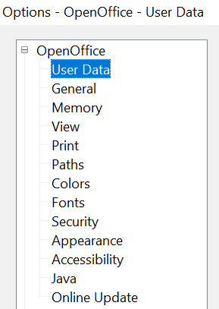

Note | The Back button has the same effect on all pages of the Options dialog. It resets the options to the values that were in place when you launched OpenOffice.

User Data Options
Calc uses the first and last name stored in the OpenOffice – User Data page to fill in the Created and Modified fields in the document properties, and the optional Author field, often used in the footer of a printed spreadsheet. Fill in the form on this page.

Print Options
Set the print options to suit your default printer and your preferred printing method. You can change these settings at any time, either through this dialog or during the printing process, by clicking the Options button on the Print dialog.
In the Options dialog, click OpenOffice > Print.
See Chapter 6 (Printing, Exporting, and E-mailing) for more about the options on this page.

Color Options
On the OpenOffice – Colors page (Figure 1), you can specify colors to use in documents. You can select a color from a color table, edit an existing color, and define new colors. These colors are stored in your color palette and are then available in all components of OpenOffice.
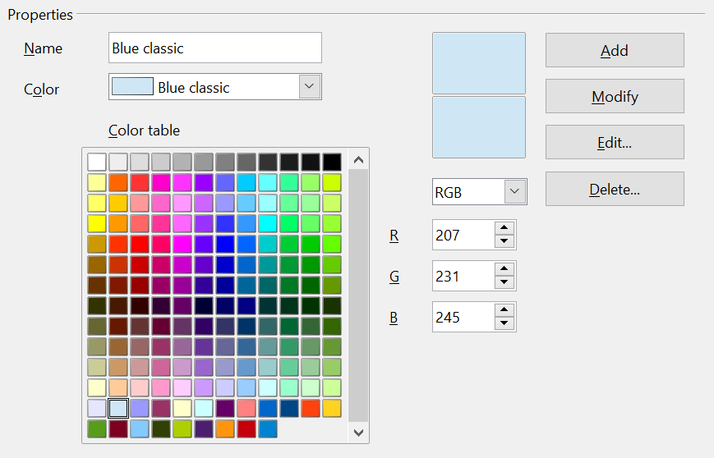
Figure 1: Defining colors to use in color palettes
To modify a color:
- Select the color to be modified, from the list or the color table.
- Enter the new values that define the color. If necessary, change the settings from RGB (Red, Green, Blue) to CMYK (Cyan, Magenta, Yellow, Black) or vice versa. The changed color appears in the lower of the two color preview boxes at the top.
- Modify the Name if desired.
- Click the Modify button. The newly defined color is now listed in the Color table.
Or, click the Edit button to open the Color dialog, shown in Figure 2. Here you can select a color from the color window in the upper left area, or you can enter values on the right using your choice of RGB, CMYK, or HSB (Hue, Saturation, and Brightness) values.
The large color window is linked directly with the color input fields on the right; as you choose a color in the window, the numbers change accordingly. The two color fields at the lower left show the value of the selected color on the left and the currently set value from the color value fields on the right.
Modify the color components as required. Then click OK to exit the dialog. The newly defined color now appears in the lower part of the color preview boxes shown in Figure 1. Type a name for this color in the Name box, then click the Add button. A small box showing the new color is added to the Color table.
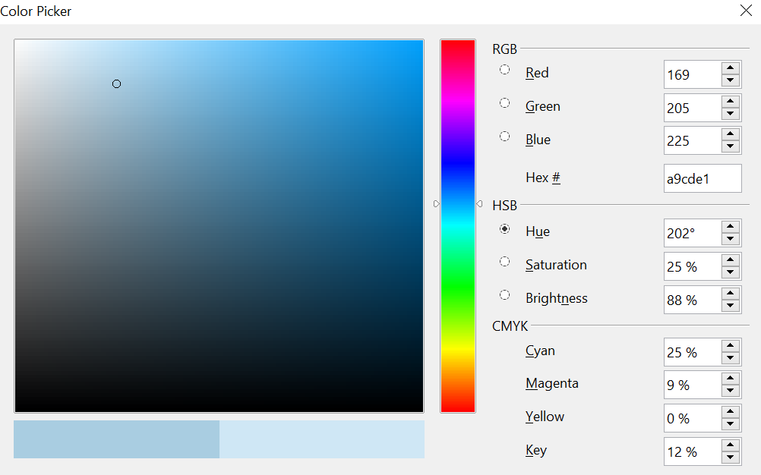
Figure 2: Editing colors

Note | Another way to define or alter colors is through the Colors tab of the Area dialog. You can also use this dialog to save and load palettes, a feature that is not otherwise possible here.  In Calc, draw a temporary draw object and use the context menu of this object to open the Area dialog. If you load a palette in one component of OpenOffice, it is only active in that component; the other components keep their own palettes.

Security Options
Use the OpenOffice – Security page to choose security options for saving and opening documents that contain macros (Figure 3).
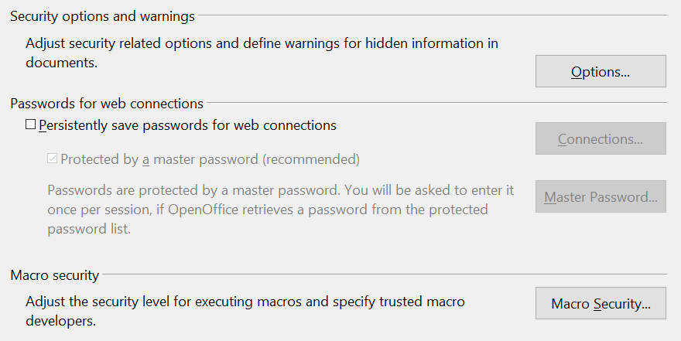
Figure 3: Choosing security options for opening and saving documents
Security options and warnings
If you record changes, save multiple versions, or include hidden information or notes in your documents, and you do not want some recipients to see that information, you can set warnings to remind you to remove this information, or you can have OpenOffice automatically remove some information. Note that, unless removed, much of this information is retained in a file, whether the file is in OpenOffice’s default OpenDocument format or has been saved to other formats, including PDF.
Click the Options button to open a separate dialog with specific choices (Figure 4).
Macro security
Click the Macro Security button to open the Macro Security dialog (not shown here), where you can adjust the security level for executing macros and specify trusted sources.

Security Options and Warnings
The following options are available in the Security options and warnings dialog (Figure 4).
Remove personal information on saving
Select this option to always remove user data from the file properties when saving the file. To manually remove personal information from specific documents, deselect this option and then use the Delete button under File > Properties > General.
Ctrl-click required to follow hyperlinks
Many people find creation and editing of documents easier when accidental clicks on links don't activate those links.
The other options on this dialog should be self-explanatory.

Figure 4: Security options and warnings dialog

Appearance Options
On the OpenOffice – Appearance page, you can specify which items are visible and the colors used to display various items (Figure 5).
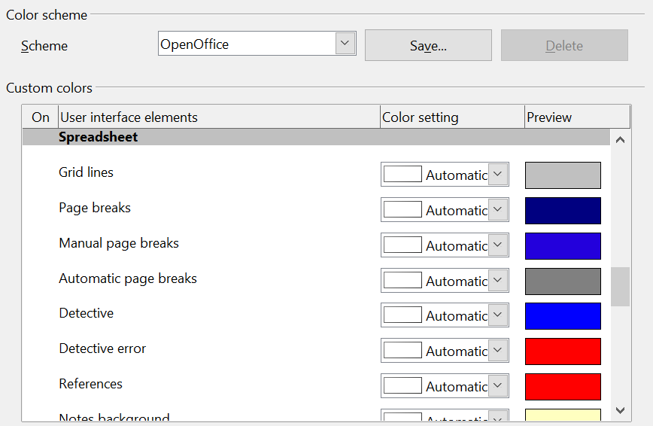

Figure 5: Changing the colors in Calc
Scroll down the page until you find Spreadsheet. To change the default color for grid points, click the down arrow by the color and select a new color from the pop-up box.
If you wish to save your color changes as a color scheme, click Save, type a name in the Scheme box, and then click OK.

Choosing Options for Loading and Saving Documents
You can set the Load/Save options to suit your working style. This chapter describes only a few of the options, those more relevant to working with Calc. See Chapter 2 (Setting Up OpenOffice) in the Getting Started guide for a description of the other options.
If the Options dialog is not already open, click Tools > Options. Click the + sign to the left of Load/Save to display the list of load/save options pages (Figure 6).
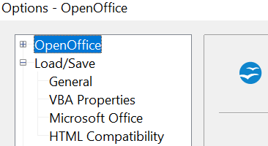
Figure 6: Load/Save options

General Load/Save Options
Most of the choices on the Load/Save – General page (Figure 7) are familiar to users of other office suites. Those specific to OpenOffice are in the Default file format and ODF settings section.
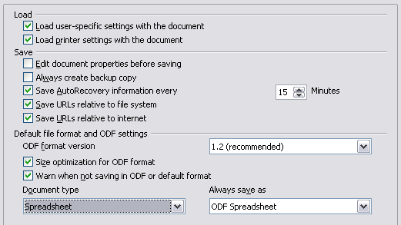
Figure 7: Choosing Load and Save options
ODF format version
OpenOffice saves documents by default in OpenDocument Format (ODF) version 1.2 Extended. While this allows for improved functionality, it may introduce backwards compatibility issues. When a file saved in ODF 1.2 Extended is opened in an older version of OpenOffice (using ODF 1.0/1.1), some of its advanced features may be lost. Two notable examples are cross-references to headings and the formatting of numbered lists.
Size optimization for ODF format
OpenOffice documents are XML files. When you select this option, OpenOffice writes the XML data without indents and line breaks. If you want to view the XML files in a text editor in a structured format, deselect this option.
Document type
If you routinely share documents with Microsoft Excel users, you may want to change the Always save as attribute for spreadsheets to one of the Excel formats. Excel can open and save in the .ods format native to OpenOffice.
Note | Although OpenOffice can open files in the .xlsx format produced by Microsoft Office, it cannot save in this format.

VBA Properties Load/Save Options
On the Load/Save – VBA Properties page, you can choose whether to keep any macros in Microsoft Office documents that are opened in OpenOffice (Figure 8).
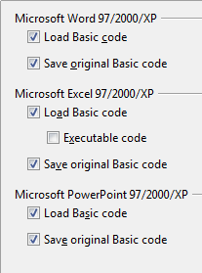
Figure 8: Choosing Load/Save VBA Properties
- If you choose Save original Basic code, the macros will not work in OpenOffice, but are retained if you save the file in Microsoft Office format.
- If you choose Load Basic code, the code is saved in an OpenOffice document but is not retained if you save it in Microsoft Office format.
- If you are importing a Microsoft Excel file containing VBA (Visual Basic for Applications) code, you can select the Executable code option. Normally, the code is preserved but rendered inactive. With this option, the code is ready to be executed. VBA code and OpenOffice Basic code are very different. It's very unlikely a VBA macro will run correctly in OpenOffice without modifications.

Microsoft Office Load/Save Options
On the Load/Save – Microsoft Office page, you can choose what to do when importing and exporting Microsoft Office OLE objects (linked or embedded objects or documents such as spreadsheets or equations) (Figure 9).
Select the [L] options to convert Microsoft OLE objects into the corresponding OpenOffice OLE objects when a Microsoft document is loaded into OpenOffice (mnemonic: “L” for “load”).
Select the [S] options to convert OpenOffice OLE objects into corresponding Microsoft OLE objects when a document is saved in a Microsoft format (mnemonic: “S” for “save”).
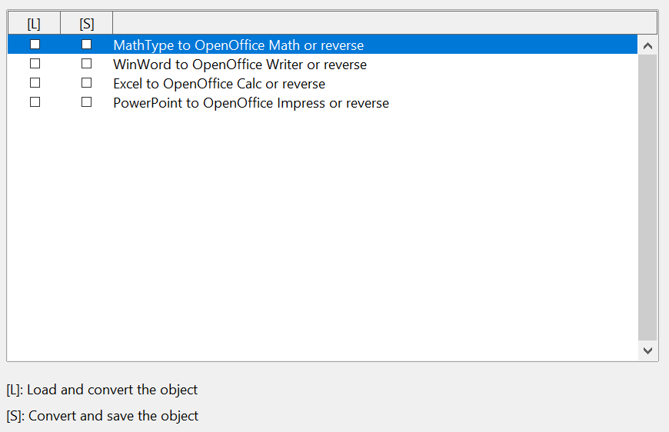
Figure 9: Choosing Load/Save Microsoft Office options

HTML compatibility Load/Save Options
Choices made on the Load/Save – HTML Compatibility page (Figure 10) affect HTML pages imported into OpenOffice and those exported from OpenOffice. See HTML documents; importing/exporting in the Help for more information.
The main items of interest for Calc users are in the Export section: OpenOffice Basic and Display warning.
Export - OpenOffice Basic
Select this option to include OpenOffice Basic macros (scripts) when exporting to HTML format. You must activate this option before you create the OpenOffice Basic macro., otherwise, the script will not be inserted. OpenOffice Basic macros must be located in the header of the HTML document. Once you have created the macro in the OpenOffice Basic IDE (Integrated Development Environment), it appears in the source text of the HTML document in the header.
To have the macro run automatically when the HTML document opens, choose Tools > Customize > Events. See Chapter 12 (Calc Macros) for more information.
Export - Display warning
When the OpenOffice Basic option (see above) is not selected, the Display warning option becomes available (Figure 10). If the Display warning option is selected, then when exporting to HTML, a warning is shown that OpenOffice Basic macros will be lost.
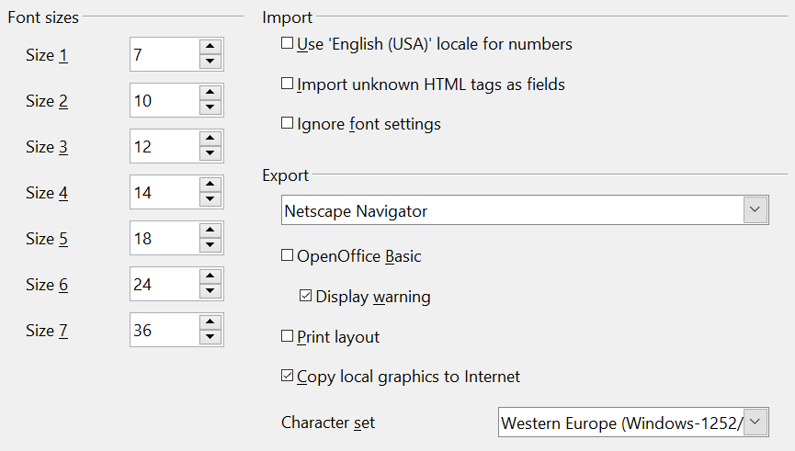
Figure 10: Choosing HTML compatibility options

Choosing Options for Calc
In the Options dialog, click the + sign to the left of OpenOffice Calc on the left-hand side as shown below. A list of subsections drops down.
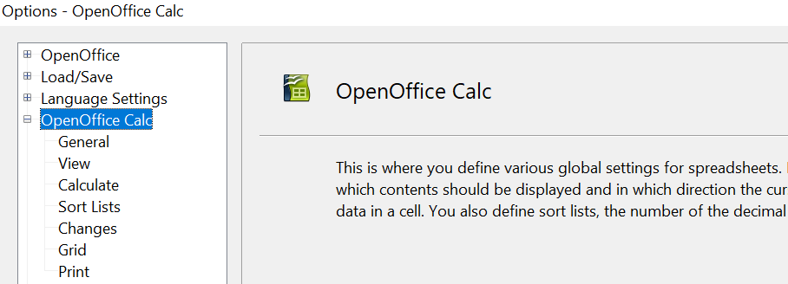

General Options for Calc
In the Options dialog, choose OpenOffice Calc > General (Figure 11).
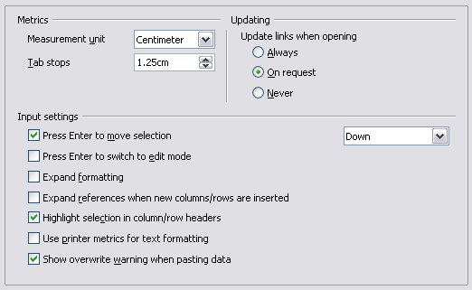
Figure 11: Selecting general options for Calc

Metrics Section
Choose the unit of measurement used in spreadsheets and the default tab stops distance.

Updating Section
Choose whether to update links when opening a document always, only on request, or never. Regardless of this setting, you can manually update links at any time. You may want to avoid updating links when opening documents if they often contain many charts or linked graphics that would slow down file loading.

Input Settings Section
Press Enter to move selection
Specifies that pressing Enter moves the cursor to another cell. If this option is selected, you can also choose the direction the cursor moves: up, down, left, or right. If this option is not selected, pressing Enter completes data entry for a cell but does not move the cursor.
Press Enter to switch to edit mode
Specifies that pressing Enter puts the selected cell into edit mode.
Expand formatting
Specifies whether to automatically apply the formatting attributes of an inserted cell to empty adjacent cells. If, for example, an inserted cell has the bold attribute, this attribute will also apply to empty adjacent cells. However, cells that already have a special format will not be modified by this function. To see the affected range, press Ctrl+* (multiplication sign on the number pad). The format will also apply to all new values inserted within this range.
Expand references when new columns/rows are inserted
Specifies whether to expand references when inserting columns or rows adjacent to the reference range. This is only possible if the reference range, where the column or row is inserted, originally spanned at least two cells in the desired direction.
Example: If the range A1:B1 is referenced in a formula and you insert a new column after column B, the reference is expanded to A1:C1. If the range A1:B1 is referenced and a new row is inserted under row 1, the reference is not expanded, since there is only a single cell in the vertical direction.
If you insert rows or columns in the middle of a reference area, the reference is always expanded.
Highlight selection in column/row headings
Specifies whether to highlight column and row headers in the selected columns or rows.
Use printer metrics for text formatting
Specifies that printer metrics are applied for both printing and formatting the display on the screen. If this option is not selected, a printer-independent layout is used for screen display and printing.
Show overwrite warning when pasting data
Specifies that, if you paste cells from the clipboard to a cell range that is not empty, a warning appears.

View Options for Calc
In the Options dialog, choose OpenOffice Calc > View (Figure 12).
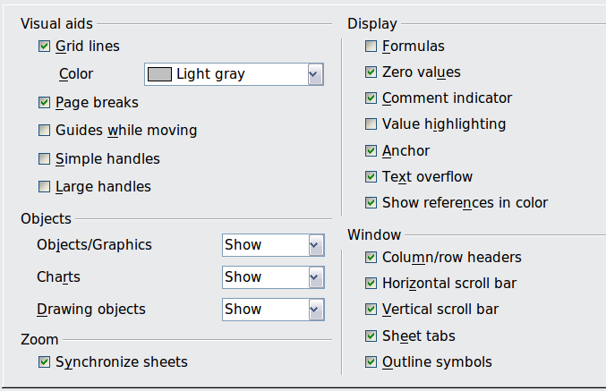
Figure 12: Selecting view options for Calc

Visual Aids Section
Specifies which lines are displayed.
Grid lines
Specifies whether to display grid lines between the cells when viewed onscreen. If this option is selected, you can also specify the color for the grid lines in the current document. The color choice overrides the selection made in Tools > Options > OpenOffice > Appearance > Spreadsheet > Grid lines.
For printing, choose Format > Page > Sheet and mark the Grid option.
Page breaks
Specifies whether to view the page breaks within a defined print area.
Guides while moving
Specifies whether to view guides when moving drawings, frames, graphics, and other objects. These guides help you align objects.
Simple handles
Specifies whether to display the handles (the eight points on a selection box) as simple squares without a 3D effect.
Large handles
Specifies that larger-than-normal handles (the eight points on a selection box) are displayed.

Display Section
Select various options for the screen display.
Formulas
Specifies whether to show formulas instead of results in the cells.
Zero values
Specifies whether to show numbers with the value of 0.
Comment indicator
Specifies that a small rectangle is shown in the top right corner of the cell when a comment exists for that cell. The text of the comment is shown when you hover the pointer over the cell, if tips are enabled under Tools > Options > OpenOffice > General.
To display a comment permanently, right-click on the cell and select Show comment from the pop-up menu.
Value highlighting
Select this option to highlight all values in the sheet. Text is highlighted in black; numbers, including dates and logical values, in blue; and formula results in green.
When this command is active, any colors assigned in the document are not displayed.
Anchor
Specifies whether the anchor icon is displayed when an inserted object, such as a graphic, is selected.
Text overflow
If a cell contains text that is wider than the width of the cell, the text is displayed over empty neighboring cells in the same row. If there is no empty neighboring cell, a small triangle at the cell border indicates that the text continues.
Show references in color
Specifies that each reference is highlighted in color in the formula. The cell range is also enclosed by a colored border as soon as the cell containing the reference is selected for editing.

Objects Section
Specifies whether to display or hide objects in three object groups: objects and graphics, charts, and drawing objects.

Window Section
Specifies whether some elements are visible onscreen: column/row headers, horizontal scrollbar, vertical scrollbar, sheet tabs, and outline symbols.
If the Sheet tabs option is not selected, you can only switch between the sheets by using the Navigator.
Note that there is a slider between the horizontal scrollbar and the sheet tabs that may be set to one end.

Zoom Section
Select the Synchronize sheets option to apply any selected zoom factor to all sheets in the spreadsheet. If this option is not selected, separate zoom factors can be applied to individual sheets.

Calculate Options
In the Options dialog, choose OpenOffice Calc > Calculate (Figure 13).
Use this page to define the calculation settings for spreadsheets.
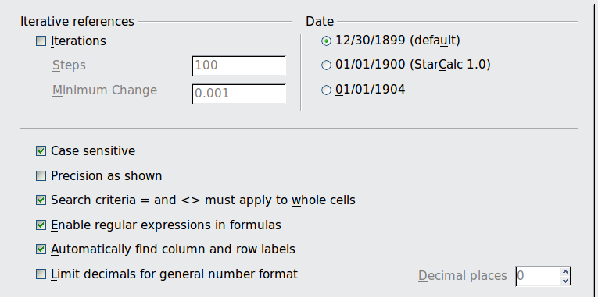
Figure 13: Calc calculation options

Iterative References Section
Iterative references are formulas that are continuously repeated until the problem is solved. In this section, you can choose the number of approximation steps carried out during iterative calculations and the degree of precision of the answer.
Iterations
Select this option to enable iterations, that is, repetitions of a sequence of instructions. If this option is not selected, an iterative reference causes an error message.
Steps
Sets the maximum number of iteration steps.
Minimum Change
Specifies the difference between two consecutive iteration step results. If the result of the iteration is lower than the minimum change value, then the iteration will stop.

Date Section
Select the start date for the internal conversion from days to numbers.
12/30/1899 (default)
Sets 12/30/1899 as day zero.
01/01/1900 (StarCalc 1.0)
Sets 1/1/1900 as day zero. Use this setting for StarCalc 1.0 spreadsheets containing date entries.
01/01/1904
Sets 1/1/1904 as day zero. Use this setting for spreadsheets imported in a foreign format.

Other Options
Specify a variety of options relevant to spreadsheet calculation.
Case sensitive
Specifies whether to distinguish between upper and lower case in texts when comparing cell contents. The EXACT text function is always case-sensitive, independent of the settings in this dialog.
Decimal places
Defines the number of decimals to be displayed for numbers with the Standard number format. The numbers are displayed as rounded numbers, but they are not saved as such.
Precision as shown
Specifies whether to make calculations using the rounded values displayed in the sheet. Charts will be shown with the displayed values. If this option is not selected, the displayed numbers are rounded, but they are calculated internally using the non-rounded number.
Search criteria = and <> must apply to whole cells
Specifies that the search criteria you set for the Calc database functions must match the whole cell exactly.
This search: | Has this result:
win | Finds win, but not win95, os2win, or upwind
win.* | Finds win and win95, but not os2win or upwind
.*win | Finds win and os2win, but not win95 or upwind
.*win.* | Finds win, win95, os2win, and upwind
If this option is not selected, the win search pattern acts like .*win.* —the search pattern can be at any position within the cell when searching with the Calc database functions.
Enable regular expressions in formulas
Specifies that regular expressions are enabled when searching and for character string comparisons. This relates to database functions, specifically VLOOKUP, HLOOKUP, and SEARCH.
Automatically find column and row labels
Specifies that you can use the text in any cell as a label for the column below the text or the row to the right of the text. The text must consist of at least one word and must not contain any operators.
Example: Cell E5 contains the text Europe. Below, in cell E6, is the value 100, and in cell E7, the value 200. If the Automatically find column and row labels option is selected, you can write the following formula in cell A1: =SUM(Europe).

Sort Lists Options
In the Options dialog, choose OpenOffice Calc > Sort Lists (Figure 14). Sort lists are used for more than sorting, for example, filling a series of cells during data entry. In addition to the supplied lists, you can define and edit your own lists, as described in “Defining a fill series” in Chapter 2 (Entering, Editing, and Formatting Data).
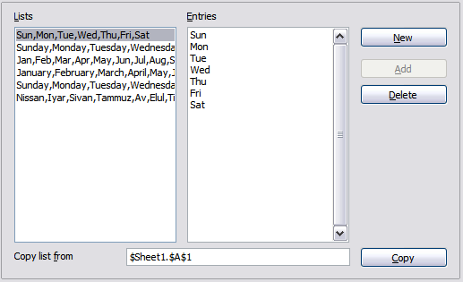Figure 14: Defining sorting lists in Calc

Changes Options
In the Options dialog, choose OpenOffice Calc > Changes (Figure 15).
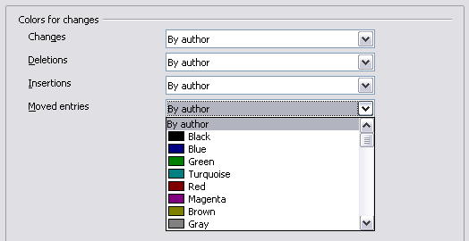
Figure 15: Calc options for highlighting changes
On this page, you can specify options for highlighting recorded changes in spreadsheets. You can assign specific colors for insertions, deletions, and other changes, or you can let Calc assign colors based on the author of the change; in the latter case, one color will apply to all changes made by that author.

Grid Options
The Grid page defines the grid settings for spreadsheets. Using a grid helps you determine the exact position of any charts or other objects you might add to a spreadsheet. You can also set this grid in line with the snap grid.
If you have activated the snap grid but wish to move or create individual objects without snap positions, you can press the Ctrl key to deactivate the snap grid for as long as needed.
In the Options dialog, choose OpenOffice Calc > Grid (Figure 16).
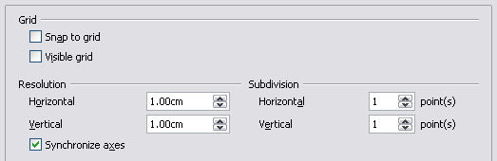Figure 16: Calc grid options

Grid Section
Snap to grid activates the snap function.
Visible grid displays grid points on the screen. These points are not printed.

Resolution Section
Here you can set the unit of distance for the spacing between horizontal and vertical grid points, and subdivisions (intermediate points) of the grid.
Synchronize axes changes the current grid settings symmetrically.

Print Options
In the Options dialog, choose OpenOffice Calc > Print. See Chapter 6 (Printing, Exporting, and E-mailing) for more about the options on this page.

Controlling Calc’s AutoCorrect Functions
Some people find some or all of the items in OpenOffice's AutoCorrect function annoying, because they change what you type, even if you don't want it to. Many people find some of the AutoCorrect functions quite helpful; if you do, then select the relevant options. But if you find unexplained changes appearing in your document, this is a good place to look to find the cause.
To open the AutoCorrect dialog, click Tools > AutoCorrect Options. (You need to have a document open for this menu item to appear.)
In Calc, this dialog has four tabs, as shown in Figure 17 below. Options are described in the Help; many will be familiar to users of other office suites.
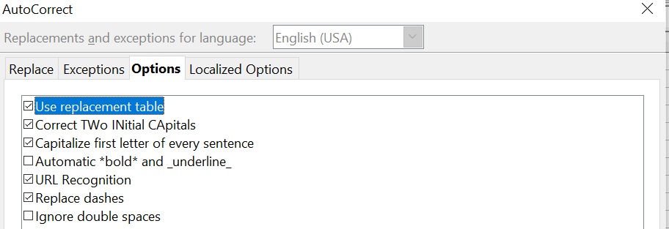

Figure 17: The AutoCorrect dialog in Calc

Customizing the User Interface

Customizing the Menu Font
If you want to change the menu font from that supplied by OpenOffice to the system font for your operating system, do this:
- Choose Tools > Options > OpenOffice > View.
- Check Use system font for user interface and click OK.

Customizing Menu Content
In addition to changing the menu font, you can add and rearrange items on the menu bar, add items to menus, and make other changes.
To customize menus:
- Choose Tools > Customize.
- On the Customize dialog, pick the Menus tab (Figure 18).
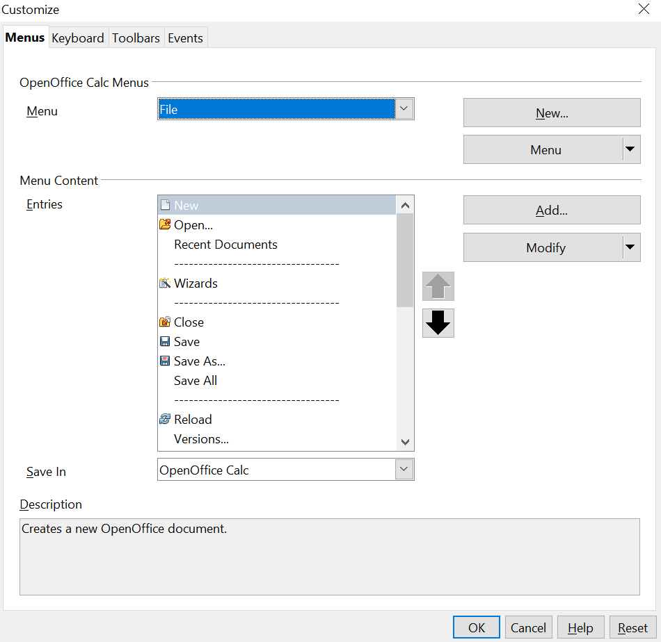
Figure 18: The Menus tab of the Customize dialog
- In the Save In drop-down list, choose whether to save this changed menu for Calc or a selected document.
- In the section OpenOffice Calc Menus, select from the Menu drop-down list the menu that you want to customize. The list includes all the main menus, as well as sub-menus, which are menus contained under another menu. For example, in addition to File, Edit, View, and so on, there is File | Send and File |Templates. The commands available for the selected menu are shown in the central part of the dialog.
- To customize the selected menu, click on the Menu or Modify buttons. You can also add commands to a menu by clicking on the Add button. These actions are described in the following sections. Use the up and down arrows next to the Entries list to move the selected menu item to a different position.
- When you've finished your changes, click OK to save them.

Creating a New Menu
In the Customize dialog, click New to display the dialog shown in Figure 19.
- Type a name for your new menu in the Menu name box.
- Use the up and down arrow buttons to move the new menu into the required position on the menu bar. Click OK to save.
The new menu now appears on the list of menus in the Customize dialog. (It will appear on the menu bar itself after you save your customizations.)
After creating a new menu, you need to add some commands to it, as described in “Adding a Command to a Menu” on page 371.
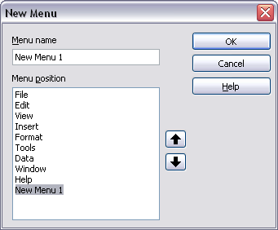
Figure 19: Adding a new menu

Modifying Existing Menus
To modify an existing menu, select it in the Menu list and click the Menu button to drop down a list of modifications: Move, Rename, Delete. Not all of these modifications can be applied to every entry in the Menu list. For example, Rename and Delete are not available for the supplied menus.
To move a menu (such as File), choose Menu > Move. A dialog similar to the one shown in Figure 19 (but without the Menu name box) opens. Use the up and down arrow buttons to move the menu into the required position.
To move submenus (such as File | Send), select the main menu (File) in the Menu list and then, in the Menu Content section of the dialog, select the submenu (Send) in the Entries list and use the arrow keys to move it up or down in the sequence. Submenus are easily identified in the Entries list by a small black triangle on the right side of the name.
In addition to renaming, you can specify a keyboard shortcut that allows you to select a menu command, when you press Alt+ an underlined letter in a menu command.
- Select a menu or menu entry.
- Click the Menu button and select Rename.
- Add a tilde (~) in front of the letter that you want to use as an accelerator. For example, to select the Save All command by pressing Alt+V, enter Sa~ve All.

Adding a Command to a Menu
You can add commands to the supplied menus and to menus you have created. On the Customize dialog, select the menu in the Menu list and click the Add button in the Menu Content section of the dialog (Figure 15).
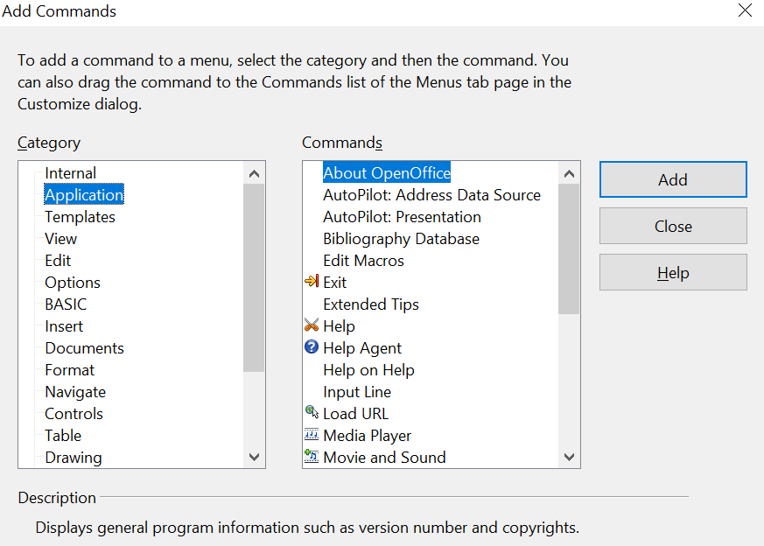
Figure 20: Adding a command to a menu
On the Add Commands dialog, select a category and then the command, and click Add. The dialog remains open, so that you can select several commands. When you have finished adding commands, click Close. Back on the Customize dialog, you can use the up and down arrow buttons to arrange the commands in your preferred sequence.

Modifying Menu Entries
In addition to changing the sequence of entries on a menu or submenu, you can add submenus, rename or delete the entries, and add group separators.
To begin, select the menu or submenu in the Menu list near the top of the Customize tab, then select the entry in the Entries list under Menu Content. Click the Modify button and choose the required action from the drop-down list of actions.
Most of the actions should be self-explanatory. Begin a group adds a separator line after the highlighted entry.

Customizing Toolbars
You can customize toolbars in several ways, including choosing which icons are visible, and locking the position of a docked toolbar, as described in Chapter 1 (Introducing OpenOffice) of the Getting Started guide. This section describes how to create new toolbars and add other icons (commands) to the list of those available on a toolbar.
To get to the toolbar customization dialog, do any of the following:
- On the toolbar, click the arrow at the end of the toolbar and choose Customize Toolbar.
- Choose View > Toolbars > Customize from the menu bar.
- Choose Tools > Customize from the menu bar and pick the Toolbars tab (Figure 16).
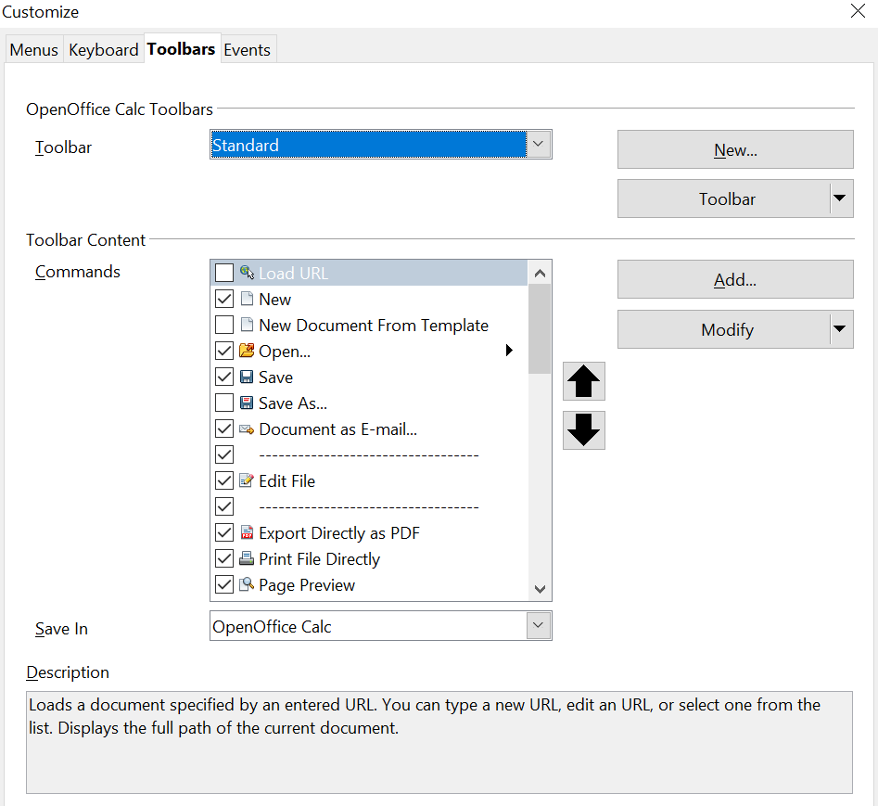
Figure 21: The Toolbars tab of the Customize dialog
To customize toolbars:
- In the Save In drop-down list, choose whether to save this changed toolbar for Calc or for a selected document.
- In the section OpenOffice Calc Toolbars, select from the Toolbar drop-down list the toolbar that you want to customize.
- You can create a new toolbar by clicking on the New button, or customize existing toolbars by clicking on the Toolbar or Modify buttons, and add commands to a toolbar by clicking on the Add button. These actions are described below.
- When you have finished making all your changes, click OK to save them.

Creating a New Toolbar
To create a new toolbar:
- Choose Tools > Customize > Toolbars from the menu bar.
- Click New. On the Name dialog shown below, type the new toolbar's name and choose from the Save In drop-down list where to save this changed toolbar: for Calc or a selected document.
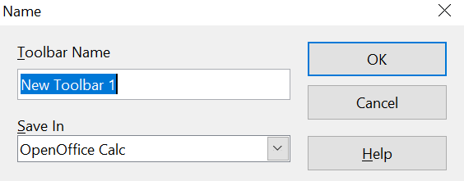
The new toolbar now appears on the list of toolbars in the Customize dialog. After creating a new toolbar, you need to add commands to it, as described below.

Adding a Command to a Toolbar
If the list of available buttons for a toolbar does not include all the commands you want on that toolbar, you can add commands. When you create a new toolbar, you need to add commands to it.
- On the Toolbars tab of the Customize dialog, select the toolbar in the Toolbar list and click the Add button in the Toolbar Content section of the dialog.
- The Add Commands dialog is the same as that for adding commands to menus (Figure 15). Select a category and then the command, and click Add. The dialog remains open, so that you can select several commands. When you have finished adding commands, click Close. If you insert an item that does not have an associated icon, the toolbar will display the full name of the item. The next section describes how to choose an icon for a toolbar command.
- Back on the Customize dialog, you can use the up and down arrow buttons to arrange the commands in your preferred sequence.
- When you are done making changes, click OK to save.

Choosing Icons for Toolbar Commands
Toolbar buttons usually have icons rather than words on them. But not every command has an associated icon.
To choose an icon for a command, select the command and click Modify > Change icon. On the Change Icon dialog (Figure 29), scroll through the available icons, select one, and click OK to assign it to the command.
To use a custom icon, create it in a graphics program and import it into OpenOffice by clicking the Import button on the Change Icon dialog. Custom icons must be 16 x 16 or 26 x 26 pixels in size and cannot contain more than 256 colors.
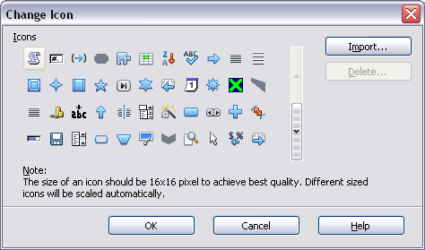
Figure 22: Change Icon dialog

Customizing Keyboard Shortcuts
In addition to using the built-in keyboard shortcuts (listed in Appendix A), you can define your own. You can assign shortcuts to standard OpenOffice functions or your macros and save them for use with the entire OpenOffice suite or only for Calc.
Caution | Be careful when reassigning your operating system’s or OpenOffice’s predefined shortcut keys. Many key assignments are universally understood shortcuts, such as F1 for Help, and are always expected to provide certain results. Although you can easily reset the shortcut key assignments to the defaults, changing some common shortcut keys can cause confusion, frustration and possible data loss or corruption, especially if other users share your computer.

To adapt shortcut keys to your needs, use the Customize dialog, as described below.
- Select Tools > Customize > Keyboard. The Keyboard tab of the Customize dialog opens.
- To have the shortcut key assignment available only with Calc, select Calc in the upper-right corner of the tab; otherwise, select OpenOffice to make it available to every component.
- Next, select the required function from the Category and Function lists.
- Now select the desired shortcut keys in the Shortcut keys list and click the Modify button at the upper right.
- Click OK to accept the change. Now the chosen shortcut keys will execute the function chosen in step 3 above whenever they are pressed.

Tip | Once you have selected any shortcut in the Shortcut keys list, you can jump to a desired shortcut by pressing the associated keys. For example, you can click on F1, the first entry in the list, and jump to Ctrl + Shift + S by pressing that key combination.

Note | All existing shortcut keys for the currently selected Function are listed in the Keys selection box. If the Keys list is empty, it indicates that the chosen key combination is free for use. If it were not, and you wanted to reassign a shortcut key combination that is already in use, you must first delete the existing key.  Shortcut keys that are grayed out in the listing on the Customize dialog, such as F1 and F10, are not available for reassignment.

Example: Assigning Styles to Shortcut Keys
You can configure shortcut keys to quickly assign styles in your document.
- On the Keyboard tab of the Customize dialog (Figure 28), choose the shortcut keys you want to assign a style to. In this example, we have chosen Ctrl+3.
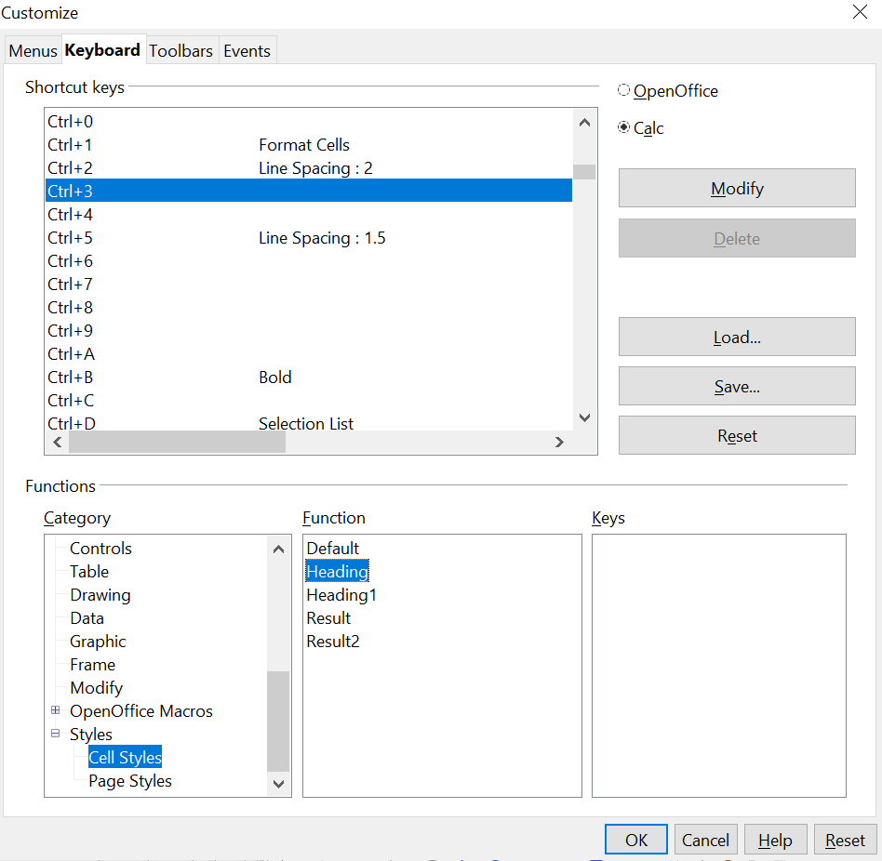

Figure 23: Assigning a cell style to a key combination
- In the Functions section at the bottom of the dialog, scroll down in the Category list to Styles. Click the + sign to expand the list of styles.
- Choose the category of style. (This example uses a cell style, but you can also choose page styles.) The Function list now displays the names of the available styles for the selected category. The example shows the predefined cell styles.
- To assign Ctrl+3 to be the shortcut key combination for the Heading style, select Heading in the Function list. Then click Modify. Ctrl+3 now appears in the Keys list on the right, and Heading appears next to Ctrl+3 in the Shortcut keys box at the top.
- Make any other required changes, and then click OK to save these settings and close the dialog.

Saving Changes to a File
Changes to the shortcut key assignments can be saved in a keyboard configuration file for use at a later time, permitting you to create and apply different configurations as the need arises. To save keyboard shortcuts to a file:
- After making your keyboard shortcut assignments, click the Save button on the Customize dialog.
- In the Save Keyboard Configuration dialog, select All files from the Save as Type list.
- Next, enter a name for the keyboard configuration file in the File name box, or select an existing file from the list. If you need to, browse to find a file from another location.
- Click Save. A confirmation dialog appears if you are about to overwrite an existing file. Otherwise, there will be no feedback, and the file will be saved.

Loading a Saved Keyboard Configuration
To load a saved keyboard configuration file and replace your existing configuration, click the Load button of the Customize dialog, then select the configuration file from the Load Keyboard Configuration dialog.

Resetting the Shortcut Keys
To reset all of the keyboard shortcuts to their default values, click the Reset button near the bottom right of the Customize dialog. Use this feature with care as no confirmation dialog will be displayed; the defaults will be set without any further notice or user input.

Running Macros from Key Combinations
You can also define shortcut key combinations that will run macros. These shortcut keys are strictly user-defined; none are built in. For more information on macros, see Chapter 12 (Calc Macros).

Adding Functionality with Extensions
An extension is a package that can be installed into OpenOffice to add new functionality.
Although individual extensions can be found in different places, the official OpenOffice extension repository is located at: https://extensions.openoffice.org/. Some extensions are free of charge, while others are available for a fee. Check the descriptions to see what licenses and fees apply to the ones that interest you.

Installing Extensions
To install an extension, take these steps:
- Download an extension and save it anywhere on your computer.
- In OpenOffice, select Tools > Extension Manager from the menu bar. In the Extension Manager dialog (Figure 25), click Add.
- A file browser window opens. Find and select the extension you want to install and click Open. The extension begins installing. You may be asked to accept a license agreement.
- When the installation is complete, the extension is listed in the Extension Manager dialog.

Tip | To get extensions that are listed in the repository, you can open the Extension Manager and click the Get more extensions online link. You do not need to download them separately as in step 1 above.

Note | To install a shared extension, you need write access to the OpenOffice installation directory.

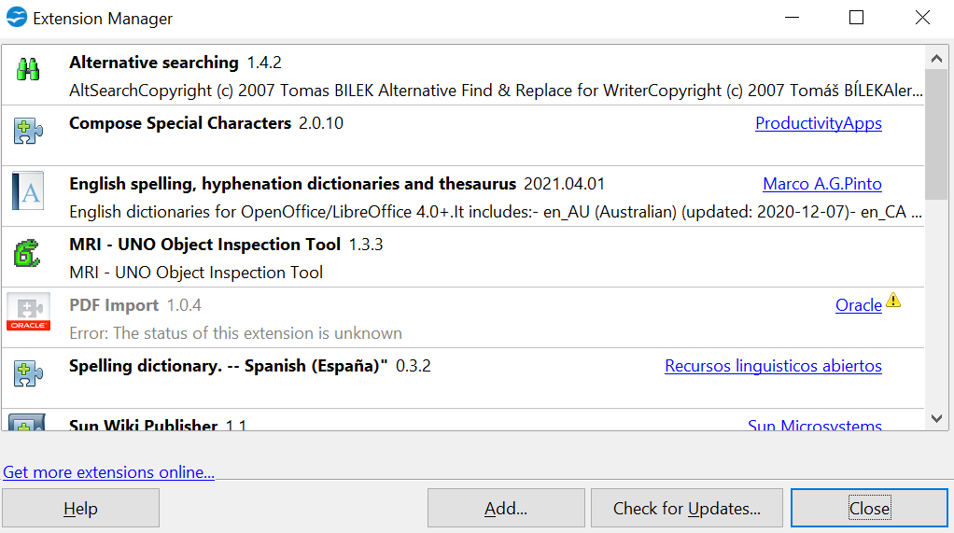
Figure 24: Installing an extension

Appendix A
Keyboard Shortcuts

Introduction
You can use Calc without a mouse or trackball by using its built-in keyboard shortcuts.
OpenOffice has a general set of keyboard shortcuts available in all components and a component-specific set directly related to the work of that component.
For help with OpenOffice’s keyboard shortcuts or using OpenOffice with a keyboard only, search the OpenOffice online help using the “shortcut” or “accessibility” keywords.
In addition to using the built-in keyboard shortcuts listed in this Appendix, you can define your own. See Chapter 14 (Setting Up and Customizing Calc) for instructions.
Formatting and editing shortcuts are described in Chapter 2 (Entering, Editing, and Formatting Data).

Navigation and Selection Shortcuts
Table 31: Spreadsheet navigation shortcuts
Shortcut Keys | Effect
Ctrl+Home | Moves the cursor to the first cell in the sheet (cell A1).
Ctrl+End | Moves the cursor to the intersection of the last row and the last column that have content. The cell itself may be empty.
Home | Moves the cursor to the first cell of the current row.
End | Moves the cursor to the last cell of the current row in a column containing data.
Ctrl+Left Arrow | Moves the cursor to the left edge of the current data range. If the column to the left of the cell that contains the cursor is empty, the cursor moves to the next column to the left that contains data.
Ctrl+Right Arrow | Moves the cursor to the right edge of the current data range. If the column to the right of the cell that contains the cursor is empty, the cursor moves to the next column to the right that contains data.
Ctrl+Up Arrow | Moves the cursor to the top edge of the current data range. If the row above the cell that contains the cursor is empty, the cursor moves up to the next row that contains data.
Ctrl+Down Arrow | Moves the cursor to the bottom edge of the current data range. If the row below the cell that contains the cursor is empty, the cursor moves down to the next row that contains data.
Ctrl+Shift+Arrow | Selects all cells containing data, from the current cell to the end of the continuous range of data cells, in the direction of the arrow pressed. If used to select rows and columns together, a rectangular cell range is selected.
Ctrl+Page Up | Moves one sheet to the left. In the page preview, it moves to the previous print page.
Ctrl+Page Down | Moves one sheet to the right. In the page preview, it moves to the next print page.
Page Up | Moves the viewable rows up one screen.
Page Down | Moves the viewable rows down one screen.
Alt+Page Up | Moves the viewable columns one screen to the left.
Alt+Page Down | Moves the viewable columns one screen to the right.
Shift+Ctrl+Page Up | Adds the previous sheet to the current selection of sheets. If all the sheets in a spreadsheet are selected, this combination only selects the previous sheet. Makes the previous sheet the current sheet.
Shift+Ctrl+Page Down | Adds the next sheet to the current selection of sheets. If all the sheets in a spreadsheet are selected, this combination only selects the next sheet. Makes the next sheet the current sheet.
Ctrl+* | Selects the data range that contains the cursor. A range is a contiguous cell range that contains data and is bounded by empty rows and columns. The “*” key is the multiplication sign on the numeric keypad.
Ctrl+/ | Selects the matrix formula range that contains the cursor. The “/” key is the division sign on the numeric key pad.
Enter — in a selected range | By default, moves the cursor down one cell in a selected range. To specify the direction that the cursor moves, choose Tools > Options > OpenOffice Calc > General.

Function and Arrow Key Shortcuts
Table 32: Function key shortcuts
Shortcut Keys | Effect
F1 | Displays the OpenOffice help browser. When the help browser is already open, F1 jumps to the main help page.
Shift+F1 | Displays context help.
Ctrl+F1 | Displays the comment that is attached to the current cell.
F2 | Switches to Edit mode and places the cursor at the end of the contents of the current cell. If the cursor is in an input box in a dialog that has a minimize button, the dialog is hidden and the input box remains visible. Press F2 again to show the whole dialog.
Ctrl+F2 | Opens the Function Wizard.
Shift+Ctrl+F2 | Moves the cursor to the input line, where you can enter a formula for the current cell.
Ctrl+F3 | Opens the Define Names dialog.
F4 | Shows or hides the Data Sources menu.
Shift+F4 | Rearranges the relative or absolute references (for example, A1, $A$1, $A1, A$1) in the input field.
F5 | Shows or hides the Navigator.
Shift+F5 | Traces dependents, that is, items whose nature and role are contingent upon the current field.
Shift+Ctrl+F5 | Moves the cursor to the Name box.
F7 | Checks spelling in the current sheet.
Ctrl+F7 | Opens the Thesaurus if the current cell contains text.
Shift+F7 | Traces precedents, that is, items whose nature and role determine those of the current field.
F8 | Turns additional selection mode on or off. In this mode, you can use the arrow keys to extend the selection. You can also click in another cell to extend the selection.
Ctrl+F8 | Colors cells depending on whether they contain text (black), numbers (blue), or a formula (green).
F9 | Recalculates all of the formulas in the sheet whose inputs have changed.
Shift+Ctrl+F9 | Hard recalculate. All formulas are recalculated.
F11 | Opens the Styles and Formatting window where you can apply a formatting style to the contents of the cell or to the current sheet.
Shift+F11 | Creates a document template.
Shift+Ctrl+F11 | Updates templates.
F12 | Groups the selected data range.
Ctrl+F12 | Ungroups the selected data range.
Table 33. Arrow key shortcuts
Shortcut Keys | Effect
Alt+Down Arrow | Increases the height of the current row.
Alt+Up Arrow | Decreases the height of the current row.
Alt+Right Arrow | Increases the width of the current column.
Alt+Left Arrow | Decreases the width of the current column.
Alt+Shift+Arrow Key | Optimizes the column width or row height based on the current cell.

Cell Formatting Shortcuts
Ctrl+1 opens the Format Cells dialog.
Note | The shortcut keys shown in Table 31 do not use the number keys on the number pad. They use the number keys above the letter keys on the main keyboard.
Table 34: Formatting shortcut keys
Shortcut Keys | Effect
Ctrl+Shift+1 | Two decimal places, thousands separator
Ctrl+Shift+2 | Standard exponential format
Ctrl+Shift+3 | Standard date format
Ctrl+Shift+4 | Standard currency format
Ctrl+Shift+5 | Standard percentage format (two decimal places)
Ctrl+Shift+6 | Standard format

Pivot Table Shortcuts
These shortcuts apply to the dialog used to define the layout of a Pivot Table.
Table 35: Pivot Table shortcut keys
Shortcut Keys | Effect
Tab | Changes the focus by moving forward through the areas and buttons of the dialog.
Shift+Tab | Changes the focus by moving backward through the areas and buttons of the dialog.
Up arrow | Moves the focus up one item in the current dialog area.
Down arrow | Moves the focus down one item in the current dialog area.
Left arrow | Moves the focus one item to the left in the current dialog area.
Right arrow | Moves the focus one item to the right in the current dialog area.
Home | Selects the first field in the current layout area.
End | Selects the last field in the current layout area.
Alt+R | Copies or moves the current field into the “Row” area.
Alt+C | Copies or moves the current field into the “Column” area.
Alt+D | Copies or moves the current field into the “Data” area.
Ctrl+Up Arrow | Moves the current field up one place.
Ctrl+Down Arrow | Moves the current field down one place.
Ctrl+Left Arrow | Moves the current field one place to the left.
Ctrl+Right Arrow | Moves the current field one place to the right.
Ctrl+Home | Moves the current field to the first place.
Ctrl+End | Move the current field to the last place.
Alt+O (the letter O) | Displays the options for the current field.
Delete | Removes the current field from the area.

Appendix B
Description of Functions

Functions Available in Calc
Calc provides all the commonly used functions found in modern spreadsheet applications. Since many of Calc’s functions require very specific and carefully calculated input arguments, the descriptions in this appendix should not be considered complete references for each function. Refer to the application Help or the OpenOffice wiki for details and examples of all functions. On the wiki, start with https://wiki.openoffice.org/wiki/Documentation/How_Tos/Calc:_Functions_listed_by_category
Over 300 standard functions are available in Calc. More can be added through extensions to Calc (see Chapter 14). The following tables list Calc’s functions organized into eleven categories.
Note | Functions whose names end with _ADD are provided for compatibility with Microsoft Excel functions. They return the same results as the corresponding functions in Excel (without the suffix), which, though they may be correct, are not based on international standards.

Terminology: Numbers and Arguments
Some of the descriptions in this appendix define limitations on the number of values or arguments that can be passed to the function. Specifically, functions that refer to the following arguments may lead to confusion.
- Number_1; number_2;… number_30
- Numbers 1 to 30
- a list of up to 30 numbers
There is a significant difference between a list of numbers (or integers) and the number of arguments a function will accept. For example, the SUM function will accept a maximum of 30 arguments. This limit does NOT mean that you can only sum 30 numbers, but that you can only pass 30 separate arguments to the function.
Arguments are values separated by semicolons and can include ranges that refer to multiple values. Therefore, one argument can refer to several values, and a function that limits input to 30 arguments may accept more than 30 separate numerical values. For example, SUM(A1:A20;B11:B30) sums 40 values using two arguments.
This appendix attempts to clarify this situation by using the term arguments, rather than any of the other phrases.

Mathematical Functions
Table 36: Mathematical functions
Syntax | Description
ABS(number) | Returns the absolute value of the given number.
ACOS(number) | Returns the inverse cosine of the given number in radians.
ACOSH(number) | Returns the inverse hyperbolic cosine of the given number in radians.
ACOT(number) | Returns the inverse cotangent of the given number in radians.
ACOTH(number) | Returns the inverse hyperbolic cotangent of the given number in radians.
ASIN(number) | Returns the inverse sine of the given number in radians.
ASINH(number) | Returns the inverse hyperbolic sine of the given number in radians.
ATAN(number) | Returns the inverse tangent of the given number in radians.
ATAN2(number_x; number_y) | Returns the inverse tangent of the specified x and y coordinates. Number_x is the value for the x coordinate. Number_y is the value for the y coordinate.
ATANH(number) | Returns the inverse hyperbolic tangent of the given number. (Angle is returned in radians.)
BESSELI(x; n) | Calculates the modified Bessel function In(x). x is the value on which the function will be calculated. n is the order of the Bessel function.
BESSELJ(x; n) | Calculates the Bessel function Jn(x) (cylinder function). x is the value on which the function will be calculated. n is the order of the Bessel function.
BESSELK(x; n) | Calculates the modified Bessel function Kn(x). x is the value on which the function will be calculated. n is the order of the Bessel function.
BESSELY(x; n) | Calculates the modified Bessel function Yn(x), also known as the Weber or Neumann function. x is the value on which the function will be calculated. n is the order of the Bessel function.
CEILING(number; significance; mode) | Rounds the given number to the nearest integer or multiple of significance. Significance is the value to whose multiple the value is to be rounded up. Mode is an optional value. If it is indicated and non-zero, and if the number and significance are negative, rounding up is carried out based on that value.
COMBIN(count_1; count_2) | Returns the number of combinations for a given number of objects. Count_1 is the total number of elements. Count_2 is the selected count from the elements.
COMBINA(count_1; count_2) | Returns the number of combinations for a given number of objects (repetition included). Count_1 is the total number of elements. Count_2 is the selected count from the elements.
CONVERT(value; "text"; "text") | Converts a currency value of a European currency into Euros. Value is the amount in the currency to be converted. Text is the official abbreviation for the currency in question (for example, "EUR"). The first Text parameter gives the source value to be converted; the second Text parameter gives the destination value. Both text arguments must be within quotes.
CONVERT_ADD(number; from_unit; to_unit) | Converts a value from one unit of measure to the corresponding value in another unit of measure. Number is the number to be converted. From_unit is the unit from which conversion is taking place. To_unit is the unit to which the conversion is taking place.
COS(number) | Returns the cosine of the given number (angle in radians).
COSH(number) | Returns the hyperbolic cosine of the given number (angle in radians).
COT(number) | Returns the cotangent of the given number (angle in radians).
COTH(number) | Returns the hyperbolic cotangent of the given number (angle in radians).
COUNTBLANK(range) | Returns the number of empty cells. Range is the cell range in which the empty cells are counted.
COUNTIF(range; criteria) | Returns the number of elements that meet specific criteria within a cell range. Range is the range to which the criteria are to be applied. Criteria indicates the criteria in the form of a number, a regular expression, or a character string by which the cells are counted. The character string may express a mathematical condition like ">= 5".
COUNTIFS(range 1; criteria 1; range 2; criteria 2;…) | Checks criteria along two or more cell ranges and counts the range positions where all of the criteria are met. If in the nth position of every cell range, all of the criteria are true, the count increases by one. Each range X is a range where criteria X is tested. The criteria may be in the form of a number, a regular expression, or a character string. The character string may express a mathematical condition like ">= 5".
DEGREES(number) | Converts the given number in radians to degrees.
DELTA(number_1; number_2) | Returns TRUE (1) if both numbers are equal, otherwise returns FALSE (0).
ERF(lower_limit; upper_limit) | Returns values of the Gaussian error integral. Lower_limit is the lower limit of the integral. Upper_limit (optional) is the upper limit of the integral. If this value is missing, the calculation takes places between 0 and the lower limit.
ERFC(lower_limit) | Returns complementary values of the Gaussian error integral between x and infinity. Lower_limit is the lower limit of the integral (x).
EVEN(number) | Rounds the given number up to the nearest even integer.
EXP(number) | Returns e raised to the power of the given number.
FACT(number) | Returns the factorial of the given number.
FACTDOUBLE(number) | Returns the factorial of the number with increments of 2. If the number is even, the following factorial is calculated: n*(N-2)*(n-4)*...*4*2. If the number is uneven, the following factorial is calculated: n*(N-2)*(n-4)*...*3*1.
FLOOR(number; significance; mode) | Rounds the given number down to the nearest multiple of significance. Significance is the value to whose multiple the number is to be rounded down. Mode is an optional value. If it is indicated and non-zero, and if the number and significance are negative, rounding up is carried out based on that value.
GCD(numbers) | Returns the greatest common divisor of one or more integers. Numbers is a list of up to 30 numbers whose greatest common divisor is to be calculated, separated by semicolons. Numbers can also be a cell range.
GCD_ADD(numbers) | Returns the greatest common divisor of a list of numbers. Numbers is a list of up to 30 numbers separated by semicolons.
GESTEP(number; step) | Returns 1 if number is greater than or equal to step.
INT(number) | Rounds the given number down to the nearest integer.
ISEVEN(value) | Returns TRUE if the given value is an even integer, or FALSE if the value is odd. If the value is not an integer, the function evaluates only the integer part of the value.
ISODD(value) | Returns TRUE if the given value is an odd integer, or FALSE if the value is even. If the value is not an integer, the function evaluates only the integer part of the value.
LCM(integer_1; integer_2; ... integer_30) | Returns the least common multiple of one or more integers. Integer_1; integer_2;… integer_30 are integers whose lowest common multiple is to be calculated. The integer_x arguments can also be a cell range.
LCM_ADD(numbers) | Numbers is a list of up to 30 numbers separated by semicolons. The result is the lowest common multiple of a list of numbers.
LN(number) | Returns the natural logarithm based on the constant e of the given number.
LOG(number; base) | Returns the logarithm of the given number to the specified base. Base is the base for the logarithm calculation.
LOG10(number) | Returns the base-10 logarithm of the given number.
MOD(dividend; divisor) | Returns the remainder after a number is divided by a divisor. Dividend is the number that will be divided by the divisor. Divisor is the number by which to divide the dividend.
MROUND(number; multiple) | Rounds number to the nearest integer multiple of multiple.
MULTINOMIAL (number(s)) | Returns the factorial of the sum of the arguments divided by the product of the factorials of the arguments. Number(s) is a list of up to 30 numbers separated by semicolons.
ODD(number) | Rounds the given number up to the nearest odd integer.
PI() | Returns the value of PI to fourteen decimal places.
POWER(base; power) | Returns the result of a number raised to a power. Base is the number that is to be raised to the given power. Power is the exponent by which the base is to be raised.
PRODUCT(number 1 to 30) | Multiplies all the numbers given as arguments and returns the product. Number 1 to number 30 are up to 30 arguments whose product is to be calculated, separated by semicolons. The arguments may be cell ranges.
QUOTIENT(numerator; denominator) | Returns the integer result of a division operation. Numerator is the number that will be divided. Denominator is the number the numerator will be divided by.
RADIANS(number) | Converts the given number in degrees to radians.
RAND() | Returns a random number between 0 and 1. This number will recalculate every time data is entered or F9 is pressed.
RANDBETWEEN (bottom; top) | Returns an integer random number between bottom and top (inclusive). This number will recalculate when the Control+Shift+F9 key combination is pressed.
ROUND(number; count) | Rounds the given number to a certain number of decimal places according to valid mathematical criteria. Count (optional) is the number of decimal places to which the value is to be rounded. If the count parameter is negative, the number is rounded to a multiple of 10, 100, 1000, etc..
ROUNDDOWN(number; count) | Rounds the given number. Count (optional) is the number of decimal places to be rounded down to. If the count parameter is negative, the number is rounded to a multiple of 10, 100, 1000, etc..
ROUNDUP(number; count) | Rounds the given number up. Count (optional) is the number of decimal places to which rounding up is to be done. If the count parameter is negative, the number is rounded to a multiple of 10, 100, 1000, etc..
SERIESSUM(x; n; m; coefficients) | Returns a sum of powers of the number x in accordance with the following formula:  SERIESSUM(x;n;m;coefficients) = coefficient_1*x^n + coefficient_2*x^(n+m) + coefficient_3*x^(n+2m) +...+ coefficient_i*x^(n+(i-1)m).  x is the number as an independent variable. n is the starting power. m is the increment. Coefficients is a series of coefficients. For each coefficient, the series sum is extended by one section. You can only enter coefficients using cell references.
SIGN(number) | Returns the sign of the given number. The function returns the result 1 for a positive sign, –1 for a negative sign, and 0 for zero.
SIN(number) | Returns the sine of the given number (angle in radians).
SINH(number) | Returns the hyperbolic sine of the given number (angle in radians).
SQRT(number) | Returns the positive square root of the given number. The value of the number must be positive.
SQRTPI(number) | Returns the square root of the product of the given number and PI.
SUBTOTAL(function; range) | Calculates subtotals defined by cells that are visible after using a filter. If a range already contains subtotals, these are not used for further calculations. Function is a value that stands for another function, such as Average, Count, Min, Sum, and Var. Range is the range whose cells are included.
SUM(number_1; number_2; … number_30) | Adds all the numbers in a range of cells. Number_1; number_2;… number_30 are up to 30 arguments whose sum is to be calculated. You can also enter a range using cell references.
SUMIF(range; criteria; sum_range) | Adds the cells specified by a given criteria. The search supports regular expressions. Range is the range to which the criteria are to be applied. Criteria is the cell in which the search criterion is shown, or the search criterion itself. Sum_range is the range from which values are summed; if it has not been indicated, the values found in the Range are summed.
SUMIFS(sum_range; range 1; criteria 1; range 2; criteria 2; …) | Returns the sum of sum_range using only those positions where every range X meets criteria X.
SUMSQ(number_1; number_2; … number_30) | Calculates the sum of the squares of numbers (totaling up of the squares of the arguments) Number_1; number_2;… number_30 are up to 30 arguments, the sum of whose squares is to be calculated.
TAN(number) | Returns the tangent of the given number (angle in radians).
TANH(number) | Returns the hyperbolic tangent of the given number (angle in radians).
TRUNC(number; count) | Truncates a number by removing the digits after the count decimal places. Cell formatting or settings specified in Tools > Options > OpenOffice Calc > Calculate may limit the display of the number to fewer decimal places. Number is the number whose decimal places are to be cut off. Count is the number of decimal places that are not cut off.

Financial Analysis Functions

A Note About Dates
Date values are used in several financial functions. They can be entered in the format "YYYY-MM-DD", e.g., "2021-03-31". For more flexibility with date formats, you can enter the date in a cell and use the cell reference in the financial function.

A Note About Interest Rates
You can enter interest rates in either of two ways:
- As a decimal: To enter an interest rate as a decimal, divide it by 100 before entering it into a function. For example, to compute a loan with a 3.25% interest rate, enter .0325 into the function.
- As a percentage: To enter an interest rate as a percentage, type in the interest rate followed by the % key. For example, to compute a loan with a 3.25% interest rate, enter 3.25% into the function.
If you enter it as 3.25, the function will treat it as a 325% interest rate.
Accounting systems vary in the number of days in a month or a year used for calculations. The following table lists the integers used for the basis parameter in some financial analysis functions.
Table 37: Basis calculation types
Basis | Calculation
0 or missing | US method (NASD), 12 months of 30 days each, a year has 360 days.
1 | Exact number of days in each month and year.
2 | Exact number of days in a month, a year has 360 days.
3 | Exact number of days in a month, a year has 365 days.
4 | European method, 12 months of 30 days each.
Table 38: Financial analysis functions
Syntax | Description
ACCRINT(issue; first_interest; settlement; rate; par; frequency; basis) | Calculates the accrued interest of a security in the case of periodic payments. Issue is the issue date of the security. First_interest is the first interest date of the security. Settlement is the maturity date. Rate is the annual nominal rate of interest (coupon interest rate). Par is the par value of the security. Frequency is the number of interest payments per year (1, 2, or 4). Basis indicates how the year is to be calculated.
ACCRINTM(issue; settlement; rate; par; basis) | Calculates the accrued interest of a security in the case of a one-off payment at the settlement date. Issue is the issue date of the security. Settlement is the maturity date. Rate is the annual nominal rate of interest (coupon interest rate). Par is the par value of the security. Basis indicates how the year is to be calculated.
AMORDEGRC(cost; date_purchased; first_period; salvage; period; rate; basis) | Calculates the amount of depreciation for a settlement period as degressive amortization. Unlike AMORLINC, a depreciation coefficient that is independent of the depreciable life is used here. Cost is the acquisition cost. Date_purchased is the date of acquisition. First_period is the end date of the first settlement period. Salvage is the salvage value of the capital asset at the end of the depreciable life. Period is the settlement period to be considered. Rate is the rate of depreciation. Basis indicates how the year is to be calculated.
AMORLINC(cost; date_purchased; first_period; salvage; period; rate; basis) | Calculates the amount of depreciation for a settlement period as linear amortization. If the capital asset is purchased during the settlement period, the proportional amount of depreciation is considered. Cost is the acquisition cost. Date_purchased is the date of acquisition. First_period is the end date of the first settlement period. Salvage is the salvage value of the capital asset at the end of the depreciable life. Period is the settlement period to be considered. Rate is the rate of depreciation. Basis indicates how the year is to be calculated.
COUPDAYBS(settlement; maturity; frequency; basis) | Returns the number of days from the first day of interest payment on a security until the settlement date. Settlement is the date of purchase of the security. Maturity is the date on which the security matures (expires). Frequency is the number of interest payments per year (1, 2, or 4). Basis indicates how the year is to be calculated.
COUPDAYS(settlement; maturity; frequency; basis) | Returns the number of days in the current interest period in which the settlement date falls. Settlement is the date of purchase of the security. Maturity is the date on which the security matures (expires). Frequency is the number of interest payments per year (1, 2, or 4). Basis indicates how the year is to be calculated.
COUPDAYSNC(settlement; maturity; frequency; basis) | Returns the number of days from the settlement date until the next interest date. Settlement is the date of purchase of the security. Maturity is the date on which the security matures (expires). Frequency is the number of interest payments per year (1, 2, or 4). Basis indicates how the year is to be calculated.
COUPNCD(settlement; maturity; frequency; basis) | Returns the date of the first interest date after the settlement date, and formats the result as a date. Settlement is the date of purchase of the security. Maturity is the date on which the security matures (expires). Frequency is the number of interest payments per year (1, 2, or 4). Basis indicates how the year is to be calculated.
COUPNUM(settlement; maturity; frequency; basis) | Returns the number of coupons (interest payments) between the settlement date and the maturity date. Settlement is the date of purchase of the security. Maturity is the date on which the security matures (expires). Frequency is the number of interest payments per year (1, 2, or 4). Basis indicates how the year is to be calculated.
COUPPCD(settlement; maturity; frequency; basis) | Returns the date of the interest date prior to the settlement date, and formats the result as a date. Settlement is the date of purchase of the security. Maturity is the date on which the security matures (expires). Frequency is the number of interest payments per year (1, 2, or 4). Basis indicates how the year is to be calculated.
CUMIPMT(rate; NPER; PV; S; E; type) | Calculates the cumulative interest payments (the total interest) for an investment based on a constant interest rate. Rate is the periodic interest rate. NPER is the payment period with the total number of periods. NPER can also be a non-integer value. The rate and NPER must refer to the same unit, and thus both must be calculated annually or monthly. PV is the current value in the sequence of payments. S is the first period. E is the last period. Type is the due date of the payment at the beginning (1) or end (0) of each period.
CUMIPMT_ADD(rate; NPER; PV; start_period; end_period; type) | Calculates the accumulated interest for a period. Rate is the interest rate for each period. NPER is the total number of payment periods. The rate and NPER must refer to the same unit, and thus both must be calculated annually or monthly. PV is the current value. Start_period is the first payment period for the calculation. End_period is the last payment period for the calculation. Type is the due date of the payment at the beginning (1) or end (0) of each period.
CUMPRINC(rate; NPER; PV; S; E; type) | Returns the cumulative principal paid for an investment period with a constant interest rate. Rate is the periodic interest rate. NPER is the payment period with the total number of periods. NPER can also be a non-integer value. The rate and NPER must refer to the same unit, and thus both must be calculated annually or monthly. PV is the current value in the sequence of payments. S is the first period. E is the last period. Type is the due date of the payment at the beginning (1) or end (0) of each period.
CUMPRINC_ADD(rate; NPER; PV; start_period; end_period; type) | Calculates the cumulative redemption of a loan in a period. Rate is the interest rate for each period. NPER is the total number of payment periods. The rate and NPER must refer to the same unit, and thus both must be calculated annually or monthly. PV is the current value. Start period is the first payment period for the calculation. End period is the last payment period for the calculation. Type is the due date of the payment at the beginning (1) or end (0) of each period.
DB(cost; salvage; life; period; month) | Returns the depreciation of an asset for a specified period using the double-declining balance method. Cost is the initial cost of an asset. Salvage is the value of an asset at the end of the depreciation. Life defines the period over which an asset is depreciated. Period is the length of each period. The life must be entered in the same date unit as the depreciation period. Month (optional) denotes the number of months for the first year of depreciation.
DDB(cost; salvage; life; period; factor) | Returns the depreciation of an asset for a specified period using the arithmetic-declining method. Note that the book value will never reach zero under this calculation type. Cost fixes the initial cost of an asset. Salvage fixes the value of an asset at the end of its life. Life is the number of periods defining how long the asset is to be used. Period defines the length of the period. The period must be entered in the same time unit as the life. Factor (optional) is the factor by which depreciation decreases.
DISC(settlement; maturity; price; redemption; basis) | Calculates the allowance (discount) of a security as a percentage. Settlement is the date of purchase of the security. Maturity is the date on which the security matures (expires). Price is the price of the security per 100 currency units of par value. Redemption is the redemption value of the security per 100 currency units of par value. Basis indicates how the year is to be calculated.
DOLLARDE(fractional _dollar; fraction) | Converts a quotation that has been given as a decimal fraction into a decimal number. Fractional_dollar is a number given as a decimal fraction. (In this number, the decimal value is the numerator of the fraction.) Fraction is a whole number that is used as the denominator of the decimal fraction.
DOLLARFR(decimal _dollar; fraction) | Converts a quotation that has been given as a decimal number into a mixed decimal fraction. The decimal of the result is the numerator of the fraction that would have Fraction as the denominator. Decimal_dollar is a decimal number. Fraction is a whole number that is used as the denominator of the decimal fraction.
DURATION(rate; PV; FV) | Calculates the number of periods required by an investment to attain the desired value. Rate (a constant) is the interest rate to be used for the entire duration. PV is the present value. FV is the desired future value of the investment.
DURATION_ADD (settlement; maturity; coupon; yield; frequency; basis) | Calculates the duration of a fixed interest security in years. Settlement is the date of purchase of the security. Maturity is the date on which the security matures (expires). Coupon is the annual coupon interest rate (nominal rate of interest). Yield is the annual yield of the security. Frequency is the number of interest payments per year (1, 2, or 4). Basis indicates how the year is to be calculated.
EFFECT_ADD(nominal _rate; Npery) | Calculates the effective annual rate of interest on the basis of the nominal interest rate and the number of interest payments per annum. Nominal interest refers to the amount of interest due at the end of a calculation period. Nominal_rate is the annual nominal rate of interest. Npery is the number of interest payments per year.
EFFECTIVE(NOM; P) | Calculates the effective annual rate of interest on the basis of the nominal interest rate and the number of interest payments per annum. Nominal interest refers to the amount of interest due at the end of a calculation period. NOM is the nominal interest. P is the number of interest payment periods per year.
FV(rate; NPER; PMT; PV; type) | Returns the future value of an investment based on periodic, constant payments and a constant interest rate. Rate is the periodic interest rate. NPER is the total number of periods. PMT is the annuity paid regularly per period. PV (optional) is the present cash value of an investment. Type (optional) defines whether the payment is due at the beginning (1) or the end (0) of a period.
FVSCHEDULE(principal; schedule) | Calculates the accumulated value of the starting capital for a series of periodically varying interest rates. Principal is the starting capital. Schedule is a series of interest rates. Schedule has to be entered with cell references.
INTRATE(settlement; maturity; investment; redemption; basis) | Calculates the annual interest rate that results when a security (or other item) is purchased at an investment value and sold at a redemption value with no interest being paid. Settlement is the date of purchase of the security. Maturity is the date on which the security is sold. Investment is the purchase price. Redemption is the selling price. Basis indicates how the year is to be calculated.
IPMT(rate; period; NPER; PV; FV; type) | Calculates the periodic amortization for an investment with regular payments and a constant interest rate. Rate is the periodic interest rate. Period is the period for which the compound interest is calculated. NPER is the total number of periods during which the annuity is paid. Period=NPER, if compound interest for the last period is calculated. PV is the present cash value in the sequence of payments. FV (optional) is the desired value (future value) at the end of the periods. Type (optional) defines whether the payment is due at the beginning (1) or the end (0) of a period.
IRR(values; guess) | Calculates the internal rate of return for an investment. The values represent cash flow values at regular intervals; at least one value must be negative (payments), and at least one value must be positive (income). Values is an array containing the values. Guess (optional) is the estimated value. If you can provide only a few values, you should provide an initial guess to enable the iteration.
ISPMT(rate; period; total_periods; invest) | Calculates the level of interest for unchanged amortization installments. Rate sets the periodic interest rate. Period is the number of installments for calculation of interest. Total_periods is the total number of installment periods. Invest is the amount of the investment.
MDURATION(settlement; maturity; coupon; yield; frequency; basis) | Calculates the modified Macauley duration of a fixed interest security in years. Settlement is the date of purchase of the security. Maturity is the date on which the security matures (expires). Coupon is the annual nominal rate of interest (coupon interest rate) Yield is the annual yield of the security. Frequency is the number of interest payments per year (1, 2, or 4). Basis indicates how the year is to be calculated.
MIRR(values; investment; reinvest_rate) | Calculates the modified internal rate of return of a series of investments. Values corresponds to the array or the cell reference for cells whose content corresponds to the payments. Investment is the rate of interest of the investments (the negative values of the array) Reinvest_rate is the rate of interest of the reinvestment (the positive values of the array).
NOMINAL(effective_rate; Npery) | Calculates the yearly nominal interest rate, given the effective rate and the number of compounding periods per year. Effective_rate is the effective interest rate Npery is the number of periodic interest payments per year.
NOMINAL_ADD(effective_rate; Npery) | Calculates the yearly nominal rate of interest, given the effective rate and the number of compounding periods per year. Effective_rate is the effective annual rate of interest. Npery is the number of interest payments per year.
NPER(rate; PMT; PV; FV; type) | Returns the number of periods for an investment based on periodic, constant payments and a constant interest rate. Rate is the periodic interest rate. PMT is the constant annuity paid in each period. PV is the present value (cash value) in a sequence of payments. FV (optional) is the future value, which is reached at the end of the last period. Type (optional) defines whether the payment is due at the beginning (1) or the end (0) of a period.
NPV(Rate; value_1; value_2; ... value_30) | Returns the net present value of an investment based on a series of periodic cash flows and a discount rate. Rate is the discount rate for a period. Value_1; value_2;… value_30 are values representing deposits or withdrawals.
ODDFPRICE(settlement; maturity; issue; first_coupon; rate; yield; redemption; frequency; basis) | Calculates the price per 100 currency units par value of a security, if the first interest date falls irregularly. Settlement is the date of purchase of the security. Maturity is the date on which the security matures (expires). Issue is the date of issue of the security. First_coupon is the first interest date of the security. Rate is the annual rate of interest. Yield is the annual yield of the security. Redemption is the redemption value per 100 currency units of par value. Frequency is the number of interest payments per year (1, 2, or 4). Basis indicates how the year is to be calculated.
ODDFYIELD(settlement; maturity; issue; first_coupon; rate; price; redemption; frequency; basis) | Calculates the yield of a security if the first interest date falls irregularly. Settlement is the date of purchase of the security. Maturity is the date on which the security matures (expires). Issue is the date of issue of the security. First_coupon is the first interest period of the security. Rate is the annual rate of interest. Price is the price of the security. Redemption is the redemption value per 100 currency units of par value. Frequency is the number of interest payments per year (1, 2, or 4). Basis indicates how the year is to be calculated.
ODDLPRICE(settlement; maturity; last_interest; rate; yield; redemption; frequency; basis) | Calculates the price per 100 currency units par value of a security, if the last interest date falls irregularly. Settlement is the date of purchase of the security. Maturity is the date on which the security matures (expires). Last_interest is the last interest date of the security. Rate is the annual rate of interest. Yield is the annual yield of the security. Redemption is the redemption value per 100 currency units of par value. Frequency is the number of interest payments per year (1, 2, or 4). Basis indicates how the year is to be calculated.
ODDLYIELD(settlement; maturity; last_interest; rate; price; redemption; frequency; basis) | Calculates the yield of a security if the last interest date falls irregularly. Settlement is the date of purchase of the security. Maturity is the date on which the security matures (expires). Last_interest is the last interest date of the security. Rate is the annual rate of interest. Price is the price of the security. Redemption is the redemption value per 100 currency units of par value. Frequency is the number of interest payments per year (1, 2, or 4). Basis indicates how the year is to be calculated.
PMT(rate; NPER; PV; FV; type) | Returns the periodic payment for an annuity with constant interest rates. Rate is the periodic interest rate. NPER is the number of periods in which annuity is paid. PV is the present value (cash value) in a sequence of payments. FV (optional) is the desired value (future value) to be reached at the end of the periodic payments. Type (optional) defines whether the payment is due at the beginning (1) or the end (0) of a period.
PPMT(rate; period; NPER; PV; FV; type) | Returns for a given period the payment on the principal for an investment that is based on periodic and constant payments and a constant interest rate. Rate is the periodic interest rate. Period is the amortization period. NPER is the total number of periods during which annuity is paid. PV is the present value in the sequence of payments. FV (optional) is the desired (future) value. Type (optional) defines whether the payment is due at the beginning (1) or the end (0) of a period.
PRICE(settlement; maturity; rate; yield; redemption; frequency; basis) | Calculates the market value of a fixed interest security with a par value of 100 currency units as a function of the forecast yield. Settlement is the date of purchase of the security. Maturity is the date on which the security matures (expires). Rate is the annual nominal rate of interest (coupon interest rate). Yield is the annual yield of the security. Redemption is the redemption value per 100 currency units of par value. Frequency is the number of interest payments per year (1, 2, or 4). Basis indicates how the year is to be calculated.
PRICEDISC(settlement; maturity; discount; redemption; basis) | Calculates the price per 100 currency units of par value of a non-interest-bearing security. Settlement is the date of purchase of the security. Maturity is the date on which the security matures (expires). Discount is the discount of a security as a percentage. Redemption is the redemption value per 100 currency units of par value. Basis indicates how the year is to be calculated.
PRICEMAT(settlement; maturity; issue; rate; yield; basis) | Calculates the price per 100 currency units of par value of a security that pays interest on the maturity date. Settlement is the date of purchase of the security. Maturity is the date on which the security matures (expires). Issue is the date of issue of the security. Rate is the interest rate of the security on the issue date. Yield is the annual yield of the security. Basis indicates how the year is to be calculated.
PV(rate; NPER; PMT; FV; type) | Returns the present value of an investment resulting from a series of regular payments. Rate defines the interest rate per period. NPER is the total number of payment periods. PMT is the regular payment made per period. FV (optional) defines the future value remaining after the final installment has been made. Type (optional) defines whether the payment is due at the beginning (1) or the end (0) of a period.
RATE(NPER; PMT; PV; FV; type; guess) | Returns the constant interest rate per period of an annuity. NPER is the total number of periods during which payments are made (payment period). PMT is the constant payment (annuity) paid during each period. PV is the cash value in the sequence of payments. FV (optional) is the future value, which is reached at the end of the periodic payments. Type (optional) defines whether the payment is due at the beginning (1) or the end (0) of a period. Guess (optional) determines the estimated value of the interest with iterative calculation.
RECEIVED(settlement; maturity; investment; discount; basis) | Calculates the amount received that is paid for a fixed-interest security at a given point in time. Settlement is the date of purchase of the security. Maturity is the date on which the security matures. Investment is the purchase sum. Discount is the percentage discount on acquisition of the security. Basis indicates how the year is to be calculated.
RRI(P; PV; FV) | Calculates the interest rate resulting from the profit (return) of an investment. P is the number of periods needed for calculating the interest rate. PV is the present value (must be >0). FV determines what is desired as the cash value of the deposit.
SLN(cost; salvage; life) | Returns the straight-line depreciation of an asset for one period. The amount of the depreciation is constant during the depreciation period. Cost is the initial cost of an asset. Salvage is the value of an asset at the end of the depreciation. Life is the depreciation period determining the number of periods in the depreciation of the asset.
SYD(cost; salvage; life; period) | Returns the arithmetic-declining depreciation rate. Use this function to calculate the depreciation amount for one period of the total depreciation span of an object. Arithmetic declining depreciation reduces the depreciation amount from period to period by a fixed sum. Cost is the initial cost of an asset. Salvage is the value of an asset after depreciation. Life is the period fixing the time span over which an asset is depreciated. Period defines the period for which the depreciation is to be calculated.
TBILLEQ(settlement; maturity; discount) | Calculates the annual return on a treasury bill. Settlement is the date of purchase of the security. Maturity is the date on which the security matures (expires). Discount is the percentage discount on acquisition of the security.
TBILLPRICE(settlement; maturity; discount) | Calculates the price of a treasury bill per 100 currency units. Settlement is the date of purchase of the security. Maturity is the date on which the security matures (expires). Discount is the percentage discount upon acquisition of the security.
TBILLYIELD(settlement; maturity; price) | Calculates the yield of a treasury bill. Settlement is the date of purchase of the security. Maturity is the date on which the security matures (expires). Price is the price (purchase price) of the treasury bill per 100 currency units of par value.
VDB(cost; salvage; life; start; end; factor; type) | Returns the depreciation of an asset for a specified or partial period using a variable declining balance method. Cost is the initial value of an asset. Salvage is the value of an asset at the end of the depreciation. Life is the depreciation duration of the asset. Start is the start of the depreciation entered in the same date unit as the life. End is the end of the depreciation. Factor (optional) is the depreciation factor. FA=2 is double rate depreciation. Type (optional) defines whether the payment is due at the beginning (1) or the end (0) of a period.
XIRR(values; dates; guess) | Calculates the internal rate of return for a list of payments that take place on different dates. The calculation is based on a 365-day per year basis, ignoring leap years. If the payments take place at regular intervals, use the IRR function. Values and dates are a series of payments and the series of associated date values entered as cell references. Guess (optional) is a guess for the internal rate of return. The default is 10%.
XNPV(rate; values; dates) | Calculates the capital value (net present value) for a list of payments that take place on different dates. The calculation is based on a 365-day per year basis, ignoring leap years. If the payments take place at regular intervals, use the NPV function. Rate is the internal rate of return for the payments. Values and dates are a series of payments and the series of associated date values entered as cell references.
YIELD(settlement; maturity; rate; price; redemption; frequency; basis) | Calculates the yield of a security. Settlement is the date of purchase of the security. Maturity is the date on which the security matures (expires). Rate is the annual rate of interest. Price is the price (purchase price) of the security per 100 currency units of par value. Redemption is the redemption value per 100 currency units of par value. Frequency is the number of interest payments per year (1, 2, or 4). Basis indicates how the year is to be calculated.
YIELDDISC(settlement; maturity; price; redemption; basis) | Calculates the annual yield of a non-interest-bearing security. Settlement is the date of purchase of the security. Maturity is the date on which the security matures (expires). Price is the price (purchase price) of the security per 100 currency units of par value. Redemption is the redemption value per 100 currency units of par value. Basis indicates how the year is to be calculated.
YIELDMAT(settlement; maturity; issue; rate; price; basis) | Calculates the annual yield of a security, the interest of which is paid on the date of maturity. Settlement is the date of purchase of the security. Maturity is the date on which the security matures (expires). Issue is the date of issue of the security. Rate is the interest rate of the security on the issue date. Price is the price (purchase price) of the security per 100 currency units of par value. Basis indicates how the year is to be calculated.

Statistical Analysis Functions
Calc includes over 70 statistical functions that enable the evaluation of data from simple arithmetic calculations, such as averaging, to advanced distribution and probability computations.
Table 39: Statistical analysis functions
Syntax | Description
AVEDEV(number1; number2; … number_30) | Returns the average of the absolute deviations of data points from their mean. Displays the diffusion in a data set. Number_1; number_2; … number_30 are values or ranges that represent a sample. Each number can also be replaced by a reference.
AVERAGE(number_1; number_2; … number_30) | Returns the average of the arguments. Number_1; number_2; … number_30 are numerical values or ranges. Text is ignored.
AVERAGEA(value_1; value_2; … value_30) | Returns the average of the arguments. The value of a text is 0. Value_1; value_2; … value_30 are values or ranges.
B(trials; SP; T_1; T_2) | Returns the probability of a sample with a binomial distribution. Trials is the number of independent trials. SP is the probability of success on each trial. T_1 defines the number of successes or the lower limit for the number of successes. T_2 (optional) defines the upper limit for the number of successes, if there is a range.
BETADIST(number; alpha; beta; start; end; cumulative) | Returns the cumulative beta probability density function. Number is the value between Start and End at which to evaluate the function. Alpha and Beta are the shape parameters of the distribution. Start (optional) and End (optional) are the bounds for number. They expand or contract the range over which the Beta distribution is supported. The default values are 0 and 1. Cumulative (optional) can be 0 or False to calculate the probability density function. It can be any other value, or True, or omitted to calculate the cumulative distribution function.
BETAINV(number; alpha; beta; start; end) | Returns the inverse of the cumulative beta probability density function. Number is the value between Start and End at which to evaluate the function. Alpha and Beta are the shape parameters of the distribution. Start (optional) and End (optional) are the bounds for number. They expand or contract the range over which the Beta distribution is supported. The default values are 0 and 1.
BINOMDIST(X; trials; SP; C) | Returns the individual term binomial distribution probability. X is the number of successes in a set of trials. Trials is the number of independent trials. SP is the probability of success on each trial. C = 0 calculates the probability of a single event, and C = 1 calculates the cumulative probability.
CHIDIST(number; degrees_freedom) | Returns the right-tailed probability of the chi-square distribution. The probability determined by CHIDIST can also be determined by CHITEST. Number is the chi-square value of the random sample used to determine the error probability. Degrees_freedom is the degrees of freedom of the experiment.
CHIINV(number; degrees_freedom) | Returns the inverse of the one-tailed probability of the chi-squared distribution. Number is the value of the error probability. Degrees_freedom is the degrees of freedom of the experiment.
CHITEST(data_B; data_E) | Returns the chi-square distribution from a random distribution of two test series based on the chi-square test for independence. The probability determined by CHITEST can also be determined with CHIDIST, in which case the chi-square of the random sample must then be passed as a parameter instead of the data rows. Data_B is the array of the observations. Data_E is the range of the expected values.
CONFIDENCE(alpha; STDEV; size) | Returns the (1 - alpha) confidence interval for a normal distribution. Alpha is the level of the confidence interval. STDEV is the standard deviation for the total population. Size is the size of the total population.
CORREL(data_1; data_2) | Returns the correlation coefficient between two data sets. Data_1 is the first data set. Data_2 is the second data set.
COUNT(value_1; value_2; … value_30) | Counts how many numbers are in the list of arguments. Text entries are ignored. Value_1; value_2; … value_30 are values or ranges which are to be counted.
COUNTA(value_1; value_2; … value_30) | Counts how many values are in the list of arguments. Text entries are also counted, even when they contain an empty string of length 0. If an argument is an array or reference, empty cells within the array or reference are ignored. value_1; value_2; … value_30 are up to 30 arguments representing the values to be counted.
COVAR(data_1; data_2) | Returns the covariance of the product of paired deviations. Data_1 is the first data set. Data_2 is the second data set.
CRITBINOM(trials; SP; alpha) | Returns the smallest value for which the cumulative binomial distribution is less than or equal to a criterion value. Trials is the total number of trials. SP is the probability of success for one trial. Alpha is the threshold probability to be reached or exceeded.
DEVSQ(number_1; number_2; … number_30) | Returns the sum of squares of deviations based on a sample mean. Number_1; number_2; … number_30 are numerical values or ranges representing a sample.
EXPONDIST(number; lambda; C) | Returns the exponential distribution. Number is the value of the function. Lambda is the parameter value of the distribution. C is a logical value that determines the form of the function. C = 0 calculates the probability density function, and C = 1 calculates the distribution.
FDIST(number; degrees_freedom_1; degrees_freedom_2) | Calculates the values of an F probability distribution. Number is the value for which the F distribution is to be calculated. Degrees_freedom_1 is the degrees of freedom in the numerator in the F distribution. Degrees_freedom_2 is the degrees of freedom in the denominator in the F distribution.
FINV(number; degrees_freedom_1; degrees_freedom_2) | Returns the inverse of the F probability distribution. Number is probability value for which the inverse F distribution is to be calculated. Degrees_freedom_1 is the number of degrees of freedom in the numerator of the F distribution. Degrees_freedom_2 is the number of degrees of freedom in the denominator of the F distribution.
FISHER(number) | Returns the Fisher transformation for the given number and creates a function close to a normal distribution.
FISHERINV(number) | Returns the inverse of the Fisher transformation for the given number and creates a function close to a normal distribution.
FORECAST(value; data_Y; data_X) | Extrapolates future values based on a linear fit of existing x and y values. Value is the x value, for which the y value of the linear regression is to be returned. Data_Y is the array or range of known y’s. Data_X is the array or range of known x’s.
FTEST(data_1; data_2) | Returns the result of an F test. Data_1 is the first record array. Data_2 is the second record array.
GAMMADIST(number; alpha; beta; C) | Returns the values of a Gamma distribution. Number is the value for which the Gamma distribution is to be calculated. Alpha is the parameter Alpha of the Gamma distribution. Beta is the parameter Beta (scale) of the Gamma distribution. C = 0 calculates the density function, and C = 1, which is the default, calculates the distribution.
GAMMAINV(number; alpha; beta) | Returns the inverse of the Gamma cumulative distribution. This function allows you to search for variables with different distributions.  Number is the probability value for which the inverse Gamma distribution is to be calculated. Alpha is the parameter Alpha of the Gamma distribution. Beta is the parameter Beta (scale) of the Gamma distribution.
GAMMALN(number) | Returns the natural logarithm of the Gamma function, Γ(x), for the given number.
GAUSS(number) | Returns the standard normal cumulative distribution, shifted by 0.5 on the y axis so it passes through (0,0), for the given number.
GEOMEAN(number_1; number_2; … number_30) | Returns the geometric mean of a sample. Number_1; number_2; … number_30 are numerical arguments or ranges that represent a random sample.
HARMEAN(number_1; number_2; … number_30) | Returns the harmonic mean of a data set. Number_1; number_2; … number_30 are values or ranges that can be used to calculate the harmonic mean.
HYPGEOMDIST(X; n_sample; successes; n_population) | Returns the hypergeometric distribution. X is the number of results achieved in the random sample. N_sample is the size of the random sample. Successes is the number of possible results in the total population. N_population is the size of the total population.
INTERCEPT(data_Y; data_X) | Calculates the y-value at which a line will intersect the y-axis by using known x-values and y-values. Data_Y is the dependent set of observations or data. Data_X is the independent set of observations or data.  Names, arrays, or references containing numbers must be used here. Numbers can also be entered directly.
KURT(number_1; number_2; … number_30) | Returns the kurtosis of a dataset (at least 4 values are required). Number_1; number_2; … number_30 are numerical arguments or ranges representing a random sample of distribution.
LARGE(data; rank_c) | Returns the Rank_c-th largest value in a data set. Data is the cell range of data. Rank_c is the ranking of the value (2nd largest, 3rd largest, etc.) written as an integer.
LOGINV(number; mean; STDEV) | Returns the inverse of the lognormal distribution for the given Number, a probability value. Mean is the arithmetic mean of the standard logarithmic distribution. STDEV is the standard deviation of the standard logarithmic distribution.
LOGNORMDIST(number; mean; STDEV; cumulative) | Returns the cumulative lognormal distribution or the probability density for the given Number. Mean is the mean value of the standard logarithmic distribution. STDEV is the standard deviation of the standard logarithmic distribution. Cumulative (optional) = 0 calculates the density function; Cumulative = 1, the default, calculates the distribution.
MAX(number_1; number_2; … number_30) | Returns the maximum value in a list of arguments. Number_1; number_2; … number_30 are numerical values or ranges.
MAXA(value_1; value_2; … value_30) | Returns the maximum value in a list of arguments. Unlike MAX, text can be entered. The value of the text is 0. Value_1; value_2; … value_30 are values or ranges.
MEDIAN(number_1; number_2; … number_30) | Returns the median of a set of numbers. Number_1; number_2; … number_30 are values or ranges, which represent a sample. Each number can also be replaced by a reference.
MIN(number_1; number_2; … number_30) | Returns the minimum value in a list of arguments. Number_1; number_2; … number_30 are numerical values or ranges.
MINA(value_1; value_2; … value_30) | Returns the minimum value in a list of arguments. Here text can also be entered. The value of the text is 0. Value_1; value_2; … value_30 are values or ranges.
MODE(number_1; number_2; … number_30) | Returns the most common value in a data set. Number_1; number_2; … number_30 are numerical values or ranges. If several values have the same frequency, it returns the smallest value. An error occurs when a value does not appear twice.
NEGBINOMDIST(X; R; SP) | Returns the negative binomial distribution. X is the number of unsuccessful tests. R is the number of successful tests. SP is the probability of the success of an attempt.
NORMDIST(number; mean; STDEV; C) | Returns the normal distribution for the given Number in the distribution. Mean is the mean value of the distribution. STDEV is the standard deviation of the distribution. C = 0 calculates the density function, and C = 1 calculates the distribution.
NORMINV(number; mean; STDEV) | Returns the inverse of the normal distribution for the given Number in the distribution. Mean is the mean value in the normal distribution. STDEV is the standard deviation of the normal distribution.
NORMSDIST(number) | Returns the standard normal cumulative distribution for the given Number.
NORMSINV(number) | Returns the inverse of the standard normal distribution for the given Number, a probability value.
PEARSON(data_1; data_2) | Returns the Pearson product-moment correlation coefficient r. Data_1 is the array of the first data set. Data_2 is the array of the second data set.
PERCENTILE(data; alpha) | Returns the alpha-percentile of data values in an array. Data is the array of data. Alpha is the percentage of the scale, between 0 and 1.
PERCENTRANK(data; value) | Returns the percentage rank (percentile) of the given value in a sample. Data is the array of data in the sample.
PERMUT(count_1; count_2) | Returns the number of permutations for a given number of objects. Count_1 is the total number of objects. Count_2 is the number of objects in each permutation.
PERMUTATIONA(count_1; count_2) | Returns the number of permutations for a given number of objects (repetition allowed). Count_1 is the total number of objects. Count_2 is the number of objects in each permutation.
PHI(number) | Returns the values of the distribution function for a standard normal distribution for the given Number.
POISSON(number; mean; C) | Returns the Poisson distribution for the given Number. Mean is the mean value of the Poisson distribution. C = 0 calculates the density function, and C = 1 calculates the distribution.
PROB(data; probability: start; end) | Returns the probability that values in a range are between two limits. Data is the array or range of data in the sample. Probability is the array or range of probabilities of each Data value. Start is the start value of the interval whose probabilities are to be summed. End (optional) is the end value of the interval whose probabilities are to be summed. If this parameter is missing, the probability for the Start value is calculated.
QUARTILE(data; type) | Returns the quartile of a data set. Data is the array of data in the sample. Type is the type of quartile. (0 = Min, 1 = 25%, 2 = 50% (Median), 3 = 75% and 4 = Max.).
RANK(value; data; type) | Returns the rank, that is, where the value occurs, of the given Value in a sample. Data is the array or range of data in the sample. Type (optional) is the sequence order, either the default setting of ascending (0) or descending (1).
RSQ(data_Y; data_X) | Returns the square of the Pearson correlation coefficient based on the given values. Data_Y is an array or range of data points. Data_X is an array or range of data points.
SKEW(number_1; number_2; … number_30) | Returns the skewness of a distribution. Number_1; number_2; … number_30 are numerical values or ranges.
SLOPE(data_Y; data_X) | Returns the slope of the linear regression line. Data_Y is the array or matrix of Y data. Data_X is the array or matrix of X data.
SMALL(data; rank_c) | Returns the Rank_c-th smallest value in a data set. Data is the cell range of data. Rank_c is the rank of the value (2nd smallest, 3rd smallest, etc.) written as an integer.
STANDARDIZE(number; mean; STDEV) | Converts a random variable to a normalized value. Number is the value to be standardized. Mean is the arithmetic mean of the distribution. STDEV is the standard deviation of the distribution.
STDEV(number_1; number_2; … number_30) | Estimates the standard deviation based on a sample. Number_1; number_2; … number_30 are numerical values or ranges representing a sample based on an entire population.
STDEVA(value_1; value_2; … value_30) | Calculates the standard deviation of an estimation based on a sample. Value_1; value_2; … value_30 are values or ranges representing a sample derived from an entire population. Text has the value 0.
STDEVP(number_1; number_2; … number_30) | Calculates the standard deviation based on the entire population. Number_1; number_2; … number_30 are numerical values or ranges representing an entire population.
STDEVPA(value_1; value_2; ! value_30) | Calculates the standard deviation based on the entire population. Value_1; value_2; … value_30 are values or ranges representing an entire population. Text has the value 0.
STEYX(data_Y; data_X) | Returns the standard error of the predicted y value for each x in the regression. Data_Y is the array or matrix of Y data. Data_X is the array or matrix of X data.
TDIST(number; degrees_freedom; mode) | Returns the t-distribution for the given Number. Degrees_freedom is the number of degrees of freedom for the t-distribution. Mode = 1 returns the one-tailed test, Mode = 2 returns the two-tailed test.
TINV(number; degrees_freedom) | Returns the inverse of the t-distribution for the given Number associated with the two-tailed t-distribution. Degrees_freedom is the number of degrees of freedom for the t-distribution.
TRIMMEAN(data; alpha) | Returns the mean of a data set without the Alpha proportion of data at the margins. Data is the array of data in the sample. Alpha is the proportion of the marginal data that will not be considered.
TTEST(data_1; data_2; mode; type) | Returns the probability associated with a Student’s t-test. Data_1 is the dependent array or range of data for the first record. Data_2 is the dependent array or range of data for the second record. Mode = 1 calculates the one-tailed test, Mode = 2 the two-tailed test. Type of t-test to perform: paired (1), equal variance (homoscedastic) (2), or unequal variance (heteroscedastic) (3).
VAR(number_1; number_2; … number_30) | Estimates the variance based on a sample. Number_1; number_2; … number_30 are numerical values or ranges representing a sample based on an entire population.
VARA(value_1; value_2; … value_30) | Estimates a variance based on a sample. The value of text is 0. Value_1; value_2; … value_30 are values or ranges representing a sample based on an entire population.
VARP(Number_1; number_2; … number_30) | Calculates a variance based on the entire population. Number_1; number_2; … number_30 are numerical values or ranges representing an entire population.
VARPA(value_1; value_2; … value_30) | Calculates the variance based on the entire population. The value of text is 0. Value_1; value_2; … value_30 are values or ranges representing an entire population.
WEIBULL(number; alpha; beta; C) | Returns the values of the Weibull distribution for the given Number. Alpha is the Alpha (shape) parameter of the Weibull distribution. Beta is the Beta (scale) parameter of the Weibull distribution. C indicates the type of function: C=0, the probability density function is calculated; C=1, the distribution is calculated.
ZTEST(data; mean; sigma) | Returns the two-tailed P value of a Z-test for data with a normal distribution. Data is the array of data. Mean is the known mean. Sigma (optional) is the standard deviation of the total population. If this argument is missing, the standard deviation of the sample is processed.

Date and Time Functions
Use these functions to insert, edit, and manipulate dates and times. OpenOffice handles and computes a date/time value as a number. When you assign the number format “Number” to a date or time value, it is displayed as a number. For example, 01/01/2000 12:00 PM converts to 36526.5. This is simply a matter of formatting; the actual value is always stored and manipulated as a number. To see the date or time displayed in a standard format, change the number format (date or time) accordingly.
Table 40: Data and time functions
Syntax | Description
DATE(year; month; day) | Converts a date written as year, month, day to an internal serial number and displays it in the cell’s formatting. Year is an integer between 1583 and 9956 or 0 and 99. Month is an integer between 1 and 12. Day is an integer between 1 and 31.
DATEVALUE("Text") | Returns the internal date number for text in quotes. Text is a valid date expression and must be entered with quotation marks.
DAY(number) | Returns the day, as an integer, of the given date value. A negative date/time value can be entered. Number is a date value.
DAYS(date_2; date_1) | Calculates the difference, in days, between two date values. Date_1 is the start date. Date_2 is the end date. If Date_2 is an earlier date than Date_1, the result is a negative number.
DAYS360(date_1; date_2; type) | Returns the difference between two dates based on the 360-day year used in interest calculations. If Date_2 is earlier than Date_1, the function will return a negative number. Type (optional) determines the type of difference calculation: the US method (0) or the European method (≠0).
DAYSINMONTH(date) | Calculates the number of days in the month of the given date.
DAYSINYEAR(date) | Calculates the number of days in the year of the given date.
EASTERSUNDAY(integer) | Returns the date of Easter Sunday for the entered year. Year is an integer between 1583 and 9956 or 0 and 99.
EDATE(start_date; months) | The result is a date a number of Months away from the given Start_date. Months is the number of months. For example,  =EDATE("2020-12-31";2) returns February 28, 2021.
EOMONTH(start_date; months) | Returns the date of the last day of a month that falls Months away from the given Start_date. Months is the number of months before (negative) or after (positive) the start date.
HOUR(number) | Returns the hour, as an integer, for the given time value. Number is a time value.
ISLEAPYEAR(date) | Determines whether a given date falls within a leap year. Returns either 1 (TRUE) or 0 (FALSE).
MINUTE(number) | Returns the minute, as an integer, for the given time value. Number is a time value.
MONTH(number) | Returns the month, as an integer, for the given date value. Number is a time value.
MONTHS(start_date; end_date; type) | Calculates the difference, in months, between two date values. Type is one of two possible values, 0 (interval) or 1 (in calendar months). If end_date is an earlier date than start_date, the result is a negative number.
NETWORKDAYS(start _date; end_date; holidays) | Returns the number of workdays between start_date and end_date. Holidays can be deducted. Start_date is the date from which the calculation is carried out. End_date is the date up to which the calculation is carried out. If the start or end date is a workday, the day is included in the calculation. Holidays (optional) is a list of holidays. Enter a cell range in which the holidays are listed individually.
NOW() | Returns the computer system date and time. The value is updated when your document recalculates. NOW is a function without arguments.
SECOND(number) | Returns the second, as an integer, for the given time value. Number is a time value.
TIME(hour; minute; second) | Returns a time value from values for hours, minutes, and seconds. This function can be used to convert a time based on these three elements to a decimal time value. Hour, minute, and second must all be integers.
TIMEVALUE(text) | Returns the internal time number from a text enclosed by quotes in a time entry format. The internal number indicated as a decimal is the result of the date system used in OpenOffice to calculate date entries.
TODAY() | Returns the current computer system date. The value is updated when your document recalculates. As the empty parentheses indicate, TODAY is a function without arguments.
WEEKDAY(number; type) | Returns the day of the week for the given number (date value). The day is returned as an integer based on the type. Type determines the type of calculation: type = 1 (default), the weekdays are counted starting from Sunday (Monday = 2); type = 2, the weekdays are counted starting from Monday (Monday = 1); type = 3, the weekdays are counted starting from Monday (Monday = 0).
WEEKNUM(number; mode) | Calculates the number of the calendar week of the year for the date argument number. Mode sets the start of the week and the calculation type: 1 = Sunday, 2 = Monday.
WEEKNUM_ADD(date; return_type) | Calculates the calendar week of the year for a Date. Date is the date within the calendar week. Return_type sets the start of the week and the calculation type: 1 = Sunday, 2 = Monday.
WEEKS(start_date; end_date; type) | Calculates the difference in weeks between two dates, start_date and end_date. Type is one of two possible values, 0 (interval) or 1 (in numbers of weeks).
WEEKSINYEAR(date) | Calculates the number of weeks in a year until a certain date. A week that spans two years is added to the year in which most days of that week occur.
WORKDAY(start_date; days; holidays) | Returns a date number that can be formatted as a date. You then see the date of a day that is a certain number of Workdays away from the start_date. Holidays (optional) is a list of holidays. Enter a cell range in which the holidays are listed individually.
YEAR(number) | Returns the value of the year portion of a date. Number shows the date value for which the year is to be returned.
YEARFRAC(start_date; end_date; basis) | Returns a number between 0 and 1, representing the fraction of a year between start_date and end_date. Start_date and end_date are two date values. Basis is chosen from a list of options and indicates how the year is to be calculated.
YEARS(start_date; end_date; type) | Calculates the difference in years between two dates: the start_date and the end_date. Type calculates the type of difference.

Logical Functions
Use the logical functions to test values and produce results based on the result of the test. These functions are conditional and provide the ability to write longer formulas based on input or output.
Table 41: Logical functions
Syntax | Description
AND(logical_value_1; logical_value_2; …logical_value_30) | Returns TRUE if all arguments are TRUE. If any element is FALSE, this function returns the FALSE value. Logical_value_1; logical_value_2; …logical_value_30 are conditions to be checked. All conditions can be either TRUE or FALSE. If a range is entered as a parameter, the function uses the value from the range that is in the current column or row. The result is TRUE if the logical value in all cells within the cell range is TRUE.
FALSE() | Set the logical value to FALSE. The FALSE() function does not require any arguments.
IF(test; then_value; otherwise_value) | Returns a value depending on a logical test. Test is any value or expression that can be TRUE or FALSE. Then_value (optional) is the value that is returned if the logical test is TRUE. Otherwise_value (optional) is the value that is returned if the logical test is FALSE.
NOT(logical_value) | Reverses the logical value. Logical_value is any value to be reversed.
OR(logical_value_1; logical_value_2; …logical_value_30) | Returns TRUE if at least one argument is TRUE. Returns the value FALSE if all the arguments have the logical value FALSE. Logical_value_1; logical_value_2; …logical_value_30 are conditions to be checked. All conditions can be either TRUE or FALSE. If a range is entered as a parameter, the function uses the value from the range that is in the current column or row.
TRUE() | Sets the logical value to TRUE. The TRUE() function does not require any arguments.

Informational Functions
These functions provide information (or feedback) regarding the results of a test for a specific condition, or a test for the type of data or content a cell contains.
Table 42: Informational functions
Syntax | Description
CELL(info_type; reference) | Returns information on a cell, such as its address, formatting, or contents, based on the value of the info_type argument. Info_type specifies the type of information to be returned and comes from a predefined list of arguments. Info_type is not case sensitive, but it must be enclosed within quotes. Reference is the address of the cell to be examined. If reference is a range, the cell reference moves to the top left of the range. If reference is missing, Calc uses the position of the cell in which this formula is located.
CURRENT() | Calculates the current value of a formula at the actual position within the formula.
FORMULA(reference) | Displays the formula of a formula cell determined by reference. The formula will be returned as a string. If reference is not a formula cell, or if the presented argument is not a reference, returns the error value #N/A.
ISBLANK(value) | Returns TRUE if the reference to a cell is blank. This function is used to determine if the content of a cell is empty. A cell with a formula inside is not empty. Value is the cell to be tested.
ISERR(value) | Returns TRUE if the value refers to any error value except #N/A. You can use this function to control error values in certain cells. If an error occurs, the function returns TRUE. Value is any value or expression in which a test is performed to determine whether an error value, not equal to #N/A, is present.
ISERROR(value) | ISERROR tests if the cells contain general error values. ISERROR recognizes the #N/A error value. If an error occurs, the function returns TRUE. Value is any value where a test is performed to determine whether it is an error value.
ISEVEN_ADD(number) | Tests for even numbers. Returns TRUE (1) if the number returns a whole number when divided by 2.
ISFORMULA(reference) | Returns TRUE if a cell is a formula cell. Reference indicates the reference to a cell to test.
ISLOGICAL(value) | Returns TRUE if the cell contains a logical number format. The function is used to check for both TRUE and FALSE values in certain cells. Value is the cell to be tested for logical number format.
ISNA(value) | Returns TRUE if a cell contains the #N/A (value not available) error value. Value is the value or expression to be tested.
ISNONTEXT(value) | Tests if the cell contents are text or numbers, and returns FALSE if the contents are text. Value is any value or expression where a test is performed to determine whether it is a text, or numbers, or a Boolean value.
ISNUMBER(value) | Returns TRUE if the value refers to a number. Value is any expression to be tested to determine whether it is a number or text.
ISODD_ADD(number) | Returns TRUE (1) if the number does not return a whole number when divided by 2. Number is the number to be tested.
ISREF(value) | Tests if the content of a cell is a reference. Value is the value to be tested, to determine whether it is a reference.
ISTEXT(value) | Returns TRUE if the cell contents refer to text. Value is a value, a number, a Boolean value, or an error value to be tested.
N(value) | Returns the numeric value of its argument. Text, FALSE, and #N/A have a value of zero. Value is the parameter to be converted into a number.
NA() | Returns the error value #N/A.
TYPE(value) | Returns the type of value. Value is a specific value for which the data type is determined. The returned values are: 1 = number, 2 = text, 4 = Boolean value, 8 = formula, 16 = error value.

Database Functions
This section deals with functions used with data organized as a single row of data for a single record. The Database category should not be confused with the Base database component in OpenOffice. A Calc database is simply a range of cells that comprises a block of related data, where each row contains a separate record. There is no connection between a database in OpenOffice Base and the Database category in OpenOffice Calc.
The database functions use the following common arguments:
- Database is a range of cells that define the database.
- Database_field specifies the column on which the function operates after the search criteria of the first parameter are applied and the data rows are selected. It is not related to the search criteria itself. The number 0 specifies the whole data range. To reference a column by using the column header name, place quotation marks around the header name.
- Search_criteria is a cell range containing the search criteria. Empty cells in the search criteria range will be ignored.
Note | All of the search-criteria arguments for the database functions support regular expressions. For example, “all.*" can be entered to find the first location of “all” followed by any characters. To search for text that is also a regular expression, precede every character with a \ character. You can switch the automatic evaluation of regular expressions on and off in Tools > Options > OpenOffice Calc > Calculate.

Table 43: Database average
Syntax | Description
DAVERAGE(database; database_field; search_criteria) | Returns the average of the values of all cells (fields) in all rows (database records) that match the specified search_criteria. The search supports regular expressions.
DCOUNT(database; database_field; search_criteria) | Counts the number of rows (records) in a database that match the specified search_criteria and contain numerical values. The search supports regular expressions. For the database_field parameter, enter a cell address to specify the column, or enter the number 0 for the entire database. The parameter cannot be empty.
DCOUNTA(database; database_field; search_criteria) | Counts the number of rows (records) in a database that match the specified search_criteria and contain numeric or alphanumeric values. The search supports regular expressions.
DGET(database; database_field; search_criteria) | Returns the contents of the referenced cell in a database that matches the specified search_criteria. In case of an error, the function returns either #VALUE! for no row found, or Err502 for more than one cell found.
DMAX(database; database_field; search_criteria) | Returns the maximum content of a cell (field) in a database (all records) that matches the specified search_criteria. The search supports regular expressions.
DMIN(database; database_field; search_criteria) | Returns the minimum content of a cell (field) in a database that matches the specified search_criteria. The search supports regular expressions.
DPRODUCT(database; database_field; search_criteria) | Multiplies all cells of a data range where the cell contents match the search_criteria. The search supports regular expressions.
DSTDEV(database; database_field; search_criteria) | Calculates the standard deviation of a population based on a sample, using the numbers in a database column that match the search_criteria. The records are treated as a sample of data.
DSTDEVP(database; database_field; search_criteria) | Calculates the standard deviation of a population based on all cells of a data range which match the search_criteria. The records from the example are treated as the whole population.
DSUM(database; database_field; search_criteria) | Returns the sum of all cells in a database field in all rows (records) that match the specified search_criteria. The search supports regular expressions.
DVAR(database; database_field; search_criteria) | Returns the variance of all cells of a database field in all records that match the specified search_criteria. The records from the example are treated as a sample of data.
DVARP(database; database_field; search_criteria) | Calculates the variance of all cell values in a database field in all records that match the specified search_criteria. The records are treated as an entire population.

Array Functions
Table 44: Array functions
Syntax | Description
FREQUENCY(data; classes) | Counts how many elements of the cell range data are in each of the bins defined by the cell range classes.
GROWTH(data_Y; data_X; new_data_X; function_type) | Calculates the points of an exponential trend in an array. Data_Y is the Y Data array. Data_X (optional) is the X Data array. New_Data_X (optional) is the X data array, in which the values are recalculated. Function_type is optional. If function_type = 0, functions in the form y = m^x are calculated. Otherwise, y = b*m^x functions are calculated.
LINEST(data_Y; data_X; linear_type; stats) | Returns the parameters of a linear trend. Data_Y is the Y Data array. Data_X (optional) is the X Data array. Linear_Type (optional): If the line goes through the zero point, then set Linear_Type = 0. Stats (optional): If Stats=0, only the regression coefficients are calculated. Otherwise, other statistics will be seen.
LOGEST(data_Y; data_X; function_type; stats) | Fits the data to an exponential regression curve (y=b*m^x). Data_Y is the Y Data array. Data_X (optional) is the X Data array. Function_type (optional): If function_type = 0, functions in the form y = m^x are calculated. Otherwise, y = b*m^x functions are calculated. Stats (optional). If Stats=0, only the regression coefficient is calculated.
MDETERM(array) | Returns the determinant of an array. This function returns a value in the current cell; it is not necessary to define a range for the results. Array is a square array.
MINVERSE(array) | Returns the inverse array. Array is a square array that is to be inverted.
MMULT(array1; array2) | Calculates the array product of two arrays. The number of columns for array 1 must match the number of rows for array 2. Array1 is the first array used in the array product. Array2 is the second array.
MUNIT(dimensions) | Returns the unitary square array of a certain size. The unitary array is a square array where the main diagonal elements equal 1 and all other array elements are equal to 0. Dimensions refers to the size of the array unit.
SUMPRODUCT(array 1; array 2; …array 30) | Multiplies corresponding elements in the given arrays, and returns the sum of those products. Array 1; array 2;…array 30 are arrays whose corresponding elements are to be multiplied. At least one array must be part of the argument list. If only one array is given, all array elements are summed.
SUMX2MY2(array_X; array_Y) | Returns the sum of the difference of squares of corresponding values in two arrays. Array_X is the first array. Array_Y is the second array whose elements are to be squared.
SUMX2PY2(array_X; array_Y) | Returns the sum of the sum of squares of corresponding values in two arrays. Array_X is the first array whose arguments are to be squared and added. Array_Y is the second array, whose elements are to be added and squared.
SUMXMY2(array_X; array_Y) | Adds the squares of the difference between corresponding values in two arrays. Array_X is the first array, and Array_Y is the second array.
TRANSPOSE(array) | Transposes the rows and columns of an array. Array is the array in the spreadsheet that is to be transposed.
TREND(data_Y; data_X; new_data_X; linear_Type) | Returns values along a linear trend. Data_Y is the y-data array. Data_X (optional) is the x-data array. New_data_X (optional) is the array of the x-data, which is used for recalculating values. Linear_type is optional. If linear_type = 0, then lines will be calculated through the zero point. Otherwise, offset lines will also be calculated. The default is linear_type <> 0.

Spreadsheet Functions
Use spreadsheet functions to search and address cell ranges and provide feedback regarding the contents of a cell or range of cells. You can use functions such as HYPERLINK() and DDE() to connect to other documents or data sources.
Table 45: Spreadsheet functions
Syntax | Description
ADDRESS(row; column; abs; sheet) | Returns a cell address (reference) as text, according to the specified row and column numbers. Optionally, whether the address is interpreted as an absolute address (for example, $A$1), a relative address (as A1), or in a mixed form (A$1 or $A1) can be determined. The name of the sheet can also be specified. Row is the row number for the cell reference. Column is the column number for the cell reference (the number, not the letter). Abs determines the type of reference. Sheet is the name of the sheet.
AREAS(reference) | Returns the number of individual ranges that belong to a multiple range. A range can consist of contiguous cells or a single cell. Reference is the reference to a cell or cell range.
CHOOSE(index; value1; … value30) | Uses an index to return a value from a list of up to 30 values. Index is a reference or number between 1 and 30, indicating which value is to be taken from the list. Value1; … value30 is the list of values entered as a reference to a cell or as individual values.
COLUMN(reference) | Returns the column number of a cell reference. If the reference is a cell, the column number of the cell is returned; if the parameter is a cell area, the corresponding column numbers are returned in a single-row array if the formula is entered as an array formula. If the COLUMN function with an area reference parameter is not used for an array formula, only the column number of the first cell within the area is determined. Reference is the reference to a cell or cell area whose first column number is to be found. If no reference is entered, the column number of the cell in which the formula is entered is found. Calc automatically sets the reference to the current cell.
COLUMNS(array) | Returns the number of columns in the given reference. Array is the reference to a cell range whose total number of columns is to be found. The argument can also be a single cell.
DDE(server; file; range; mode) | Returns the result of a DDE-based link. If the contents of the linked range or section change, the returned value will also change. The spreadsheet can be reloaded, or Edit > Links selected, to view the updated links. Cross-platform links, for example, from an OpenOffice installation running on a Windows machine to a document created on a Linux machine, are not supported. Server is the name of a server application. OpenOffice applications have the server name “Soffice”. File is the complete file name, including path. Range is the area containing the data to be evaluated. Mode is an optional parameter that controls the method by which the DDE server converts its data into numbers.
ERRORTYPE(reference) | Returns the number corresponding to an error value occurring in a different cell. With the aid of this number, an error message text can be generated. If an error occurs, the function returns a logical or numerical value. Reference contains the address of the cell in which the error occurs.
HLOOKUP(search_criteria; array; index; sorted) | Searches for a value in the first row of a range and returns a value from that column. Search_criteria determines what is searched for. Array sets which cell range is searched. Index sets the row from which a value is returned, relative to the first row of the array. Sorted is TRUE or FALSE, indicating whether the first row is sorted in ascending order.
HYPERLINK(URL) or HYPERLINK(URL; cell_text) | When a cell that contains the HYPERLINK function is clicked, the hyperlink opens. URL specifies the link target. The optional cell_text argument is the text displayed in the cell. If the cell_text parameter is not specified, the URL is displayed.
INDEX(reference; row; column; range) | Returns the content of a cell, specified by row and column number or an optional range name. Reference is a cell reference, entered either directly or by specifying a range name. If the reference consists of multiple ranges, the reference or range name must be enclosed in parentheses. Row (optional) is the row number of the reference range from which to return a value. Column (optional) is the column number of the reference range from which to return a value. Range (optional) is the index of the subrange if referring to a multiple range.
INDIRECT(reference) | Returns the reference specified by a text string. This function can also be used to return the area of a corresponding string. Reference is a reference to a cell or an area (in text form) from which to return the contents.
LOOKUP(search_criterion; search_vector; result_vector) | Returns the contents of a cell either from a one-row or one-column range or from an array. Optionally, the assigned value (of the same index) is returned in a different column and row. Unlike VLOOKUP and HLOOKUP, search and result vectors may be located at different positions; they do not have to be adjacent. Additionally, the search vector for the LOOKUP must be sorted; otherwise, the search will not return any usable results. The search supports regular expressions. Search_criterion is the value to be searched for; entered either directly or as a reference. Search_vector is the single row or column to be searched. Result_vector is another single-row or single-column range from which the result of the function is taken. The result is the cell of the result vector with the same index as the instance found in the search vector.
MATCH(search_criterion; lookup_array; type) | Returns the relative position of an item in an array that matches a specified value. The function returns the position of the value found in the lookup_array as a number. Search_criterion is the value to be searched for in the single-row or single-column array. Lookup_array is the reference searched. Type may take the values 1, 0, or –1 for matching as <=, exact match, or >=. The search supports regular expressions.
OFFSET(reference; rows; columns; height; width) | Returns the value of a cell offset by a certain number of rows and columns from a given reference point. Reference is the cell from which the function searches for the new reference. Rows is the number of rows by which the reference is moved up (negative value) or down. Columns is the number of columns by which the reference is moved to the left (negative value) or to the right. Height is the optional vertical height for an area that starts at the new reference position. Width is the optional horizontal width for an area that starts at the new reference position.
ROW(reference) | Returns the row number of a cell reference. If the reference is a cell, it returns the row number of the cell. If the reference is a cell range, it returns the corresponding row numbers in a one-column Array if the formula is entered as an array formula. If the ROW function with a range reference is not used in an array formula, only the row number of the first range cell will be returned. Reference is a cell, an area, or the name of an area. If a reference is not indicated, Calc automatically sets the reference to the current cell.
ROWS(array) | Returns the number of rows in a reference or array. Array is the reference or named area whose total number of rows is to be determined.
SHEET(reference) | Returns the sheet number of a reference or a string representing a sheet name. If no parameters are entered, the result is the sheet number of the spreadsheet containing the formula. Reference (optional) is the reference to a cell, an area, or a sheet name string.
SHEETS(reference) | Determines the number of sheets in a reference. If no parameters are entered, the result is the number of sheets in the current document. Reference (optional) is the reference to a sheet or an area.
STYLE(style; time; style2) | Applies a style to the cell containing the formula. After a set amount of time, another style can be applied. This function always returns the value 0, allowing it to be added to another function without changing the value. Style is the name of a cell style assigned to the cell. Time is an optional time in seconds. Style2 is the optional name of a cell style assigned to the cell after a certain amount of time has passed.
VLOOKUP(search_criterion; array; index; sort_order) | Searches vertically with reference to adjacent cells to the right. If a specific value is contained in the first column of an array, it returns the value to the same line of a specific array column named by index. The search supports regular expressions. Search_criterion is the value searched for in the first column of the array. Array is the reference, which must include at least two columns. Index is the number of the column in the array that contains the value to be returned. The first column has the number 1. Sort_order (optional) indicates whether the first column in the array is sorted in ascending order. If the first column is not sorted, Sort_order must be set to zero.

Text Functions
Use Calc’s text functions to search and manipulate text strings or character codes.
Table 46: Text functions
Syntax | Description
ARABIC(text) | Calculates the value of a Roman number. The value range must be between 0 and 3999. Text is the text that represents a Roman number.
BASE(number; radix; [minimum_length]) | Converts a positive integer to a specified base, then into text using the characters from the base's numbering system (decimal, binary, hexadecimal, etc.). Only the digits 0-9 and the letters A-Z are used. Number is the positive integer to be converted. Radix is the base of the number system. It may be any positive integer between 2 and 36. Minimum_length (optional) is the minimum length of the character sequence that has been created. If the text is shorter than the indicated minimum length, zeros are added to the left of the string.
CHAR(number) | Converts a number into a character according to the current code table. The number can be a two-digit or three-digit integer number. Number is a number between 1 and 255 representing the code value for the character.
CLEAN(text) | Removes all non-printing characters from the string. Text refers to the text from which to remove all non-printable characters.
CODE(text) | Returns a numeric code for the first character in a text string. Text is the text for which the code of the first character is to be found.
CONCATENATE(text_1; text_2; … text_30) | Combines several text strings into one string. Text_1; text_2; … text_30 are text passages that are to be combined into one string.
DECIMAL(text; radix) | Converts text with characters from a number in the base radix given to a positive integer in base 10. The radix must be in the range 2 to 36. Spaces and tabs are ignored. The text field is not case-sensitive. Text is the text to be converted. To differentiate between a hexadecimal number, such as A1, and the reference to cell A1, place the number in quotation marks; for example, "A1" or "FACE”. Radix is the base of the number system.
DOLLAR(value; decimals) | Converts a number to an amount in the currency format, rounded to a specified decimal place. Value is the number to be converted to currency; it can be a number, a reference to a cell containing a number, or a formula that returns a number. Decimals (optional) is the number of decimal places. If no decimal value is specified, all numbers in currency format will be displayed with two decimal places. The currency format is set in the system settings.
EXACT(text_1; text_2) | Compares two text strings and returns TRUE if they are identical. This function is case-sensitive. Text_1 is the first text to compare. Text_2 is the second text to compare.
FIND(find_text; text; position) | Looks for a string of text within another string. Where to begin the search can also be defined. The search term can be a number or any string of characters. The search is case-sensitive. Find_text is the text to be found. Text is the text where the search takes place. Position (optional) is the position in the text from which the search starts.
FIXED(number; decimals; no_thousands_separator) | Specifies that a number be displayed with a fixed number of decimal places and with or without a thousands separator. This function can be used to apply a uniform format to a column of numbers. Number is the number to be formatted. Decimals is the number of decimal places to be displayed. No_thousands_separator (optional) determines whether the thousands separator is used or not. If the parameter is a number not equal to 0, the thousands separator is suppressed. If the parameter is equal to 0 or if it is missing altogether, the thousands separators of the current locale setting are displayed.
LEFT(text; number) | Returns the first character or characters in a text string. Text is the text from which the initial partial words are to be determined. Number (optional) is the number of characters to be returned from the start text. If this parameter is not defined, one character is returned.
LEN(text) | Returns the length of a string, including spaces. Text is the text whose length is to be determined.
LOWER(text) | Converts all uppercase letters in a text string to lowercase. Text is the text to be converted.
MID(text; start; number) | Returns a text segment of a character string. The parameters specify the starting position and the number of characters. Text is the text containing the characters to extract. Start is the position of the first character in the text to extract. Number is the number of characters in the part of the text.
PROPER(text) | Capitalizes the first letter in all words of a text string. Text is the text to be converted.
REPLACE(text; position; length; new_text) | Replaces part of a text string with a different text string. This function can be used to replace both characters and numbers (which are automatically converted to text). The result of the function is always displayed as text. To perform further calculations with a number that has been replaced by text, convert it back to a number using the VALUE function. Any text containing numbers must be enclosed in quotation marks so it is not interpreted as a number and automatically converted to text. Text is text of which a part will be replaced. Position is the position within the text where the replacement will begin. Length is the number of characters in text to be replaced. New_text is the text that replaces the selected characters.
REPT(text; number) | Repeats a character string by the given number of copies. Text is the text to be repeated. Number is the number of repetitions. The result can be a maximum of 255 characters.
RIGHT(text; number) | Extracts the last character or characters in a text string. Text is the text of which the right part is to be determined. Number (optional) is the number of characters from the right part of the text.
ROMAN(number; mode) | Converts a number into a Roman numeral. The value range must be between 0 and 3999; the modes can be integers from 0 to 4. Number is the number that is to be converted into a Roman numeral. Mode (optional) indicates the degree of simplification. The higher the value, the greater the simplification of the Roman numeral.
ROT13(text) | Encrypts a character string by moving the characters 13 positions in the alphabet. After the letter Z, the alphabet begins again (Rotation). Applying the encryption function again to the resulting code decrypts the text. Text: Enter the character string to be encrypted. ROT13(ROT13(Text)) decrypts the code.
SEARCH(find_text; text; position) | Returns the position of a text segment within a character string. The start of the search can be set as an option. The search text can be a number or any sequence of characters. The search is not case-sensitive. The search supports regular expressions. Find_text is the text to be searched for. Text is the text where the search will take place. Position (optional) is the position in the text where the search is to start.
SUBSTITUTE(text; search_text; new text; occurrence) | Substitutes new text for old text in a string. Text is the text in which text segments are to be exchanged. Search_text is the text segment that is to be replaced (a number of times). New text is the text that replaces the existing text segment. Occurrence (optional) indicates how many occurrences of the search text are to be replaced. If this parameter is missing, the search text is replaced throughout.
T(value) | Converts a number to a blank text string. Value is the value to be converted. Also, a reference can be used as a parameter. If the referenced cell includes a number or a formula containing a numerical result, the result will be an empty string. If value is text, it is returned unchanged.
TEXT(number; format) | Converts a number into text according to a given format. Number is the numerical value to be converted. Format is the text that defines the format. Use decimal and thousands separators according to the language set in the cell format.
TRIM(text) | Removes leading and trailing spaces, or multiple internal spaces from a string. Text is the text in which spaces are removed.
UPPER(text) | Converts the string specified in the text parameter to uppercase.
VALUE(text) | Converts a text string into a number. Text is the text to be converted to a number.

Converting Decimal, Binary, Octal, Hexadecimal
Table 47: Converting Decimal, Binary, Octal, Hexadecimal
Syntax | Description
BIN2DEC(number) | Returns the decimal number for the binary number entered. Number is the binary number.
BIN2HEX(number; places) | Returns the hexadecimal number for the binary number entered. Number is the binary number. Places is the number of places to be output.
BIN2OCT(number; places) | Returns the octal number for the binary number entered. Number is the binary number. Places is the number of places to be output.
DEC2BIN(number; places) | Returns the binary number for the decimal number entered between –512 and 511. Number is the decimal number. Places is the number of places to be output.
DEC2HEX(number; places) | Returns the hexadecimal number for the decimal number entered. Number is the decimal number. Places is the number of places to be output.
DEC2OCT(number; places) | Returns the octal number for the decimal number entered. Number is the decimal number. Places is the number of places to be output.
HEX2BIN(number; places) | Returns the binary number for the hexadecimal number entered as a string. Number is the hexadecimal number. Places is the number of places to be output.
HEX2DEC(number) | Returns the decimal number for the hexadecimal number entered as a string. Number is the hexadecimal number.
HEX2OCT(number; places) | Returns the octal number for the hexadecimal number entered as a string. Number is the hexadecimal number. Places is the number of places to be output.
OCT2BIN(number; places) | Returns the binary number for the octal number entered. Number is the octal number. Places is the number of places to be output.
OCT2DEC(number) | Returns the decimal number for the octal number entered. Number is the octal number.
OCT2HEX(number; places) | Returns the hexadecimal number for the octal number entered. Number is the octal number. Places is the number of places to be output.

Complex Number Functions
Table 48 Complex number functions
Syntax | Description
COMPLEX(real_num; i_num; suffix) | Returns a complex number from a real coefficient and an imaginary coefficient. Real_num is the real coefficient of the complex number. I_num is the imaginary coefficient of the complex number. Suffix is a list of options, "i” or "j”.
IMABS(complex_number) | Returns the absolute value (modulus) of a complex_number. The complex number is entered in the form "x + yi" or "x + yj".
IMAGINARY(complex _number) | Returns the imaginary coefficient of a complex_number. The complex number is entered in the form "x + yi" or "x + yj".
IMARGUMENT(complex _number) | Returns the argument (the phi angle in radians) of a complex_number. The complex number is entered in the form "x + yi" or "x + yj".
IMCONJUGATE(complex _number) | Returns the conjugated complex complement to a complex_number. The complex number is entered in the form "x + yi" or "x + yj".
IMCOS(complex_number) | Returns the cosine of a complex_number. The complex number is entered in the form "x + yi" or "x + yj".
IMDIV(numerator; denominator) | Returns the division of two complex numbers. Numerator, Denominator are entered in the form "x + yi" or "x + yj".
IMEXP(complex_number) | Returns the power of e (the Eulerian number) and the complex_number. The complex_number is entered in the form "x + yi" or "x + yj".
IMLN(complex_number) | Returns the natural logarithm of a complex_number. The complex_number is entered in the form "x + yi" or "x + yj”.
IMLOG10(complex _number) | Returns the common logarithm of a complex_number. The complex number is entered in the form "x + yi" or "x + yj".
IMLOG2(complex _number) | Returns the binary logarithm of a complex_number. The complex number is entered in the form "x + yi" or "x + yj".
IMPOWER(complex _number; number) | Returns the integer power of a complex_number. The complex number is entered in the form "x + yi" or "x + yj". Number is the exponent.
IMPRODUCT(complex _number; complex_number_1; …) | Returns the product of up to 29 complex_numbers. The complex numbers are entered in the form "x + yi" or "x + yj".
IMREAL(complex _number) | Returns the real coefficient of a complex_number. The complex number is entered in the form "x + yi" or "x + yj".
IMSIN(complex_number) | Returns the sine of a complex_number. The complex number is entered in the form "x + yi" or "x + yj".
IMSQRT(complex_number) | Returns the square root of a complex_number. The complex numbers are entered in the form "x + yi" or "x + yj".
IMSUB(complex_number_1; complex_number_2) | Returns the subtraction of two complex_numbers. The complex_numbers are entered in the form "x + yi" or "x + yj".
IMSUM(complex_number; complex_number_1; …) | Returns the sum of up to 29 complex numbers. The complex_numbers are entered in the form "x + yi" or "x + yj".

Appendix C
Calc Error Codes

Introduction to Calc Error Codes
Calc provides feedback for errors in calculation, incorrect use of functions, invalid cell references and values, and other user-initiated mistakes. The feedback may be displayed within the cell that contains the error (Figure 3), on the status bar (Figure 2), or in both, depending on the type of error. In general, if the error occurs in the cell that is selected (or contains the cursor), the error message is displayed on the status bar as well as in the cell.
For example, Figure 3 shows three error codes. In cell C1, it shows the error returned when a column is too narrow to display the entire formatted date. The date displayed within the input line, 04/05/2021, would fit within the cell without a problem; however, the format used by the cell produces the date value Monday, April 05, 2021. The simplest solution is to make the column wider.
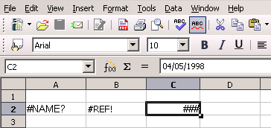
Figure 1: Error codes displayed within cells
When the cell displaying the #REF error code in Figure 3 is selected, the status bar displays the error message as shown in Figure 2. This message is more descriptive than the one displayed in the cell, but it may not provide enough information to correctly diagnose the problem. For a more detailed explanation, consult the following tables and the Help topic, “Error Codes in OpenOffice Calc.”
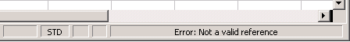
Figure 2: An error message displayed in the status bar.
This appendix presents error codes in two tables. The first table explains error messages displayed within the cell that contains the error. Except in the case of the ### error, they all correspond to a Calc error code number. The second table explains all the error codes, listed by code number, including those listed in the first table.

Error Codes Displayed Within Cells
Cell error | Code | Explanation of the error
### | N/A | The column is too narrow to display the complete, formatted contents of the cell. There is no corresponding numerical error code. The solutions to this problem are to increase the width of the column or select Format > Cells > Alignment and click either “Wrap text automatically” or “Shrink to fit cell size” to make the text match the current column width.
Err:502 | 502 | Function argument is not valid, or the DGET function finds more than one matching cell.
#NUM! | 503 | A calculation resulted in a value that exceeded the defined range of acceptable values.
#VALUE | 519 | The formula in the cell returns a value that does not correspond to the definition of the formula or the functions used. This error could also mean that the cell referenced by the formula contains text instead of a number.
#REF! | 524 | The formula in the cell uses a reference that does not exist. Either a column or row description name could not be found, or the column, row, or sheet that contains a referenced cell is missing.
#NAME? | 525 | An identifier could not be evaluated; for example, it may not contain a valid reference, domain name, column/row label, macro, or an incorrect decimal divider, or the add-in may not be found. For example, entering in a cell =sum(bob*5) where there is no cell named “bob” or containing the text “bob” generates this error.
#DIV/0! | 532 | Division operator / if the denominator is 0.  Some additional functions return this error; see the next table for details.

General Error Codes
The following table is an overview of the most common error messages for OpenOffice Calc.
Note | Errors described as Internal errors should not be encountered by users under normal conditions. Errors described as Not used are not currently assigned to any error condition.

Code | Message | Explanation of the error
501 | Invalid character | Character in a formula is not valid. This error is the same as the Invalid Name error (525) except that it occurs within a formula. The cell containing the error will display the #NAME? error reference.
502 | Invalid argument | Function argument is not valid; for example, a negative number for the root function. This error also occurs if the DGET function finds more than one matching cell.
503 | Invalid floating point operation (cell displays #NUM!) | Division by 0, or another calculation that results in a value too big or too small.
504 | Parameter list error | Function parameter is not valid; for example, text instead of a number, or a domain reference instead of a cell reference.
505 | Internal syntax error | Not used.
506 | Invalid semicolon | Not used.
507 | Pair missing | Not used.
508 | Pair missing | Missing bracket or parenthesis; for example, closing brackets but no opening brackets.
509 | Missing operator | Operator is missing; for example,  =2(3+4), where the operator between "2" and "(" is missing.
510 | Missing variable | Variable is missing; for example, when two operators are together =1+*2.
511 | Missing variable | Function requires more variables than are provided; for example, AND() and OR().
512 | Formula overflow | The total number of internal tokens (that is, operators, variables, brackets) in the formula exceeds 512, or the total number of matrices the formula creates exceeds 150. This includes basic functions that receive an array that is too large as a parameter.
513 | String overflow | An identifier in the formula exceeds 64 KB in size, or a result of a string operation exceeds 64 KB in size.
514 | Internal overflow | Sort operation attempted on too much numerical data (max. 100000) or a calculation overflow.
515 | Internal syntax error | Not used.
516 | Internal syntax error | Matrix is expected on the calculation stack, but it is not available.
517 | Internal syntax error | Unknown error; for example, a document with a newer function is loaded in an older version of Calc that does not contain the function.
518 | Internal syntax error | Variable is not available.
519 | No result (cell displays #VALUE) | Formula yields a value that does not correspond to the definition, or a cell that is referenced in the formula contains text instead of a number.
520 | Internal syntax error | Compiler creates an unknown compiler code.
521 | Internal syntax error | No result.
522 | Circular reference | Formula refers directly or indirectly to itself, and the Iterations option is not selected under Tools > Options > OpenOffice Calc > Calculate.
523 | The calculation procedure does not converge | Financial statistics function missed a targeted value, or iterations of circular references do not reach the minimum change within the maximum steps that are set.
524 | Invalid references (cell displays #REF!) | A column or row description name could not be resolved, or the column, row, or sheet that contains a referenced cell is missing.
525 | Invalid names (cell displays #NAME?) | An identifier could not be evaluated; for example, it may not contain a valid reference, domain name, column/row label, macro, or an incorrect decimal divider, or the add-in may not be found.
526 | Internal syntax error | Obsolete, no longer used, but could come from old documents.
527 | Internal overflow | References, such as when a cell references a cell, are too encapsulated, or deeply nested.
528–531 | — | Not used.
532 | Division by zero | Division operator / if the denominator is 0.  Several functions return this error; for example:  VARP with less than 1 argument  STDEVP with less than 1 argument  VAR with less than 2 arguments  STDEV with less than 2 arguments  STANDARDIZE with stdev=0  NORMDIST with stdev=0

In this case, the word - undefined – is misleading because the output position is defined by the cell. A better term would be -unnamed-.

