Apache OpenOffice
Version 4.1
Impress Guide

AOO Documentation Team

Copyright
This document is Copyright © 2025 by The Apache Software Foundation. You may distribute it and/or modify it under the terms of the Creative Commons Attribution License, version 3.0 or later (https://creativecommons.org/licenses/by/3.0/).
Apache, Apache OpenOffice, and OpenOffice.org are trademarks of the Apache Software Foundation. Used with permission.
Acknowledgments
This book is updated from a previous version by the OOoAuthors team. The AOO Documentation Team appreciates the many contributions of Michael Scarborough and Michele Petrovsky.
Publication date and software version
Published October 30, 2025. Based on Apache OpenOffice 4.1.
Note for Mac Users
Some keystrokes and menu items differ on a Mac from those used in Windows and Linux. The table below gives some common substitutions for the instructions in this chapter. For a more detailed list, see the application Help.

Windows/Linux | Mac equivalent | Effect
Tools > Options menu selection | OpenOffice > Preferences | Access setup options
Right-click | Control+click | Open context menu
Ctrl (Control) | z (Command) | Used with other keys
F5 | Shift+z+F5 | Open the Navigator
F11 | z+T | Open Styles & Formatting window

Contents
Chapter 1
Introducing Impress 9
What is Impress? 10
Starting Impress 10
The Main Impress Window 11
Slides Pane 11
Sidebar 12
Workspace 13
Toolbars 13
Status Bar 13
Navigator 14
Workspace Views 14
Normal View 14
Outline View 15
Notes View 15
Handout View 16
Slide Sorter View 17
Creating a New Presentation 19
Formatting a Presentation 22
Inserting Slides 22
Selecting a Layout 22
Modifying the Slide Elements 24
Modifying the Appearance of Slides 26
Modifying the Slide Show 26
Running the Slide Show 27
Chapter 2
Using Slide Masters, Styles, and Templates 29
Designing a Presentation 30
What are Slide Masters? 30
Working with Slide Masters 31
Creating Slide Masters 31
Applying a Slide Master 31
Loading Additional Slide Masters 32
Modifying a Slide Master 33
Choosing and Applying the Background 34
Slide Master Styles 37
The Styles and Formatting Window 38
Modifying Default Text Areas 39
Adding Text to All Slides 41
Working with Styles in Impress 42
Working with Templates 42
Using Templates Supplied with AOO 42
Using Templates From Other Sources 43
Creating Your Own Templates 43
Setting a Default Template 44
Modifying a Template 45
Organizing templates 46
Chapter 3
Adding and Formatting Text 48
Introduction 49
Working with Text Boxes 49
Using Text Boxes Created from the Layout Panel 49
Using Text Boxes Created from the Text Box Tool 49
Moving a Text Box 50
Resizing a Text Box 51
Deleting a Text Box 51
Inserting Text 52
Pasting Text 52
Inserting Special Characters 53
Inserting Non-breaking Spaces and Hyphens 54
Introduction to Formatting Text 54
Selecting Text 55
Using Styles to Format Text 55
Modifying a Presentation Style 55
Updating a Style from a Selection 56
Applying a Presentation Style 56
Formatting Characters 57
Font Tab 57
Font Effects Tab 58
Position Tab 58
Formatting Paragraphs 59
Indents and Spacing Tab 60
Alignment Tab 61
Tabs Tab 62
Asian Typography Tab 62
Creating Bulleted and Numbered Lists 63
Creating Lists in AutoLayout Text Boxes 63
Creating Lists in Other Text Boxes 63
Creating a New Outline Level 64
Changing the Appearance of the List 64
Changing the Order or the Outline Level Lines 68
Using Tables 68
Creating a Table 69
Modifying a Table 69
Deleting a Table 73
Using Fields 73
Inserting a Field 73
Customizing Fields 74
Using Hyperlinks 74
Editing Text Hyperlinks 76
Working with Hyperlink Buttons 76
Chapter 4
Adding and Formatting Pictures 77
Introduction 78
Inserting Pictures 78
Inserting a Picture from a File 78
Inserting a Picture from a Scanner 79
Inserting a Picture from the Gallery 80
Managing the Gallery Themes 82
Adding Images to the Gallery 82
Deleting Images from the Gallery 82
Adding a New Theme to the Gallery 83
Formatting Pictures 83
Moving a Picture 83
Resizing a Picture 83
Rotating a Picture 84
Formatting using the Picture Toolbar 85
Deleting a Picture 89
Creating an Image Map 89
Chapter 5
Managing Graphic Objects 91
Introduction 92
Creating Lines and Shapes 94
Grouping Shapes Together 95
Moving Graphic Objects 96
Resizing Graphic Objects 97
Applying Special Effects 97
Rotating Graphic Objects 98
Flip an Object 100
Mirror Copies 100
Distorting an Image 101
Aligning Shapes 103
Snapping Objects to Grid or Snap Guides 103
Using the Grid 103
Using Snap Guides 103
Arranging Shapes 105
Working with Connectors 105
Managing Glue Points 106
Working with 3D Shapes 107
Converting an Object to a Different Type 108
Setting up Interaction with a Shape 109
Animating Images 110
Creating an Animation 110
Other functions of the Animator 111
Using Fontwork 112
Using the Fontwork Toolbar 114
Modifying Fontwork Text as a Shape 115
Chapter 6
Formatting Graphic Objects 116
Formatting Objects 117
Formatting Lines 117
General Line Settings 118
Creating Line Styles 120
Creating Arrow Styles 121
Line Shadow 122
Formatting the Fill Area 122
Uniform Color 124
Fill with a Gradient 124
Fill with a Line Pattern (Hatching) 124
Fill with an Image 125
Using the Area Dialog 125
Creating New Area Fills 127
Adding Custom Colors 127
Creating Gradients 128
Creating Hatching Patterns 130
Working with Bitmap Fills 131
Formatting Shadows 134
Transparency Formatting 135
Advanced Gradient Controls 137
Formatting Text 139
Text Animation 140
Formatting Connectors 141
Working with Graphics Styles 141
Linked Graphic Styles 142
Creating Graphics Styles 142
Modifying a Graphics Style 144
Applying Graphics Styles 145
Deleting Graphics Styles 145
Assigning Styles to Shortcut Keys 145
Chapter 7
Including Spreadsheets, Charts, and Other Objects 146
Using Spreadsheets in Impress 147
Inserting a Spreadsheet from a File 147
Inserting a Blank Spreadsheet 147
Editing a Spreadsheet 148
Resizing and Moving a Spreadsheet 149
Navigating the Spreadsheet 149
Entering Data 150
Formatting Spreadsheet Cells 151
Inserting a Chart 152
Choosing a Chart Type 153
Entering Chart Data 156
Inserting Other Objects 160
Movies and Sound 161
OLE Objects 162
Formulas 164
Inserting the Contents of a File 164
Chapter 8
Adding and Formatting Slides, Notes, and Handouts 165
Introduction 166
Adding, Renaming, and Removing Slides 166
Adding a New Slide 166
Inserting a Slide from Another Presentation 167
Duplicating a Slide 168
Renaming a Slide 169
Expanding a Slide 169
Creating a Summary Slide 170
Deleting a Slide 170
Creating Slides from an Outline 171
Sending an Outline from Writer to Impress 171
Sending an AutoAbstract from Writer to Impress 172
Copying and Pasting an Outline 173
Modifying Slides 173
Formatting the Slide or Page Area 173
Printing Slides 174
Choosing a Slide Master from the List 175
Changing the Background of a Slide 175
Choosing a Slide Layout from the List 175
Adding Comments 176
Editing, Deleting, and Replying to Comments 177
Adding and Formatting Notes 178
Adding Notes to a Slide 178
Formatting Notes 179
Printing Notes 181
Exporting Notes to PDF 182
Creating Handouts 182
Changing the Layout 183
Formatting Handouts 184
Printing Handouts 185
Chapter 9
Slideshows 186
Creating a Slideshow 187
Choosing Basic Settings for a Slideshow 187
Hiding Slides 189
Showing Slides in a Different Order 189
Using Slide Transitions 191
Setting the Timing of Automatic Slide Changes 192
Playing a Sound Throughout the Presentation 193
Removing a Transition Effect 193
Using Slide Animation Effects 193
Applying an Animation Effect 194
Starting an Animation Effect 194
Choosing Additional Properties of an Animation Effect 195
Advanced Animation Effects 201
Removing Animation Effects 203
Using Interactions 203
Running a Slideshow 204
Using the Presenter Screen 205
Navigating Using the Right-click Menu 207
Chapter 10
Printing, e-mailing, exporting, and saving slideshows 208
Introduction 209
Quick Printing 209
Controlling Printing 209
Selecting General Printing Options 210
Printing Multiple Pages on a Single Sheet of Paper 210
Selecting Slides to Print 211
Selecting Other Information to Print 212
Printing in Black and White (on a Color Printer) 212
Printing Handouts, Notes, or Outlines in Impress 212
Selecting Default Print Options 213
Printing a Brochure 213
Exporting to PDF 214
Quick Export to PDF 214
Controlling PDF Content and Quality 214
Exporting as Web Pages (HTML files) 220
E-mailing a Presentation 224
Digital Signing of Documents 225
Removing Personal Data 226
Opening and Saving a PowerPoint File 226
Saving an Impress File as a PowerPoint File 226
Opening a PowerPoint File in Impress 227
Chapter 11
Setting Up and Customizing Impress 228
Choosing Options That Affect All of AOO 229
User Data Options 229
Print Options 229
Color Options 230
Appearance Options 230
Choosing Options for Impress 231
General Options 231
View Options 233
Grid Options 233
Print Options 235
Customizing the User Interface 236
Customizing the Menu Font 236
Customizing Menu Content 236
Customizing Toolbars 239
Customizing Keyboard Shortcuts 242
Adding Functionality with Extensions 244
Installing Extensions 244

Chapter 1
Introducing Impress

What is Impress?
Impress is Apache OpenOffice’s slide show or presentation program. You can create slides that contain different elements, including text, bulleted and numbered lists, tables, charts, clip art, and a wide range of graphic objects. Impress also includes a spelling checker, a thesaurus, prepackaged text styles, and attractive background styles.
This chapter introduces the Impress user interface and describes how to create a simple slide show using the Presentation Wizard.
The rest of this guide illustrates many other features available in Impress that can be used to create more sophisticated slide shows.
Note | Drawings are created in the same way with Impress as they are with Draw. Refer to the Draw Guide for details on how to use drawing facilities.

Starting Impress
You can start Impress in several ways:
- If no component of AOO is open, from the Start Center, click on the Presentation icon.
- From the system menu or the Quickstarter. Details vary with your operating system; see Chapter 1 in the Getting Started guide for more information.
- From any open component of AOO: click the triangle to the right of the New icon on the main toolbar and select Presentation from the drop-down menu, or choose File > New > Presentation from the menu bar.
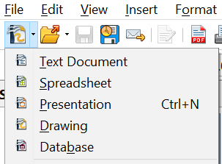

Figure 1: Opening the presentation wizard
When you start Impress for the first time, the Presentation Wizard is shown. For detailed instructions about how to use the wizard, see “Creating a New Presentation” on page 18. If you prefer not to use the wizard in the future, you can select Do not show this wizard again.
Click Create to open the main Impress window.

The Main Impress Window
The main Impress window (Figure 2) has three parts: the Slides pane, the Workspace, and the Sidebar. Additionally, several toolbars can be displayed or hidden during the creation of a presentation.
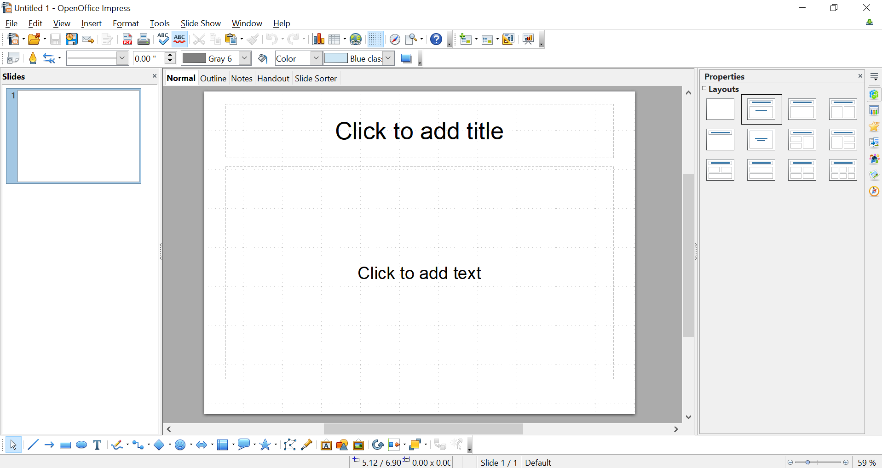

Figure 2: Main window of Impress
Slides Pane
Workspace
Slides Pane
Sidebar
Tip | You can remove the Slides pane or the Sidebar from view by clicking the X in the upper-right corner of each pane. You can also show or hide these panes using View > Slide Pane or View > Sidebar or by clicking the Hide/Show markers that have been circled in the middle of the vertical separator lines. Hiding these panes allows you to maximize the Workspace area.

Slides Pane
The Slides pane contains thumbnail pictures of the slides in your presentation, in the order they will be shown—unless you change the slide show order, as described in Chapter 9 (Slide Shows). Clicking a slide in this pane selects it and places it in the Workspace. When a slide is in the Workspace, you can change it in any way you like.
Several other operations can be performed simultaneously on one or more slides in the Slides pane:
- Add new slides to the presentation.
- Mark a slide as hidden so that it will not be shown as part of the presentation.
- Delete a slide from the presentation if it is no longer needed.
- Rename a slide.
- Duplicate a slide (copy and paste) or move it to a different position in the presentation (cut and paste).
While there are more efficient ways of carrying out the operations immediately below, it's possible to do them using the Slides pane.
- Change the slide transition following the selected slide or after each slide in a group of slides.
- Change the sequence of slides in the presentation.
- Change the slide design.
- Change the slide layout for a group of slides simultaneously.

Sidebar
The Sidebar has seven decks: To select the deck you wish to use, click on its icon on the right edge of the Sidebar.
Properties
This deck adapts to what is selected in the Workspace. In Figure 2, nothing is selected in the slide, so the deck shows a single panel of slide layouts. Clicking on a layout icon in the Sidebar applies that layout to the current slide. If you click on the text Click to add text in the slide, a text cursor appears on the slide, and the Properties deck changes to have two panels, one for text properties and one for paragraph properties. If a shape, picture, or table were on the slide and selected, panels appropriate for setting the properties of the selected object would appear.
Master Pages
On this deck, you define the page style for your presentation. It has three panels: Used in This Presentation, Recently Used, and Available for Use. Impress contains prepackaged Master Pages (slide masters). One of them—Default—is blank, and the rest have a background and styled text.
Custom Animation
A variety of animations for selected elements of a slide are listed. Animation can be added to a slide and later changed or removed. See Chapter 9 (Slide Shows) for an overview of how to add and customize animations.
Slide Transition
Many transitions are available, including No Transition, which makes the next slide simply replace the existing one. You can select the transition speed (slow, medium, fast). You can also choose between an automatic or manual transition, and how long the selected slide should be shown (automatic transition only).
Styles and Formatting
The Styles and Formatting deck is identical to the tool opened by the menu Format > Styles and Formatting. Impress documents have Graphics Styles and Presentation Styles. Graphics Styles are generally applied to drawn objects, setting properties like their fill color and line type, and images and Presentation Styles are applied to text, such as bullet points and title.
Gallery
The Gallery deck provides access to a variety of images, clip art, and sounds. These are stored in themes. You can add your own items and themes. The menu Tools > Gallery opens the same tool but places it by default above the Workspace, inconveniently shrinking the Workspace.
Navigator
The Navigator deck is identical to the tool opened by the menu View > Navigator or pressing Ctrl + Shift + F5. This allows you to move easily among the slides and select content such as shapes and objects. It is much easier to select objects if you give them meaningful names rather than using the default names like Shape1.

Workspace
The Workspace (normally in the center) has five tabs, also called View buttons.
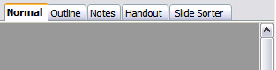
Figure 3: Workspace tabs
The Workspace below the View buttons changes depending on the chosen view. The workspace views are described in detail on page 14.

Toolbars
Many toolbars can be used during slide creation; they can be displayed or hidden by clicking View > Toolbars and selecting from the menu.
You can also select the icons that you wish to use for each toolbar. For more information, refer to Chapter 11 (Setting Up and Customizing Impress).
Many of the toolbars in Impress are similar to the toolbars in Draw. Refer to the Draw Guide for details on the functions available and how to use them.

Status Bar
The status bar, located at the bottom of the Impress window, contains information that you may find useful when working on a presentation.

Figure 4: Left end of the Impress status bar

Figure 5: Right end of Impress status bar
From left to right, you will find:
- A general information area, which changes depending on the selection. For example:
Selected Item | Information Displayed on the Status Bar
Text area | TextEdit: Paragraph x, Row y, Column z
Embedded Spreadsheet | Embedded object (OLE) ‘ObjectName’ selected
Graphics | Bitmap with transparency selected
- The position of the cursor or of the top left corner of the selection measured from the top left corner of the slide, followed by the width and height of the selection or of the text box where the cursor is located.
- A modified flag, showing a star when the file needs saving.
- A flag indicating whether the document is digitally signed.
- The slide number currently displayed in the workspace, and the total number of slides in the presentation.
- The slide master or page style associated with the slide, handout, or notes page currently in the Workspace.
- The zoom slider and zoom level (percent) of the Workspace.
Note | The sizes are given in the current measurement unit (not to be confused with the ruler units). This unit is defined in Tools > Options > OpenOffice Impress> General
You can hide the information in the Status Bar by selecting View > Status Bar from the main menu.

Navigator
The Navigator displays all objects contained in a document. It provides another convenient way to move around a document and find items in it. To display the Navigator, click its icon on the Standard toolbar, or choose View > Navigator on the menu bar, or press Ctrl+Shift+F5.
The Navigator is more useful if you give your slides and objects (pictures, spreadsheets, and so on) meaningful names, instead of leaving them as the default “Object 1” and “Shape 1” shown in the example.

Workspace Views
Each of the workspace views is designed to facilitate the completion of certain tasks. Familiarizing yourself with these views will help you accomplish tasks more quickly.

Normal View
Normal view is the main view for creating individual slides. Use this view to format and design slides and to add text, graphics, and animation effects.
To place a slide in the slide design area (Workspace) of the Normal view (Figure 2), either click the slide thumbnail in the Slides pane or double-click it in the Navigator (page 14).

Outline View
Outline view contains all of the slides of the presentation in their numbered sequence. It shows topic titles, bulleted lists, and numbered lists for each slide in outline format. Only the text contained in the default text boxes in each slide is shown, so if your slide includes other text boxes or drawing objects, the text in these objects is not displayed. Slide names are not included.
Figure 6: Outline view
Use Outline view for:
- Making changes in the text of a slide:
  - Add or delete text in a slide, just as in the Normal view.
  - Move the paragraphs of text in the selected slide up or down by using the up and down arrow buttons (Move Up or Move Down) on the Text Formatting toolbar.
  - Change the outline level for any of the paragraphs in a slide using the left and right arrow buttons (Promote or Demote).
  - Simultaneously move a paragraph and change its outline level using a combination of these four arrow buttons.
- Compare the slides with your outline (if you have prepared one in advance). If you notice from your outline that another slide is needed, you can create it directly in the Outline view, or you can return to the Normal view to create it.

Notes View
Use the Notes view (Figure 7) to add notes to a slide. These notes are not seen when the presentation is shown.
- Click the Notes tab in the Workspace.
- Select the slide to which you want to add notes.
  - Click the slide in the Slide pane, or
  - Double-click the slide’s name in the Navigator.
- In the text box below the slide, click on the words Click to add notes and begin typing.
You can resize the Notes text box using the green resizing handles and move it by placing the pointer on the border, then clicking and dragging. To make changes in the text style, use the Styles and Formatting deck of the Sidebar or press the F11 key to open the Styles and Formatting window and modify the Notes style among the Presentation styles.
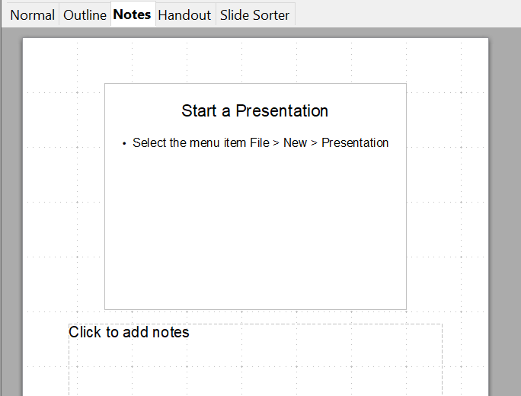
Figure 7: Adding notes in Notes view

Handout View
Handout view is for setting up the layout for a printed handout. Click the Handout tab in the workspace, then choose the Properties deck of the Sidebar. You can then choose to print 1, 2, 3, 4, 6, or 9 slides per page.
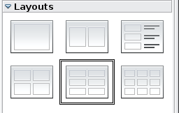
Figure 8: Handout layouts
Use this view also to customize the information printed on the handout. Refer to Chapter 10 of this book for instructions on printing slides, handouts, and notes.

Slide Sorter View
The Slide Sorter view contains all of the slide thumbnails. Use this view to work with a group of slides or with only one slide.
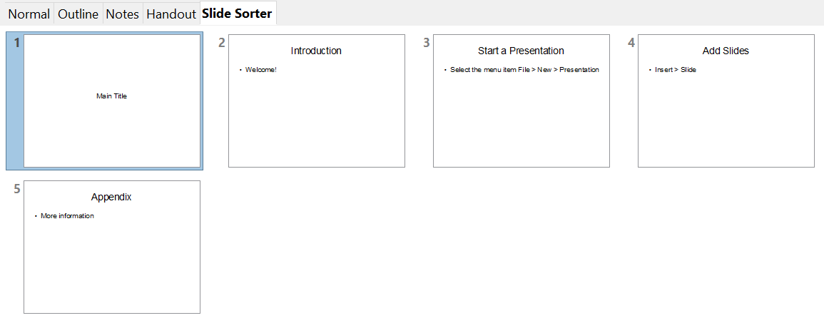

Figure 9: Slide Sorter view

Customizing Slide Sorter View
To change the number of slides per row:
- Check View > Toolbars > Slide View to show or hide the Slide view toolbar.
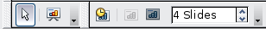
Figure 10: Slide Sorter and Slide View toolbars
- Adjust the number of slides (up to a maximum of 15).

Moving a Slide Using Slide Sorter
To move a slide in a presentation using the Slide Sorter:
- Click the slide. A thick border is drawn around it.
- Drag and drop it to the location you want. As you move the slide, a black vertical line appears to one side of the slide. Drag the slide until this black vertical line is located where you want the slide to be.

Selecting and Moving Groups of Slides
To select a group of slides, use one of these methods:
- Use the Control (Ctrl) key: Click on the first slide and, while pressing Control, select the other desired slides.
- Use the Shift key: Click on the first slide, and while pressing the Shift key, select the final slide in the group. This selects all of the other slides between the first and the last.
- Use the mouse: Click slightly to the left of the first slide to be selected. Hold down the left mouse button, and drag the mouse pointer to a spot slightly to the right of the last slide to be included. (You can also do this right to left.) A dashed outline of a rectangle forms as you drag the pointer through the slide thumbnails, and a thick border is drawn around the selected slides. Make sure the rectangle includes all the slides you want to select.
To move a group of slides:
- Select the group.
- Drag and drop the group to its new location. A vertical black line appears to show you where the group of slides will go.

Working in Slide Sorter View
You can work with slides in the Slide Sorter view just as you can in the Slide pane.
To make changes, right-click a slide and choose any of the following from the pop-up menu:
- Add a new slide after the selected slide.
- Rename or delete the selected slide.
- Change the slide layout using the Sidebar.
- Change the slide transition of one or more slides using the Sidebar.
- Mark a slide as hidden. Hidden slides will not be shown in the slide show.
- Copy or cut and paste a slide.

Renaming Slides
Right-click on a thumbnail in the Slides pane or the Slide Sorter and choose Rename Slide from the pop-up menu. In the Name field, delete the old name of the slide and type the new name. Click OK.

Creating a New Presentation
This section shows you how to set up a new presentation using the Presentation Wizard.
Tip | First decide on the purpose of the presentation. Then, plan the presentation. Although you can make changes as you go, having an idea of who the audience will be, the structure and content of the presentation, and how the presentation will be delivered, will save you time and effort from the start.
When you start Impress, the Presentation Wizard appears.
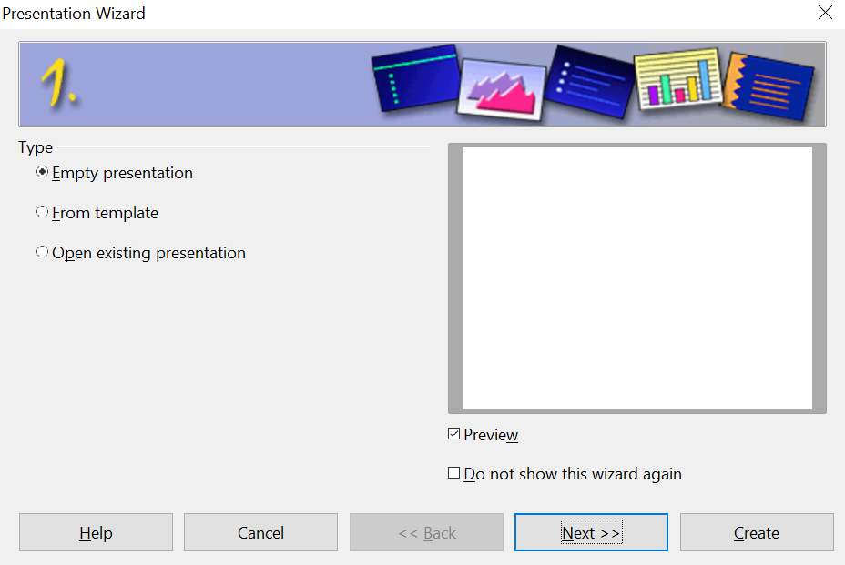

Figure 11. Choosing the type of presentation
Tip | If you do not want the wizard to start every time you start Impress, select the Do not show this wizard again option. You can enable the wizard again later by going to Tools > Options > OpenOffice Impress > General and selecting the Start with wizard option.  Leave the Preview option selected, so templates, slide designs, and slide transitions appear in the preview box as you choose them.
- Under Type, choose one of the options:
- Empty presentation creates a blank presentation.
- From template uses a template design already created as the basis for a new presentation. The wizard changes to show a list of available templates. Choose the template you want. More details can be found in Chapter 2.
- Open existing presentation continues work on a previously created presentation. The wizard changes to show a list of existing presentations. Choose the one you want.
- Click Next. Figure 12 shows the Presentation Wizard step 2 as it appears if you selected Empty presentation at step 1. If you selected From template, an example slide is shown in the Preview box.
- Choose a design under Select a slide design. The slide design section gives you two main choices: Presentation Backgrounds and Presentations. Each one has a list of choices for slide designs. If you want to use one of these other than <Original>, click it to select it.
The types of Presentation Backgrounds are shown in Figure 12. When you click an item, a preview of the slide design appears in the Preview window. <Original> is an empty background.

Impress contains three choices under Presentations:
  - <Original> is for a blank presentation slide design.
  - Both Introducing a New Product and Recommendation of a Strategy have their own prepackaged slide designs. Each design appears in the Preview window when its name is clicked.
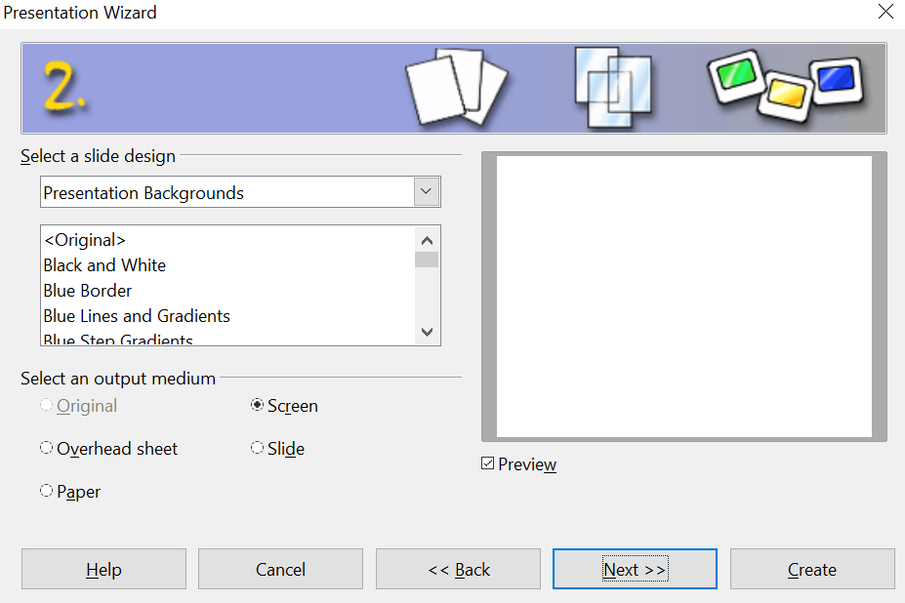

Figure 12. Selecting a slide design
To start with a blank presentation, select <Original>. Click an item to see a preview of the slide design in the Preview window.
Note | Introducing a New Product and Recommendation of a Strategy are prepackaged presentation templates. They can be used to create a presentation by choosing From template in the first step (Figure 11).
- Select how the presentation will be used under Select an output medium. Most often, presentations are created for display on a computer monitor, so you would select Screen. You can change the page format at any time.
Note | The default Screen page is optimized for a 4:3 display (28cm x 21cm), so it is not suitable for modern widescreen displays. You can change the slide size at any time, switching to Normal view and selecting Format > Page.
- Click Next. The Presentation Wizard step 3 appears.
Choose the desired slide transition from the Effect drop-down menu.
Select the desired speed for the transition between the different slides in the presentation from the Speed drop-down menu. Medium is a good choice for now.
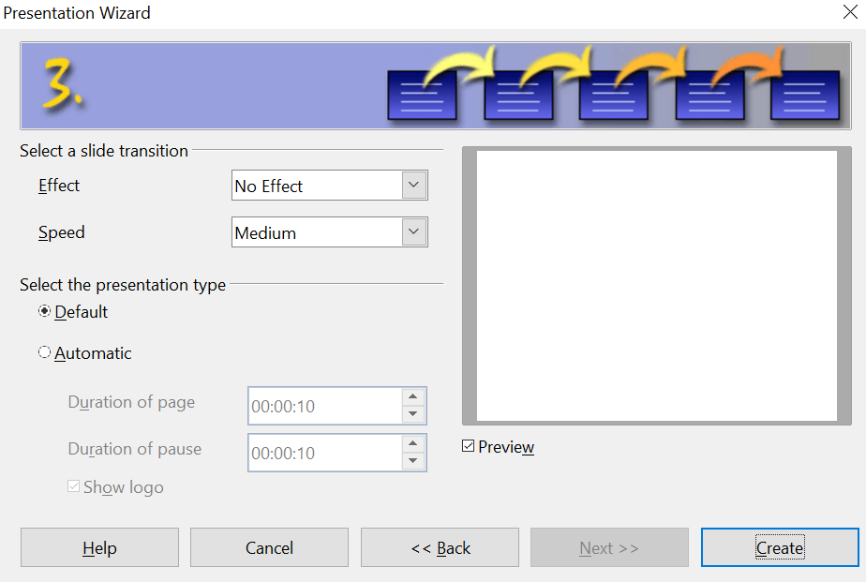

Figure 13: Selecting a slide transition effect
- Click Create. A new presentation is created.
Tip | Unless you are skilled at creating presentations, you might want to accept the default values for both Effect and Speed. Both of these values can be changed later while working with slide transitions and animations. These two are explained in more detail in Chapter 9 (Slide Shows).
Note | If you selected From template on step 1 of the Wizard, the Next button will be active on step 3, and other pages will be available. These pages are not described here.

Formatting a Presentation
A new presentation only contains one empty slide. In this section, we will start adding new slides and preparing them for the intended contents.

Inserting Slides
This can be done in a variety of ways; take your pick.
- Insert > Slide.
- Right-click on the present slide, and select Slide > New Slide from the pop-up menu.
- Click the Slide icon in the Presentation toolbar.

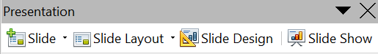
Sometimes, rather than starting from a new slide, you want to duplicate a slide you have already inserted. To do so, select the slide you want to duplicate from the Slides pane and then choose Insert > Duplicate Slide.

Selecting a Layout
In the Sidebar, make sure nothing is selected in the current slide. Then select the Properties deck to display the available layouts. The Layouts differ in the number of elements a slide will contain, from a blank slide to a slide with six content boxes and a title.
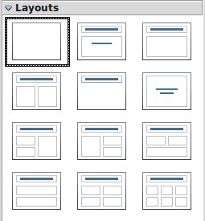
Figure 14: Choosing a slide layout
The first slide in a presentation is normally a title slide. The Title Slide (which also contains a section for a subtitle) or Title Only are suitable layouts for the first slide, while for most of the slides, you will probably use the Title, Contents layout.
To create the title, click on Click to add title (assuming the Blank Slide layout was not used) and then type the title text. To adjust the formatting of the title, modify the Title presentation style; see Chapter 2 (Using Slide Masters, Styles, and Templates) for instructions.
If you are using the Title Slide layout, click on Click to add text to add a subtitle. Proceed as above to make adjustments to the formatting if required, modifying the Subtitle presentation style instead.
Tip | To view the names of prepackaged layouts, use the Tooltip feature: position the cursor on an icon in the Layout section (or on any toolbar icon) and its name will be displayed in a small rectangle.  If tooltips are not enabled, choose Tools > Options > OpenOffice > General > Help and select the Tips option. If the Extended tips option is also selected, you will get more detailed tooltip information, but the layout names themselves will not be provided.
To select or change the layout, place the slide in the work area and select the desired layout from the Properties deck of the Sidebar. Remember that the Sidebar content depends on what is selected. It will show the available layouts if no objects on the slide are selected
Several layouts contain one or more content boxes. Each of these boxes can be configured to contain one of the following elements: Text, Media clip, Picture, Chart, or Table.
You can choose the type of content by clicking on the icon that is displayed in the middle of the contents box, as shown in Figure 15. If instead you intend to use the contents box for text, just click anywhere on the box to get a cursor.
Figure 15: Selecting the desired contents type for a contents box
Note | Text and graphic elements can be readjusted at any time during the preparation of the presentation, but changing the layout of a slide that already contains some content can have a dramatic effect. It is therefore recommended that you pay particular attention to the layout you select. If you do need to change the layout after contents have been added, the contents are not lost, though they may need to be reformatted.

Modifying the Slide Elements
At this stage, the slide consists of everything contained in the slide master, as well as in the chosen layout slide. You may want to remove unneeded elements and add objects (such as pictures), as well as insert text. Most content can be inserted using a content box, as shown in Figure 15, or directly on the slide. Both methods are described in the following sections.
Caution   | Changes to any of the prepackaged layouts should only be made using View > Normal. Attempting to make changes by modifying the slide master itself may result in erratic results and requires extra care as well as a certain amount of trial and error.

Inserting Text
Clicking on Click to add text in the content box starts the process of making a bulleted outline. Type the text you want for the first bullet and press Enter to start a new bulleted paragraph. You can use the Tab key to move the text to a lower outline level and Shift + Tab to move text to a higher outline level. You can also change the outline levels using the arrow icons on the Text Formatting toolbar. You can change the bullet character, indentation of the bullets, spacing of the text, and other formatting details by modifying the Outline styles among the Presentation styles in the Styles and Formatting deck of the Sidebar. It is not a good idea to set the formatting manually because that will have to be repeated on every slide, and if you change your mind about any detail, every slide with bullet points will have to be edited.
Text can also be entered inside a text box graphic. This is started by clicking the text box icon, an uppercase T, on the Drawing toolbar. Click and drag the cursor, which is now a cross, on the slide approximately where you want the text to be. When you release the mouse button, the text cursor will be inside the text box. As you type the text, the height of the box will increase as necessary. Click outside the box to finish the input. You can click immediately next to the text to select the box; it will have eight handles, and use click and drag to move or resize the box. You can change the text style used in the box by modifying the Default style among the Graphics styles in the Styles and Formatting deck of the Sidebar, or you can apply a different style. You can also right-click on the selected box and choose from several menu items to change the box's appearance, position, and size.

Inserting a Table
Click the Insert Table icon of the content box to bring up a dialog for setting the number of rows and columns in the table. Clicking OK in that dialog inserts a table that fills the width of the content box and has a default color scheme. If there is no content box or if it has been used for another purpose, you can insert a table with Insert > Table. This brings up the dialog for picking the number of rows and columns, just as with the content box. After clicking OK, the table is inserted near the center of the slide.
After inserting the table, clicking inside it, and then selecting the Properties deck of the Sidebar gives you access to the Table Design panel, where you can change the color scheme, banding, and other table features. You can also select one or more table cells with the mouse and use the Table toolbar to change colors, borders, text properties, or insert or delete entire rows and columns. As with most objects, you can right-click on the table and bring up a context menu for resizing, positioning, and adjusting many of the table's properties.

Inserting a Picture
The Insert Picture icon of the content box opens a dialog for selecting a file. Navigate to the desired file, choose whether to insert a link or the actual picture file at the lower left of the dialog, and click Open. The picture will be sized to fill either the height or the width of the content box while keeping the original height/width ratio. Alternatively, you can insert a picture with Insert > Picture > From File. The same dialog will open, and you can choose the file, whether to link it, and click Open. The picture will be inserted near the center of the slide.
Once the picture is inserted, you can select it and resize it with the handles. It is usually best to hold the Shift key while resizing a picture manually so that it keeps a constant height/width ratio and does not become distorted. You can also right-click on the image and adjust its position, size, and other properties through dialogs, including an option to crop the image.

Caution | When resizing a graphic, right-click the picture. Select Position and Size from the context menu, and make sure that Keep ratio is selected. Then adjust the height or width to the size you need. Failure to do so will cause the picture to become distorted. Also, be aware that as you adjust one dimension, both dimensions will change.  Remember also that resizing a bitmap (.bmp) image will reduce its quality on screen, even though the original image is unchanged, since Impress stores the original file. A better approach is to create an image of the desired size outside of Impress, and then import it into the presentation.

Inserting a Chart
Clicking the Insert Chart icon in the content box or using Insert > Chart inserts a default column chart. The chart should be inserted as the selected object on the slide, but you can double-click near its edge to select it if needed. The first task is to enter the data for the chart and set its type (bar chart, scatter chart, etc.). Right-click on the selected chart and choose Chart Data Table. This brings up a dialog with a data table and icons for adding or deleting columns and rows. This dialog is appropriate for only very simple data. After entering the data, you can right-click on the chart again, pick the Chart Type, and set other chart properties. Using Calc to make the chart is almost certainly a better choice. It can then be copied and pasted into your presentation.

Inserting a Movie
Apache OpenOffice (AOO) Impress supports media formats, including AVI, MOV, MPG, and WAV, among others. However, its capabilities may vary depending on the specific version, operating system, and codecs installed on your computer. To ensure compatibility, it's recommended to convert media files to common formats like .avi or .mpg before inserting them into your presentation
To remove any element on the slide that is not required, click the element to select it. The green handles show that it is selected; press the Delete key to remove it.

Modifying the Appearance of Slides
To change the background and other characteristics of all slides in the presentation, you need to modify the slide master or choose a different slide master.
A Slide Master is a slide with a specified set of characteristics that acts as a template and is used as the starting point for creating other slides. These characteristics include the background, objects in the background, formatting of any text used, and any background graphics.
Note | AOO uses three interchangeable terms for this one concept. Master slide, slide master, and master page all refer to a slide that is used to create other slides. This book, however, uses only the term slide master, except when describing the user interface.
Impress has a range of prepackaged slide masters, found in the Master Pages deck of the Sidebar. You can also create and save additional slide masters or add more from other sources. See Chapter 2 for information on creating and modifying slide masters.
If all you need to do is change the background, you can take a shortcut:
- Select Format > Page and go to the Background tab.
- Select the desired background between solid color, gradient, hatching, and bitmap. Click OK to apply it.
A dialog box opens, asking if the background should be applied to all the slides. If you click Yes, Impress automatically modifies the slide master for you.

Modifying the Slide Show
By default, the slide show will display all the slides in the same order as they appear in the slide sorter, without any transition between slides. Also, this default display requires some keyboard or mouse interaction to move from one slide to the next.
Now is a good time to review the entire presentation and answer some questions. Run the slide show at least once (see “Running the Slide Show” on page 27) before answering them. You might want to add some questions of your own.
- Are the slides in the correct order? If not, some of them will need to be moved.
- Is the information well-spaced and visible to members of an audience at the back of a large room? They may not be able to see information at the bottom of a slide, so you may need to design your presentation to fit the top three-quarters of the screen.
- Would an additional slide make a particular point clearer? If so, another slide needs to be created.
- Do some of the slides seem unnecessary? Hide or delete them.
- Would custom animations help some of the slides? (Advanced technique.)
- Should some of the slides have a different slide transition than others? The transition of those slides should be changed.
Caution | If one or more slides seem unnecessary, hide the slide or slides, and view the slideshow a few more times to make sure they aren't needed. To hide a slide, right-click the slide in the Slides pane and select Hide Slide in the pop-up menu. Do not delete a slide until you have done this; otherwise, you may have to create that slide again.
Once you have answered these and your own questions, make the necessary changes. This is done most easily in the Slide Sorter view (see page 16). Use the Slide Show menu to change the order of the slides, choose which ones are shown, automate moving from one slide to the next, and other settings. To change the slide transition, animate slides, add a soundtrack to the presentation, and make other enhancements, use functions in the Sidebar.

Custom Animations
If you wish to add a custom animation to a slide, do it now. Custom animations are found on the Tasks pane. This is an advanced technique and is explained in Chapter 9 (Slide shows).

Slide Transitions
Your first slide show should probably have the same slide transition for all slides. Setting Advance slide to On mouse click is the default. If you want each slide to be shown for a specific amount of time, click Automatically after and enter the number of seconds. Click Apply to all slides.
Transition choices are found on the Sidebar. For more information about slide transitions, see Chapter 9 (Slide Shows).
Tip | The Slide transition section has a very useful option: Automatic preview. With this option selected, when you make any changes in a slide transition, the new slide is previewed in the Slide Design area, including its transition effect.

Running the Slide Show
To run the slide show, do one of the following:
- Click Slide Show > Slide Show on the main menu bar.
- Click the Slide Show button on the Presentation toolbar or the Slide Sorter toolbar (Figure 10).
- Press F5 or F9. (F5 only on a Mac.)
If the slide transition is Automatically after x seconds, let the slide show run by itself.
If the slide transition is On mouse click, do one of the following to move from one slide to the next.
- Use the arrow keys on the keyboard to go to the next slide or to go back to the previous one.
- Click the mouse button to advance to the next slide.
- Press the Spacebar on the keyboard to advance to the next slide.
Right-click anywhere on the screen to open a menu from which you can navigate the slides and set other options.
When you advance past the last slide, the message Click to exit presentation… appears. Click the mouse or press any key to exit the presentation.
To exit the slide show at any time, including at the end, press the Esc key.

Chapter 2
Using Slide Masters, Styles, and Templates

Designing a Presentation
In addition to carefully planning the content (as discussed in Chapter 1), you also need to plan the presentation's appearance. It is best to do this after you have developed an outline; the outline will determine some of the requirements for the slides’ appearance. For example:
- What color combinations (background and text) will look good and also be easy for your audience to read?
- Would a picture help your audience better understand the contents?
- Do you want a particular text and a picture to appear on all the slides? (for example, a company name and logo.)
- Would the audience benefit from having the slides numbered so that they can quickly refer to one of them?
- Do you want a background graphic or a gradient? If so, you need to pick something that does not interfere or clash with content, such as the colors used in charts.
- Will you need one slide master or several? Will one slide design suit all of the content?
You can change the appearance of slides as you develop the presentation, but planning ahead will save you time in the long run.

What are Slide Masters?
A slide master is a slide that is used as the starting point for other slides. It is similar to a page style in Writer: it controls the basic formatting of all slides based on it. A slide show can have more than one slide master.
Note | AOO uses three terms for this one concept. Master slide, slide master, and master page all refer to a slide that is used to create other slides. This book uses the term slide master, except when describing the user interface.
A slide master has a defined set of characteristics, including the background color, graphic, or gradient; objects (such as logos, decorative lines, and other graphics) in the background; headers and footers; placement and size of text frames; and the formatting of text.
All of the characteristics of slide masters are controlled by styles. The styles of any new slide you create are inherited from the slide master from which it was created. In other words, the styles of the slide master are available and applied to all slides created from that slide master. Changing a style in a slide master results in changes to all slides based on that slide master. However, it is possible to modify each slide without affecting the slide master.
Note | Although it is highly recommended to use slide masters whenever possible, there are occasions when manual changes are needed for a particular slide, for example, to enlarge the chart area when using text and chart layouts.
Slide masters have two types of styles associated with them: presentation styles and graphics styles. The prepackaged presentation styles can be modified, but new presentation styles cannot be created. However, new graphics styles can be created.
Presentation styles are discussed in detail in Chapter 3 (Working with Text). The use of graphics styles is covered in Chapter 6 (Formatting Graphic Objects). See also Working with Styles in Impress on page 41.

Working with Slide Masters
Impress comes with 30 pre-packaged slide masters. They are shown in the Master Pages deck of the Sidebar (Figure 16). This deck has three panels: Used in This Presentation, Recently Used, and Available for Use. Click the + sign next to the name of a panel to expand it to show thumbnails of the slides, or click the – sign to collapse the panel to hide the thumbnails.
Each of the slide masters shown in the Available for Use list is from a template of the same name. If you have created your templates or added templates from other sources, slide masters from those templates will also appear in this list. See Working with Templates on page 41 for more about templates.

Creating Slide Masters
You can create a new slide master in a way that is similar to modifying a default slide master.
To start, enable editing of slide masters by selecting View > Master > Slide Master. You can also right-click on the default slide master in the Master Pages section of the tasks pane and select Edit Master.
On the Master View toolbar, click the New Master icon (the leftmost icon in the figure below).
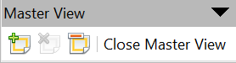
A second slide master appears in the Slides pane. Modify this slide master to suit your requirements. It is recommended that you rename this new slide master. To do this, right-click on the slide in the Slides pane and select Rename master from the pop-up menu.
When you are done, close the Master View toolbar to return to normal slide editing mode.

Applying a Slide Master
In the Sidebar, be sure the Master Pages deck is showing. (See Figure 16.)
To apply one of the slide masters to all slides in your presentation, click on it in the list.
To apply a different slide master to one or more selected slides:
- In the Slides Pane, select the slides you want to change.
- In the Sidebar, right-click on the slide master you want to apply to the selected slides, and click Apply to Selected Slides on the pop-up menu.
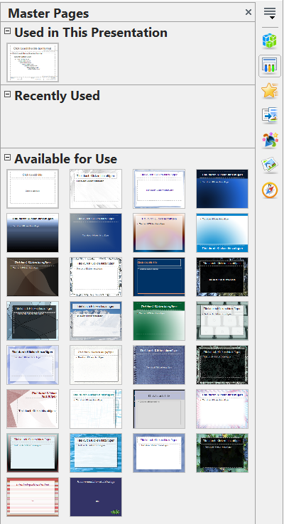

Figure 16: Available master pages (slides)

Loading Additional Slide Masters
Sometimes, in the same set of slides, you may need to mix multiple slide masters that may belong to different templates (the use of templates is explained later in Working with Templates on page 41). For example, you may need a completely different layout for the first slide of the presentation, or you may want to add a slide from a different presentation to your current presentation (based on a template available on the hard disk).
The Slide Design dialog box (Figure 17) makes this possible. Access this dialog box either from the menu bar (Format > Slide design) or from the pop-up menu that appears when you right-click on a slide in the Slides pane.
The main window in the dialog box shows the slide masters already available for use. To add more:
- Click the Load button.
- In the Load Slide Design dialog box, select the template from which to load the slide master. Click OK.
- Click OK again to close the slide design dialog box.
The slide masters in the template you selected are now also shown in the Master Pages deck of the Sidebar in the Available for use panel.
Note | The slide masters you have loaded will also be available the next time you load the presentation. If you want to delete unused slide masters, click the corresponding checkbox in the Slide Design dialog box.
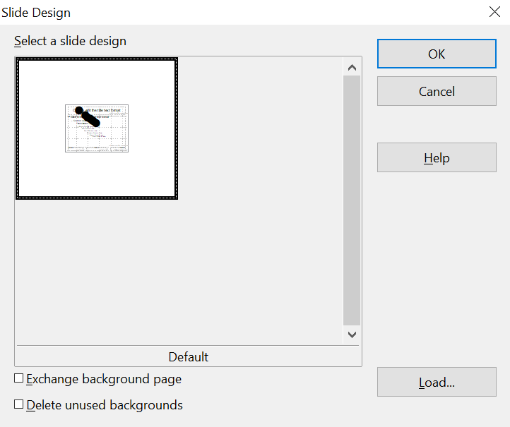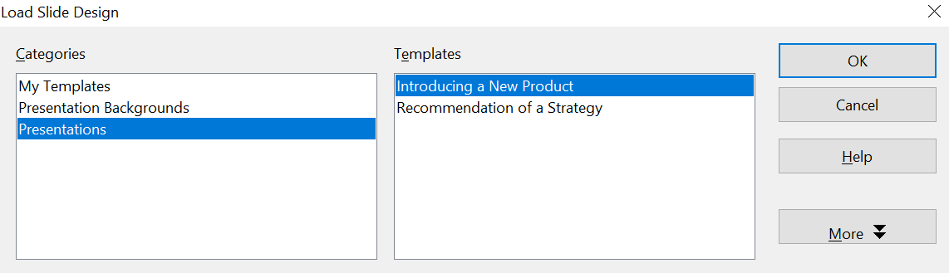

Figure 17: Loading slide masters from a presentation template
Tip | To limit the size of the presentation file, consider minimizing the number of slide masters used.

Modifying a Slide Master
The following items can be changed on a slide master:
- Background (color, gradient, hatching, or bitmap)
- Background objects (for example, add a logo or decorative graphics)
- Text attributes for the main text window and notes
- Size, placement, and contents of header and footer elements to appear on every slide
- Size and placement of default frames for slide titles and content
Refer to Figure 20 for a graphical representation of many of these elements.
Before working on the slide master, make sure that the Styles and Formatting window is open. See page 37 for instructions on doing this.
To select a slide master for modification:
- Select View > Master > Slide Master from the menu bar. This unlocks the properties of the slide master, allowing you to edit it.
- Click the Master Pages icon in the Sidebar. This gives you access to the prepackaged slide masters.
- Click on the slide master you want to modify from those available (Figure 16).
- Make changes as described in this chapter, then click the Close Master View icon on the Master View toolbar. Save the file before continuing.
Caution | Any changes made to one slide when in Master View mode will appear on all slides using this slide master. Always make sure you close Master View and return to Normal view before working on any of the presentation slides. Select View > Normal from the menu bar, or click Close Master View in the Master View toolbar to return to the normal slide view.
The changes made to one of the slides in Normal view (for example, changes to the bullet point style, the color of the title area, and so on) will not be overridden by subsequent changes to the slide master. However, there are cases where it is desirable to revert a manually modified element of the slide to the style defined in the slide master. To do this, select the element and choose Format > Default Formatting from the menu bar.
It is also possible to modify the default layout of the slide master, for example, by moving the title to the side; however, you are restricted to modifications to the “Title, Text” layout (that is, the layout containing a title box and a text box).
Sometimes, depending on the contents of the slide, you may want to apply a different layout. The title and text boxes will inherit the properties of the slide master. However, if you have changed the position of these text boxes in the slide master, the layout may appear corrupted, and you may need to manually reposition some of the layout elements.

Choosing and Applying the Background
Backgrounds can be applied to a number of elements in Impress, including the page, a default text area, a graphic object, and more. The procedures to apply a background are always the same.
The following procedure is used to apply a background to the page.
- To begin, do one of the following:
  - Select Format > Page from the menu bar. On the Page Setup dialog box, choose the Background tab.
  - Make sure the Presentation Styles icon is selected in the Styles and Formatting window (Figure 21). Then, right-click Background and select Modify from the pop-up menu. This opens the Background dialog box.
- Select the type of fill you want for your background from the five choices: None, Color, Gradient, Hatching, or Bitmap as shown in Figure 18.
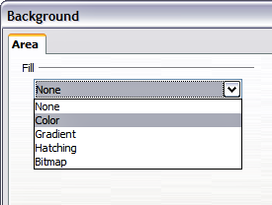
Figure 18: Background choices
A list of choices for the selected fill type then appears (see Figure 19 for an example).
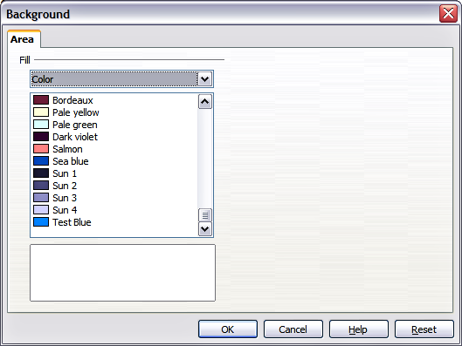Figure 19: Background colors
- Select one of the items on the list and click OK. The fill you have chosen is added to the slide master, replacing any previously selected fill.
Tip | You can make custom additions to each type of background, with the obvious exception of None. After you create new fills, they are listed in the Background dialog box along with the fills provided with AOO. For example, the last color in Figure 19, Test Blue, is a custom color. See Chapter 6 for more information.

Adding Background Objects
This section describes how to add background objects and graphic elements (such as a logo, decorative lines, and so on). AOO supports a large number of graphical formats.
When you want the same graphic to appear on every slide of your presentation, the easiest and quickest solution is to use the slide master. It saves time while creating the presentation, and also when you want to modify or reposition the graphic on the slide. If the graphic is added to each slide manually, these operations have to be performed on each individual slide in the presentation.
One of the most common actions in preparing a presentation is to add a picture to the slide master. To insert a picture already available on your system, follow these steps:
- Choose View > Master > Slide Master from the menu bar.
- Select from the menu bar Insert > Picture > From File.
- Navigate to the directory where your picture is and select it. To see a preview, select the corresponding checkbox in the file browser dialog box.
Caution | AOO offers the option to insert a picture as a link to the file rather than embedding it in the document. This can be useful when a presentation is not intended to be distributed but rather will remain in the existing hierarchical directory structure: for example, a presentation created and displayed to a group of clients on a single notebook computer.  If the presentation file is to be distributed, the picture should be embedded to avoid the “missing picture” syndrome when the presentation is given on a different computer.
Once the picture is inserted, you need to move it to the background. To do this, while the picture is still selected, right-click on the it and select Arrange > Send to Back from the context menu. You may also need to reposition it and modify its size. To do that, see Chapter 4 (Adding and Formatting Pictures).
Tip | If you want the image to blend with the background, you can set the background color of the picture to transparent. Select the picture, then choose Tools > Color Replacer from the menu bar. Select the first checkbox, then move the mouse cursor over the picture and click on the color you want to make transparent. This color appears next to the checkbox. Make sure that Replace with... is set to Transparent and click Replace.
Tip | An easy way to make the picture lighter, so that the text stands out better against its background, is to increase the transparency of the picture or change the gamma. Both of these adjustments can be made quickly from the Picture toolbar.
In addition to pictures, you can add a number of other background objects, such as decorative lines, text, and shapes. Figure 20 is an example of a slide master with a custom background gradient, a background image, a picture in the top right corner, decorative lines, and customized presentation styles.
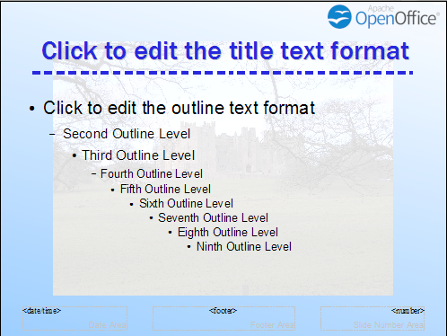Figure 20: Example of a complex slide with several modifications

Slide Master Styles
Within the slide master, you can define a complete set of styles that define the default appearance of text and graphic objects inserted in slides based on that background. If, for example, your slide master has a dark background, you may want to set the font color of the title and text areas to be light. Rather than manually changing the font color for every new slide you create, a time-consuming operation prone to errors and omissions, simply modify the style in the slide master. Changes made to styles in the slide master only apply to the slides based on that particular slide master.
Styles in Impress are subdivided into two main categories: Presentation styles and Graphics styles.

Presentation Styles
Presentation styles affect three elements of a slide master: the background, background objects (such as icons, decorative lines, and text frames), and the text placed on the slide. Text styles are further divided into Notes, Outline 1 through Outline 9, Subtitle, and Title. The outline styles are used for the different levels of the outline to which they belong. For example, Outline 2 is used for the subpoints of Outline 1, and Outline 3 is used for the subpoints of Outline 2.
The prepackaged presentation styles can be modified, but new presentation styles cannot be created.

Graphics Styles
Graphics styles apply to lines, shapes, and text boxes created using the Impress drawing tools and define the formatting of such objects.
There are 16 prepackaged graphics styles to choose from. You can create additional styles or modify the prepackaged styles.
Note | The presence of text and title styles both in the Presentation and Graphics styles may seem confusing. This apparent duplication is because Impress facilitates the operation of adding structured text to the slides by means of special text boxes where the Presentation styles apply (Autolayout boxes). The title and other text styles in the Graphics styles group continue to apply to other text boxes you may want to add, or to the text associated with shapes or lines.

The Styles and Formatting Window
To work on the slide master styles, start by opening the Styles and Formatting deck in the Sidebar, as shown in Figure 21. The same tool is available by pressing F11 or selecting Format > Styles and Formatting from the main menu.
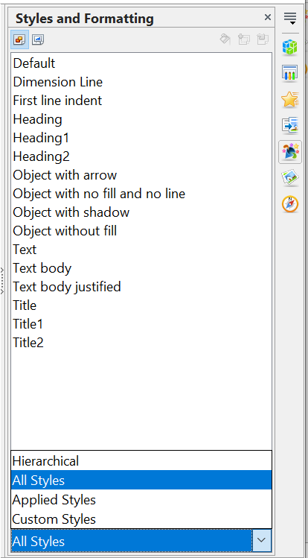

Figure 21: Styles and Formatting window
Graphics Styles
Presentation Styles
Sidebar icons
Tip | At the bottom of the Styles and Formatting window is a drop-down list. You can choose to show all styles or groups of styles, for example, applied styles or (in the case of Graphics styles) custom styles.
You can dock or undock the Styles and Formatting window by holding down the Control key while double-clicking the top of the window between the icons (see Figure 21). Press F11 to close the Styles and Formatting window when you no longer need it. OpenOffice will remember its position the next time you reopen it.

Modifying Default Text Areas
When a slide master is opened for editing, it contains five areas, as shown in Figure 22:
- Title area for AutoLayouts
- Object area for AutoLayouts
- Date area
- Footer area
- Slide number area
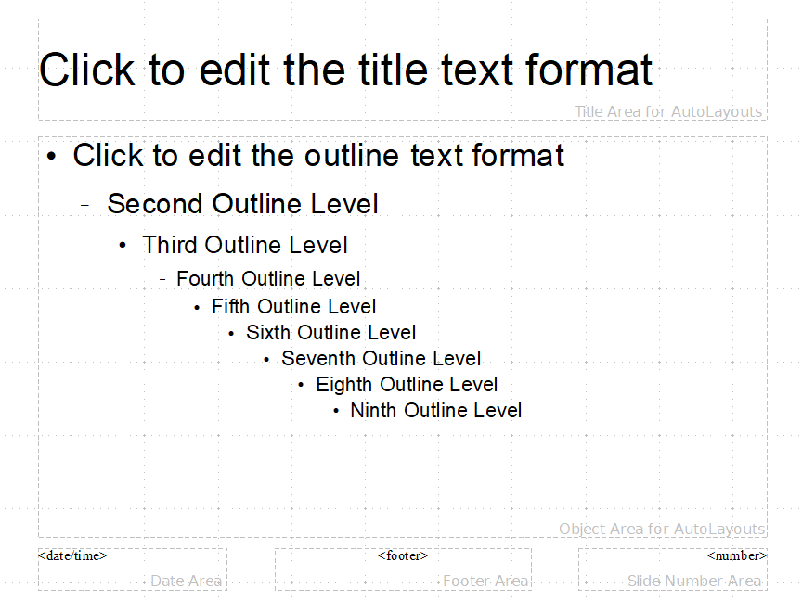

Figure 22: Slide master showing five editable areas
Click with the left mouse button on any of these areas to display eight green squares (handles) around the rectangle. Use these handles to modify the size and position of the area.
- To change the position, move the mouse towards one of the edges, away from the green handles, until the cursor changes shape, then click the left mouse button and drag the area to the desired position.
- To modify the shape and size of one of the rectangular areas, use one of the 8 green handles. The handles in the corners modify both sides of the rectangle simultaneously, while those in the middle of the sides modify only one dimension at a time. The shape of the mouse cursor usually changes when over the handle, giving a clear visual indication of how it will affect the shape of the rectangular area.
Tip | To keep the ratio between the sides of the rectangular area constant, move the mouse to one of the 4 green handles at the corner of the area and keep the Shift key pressed while dragging the handle with the mouse.
To accurately control the shape, size, and position of the default text area, it is better to use the Position and Size dialog box rather than the mouse. First, select the rectangular area by clicking on any point inside it, then press F4 or choose Format > Position and Size. The dialog box shown in Figure 23 is displayed.
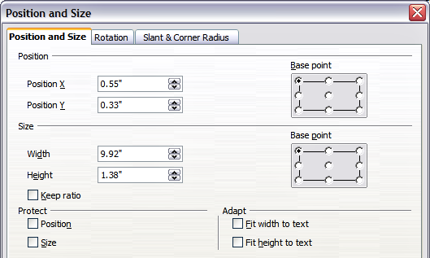Figure 23: The Position and Size dialog box
The functions of this dialog box are explained in the Draw Guide, so only a short description of the most important fields is provided in this chapter.
Use the Position section to specify the X (horizontal) and Y (vertical) position of the rectangular area. The values represent the distance of the base point (selected on the right side) relative to the top-left corner of the slide.
Use the Size section to specify the width and height of the rectangular area. In the Base point section, select the part of the rectangular area you do not want to move while resizing. The default setting (top left corner) means that the position of the top left corner of the chosen area will not change after resizing.
You can also use the Rotation tab of the dialog box to rotate the default text area. For example, you can place the footer area on the side by rotating each text area by 90 degrees, and obtain a more modern-looking layout. In general, it is preferable to use only right angles for ease of editing, although the program does not impose restrictions on the values that can be used.

Further Modifications to the Default Text Areas
Besides the shape, size, and position, it is also possible to modify other aspects of the 5 areas of the slide master, such as the background, border, alignment relative to the slide, and position relative to other objects.
While the background style and line style of an area can be accessed from the Format menu, to access the Alignment and Arrange menus, you must either open the Drawing toolbar or use the context menu. To display the Drawing toolbar (Figure 24), select it in View > Toolbars; to open the context menu, right-click on the edge of the rectangular area after selecting it. On the Drawing toolbar, click the arrow next to the Alignment or Arrange icon (highlighted in Figure 24) to display choices. See the Draw Guide for details.

Figure 24: Alignment and Arrange icons on the Drawing toolbar
The date area and slide number area do not automatically appear on every slide, even though you have defined them. To show them, you need to close the Master View and select the desired field from the menu bar: Insert > Page number or Insert > Date and time. This procedure is explained in detail in Chapter 8 (Adding and Formatting Slides, Notes, and Handouts).

Adding Text to All Slides
Some of the supplied slide masters have text objects in the footer. You can add other text objects to the master page for your slides; these additions can act as a header or footer.
- Choose View > Master > Slide Master from the menu bar.
- On the Drawing toolbar (see Figure 24), select the Text icon.
- Click once and drag in the master page to draw a text object, and then type or paste your text into the object or add fields as described below.
- Choose View > Normal when you are finished.
To add a field, such as the date or page number, to a text object in the header or footer, choose Insert > Fields. and select the required field from the submenu. If you want to edit a field in your slide, select it and choose Edit > Fields.
The types of data you can use as fields in Impress are:
- Date (fixed).
- Date (variable) —updates automatically when you reload the file.
- Time (fixed).
- Time (variable)—updates automatically when you reload the file
- Author—First and last names listed in the Apache OpenOffice user data.
- Page number (slide number).
- File name.
Tip | To change the number format (1,2,3 or a,b,c or i,ii,iii, etc.) for the page number field, choose Format > Page and then select a format from the list in the Layout Settings area of the Page tab.  To change the author information, go to Tools > Options > OpenOffice > User Data.

Working with Styles in Impress
If you are familiar with styles in Writer, you'll find not only similarities but also differences in Impress. Presentation styles are similar to paragraph styles in Writer, and are used in a very similar fashion. You cannot create new presentation styles, but you can fully configure the existing ones. Note that, as with Heading styles in Writer, Outline styles in Impress are hierarchically linked, so that a change in Outline 1 will cascade through all other Outline levels.
In Impress, you will also find the graphics styles very useful. They define the characteristics of a graphic object (including a text object). If, for example, you need to create an organization chart diagram in one of the slides of your presentation, you will likely want all of the boxes to have a consistent appearance, meaning the same line style, same font type, maybe the same shadow, and so on. The easiest way to achieve this result with minimal effort is to create a graphics style for the boxes and apply it to each one. The major benefit is that if you decide to modify, say, the background color of the boxes later on, all you need to do is modify the style, rather than each individual box.
Presentation styles are discussed in detail in Chapter 3 (Working with Text). The use of graphics styles is covered in Chapter 6 (Formatting Graphic Objects).

Working with Templates
All documents in Apache OpenOffice (AOO) are based on templates. However, Impress is a little different from other AOO components in that it starts with the Presentation Wizard unless you have elected to turn the Wizard off.
When you choose File > New > Presentation from the menu bar, if the Presentation Wizard is active, it offers several choices for a new presentation, one of which is “From template”.
If you have turned the Presentation Wizard off, when you start a new presentation by choosing File > New > Presentation from the menu bar, AOO uses the default presentation template. If you have not defined your own default template, AOO uses a blank template supplied with the program.

Using Templates Supplied with AOO
Impress comes with a set of predefined templates. Two are in the Presentations folder, and the others are in the Presentation backgrounds folder. The difference between them is that Presentation templates include a series of slides with sample titles and topics, while Presentation background templates have only backgrounds and background objects. Both types have predefined presentation and graphics styles.
You can create a new presentation from a previously saved presentation template by choosing File > New > Templates and Documents from the menu bar. This opens the Templates and Documents – Templates window. To open a new presentation based on a template, double-click that template’s name in the list.

Using Templates From Other Sources
If you have created your own templates or imported templates from another location, they are probably stored in the My Templates folder within the Templates and Documents – Templates window. Templates installed using the Extension Manager may be installed in their own folders. You can use them in the same way as the templates installed with Impress.
See page 46 for information on importing templates into AOO.

Installing Templates Using the Extension Manager
The Extension Manager provides an easy way to install collections of templates, graphics, macros, or other add-ins that have been “packaged” into files with a .OXT extension.
Although individual extensions can be found in different places, the official Apache OpenOffice extension repository is at https://extensions.openoffice.org/. Some extensions are free of charge, while others are available for a fee. Check the descriptions to see what licenses and fees apply to the ones that interest you.
For more about the Extension Manager and some extensions of interest to Impress users, see Chapter 11 (Setting up and Customizing Impress).
To install a collection of templates packaged as an extension:
- Download the extension and save it anywhere on your computer.
- In AOO, select Tools > Extension Manager from the menu bar. In the Extension Manager dialog box, click Add.
- A file browser window opens. Find and select the extension you want to install and click Open. The extension begins installing. You may be asked to accept a license agreement.
- When the installation is complete, the extension is listed in the Extension Manager dialog box.
The slide masters from the templates will now appear in the list of Available Master Pages in the Sidebar (Figure 16).
Tip | To get extensions that are listed in the repository, you can open the Extension Manager and click the Get more extensions online link. You do not need to download them separately as in step 1 above.

Creating Your Own Templates
To create a template from a presentation:
- Open the presentation that you want to use as a template.
- From the main menu, choose File > Templates > Save. The Templates window opens (see Figure 25).
- In the New template field, type a name for the new template.
- In the Categories list, click the folder in which you want to store the template. This is usually the My Templates folder, unless you have created other folders.
To learn more about template folders, see “Organizing templates” on page 45.
- Click OK. AOO saves the new template, and the Templates window closes.
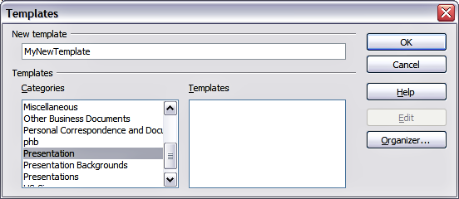Figure 25. Saving a new template
Note | All the slide masters used in the template become available for use in other presentations.

Setting a Default Template
You can set a custom presentation template to be the default template. You can reset the default later if you choose.

Setting a Custom Template as the Default
You can set any template to be the default, as long as it is in one of the folders displayed in the Template Management dialog box.
To set a custom template as the default:
- From the main menu, choose File > Templates > Organize. The Template Management dialog box opens as shown below.
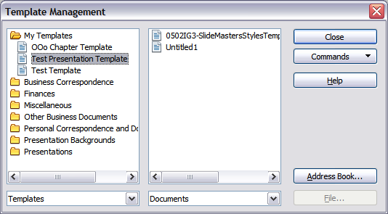Figure 26. Template Management dialog box
- In the box on the left, double-click the folder containing the template that you want to set as the default, then select the template.
- Click the Commands button.
- From the drop-down menu, choose Set As Default Template. The next time that you create a document by choosing File > New, the document will be created from this template.

Resetting the Default to Impress’s Built-in Default Template
To re-enable Impress’s Default presentation background template as the default:
- In the Template Management dialog box, click the Presentation Backgrounds folder in the box on the left.
- Click the Commands button.
- From the drop-down menu, choose Reset Default Template > Presentation.
Note | Use the instructions in this section only if you have customized the presentation template.

Modifying a Template
You can edit a template’s styles and content, and then, if you wish, you can reapply the template’s styles to documents that were created from that template.
Note | You can only reapply styles. You cannot reapply content.
To edit a template:
- From the main menu, choose File > Templates > Edit. A standard file browser window opens.
- Find and select the template that you want to edit, and then click Open. The selected template opens in Impress.
- Edit the template just as you would any other presentation. To save your changes, choose File > Save from the main menu.
The next time you open a presentation created from the changed template, the following message appears.
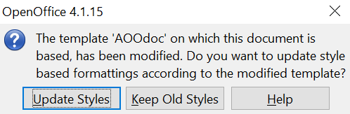

Figure 27. Update styles message
Click Update Styles to apply the template’s changed styles to the document. Click Keep Old Styles if you never want to apply the template’s changed styles to the document. Whichever option you choose, the message box closes and the presentation opens in Impress.

Organizing templates
AOO can only use templates that are in AOO template folders. You can create new AOO template folders and use them to organize your templates. For example, you might have separate template folders for different purposes or projects. You can also import and export templates.
To begin, choose File > Templates > Organize from the main menu. The Template Management dialog box (Figure 26) opens.
Note | All the actions made available by the Commands button in the Template Management window can also be accessed by right-clicking on the templates or the folders.

Creating a Template Folder
To create a template folder:
- In the Template Management dialog box, click any folder.
- Click the Commands button and choose New from the drop-down menu. A new folder called Untitled appears.
- Type a name for the new folder, and then press Enter. AOO saves the folder with the name that you entered.

Deleting a Template Folder
You cannot delete the template folders supplied with AOO or installed using the Extension Manager. You can only delete folders you have created.
To delete a template folder that you have created:
- In the Template Management dialog box, select the folder that you want to delete.
- Click the Commands button and choose Delete from the drop-down menu. A message box appears, asking you to confirm the deletion. Click Yes.

Moving a Template
To move a template from one template folder to another:
- In the Template Management dialog box, double-click the folder that contains the template you want to move. A list of all the templates contained in that folder appears underneath the folder name.
- Click the template that you want to move and drag it to the desired folder. If you do not have the authority to delete templates from the source folder, this action copies the template instead of moving it.

Deleting a Template
You cannot delete the templates supplied with AOO or installed using the Extension Manager; you can only delete templates that you have created or imported.
To delete a template:
- In the Template Management dialog box, double-click the folder that contains the template you want to delete. Click the template that you want to delete.
- Click the Commands button and choose Delete from the drop-down menu. A dialog box appears, asking you to confirm the deletion. Click Yes.

Importing a Template
If the template that you want to use is in a different location, you must import it into an AOO template folder.
To import a template into a template folder from another location on your computer:
- In the Template Management dialog box, click the folder into which you want to import the template.
- Click the Commands button and choose Import Template from the drop-down menu. A standard file browser window opens.
- Find and select the template you want to import, then click Open. The file browser window closes, and the template appears in the selected template folder.
- If you want, type a new name for the template and then press Enter.

Exporting a Template
To export a template from a template folder to another location:
- In the Template Management dialog box, double-click the folder that contains the template you want to export.
- Click the template that you want to export.
- Click the Commands button and choose Export Template from the drop-down menu. The Save As window opens.
- Find the folder into which you want to export the template, and click Save.

Chapter 3
Adding and Formatting Text

Introduction
This chapter describes how to add text to slides and format the text. Text in slides is contained in text boxes.
There are two ways to add text boxes to a slide:
- Choose a predefined layout from the Layouts panel of the Properties deck of the Sidebar, containing text elements as described in Chapter 1. These text boxes are called AutoLayout text boxes.
- Create a text box using the text tool in the Drawing toolbar.
This chapter describes how to create, modify, use, and delete text boxes. It also discusses the various types of text that can be inserted and explains how to format the text. Finally, it provides information on how to insert special forms of text, such as numbered or bulleted lists, tables, fields, and hyperlinks.

Working with Text Boxes

Using Text Boxes Created from the Layout Panel
In Normal view:
- Click in the text box that reads Click to add text.
- Type or paste your text in the text box.
These text boxes are known as AutoLayout text boxes. See also “Creating Bulleted and Numbered Lists” on page 62.

Using Text Boxes Created from the Text Box Tool
In Normal View:
- Click on the Text icon on the Drawing toolbar. If the toolbar with the text icon is not visible, choose View > Toolbars > Drawing.
- Click and drag to draw a text box on the slide, and to set the width. Do not worry about the height—the text box will expand if needed as you type. To reposition the text box to a different part of the slide, see “Moving a Text Box” on page 49; to change the width, see “Resizing a Text Box” on page 50.
- Release the mouse button when finished. The cursor appears in the text box, which is now in edit mode (gray hashed border; see Figure 28).
- Type or paste your text in the text box.
- Click outside the text box to deselect it.
Note | In addition to boxes where text is horizontally aligned, it is possible to insert text boxes where the text is aligned vertically. This choice is available only when Asian languages are enabled in Tools > Options > Language Settings > Languages.  Click on the icon in the drawing toolbar to create a vertical text box. Note that when editing the contents, the text is displayed horizontally.
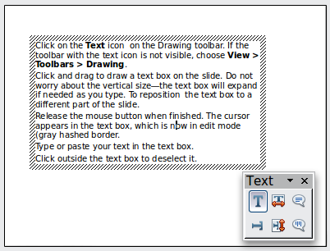
Figure 28: Selected text box and text toolbar

Moving a Text Box
In Normal view, notice how the pointer changes from an arrow to an I-beam as you move it over the text in a text box.
- Click when the pointer becomes an I-beam to put the text box in edit mode. In this mode, a gray border is visible around the text box edges.
- Move the I-beam (or pointer) over the gray border. Notice how it changes shape to become the usual “move” symbol (for example, a hand).
- When the “move” symbol appears, click once. Blue selection handles appear.
- Click anywhere in the text box or on the gray border (except for the blue handles) and drag to move the text box. A semi-transparent copy of the text box shows where your text box will be placed. See Figure 29.
- Release the mouse button when the text box is in the desired position. To return to edit mode, click outside the text box area and then repeat step 1) of this procedure.
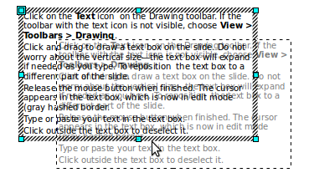
Figure 29: Moving a text box

Resizing a Text Box
In Normal view, enter edit mode by clicking on the text box. Then move the mouse to the gray edge of the text box. When the cursor shape changes, click the left mouse button again. The text box should now display blue resizing handles (Figure 30). Move the pointer over any handle. Notice how the pointer changes shape, indicating the direction in which the text box will be resized. The corner handles change the two dimensions of the text area simultaneously, while the four handles at the center of each side modify only one dimension.
When the two-headed arrow is displayed, click and drag to resize the text box.
Tip | To maintain the proportions of a text box while resizing, press and hold the Shift key, then click and drag. Make sure to release the mouse button before releasing the Shift key.
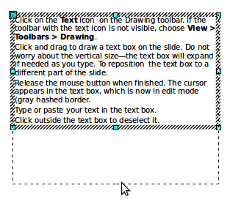
Figure 30: Resizing a text box
Impress also provides a different type of text box, which automatically resizes horizontally to fit the text as it is inserted. To insert an auto-resizing text box, click on the icon in the text toolbar (see Figure 28) and then click on the place in the slide where you want the first letter of the text to appear. If the text toolbar is not visible, choose View > Toolbars > Text.
For more accurate control over the shape, size, and position of the text box, instead of using the mouse, use the Position and Size dialog box. Select the text box, then press F4 or select Format > Position and Size from the menu bar. The use of this dialog box is explained in Chapter 2.

Deleting a Text Box
- Click the text once to display the gray border.
- Move the cursor to the edge of the text box and click the left mouse button. The gray border now shows blue selection handles.
- Press Delete.
Tip | Sometimes it is faster to delete a text box by dragging a selection rectangle around it and then hitting the Delete key. Take care to avoid selecting and accidentally deleting other text boxes or shapes.

Inserting Text

Pasting Text
Text may be inserted into the text box by copying it from another document and pasting it into Impress. However, the pasted text may not match the formatting of the surrounding text or that of the other slides in the presentation. While this may be acceptable in some situations, in most cases, you want to ensure the presentation style is consistent. There are several ways to ensure consistency; they're explained below.

Pasting Unformatted Text
It is normally good practice to paste text without formatting and apply the formatting later. To paste without formatting, either press Control+Shift+V and then select Unformatted text from the dialog box that appears, or click on the small black triangle next to the paste symbol in the standard toolbar 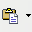 and select Unformatted text. The unformatted text will be formatted with the outline style at the cursor position in an AutoLayout text box or with the default graphic style in a normal text box.

Formatting Pasted Text
If pasting the text into an AutoLayout area, in order to give the pasted text the same look and feel as the rest of the presentation, apply the appropriate outline style to the text.
- Paste the text in the desired position. Do not worry if it does not look right: it will in a minute.
- Select the text you have just pasted (see “Selecting Text” on page 54 for details on how to do that).
- Select Format > Default formatting from the menu bar. This operation will assign one of the nine Presentation styles to the text (depending on where the insertion is made).
- Use the four arrow buttons in the Text Formatting toolbar to move the text to the appropriate position and give it the appropriate outline level. The button with the arrow pointing left promotes the list entry by one level (for example, from Outline 3 to Outline 2), the right arrow button demotes the list entry by one level, and the up and down arrow buttons move the list entry.
- Apply manual formatting as required to sections of the text (to change font attributes, tabs, and so on).
If you are pasting text into a text box, you can still use styles to quickly format the text. Note that only one graphic style can be applied to copied text.
- Paste the text in the desired position.
- Select the text you have just pasted (see “Selecting Text” on page 54 for details).
- Select the desired graphic style.
- Apply manual formatting as required to sections of the text.
Tip | Presentation styles are very different from Writer styles and are applied in quite a different way. Refer to ”Using Styles to Format Text” on page 54 for details.

Inserting Special Characters
To insert special characters, such as copyright, math, geometric, or monetary symbols, or characters from another language:
- Click in the place in the text where you want to insert the character.
- Choose Insert > Special Character. The Special Characters dialog box appears (Figure 31). Alternatively, if the icon is visible on the Formatting toolbar, you can click this to bring up the Special Characters dialog box.
Tip | To show toolbar buttons that are not visible, click on the small down-arrow on the right end of the toolbar, move the cursor over Visible Buttons, and then click on the icon you wish to make visible.
- Choose the font and character subset from the Font and Subset drop-down menus.
- Click the character you want to insert. You may have to scroll to find the one you want.
- Click OK.
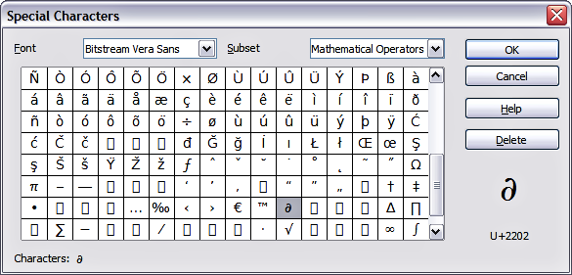Figure 31: Insert special characters dialog box
Characters you select will be inserted in the order they were selected. If you accidentally click the wrong character, clicking another character will only add it to the ones being inserted. Click Delete so that all the characters selected will be deleted, then click the correct characters. Alternatively, you can also simply insert all selected characters and delete any unwanted ones; special characters behave like any other character.

Inserting Non-breaking Spaces and Hyphens
Where it is not desirable for words separated by a space or by a hyphen to extend over two lines, or where an optional hyphen is desired, you can insert a special formatting mark.
To access the Formatting marks options, select from the menu bar Insert > Formatting marks. Impress supports three formatting marks:
- Non-breaking space: A non-breaking space between two words prevents these two words from being separated over two lines. Press Control+Shift+Spacebar on the keyboard to insert a non-breaking space.
- Non-breaking hyphen: A non-breaking hyphen keeps the two words separated by the hyphen on the same line.
- Optional hyphen: An invisible hyphen that is activated (thus breaking the word) only when the word is too long to fit on one line.

Introduction to Formatting Text
The appropriate use of text formatting can give a presentation a consistent look and a dynamic feel, and can enhance the audience’s understanding of your message by preventing distracting elements.
When you enter text, either in an AutoLayout text box or a normal text box, it is formatted with a set of predefined attributes known as a style. The style used depends on the outline level of the point where the text was entered for AutoLayout text boxes (for example, if you are entering a level 2 item, Impress will format it according to the Outline 2 presentation style) or the Default Graphic style for text boxes.
Tip | Sometimes, as seen also in the “Pasting Text” section on page 51, it is very useful to reapply the baseline style to a selection of text, thus eliminating any manual formatting applied to it (particularly if you made a mistake and you do not know how to undo it). To do this, select the manually formatted text, and then select Format > Default formatting from the menu bar.
Formatting text may require some intervention in three areas:
- The character attributes (for example, the font color)
- The paragraph attributes (for example, the alignment)
- The list attributes (for example, the type of bullet)
In some cases, it is quicker and more efficient to apply manual formatting, but in situations where you need to perform the same modifications to many different parts of a presentation, the use of styles is recommended. Both these techniques are described here.
Note | Unlike in Writer, where it is recommended to use styles whenever possible, in Impress, manual formatting needs to be used more often. This is because presentation styles are fixed; therefore, it is not possible, for example, to have two different level 1s or different types of bullet points for the same outline level.  Also, the lack of support for character styles forces the use of manual formatting to modify sections of the text.

Selecting Text
Text must be selected before it can be formatted.
- To format all the text in a text box, click once on the text, then click once on the border of the text box. The green resizing handles are displayed. Now any formatting changes will apply to all the text in the text box.
- To format only part of the text, click once on the text, then select the text to be formatted by clicking and dragging (highlighting) over it. You can also use keyboard combinations to select text: move the cursor where you want to begin your selection, press Shift, and then use the arrow buttons to extend your selection. Formatting changes will apply only to the selected text.
Tip | To select text word by word, instead of by character, press the Control key and Shift key together. To speed up the selection even further, you can combine the Shift key with the Home key or the End key to extend the selection up to the start or end of the line in which the cursor is positioned, respectively.

Using Styles to Format Text
Impress has two categories of styles: presentation styles and graphics styles. Presentation styles are used on text inserted into an AutoLayout area, slide master backgrounds, and background objects. However, for text inserted in a text box or a graphic object, you need to apply a graphic style.
In this chapter, we focus mostly on Presentation styles. For information on graphic styles, see Chapter 6 (Formatting Graphic Objects).

Modifying a Presentation Style
To modify a presentation style, follow these steps:
- Open the Styles and Formatting deck of the Sidebar or open the same tool as a window by pressing F11 or selecting Format > Styles and Formatting from the menu bar.
- Select the style category by clicking on the Presentation Styles icon at the top of the Style and Formatting window.
- Right-click on the style to be modified and select Modify from the pop-up menu.
The top portion of the dialog box for a presentation style is shown in Figure 32.
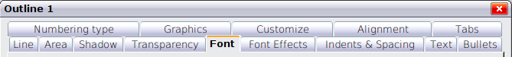
Figure 32: The dialog box for a presentation style
This dialog box consists of 14 pages, which can be divided in two groups: those that determine the formatting of the text and those that determine the properties of the slide master background and the background objects.
There is no difference between the parameters that characterize a style and the attributes given manually to portions of text; in fact, the pages that open when applying formatting manually are the same as those you configure in the style dialog box. Therefore, once you master the formatting of text, you will know how to create and modify a style. In particular:
- For the Font and Font Effects style tabs, refer to “Formatting Characters” on page 56.
- For the Indents and Spacing, Alignment, and Tabs style tabs, refer to “Formatting Paragraphs” on page 58.
- For the Bullet and numbering type, Graphics, Customize style tabs, refer to “Creating Bulleted and Numbered Lists” on page 62.
The other tabs of the Presentation Style dialog box are all related to formatting the background and background objects and are described in detail in Chapter 6.

Updating a Style from a Selection
To update a style from a selection:
- Select an item that has the format you want to adopt.
- In the Styles and Formatting window, select the style you want to update, and then click the Update Style icon (see Figure 33).
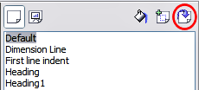
Figure 33. Updating a style from a selection

Applying a Presentation Style
To apply a presentation style, move the paragraph to the appropriate outline level as described in “Changing the Order or the Outline Level Lines” on page 67. This is different from Writer, where you select the desired style from the Styles and Formatting window.

Formatting Characters
To view the character formatting options, select Format > Character or click the Character button on the Text Formatting toolbar. (If a toolbar with the text icon is not visible, choose View > Toolbars > Text Formatting.) The Character dialog box appears (Figure 34). Note that character styles do not exist in Impress.

Font Tab
Use the Font tab to select the desired font type, its base attributes (Italic, Bold, etc.), as well as the size. A sample of the font is displayed in the lower part of the dialog box. You can also specify the language of this text.
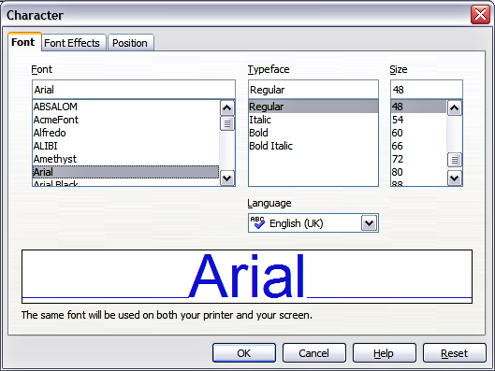
Figure 34: The dialog box to set the basic font attributes
Tip | When writing a presentation in multiple languages, you can make the best of the language setting by creating two styles that differ only in language, but are otherwise the same. This allows you to check the spelling of all of the contents without affecting the appearance.
This tab is available when creating or modifying a presentation style or a graphics style.
If Asian language support has been enabled (Tools > Options > Language Settings > Languages), the Font page looks like Figure 35.
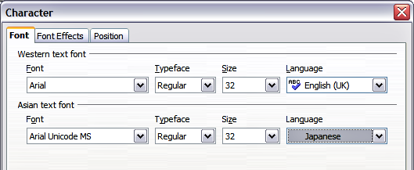
Figure 35: The Font page when Asian language support is enabled

Font Effects Tab
Use the Font Effects tab shown in Figure 36 to apply special effects to the text, such as overlining and underlining, color, shadow, and so on. As for the Font page, a sample of the text is displayed in the lower part of the dialog box, allowing a quick visual check of the effects applied. This tab is available when creating or modifying a presentation style or a graphics style.
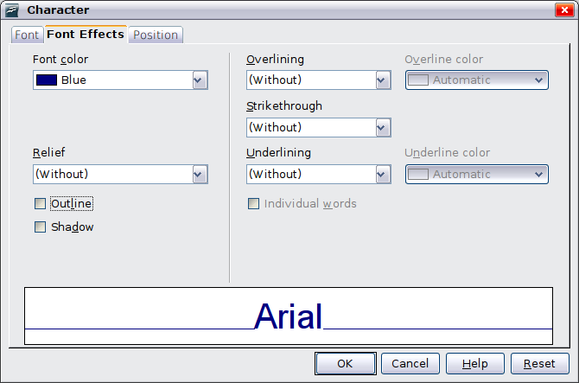
Figure 36: Advanced options for the character can be set in the Font Effects page

Position Tab
The Position tab, shown in Figure 37, has advanced options to customize text. This page is not available when creating or modifying a presentation style or a graphics style.
Use this tab to set the text position relative to the baseline when you need to insert subscripts or superscripts.
To create a superscript or a subscript, do the following:
- Select Superscript or Subscript as applicable.
- Specify the amount by which the text should be raised (superscripts) or lowered (subscripts).
- Specify the dimensions of the character relative to the baseline character size (in percentage).
The amount by which the text is raised or lowered can be set to automatic by selecting Automatic.
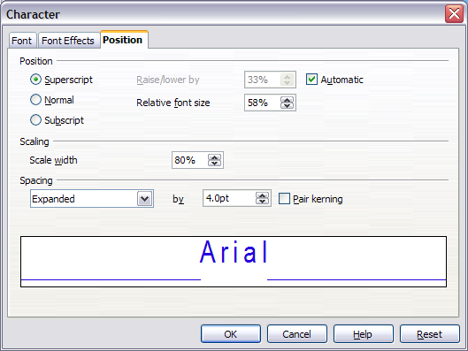Figure 37: Setting the character position attributes
Two more position attributes can be set on this page:
- The (width) scaling of the text specifies the percentage of the font width by which to compress or expand the individual characters of the selected text.
- The spacing between the characters of the font, which can be defined in number of points. Selecting the Pair kerning checkbox causes AOO to automatically adjust the spacing between certain pairs of characters to visually improve the appearance. For example, when writing a V followed by an A (VA), the spacing between the two letters is reduced (strong kerning) as can be easily seen when compared with, say, VS, which is not a kerning pair.

Formatting Paragraphs
To view the paragraph formatting options, select Format > Paragraph or click the Paragraph button on the Text Formatting toolbar. If a toolbar with the text icon is not visible, choose View > Toolbars > Text Formatting. The Paragraph dialog box is shown. It contains three pages that are described in detail below. If Asian language support has been activated, a tab such as that shown in Figure 38, called Asian Typography, is also displayed.
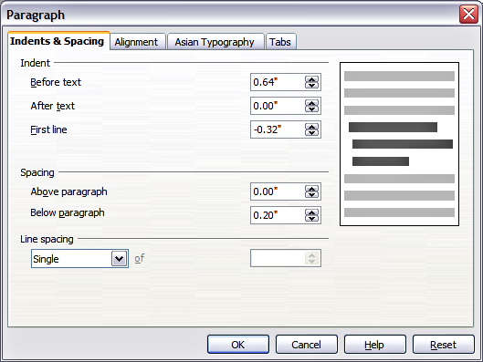Figure 38: The paragraph formatting dialog box

Indents and Spacing Tab
The Indents and Spacing tab, shown in Figure 39, has four sections:
- Indent: modifies the indentation of the text (before and after) as well as the indentation of the first line.
- Spacing: defines the space before and after each paragraph formatted with the style.
Tip | You can change the default unit of measurement, for example, from inches to centimeters, from Tools > Options > OpenOffice Impress > General.
- Line spacing: determines the spacing between two lines formatted with the style. Note that selecting Proportional spacing requires specifying the percentage of a line to be used as spacing; 100% corresponds to a single line, 200% to a double line, 50% to half a line. If Leading is selected, specify the amount of line spacing in your default unit of measurement.
Tip | Setting the line spacing to less than 100% is a good method to cram a lot of text into a text box. However, care must be taken, as too small a value will make the text hard to read.
- Preview area: provides a visual representation of the settings before you apply them.
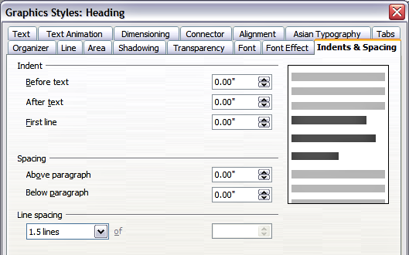
Figure 39: Insert and Spacing settings for the selected paragraph or style
The Indents and Spacing page is also available when creating or modifying a graphics style or when modifying a presentation style.

Alignment Tab
Use the Alignment page shown in Figure 40 to determine the text alignment: Left, Right, Center, or Justified. A preview shows the effects of the changes.
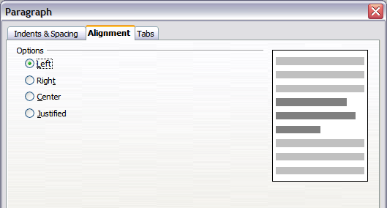Figure 40: Alignment tab of paragraph style
The same choices can be accessed from the Text Formatting toolbar.
This tab is also available when creating or modifying a graphics style or modifying a presentation style.

Tabs Tab
Use the Tabs tab, like that in Figure 41, to set tab stops. To delete an existing tab stop, select it in the list and click the Delete button. To delete all the tab stops, click the Delete All button.
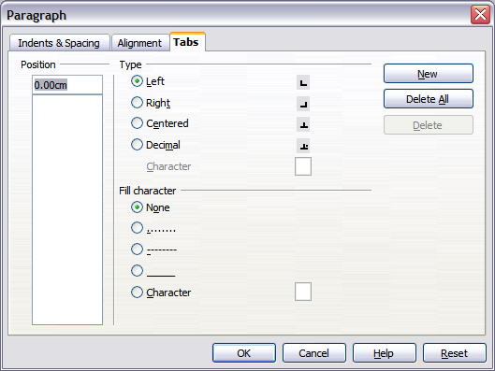Figure 41: Tabs page in a paragraph
To create a new tab stop:
- Set the size of the tab stop in the edit box on the left.
- Select the type. If you set the type to Decimal, specify in the box below the character to be regarded as the decimal point.
- Select a fill character that will be drawn from the tab insertion point up to the tab stop. You can choose any character to act as a fill character.
- Click the New button to apply the new tab stop.
This tab is available in the Format > Paragraph dialog box (see Figure 39) and in the Graphics Styles dialog box.

Asian Typography Tab
Use the Asian Typography page, shown in Figure 42, to set the following properties relative to line changes:
- Apply list of forbidden characters to the beginning and end of lines
- Allow hanging punctuation
- Apply spacing between Asian, Latin, and Complex text
The use of these options is self-explanatory.
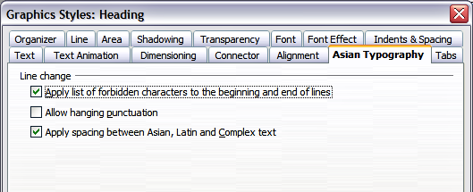
Figure 42: The Asian Typography page

Creating Bulleted and Numbered Lists
The procedure to create a bulleted or numbered list varies depending on the type of text box used, although the tools to manage the list and customize the appearance are the same.
In text boxes created automatically by Impress (called AutoLayout), the outline styles available are, by default, bulleted lists, while for normal text boxes, an additional step is required to create a bulleted list.

Creating Lists in AutoLayout Text Boxes
Every text box included in the available layouts is already formatted as a bulleted list; therefore, to create a bulleted list, the only necessary steps are:
- From the Layout deck, choose a slide design that contains a text box. Those are easily recognizable from the thumbnail.
- Click in the text box that reads Click to add an outline.
- Type the text, then press Enter to start a new bulleted line.
The default list type is a bulleted list. To customize the list appearance or to change from bulleted to numbered and vice versa, refer to “Changing the Appearance of the List ” on page 63.
Tip | Press Shift+Enter to start a new line without creating a new bullet or number. The new line will have the same indentation as the previous line. Click the bullets icon on/off on the text formatting toolbar for a line without bullet. If the text formatting toolbar is not showing, enable it by selecting View > Toolbar > Formatting in the menu bar.

Creating Lists in Other Text Boxes
To create a list in a text box, follow these steps:
- Place the cursor in the text box.
- Click the Bullets On/Off button in the text formatting toolbar.
- Type the text and press Enter to start a new bulleted line.
The way to change the appearance of a list is explained on page 63.

Creating a New Outline Level
- If necessary, press Enter to begin a new line.
- Press Tab or click the indentation arrows in the Text Formatting toolbar. Each time you press Tab or click the right arrow, the line indents to the next outline level. Pressing Enter creates a new line at the same level as the previous one. To return to the previous level, press Shift+Tab or click the left arrow.
In the AutoLayout text boxes, promoting or demoting an item in the list corresponds to applying a different outline style, so the second outline level corresponds to Outline 2 style, the third to Outline 3 style, and so on. As a consequence, a change in the level also produces other changes (for example, font size, bullet type, and so on).
Caution | Do not try to change the outline level by selecting text and then clicking the desired outline style, as you would in Writer. Due to the way presentation styles work, it's not possible to apply them in Writer fashion.

Changing the Appearance of the List
You can fully customize the appearance of a list, changing the bullet type or numbering for the entire list or for a single entry. All the changes can be made using the Bullets and Numbering dialog box (Figure 43), which is accessed by selecting Format > Bullets and Numbering or by clicking on the Bullets and Numbering icon on the text formatting toolbar.

Selecting the Entries
For the entire list:
- Select the entire list or click on the gray border of the text box so that just the green resizing handles are displayed.
- Select Format > Bullets and Numbering or click on the Bullets and Numbering icon .
- The Bullets and Numbering dialog box (Figure 43) contains five tabs: Bullets, Numbering type, Graphics, Position, and Customize.
  - If a bulleted list is needed, select the desired bullet style from the six default styles available on the Bullets page.
  - If a graphics style is needed, select one from those available on the Graphics page.
  - If a numbered list is needed, select one of the 6 default numbering styles on the Numbering type page.
Later in this section, there is an explanation of how to add further bullets and numbering styles to the existing ones.
For a single line in the list:
- Click anywhere in the line to place the cursor in it.
- Follow steps 2 and 3 of the previous instruction set.
If the list was created in an AutoLayout text box, then another way to change the entire list is to modify the Outline styles. Changes made to the outline style will apply to all the slides using it, so be careful before using this command. The tabs related to list management are described below.
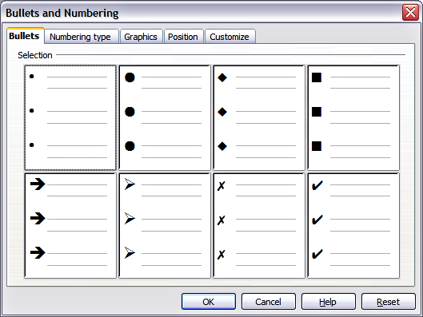
Figure 43: The Bullets and Numbering dialog box

Position Tab
Use the Position tab, shown in Figure 44, to fine-tune the indentation and spacing of the bullet point and its text. This page is particularly effective when used in combination with the Customize page.
To set up an outline level, first select it from the list on the left side of the page. Select level 1 – 10 to modify all the levels simultaneously. Then set the Indent, which is the spacing between the bullet or number and the text. If you select the Relative option, the indent value will be measured relative to the previous level and not from the margin.
The numbering alignment is only useful when creating a numbered list; use it to specify the alignment of the numbers. For example, you may want to align them to the right to line up one- and two-digit numbers in a pleasing way.
Tip | To appreciate fully how the numbering alignment works, create a numbered list with more than 10 elements. Then, make sure that enough room has been made for a two (or more) digit number using the Width of numbering field.
The Position tab is not available when modifying a presentation or graphics style; however, the same effects can be obtained by using the Indents and Spacing tab of the dialog box for creating or modifying a slide (see Figure 39).
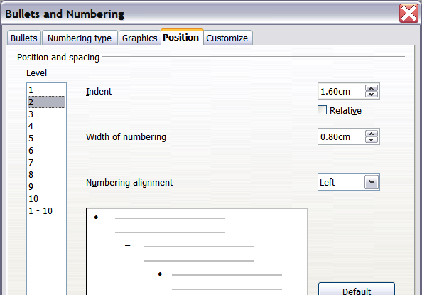
Figure 44: The Position tab used to set list indentation

Customize Tab
Use the Customize tab, shown in Figure 45, to alter the style of all the outline levels.
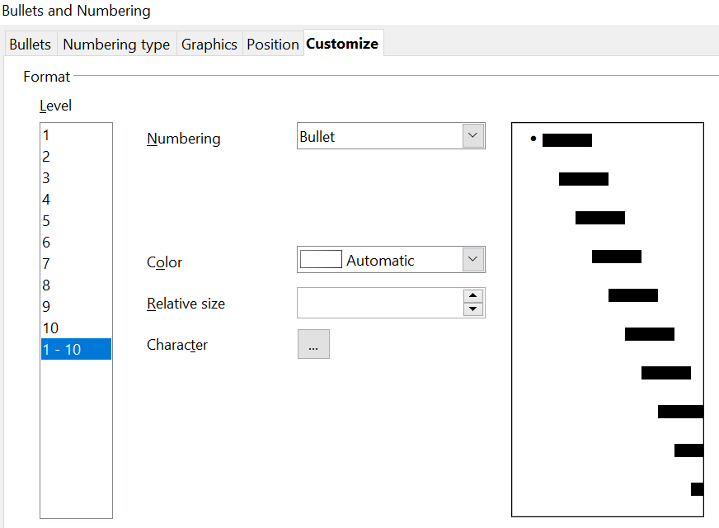

Figure 45: The Customize page for the list outline
The options available on this tab depend on the type of marker selected for the list. First, select the level you want to modify on the left side of the box. To modify all levels at once, select 1 – 10 as the level. Because the levels are arranged in a hierarchical structure, a change to, for example, the font attribute of any level propagates through all the lower levels.
Depending on the numbering style selected in the Numbering box (bullet, graphic, or numbering), some of the following options may become available on the tab:
- Before: Enter any text to appear before the number (for example, Step).
- After: Enter any text to appear after the number (for example, a punctuation mark).
- Color: Pick the color for the list marker (number or bullet character).
- Relative size: Specify the size of the number relative to the size of the characters in the paragraph of the list.
- Start at: Enter the first value of the list (for example, you might want the list to start at 4 instead of 1).
- Character button: Click this button to select the character for the bullet.
- Graphics selection button: Opens a gallery of available graphics or allows the selection of a file on the hard disk to be used as a marker.
- Width and Height: Specify the dimensions of the graphic marker.
- Keep ratio checkbox: If selected, the ratio between the width and the height of the graphic marker is fixed.
The right side of the screen shows a preview of the modifications made. To revert to the default values, click the Reset button in the bottom right corner.
Using the Customize tab, you can create complex structured layouts, for example, a nested list with numbering followed by bullets, as shown in Figure 46.
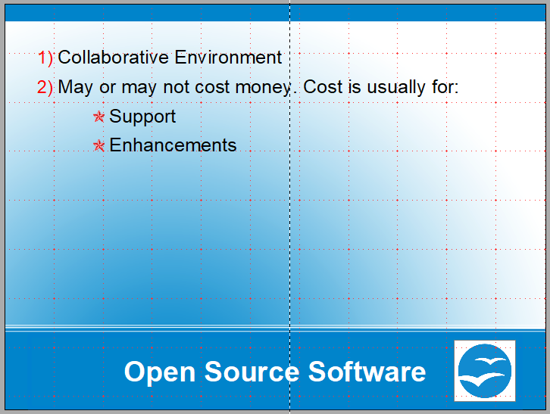

Figure 46: Nested list with mixture of numbers and bullets

Changing the Order or the Outline Level Lines
Click once in a line of text to place the cursor in it, then click on the Outline tab (to the right of the Normal tab) in the Workspace and use the Promote/Demote buttons in the Text Formatting toolbar to move the text to the appropriate position and give it the appropriate outline level.
The button with the arrow pointing left promotes the list entry by one level (for example, from Outline 3 to Outline 2), the right arrow button demotes the list entry by one level, and the up and down arrow buttons move the list entry. Numbering adjusts automatically.
Tip | You can also use the Tab key and Shift + Tab keys to promote and demote the outline level of a line in a list.

Using Tables
Tables are a powerful mechanism for quickly conveying structured information, making them an important tool when creating a presentation. You can create tables directly in Impress, so there is no need to embed a Calc spreadsheet or a Writer text table. But be aware that in some circumstances it makes sense to do so—the functionality provided by a Calc spreadsheet is far superior to that provided by an Impress table.
Many predefined table designs are available in the Table Design panel of the Sidebar's Properties deck when a table is selected. Figure 47 shows the Properties deck when a table is selected and with the Text and Paragraph panels collapsed.
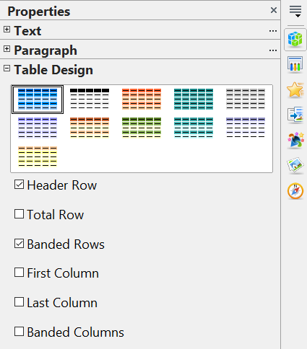

Figure 47: The Table Design task pane

Creating a Table
When working with tables, it is useful to know the number of rows and columns needed as well as the look and feel. These parameters can be adjusted later, but it's more laborious than setting the correct table dimensions from the beginning.
To insert a table, proceed as follows:
- Position the slide that will contain the table in the work area. It is most convenient if the slide has an AutoLayout box dedicated to the table. If the slide is blank, select a layout from the Properties deck of the Sidebar that has the right number of AutoLayout boxes for the planned slide content.
- If necessary, set the Sidebar to the Properties deck.
- You can either click the Insert Table icon in the AutoLayout box or select the menu Insert > Table. A box will appear where you can choose the number of columns and rows in the table. Make your choices, then click OK to finish inserting the table.
- You can apply any of the table designs displayed in the Sidebar by clicking on the design's icon.

If you inserted the table from the Insert menu, it is initially placed at the center of the slide. You can move it by selecting it and dragging it to a new position, or by using the method described in “Position and Size” on page 72.

Modifying a Table
Once the table is added to the slide, you can control its appearance, size, position, and so on using a combination of Sidebar options, the Table toolbar, and the Table properties dialog box.

Sidebar Options
The following options are available in the Table Design panel of the Sidebar:
- Header Row: selected by default, it adds a first row with a different background from the rest of the table.
- Total Row: the opposite of Header row; if selected, it changes the background of the last row to make it stand out from the other rows.
- Banded Rows: selected by default, this option colors alternate rows with different backgrounds, making it easier to read data presented in rows.
- First Column: highlights the first column of the table by allocating a darker background to it.
- Last Column: does the same to the last column.
- Banded Columns: when selected, alternate columns are colored differently.

Table Toolbar
When a table is selected, 8 blue square handles appear around the edges, and the Table toolbar, seen in Figure 48, should be displayed. If necessary, you can open the toolbar using View > Toolbars > Table. By default, the toolbar will float, but you can dock it at any time to the side or top edge of the work area.
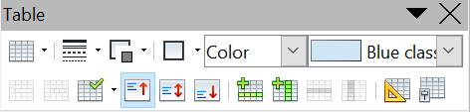

1 | Create Table | 7 | Merge Cells | 13 | Insert Row
2 | Line Style | 8 | Split Cells | 14 | Insert Column
3 | Line Color (border) | 9 | Optimize | 15 | Delete Row
4 | Borders | 10 | Top alignment | 16 | Delete Column
5 | Area style filling | 11 | Center alignment | 17 | Table design
6 | Available fillings | 12 | Bottom alignment | 18 | Table properties
Figure 48: The Table Toolbar
1
2
3
4
5
6
7
8
9
18
17
16
15
18
14
13
12
11
10
The Table toolbar contains the majority of the tools you need to manipulate a table; these are described below.
Table
Use to create a new table, like that in Figure 49, on the selected slide. Opens the Insert Table dialog box, where you can select the desired number of rows and columns. Click on the small black triangle next to the button to open the graphic tool for inserting a table. To use the tool, move the mouse to the right and down in the grid until you reach the cell you want to be the last, and click there.
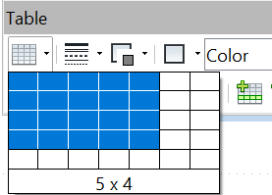

Figure 49: Creating a 5x4 table with the graphic tool
Note | Any newly inserted table is given a set of default attributes such as color scheme, banded rows, header row, and so on. Currently, such defaults are hard-coded in AOO and cannot be changed.
Line Style
Use to change the style of the border line of the selected cells. Opens a new dialog box where you can choose from a range of predefined styles.
Line Color
Open a color selection dialog box where you can choose the color of the border lines around the selected cells.
Borders
Use to select among some predefined border configurations. The borders are applied to the selected cells. If the desired border pattern is not available, you will need to use the Table properties dialog box.
Area filling
In the drop-down menu, first choose how the selected cells should be filled: Invisible, Color, Gradient, Hatching, or Bitmap. Depending on the selection, the Available Fillings drop-down menu is populated with the available schemes. Refer to Chapter 6 (Formatting Graphic Objects) for details on how to manage area filling styles.
Merge cells
Merges the selected cells. Note that the contents of the merged cells are also merged.
Split cells
The opposite operation of Merge cells. Make sure that the cursor is positioned on the cell you want to split, then click to open the Split Cells dialog box shown in Figure 50.
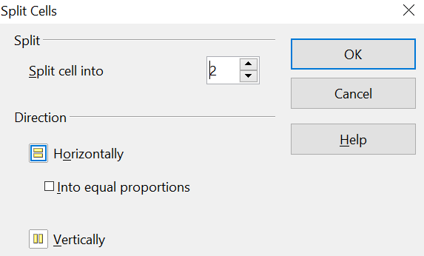

Figure 50: Split cell dialog box
Select the number of resulting cells from the split, as well as whether the cell should be split horizontally or vertically. When splitting horizontally, you can select the “into equal proportions” option to get all cells of equal size. The contents of the split cell are kept in the original cell (the one on the left or the top).
Optimize
Evenly distributes the selected cells either horizontally or vertically. If you want to optimize the whole table, you can evenly distribute rows or columns by right-clicking on the table edge and selecting Row > Space Equally or Column > Space Equally from the pop-up menu.
Vertical Alignment
You can select the vertical alignment of the text on a cell-by-cell basis between Top, Center, and Bottom. The chosen setting only applies to the selected cells. The alignment commands can be applied to all the cells of the table by right-clicking on the edge of the table, choosing Cell from the pop-up menu, and then choosing the required alignment.
Insert or delete rows and columns
Use the Table toolbar to insert or delete rows and columns of your table. Rows and columns are inserted below and to the right of the selected cell. You can insert rows and columns at the end of the table using the pop-up menu that opens by right-clicking on the edge of the table. The insert commands are under the Row or under the Column menu.
Table Design
The only purpose of this button is to open the Properties deck in the Sidebar.

Table Properties
Click the Table Properties icon to open the Format Cells dialog box like that in Figure 51, which contains the following tabs:
- Font: see “Font Tab” on page 56 for a description of the available options.
- Font Effects: see “Font Effects Tab” on page 57 for a description of the available options.
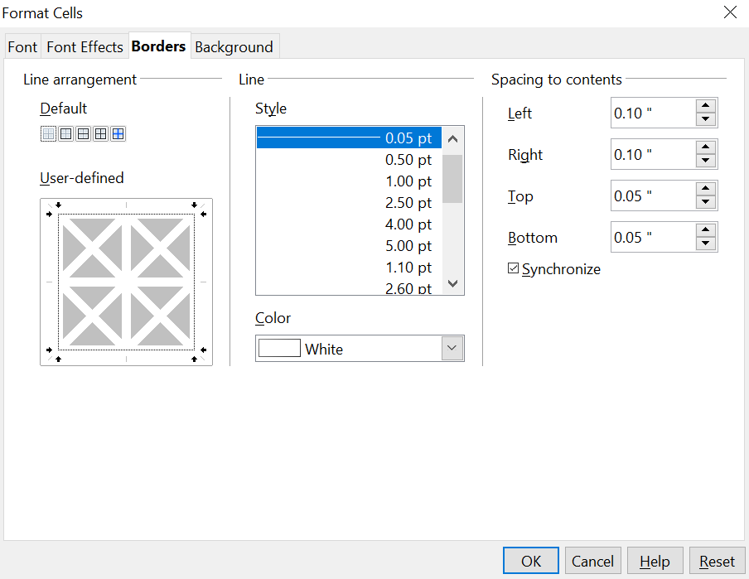

Figure 51: The Format Cells dialog box showing the Borders tab
- Borders: here you can set advanced properties not available from the Table Toolbar, such as the spacing between the text and the border, and set the style of each border of the table separately. This tab also provides the same options as the line style and line color buttons of the Table Toolbar.
Note | It is currently not possible to define diagonal borders for Impress tables.
- Background: changes the background of the selected cells and provides the same functionality as the Area Style Filling and Available Filling drop-down menus of the Table Toolbar.
Note | The Table Properties dialog box can also be accessed from the pop-up menu that opens when right-clicking on the table.

Position and Size
Impress treats tables just like any other graphic object; therefore, it is possible to change their position on the slide and their size by using the mouse or, for more accurate control, with the Position and Size dialog box. You can open the dialog box by pressing F4 when the table is selected or by right-clicking on the table and then selecting Position and Size from the pop-up menu. The functions provided in this dialog are described in Chapter 6 (Formatting Graphic Objects).
Note | Unlike other graphic objects, tables cannot be rotated.

Deleting a Table
To delete a table, select it and then press the Delete key on the keyboard.

Using Fields
Fields allow the automatic insertion of text into the slide. Think of a field as a kind of formula that is calculated when the document is loaded or printed, and the result is written to the document. Fields are commonly used when creating templates and slide masters, as explained in Chapter 2. Examples of fields include: date/time, slide number, file name, and author.

Inserting a Field
To insert a field into a slide, move the cursor where the field will be and then select from the menu bar Insert > Fields, followed by one of these choices:
- Date (fixed): inserts the date at the time of inserting the field.
- Date (variable): The field is updated to contain the date when the file is opened.
- Time (fixed): a field displaying the time of insertion.
- Time (Variable): a field that is updated to the time of opening the file.
- Author: The author of the presentation. This information is derived from the value recorded in the general options. To modify this information, go to Tools > Options > OpenOffice section, then select User Data.
- Page number: inserts the page number of the slide.
- File name: a field with the name of the file.
By default, fields are displayed with a gray background when you are in edit mode.

Customizing Fields
The appearance of all the fields, except for the page number field, can be customized using the corresponding field editor. To access the field editor (Figure 52):
- Move the cursor to the field and select it. This may be easier using the arrow keys than with the mouse.
- Select Edit > Fields from the menu bar.
- Select the desired format in the dialog box that appears.
- Click OK when satisfied.
Tip | A similar list of format choices can be accessed by selecting the field and right-clicking.
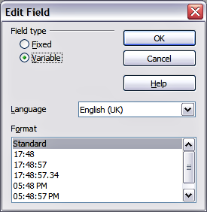
Figure 52: Setting the Time format for a time field
Modifications to the page number fields can be done in two different ways:
- Select the field and apply the formatting manually.
- Switch to the slide master editing mode (View > Master > Slide Master), then modify the Background object style as desired. Once back in Normal view, insert the page numbers from the Insert > Page Number box. See Chapter 2 for more information about editing a slide master.

Using Hyperlinks
When inserting text (such as a website address or URL) that can be used as a hyperlink, Impress formats it automatically, creating the hyperlink and applying a color and underlining. If you do not want Impress to do that, select Edit > Undo Insert from the menu bar or press Control+Z immediately after the formatting has been applied.
You can also insert hyperlinks manually.
Tips | To prevent AOO from automatically turning website addresses (URLs) into hyperlinks, go to Tools > AutoCorrect > Options and deselect the URL Recognition checkbox.  To change the color of hyperlinks, go to Tools > Options > OpenOffice > Appearance, scroll to Unvisited links and/or Visited links, select the checkboxes, pick the new colors and click OK. Caution: this will change the color for all hyperlinks in all components of OpenOffice—this may not be what you want.
To insert a hyperlink or to customize the appearance of a hyperlink, select Insert > Hyperlink from the menu bar. The dialog box shown in Figure 53 opens.
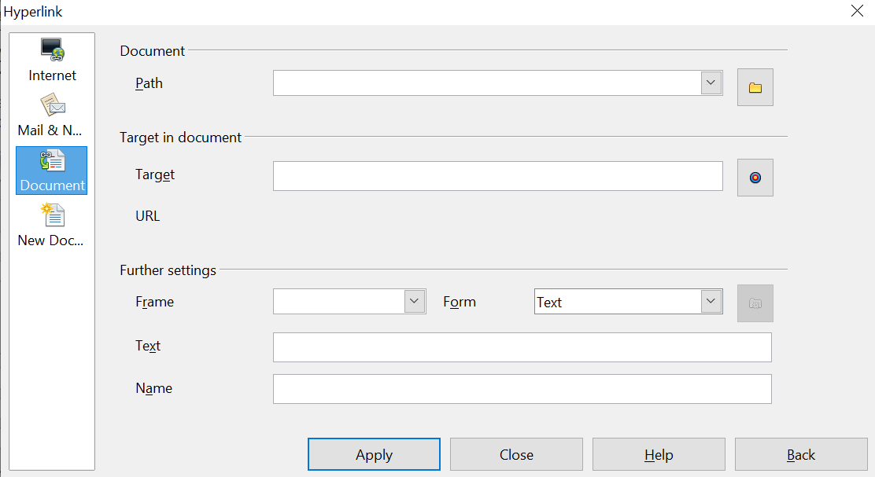

Figure 53: Dialog box to edit hyperlinks
On the left side, select one of the four types of hyperlinks:
- Internet: a web address, normally starting with https://
- Mail & News: for example, an email address.
- Document: the hyperlink points to another document or to another place, commonly referred to as a bookmark, in the presentation.
- New document: the hyperlink creates a new document.
The top right part of the dialog box changes according to the choice made for the hyperlink type. A full description of all the choices and their interactions is beyond the scope of this chapter. Here is a summary of the most common choices used in presentations:
- For an Internet type hyperlink, choose the type of hyperlink (choose between Web, FTP, or Telnet), and enter the required web address (URL).
- For a Mail and News type hyperlink, specify whether it is a mail or news link, the receiver address, and for email, also the subject.
- For a Document type hyperlink, specify the document path (the Open File button opens a file browser); leave this blank if you want to link to a target in the same presentation. Optionally, you can specify the target in the document (for example, a specific slide). Click on the Target icon to open the Navigator, where you can select the target. Alternatively, if you know the name of the target, you can type it into the box.
Note | For navigation within a presentation, it is generally better to use the object interaction menu. That item is located in either the Drawing toolbar or in the pop-up menu that opens when right-clicking an object.
- For a New Document type hyperlink, specify whether to edit the newly created document immediately or create it (Edit later) and the type of document to create (text, spreadsheet, etc.). For a presentation, Edit now is the more likely choice. The Select path button opens a directory picker.
The Further settings section in the bottom right part of the dialog box is common to all the hyperlink types, although some choices are more relevant to some types of links.
- Set the value of Frame to determine how the hyperlink will open. This applies to documents that open in a Web browser.
- Form specifies if the link is to be presented as text or as a button. See “Working with Hyperlink Buttons” for more information.
- Text specifies the text that will be visible to the user.
- Name is applicable to HTML documents. It specifies text that will be added as a NAME attribute in the HTML code behind the hyperlink.
- Event button: activated to allow AOO to react to events for which the user has written some code (macro). This function is not normally needed in Impress.

Editing Text Hyperlinks
To edit a text hyperlink, select it (by dragging across the text, not clicking on it), then choose Edit > Hyperlink from the main menu bar. Make changes as needed and click Apply when done. If you need to edit several hyperlinks, you can leave the Hyperlink dialog box open until you have edited them all, but be sure to click Apply after each one. When you are finished, click Close.

Working with Hyperlink Buttons
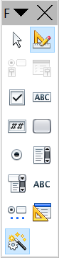
A hyperlink button is inserted in the center of the current slide. In most cases, that is not where you want it to appear. To edit the text or size of a hyperlink button, or to move it to another place on the slide, first display the Form Controls toolbar (View > Toolbars > Form Controls). Select the Design Mode On/Off icon (upper right corner of the toolbar).
Now you can click on the button and drag it to another position, or right-click and select Control to open a dialog box where you can change the text on the button, the size of the button, and other properties.
When you have finished editing the button, click the Design Mode On/Off icon again to make the button active again. For a detailed description of the button properties and on how to work with Form Controls, refer to the Writer Guide.

Chapter 4
Adding and Formatting Pictures

Introduction
Why are pictures so often used in presentations? They can convey a large amount of information more quickly than the written word. They can also give the presentation a professional look by adding logos and hallmarks. You can use Impress to create a presentation consisting only of pictures, such as a slideshow of holiday snapshots to share with friends.
This chapter describes how to insert and format pictures.

Inserting Pictures
This section describes several ways to insert a picture from an external source into an Impress presentation. Once the picture has been inserted, it can be formatted as explained later in this chapter.

Inserting a Picture from a File
Inserting a picture from a file is quick and easy. First, choose the slide layout, as described in Chapter 1 (Introducing Impress). Most layouts include a set of icons for inserting objects, but you can insert a picture into any slide.
Figure 54: Slide with a placeholder for inserting objects
Whether you are using an AutoLayout for the placement of the picture or you are just inserting a picture, follow these steps:
- Click on the Insert Picture icon or choose Insert > Picture > From file from the menu bar.
- In the Insert picture dialog, navigate to the directory containing the desired picture.
- Select the file. AOO recognizes a large number of image types. If the Preview option (in the lower left-hand area) is selected, a thumbnail of the selected file will be displayed in the preview pane on the right (not shown below).
- Click Open to place the picture on the current (selected) slide. The picture is now displayed on the slide with green resizing handles around it.
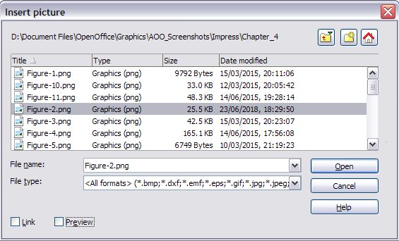Figure 55: Inserting a picture from a file
Notice the two options, Link and Preview, in the lower left of the Insert picture dialog. Their position is determined by the underlying operating system, but most frequently, they are located at the bottom left.
Select the Link option to insert the picture as a link to the file rather than embedding it in the file itself. In general, it is preferable to embed images so that the presentation can be copied to other computers. However, on some occasions, it makes sense to link the image rather than embed it. These include:
- When the image file is quite large, linking rather than embedding will dramatically reduce the size of the presentation file
- When the same image file is used in many presentations (for example, when using the same background image for all the presentations created)
- When the linked file will be available when loading the presentation (for example, if the presentation is a slide show of holiday pictures)

Inserting a Picture from a Scanner
Inserting an image from a scanner is usually straightforward. Make sure the scanner is supported by the SANE system if you are running Linux or any other UNIX-like system, or TWAIN if you are using a Windows version. Also, make sure the scanner is already configured on the machine where AOO is running. In case more than one scanner or equivalent device is present, select the source from Insert > Picture > Scan > Select Source.
To insert an image from the scanner:
- Prepare the image in the scanner and make sure that the scanner is ready.
- Choose Insert > Picture > Scan > Request.
- The rest of the procedure depends on the scanner driver and interface. You will normally be required to specify the resolution, a scan window, and other parameters. Consult the scanner’s documentation for more information.
- When the image is ready, Impress places it in the slide. At this point, it can be edited as would any other image.

Inserting a Picture from the Gallery
The Gallery contains a collection of images that you can use in a presentation. You can also add your own images to the Gallery, making it an essential tool for creating presentations quickly and with a consistent look. The Gallery is available in all components of OpenOffice. For an introduction to the Gallery, see Chapter 10 (Graphics, the Gallery, and Fontwork) in the Getting Started guide.
Choose Tools > Gallery or click the Gallery icon on the Drawing toolbar or select the Gallery deck in the Sidebar (Figure 56).
The Gallery displays named themes with images stored under each category. Select a theme from the theme pane and then scroll through the images to find a suitable one. Click on the image and drag it onto the workspace. Figure 56 shows an example of the Sidebar Gallery deck.
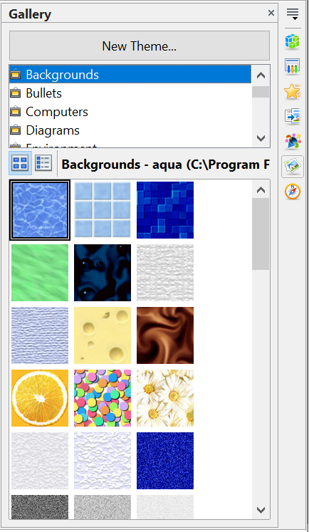

Figure 56. The Gallery Deck of the Sidebar

At this point, the image will be in your slide, but its size may not be satisfactory. If necessary, resize it as described in “Resizing a Picture” on page 82.

Positioning the Gallery
If you access the Gallery with Tools > Gallery or with the icon on the Drawing toolbar, it appears above the workspace. This shrinks the workspace, and you may want to optimize the size of the Gallery, undock it to place it in a more convenient position, or hide it. On modern wide screens, it is usually more convenient to use the Gallery in the Sidebar
To expand the Gallery when it's above the workspace, position the pointer over the line that divides it from the top of the workspace. When the pointer changes to parallel lines with arrows, click and drag downward. The workspace will resize in response.
By default, the Gallery is docked above the Impress workspace. To undock it, hold down the Control key and double-click on the upper part of the Gallery next to the View icons. To dock it again, double-click in the same area.
When the Gallery is docked, to hide it and view the full Impress workspace, click the Hide/Show button in the middle of the thin bar separating the Gallery from the workspace (see Figure 57). The Hide/Show button lets you keep the Gallery open for quick access while you create your slide show, yet out of the way when you need it to be.
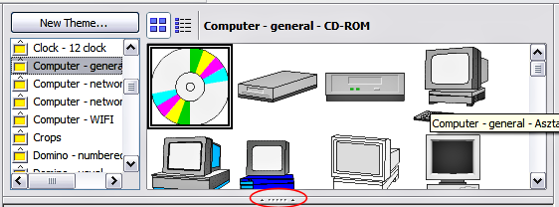Figure 57: The Gallery with the Hide/Show selector circled

Managing the Gallery Themes
Graphics in the Gallery are grouped by themes, such as Bullets, Rulers, and Text shapes. The box above or on the left of the gallery window lists the available themes. Click on a theme to see its graphics displayed in the Gallery window.
The default themes are locked; no items can be added or deleted from these themes. The locked themes are easily recognizable by right-clicking on them; the only available option in the pop-up menu is Properties.
In a default installation, only the My Theme theme is customizable. You can add your own graphics to this gallery or add new themes as explained on page 82.

Adding Images to the Gallery
You can add new images to themes that you created, or to My Theme :
- Right-click on the theme name in the list of themes and choose Properties from the pop-up menu.
- Click the Files tab, if necessary.
- Click Add.
- Select a file; click Open. The image is added to the theme.

Deleting Images from the Gallery
To delete an image from a theme:
- Right-click on the image in the Gallery window.
- Choose Delete from the pop-up menu. A message appears, asking if you want to delete this object.
- Click Yes.
Note | The image is deleted from the Gallery only. The original image file is not deleted.
All the images in a gallery are actually linked files. From time to time, it is beneficial to update the gallery theme to ensure that all the files are still there. To do so, right-click on the theme where you added at least one file and then select Update from the pop-up menu.

Adding a New Theme to the Gallery
- Click the New Theme button above the list of themes.
- Click the General tab and type a name for the new theme.
- Click the Files tab (Figure 58).
- Click Find Files. The Select Path dialog opens. Navigate to the folder that contains the image files for the new theme and click Select.
- Back on the Files tab, either click on Add All to install all of the files in the selected folder, or use File Type and/or select one or more files from the displayed list, and click on Add to install a selection of files to the new theme.
- Click OK when finished.
- The new theme will now be displayed on the list of themes in the Gallery.
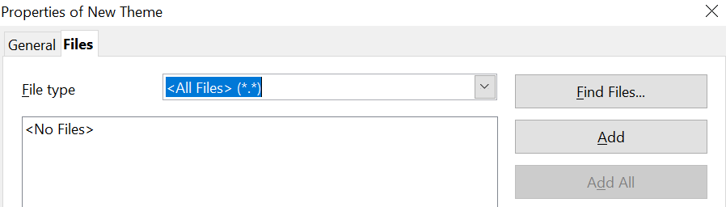

Figure 58. Setting up a new theme in the Gallery

Formatting Pictures
This section discusses formatting pictures inserted with one of the methods explained in “Inserting Pictures” on page 77.

Moving a Picture
- Click the picture, if necessary, to show the green resizing handles.
- Move the pointer over the picture until the pointer changes shape. On most operating systems, the cursor associated with moving objects is a four-headed arrow, but it may also be a hand or other similar symbol.
- Click and drag the picture to the desired position.
- Release the mouse button.
For a more accurate placement of the picture, use the Position and Size dialog described in Chapter 6 (Formatting Graphic Objects).

Resizing a Picture
- Click the picture in order to see its green resizing handles.
- Position the pointer over one of these handles. The pointer changes shape, giving a graphical representation of the direction of the resizing.
- Click and drag to resize the picture.
- Release the mouse button when satisfied with the image's new size.
The corner handles resize both the width and the height of the graphic object simultaneously, while the other four handles only resize one dimension at a time.
Tip | To retain the original proportions of the graphic, Shift+click one of the corner handles, then drag. Be sure to release the mouse button before releasing the Shift key.
For more accurate resizing of the graphic object, use the Position and Size dialog described in Chapter 6 (Formatting Graphic Objects).
Caution | Be aware that re-sizing a bit-mapped (raster) image will adversely affect the resolution, causing some degree of blurring. Some image formats, such as .bmp (Microsoft bit map), create files which, when compressed, actually enlarge the physical size of the file. It is better to use a specialized graphics manipulation program to correctly scale the picture to the desired size before inserting it into your presentation.

Be aware of the following regarding the structure, file formats, and file name extensions for raster images.

- .JPEG or .JPG (Joint Photographic Experts Group): Excellent for photographs, often using lossy compression to balance quality and file size.
- .PNG (Portable Network Graphics): Good for web graphics, supporting lossless compression, which is ideal for images with sharp lines and transparency.
- .GIF (Graphics Interchange Format): Suitable for simple web graphics and animations, though less common now than PNG for static images.)
- .TIFF (or .TIF (Tagged Image File Format): A versatile format that can handle both lossy and lossless compression and is frequently used in GIS and professional photography.)
- .BMP (Bitmap): A simple, uncompressed raster format often used for basic images.

Rotating a Picture
As with the position of the image on the page, rotation of a picture can be done manually or using a dedicated dialog. The Rotation dialog is described in Chapter 6 (Formatting Graphic Objects). To rotate a picture manually, do as follows:
- Select the picture if necessary so that the green handles around it show.
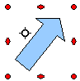
Figure 59: Shape showing the red rotating handles
- Click the Rotate button on the Drawing toolbar. This toolbar is usually located at the bottom of the screen, but it can be undocked and used as a floating toolbar. If the toolbar is not showing, select View > Toolbars > Drawing. The Drawing toolbar is discussed in detail in Chapter 5 (Creating Graphic Objects).
At this stage, a black crosshair with a circle appears in the center of the picture, representing the pivot point for the rotation. Normally, the center of the picture will be just fine, but on some occasions, you may wish to rotate around a corner or even around a point outside the picture. To do this, click on the crosshair and drag it to the desired position before applying the rotation, as shown in Figure 59.
Note | Icons representing functions in toolbars are different, depending on the operating system used. When in doubt, hover the mouse over the icons and wait for the tooltip to appear, showing the name of the button.
- Eight red circular handles replace the green square handles, as shown in Figure 59. Move the mouse over one of the corner handles, and the mouse cursor shape will change. Click the mouse and move in the direction you want to rotate the picture.
- When satisfied, release the mouse button.
To restrict rotation angles to multiples of 15 degrees, press the Shift key while rotating the graphic. This is a very handy way to rotate pictures of right angles, for example, from portrait to landscape or vice versa.

Formatting using the Picture Toolbar
When a picture is selected, the Picture toolbar shown in Figure 60 becomes available. This toolbar provides several formatting options, which are described in this section. If the picture toolbar does not appear when an image is selected, display it by selecting View > Toolbars > Picture from the menu bar.
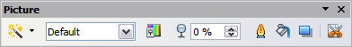Figure 60: The Picture toolbar

Applying Filters
Use the icon on the toolbar to apply various filters to the selected picture. The best way to judge if a filter works for your picture is to try it. To apply a filter:
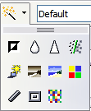
Figure 61: The graphic filters available in Impress
- Select the image so that the green handles around it are displayed.
- Click on the icon in the Picture toolbar. The toolbar will expand to show the icons in Figure 61.
- Select the filter you wish to apply. To show the name of the filter, hover the mouse pointer over the icon and wait for the tooltip to appear.
If you are not satisfied with the effect obtained or want to try a different one, before doing anything else, click the Undo button or select Edit > Undo: Bitmap Graphic Filter from the menu bar, or press Control+Z.
Table 1 describes briefly each of the available graphic filters and their effects. See the Draw Guide for examples of the effects.
Table 1: Graphic filters and their effects
Icon | Name | Effect
 | Invert | Inverts the color values of a color image, or the brightness values of a grayscale image.
 | Smooth | Softens the contrast of an image.
 | Sharpen | Increases the contrast of an image.
 | Remove noise | Removes single pixels from an image.
 | Solarization | Mimics the effects of too much light in a picture. A further dialog opens to adjust the parameters.
 | Aging | Simulates the effects of time on a picture. It can be applied several times. A further dialog will open to adjust the aging level.
 | Posterize | Makes a picture appear like a painting by reducing the number of colors used.
 | Pop Art | Modifies the picture dramatically.
 | Charcoal | Displays the image as a charcoal sketch.
 | Relief | A dialog is displayed to adjust the light source, which in turn will create the shadow and hence the relief effect.
 | Mosaic | Joins groups of pixels into a single area of one color.

Changing the Graphics Mode
Use the graphics mode drop-down list in the Picture toolbar to change the mode of the image. Choose between:
- Default: No changes to the graphic object.
- Grayscale: The image is converted to scales of gray.
- Black/White: Each pixel of the image is converted to black or white depending on the brightness value.
- Watermark: adjusts the brightness of the image, making it suitable for use as a watermark. For more information on inserting watermarks in the presentation, refer to Chapter 2 (Slide Masters).

Adjusting the Color
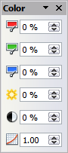
Figure 62: The color adjustment dialog
Clicking the color adjustment button on the Picture toolbar opens the color adjustment dialog, like that in Figure 62.
Use this dialog to modify the individual color components of the image (red, green, blue) as well as the brightness, contrast, and gamma of the image. If the result is not satisfactory, press Control+Z to restore the default values.
Increasing the gamma value of a picture makes it more suitable for use as a background or watermark; an image modified in this way will interfere less with dark text.
In the context of either image processing or image transmission, gamma refers to the clarity or cloudiness of an image. Under the hood, gamma involves the number of bits needed to encode an image, or the bandwidth needed to transport it. Too many bits, or too much bandwidth, can result in highlights indistinguishable to the human eye, while too few bits or too little bandwidth might produce unintended shadows.

Setting the Object Transparency
Modify the percentage value in the Transparency box on the Picture toolbar to make the image more transparent. Note that this differs from the transparency settings for a line or a shape (described in Chapter 5). As with the gamma value, increasing the transparency of a picture makes the picture blend more smoothly into the background, making overlay text easier to read.

Adjusting the Line, Area, and Shadow Settings
These settings are not very commonly used for images, except for the shadow setting, which applies a shadow to the image.

Cropping Pictures
Impress provides two ways to crop a picture: interactively or using a dialog. The interactive method is easier to use, but the dialog provides more precise control. You can use both methods: first, cropping interactively, then using the dialog to fine-tune the result.
To crop a selected picture interactively, click the Crop icon on the Picture toolbar (Figure 60). A set of crop marks appears around the picture (see Figure 63).
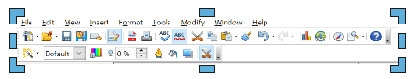

Figure 63: Interactive crop marks
When you place the cursor over any of the crop marks, the cursor changes shape. Drag the mark to crop the picture. Click outside the picture to deactivate cropping mode.
Press the Shift button while working on the crop marks to produce the following effects:
- For a corner mark, the two sides of the picture forming the corner are cropped proportionally, with the picture anchored to the opposite corner mark.
- For a side mark, both dimensions are changed proportionally, with the image anchored to the opposite side mark.
The interactive crop mode operates in Keep Scale mode (see below).
To crop using the dialog, right-click a selected picture and choose Crop Picture (or choose Format > Crop Picture from the menu bar).
The Crop dialog (Figure 64) has the following options:
- Keep scale / Keep image size buttons: when Keep scale is selected (default), cropping the image does not alter the scale of the picture. When Keep image size is selected, cropping produces enlargement (for positive cropping values), shrinking (for negative cropping values), or distortion of the image so that the image size remains constant.
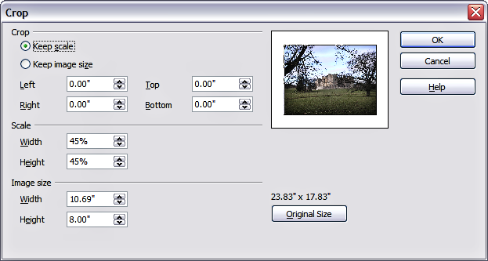
Figure 64: The options available when cropping a picture
- Left, Right, Top, and Bottom: The function of these boxes changes according to the choice made between Keep scale and Keep image size. In both cases, when a value is entered in one of these boxes, the image is cropped by that amount. For example, a value of 3cm in the Left box will cut 3cm from the left side of the picture.
When Keep scale is selected, the size of the image also changes, so in this example, the width will be reduced by 3 cm. If Keep image size is selected instead, the remaining part of the image is enlarged (positive values for cropping) or shrunk (negative values for cropping) so that the width and height of the image remain unchanged.
Note that the Width and Height fields change as you enter the values when in this mode. Use the thumbnail next to these fields to determine the correct amount by which to crop.
- Scale Width and Height: specify in percentages the scaling of the picture. The size of the image changes accordingly.
- Image size: specify the size of the image in your preferred unit of measurement. The image enlarges or shrinks accordingly.
- Original size: when clicked, restores the original image size.

Deleting a Picture
- Click on the picture, if necessary, to show the green resizing handles.
- Press Delete.

Creating an Image Map
An image map defines areas of an image (called hotspots) that are associated with a URL (a web address or a file on a computer). Hotspots are the graphic equivalent of text hyperlinks. Clicking on a hotspot causes Impress to open the linked page in the appropriate program (for example, the default browser for an HTML page, AOO Writer for an .ODT file, or a PDF viewer for a PDF file). You can create hotspots of various shapes and include several hotspots in the same image.
To use the image map tool:
- Select the picture where hotspots will be defined.
- Choose Edit > ImageMap from the menu bar. The ImageMap Editor dialog in Figure 65 opens. The main part of the dialog shows the image on which the hotspots will be defined. In this image, an active hotspot is indicated by a white shading, while an inactive hotspot is identified by a red border but no shading.
- Use the tools and fields in the dialog to define the hotspots and links necessary.
- Click the Apply icon to apply the settings.
- When done, click the Save icon to save the imagemap to a file, then click the X in the upper-right corner to close the dialog.
The top part of the dialog contains the following tools:
- Apply button: Click this button to apply the changes.
- Load, Save, and Select icons.
- Tools for drawing a hotspot shape: these tools work in exactly the same way as the corresponding tools in the Drawing toolbar (described in Chapter 5).
- Edit, Move, Insert, Delete Points: advanced editing tools to manipulate the shape of a polygon hotspot. Select the Edit Points tool to activate the other tools.
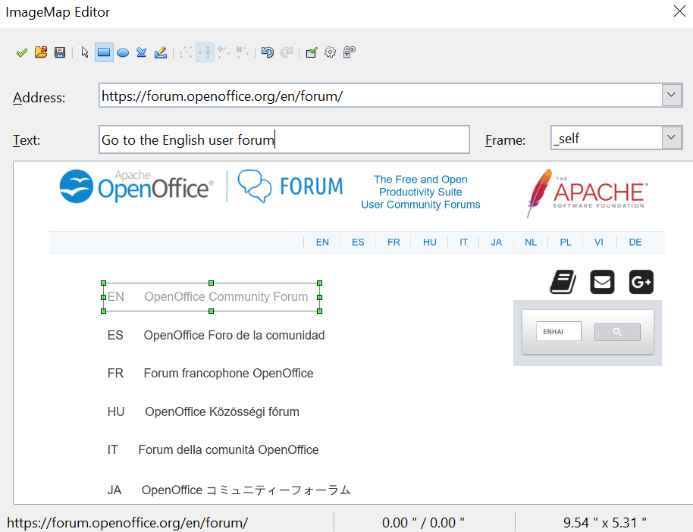

Figure 65: The dialog to create or edit an image map
- Active icon: toggles the status of the hotspot, activating a selected hotspot or deactivating it if it's active.
- Macro: associates a macro with the hotspot instead of a hyperlink.
- Properties: sets the hyperlink properties and adds the Name attribute to the hyperlink.
Below the toolbar, specify for the selected hotspot:
- Address: the address pointed to by the hyperlink. You can also point to an anchor in a document, such as a specific slide number; to do this, write the address in this format: file:///<path>/document_name#anchor_name
- Text: enter the text that will be displayed when the mouse is moved over the hotspot.
- Frame: where the target of the hyperlink will open: pick among _blank (opens in a new browser window), _self (opens in the active browser window), _top, or _parent.
Tip | The value _self for the target frame will work just fine in the vast majority of contexts. It is therefore not recommended to use the other values unless absolutely necessary.

Chapter 5
Managing Graphic Objects
Moving, rotating, distorting, and positioning objects; animations; Fontwork

Introduction
This chapter describes how to manage graphic objects, specifically how to rotate, distort, arrange, and position them on a slide. Though this chapter focuses on the shapes that can be created with the available tools in Impress, some of the techniques described here are also applicable to images imported into Impress.
The Drawing toolbar contains most of the tools normally used to create graphic objects. If this toolbar is not showing, select View > Toolbars > Drawing from the main menu bar.
The toolbar can be divided into two parts. The first part contains drawing objects, as shown in Figure 66. The second part of the toolbar, shown in Figure 68 on page 93, contains more generic tools.
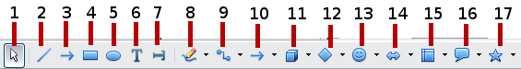
1 | Select | 5 | Ellipse | 9 | Connector | 12 | Basic shapes | 16 | Callouts
2 | Line | 6 | Text | 10 | Lines and Arrows | 13 | Symbol shapes | 17 | Stars
3 | Arrow | 7 | Vertical text | 10 | Lines and Arrows | 14 | Block arrows
4 | Rectangle | 8 | Curve | 11 | 3D Objects | 15 | Flowcharts
Figure 66: First section of Drawing toolbar
The tools in the first part of the Drawing toolbar are:
- Select: selects objects. To select a group of objects, click and drag with the mouse to define a rectangle that contains all of the objects. It is also possible to select several objects by pressing the Shift key while selecting individual objects.
- Line: draws a straight line from the point where you click the mouse to the point where you release the mouse button after having dragged the mouse pointer. Press the Shift key to restrict the angle of the line to multiples of 30°; use the Control key to detach the end point of the line from the grid (see “Snapping Objects to Grid or Snap Guides“ on page 102).
- Arrow: draws a straight line ending with an arrowhead. The arrowhead is placed where you release the mouse button. The Shift and Control keys have the same effect as they had for the Line tool.
- Rectangle: draws a rectangle when you drag the mouse from the top left to the bottom right corner. Press the Shift button to draw a square.
- Ellipse: draws an ellipse. Press the Shift button to draw a circle.
- Text: creates a text box with text aligned horizontally.
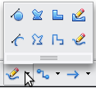
- Vertical text: creates a text box with text aligned vertically. This tool is available only when Asian language support has been enabled in Tools > Options > Language Settings > Languages.
- Curve: draws a curve. Click the black triangle for more options (shown at right), including polygons. Note that the title of the submenu, when undocked, is Lines.
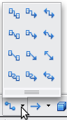
- Connector: draws a connector line between two figures. Click the black triangle for additional connectors. Their use is described in “Working with Connectors“ on page 104.

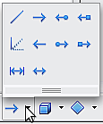
- Lines and Arrows: draws a line ending in an arrow. Click the black triangle for additional choices. When torn off, this toolbar is titled Arrows.

- Basic Shapes, Symbol Shapes, Block Arrows, Flowcharts, Callouts, Stars: click the black triangle to open a toolbar showing the available shapes in that category. The default shapes are shown in Figure 67. Select the desired shape, then draw it by dragging the mouse to define an enclosing rectangle. Keep the Shift key pressed to obtain a shape where the height and width are equal.
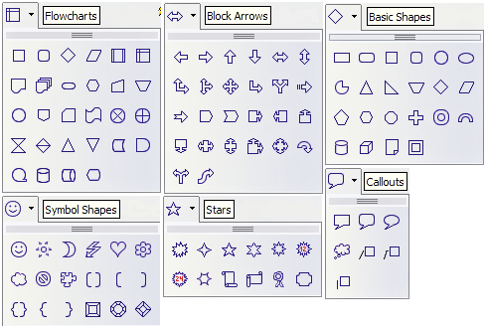Figure 67: Available shapes for Impress
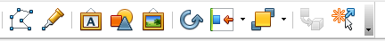

1 | Edit Points | 4 | From File | 7 | Alignment | 10 | Interaction
2 | Glue Points | 5 | Gallery | 8 | Arrange | 11 | Visible buttons
3 | Fontwork | 6 | Rotate | 9 | Extrusion On/Off
Figure 68: The second section of the drawing toolbar with utility tools
1
2
3
4
5
6
7
8
9
11
1
2
3
4
5
6
7
8
9
10
The tools in the second part of the Drawing toolbar are:
- Edit points: To edit the individual points that form the shape or line, select this tool, and then select a shape or a line.
- Glue points: To edit the glue points of a graphic object, select this tool. Glue points are the positions where connector lines terminate or start. See “Managing Glue Points” on page 105 for instructions.
- Fontwork: opens the Fontwork gallery. See “Using Fontwork” on page 111 for further information.
- From file: Equivalent to Insert > Picture > From file on the main menu. See Chapter 4 for details.
- Gallery: opens the gallery. Equivalent to Tools > Gallery on the main menu. See Chapter 4 for details.
- Rotate: Select this tool to rotate an object. As rotation is considered a formatting attribute. This is discussed in Chapter 6 of this book.
- Align object: See “Aligning Shapes“ on page 102.
- Arrange object: See “Arranging Shapes“ on page 104.
- Extrusion On/Off: switches 3D effects on or off for the selected object. Clicking this button also opens the 3D settings toolbar. See “Working with 3D Shapes” on page 106 for details.
- Interaction: opens a dialog where you can specify the interaction between the user and the object. See “Setting up Interaction with a Shape” on page 108.
- Visible buttons: Use the black triangle on the far right of the toolbar to open a menu from which you can add or subtract buttons on the toolbar. See Chapter 1 (Introducing Impress) for more information.

Creating Lines and Shapes
To create shapes and lines:
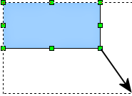
Figure 69: Creating a shape
- Select the desired line or shape tool.
- Click and drag to create the object on the slide.
When drawing a freehand polygon (that is, when you create a shape segment by segment from one of the tools on the Curves toolbar, shown on page 91), keep the Shift key pressed to restrict the angle between the segments to multiples of 45 degrees. To finish drawing a polygon, double-click on the last part of the segment. If a closed polygon is selected, Impress draws the line connecting the last point to the start point and fills the inside area with the default color.
When drawing certain shapes, one or more yellow dots are displayed along with the green resizing handles. These dots perform a different function depending on the shape to which they are applied. With the basic shapes, the yellow dot (or dots) is used for the following purposes:
- Rounded rectangle and Rounded square shapes: Use the yellow dot to change the size of the curve, replacing the corners.
- Circle Pie: Use the two yellow dots to change the size of the filled sector.
- Isosceles triangle: Move the yellow dot on one vertex to modify the triangle type.
- Trapezoid, Parallelogram, or Octagon: Move the yellow dot to change the angle between the sides.
- Cross: Use the yellow dot to change the thickness of the four sides.
- Ring: Use the yellow dot to change the internal diameter.
- Block arc: Use the yellow dot to change both the internal diameter and the size of the filled area.
- Cylinder and Cube: Use the yellow dot to change the perspective.
- Folded corner: Use the yellow dot to change the size of the corner.
- Frame: Use the yellow dot to change the internal rectangle diagonal.

Grouping Shapes Together
It is often convenient to group shapes together to cause Impress to treat them as a single shape. A group of shapes can be formatted as if it were a single shape, moved, rotated, deleted, and so on. To group shapes together, do as follows:
- Select the shapes to be grouped. To do this, use the selection tool on the drawing toolbar and draw a rectangle around the shapes to be grouped, or click on each shape to be added to the group while pressing the Shift key.
- When the green resizing handles show, select Format > Group > Group or press Control+Shift+G on the keyboard.
Once the group is defined, click on any of the shapes within the group to select it. To edit only the shapes in the group, press F3 when the group is selected or select Format > Group > Enter group from the menu bar. Notice that any shapes not part of the group are grayed out and that only the shapes belonging to the group can be edited. Use this function when you need to apply a particular format to a single member of the group. To exit from group mode, press Control+F3 or select Format > Group > Group from the menu bar.
For more about working with grouped objects, see Chapter 5 (Combining Multiple Objects) in the Draw Guide.
To ungroup objects:
- Select the group of shapes.
- When the green resizing handles show, select Format > Group > Ungroup from the menu bar.
Tip | If you use the group and ungroup commands often, consider adding them to one of the toolbars shown by default, so that the commands are readily available. To do so, you will need to customize the selected toolbar. See Chapter 11 (Setting Up and Customizing Impress).

Moving Graphic Objects
- Click the graphic object, if necessary, to show the green resizing handles..
- Move the pointer over the graphic object until the pointer changes shape. On most operating systems, the cursor associated with moving objects is a four-headed arrow, but it may also be a hand or another symbol.
- Click and drag the graphic object to the desired position (you can also use the arrow keys).
- Release the mouse button.
Tip | By default, Impress makes objects snap to the grid. To position the object between two points of the grid, hold down the Control key, then click on the object and move it to the desired position.  Alternatively, you can modify the grid resolution by going to Tools > Options > OpenOffice Impress > Grid.
For a more accurate placement of the graphic object, use the Position and Size dialog box shown in Figure 70. First, select the graphic object by clicking on it; when the resizing green handles are displayed, either press F4 or select Format > Position and Size from the menu bar.
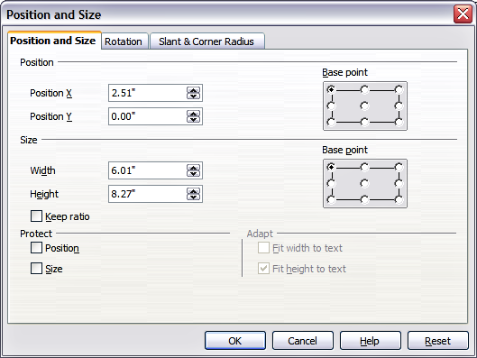Figure 70: Fine adjustment of position and size of the graphic object
Use the Position tab of the dialog to specify the X (horizontal) and Y (vertical) position of the graphic object. The values represent the distance of the base point (selected on the right side of the dialog) relative to the top left corner of the slide.
To prevent accidental modification of the position of the graphic object, select the Position option in the Protect section (bottom left) of the dialog.
The unit of measurement for this and the other dialog boxes in this section is set in Tools > Options > OpenOffice Impress > General.

Resizing Graphic Objects
- Click the graphic object to show the green resizing handles.
- Position the pointer over one of the green resizing handles. The pointer changes shape, giving a graphical representation of the direction of the resizing.
- Click and drag to resize the graphic object.
- Release the mouse button to complete resizing.
The corner handles resize both the width and the height of the graphic object simultaneously, while the other four handles resize only one dimension at a time.
Tip | To retain the original proportions of the graphic, Shift+click one of the corner handles, then drag. Be sure to release the mouse button before releasing the Shift key.
For more accurate resizing of the graphic object, use the Position and Size dialog (Figure 70). Select as the base point the part of the graphic object that you would like to anchor to the page. The default setting (top-left corner) means that when resizing, the position of the top left corner of the object will not change. Now modify either the Width value or the Height value of the object. To maintain proportions between width and height, select the Keep ratio option before modifying any value. When Keep ratio is selected, changes to one of the dimensions result in automatic changes to the other.
To prevent accidental modifications of the size, make sure that the Size option is selected in the Protect section in the bottom left part of the dialog.

Applying Special Effects
Besides the basic actions of moving and resizing an object, a number of special effects can also be applied to the objects in Impress. Several of these effects are readily available in the Mode toolbar shown in Figure 71. If the Mode toolbar is not showing, select it from View > Toolbars > Mode.
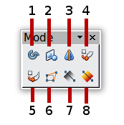
1 | Rotate | 4 | Set in Circle (perspective) | 7 | Transparency
2 | Flip | 5 | Set to Circle (slant) | 8 | Gradient
3 | In 3D Rotation Object | 6 | Distort
Figure 71: Mode toolbar
This section describes how to rotate, flip, distort, and two ways of setting an object in a circle. The transparency and gradient tools, which are more specific to formatting, are discussed in Chapter 6.

Rotating Graphic Objects
Rotation of an object can be carried out manually or using a dedicated dialog, just like changing the object position and size. To rotate a graphic manually:
- Select the graphic object if necessary so that the green handles show around it.
- Click the Rotate button in the Drawing toolbar or in the Mode toolbar.
Note | The icons representing the functions in the toolbars are different depending on the operating system used. When in doubt, hover the mouse over the icons and wait for the tooltip to appear, showing the name of the button. The tooltip for the sub-toolbar containing the Rotate function is Effects.
- Eight red handles replace the green square handles, as shown in Figure 72. Move the mouse over one of the corner handles, and the mouse cursor shape will change. Click the mouse and move in the direction in which you want to rotate the graphic object.
- When satisfied, release the mouse button.
At step 2), a black cross hair with a circle appears in the middle of the picture: this represents the pivot point for the rotation. Normally, the center of the picture will be fine, but on some occasions, you may wish to rotate around a corner or even around a point outside the picture; to do that, click on the crosshair and drag it to the desired position.
To restrict the rotation angles to multiples of 15 degrees, press the Shift key while rotating the graphic. This is very handy for rotating pictures through a right angle, for example, from portrait to landscape or back.

Figure 72: Shape showing the red rotating handles. Only the corner ones are active. The black crosshair indicates the rotation pivot.
Instead of rotating a graphic object manually, you can use the Rotation dialog shown in Figure 73. To display this dialog, select the graphic object so that the green resizing handles are shown, then press F4 or select Format > Position and Size and select the Rotation tab.
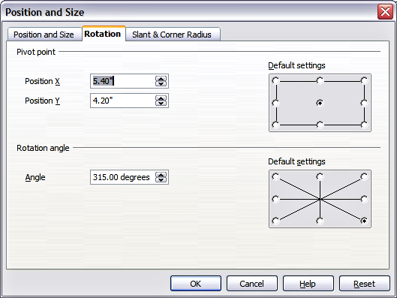Figure 73: The Rotation page of the Position and Size dialog
In the upper part of the dialog, select the position of the pivot point relative to the top left corner of the page. The default position of the pivot point is the center of the figure.
In the lower part of the dialog, select the angle by which to rotate the graphic object. To the right of the Angle text box, 8 default rotation values can be easily selected.

Flip an Object
Select an object and click the Flip icon . You will see a dashed line through the middle of the object.
This dashed line is the axis of symmetry. The object will be reflected symmetrically around this line. Move one or both ends of the line with your mouse to set the orientation of the axis.
Then, grab any one of the eight green handles and move it across to the other side of the dashed line. The new position of the figure is shown faintly until the mouse is released.
 |  | 

Note | If you press the Shift key while moving the line, the line will rotate in 45-degree increments.

Mirror Copies
This useful command does not exist in Draw or Impress. It can, however, be easily imitated.
Move the axis of symmetry to the desired location of the mirror axis. Copy the object to the clipboard. Flip the object, then click on an empty area of the page to deselect it. Paste from the clipboard to put a copy of the object in its original location, and now you have a mirror copy.

Figure 74: Making a mirror copy of an object

Distorting an Image
Three tools on the Mode toolbar let you drag the corners and edges of an object to distort the image.
The Distort tool distorts an object in perspective; the Set to Circle (slant) and Set in Circle (perspective) tools both create a pseudo three-dimensional effect. In all three cases, you are initially asked if you want to transform the object into a curve. This is a necessary first step, so click Yes. Then you can move the object handles to produce the desired effect.
The results of using these tools are shown in the following figures.

Distort an Object
Select an object and click on the Distort icon . After converting to a curve as requested, move the handles to stretch the object.
The corner handles distort, as shown in Figure 75. The vertical midpoint handles distort the figure horizontally, and the horizontal ones distort it vertically.
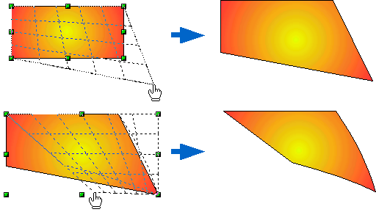
Figure 75: Distort an image

Set in Circle (Perspective)
Select an object and click the Set in Circle (perspective) icon. After converting to a curve, move the object handles to give a pseudo-three-dimensional perspective.
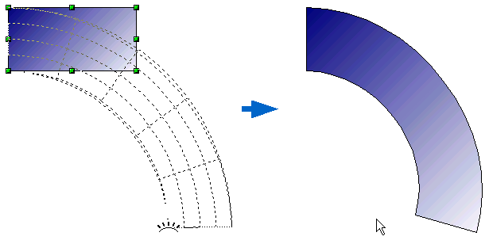
Figure 76: Set an image in a circle with perspective

Set to Circle (Slant)
Select an object and click on the Set to Circle (slant) icon. After converting to a curve, move the object handles to give a pseudo three-dimensional slant perspective.
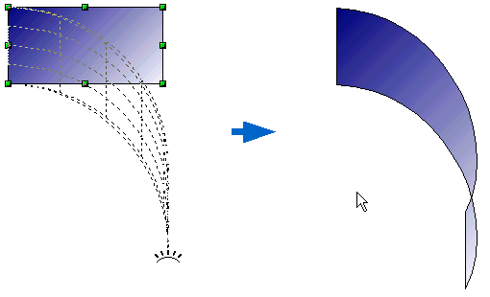
Figure 77: Set an image to a circle with slant perspective
Note | Transforming an object into a curve is a safe operation, but it cannot be reversed other than by clicking the Undo button.

Aligning Shapes
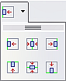
Use the alignment tools to adjust the relative position of a graphic object compared to another object. Clicking on the arrow beside the Alignment icon in the Drawing toolbar opens the extended toolbar. The same alignment options are available from the right-click menu.
The toolbar has six icons. The first three determine the horizontal alignment of the selected objects (Left, Center, Right); the other three determine the vertical alignment of the selected objects (Top, Middle, Bottom). If only one object is selected, it is aligned to the page; however, when several objects are selected together, single objects are aligned to the border of the group selection.

Snapping Objects to Grid or Snap Guides
Sometimes it is important to align objects to specific points on the page, or to ensure objects that appear on multiple slides are placed in exactly the same position on each such slide. For this purpose, Impress provides two mechanisms: the Grid and Snap Guides (also known as Snap Lines).

Using the Grid
Options for the grid are available in the menu that opens when you right-click on an empty part of the page in Normal view. From this menu, choose Grid. Or, select View > Grid from the menu bar. In both cases, a submenu with three options opens:
- Visible Grid: displays the grid.
- Snap to Grid: The anchor points of an object will always be placed on a grid when the object is moved or resized.
- Grid to Front: displays the grid in the foreground.
To set up the grid spacing and snapping options, choose Tools > Options > OpenOffice Impress > Grid from the menu bar.

Using Snap Guides
Options for the guides are available in the menu that opens when you click on an empty part of the page in Normal view and choose Snap Lines, or select View > Guides from the menu bar. A submenu with three options opens:
- Display Guides (Snap Lines Visible): The guides are shown on the slide.
- Snap to Guides (Snap to Snap Lines): The anchor points of the objects snap to the guides when the object is moved or resized.
- Guides to Front (Snap Lines to Front): The guides are brought to the foreground and cover the objects.
Note | The main menu uses the term Guides, but the pop-up menu refers to Snap Lines.
To create a new guide:
- Right-click on an empty part of the work area and select Insert Snap Point/Line from the pop-up menu.
- In the dialog that appears, specify the type (Point, Vertical line, or Horizontal line).
- Depending on the choice made, the two edit fields X and Y become active; enter the position of the guide.
- Click OK to close the dialog.
Tip | When positioning the Snap Guides, it is useful to display the rulers. To do so, select View > Rulers.
Tip | Drag a Snap Guide directly onto the slide by clicking on the ruler and then dragging it onto the slide.
To edit a guide:
- Right-click next to or on the guide to be edited.
- Select Edit Snap line from the pop-up menu.
- Enter the new value (or values) and click OK.
To delete a guide:
- Right-click next or on the guide to be deleted.
- Choose Delete Snap line from the pop-up menu.
Figure 78 shows the three types of guides, the grid on a slide, and the dialog to create a new guide.
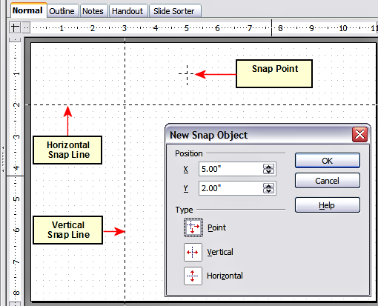
Figure 78: Gridline, snap lines, and snap point on a slide

Arranging Shapes
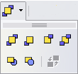
Arrange determines the stacking order of the selected object. Draw and Impress organize objects in a stack, so that objects on a high level cover objects on lower levels if overlapping occurs. To modify the position of an object in the stack, click the small triangle on the side of the Arrange icon to open the extended toolbar. The same arrange options described below are available from the right-click menu.
The first four tools determine the position of the selected object:
- Bring to front: the selected object is moved on top of any other object.
- Bring forward: the selected object is moved one level up in the stack.
- Send backwards: the selected object is moved one level down in the stack.
- Send to back: the selected object is given the lowest position in the stack.
The other three tools determine the relative positions of the selected object and of a second selected object:
- In front of object: brings the first selected object in front of the second selected object.
- Behind object: brings the first selected object behind the second selected object.
- Reverse: swaps the stacking order of two selected objects.
To use the In front of object and Behind object tools:
- Select the first object by clicking on it.
- When the green handles show, select the desired arrange action.
- The mouse pointer changes to a pointing hand. Click on the second object.

Working with Connectors
Connectors are lines that can be anchored to particular places, called glue points, on the graphic object. The advantage of connectors is that when the graphic to which the connector is attached is moved or resized, the connector automatically adjusts to the change. When creating a flowchart, org chart, schematic, or diagram, connectors are highly recommended instead of simple lines.
Impress offers a wide variety of predefined connectors, which differ in the termination shape (none, arrow, custom) and in the way the connector is drawn (straight, line, curved).
When a connector is drawn or selected, Impress displays red handles, which are not shown for normal lines. In particular, termination points are identified by red circles, while square handles are used to modify the routing of a connector (where applicable).
Draw a connector in a similar way to drawing any object. First, select the connector style from the Connector toolbar, then move the mouse cursor over one of the objects to be connected. When the cursor is over the object, small black crosses appear around it; these represent the glue points to which the connector can be attached. Click on the required glue point to attach one end of the connector, then hold the mouse button down and drag the connector to the second object. When the cursor is over the glue point of the target object, release the mouse button.
For instructions on how to format a connector, refer to the corresponding section in Chapter 6 (Formatting Graphic Objects).

Managing Glue Points
As described above, a glue point is the point of attachment for a connector to a shape or graphic object. Each shape has several predefined glue points, but it is possible to define new ones and edit existing ones, using the Gluepoints toolbar shown in Figure 79.
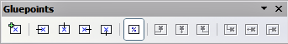

1 | Insert point | 4 | Exit right | 7 | Horizontal left | 10 | Vertical left
2 | Exit left | 5 | Exit bottom | 8 | Horizontal center | 11 | Vertical top
3 | Exit top | 6 | Relative | 9 | Horizontal right | 12 | Vertical right
Figure 79: The Gluepoints toolbar
1
2
3
4
5
6
7
8
9
10
11
12
Use the first tool to insert a new glue point. The next four tools determine the exit direction of the connector terminating at the glue point. To maintain the relative position of the glue point when resizing the object, make sure that the Glue point relative icon (highlighted in Figure 79) is selected. Deselecting the Glue point relative icon activates the remaining six icons on the toolbar; use these to fix the position of the glue point during the resizing of the object. Hover the mouse over the buttons to display a tooltip giving a brief description of its function.
To delete a custom glue point, select it with the mouse and press the Delete key.
Setting custom glue points is particularly useful when multiple connectors terminate on the same side of a shape, or when the default glue point position is unsatisfactory.
To move a predefined or newly inserted glue point:
- Select the glue point tool from the drawing toolbar (see Figure 68).
- Click on the glue point you want to move. The glue point should now be highlighted.
- Keep the mouse button pressed and drag the glue point to the desired position. Release the mouse button.
Tip | Glue points are placed by default on the grid (see “Snapping Objects to Grid or Snap Guides“ on page 102 for information). But sometimes it's necessary to fine-tune the position of a glue point depending on its shape. To do this, keep the Control key pressed while dragging the glue point to the new position.

Working with 3D Shapes
3D graphic objects can be created in different ways in Impress:
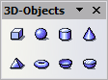
- From the 3D-Objects toolbar. The 3D-Objects tool is not included in the default Drawing toolbar. To include it, click on the small triangle at the end of the toolbar, select Visible Buttons, and select 3D-Objects from the list. On the Drawing toolbar, click on the triangle by the 3D-Objects icon to display the extended 3D Objects toolbar.
- From the Convert sub-menu. Select a shape, right-click on it, and in the Convert sub menu choose either To 3D to add thickness to the object or To 3D Rotation Object to create a 3D shape resulting from the rotation of the object around an axis.
- From the Extrusion on/off icon on the drawing toolbar. Select the shape to which to apply a 3D effect, then click the button on the Drawing toolbar (see Figure 80).
Caution | You can not apply extrusion to rectangular and oval shapes created by using the rectangle or oval tools. Instead, select the desired shape from the basic shapes menu to create a rectangle or oval with 3D effects. Alternatively, right-click on the object, then select Convert > To 3D. Note that in this case, the Extrusion on/off menu will not be enabled.
Although Impress offers advanced functions to manipulate 3D objects, this book describes only the 3D settings applicable to an object with Extrusion enabled. For additional information on using advanced 3D effects such as geometry and shading, refer to the Draw Guide.
Click on to activate the extrusion. The shape changes, and a default thickness is added to it. At the same time, the 3D-Settings toolbar should become visible. If the toolbar does not appear, select View > Toolbars > 3D-Settings.
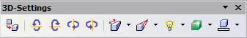
Figure 80: The 3D-Settings toolbar
Use the tools to change the appearance of the 3D object.
 | Extrusion On/Off: adds thickness to an object and activates the 3D properties.
 | Tilt Down: tilts the object downwards around a horizontal axis.
 | Tilt Up: tilts the object up around a horizontal axis.
 | Tilt Left: tilts the object left around a vertical axis.
 | Tilt Right: tilts the object right around a vertical axis.
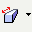 | Depth: determines the thickness of the shape. An extended toolbar opens, displaying some default values. If none of them is satisfactory, select Calculate and then enter the desired thickness.
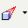 | Direction: opens an extended toolbar that lets you pick the direction of the perspective as well as the type (parallel or perspective)..
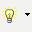 | Lighting: opens an extended toolbar that lets you specify the direction and intensity of light.
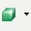 | Surface: Choose between Wire frame (useful when manipulating the object), Matt, Plastic, or Metal.
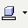 | 3D Color: Select the color of the object's thickness.
Most of the Fontwork shapes (see “Using Fontwork” on page 111) have 3D properties and can be manipulated with the 3D-Settings toolbar.
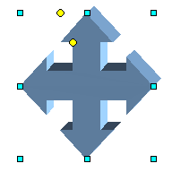
Figure 81: Example of 3D object
Note that when rotating a 3D object, in addition to the corner red handles, four handles on the sides of the frame become available.
Figure 81 is an example of a customized 3D object.

Converting an Object to a Different Type
You can convert an object into a different type. Right-click on the object and select Convert to display a menu containing the following options:
- To Curve: converts the selected object to a Bézier curve. Choose Edit Points to edit the Bézier curve.

Note | Bézier curves are widely used in computer graphics. Such curves are composed of control points that define a smooth, continuous curve, described by a formula. Usually, the curve is intended to approximate a real-world shape that otherwise has no mathematical representation. Recent uses include computer fonts and animation.

- To Polygon: converts the selected object to a polygon. After the conversion, choose Edit Points to edit the shape. A polygon always consists of straight segments.
- To Contour: For basic shapes, this is equivalent to converting to a polygon. For more complex shapes (or for text objects) this conversion creates a group of polygons that you can then manipulate by pressing F3 to enter the group.
- Convert to 3D: converts the selected object to a three-dimensional (3D) object.
- Convert to 3D Rotation Object: creates a three-dimensional shape by rotating the selected object around its vertical axis.
- To Bitmap: converts the selected object to a bitmap.
- To metafile: converts the selected object to Windows Metafile Format (WMF), containing both bitmap and vector graphic data.
Note | In most cases, the conversion to a different type does not produce immediately visible results.

Setting up Interaction with a Shape
You can associate a shape or an image with some action to be performed when the user clicks on it. To create an interaction:
- Select the graphic object for which an interaction will be created.
- When the green handles appear, select from the Drawing toolbar (Figure 68) the Interaction button 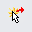 or right-click on the object and select Interaction from the pop-up menu.
- The dialog shown in Figure 82 is displayed. Select the interaction type and the parameters (if applicable). Click OK to close the dialog.
To remove an interaction from a graphic object, follow steps 1–3 above, taking care to select No action as the interaction type at step 2.
The possible actions and their parameters are described in Table 2.
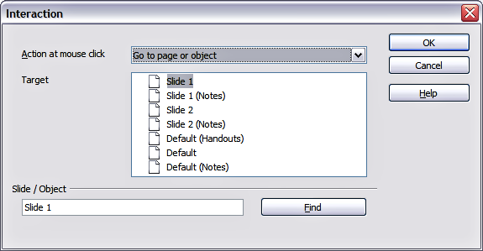
Figure 82: dialog to set the interaction with a graphic object
Table 2: Interactions and their parameters
Interaction type | Parameters
Go to Previous slide | No parameters.
Go to Next slide | No parameters.
Go to First slide | No parameters.
Go to Last slide | No parameters.
Go to Page or Object | Specify the target from the list in the Target box. You can search for a specific target in the Document box at the bottom of the screen.
Go to Document | Select the document in the Document box. Use the Browse button to open a file picker dialog. If the document to be opened is in Open Document Presentation format, the target list will be populated, allowing the selection of the specific target in the document.
Play sound | Select the file containing the sound to be played. Use the Browse button to open a file picker dialog.
Run program | Select the program to execute. Use the Browse button to locate it.
Run Macro | Select a macro that will run during the presentation. Use the Browse button to open the macro browser dialog.
Exit presentation | When the mouse is clicked over the graphic object, the presentation will terminate.

Animating Images
An animated image consists of a sequence of images (frames) that are displayed in succession. Each frame may contain one or multiple drawing objects. To start creating a custom animated image, open the Animation dialog from Insert > Animated Image (Figure 83).
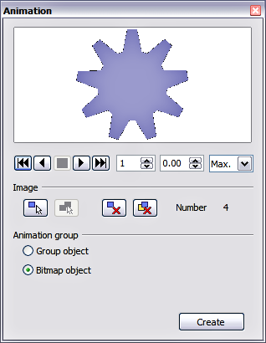
Figure 83: The Animation dialog

Creating an Animation
Several mechanisms can be used to create an animated image. This chapter describes only two of them, which should be sufficient to understand the functions offered.

Frame-by-Frame Animation
- Create the image you intend to animate using the drawing tools.shown in Figure 18
- Select the image and click the Apply Object button. This copies the object (or objects) into the upper part of the Animation dialog.
- Apply some desired transformation to the object: for example, rotate it or change the color; if you are animating text, add or subtract a letter, and so on.
- When you are ready, create the second frame of the animation and click the Apply Object button again.
- Repeat steps 3 and 4 until you have created all the desired frames of the animation.
- Select Bitmap object in the Animation group section of the Animator dialog. This allows you to customize the timing of each frame and the number of repetitions for the animation (set the value to Max to obtain an infinite loop).
- Click Create to place the animated image on the slide.
Note | If the image to be copied in the Animator consists of several objects, you can choose to treat each object as a separate frame. In this case, click the Apply objects individually button . Remember that each object will be centered in the animation.

Animated Image in One Step
For some simple animations, it is possible to create all the animation frames in advance and place them on the slide. This method works well for a rotating line, a shape gradually changing color, or shapes increasing or decreasing in size. In most cases, it is convenient to use the Edit > Duplicate command.
When all the frames are already prepared, use the Apply objects individually to create one frame for each object.
It is easy to obtain, for example, a rotating line segment:
- Draw a fairly thick horizontal segment (use Format > Line or the Line and Filling toolbar to add thickness).
- Open the Duplicate dialog by selecting Edit > Duplicate and set the number of copies to 5, the X and Y axis to 0.1, the angle to 30, the enlargement width and height to 0, and press the OK button.
- Select the 6 segments created by Impress and open the Animator (Insert > Animated image from the main menu bar).
- In the Animator dialog, click Apply objects individually.
- Select Bitmap object in the lower part of the dialog,
- Create a new empty slide to contain your animation, then click the Create button.

Other functions of the Animator
You can review the animation at any time by clicking the Play button as well as navigate the various frames using the other controls available.
If you are not satisfied with a particular frame, you can remove it. To do so:
- Navigate to the frame by using the Image Number box with the spin buttons (just to the right of the play controls).
- Click the Delete current image button .
You can also delete the entire animation by clicking the Delete all images button .
Tip | If you want to work on the animation frames a bit more, you can copy them into the Impress work area by selecting Group object and then clicking Create.
Tip | Since all the objects are centered in the animation window, to animate an object off the center of the image, create a blank rectangle of the same size of the final image and select it along with the object to be animated. Make sure that Group object is selected before clicking the Apply object button.

Using Fontwork
Use Fontwork to obtain special text effects. For more about this topic, see Chapter 11 (Graphics, the Gallery, and Fontwork) in the Getting Started guide.
To start using Fontwork:
- Open the Fontwork Gallery by clicking the  icon on the Drawing toolbar (see Figure 68) or on the Fontwork toolbar (see Figure 86). If the Drawing toolbar is not showing, you can go directly to the Fontwork toolbar by selecting View > Toolbars > Fontwork from the main menu bar.
- Select the preferred style from the Fontwork Gallery (Figure 84) and click OK. You can modify it later, so pick one that provides an effect similar to the desired one. The text Fontwork in the selected style appears on the slide.
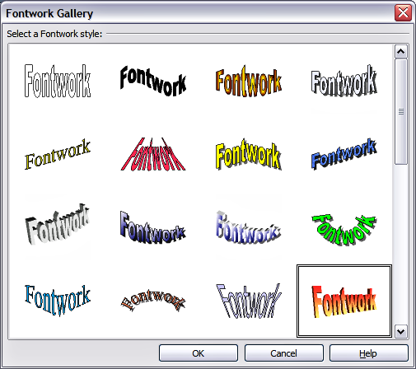
Figure 84: The Fontwork gallery
- Double-click the object to edit the Fontwork text. Type your own text in place of the black Fontwork that appears over the object (Figure 85).
- Press the Esc key or click outside the area with the green resizing handles to exit.
Now that the Fontwork object is created, you can edit some of its attributes. To do this, you can use the Fontwork toolbar or other options as described in the next section.
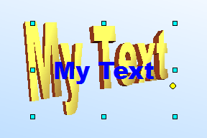
Figure 85. Editing Fontwork text

Using the Fontwork Toolbar
Make sure that the Fontwork toolbar, shown in Figure 86, is visible in the workspace. If not, select View > Toolbars > Fontwork from the main menu bar.
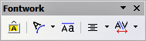
Figure 86: The Fontwork toolbar
In addition to the Fontwork Gallery icon, this toolbar contains the following icons:
Fontwork shape: to change the shape of the selected object, choose a shape from the extended toolbar.
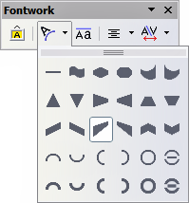
 Fontwork Same Letter Heights: Changes the height of characters in the way shown in Figure 87. Toggles between normal height (some characters taller than others, for example, capital letters, d, h, l, and others) and all letters the same height.

Figure 87. Left: normal letters; right: same letter heights
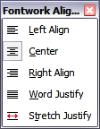
Fontwork Alignment: Specify the alignment of the text within the frame from the choices available. The effects of the text alignment can only be appreciated if the text spans over two or more lines. In the Stretch Justify mode, all the lines are filled completely.

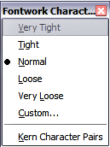
 Fontwork Character Spacing: select the desired spacing and whether kerning pairs should be used. For custom spacing, input a percentage value: 100% is normal spacing; less than 100% is tight spacing; more than 100% is expanded spacing.

Modifying Fontwork Text as a Shape
It is possible to treat Fontwork text as a shape and therefore apply to it all the formatting that has been described in this chapter. Assign line properties only to Fontwork, which does not have a 3D effect; otherwise, the changes will not be visible.
Tip | Change the Fontwork color quickly using the Area fill color swatch on the Line and Filling toolbar.
You can modify some of the Fontwork shapes just as you modify the angles of Trapezoids and Parallelograms by moving the yellow dot displayed along with the green resizing handles.

Chapter 6
Formatting Graphic Objects

Formatting Objects
This chapter describes how to format graphic objects created with available drawing tools.
The format of each graphic object, in addition to its size, rotation, and position on the slide, is determined by several attributes that define the line, text, and area fill of each object. These attributes, among others, also contribute to a graphics style. Although this chapter concentrates on the manual formatting of objects, it also shows how to create, apply, modify, and delete graphics styles. If your presentation requires a consistent appearance for its graphic objects, applying graphics styles can save time and prevent errors.

Formatting Lines
In OpenOffice, the term line refers to both a freestanding segment and the outer edge of a shape. In most cases, the properties of the line you can modify are its style (solid, dashed, invisible, and so on), its width, and its color. All these options can be applied with a few clicks of the mouse. Select the line you need to format and then use the controls on the Properties deck of the Sidebar, like that shown in Figure 88, or the Line and Filling toolbar to select your desired options.
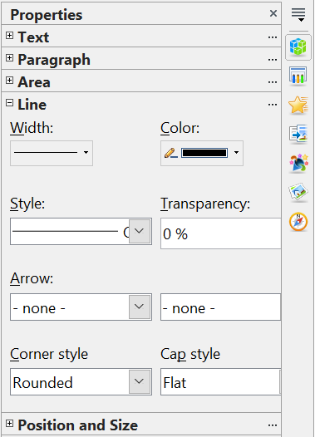
Figure 88: (Top) The Line pane of the Sidebar's Properties deck
(Bottom) Line and Filling toolbar with common line options highlighted
If you need to fine-tune the appearance of a line, choose Format > Line from the menu bar, or the More Options button at the top right of the Line pane of the Sidebar, or right-click on the line and select Line from the pop-up menu, or select the Line icon from the Line and Filling toolbar. These methods open the Line dialog shown in Figure 89, where you can set all the properties of the line at once.
The dialog consists of four tabs: Line, Shadow, Line Styles, and Arrow Styles.

General Line Settings
From the Line tab, you can set the basic parameters of the line. This tab is subdivided into four parts:
The Line Properties section (on the left side) is the most important. It includes the following parameters:
- Line style: A variety of line styles is available in the drop-down list, but more can be defined if needed.
- Color: Choose among the predefined colors or refer to “Adding Custom Colors” on page 126 to create a new one.
- Width: specifies the thickness of the line.
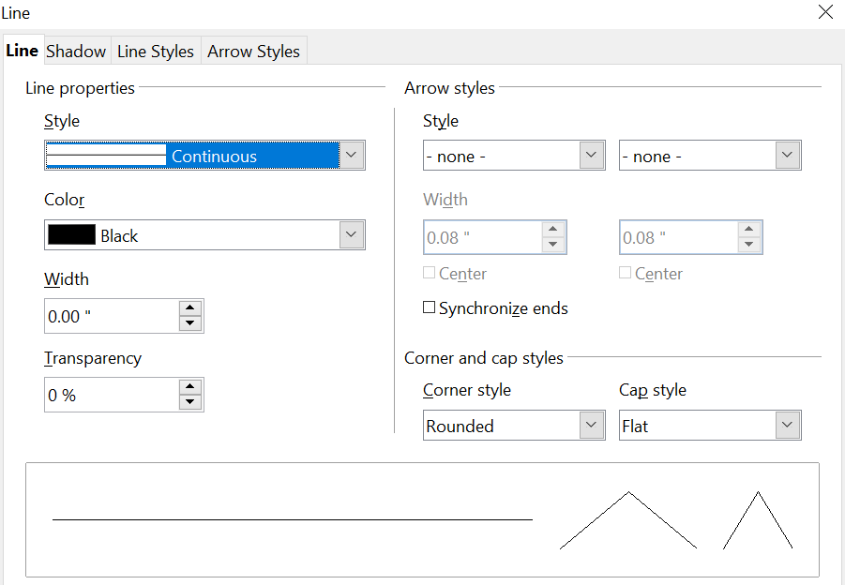

Figure 89: Main line formatting dialog
- Transparency: sets the transparency value of the line, a useful property when you don't want to completely hide the background. Figure 90 illustrates the effects on a line of different degrees of transparency.

Figure 90: The vertical lines have different levels of transparency (0%, 25%, and 50%).
The Arrow styles section of this tab is only applicable to line segments. It has no effect on the line that forms the border of a shape or of a polygon. Use this section to set the styles of the two ends of the segment. You can configure the two ends independently, selecting for each of them the arrow shape (Style drop-down menu), the Width, and the termination style (Center option). Selecting the Center option moves the center of the arrowheads to the end point of the line. Figure 91 shows the effects of selecting this option. To make the two ends identical, select the Synchronize ends option. To create new arrowheads, use the Arrow styles tab, as described in the following section.
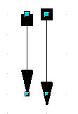
Figure 91: Default arrowheads (left) vs centered arrowheads (right)
The Corner style and Cap style sections of this tab determine how the connection between two segments and the line ends should look. There are four available options in the Corner style drop-down menu and three options in the Cap style drop-down. To appreciate the difference between styles, choose a thick line style and observe how the preview changes.
The bottom part of the tab previews the applied style for a single line and two different corners so that the corner and cap style choices can be quickly evaluated.
A faster way to set the arrowheads for a selected line is to click on the Arrow drop-down in the Sidebar or the Arrow Style icon in the Line and Filling toolbar (Figure 88). This opens the Arrowheads menu shown in Figure 92, where you can choose one of the many predefined arrowhead styles for the start and termination of the selected segment.

Figure 92: Arrowheads menu

Creating Line Styles
Use the Line Styles tab, like that in Figure 93, to create new line styles and load previously saved line styles. Normally, it is not a good practice to modify the predefined styles. Instead, create new ones when necessary.
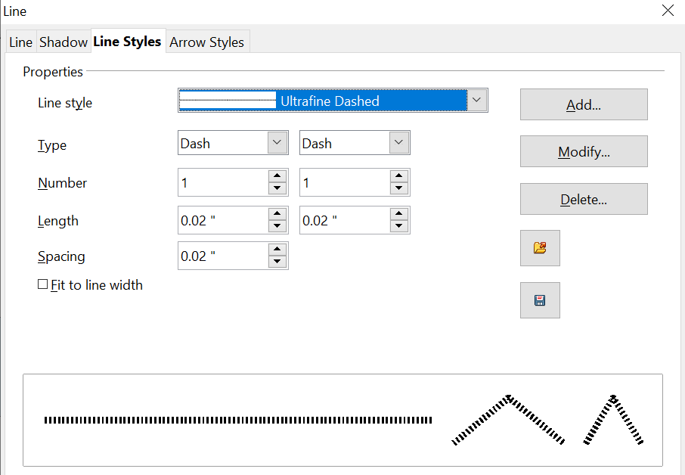

Figure 93: Advanced options for creating line styles
To create a new line style:
- Choose Format > Line from the menu bar.
- Click on the Line Styles tab.
- Select from the Line style drop-down menu a style similar to the desired one.
- Click Add. On the pop-up dialog, type a name for the new line style and click OK.
- Now define the new style. Start by selecting the line type for the new style. To alternate two line types (for example, dashes and dots) within a single line, select different types in the two Type boxes.
- Specify the number and length (not available for dot style) of each of the types of line selected, set the spacing between the various elements, and decide if the style should fit to the line width (length).
The new line style is available only in the current document. If you want to reuse the line style in other presentations, click the Save Line Styles icon and type a descriptive name. This saves all of the line styles in this presentation. (Saved styles have a file extension of .sod.)
To make previously saved line styles available in the current presentation, click the Load Line Styles icon, select the saved list of styles, and click Open.
Use the Modify button to change the name of the style.

Creating Arrow Styles
Use the fourth tab of the Line dialog to create new arrow styles, such as the ones in the figure below, to modify existing arrow styles, or load previously saved arrow styles.

- First, draw a curve with the shape you want for the arrowhead.
Note | The arrowhead must be a curve. A curve is something you could draw without lifting a pencil. For example, is a curve but is not a curve. You can however draw shapes which are not curves and then at the end convert them to a curve.
The top part of the shape will point in the direction of the line. In Figure 94 the corner at the top of the shape will point towards the “outside” of the line.

Figure 94: To create your own arrowhead, first draw a curve.
- Select the curve. With the resizing handles showing, select Format > Line from the menu bar, or right-click and choose Line from the pop-up menu.
- Go to the Arrow styles tab (Figure 95), click the Add button, type a name for the new arrow style, and click OK.
- You can now access the new style from the Arrow style list. When you select the name of the new style, it is shown at the bottom of the dialog.

Line Shadow
Use the Shadow tab of the Line dialog to add and format the line shadow. The settings on this tab are the same as those for shadows applied to other objects and are described in “Formatting Shadows” on page 133.
A faster way to apply a shadow to the line is using the last button of the Line and Filling toolbar of Figure 88. The main disadvantage of using the toolbar button is that the shadow appearance will be constrained by the shadow settings of the default graphics style.
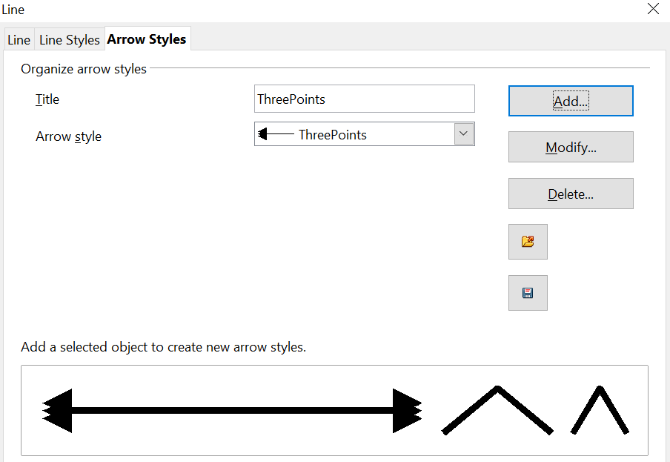
Figure 95: Advanced options for creating arrow styles

Formatting the Fill Area
The term area fill refers to the inside of an object, which can be a uniform color, a gradient, a hatching pattern, or an image. An area fill, such as that shown in Figure 96, can be made partly or wholly transparent and can throw a shadow.

Figure 96: Different types of area fill
The Line and Filling toolbar (Figure 97) has the majority of the tools normally used to format graphic objects. If this toolbar is not showing, choose View > Toolbars > Line and Filling from the menu bar. You can also use the Area dialog, described on page 124.
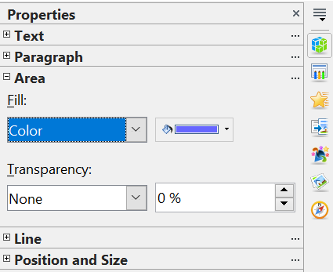
Figure 97: Common fill options on the Area pane of the Sidebar (top) and the Line and Filling toolbar (bottom)
To format the area of an object, select it so that the green resizing handles show. A wide number of default fillings are readily available from the Line and Filling toolbar. First, select the type of fill from the pull-down menu to the right of the paint can icon. If you want no fill at all, select None.
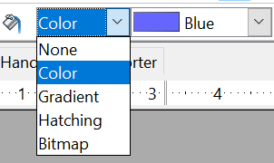
Once you have decided on a predefined or custom fill, you can further refine it by adding a shadow or transparency.

Uniform Color
Select the object you wish to edit. On the Sidebar or the Line and Filling toolbar, select Color from the pull-down list, and then choose a color from the drop-down menu, like that in Figure 98.
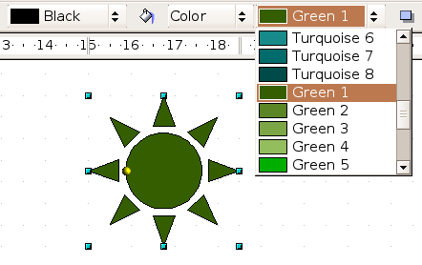
Figure 98: Filling with a color

Fill with a Gradient
A gradient fill provides a smooth transition from one color to another. The transition pattern may vary from a simple linear transition to a more complex radial transition.
Select the object you wish to edit. On the Sidebar or Line and Filling toolbar, select Gradient and then choose a gradient from the drop-down menu, like that in Figure 99.
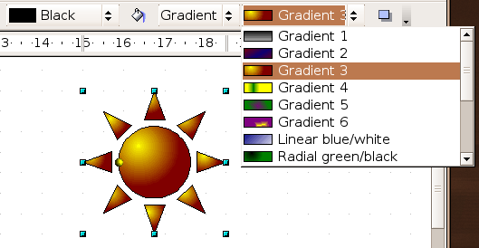
Figure 99: Filling with a gradient

Fill with a Line Pattern (Hatching)
Select the object you wish to edit. On the Sidebar or Line and Filling toolbar, select Hatching. Then choose a hatching fill, like that shown in Figure 100, from the drop-down menu. A hatching fill is applied throughout the area.
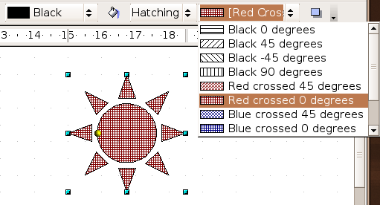
Figure 100: Filling with a line pattern

Fill with an Image
You can fill an object only with a bitmap image, that is, a binary digit map that functions as a digital image file format. Bitmaps represent a graphic using pixels, each pixel having its own color and collectively forming the image. No vector graphic image, such as an image created using mathematical formulas to represent the image, can be used here. Select the object you wish to edit. On the Sidebar or Line and Filling toolbar, select Bitmap, as shown in Figure 101, and then choose a bitmap fill from the drop-down menu.
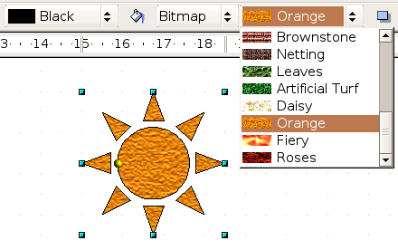
Figure 101: Filling with an image

Using the Area Dialog
In addition to using the Line and Filling toolbar, you can use the Area dialog to apply existing fills and create your own. To open it, choose Format > Area from the menu bar, or click the three dots at the top right corner of the Area pane of the Sidebar, or click on the paint bucket icon on the Line and Filling toolbar, or right-click on the object and select Area, like that in Figure 102.
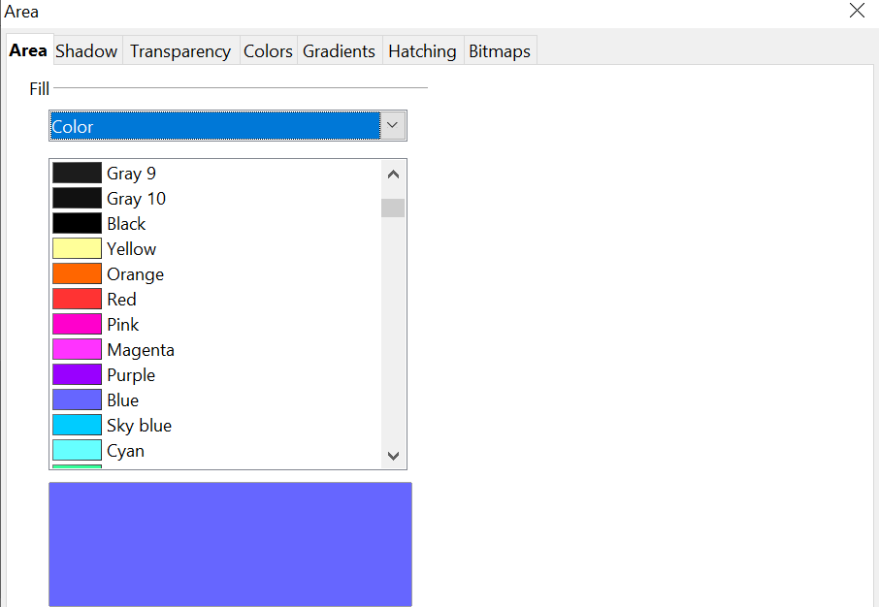

Figure 102: Area tab of the area formatting dialog
Use the Area tab to apply predefined fills, both those supplied with OpenOffice and those you create yourself. Use the Colors, Gradients, Hatching, and Bitmaps tabs to define new fills, as described in “Creating New Area Fills” on page 126. The Transparency tab is discussed on page 134. To make the object cast a shadow, see page 133.
To apply an area fill, first select the required fill type from the top-left drop-down list. The tab changes to show the list of predefined options for that fill type in the middle section.
When using the Area tab of the Area dialog, additional options may become available after selecting the fill type and one of the available fill options.
- For gradient fills, you can override the number of steps (increments) that should be applied to the transition from one color to the other. To do so, select Gradient on the Area tab and deselect the Automatic option under Increments. Then enter the number of steps required in the box to the right.
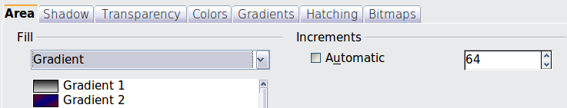
- For hatching, you can apply a different background color by selecting the Background color option and choosing a color from the drop-down list.
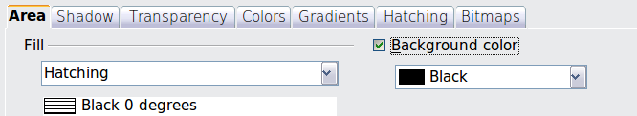
- For bitmaps, you can customize a large number of parameters. Refer to “Working with Bitmap Fills” on page 130 for additional information.

Creating New Area Fills
The following sections describe how to create new fills and how to apply them.
Although you can change the characteristics of an existing fill and then click the Modify button, it is recommended that you create new fills or modify custom fills rather than the predefined ones. Pre-defined fills may be reset when updating OpenOffice.

Adding Custom Colors
On the Colors tab, shown in Figure 103, you can modify existing colors or create your own.
You can specify a new color either as a combination of the three primary colors, Red, Green, and Blue (RGB notation) or by the percentage of Cyan, Magenta, Yellow, and Black (CMYK notation).
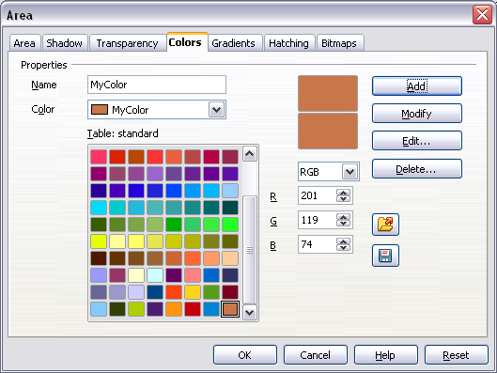
Figure 103: A custom color has been added to the list
To create a new color:
- Enter the name for the color in the Name box.
- Select whether to define the color in RGB or CMYK. For RGB, specify the Red, Green, and Blue components on a 0 to 255 scale. For CMYK, specify the Cyan, Magenta, Yellow, and Black (K) components, from 0% to 100%.
- Click the Add button. The color is now added to the list on the Area tab.
To modify a color:
- Select the color to modify from the list.
- Enter the new values that define the color (if necessary, change the settings between RGB and CMYK).
- Modify the name as required.
- Click the Modify button.
Alternatively, use the Edit button (this will open a new dialog), modify the color components as required, and click OK to exit the dialog.
Use the Load and Save buttons in the dialog to use a different color palette or to save your own custom colors.
Tip | You can also add custom colors using Tools > Options > OpenOffice > Colors. This method makes the color available to all components of OpenOffice, whereas colors created using the Area dialog are only available for Impress.

Creating Gradients
To create a new gradient or to modify an existing one, select the Gradients tab shown in Figure 104 from the Area dialog. Several types of gradients are predefined, and in most cases, changing the From and To colors will be sufficient to obtain the desired result.
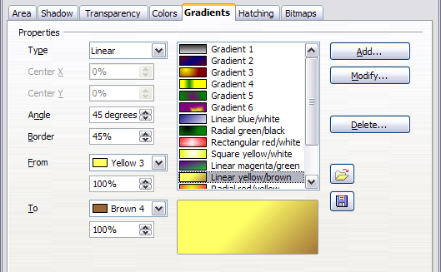
Figure 104: The Gradients tab of the Area dialog
It is highly recommended that you create a new gradient even if you just want to change two colors. Predefined colors should be used only as starting points.
To create a new gradient:
- First, choose the From and To colors with the tool shown in Figure 105.
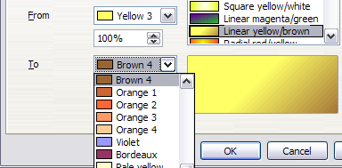
Figure 105: Gradient transition color selection
- Then choose a type of gradient from the list: Linear, Axial, Radial, Ellipsoid, Square, or Rectangular, as is illustrated in Figure 106.
A preview of the gradient type is shown under the available gradients list in the middle of the dialog. Figure 104 shows an example.
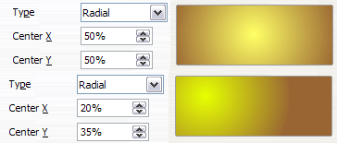
Figure 106: Center option in a radial gradient
- Depending on the chosen type, some options will be grayed out. Set all the properties as desired (very often, the default values will work well). The properties to set to create a gradient are summarized in Table 3.
- Click the Add button to add the newly created gradient to the list.
Tip | The newly created gradients remain available to all OpenOffice components and also for future presentations. It pays to give them descriptive names.
Table 3: Gradient properties
Property | Meaning
Center X | For Radial, Ellipsoid, Square, and Rectangular gradients, modify these values to set the horizontal offset of the gradient center.
Center Y | For Radial, Ellipsoid, Square, and Rectangular gradients, modify these values to set the vertical offset of the gradient center.
Angle | For all the gradient types, specifies the angle of the gradient axis.
Border | Increase this value to make the gradient start further away from the border of the shape.
From | The start color for the gradient. In the edit box below, enter the intensity of the color: 0% corresponds to black, 100% to the full color.
To | The end color for the gradient. In the edit box below, enter the intensity of the color: 0% corresponds to black, 100% to the full color.

Creating Hatching Patterns
You can create new hatching patterns or modify existing ones. Start by selecting the Hatching tab of the Area dialog, shown in Figure 107.
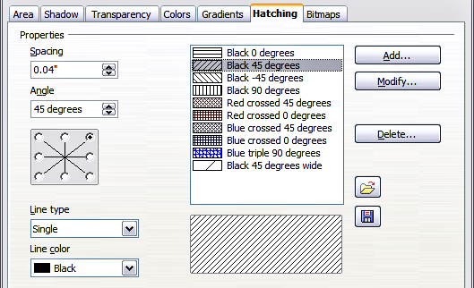
Figure 107: The Hatching tab of the Area fill dialog
As with gradients and colors, it is better to create a new pattern than to modify a predefined one.
To do so:
- Select a pattern similar to the one that will be created as a starting point.
- Modify the properties of the lines forming the pattern. A preview is displayed in the window below the available patterns.
- Click the Add button and choose a name for the newly created hatching.
The properties that can be set for a hatching pattern are shown in Table 4.
Table 4: Properties of hatching patterns
Property | Meaning
Spacing | Determines the spacing between two lines of the pattern. As the value is changed, the preview window is updated.
Angle | Use the mini map below the numerical value to quickly set the angle formed by the line to multiples of 45 degrees. If the required angle is not a multiple of 45 degrees, enter the desired value in the edit box.
Line type | Set single, double, or triple line for the style of the pattern.
Line color | Use the list to select the color of the lines that will form the pattern.

Working with Bitmap Fills
On the Area tab, choose Bitmap from the drop-down list. Select the bitmap to be used to fill the area from the list. Note that any imported bitmaps will become available in the list.
Set the size, position, and offset parameters (as applicable) on the right side of the tab, and then click OK to close the dialog.
As Figure 108 shows, there are several parameters to be configured when using a bitmap fill. These are described in Table 5.
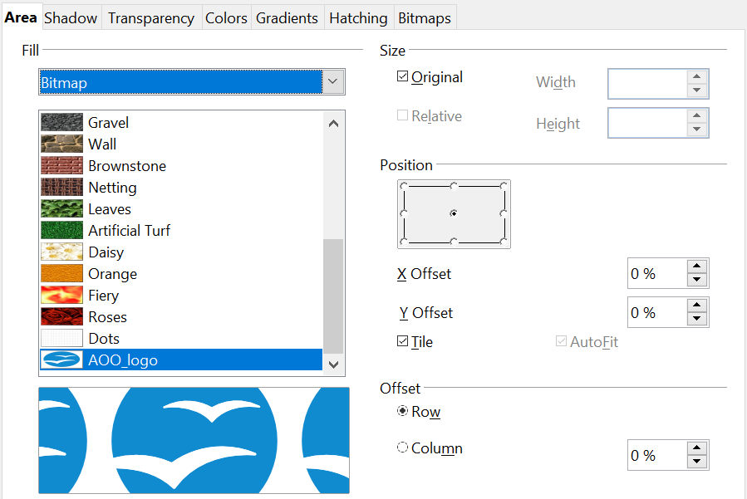

Figure 108: Advanced formatting for bitmap fill
Table 5: Bitmap fill properties
Property | Meaning
Size – Original | Select this box to retain the original size of the bitmap.
Size – Relative | To rescale the object, deselect the Original option and select this one. The Width and Height edit boxes are enabled.
Size – Width | When Relative is selected, 100% means that the bitmap's original width will be resized to occupy the whole fill area width, 50% means that the bitmap's width will be half that of the fill area.
Size – Height | When Relative is selected, 100% means that the bitmap's original height will be resized to occupy the whole fill area height, 50% means that the bitmap's height will be half that of the fill area.
Position – Anchor Map | Select from the map the place within the area to which the bitmap should be anchored.
Position – Tile | When this option is selected, the bitmap will be tiled to fill the area. The size of the bitmap used for the tiling is determined by the Size settings.
Position – X offset | When Tile is enabled, enter in this box the offset for the width of the bitmap in percentage values. 50% offset means that Impress will place the middle part of the bitmap at the anchor point and start tiling from there.
Position – Y offset | This will have a similar effect to the X offset, but will work on the height of the bitmap.
Position – Autofit | Stretches the bitmap to fill the whole area. Selecting this option disables all the size settings.
Offset – Row | If Tile is enabled, it offsets the rows of tiled bitmaps by the percentage entered in the box so that two subsequent rows are not aligned.
Offset – Column | If Tile is enabled, it offsets the columns of tiled bitmaps by the percentage entered in the box so that two subsequent columns of bitmaps are not aligned.
The best way to acquire an understanding of these parameters is to use them. Figure 109 shows some examples of bitmap fills and the parameters used.

Figure 109: Examples of bitmap fill
Original image
Tiled
25% width & height
Anchor top left
Tiled
25% width & height
Anchor center
Column offset 30%
Tiled
35% width, 35% height
Anchor top left

Creating and Importing Bitmaps
You can add (import) new bitmap fills or create your own pattern on an 8x8 grid, using the Bitmaps tab of the Area dialog.
To create a bitmap fill:
- Start with the Blank bitmap type at the top of the list to activate the Pattern editor, as shown in Figure 110.
- Select the Foreground and Background colors. The square in the Pattern editor will fill with the chosen color.
- Start creating the pattern by clicking the squares (pixels) with the left mouse button that you want to be painted in the background color. Check the preview window to see if the desired effect is achieved.
- When done, click Add to save the pattern.
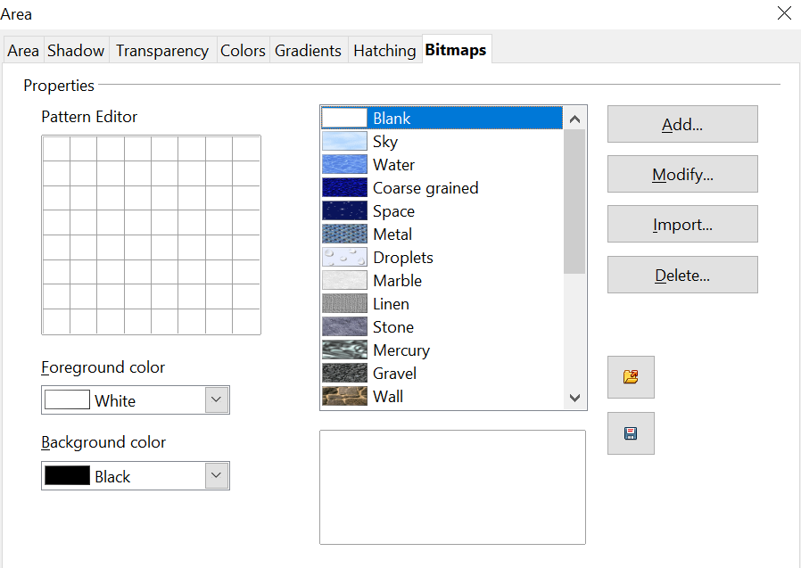

Figure 110: The Bitmaps tab of the Area fill dialog.
To import a bitmap created in Draw or another program:
- Click the Import button.
- A file picker dialog is displayed. Browse to the directory containing the bitmap file, select it, and then click Open.
- Type a name for the imported bitmap and click OK.
Note | Bitmaps generally have an extension .bmp or .png. To create a bitmap image with Draw, select File > Export, choose PNG from the pull-down list of file formats, give the file a name, and save it.

Formatting Shadows
Shadowing can be applied to both lines and areas. To apply a shadow to an area, first select the object to which shadowing should be applied, then select Format > Area.
Shadows can also be applied to lines. One way is to click the Shadow icon 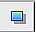 on the Line and Filling toolbar (the last tool on the right-hand end). Alternatively, you can apply a style to the line that uses a shadow (see “Working with Graphics Styles” on page 140 for additional information on using styles).
Using the first method, you cannot customize the shadow; it is applied according to the default settings. The second method offers the opportunity to configure the shadow properties.
The dialog to customize a shadow is shown in Figure 111.
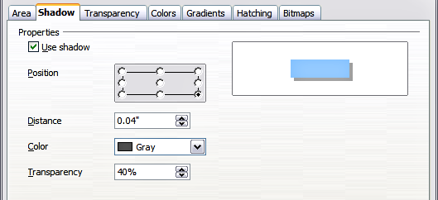
Figure 111: Dialog for customizing the shadowing of graphic objects
When the Use shadow option is selected, the following parameters can be set:
- Position: The selected point in the mini-map determines the direction in which the shadow is cast.
- Distance: determines the distance between the object and the shadow.
- Color: sets the color of the shadow.
- Transparency: determines the amount of transparency for the shadow.
Tip | When the transparency value is set above 0%, the shadow does not completely hide the objects below. This produces a pleasant visual effect, as shown in Figure 112.
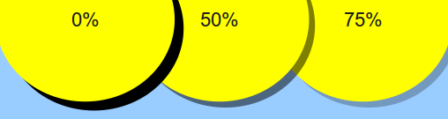
Figure 112: Shadows with different levels of transparency

Transparency Formatting
Transparency is also applicable to lines, areas, and shadows. To apply transparency to lines, refer to “Formatting Lines” on page 116; for shadows, refer to “Formatting Shadows” above.
To apply transparency to areas, select Format > Area and then go to the Transparency tab, as shown in Figure 113.
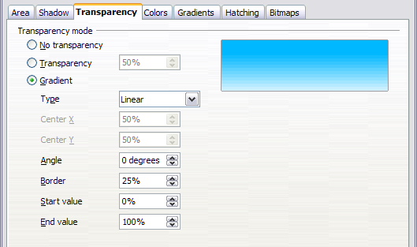
Figure 113: Setting the object transparency
The two types of transparency are uniform transparency and gradient transparency. To obtain uniform transparency, select Transparency and then select the percentage of transparency required. For a gradient transparency (so that the area becomes gradually transparent), select Gradient and then set the parameters of the gradient. Refer to Table 5 on page 130 for a description of most of the settings. In the Transparency tab, specify the Start value and the End value for the transparency gradient. 0% is fully opaque, 100% means fully transparent.
An example of gradient transparency is shown in Figure 114.
For more information on gradient transparency, including an example of combining a color gradient with gradient transparency, refer to “Advanced Gradient Controls” on page 136.
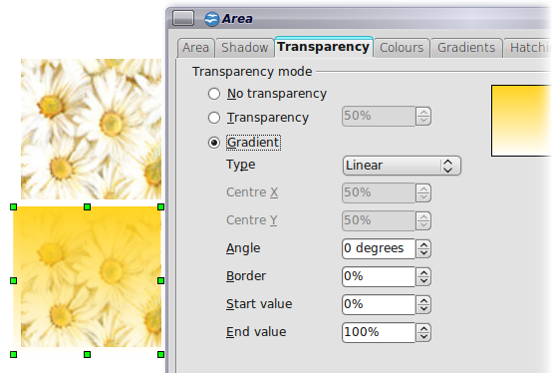
Figure 114: Example of gradient transparency

Advanced Gradient Controls
As discussed in “Creating Gradients” on page 127 and “Transparency Formatting” on page 134, gradient properties can be configured using the parameters in Table 5 on page 130.
Impress also provides a graphical interface for modifying the gradient parameters using only the mouse. To use these tools, click on the Transparency icon or the Gradient icon in the Mode toolbar shown in Figure 115.
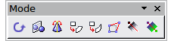
Figure 115: The Mode toolbar
When an object with a gradient fill is selected, click on the Gradient icon to display a dashed line connecting two squares colored as the “From” color and the “To” color of the gradient, as shown in Figure 116 and Figure 117 below.
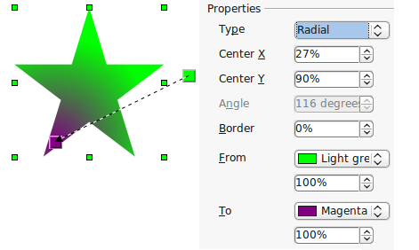
Figure 116: Green to magenta gradient
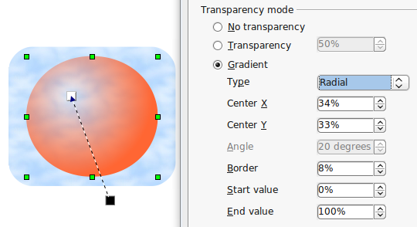
Figure 117: Transparency gradient (note how the background becomes visible close to the white square)
For linear gradients, move the square corresponding to the From color to change where the gradient starts (that is, the Border property). Move the square corresponding to the To color to change the orientation (Angle property).
For axial gradients, you can move only the To color to change both the angle and the border properties of the gradient.
For radial gradients, move the From color to modify the border property (that is, how “wide” the gradient circle is). Move the To color to change the point where the gradient ends (Center X and Center Y values).
For ellipsoid gradients, move the From color to modify the border property (the size of the gradient ellipsoid). Move the To color to change the angle of the ellipsoid axis and the axis itself.
For square and rectangular gradients, move the From color to modify the border (the size of the gradient square or rectangle) and the angle of the gradient shape. Move the To color to change the center of the gradient.
The same actions can be performed for transparency gradients, with the difference that the two squares activated by the Transparency icon represent the fully opaque point (black square) and the fully transparent point (white square).
These icons are grayed out by default and are only activated when an object with gradient filling, gradient transparency, or both is selected.
In both cases, a dashed line connecting two small squares appears on top of the object. Click outside the object to set the gradient.
Note | Moving the squares will have different effects depending on the type of gradient. For example, for a linear gradient, the start and end squares of the gradient will always be situated to either side of the center point of the object.

Formatting Text
Impress provides two dialog boxes related to text formatting: Format > Character and Format > Text.
To modify formatting such as font and font effects, select the text in the shape and then go to Format > Character. For more information, see Chapter 3 (Adding and Formatting Text). This section covers the formatting of the overall shape of text, which is added to a line or a shape.
To add text to an object (a shape or a line):
- Select the object to which text will be added.
- With the green resizing handles showing, double-click on the object and wait for the cursor to become an I-beam, or just start typing.
- Type the text. When finished, click somewhere outside the object or press Esc.
To format the text in a shape:
- Select the object to which text was added.
- Select Format > Text or right-click on the shape and select Text from the pop-up menu. The Text dialog is displayed.
The top section of the Text tab, shown in Figure 118, offers several options in the form of checkboxes. Some of the options will be grayed out, depending on the object to which the text will be attached.
- Select Fit width to text to expand the width of the shape or line if the text is too long for it.
- Select Word wrap text in shape to start a new line automatically when the edge of the shape is reached.
- Select Fit height to text to expand the object height whenever it is smaller than the text (set by default for lines).
- Select Resize shape to fit text to expand a custom shape when the text inserted in the shape is too large.
- Select Fit to frame to expand the text so that it fills all the available space.
- Select Adjust to contour to make the text follow a curved line.
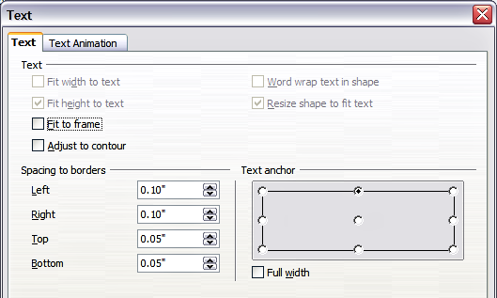
Figure 118: Main dialog to set the text properties
In the Spacing to borders section, specify the amount of space to be left between the border of the shape or line and the text. This is similar to the settings for indentation and spacing for paragraphs.
The text anchor grid in the bottom right corner of the dialog is used to decide where to anchor the text. The Full width option determines if the anchoring should be applied to the full width of the shape.

Text Animation
Use the Text Animation tab to add special effects to the text. Choose between the four options on the list and, when applicable, the direction of the effect by picking one of the four arrow buttons to the right. The available effects are:
- Blink: the text will blink on the screen.
- Scroll through: the text will move into the shape and then out, following the chosen direction.
- Scroll back and forth: the text will move first in the chosen direction but will bounce back at the shape border.
- Scroll in: the text will scroll in towards the given direction, starting from the edge of the shape and stopping in the center.
The default is no animation.
The other properties that can be set are:
- Start inside option: when set, the animation will start from inside the shape.
- Text visible when editing option: Set this box to see the text while editing.
- Animation cycles: includes three further options to set the frequency of the animation, the increments between two positions of the animation, and finally, the delay before the animation starts.
To see some of the animations in action, you need to start the presentation. Press F9 or select Slide Show > Slide Show from the main menu. To return to the edit mode, press Esc.

Formatting Connectors
Connectors are lines that join two shapes. Connectors always start from a glue point on the shape. Refer to Chapter 5 (Creating Graphic Objects) for a description of the usage of connectors.
Connector properties can be accessed and modified in two ways:
- Manual formatting: right-click on the connector line and select Connector in the pop-up menu.
- Style-based formatting: select one of the available graphics styles or create a new one.
Both methods open the Connector dialog, like that in Figure 119, where you can set the style of the connectors. Choose between Standard (the default), Line, Straight, and Curved connector. Whenever multiple connectors overlap, use the Line skew section of the dialog to distance the lines. It is possible to customize the distance between 4 different lines.
In the Line spacing section of the dialog, set the horizontal and vertical space between the connector and the object at each end of the connector.
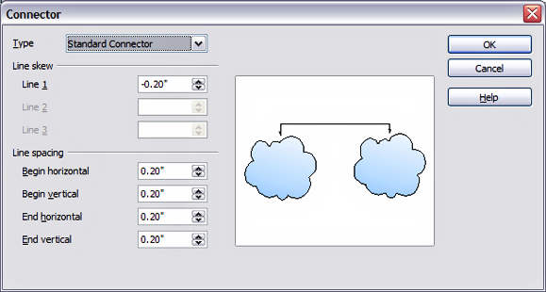Figure 119: Setting up the connector properties

Working with Graphics Styles
To achieve consistency in the style across the slides of a presentation (or a portfolio of presentatios), or simply to apply the same formatting to a large number of objects, the best approach is to use graphics styles.
Graphics styles are the equivalent of paragraph styles for graphic objects. A graphics style groups all the formatting attributes that a graphic object can have and associates them with a name, making them quickly reusable. If a style is modified (for example, by changing the area transparency), the changes are automatically applied to all graphics using that style.
If you use Impress frequently, a library of well-defined graphics styles is an invaluable tool for speeding up the process of formatting your work according to your taste or any style guidelines you may need to follow (company colors, fonts, and so on).
Use the Styles and Formatting window to access styles you will need often. If the window is not visible, select its icon on the Sidebar, or press F11, or click the Styles and Formatting icon at the left-hand end of the formatting bar, or select Format > Styles and Formatting from the menu bar. If you use the windows outside of the Sidebar, press F11 again when the dialog is no longer needed to maximize the workspace area.

Linked Graphic Styles
Graphic styles support inheritance; that is, a style can be linked to another (parent) style so that it inherits all the formatting settings of the parent. You can use this property to create “families” of styles.
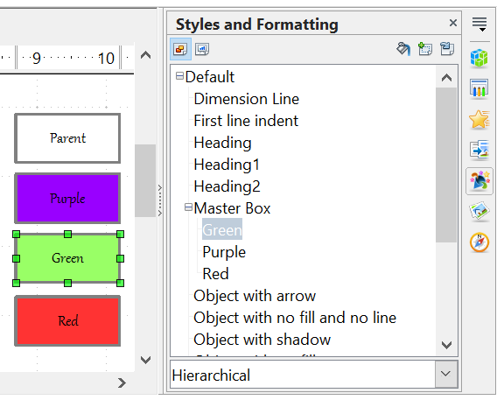

For example, if you need multiple boxes that differ in color but are otherwise identically formatted, the best way to proceed is to define a generic style for the box, including borders, area fill, font, and so on, and a number of hierarchically dependent styles that differ only in the fill color attribute. If you need to change the font size or the border thickness later, it is sufficient to change the parent style. All the other styles (sometimes called children) will change accordingly.

Creating Graphics Styles
You can create a new graphics style in two ways:
- Using the Style dialog
- From a selection

Creating a New Graphic Style Using the Style Dialog
Choose the Graphics Styles icon at the top of the Styles and Formatting window.
To link a new style with an existing style, as illustrated in Figure 120, first select that style, and then right-click and choose New. Otherwise, select Default, then right-click and choose New.
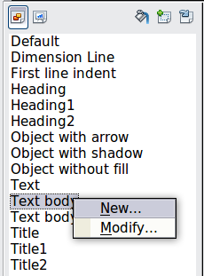
Figure 120: Linking a new style with an existing style
As discussed in the preceding section, when styles are linked, changing a property of the parent style will change it in all the linked styles. Sometimes this is exactly what you want; at other times, you do not want the changes to apply to all the linked styles. It pays to plan ahead.
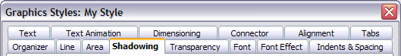
Figure 121: Top of dialog to create a new graphics style
The Graphics style dialog shown in Figure 121 consists of 14 tabs (15 if Asian language support has been enabled), which may be grouped as follows:
- The Organizer tab contains a summary of the style and its hierarchical position.
- The Font, Font Effects, Indents & Spacing, Alignment, Tabs, and Asian typography tabs set the properties of the text inserted in a text box or in a graphic object.
- The Dimensioning tab is used to set the style of dimension lines.
- The Text, Text animation, Connector, Line, Area, Shadowing, and Transparency tabs determine the formatting of a graphic object and are discussed elsewhere in this chapter.
Note | In most cases, you will not need to configure the parameters of every tab. For example, to create a simple line style, you might use only 3 of the 15 tabs.

Creating a New Graphics Style from a Selection
You can create a new style from manually formatted text or graphics:
- Select the item you want to save as a style. If the selected object is already styled, then the new style will be linked to such style.
- In the Styles and Formatting window, click the New Style from Selection icon, highlighted in Figure 122.
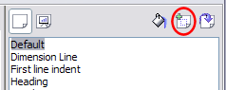
Figure 122: New style from selection
- In the Create Style dialog, like that in Figure 123, type a name for the new style. The list shows the names of existing custom styles of the selected type. Click OK to save the new style.

Figure 123: Naming a new style created from a selection

Modifying a Graphics Style
To change an existing style, right-click on it in the Styles and Formatting window and choose Modify from the pop-up menu.
The dialog for modifying a graphic style is the same as the one for creating a new graphic style.
Make the required changes to the style and then click OK to save them.

Updating a Graphic Style from a Selection
To update a style from a selection:
- Select an item that has the format you want to adopt as a style.
- In the Styles and Formatting window, select the style you want to update, and then click the Update Style icon shown in Figure 124.
Figure 124. Updating a style from a selection
Tip | Any changes you make to a style are effective only in the document on which you are working. The changes do not go into any associated template. If you want the changes to apply to more than one document, you need to change the template (see Chapter 2).

Applying Graphics Styles
You can apply a graphics style in two ways, both of which start from the Styles and Formatting window. First, make sure that the graphic styles are shown, then do one of the following:
- Select the object to which you want to apply a graphic style and double-click on the name of the style you want to apply.
- Click the Fill Format mode icon and then click on the name of the style you want to apply. When you move your cursor over the workspace, the mouse pointer changes to this icon. Position the moving icon on the graphic object to be styled and click the mouse button. This mode remains active until you turn it off, so you can apply the same style to several objects. To quit Fill Format mode, click the Fill Format mode icon again. When Fill Format mode is active, a right-click anywhere in the document undoes the last Fill Format action. Be careful not to accidentally right-click and thus undo actions you want to keep.
Tip | At the bottom of the Styles and Formatting window is a drop-down list. You can choose to show all styles or groups of styles such as applied styles or (in the case of graphics styles) custom styles.

Deleting Graphics Styles
You cannot delete any of the predefined styles, even if you are not using them.
You can delete any user-defined (custom) styles, but before doing so, you should make sure the styles are not in use. If an unwanted style is in use, replace it with a substitute style.
To delete unwanted styles, right-click on them (one at a time) in the Styles and Formatting window and click Delete on the pop-up menu. Click Yes in the message box that pops up.

Assigning Styles to Shortcut Keys
AOO provides a set of predefined keyboard shortcuts that allow you to apply styles while typing in a document quickly. You can redefine these shortcuts or define your own, as described in Appendix A (Keyboard Shortcuts).

Chapter 7
Including Spreadsheets, Charts, and Other Objects

Using Spreadsheets in Impress
A spreadsheet embedded in Impress includes most of the functionality of a spreadsheet in Calc, and is therefore capable of performing complex calculations and data analysis. However, if you plan to use complex data or formulas, you are better off performing the necessary operations in a separate Calc spreadsheet and using Impress only to display the embedded spreadsheet and its results.
You may also be tempted to use spreadsheets in Impress for creating complex tables or presenting data in a tabular format. However, the Table Design feature (described in Chapter 3) is often more suitable and faster.
To include spreadsheet cells in an Impress slide, you can either insert an existing file or insert a new table.

Inserting a Spreadsheet from a File
When you insert an existing spreadsheet into your slide, subsequent changes that are made to the original spreadsheet file do not affect your slide. You can, however, make changes to the spreadsheet within your slide.
- Go to the slide where you want to insert the spreadsheet.
- Choose Insert > Object > OLE Object from the menu bar.
- On the Insert OLE Object dialog box (Figure 125), choose Create from file. The dialog box changes to show a File field. Click Search.
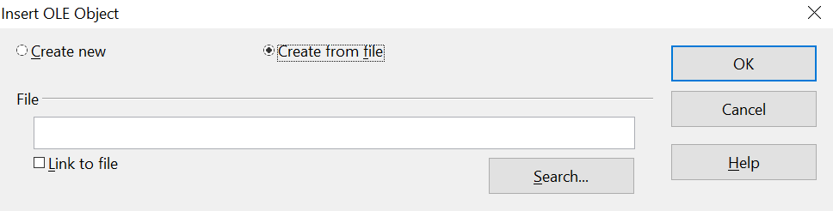

Figure 125: Inserting a spreadsheet file
- On the Open dialog box, locate the file you want to insert, and then click OK.
- Choose the Link to file option if you wish to insert the file as a live link.
The entire spreadsheet is inserted into your slide. To show a different sheet in the spreadsheet, double-click the spreadsheet and then select a different sheet.

Inserting a Blank Spreadsheet
To add a blank spreadsheet to a slide:
- Go to the slide where you want to insert the spreadsheet.
- Choose Insert > Object > OLE Object from the menu bar.
- On the Insert OLE Object dialog box (Figure 126), choose Create new and OpenOffice 4.1 Spreadsheet, then click OK.
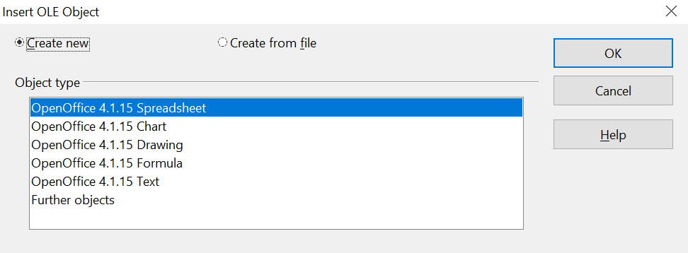

Figure 126: Inserting a blank spreadsheet
This inserts a blank spreadsheet in the center of a slide, as shown in Figure 127. The spreadsheet is in edit mode, so you can insert data and modify the formatting. See “Entering Data” on page 149 and “Formatting Spreadsheet Cells” on page 150.
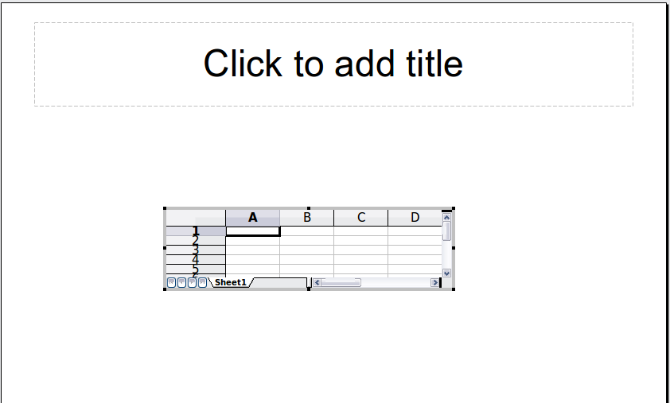
Figure 127: A spreadsheet in edit mode. Note the active cell and the small black resizing handles on the gray border

Editing a Spreadsheet
When editing a spreadsheet, some of the contents of the menu bar and the Formatting toolbar (see Figure 128) change to show entries and tools that support working with spreadsheets.
One of the most important changes is the presence of the Formula bar, just below the Formatting toolbar. From left to right, the Formula bar contains:
- The active cell reference or the name of the selected range
- The Formula Wizard button
- The Sum and Formula buttons or the Cancel and Accept buttons (depending on the contents of the cell)
- A long formula bar that allows you to enter or review the contents of a cell
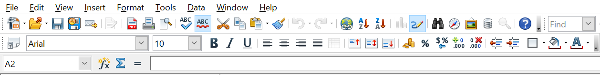

Figure 128: The menu bar and the formatting toolbar in spreadsheet editing mode
Main Menu
Standard
Toolbar
Formatting
Toolbar
Formula
Bar
If you are familiar with Calc, you will immediately recognize the tools and the menu items Impress offers; they are much the same as those in Calc.

Resizing and Moving a Spreadsheet
When resizing or moving a spreadsheet, ignore the row and column names (easily recognizable by their light gray background) and the horizontal and vertical scroll bars. They are only used for editing purposes and will not be included in the visible area of the spreadsheet on the slide.
To resize the area occupied by the spreadsheet:
- Double-click to enter edit mode, if it is not already active. Notice the black handles found in the gray border surrounding the spreadsheet (see Figure 127).
- Move the mouse over one of the handles. The cursor changes shape to give a visual representation of the effects applied to the area.
- Click and hold the left mouse button and drag the handle. The corner handles move the two adjacent sides simultaneously, while the handles at the midpoint of the sides modify one dimension at a time.
You can move the spreadsheet, that is, change its position within the slide, whether in edit mode or not. In either mode:
- Move the mouse over the border until the cursor changes to a four-headed arrow.
- Click and hold the left mouse button and drag the spreadsheet to the desired position.
- Release the mouse button.
When selected, the spreadsheet object is treated like any other object. Therefore, resizing it changes the scale rather than the spreadsheet area. This is not recommended because it may distort the fonts and picture shapes.

Navigating the Spreadsheet

How a Spreadsheet is Organized
Ordinarily, a spreadsheet consists of multiple tables called sheets, which in turn contain cells. However, in Impress, only one of these tables can be shown at a time on a slide.
The default for a spreadsheet embedded in Impress is one single table called Sheet 1. The name of the table is shown at the bottom of the spreadsheet area (see Figure 127).
If required, you can add other sheets. To do that:
- Right-click on the bottom area near the existing tab.
- Select Insert > Sheet from the pop-up menu.
Just as in Calc, you can rename a sheet or move it to a different position using the same pop-up menu or the Insert menu on the main menu bar.
Note | Even if you have many sheets in your embedded spreadsheet, only one sheet—the one that is active when leaving the spreadsheet edit mode—is shown on the slide.
Each sheet is further organized into cells. Cells are the elementary units of the spreadsheet. They are identified by a row number (shown on the left side on a gray background) and a column letter (shown in the top row also on a gray background). For example, the top left cell is identified as A1, meaning it's the cell in column A in the first row, row 1. This would make the cell in the third column, second row, C2. All data elements, whether text, numbers, or formulas, are entered into a cell.

Moving the Cursor to a Cell
To move around the spreadsheet and select an active cell, you can:
- use the arrow keys.
- left-click with the mouse on the desired cell.
- use the combinations Enter and Shift+Enter to move one cell down or one cell up, respectively; Tab key and Shift+Tab key to move one cell to the right or to the left, respectively.
Other keyboard shortcuts are available to quickly move to certain cells in the spreadsheet. Refer to Chapter 5 (Getting Started with Calc) in the Getting Started guide for further information.

Entering Data
Keyboard input is received by the active cell, identified by a thick black border (see Figure 127, where cell A1 is active). The cell reference, given as column/row coordinates, is also shown on the left end of the formula bar.
To insert data, first select the cell to make it active, and then start typing. Note that the input is also added to the main part of the formula bar, where it may be easier to read.
Impress will try to automatically recognize the type of content (text, number, date, time, and so on) in a cell and apply default formatting to it. Note how the formula bar icons change according to the type of input, displaying Accept and Reject buttons () whenever the input is not a formula. Use the green Accept button to confirm the input made in a cell or select a different cell. In case Impress wrongly recognizes the type of input, you can change it using Format > Cells in the main menu bar.
Tip | Sometimes it is useful to treat numbers as text (for example, telephone numbers) and to prevent Impress from removing the leading zeros or right-aligning them in a cell. To force Impress to treat input as text, type a single apostrophe before entering the number.

Formatting Spreadsheet Cells
Often, for the purposes of a presentation, it may be necessary to increase the size of the font considerably or to match it to the style used in the presentation.
The fastest and most flexible way to format an embedded spreadsheet is to use styles. When working on an embedded spreadsheet, you can access the cell styles created in Calc and use them. However, a better approach is to create specific cell styles for presentation spreadsheets, as Calc cell styles may not be suitable when used in Impress.
To apply a style to a cell or group of cells simultaneously (or manually format their cell attributes), first select the range to which the changes will apply. A range consists of one or more cells, normally forming a rectangular area. A selected range consisting of more than one cell can be recognized easily because all its cells are shaded. To select a multiple-cell range:
- Click on the first cell belonging to the range (either the left top cell or the right bottom cell of the rectangular area).
- Keep the left mouse button pressed and move the mouse to the opposite corner of the rectangular area, which will form the selected range.
- Release the mouse button.
To add further cells to the selection, hold down the Control key and repeat steps 1 to 3 above.
Tip | You can also click on the first cell in the range, hold down the Shift key, and click in the cell in the opposite corner. Refer to Chapter 5 (Getting Started with Calc) in the Getting Started book for further information on selecting ranges of cells.
Some shortcuts are very useful to speed up selection and are listed below:
- To select the whole visible sheet, click on the blank cell between the row and column indexes, or press Control+A.
- To select a column, click on the column index at the top of the spreadsheet.
- To select a row, click on the row index on the left side of the spreadsheet.
Once the range is selected, you can modify the formatting, such as font size, alignment (including vertical alignment), font color, number formats, borders, background, and so on. To access these settings, choose Format > Cells from the main menu bar (or right-click and choose Format Cells from the pop-up menu). This command opens the dialog box shown in Figure 129.
If the text does not fit the width of the cell, you can increase the width by hovering the mouse over the line separating two columns until the mouse cursor changes to a double-headed arrow; then click the left button and drag the separating line to the new position. A similar procedure can be used to modify the height of a cell (or group of cells).
To insert rows and columns in a spreadsheet, use the Insert menu or right-click on the row and column headers and select the appropriate option from the pop-up menu. To merge multiple cells, select the cells to be merged and select Format > Merge cells from the main menu bar. To split a group of merged cells, select the group and deselect Format > Merge Cells.
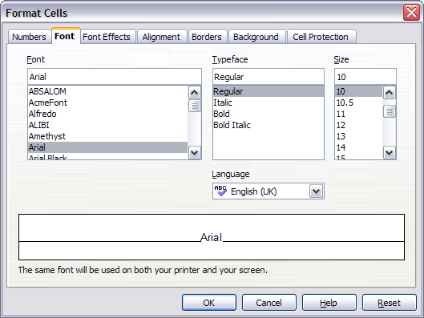
Figure 129: The Format Cells dialog box consists of 7 tabs (8 if you have Asian language support enabled)
When you are satisfied with the formatting and the appearance of the table, exit edit mode by clicking outside the spreadsheet area. Note that Impress will display exactly the section of the spreadsheet that was on the screen before leaving edit mode. This allows you to hide additional data from view, but it may cause the apparent loss of rows and columns. Therefore, ensure that the desired part of the spreadsheet is showing on the screen before leaving edit mode.
Tip | To get back into edit mode, right-click and select Edit.

Inserting a Chart
The use of charts is described in detail in Chapter 3 (Creating Charts and Graphs) of the Calc Guide.
To add a chart to a slide:
- Select the Insert Chart icon on the slide layout (see Figure 130) or use Insert > Chart, or click the Insert Chart icon on the Standard toolbar.
- A full-sized chart appears, containing arbitrary sample data (see Figure 131).
- To enter your own data in the chart, see “Entering Chart Data” on page 155.
Figure 130: Slide with a placeholder for inserting objects
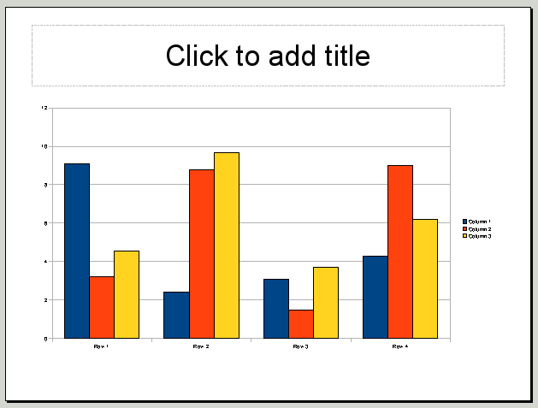
Figure 131: Chart made with sample data

Choosing a Chart Type
Your data can be presented using a variety of different charts; choose a chart type that best suits the message you want to convey to your audience (see “Chart Types” on page 153).
To choose a chart type:
- Double-click the sample chart. The window changes; the side panes are gone, and the main toolbar shows tools specific to charts. The chart itself now has a gray border. (If the main toolbar is not showing, select View > Toolbars > Main Toolbar.)
- Click the Chart Type icon or select Format > Chart Type, or right-click on the chart and choose Chart Type. The Chart Type dialog box appears as shown below in Figure 132.
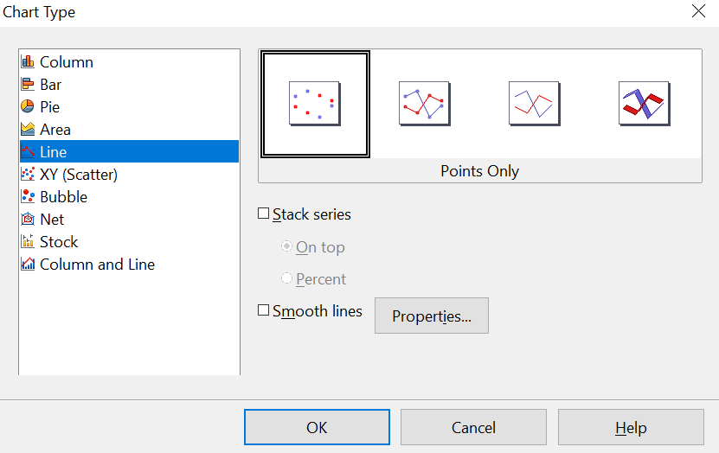

Figure 132: Chart Type dialog box showing two-dimensional charts
- As you change selections in the list on the left, the chart examples on the right, and the chart in the main window, also change. If you move the Chart Type dialog box to one side, you can see the full effect in the main window.
- As you change chart types, other selections become available on the right-hand side. For example, some chart types have both three-dimensional and two-dimensional variants; 3D charts have further choices of shape for the columns or bars.
- Choose the chart characteristics you want, and then click OK. The Chart Type dialog box closes, and you return to the edit window.
You can now continue to format the chart, add data to it, or click outside the chart to return to normal view.

Chart Types
The following summary of the chart types available will help you choose a type suitable for your data. For more details, see Chapter 3 (Creating Charts and Graphs) in the Calc Guide.
Column charts
Column charts are commonly used for data that shows trends over time. They are best for charts that have a relatively small number of data points; extended time series are better represented by a line chart.
Bar charts
Bar charts are excellent for giving an immediate visual impact for data comparison when time elapsed is not important, such as comparing the popularity of a few products in a specific marketplace.
Pie charts
Pie charts are excellent for comparing proportions, for example, departmental spending comparisons: what the department spent on different items, or what different departments spent. They work best with smaller numbers of values, about half a dozen; more than this, and the visual impact begins to fade.
This is one of the charts that can be made into a 3D chart. It can then be tilted, given shadows, and generally turned into a work of art. You can choose to explode the pie chart, but this is an all-or-nothing option, giving you no control over the degree of separation of the segments.
Area charts
An area chart is a version of a line or column graph. It may be useful where you wish to emphasize the volume of change. Area charts have a greater visual impact than line charts, but the data you use will make a difference. You may need to include transparency values in an area chart.
Line charts
A line chart shows a progression where the x-axis is labeled with categories. It is ideal for raw data and useful for charts with plentiful data showing trends or changes over time, where you want to emphasize continuity. For example, you can show results for consecutive months, and the data points will be evenly spaced, despite the number of days in each month varying between 28 and 31. 3D lines confuse the viewer, so using a thicker line often works better.
Scatter or XY charts
Scatter charts are great for visualizing data where both axes have numeric values: for example, weather data, reactions under different acidity levels, conditions at altitude, or any data that matches two numeric series. The x-axis usually plots the independent variable or control parameter, often a time series.
Bubble charts
A bubble chart is used to represent three variables: two identify the position of the center of a bubble on a Cartesian graph, while the third indicates the radius of the bubble. You might plot an average value on the y-axis and a time value on the x-axis, while the size of the bubble can represent the number of measurements used in each average.
Net charts
A net chart is similar to polar or radar graphs. They are useful for comparing data that are not time series, but show different circumstances, such as variables in a scientific experiment. The poles of the net chart are the y-axes of other charts. Generally, between three and eight axes are best; any more and this type of chart becomes confusing.
Stock charts
A stock chart is a specialized column graph specifically for stocks and shares. You can choose traditional lines, candlestick, and two-column charts. The data required for these charts is quite specialized, with series for opening price, closing price, and high and low prices. The x-axis represents a time series.
Column and line charts
A column and line chart is a combination of the two other chart types mentioned in its name. It is useful for combining two distinct but related data series, for example, sales over time (column) and the profit margin trends (line).

Entering Chart Data

Opening a Chart Data Window
- If the chart is not already in edit mode (with a gray border), double-click it. The main toolbar now shows tools specifically for charts. (If the main toolbar is not showing, select View > Toolbars > Standard.)
- Click the Chart Data icon or select View > Chart Data Table, or right-click on the chart and choose Chart Data Table. The Data Table dialog box appears (Figure 133).
Tip | If you drag the Data Table dialog box away so that your chart is visible, you can immediately see the results of each change after clicking in a different cell.
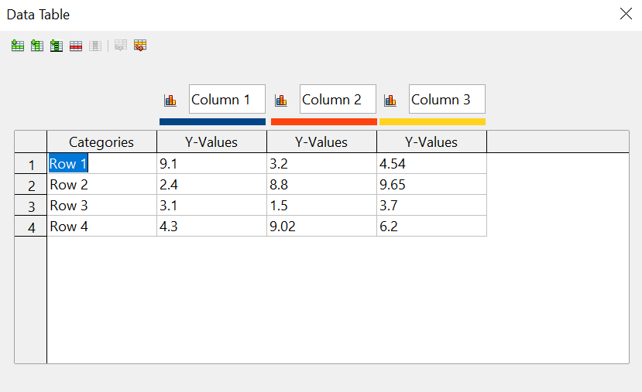
Figure 133: Data Table dialog box

Entering Data
Enter data in the Data Table dialog. Type or paste information into the areas indicated for the desired rows and columns.
You can use the buttons in the top left corner for large-scale editing:
- The two Insert buttons insert a row or column (series).
- The Delete buttons remove a selected row or column (series) with its data.
- The Move buttons move the contents of the selected column to the right, or the contents of the selected row down.

Adding or Removing Elements from a Chart
The default chart includes only two elements: the chart wall and the legend (also known as the key). You can add other elements using the Insert menu (Figure 134). The various choices open dialog boxes in which you can specify details.
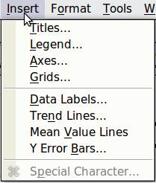
Figure 134: Chart Insert menu

Formatting the Chart
The Format menu (Figure 135) has many options for formatting and fine-tuning the look of your charts.
Double-click the chart so that it is enclosed by a gray border, indicating edit mode. Then, select the chart element that you want to format. Choose Format from the menu bar, or right-click to display a pop-up (context) menu relevant to the selected element.
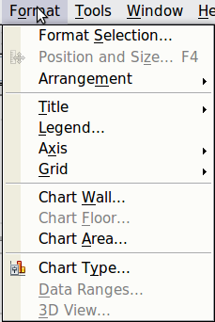
Figure 135: Chart format menu
The formatting choices are as follows.
- Format Selection opens a dialog in which you can specify the area fill, borders, transparency, characters, font effects, and position of the selected element of the chart.
- Position and Size opens the Position and Size dialog (see “Resizing and Moving the Chart”).
- Arrangement provides two choices: Bring Forward and Send Backward, of which only one can be active for specific items. Use these choices to arrange overlapping data series.
- Title formats the titles of the chart and its axes.
- Legend formats the location, borders, background, and type of the legend.
- Axis formats the lines that create the chart as well as the font of the text that appears on both the X and Y axes.
- Grid formats the lines that create a grid for the chart.
- Chart Wall, Chart Floor, and Chart Area are described in the following sections.
- Chart Type changes the type of chart displayed, and whether it is two- or three-dimensional.
- 3D View formats the various viewing angles of 3D charts.
Note | Chart Floor and 3D View are available only for a 3D chart. These options are unavailable (grayed out) if a 2D chart is selected.
A chart has two main areas: the chart wall and the chart area (Figure 136). These control different settings and attributes for the chart. Knowing the difference is helpful when formatting a chart.
- Chart wall contains the graphic of the chart displaying the data.
- Chart area is the area surrounding the chart graphic. The (optional) chart title and the legend (key) are in the chart area.
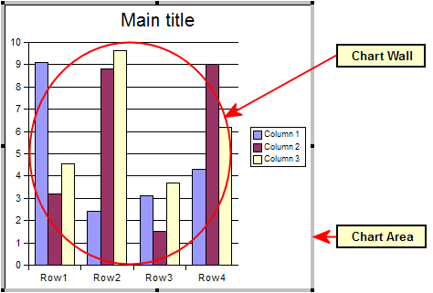Figure 136: The Chart wall and Chart area
Note | Format > Chart Floor is only available for 3D charts and has the same formatting options as Chart Area and Chart Wall.

Resizing and Moving the Chart
You can resize or move all elements of a chart at the same time, in two ways: interactively, or by using the Position and Size dialog. You may use a combination of both methods.
To resize a chart interactively:
- Click on the chart to select it. Green sizing handles appear around the chart.
- To increase or decrease the size of the chart, click and drag one of the corner handles. To maintain the correct aspect ratio, hold the Shift key down while you click and drag.
To move a chart interactively:
- Click on the chart to select it. Green sizing handles appear around the chart.
- Hover the mouse pointer anywhere over the chart other than on a handle. When it changes shape, click and drag the chart to its new location.
- Release the mouse button when the element is in the desired position.
To resize or move a chart using the Position and Size dialog:
- Click on the chart to select it. Green sizing handles appear around the chart.
- Choose Format > Position and Size from the menu bar, or right-click and choose Position and Size from the pop-up menu, or press F4. For more about the use of this dialog, see Chapter 6 (Formatting Graphic Objects).

Moving Chart Elements
You may want to move or resize individual elements of a chart, independent of other chart elements, such as moving the legend to a different location. Pie charts allow individual wedges of the pie to be moved (in addition to the choice of “exploding” the entire pie).
- Double-click the chart so a gray border encloses it.
- Click any of the elements—the title, the legend, or the chart graphic—to select it. Green resizing handles appear.
- Move the pointer over the selected element. When it changes shape, click and drag to move the element.
- Release the mouse button when the element is in the desired position.
Note | If your graphic is 3D, round red handles appear, which control the three-dimensional angle of the graphic. You cannot resize or reposition the graphic while the round red handles are showing. Shift + Click to return to the green resizing handles. You can now resize and reposition your 3D chart graphic. See the following tip.
Tip | You can resize the chart graphic using its green resizing handles (Shift + Click, then drag a corner handle to maintain the proportions). However, you cannot resize the title or the legend.

Changing the Chart Area Background
- The chart area is the area surrounding the chart graphic, including the (optional) main title and legend.
- Double-click the chart so that it is enclosed by a gray border.
- Select Format > Chart Area.
- In the Chart Area dialog shown in Figure 137, choose the desired format settings.
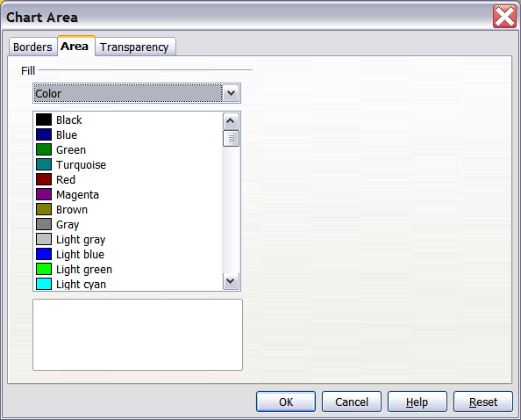Figure 137: Chart Area dialog box

Changing the Chart Graphic Background
The chart wall is the area that contains the chart graphic.
- Double-click the chart so a gray border encloses it.
- Select Format > Chart Wall. The Chart Wall window appears. It has the same formatting options as described in “Changing the Chart Area Background” above.
- Choose your settings and click OK.

Inserting Other Objects
Impress offers the capability of inserting various object types, such as music or video clips, Writer documents, Math formulas, generic OLE objects, and others, in a slide. A typical presentation may contain movie clips, sound clips, OLE objects, and formulas; other objects are less frequently used since they do not appear during a slide show.
This section covers the part of the Insert menu shown in Figure 138: Movie and Sound, and Object.
Note | OLE (Object Linking and Embedding) is a Microsoft technology that enables linking files and applications together. An OLE object is a combination of data and the application needed to modify that data.

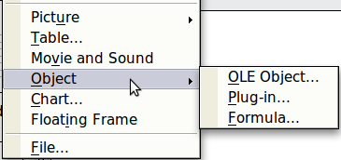
Figure 138: Part of the Insert menu

Movies and Sound
Note | On UNIX systems, the Media Player requires the Java Media Framework API (JMF). Download and install the JMF files, and add the path to the installed jmf.jar to the class path in Tools > Options > OpenOffice > Java.
To insert a movie clip or a sound into a presentation, select Insert > Movie and Sound. Select the media file to insert from the dialog to place the object on the slide.
To insert media clips directly from the Gallery:
- If it is not already open, open the Gallery by selecting Gallery deck of the Sidebar or Tools > Gallery.
- Browse to the Theme containing media files (for example, the Sounds theme).
- Click on the movie or sound to be inserted and drag it into the slide area.
The Media Playback toolbar (Figure 139) is automatically opened (by default, at the bottom of the screen, just above the Drawing toolbar; it can also be made to float). You can preview the media object and resize it. If the toolbar does not open, select View > Media Playback.
Figure 139: The media playback toolbar (movie clip)
The Media Playback toolbar contains the following tools:
- Add button: opens a dialog from which you can select the media file to be inserted.
- Play, Pause, Stop buttons: control the media playback.
- Repeat button: if pressed, the media will restart when finished.
- Playback slider: selects the position within the media clip.
- Timer: displays the current position of the media clip.
- Mute Button: when selected, the sound will be suppressed.
- Volume Slider: adjusts the volume of the media clip.
- Scaling drop-down menu: (only available for movies) allows scaling of the movie clip.
The movie will start playing as soon as the slide is shown during the presentation.
Note that Impress will only link the media clip, not embed it. Therefore, if the presentation is moved to a different computer, the link will be broken, and the media clip will not play. For an easy workaround that prevents this from happening:
- Place the media file to be included in the presentation in the same folder where the presentation is stored.
- Insert the media file in the presentation.
- Send both the presentation and the media file to the computer to be used for the presentation, and place both files in the same folder on that computer.
Impress offers the possibility to preview the media clips that are to be inserted using the embedded media player. To open it, select Tools > Media Player. The media player is shown in Figure 140. Its toolbar is the same as that of the Media Playback toolbar described above.
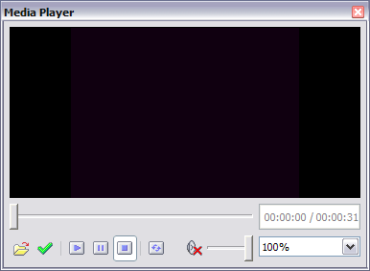
Figure 140: The embedded media player

OLE Objects
Use an OLE (Object Linking and Embedding) object to insert in a presentation either a new document or an existing one. Embedding inserts a copy of the object and details of the presumed source program into the target document; this is the program associated with the file type by the operating system. The major benefit of an OLE object is that editing it can be quick and easy: just double-click it. You can also insert a link to the object, which will appear as an icon rather than an area showing its contents.
To create and insert a new OLE object:
- Select Insert > Object > OLE object from the main menu. This opens the dialog shown in Figure 126 on page 147.
- Select Create new and select the object type among the available options.
- Click OK. An empty container is placed in the slide.
- Double-click on the OLE object to enter edit mode. The application devoted to handling that type of file will open the object.
Note | If the object inserted is handled by OpenOffice, the transition to the program to manipulate the object will be seamless. In other cases, the object opens in a new window, and an option in the File menu becomes available to update the object you inserted.
To insert an existing object:
- Select Insert > Object > OLE object from the main menu.
- In the Insert OLE Object dialog box, select Create from file. The dialog changes to look like Figure 125 on page 146.
- To insert the object as a link, select the Link to file option. Otherwise, the object will be embedded.
- Click Search, select the required file in the file window, then click Open. A section of the inserted file is shown on the slide.

Other OLE Objects
Under Windows, the Insert OLE Object dialog box has an extra entry, Further objects.
- Double-click on the entry Further objects to open the dialog box shown in Figure 141.
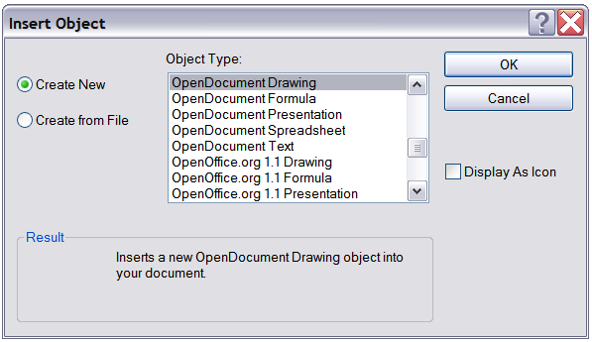
Figure 141: Advanced menu to insert an OLE object under Windows
- Select Create New to insert a new object of the type selected in the Object Type list, or select Create from File to create a new object from a file.
- If you choose Create from File, the dialog shown in Figure 142 opens. Click Browse and choose the file to insert. The inserted file object is editable by the Windows program that created it.
If you want to insert a link to an object instead of inserting an object, select the Display As Icon checkbox.
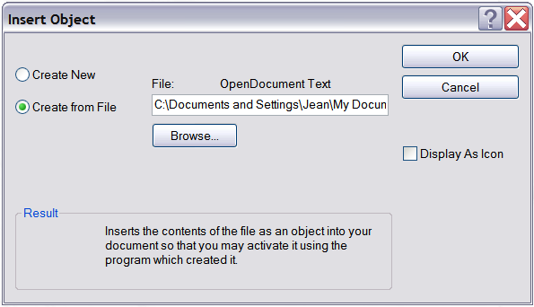
Figure 142: Insert object from a file

Formulas
Use Insert > Object > Formula to create a Math object in a slide. When editing a formula, the main menu changes to the Math main menu.
Care should be taken to ensure the font sizes used are compatible with the font size used in the rest of the slide. To change the font attributes of the Math object, select Format > Font Size from the main menu bar. To change the font type, select Format > Fonts from the main menu bar.
For additional information on how to create formulas, refer to Chapter 9 (Getting Started with Math) in the Getting Started guide or the Math Guide.
Note | Unlike formulas in Writer, a formula in Impress is treated as an object; therefore, it will not be automatically aligned with the rest of the text. However, the formula can be rearranged - like any other object, but not resized.

Inserting the Contents of a File
You can insert the contents of certain files into a presentation. The types of files accepted are OpenOffice Draw files, HTML files, or plain text files.
Select Insert > File from the main menu to open a file picker window. With an active internet connection, it is also possible to insert a URL in the file name field. Select the file and click Insert.

Chapter 8
Adding and Formatting Slides, Notes, and Handouts

Introduction
This chapter describes how to add new slides to your presentation and how to format them. It also explains how to format both Notes and Handouts. Notes are generally used as prompts or cues for the person giving the presentation. Handouts are normally used for providing a printout of slides to your audience.
Two pop-up menus are quite useful when performing the operations on slides that are described in this chapter. One menu (shown in Figure 143) is displayed by right-clicking on a slide in Normal view and then selecting Slide. The other menu appears by right-clicking on the slide thumbnail in the Slides pane, as shown in Figure 144.
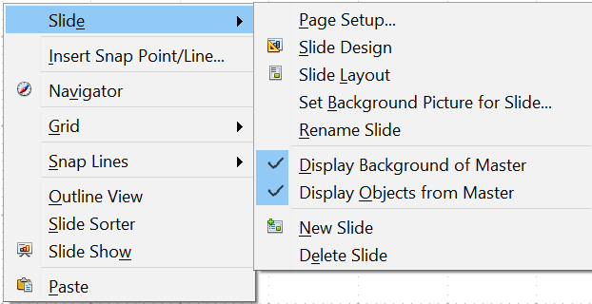

Figure 143: Slide pop-up submenu
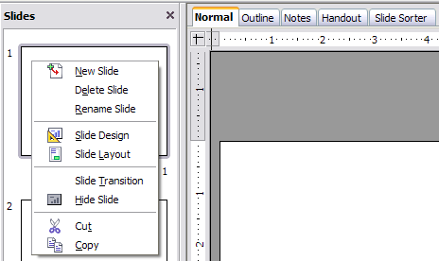
Figure 144: (Left) Pop-up menu on the Slides Pane

Adding, Renaming, and Removing Slides

Adding a New Slide
There are several equivalent ways to add a slide to a presentation:
- Select Insert > Slide (works in Normal, Outline, and Slide Sorter view).
- Right-click on the Slides pane and select New Slide from the pop-up menu (works in Normal, Outline, and Notes view).
- Right-click on the main work area while in Slide Sorter view and select New Slide from the pop-up menu.
- In the work area in Normal view, right-click on the active slide and select Slide > New Slide.
The new slide is inserted either after the current slide or at the position where the mouse was clicked.
If multiple slide masters are used in the presentation, the new slide will apply the master of the previous slide in the sequence.

Inserting a Slide from Another Presentation
You can insert slides from other presentations in three ways:
- Using Insert > File. With this method, you can optionally link the slides instead of copying (embedding) them into the presentation. For more information on the difference between linked and embedded files, see Chapter 4 (Adding and Formatting Pictures).
- Copying and pasting.
- Dragging and dropping to copy or move slides.
To insert a slide from another presentation:
- In Normal view, select the slide after which you want to insert the new slide, then choose Insert > File from the menu bar.
- In the file browser, locate the file containing the slide that you want to insert, and click Insert.
- In the Insert Slides/Objects dialog (Figure 145), click the plus sign next to the icon for the presentation file, and then select the slides that you want to insert.
Tip | Figure 145 highlights the importance of giving descriptive names to the slides in any presentation. Refer to “Renaming a Slide” on page 168 for the instructions on how to perform this operation.
- If desired, select the Link option.
- Click OK. The slides are inserted after the selected slide in the presentation.
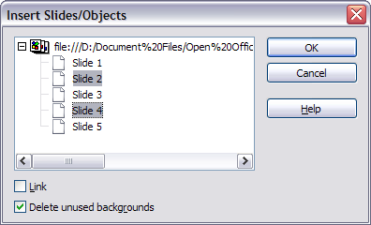
Figure 145: Inserting slides from another presentation
To copy and paste slides between presentations:
- Open the presentations you want to copy from or paste into.
- In the presentation containing the slides that you want to copy, choose View > Slide Sorter.
- Select the slides, and then choose Edit > Copy, or click the Copy button on the main toolbar, or press Control+C.
- Change to the presentation where you want to paste the slides, and then choose View > Normal.
- Select the slide that you want the copied slides to follow, and then choose Edit > Paste, or click the Paste button on the main toolbar, or press Control+V.
To move slides between presentations:
- Open both presentations. Arrange the windows so both presentations are visible. Choose View > Slide Sorter in each window.
- In the presentation containing the slides that you want to move, select the required slides. To move the slides, drag and drop them into the other presentation.
Tip | If you hold down the Control key while dragging and dropping, the slide gets copied in the target presentation, rather than simply being moved there.

Duplicating a Slide
Duplicating a slide is a convenient way to add slides, since the new slide will inherit formatting, layout, and animations from its forerunner. To duplicate a slide:
- Go to Normal view either by clicking on the tab in the work area or selecting View > Normal from the menu bar.
- Make sure that the slide to be duplicated is in the work area.
- Select Insert > Duplicate Slide from the menu bar.
The duplicated slide is inserted after the original slide and is displayed in the work area.
Tip | Duplicating a slide is a good way to prevent slides from having too much information crowded on them. Try duplicating the “busy” slide and splitting the points over two or more slides. All the formatting, backgrounds, and so on will be preserved.

Renaming a Slide
To rename a slide, do one of the following:
- Right-click on the slide thumbnail in the Slides pane or in the main area when in Slide Sorter view and select Rename Slide from the pop-up menu.
- In Normal view, right-click on the slide in the work area. Then select Slide > Rename Slide from the pop-up menu.
In the Rename Slide dialog, type a new name for the slide and then click OK.

Expanding a Slide
Sometimes you'll have a slide with so many sub-points that they can't fit in the space available. Instead of reducing font size or using other methods to squeeze more text into the space, it is usually better to subdivide the contents of the slide into two or more slides.
As mentioned in the Tip above, you can duplicate the slide and manually split the points. Another method would be to “expand” the contents of the slide. To do this:
- [optional] Duplicate the slide (in case it is needed later).
- Choose Insert > Expand Slide from the menu bar. Impress creates a new slide for each instance of the highest outline level. The outline text becomes the title of the new slide. Outline points below the top level on the original slide are moved up one level on the new slide.
- If required, repeat steps 2 and 3 on any slide where level 2 entries of the outline exist, to expand those as well.
Figure 146 shows a slide with an outline consisting of three high level points and two second-level points under bullet point 2. The Expand command has generated three slides, each having as a title the first-level outline and (if present) the second-level points in the text area.
Caution | For the Expand command to work, ensure that the slide layout contains only one text AutoLayout box. If the slide layout is not suitable for expansion, the menu item is grayed out.
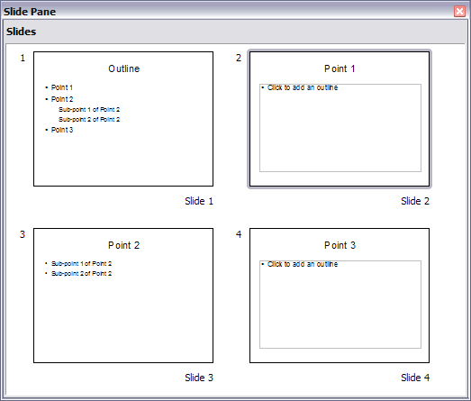Figure 146: Slide 1 is expanded in slides 2, 3 and 4

Creating a Summary Slide
It is also possible to “reverse” the Expand operation to create summaries. The Summary command is useful to create an agenda for a presentation.
- Select the slide that will be the first one to appear in the summary by clicking on it in the Slides Pane or in Slide Sorter view.
- Select Insert > Summary Slide. Impress creates a new slide at the end of the presentation where all the slide titles, from the selected one to the last, are written as bullet points in the body of the slide.
- Move this slide to wherever you want it to appear in the presentation.

Deleting a Slide
To delete a slide, use the most convenient of these methods:
- In Normal, Outline, or Slide Sorter view, select a slide and then click Edit > Delete Slide or press the Delete key.
- In the Slides Pane (not available in Slide Sorter view), select the slide to be deleted, right-click it, and select Delete Slide from the pop-up menu. Alternatively, select the slide and then press the Delete key.
- In Normal view, right-click on the work area, then select Slide > Delete Slide from the pop-up menu.
Tip | When working in the Slide sorter view (View > Slide sorter) it is possible to delete multiple slides simultaneously by selecting them with the mouse and pressing the Delete key.

Creating Slides from an Outline
When planning a presentation, it may be useful to develop an outline using AOO Writer. Once the outline is ready, you may want to create one or more separate slides for each of the top-level outline elements. You can do this in several ways:
- Sending the outline from Writer to Impress (creates a new presentation)
- Sending an AutoAbstract from Writer to Impress (creates a new presentation)
- Copying and pasting the outline from Writer to Impress

Sending an Outline from Writer to Impress
If a text document in Writer contains headings formatted with the default Heading paragraph styles, you can choose File > Send > Outline to Presentation to create a new presentation containing the headings as an outline.
The new presentation opens in Outline view, as shown in Figure 147.
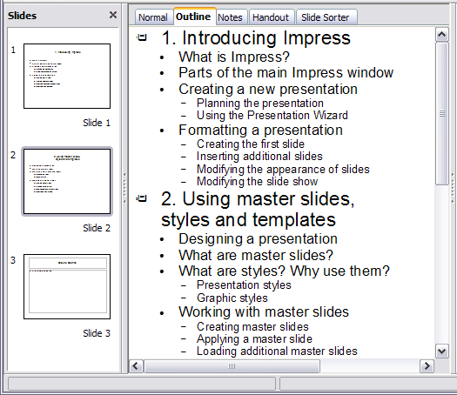Figure 147: Outline created from a Writer document
Click on the Normal tab to populate the slides in the Slides pane.
As shown in Figure 148, some outline levels may have too many points to fit on one slide. You can expand those slides as described in “Expanding a Slide” on page 168, or duplicate the slides and manually change their contents, as described in “Duplicating a Slide” on page 167.
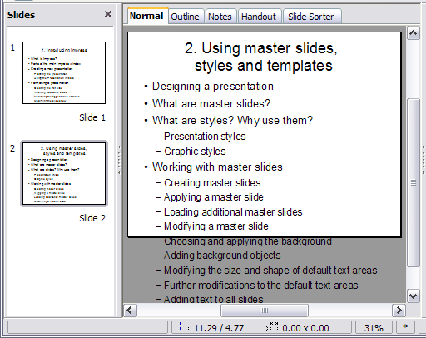
Figure 148: Slides created from an outline may have too many points to fit the space

Sending an AutoAbstract from Writer to Impress
To send an AutoAbstract from Writer to Impress, the text chosen must contain headings formatted with the default Heading paragraph styles. Then, you can use the AutoAbstract feature to copy the headings and a number of subsequent paragraphs to a new presentation, and you can specify the number of outline levels as well as the number of paragraphs displayed.
- Choose File > Send > AutoAbstract to Presentation.
- On the Create AutoAbstract dialog (Figure 149), choose the number of outline levels to be copied to the presentation. For example, if you choose 4 levels, all paragraphs formatted with Heading 1 to Heading 4 are included, along with the number of paragraphs specified in Subpoints per level.
- The new presentation opens in Outline view. Click on the Normal tab to populate the slides in the Slides pane.
- If an outline has too many points to fit on one slide, see “Expanding a Slide” on page 168 or duplicate the slides and manually change their contents as described in “Duplicating a Slide” on page 167.
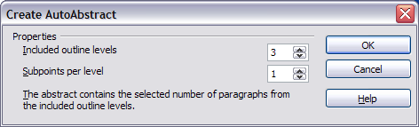
Figure 149: Choosing outline levels for an autoabstract

Copying and Pasting an Outline
Use this method to add slides from an outline to an existing presentation.
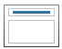
- Create a new slide and choose the “Title, Content” layout (see “Choosing a Slide Layout from the List” on page 174).
- Paste the outline created with Writer into the text area. Do not worry if the text does not fit the space on the slide.
- When pasting, the hierarchical structure of the outline may be lost. If necessary, use the Demote button on the Text Formatting toolbar to recreate it so that the outline points are at the correct hierarchical level.
Tip | It may be useful to open the Style and Formatting window at the Presentation styles page to track the outline level of each item.
If some outline levels have too many points to fit on one slide, see “Duplicating a Slide” or “Expanding a Slide” on page 167.

Modifying Slides
Use slide masters to avoid manually changing the formatting of individual slides. Multiple slide masters can be used in a single presentation to avoid modifying slide backgrounds or other features. See Chapter 2 (Slide Masters, Styles, and Templates) for details about using slide masters.

Formatting the Slide or Page Area
The Page Setup dialog (Figure 150) can be used to set up the page layout for different views in Impress, such as Notes or Handouts (see pages 178 and 181).
Note | Any changes to page format (size, margins, orientation, and so on) apply to all slides in the presentation. You cannot define more than one page style in Impress, as you can in Writer or Calc.  You can change the background of individual slides, as described on page 174.
To start, click the Normal tab in the main work area or select View > Normal in the menu bar. Select Format > Page from the menu bar, or right-click and choose Page Setup to open the Page Setup dialog shown in Figure 150. The Page tab has three sections: Paper format, Margins, and Layout settings. Settings on this tab affect all slides in the presentation.
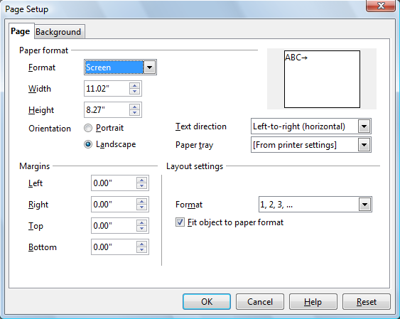Figure 150: The Page Setup dialog box
In the Paper format section, select the preferred Paper format from the drop-down list. The dimensions change automatically when a standard format is selected. The list contains selections for displaying the slides and printing them on paper.
The default values for the Screen settings are optimized for screen presentation (4:3 ratio). If your computer uses a wide-screen monitor, you may wish to take advantage of that by selecting the User format and editing the Width and Height manually.
In the Margins section, change the spacing between the edges of the page and the contents of the slide.
In the Layout settings section, select the page number format in the Format drop-down list. To allow resizing the slide objects and fonts to fit the paper, select the Fit object to paper format checkbox.

Printing Slides
You can also select the orientation of the slide or paper (Portrait or Landscape) and the paper tray to be used. Note that in Impress, you cannot specify different trays for different pages (slides), as you can in Writer; however, you can specify different trays for printing slides, notes, and handouts. For more about printing presentations, see Chapter 10.

Choosing a Slide Master from the List
In the Sidebar, select the Master Pages deck.
To apply one of the slide masters to all slides in your presentation, click on it in the Available for Use list.
To apply a different slide master to one or more selected slides:
- In the Slide Pane or the Slide Sorter view, select the slides you want to change.
- In the Sidebar, right-click on the slide master you want to apply to the selected slides, and click Apply to Selected Slides on the pop-up menu.
Chapter 2 (Slide Masters, Styles, and Templates) discusses slide masters (also called “master slides” and “master pages”) in detail.

Changing the Background of a Slide
This section describes how to modify the background of a single slide.
Tip | For easy maintenance, it is recommended that slide masters be used to modify a slide's background by creating additional slide masters as required.
Note | Applying a background to individual slides is no different than filling the area of a shape. See Chapter 6 (Formatting Graphic Objects) for detailed instructions.
To change the background for a slide:
- Switch to Normal view by clicking the tab in the main work area or by selecting View > Normal.
- Select the slide you want to change.
- Select Format > Page from the menu bar, or right-click and choose Slide > Page Setup to open the Page Setup dialog. Choose the Background tab.
- Follow the instructions in “Formatting Areas” in Chapter 6.
- Click OK to save the changes. A pop-up message asks if you want to change the background on all slides. To change only the selected slide, click No. If you press Yes, Impress will apply the new background to all the slides used in the presentation.

Choosing a Slide Layout from the List
After creating a new slide, decide what this slide will contain and what layout is most suitable for the purpose. Impress offers various types of predefined layouts that can be applied to a slide, as shown in Figure 151.
To apply a layout to a slide:
- In the Sidebar, select the Properties deck and make sure nothing is selected in the slide so that the Layouts pane is displayed.
- Hover the mouse cursor over the layout thumbnail to get a tooltip with a summary of the contents included in the layout.
- Click on the selected layout to apply it to the slide.
Note | If the layout is changed when the slide already contains contents, Impress will not delete the contents. Rather, it will simply reposition the slide according to the chosen layout. This may cause slide elements to overlap.
If these layouts do not fit the presentation style, the elements can be rearranged on an individual slide and duplicated as often as needed by copying to another presentation or saving as a template.
All the techniques in Chapter 3 (Adding and Formatting Text) for working with text boxes can be applied to the Title and AutoLayout text elements of the slide, while the placeholder for images can be moved and resized as discussed in Chapter 4 (Adding and Formatting Pictures). Chapter 7 describes how to include and modify spreadsheets, charts, and other objects.
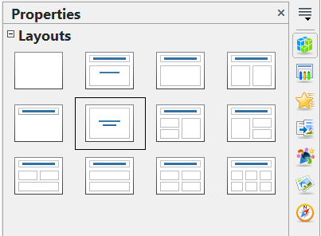
Figure 151: Automatic layouts for slides

Adding Comments
When creating a presentation in a collaborative environment, it's useful to add comments to the presentation for the benefit of any other people working on it.
To add a comment, switch to Normal view and select the slide where you want the comment to appear. Select Insert > Comment from the main menu to display the comment box of Figure 152 in the top left corner of the slide. Once you are finished typing your comment, you can close the comment box by clicking anywhere outside the comment box.
Each comment is color-coded and marked with the initials of the author as well as a sequential number, and is shown in the top left corner of the slide in Normal view. Clicking on a comment box displays the full text of the comment. The size of the comments box is fixed, and scroll bars are included when needed.
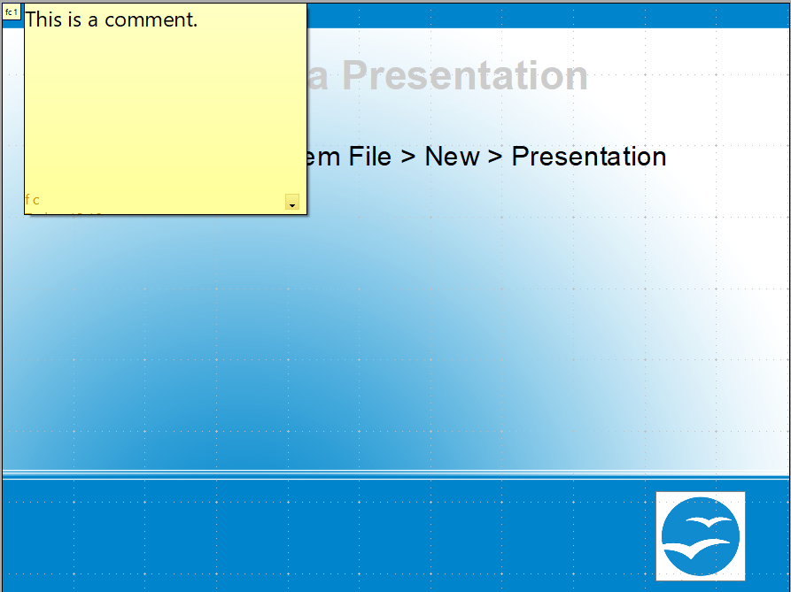

Figure 152: Comments text box in action

Editing, Deleting, and Replying to Comments
You can only edit comments if you created them. You can reply to a comment created by a different person by selecting Reply from the comments menu described below.
A limited set of options is available for formatting the comment text; these can be accessed by right-clicking on the comment box. Use the pop-up menu to apply one or more font attributes (bold, italic, underline, strikethrough) and to paste the contents of the clipboard.
When a comment box is open, you can click on the small triangle pointing down in the lower right part of the comments box to display the comments menu shown in Figure 153. Use this menu to delete the current comment, delete all comments from the author of the selected comment, or delete all comments in the presentation. If the comment you opened was created by a different author, the menu also displays the option to reply to the comment.
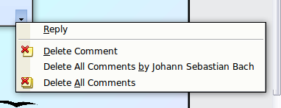Figure 153: Comments menu

Adding and Formatting Notes
Notes view provides a convenient way to create reminders or add extra information to slides in a presentation. Notes are not displayed during a slide show, so with the dual monitor support feature, you can use notes as a presentation cue. You can also print the notes pages and use them as handouts.
Note | If you regularly give presentations in public using a projector, you may want to consider enabling the Presenter Screen. This displays the slide notes, the next slide, and other useful information on your screen while only the slide is shown through the projector. Turn on the Presenter Screen by selecting Tools > Options, expanding the OpenOffice Impress list on the left, choosing General, and selecting With Presenter Screen. See Chapter 9 Slide Shows for more details.

Adding Notes to a Slide
To add notes to a slide:
- In the Slides pane, select the slide to which you want to add notes.
- Switch to Notes view, shown in Figure 154, by clicking the tab in the main work area, or select View > Notes.
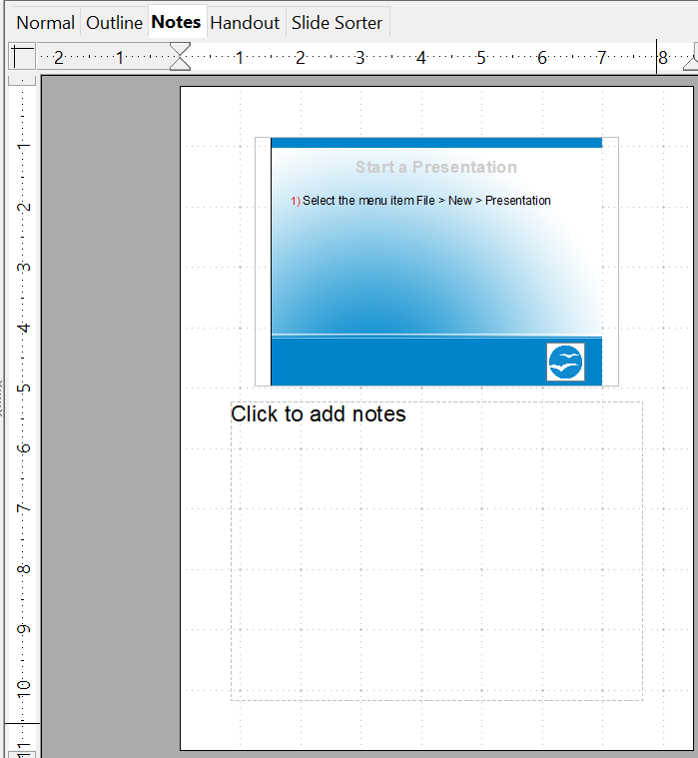
Figure 154: The work area in Notes view
- Click in the text box showing “Click to add notes” and type or paste text or graphics as needed.
- To add notes to another slide, select it in the Slides pane. The Notes view changes to show the selected slide.
- When done entering notes, return to Normal view.

Formatting Notes
It is highly recommended to use the Notes Master and the Notes Presentation style to format the appearance of notes, rather than formatting them for each slide individually.
All the formatting guidelines given in this section can be applied to either the Notes Master or the Notes Presentation style.
To open Notes Master, like that in Figure 155, choose View > Master > Notes Master from the menu bar.
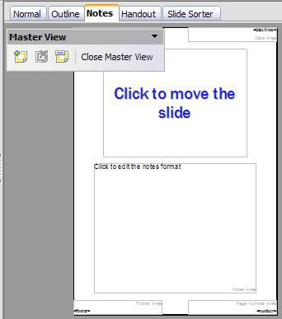
Figure 155: Notes Master View

Formatting the Notes Page
To format the Notes page:
- Switch to Notes view by clicking the tab in the main work area, or select View > Notes.
- Select Format > Page from the menu bar, or right-click and choose Slide > Page Setup to open the Page Setup dialog box, shown in Figure 156.
- Set the desired parameters. The Page Setup dialog for notes is the same as the dialog for slides. Refer to “Formatting the Slide or Page Area” on page 172 for a description of this dialog. The only difference is that by default, the Notes page orientation is set to portrait.
- Click OK to close the dialog.
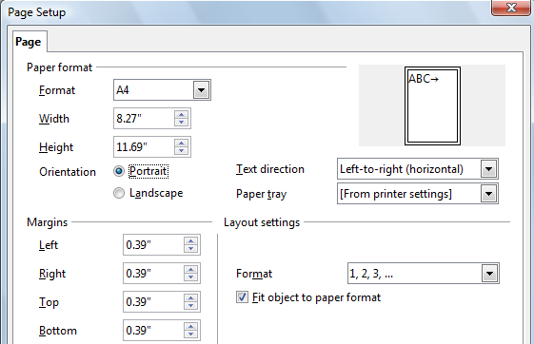Figure 156: The Page Setup dialog for notes

Setting Automatic Layout Options
In Notes view, Impress provides four areas to input information about the presentation:
- Header area
- Date and Time area
- Footer area
- Page number area
To customize these fields, proceed as follows:
- Switch to Notes view from the corresponding tab in the work area or by selecting View > Notes from the main menu, or open the Notes Master (View > Master > Notes Master).
- Choose Insert > Date and Time for the Date and time. Choose between Fixed (enter in the edit box the date and time that should be displayed) or Variable (the date and time of the slide creation will be inserted in the notes pages). Use the two drop-down menus to select the format of the date and the language.
- Choose Insert > Page Number from the main menu to display the Header and Footer dialog box. Select the Notes and Handouts tab (Figure 157).
- Select the check boxes to activate the corresponding areas. For the Header and Footer, type the text in the edit fields.
If the Page number checkbox is activated, to format the type of numbering, refer to “Formatting the Notes Page” on page 178.
- Click the Apply to All button to save these settings and close the dialog box.
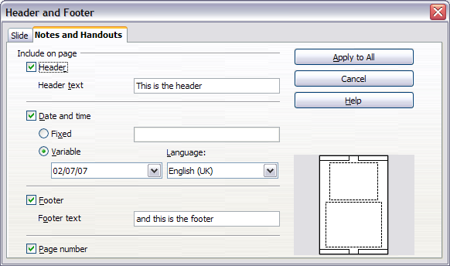
Figure 157: The dialog to set up header and footer for notes

Text Formatting
When text is inserted in the Notes text box, it is automatically formatted using the predefined Notes style found in Presentation styles. The best way to format the notes text is therefore to modify this style to suit your needs. Refer to Chapter 2 (Slide Masters, Styles, and Templates) to learn how to work with styles.
If manual formatting is required, for example, to highlight a particular section of the notes, the guidelines given in Chapter 3 (Adding and Formatting Text) apply.

Advanced Notes Formatting
You can make other changes to the Notes pages. For example, you can:
- Move the text box and the slide image around the page
- Resize the slide image and text box (only from the Slide Master view).
- Add other text boxes to the page.

Printing Notes
- Choose File > Print from the menu bar to see a screen like that in Figure 158.
- From the Print dialog, in the Print section of the General tab, select Notes from the Document list.
- Make any other needed changes and then click OK to print.
For more about printing slides, notes, and handouts, see Chapter 10.
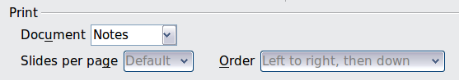
Figure 158: Select Notes for printing

Exporting Notes to PDF
- Choose File > Export as PDF from the menu bar to access the screen shown in Figure 159.
- In the PDF Options dialog, choose the General tab.
- Under General, make sure that Export notes pages is checked, and then click OK.
- In the Export dialog, give the file and name, select the folder in which to save it, and click Export.
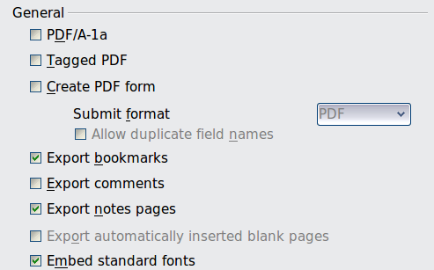
Figure 159: Exporting Notes to PDF
The Notes pages follow the presentation in the PDF (that is, if your presentation has 10 slides, the PDF contains 20 pages: 10 pages of individual slides, followed by 10 pages with notes formatted for paper). If you want only the Notes pages, you will need to use another program to remove the unwanted pages of slides from the PDF.

Creating Handouts
A handout is a special view of the presentation suitable for printing and distributing to the audience. Each handout page contains one to nine thumbnails of the slides so that the audience can follow what is presented and use it as a reference. This section explains how to customize the handout page. An example is shown in Figure 160.
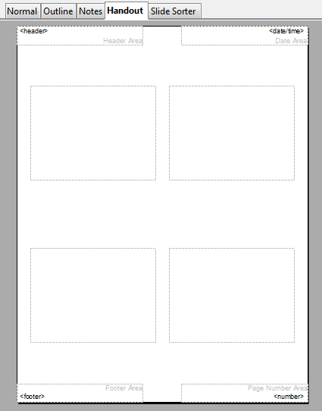
Figure 160: Example of handout with four slide thumbnails
Note that the Handout view consists of only one page, regardless of the number of slides in the presentation or the number of pages of slides that will be printed.

Changing the Layout
When creating handouts, first decide how many slide thumbnails you want printed on each handout page.
- Select the Handout view either by clicking on the tab in the work area or by selecting View > Handout Page from the menu bar.
- If the Sidebar is not visible, select View > Sidebar from the menu bar.
- In the Sidebar, select the Properties deck and expand the Layouts pane, which looks like Figure 161 in Handout view.
- Choose the preferred layout. The main work area changes to reflect the choice.
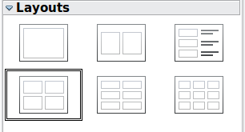
Figure 161: Layouts for handouts

Formatting Handouts
You can format several aspects of the handout, from the page style to the elements that appear on the page. You cannot format individual handout pages; any changes apply to all handouts in the presentation file.

Formatting the Page
To format the handout pages:
- Be sure you are in Handouts view. Click the Handouts tab in the work area or select View > Handout Page from the menu bar.
- Select Format > Page from the main menu, or right-click on the handout and select Slide > Page Setup from the pop-up menu.
- On the Page Setup dialog (Figure 156 on page 179), set the paper size, orientation (portrait or landscape), margins, and other parameters. Click OK.

Setting Automatic Layout Options
In Handout view, as in Notes view, Impress creates four areas where you can put information about the presentation:
- Header area
- Date and Time area
- Footer area
- Slide number area
Note | The information in these areas does not show in Handout view, but it does appear correctly on the printed handouts.
The way to access and customize these areas is the same as for the Notes and uses the same dialog. Refer to “Setting Automatic Layout Options” on page 179 for information.

Moving Thumbnails and Adding Graphics
You can move, but not resize, slide thumbnails; you can also add lines, boxes, and other graphic elements to the handouts. See Chapter 5 (Managing Graphic Objects) for instructions on using the graphics tools.
Tip | After designing a handout, you may wish to save it in a template so you can reuse it whenever you want. See “Working with templates” in Chapter 2 (Slide Masters, Styles, and Templates) for instructions on saving templates and starting a new presentation from a template.
Caution | If you click on one of the other handout layouts and then return to the one you have reformatted, the slide thumbnails return to their original positions, although any lines or other graphics you have added remain where you put them. You will need to move the thumbnails back to where you want them.

Printing Handouts
- Choose File > Print from the menu bar.
- On the General page of the Print dialog, in the Print section, select Handouts in the Document list to access a screen like that in Figure 162. Specify the number of slides per page and the order in which to print multiple slides.
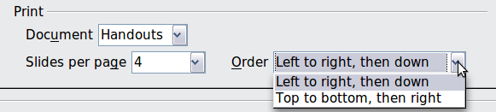
Figure 162: Select Handouts for printing
- To select which slides to include in the handouts, in the Range and copies section of the General page, shown in Figure 163, select Slides and specify the slide numbers to be included.
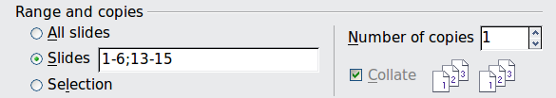
Figure 163: Choose which slides to print
For more about printing slides, notes, and handouts, see Chapter 10.

Chapter 9
Slideshows
Transitions, animations, and more

Creating a Slideshow
OpenOffice Impress gives you the tools to organize and display a slideshow, including:
- Which slides to show, and in what sequence
- Whether to run the show automatically or manually
- Transitions between slides
- Animations on individual slides
- Interactions: what happens when you click a button or link
Most tasks associated with creating a slideshow are best done in Slide Sorter view. Choose View > Slide Sorter from the menu bar or click the Slide Sorter tab at the top of the workspace. All of your slides appear in the workspace; you may need to scroll to see them all.

Choosing Basic Settings for a Slideshow
Basic settings for a slideshow include the slide to start from, the method of advancing slides, the type of presentation, and pointer options.
Choose Slide Show > Slide Show Settings. The Slide Show dialog appears (Figure 164).
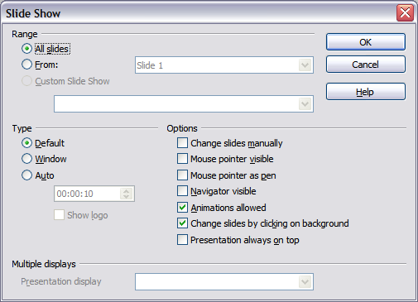Figure 164: Choosing slideshow settings
In the Range section, choose which slides to include in the slideshow:
- All slides includes all of the slides except for those marked Hidden (see “Hiding Slides” on page 188). Slides are shown in the sequence in which they occur in the file. To change the sequence, either rearrange the slides in the slide sorter or choose a custom slide show (see below).
- From: starts the show at a slide other than the first. For example, you might have several slides at the beginning that describe you and your company, but when you present this show to your work colleagues, you want to skip that introduction.
- Custom Slide Show shows the slides in a different sequence than you have previously set up. This choice is not available until after you set up a custom slideshow (see “Showing Slides in a Different Order” on page 188). You can set up as many custom shows as you wish from a single set of slides; they will appear in the drop-down list under this choice.
In the Type section, choose how the slides will be displayed:
- Default shows the slides full screen, without the OpenOffice program controls visible, and exits the show after the last slide.
- Window runs the slideshow in the OpenOffice program window and exits the show after the last slide.
- Auto restarts the slideshow after the last slide. A pause slide is displayed between the last slide and the start slide. Press the Esc key to stop the show. In the box under this choice, specify the length of time before the show restarts. If you enter zero, the show restarts immediately without showing a pause slide. This setting does not control how slides advance within the presentation. See the section Using Slide Transitions for those settings. The Show Logo option shows the OpenOffice logo on the pause slide.
In the Options section:
- Change slides manually prevents slides from changing automatically, even if an automatic transition has been set up.
- Mouse pointer visible shows the mouse pointer during a slideshow. If you do not have a laser pointer or other device to highlight items of interest during the show, this can be quite useful.
- Mouse pointer as pen enables you to write or draw on slides during the presentation. Anything you write with the pen is not saved when you exit the slideshow. The availability of the pen, its color, and its width can be conveniently controlled by right-clicking on a slide during the slideshow.
- Navigator visible displays the Navigator during the slideshow. For more about the Navigator, see Chapter 1 (Introducing Impress).
- Animations allowed displays all frames of animated GIF files during the slideshow. If this option is not selected, only the first frame of an animated GIF file is displayed. (This has nothing to do with the slide animations described in “Using Slide Animation Effects” on page 192.)
- Change slides by clicking on background advances to the next slide when you click on the background of a slide. Other ways of advancing to the next slide include pressing the spacebar on the keyboard.
- Presentation always on top prevents any other program window from appearing on top of the presentation.
In the Multiple displays section, you can choose which display to use for full-screen slideshow mode if the current desktop is displayed on more than one monitor. If the current desktop spans only one monitor, or if the multiple-display feature is not supported on the current system, you cannot select another display. By default, the primary display is used for slideshow mode.
Note | This multi-displays setting is not a property saved in the document, but is instead saved as a local setting in the user configuration. This means that if you open the presentation on a different computer, the local settings, that is, the settings on that different computer, are applied.

Hiding Slides
You may not want to show all of the slides in a particular show. You can either hide some of the slides or set up a custom slideshow; which method is best depends on your needs. For example, you may have draft slides that you do not want to show until they are finished, or you may have some slides that contain information for yourself, but not your audience.
To hide a slide:
- In the Slides pane, or in Slide Sorter view, select the slides that you want to hide.
- Click the Hide Slide icon on the Slide View toolbar, or right-click and select Hide Slide from the context menu, or choose Slide Show > Hide Slide. The slide is now shown with diagonal lines through it, indicating that it is hidden (Figure 165). The slide remains in the file.
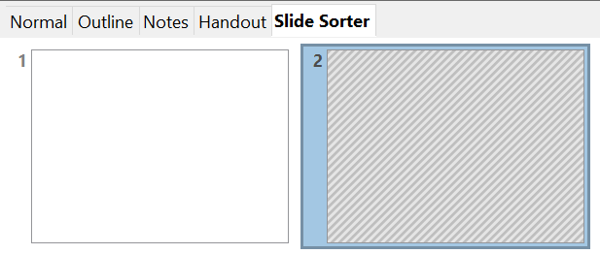

Figure 165: Slide 2 is hidden
To show a hidden slide:
- In the Slides pane, or in Slide Sorter view, select the hidden slides that you want to show.
- Click the Show Slide icon on the Slide View toolbar, or right-click and select Show Slide from the context menu, or choose Slide Show > Show Slide.

Showing Slides in a Different Order
To show the slides in a different order, you can either rearrange them in the slide sorter or set up a custom slideshow. You can define as many custom slideshows as you need from one set of slides. In a custom slideshow, you can choose which slides to include as well as the order in which they are shown. Any slides marked Hidden will not appear in a custom show.

Setting up a Custom Slideshow
To set up a new custom slideshow:
- Choose Slide Show > Custom Slide Show from the menu bar.
- On the Custom Slide Shows dialog (Figure 166), click New.
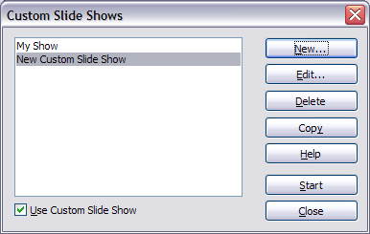
Figure 166: Start here to define or change a custom slideshow
- On the Define Custom Slide Show dialog, type a name for the new custom show. Then, in the Existing slides list, select the slides to include in the show, in the order you want to show them. Click the >> button to include the slides in the Selected slides list. In Figure 167, Title Slide and Slide 4 have been included; Slide 2 has been selected but not yet included.
You can select and include several slides at the same time. Hold down the Shift key and click the first and last slide in a group to select that group (for example, slides 3 through 7), or hold down the Control key and click on individual slides to select them (for example, slides 3, 5, and 9).
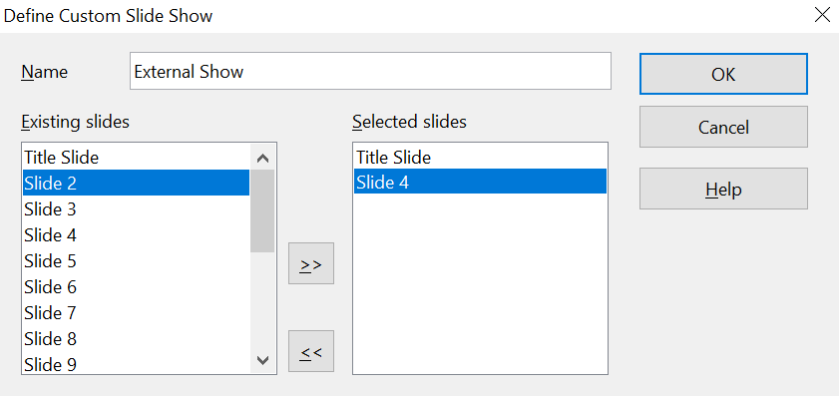
Figure 167: Defining a custom slideshow
- When you have finished arranging the order of the slides, click OK to save this custom show and return to the Custom Slide Shows dialog. To activate your custom show, select the Use Custom Slide Show option at the bottom.
Note | If you include several slides at the same time, they are added to the Selected slides list in numerical order, regardless of the order in which you selected them. In other words, if you click on slides 3, 9, and 5 in that order, and add them all at the same time, they will be included in the Selected slides list in this order: 3, 5, 9. To rearrange them, either select and include them one at a time or select and drag them up or down the list. You can also use the Slide Sorter view to rearrange the order of slides.
Tip | Slides are added to the Selected slides list after whichever slide is currently highlighted in that list. The last slide added is highlighted unless you select a different one. For example, you may have added slides 1, 2, 3, and 9, in that order. Slide 9 will be highlighted. If you now want to add slide 15 between slides 2 and 3, select slide 2 in the Selected slides list, then select slide 15 in the Existing slides list and click >>.  You can also add slide 15 to the end of the Selected slides list and then drag it up to where you want it in the sequence.

Editing, Deleting, or Copying a Custom Slideshow
To edit a custom slideshow (add, remove, or change the order of slides, or change the name of the show), select it in the Custom Slide Shows dialog (Figure 166) and click Edit.
To delete a custom slideshow, select it in the Custom Slide Shows dialog and click Delete. Deletion is immediate; no confirmation message appears.
To create a copy of a slideshow, select it in the Custom Slide Shows dialog and click Copy. You can now edit the copy to rename it, add to, remove from, or change the order of slides within it.
You can run a custom slideshow (for example, to test it) from the Custom Slide Shows dialog if the Use Custom Slide Show checkbox is selected. Select the slideshow from the list and click Start.
When you have finished working with custom slide shows, click Close to save all changes and close the Custom Slide Shows dialog.

Using Slide Transitions
Slide transitions are the effects that occur when one slide gives way to the next in a presentation, like Roll down from top or Fly in from left. They add dynamic flair to a slideshow, smoothing the transition between slides.
- In the Sidebar, choose the Slide Transition deck (Figure 168)
- In the Slides pane or Slide Sorter view, select the slides to which you want to apply the transition. If you want the transition to apply to all slides, you do not need to select them first.
- In the Apply to selected slides list, select a transition.
- Modify the selected transition by changing the speed or adding a sound in the Modify transition area. If you choose to play a sound, select it in the Sound list. The Loop until next sound option now becomes active. Select this option to play the sound repeatedly until another sound starts. If you select this option and there are no subsequent sounds in your slideshow, the sound will play continuously for the remainder of the show.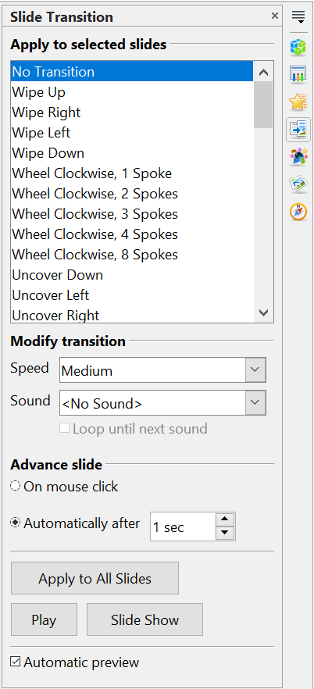

Figure 168: Slide Transition deck of the Sidebar
- Next, choose how to advance to the next slide: manually (on mouse click) or automatically. If you choose automatically, you can specify how long the slide remains visible before it automatically advances to the next slide.
- To apply the transition to all slides, click the Apply to All Slides button.
To start the slideshow from the current slide (so you can see all the transitions), click the Slide Show button.
If the Automatic preview checkbox is marked, the effect of a selected transition is immediately displayed in the work area. You can replay the effect at any time by pressing the Play button.
You can apply a single type of transition to all slides in the presentation, or apply a different transition to any single slide. You can even have a different transition for every slide in the show. But be careful. While trying many different transitions may be fun, it might give your show an unprofessional appearance.
Tip | If you want most of your slides to have the same transition, but a few to be different, you may find it easier to apply one transition to all slides, and then change only the ones you want to make unique.

Setting the Timing of Automatic Slide Changes
You can set up a slideshow to run automatically, either unattended or while you speak. To set the default time for slides to be displayed before changing to the next slide, go to the Slide Transition deck of the Sidebar (Figure 168), leave the transition effect set to No Transition, choose Automatically after in the Advance slide section, set a time, and click the Apply to All Slides button.
To vary the timing for some slides, choose Slide Show > Rehearse Timings from the menu bar, or click the Rehearse Timings icon on the Slide Show toolbar. The slideshow begins in full-screen mode, and a timer appears in the lower-left corner of the screen.
When you want to advance to the next slide, click the timer and then advance the slide manually with the Enter key. To keep the default setting for this slide, click the slide, not the timer. Continue for all slides in your presentation. Impress records the display time for each slide. When you next look at the time set under Automatically after, you will see that the times have changed to match what you set when rehearsing.
If you want the whole presentation to auto-repeat, open the menu Slide Show > Slide Show Settings. Click Auto and OK.

Playing a Sound Throughout the Presentation
You can use the Slide Transition pane to set up Impress so that your chosen sound is played throughout the presentation. To do that:
- Select the slide where you want the sound to start and go to the Slide Transition pane.
- In the Modify transition section, select the entry Other sound from the Sound drop-down menu and choose a sound file.
- Select the Loop until next sound checkbox if you want the sound to restart once it is finished.
Caution | Do not click the Apply to all button. Doing so would cause your selected sound to restart at every slide.
Note | The sound file is linked to the presentation rather than embedded. If you plan to display the presentation on a different machine, you must also make the sound file available on the machine where the presentation will be played and re-establish the link to the local sound file before starting the slideshow.

Removing a Transition Effect
- Select the desired slides.
- Choose No Transition in the list on the Slide Transition deck of the Sidebar.

Using Slide Animation Effects
Slide animations are similar to transitions, but they are applied to individual elements on a single slide—a title, chart, shape, or individual bullet point. Animations can make a presentation more lively and memorable. Just as with transitions, the heavy use of animations can be fun, but also distracting and even annoying for an audience expecting a professional presentation.
Animation effects need to be applied from Normal view so that you can select individual objects on a single slide.
Note | At present, it is not possible to apply animation effects to the slide master elements. This means that if you want to display the items in a text box one by one, you need to apply the effects to each text box, or alternatively, copy the text box from one slide to another.

Applying an Animation Effect
In Normal view, display the desired slide. Select the text or object you want to animate. An object, such as a graphic or an entire text box, will have green handles around it when selected. If you choose only a portion of the text in a text box, you may not see any green handles.
In the Sidebar, choose the Custom Animation deck(Figure 169).
Click Add. The Custom Animation dialog (Figure 170) appears. Choose an effect from one of the tabs of this dialog, and choose the speed or duration of that effect. See the example on page 194 for some hints on how to combine multiple effects.  To choose the animation to be applied when the object is placed on the screen, use an effect from the Entrance page, for example, Fly In or Dissolve In.  Use the Emphasis page to apply a basic effect, such as changing the font color, or to add special effects such as blinking text.  To choose the effect to be applied when the object is leaving the screen, use the Exit page.  If you want the object to move along a line or curve, select an animation from the Motion Paths page. An example of this type of animation is provided in “Example: Setting up a Motion Path” on page 198.  Click OK to save the effect and return to the Custom Animation deck of the Sidebar. Here you can choose how to start the animation, change the speed, and apply additional properties to the selected effect. | 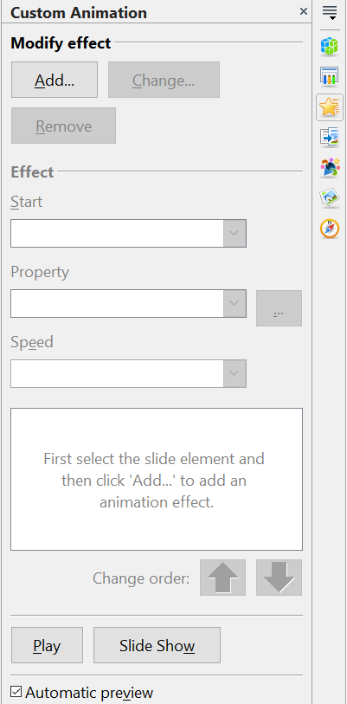  Figure 169: Task pane, showing Custom Animation page

Starting an Animation Effect
You have three choices for starting an animation effect:
On click — The animation does not start until you click the mouse.
With previous — The animation runs at the same time as the previous animation.
After previous — The animation runs as soon as the previous animation ends.
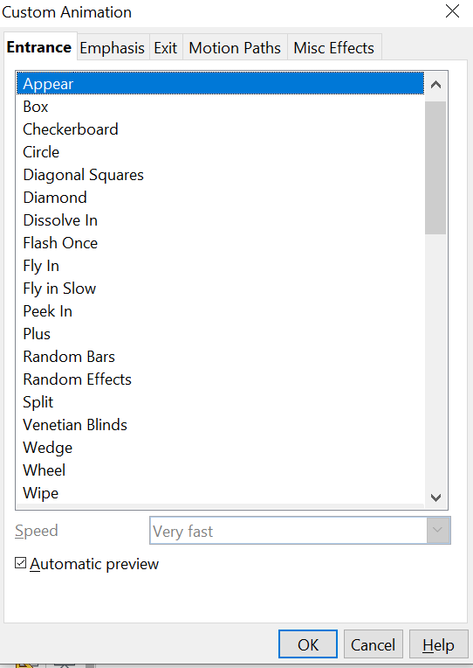

Figure 170: Custom Animation dialog. Choices may vary depending on the selected object; for example, pictures and text have different Emphasis choices.

Choosing Additional Properties of an Animation Effect
Many animations have properties that you can set or change. For example, if you choose the Change Font Color effect on the Emphasis page, you can specify the font color. If you choose Fly In on the Entrance page, you can specify the direction from which the object flies in.
The label on the properties box changes depending on the choices available for each effect. For example, a Fly In effect has a box labeled Direction, and a Change Font Color effect has a box labeled Font color.

Example: Using Multiple Animation Effects
To illustrate how you can set up multiple effects, let’s look at a common animation: list items fly in one at a time from the bottom of the slide, and as each new item appears, the previous items change to a different color. Here is how to create these effects:
Step 1. Apply the “fly in” effect to individual list items.
- Display the Custom Animation deck of the Sidebar.
- Create a slide with several items in a bullet list. Our example slide (Figure 171) has four.
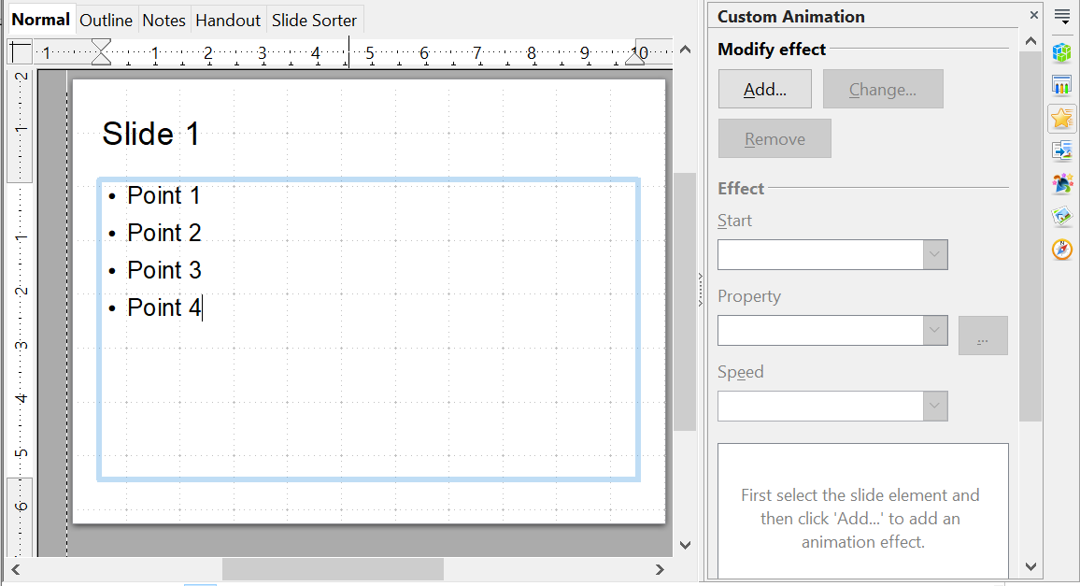

Figure 171: Example slide for multiple animations
- Select all four items. Click Add on the Custom Animation pane.
- On the Entrance page of the Custom Animation dialog (Figure 172), select Fly In, optionally change the Speed to Medium, and click OK.
- The four effects you have just set up are listed in the animations list on the Custom Animation page, as shown in Figure 173.
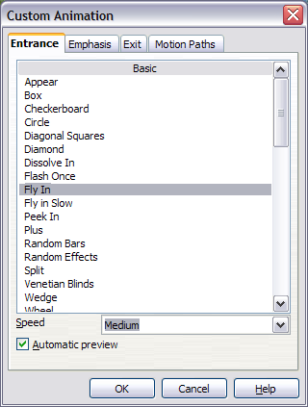
Figure 172: Choosing an entrance effect
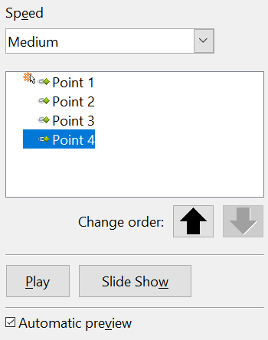

Figure 173: Animation list, showing four items
Start type
showing
"On Click" icon
Effect type
showing
"Entrance" icon
Animated
Objects
Step 2. Apply the “change font color” effect to some list items.
Now we want to set each of the first three list items to change color when the following item appears on the slide. To do this:
- Select the first three items on the slide (not the animations list) and click Add in the Custom Animation pane. This time, we go to the Emphasis page of the Custom Animation dialog and choose Change Font Color, as shown in Figure 174. Click OK to save this effect.
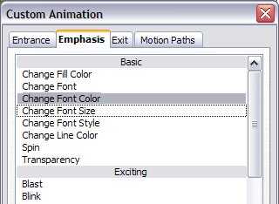
Figure 174: Choosing an emphasis effect
- Notice that the three new animations are listed at the bottom of the animations list, and the “type of effect” icon for these three effects (in the second column) is different from the icon for the first four effects (see Figure 175).
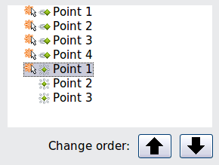
Figure 175: Animation list after adding a second set of animations
- You could, if you wish, select any of the last three items and choose a different color from the Font color list on the Custom Animation pane.
- Use the Change order: up-arrow button to move each of the last three items up the list to just under the other item with the same name. The animation list will now look like Figure 176.
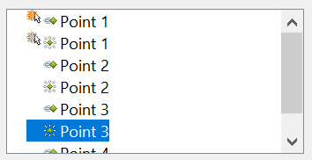

Figure 176: Animation list after moving items into required sequence
Step 3. Change the timing for some list items from With previous to On click
Notice that all of the items on the animations list (except for the two “Point one” items) are set to start at the same time as the previous item. However, it is best if, when you click to make the next point appear, the previous point is dimmed. You can set the color change of the previous point and the entrance of the new point to run on one mouse click simultaneously.
- Select the color change animations for points 2 and 3 and choose On click from the Start list, then select the entrance animations (except the first) and choose With Previous from the Start list. The animation list now looks like Figure 177.
- Test this set of animations by clicking the Slide Show button.
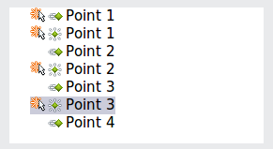
Figure 177: Final list of animations

Example: Setting up a Motion Path
The Motion path effect moves an object along a path that consists of a combination of straight and curved lines. Several pre-packaged paths are provided in AOO, but it is not difficult to create your own custom path. Start by selecting the object you want to animate and clicking Add on the Custom Animation deck of the Sidebar. Choose the Motion Paths tab and select a pre-packaged motion path animation that is similar to the effect you want to obtain. Alternatively, use the Polygon or Curve animation to create a new path.
Select the object to show the animation path, which will be displayed as a thin gray line with a triangle showing the starting point and another indicating the end point. Click on any point on the line so that blue handles are displayed around it. When the blue handles around the path are shown, you can move or resize the path the same way you would perform these operations on a graphic object.
Note | When moving a path, remember also to move the object on that path. Otherwise, the animation will start with a jump. Also note that currently it is not possible to rotate a path.
If instead you want to modify the individual points on the line, select the Points tool from the Drawing toolbar while the path is selected. The Edit Points toolbar of Figure 178 should be displayed; if not, select it from View > Toolbars > Edit Points.
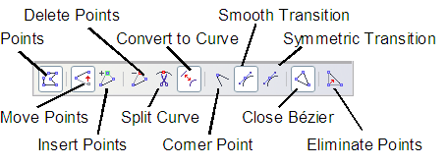
Figure 178: The Edit Points toolbar
Once a point is selected, you can add an additional point, delete it, move it, and so on. For a detailed explanation on how to manipulate the points on a curve, see the Draw Guide. Once you are satisfied with the shape of the curve and its speed, click anywhere on the screen to deselect the object and continue normal editing.
Figure 179 shows a polygon motion path with a curved section.
You can combine a motion with other effects, such as spinning, changing size, or colors, to create dramatic effects.
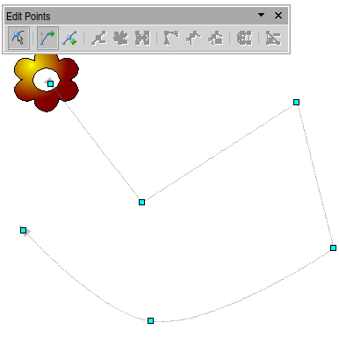
Figure 179: Object set to move along a polygon and curve path

Advanced Animation Effects
On the Custom Animation pane of the Sidebar, click the Effect Options button [...] next to the Properties drop-down list to display the Effect Options dialog.
Note | What you see in the Effect Options dialog depends on the selected animation object. For example, the dialog has three tabs for text objects but only two tabs for picture objects (the Text Animation tab does not appear). The Settings section on the Effect tab also varies. Figure 180 shows the Effect page for a Direction effect, and Figure 181 shows the Settings section for a Font Color effect.
On the Effect tab of the Effect Options dialog (Figures 180 and 181), you can choose a sound to play, whether to dim or hide the object after animation, and (in the case of text objects) whether to animate the text all at once or word by word or letter by letter.
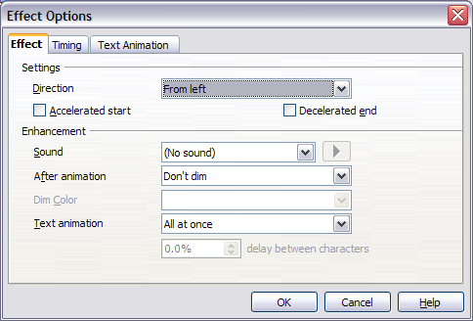
Figure 180: Effect options settings for a direction effect
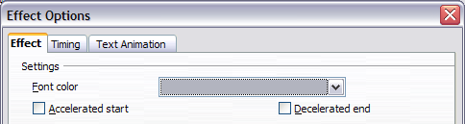
Figure 181: Effect options settings for a font color effect
On the Text Animation tab of the Effect Options dialog (Figure 182), you can group text in other ways: as one object, all paragraphs at once, or by first-level paragraphs (that is, one list item together with its sub-items, if any).
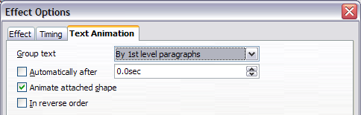Figure 182: Text Animation effect options
The choices on the Timing tab of the Effect Options dialog, shown in Figure 183, allow you to change the speed, delay, and other aspects of the effect’s timing.
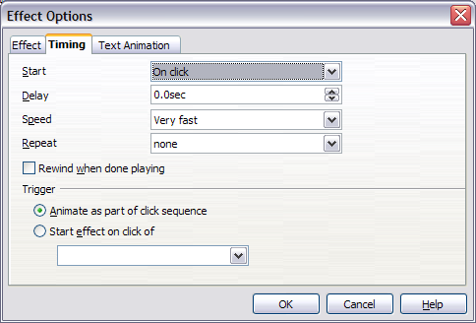
Figure 183: Timing tab of Effect Options dialog

Removing Animation Effects
- On the Custom Animation deck of the Sidebar, select the desired object.
- Click the Remove button.

Using Interactions
Interactions are things that happen when you click on an object in a slide. They are typically used with buttons or images, but text objects can also have interactions. Possible interactions include: go to previous slide, go to next slide, go to first slide, go to last slide, go to page or object (such as a specific slide or named object within a slide), go to document, play sound, or run a macro.
To apply an interaction to an object (or change an interaction applied to an object), right-click on the object and choose Interaction from the pop-up menu. The Interaction dialog (Figure 184) appears. Select an interaction from the Action at mouse click drop-down list.
With some interactions, after you select one, the dialog changes to offer more choices. For example, Figure 185 shows the Interaction dialog after choosing Go to page or object.
Tip | A sound interaction can also be applied using the Effect Options dialog (Figure 180).
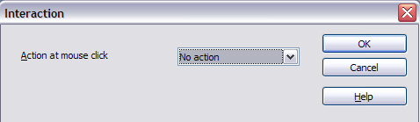
Figure 184: Dialog before choosing an interaction
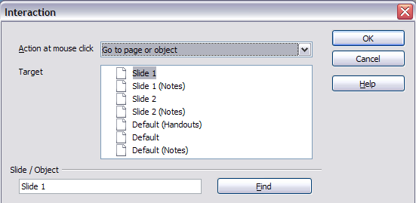
Figure 185: Dialog after choosing the “Go to page or object” interaction, showing choices for the target slide or object

Running a Slideshow
To run the slideshow, do one of the following:
- Press F5 or F9.
- Click Slide Show > Slide Show on the main menu bar.
- Click the Slide Show button on the Presentation toolbar or the Slide Sorter toolbar.
If the slide transition is Automatically after x seconds, let the slideshow run by itself.
If the slide transition is On mouse click, do one of the following to advance from one slide to the next.
- Press the down arrow key, the right arrow key, or the Page Down key on the keyboard.
- Click the left mouse button.
- Press the Spacebar.
To go backwards through the show one slide at a time, press the up arrow key, the left arrow key, or the Page Up key. For more complex navigation, use the Presenter Screen or the right-click menu (see below).
Custom animations on a slide are run in the specified order when performing one of the above actions.
When you advance past the last slide, the message Click to exit presentation… appears. Click the left mouse button or press any key to exit the presentation.
To exit the slideshow and return to the Impress workspace at any time, including at the end, press the Esc key.

Using the Presenter Screen
If your computer supports two displays, the Presenter Screen provides several tools to help you deliver a smooth and timely presentation. To enable the Presenter Screen, choose Tools > Options, expand the OpenOffice Impress list on the left, click on General, and select the box labeled With Presenter Screen in the Start Presentation section of the dialog.
To choose which display shows the slideshow, choose Slide Show > Slide Show Settings… from the main menu bar (see Figure 164). In the Multiple displays section at the bottom of the dialog, choose the display that your audience will see.
When you start the slideshow, the display not showing the slideshow will have the Presenter Screen as shown in Figure 186.
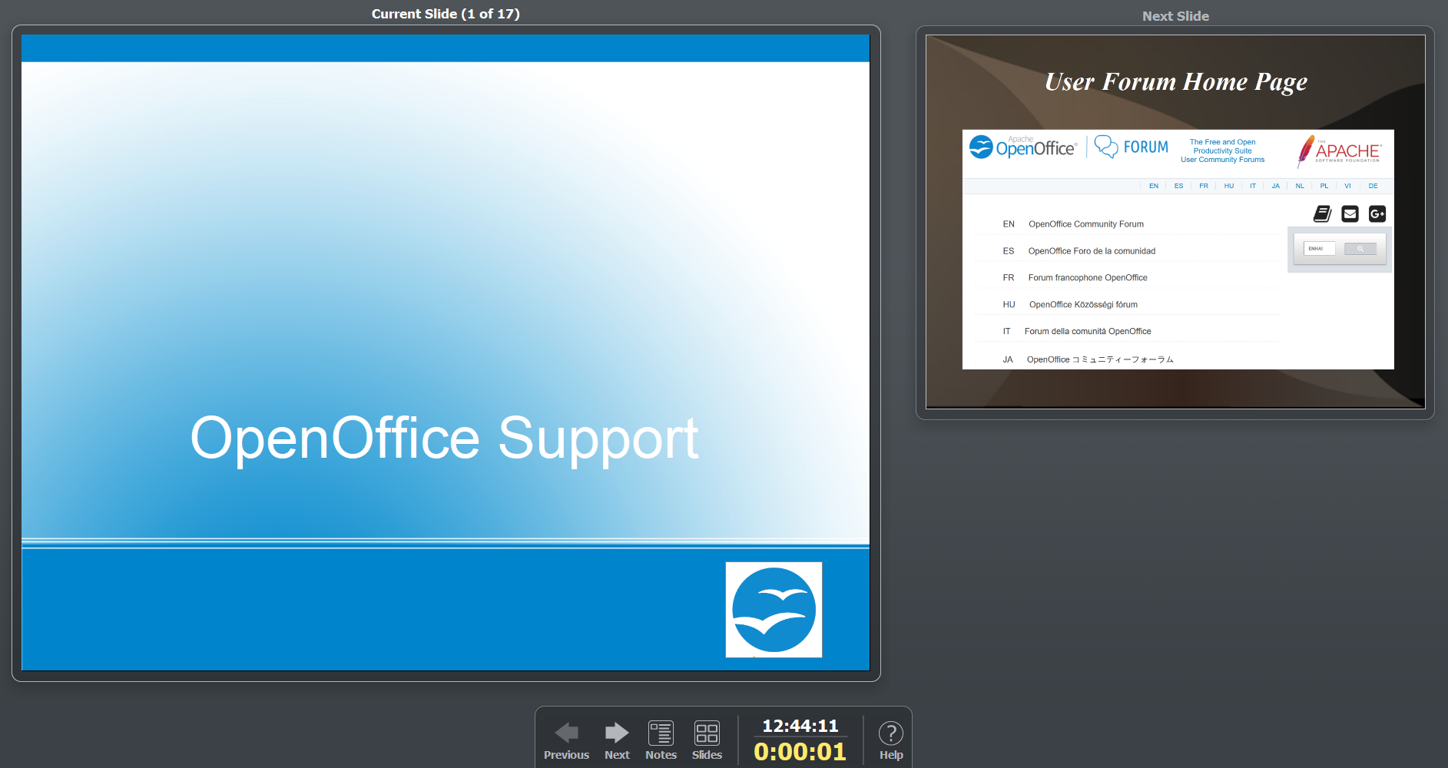

Figure 186: The Presenter Screen's default layout
The main pane on the left shows the current slide, and the pane on the right shows the next slide. The toolbar at the bottom has arrows for moving to the next or the previous slide, buttons to switch to Notes or Slides view, the current time, and the total duration of the current slideshow. Moving between slides can also be done with the keyboard, as explained in the previous section.
If you click the Notes button, the view changes as shown in Figure 187. The current and next slides are still displayed, but the notes attached to the current slide occupy the right side of the screen. You can return to the default view by clicking the Close button at the bottom of the Notes pane.
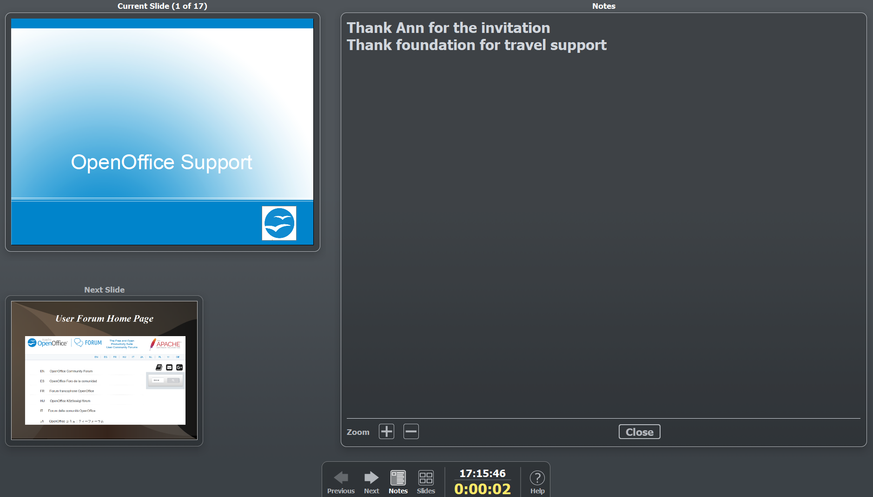

Figure 187: The Notes view of the Presenter Screen

Clicking the Slides button on the toolbar displays all of the slides in the presentation, as shown in Figure 188. You can quickly jump to any slide by clicking on its icon. The audience does not see the Slides view; they see a clean transition to the newly chosen slide.
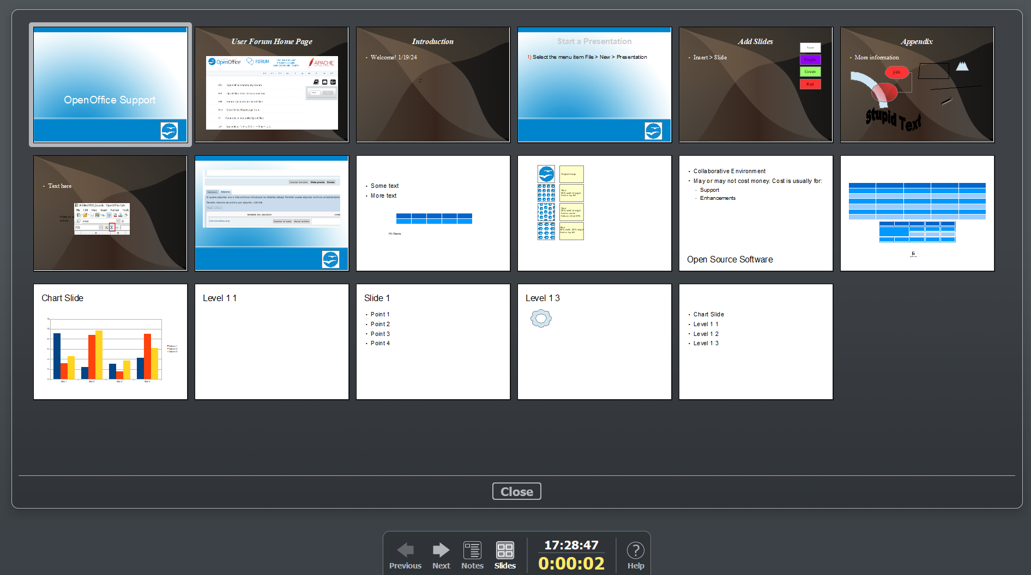

Figure 188: The Slides view of the Presenter Screen

Navigating Using the Right-click Menu
If your presentation consists of more than one slide, right-clicking anywhere on the screen brings up a menu. The choices for navigating the presentation are:
Next: Moves to the next slide in the defined sequence.
Previous: Move to the previous slide in the defined sequence.
Go to Slide: Displays a submenu allowing quick navigation through the presentation. Choices on the submenu include First slide, Last Slide, or any slide in the show. This illustrates why giving the slides meaningful names, rather than using the default Slide 1, Slide 2, and so on, can be very helpful.
Screen: Displays a submenu with two choices. Each choice blanks the screen, showing it as either all black or all white. This can be useful if you want to pause the show for a while (perhaps during a break or to demonstrate something on another computer).
End Show: Ends the presentation and returns you to the Impress workspace. This is the same effect as pressing the Esc key.
The context menu also has the options, Mouse pointer as Pen, Pen Width (with five options), Change pen Color, Erase all ink on Slide.

Chapter 10
Printing, e-mailing, exporting, and saving slideshows

Introduction
This chapter discusses printing, exporting, and e-mailing documents from OpenOffice Impress.

Quick Printing
Click the Print File Directly icon to send the entire document to the default printer defined for your computer.
Note | You can change the action of the Print File Directly icon to send the document to the printer defined for the document, instead of the default printer for the computer. Go to Tools > Options > Load/Save > General and select the Load printer settings with the document option.

Controlling Printing
Impress provides many options for printing a presentation, including multiple slides on one page, a single slide per page, with notes, as an outline, with date and time, and with page names, among others.
For more control over printing a presentation, choose File > Print to display the Print dialog shown in Figure 189.
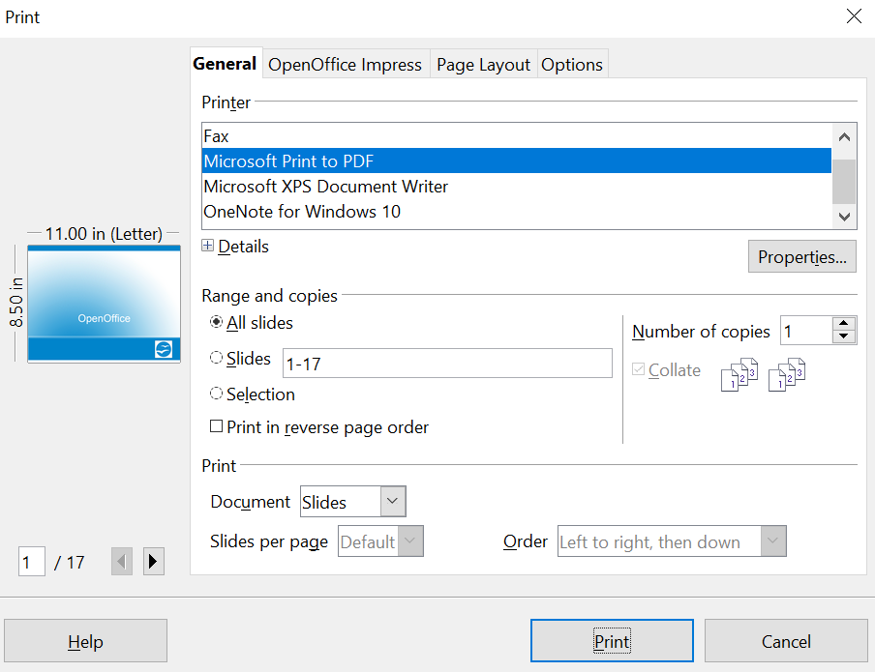

Figure 189. The Print dialog
The Print dialog has four tabs, from which you can choose a range of options, described in the following sections.
Note | The options selected on the Print dialog apply to this printing of this document only.  To specify default printing settings, go to Tools > Options > OpenOffice – Print and Tools > Options > OpenOffice Impress – Print. See “Selecting Default Print Options” on page 212 for more information.

Selecting General Printing Options
On the General tab of the Print dialog (Figure 189), you can choose:
- The printer (from the available printers)
- Which slides to print, the number of copies to print, and whether to collate multiple copies (Range and copies section)
- Whether to print slides, notes, handouts, or an outline of the presentation.
- For handouts, how many slides per printed page and in what order (see page 211 for details).
Click the Properties button to display a dialog where you can choose portrait or landscape orientation, which paper tray to use, and the paper size to print on.
The Options tab of the Print dialog provides other choices, as shown in Figure 190.
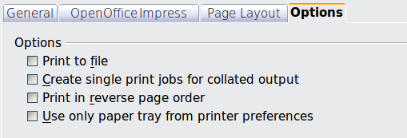
Figure 190: General print options

Printing Multiple Pages on a Single Sheet of Paper
You can print multiple pages of a document on one sheet of paper. To do this:
- In the Print dialog, select the Page Layout tab (Figure 191).
- In the Layout section, select from the drop-down list the number of pages to print per sheet. The preview panel on the left of the Print dialog shows how the printed document will look.
- When printing more than 2 pages per sheet, you can choose the order in which they are printed across and down the paper. The two pictures in Figure 191 show the difference.
- In the Page sides section, select whether to print all pages or only some pages.
- Click the Print button.
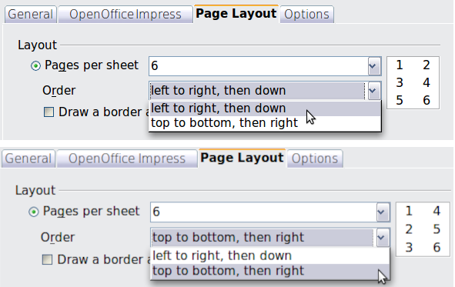Figure 191: Printing multiple pages per sheet of paper

Selecting Slides to Print
In addition to printing a full presentation, you can choose to print individual slides, a range of slides, or a selection of slides using the Ranges and copies section of the General tab in the Print dialog.
Be sure Slides is selected in the Document box in the Print section, as illustrated in Figure 192.
Figure 192: Ranges and copies section of Print dialog
To print an individual slide or several slides, do either of the following:
- Open the Print dialog, choose the Slides option in the Ranges and copies section, type the slide numbers, and click Print. Multiple slides may be represented by a list (for example, 1, 3, 7, 11) or a range (for example, 1-4).
- Select the slides in the Slides pane or the Slide Sorter view, then open the Print dialog and choose Selection in the Ranges and copies section, and click Print.

Selecting Other Information to Print
On the OpenOffice Impress tab of the Print dialog, you can choose:
- What to print in addition to the slides: Slide name, date and time, and hidden slides (pages).
- Whether to print in color, grayscale, or black and white (on a color printer).
- The size to print slides.
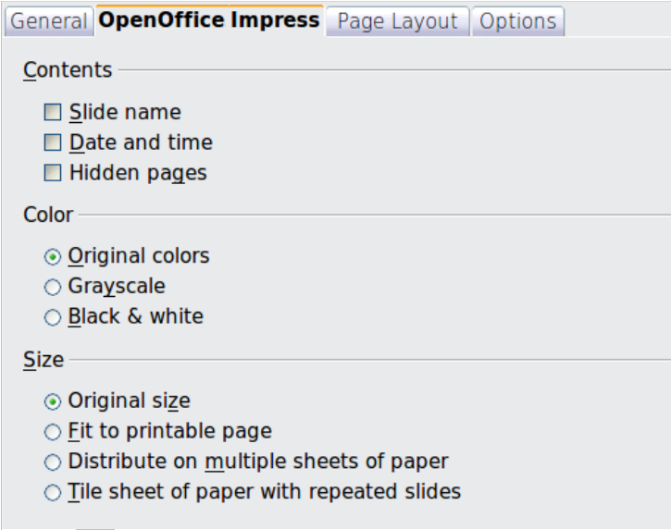Figure 193: Selecting other information to print

Printing in Black and White (on a Color Printer)
You may wish to print slides in black and white or grayscale on a color printer. To do this, choose either Grayscale or Black & white in the Color section on the OpenOffice Impress tab of the Print dialog (Figure 193).

Printing Handouts, Notes, or Outlines in Impress
The Document box also gives you the option to print Handouts, Notes, or an Outline.
Handouts mean the slides are printed in reduced size on the page, from one to nine slides per page. The slides can be printed horizontally (landscape orientation) or vertically (portrait orientation) on the page.
Notes prints a single slide per page with any notes entered for that slide in Notes View.
Outline prints the title and headings of each slide in outline format.
To print handouts, notes, or outlines:
- Choose File > Print from the menu bar.
- In the Print section of the Print dialog, select the required option from the Document box.
- For Handouts, as shown in Figure 194, you can then choose how many slides to print per page, and the order in which they are printed.
- Click the Print button.
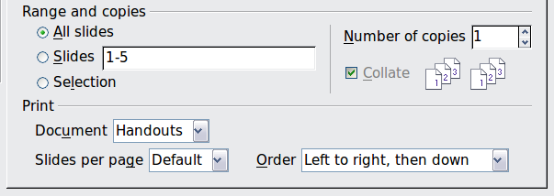Figure 194: Printing handouts

Selecting Default Print Options
Selections on the Print dialog override any default settings. To specify default settings for printing, use Tools > Options > OpenOffice Impress > Print.
Other printer settings are found in Tools > Options > OpenOffice > Print. Use this page to specify quality settings for printing and whether to have Impress warn you if the paper size or orientation of your document does not match the printer settings.
See Chapter 11 (Setting Up and Customizing Impress) for details.

Printing a Brochure
You can print a presentation with two slides on each side of a sheet of paper, arranged so that when the printed pages are folded in half, the slides are in the correct order to form a booklet or brochure.
To print a brochure on a single-sided printer, as is illustrated in Figure 195:
- Choose File > Print.
- In the Print dialog, click Properties.
- Check that the printer is set to the same orientation (portrait or landscape) as specified in the page setup for your document. Usually, the orientation does not matter, but it does for brochures. Click OK to return to the Print dialog.
- Select the Page layout tab in the Print dialog.
- Select the Brochure option.
- In the Page sides section, select Back sides / left pages option from the Include drop-down list.
- Click the Print button.
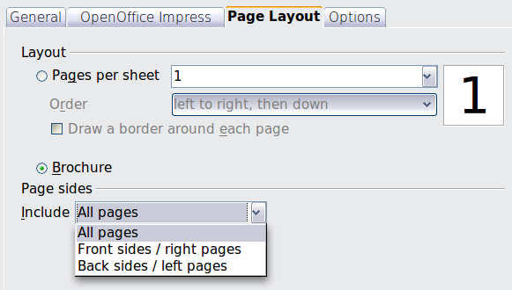
Figure 195: Printing a brochure from Impress
- Take the printed pages from the printer, turn them over, and reinsert them into the printer in the correct orientation to print on the blank side. You may need to experiment to determine the correct arrangement for your printer.
- On the Print dialog, in the Page sides section, select Front sides / right pages option from the Include drop-down box.
- Click the Print button.
Tip | If your printer can print double-sided automatically, choose All pages.

Exporting to PDF
Impress can export presentations to PDF (Portable Document Format). This industry-standard file format for file viewing is ideal for sharing the file with others to view using Adobe Reader or other PDF viewers.

Quick Export to PDF
Click the Export Directly as PDF icon to export the entire presentation using the default PDF settings. You are asked to enter the file name and location for the PDF file, but you do not get a chance to choose a page range or the print quality.

Controlling PDF Content and Quality
For more control over the content and quality of the resulting PDF, use File > Export as PDF. The PDF Options dialog opens. This dialog has five tabs, described in this section. Make your selections, and then click Export. Then you are asked to enter the location and file name of the PDF to be created, and click Save to export the file.

General Tab of PDF Options Dialog
On the General tab, you can choose which pages (slides) to include in the PDF, the type of compression to use for images (which affects the quality of images in the PDF), and other options, like those shown in Figure 196.
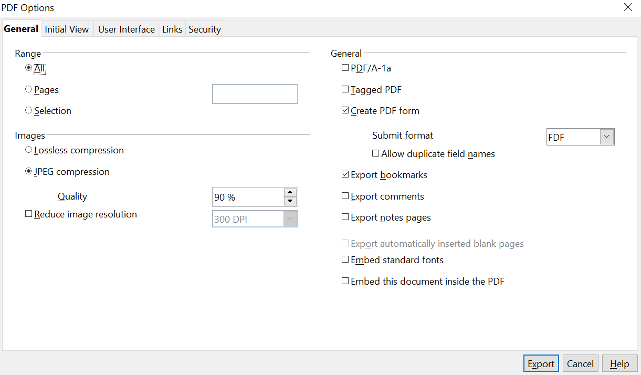

Figure 196: General tab of PDF Options dialog
Range section
- All: Exports the entire document.
- Pages: To export a range of slides, use the format 3-6 (pages 3 to 6). To export single slides, use the format 7;9;11 (slides 7, 9, and 11). You can also export a combination of slide ranges and single slides by using a format like 3-6;8;10;12.
- Selection: Exports whatever material is selected.
Images section
- Lossless compression: Images are stored without any loss of quality. Tends to make large files when used with photographs. Recommended for images or graphics that don't originate from photos.
- JPEG compression: Allows for varying degrees of quality. A setting of 90% tends to work well with photographs (small file size, little perceptible loss).
- Reduce image resolution: Lower-DPI (dots per inch) images have lower quality. For viewing on a computer screen, generally a resolution of about 100dpi is sufficient, while for printing, it is generally preferable to use at least 300 or 600 dpi, depending on the printer's capability. Higher dpi settings greatly increase the size of the exported file.
Note | EPS (Encapsulated PostScript) images with embedded previews are exported only as previews. EPS images without embedded previews are exported as empty placeholders.
General section
- PDF/A-1: PDF/A is an ISO standard for long-term preservation of documents, by embedding all the information necessary for faithful reproduction (such as fonts) while forbidding other elements (including forms, security, and encryption). PDF tags are written. If you select PDF/A-1, the forbidden elements are grayed out (not available).

Note | ISO is a voluntary, non-treaty organization that creates international standards in many areas, including computer and data communications.

- Tagged PDF: Tagged PDF contains information about the structure of the document’s contents. This can help to display the document on devices with different screens, and when using screen reader software. Some tags that are exported are table of contents, hyperlinks, and controls. This option can significantly increase file sizes.
- Create PDF form - Submit format: Choose the format of submitting forms from within the PDF file. This setting overrides the control’s URL property that you set in the document. There is only one common setting valid for the whole PDF document: PDF (sends the entire document), FDF (sends the control contents), HTML, and XML. Most often, you will choose the PDF format.
- Export bookmarks: Exports slide names as “bookmarks” (a table of contents list displayed by some PDF readers, including Adobe Reader).
- Export comments: Exports comments as PDF notes. You may not want this!
- Export notes pages: Exports a set of Notes pages after the set of slides.
- Export automatically inserted blank pages: Not used in Impress.
- Embed standard fonts: In previous versions of AOO, the standard fonts (Times, Helvetica, Courier, Symbol, and Zapf Dingbats) were only embedded into the PDF when the resulting file was of the PDF/A type, since the PDF/A standards require this. In recent versions, you can choose to embed these fonts in all PDF documents created by AOO to enhance display accuracy in PDF viewers.

Initial View Tab of PDF Options Dialog
On the Initial View tab (Figure 197), you can choose how the PDF opens by default in a PDF viewer. The selections should be self-explanatory.

Figure 197: Initial View tab

User Interface Tab of PDF Options Dialog
On the User Interface tab, shown in Figure 198, you can choose more settings to control how a PDF viewer displays the file. Some of these choices are particularly useful when creating a PDF for use as a presentation or a kiosk-type display.
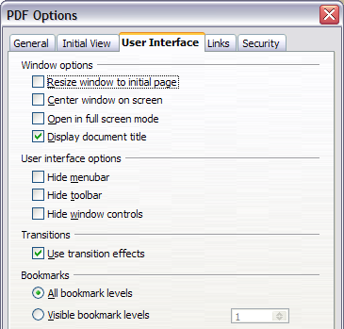
Figure 198: User Interface tab
Window options section
- Resize window to initial page. Causes the PDF viewer window to resize to fit the first page of the PDF.
- Center window on screen. Causes the PDF viewer window to be centered on the computer screen.
- Open in full screen mode. Causes the PDF viewer to open in full-screen mode instead of a smaller window.
- Display document title. Causes the PDF viewer to display the document’s title in the title bar.
User interface options section
- Hide menubar. Causes the PDF viewer to hide the menu bar.
- Hide toolbar. Causes the PDF viewer to hide the toolbar.
- Hide window controls. Causes the PDF viewer to hide other window controls.
Transitions section
Includes Impress slide transition effects as the respective PDF effects.
Bookmarks section
Select how many heading levels are displayed as bookmarks if Export bookmarks is selected on the General tab.

Links Tab of PDF Options Dialog
On the Links tab, like that in Figure 199, you can choose how links are exported to PDF.

Figure 199: Links tab of PDF Options dialog
Export bookmarks as named destinations
If you have defined Writer bookmarks, Impress or Draw slide names, or Calc sheet names, this option exports them as “named destinations” to which Web pages and PDF documents can link.
Convert document references to PDF targets
If you have defined links to other documents with OpenDocument extensions (such as .ODT, .ODS, and .ODP), this option converts the file names to .PDF in the exported PDF document.
Export URLs relative to file system
If you have defined relative links in a document, this option exports those links to the PDF.
Cross-document links
Defines the behavior of links clicked in PDF files.

Security Tab of PDF Options Dialog
PDF export includes options to encrypt the PDF (so it cannot be opened without a password) and apply some digital rights management (DRM) features.
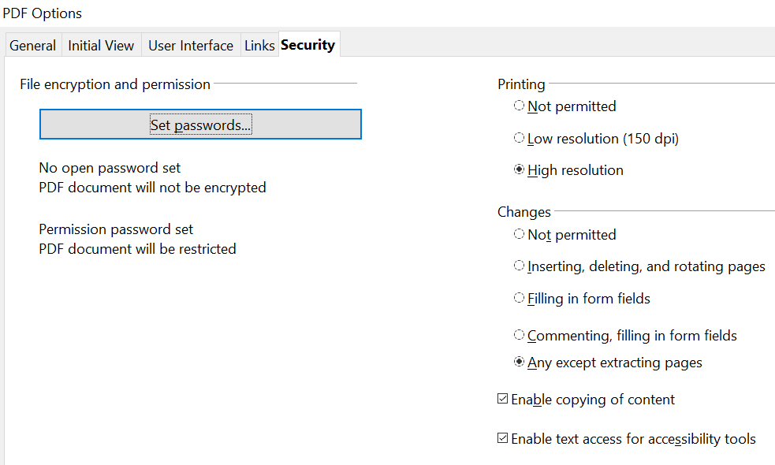

Figure 200: Security tab
Note | Permission settings are effective only if the user’s PDF viewer respects the settings.
- With an open password set, the PDF can only be opened with the password. Once opened, there are no restrictions on what the user can do with the document (for example, printing, copying, or changing it).
- With a permissions password set, anyone can open the PDF, but its permissions can be restricted. See the options in Figure 200.
- With both the open password and permission password set, the PDF can only be opened with the correct password, and its permissions can be restricted.
Figure 201 shows the pop-up dialog displayed when you click the Set passwords button on the Security tab of the PDF Options dialog.
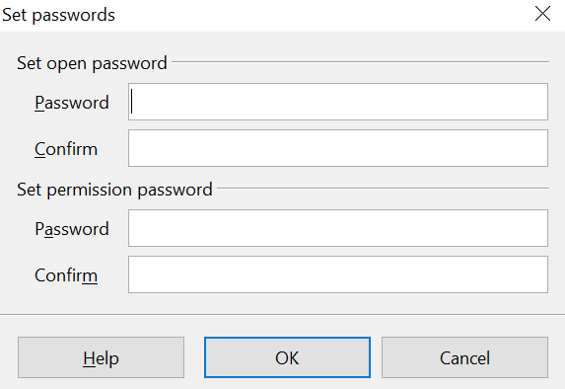

Figure 201: Setting a password to encrypt a PDF
After you set a password for permissions, the other choices on the Security tab (shown in Figure 200) become available. These selections should be self-explanatory.

Exporting as Web Pages (HTML files)
You can export presentations as a series of web pages that can be viewed in any browser.
Note | Saving as web pages (HTML format) does not retain animation and slide transitions.
- Select File > Export and choose HTML Document as the file type.
- Create a folder for the files, supply a name for the resulting HTML file, and click Save. The HTML Export Wizard shown in Figure 202 opens.
Note | Depending on the size of your presentation and the number of graphics it contains, the HTML export function creates many HTML, JPG, and GIF files. If you simply save to your desktop rather than in a specific folder, these separate HTML and graphics files could end up anywhere on your machine. Be sure to create a folder to hold all the files.
- Choose the design for all of the pages, either from an existing design or by creating a new one.
If you have not previously saved a design, the Existing Design choice is not available.
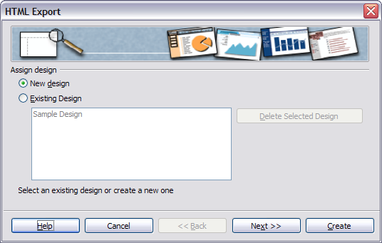Figure 202: HTML Export – Choose a design
- Click Next to select the publication type of web pages to create, as illustrated in Figure 203.
  - Standard HTML: one page for each slide, with navigation links to move from slide to slide.
  - Standard HTML with frames: one page with a navigation bar on the left-hand side; uses slide title as navigation links. Click on links to display pages on the right side.
  - Automatic: one page for each slide, with each page set with the Refresh meta tag so a browser automatically cycles from one page to the next.
  - WebCast: generates an ASP or Perl application to display the slides. Unfortunately, AOO has no direct support for PHP yet.
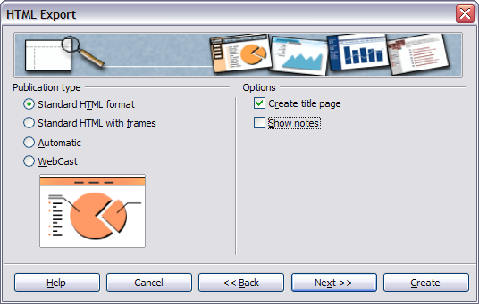Figure 203: HTML Export – Choose publication type
- Decide in what format images will be saved (PNG, GIF or JPG), and what resolution to use, as Figure 204 shows. When choosing a resolution, consider if you can what resolution the majority of your viewers might use.
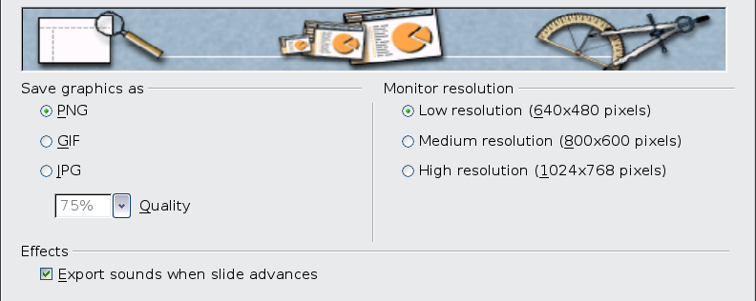Figure 204: HTML Export – Choose graphics type
- If Create title page was chosen in step 4, supply the information for it on the next page, like that shown in Figure 205. The title contains an author name, e-mail address and home page, along with any additional information you want to include.
This page of the Wizard does not display if Create title page was not chosen.
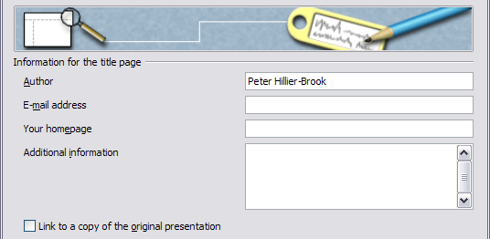
Figure 205: HTML Export – Title page information
- Choose the navigation button style to use for your viewers to move from one page to another, as Figure 206 illustrates. If you do not choose any, AOO will create a text navigator.
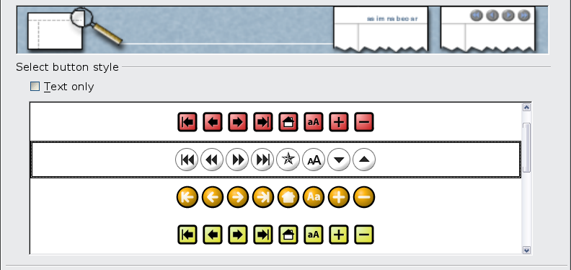Figure 206: HTML Export – Choose navigation style
- Select the color scheme for the web pages, with the tab shown in Figure 207. Available schemes include the document’s existing scheme, one based upon browser colors, and a completely user-defined scheme. You can save a new scheme so that it will appear on the first page of the HTML export wizard.
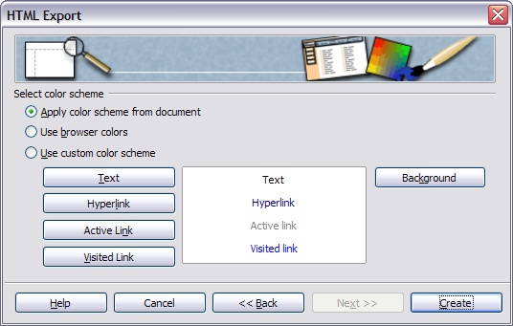Figure 207: HTML Export – Choose color scheme
- Click Create to generate the HTML files. If this is a new design, a small dialog pops up, like that in Figure 208. If you want to reuse this design, give it a name and save it. Otherwise, click Do Not Save.
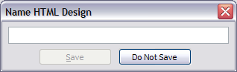
Figure 208: Naming the design

E-mailing a Presentation
AOO provides several ways to send an Impress document quickly and easily as an email attachment in one of three formats: .ODP (OpenDocument Presentation, AOO’s default format), .PPT (Microsoft PowerPoint format), or PDF. These methods require that you have an email program on your computer. If you use web-based email service, you must access it manually and attach the Impress document.
To send the current document in .ODP format:
- Choose File > Send > Document as E-mail. OpenOffice opens a new e-mail in your default e-mail program. The document is attached.
- In your e-mail program, enter the recipient, subject and any text you want to add, then send the e-mail.
File > Send > E-mail as OpenDocument Presentation has the same effect.
If you choose E-mail as Microsoft PowerPoint, AOO first creates a .PPT file and then opens your e-mail program with the .PPT file attached. The .PPT file is not saved on your computer. This gives you no opportunity to check if any formatting problems occurred during the file type change.
Similarly, if you choose E-mail as PDF, AOO first creates a PDF using your default PDF settings (as when using the Export Directly as PDF toolbar button) and then opens your e-mail program with the .PDF file attached. The PDF file is not saved on your computer.
Tip | If you want to keep a copy of the .PPT or .PDF file as well as e-mailing it to someone, first save or export the presentation into the required format, then attach it to an e-mail in the usual way.

Digital Signing of Documents
To sign a document digitally, you need a personal key, the certificate. A personal key is stored on your computer as a combination of a private key, which must be kept secret, and a public key, which you add to your documents when you sign them. You can get a certificate from a certification authority, which may be a private company or a governmental institution.
When you apply a digital signature to a document, a checksum is computed from the document’s content plus your personal key. The checksum and your public key are stored together with the document.

Note | A checksum is a computed value that depends on the contents of a block of data. Checksums are transmitted or stored along with their data in order to detect corruption of that data. The receiving system recomputes the checksum based upon the received data, and compares this value with the one sent with the data. If the two values are the same, the receiver has some confidence that the data was received correctly.  A checksum may be 8 bits, 16, 32, or some other size. It's calculated by summing the bytes or words of the data block but ignoring overflow. The checksum may be negated so that the total of the data words plus the checksum is zero.  Internet packets use a 32-bit checksum.

When someone later opens the document on any computer with OpenOffice, the program will compute the checksum again and compare it with the stored checksum. If both are the same, the program will signal that you see the original, unchanged document. In addition, the program can show you the public key information from the certificate. You can compare the public key with the public key that is published on the website of the certificate authority.
Whenever someone changes something in the document, this change breaks the digital signature.
On Windows operating systems, the Windows features for validating a signature are used. On Solaris and Linux systems, files that are supplied by Thunderbird, Mozilla or Firefox are used. For a more detailed description of how to get and manage a certificate and signature validation, see “Using Digital Signatures” in the AOO Help.
Note | Oracle Solaris is a proprietary Unix operating system offered by Oracle for SPARC and x86-64 based workstations and servers. Sun Microsystems was an American company, founded in 1982, that specialized in computer workstations, servers, and software. It was known for pioneering technologies like the SPARC processor, the Unix-based Solaris operating system, and the Java programming language. Sun was acquired by Oracle Corporation in 2010.

To sign a document:
- Choose File > Digital Signatures.
- If you have not saved the document since the last change, a message appears. Click Yes to save the file.
- After saving, you see the Digital Signatures dialog. Click Sign Document to add a public key to the document.
- In the Select Certificate dialog, select your certificate and click OK.
- You see the Digital Signatures dialog again, where you can add more certificates if you want. Click OK to add the public key to the saved file.
A signed document shows an icon in the status bar. You can double-click the icon to view the certificate.

Removing Personal Data
You may wish to ensure that personal data, versions, notes, hidden information, or recorded changes are removed from files before sending them to others or creating PDFs from them.
In Tools > Options > OpenOffice > Security > Options, you can set AOO to remind (warn) you when files contain certain information and remove personal information automatically when saving documents or creating PDFs.
To remove personal and some other data from a file, go to File > Properties. On the General tab, uncheck Apply user data and then click the Reset button. This removes any names in the created and modified fields, deletes the modification and printing dates, and resets the editing time to zero, the creation date to the current date and time, and the version number to 1.
To remove version information, either go to File > Versions, select the versions from the list and click Delete, or use Save As and save the file with a different name.

Opening and Saving a PowerPoint File
OpenOffice’s Impress file format is highly compatible with Microsoft’s PowerPoint format. You can open a PowerPoint presentation in Impress, edit it, then save it in its original PowerPoint format, or in Impress format. You can also create a new presentation in Impress and save it as a PowerPoint file.

Saving an Impress File as a PowerPoint File
- Choose File > Save As from the menu bar.
- Select the location where you want the PowerPoint file saved and type a name for the file.
- Under File type, choose Microsoft PowerPoint 97/2000/XP (.ppt).
- Click Save. If you have the “Warn when not saving in ODF or default format” option set in Options > Load/Save > General, the message shown in Figure 209 appears. Click Keep Current Format to confirm that you want to save the file in Microsoft PowerPoint format. You can deselect the Ask when not saving in ODF format checkbox, and the message will not be shown again unless you re-enable it in the Options.
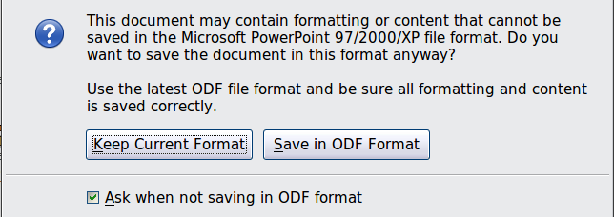
Figure 209: Warning message when saving in Microsoft PowerPoint format
Tip | Always save your work in Impress OpenDocument format (.odp) before saving in Microsoft format. Keep the Impress file as your working copy; if you need to change the presentation, change it in the Impress version and then save it again as PowerPoint. You are much less likely to have problems than if you open a file previously saved in PowerPoint format, edit it, and save it again.

Opening a PowerPoint File in Impress
If you receive a file from someone in PowerPoint format and need to edit it in Impress, here is how:
- In OpenOffice, choose File > Open from the menu bar.
- Under File type, choose All files (*.*) or Presentations or Microsoft PowerPoint 97/2000/XP from the drop-down list.
- Navigate to the PowerPoint file, select it, and click Open.
The PowerPoint file can now be edited and saved as an Impress file or a PowerPoint file. To save the file as an Impress file, choose OpenDocument Presentation (.odp) as the File Type.

Chapter 11
Setting Up and Customizing Impress

Choosing Options That Affect All of AOO
This section covers some of the settings that apply to all components of OpenOffice. and are of most interest to users of Impress. Other general options are discussed in Chapter 2 (Setting Up OpenOffice) in the Getting Started guide.
- Click Tools > Options (OpenOffice > Preferences on a Mac). The list on the left-hand side of the Options – OpenOffice dialog varies depending on which component of AOO is open. The illustrations in this chapter show the list as it appears when Impress is open.
- Click the expansion marker (+ or triangle) by OpenOffice on the left-hand side. A list of subsections drops down (Figure 210).
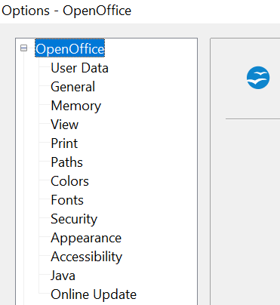
Figure 210: OpenOffice options
Note | The Back button has the same effect on all pages of the Options dialog. It resets the options to the values that were in place when you opened OpenOffice.

User Data Options
Impress uses the first and last name stored in the User Data page to fill in the Created by and Modified by fields in the document properties, the optional Author field often in the footer of a presentation, and the name associated with comments. You will want to ensure that your name appears there. To do this:
- In the Options dialog, click OpenOffice > User Data.
- Fill in the form or delete any existing incorrect information.

Print Options
On the OpenOffice – Print page, set the print options to be compatible with your default printer and your most frequently used printing method.
You can change these settings at any time, either through the Options dialog or during the printing process (by clicking the Options button on the Print dialog).
See Chapter 10 (Printing, e-mailing, exporting, and saving slide shows) for more about the options on this page.

Color Options
On the OpenOffice – Colors page (Figure 211), you can specify colors to use in AOO documents. You can select a color from a color table, edit an existing color, and define new colors. These colors are stored in your color selection palette and are then available in all components of AOO. You can also define colors within Impress by choosing Format > Area on the menu bar, or through the Line and Filling toolbar, but those colors will not be available to other components of AOO.
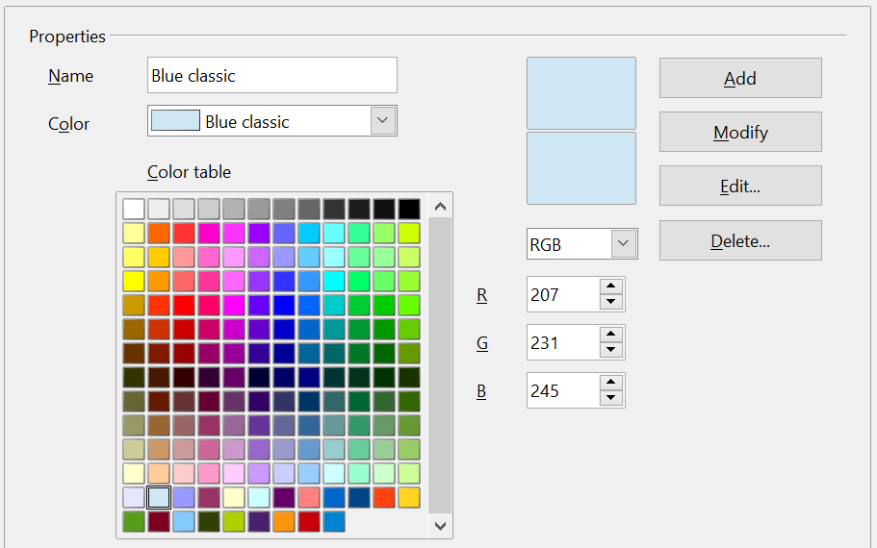

Figure 211. Defining colors to use in color palettes in AOO

Appearance Options
On the OpenOffice – Appearance page, you can specify which items are visible, as well as the colors used to display various elements of the user interface.
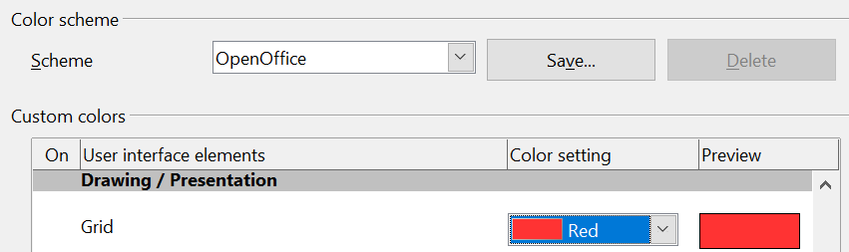
Figure 212. Changing the color of grid points in Impress and Draw
The only choice specific to Impress (and Draw) is the color of the grid points. Scroll down in the page until you find Drawing/Presentation.
To change the default color for grid points, click the down arrow by the color and select a new color from the pop-up box.
If you wish to save your color changes as a color scheme, click Save, type a name in the Scheme box, and click OK.

Choosing Options for Impress
In the Options dialog, click the expansion marker to the left of OpenOffice Impress on the left-hand side as shown in Figure 213. A list of subsections drops down.
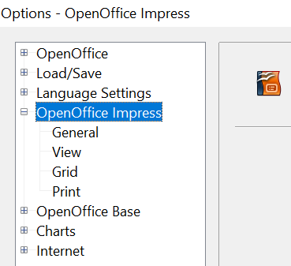
Figure 213: Options for Impress

General Options
In the Options dialog, click OpenOffice Impress > General (Figure 214).
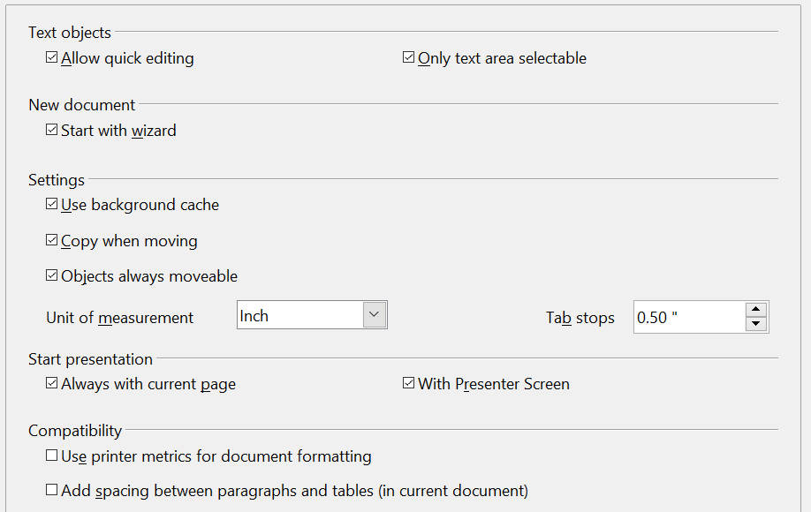
Figure 214: Specifying general options for Impress

Text Objects Section
Allowquick editing sets Impress to switch immediately to text editing mode when you click a text object. You can also activate the text editing mode through the Allow Quick Editing icon on the Options toolbar.
Only text area selectable sets Impress to select a text frame when you click on text. In the area of the text frame that is not filled with text, an object behind the text frame can be selected. You can also activate this mode through the Select Text Area Only icon on the Options toolbar.

New Document Section
Start with Wizard sets Impress to start the Presentation Wizard when creating a new presentation using File > New > Presentation or other methods.

Settings Section
Use background cache sets Impress to use the cache for displaying objects on the master page. This setting speeds up the display. Uncheck this box if you want Impress to draw the background every time you display a slide.
Copy when moving automatically creates a copy when you move, rotate, or resize an object while holding down the Ctrl key (⌘ key for Mac). The original object will remain in its current position and size.
Objects always movable lets you move an object with the Rotate tool enabled. If this box is not checked, the Rotate tool can only be used to rotate an object.
Unit of measurement determines the unit of measurement for presentations.
Tab stops defines the spacing between tab stops.

Start Presentation Section
Always with current page specifies that a presentation starts with the current slide. Unmark this box to always start a presentation with the first page.
With Presenter Screen activates a window with extra information for the presenter during a slide show if the slide show is displayed on a second screen or an external device. See Chapter 9 Slide Shows for more information.

Compatibility Section
The settings in this area are valid for the current document only.
Use printer metrics for document formatting applies printer metrics for both printing and formatting the display on the screen. Some formatting will depend on the printer selection or the default printer on your computer, and may vary if the presentation is moved to a different computer. If this box is not checked, a printer-independent layout is used for screen display and printing.
Add spacing between paragraphs (in current document) calculates the paragraph spacing in Impress exactly as Microsoft PowerPoint does. Microsoft PowerPoint calculates the total spacing between paragraphs by adding the bottom spacing of one paragraph with the top spacing of the next. Impress normally uses only the larger of the two spacings.

View Options
In the Options dialog, click OpenOffice Impress > View (Figure 215).
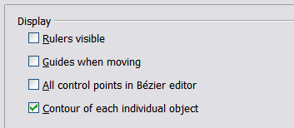
Figure 215: Specifying view options for Impress
Rulers visible displays the rulers at the top and the left of the work area.
Guides when moving displays dotted guides that extend beyond the box containing the selected object and cover the entire work area, helping you position the object when moving it. You can also use the Guides when moving icon on the Options toolbar.
All control points in Bézier editor displays the control points of all Bézier points if you have previously selected a Bézier curve. If this box is not marked, only the control points of the selected Bézier points will be visible.

Note | A Bézier curve is a mathematical curve defined by a set of control points that guide its shape. It is a parametric function used in computer graphics, design, and animation to create smooth, scalable, and precise shapes. The curve starts at the first control point and ends at the last, while the intermediate control points "pull" the curve towards them to determine its path

Contour of each individual object displays the contour line of the object when it is moved. This enables you to see if single objects conflict with other objects in the target position. If you do not mark this box, Impress displays only a square contour that includes all selected objects.

Grid Options
The Grid page defines the grid settings for Impress. Using a grid helps you determine the exact position of your objects. You can also set this grid in line with the snap grid.
To open the Options dialog shown in Figure 216, click OpenOffice Impress > Grid.

Grid Section
Snap to grid activates the “snap” function.
If you have activated the snap grid but wish to move or create individual objects without snap positions, you can press the Ctrl key to deactivate the snap grid for as long as needed.
Visible grid displays grid points on the screen. These points will not display or print as part of a presentation.

Resolution Section
Here you can set the unit of distance for the spacing between horizontal and vertical grid points and subdivisions (intermediate points) of the grid.
Synchronize axes applies any changes to the Resolution or Subdivision settings to both axes.
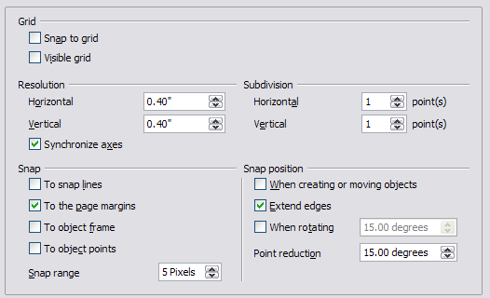
Figure 216: Specifying grid options for Impress

Snap Section
A graphic object will be snapped (aligned with an existing reference point) if it is dragged within snap range of that point. Whether the distance is measured from the mouse pointer or from the edge of the object depends on the setting of Contour of each individual object in the View options page.
To snap lines snaps the edge of a dragged object to the nearest snap line when you release the mouse button. You can also use the Snap to Guides icon on the Options toolbar.
To the page margins aligns the contour of the graphic object with the nearest page margin. You can also use the Snap to Page Margins icon on the Options toolbar.
To object frame aligns the contour of the graphic object to the border of the nearest graphic object. You can also use the Snap to Object Border icon on the Options toolbar.
To object points aligns the contour of the graphic object to the points of the nearest graphic object. You can also use the Snap to Object Points icon on the Options toolbar.
Snap range defines the distance within which snapping occurs. Impress snaps to a snap point only if the mouse pointer (or the object contour) is nearer to that point than the distance selected in the Snap range box.

Snap Position Section
When creating or moving objects restricts graphic objects vertically, horizontally, or diagonally (45°) during these actions. You can temporarily deactivate this setting by pressing the Shift key.
Extend edges controls how a square or circle is drawn with the drawing tool. When the Extend edges box is marked, the sides of the square created when the Shift key is pressed before you release the mouse button will be equal to the longer side of the rectangle you have actually drawn. This also applies to the ellipse tool: when the Shift key is pressed before you release the mouse button, a circle will be created based on the longest diameter of the ellipse. When the Extend edges box is not marked, a square or a circle will be created based on the shorter side or diameter.
When rotating restricts the rotation of graphic objects within the rotation angle that you select in the When rotating box. If you want to rotate an object outside of the defined angle, press the Ctrl key (Shift key on Mac) when rotating. Release the key when the desired rotation angle is reached.
Point reduction defines the angle for point reduction. When working with polygons, you might find it useful to reduce the number of editing points to make it easier to snap to a desired point.

Print Options
To open the Options dialog shown in Figure 217, click OpenOffice Impress > Print.
See Chapter 10 (Printing, e-mailing, exporting, and saving slide shows) for more about the options on this page.
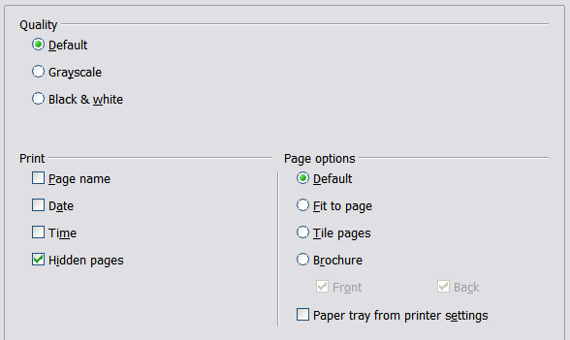
Figure 217: Specifying print options for Impress

Customizing the User Interface

Customizing the Menu Font
If you want to change the menu font from that supplied by AOO to the system font for your operating system, do this:
- Choose Tools > Options > OpenOffice > View.
- Check Use system font for user interface and click OK.

Customizing Menu Content
You can customize menus: add and rearrange items on the menu bar, add items to menus, and make other changes.
- Choose Tools > Customize.
- On the Customize dialog, pick the Menus tab (Figure 218).
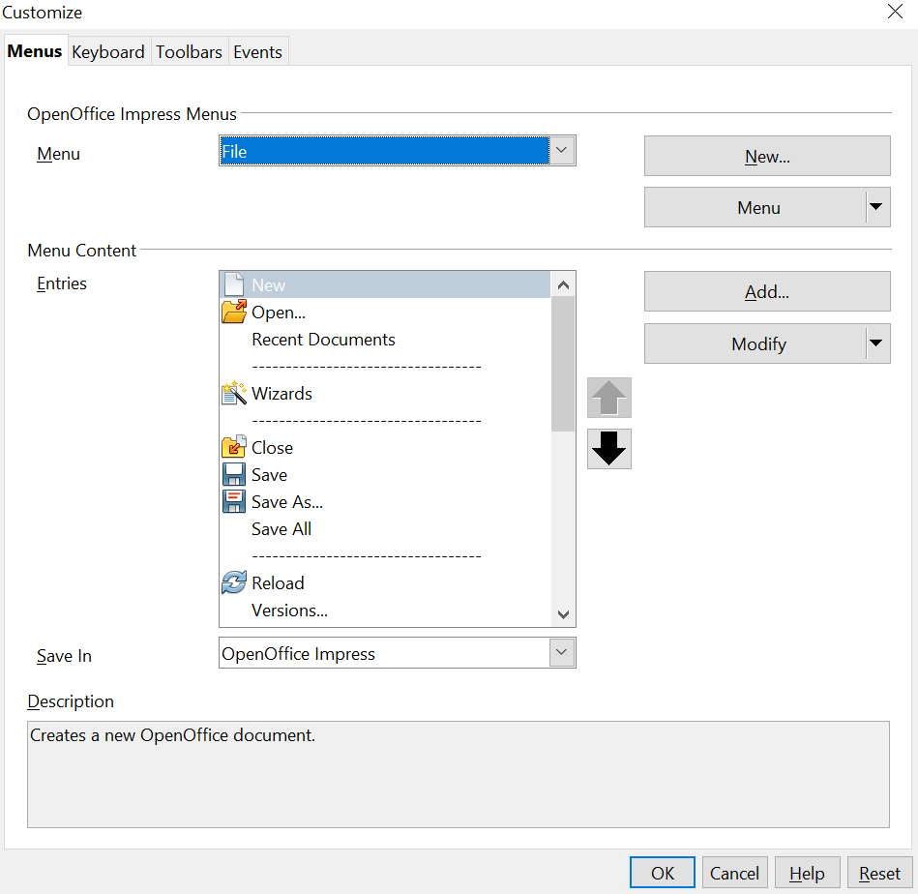
Figure 218. The Menus tab of the Customize dialog
- In the Save In drop-down list, choose whether to save this changed menu for Impress or for a selected document (for example, MySlideShow.odp).
- In the section OpenOffice Impress Menus, select the menu you want to customize from the Menu drop-down list.
- To customize the selected menu, click on the Menu or Modify buttons. You can also add commands to a menu by clicking on the Add button. These actions are described in the following sections. Use the up and down arrows next to the Entries list to move the selected menu item to a different position.
- When you have finished making all your changes, click OK to save them.

Creating a New Menu
In the Menus tab of the Customize dialog, click New to display the dialog shown in Figure 219.
- Type a name for your new menu in the Menu name box.
- Use the up and down arrow buttons to move the new menu into the required position on the menu bar.
- Click OK to save.
The new menu now appears on the list of menus in the Customize dialog. (It will appear on the menu bar itself after you save your customizations.)
After creating a new menu, you need to add some commands to it, as described in “Adding a Command to a Menu” on page 238.
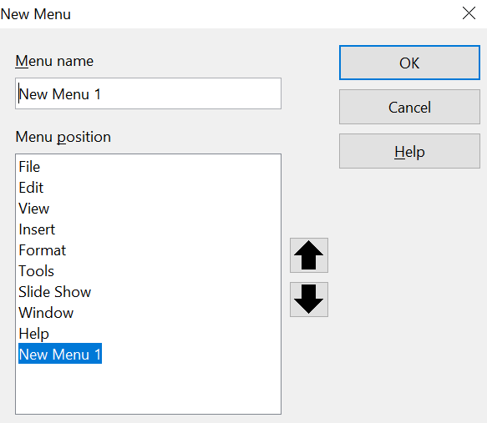

Figure 219: Adding a new menu

Modifying Existing Menus
To modify an existing menu, select it in the Menu list and click the Menu button to drop down a list of modifications: Move, Rename, and Delete. Not all of these modifications can be applied to all the entries in the Menu list. For example, Rename and Delete are not available for the menus supplied by AOO.
To move a menu (such as File), choose Menu > Move. A dialog similar to the one shown in Figure 219 (but without the Menu name box) opens. Use the up and down arrow buttons to move the menu into the required position.
To move submenus (such as File | Send), select the main menu (File) in the Menu list and then, in the Menu Content section of the dialog, select the submenu (Send) in the Entries list and use the arrow keys to move it up or down in the sequence. Submenus are easily identified in the Entries list by a small black triangle on the right side of the name.
In addition to renaming, you can specify a keyboard shortcut that allows you to select a menu command when you press Alt+ an underlined letter in a menu command.
- Select a menu or menu entry.
- Click the Modify button and select Rename.
- Add a tilde (~) in front of the letter that you want to use as an accelerator. For example, to select the Save All command by pressing Alt+V (after opening the File menu using Alt+F), enter Sa~ve All.
Caution | Be careful when using these shortcuts. In the example above, if the File menu is not already open, pressing Alt+V opens the View menu. However, if another menu is open, Alt+V might activate a different command.

Adding a Command to a Menu
You can add commands to the supplied menus and to menus you have created. In the Customize dialog, select the menu in the Menu list and click the Add button in the Menu Content section of the dialog.
On the Add Commands dialog (Figure 220), select a category, choose the command, and click Add. The dialog remains open, so that you can select additional commands. When you have finished adding commands, click Close. Back in the Customize dialog, you can use the up and down arrow buttons to arrange the commands in your preferred sequence.
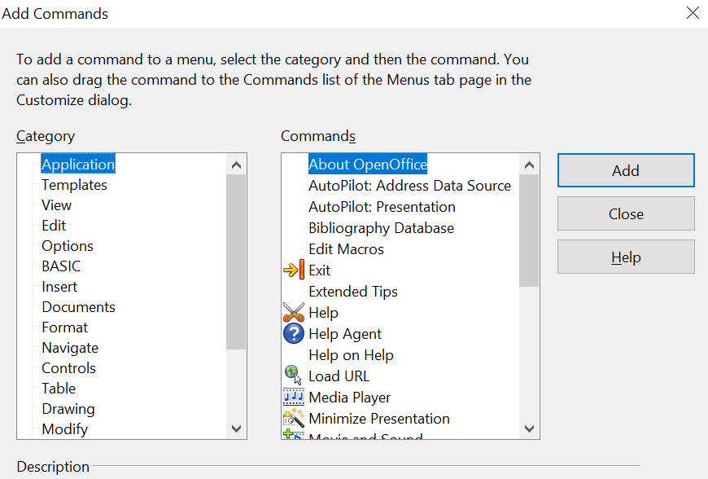

Figure 220: Adding a command to a menu

Modifying Menu Entries
In addition to changing the sequence of entries on a menu or submenu, you can add submenus, rename or delete the entries, and add group separators.
To begin, select the menu or submenu in the Menu list near the top of the Customize tab, then select the entry in the Entries list under Menu Content. Click the Modify button and choose the required action from the drop-down list. Most of the actions should be self-explanatory. Begin a group adds a separator line after the highlighted entry.

Customizing Toolbars
You can customize toolbars in several ways, including choosing which icons are visible and locking the position of a docked toolbar, as described in Chapter 1 (Introducing OpenOffice) of the Getting Started guide. This section describes how to create new toolbars and add other icons, that is, commands, to the list of those available on a toolbar.
To get to the toolbar customization dialog (Figure 221), do any of the following:
- On the toolbar, click the arrow at the end of the toolbar and choose Customize Toolbar.
- Choose View > Toolbars > Customize from the menu bar.
- Choose Tools > Customize > Toolbars tab from the menu bar.
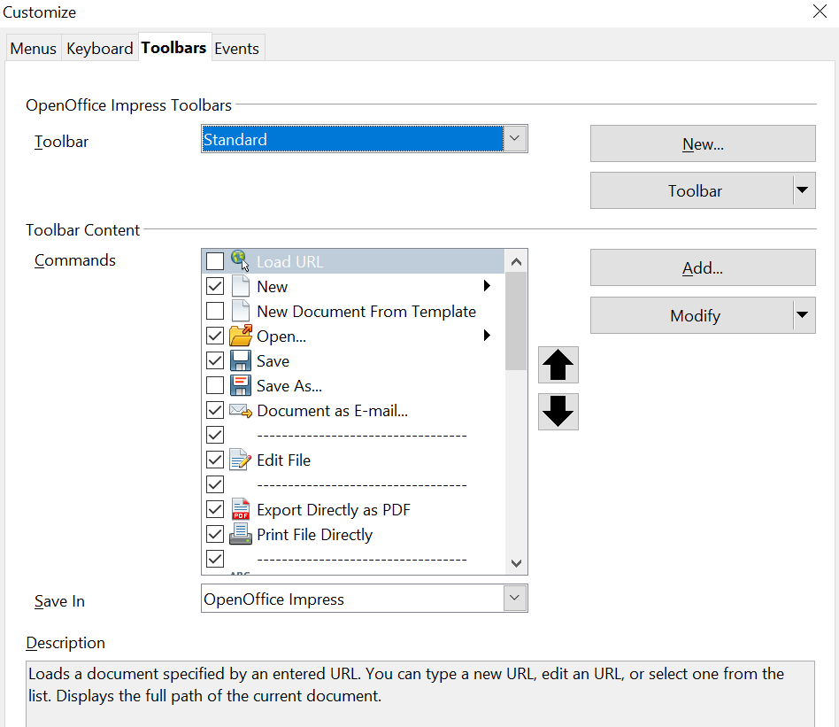

Figure 221. The Toolbars tab of the Customize window
To customize toolbars:
- In the Save In drop-down list, choose whether to save this changed toolbar for Impress or for a selected document.
- In the OpenOffice Impress Toolbars section, select the toolbar that you want to customize from the Toolbar drop-down list.
- Click the Toolbar button on the right to display a drop-down list of choices.
- To display or hide commands, select or deselect the check boxes in the Toolbar Content – Commands section.
- To change the hierarchical position of commands on a toolbar, select a command and then click the up arrow to move the command higher in the list, or the down arrow to move the command to a lower spot in the hierarchy. Both arrows are to the right of the lists.
- You can create a new toolbar by clicking on the New button, or customize existing toolbars by clicking on the Toolbar or Modify buttons, and add commands to a toolbar by clicking on the Add button. These actions are described below.
- When finished customizing toolbars, click OK to save your changes.

Creating a New Toolbar
To create a new toolbar:
- Choose Tools > Customize > Toolbars from the menu bar.
- Click New. In the Name dialog (Figure 222), type the new toolbar's name and, from the Save In drop-down list, choose where to save the changed menu.
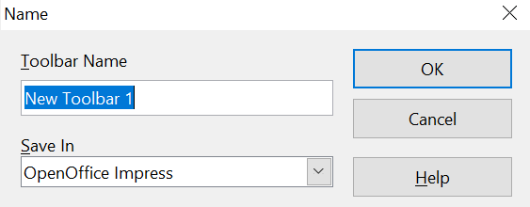

Figure 222: Dialog used to create a new toolbar
The new toolbar now appears on the list of toolbars in the Customize dialog. After creating a new toolbar, you need to add some commands to it, as described below.

Adding a Command to a Toolbar
If the list of available buttons for a toolbar does not include all the commands you want on that toolbar, you can add commands.
- On the Toolbars tab of the Customize dialog, select the toolbar in the Toolbar list and click the Add button in the Toolbar Content section of the dialog.
- The Add Commands dialog is the same as the one used for adding commands to menus. Select a category, choose the command, and click Add. The dialog remains open, so you can select additional commands. When you have finished adding commands, click Close. If you insert an item that does not have an associated icon, the toolbar will display the full name of the item; the next section describes how to choose an icon for a toolbar command.
- Back on the Customize dialog, you can use the up and down arrow buttons to arrange the commands in your preferred sequence.
- When you are done making changes, click OK to save.

Choosing Icons for Toolbar Commands
Toolbar buttons usually have icons, not words, on them, but not all commands have associated icons.
To choose an icon for a command, select the command and click Modify > Change icon. On the Change Icon dialog (Figure 223), you can scroll through the available icons, select one, and click OK to assign it to the command.
To use a custom icon, create it in a graphics program and import it into AOO by clicking the Import button on the Change Icon dialog. Custom icons must be 16 x 16 or 26 x 26 pixels in size and cannot contain more than 256 colors.
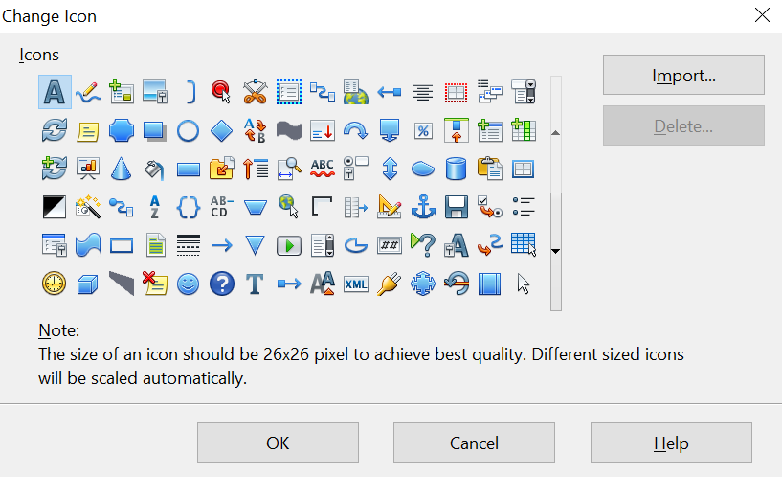

Figure 223: Change Icon dialog

Customizing Keyboard Shortcuts
The Appendix to this book lists the default keyboard shortcuts supplied with Impress. You can change these defaults or add new shortcuts. You can assign shortcuts to standard Impress functions or your own macros and save them for use with Impress only, or with the entire OpenOffice suite.
Caution | Be careful when reassigning your operating system’s or AOO’s predefined shortcut keys. Many key assignments are universally understood shortcuts, such as F1 for Help, and are always expected to provide certain results. Although you can easily reset the shortcut key assignments to the defaults, changing some common shortcut keys can cause confusion, frustration, and possible data loss or corruption, especially if other users share your computer.
As an example, suppose you wish to assign a shortcut key to insert a duplicate slide in your presentation easily. You could assign the Insert key as a logical shortcut for this purpose, as described below:
- Choose Tools > Customize.
- On the Customize dialog, pick the Keyboard tab (Figure 224).
- As the shortcut key assignment is only relevant with Impress, and not OpenOffice in general, select the Impress button (at the upper right corner of the Keyboard tab).
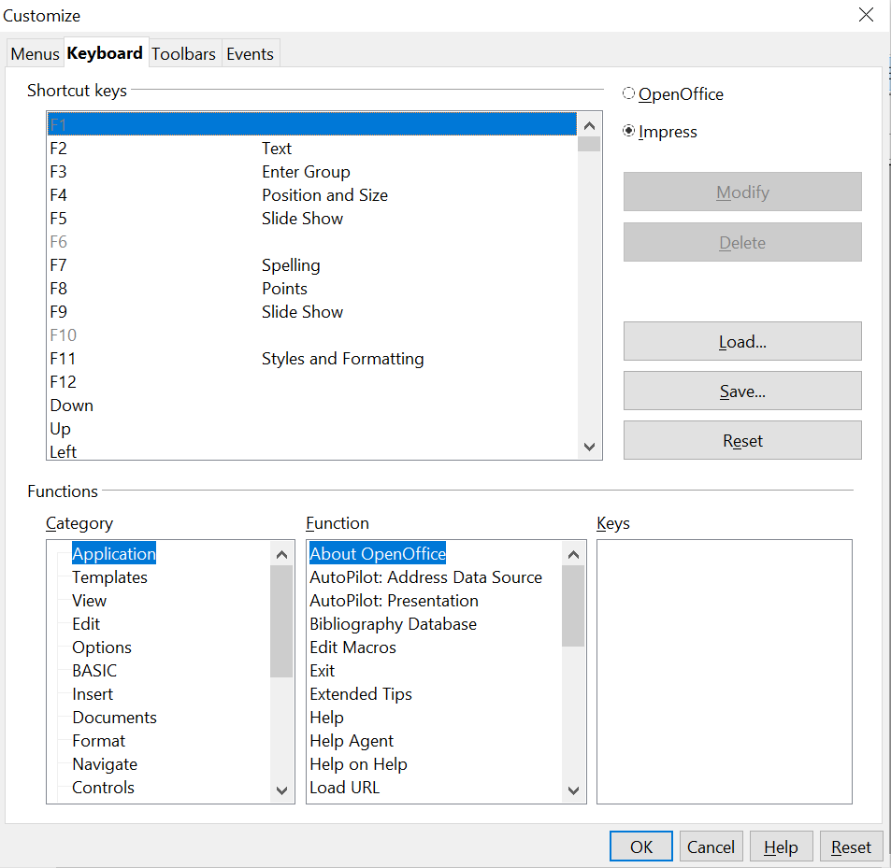

Figure 224: Customizing keyboard shortcuts
- Next, select Insert in the Category list and Duplicate Slide in the Function list.
- Now select the shortcut key Insert in the Shortcut keys list and click the Modify button at the upper right.
- Click OK to accept the change. Now the Insert shortcut key will insert a duplicate slide immediately after the currently selected slide.
Note | All existing shortcut keys for the currently selected Function are listed in the Keys selection box. Since there was no currently assigned shortcut for the Insert > Duplicate Slide function, the Keys list was empty. If it had not been, and you wished to reassign a shortcut key combination that was already in use, you would first have had to Delete the existing Key.  Shortcut keys that are greyed out in the Customize dialog listing, such as F1 and F10, are not available for reassignment.

Saving Changes to a File
Changes to the shortcut key assignments (and other configurations) can be saved in a keyboard configuration file for use at a later time, thus permitting you to create and apply different configurations as the need arises. To save keyboard shortcuts to a file:
- After making your keyboard shortcut assignments, click the Save button near the bottom right of the Customize dialog.
- In the Save Keyboard Configuration dialog, select All files from the Save as Type list.
- Next, enter a name for the keyboard configuration file in the File name box, or select an existing file from the list. If you need to, browse to find a file from another location.
- Click Save. A confirmation dialog will appear if you are about to overwrite an existing file; otherwise, there will be no feedback, and the file will be saved.

Loading a Saved Keyboard Configuration
To load a saved keyboard configuration file and replace your existing configuration, click the Load button near the bottom right of the Customize dialog, and then select the configuration file from the Load Keyboard Configuration dialog.

Resetting the Shortcut Keys
To reset all of the keyboard shortcuts to their default values, click the Reset button beneath the Save button on the right side of the Customize dialog. Use this feature with care, as no confirmation dialog will be displayed; the defaults will be set without any further notice or user input.

Running Macros from Key Combinations
You can also define shortcut key combinations that will run macros. These shortcut keys are strictly user-defined; none are built in. For information on macros, see Chapter 13 (Getting started with macros) in the Getting Started guide.

Adding Functionality with Extensions
An extension is a package that can be added to your existing OpenOffice configuration to offer new functionality.
Although individual extensions can be found in different places, the official Apache OpenOffice extension repository is at https://extensions.openoffice.org/. Some extensions are free of charge; others are available for a fee. Check the descriptions to see what licenses and fees apply to the ones that interest you.

Installing Extensions
To install an extension, follow these steps:
- Download an extension and save it anywhere on your computer.
- In AOO, select Tools > Extension Manager from the menu bar. In the Extension Manager dialog (Figure 225), click Add.
- A file browser window opens. Find and select the extension you want to install and click Open. The extension begins installing. You may be asked to accept a license agreement.
- When the installation is complete, the extension is listed in the Extension Manager dialog.
Tip | To get extensions that are listed in the repository, you can open the Extension Manager and click the Get more extensions online link.
Note | To install a shared extension, you need write access to the OpenOffice installation directory.
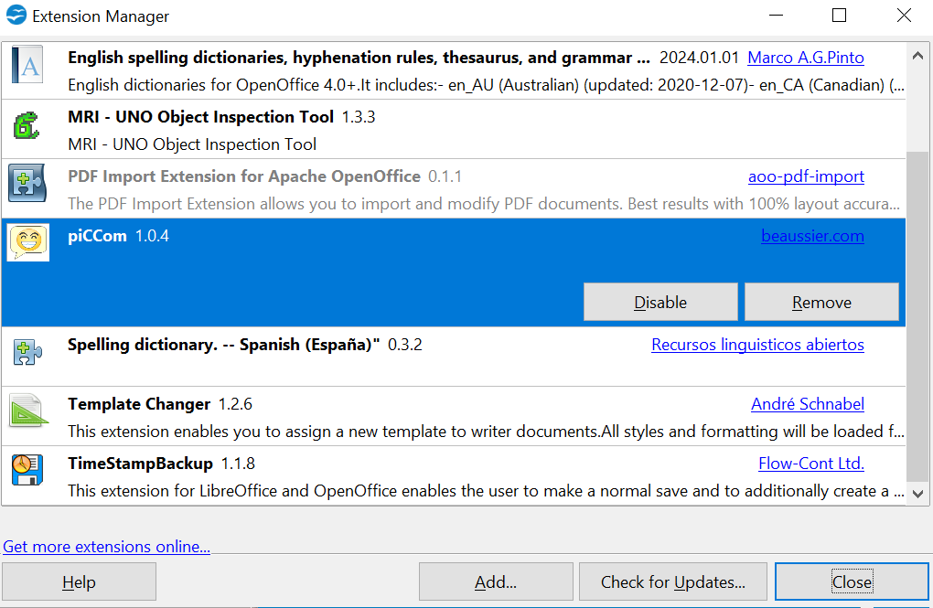

Figure 225: The Extension Manager

Appendix A
Keyboard Shortcuts

Introduction
You can use OpenOffice (AOO) without a pointing device, such as a mouse or trackball, by using its built-in keyboard shortcuts. Tasks as varied and complex as docking and un-docking toolbars and windows, or changing the size or position of objects can all be accomplished with only a keyboard. AOO has its own extensive set of keyboard shortcuts and, in addition, each component of AOO provides others which are specific to that component's function.
For help with AOO’s keyboard shortcuts, or using AOO with a keyboard only, search the AOO Help using the “shortcut” or “accessibility” keywords.
As well as using the built-in keyboard shortcuts (listed in this Appendix), you can also define your own. You can assign shortcuts to standard Impress functions or your own macros and save them for use with Impress only, or with the entire OpenOffice suite.
To adapt shortcut keys to your needs, use the Customize dialog as described in this section and in “Customizing keyboard shortcuts” in Chapter 11 (Setting Up and Customizing Impress).

Tip for Mac Users
Some keystrokes and menu items differ on a Mac from those used in Windows and Linux. The table below gives some common substitutions for the instructions in this chapter. For a more detailed list, see the application Help.

Windows/Linux | Mac equivalent | Effect
Tools > Options menu selection | OpenOffice > Preferences | Access setup options
Right-click | Control+click | Open context menu
Ctrl (Control) | z (Command) | Used with other keys
F5 | Shift+z+F5 | Open the Navigator
F11 | z+T | Open Styles & Formatting window

Function Keys for Impress
Shortcut Keys | Effect
F2 | Select text tool
F3 | Enter group
Ctrl+F3 | Exit group
Shift+F3 | Duplicate graphic object
F4 | Open Position and Size dialog box
F5 | View slide show
Ctrl+Shift+F5 | Open Navigator
F7 | Start spelling checker
Ctrl+F7 | Open thesaurus
F8 | Edit points
Ctrl+Shift+F8 | Fit text to frame
F11 | Open the Styles and Formatting window

Other Shortcut Keys for Impress
Shortcut Keys | Effect
Arrow key | Move the selected object or the page view in the direction of the arrow.
Ctrl+Arrow key | Move the slide in the normal view.
Shift+drag | Constrain the movement of the selected object horizontally or vertically.
Ctrl+drag  (with Copy when moving option active) | Hold down Ctrl and drag an object to create a copy of the object.
Alt key | Hold down Alt to draw or resize objects by dragging from the center of the object outward.
Alt+click | Select the object behind the currently selected object.
Alt+Shift+click | Select the object in front of the currently selected object.
Shift+click | Select adjacent items or a text passage. Click at the start of a selection, move to the end of the selection, and then hold down Shift while you click.
Shift+drag  (when resizing) | Hold down Shift while dragging to resize an object to maintain the proportions of the object.
Tab | Select objects in the order in which they were created.
Shift+Tab | Select objects in the reverse order in which they were created.
Escape | Exit current mode.
Enter | Activate a place-holder object in a new presentation (only if the frame is selected).
Ctrl+Enter | Move to the next text object on the slide.  If there are no text objects on the slide, or if you have reached the last text object, a new slide is inserted after the current slide. The new slide uses the same layout as the current slide.

Shortcut Keys in the Normal View
Shortcut Keys | Effect
Plus(+) key | Zoom in.
Minus(-) key | Zoom out.
Times(×) key  (number pad) | Fit page in window.
Divide(÷ or /) key  (number pad) | Zoom in on current selection.
Shift+Ctrl+G | Group selected objects.
Shift+Ctrl+Alt+A | Ungroup selected group.
Ctrl+click | Enter a group, so that you can edit the individual objects of the group. Click outside the group to return to the normal view.
Shift+Ctrl+K | Combine selected objects.
Shift+Ctrl+K | Split selected object. This combination only works on an object that was created by combining two or more objects.
Ctrl+Plus key | Bring to front.
Shift+Ctrl+Plus key | Bring forward.
Ctrl+Minus key | Send backward.
Shift+Ctrl+Minus key | Send to back.

Shortcut Keys in Slide Shows
Shortcut Keys | Effect
Esc | End presentation.
Spacebar or Right arrow or Down arrow or Page Down or Enter or Return or N | Play next effect (if any, else go to next slide).
Alt+Page Down | Go to next slide without playing effects.
[number] + Enter | Type the number of a slide and press Enter to go to the slide.
Left arrow or Up arrow or Page Up or Backspace or P | Play previous effect again. If no previous effect exists on this slide, show previous slide.
Alt+Page Up | Go to the previous slide without playing effects.
Home | Jump to first slide in the slide show.
End | Jump to the last slide in the slide show.
Ctrl+Page Up | Go to the previous slide.
Ctrl+Page Down | Go to the next slide.
B or . | Show black screen until next key or mouse wheel event.
W or , | Show white screen until next key or mouse wheel event.

Navigating in the Slide Sorter
Shortcut Keys | Effect
Escape | Moves the focus to the first slide.
Arrow key | Moves the focus to the next slide.
Spacebar | Makes the slide with the focus the current slide.

The shape of the cursor to move and resize objects is operating system specific.

