Chapter 1
Introducing Calc
Using Spreadsheets in Apache OpenOffice

What is Calc?
Calc is the spreadsheet component of Apache OpenOffice (AOO). In a spreadsheet, you enter data, usually numerical, and then manipulate that data to produce certain results.
Alternatively, you can enter data and then use Calc in a ‘What if…’ manner by changing some data and observing the results, without having to retype the entire spreadsheet.
Other features provided by Calc include:
- Functions, which can create formulas that perform complex calculations on data
- Database functions that arrange, store, and filter data, both numerical and textual
- Dynamic charts: a wide range of 2D and 3D charts that can change as the data upon which they are based changes
- Macros for recording and executing repetitive tasks. The supported programming or scripting languages include OpenOffice Basic, Python, BeanShell, and JavaScript
- Ability to open, edit, and save Microsoft Excel spreadsheets. Files in the more recent XLSX format can be opened, but they'll be saved in the older XLS format.
- Import and export of spreadsheets in multiple formats, including HTML, CSV, PDF, and PostScript
Note | If you want to use macros written in Microsoft Excel using VBA macro code, you must first edit the code in the AOO Basic IDE editor. See Chapter 12 (Calc Macros).

Spreadsheets, Sheets, and Cells
Calc works with entities called spreadsheets. Spreadsheets are not necessarily stand-alone and can be composed of multiple individual sheets, each sheet containing cells organized in rows and columns. A specific cell is identified by its row number and column letter – for instance, D7 for row 7, column D, as in the illustration below.

A1 | B1 | C1 | D1 | E1 | F1 | G1
2
3
4
5
6
7 |  |  | D7
8
Cells hold data, including text, numbers, formulas, and so on, that make up what will be displayed and manipulated.
A spreadsheet can have many sheets, each with many individual cells. Each sheet can have a maximum of 1,048,576 rows and a maximum of 1024 columns.

Parts of the Main Calc Window
When Calc is started, the main window looks similar to Figure 1.
Note | If any part of the Calc window in Figure 1 is not shown, you can display it using the View menu. For example, View > Status Bar will toggle (show or hide) the Status Bar. It is not always necessary to display all the parts as shown; show or hide any of them, as desired.

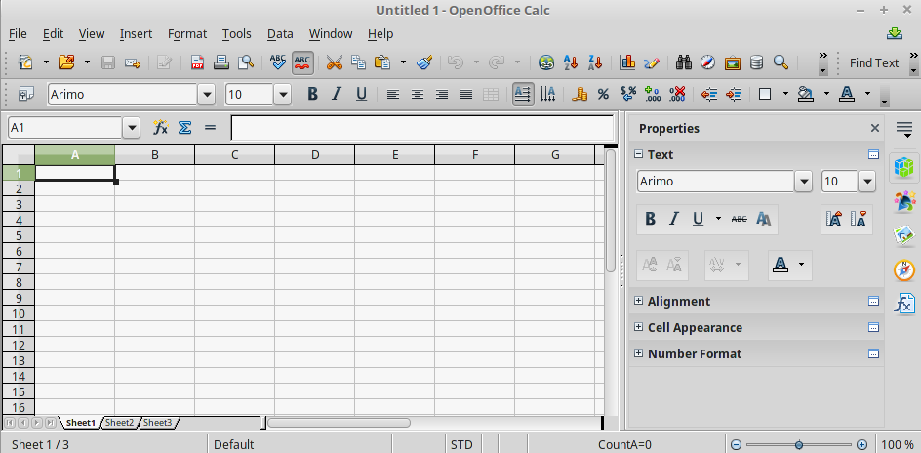
Figure 1: Parts of the Calc window
Title bar
Menu bar
Standard toolbar
Formatting toolbar
Sidebar
Name box
Row headers
Column headers
Active cell
Sheet tabs
Status bar
Formula bar

Title Bar
The Title bar, located at the top, shows the name of the current spreadsheet. When the spreadsheet is newly created, its name is Untitled X, where X is a number. When you save a spreadsheet for the first time, you are prompted to enter a name of your choice.

Menu Bar
Under the Title bar is the Menu bar. When you choose one of the menus, a submenu appears with other options. You can modify the Menu bar, as discussed in Chapter 14 (Setting Up and Customizing Calc).
- File contains commands that apply to the entire document, such as Open, Save, Wizards, Export as PDF, and Digital Signatures.
- Edit contains commands for editing the document, such as Undo, Changes, Compare Document, and Find & Replace.
- View contains commands for modifying how the Calc user interface looks, such as Toolbars, Full Screen, and Zoom.
- Insert contains commands for inserting elements, such as cells, rows, columns, sheets, and pictures into a spreadsheet.
- Format contains commands for modifying the layout of a spreadsheet, such as Styles and Formatting, Page, and Merge Cells.
- Tools contains functions, such as Spelling, Share Document, Cell Contents, Gallery, and Macros.
- Data contains commands for manipulating data in your spreadsheet, such as Define Range, Sort, Filter, and Pivot Table.
- Window contains commands for the display window, such as New Window, Split, and Freeze.
- Help contains links to the Help file bundled with the software, What's This?, Support, and Check for Updates.

Toolbars
Calc has several types of toolbars
- docked, that is, fixed in place
- floating
- tear-off
Docked toolbars can be moved to different locations or made to float, and floating toolbars can be docked.
By default, four toolbars are located under the Menu bar by default: the Standard toolbar, the Find toolbar, the Formatting toolbar, and the Formula Bar.
The icons (buttons) on these toolbars provide a wide range of common commands and functions. As discussed in Chapter 14 (Setting Up and Customizing Calc), you can also modify these toolbars.
Placing the mouse pointer over any toolbar icons will display a small box called a tooltip. It gives a brief explanation of the icon’s function. For a more detailed explanation, choose Help > What’s This? and hover the mouse pointer over the icon. To turn this feature off again, click once or press the Esc key twice. Tips and extended tips can be turned on or off from Tools > Options > OpenOffice > General.

Displaying or Hiding Toolbars
To display or hide toolbars, choose View > Toolbars, then click on the name of a toolbar in the list. An active toolbar shows a check mark beside its name. Tear-off toolbars are not listed in the View menu.

Palettes and Tear-off Toolbars
Toolbar icons with a small triangle to the right display palettes, tear-off toolbars, and other items that can be chosen. Figure 2 shows an example of a palette. It is displayed by clicking the small triangle to the right of the Borders toolbar icon.
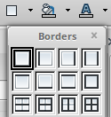

Figure 2: Toolbar palette
Figure 3 shows an example of a tear-off toolbar. Tear-off toolbars can be floating or docked along an edge of the screen or in one of the existing toolbar areas. To move a floating tear-off toolbar, drag it by its title bar.
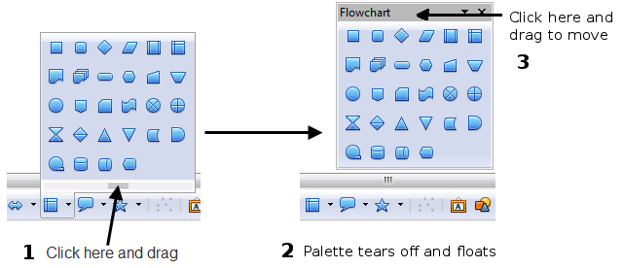
Figure 3: Example of a tear-off toolbar

Moving Toolbars
To move a docked toolbar, place the mouse pointer over the toolbar handle, hold down the left mouse button, drag the toolbar to the new location, and then release the mouse button. Figure 4 illustrates this tactic.
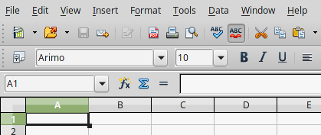

Figure 4: Moving a docked toolbar
Handles of docked
toolbars
To move a floating toolbar, click on its title bar and drag it to a new location, as was shown in Figure 3 for a tear-off toolbar.

Docking/Floating Windows and Toolbars
Toolbars and some windows, such as the Navigator and the Styles and Formatting window, are dockable. You can move, resize, or dock them to an edge.
To dock a window or toolbar, hold down the Control key and double-click on the frame of the floating window (or in a vacant area near the icons at the top of the floating window) to dock it in its last position.
To undock a window, hold down the Control key and double-click on the frame (or a vacant area near the icons at the top) of the docked window.
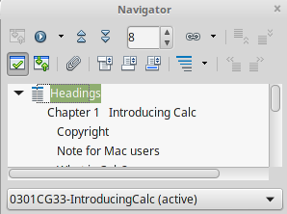

Figure 5: Control+double-click to dock or undock

Customizing Toolbars
You can customize toolbars in several ways, including:
- choosing which icons are visible
- locking the position of a docked toolbar.
To access a toolbar’s customization options, use the down-arrow at the end of the toolbar or on its title bar (Figure 6).
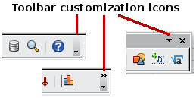
Figure 6: Customizing toolbars
Choose Visible Buttons from the drop-down menu to show or hide icons defined for the selected toolbar. Visible icons are indicated by a border around the icon (Figure 7). Click on icons to hide or show them on the toolbar.
You can also add icons and create new toolbars, as described in Chapter 16.
Figure 7: Selection of visible toolbar icons

Formatting Toolbar
In the Formatting toolbar, the three boxes on the left are the Apply Style, Font Name, and Font Size lists (see Figure 8). They show the current settings for the selected cell or area. (The Apply Style list may not be visible by default.) Click the down-arrow to the right of each box to open the list.
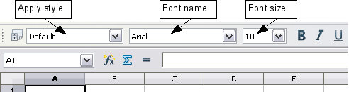
Figure 8: Apply Style, Font Name and Font Size lists

Note | If any of the icons (buttons) in Figure 8 are not shown, you can display it by clicking the small triangle at the right end of the Formatting toolbar, selecting Visible Buttons in the drop-down menu, and selecting the desired icon (for example, Apply Style) in the drop-down list. It is not always necessary to display all the toolbar buttons as shown; show or hide any of them, as desired.

Formula Bar
On the left-hand side of the Formula Bar is a small text box called the Name Box. It contains a letter and number combination such as D7. This combination called the cell reference, is the elected cell's column letter and row number.
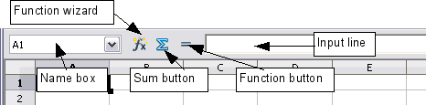
Figure 9: Formula Bar
To the right of the Name Box are the Function Wizard, Sum, and Function buttons.
Clicking the Function Wizard button opens a dialog from which you can search through a list of available functions. This can be very useful; it shows how functions are formatted.
In a spreadsheet, the term function applies to much more than mathematical functions. See Chapter 7 (Using Formulas and Functions) for more details.
Clicking the Sum button inserts a formula into the current cell that will total the numbers in the cells above the current cell. If there are no numbers above the current cell, the values in the cells to the left are placed in the Sum formula.
Clicking the Function button inserts an equal (=) sign into the selected cell and the Input line. That equal sign must be present to allow the cell in question to accept a formula.
When you enter new data into a cell, the Sum and Equals buttons change to Cancel and Accept buttons .
The contents of the current cell, whether data or a formula, are displayed in the Input line, which is the remainder of the Formula Bar. You can either edit the cell contents of the current cell there, or you can do that in the current cell. To edit inside the Input line area, click in the area, then type your changes. To edit within the current cell, double-click the cell.

Sidebar
The Sidebar combines functions from several toolbars and menus into one convenient location. For a thorough description of it, see the Getting Started Guide. Briefly, the Sidebar in Calc has five Decks that can be selected with the colored icons at the right edge of the Sidebar region, as seen in Figure 1. Starting from the top, these icons represent Properties, Styles and Formatting, the Gallery, the Navigator, and the Function Wizard. More details about using the Sidebar are provided in the relevant sections in later chapters. Hiding the Sidebar is sometimes convenient when working with a spreadsheet with many columns. This can be done with the menu View > Sidebar or by double-clicking the Hide button which is a faint series of dots at the left edge in the vertical middle of the Sidebar.

Right-click (Context) Menus
Right-click on a cell, graphic, or other object to open a context menu. Often the context menu is the fastest and easiest way to reach a function. If you’re not sure where a function is located in the menus or toolbars, you may be able to find it by right-clicking.

Individual Cells
The main section of the screen displays the cells in the form of a grid, with each cell being at the intersection of a column and a row.
At the top of the columns and at the left end of the rows are a series of gray boxes containing letters and numbers. These are the column and row headers. The columns start at A and go on to the right, and the rows start at 1 and go down.
These column and row headers form the cell references that appear in the Name Box on the Formula Bar (see Figure 9). You can turn these headers off by selecting View > Column & Row Headers.

Sheet Tabs
Sheet tabs can be found at the bottom of the grid of cells. These tabs enable access to each individual sheet, with the visible, active sheet having a white tab. Clicking on another sheet tab displays that sheet, and its tab turns white. You can also select multiple sheet tabs at once by holding down the Control key while you click the names.
You can choose colors for sheet tabs. Right-click on a tab and select Tab Color from the pop-up menu to open a palette of colors. To add new colors to the palette, see “Color options” in Chapter 14 (Setting up and Customizing Calc).
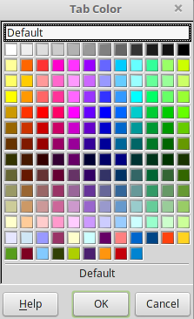
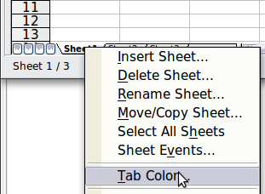
Figure 10: Choose tab color

Status Bar
The Calc status bar provides information about the spreadsheet, and convenient ways to change some of its features.
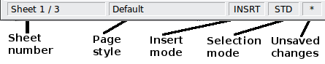
Figure 11: Left end of Calc status bar
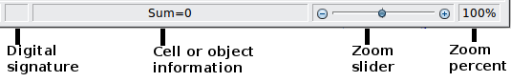
Figure 12: Right end of Calc status bar
Sheet sequence number ()
Shows the sequence number of the current sheet and the total number of sheets in the spreadsheet. The sequence number may not correspond with the name on the sheet tab.
Page style ()
Shows the page style of the current sheet. To edit the page style, double-click on this field. The Page Style dialog opens.
Insert mode ()
Click to toggle between INSRT (Insert) and OVER (Overwrite) modes when typing. This field is blank when the spreadsheet is not in a typing mode (for example, when selecting cells).
Selection mode ()
Click to toggle between STD (Standard), EXT (Extend), and ADD (Add) selection. EXT is an alternative to Shift+click when selecting cells. See page 22 for more information.
Unsaved changes ()
An asterisk (*) appears here if changes to the spreadsheet have not been saved.
Digital signature ()
If the document has not been digitally signed, double-clicking in this area opens the Digital Signatures dialog, with which you can sign the spreadsheet. See Chapter 6 (Printing, Exporting, and E-mailing) for more about digital signatures.
If the document has been digitally signed, an icon shows in this area. You can double-click the icon to view the certificate. Note that a document can be digitally signed only after it has been saved.
Cell or object information ()
Displays information about the selected items. When a group of cells is selected, the sum of the contents is displayed by default; you can right-click on this field and select other functions, such as the average value, maximum value, minimum value, or count (number of items selected).
When the cursor is on an object such as a picture or chart, the information shown includes its size and location.
Zoom ()
To change the view magnification, drag the Zoom slider or click on the + and – signs. You can also right-click on the zoom level percentage to select a magnification value or double-click to open the Zoom & View Layout dialog.

Starting New Spreadsheets
You can start a new, blank document in Calc in several ways.
- From the operating system menu, in the same way that you start other programs. When AOO was installed on your computer, in most cases, a menu entry for each component was added to your system menu. Mac users should see the OpenOffice icon in the Applications folder. When you double-click this icon, AOO opens at the Start Center (Figure 14).
- From the Quickstarter, which is found in Windows, some Linux distributions, and in a slightly different form, in macOS. The Quickstarter is an icon that is placed in the system tray or the dock during system startup. It indicates that OpenOffice has been loaded and is ready to use.
Right-click the Quickstarter icon (Figure 13) in the system tray to open a pop-up menu from which you can open a new document, open the Templates and Documents dialog box, or choose an existing document to open. You can also double-click the Quickstarter icon to display the Templates and Documents dialog box.
See Chapter 1 (Introducing OpenOffice) in the Getting Started guide for more information about using the Quickstarter.
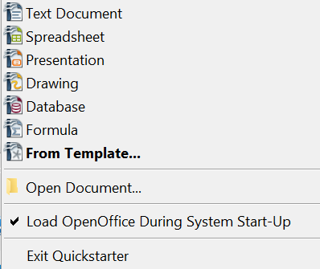

Figure 13: Quickstarter pop-up menu on Windows
- From the Start Center. When AOO is open without any documents open, e.g., if you close all the open documents but leave the program running, the Start Center is shown. Click one of the icons to open a new document of that type, or click the Templates icon to start a new document using a template. If a document is already open in AOO, the new document opens in a new window.
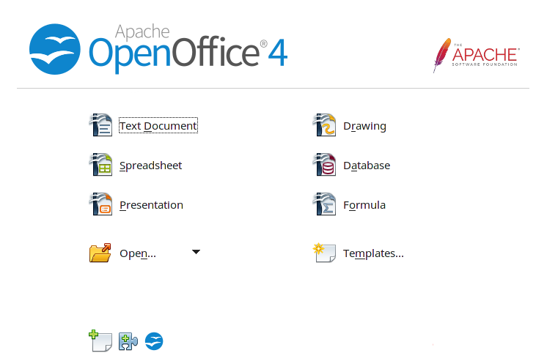

Figure 14: OpenOffice Start Center
When AOO is open, you can start a new document in any of the following ways.
- Press the Control+N keys.
- Use File > New > Spreadsheet.
- Click the New button on the main toolbar.

Starting a New Document from a Template
Calc documents can also be created from templates. Follow the procedures above, but instead of choosing Spreadsheet, choose the Templates icon from the Start Center or File > New >Templates and Documents from the Menu bar or toolbar.
On the Templates and Documents window (Figure 15), navigate to the appropriate folder and double-click on the required template. A new spreadsheet, based on the selected template, opens.
A new OpenOffice installation does not contain many templates, but you can add more by downloading them from https://extensions.openoffice.org and installing them as described in Chapter 14 (Setting Up and Customizing Calc).
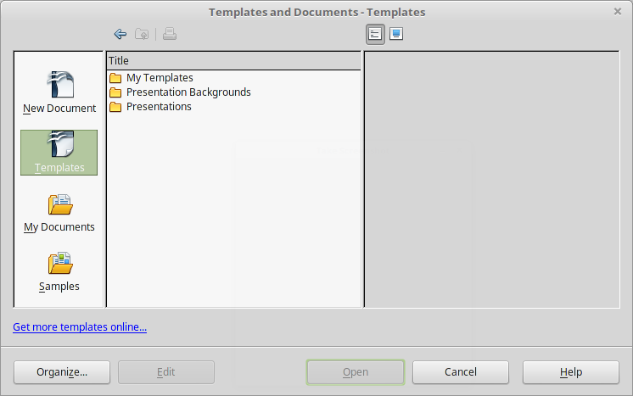

Figure 15: Starting a new spreadsheet from a template

Opening Existing Spreadsheets
When no document is open, the Start Center (Figure 14) provides an icon for opening an existing document, or choosing from a list of recently-edited documents.

You can also open an existing document in one of the following ways.
- Choose File > Open….
- Click the Open button on the main toolbar.
- Press Control+O on the keyboard.
- Use File > Recent Documents to display the last 10 files opened in any of the AOO components.
- Use the Open Document or Recent Documents selections on the Quickstarter.
In each case, the Open dialog box appears. Select the file you want, and then click Open. If a document is already open in AOO, the second document opens in a new window.

Opening CSV Files
Comma-separated-values (CSV) files are text files that contain the cell contents of a single sheet. Each line in a CSV file represents a row in a spreadsheet. Commas, semicolons, or other characters are used to separate the cells. Text is entered in quotation marks; numbers are entered without quotation marks.
To open a CSV file in Calc:
- Choose File > Open.
- Locate the CSV file that you want to open.
- If the file has a *.csv extension, select the file and click Open.
- If the file has another extension (for example, *.txt), select the file, select Text CSV (*csv;*txt) in the File type box (scroll down into the spreadsheet section to find it) and then click Open.
- On the Text Import dialog (Figure 16), select the Separator options to divide the text in the file into columns.
You can preview the layout of the imported data at the bottom of the dialog. Right-click a column in the preview to set the format or hide the column.
If the CSV file uses a text delimiter character not in the Text delimiter list, click in the box, and type the character.
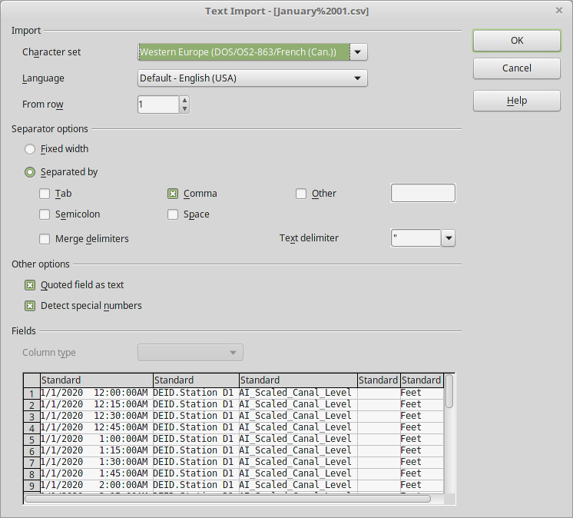
Figure 16: Text Import dialog, with Comma (,) selected as the separator and double quotation mark (“) as the text delimiter.
- The Detect special numbers option is very helpful for importing numbers written with currency symbols or dates that will otherwise be treated as text.
- Click OK to open the file.
Caution   | If you do not select Text CSV (*csv;*txt) as the file type when opening the file, the document opens in Writer, not Calc.

Saving Spreadsheets
Spreadsheets can be saved in three ways.
- Press Control+S.
- Choose File > Save (or Save All or Save As).
- Click the Save button on the main toolbar.
If the spreadsheet has not been saved previously, then these actions will open the Save As dialog. There, you can specify the spreadsheet name and the location to save it.
Note | If the spreadsheet has been previously saved, then saving it using the Save (or Save All) command will overwrite an existing copy. However, you can save the spreadsheet in a different location or with a different name by selecting File > Save As.

Saving as a Microsoft Excel Document
Some users of Microsoft Excel may be unwilling to use *.ods files. In such a case, you can save a document as an Excel file (*.xls). Be aware that some formatting may be lost when saving in a non-AOO format, particularly in complex documents.
- Important—First save your spreadsheet in the file format used by OpenOffice, *.ods. If you do not, any changes you may have made since the last time you saved it will only appear in the Microsoft Excel version of the document.
- Then choose File > Save As.
- On the Save As dialog (Figure 17), in the File type (or Save as type) drop-down menu, select the type of Excel format you need. Click Save.
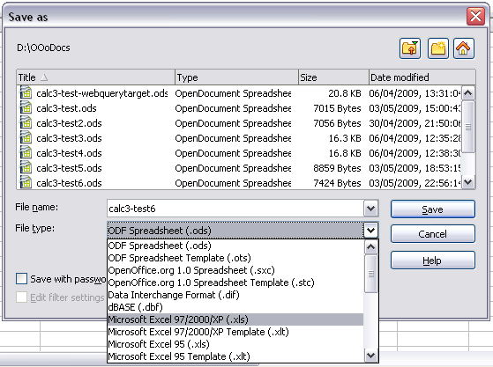
Figure 17. Saving a spreadsheet in Microsoft Excel format
Caution | From this point on, all changes you make to the spreadsheet will occur only in the Microsoft Excel document, since you have changed the name and file type of that document. If you want to go back to working with the *.ods version of your spreadsheet, you must open it again.

Tip | To have Calc save documents by default in a Microsoft Excel file format, go to Tools > Options > Load/Save > General. In the section named Default file format and ODF settings, under Document type, select Spreadsheet, then under Always save as, select your preferred file format.

Saving as a CSV File
To save a spreadsheet as a comma-separated value (CSV) file:
- Choose File > Save As.
- In the File name box, type a name for the file.
- In the File type list, select Text CSV (*.csv) and click Save.
You may see the message box shown below. Click Keep Current Format.

- In the Export of text files dialog, select the options you want and then click OK.
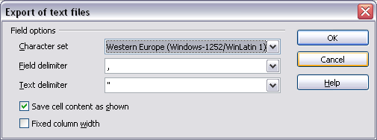
Figure 18: Choosing options when exporting to Text CSV
The CSV file format only stores text and data from a single sheet. Since that's the case, only the active sheet will be saved. Any graphics or charts will not be part of the CSV file.

Saving in Other Formats
Calc can save spreadsheets in various formats, including HTML, through the Save As dialog. Calc can also export spreadsheets to PDF and XHTML file formats. For more information, see Chapter 6 (Printing, Exporting, and E-mailing).

Password Protection
Calc provides two levels of document protection:
- read-protect, under which the file cannot be viewed without a password
- write-protect, with which the file can be viewed in read-only mode but cannot be changed without a password.
The latter method can make content available for reading by a selected group and for reading and editing by a different group.
- Use File > Save As when saving the document. (You can also use File > Save the first time you save a new document.)
- On the Save As dialog, type the file name, select the Save with password option, and then click Save.

- The Set Password dialog opens.
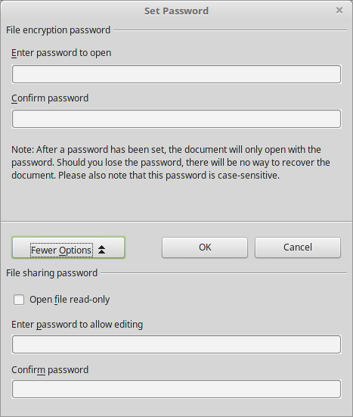

Figure 19: Two levels of password protection
The Set Password dialog offers several choices:
- To read-protect the document, type a password in the two fields at the top of the dialog box.
- To write-protect the document, click the More Options button and select the Open file read-only checkbox.
- To write-protect the document but allow selected people to edit it, select the Open file read-only checkbox and type a password in the two boxes at the bottom of the dialog box.
- Click OK to save the file. If either pair of passwords do not match, you receive an error message. Close the message box to return to the Set Password dialog box and enter the password again.
Caution | AOO uses a very strong encryption mechanism that makes it almost impossible to recover the contents of a document if you lose the password.

Navigating within Spreadsheets
Calc provides many ways to navigate within a spreadsheet, from cell to cell and sheet to sheet. Use the method you prefer!

Going to a Particular Cell
Using the mouse
Place the mouse pointer over the cell and click.
Using a cell reference
Click on the small inverted black triangle just to the right of the Name Box (Figure 9). The existing cell reference will be highlighted. Type the cell reference of the cell you want to go to, and press Enter. Cell references are case insensitive; a3 or A3, for example, are the same. Or just click into the Name Box, backspace over the existing cell reference, type in the cell reference you want, and press Enter.
Using the Navigator
Click on the Navigator button in the Sidebar or the Standard toolbar (or press F5) to display the Navigator. Type the cell reference into the top two fields, labeled Column and Row, and press Enter. In Figure 32 on page 32, the Navigator would select cell A7. For more about using the Navigator, see page 32.

Tip | The Navigator can make your job a lot easier, especially when dealing with crowded spreadsheets. Think of it as Calc's analog to a Star Trek transporter.

Moving from Cell to Cell
In an AOO spreadsheet, one cell normally has a darker black border. This black border indicates where the focus is (see Figure 20). In turn, focus indicates which cell is enabled to receive input. If a group of cells is selected, they have a highlight color (usually gray), with the focus cell having a dark border.
Using the mouse
To move the focus using the mouse, simply move the mouse pointer to the cell where you want it to be and click the left mouse button. This action changes the focus to the new cell and is most useful when the two cells are a large distance apart.
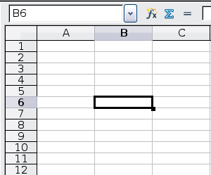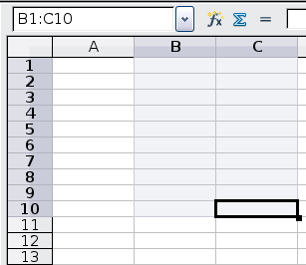
Figure 20. (left) One selected cell and (right) a group of selected cells
Using the Tab and Enter keys
- Pressing Enter or Shift+Enter moves the focus down or up, respectively.
- Pressing Tab or Shift+Tab moves the focus to the right or to the left, respectively.
Using the arrow keys
Pressing the arrow keys on the keyboard moves the focus in the direction of the arrows.
Using Home, End, Page Up, and Page Down
- Home moves the focus to the start of a row.
- End moves the focus to the column furthest to the right that contains data.
- Page Down moves the display down one complete screen; Page Up moves the display up one complete screen.
- Combinations of Control (often represented on keyboards as Ctrl) and Alt with Home, End, Page Down (PgDn), Page Up (PgUp), and the arrow keys move the focus of the current cell in other ways. Table 1 describes the keyboard shortcuts for moving about a spreadsheet.
Tip | Use one of the four Alt+Arrow key combinations to resize a cell's height or width. For example, Alt+↓ increases the height of a cell.

Table 1. Moving from cell to cell using the keyboard
Key Combination | Movement
→ | Right one cell
← | Left one cell
↑ | Up one cell
↓ | Down one cell
Control+→ | To the next column to the right containing data in that row or to the last column (Column AMJ)
Control+← | To the next column to the left containing data in that row or to Column A
Control+↑ | To the next row above containing data in that column or to Row 1
Control+↓ | To the next row below containing data in that column or to Row the last row (1048576)
Control+Home | To Cell A1
Control+End | To lower right-hand corner of the rectangular area containing data
Alt+Page Down | One screen to the right (if possible)
Alt+Page Up | One screen to the left (if possible)
Control+Page Down | One sheet to the right (in sheet tabs)
Control+Page Up | One sheet to the left (in sheet tabs)
Tab | To the next cell on the right
Shift+Tab | To the next cell on the left
Enter | Down one cell (unless changed by user)
Shift+Enter | Up one cell (unless changed by user)

Customizing the Effects of the Enter Key
You can customize the direction in which the Enter key moves the focus by selecting Tools > Options > OpenOffice Calc > General.
The four choices for the direction of the Enter key are shown on the right-hand side of Figure 21. It can move the focus down, right, up, or left. Depending on the file being used or on the type of data being entered, setting a different direction can be useful.
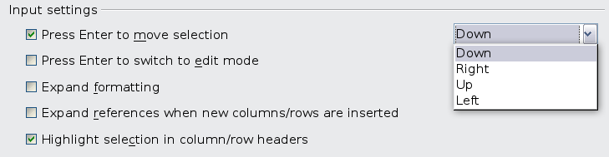
Figure 21: Customizing the effect of the Enter key
The Enter key can also be used to switch into and out of the editing mode. Use the first two options under Input settings in Figure 21 to change the Enter key settings.

Moving from Sheet to Sheet
Each sheet in a spreadsheet is independent of the others, though they can be linked with references from one sheet to another. There are three ways to navigate between different sheets in a spreadsheet.
Using the keyboard
Pressing Control+Page Down moves one sheet to the right, and pressing Control+Page Up moves one sheet to the left.
Using the mouse
Clicking on one of the sheet tabs at the bottom of the spreadsheet selects that sheet.
If you have a lot of sheets, then some sheet tabs may be hidden behind the horizontal scroll bar at the bottom of the screen. If this is the case, then the four buttons at the left of the sheet tabs can move the tabs into view. Figure 22 shows how to do this.
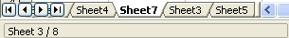

Figure 22. Sheet tab arrows
Move to the first sheet
Move left one sheet
Move right one sheet
Move to the last sheet
Sheet tabs

Note | Notice that sheets are not numbered in order. Sheet numbering is arbitrary; you can identify a sheet however you wish. Also, sheet tab arrows shown in Figure 22 only appear if you have some sheet tabs that can not be seen. Otherwise, they appear faded as in Figure 1.

Selecting Items in a Sheet or Spreadsheet

Selecting Cells
Cells can be selected in a variety of combinations and quantities.
Single cell
Left-click in the cell. The result will look like the left side of Figure 20. You can verify your selection by looking in the Name Box.
Range of contiguous cells
A range of cells can be selected using the keyboard or the mouse.
To select a range of cells by dragging the mouse:
- Click in a cell.
- Press and hold down the left mouse button.
- Move the mouse around the screen.
- Once the desired block of cells is highlighted, release the left mouse button.
To select a range of cells without dragging the mouse:
- Click in the cell which is to be one corner of the range of cells.
- Move the mouse to the opposite corner of the range of cells.
- Hold down the Shift key and click.
Tip | You can also select a contiguous range of cells by first clicking in the STD field on the status bar and changing it to EXT before clicking in the opposite corner of the range of cells in step 3 above. If you use this method, be sure to change EXT back to STD, or you may find yourself extending the selection unintentionally.

To select a range of cells without using the mouse:
- Select the cell that will be one of the corners in the range of cells.
- While holding down the Shift key, use the cursor arrows to select the rest of the range.
The result of these methods looks like the right side of Figure 20.
Tip | You can also directly select a range of cells using the Name Box. Click into the Name Box as described in “Using a cell reference” on page 19. To select a range of cells, enter the cell reference for the upper left-hand cell, followed by a colon (:), and then the lower right-hand cell reference. For example, to select the range that would go from A3 to C6, you would enter A3:C6.

Range of noncontiguous cells
- Select the cell or range of cells using one of the methods above.
- Move the mouse pointer to the start of the next range or single cell.
- Hold down the Control key and click or click-and-drag to select another range of cells to add to the first range.
- Repeat as necessary.
Tip | You can also select a noncontiguous range of cells by first clicking twice in the STD field on the status bar to change it to ADD before clicking on a cell that you want to add to the range of cells in step 3 above. This method works best when adding single cells to a range. If you use this method, be sure to change ADD back to STD, or you may find yourself adding more selections unintentionally.

Selecting Columns and Rows
Entire columns and rows can be selected very quickly in AOO.
Single column or row
To select a single column, click on the column identifier letter (see Figure 1).
To select a single row, click on the row identifier number.
Multiple columns or rows
To select multiple columns or rows that are contiguous:
- Click on the first column or row in the group.
- Hold down the Shift key.
- Click the last column or row in the group.
To select multiple columns or rows that are not contiguous:
- Click on the first column or row in the group.
- Hold down the Control key.
- Click on all the subsequent columns or rows while holding down the Control key.
Entire sheet
To select the entire sheet, click the small box between the A column header and the 1 row header.
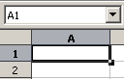

Figure 23. Select All box
Select All
You can also press Control+A to select the entire sheet.

Selecting Sheets
You can select either one or multiple sheets. Selecting multiple sheets can be effective when you want to make changes to them simultaneously.
Single sheet
Click on the tab for the sheet you want to select. The tab of the active sheet becomes white (see Figure 22).
Multiple contiguous sheets
To select multiple contiguous sheets:
- Click on the sheet tab for the first desired sheet.
- Move the mouse pointer over the sheet tab for the last desired sheet.
- Hold down the Shift key and click on the sheet tab.
All the tabs between these two sheets will turn white. Any actions that you perform now will affect all highlighted sheets.
Multiple noncontiguous sheets
To select multiple noncontiguous sheets:
- Click on the sheet tab for the first desired sheet.
- Move the mouse pointer over the sheet tab for the second desired sheet.
- Hold down the Control key and click on the sheet tab.
- Repeat as necessary.
The selected tabs will turn white. Any actions that you perform will now affect all highlighted sheets.
All sheets
Right-click any one of the sheet tabs and choose Select All Sheets from the pop-up menu.

Working with Columns and Rows

Inserting Columns and Rows
Columns and rows can be inserted individually or in groups.
Note | When you insert a single new column, it is inserted to the left of the highlighted column. When you insert a single new row, it is inserted above the highlighted row.  Cells in the new columns or rows are formatted like the corresponding cells in the column or row before (or to the left of) which the new column or row is inserted.
Single column or row
Using the Insert menu:
- Select the cell, column, or row where you want the new column or row inserted.
- Choose either Insert > Columns or Insert > Rows.
Using the mouse:
- Select the cell, column, or row where you want the new column or row inserted.
- Right-click the header of the column or row.
- Choose Insert Rows or Insert Columns.
Multiple columns or rows
Multiple columns or rows can be inserted simultaneously rather than one at a time.
- Highlight the required number of columns or rows by holding down the left mouse button on the first one and then dragging across the required number of identifiers.
- Proceed as for inserting a single column or row above.

Deleting Columns and Rows
Columns and rows can be deleted individually or in groups.
Single column or row
A single column or row can be deleted by using the mouse.
- Select the column or row to be deleted.
- Choose Edit > Delete Cells from the menu bar.
Or,
- Right-click on the column or row header.
- Choose Delete Columns or Delete Rows from the pop-up menu.
Multiple columns or rows
Multiple columns or rows can be deleted at once rather than deleting them one at a time.
- Highlight the required columns or rows by holding down the left mouse button on the first one and then dragging across the required number of identifiers.
- Proceed as for deleting a single column or row above.
Tip | Instead of deleting a row or column, you may wish to delete the contents of the cells, but keep the empty row or column. See Chapter 2 (Entering, Editing, and Formatting Data) for instructions.

Working with Sheets
Like any other Calc element, sheets can be inserted, deleted, and renamed.

Inserting New Sheets
There are several ways to insert a new sheet.
The first step for all such methods is to select the sheets that will be next to the new sheet to be inserted. Then, any of the following options can be used.
- Choose Insert > Sheet from the menu bar.
- Right-click on the sheet tab and choose Insert Sheet.
- Click in an empty space at the end of the line of sheet tabs.
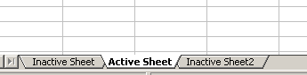

Figure 24. Creating a new sheet
Click here to insert a new sheet
Each method opens the Insert Sheet dialog (Figure 25). From there, you can select whether the new sheet should go before or after the selected sheet and how many sheets you want to insert. If you are inserting only one sheet, you can give the sheet a name.

Deleting Sheets
Sheets can be deleted individually or in groups.
Single sheet
Right-click on the tab of the sheet you want to delete. Then,
- Choose Delete Sheet from the pop-up menu, or
- Choose Edit > Sheet > Delete from the Menu bar.
Either way, an alert will ask if you want to delete the sheet permanently. Click Yes.
Multiple sheets
To delete multiple sheets, select them as described earlier, then either right-click over one of the tabs and choose Delete Sheet from the pop-up menu or choose Edit > Sheet > Delete from the Menu bar.
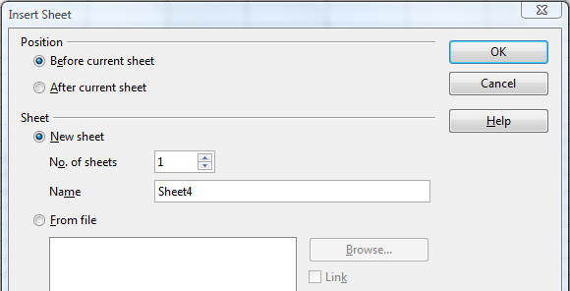Figure 25: Insert Sheet dialog

Renaming Sheets
The default name for a new sheet is SheetX, where X is a number. While this works for a small spreadsheet with only a few components, it becomes awkward when there are many sheets.
To give a sheet a more meaningful name, you can:
- Enter the name in the Name box when you create the sheet, or
- Right-click on a sheet tab and choose Rename Sheet from the pop-up menu; replace the existing name with a different one.
- Double-click on a sheet tab to pop up the Rename Sheet dialog.
Note | Sheet names must start with either a letter or a number. Only letters, numbers, spaces, and underscore characters are allowed after the first character. If you use an invalid name when trying to rename a sheet, Calc will give you an error message.

Viewing Calc

Using Zoom
Use the zoom function to view more or fewer cells in a given window.
In addition to using the Zoom slider on the Status bar (see page 11), you can open the Zoom dialog and make a selection on the left-hand side.
- Choose View > Zoom from the Menu bar, or
- Double-click on the percentage figure in the Status bar at the bottom of the window.
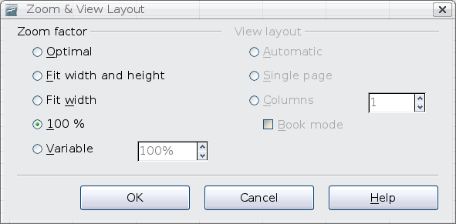
Figure 26. Zoom dialog
Optimal
Resizes the display to fit the width of the selected cells. To use this option, you must first highlight a range of cells.
Fit Width and Height
Displays the entire page on your screen.
Fit Width
Displays the complete width of the document page. The top and bottom edges of the page may not be visible.
100%
Displays the document at its actual size.
Variable
Enter a zoom percentage of your choice.

Freezing Rows and Columns
Freezing locks a number of rows:
- at the top of a spreadsheet
- a number of columns on the left of a spreadsheet
- or both.
After freezing, frozen columns and rows remain in view even when scrolling around within the sheet.
Figure 27 shows some frozen rows and columns. The heavier horizontal line between rows 3 and 14 and the heavier vertical line between columns C and H denote the frozen areas. Rows 4 through 13 and columns D through G have been scrolled off the page. The first three rows and columns remained because they are frozen into place.
You can set the freeze point at one row, one column, or both a row and a column as in Figure 27.
Freezing single rows or columns
- Click on the header for the row below where you want the freeze or for the column to the right of where you want the freeze.
- Choose Window > Freeze.
A dark line appears, indicating where the freeze is put.
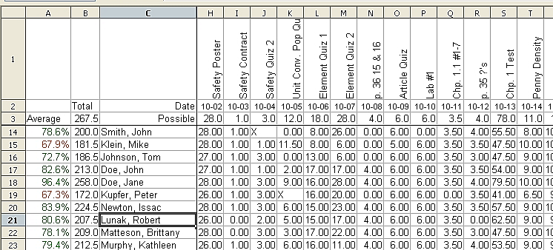
Figure 27. Frozen rows and columns
Freezing a row and a column
- Click into the cell that is immediately below the row you want frozen and immediately to the right of the column you want frozen.
- Choose Window > Freeze.
Two lines appear on the screen, a horizontal line above this cell and a vertical line to the left of this cell. Now as you scroll around the screen, everything above and to the left of these lines will remain in view.
Unfreezing
To unfreeze rows or columns, choose Window > Freeze. The check mark by Freeze will vanish.

Splitting the Screen
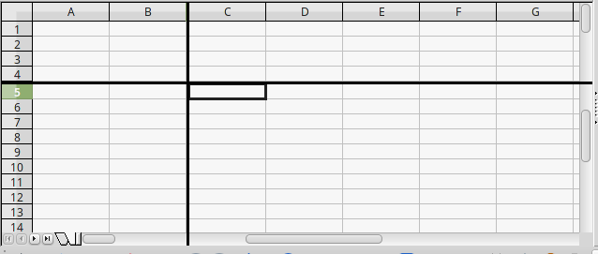

Figure 28. Split screen example
Another way to change the view is by splitting the screen. A screen can be split horizontally, vertically, or both. You can therefore have up to four portions of the spreadsheet in view at any one time.
For example, let's say you're working with a large spreadsheet, one of whose cells contains a number that is used by three formulas in other cells. Splitting the screen allows you to position the cell containing the number in one section, and each of the cells with formulas in the other sections.
That then allows you to change the value in the cell, and observe how it affects each formula.

Splitting the Screen Horizontally
To split the screen horizontally:
- Move the mouse pointer into the vertical scroll bar, on the right-hand side of the screen, and place it over the small button at the top with the black triangle.
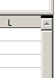

Figure 29. Split screen bar on vertical scroll bar
Split screen bar
- Immediately above this button, you will see a thick black line (Figure 29). Move the mouse pointer over this line, and it turns into a line with two arrows (Figure 30).

Figure 30. Split-screen bar on vertical scroll bar with cursor
- Hold down the left mouse button. A gray line appears, running across the page. Drag the mouse downwards and this line follows.
- Release the mouse button and the screen splits into two views, each with its own vertical scroll bar. You can scroll the upper and lower parts independently.
Tip | You can also split the screen using a menu command. Click in a cell immediately below and to the right of where you wish the screen to be split, and choose Window > Split.

Splitting the Screen Vertically
To split the screen vertically:
- Move the mouse pointer into the horizontal scroll bar at the bottom of the screen and place it over the small button on the right with the black triangle.
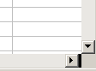

Figure 31: Split bar on horizontal scroll bar
Split screen bar
- Immediately to the right of this button is a thick black line (Figure 31). Move the mouse pointer over this line, and it turns into a line with two arrows.
- Hold down the left mouse button, and a gray line appears, running up the page. Drag the mouse to the left and this line follows.
- Release the mouse button, and the screen is split into two views, each with its own horizontal scroll bar. You can scroll the left and right parts of the window independently.
Figure 28 shows a spreadsheet that has been split both horizontally and vertically. There are four scroll bars, two for each direction, so that regions can be adjusted independently.

Removing Split Views
To remove a split view, do any of the following:
- Double-click on each split line.
- Click on and drag the split lines back to their places at the ends of the scroll bars.
- Choose Window > Split to remove all split lines at the same time.

Using the Navigator
In addition to the cell reference boxes (labeled Column and Row), the Navigator provides several other ways to move quickly through a spreadsheet and to find specific items.
To open the Navigator, click its icon on the Sidebar or the Standard toolbar, press F5, choose View > Navigator on the Menu bar, or double-click on the Sheet Sequence Number in the Status Bar. You can dock the Navigator to either side of the main Calc window or leave it floating. To dock or float the Navigator, hold down the Control key and double-click in an empty area near the icons at the top.
The Navigator displays lists of all the objects in a spreadsheet document, grouped into categories. If an indicator (plus sign or arrow) appears next to a category, at least one object of this kind exists. To open a category and see the list of items, click on the indicator.
To hide the list of categories and show only the icons at the top, click the Contents icon . Click this icon again to show the list.
Table 2 summarizes the functions of the icons at the top of the Navigator.
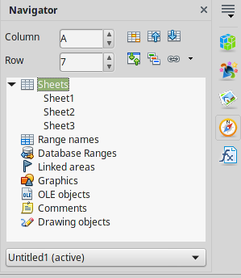
Figure 32: The Navigator in Calc's Sidebar
Table 2: Function of icons in the Navigator
Icon | Action
 | Data Range. Specifies the current data range denoted by the position of the cell cursor.
 | Start/End. Moves to the cell at the beginning or end of the current data range, which you can highlight using the Data Range button.
 | Contents. Shows or hides the list of categories.
 | Toggle. Switches between showing all categories and showing only the selected category.
 | Displays all available scenarios. Double-click a name to apply that scenario. See Chapter 9 (Data Analysis) for more information.
 | Drag Mode. Choose hyperlink, link, or copy. See “Choosing a Drag Mode” for details.

Moving Quickly through a Document
The Navigator provides several convenient ways to move around a document and find items in it.
- To jump to a specific cell in the current sheet, type its cell reference in the Column and Row boxes at the top of the Navigator and press the Enter key; for example, in Figure 32 the cell reference is A7.
- When a category is showing the list of objects in it, double-click on an object to jump directly to that object’s location in the document.
- To see the content in only one category, highlight that category and click the Toggle icon. Click the icon again to display all the categories.
- Use the Start and End icons to jump to the first or last cell in the selected data range.
Tip | Ranges, scenarios, pictures, and other objects are much easier to find if you have given them informative names when creating them. Instead of keeping Calc’s default Graphics 1, Graphics 2, Object 1, and so on, use mnemonics in assigning names, in order to indicate the position of the object in the document.

Choosing a Drag Mode
Sets the drag and drop options for inserting items into a document using the Navigator.
Insert as Hyperlink
Creates a hyperlink when you drag and drop an item into the current document.
Insert as Link
Inserts the selected item as a link where you drag and drop an object into the current document.
Insert as Copy
Inserts a copy of the selected item where you drag and drop in the current document. You cannot drag and drop copies of graphics or OLE objects.

Using Document Properties
To open the Properties dialog for a document, choose File > Properties.
The Properties dialog has six tabs. The information on the General tab and the Statistics tab is generated by the program. Other information (the name of the person on the Created and Modified lines of the General tab) is derived from the User Data page in Tools > Options.
The Internet tab is relevant only to HTML documents. The file sharing options on the Security tab are discussed elsewhere in this book.
Use the Description and Custom Properties pages to hold:
- Metadata to assist in classifying, sorting, storing, and retrieving documents. Some of this metadata is exported to the closest equivalent in HTML and PDF; some fields have no equivalent and are not exported.
- Information that changes. You can store data for use in fields in your document; for example, the title of the document, contact information for a project participant, or the name of a product might change during the course of a project.
This dialog can be used in a template, where the field names can serve as reminders to users of information they need to include.
You can return to this dialog at any time and change the information you entered. When you do so, all the references to that information will change wherever they appear in the document. For example, on the Description tab (Figure 33) you might need to change the contents of the Title field from the draft title to the final title.
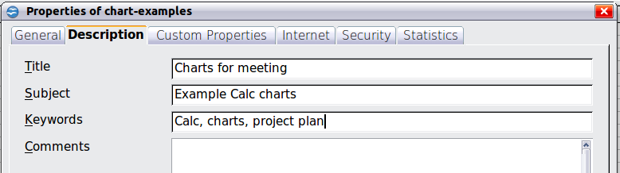
Figure 33: The Description page of the document’s Properties dialog
Use the Custom Properties tab (Figure 34) to store information that does not fit into the fields supplied on the other pages of this dialog box.
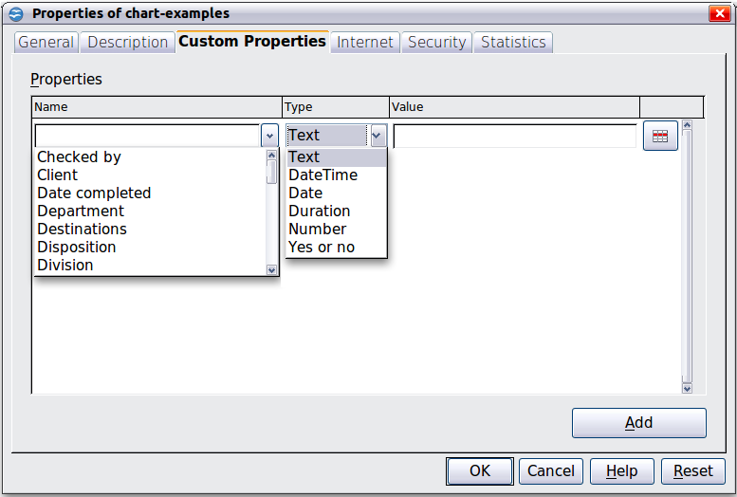
Figure 34: Custom Properties page, showing drop-down lists of names and types
When the Custom Properties tab is first opened in a new document, it may be blank. However, if the new document is based on a template, this page may contain fields.
Click Add to insert a row of boxes into which you can enter your custom properties.
- The Name box includes a drop-down list of typical choices; scroll down to see all the choices. If none of the choices meet your needs, you can type a new name into the box.
- In the Type column, you can choose from text, date+time, date, number, duration, or yes/no for each field. You cannot create new types.
- In the Value column, type or select what you want to appear in the document where this field is used. Choices may be limited to specific data types depending on the selection in the Type column; for example, if the Type selection is Date, the Value for that property is limited to a date.
To remove a custom property, click the button at the end of the row.
Tip | To change the format of the Date value, go to Tools > Options > Languages and change the Locale setting. Be careful! This change affects all open documents, not just the current one.

