Chapter 8
Using Pivot Tables

Introduction
Many requests for software support result from complicated formulas and solutions that try to solve simple day-to-day problems. Another solution is to use a Pivot Table, a tool for easily combining, comparing, and analyzing large amounts of data. With a Pivot Table, you can summarize the same source data in a variety of ways, displaying the details of areas of interest and creating reports.
This chapter is divided into two sections:
- “Examples with Step-by-Step Descriptions” uses three typical cases to demonstrate the advantages and applications of a Pivot Table. Follow the examples to learn how easy it is to use this tool.
- “Functions in Detail,” on page 20, describes the use of Pivot Tables in detail. You can use this part to look up how a function is used, and it is not necessary to understand or even read through all of this section to use Pivot Tables effectively.

Examples with Step-by-Step Descriptions
This section demonstrates some of the possibilities of Pivot Tables. By following the step-by-step description, you can recreate the examples and learn about the power of this tool.

Note | In several places in the following examples, there is an instruction to "select a cell." It can be very important that only a single cell be selected.

Example 1: Sales Volume Overview
A typical introductory example in instructional materials for beginners with spreadsheets is a simple sales volume overview.
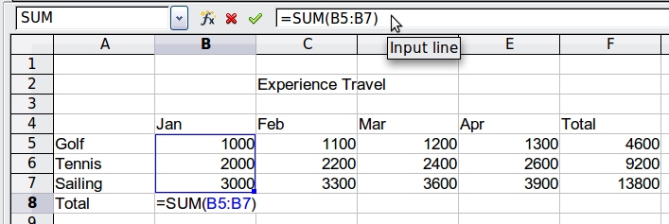
Figure 1: Typical example for beginners
This example demonstrates the user interface, and how to insert text and numbers into cells. Useful aids like AutoFill and drag and drop have been demonstrated in other chapters. The most important point here is the connection formulas establish between cells. As an example, consider that we can do addition with either the plus operator or the SUM function.
This small exercise might be useful for a first contact with the program, but it shows only a very small fraction of the tasks in an office. To create such a sales overview, you also need the original data. That is, before you can use a spreadsheet to create a sales overview, you need to add the single purchases from different lists and then enter the sums into the relevant cells B5 to F7.

Practical Problems and Questions
- To display additional values for May, June, July, and so on, you need to add extra columns; that is, you have to change the structure of the calculation sheet. This is not only somewhat inefficient from a workflow point of view, but it also raises some practical questions: How do references react if you add more columns or rows to the sum formulas?
- The layout, where the timeline is displayed horizontally, is less convenient if you want to add more months. A vertical layout might be a more efficient use of space. How can the table be transposed? Do you have to enter everything again?
- What if management asks unexpected questions or adds additional subdivisions? In such cases, you again have to manually add all the sums and create different tables with many variations.
- The automated categorization and calculation provided by a Pivot Table is faster and less error-prone than manually entering values or formulas in a table. This is true even if the calculation is only done once. If the calculation must be done frequently, the benefits of automated processing become even greater.

Solution
The most important part of your task in the example is the addition of the Total sales per month cells, which had to be done manually. To do this automatically with the program, just get the data into Calc. You can enter the single numbers by hand or you can import a file from your bookkeeping software. In any case we assume a continuous table that keeps track of all sales in a simple form shown in Figure 2.
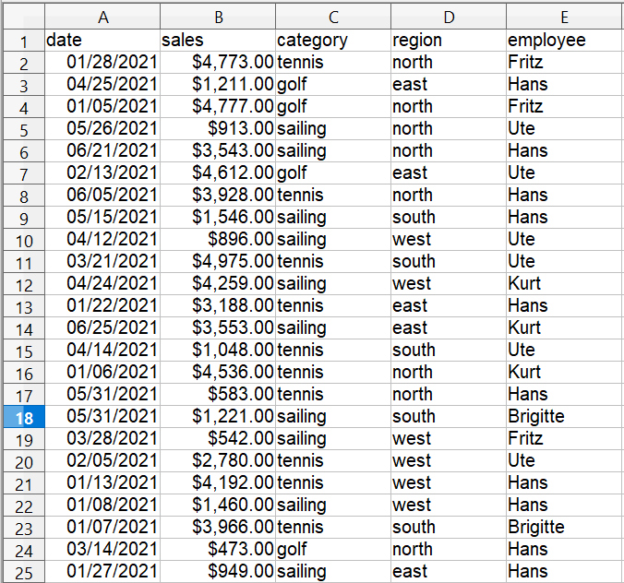

Figure 2: Basic data in Calc
You can create the sales volume overview by following these instructions:
- Select the cell A1 (or any other single cell within the list).
- Select Data > Pivot Table > Create. On the Select Source dialog, choose Current selection and click OK.
- The Pivot Table dialog (Figure 3) has four white layout areas and several fields resembling buttons. These small fields are the titles of the different columns of your list.
  - Drag and drop with the mouse to move the date field into the Column Fields area.
  - Move the sales field into the Data Fields area.
  - Move the category field into the Row Fields area.
- Click More to see more options in the lower part of the dialog.
- In the Results to drop-down list, select – new sheet –.
- Click OK.
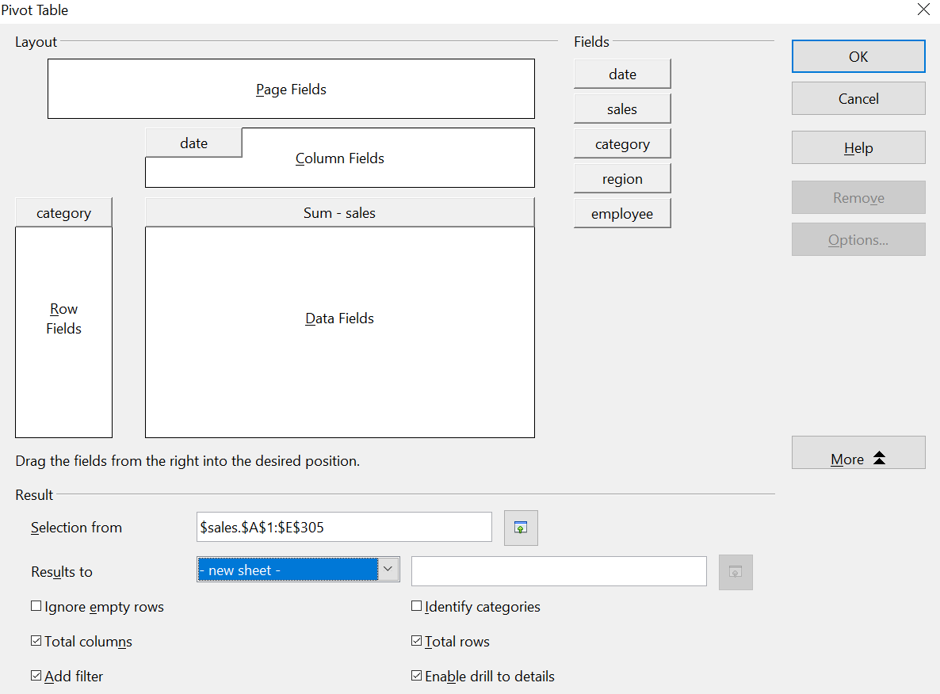

Figure 3: Pivot Table dialog
- The result appears on a new sheet. It has the desired structure, but the columns are not yet grouped into months.
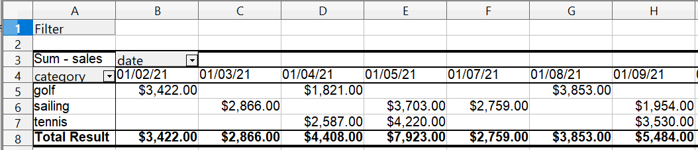

Figure 4: Pivot Table result without grouping
- To group the columns, select cell B4 or any other cell that contains a date. Then select Data > Group and Outline > Group. On the Grouping dialog (Figure 5), make sure Intervals and Months are selected in the Group by section, and click OK. The result is now grouped for months (Figure 6).
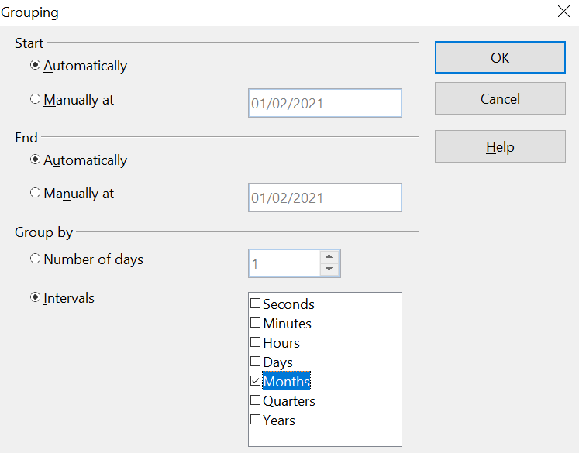

Figure 5: Grouping on months
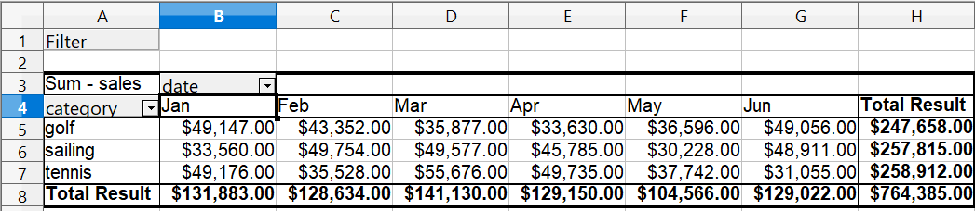

Figure 6: Pivot Table grouped for months
You can recognize the beginners’ example in this result. It is very easy to produce without any further knowledge about the spreadsheet. You do not have to enter any formulas, and the data region was selected automatically when you selected a single cell in the data region and started the Pivot Table process.

Advantages
- No manual entering or adding of any values is necessary. That means less work and fewer errors.
- The layout is very flexible: months are horizontal, and categories vertical or vice versa, in two mouse clicks.
- Additional differentiating factors are immediately available.
- Many types of evaluation are possible; for example, number or average instead of sum, accumulated values, comparisons, and so on.
- If more data are inserted into the original data set, the Pivot Table can be updated with two clicks.
We will now demonstrate some of these advantages.
Starting with the result of Figure 6, use the mouse to drag the Date field under the Category field, as shown in Figure 7.

Figure 7: Drag Date field under Category field
Now the summary is as shown in Figure 8.
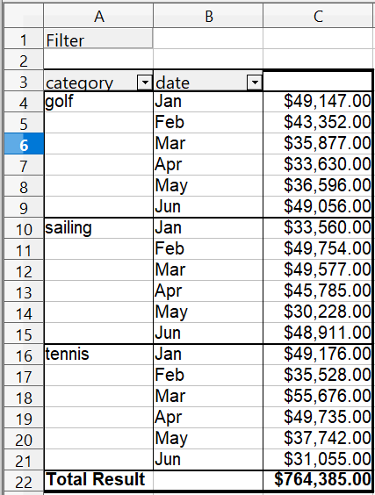
Figure 8: Changed layout
To transpose the table completely, just drag the Category field above the area of the displayed values, to cell C3 (see Figure 9). The result of this action is shown in Figure 10.

Figure 9: Reposition Category field
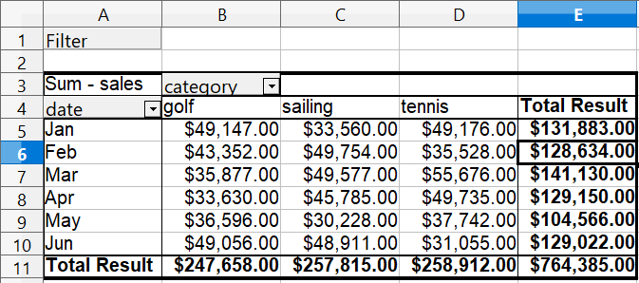

Figure 10: Transposed layout of Figure 8
In contrast to the beginners’ example in Figure 1, viewing or adding different aspects of the underlying data is now very simple. For example, to see the values for different regions, do the following:
- Select the cell A3 (or any other single cell that is part of the Pivot Table result).
- Select Data > Pivot Table > Create to start the Pivot Table again.
Drag the Region field into the Row Fields area. Depending on the order you choose for the row fields, the result is either regions with date subdivisions or vice versa.
- Click OK. The result is shown in Figure 11.
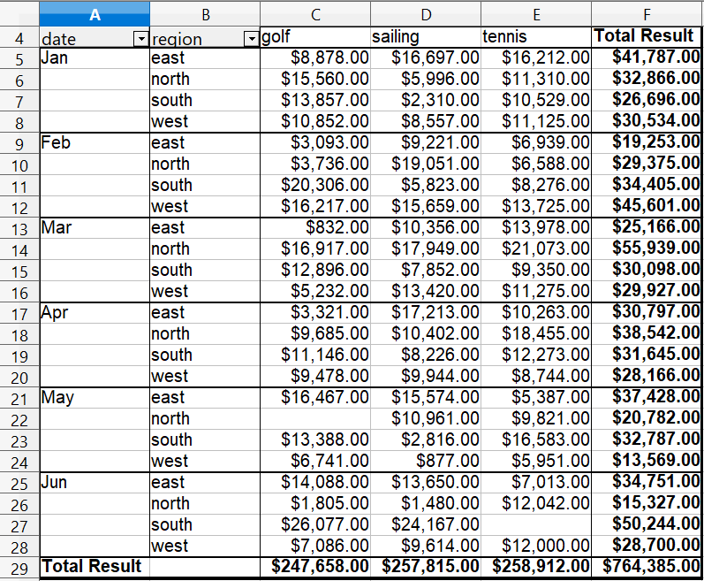
Figure 11: Additional subdivision into regions, added later
In another variation, you may want to add the ability to select data about individual employees.
- Select the cell A3 (or any other single cell that is part of the Pivot Table result).
- Select Data > Pivot Table > Create to start the Pivot Table again.
  - You do not need the Region field in this case. Drag it out of the layout area.
  - Drag the Employee field into the Page Fields area.
- Click OK. The result is shown in Figure 12.
Fields you use as page fields are placed in the result above the summary with the name Filter. You then have a drop-down list that you can use to show only the sums of a given employee.
The following examples will show you more of the powerful features of Pivot Tables.
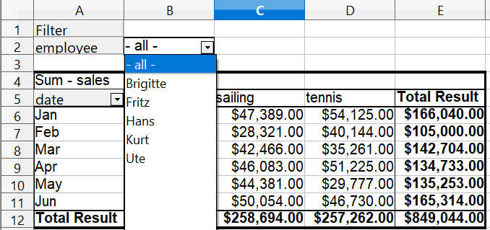

Figure 12: Selection of subtotals for an employee.

Example 2: Timekeeping
This example is often used by consultants and in several variations in user support. The task is to provide a means for one or more users to keep track of working hours.
Note | In the real world, timekeeping requires tracking working time on individual projects. Specialized database software is often used, but for simple applications in a small company, a Calc spreadsheet and a Pivot Table might suffice.

A typical way of doing this is to create a spreadsheet per month and a sum sheet with all the results of one year. For each employee, there is one file (see Figures 13 and 14 for examples of two pages from the file for one employee).

Practical Problems and Questions
- It is very difficult and time-consuming to create the timekeeping table: 12 sheets that have to be copied from a raw template and adjusted for each month, and a sheet with all the yearly sums with references to all the other sheets. Users often search for a macro to make the creation easier.
- The file shown contains only the data of one employee. How can you get all the data for all the employees to summarize all the work hours from all employees of a department or the whole company?
- How can you compare employees and/or departments?
- The file shown contains data for one year. How can you compare it with the data of the previous years?
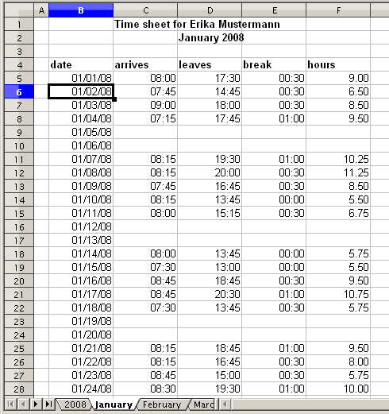
Figure 13: One month of timekeeping for one employee
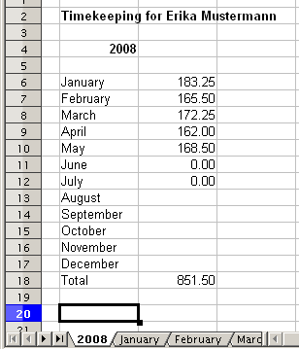
Figure 14: Yearly sums for one employee

Solution
To use a Pivot Table for this task, collect all the data into one table. This is an important step, often missed by novices. It seems convenient to have separate sheets for each person or each month, but the full power of a spreadsheet becomes available when all the data is in a single table. Then, tools like Pivot Tables can be used to filter and summarize the data, and new data can be added very easily.
In very simple cases, each employee takes care of their own working hours. If you need calculations that cover several employees, departments, or the whole company, just copy everything into one huge table (Figure 15).
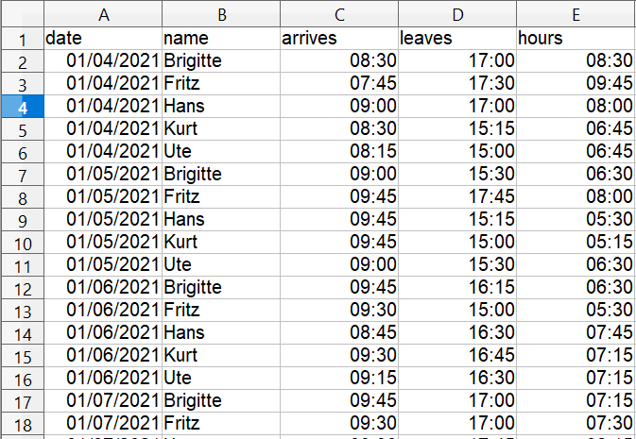

Figure 15: Employee time in Calc
Using a Pivot Table requires only 12 mouse clicks and gives you a nice overview within seconds:
- Select the cell A1 (or any other single cell within the data).
- Choose Data > Pivot Table > Create and click OK.
- On the Pivot Table dialog (Figure 16):
  - Drag date into the Row Fields area.
  - Drag hours into the Data Fields area. Notice that it becomes Sum – hours.
  - Drag name into the Column Fields area.
- Click More to show more options in the lower part of the dialog.
- Choose – new sheet – for Results to.
- Click OK.
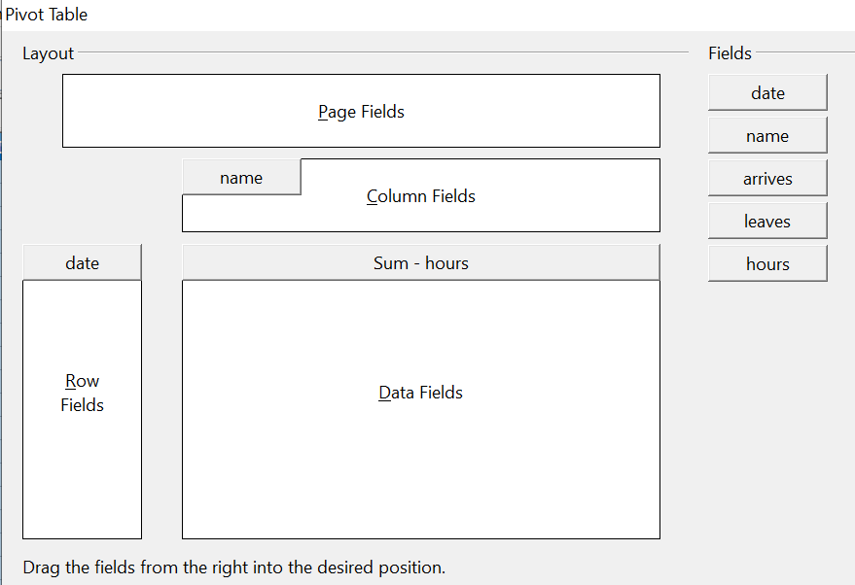

Figure 16: Part of the Pivot Table dialog
The result appears on a new sheet (Figure 17).
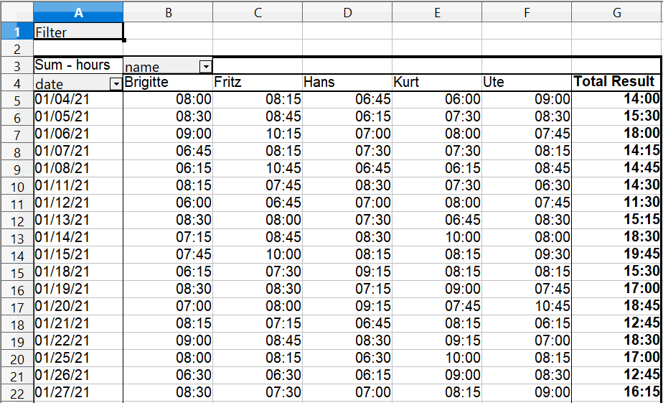

Figure 17: The evaluation, done within seconds with a Pivot Table
The result is much more powerful than is possible with the classic formula-based calculation. For example, you can summarize the daily results into a monthly result very easily:
- To group together the rows, select the cell A5 (or any other cell that contains a date).
- Choose Data > Group and Outline > Group. On the Grouping dialog, leave Start and End as Automatically; in the Group by section, choose Intervals and Months. Click OK. The result is now grouped into months.
- You may have to set the format of the cells to display values of hours larger than 24. This can be done with the menu Format > Cells and choosing a Time format whose format code has the hours in brackets: [HH]:MM.
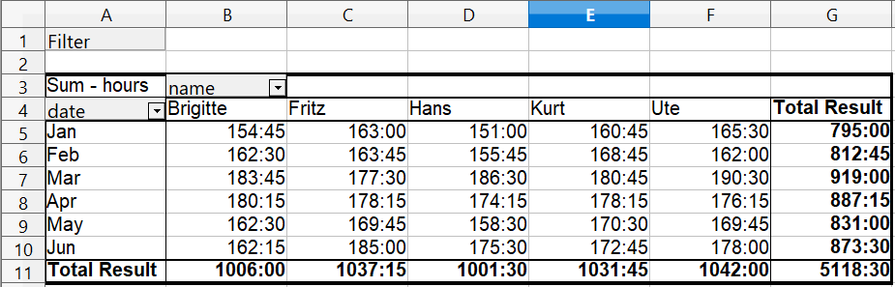

Figure 18: Monthly sums
If you need a result with a percentage, start with the Pivot Table from Figure 18.
- Select the cell A3 (or any other single cell that contains a result of the Pivot Table).
- Choose Data > Pivot Table > Create.
- Double-click Sum – hours to open the Data Field dialog (Figure 19).
- Click on More to see more options.
- Switch Displayed value > Type to % of column.
- Click OK to return to the Pivot Table dialog, then click OK again.
An example of the output is shown in (Figure 20).
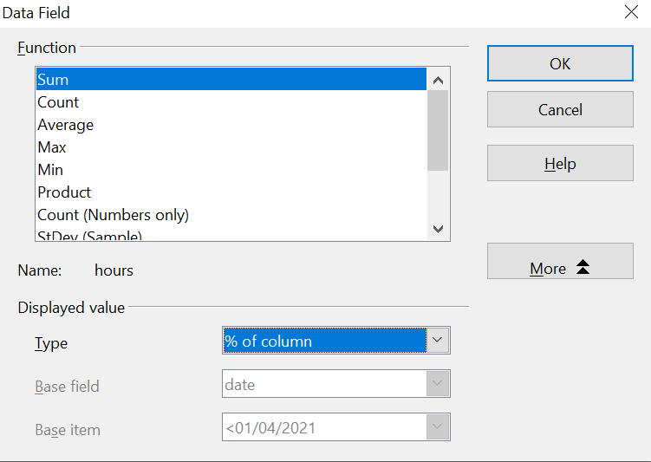

Figure 19: Properties of the data field
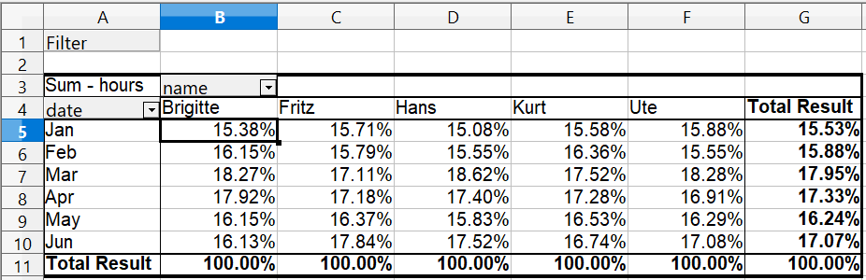

Figure 20: Result with percentages
To get a comparison between employees, start the Pivot Table again from the output sheet:
- Select cell A3 (or any other cell containing a Pivot Table result).
- Choose Data > Pivot Table > Create.
- Double-click on Sum – hours to open the Data Field dialog.
- Click More to see more options.
  - Switch the Type of the displayed value to Difference from.
  - Switch the Base field to name.
  - Switch the Base item to Brigitte.
- Click OK to return to the Pivot Table dialog, then click OK again.
See the comparison in Figure 21.
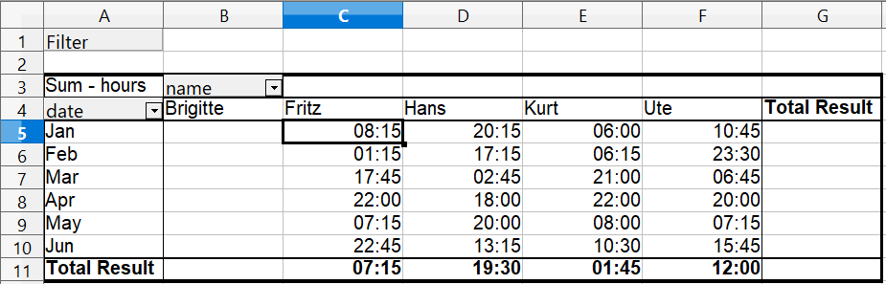

Figure 21: Absolute comparison with Brigitte
As a final example, we switch to an accumulated view, that is, continuing sums of all values:
- Select cell A3 (or any other cell containing a Pivot Table result).Choose Data > Pivot Table > Create.
- Double-click on Sum – hours to open the Data Field dialog.
- Click More to see more options.
  - Switch the type of the displayed value to Running total in.
  - Switch the Base field to Date.
- Click OK to return to the Pivot Table dialog, then click OK again.
The accumulated values are shown in Figure 22.
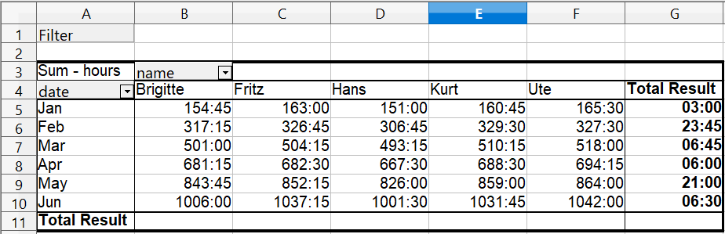
Figure 22: The Pivot Table now shows accumulated values

Differences and Advantages
These examples show an important aspect of Pivot Tables. Normally, you have to collect your data according to how you want the result represented. This means you have to use a specific structure, and you are stuck with it. However, Pivot Table works more like a database. Source data are collected in a single spreadsheet. Only when you want to look at the data in more detail do you select which part of the data you want to use and how to arrange the results.

Example 3: Frequency Distribution
To show the frequency of incidents, Calc uses the function FREQUENCY, an advanced feature. Alternatively, you can use a Pivot Table.
In our example, we want to investigate the number of emails sent to a mailing list. We want to know how the activity on the list is distributed during the day.
The first few rows of data are shown in Figure 23.
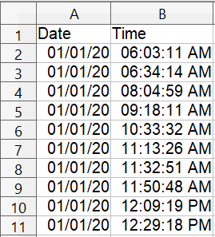
Figure 23: Data in Calc

Solution with an Array Formula
To calculate the frequency, you must create 24 classes, one for each hour. These are in C2:C25 in Figure 24. In the next column, you enter a formula that uses the FREQUENCY function to calculate the number of emails.
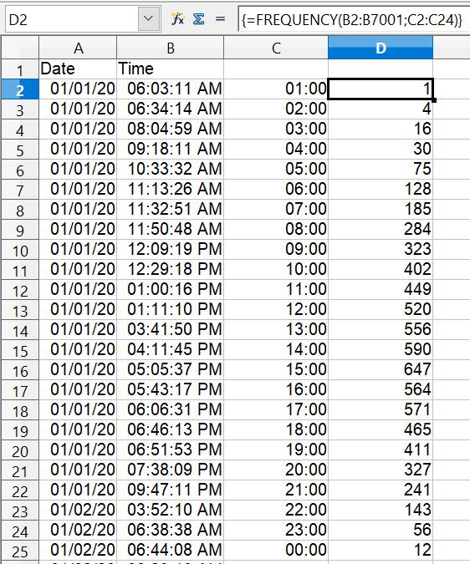

Figure 24: FREQUENCY function in an
array formula
The first argument in the FREQUENCY function is the cell area with the times of all 7000 emails. The second argument is the cell area C2:C25 that describes the frequency classes. Select the cell area F2:F25, and enter the formula. Finish the formula by using the key combination Shift+Ctrl+Enter. This indicates to the program you want to use an array formula. To indicate the array formula, the program uses curly brackets.

Solution with a Pivot Table
Thankfully, a Pivot Table allows you to achieve the same result more quickly and easily. Starting with the raw data (Figure 23), you only need a few mouse clicks.

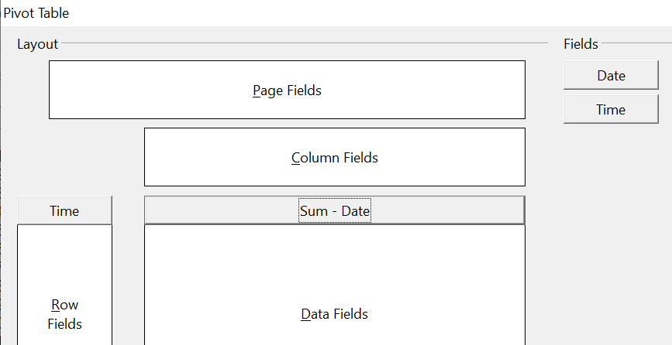
Figure 25: Part of Pivot Table dialog
- Select the cell A1 (or any other cell within the list).
- Choose Data > Pivot Table > Create and click OK.
- In the Pivot Table dialog (Figure 25):
  - Drag Time into the Row Fields area.
  - Drag Date into the Data Fields area.
- Click More to show more options in the lower part of the dialog.
- Choose – new sheet – for Results to.
- In this case, we need to count the number of values, not their sum. Double-click on Sum – Date to open the Data Field dialog and select the function Count (see Figure 26).
- Click OK. As an intermediate result, you get a Pivot Table that has a separate line for every time within the raw data.
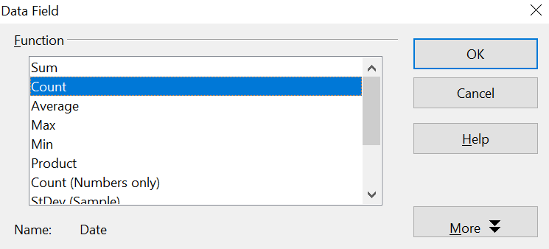

Figure 26: Properties of the data field
Note | This may be a very time-consuming process because of the large number of items. The time does not depend significantly on the number of lines, but rather on the number of rows needed for the table that contains the results.

- To group the rows, select cell A4 or any other cell that contains a time.
- Choose Data > Group and Outline > Group, select Hours for the interval, and click OK (See Figure 27). The result is now grouped according to hours, as shown in Figure 29.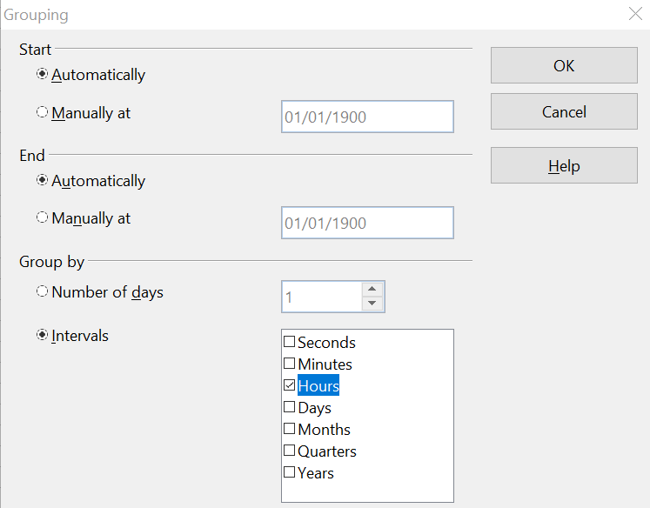

Figure 27: properties for grouping according to hours
- Restart the Pivot Table and double-click on the Count-Date data field. Figure 28 shows the Data Field dialog for the data field Number – Date. Click More and select as type % of column. The result is shown in Figure 30. Figure 29 shows the absolute occurrence.
Whether the relative values are shown as a decimal (0.1) or as a percentage (10%) depends only on the cell formatting.
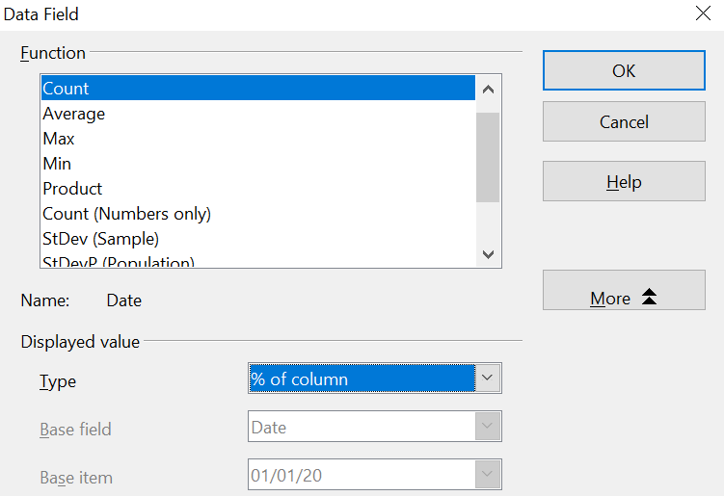

Figure 28: Data Field settings for relative values
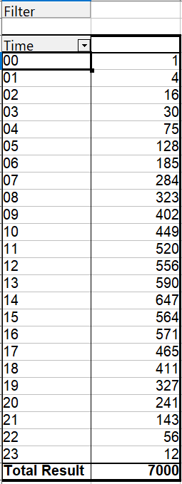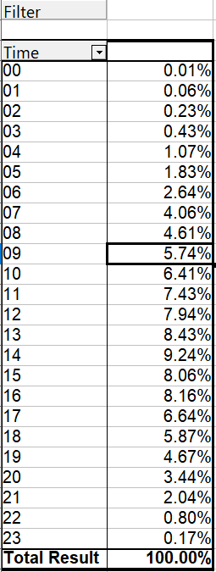

Figure 29: Frequency distribution

Figure 30: Relative occurrence

Functions in Detail
This part of the Calc guide describes in detail the use and options of Pivot Tables. Be aware, though, that those details may go well beyond what an individual user, especially one new to spreadsheets as analytical tools, needs to know in any particular case.

The Database
The first thing we need to have on hand for a Pivot Table is a set of raw data, similar to a database table. Such a set should comprise rows (AKA records) and columns (AKA fields). Moreover, field names must be in the first row of any such list.
Almost anything can serve as a data source – for instance, one can use an external file. In many cases, it is most convenient to use the raw data in the file that will contain the Pivot Table. For processing lists of data, Calc and its Pivot Tables need to know where the list is in the spreadsheet. That can be anywhere in the sheet, in any position; a spreadsheet can even contain several unrelated lists.
Calc recognizes your lists automatically. It uses the following logic:
- You must begin your effort by selecting a cell that is within the range of the items in your list.
- Starting from that cell, Calc checks the surrounding cells in all four directions (left, right, above, below). A border is recognized if the program discovers an empty row or column or if it hits the spreadsheet's first or last row or column.
- This means that the Pivot Table's functions can only work correctly if there are no empty rows or columns in your list. Avoid these; if you want to distinguish regions of the data, format your list by using cell formats.
Caution   | Again, be careful - no empty rows or empty columns are allowed within lists.
If you select more than one single cell before creating the Pivot Table, the automatic list recognition is disabled. Calc assumes that the list exactly matches the cells you have selected.
Caution | When using the Pivot Table, always select only one cell or carefully select the entire data set. Failing to do so may result in empty rows or columns.

In addition to these formal aspects, logical structure is very important when using Pivot Tables. When entering data, don't add outlines, groups, or summaries. Here are some mistakes commonly made by inexperienced spreadsheet users:
- You made several sheets, for example, a sheet for each group of articles. Analyses are then possible only within each group. Analyses for several groups would be a lot of work.
- In the Sales list, instead of only one column for the amount, you created a column for each employee's amounts. The amounts had to be entered manually into the appropriate column, making an analysis with a Pivot Table impossible. In contrast, one benefit of a Pivot Table is that you can get results for each employee if you've entered data with the appropriate layout.
- You entered the amounts in chronological order. At the end of each month you made a sum total. In this case, processing the list for different criteria is not possible because the Pivot Table will treat the sum totals the same as any other figure. Getting monthly results is one of the very fast and easy features of Pivot Tables.

Start
Start the Pivot Table with Data > Pivot Table > Create. If the list to be analyzed is in a spreadsheet table, select only one cell within this list (See Figure 31). Calc recognizes and selects the rest of the list automatically.

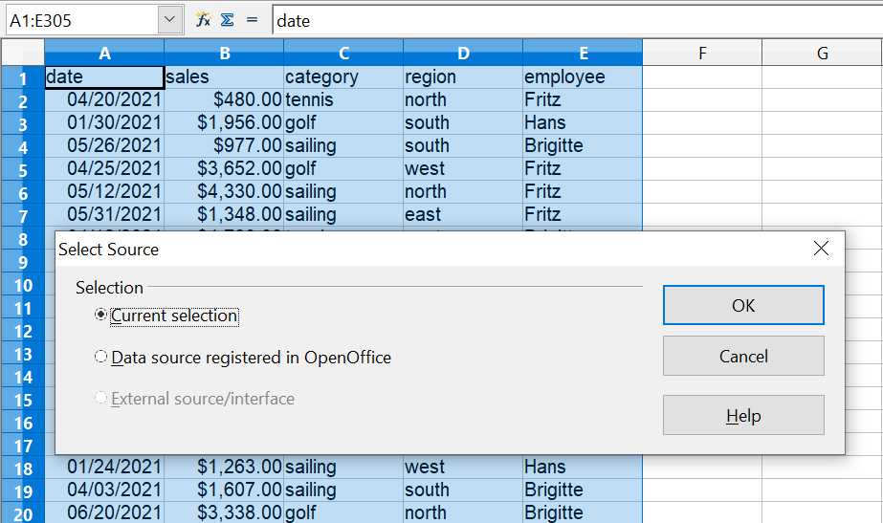

Figure 31: After starting the Pivot Table

Data Sources
There are two possible data sources for a Pivot Table: a Calc spreadsheet or an external data source. If you use the latter, it must be registered in OpenOffice.

Calc Spreadsheet
Analyzing a list in a Calc spreadsheet is the simplest and most frequent use of Pivot Tables. The list might be updated regularly, or its data might be imported from a different application.
For example, a huge list can be copied from a different application and pasted into Calc. The behavior of Calc while inserting the data depends on the format of the data. If the data is in a common spreadsheet format, it is copied directly into Calc. However, if the data is in plain text, the Text Import dialog appears; see Chapter 1 (Introducing Calc) for more information.
Calc can import data from many foreign data formats and other spreadsheets. It can also accept data from databases such as MySQL and even simple text files, including those using CSV formats.

Caution | The drawback of copying or importing foreign data is that it will not update automatically if there are changes in the source file.

Registered Data Source
A data source registered in OpenOffice can act as a connection to data held outside Calc. This means that the data to be analyzed will not be saved in Calc; Calc always uses the original data. Calc is able to use many different data sources, as well as databases that are created and maintained with OpenOffice Base. See Chapter 10 (Linking Calc Data) for more information.

The Pivot Table Dialog
The function of the Pivot Table is managed in two places: first in the Pivot Table dialog and second through manipulations of the result in the spreadsheet. This section describes the dialog in detail.

Basic Layout
In the Pivot Table dialog shown in Figure 32, four white areas show the layout of the result. Next to these white areas are buttons with the names of the fields (columns) in your data source. To choose a layout, drag and drop the field buttons into the white areas.
The Data Fields area in the middle must contain at least one field. If they care to, advanced users can use more than one field here. For each data field, an aggregate function is used. For example, if you move the sales field into the Data Fields area, it appears as Sum – sales.
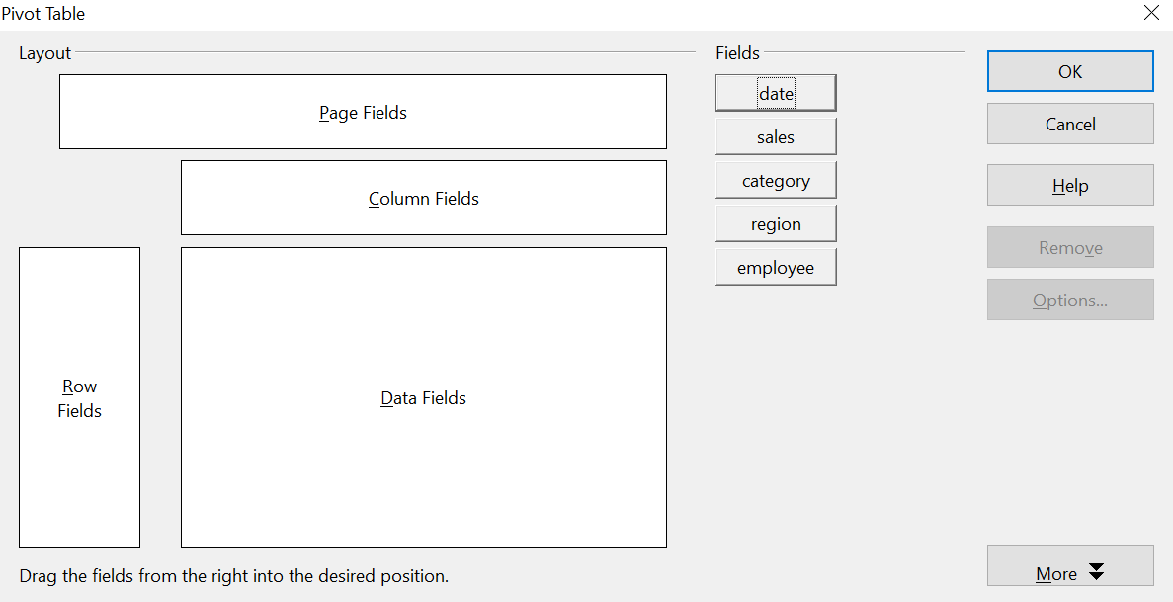

Figure 32: Pivot Table dialog

Row Fields and Column Fields indicate the categories by which the result will be sorted in the rows and columns. If there are no entries in one of these areas, then partial sums will not be provided for the corresponding rows or columns. When more than one field is used simultaneously to get partial sums for rows or columns, the order in which the fields are presented organizes sums from overall to specific.
For example, if you drag region and employee into the Row Fields area, the sum will be grouped first by employees and the listings for different regions are within that.
Fields placed into the Page Fields area appear in the result above as a drop-down list. The summary in your result considers only that part of your data that you have explicitly selected. For example, if you use employee as a page field, you can then filter the result shown for each employee.
To remove a field from the white layout area, drag it to the border and drop it (the cursor will change to a crossed symbol) or click the Remove button.

More Options
Click More to expand the Pivot Table dialog and show additional options. The options revealed by the More button are shown in Figure 33.
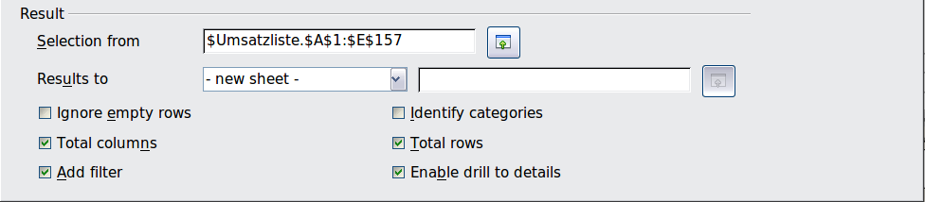
Figure 33: Expanded Pivot Table dialog
Selection from
Shows the range of cells used in the Pivot Table.
Results to
Results to defines where your result will be shown. If you do not enter anything, the Pivot Table result will be below the list that contains your data. Be careful - any data already in that location could be overwritten. To avoid that, choose a named cells range from the list that displays – undefined – or leave Results to as – undefined - and enter a cell reference to tell Calc where to show the results. Another, and probably better, approach is to use - new sheet – to add a new sheet to the spreadsheet file and place the results there.
Ignore empty rows
If the source data is not in the recommended form, this option tells the Pivot Table to ignore empty rows.
Identify categories
If the source data has missing entries in a list and does not meet the recommended data structure (See Figure 34) and this option is chosen, the Pivot Table fills the gaps with the category above that. If this option is not chosen, the Pivot Table inserts (empty). See Figure 36, where (empty) is displayed in the leftmost column.
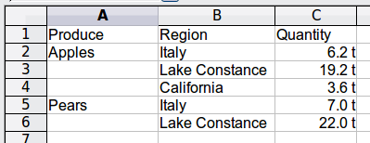
Figure 34: Example of data with missing entries in Column A
The option Identify categories ensures that rows 3 and 4 are added to the product Apples, and row 6 is added to Pears as shown in Figure 35.
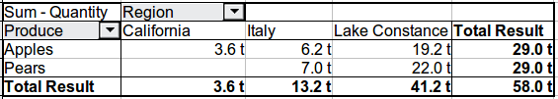
Figure 35: Pivot Table result with Identify categories selected
Keep in mind that without category recognition, a Pivot Table will show an (empty) category.
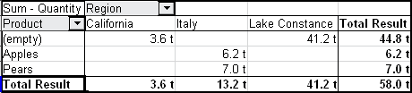
Figure 36: Pivot Table result without Identify categories selected

In most instances, Pivot Tables perform better without category recognition. Also, a list showing missing entries is less useful because you cannot use other functions, such as sorting or filtering.
Total columns / total rows
With this option, you decide whether the Pivot Table will show an extra row with the sums of each column or add a column with the sums of each row to the very right.
Add filter
Use this option to add or hide the cell labeled Filter above the Pivot Table results. This cell is a convenient button for additional filtering options within the Pivot Table.
Enable drill to details
If you double-click on a single cell in the Pivot Table result, this function gives a more detailed listing of an individual entry. If this function is disabled, the double-click will keep its usual edit function within a spreadsheet.

More Settings for the Fields – Field Options
The options discussed in the previous section are generally valid for the Pivot Table. Additionally, you can change settings for every field you have added to the Pivot Table layout. Do this by clicking on the Options button in the Pivot Table dialog or double-clicking on the appropriate field.
The differences between data fields, row or column fields, and page fields of the Pivot Table are outlined below.

Data Fields
Select the Sum function in the Options dialog of a data field to accumulate the values from your data source. You will need the sum function in many cases, but other functions, like standard deviation or simply counting, are also available. For example, the counting function can be useful for non-numerical data fields.
On the Data Field dialog (See Figure 37), click More to see more options.

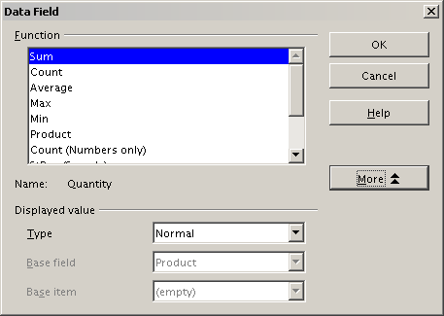
Figure 37: Expanded dialog for a data field
In the Displayed value section, you can choose other possibilities for analysis by using the aggregate function. Depending on the setting for Type, you may have to choose definitions for Base field and Base item. The table below lists the possible types of displayed values and associated base field and item, together with a note on usage.
Type | Base field | Base item | Analysis
Normal | — | — | Simple use of the chosen aggregate function (for example, sum)
Difference from | Selection of a field from the data source of the Pivot Table (for example, employee) | Selection of an item from the selected base field (for example, Brigitte) | Result as difference from the result of the base item (for example, Sales volume of the employees as difference from the sales volume of Brigitte)
% of | Selection of a field from the data source of the Pivot Table (for example, employee) | Selection of an item from the selected base field (for example, Brigitte) | Result as a ratio based on the result of the base item (for example, Sales result of the employee relative to the sales result of Brigitte)
% difference from | Selection of a field from the data source of the Pivot Table (for example, employee) | Selection of an item from the selected base field (for example. Brigitte) | Result as relative difference to the result of the base item (for example, Sales volume of the employees as relative difference of the sales volume of Brigitte)
Running total in | Selection of a field from the data source of the Pivot Table (for example, date) | — | Result as a continuing sum (for example, running sum of the sales volume for days or months)
% of row | — | — | Result as relative part of the result in the whole row (for example the row sum)
% of column | — | — | Result as relative part of the total column (for example, the column sum)
% of total | — | — | Result as relative part of the overall result (for example the total sum)
Index | — | — | Default result x total result / (row result x column result)

Row and Column Fields
In the Options dialog for the row or column fields, you can choose to show partial sums for each category. Be aware that in Calc, partial sums are deactivated by default since they're only useful if the values in one row or column field can be divided into partial sums for another field.
Some examples are shown in the next three figures.

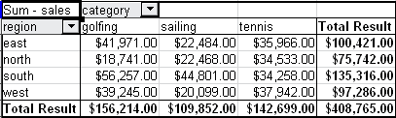
Figure 38: No subdivision with only one row or column field
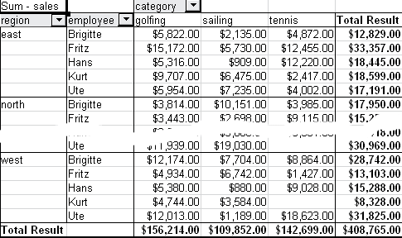
Figure 39: Division of the regions by employees (two row fields) without partial sums
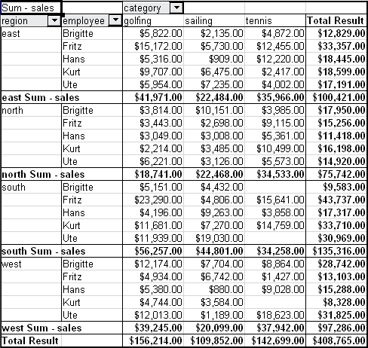
Figure 40: Division of the regions for employees with partial sums (by region)
Choose the option Automatically to activate the aggregate function for partial results that can also be used for data fields. To set up the aggregate function for the partial results independently from the overall settings of the Pivot Table, choose User-defined. See Figure 41.
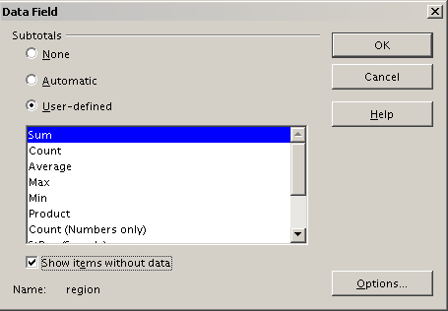
Figure 41: Preferences dialog of a row or column field
Normally, the Pivot Table does not show a row or column for categories with no entries in the underlying database. However, you can force this by choosing the Show items without data option.
For illustration purposes, the data was manipulated so that the employee Brigitte has no sales values for the category golfing. In Figure 42, there is no column for this category, but the column does appear in Figure 43.
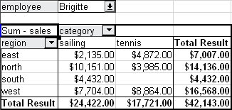
Figure 42: Default setting
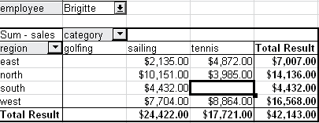
Figure 43: Setting “Show Items without data”

Page Fields
The Options dialog for page fields is the same as for row and column fields. Given the flexibility Pivot Tables provide, you can switch fields between pages, columns, or rows. Doing so still allows fields to keep the settings you made for them. The page field has the same properties as a row or column field, but only when you use such a field not as a page field but as a row or a column field.

Working with the Results of the Pivot Table
As we've mentioned, Pivot Tables are very flexible. An analysis can be totally restructured with only a few mouse clicks. Also, some functions of a Pivot Table can only be used with the results of an analysis.

Start the Dialog
Right-click in the area of the resulting table of the Pivot Table. The command Edit Layout opens the Pivot Table dialog with all current settings.

Change Layout by Using Drag and Drop
The easiest and fastest method of changing the layout of the Pivot Table is to drag and drop. In the the Pivot Table's result table, move one of the page, column, or row fields to a different position.
You can remove a column, row, or page field from the Pivot Table by clicking on it and dragging it completely out of the Pivot Table.

Grouping Rows or Columns
For many analyses or summaries, categories must be grouped. You can merge such results as classes or periods. In a Pivot Table, do a grouping only after making an ungrouped Pivot Table.

Caution | You can access the grouping with the menu entry Data > Group and Outline > Group or by pressing F12. It is important that you select the correct cell area. If you want to group some dates, click on one of the date cells before starting the grouping process. How the grouping function works is determined mainly by the type of values that have to be grouped. You need to distinguish between scalar values, date or time values, or other values, such as text, that you want grouped.

Note | Before you can group, you have to produce a Pivot Table with ungrouped data. The time needed to create a Pivot Table depends mostly on the number of columns and rows in the resulting table, not on the extent of the basic data. By grouping, you can produce a Pivot Table with only a few rows and columns. Pivot Tables can contain many categories, depending on your data source.

Grouping of Categories with Scalar Values
For grouping scalar values, select a single cell in the row or column of the category to be grouped.
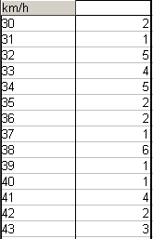
Figure 44: Pivot Table without grouping (frequency of the km/h values of a radar control)
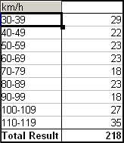
Figure 45: Pivot Table with grouping (classes of 10 km/h each)
Choose Data > Group and Outline > Group from the menu bar or press F12; you get the following dialog.
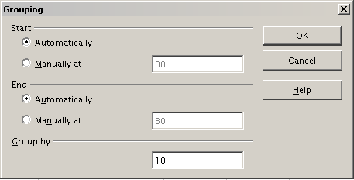
Figure 46: Grouping dialog with scalar categories
You can define in which value range (start/end) the grouping should take place. The default setting is the whole range from smallest to biggest value. In the field Group by you can enter the class size, that is, the interval size - in the example shown in Figures 44, 45, and 46, groups of 10 km/h each were chosen.

Grouping of Categories with Date or Time Values
For grouping date or time values, select a single cell in the column or row of the category to be grouped. This was demonstrated in all three examples in the section Examples with Step-by-Step Descriptions. With the menu entry Data > Group and Outline > Group or by pressing F12, you get the dialog shown in Figure 47.
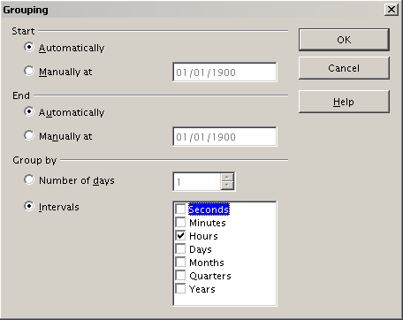
Figure 47: Grouping dialog for categories with dates or times
As this figure illustrates, you can decide the range of dates or times (start/finish) over which grouping should occur. The default setting is the entire period from the earliest to the latest value. In the field Group by, you can enter the class size (interval) which should be used for grouping. Possible intervals are: seconds, minutes, hours, days, months, quarters, and years. These can be combined, for example, by grouping by years and then within each year according to month.
Alternatively, you can enter any number of days as a grouping interval.
Tip | For grouping the output of the Pivot Table in calendar weeks, choose the beginning date on a Sunday or Monday and enter the grouping interval (Number of Days) as 7.

Grouping without the Automatic Creation of Intervals
If your categories contain text fields, the automatic creation of intervals is not possible. But you still can define, for each field, which values you want to put together in one group.
Every time you use the menu entry Data > Group and Outline > Group, or press F12 while you have more than one cell selected, all the cells will be selected as one group.
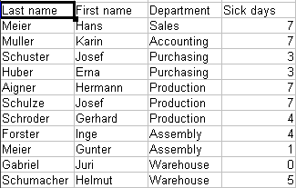
Figure 48: Database with nonscalar categories (departments)
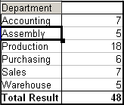
Figure 49: Pivot Table with nonscalar categories
For grouping nonscalar categories, that is, categories based upon text, select all the individual field values you want to put in this one group.
Tip | You can select several non-contiguous cells in one step by pressing and holding the Control key while left-clicking with the mouse.

Given the input data shown in Figure 48, execute the Pivot Table with Department in the Row Field and Sum (Sick Days) in the Data Field. The output should look like that in Figure 49. Next, select the Departments Accounting, Purchasing and Sales, with your mouse.
Choose the Data > Group and Outline > Group from the Menu bar or press F12. The output should now look like that in Figure 50. Repeat this for all groups you want to create from different categories. Start by selecting Assembly, Production, and Warehouse, and Group again. The output should look like Figure 51.
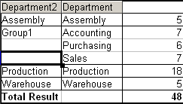
Figure 50: Summary of single categories in one group
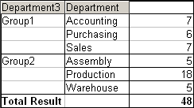
Figure 51: Grouping finished
You can change automatically-given names for groups and for the newly created group field by editing the name in the input field - for example, changing 'Group2' to 'Technical'. The Pivot Table will remember your settings, even if you change the layout later. For the following pictures, the dialog was called again (with a right-click, Edit Layout) and selecting the icon “Department 2”, then Options, and finally, from the preferences menu, Automatic. These choices generated the partial sum results shown in Figure 52. Double-clicking Group 1 and Technical collapses the entries, as shown in Figure 53.
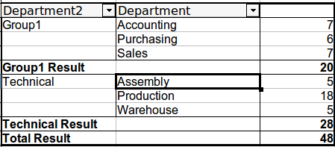
Figure 52: Renamed groups and partial results
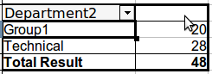
Figure 53: Reduced to the new groups

Sorting the Result
The result of any Pivot Table is sorted (categories) into columns and rows in ascending order. You can change the sorting in three ways:
- Select sort order from drop-down menus on each column heading.
- Sort manually by using drag and drop.
- Sort automatically by choosing the options in the preferences dialog of the row or column field.
Select sort order from drop-down menus on each column heading
The simplest way to sort entries is to click the arrow on the right side of the heading and check the box(es) for the desired sort order. The custom sorting dialog is shown in Figure 54. Additional options exist to show all, only the current item or to hide only the current item.
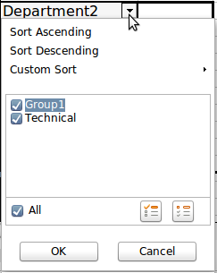
Figure 54: Custom sorting
Sort manually by using drag-and-drop
You can change the order within categories by moving cells with the category values in the result table of the Pivot Table.

Note | Be aware that in Calc a cell must be selected. It is not enough that this cell contains the cursor. The background of a selected cell is marked with a different color. To achieve this, click in one cell with no extra key pressed and redo this by pressing, at the same time, either the Shift or Ctrl key. Another possibility is to keep the mouse button pressed on the cell you want to select, move the mouse to a neighbor cell and move back to your original cell before you release the mouse button.

Sort automatically
To sort automatically, start the options of the row or column field preferences: right-click on the table area with the Pivot Table result and choose Edit Layout to open the Pivot Table dialog (Figure 32). Within the Layout area of the Pivot Table dialog, double-click the field you want to sort. In the Data Field dialog, (Figure 41), click Options to display the Data Field Options dialog (Figure 55).
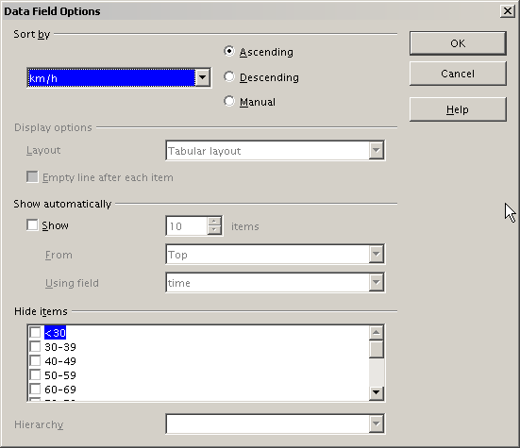
Figure 55: Options for a row or column field
For Sort by, choose either Ascending or Descending. A drop-down list will appear on the left; choose the field this setting should apply to. Note that with this method, you can specify that sorting does not happen according to categories but according to the results of the data field.

Drilling (Showing Details)
Drill Down allows you to show the related detailed data for a single, compressed value in the Pivot Table result. To activate a drill down, double-click on the cell or choose Data > Group and Outline > Show Details. To drill down effectively, you have to distinguish two cases:
- The active cell is the category of a row or column field.
In this case drill down means an additional breakdown into the categories of another field.
For example, double-click on the cell with the value golfing in the row field region (Figure 56). In this case, the values aggregated in the golfing category are subdivided according to another field.
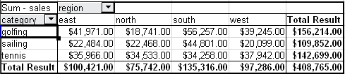
Figure 56: Before the drill down for the category golfing
Since there are more possibilities for subdivision, a dialog appears (Figure 57) so you can choose your setting.
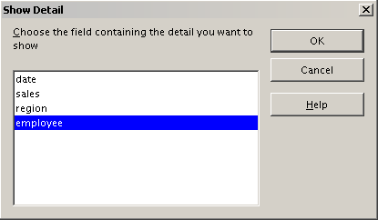
Figure 57: Selection of the field for the subdivision
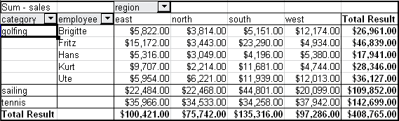
Figure 58: After the drill down
To hide the details again, double-click on the cell golfing (Figure 58) or choose Data > Group and Outline > Hide Details.
The Pivot Table remembers your selection, so the dialog does not appear for the next drill-down for a category in the field region. To remove the selection employee, open the Pivot Table dialog by right-clicking and choosing Edit Layout, then delete the unwanted selection in the row or column field.
- The active cell is a value of the data field.
In this case, drill-down means a listing of all data entries of the data source that aggregates to this value.
Double-click the cell with the value $18,741 from Figure 56. You now have a new list of all data sets included in this value. This list is displayed in a new sheet, as shown in Figure 59.
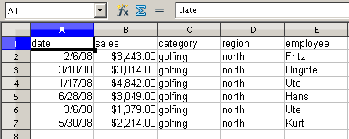
Figure 59: New table sheet after the drill down for a value in a data field

Filtering
To limit the Pivot Table analysis to a subset of the information that is contained in the data basis, you can filter the Pivot Table.
Note | An Autofilter or default filter used on the source data has no effect on the Pivot Table analysis process. The Pivot Table always uses the complete list that was selected when it was started.

To do this, click Filter on the top left side above the results, as seen in Figure 60.
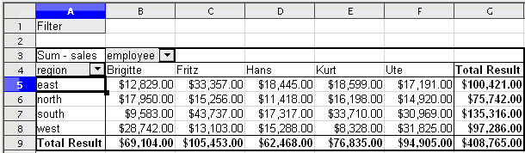
Figure 60: Filter field in the upper left area of the Pivot Table
In the Filter dialog (Figure 61), you can define up to 3 filter options that are used in the same way as Calc’s default filter.
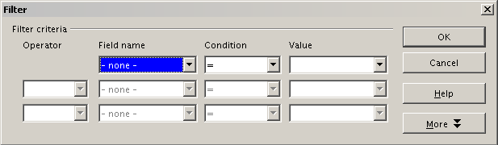
Figure 61: Dialog for defining the filter
Note | Even if they are not called a filter, page fields are a practical way to filter the results. The advantage is that the filtering criteria used are clearly visible.

Updating or Refreshing Changed Values
After creating a Pivot Table, changes in the source data do not cause an automatic update in that table. You have to manually update or refresh the Pivot Table if you've changed any of the underlying data values or added new data rows.
Changes in source data could appear in two ways:
- The content of existing data sets has been changed.
For example, you might have changed a sales value in an existing row of data. To update the Pivot Table, right-click in the result area and choose Refresh (or choose Data > Pivot Table > Refresh from the menu bar).
- You have added or deleted data sets in the original list.
In this case, the Pivot Table has to use a different area of the spreadsheet for its analysis. If you insert data within the currently used data range, for example, by using the menu Insert > Cells, you can update the Pivot Table result using the Refresh option. If you type data into cells outside of the original area, you must redo the Pivot Table from the beginning.

Cell Formatting
Calc automatically formats the cells in the results area of the Pivot Table. You can change this formatting using all the tools in Calc, but remember, if you make changes in the design of the Pivot Table or any updates, the formatting of those features will return to that applied by Calc.
For a number format in the data field, Calc uses the format used in the corresponding cell in the source data. In most cases, this works well. However, if a result is a fraction or a percentage, the Pivot Table does not recognize that this might be a problem; such results must either be without a unit or be displayed as a percentage. While you can correct the number format manually, the correction will remain in effect only until the next update.

Multiple Data Fields
Until now, we have assumed that the layout of the Pivot Table contains only one data field. However, it is possible to have several data fields in the middle of the layout. This makes summaries and analyses of multiple aspects possible.
For example, you could list all the sales values per day and give the number of entries per day. To do this, put the sales and the date fields into the Data Fields area. For the date field, choose the Count option for the aggregate function (see Figure 62).
Since every entry has a specific date, the field, as just described, will give you the number of entries for each date. If you group the values per month, you get an overview with the sales value and the number of closed sales for each category and month (see Figure 63).
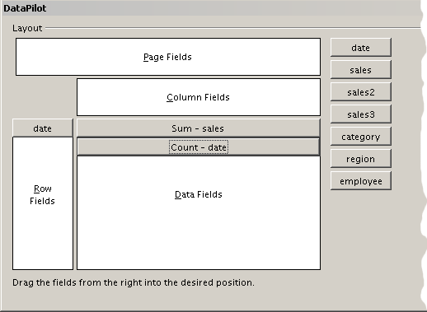
Figure 62: Multiple data fields in the Pivot Table
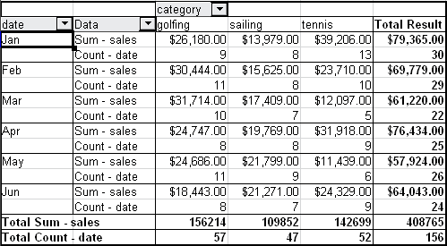
Figure 63: Pivot Table shows sales value and number of entries
When using multiple data fields, the Pivot Table result area contains a field called Data that allows manipulation of the existing data fields. You can move this field like any other row or column field by using drag and drop. This is an easy way to achieve different structures for the results (see Figures 64 and 65); drag and drop the Data field onto the date field label or the category field label.
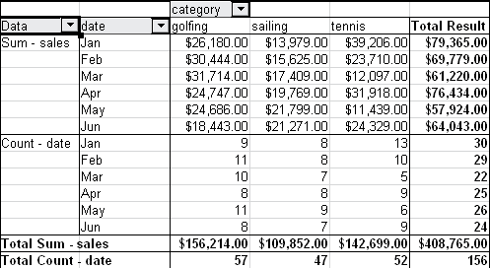
Figure 64: Layout option for presenting the sums and numbers of the sales values
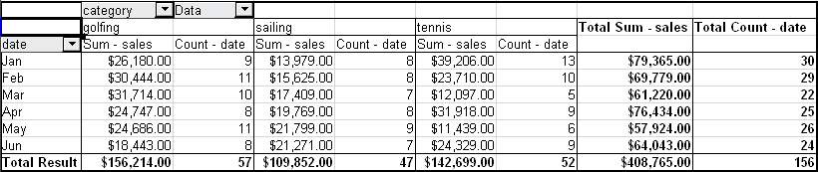
Figure 65: Another layout option for presenting the sums and numbers of the sales values
If you want to put the different data fields in other columns and your Pivot Table does not contain another column field, or if you've sorted data fields in different rows and don’t have another row field (Figure 66), it's helpful to disable viewing for row or column sums (Figure 67). Just drag the category field label up to the Filter area.
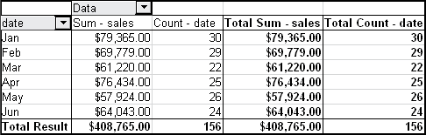
Figure 66: Unnecessary columns
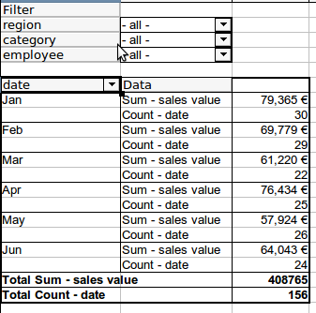
Figure 67: Disabled column sums
A frequent use case for multiple data fields is the aggregation of one value according to different aggregate functions at the same time. For instance, you can create a Pivot Table that shows you the monthly sales values and shows you additionally the smallest and the largest amounts.
To do this during the Pivot Table creation, after you drag the sales button to the Data Fields area, double-click on it to open the Data Field Options dialog. Hold the Ctrl key while you click on the various aggregation functions. Figure 68 shows the selection of the Sum, Max, and Min functions for the sales field.
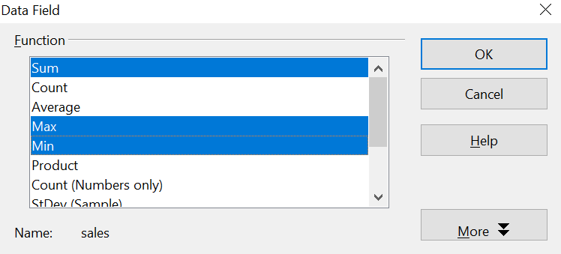

Figure 68: Multiple analyses for the same data field

After you click OK in the Data Field dialog, the Pivot Table dialog will show Result – sales, as shown in Figure 69.
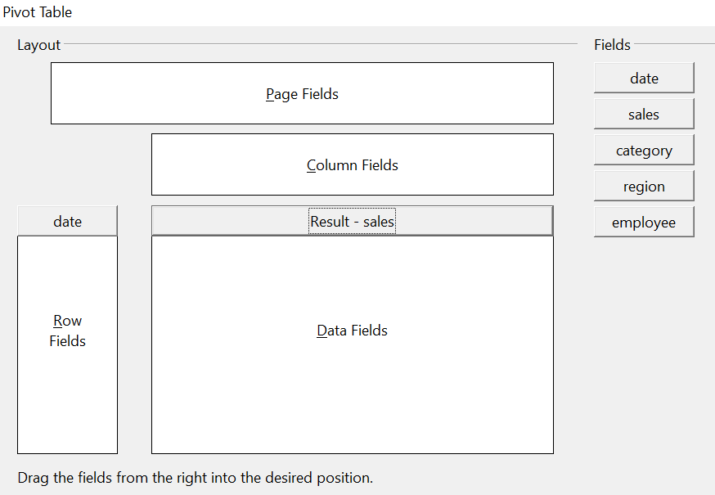
Figure 69: Pivot Table dialog after choosing multiple functions
After grouping by month, the resulting Pivot Table is shown in Figure 70.
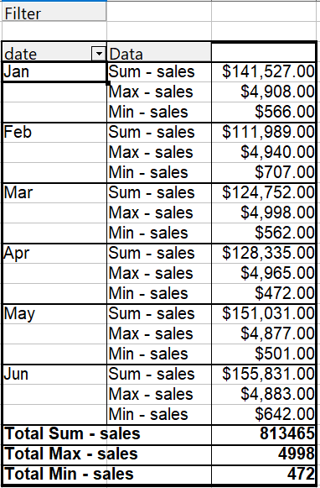

Figure 70: Sum, Max, and Min of the sales data

Shortcuts
If you use Pivot Tables very often, you might find the frequent use of the menu paths (Data > Pivot Table > Create and Data > Group and Outline > Group) inconvenient.
For grouping, a shortcut is already defined: F12. What's more, when creating a Pivot Table, you can define your own keyboard shortcut. If you prefer toolbar icons instead of keyboard shortcuts, you can create a user-defined symbol and add it to either your custom-made toolbar or the Standard toolbar.
For an explanation of how to create keyboard shortcuts or add icons to toolbars, see Chapter 14 (Setting Up and Customizing Calc).

Function GETPIVOTDATA
The function GETPIVOTDATA can be used with formulas in Calc if you need to reuse results from a Pivot Table elsewhere in your spreadsheet.

Difficulty
Normally, you create a reference to a value by entering the address of the cell that contains the value. For example, the formula =C6*2 creates a reference to cell C6 and returns the doubled value.
If this cell is located in the results area of a Pivot Table, it contains the result that was calculated by referencing specific categories of the row and column fields. In Figure 71, cell C6 contains the sum of the sales values of the employee Hans in the Sailing category. The formula in the cell C12 uses this value.
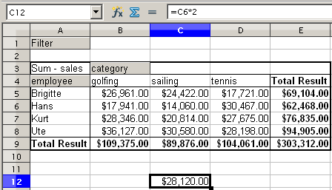
Figure 71: Formula reference to a cell of the Pivot Table
If the underlying data or the layout of the Pivot Table changes, you must be mindful that the sales value for Hans might appear in a different cell. Your formula still references the cell C6 and, therefore, uses the wrong value. The correct value is in a different location. For example, in Figure 72, the location is now C7 because the employee Fritz is included in the Pivot Table.
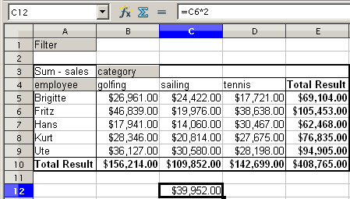
Figure 72: The value that you really want to use can be found now in a different location.
The function GETPIVOTDATA allows you to have a reference to a value inside the Pivot Table by using the specific identifying categories of that value.

Syntax
The syntax has two variations:
GETPIVOTDATA(target field, pivot table; [ Field name / Element; ... ])
GETPIVOTDATA(pivot table; specification)

First Syntax Variation
The target field specifies which data field of the Pivot Table is used within the function. If your Pivot Table has only one data field, this entry is ignored, but you must enter it anyway.
If your Pivot Table has more than one data field, then you must enter the field name from the underlying data source (for example, “sales”) or the field name of the data field itself (for example, “sum – sales”).
The argument pivot table specifies the Pivot Table that you want to use. Your document may contain more than one Pivot Table. In any case, enter a cell reference from within the results area of your Pivot Table.
Example: GETPIVOTDATA("sales";A1)
If you enter only the first two arguments, then the function returns the total result of the Pivot Table (“Sum – sales” as the field will return a value of 408,765).
Add more arguments structured as pairs (field name and item) to retrieve specific partial sums. In the example in Figure 73, if we want to get the partial sum of Hans for sailing, the formula in cell C12 would look like this:
=GETPIVOTDATA("sales";A1;"employee";"Hans";"category";"sailing")
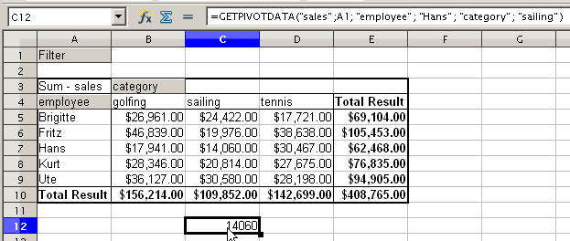
Figure 73: First syntax variation

Second Syntax Variation
The argument pivot table has to be given the same way as the first syntax variation.
For the specifications, enter a list separated by spaces to specify the value you want from the Pivot Table. This list must contain the name of the data field if there is more than one data field, otherwise it is not required. To select a specific partial result, add more entries in the form of Field name[item].
In the example in Figure 74, where we want to get the partial sum of Hans for Sailing, the formula in cell C12 would look like this:
=GETPIVOTDATA(A1;"sales employee[Hans] category[sailing]")
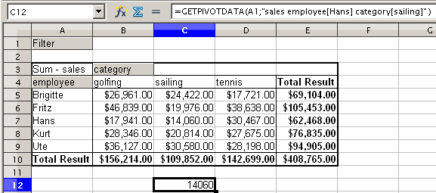
Figure 74: Second syntax variation

In this case, the word - undefined – is misleading because the output position is defined by the cell. A better term would be -unnamed-.

